Original Research Article

IN VITRO MICROPROPAGATION OF ACORUS CALAMUS USING RHIZOME EXPLANTS

ABSTRACT: The present investigation has been conducted on “In-vitro micro propagation of Acorus calamus L. using rhizome explants” was undertaken to identify a suitable media combinations for the micro propagation of Acorus calamus L. The authenticated mother plant of Acorus calamus L. was collected from the Dhanvantari Nursery, Kedgaon. Tal - Nagar, Dist.- Ahmednagar (Maharashtra). The surface sterilization treatments of 0.1% Bavistin along with 0.1% HgCl₂ and 70% ethanol were found effective for Acorus calamus L. The MS media supplemented with different concentrations of BAP was used for initiation. MS medium supplemented with 0.40 µl/200ml, 0.50 µl/200ml and 0.60 µl/200ml shows highest direct regeneration. Then the well grown cultures were transferred to the new medium with different concentration of BAP and NAA for the Multiplication of shoots, 0.60 µl BAP + 0.60 µl NAA provided the highest multiplication rate, with increased number of shoots per explant. Following successful multiplication, the shoots were moved to MS media with varying IBA concentrations (0.25 and 0.35 µl/250 ml). Both treatments showed significant rooting, with 0.35 µl IBA showing the greatest root length and density.
Keywords: Acorus calamus, in vitro micropropagation, mother plant, Bavistin, MS media.

1. Introduction
Acorus calamus L., commonly known as Vekhand or Sweet Flag, is a perennial, semi-aquatic herb belonging to the family Acoraceae (Ahmed et. al. 2007). It typically thrives in wetlands and marshy habitats of temperate to subtropical regions and is native to India, with wide distribution across Asia, Europe, and North America. (Verma S., and Singh N., 2012) The plant features sword-shaped leaves arising from a branched underground rhizome, which is the primary source of its medicinal properties.
Acorus calamus has been used in Ayurveda, Unani and traditional Chinese medicine. Its rhizomes contain essential oils and α-asarone, β-asarone etc. that confer to it various antimicrobial, anti-inflammatory, analgesic, neuroprotective, antioxidant, and insecticidal activities (Zuba D, Byrska B, 2012). It has been used medicinally to heal everything from asthma and bronchitis, to digestive problems, epilepsy and memory loss. In addition, it is used in perfume and cosmetic industry for its good fragrance. It makes a good addition to other tonics and stimulants. It is a traditional source of medicine for colds, coughs and other respiratory problems — such as bronchitis. It is also used as a cough syrup (Babar et al., 2020). Several traditional names have been associated with sweet flags. Long used by indigenous societies around the world — as evidenced by its many names. Calamus, myrtle, myrtle grass, myrtle sedge, cinnamon sedge, gladdon, sweet rush, sweet root, sweet cane, flag root, myrtle flag and sweet cinnamon are just some of the vernacular names (Grieve, 1971). Volatil-oil fragrance is due to aromatic substances, namely asarone in leaves and arylaldehyde in roots. (Altaf et. al. 2010).
Acorus calamus has a great number of medicinal and economic applications, but it has a limitation in its cultivation. The propagation of this species is mostly asexual, via rhizome pieces, consequently with low multiplication rates and high risk of pathogen spread, especially bacterial diseases as leaf blight and rot. In addition, habitat destruction and overharvesting have resulted in a decline of natural populations.
To overcome these limitations, plant tissue culture techniques—particularly micropropagation—offer a promising solution. Micropropagation is a method of clonal propagation under sterile, in vitro conditions that enables the rapid multiplication of genetically uniform and disease-free plantlets. This technique is particularly beneficial for medicinal plants like Acorus calamus, where consistent phytochemical composition and large-scale propagation are crucial for pharmaceutical applications.
The present study aims to establish a reliable and efficient micropropagation protocol for Acorus calamus using shoot tip and rhizome explants. By optimizing culture media and growth regulator combinations, this research intends to facilitate large-scale production, aid in conservation efforts, and support commercial cultivation of this valuable medicinal herb.
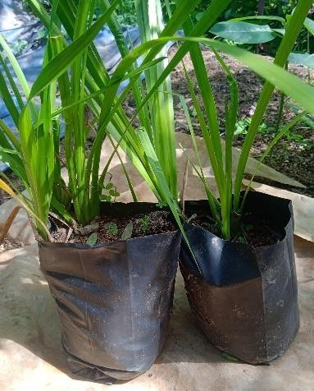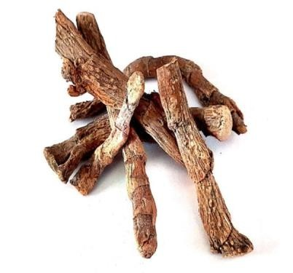
Fig 1- Acorus calamus and its rhizome explants
2. Materials and Methods
2.1 Plant Material and Explant Collection
Authentic Acorus calamus L. mother plants were procured from Dhanvantari Nursery, Tal. Nagar, Dist. Ahilyanagar, Maharashtra. Rhizome segments were selected as explants for in vitro culture.
2.2 Sterilization of Glassware and Instruments
All the glassware and instruments (culture bottles, forceps, scalpels) were first washed with detergent under running tap water, rinsed with double-distilled water (DDW), wrapped in paper, and autoclaved at 121 °C and 15 psi for 20 minutes.
2.3 Preparation of Stock Solutions
Macronutrients, micronutrients, iron, glycine, potassium iodide (KI), vitamins, and inositol were individually prepared as concentrated stock solutions in DDW. Growth regulators were dissolved in suitable solvents before being made up to volume. All stocks were refrigerated; iron solution was stored in amber colour bottles.
2.4 Culture Media Preparation
Murashige and Skoog (MS) medium was used supplemented with 30 g/L sucrose, 100 mg/L inositol, and solidified with 8 g/L agar. The pH was adjusted to 5.6–5.8. Growth regulators were added before autoclaving at 121 °C for 15–20 minutes. The medium was then poured into sterile culture bottles.
2.5 Surface Sterilization of Explants
Rhizome segments (0.5–1 cm) were washed in tap water (10–15 min), treated with Dettol (10 min), and rinsed thoroughly with DDW. Explants were then immersed in a fungicide Bavistin solution (1.0%) for 30 min on a rotary shaker, followed by multiple rinses with DDW. In the aseptic laminar area, explants were treated with 0.1% (w/v) HgCl₂ for 1 minute and rinsed thoroughly with sterile DDW.
2.6 Inoculation and Shoot Initiation
Surface-sterilized explants were inoculated onto MS media supplemented with varying concentrations of 6-Benzylaminopurine (BAP). Five concentrations (1.0–3.0 mg/L) were initially selected. Due to limited explants, media volumes were scaled down to 200 mL, and BAP concentrations adjusted accordingly (100–600 µL/200 mL).
2.7 Culture Conditions
Cultures were maintained at 25 ± 2 °C with a photoperiod of 16 hours light and 8 hours dark less than 2000–3000 lux from white fluorescent lamps.
2.8 Culture Initiation and Sub culturing
Initial shoot formation was observed within one week, with substantial development after 2–3 weeks. Well-developed shoots were excised and subculture onto fresh multiplication media.
2.9 Shoot Multiplication
Excised shoots were cultured on MS media supplemented with combinations of BAP (0.60 µL/250 mL) and NAA (0.35–0.60 µL/250 mL) to assess multiplication efficiency.
2.10 Root Induction
Multiplied shoots were transferred to rooting media containing Indole-3-butyric acid (IBA) at 0.25 and 0.35 µL/250 mL concentrations to induce root development.

3. Results
The present study aimed at establishing a protocol for in vitro micropropagation of Acorus calamus L. using rhizome segments as explants.

3.1 Establishment of In Vitro Culture
Rhizome segments of Acorus calamus were successfully used as explants and cultured on MS medium supplemented with varying concentrations of BAP. All tested concentrations supported shoot initiation, with differences in shoot length and response rate. The results demonstrate that shoot induction was effectively influenced by BAP concentrations.

3.2 Initiation of Culture
Shoot induction was recorded across all treatments. Among the five tested concentrations of BAP (0.10 to 0.60 µl/200 ml), the highest average shoot length (6.25 cm) was observed with 0.60 µl BAP. A detailed comparison is presented in Table 1

Table 1: Effect of BAP on Shoot Initiation
Sr. No. | Media + BAP (µl/200ml) | Average Shoot Length (cm)
1 | MS + 0.10 | 3.85±1.128
2 | MS + 0.30 | 3.70±1.109
3 | MS + 0.40 | 5.75±0.629
4 | MS + 0.50 | 5.00±0.883
5 | MS + 0.60 | 6.25±2.298
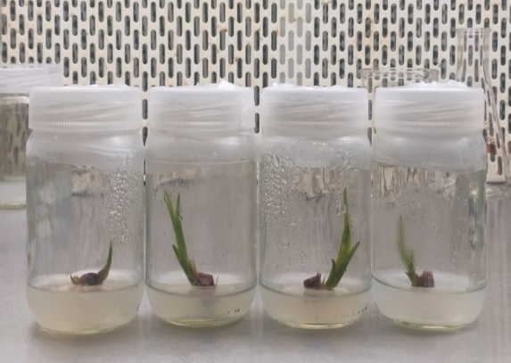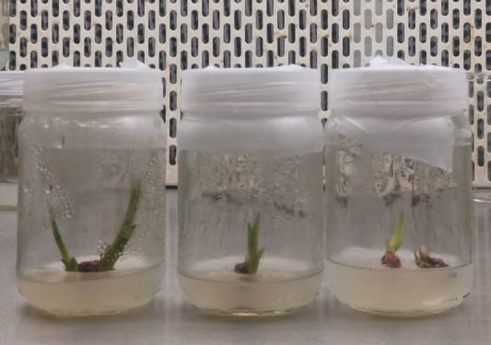

Plate 1: The results of shoot initiation

3.3 Shoot Multiplication
After 20 days in initiation medium, the explants were transferred to multiplication medium containing BAP and NAA. The maximum number of multiple shoots (average 4.5) was observed with a combination of 0.60 µl BAP and either 0.35 µl or 0.60 µl NAA.

Table 2: Shoot Multiplication Using BAP and NAA
Sr. No. | BAP + NAA (µl/250ml) | Avg. no. of Shoots per Explant |  | Avg. Shoot Length (cm)
1 | 0.60 BAP + 0.35 NAA | 4.5 |  | 4.30±0.6639
2 | 0.60 BAP + 0.50 NAA | 4.25 |  | 3.15±0.8131
3 | 0.60 BAP + 0.60 NAA | 4.5 |  | 4.30±0.6639

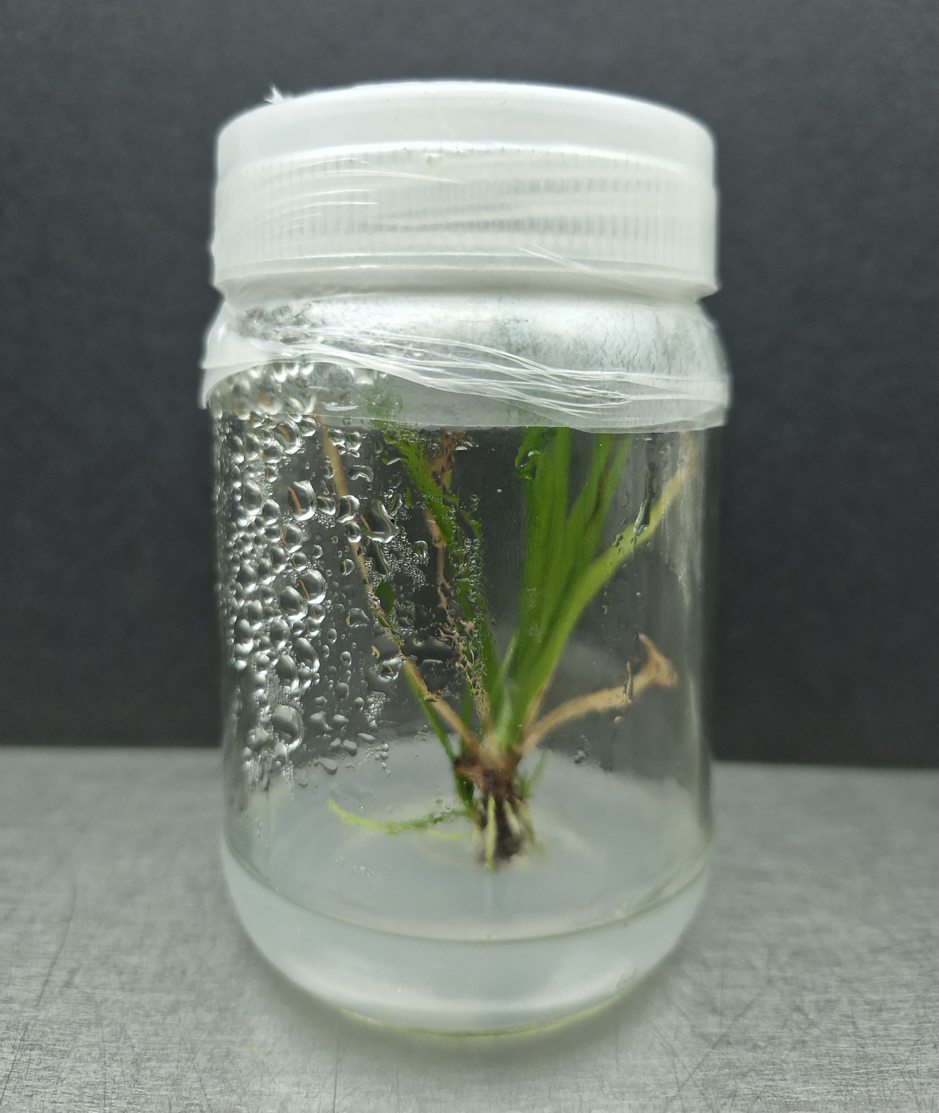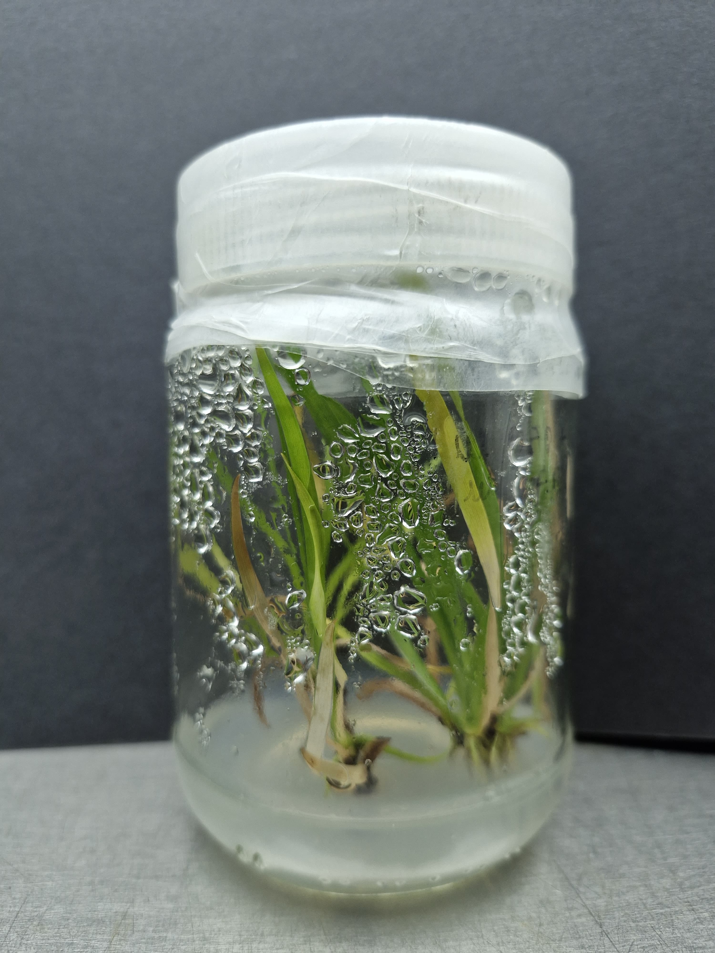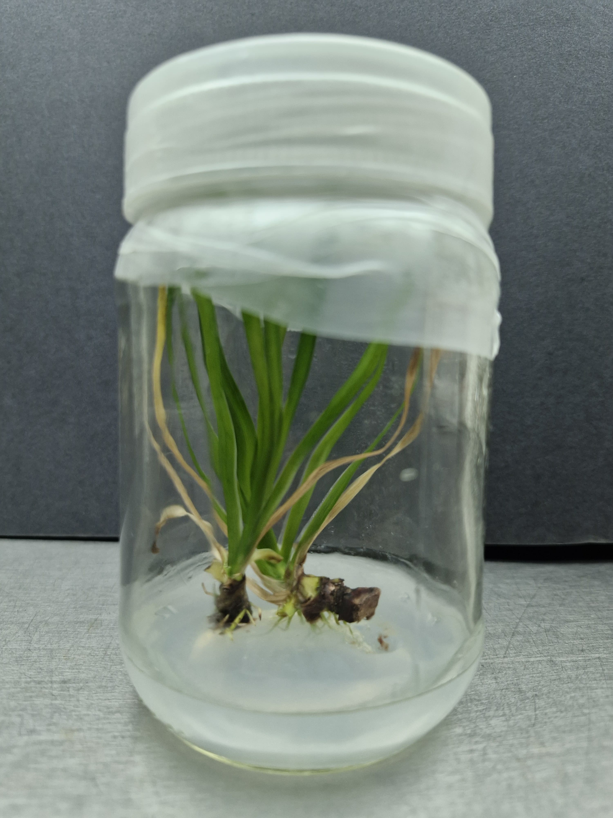

Plate 2: Results of the Shoot multiplication

3.4 Root Initiation
The successfully multiplied shoots were transferred to MS medium with different concentrations of IBA (0.25 and 0.35 µl/250 ml). Rooting was observed in both treatments, with enhanced root length and density in 0.35 µl IBA.

Table 3: Rooting Efficiency Using IBA
Sr. No. | IBA (µl/250ml) | Observation
1 | 0.25 | Rooting observed, moderate root length
2 | 0.35 | Increased root length and number

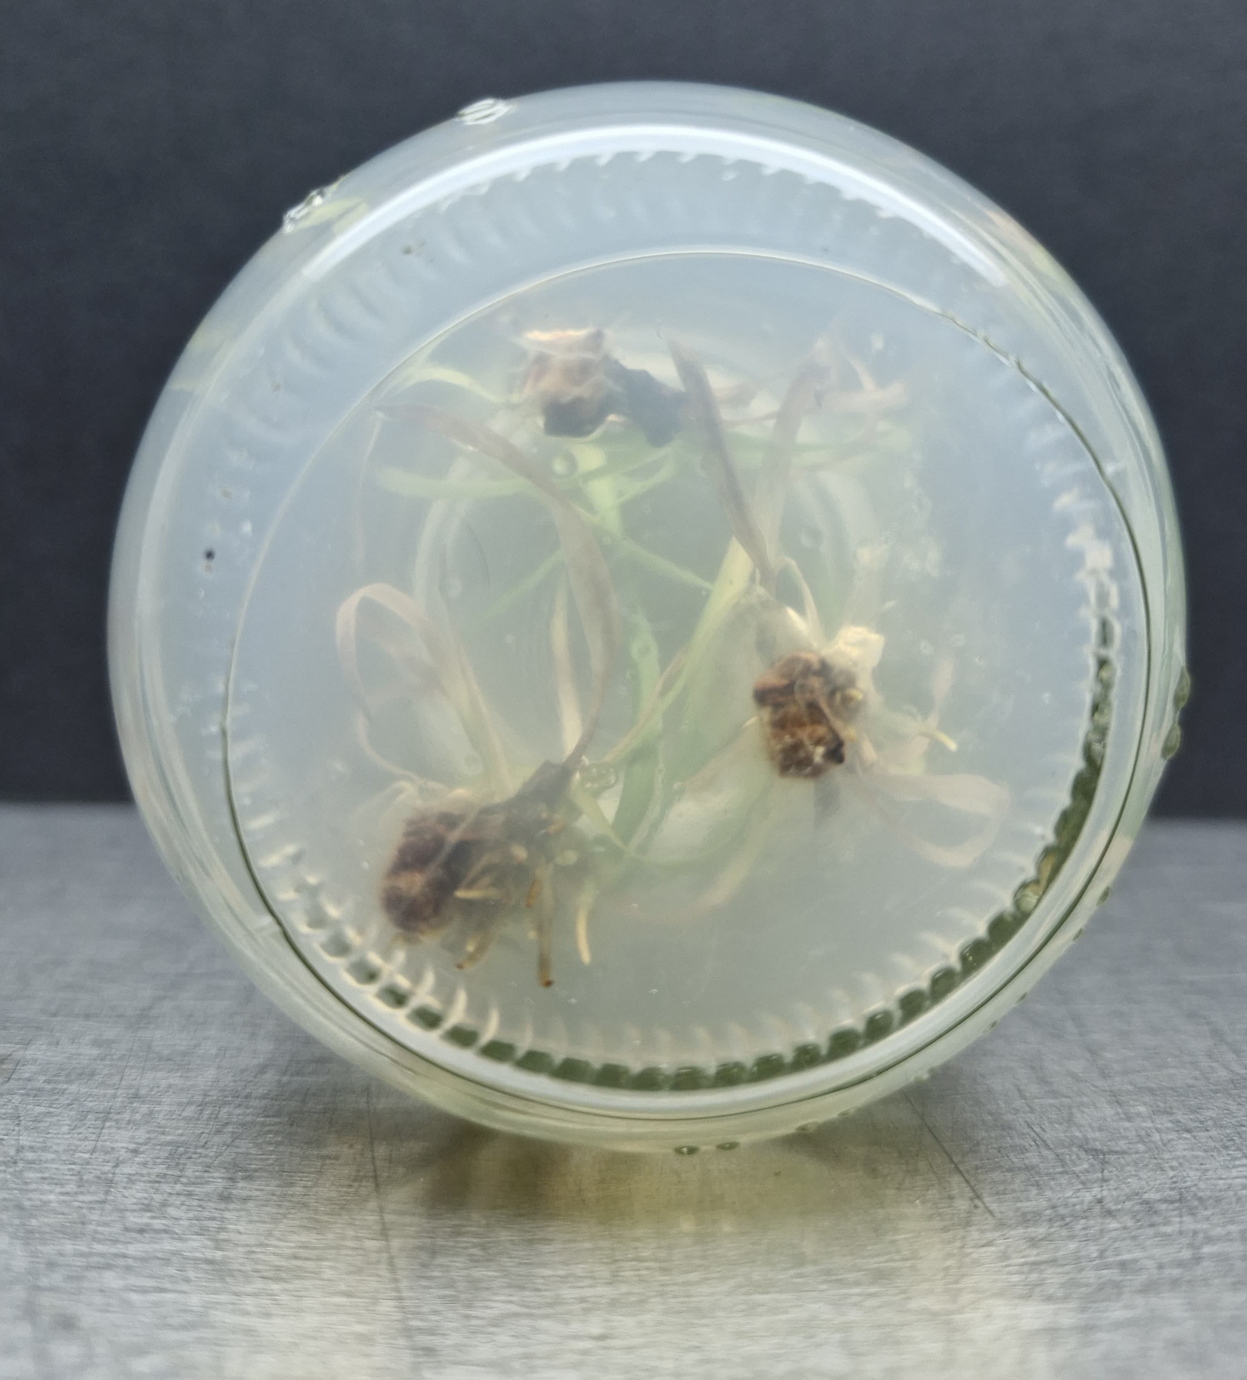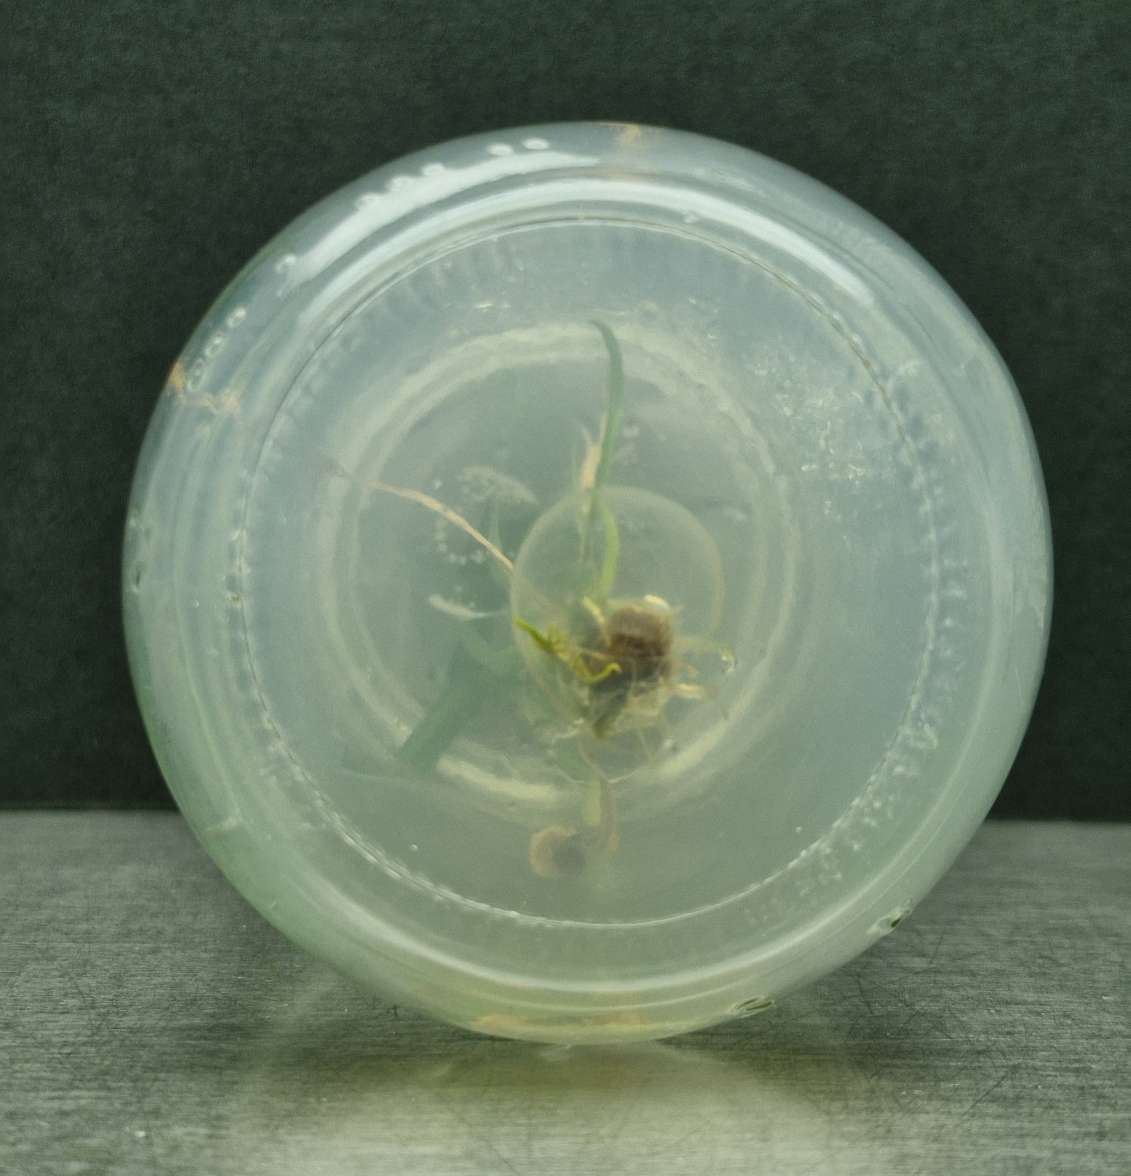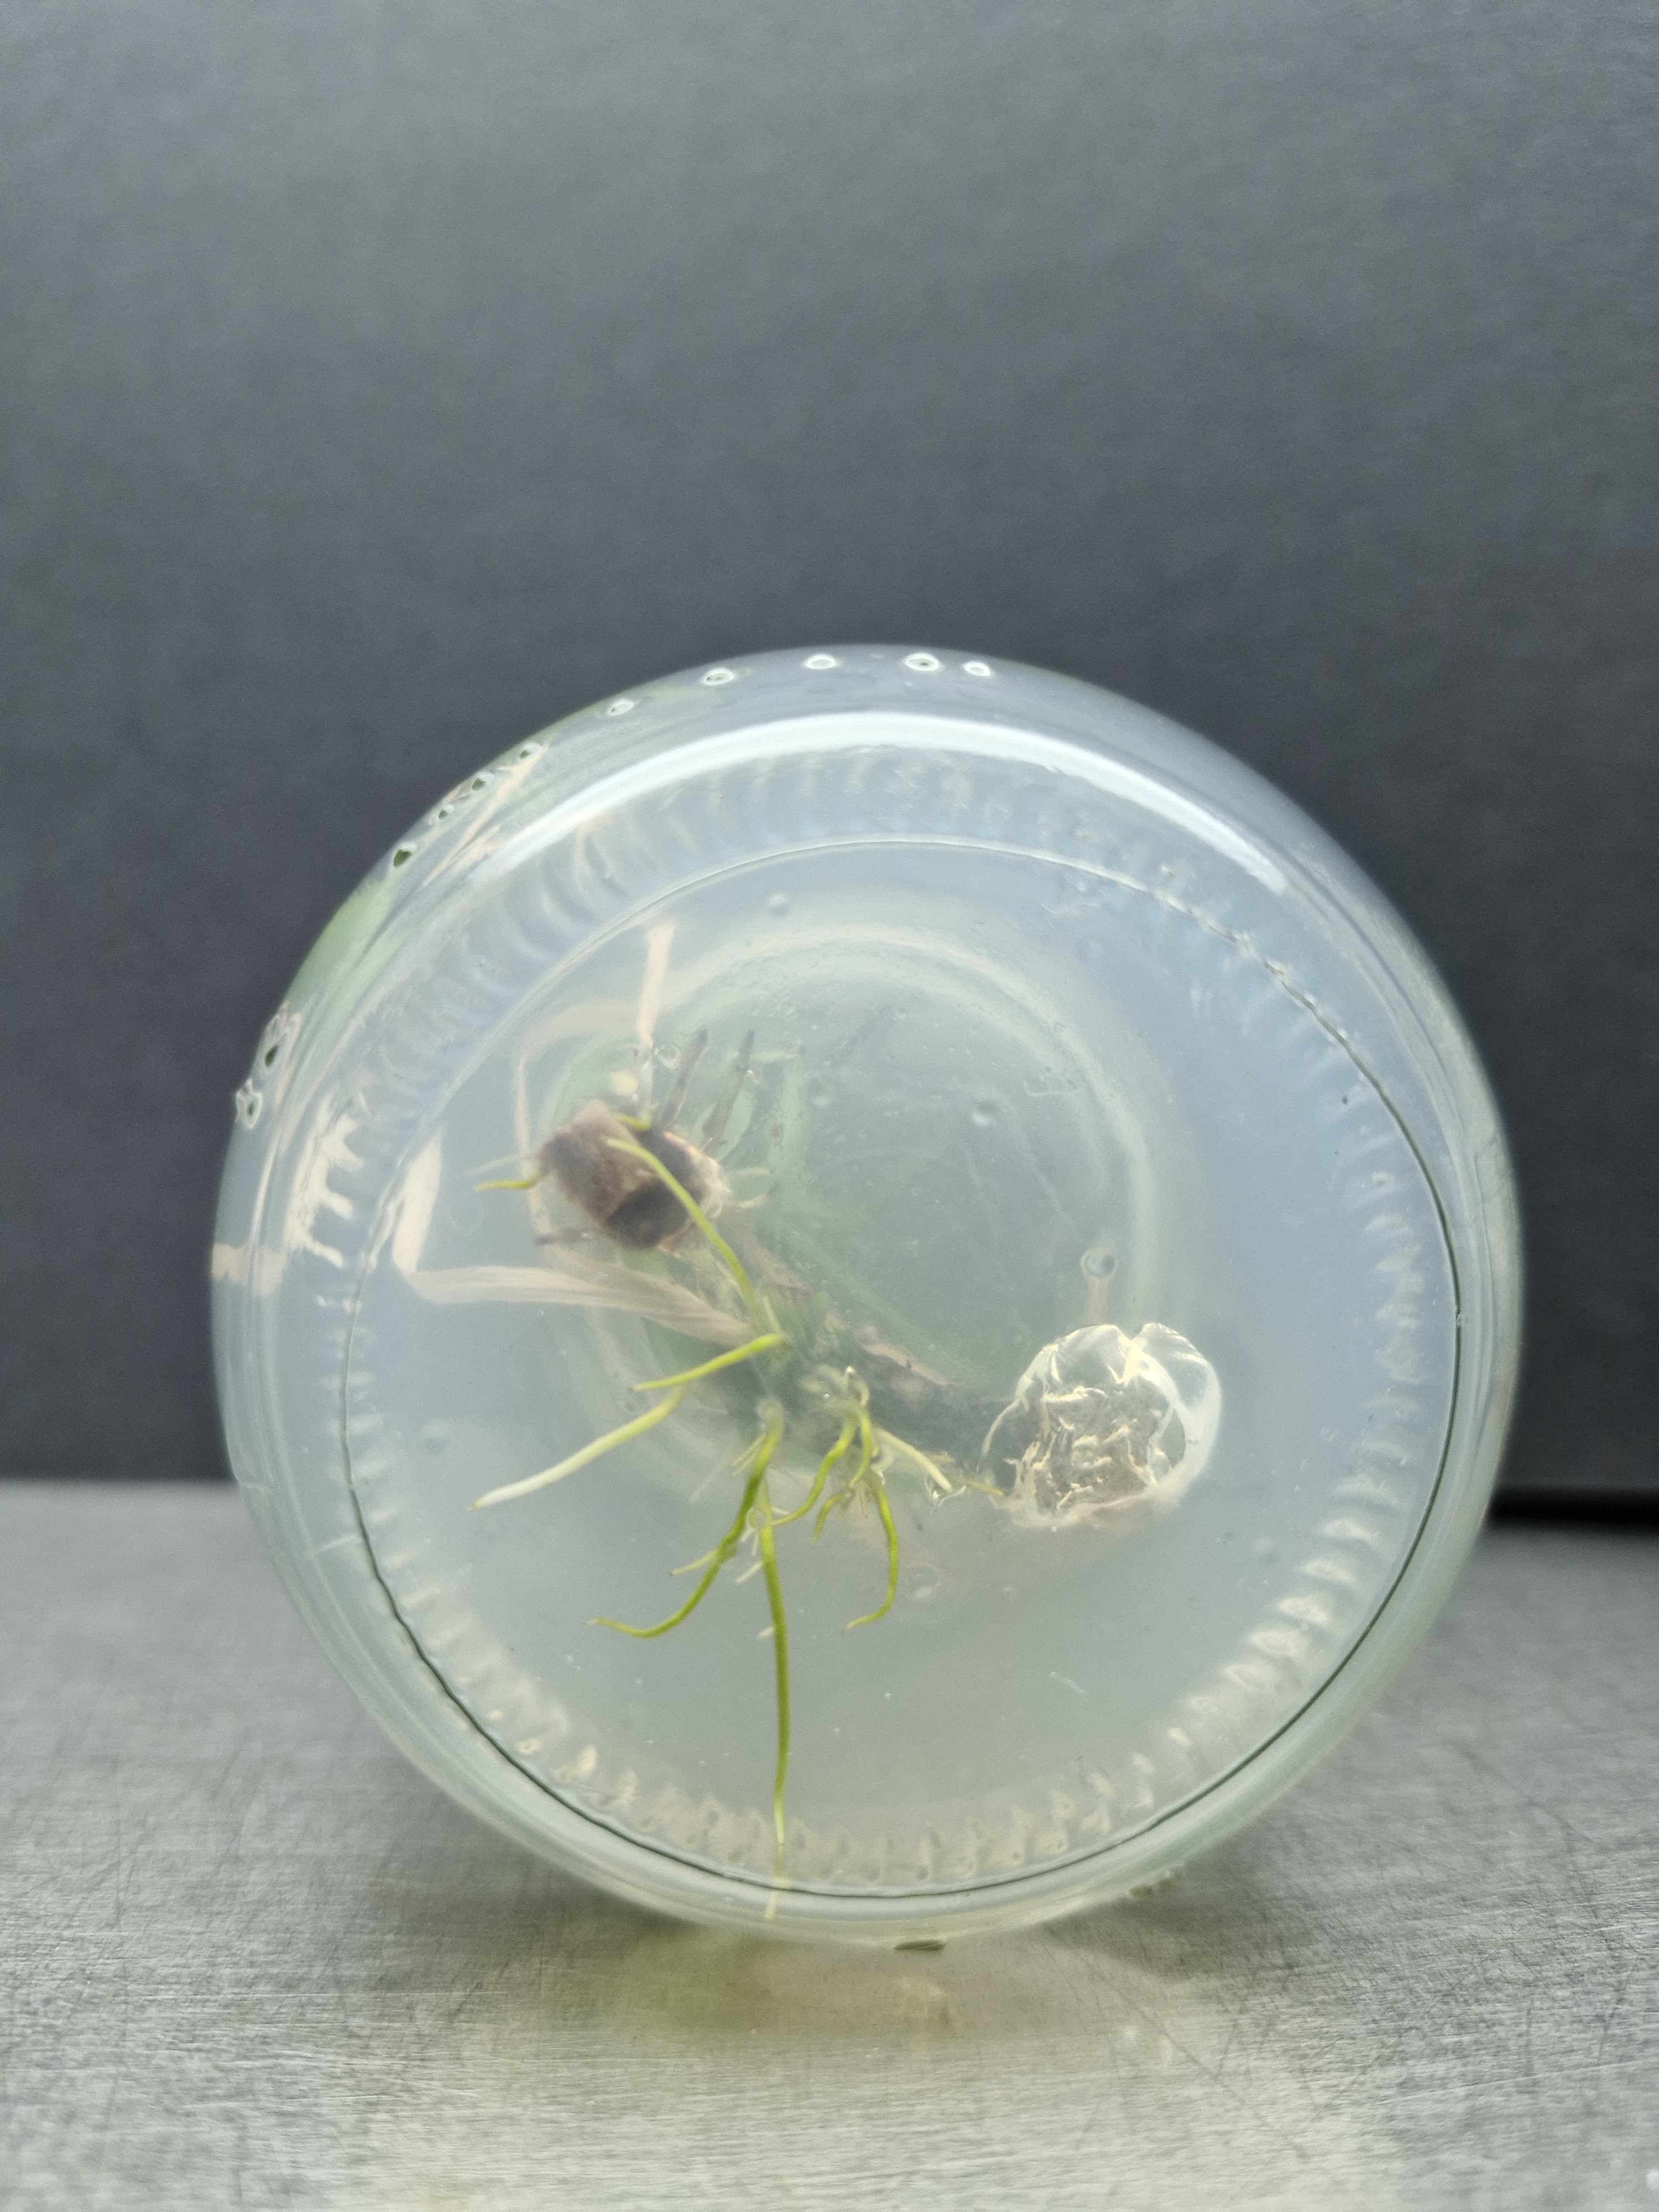

Plate 3: Results of the Rooting

3.5 Hardening
Rooted plantlets were removed from culture bottles, washed thoroughly, and treated with 1% Bavistin for 15–20 minutes. They were then transferred to portray containing a sterilized cocopeat-soil mixture (2:1) in polythene bags. Primary hardening was carried out under high humidity conditions, followed by secondary hardening under controlled exposure to ambient conditions.
4. Discussion
The present investigation, titled “In vitro Micropropagation of Acorus calamus L.”, was successfully carried out by investigating the effects of several plant growth regulators on the initiation, multiplication, and roots stages of development, the study sought to design a dependable and effective in vitro propagation strategy.
Rhizome segments of Acorus calamus were cultivated on MS media supplemented with varying doses of Benzyl Amino Purine (BAP) during the initiation phase. These concentrations ranged from 0.10 µl/200 ml to 0.60 µl/200 ml. BAP doses of 0.40 µl, 0.50 µl, and 0.60 µl showed the best shoot induction among the investigated concentrations; by 20 days, explants showed robust and healthy shoot emergence. These findings imply that moderate BAP concentrations are ideal for Acorus calamus shoot initiation.
After the successful shoot initiation, the explants were transferred to the multiplication medium supplemented with BAP and NAA. The best response was observed with 0.60 µl BAP + 0.60 µl NAA suggesting that auxin (NAA) greatly increased shoot proliferation. These results are consistent with those of Gholipour A.(2021), who likewise used rhizome explants and a hormonal combination of 1 mg/L BAP and 1 mg/L NAA to demonstrate effective shoot multiplication. Successfully multiplied shoots were transfered on MS media supplemented with 0.25 µl and 0.35 µl/250 ml of Indole-3-butyric acid (IBA) for the rooting stage. The rooting was enhanced by both the treatments. Initially Altaf A.(2010), also got the similar results by using IBA for rooting. The use of particular growth hormone combinations and its concentration makes a great impact on the micropropagation process.

5. Summary & Conclusion
The present study, conducted at the College of Agricultural Biotechnology, Loni (Maharashtra), was aimed at developing an efficient protocol for the in vitro micropropagation of Acorus calamus (commonly known as Vekhand), a perennial aromatic herb belonging to the family Acoraceae. Conventionally propagated through rhizomes, Acorus calamus is prone to fungal diseases such as leaf spot and leaf blight. Micropropagation offers a reliable alternative for producing disease-free planting material on a large scale. The rhizome segments were used as explants. Dettol, Bavistin (1.0%) and Mercuric chloride (0.1%) was used for the surface sterilization followed by repeated washing with sterile distilled water. Explants were cultured on MS medium containing different concentrations of BAP (0.10–0.60 µl/200 ml). Best shoot induction was observed with 0.40–0.60 µl BAP, where healthy and elongated shoots formed within 20 days.
Successfully initiated shoots were transferred to multiplication media containing 0.60 µl BAP combined with varying concentrations of NAA. Among the combinations tested, 0.60 µl BAP + 0.60 µl NAA provided the highest multiplication rate, with the increased number of shoots per explants. Rooting was successfully achieved using MS medium supplemented with IBA at 0.25 µl and 0.35 µl/250 ml. Root formation was consistent across both concentrations under aseptic culture room conditions. The in vitro rooted plantlets were acclimatized through a two-step hardening process. Initially, plantlets were washed to remove agar, treated with 1% Bavistin solution, and then transplanted into portray trays containing a 2:1 mixture of sterilized cocopeat and soil. Primary hardening was carried out in a humid chamber, followed by secondary hardening under semi-natural conditions to ensure adaptation for field transfer.
Conclusion:
This study successfully established a reproducible protocol for the in vitro propagation of Acorus calamus using rhizome explants. The optimized concentrations of BAP, NAA, and IBA played a crucial role in enhancing shoot induction, multiplication, and rooting efficiency. This method provides a promising tool for rapid clonal propagation and large-scale production of healthy, disease-free Acorus calamus plants, contributing significantly to conservation, commercial cultivation, and the pharmaceutical industry.
References:
A.Wulansari, Aida, (2023) &quot;Modification of media compositions for micropropagation of Acorus calamus L.&quot; Biogenesis: Journal Ilmiah Biology 11.1.1-13.

Ahmed M., Ahmed S., Hannan M., Hossain M., Islam R., Khatun M., Salahin M.,Sultana R., George and Razvy M. (2007). Standardization of a Suitable Protocol for in vitro Clonal Propagation of Acorus calamus L. an Important Medicinal Plant in Bangladesh. Amer. Eur. J. of Sci. Res. 2(2): 136-140.

Ajaikumar B., Kunnumakkara, Anindita D., Ganesan P., Javadi M. Khwairak pm A.,Roy N. and Yengkhom D. (2018). Acorus calamus L. a bio-reserve of medicinal values. J. of Basic and Cli. Phys. And Pharma. (29), 210-216.

Akhade A., Baokar S., Pawar V. and Shivakumar H. (2011). Antidepressant-like effects of Acorus calamus L. in forced swimming and tail suspension test in mice. J. of Trop.Bio. Med. (1), S17–S19.

Altaf A., Hareesh V., Honnesh N., Shashidhara S. and Rajasekharan P. (2010). In vitro regeneration of Acorus calamus L. – an important medicinal plant. J. of Curr. Pharm.Res. 2(1):36-39.

Angier, B. (1974) Field Guide to Edible Wild Plants. Stackpole Books; Harrisburg –Pennsylvania. Page 224.

Balakumbahan R., Rajamani K., and Kumanan K., (2010), Acorus calamus: An overview, Journal of Medicinal Plants Research; 4(25):2740-2745.

Babar P., Chavan J., Deshmukh A. and Salunkhe S. (2020). Micropropagation, polyphenol content and biological properties of sweet flag (Acorus calamus L.): a potent medicinal and aromatic herb. Vegetos. 33,296-303.

Grieve, M. (1971). Acorus calamus: A Review on Its Phytochemical and Pharmacological Profile.; Dover Publications, Inc; New York. Vol. II. Pages 726 – 729

Gholipour A., Kazemitabar S. K., Ramzanpour H., (2021), A comparative study on Acorus calamus (Acoraceae) micropropagation and selection of suitable population for cultivation in Iran, Acta Biologica Szegediensis; 65(1):29-34.

Imam H., Riaz Z., Azhar M., Sofi G., Hussain A. (2013), Sweet flag (Acorus calamus Linn.): An incredible medicinal herb, International Journal of Green Pharmacy; 7(1):288-296

Khan, B.M., J. Bakht, S.H. Shah and M. Shafi. (2016). Micropropagation of medicinally important weed, Acorus calamus, rhizome explants with indigenous natural growth regulators. Pak J. weed Sci. Res. 22(3): 441-462

Lee, S.C., J.S. Lee, and S.J. Jeong. 2005. Plant growth by bud number and medium composition in division of Acorus calamus. Kor. J. Hort. Sci. Technol. 23:455–458

Nisa N. T., (2018), In Vitro Studies in Acorus calamus L, International Journal of Advance Research in Science and Engineering; 7(4):162-170

Sabitha Rani A., Subhadra V. V., and Reddy V. D. (2000), In vitro propagation of Acorus
calamus Linn. – A medicinal plant, Indian Journal of Experimental Biology; 38:730-732.

Sharma V., Sharma R., Gautam D. S., Kuca K., Nepovimova E., and Martins N., (2020) Role of Vacha (Acorus calamus Linn.) in Neurological and Metabolic Disorders: Evidence from Ethnopharmacology, Phytochemistry, Pharmacology and Clinical Study, Journal of Clinical Medicine; 9(1):1-45

Verma S., and Singh N., (2012) In vitro Mass Multiplication of Acorus calamus L. – An Endangered Medicinal Plant Am-Euras. J. Agric. &amp; Environ. Sci., 12 (11): 1514-1521

Quraishi A., Mehar S., Sahu D., Jadhav S. K., (2017), In Vitro Mid-Term Conservation of Acorus calamus L. via Cold Storage of Encapsulated Micro rhizome, An International Journal of Brazilian Archives of Biology and Technology; 60(1):1-9.

Zuba D, Byrska B (2012). Alpha- and beta-asarone in herbal medicinal products. A case study. Forensic Sci Int 223(1-3): 5-9.

