Original Research Article

Developing Monotherapy against Hepatitis E Virus by Combining Phytochemicals Using Viro-Bioinformatics

Abstract:
Hepatitis E virus (HEV) is a prominent cause of acute viral hepatitis worldwide, particularly threatening pregnant women and immunocompromised individuals due to the absence of specific antiviral treatments. This research employs an integrative in silico approach to identify phytochemical inhibitors against HEV, utilizing structure-based drug design and viroinformatics. Three essential HEV proteins—ORF1, ORF2, and ORF3—were selected for virtual screening. Phytochemicals from 15 medicinal plants were computationally screened, revealing seven promising candidates (Glycyrrhizin, Withanolides A, Rosmarinic acid, Zingerone, Chicoric acid, Acetogenins, Andrographolide) with strong binding affinities and favorable ADMET characteristics. Glycyrrhizin showed the highest binding affinity to the ORF2 capsid protein with a binding energy of −13.5 kcal/mol, indicating strong antiviral potential. To enhance phytochemical production, biosynthetic genes (4CL, SDR, RAS1, CYP88D6) were in silico cloned into plant expression vectors and computationally integrated into Ocimum sanctum and Glycyrrhiza glabra. KEGG pathway analysis confirmed increased metabolite synthesis and stress tolerance. This comprehensive computational pipeline supports the development of cost-effective, plant-based antivirals for HEV, paving the way for experimental validation and clinical application.

Key Words: Hepatitis E Virus (HEV), Phytochemicals, Molecular Docking, Recombinant DNA Technology (RDT), Glycyrrhizin.

1

1. INTRODUCTION

1.1 Hepatitis E Virus (HEV)
Hepatitis E virus (HEV) is a leading cause of acute viral hepatitis globally, accounting for approximately 20 million infections annually. It surpasses other hepatotropic viruses such as Hepatitis A (HAV), B (HBV), C (HCV), and D (HDV) in terms of incidence [Kinast, V., 2019]. First identified in 1983 by Russian virologist Dr. Mikhail Balayan—who self-experimented by ingesting fecal suspensions from infected soldiers—HEV has since emerged as a significant global health concern [Balayan M.S., 1983].
HEV is a quasi-enveloped, positive-sense; single-stranded RNA virus classified under the genus Orthohepevirus within the Hepeviridae family [Smith, D. B., 2016]. Genotypes 1 and 2 are restricted to human hosts and are predominantly found in developing countries, where they are typically transmitted via contaminated water. Genotype 1 infection is especially hazardous during pregnancy, with mortality rates reaching up to 30% in the third trimester. In contrast, genotypes 3 and 4 are zoonotic and found in animals such as pigs, deer, and wild boars. These genotypes can be transmitted to humans primarily through the consumption of undercooked or contaminated meat products [Todt, D., Moeller, 2018; Kamar, N., 2017].
The HEV genome contains three main open reading frames (ORFs) (Refer to Fig. 1). ORF1 encodes non-structural proteins essential for viral replication, such as RNA-dependent RNA polymerase and methyltransferase [Rozanov MN, 1992]. While HEV1 and HEV2 are exclusively human pathogens with no confirmed zoonotic transmission, they are responsible for recurrent epidemics in parts of Asia, Africa, Mexico, and the Middle East [Aggarwal R., 2011].
Clinically, acute HEV infection begins with a prodromal phase characterized by non-specific symptoms such as nausea, fever, and vomiting, followed by the icteric phase marked by jaundice and dark-colored urine [Mansuy J., 2009].

Fig-1 – The genomic organization and virion structure of the Hepatitis E virus (HEV).
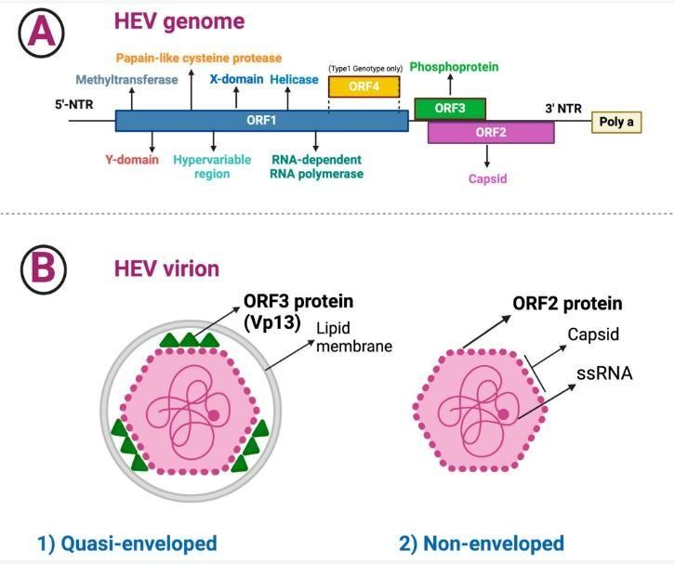
A)

B)

Fig 1 – Genomic Organization and Virion Structure of HEV:
- A) The HEV genome is a 7.2 kb positive-sense RNA, capped at the 5′ end with methyl guanosine and ending in a 3′ poly(A) tail. It comprises three partially overlapping ORFs:
  - ORF1: Non-structural proteins
  - ORF2: Capsid protein
  - ORF3: A small, multifunctional protein important for virion release
The 5′ UTR (~28 nucleotides) forms secondary structures aiding replication.
- B) The virion exists in two forms:
  - Quasi-enveloped virions, found in serum and culture supernatants, are cloaked in host-derived membranes.
  - Non-enveloped virions are excreted via bile and feces.
Genotypes 3 and 4 are zoonotic, with animal reservoirs (notably pigs), whereas genotypes 1 and 2 are human-restricted. While most HEV infections are asymptomatic, severe outcomes including fulminant hepatitis, chronic hepatitis in immunocompromised individuals, and extrahepatic manifestations have been documented [Waqar, S., 2018].

Table 1 – Overview of HEV Pathogenesis
Transmission | Hepatitis E infection is found worldwide and is common in low- and middle-income countries with limited access to essential water, sanitation, and hygiene and health services. It’s primarily caused by genotype 1 and less frequently by genotype 2. In areas with enhanced sanitation, hepatitis E is uncommon, with sporadic instances primarily attributed to genotype 3. These infections commonly result from the consumption of undercooked animal products, specifically pork liver, and are not connected to water or food contamination [Hepatitis E. (2024)].
Symptom’s | The incubation period following exposure to HEV ranges from 2 to 10 weeks, with an average of 5 to 6 weeks. The infected persons excrete the virus beginning from a few days before to 3-4 weeks after onset of the disease. The symptoms of HEV abdominal pain, itching, skin rash, or joint pain; jaundice (yellow colour of the skin), dark urine and pale stools; and a slightly enlarged, tender liver (hepatomegaly) [Waqar, S (2018)].
Diagnosis | The diagnosis for HEV involved serum concentrations of bilirubin, alanine aminotransferase (ALT), and aspartate aminotransferase (AST). Laboratory diagnosis of HEV infection is difficult due to the lack of standardized testing. Many commercial kits have been developed to test for anti-HEV IgM and IgG, but the utility is limited as there are many false positives and negatives. Definitive diagnosis is made with the detection of HEV in serum or stool by polymerase chain reaction (PCR). Because the viremia from HEV can be relatively short-lived, especially in immunocompetent patients, a negative HEV PCR does not exclude the possibility of recent HEV infection [Waqar, S (2018)].

1.1.1 Genome Organization
HEV belongs to the Hepeviridae family and is a single-stranded, positive-sense RNA virus. Mammalian HEV genomes are approximately 7200 nucleotides in length, whereas avian HEV genomes are about 6650 nucleotides [Huang, 2004]. The RNA features a 5′-cap, a short 5′ untranslated region (~26 nucleotides), three main ORFs, and a 3′ UTR [Zhang, M., 2001].
Fig 2 – Genomic Organization of Hepatitis E Virus (HEV)
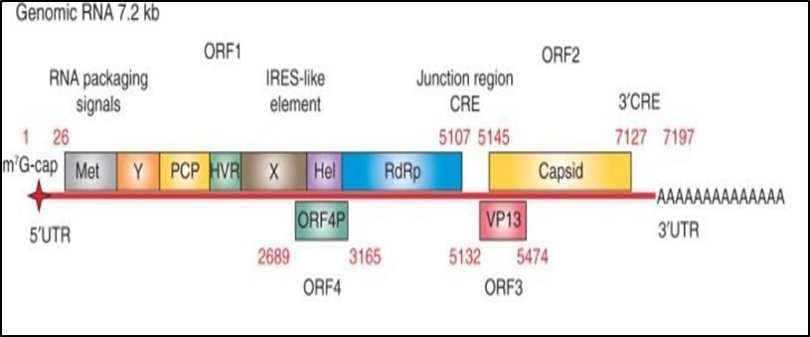

1.1.2 Open Reading Frames (ORFs)
Open reading frames (ORFs) are nucleotide sequences bounded by start and stop codons, which encode functional proteins. In viral genomes, ORFs often overlap and encode multifunctional proteins essential for replication and host interaction [Guo, H., Li, Y., 2019].
HEV contains three major ORFs:
- ORF1 encodes non-structural replication proteins.
- ORF2 encodes the capsid protein.
- ORF3 encodes a small multifunctional regulatory protein.
Genotypes 1 and 2 are human-specific, whereas genotypes 3 and 4 have zoonotic potential. Pigs are a major reservoir, and other animals like deer and rabbits also harbor HEV [Meng, X. J., 2010/2011].

ORF1
Comprising 5082 nucleotides, ORF1 encodes a polyprotein with essential enzymatic domains: methyltransferase (MeT), papain-like cysteine protease (PCP), helicase (Hel), and RNA-dependent RNA polymerase (RdRp) [Tsarev, S. A., 1992; Ahmad, I., 2011]. Certain RdRp mutations (e.g., Cys-1483→Trp and Asp-1530→Thr) are associated with ribavirin resistance and acute liver failure, highlighting their role in pathogenicity [Borkakoti, J., Ahmed, 2016].

ORF2
ORF2, comprising 1983 nucleotides in genotype 1, encodes the viral capsid protein. It begins 37 nucleotides downstream of the ORF1 stop codon and largely overlaps ORF3 [Reyes, G. R., 1993]. Specific amino acid substitutions (e.g., Pro-259→Ser, Lys-350→Glu) have been linked to increased severity of liver failure [Borkakoti, J., 2014].

ORF3
ORF3 begins 24 nucleotides after ORF1 and overlaps ORF2 by about 300 nucleotides in a different reading frame. It encodes a 13kDa protein known as VP13, which plays multiple regulatory roles in host-virus interaction [Graff, J., 2005]. ORF3 activates the MAPK/ERK signalling pathway via inhibition of dual-specificity phosphatase 6 (PYST1), promoting cell survival [Kar-Roy, A., Korkaya, H., 2005].
HEV’s compact genome, with overlapping ORFs and multifunctional proteins, represents a highly efficient strategy for viral replication and host manipulation. Understanding the roles of ORFs in viral replication, immune evasion, and host specificity is vital for the development of diagnostics and therapeutic interventions, particularly for vulnerable populations such as pregnant women and immunocompromised individuals.

1.2 Phytochemicals and HEV
Phytochemicals are plant-derived bioactive compounds with significant therapeutic potential. In countries like India and China, where over 75% of the population relies on traditional medicine, phytochemicals are a cornerstone of primary healthcare [Sharma B.R.]. These compounds—found in fruits, vegetables, herbs, grains, and nuts—include carotenoids, polyphenols, phytosterols, saponins, dietary fibers, and polysaccharides. Notable for their antioxidant, antiviral, antidiarrheal, antimicrobial, anthelmintic, and anti-inflammatory properties, they offer promising avenues for managing HEV infections [Jaeger R., 2016].

1.3 In Silico Recombinant DNA Technology (RDT)
Recombinant DNA technology (RDT) enables the targeted overexpression of genes responsible for phytochemical biosynthesis, thereby enhancing a plant’s antiviral and stress-resistance traits. This approach has revolutionized plant molecular biology by allowing precise genetic manipulation. Tools such as Biopython facilitate computational steps in RDT, such as identifying promoters, origins of replication, and restriction enzyme sites in nucleotide sequences (e.g., FASTA format) [Khan, S., Ullah, 2016]. This in silico approach streamlines experimental design, minimizes lab resource use, and enhances the accuracy of cloning and vector construction workflows [Bertrand, L., Nelde, 2025]. Ultimately, this integration of bioinformatics with molecular biology supports more effective therapeutic development against HEV and similar pathogens.

2. Materials and Methods

2.1 Target Protein Site Selection
A systematic in silico approach was employed to identify and prepare an appropriate protein target for downstream computational evaluation. The process began with an extensive literature survey using databases such as PubMed, ScienceDirect, and Google Scholar to identify proteins of clinical and biological relevance associated with Hepatitis E virus (HEV). Proteins frequently implicated in viral pathogenesis, host-pathogen interactions, and viral replication mechanisms were shortlisted for further analysis.
Primary amino acid sequences of the selected candidate proteins were retrieved from the NCBI Protein Database (https://www.ncbi.nlm.nih.gov/protein) and cross-validated using the UniProt Knowledgebase (UniProtKB) (https://www.uniprot.org/). Preference was given to manually curated Swiss-Prot entries due to their high annotation accuracy. Functional annotations—including enzymatic roles, conserved domains, and subcellular localization—were examined to confirm biological significance.
HEV comprises eight genotypes, of which genotypes 1, 2, 3, 4, and 7 are known to infect humans. Genotypes 1 and 2 are waterborne and primarily observed in developing regions, while genotypes 3 and 4 are zoonotic and transmitted via undercooked meat, according to the World Health Organization (WHO).
For structural analysis, three-dimensional (3D) protein structures were sourced from the Protein Data Bank (PDB) (https://www.rcsb.org/) using UniProt accession numbers. When multiple structural entries were available, the structure with the highest resolution and completeness was selected. In the absence of experimentally solved structures, homology modeling was conducted using SWISS-MODEL.
Protein structure preparation was carried out in UCSF Chimera, which included the removal of heteroatoms (ligands, ions, and water), addition of hydrogen atoms, and energy minimization. The refined 3D model was used for further analyses, including molecular docking and dynamics simulations.

2.2 Phytochemical Analysis and Selection
To identify and evaluate suitable phytochemicals for docking studies, multiple databases and computational tools were utilized. The IMPAAT (Integrated Metabolic Pathways and Toxicology Analysis Tool) was used to explore phytochemical pathways and associated toxicological data. Additional information regarding molecular structure, pharmacological activity, and biological properties was obtained from NCBI and PubChem (https://pubchem.ncbi.nlm.nih.gov).
To assess pharmacokinetics and safety profiles, SwissADME (http://www.swissadme.ch) was employed. This tool provided predictions on absorption, distribution, metabolism, excretion (ADMET), and toxicity parameters. Metrics such as water solubility, gastrointestinal absorption, bioavailability, and potential hepatotoxicity were analyzed to shortlist compounds with favourable drug-likeness and minimal toxicity. This integrative approach facilitated the rational selection of non-toxic and pharmacologically promising phytochemicals for downstream computational screening.

2.3 In Silico Recombinant DNA Technology (RDT) and Metabolic Pathway Analysis
The biosynthetic pathways of selected phytochemicals were mapped using the KEGG (Kyoto Encyclopedia of Genes and Genomes) database to identify the genes and enzymes involved in the synthesis of secondary metabolites. Genomic and protein sequences were downloaded in FASTA format for bioinformatic processing. Sequence alignment, open reading frame (ORF) prediction, and codon optimization were conducted using Biopython modules, specifically Bio.Seq and Bio.SeqIO. Restriction enzyme sites for gene cloning were identified with the Bio.Restriction module.
The design of recombinant DNA constructs was executed in silico, with gene sequences inserted into suitable expression vectors (e.g., pET, pUC, pCAMBIA) based on the intended host system. Computational experiments were performed in a Python environment using Jupyter Notebook and PyCharm. Plasmid constructs were visualized using SnapGene Viewer, ensuring that the synthesized gene sequences were properly integrated into vector backbones for expression analysis.

2.4 Molecular Docking

Software and Tools Used
- AutoDock Tools 1.5.7 (http://autodock.scripps.edu) – Preparation of protein and ligand files in .pdbqt format and grid box parameter setup.
- AutoDock 4.2 and AutoDock Vina (https://vina.scripps.edu) – Used to perform molecular docking, calculate binding affinities, and predict binding poses.
- DeepSite (https://www.playmolecule.org/DeepSite/) and PrankWeb (https://prankweb.cz/) – Active/binding site prediction servers.
- UCSF Chimera (https://www.cgl.ucsf.edu/chimera/) – Used for structure visualization, hydrogen addition, and format conversions.

Protein Preparation
The 3D structure of the target protein was obtained from the PDB in .pdb format. Using AutoDock Tools, non-essential molecules (e.g., water and ligands) were removed. Hydrogen atoms were added, Gasteiger charges were assigned, and non-polar hydrogens were merged. The processed structure was saved in .pdbqt format. Binding site coordinates (X, Y, Z) were predicted using DeepSite and PrankWeb, which were used to define a grid box encompassing the active site in AutoDock.

Ligand Preparation
Ligands were retrieved in .sdf format from PubChem. Using UCSF Chimera, ligands were converted to .mol2 format, hydrogen atoms were added, and molecular geometry was optimized. Gasteiger charges were assigned, and the ligands were converted into .pdbqt format using AutoDock Tools.

2.5 Docking Procedure
Molecular docking was performed using AutoDock Vina to estimate binding affinity and interaction modes between selected phytochemicals and the target protein.
- Grid Box Parameters: A cubic grid box (40 × 40 × 40 points) with a spacing of 0.375 Å was centered on the predicted binding site to cover the ligand-accessible region.
- Docking Settings: The exhaustiveness was set to 8, and 10 docking poses were generated for each ligand.
- Outputs: AutoDock Vina provided binding affinity scores (in kcal/mol) and predicted poses. These were evaluated to identify the most favorable ligand–protein interactions.
Top-scoring poses were further analyzed based on their binding energies and specific interactions such as hydrogen bonding, π–π stacking, and hydrophobic contacts. Visualization and post-docking analysis were conducted using UCSF Chimera.

RESULTS

3.1 Target Site Selection
Table 2 – Open Reading Frame 1 Protein (ORF1)
Sr No. | UniProt ID | Genotypes | PDBID
1. | Q81862 | GENO I | PDB ID – 6NU9
2. | Q6J8G2 | GENO III | PDB ID – 6NU9
3. | Q03495 | GENO II | PDB ID – 6NU9
Role of UniProt ID for HEV Protein (PDB: 6NU9)
The ORF1 protein is critical for the HEV replication process, particularly due to its role in RNA capping. This process is necessary because HEV RNA synthesis occurs in the cytoplasm, whereas host capping enzymes are primarily nuclear. Unlike eukaryotic capping, which forms a covalent bond with GMP, the viral methyltransferase establishes a bond with 7-methyl-GMP and transfers a methyl group from S-adenosylmethionine to GTP or GDP, forming m⁷GTP or m⁷GDP, respectively. Notably, GDP proves to be a more efficient substrate than GTP in this context.
Table 3. – Open Reading Frame 2 Protein (ORF2)
Sr No. | UniProt ID | Genotypes | Protein Database (PDB)-ID
1. | P29326 | GENO I | 3RKD
2. | Q81871 | GENO I | 4PLK
3. | Q9IVZ8 | GENO IV | 3RKC
4. | A0A4P6DD72_HEV | - | 6LAT

Role of UniProt ID for HEV ORF2 Proteins
ORF2 encodes the viral capsid protein and demonstrates dual characteristics: it exists in a non-enveloped form in feces and bile, and as a quasi-enveloped form in serum and cell cultures. This quasi-envelopment aids in evading host immune responses, particularly antibody-mediated neutralization, without hindering viral entry into host cells.
Table 4 – Open Reading Frame 3 Protein (ORF3)
Sr No. | UniProt ID | Genotypes | Protein Database (PDB)-ID
1. | Q03499 | GENO II | 2ZZQ
2. | Q81870 | GENO I | 2ZZQ
3. | Q90299 | GENO I | 2ZZQ
Role of UniProt ID for HEV Protein (PDB: 2ZZQ)
The ORF3 protein is a small multifunctional phosphoprotein integral to virion morphogenesis, egress, and evasion of host immune responses. It interacts with host proteins like TSG101 (involved in vesicle formation) to aid in viral release. Additionally, ORF3 acts as a viroporin, forming ion-conductive pores. It suppresses type I interferon production by downregulating TLR3 and TLR7 pathways and interferes with IRF3 phosphorylation via SIRPα interaction. It also associates with host microtubules to facilitate viral transport.

Fig. -3 Target Structure of Proteins from PDB databases.
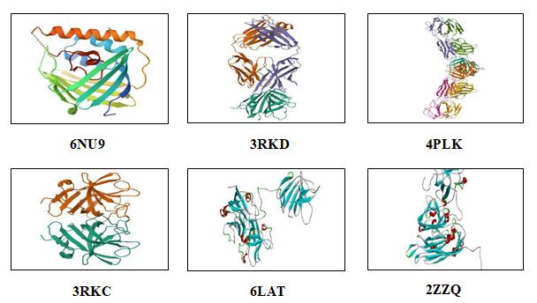
The UniProt IDs associated with HEV ORF1, ORF2, and ORF3 proteins are instrumental in elucidating their structure-function relationships and identifying therapeutic targets for antiviral interventions.

3.2 Phytochemical Analysis and Selection
Table 5 – Phytochemicals from Selected Plants Highlighting Low Toxicity
Plant Name | Key Actions | Active Compounds | Good ADMET  Properties (Yes/No)
Andrographis paniculata | Inhibits viral replication, enhances immune function | Andrographilde | Yes
Echinacea purpurea | Modulates immune response, inhibits viral entry | Chichoric acid | Yes
Zingiber officinale | Inhibits influenza and other viral infections | Zingerone | Yes
Curcuma longa | Anti-inflammatory, antiviral effects (esp. coronaviruses) | Bisdemethoxycurcumin | No
Allium sativum | Inhibits viral attachment and replication. | Allicin | No
Carica papaya | Antiviral against dengue, Zika, and others | Carpaine | No
Ocimum sanctum (Tulsi) | Boosts immune system, antiviral against various viruses | Rosmarinic acid | Yes
Cinnamomum verum | Antiviral against influenza and herpes simplex | Cinnamaldehyde | No
Withania somniferous | Antiviral against several viruses enhances immunity. | Withanolides A | Yes
Glycyrrhiza glabra | Inhibits viral replication. | Glycyrrhizin | Yes
Melaleuca alternifolia | Antiviral against HSV, influenza, and other viruses | Terpinen-4-ol | No
Mentha piperita | Inhibits viral replication, reduces infection symptoms for HIV | Menthol | No
Tamarindus indica | Antiviral effects (esp. herpes simplex virus) | Anthocyanins | No
Annona muricata (Graviola) | Antiviral effects against various viruses | Acetogenins | Yes
Hibiscus sabdariffa | Antiviral against HIV, herpes simplex, and influenza | Anthocyanins | No
Out of 15 screened medicinal plants, seven phytochemicals were identified as having potential anti-HEV properties. These candidates exhibited low toxicity and favourable ADMET (Absorption, Distribution, Metabolism, Excretion, and Toxicity) profiles, making them viable leads for future drug development.

Fig 4- 3D Structures of Selected Phytochemicals

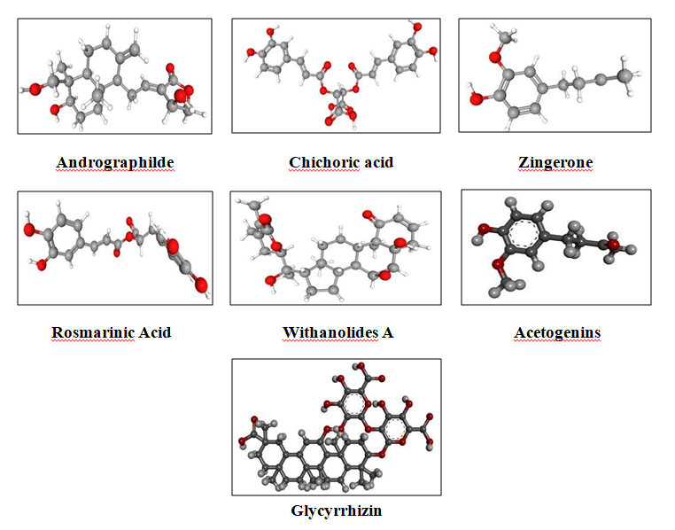

The three-dimensional representations of the shortlisted phytochemicals illustrate their structural conformations, which are critical for understanding binding interactions with viral targets.

3.3 In Silico Recombinant DNA Technology (RDT) and Metabolic Pathway Engineering
The application of Biopython in in silico RDT enabled the targeted enhancement of phytochemical biosynthesis in plants such as Echinacea purpurea, Zingiber officinale, Ocimum sanctum, and Glycyrrhiza glabra. Key genes involved include:
- 4CL (4-Coumarate CoA Ligase) – Central to the phenylpropanoid pathway, boosting chichoric acid synthesis with immunomodulatory and antiviral properties.
- SDR (Short-chain Dehydrogenase/Reductase) – Involved in zingerone formation, contributing to antiviral activity.
- RAS1 (Rosmarinic Acid Synthase 1) – Facilitates rosmarinic acid biosynthesis, enhancing antiviral defense and stress tolerance.
- CYP88D6 – A cytochrome P450 enzyme catalyzing glycyrrhizin biosynthesis, a triterpenoid saponin with broad-spectrum antiviral properties.
KEGG pathway analysis confirmed the integration of these genes into core secondary metabolic pathways. Overexpression of these genes enhances both phytochemical yield and plant resilience under abiotic stress.
Plasmid pCAMBIA-1301 (Accession ID: AF234297) was selected using SnapGene Viewer for RDT implementation.
Table 6 – Genes of Interest (GOIs) and Their Target Phytochemicals
Sr No. | PLANT | GOI
1. | Echinacea purpurea | 4CL
2. | Zingiber officinale | SDR
3. | Ocimum santum | RAS1
4. | Glycyrrhiza glabra | CYP88D6

Fig.5 -Depicts The KEGG Metabolic pathways of 4CL 4-Coumarate CoA Ligase. The pink colour box representing the step where 4CL4 forms.
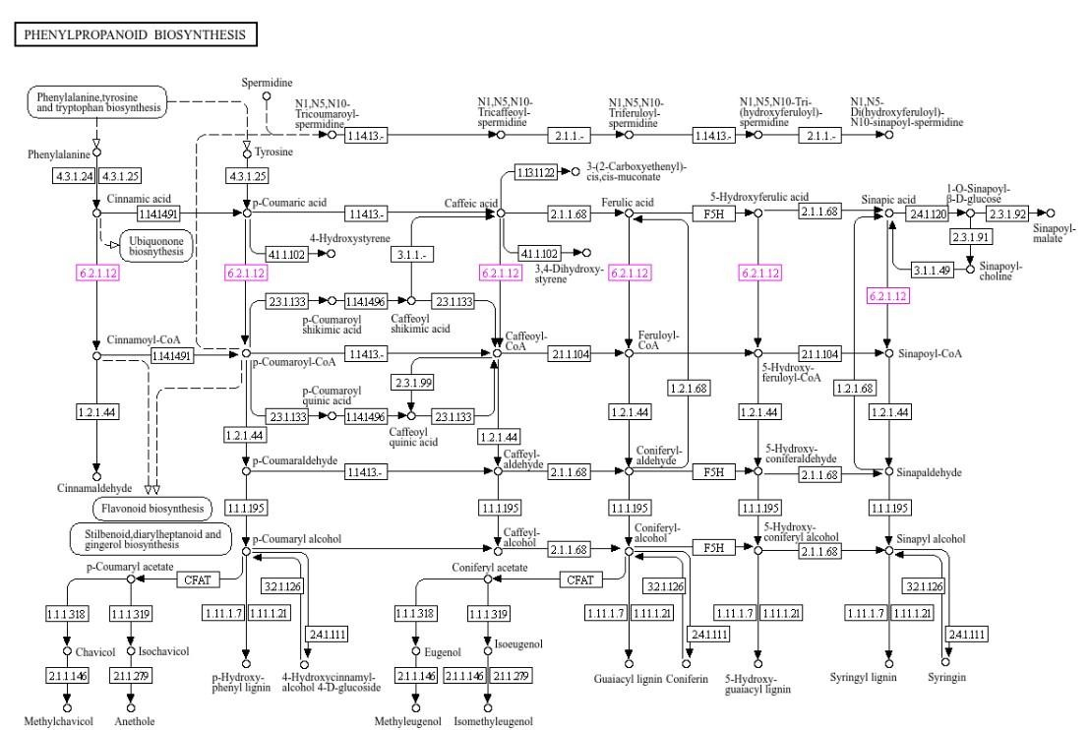
Fig.6 -Depicts The KEGG Enzyme pathways of SDR (Short-chain Dehydrogenase/Reductase.The red colour double arrow in the figure depicts the SDR formation.
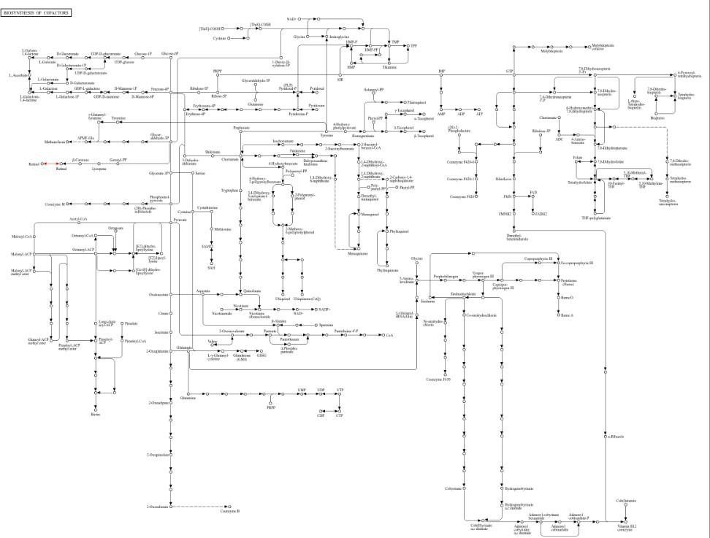
Fig.7 Depicts the KEGG Enzyme Pathways of SDR (Short-chain Dehydrogenase/ Reductase.
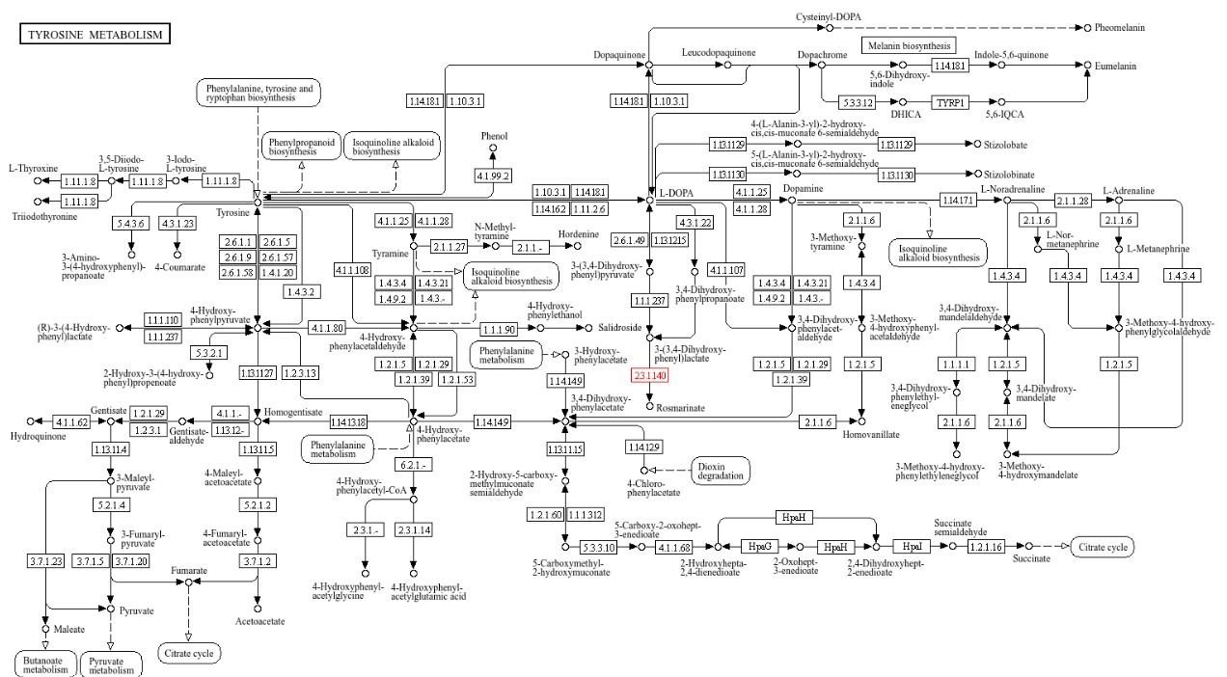

Fig.8 -Depicts plasmid structure pCAMBIA-1301 using SnapGeneViewer.
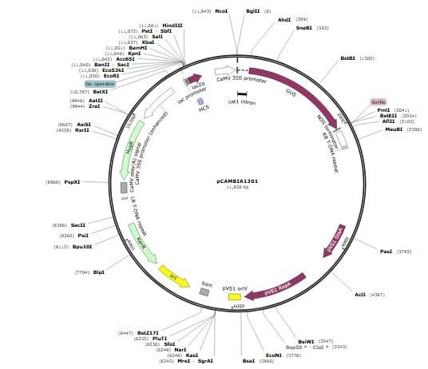

These figures depict:
- KEGG pathway positions of 4CL and SDR genes.
- The plasmid structure of pCAMBIA-1301 used for gene insertion.
Refer to GitHub Repository:
RDT Biopython Code – GitHub Link
Fig.9-The results of RDT using Biopython
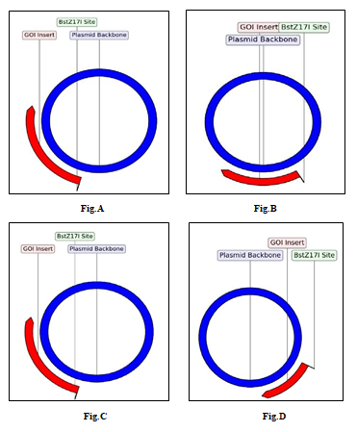
These illustrate successful gene recombination at BstZ17I site, visualizing the plasmid backbone (blue) and inserted GOIs (red).
Fig.9A - The gene RAS1 successfully able to recombinant at site BstZ17I.
Fig 9B- The gene SDR successfully able to recombinant at site BstZ17I.
Fig .9C- The gene 4CL successfully able to recombinant at site BstZ17I.
Fig 9D- The gene successfully able to recombinant at site BstZ17I.

3.4 Molecular Docking
Molecular docking analyses revealed binding affinities between phytochemicals and HEV target proteins, indicating their potential efficacy based on docking scores (kcal/mol).

Fig. 10- Acetogenins Molecular Docking Results with binding energy (kcal/mol).
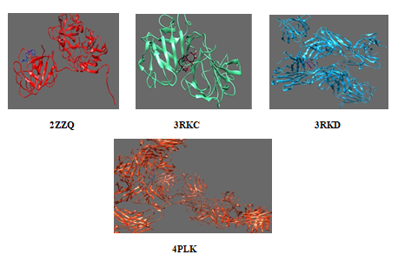
Fig. 11 - Molecular Docking Results with binding energy (kcal/mol) of Andrographilde.
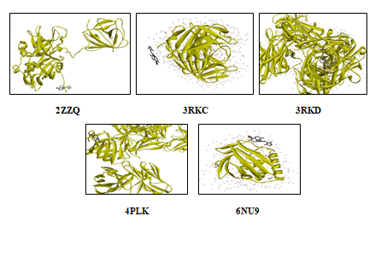

Fig. 12 - Molecular Docking Results with binding energy (kcal/mol) of Glycyrrhizin
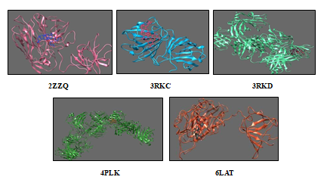

Fig. 13- Molecular Docking Results with binding energy (kcal/mol) of Rosmarinic
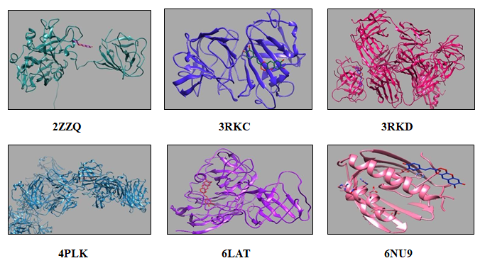

Fig. 14- Molecular Docking Results with binding energy (kcal/mol) of Withanolide A
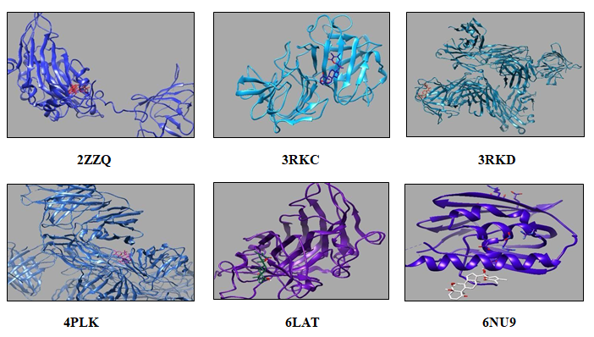
Fig. 15 - Molecular Docking Results with binding energy (kcal/mol) of Zingerone
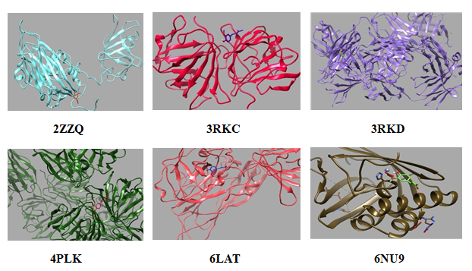

- Acetogenins: Strongest affinity with 4PLK (-6.63 kcal/mol); weakest with 2ZZQ (-3.592 kcal/mol).
- Andrographolide: Most stable with 3RKD (-6.53 kcal/mol); least with 2ZZQ (-2.89 kcal/mol).
- Glycyrrhizin: Strongest binding with 4PLK (-13.5 kcal/mol); weak interaction with 6NU9 (positive score).
- Rosmarinic Acid: Highest affinity with 4PLK (-8.5 kcal/mol); lowest with 6LAT (-6.8 kcal/mol).
- Withanolide A: Strongest with 4PLK and 6NU9 (-9.6 kcal/mol); moderate with 2ZZQ (-6.4 kcal/mol).
- Zingerone: Strongest with 6LAT (-6.4 kcal/mol); weakest with 2ZZQ (-4.4 kcal/mol).
These results highlight several phytochemicals—especially Glycyrrhizin, Rosmarinic acid, and Withanolide A—as promising candidates for further antiviral drug research against HEV.

Discussion
The present study highlights the integrative potential of bioinformatics, molecular docking, and phytochemical research in identifying novel monotherapeutic strategies against Hepatitis E Virus (HEV). One of the primary challenges in combating HEV lies in its distinctive replication mechanism—specifically, the cytoplasmic synthesis of viral RNA, which requires virus-encoded methyltransferases for RNA capping. Unlike host capping enzymes that reside in the nucleus, these viral methyltransferases serve as unique and promising antiviral targets.
To advance therapeutic research, we employed SnapGene Viewer along with the pCAMBIA-1301 plasmid (Accession ID: AF234297) to establish a recombinant expression platform. This system facilitates the genetic engineering and heterologous expression of HEV proteins and key biosynthetic enzymes, laying the groundwork for both vaccine development and the scalable production of antiviral phytochemicals.
Through in silico modelling using Biopython and reverse drug targeting (RDT), we enhanced the biosynthetic capacity of medicinal plants such as Echinacea purpurea, Zingiber officinale, Ocimum sanctum, and Glycyrrhiza glabra. The overexpression of specific biosynthetic genes—4CL, SDR, RAS1, and CYP88D6—resulted in increased yields of Chichoric acid, Zingerone, Rosmarinic acid, and Glycyrrhizin, respectively. These phytochemicals are integral to KEGG-annotated phenylpropanoid, flavonoid, and terpenoid pathways and are recognized for their potent antiviral and immunomodulatory activities.
Molecular docking analyses further validated their potential, with Glycyrrhizin showing the strongest binding affinity to the HEV 4PLK protein (−13.5 kcal/mol), followed closely by Rosmarinic acid and Withanolide A. While Zingerone exhibited moderate affinity, its specific interactions suggest a promising avenue for further exploration. Chichoric acid demonstrated broad-spectrum binding across multiple HEV targets, underscoring its potential as a multitarget antiviral agent.
Collectively, these computational findings lay a robust foundation for subsequent experimental validation. The enhanced phytochemical biosynthesis and confirmed antiviral interactions support the development of affordable, plant-derived therapeutics against HEV.
Future directions should include in vitro and in vivo validation, detailed pharmacokinetic profiling, and translational studies to fully harness the therapeutic value of these compounds.

COMPETING INTERESTS DISCLAIMER:
Authors have declared that they have no known competing financial interests OR non-financial interests OR personal relationships that could have appeared to influence the work reported in this paper.

References: -
- Aggarwal, R. (2011). Hepatitis E: Historical, contemporary and future perspectives. J Gastroenterol Hepatol, 26 Suppl 1, 72–82. doi:10.1111/j.1440-1746.2010.06540x.
- Ahmad, I., Holla, R. P., & Jameel, S. (2011). Molecular virology of hepatitis E virus.
Virus research, 161(1), 47-58.
- Balayan, M. S., Andjaparidze, A. G., Savinskaya, S. S., Ketiladze, E. S., Braginsky, D. M., Savinov, A. P., & Poleschuk, V. F. (1983). Evidence for a virus in non-A, non-B hepatitis transmitted via the fecal-oral route. Intervirology, 20, 23–31.
- Bertrand, L., Nelde, A., Ramirez, B. C., Hatin, I., Arbes, H., François, P., ... & Moris, A. (2025). Unveiling conserved HIV-1 open reading frames encoding T cell antigens using ribosome profiling. Nature communications, 16(1), 1707.
- Borkakoti, J., Ahmed, G., & Kar, P. (2016). Report of a novel C1483W mutation in the hepatitis E virus polymerase in patients with acute liver failure. Infection, Genetics and Evolution, 44, 51-54.
- Borkakoti, J., Ahmed, G., Hussain, S. A., Rai, A., & Kar, P. (2014). Novel molecular alterations in the ORF 2 capsid gene of hepatitis E virus in patients with acute liver failure in North India. Archives of virology, 159, 3391-3394.
- Cao, D., & Meng, X. J. (2012). Molecular biology and replication of hepatitis E virus. Emerging microbes & infections, 1(1), 1-10.
- Graff, J., Nguyen, H., Yu, C., Elkins, W. R., St. Claire, M., Purcell, R. H., & Emerson, S. U. (2005). The open reading frame 3 gene of hepatitis E virus contains a cis-reactive element and encodes a protein required for infection of macaques. Journal of virology, 79(11), 6680-6689.
- Guo, H., Li, Y., Liu, G., Jiang, Y., Shen, S., Bi, R., ... & Wei, W. (2019). A second open reading frame in human enterovirus determines viral replication in intestinal epithelial cells. Nature Communications, 10(1), 4066.
- Hepatitis E. https://www.who.int/news-room/fact-sheets/detail/hepatitis-e. Accessed
16 Sept. 2024.

- Huang, F. F., Sun, Z. F., Emerson, S. U., Purcell, R. H., Shivaprasad, H. L., Pierson, F.
W., ... & Meng, X. J. (2004). Determination and analysis of the complete genomic sequence of avian hepatitis E virus (avian HEV). Journal of general virology, 85(6), 1609-1618.
- Jaeger, R., & Cuny, E. (2016). Terpenoids with special pharmacological significance:
A review. Nat.Prod. Commun., 11, 1934578X1601100946. doi:10.1177/1934578X1601100946.
- Kamar, N., Izopet, J., Pavio, N., Aggarwal, R., Labrique, A., Wedemeyer, H., & Dalton,
H. R. (2017). Hepatitis E virus infection. Nature Reviews Disease Primers, 3(1), 1-16.
- Kar-Roy, A., Korkaya, H., Oberoi, R., Lal, S. K., & Jameel, S. (2004). The hepatitis E virus open reading frame 3 protein activates ERK through binding and inhibition of the MAPK phosphatase. Journal of Biological Chemistry, 279(27), 28345-28357.
- Khan, S., Ullah, M. W., Siddique, R., Nabi, G., Manan, S., Yousaf, M., & Hou, H. (2016). Role of recombinant DNA technology to improve life. International journal of genomics, 2016(1), 2405954.
- Kinast, V., Burkard, T. L., Todt, D., & Steinmann, E. (2019). Hepatitis E virus drug development. Viruses, 11(6), 485.
- Mansuy, J., Abravanel, F., Miedouge, M., Mengelle, C., Merviel, C., Dubois, M., Kamar, N., Rostaing, L., Alric, L., Moreau, J., et al. (2009). Acute hepatitis E in south- west France over a 5-year period. J. Clin. Virol., 44, 74–77. doi:10.1016/j.jcv.2008.09.010.
- Meng, X. J. (2011). From barnyard to food table: the omnipresence of hepatitis E virus
and risk for zoonotic infection and food safety. Virus research, 161(1), 23-30.
- Meng, X. J. (2010). Hepatitis E virus: animal reservoirs and zoonotic risk. Veterinary microbiology, 140(3-4), 256-265
- Reyes, G. R., Huang, C. C., Tam, A. W., & Purdy, M. A. (1993). Molecular organization and replication of hepatitis E virus (HEV). Unconventional Agents and Unclassified Viruses: Recent Advances in Biology and Epidemiology, 15-25.
- Rozanov, M. N., Koonin, E. V., & Gorbalenya, A. E. (1992). Conservation of the putative methyltransferase domain: a hallmark of the 'Sindbis-like' supergroup of positive-strand RNA viruses. J Gen Virol, 73(Pt 8):2129–2134. doi:10.1099/0022131773-8-2129.
- Shahini, E., Argentiero, A., Andriano, A., Losito, F., Maida, M., Facciorusso, A., ... & Villa, E. (2024). Hepatitis E Virus: what more do we need to know?. Medicina, 60(6), 998.
- Sharma, B. R., Kumar, V., Gat, Y., Kumar, N., Parashar, A., & Pinakin, D. J. (2018). Microbial maceration: A sustainable approach for phytochemical extraction. 3 Biotech, 8, 401. doi:10.1007/s13205-018-1423-8.
- Smith, D. B., Simmonds, P., Izopet, J., Oliveira-Filho, E. F., Ulrich, R. G., Johne, R., ... & Purdy, M. A. (2016). Proposed reference sequences for hepatitis E virus subtypes. Journal of General Virology, 97(3), 537-542.
- Todt, D., Moeller, N., Praditya, D., Kinast, V., Friesland, M., Engelmann, M., ... & Steinmann, E. (2018). The natural compound silvestrol inhibits hepatitis E virus (HEV) replication in vitro and in vivo. Antiviral research, 157, 151-158.
- Tsarev, S. A., Emerson, S. U., Reyes, G. R., Tsareva, T. S., Legters, L. J., Malik, I. A.,
... & Purcell, R. H. (1992). Characterization of a prototype strain of hepatitis E virus.
Proceedings of the National Academy of Sciences, 89(2), 559-563.
- Waqar, S., Sharma, B., & Koirala, J. (2018). Hepatitis E.
- Zhang, M., Purcell, R. H., & Emerson, S. U. (2001). Identification of the 5′ terminal sequence of the SAR‐55 and MEX‐14 strains of hepatitis E virus and confirmation that the genome is capped. Journal of medical virology, 65(2), 293-295.

