Original Research Article

Green synthesis of Copper Nanoparticles using Nyctanthes arbor-tristis and study of its biomedical applications

ABSTRACT
Aim: The aim of the present study was to synthesize copper nanoparticles using green synthesis method by using aqueous extract of leaves of medicinal plant Nyctanthes arbor-tristis and its characterization and study of its bio medicinal application.
Study Design: The research involved the preparation of a leaf extract from Nyctanthes arbor-tristis plant and the subsequent synthesis of copper oxide nanoparticles. The antibacterial activity of the synthesized copper nanoparticles was determined, highlighting their potential as antimicrobial agents. Additionally, the antioxidant activity of the nanoparticles was evaluated, suggesting their potential application as free radical scavengers.
Place and duration of the study: The study was done at Department of Microbiology, Dr. D. Y. Patil ACS College, Pimpri, Pune, Maharashtra State, India during January 2023-May 2023.
Methodology: Leaves of the Nyctanthes arbor-tristis plant were collected and ground to prepare the aqueous extract of the leaves. The Copper nanoparticles were synthesized by adding 50 ml of 4 mM copper chloride dihydrate (CuCl₂ .2H₂O) to 2 ml aqueous leaf extract of Nyctanthes arbor-tristis. The mixture was stirred on the magnetic stirrer for 2 hours at 50 ℃, followed by centrifugation of brown precipitate formed and drying of brown precipitate of copper nanoparticles for further studies. The copper nanoparticles formed were characterized using UV visible spectroscopy and its antibacterial and antioxidant property was checked.
Results: Green synthesis of copper nanoparticles was done successfully using aqueous extract of Nyctanthes arbor-tristis leaves. The characterization of copper nanoparticles using UV-visible spectroscopy revealed the absorbance peak at 222 nm which confirmed the synthesis of copper nanoparticles. The antibacterial activity against Gram negative bacterium E.coli was found to be significant with 15 mm zone of inhibition. The synthesized copper nanoparticles also showed antioxidant activity through FRAP assay.
Conclusion: Overall, the present research highlighted the green synthesis of copper nanoparticles using Nyctanthes arbor-tristis plant and studied the biomedical applications of synthesized copper nanoparticles.
Keywords:
Green synthesis, Copper nanoparticles, Nyctanthes arbor-tristis, antibacterial activity, UV-Visible spectroscopy

1. INTRODUCTION:
Nanotechnology is one of the most dynamic and innovative fields of science and technology, having a multitude of applications ranging from medicine, engineering to environmental remediation. Various methods such as physical, chemical and green routes have been used to fabricate these nanoscale materials, however these methods have a lot of drawbacks. From the last few decades, green approaches are becoming methods of choice for the fabrication of nanoparticles (NPs), because of their biocompatibility, safety, minimal toxicity, and cost effectiveness, which makes them more ideal than other counterparts [1]. Moreover, CuO is comparatively cheaper than silver, can be mixed easily with polymers and is quite stable about physical and chemical properties. Different natural sources are being used to produce CuO-NPs including plants, microbes, and fungi etc. Plant extract consists of a variety of biomolecules and metabolites including vitamins, carbohydrates, phenolics and flavonoids, which can act as a reducing and stabling agent and can convert Cu2+ ions into CuO-NP.
Copper nanoparticles find application in industries, medicine, electronics etc. due to the peculiar properties like high electrical conductivity, low electrochemical migration behavior high melting point and after all its low cost [2]. There are reports to show that copper nanoparticles can be used as alternatives for noble metals such as in inkjet printing, for organic transformations, gas phase catalysis, photocatalysis and electrocatalysis [3] (Gawande et al., 2016). Since Cu-nanoparticles have biomedical applications, the solvent, stabilizing agent as well as reducing agent used for its synthesis should be non-toxic. This signifies the biosynthesis of Cu-nanoparticles using green synthesis method. Realizing the significant applications of copper nanoparticles in the above-mentioned fields and also the problems associated with the chemical synthesis of the said nanoparticles, this study was undertaken with the objective to biosynthesize Copper nanoparticle using the leaf extract of Nyctanthes arbor-tristis which is used as a source of bioreduction and stabilizers and to characterize the particles synthesized.
CuNPs have been synthesized using a variety of techniques, including physical, chemical, and biological methods. Extracts from a variety of plant parts, such as the juice of Citrus medica (Idilimbu) [4], the peel of Punica granatum [5] the stem of Zingiber officinale [6], the leaves of Eclipta prostrata [7], Plantago asiatica [8], Thymus vulgaris [9], the wild fruit of Ziziphus spina-christi (L.)[10], the root and leaf of Asparagus adscendens Roxb. [11], the black tea leaf [12], the Azadirachta indica leaf [13], leaves of Hagenia abyssinica [14], Celastrus paniculatus Wild leaf extract [15], Zizipus spina- Christi Wild fruit extract, Jatropha curcas leaves [16], Parthenium hysterophrous whole plant extract [17], leaves of Fortunella margarita [18], Ocimum leaf extract [2], Krameria sp. root extract [19] have all been used successfully in the synthesis of CuNPs.
Nyctanthes arbor-tristis is a valuable medicinal plant which belongs to the family Oleaceae. The plant is native to South Asia and Southeast Asia. N. arbor-tristis commonly known as Night blooming jasmine, Harsinghar, and Parijat. The tree is also known ‘tree of sorrow’ because the flowers start falling after midnight and by day break, the plant appears dull. It is a common wild hardy shrub or small tree growing to 8-10 m tall. N. arbor-tristis has been reported to possess various bioactive compounds such as flavonoids, steroids, glycosides, terpens, alkaloids etc. From ancient time, leaves of Nyctanthes arbor-tristis were believed to have medicinal properties. The leaves have been used in Ayurvedic medicine and Homoeopathy for sciatica, arthritis, and fevers, and as a laxative [20].
There are few reports of use of plant parts extract of Nyctanthes arbor-tristis for synthesis of various nanoparticles such as Sharma et al (2021) [20] reported synthesis of silver nanoparticles while Rani et al. (2023) [21] and Mohideen et al. (2025) [22] recently reported green synthesis of ZnO nanoparticles using leaf extract of Nyctanthes arbor-tristis. To the best of our knowledge, there are only two reports of use of leaf extract of Nyctanthes arbor-tristis for synthesis of Copper nanoparticles Noorfsha et al. (2022) [23] and by Sharma and Gugalia (2025) [24] . Thus, considering the immense potentiality of this plant, the present study was aimed to synthesize copper nanoparticles using aqueous extract of leaves of Nyctanthes arbor-tristis and to study its medicinal properties.
2. MATERIALS AND METHODS:
2.1 Sample Collection:
The plant leaves of plant Nyctanthes arbor-tristis were collected from Hindustan Antibiotics Colony, Pimpri, District Pune, State Maharashtra, India in the month of February -2023 (Fig. 1).
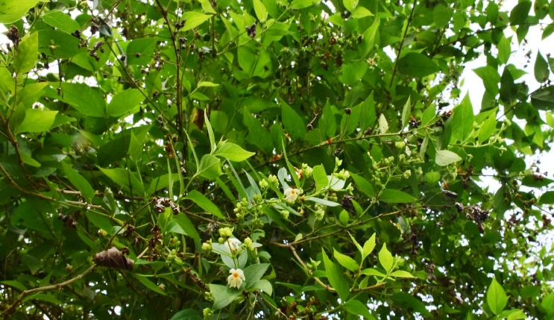
Figure 1: Photograph of Nyctanthes arbor-tristis – Parijat/Harshingar
2.2 Chemicals and reagents:
All chemicals and reagents used in the present study were of analytical grades, and Reagent-grade (purity ≥ 98%) in particular Copper chloride dihydrate, Sodium hydroxide, Nutrient broth, Muller-Hinton agar, Potato dextrose Agar, Potassium ferricyanide, Ferric chloride, Trichloroacetic acid, Bovine serum albumin were purchased from HiMedia Laboratories Pvt. Ltd., Mumbai, India. Diclofenac sodium tablet, Ciprofloxacin tablet and Ascorbic acid tablet was purchased from local Pharmaceuticals, Pune.
2.3 Preparation of Aqueous Extracts of leaves of Nyctanthes arbor-tristis
The leaves of the Nyctanthes arbor-tristis were collected and washed with distilled water to remove dust particles and completely air-dried to remove the moisture contents. The dried leaves were ground in the mixer and fine powder was prepared. 20 Gram of the fine ground powder was added in 200 ml distilled water and the mixture was boiled till half. The mixture was filtered through Whatman Filter paper no.1 and the collected aqueous extract was stored at 4℃ for further use and for synthesis of copper nanoparticles.
2.4. Green synthesis of copper nanoparticles using Aqueous Extracts of leaves of Nyctanthes arbor-tristis
For the synthesis of copper nanoparticles, 50 ml of 4 mM copper chloride dihydrate (CuCl₂ .2H₂O) was mixed in 2 ml aqueous leaf extract of Nyctanthes arbor-tristis. The mixture was stirred on the magnetic stirrer for 2 hours at 50 ℃. While stirring, drop by drop addition of 1M sodium hydroxide to the mixture was done. The color change of the mixture from green to brownish black and formation of brown black precipitate indicated the formation of copper nanoparticles. The solution was centrifuged in bench top centrifuge (R-8C DX Laboratory Centrifuge, REMI, REMI ELEKTROTECHNIK Ltd.) at 8000 rpm for 20 minutes till the brown precipitate gets settled down as a pellet. The centrifuged pellet was washed with distilled water to remove impurities and the pellet was dried in oven at 80⁰C to obtain brownish black powder of copper nanoparticles as shown in Fig. 2 and as reported earlier by Jayadev and Krishnan (2021)[2] and Sharma and Gugalia (2025) [24].

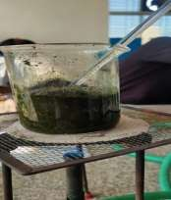
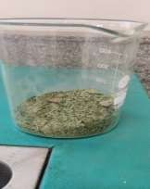
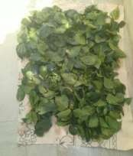
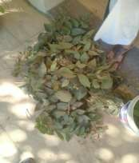

Preparation of aqueous extract of leaves of Nyctanthes arbor- tristis.

Ground powder of leaves of Nyctanthes arbor- tristis.

Dried leaves of Nyctanthes arbor- tristis.

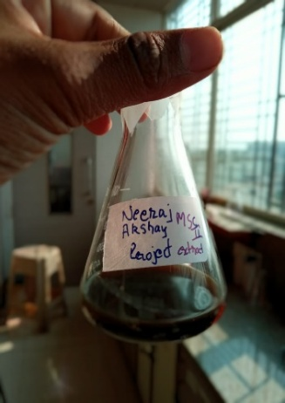
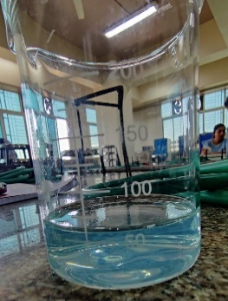
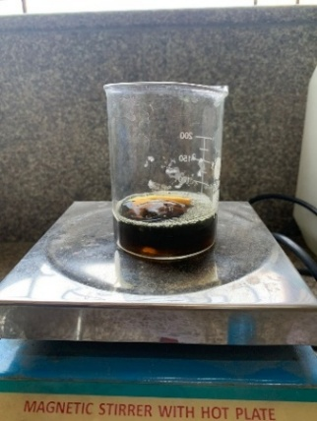
Solution of copper chloride
Brown colored precipitate of copper nanoparticles formed
Solution of copper chloride and leaf extract on stirrer

Figure 2: Schematic representation of green synthesis of copper nanoparticles using aqueous extract of Nyctanthes arbor- tristis.
2.5. Characterization of Copper Nanoparticles using UV-Visible spectroscopy
For the confirmation of synthesis of copper nanoparticles using aqueous extract of Nyctanthes arbor- tristis, the synthesized nanoparticles were characterized by using technique such as UV-Visible spectroscopy. The optical properties of the synthesized copper nanoparticles were studied using UV-Visible spectroscopy. The brown precipitate of copper nanoparticles obtained in the synthesis process was dissolved in 1ml butanol and the UV- spectra for these samples was scanned between the range of 200-800 nm on SHIMADZU UV- Spectrophotometer (Serial No- A11455009292) to observe the characteristic peak confirming Cu NPs formation. 1ml butanol without sample was used as the blank.
2.6 Antibacterial activity of synthesized copper nanoparticles
The anti-bacterial activity of synthesized copper Nanoparticles was checked using agar well diffusion method. Overnight grown broth culture of Gram-Positive bacteria viz. Staphylococcus aureus and Gram-Negative bacteria Escherichia coli was used for the assay. 100 μl bacterial culture was spread on the sterile Muller-Hinton agar plate. Wells were punched on the spreaded plate using sterile cork borer (8 mm). 100 μl solution of copper nanoparticles having concentration of 1mg/ml were added into well using sterile micropipette. DMSO was kept as negative control. Antibiotic Ciprofloxacin having concentration 500 mg (Leeford) was taken as positive control. Then the plate was pre-incubated for 10 minutes in fridge for prediffusion of Zno nanoparticles and an antibiotic and then plates were incubated for 24 hours at 37°C. Anti-bacterial activity was determined by measuring the diameter of zone of inhibition (mm).
2.7 Antioxidant activity of synthesized copper nanoparticles
The antioxidant property of Cu nanoparticles formed using aqueous extracts of leaves of Nyctanthes arbor- tristis was checked by reducing power assay using Potassium Ferricyanide (K₃[Fe(CN)₆]) by measuring their capacity to reduce ferric to ferrous ions. 8 mg/ml of Cu nanoparticles and Ascorbic acid(standard) was added in different test tubes and 1ml of ethanol was added and mixed with 2.5 ml phosphate buffer(0.2 M, pH 6.6) and 2.5 ml potassium ferricyanide [K3Fe (CN)6] (10 g/l); mixture was than incubated at 50°C for 20 min; 2.5 ml of trichloro acetic acid (100 g/l) was added to the mixture, which was then centrifuged at 3000 rpm for 10 min. Finally, 2.5 ml of the supernatant solution was mixed with 2.5 ml of distilled water and 0.5 ml FeCl3 (1 g/l). Absorbance was measured at 700 nm in UV-Visible Spectrophotometer. Distilled water employed as blank. Increased absorbance of the reaction mixture indicates stronger reducing power.
3. RESULTS AND DISCUSSION:
3.1 Green synthesis of copper nanoparticles using aqueous extracts of leaves of Nyctanthes arbor- tristis
Nyctanthes arbor- tristis plant is reported to contain several phytochemicals such as steroids, iridoid glycosides, tannins, terpenes, and triterpenoids which could act as reducing as well as capping and stabilizing agents for Cu nanoparticle synthesis. Thus, leaves extract of Nyctanthes arbor- tristis was employed here for green synthesis of copper nanoparticles. When leaf extract was added, the blue hue of the copper sulphate solution turned green. When this mixture is heated with a stirrer, a brown precipitate occurred, which indicated the synthesis of copper nanoparticles (Fig. 2). The formed copper nanoparticles were characterized with respect to UV- visible spectroscopy, antibacterial activity, antioxidant activity and anti-inflammatory activity. Nyctanthes arbor-tristis is known for its rich phytochemical composition, which includes various bioactive compounds such as flavonoids, phenolics, and terpenoids. Thus, these bioactive compounds may have contributed as a reducing as well as capping and stabilizing agents for the green synthesis of copper nanoparticles. Noorfsha et al. (2022) [23] reported the green synthesis of copper nanoparticles using use of leaf extract of Nyctanthes arbor-tristis and Sharma and Gugalia (2025) [24] also reported the use of leaf extract of Nyctanthes arbor-tristis for synthesis of copper nanoparticles and studied its characterization and cytotoxic activity.
3.2 Characterization of Copper Nanoparticles using UV-Visible spectroscopy
In order to study the optical absorption property of the synthesized copper nanoparticles using, leaves extract of Nyctanthes arbor- tristis, the UV–visible absorbance spectra was monitored at room temperature in the wavelengths of 200 to 700 nm. The spectrum showed a peak at 222 nm in case of Nyctanthes arbor- tristis synthesized copper nanoparticles (Fig. 3). Many researchers studied the UV-visible spectroscopic analysis of copper nanoparticles. Mali et al. (2020) [15] reported absorption peak of synthesized copper nanoparticles using Celastrus paniculatus leaf extract at 269 nm while Amaliyah et al. (2020) [25] reported the absorbance of synthesized Cu nanoparticles in the range from 234-255 nm. Teklu et al. (2023) [26] reported the 𝜆𝑚𝑎𝑥 of copper oxide nanoparticles at 294 nm while Jabeen et al. (2024) [27] reported that 𝜆𝑚𝑎𝑥 of synthesized copper NPs from Aloe Vera at 248 nm. Thus, our reports of 𝜆𝑚𝑎𝑥 of copper nanoparticles synthesized using aqueous leaf extract Nyctanthes arbor- tristis at 222 nm is in comparison with the earlier reports.
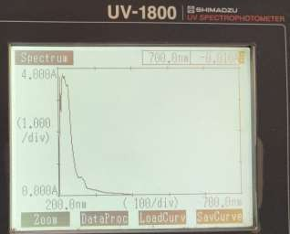

Figure 3: UV-Visible spectrum of biosynthesized copper NPs using Nyctanthes arbor- tristis (222 nm)
3.3 Antibacterial activity of synthesized copper nanoparticles
The antibacterial activity of copper nanoparticles formed using Nyctanthes arbor- tristis was tested by the well diffusion agar method and using Gram positive (Staphylococcus aureus) and Gram negative (Escherichia coli) bacteria. The antibiotic used for this assay was ciprofloxacin (100 mg/ml) as positive control and DMSO as negative control. Table 1 described the zone of inhibition in mm measured against E.coli and S. aureus.
Table 1: antibacterial activity of synthesized copper nanoparticles
Bacterial Culture | Concentration of copper nanoparticles
Bacterial Culture | 50µl | 100µl | Standard antibiotic Ciprofloxacin
Bacterial Culture | Diameter of Zones (mm)
Gram negative bacterium Escherichia coli | 10 mm | 15 mm | 26 mm
Gram positive bacterium S. aureus | 5 mm | 7 mm | 10 mm

From this Table 1, it was observed that copper nanoparticles synthesized by using Nyctanthes arbor- tristis leaf extract showed low antibacterial activity against Gram positive bacterium S.aureus and moderate antibacterial activity against Gram negative bacterium E.coli. The copper nanoparticles have proven record of excellent antibacterial properties. Murthy et al (2020) [14] reported the significant high antibacterial activity of copper nanoparticles against S.aureus (14.7 mm zone of inhibition). Khani et al (2018) [10] reported the antibacterial activity of copper nanoparticles against E.coli and S.aureus with zone of inhibition as 13 mm.
3.4 Antioxidant activity of synthesized copper nanoparticles
The copper nanoparticle synthesized using using Nyctanthes arbor- tristis leaf extract was found to have antioxidant property i.e., Free Radical Potential. In this study, the reducing capacity of the copper nanoparticles was assessed using the Fe³⁺ to Fe²⁺ reduction assay, where a colour changes from yellow to blue indicated the reduction. Figure 4 showed that there was formation of blue colored ferrous ions due to reducing ability of copper nanoparticles formed.
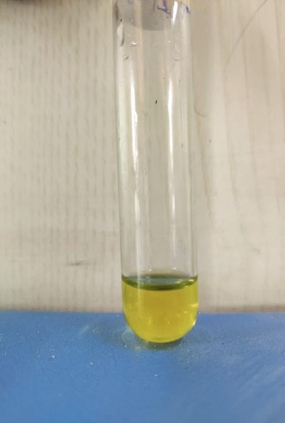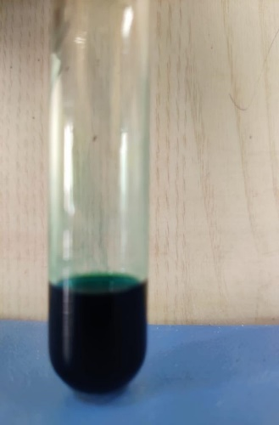
Control Test
Figure 4: Antioxident property of sunthesized copper nanoparticles
Alshammari et al. (2023) [19] reported the significant antioxidant property of copper nanoparticles of 83.81% by DPPH assay.
4. CONCLUSION:
In the present study, the aqueous extract of leaves of Nyctanthes arbor- tristis was employed for green synthesis of copper nanoparticles. The approach used for the synthesis of copper nanoparticles was ecofriendly, non- toxic, rapid and inexpensive. The antibacterial activity of copper nanoparticles showed significant result against Gram negative pathogen E.coli. The copper nanoparticles also showed antioxidant activity. Thus, the characterization studies explained the use of copper nanoparticles for future applications.

8. REFERENCES:
1. Jayachandran A, Aswathy TR, Nair AS. Green synthesis and characterization of zinc oxide nanoparticles using Cayratia pedata leaf extract. Biochem and Biophys Rep, 2021; 26:100995.
2. Jayadev A and Krishnan, N. B. (2021) Green synthesis of copper nanoparticles and its characterization. Journal of Scientific Research,65, 80-84. DOI: 10.37398/JSR.2021.650111
3. Gawande, M. B., Goswami, A., Felpin, F. X., Asefa, T., Huang, X., Silva, R., & Varma, R. S. (2016). Cu and Cu-based nanoparticles: synthesis and applications in catalysis. Chemical reviews, 116(6), 3722-3811.
4. Shende, S., Ingle, A.P., Gade, A. and Rai, M. (2015). Green synthesis of copper nanoparticles by Citrus medica Linn. (Idilimbu) juice and its antimicrobial activity, World Journal of Microbiology and Biotechnology. 31(6), 865–873.
5. Kaur, P., Thakur, R. and Chaudhury, A. (2016). Biogenesis of copper nanoparticles using peel extract of Punica granatum and their anti-microbial activity against opportunistic pathogens, Green Chemistry Letters and Reviews. 9(1), 33–38.
6. Delma, M.T. and Jaya, R.M. (2016). Green synthesis of copper and lead nanoparticles using Zingiber officinale stem extract, International Journal of Scientific and Research Publications. 6(11), 134–137.
7. Chung, I., Abdul, R.A., Marimuthu, S. (2017). Green synthesis of copper nanoparticles using Eclipta prostrata leaves extract and their antioxidant and cytotoxic activities,” Experimental and Therapeutic Medicine. 14(1), 18–24.
8. Nasrollahzadeh, M., Momeni, S. S., & Sajadi, S. M. (2017). Green synthesis of copper nanoparticles using Plantago asiatica leaf extract and their application for the cyanation of aldehydes using K4Fe (CN) 6. Journal of colloid and interface science, 506, 471-477.
9. Issaabadi, Z., Nasrollahzadeh, M. and Sajadi, S.M. (2017). Green synthesis of the copper nanoparticles supported on bentonite and investigation of its catalytic activity, Journal of Cleaner Production. 142, 3584–3591
10. Khani, R., Roostaei, B., Bagherzade, G. and Moudi, M. (2018). Green synthesis of copper nanoparticles by fruit extract of Ziziphus spina-christi (L.)Willd.: application for adsorption of triphenylmethane dye and antibacterial assay, Journal of Molecular Liquids. 255, 541–549
11. Thakur, S., Sharma, S., Thakur, S., and Rai, R. (2018). Green synthesis of coppernano-particlesusing Asparagus adscendens Roxb. root and leaf extract and their antimicrobial activities, International Journal of Current Microbiology and Applied Sciences, 7(4), 683–694.
12. Asghar, M.A., Zahir, E., Shahid, S.M. et al. (2018). Iron, copper and silver nanoparticles: green synthesis using green and black tea leaves extracts and evaluation of antibacterial, antifungal and aflatoxin B1 adsorption activity, LWT. 90, 98–107.
13. Ahmed, S., Saifullah, M., Ahmad, B., Swami, L. and Ikram, S. (2019). Green synthesis of silver nanoparticles using Azadirachta indica aqueous leaf extract, Journal of Radiation Research and Applied Science. 9(1), 1–7
14. Murthy, H. A., Desalegn, T., Kassa, M., Abebe, B., & Assefa, T. (2020). Synthesis of green copper nanoparticles using medicinal plant Hagenia abyssinica (Brace) JF. Gmel. leaf extract: Antimicrobial properties. Journal of nanomaterials, 2020(1), 3924081.
15. Mali, S. C., Dhaka, A., Githala, C. K., & Trivedi, R. (2020). Green synthesis of copper nanoparticles using Celastrus paniculatus Willd. leaf extract and their photocatalytic and antifungal properties. Biotechnology Reports, 27, e00518.
16. Ghosh, M. K., Sahu, S., Gupta, I., & Ghorai, T. K. (2020). Green synthesis of copper nanoparticles from an extract of Jatropha curcas leaves: Characterization, optical properties, CT-DNA binding and photocatalytic activity. RSC advances, 10(37), 22027-22035.
17. Nzilu, D. M., Madivoli, E. S., Makhanu, D. S., Wanakai, S. I., Kiprono, G. K., & Kareru, P. G. (2023). Green synthesis of copper oxide nanoparticles and its efficiency in degradation of rifampicin antibiotic. Scientific Reports, 13(1), 14030.
18. Amjad, Rutaba, Bismillah Mubeen, Syed Shahbaz Ali, Syed Sarim Imam, Sultan Alshehri, Mohammed M. Ghoneim, Sami I. Alzarea et al. "Green synthesis and characterization of copper nanoparticles using Fortunella margarita leaves." Polymers 13, no. 24 (2021): 4364.
19. Alshammari, S. O., Mahmoud, S. Y., & Farrag, E. S. (2023). Synthesis of green copper nanoparticles using medicinal plant Krameria sp. root extract and its applications. Molecules, 28(12), 4629.
20. Sharma, L., Dhiman, M., Singh, A., & Sharma, M. M. (2021). Biological synthesis of silver nanoparticles using Nyctanthes arbor-tristis L.: A green approach to evaluate antimicrobial activities. Materials Today: Proceedings, 43, 2915-2920.
21. Rani, N., Rani, S., Patel, H., Yadav, S., Saini, M., Rawat, S., & Saini, K. (2023). Characterization and investigation of antioxidant and antimicrobial activity of zinc oxide nanoparticles prepared using leaves extract of Nyctanthes arbor-tristis. Inorganic Chemistry Communications, 150, 110516.
22. Mohideen, A. P., Loganathan, C., Khan, M. S., Abdelzaher, M. H., Alsanousi, N., & Dayel, S. B. (2025). Green synthesis and characterization of zinc oxide nanoparticles mediated by Nyctanthes arbor-tristis leaf extract: exploring antidiabetic, anticancer, and antimicrobial activities. Journal of Cluster Science, 36(2), 57.
23. Noorafsha, Kashyap, A. K., Kashyap, A., Deshmukh, L., & Vishwakarma, D. (2022). Biosynthesis and biophysical elucidation of CuO nanoparticle from Nyctanthes arbor-tristis Linn Leaf. Applied Microbiology and Biotechnology, 106(17), 5823-5832.
24. Sharma, A. and Gugalia, G. (2025) characterization and cytotoxic activity of green synthesized copper nanoparticles. Plant Archives, Vol. 25, Supplement 2, 2025 pp. 2727-2731
25. Amaliyah, S., Pangesti, D. P., Masruri, M., Sabarudin, A., & Sumitro, S. B. (2020). Green synthesis and characterization of copper nanoparticles using Piper retrofractum Vahl extract as bioreductor and capping agent. Heliyon, 6(8).
26. Teklu, B., Kadiri, S. K., & Vidavalur, S. (2023). Green synthesis of copper oxide nanoparticles using Balanites aegyptiaca stem bark extract and investigation of antibacterial activity. Results in Chemistry, 6, 101152.
27. Jabeen, S., Siddiqui, V. U., Bala, S., Mishra, N., Mishra, A., Lawrence, R., ... & Khan, T. (2024). Biogenic synthesis of copper oxide nanoparticles from aloe vera: antibacterial activity, molecular docking, and photocatalytic dye degradation. ACS omega, 9(28), 30190-30204.

