Clinical Practice Article

Post-Treatment Weight Regain with GLP-1 Receptor Agonists: Neurobiological Mechanisms and Clinical Implications

Abstract
Weight regain after discontinuation of glucagon-like peptide-1 receptor agonists (GLP-1RAs) is common and often misattributed to simple behavioral relapse. Here, we provide a neurobiology-level explanation for why maintaining reduced body weight becomes difficult once pharmacological support is removed. We synthesize recent preclinical and clinical evidence on GLP-1RA effects on mesolimbic reward circuitry, glutamatergic transmission, gastrointestinal physiology, inflammatory signaling, and neuroendocrine stress mechanisms, integrating these domains into a unified framework for post-treatment rebound. GLP-1RAs reduce binge-like eating and cue-triggered food seeking by attenuating incentive salience for highly palatable foods. At the circuit level, GLP-1 receptor activation dampens dopaminergic signaling within ventral tegmental area–nucleus accumbens pathways and modulates glutamatergic neurotransmission, transiently lowering the motivational value of food cues. With sustained exposure, neural adaptation emerges and reward circuits partially reinstate dopaminergic responsiveness. After treatment cessation, this “trained” reward system—previously constrained by pharmacologic attenuation—rapidly reacquires heightened motivational value for food cues, facilitating compulsive relapse and accelerating weight regain. In parallel, residual inflammatory tone and persistent activation of stress systems (hypothalamic–pituitary and adrenal pathways) may amplify relapse by increasing stress reactivity and weakening inhibitory control. Together, these coordinated adaptations indicate that weight rebound after GLP-1RA withdrawal is a predictable neurobiological consequence of interacting reward, immune-inflammatory, and stress-hormone pathways, supporting maintenance strategies that target these mechanisms to improve durability of weight loss.

Keywords
GLP-1 receptor agonists; weight regain; dopamine signaling; compulsive eating; neuroinflammation; neuroendocrine adaptation; mesolimbic reward circuit

- Introduction
For a long time, weight gain after discontinuing or reducing anti-obesity medications has been interpreted as a simple behavioral disorder. However, mounting evidence suggests that this phenomenon is biologically organized and maintained, driven by a series of coordinated neurobiological, inflammatory, and neuroendocrine adaptive responses aimed at restoring compulsive eating habits (1,2).
In this context, GLP-1 receptor agonists (GLP-1RAs) have emerged as therapeutic agents that can temporarily intervene in these systems without permanently reprogramming them. Therefore, understanding post-treatment weight gain requires a comprehensive approach that includes dopaminergic signaling, compulsive eating, and adaptive plasticity of the gut-brain axis (2).

- Dopaminergic Signaling and Reward Circuit Adaptation
Compulsive eating shares key neurobiological features with other addictive behaviors, characterized by overactivity of reward circuits accompanied by a relative weakening of executive control. The mesolimbic dopaminergic pathway, including neurons projecting to the nucleus accumbens and ventral tegmental neurons of the prefrontal cortex, plays a central role in this process. Dopamine itself does not directly mediate pleasure, but rather encodes motivational salience and associative learning, thereby reinforcing behavioral responses to stimuli predicting palatable food (3,4).
During GLP-1 receptor agonist treatment, a decline in food perception, accompanied by reduced dopaminergic responsiveness, is frequently observed. Experimental results indicate that semaglutide inhibits the activity of ventral tegmental dopaminergic neurons during palatable food intake and reduces initial food consumption (5). However, this effect is not static. Long-term intake leads to neuronal adaptation, with partial recovery of dopaminergic signaling and eating behavior. This reflects the intrinsic homeostatic capacity of the reward circuit to restore functional balance (5).
This adaptation process is crucial for understanding post-treatment weight gain. After discontinuation of pharmacological modulation, the reward system remains "trained" by long-term intake of highly rewarding foods but is no longer limited by the pharmacologically inhibited motivational effects. Therefore, individuals may enter a state of acute neurobiological vulnerability where food-related stimuli rapidly regain their heightened motivational value, leading to relapse of compulsive eating and rapid weight gain (1, 3).

- Gastrointestinal Physiology and Treatment Adherence
In addition to modulating the central reward system, GLP-1 receptor agonists also have clinically significant effects on upper gastrointestinal physiology, particularly gastric emptying. This can affect treatment adherence and discontinuation in daily practice. A recent systematic review and meta-analysis reported that GLP-1 receptor agonist use was significantly associated with increased gastric residual volume and higher rates of esophagogastroduodenoscopy interruptions, but no significant increase in aspiration events was observed (6). These observations further confirm that the treatment process is affected not only by the neurocognitive rebound effect after treatment ends, but also by the clinical burden of gastrointestinal side effects and procedure-related interruptions, which may lead to dose adjustments or treatment discontinuation (1, 2, 6).

- Neuroinflammation and Reward Processing
Chronic low-grade inflammation is a hallmark of obesity and a significant intersection between metabolism and compulsive behavior. Pro-inflammatory pathways alter dopaminergic neurotransmission by activating microglia and modulating synaptic plasticity. In individuals with high inflammatory burdens, alterations in functional connectivity of the reward system are associated with anhedonia and diminished motivation, supporting the hypothesis that inflammation regulates reward processing and behavioral control (7).

This diminished reward state prompts individuals to seek stronger stimuli as a compensatory strategy, increasing the risk of compulsive eating and post-treatment weight regain (2,7). While GLP-1 receptor agonists reduce inflammatory markers during treatment, it remains unclear whether they induce persistent remodeling of the inflammation-reward axis. Therefore, the persistence of inflammatory signals after discontinuation may lead to relapse of compulsive eating behavior and weight rebound (2,7).

- Neuroendocrine Stress Mechanisms
Neuroendocrine stress mechanisms further exacerbate this vulnerability. Chronic activation of the hypothalamic-pituitary-adrenal (HPA) axis during prolonged glucocorticoid exposure promotes hedonic eating and alters signaling of appetite-regulating hormones, particularly under psychological stress (10). Prospective studies have shown that elevated cortisol and ghrelin levels predict subsequent increased appetite and weight gain (8). Ghrelin acts directly on dopaminergic neurons in the ventral tegmental area, thereby enhancing eating motivation under stress (9).
During GLP-1 receptor agonist treatment, physiological hunger is suppressed; however, stress-responsive reward circuits remain functional. After treatment cessation, these systems regain dominance, promoting rapid relapse of compulsive eating even in the absence of actual energy deficit. This vulnerability is particularly pronounced in individuals with long-term exposure to psychosocial stress (8-10).

Discussion: Integrating Mechanisms and Clinical Implications
- Conclusion
In summary, weight gain after discontinuation of GLP-1 receptor agonists should not be simply interpreted as a return to baseline levels, but rather as a manifestation of neurobiological systems adapting to disinhibition following pharmacological modulation (Figure 1). Dopaminergic adaptation, persistent inflammation, and activation of the stress axis collectively create an environment conducive to compulsive eating behavior, characterized by increased sensitivity to environmental and emotional stimuli (1-3). These considerations help to view post-treatment weight gain as a predictable biological outcome, rather than a moral or purely behavioral failure, which has significant implications for long-term clinical management (1, 2, 10,11).

6.1 Concrete Recommendations for Clinical Practice
To address the neurobiological mechanisms underlying post-treatment weight regain, we propose the following evidence-based interventions:

1. Extended Maintenance Therapy with Dose Optimization Rather than abrupt treatment discontinuation, a gradual tapering protocol or extended low-dose maintenance therapy should be considered for patients at high risk of rapid weight regain. This approach allows for continued partial suppression of reward circuit overactivity while permitting gradual neurobiological adaptation. Individualized risk stratification based on baseline inflammatory markers, cortisol levels, and psychological stress burden could guide treatment duration and maintenance dosing.
2. Biomarker-Guided Monitoring Implementation of biomarker panels during treatment and at discontinuation could identify patients at heightened risk for weight rebound. Key biomarkers include: (a) inflammatory markers (high-sensitivity C-reactive protein, interleukin-6, tumor necrosis factor-alpha); (b) neuroendocrine markers (fasting cortisol, ghrelin, leptin ratios); and (c) functional neuroimaging or neurophysiological markers of reward circuit reactivity. Patients with persistent inflammatory signals or dysregulated HPA axis function warrant intensified post-treatment support.
3. Integrated Psychotherapeutic Interventions Cognitive-behavioral therapy (CBT) specifically targeting food-related cue reactivity and stress management should be initiated before treatment discontinuation and continued for at least 6-12 months post-cessation. Mindfulness-based interventions and acceptance and commitment therapy (ACT) have demonstrated efficacy in modulating reward circuit responsiveness and reducing relapse risk in addiction-like behaviors, and may be similarly beneficial in this context.
4. Nutritional and Lifestyle Modifications Implementation of structured dietary programs emphasizing reduced exposure to highly palatable, ultra-processed foods during the post-treatment period is critical. Environmental modification to reduce cue exposure, combined with structured physical activity programs, provides additional behavioral scaffolding to counteract the heightened motivational salience of food stimuli during the vulnerable post-treatment window.

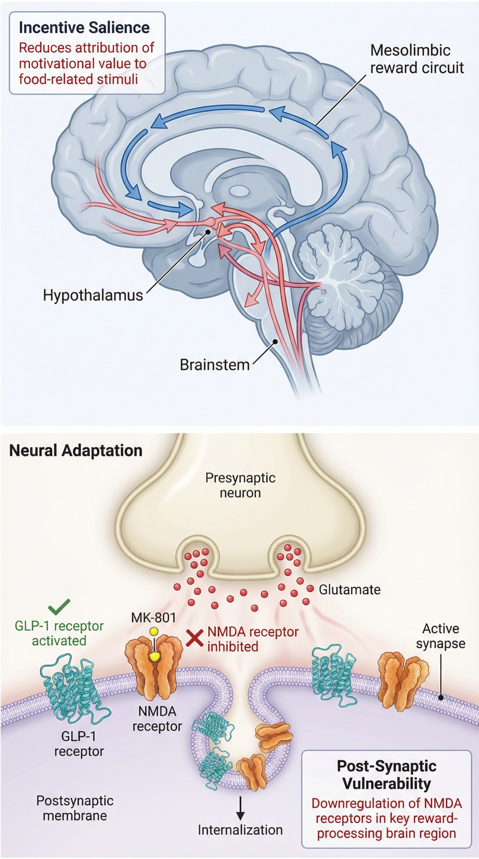

Figure 1. Neurobiological mechanisms underlying post-GLP-1RA weight regain. The mesolimbic reward circuit, comprising projections from the ventral tegmental area to the nucleus accumbens and prefrontal cortex, is central to food-related incentive salience. GLP-1 receptor activation modulates glutamatergic neurotransmission and inhibits NMDA receptors, transiently reducing the motivational value attributed to food stimuli. However, prolonged pharmacological exposure induces neural adaptation, with partial recovery of dopaminergic signaling reflecting the homeostatic resilience of reward circuits. Upon drug withdrawal, this "trained" system, no longer constrained by pharmacological attenuation, rapidly reacquires elevated motivational value for food-related cues, facilitating compulsive relapse and weight regain. Adapted from Cook; Sandoval, 2024 (9). Source: Adapted from Cook; Sandoval, 2024 (9). Annotations highlight key mechanisms discussed in the present work.

REFERENCES
- Sumithran P, Proietto J. The defence of body weight: physiological basis for weight regain. Lancet Diabetes Endocrinol. 2013;1(2):114-21. doi:10.1016/S2213-8587(13)70029-0.
- Seetharaman R, Pawar S, Advani M. One hundred years since insulin discovery: An update on current and future perspectives for pharmacotherapy of diabetes mellitus. Br J Clin Pharmacol. 2022;88(4):1598-612. doi:10.1111/bcp.15100.
- Volkow ND, Wise RA, Baler R. The dopamine motive system: implications for drug and food addiction. Nat Rev Neurosci. 2017;18(12):741-52. doi:10.1038/nrn.2017.130.
- Everitt BJ, Robbins TW. Neural systems of reinforcement for drug addiction: from actions to habits to compulsion. Nat Neurosci. 2005;8(11):1481-9. doi:10.1038/nn1579.
- Zhu Z, Gong R, Rodriguez V, et al. Hedonic eating is controlled by dopamine neurons that oppose GLP-1R satiety. Science. 2025;387(6729):eadt0773. doi:10.1126/science.adt0773.
- Abdulraheem A, Abujaber B, Ayers L, et al. Impact of GLP-1 receptor agonists on upper gastrointestinal endoscopy: an updated systematic review and meta-analysis. Surg Endosc. 2025;39(8):5135-51. doi:10.1007/s00464-025-11962-4.
- Bekhbat M, Li Z, Mehta ND, et al. Functional connectivity in reward circuitry and symptoms of anhedonia as therapeutic targets in depression with high inflammation: evidence from a dopamine challenge study. Mol Psychiatry. 2022;27(10):4113-21. doi:10.1038/s41380-022-01715-3.
- Chao AM, Jastreboff AM, White MA, Grilo CM, Sinha R. Stress, cortisol, and other appetite-related hormones: prospective prediction of 6-month changes in food cravings and weight. Obesity (Silver Spring). 2017;25(4):713-20. doi:10.1002/oby.21790.
- Cook TM, Sandoval D. Dual-action obesity drug rewires brain circuits for appetite. Nature. 2024;629(8014):1011-2. doi:10.1038/d41586-024-01352-6.
- Kuckuck S, van der Valk ES, Scheurink AJW, van Rossum EFC. Glucocorticoids, stress and eating: the mediating role of appetite-regulating hormones. Obes Rev. 2023;24(2):e13539. doi:10.1111/obr.13539.

