SENSITIVITY AANALYSIS OF A MATHEMATICAL MODEL FOR THE TRANSMISSION OF MEASLES WITH PASSIVE IMMUNITY

ABSTRACT
A mathematical model of the transmission dynamics of measles incorporating passively immune class is developed. In the formulation of this model, a set of ordinary differential equations have been used to express the dynamics of the disease. A sensitivity analysis of a deterministic compartmental model for measles transmission with passive immunity is presented. The analysis identifies parameters that significantly influence the basic reproduction number and disease dynamics. Both analytical and numerical sensitivity analyses are performed to guide effective measles control strategies.

Keywords: Equilibrium points, disease free equilibrium, measles, basic reproduction number, sensitivity analysis.

1 Introduction

Measles remains one of the most contagious viral infectious diseases affecting children worldwide, despite the availability of a safe and effective vaccine. It is transmitted through respiratory droplets and direct contact with infectious secretions, which can remain viable in the air or on contaminated surfaces for up to two hours. Due to its high basic reproduction number (R₀), measles continues to pose a serious public health challenge, particularly in low- and middle-income countries where vaccination coverage remains sub-optimal (Moss, 2017; Metcalf et al., 2018).
Although global measles mortality has declined significantly following the introduction of routine immunization programs, outbreaks continue to occur, largely driven by immunity gaps, delayed vaccination, population mobility, and inequitable access to healthcare services (Dabbagh et al., 2018; WHO & UNICEF, 2023). In sub-Saharan Africa, including Kenya, the uptake of the second dose of the measles-containing vaccine (MCV2) remains below the level required to achieve herd immunity, thereby sustaining transmission within vulnerable populations.
Maternal antibodies provide temporary passive immunity to newborns; however, this protection wanes within a few months after birth, exposing infants to infection before they become eligible for routine vaccination (Leuridan & Van Damme, 2019). This early loss of maternal immunity has important implications for measles transmission dynamics and highlights the need to explicitly incorporate passive immunity into mathematical models.
Mathematical modeling has proven to be an essential tool for understanding the transmission dynamics of measles and for evaluating the impact of vaccination and other control strategies (Thompson et al., 2018; Bonyah & Khan, 2020). In particular, compartmental models provide insights into how demographic and epidemiological parameters influence disease spread. However, uncertainty in parameter values necessitates sensitivity analysis to identify the most influential parameters affecting disease transmission.
Sensitivity analysis of the basic reproduction number (R₀) allows for the identification of parameters that have the greatest impact on measles transmission and helps guide effective public health interventions (Li et al., 2019). By determining how changes in vaccination coverage, contact rates, recovery rates, and loss of passive immunity affect R₀, policymakers can prioritize strategies that are most effective in reducing disease burden.
In this study, we develop and analyze a deterministic compartmental model for measles transmission incorporating passive immunity. Analytical and numerical sensitivity analyses are performed to determine the relative importance of key epidemiological parameters. The results provide valuable insights for strengthening measles control strategies, particularly through vaccination and early intervention.

2. Formulation of the Mathematical Model of Measles
In this section, we describe and develop the model of measles dynamics based on the several assumptions.
2.1 Model assumptions
In developing the model, the following assumptions were made;
- Individuals get into the system by birth only.
- Al new born infants acquire passive immunity from their mothers hence they are disease free.
- All the variables and parameters used in the model are non-negative.
- All recovered individuals acquire permanent immunity.
- There is free interaction within the population.

2.2 Justification of Model Assumptions
The assumption that individuals enter the population through birth reflects the long-term demographic dynamics of measles, which primarily affects children. The inclusion of a passively immune class acknowledges that newborns receive maternal antibodies that provide temporary protection against infection. This assumption is supported by immunological studies showing that maternal antibodies decay within a few months after birth.
Permanent immunity following recovery is a well-established characteristic of measles infection and justifies the absence of reinfection in the recovered class. Homogeneous mixing, although an idealization, allows the model to focus on average transmission behavior and facilitates analytical tractability. While real populations exhibit heterogeneous contact patterns, the homogeneous mixing assumption remains widely accepted in baseline measles models.
The assumption of non-negative state variables ensures biological feasibility, while the exclusion of immigration and emigration simplifies the analysis without significantly altering the qualitative behavior of the system over the timescale considered.

2.3 Model equations
The population is divided into five compartments: passively immune (M), susceptible (S), exposed (E), infectious (I), and recovered (R). The model assumes homogeneous mixing, permanent immunity after recovery, and vaccination at birth. The measles transmission model with passive immunity incorporates several epidemiological and demographic parameters. Each parameter represents a specific biological or public health process and is defined as follows:

Parameter | Description
$$\text{β}$$ | Effective contact rate between susceptible and infectious individuals
$$\text{σ}$$ | Rate of loss of passive immunity
$$\text{θ}$$ | Proportion of individuals successfully vaccinated at birth
$$\text{α}$$ | Progression rate from exposed to infectious class
$$\text{γ}$$ | Recovery rate of infectious individuals
$$\text{μ}$$ | Natural death rate
$$\text{δ}$$ | Disease-induced death rate

Table 1:Parameter Description
The total population is given by:
$$\text{N} \left(\text{t}\right)\text{= }\text{M} \left(\text{t}\right)\text{+ }\text{S} \left(\text{t}\right)\text{+ }\text{E} \left(\text{t}\right)\text{+ }\text{I} \left(\text{t}\right)\text{+ }\text{R} \left(\text{t}\right)$$
The schematic diagram below illustrates how the disease spreads in different compartments.
Figure 1: Schematics depicting transitions between different compartments, transmission and mortalities rates (Authors 2019)
The mathematical model is described by the following system of equations
$$\begin{matrix}{\text{dM}}/{\text{dt}}\text{=}\text{bN}\text{-}\text{bpN}\text{-}\left(\text{φ}\text{+}\text{μ}\right)\text{M} \\ {\text{dS}}/{\text{dt}}\text{=}\text{φM}\text{-}{\text{βIS}}/{\text{N}}\text{-}\text{μS} \\ {\text{dE}}/{\text{dt}}\text{=}{\text{βIS}}/{\text{N}}\text{-}\left(\text{μ}\text{+}\text{α}\right)\text{E} \\ {\text{dI}}/{\text{dt}}\text{=}\text{αE}\text{-}\left(\text{μ}\text{+}\text{σ}\text{+}\text{γ}\right)\text{I} \\ {\text{dR}}/{\text{dt}}\text{=}\text{bpN}\text{+}\text{γI}\text{-µ}\text{R}\end{matrix} \left(\text{1}\right)$$

2.4 Interpretation of Model Parameters
Each parameter in the model has a clear epidemiological interpretation. The effective contact rate captures both the frequency of contact between individuals and the probability of transmission per contact. This parameter is influenced by behavioral, cultural, and environmental factors, making it one of the most variable and influential components of the model.
The rate of loss of passive immunity determines the speed at which infants transition from the protected class to the susceptible class. This parameter plays a critical role in shaping early-life susceptibility and has important implications for vaccination timing. The vaccination parameter represents the proportion of newborns who successfully acquire immunity through immunization at birth or shortly thereafter.
The progression rate from exposed to infectious individuals reflects the incubation period of measles, while the recovery rate determines the duration of infectiousness. Natural and disease-induced death rates account for demographic turnover and disease severity, respectively. Together, these parameters govern the flow of individuals through the compartments and determine the overall disease dynamics.

2.5 Basic Reproduction Number $\left({\text{R}}_{\text{0}}\right)$
Basic reproduction number, ${\text{R}}_{\text{0}}$, is a significant threshold in determining whether the disease dies out or persists in the population. It is a measure of the speed with which a disease spreads through a population. In this study, we compute ${\text{R}}_{\text{0}}$, using the next generation matrix method as formulated by [8] in which we determine the dominant eigenvalue of the steady state Jacobian matrix of the model after linearization.
$${\text{R}}_{\text{0}}\text{=}\frac{\text{αβφ}\left(\text{1-}\text{p}\right)}{\left(\text{α}\text{+}\text{b}\right)\left(\text{σ}\text{+}\text{γ}\text{+}\text{b}\right)\left(\text{φ}\text{+}\text{b}\right)} \left(\text{2}\right)$$

3. Sensitivity Analysis
The normalized forward sensitivity index of R0 with respect to a parameter p is defined as:
$${\text{Υ}}_{\text{p}}\text{= (p/}{\text{R}}_{\text{0}}\text{)(∂}{\text{R}}_{\text{0}}\text{/∂p). (3)}$$

3.1 Importance of Sensitivity Analysis in Epidemiological Modeling
Sensitivity analysis is a crucial component of mathematical epidemiology, particularly when models rely on parameters that are difficult to estimate accurately. In real-world settings, parameter values may vary across populations and over time due to behavioral changes, intervention strategies, or data limitations. Sensitivity analysis helps assess the robustness of model predictions under such uncertainty.
The normalized forward sensitivity index used in this study provides a dimensionless measure of how responsive the basic reproduction number is to changes in each parameter. A positive sensitivity index indicates that an increase in the parameter leads to an increase in R₀, while a negative index implies a reduction in transmission potential.
Analytical sensitivity analysis offers valuable qualitative insights by revealing direct mathematical relationships between parameters and R₀. Numerical sensitivity analysis complements this approach by allowing simultaneous variation of multiple parameters and validating analytical findings under realistic conditions.
In the context of measles control, sensitivity analysis is particularly relevant because it highlights parameters that can be targeted through public health interventions. Parameters with high sensitivity indices warrant greater attention, as small improvements in these parameters can yield substantial reductions in disease transmission.

3.1.1 Sensitivity Index Definition
The normalized forward sensitivity index of the basic reproduction number R₀ with respect to a parameter p is defined as:
$${\text{Υ}}_{\text{P}}^{{\text{R}}_{\text{0}}}\text{ = (p / R₀) × (∂R₀ / ∂p) (4)}$$
This index measures the proportional change in R₀ resulting from a proportional change in the parameter p. For the measles transmission model with passive immunity, the basic reproduction number is given by:
$$\text{R₀ =}\text{ β(1 - θ) / [(α + μ)(γ + μ + δ)]}$$
where$\text{ β}$ is the effective contact rate, $\text{θ }$is the proportion of individuals successfully vaccinated at birth, $\text{α}$ is the progression rate from exposed to infectious,$\text{ γ}$ is the recovery rate,$\text{ μ}$ is the natural death rate, and$\text{ δ}$ is the disease-induced death rate.

3.2 Analytical Sensitivity Indices
Using the expression for$\text{ R₀}$, the sensitivity indices with respect to the key model parameters are computed as follows.

3.2.1 Sensitivity with respect to the contact rate$\text{β}$
The partial derivative of R₀ with respect to β is:
$$\text{∂R₀ / ∂β = (1 - θ) / [(α + μ)(γ + μ + δ)] (5)}$$
Hence, the sensitivity index is:
$${\text{Υ}}_{\text{β}}^{\text{R₀}}\text{ = 1 (6)}$$
This indicates that the basic reproduction number is directly proportional to the contact rate.

3.2.2 Sensitivity with respect to vaccination coverage$\text{θ}$
The partial derivative of R₀ with respect to θ is:
$$\text{∂R₀ / ∂θ = -β / [(α + μ)(γ + μ + δ)] (7)}$$
Thus, the sensitivity index is:
$${\text{Υ}}_{\text{θ}}^{\text{R₀}}\text{= - θ / (1 - θ) }\text{ (8)}$$
This negative value implies that an increase in vaccination coverage significantly reduces measles transmission.

3.2.3 Sensitivity with respect to the progression rate $\text{α}$
The partial derivative of $\text{R₀}$ with respect to$\text{ α}$ is:
$$\text{∂R₀ / ∂α = -β(1 - θ) / [(α + μ)²(γ + μ + δ)] (9)}$$
Therefore, the sensitivity index is:
$${\text{Υ}}_{\text{α}}^{\text{R₀}}\text{= - α / (α + μ) (10)}$$
This result shows that increasing the progression rate from exposed to infectious reduces R₀ by shortening the latent period.

3.2.4 Sensitivity with respect to the recovery rate$\text{γ}$
The partial derivative of R₀ with respect to γ is:
$$\text{∂R₀ / ∂γ = -β(1 - θ) / [(α + μ)(γ + μ + δ)²] (11)}$$
Hence, the sensitivity index is:
$${\text{Υ}}_{\text{γ}}^{\text{R₀}}\text{= - γ / }\text{(γ + μ + δ) (12)}$$
This indicates that faster recovery decreases the average infectious period and lowers disease transmission.

3.2.5 Sensitivity with respect to the disease-induced death rate$\text{δ}$
The partial derivative of R₀ with respect to δ is:
$$\text{∂R₀ / ∂δ = -β(1 - θ) / [(α + μ)(γ + μ + δ)²] (13)}$$
Thus, the sensitivity index is:
$${\text{Υ}}_{\text{δ }}^{\text{R₀}}\text{= - δ / (γ + μ + δ) (14)}$$

Parameter | Description | Sensitivity Index
$$\text{β}$$ | Contact rate | $$\text{+1}$$
$$\text{θ}$$ | Vaccination at birth | $$\text{-θ/(1-θ)}$$
$$\text{α}$$ | Progression rate | $$\text{-α/(α+μ)}$$
$$\text{γ}$$ | Recovery rate | $$\text{-γ/(}\text{γ+μ+δ}\text{)}$$
$$\text{δ}$$ | Disease-induced death rate | $$\text{-δ/(}\text{γ+μ+δ}\text{)}$$

Table 2: Sensitivity Indices of${\text{R}}_{\text{0}}$

Contact rate$\text{ β}$ has a sensitivity index of $\text{+1}$, indicating direct proportionality with${\text{ R}}_{\text{0}}$.
Vaccination coverage$\text{ θ}$ has a negative sensitivity index, highlighting its role in reducing transmission.
Recovery and progression rates also reduce ${\text{R}}_{\text{0}}$ when increased.

3.3. Numerical Simulations

Numerical simulations were conducted by varying each parameter by$\text{ ±20\%}$ around baseline values. The effect on ${\text{R}}_{\text{0}}$ is illustrated in Figures 2–4.

3.3.1 equilibrium points and basic reproduction number
The equilibrium points of our model were analyzed (author 2019).. In this section, we carried out numerical analysis of the equilibrium points for the system at high contact rate using Matlab software. From the results, it was found that the DFE is,
$${\text{E}}_{\text{0}}^{\text{*}}\text{=(823.08, 605.20,0,0,99.521)}$$
While the EE point for our model $\text{β}\text{=0.09091}$ is,
$${\text{E}}_{\text{1}}^{\text{*}}\text{=(833.02, 488.10, 0.0011, 0.0022, 800.8)}$$
the EE point for our model at $\text{β}\text{=1.6667}$ is,
$${\text{E}}_{\text{1}}^{\text{*}}\text{=(814.7.02, 10.1134, 0.0011, 0.0045, 1277.7)}$$
The basic reproductive number ${\text{R}}_{\text{0}}\text{=0.44097}$ for $\text{β}\text{=1.6667}$ and ${\text{R}}_{\text{0}}\text{=0.024026}$ for $\text{β}\text{=0.09091}$.

3.3.2 sensitivity index
Using parameter values in Appendix A, the sensitivity of ${\text{R}}_{\text{0}}$ to all the parameters are given out in the table 3 below. This indices will be used to identify parameters with high impact on ${\text{R}}_{\text{0}}$ and to which intervention strategies are to target.
Parameter | Sensitivity index
$$\text{β}$$ | +1.00000
$$\text{b}$$ | -0.962819
$$\text{α}$$ | +0.000686
$$\text{μ}$$ | $$\text{0}$$
$$\text{σ}$$ | -0.016918
$$\text{φ}$$ | +0.961543
$$\text{p}$$ | - 0.00051
$$\text{γ}$$ | -0.982492
Table 3: the constant sensitivity indices of model parameters

The signs and magnitude of the sensitivity indices, helps to show the direction of the response to small variation in the input parameters and importance of each parameter in the model output respectively. From the computed sensitivity indices in table 3, the parameters $\text{β}\text{,}\text{α}\text{,}$ and $\text{φ}$ have positive indices. This indicates that ${\text{R}}_{\text{0}}$ increases when these parameters are increased, when all the other parameters are held constant. The parameters $\text{b}\text{,}\text{σ}\text{,}\text{p}$ and $\text{γ}$ have negative indices. This indicates increase in these parameters while holding constant all the other parameter, decreases ${\text{R}}_{\text{0}}$ value. The parameter that is most sensitive is the contact rate, $\text{β}$, followed by $\text{φ}$ then $\text{α}$, while the least sensitive one is the recovery rate, $\text{γ}$.
From the sensitivity indices it shows that to reduce measles transmission in a population, vaccination and treating the infected people will stop the disease from being transmitted.
Sensitivity of the model variables to all the parameters at endemic equilibrium point was also carried out numerically and the results are shown in the table below.

 | $$\text{m}$$ | $$\text{s}$$ | $$\text{e}$$ | $$\text{i}$$ | $$\text{r}$$
$$\text{b}$$ | $$\text{-4.7545}$$ | $$\text{-1.5413}$$ | $$\text{+}\text{0.0018}$$ | $$\text{+}\text{1.5452}$$ | $$\text{+}\text{3683.8}$$
$$\text{p}$$ | $$\text{+0.0001348}$$ | $$\text{-0.00002168}$$ | $$\text{-0.000001963}$$ | $$\text{-}\text{0.00000209}$$ | $$\text{-}\text{0.0060}$$
$$\text{α}$$ | $$\text{-0.4611}$$ | $$\text{-0.2241}$$ | $$\text{-1.0002}$$ | $$\text{+}\text{0.2268}$$ | $$\text{+}\text{540.654}$$
$$\text{β}$$ | $$\text{-0.6234}$$ | $$\text{-1.3170}$$ | $$\text{+}\text{0.0002871}$$ | $$\text{+}\text{0.3067}$$ | $$\text{+}\text{730.9030}$$
$$\text{φ}$$ | $$\text{+0.0727}$$ | $$\text{+0.0168}$$ | $$\text{+0.0000152}$$ | $$\text{-0.0162}$$ | $$\text{-38.7167}$$
$$\text{γ}$$ | $$\text{-3419.5}$$ | $$\text{-1662.0}$$ | $$\text{+}\text{3.7581}$$ | $$\text{+}\text{1682.1}$$ | $$\text{+}\text{4011600}$$
$$\text{σ}$$ | $$\text{+}\text{58.5589}$$ | $$\text{-27.4477}$$ | $$\text{+}\text{0.0653}$$ | $$\text{+}\text{27.8060}$$ | $$\text{+}\text{66272}$$
$$\text{μ}$$ | $$\text{0}$$ | $$\text{0}$$ | $$\text{0}$$ | $$\text{0}$$ | $$\text{0}$$
Table 4: The sensitivity indices for the model variables to the parameters at EE.
From the table, the most sensitive parameter is the recovery rate due to measles treatment. It shows that the recovery increase when the measles treatment is increased. From the table, it is also shown that if the proportion of those who are successfully vaccinated is increased, the number of exposure to the virus reduces and infection is also reduced. The effect of passive immunity from maternal antibodies is also evident from the table. Increase in the immunity decreases the number of the exposed and increases the number of recovered individuals. When the contact rate is increased, the number of exposed and infected individuals also increases, while the rate at which the susceptible individual becomes exposed is increased it increases the number of infected individuals.

3.3.3 Interpretation of Numerical Sensitivity Results
The numerical sensitivity indices reveal that the effective contact rate is the most influential parameter affecting R₀. This finding underscores the importance of social behavior, population density, and movement patterns in measles transmission. Interventions aimed at reducing contact rates during outbreaks, such as isolation and public awareness campaigns, can therefore play a supportive role alongside vaccination.
Vaccination coverage exhibits a strong negative sensitivity index, confirming its critical role in disease control. Increasing vaccination coverage reduces the pool of susceptible individuals and enhances herd immunity, thereby lowering transmission potential. The progression and recovery rates exhibit moderate sensitivity, indicating that improvements in case management and early diagnosis contribute to transmission reduction, albeit to a lesser extent.
The relatively low sensitivity associated with disease-induced mortality reflects the fact that measles transmission is driven more by contact and susceptibility than by fatal outcomes.

3.3.4 The effect on ${\text{R}}_{\text{0}}$
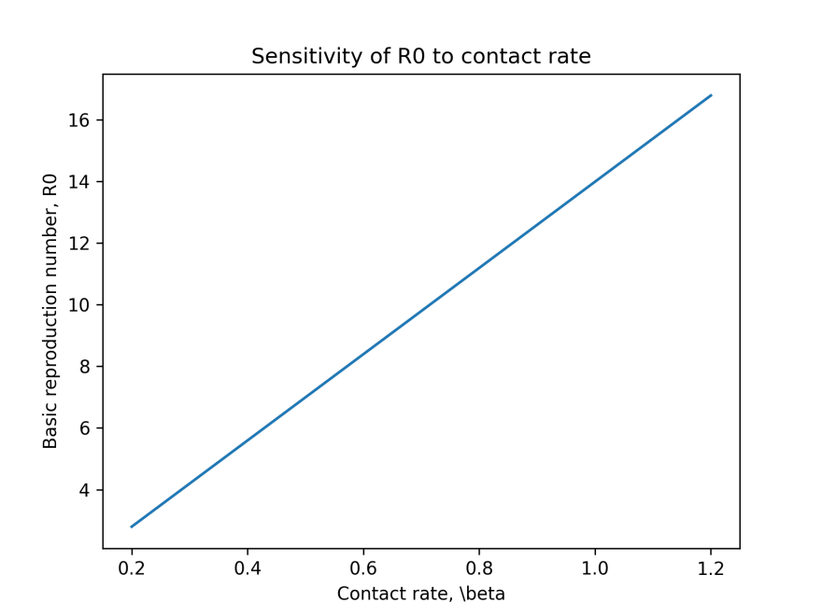
Figure 2: Sensitivity of ${\text{R}}_{\text{0}}$ to contact rate
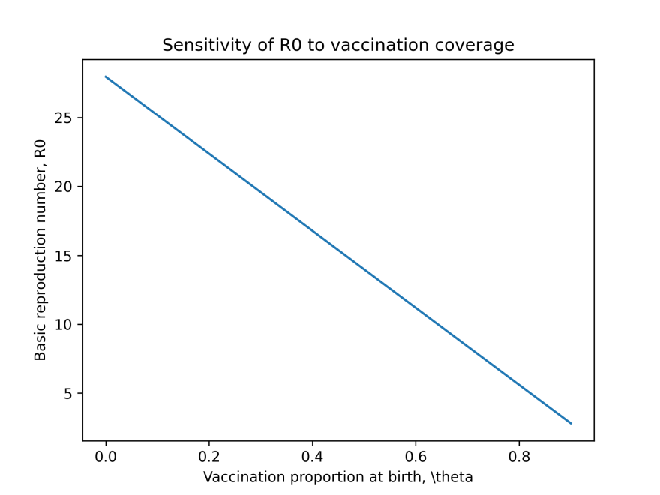
Figure 3: Sensitivity of ${\text{R}}_{\text{0}}$ to Vaccination coverage

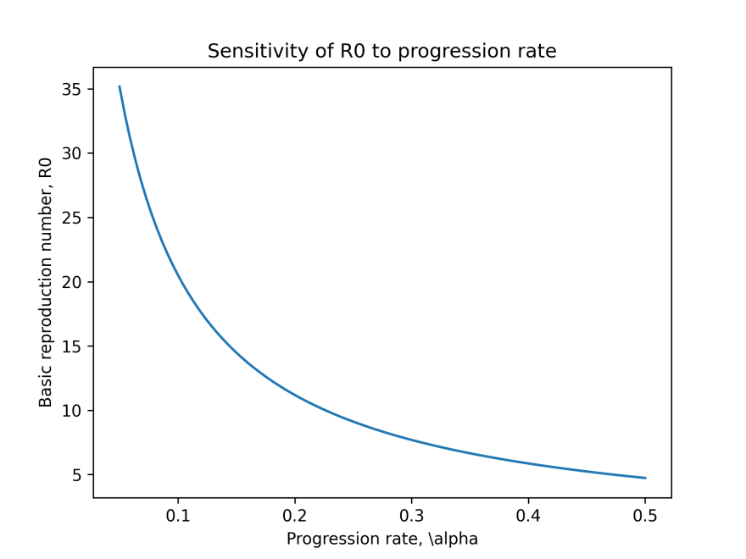
Figure 4: Sensitivity of ${\text{R}}_{\text{0}}$ to progression rate

4. Discussion and Conclusion
The findings of this study have important implications for measles control and elimination strategies. The dominance of vaccination coverage in determining transmission dynamics reinforces the need for sustained investment in routine immunization programs. Efforts should focus on improving access to vaccination services, addressing vaccine hesitancy, and ensuring completion of the recommended two-dose schedule.
The role of passive immunity highlights the vulnerability of infants and the importance of herd immunity in protecting this age group. Policymakers should consider strategies that maintain high population immunity, particularly in settings with high birth rates.
Overall, the results demonstrate that mathematical modeling combined with sensitivity analysis provides a powerful framework for informing evidence-based public health decision-making.

References
Bonyah, E., & Khan, M. A. (2020). Modeling the dynamics of measles with vaccination and treatment. Results in Physics, 19, 103455. https://doi.org/10.1016/j.rinp.2020.103455
Dabbagh, A., Patel, M. K., Dumolard, L., Gacic-Dobo, M., Mulders, M. N., Okwo-Bele, J. M., Kretsinger, K., Papania, M. J., & Rota, P. A. (2018). Progress toward regional measles elimination worldwide, 2000–2017. Morbidity and Mortality Weekly Report, 67(47), 1323–1329. https://doi.org/10.15585/mmwr.mm6747a6
Leuridan, E., & Van Damme, P. (2019). Passive transmission and maternal antibodies against measles. Vaccine, 37(9), 1186–1194. https://doi.org/10.1016/j.vaccine.2019.01.006
Li, J., Blakeley, D., & Smith, R. J. (2019). The failure of R₀. Computational and Mathematical Methods in Medicine, 2019, Article 5276104. https://doi.org/10.1155/2019/5276104
Metcalf, C. J. E., Ferrari, M., Graham, A. L., & Grenfell, B. T. (2018). Understanding herd immunity. Trends in Immunology, 39(8), 563–577. https://doi.org/10.1016/j.it.2018.04.002
Moss, W. J. (2017). Measles. The Lancet, 390(10111), 2490–2502. https://doi.org/10.1016/S0140-6736(17)31463-0
Thompson, K. M., Odahowski, C. L., & Armstrong, J. (2018). Modeling the transmission of measles and the impact of vaccination. Risk Analysis, 38(4), 709–727. https://doi.org/10.1111/risa.12895
World Health Organization & UNICEF. (2023). Measles surveillance and immunization coverage estimates. Weekly Epidemiological Record, WHO.
E. M. Musyoki, R. M. Ndung’u, and S. Osman, “A Mathematical Model for the Transmission of Measles with Passive Immunity,” International Journal of Scientific Research in Mathematical and Statistical Sciences, vol. 6, no. 2, pp. 1–8, 2019.

Appendices
Appendix A: Data for baseline parameter values
In this appendix we show the data, explanation for the parameter values of the model and the references for the values.
Parameter description | symbol | dimension | value | Range of value | reference
Birth rate | $$\text{b}$$ | $$\text{h}\text{umans}\text{ ×}{\text{year}}^{\text{-1}}$$ | $$\text{0.04015}$$ |  | $$\text{[9]}$$
Mortality rate | $$\text{µ}$$ | $$\text{h}\text{umans}\text{ ×}{\text{year}}^{\text{-1}}$$ | $$\text{0.0165}$$ |  | $$\text{[9]}$$
Contact rate | $$\text{β}$$ | $${\text{day}}^{\text{-1}}$$ | $$\text{0.09091, 1.6667}$$ |  | $$\left[\text{10,11}\right]$$
Infectious rate | $$\text{α}$$ | $${\text{day}}^{\text{-1}}$$ | $$\text{0.125}$$ |  | $$\text{[11]}$$
Recovery rate due to treatment | $$\text{γ}$$ | $${\text{day}}^{\text{-1}}$$ | $$\text{0.14286}$$ |  | $$\text{[11]}$$
Rate of mortality due to measles | $$\text{σ}$$ | $${\text{year}}^{\text{-1}}$$ | $$\text{0.00246}$$ |  | $$\text{[5]}$$
passive immunity loss rate | $$\text{φ}$$ | $${\text{year}}^{\text{-1}}$$ | $$\text{0.012045}$$ |  | $$\text{[12]}$$
Proportion of those at birth were vaccinated successfully | $$\text{p}$$ | $${\text{year}}^{\text{-1}}$$ | $$\text{0.028105 }$$ |  | $$\text{[5]}$$

