Case Study

Intrauterine Death Secondary to HELLP Syndrome with Placental Calcification in a Patient with Chronic Hypertension superimposed Preeclampsia and Gestational Thrombocytopenia

Abstract
This case highlights the complex clinical course of a 37-year-old woman G3P1+1, at 31 weeks and 3 days gestation who experienced intrauterine death secondary to HELLP syndrome and placental calcification, with the background of chronic hypertension with superimposed preeclampsia, and gestational thrombocytopenia. The patient had a history of several obstetric and medical issues, including obesity, previous preeclampsia, and gestational diabetes mellitus managed through diet, along with two previous miscarriages. This case underscores the diagnostic and management challenges associated with hypertensive disorders during pregnancy, highlighting the critical need for early detection and a coordinated approach among healthcare professionals in high-risk cases.
Introduction
Hypertensive disorders affect about 5–10% of pregnancies and are among the top causes of complications for both mothers and babies[1]. HELLP syndrome, which stands for hemolysis, elevated liver enzymes, and low platelets, is a severe and potentially life-threatening form of preeclampsia. It can develop quietly but escalate quickly. In cases of preeclampsia, chronic placental hypoperfusion and endothelial dysfunction can accelerate placental aging, leading to increased calcification, villous fibrosis, and impaired nutrient exchange, which contribute to fetal growth restriction and intrauterine demise. This case illustrates the challenges faced by a high-risk pregnant woman with chronic hypertension with superimposed preeclampsia who ultimately suffered fetal loss in the setting of HELLP syndrome.
Case Summary
The patient is a known case of chronic hypertension complicated by preeclampsia, which was first detected at 24 weeks of pregnancy during a hypertensive crisis accompanied by proteinuria (UPCI 0.03). Her initial preeclampsia profile showed no significant issues, aside from thrombocytopenia. Throughout her pregnancy, her blood pressure fluctuated between 122–187/61–104 mmHg, while home readings were more stable, ranging from 101–130/60–86 mmHg. She had multiple admission throughout pregnancy for blood pressure stabilisation and was last discharged on tablet Methyldopa 750 mg TDS and along with preeclampsia prophylaxis (tablet Cardiprin 100 mg OD and tablet calcium carbonate 500 mg TDS).
Additionally, she was diagnosed with asymptomatic gestational thrombocytopenia, with her platelet counts dropping from 101 × 10⁹/L at 14 weeks to 53 × 10⁹/L at her most recent discharge. Tests showed negative ANA results, normal complement levels, and a negative infective screening. Hematology recommended avoiding steroid treatment unless her platelet count drop further below 50 × 10⁹/L or if she was close to delivery with low counts. Her obstetric history includes a previous emergency cesarean section at 28 weeks due to severe preeclampsia and fetal distress. Other risk factors include gestational diabetes mellitus on diet control and maternal obesity.
However, at 30 weeks of gestation, she presented with a one-day history of reduced fetal movements and irregular contractions. Her blood pressure at the general practitioner clinic was recorded at 160/78 mmHg; she took her methyldopa on her way to the hospital. An ultrasound showed no fetal heart activity, with measurements indicating a gestational age of 28–30 weeks. Her blood parameters upon admission as follows:
Upon admission, initial blood investigations showed:
White cell count 10/ Hemoglobin 10.7/ Platelet 25
Urea 5.1/ Sodium 135/ Potassium 4.1/ Creatinine 72
Magnesium 0.84/ Calcium 2.2/ Phosphate 1.15
Prothrombin time 9.8/ INR 0.92/ Activated partial thromboplastin time 23
Total protein 74/ Albumin 26/ Alkaline phosphatase 437/ Alanine aminotransferase 90/ Aspartate aminotransferase 35
Total bilirubin 7.8/ Direct bilirubin 5.3/ Indirect bilirubin 2.5
Lactate Dehydrogenase 34
Uric acid 405
Reticulocyte percentage 2.53%
Diagnosis of HELLP syndrome was made and an emergency lower segment cesarean section was performed, during which she received intraoperative platelet transfusion, subsequently delivered a female stillbirth weighing 1.29 kg. The fetus appeared generally normal with no visible external defects, but the placenta looked unhealthy, showing multiple areas of calcification (Image 1).
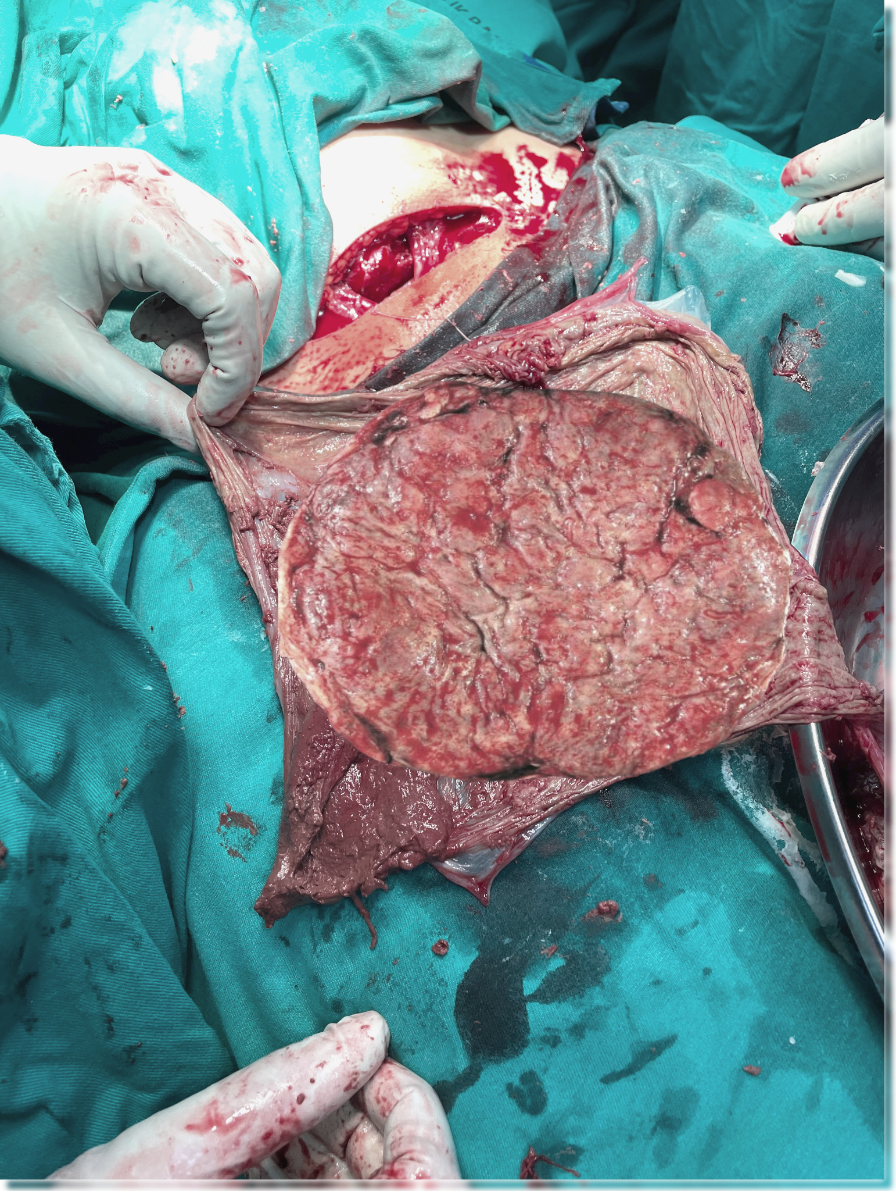
Image 1: unhealthy placenta with multiple areas of calcification

Discussion
This patient's case presents a complex interplay of risk factors including chronic hypertension with superimposed preeclampsia, obesity (with a BMI > 34), gestational diabetes mellitus, gestational thrombocytopenia and multiple pregnancy losses.
At the molecular level, dysfunctional and calcified placenta leads to hypoxia and oxidative stress, which in turn triggers the release of anti-angiogenic factors like soluble fms-like tyrosine kinase-1 (sFlt-1). This factor neutralizes placental growth factor (PlGF) and contributes to systemic endothelial dysfunction [2]. The sFlt-1/PlGF ratio is particularly useful for predictions: in the PROGNOSIS study, a ratio of above 38 indicated a likelihood of onset of preeclampsia within four weeks, with a 36.7% positive predictive value (PPV) and 66.2% sensitivity, along with 83.1% specificity [3].
Preeclampsia is a major contributor to placental insufficiency, primarily due to abnormal remodeling of the spiral arteries. When maternal spiral arteries aren't properly converted, it leads to high-resistance, low-flow circulation, which can cause intervillous thrombosis and fibrinoid necrosis [1]. This microvascular pathology diminishes uteroplacental perfusion, resulting in chronic fetal hypoxia. If this hypoperfusion continues, it can lead to intrauterine growth restriction and, in severe cases, intrauterine fetal demise [4]. A study involving 51 preeclamptic placentas reported that 66.4% exhibited pathological features, including villous necrosis, increased syncytial knots, and thrombosis. These findings are associated with impaired placental perfusion and fetal growth restriction [5]. Premature placental calcification (PPC), is observed in preeclampsia. The prevalence of PPC varies across studies, ranging from 3.8% to 23.7%. PPC is associated with adverse maternal and neonatal outcomes, including preeclampsia, fetal growth restriction, low birth weight, low Apgar scores, and abnormal Doppler parameters [6].
Histopathological studies show that up to 65% of placentas from preeclamptic pregnancies exhibit thrombotic lesions, infarctions, or both, highlighting the link between maternal endothelial dysfunction and fetal compromise [7].
Maternal complications associated with HELLP syndrome include disseminated intravascular coagulation (DIVC), hepatic rupture, renal failure, and pulmonary oedema. Maternal mortality following HELLP syndrome 2.9% and 18.% stillbirth [8]. Another study conducted in Pakistan shows a 7% risk of intrauterine fetal demise in case of HELLP syndrome [9].
The long-term effects are quite concerning: a study from Sweden involving over 2 million women found that those who experienced hypertensive disorders during pregnancy had double the risk of developing ischemic heart disease later on [10]. This elevated cardiovascular risk can persist for decades, highlighting how complications during pregnancy can serve as important indicators of future heart health.

Conclusion & Recommendations
This case really highlights the importance of close observation and active management of high-risk pregnancies, especially when there are overlapping issues like hypertension, thrombocytopenia, and a history of poor obstetric outcomes.
Here are some key recommendations to consider:
- Early multidisciplinary care: Involve obstetricians, maternal-fetal medicine specialists, hematologists, and neonatologists from the outset.
- Strict maternal and fetal monitoring: Regularly track blood pressure, platelet counts, and fetal well-being during pregnancy.
- Postpartum planning and patient education: Focus on postpartum follow-up, preparation for future pregnancies, long-term cardiovascular risk management, and empowering the patient to recognize warning signs.

Conflict of interest
The authors declare that there are no conflicts of interest related to this manuscript.
Informed consent
Both written and verbal informed consent was obtained from the patient (Mdm N) for publication of this report and any accompanying images.
Data Availability
The data supporting the findings of this study are available within the article.

COMPETING INTERESTS DISCLAIMER:
Authors have declared that they have no known competing financial interests OR non-financial interests OR personal relationships that could have appeared to influence the work reported in this paper.

References
1/ Roberts, J. M., & Escudero, C. (2012). The placenta in preeclampsia. Pregnancy Hypertension: An International Journal of Women's Cardiovascular Health, 2(2), 72-83.
2/ Yung, H. W., & Charnock-Jones, D. S. (2008). Anti-angiogenic factors in preeclampsia: sFlt-1 and soluble endoglin. Placenta, 29(Suppl A), S51–S56. https://doi.org/10.1016/j.placenta.2007.11.008
3/ Levine, R. J., et al. (2016). Soluble endoglin and other circulating antiangiogenic factors in preeclampsia. New England Journal of Medicine, 355(10), 992–1005.
4/ Brosens, I., Pijnenborg, R., Vercruysse, L., & Romero, R. (2011). The “Great Obstetrical Syndromes” are associated with disorders of deep placentation. American Journal of Obstetrics and Gynecology, 204(3), 193–201.
5/ Nurdin, R., Rina Masadah, Berti Nelwan, Djumadi Achmad, Gatot S. Lawrence, Mardiati, & Andi Alfian Zainuddin. (2022). Histopathological Findings in Placentas from Pregnancies Complicated with Preeclampsia. International Journal of Sciences: Basic and Applied Research (IJSBAR), 65(1), 31-37. make the bracket
6/ Dash, S., Das, B., Panda, S. R., Rajguru, M., Jena, P., Mishra, A., & Rath, S. K. (2021). Perinatal outcomes in premature placental calcification and the association of a color doppler study: report from a tertiary care hospital in eastern India. Clinics and Practice, 11(4), 841-849.
7/ Redline, R. W. (2008). Placental pathology: A guide for clinicians. Pathology, 40(2), 115–126.
8/ Kali, Zercan & Cagiran, Fatma & Kirici, Pinar & Meydanli, Mehmet. (2022). Incidence, Characteristics, Maternal and Perinatal Outcomes of HELLP Syndrome. Gynecology & Reproductive Health. 6. 10.33425/2639-9342.1190.
9/ Wali S, Qazi KF, Begum A, Ara J, Rekha, Bibi N. (2024). Adverse fetomaternal outcomes in women with HELLP syndrome. Journal of Population Therapeutics and Clinical Pharmacology, 31(4), 2274–2281.
10/ Crump, C., Sundquist, J., & Sundquist, K. (2023). Hypertensive disorders of pregnancy and long-term risk of ischemic heart disease in mothers: National cohort study. BMJ, 380, e072155.

