Case Study
Navigating the Grey Area: A Case of Periviable Preterm Prelabour Rupture of Membranes Complicated by Subclinical Chorioamnionitis

Abstract
This case highlights the complex clinical course of a 31-year-old woman G1P0 at 25 weeks and 2 days gestational diagnosed with subclinical chorioamnionitis complicating periviable preterm prelabour rupture of membrane (PPROM) with severe oligohydramnios, resulting in adverse fetal outcome despite initial conservative management. This case underscores the importance of close monitoring, timely identification of infection, and sensitive counselling to balance maternal safety with fetal prognosis.

Introduction
Periviable PPROM is defined as rupture of membranes occurring between 20 0/7 and 25 6/7 weeks of gestation, before the onset of labour, in the gestational window where neonatal survival is possible but highly uncertain [3,11]. This condition is a rare but serious obstetric complication associated with high perinatal mortality and significant maternal morbidity. When stratified by gestational age, population-based data from China show that leaking occurring between 24 and 27 + 6 weeks made up 25.8% to 51.6% of all PPROM cases over several study years [2].
A prospective study of 178 singleton pregnancies with PPROM between 20–25 weeks reported neonatal survival of only 6.7% when delivery occurred before 25 weeks, compared to 89.4% when delivery occurred between 26 and 34 weeks [2].
One of the most important risks in such cases is chorioamnionitis, which may occur in the absence of overt clinical signs, a condition referred to as subclinical chorioamnionitis. This entity poses a diagnostic challenge, as decisions must be made based on laboratory parameters, imaging findings, and overall clinical risk rather than classical symptoms.

Case Presentation
This patient, a 31-year-old primigravida at 25 + 2 weeks POA who presented with leaking liquor. On admission, per speculum examination revealed clear amniotic fluid with the cervical os opening to the tip of a finger. Ultrasound confirmed oligohydramnios with an amniotic fluid index (AFI) of 6.8 cm and estimated fetal weight of 612 g, with normal umbilical artery Doppler waveform. She was managed as PPROM with oligohydramnios with T Erythromycin Ethylsuccinate 400mg BD and completed antenatal corticosteroids. During admission, septic parameters demonstrated an upward trend, with white blood cell count increasing from 12.6 × 10⁹/L to 32.65 × 10⁹/L, and C-reactive protein rising from 7.22 mg/L to 13.10 mg/L. A repeat ultrasound at 26 + 4 weeks revealed anhydramnios, lung hypoplasia, and abnormal umbilical artery Doppler with intermittent absent end-diastolic flow. A diagnosis of subclinical chorioamnionitis was made. After detailed counselling regarding poor fetal prognosis and risks to maternal health, termination of pregnancy was performed. She delivered a fresh stillborn male infant weighing 790 g, no obvious gross abnormalities seen (Image 1). Placental histopathology confirmed acute chorioamnionitis, and culture grew Streptococcus agalactiae.
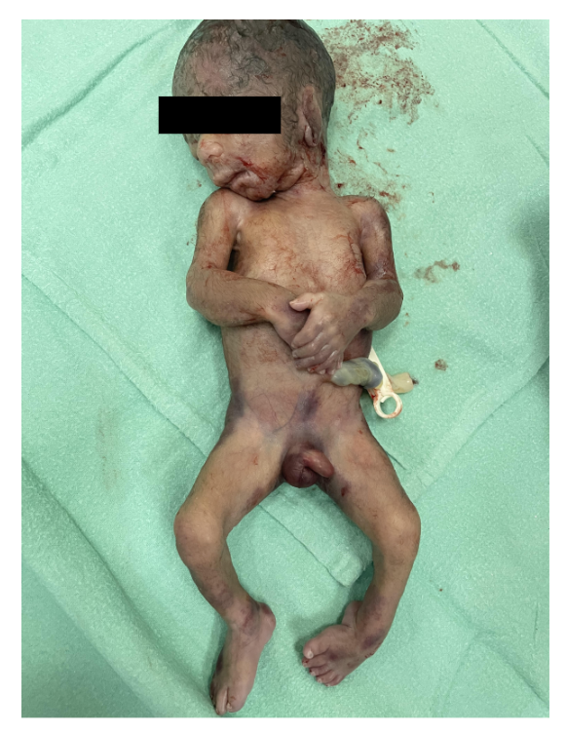
Fig 1: male fresh stillbirth

Discussion
Recognising infection in periviable PPROM remains critically challenging. Subclinical chorioamnionitis often lacks the classical clinical signs such as maternal fever, uterine tenderness, abnormal fetal heart patterns, or overt leukocytosis. Yet its presence is frequently confirmed histologically post-delivery, underscoring the risk of delayed identification. Guidance from the Society for Maternal-Fetal Medicine emphasizes the vital importance of individualized counseling due to risks of severe maternal morbidity and mortality, advocating for expectant management only when appropriate and with vigilant monitoring—including the cautious use of antibiotics for latency, weighed against gestational age thresholds [3, 11]. The Royal College of Obstetricians and Gynaecologists similarly warns of significant maternal and neonatal consequences following PPROM before 24 weeks, stressing that infection—even subclinical—can necessitate termination for medical reasons in the interest of maternal health [4].
Empirical data from retrospective cohorts highlight that over half of expectantly managed periviable PPROM cases show histological chorioamnionitis, and while maternal sepsis remains uncommon, the progression from subclinical to overt infection is unpredictable [5].
Moreover, compared to termination of pregnancy, expectant management carries substantially higher maternal morbidity—up to 60% versus 33%—emphasizing the importance of recognizing evolving infection even in the absence of overt signs [6]. The recent ACOG practice advisory echoes this concern, termination of pregnancy must be offered, while noting that elevated maternal risks with expectant management require it to be part of any informed discussion[7].
A retrospective study found that the best predictors of PPROM with chorioamnionitis were the combination of CRP and WBC count (AUC ~ 0.702; sensitivity ~ 60%, specificity ~ 76%). Including IL-6 and neutrophil count gave similar predictive value [8]. Another studies also showed prepepsin as a parameter in diagnosing chorioamnionitis in periviable leaking, however the striking fluctuations in presepsin level after the diagnosis of PPROM can be used to predict subclinical chorioamnionitis and determine the optimal timing of delivery before the clinical signs of chorioamnionitis are established. Presepsin level itself was neither diagnostic nor prognostic for neonatal sepsis. [9].
Streptococcus agalactiae (Group B Streptococcus) commonly colonizes the maternal genital tract which results in ascending infection that triggers response to weaken structural integrity and predisposes the fetal membranes to rupture, particularly in the periviable period. Such infection often begins as subclinical chorioamnionitis. In fact, colonization with S. agalactiae has been significantly correlated with histologic chorioamnionitis and premature rupture of membranes, alongside raised inflammatory markers like interleukin-8 and TNF-α in the umbilical cord blood [10].
Once infection becomes overt or maternal condition deteriorates, maternal safety unequivocally takes precedence over continuation. This case exemplifies the fragility of the periviable window and reinforces that proactive, evidence-based monitoring and shared decision-making is vital to optimize outcomes for both mother and fetus.

Conclusion & Recommendations
Periviable PPROM complicated by subclinical chorioamnionitis illustrates the difficult balance between prolonging pregnancy to improve neonatal survival and minimizing maternal–fetal risks of infection. The silent nature of subclinical infection highlights the need for vigilance and individualized care in such cases.
- Maintain high suspicion for subclinical infection in periviable PPROM, using close maternal–fetal monitoring and laboratory markers to guide timely intervention.
- Adopt individualized, multidisciplinary decision-making, incorporating maternal wishes, gestational age, and neonatal prognosis in counseling and management.
- Initiate appropriate antibiotic therapy early, including latency regimens and GBS prophylaxis, while monitoring for signs of progression to overt infection.

Conflict of interest
The authors declare that there are no conflicts of interest related to this manuscript.
Informed consent
Both written and verbal informed consent was obtained from the patient (Mdm P) for publication of this report and any accompanying images.
Data Availability
The data supporting the findings of this study are available within the article.

COMPETING INTERESTS DISCLAIMER:
Authors have declared that they have no known competing financial interests OR non-financial interests OR personal relationships that could have appeared to influence the work reported in this paper.

References
1/ Battarbee AN, Tita AT, Clark EA, et al. Society for Maternal-Fetal Medicine Consult Series #71: Management of previable and periviable preterm prelabor rupture of membranes. Am J Obstet Gynecol. 2024;231(2):B2-B14.
2/ Battarbee, A. N., Osmundson, S. S., McCarthy, A. M., Louis, J. M., Society for Maternal-Fetal Medicine (SMFM, & SMFM Publications Committee. (2024). Society for Maternal-Fetal Medicine Consult Series# 71: Management of previable and periviable preterm prelabor rupture of membranes. American Journal of Obstetrics and Gynecology, 231(4), B2-B15.
3/ Li Y, et al. Incidence and perinatal outcomes of preterm premature rupture of membranes: A multicenter study in China. BMC Pregnancy Childbirth. 2021;21:377. [PMCID: PMC8107868]
4/ Kilbride HW, et al. Survival and morbidity after premature rupture of membranes between 20 and 25 weeks’ gestation. Am J Obstet Gynecol. 1993;168(1 Pt 1):46–52.
5/ Care of Women with Preterm Prelabour Rupture of the Membranes Prior to 24+0 Weeks of Gestation. Scientific Impact Paper No. 76. London: RCOG; 2024.
6/Pylypjuk, C., & Majeau, L. (2021). Perinatal outcomes and influence of amniotic fluid volume following previable, preterm prelabor rupture of membranes (pPPROM): a historical cohort study. International journal of women's health, 627-637.
7/ Dayal, S., Jenkins, S. M., & Hong, P. L. (2024). Preterm and term prelabor rupture of membranes (PPROM and PROM). In StatPearls [Internet]. StatPearls Publishing.
8/ American College of Obstetricians and Gynecologists. Practice Advisory: Preterm Prelabor Rupture of Membranes. Washington, DC: ACOG; June 2025.
9/ Kong, X., Jiang, L., Zhang, B., Sun, L., & Liu, K. (2023). Predicting chorioamnionitis in patients with preterm premature rupture of membranes using inflammatory indexes: a retrospective study. Taiwanese Journal of Obstetrics and Gynecology, 62(1), 112-118.
10/ Çakar, E., Çakar, Ş. E., Taşan, H. A., Karçaaltıncaba, D., Şentürk, M. B., Koç, N., & Uluhan, R. (2016). Diagnostic and prognostic value of presepsin for subclinical chorioamnionitis in pregnancies between 23-28 week with preterm premature rupture of the membranes. Balkan medical journal, 33(6), 668-674.
11/ Patras, K. A., & Nizet, V. (2018). Group B streptococcal maternal colonization and neonatal disease: molecular mechanisms and preventative approaches. Frontiers in pediatrics, 6, 27.

