Original Research Article

Teachers’ Perceptions of Student Indiscipline in Elementary Schools: A Psycho-Developmental, Social, and Educational Analysis

.
ABSTRACT

Understanding how teachers conceptualise student indiscipline is central to the development of coherent and effective behaviour management practices, particularly within non-punitive educational contexts. This study examines elementary school teachers’ conceptions of student indiscipline through three analytical perspectives: psycho-developmental, social, and educational. Adopting a descriptive survey design, data were collected from 160 elementary school teachers using a self-constructed questionnaire comprising 47 statements. Frequency and percentage analyses reveal that teachers predominantly endorse all three perspectives at a partial level, indicating pluralistic but weakly integrated conceptual understandings of student indiscipline. Among the perspectives, social explanations emerge as the most strongly endorsed, while psycho-developmental and educational perspectives exhibit comparatively higher levels of uncertainty and weaker endorsement. These findings suggest that teachers’ fragmented conceptual orientations may contribute to inconsistent interpretations of student behaviour, particularly in educational settings that emphasise non-punitive discipline. The study underscores the need for strengthened conceptual integration in teacher education and professional development to support reflective and theoretically informed approaches to student behaviour management.

Keywords: student indiscipline; teacher perceptions; psycho-developmental perspective; social perspective; educational perspective; elementary education

1. Introduction
Education is widely understood as a process of shaping and modifying human behaviour in socially and morally desirable directions. Teaching, therefore, extends beyond academic instruction to include the cultivation of appropriate behaviour, self-regulation, and social responsibility among learners. Discipline plays a foundational role in creating a learning environment that is orderly, safe, and conducive to meaningful engagement. Research consistently indicates that effective learning is closely linked to students’ sense of security, emotional well-being, and positive teacher–student relationships (Hossain et al., 2025). Despite its importance, student indiscipline remains a persistent challenge in elementary schools, often disrupting classroom processes and undermining instructional effectiveness (Mwaruwa, 2024). Common manifestations of indiscipline include inattentiveness, disobedience, aggression, truancy, and classroom disruption (Ali et al., 2014). Such behaviours not only interfere with learning but also generate stress for teachers and negatively affect school climate.
Historically, corporal punishment has been used as a primary means of controlling student behaviour (Heekes, 2022). However, a substantial body of research has demonstrated that punitive disciplinary practices produce adverse psychological, emotional, and educational outcomes. Studies have shown that corporal punishment contributes to fear, anxiety, aggression, reduced motivation, poor academic performance, and strained teacher–student relationships (Rossouw, 2003; Ahmad et al., 2013). Consequently, many education systems across the world, including India, have formally prohibited corporal punishment through child-rights-based legislation such as the Right of Children to Free and Compulsory Education (RTE) Act, 2009. Although policy frameworks increasingly promote non-punitive and child-friendly approaches to discipline, the actual enactment of discipline in classrooms depends largely on teachers. Teachers serve as the key interpreters of student behaviour and disciplinary policy, and their responses are shaped by how they understand the causes and nature of indiscipline. Research indicates that teachers’ disciplinary decisions are often influenced by their personal beliefs, professional experiences, and sociocultural contexts rather than policy directives alone (Konty, 2011; Kimani et al., 2012).
Indiscipline may be conceptualized in multiple ways. Some teachers interpret it as a consequence of children’s psychological and developmental characteristics, such as emotional immaturity or unmet needs. Others attribute indiscipline to social and environmental factors, including family background, peer influence, and community conditions. A further perspective views indiscipline as arising from educational factors such as teaching methods, classroom management practices, curriculum design, and institutional climate (Roussow, 2003). These differing interpretations reflect distinct conceptual frameworks that guide teachers’ disciplinary practices.
Existing literature has extensively examined the effects of corporal punishment, teachers’ attitudes toward punishment, and alternative behaviour management strategies (Busienei, 2012; Shukla & Singh, 2013). However, comparatively limited attention has been given to teachers’ underlying conceptions of student indiscipline, particularly at the elementary level and within no-punishment policy contexts. Most studies focus on disciplinary actions and outcomes, rather than on the belief systems that precede and shape those actions. Understanding teachers’ conceptual orientations toward student indiscipline is critical, as ambiguous or fragmented conceptions may lead to inconsistent disciplinary practices and tensions between policy and classroom reality. In this context, examining teachers’ views through psycho-developmental, social, and educational perspectives offers a comprehensive lens for understanding how indiscipline is interpreted and managed in schools.
The present study seeks to address this gap by analysing elementary school teachers’ conceptions of student indiscipline across these three perspectives. By doing so, the study aims to contribute to a deeper understanding of the cognitive foundations of discipline practices in elementary education within a no-punishment framework.
2. Previous Studies and the Research Gap
The reviewed literature reveals a strong and consistent scholarly focus on student discipline, corporal punishment, and behaviour management practices, particularly examining teachers’ attitudes toward punitive discipline and its consequences. A substantial body of empirical research documents that corporal punishment—despite being legally banned in many contexts—continues to be practiced in schools, often justified by teachers as a means of maintaining order and control (Kimani et al., 2012; Wairuri, 2014; Yousif & Mohammed, 2015). Numerous studies report that punitive disciplinary practices are associated with adverse outcomes for students, including fear, anxiety, aggression, reduced motivation, poor academic performance, absenteeism, and weakened teacher–student relationships (Rossouw, 2003; Ahmad et al., 2013; Dlamini et al., 2017; Shukla & Singh, 2013). Parallel research has also examined alternative approaches to discipline, such as counselling, guidance, positive reinforcement, and behaviour modification strategies, suggesting that these methods are more conducive to creating supportive learning environments (Busienei, 2012; Mumthas et al., 2014). However, several studies highlight that teachers often feel inadequately trained to implement non-punitive strategies effectively, which contributes to continued reliance on punitive measures (Cheruvalath & Tripathy, 2015; Kimani et al., 2012).
Despite this extensive literature, existing research remains largely practice-centred and outcome-driven, focusing primarily on the use, effectiveness, or consequences of disciplinary strategies rather than on the conceptual foundations of teachers’ disciplinary decisions. While some studies implicitly acknowledge that teachers’ beliefs influence discipline practices, few have systematically examined how teachers conceptualise student indiscipline itself. Indiscipline has been variously attributed to learner misconduct, social and familial influences, or institutional and pedagogical factors (Ali et al., 2014; Rossouw, 2003), yet these perspectives are rarely analysed as distinct or coexisting conceptual frameworks guiding teachers’ thinking. This gap is particularly evident at the elementary school level, where student behaviour is closely linked to developmental processes and socialisation, and within no-punishment policy contexts, where teachers must reconcile policy expectations with classroom realities. The absence of research explicitly examining teachers’ conceptual orientations—whether psycho-developmental, social, or educational—limits understanding of why disciplinary practices often remain inconsistent even after policy reforms. Addressing this gap is essential for strengthening behaviour management reforms and teacher education. The present study responds to this gap by systematically analysing elementary school teachers’ conceptions of student indiscipline across psycho-developmental, social, and educational perspectives.

Research Questions
This study is guided by the following research questions:
- What are elementary school teachers’ conceptions of student indiscipline?
- How do teachers interpret student indiscipline from psycho-developmental, social, and educational perspectives?
- Which conceptual perspective is most strongly endorsed by elementary school teachers in understanding student indiscipline?

Objectives of the Study
In alignment with the above research questions, the objectives of the study are to:
- Examine elementary school teachers’ conceptions of student indiscipline.
- Analyse teachers’ understanding of student indiscipline through psycho-developmental, social, and educational perspectives.
- Identify the dominant conceptual perspective shaping teachers’ views of student indiscipline in elementary schools.

3. Methodology

3.1 Research Design
The study adopted a descriptive survey research design to examine elementary school teachers’ conceptions of student indiscipline. This design was considered appropriate as the study sought to describe and interpret teachers’ perceptions as they exist, without manipulating variables or establishing causal relationships. The survey approach enabled the collection of standardized data from a relatively large sample of teachers, facilitating the identification of prevailing conceptual trends.

3.2 Population and Sample
The population of the study comprised elementary school teachers working in government primary schools in western Odisha, India. The accessible population included teachers from two districts—Boudh and Sonepur. From these districts, four administrative blocks (Harbhanga, Kantamal, Birmaharajpur, and Ulunda) were selected.
A total of 160 elementary school teachers constituted the sample of the study. Purposive sampling was employed to ensure that participants had direct classroom teaching experience and were actively engaged in managing student behaviour within a no-punishment policy context.

3.3 Tool for Data Collection
Data were collected using a self-constructed questionnaire developed by the researcher. For the purpose of this article, only the section of the questionnaire related to teachers’ conceptions of student indiscipline was used.
This section consisted of 47 statements representing three conceptual perspectives:
- Psycho-developmental perspective
- Social perspective
- Educational perspective
Teachers responded to each statement using a five-point response scale: fully agree, partially agree, not sure, partially disagree, and fully disagree. The instrument was preceded by an introductory note explaining the purpose of the study and assuring confidentiality.

3.4 Validity and Reliability of the Instrument
Content validity of the questionnaire was established through an extensive review of relevant literature on student indiscipline, classroom behaviour, and teacher perceptions. The items were developed to represent three theoretically grounded perspectives of student indiscipline—psycho-developmental, social, and educational. To further ensure content relevance and clarity, the draft instrument was reviewed by subject experts in education and teacher education. Based on their suggestions, minor modifications were made to improve item wording and eliminate ambiguity, thereby ensuring adequate coverage of the construct under study.
Reliability of the instrument was determined using the test–retest method. The questionnaire was administered to a group of elementary school teachers (n = 20) during pilot testing and re-administered to the same group after a suitable time interval. The test–retest reliability coefficient was found to be 0.76, indicating an acceptable level of stability and consistency of the instrument over time. This value suggests that the questionnaire yields reasonably reliable measurements of teachers’ conceptions of student indiscipline.

3.5 Procedure of Data Collection
Data were collected over a period of approximately one month using multiple modes:
- personal visits to schools,
- direct interaction with teachers,
- digital distribution through email and messaging applications, and
Participation was voluntary, and respondents completed the questionnaire either in the presence of the researcher or independently.

3.6 Data Analysis
The collected data were analysed using descriptive statistical techniques, primarily frequency and percentage analysis. These techniques were used to determine the extent to which teachers favoured, partially favoured, or were unclear about each conceptual perspective of student indiscipline.

3.7 Ethical Considerations
Ethical principles were strictly adhered to during the study. Teachers were informed about the purpose of the research, participation was voluntary, and confidentiality of responses was assured. Identifying information such as names of teachers and schools was kept optional to protect participants’ privacy.

4. Results
This section presents the results related to elementary school teachers’ conceptions of student indiscipline behaviour. Teachers’ responses to 47 statements were analysed under three conceptual perspectives—psycho-developmental, social, and educational—using frequency and percentage analysis. The results are presented perspective-wise and followed by a comparative synthesis to highlight dominant trends.

4.1 Teachers’ Psycho-Developmental Perspective of Student indiscipline
Table and figure 1 presents teachers’ responses regarding the psycho-developmental perspective of student indiscipline. Out of 160 teachers, 22 teachers (13.8%) fully favoured this perspective, while a majority, 90 teachers (56.3%), partially favoured it. At the same time, 29 teachers (18.1%) reported that they were not clear, and 19 teachers (11.9%) partially disfavoured this perspective.
Table: 1 Psycho-development perspective of indiscipline
Psycho-Developmental Perspective |  | Frequency | Percent | Valid Percent | Cumulative Percent
 | Fully Favours this Perspective | 22 | 13.8 | 13.8 | 13.8
 | Partially Favours this View | 90 | 56.3 | 56.3 | 70.0
 | Not Clear of this Perspective | 29 | 18.1 | 18.1 | 88.1
 | Partially Disfavours this View | 19 | 11.9 | 11.9 | 100.0
 | Total | 160 | 100.0 | 100.0

The predominance of partial favour indicates that teachers acknowledge the role of psychological and developmental factors—such as emotional maturity, behavioural adjustment, and developmental stages—in shaping student indiscipline. However, the relatively low proportion of full endorsement, combined with noticeable uncertainty and partial disfavour, suggests that this understanding is tentative rather than theoretically grounded. Teachers appear to recognise developmental explanations at an intuitive level, but these explanations are not firmly internalised as a coherent conceptual framework guiding their interpretation of student behaviour.
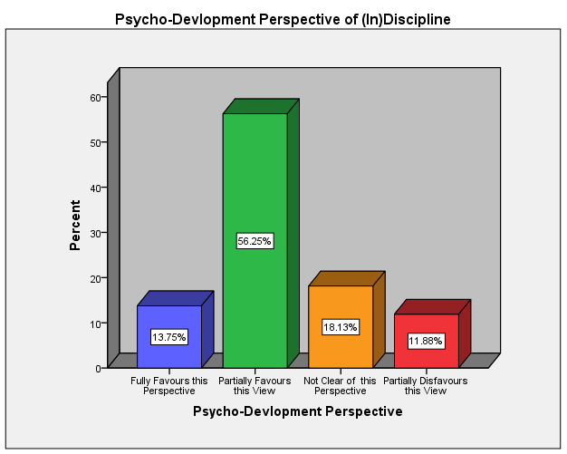
Figure:.1 psycho development perspective of indiscipline

4.2 Teachers’ Social Perspective of Student Indiscipline
Teachers’ responses related to the social perspective of indiscipline are presented in Table and Figure 2. The results show that 52 teachers (32.5%) fully favoured the social perspective, while 74 teachers (46.3%) partially favoured it. Additionally, 34 teachers (21.3%) indicated that they were not clear about this perspective. Notably, no teacher reported disfavouring the social perspective.
Table -2 social perspective of indiscipline
Social Perspective of indiscipline |  | Frequency | Percent | Valid Percent | Cumulative Percent
 | Fully Favours this Perspective | 52 | 32.5 | 32.5 | 32.5
 | Partially Favours this View | 74 | 46.3 | 46.3 | 78.8
 | Not Clear of this Perspective | 34 | 21.3 | 21.3 | 100.0
 | Total | 160 | 100.0 | 100.0

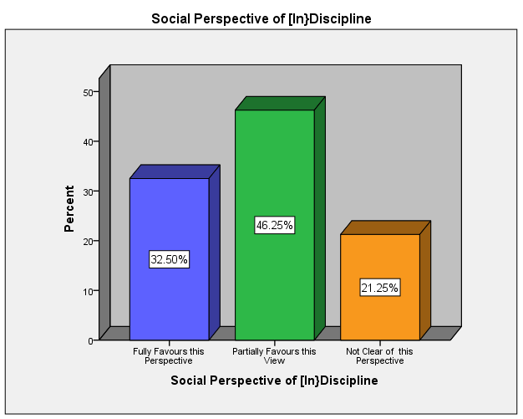
Figure.2 social perspective of indiscipline
These findings clearly indicate that the social perspective is the most strongly endorsed among the three perspectives. Teachers appear more confident in attributing student indiscipline to external social factors such as family background, peer influence, socio-economic conditions, and community environment. The relatively high level of full endorsement suggests that teachers’ interpretations of indiscipline are deeply shaped by their everyday engagement with students’ social realities. At the same time, the absence of disfavouring responses points to broad acceptance of social explanations as legitimate and convincing.

4.3 Teachers’ Educational Perspective of Student Indiscipline
Table and Figure 3 presents the distribution of teachers’ responses regarding the educational perspective of student indiscipline. Among the respondents, 26 teachers (16.3%) fully favoured this perspective, while 83 teachers (51.9%) partially favoured it. A considerable proportion, 38 teachers (23.8%), was not clear, and 13 teachers (8.1%) partially disfavoured this view.
Table 3 Educational perspective of indiscipline
Educational Perspective of inDiscipline |  | Frequency | Percent | Valid Percent | Cumulative Percent
 | Fully Favours this Perspective | 26 | 16.3 | 16.3 | 16.3
 | Partially Favours this View | 83 | 51.9 | 51.9 | 68.1
 | Not Clear of this Perspective | 38 | 23.8 | 23.8 | 91.9
 | Partially Disfavours this View | 13 | 8.1 | 8.1 | 100.0
 | Total | 160 | 100.0 | 100.0
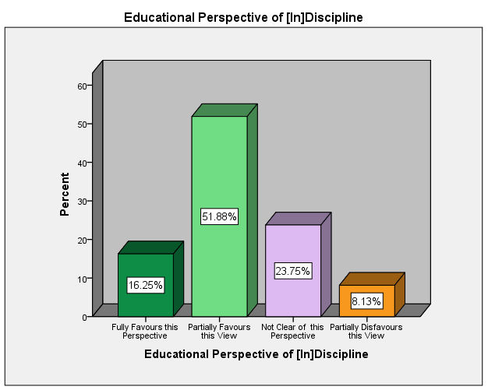

Figure 3 educational perspective of indiscipline
These results suggest that teachers acknowledge the influence of school-related and pedagogical factors—such as teaching methods, classroom management practices, curriculum demands, and institutional climate—on student behaviour. However, similar to the psycho-developmental perspective, this acknowledgement is largely moderate and uncertain. The relatively high level of uncertainty and partial disfavour indicates hesitation in fully accepting educational and instructional practices as significant contributors to student indiscipline.

4.4 Teachers’ Perceptions of Student Indiscipline across Perspectives

The synthesis of teachers’ responses across psycho-developmental, social, and educational perspectives reveals a pattern of pluralistic but weakly integrated conceptions of student indiscipline. Across all three perspectives, the dominant response category is partial favour, indicating that teachers acknowledge multiple explanatory frameworks but do not demonstrate strong, unequivocal commitment to any single perspective. This dominance of partial endorsement—psycho-developmental (56.3%), social (46.3%), and educational (51.9%)—suggests that teachers’ understandings of indiscipline are shaped primarily by situational experience and pragmatic judgment, rather than by clearly articulated theoretical frameworks.
Table 4 Teachers’ Perceptions of Student Indiscipline across Perspectives (N = 160)

Conceptual Perspective | Fully Favour n (%) | Partially Favour  n (%) | Not Clear  n (%) | Partially Disfavour  n (%) | Dominant Response Pattern
Psycho-developmental | 22 (13.8) | 90 (56.3) | 29 (18.1) | 19 (11.9) | Partial favour
Social | 52 (32.5) | 74 (46.3) | 34 (21.3) | – | Partial + full favour
Educational | 26 (16.3) | 83 (51.9) | 38 (23.8) | 13 (8.1) | Partial favour

Among the three perspectives, the social perspective emerges as the most strongly endorsed, with a substantial proportion of teachers fully favouring this view (32.5%) and nearly half partially favouring it (46.3%). The absence of any disfavouring responses further reinforces the strength of this orientation. This indicates that teachers predominantly interpret student indiscipline as a consequence of external social factors, such as family background, peer influence, and community conditions. The prominence of this perspective reflects teachers’ close engagement with students’ socio-cultural realities; however, it also suggests a tendency to externalise the causes of indiscipline, potentially reducing attention to classroom-level or instructional influences.
In contrast, the psycho-developmental perspective, while acknowledged by a majority of teachers, is characterised by weaker endorsement and greater uncertainty. Although over half of the teachers partially favour this perspective (56.3%), only a small proportion fully favour it (13.8%), while a notable percentage remain unclear (18.1%) or partially disfavour it (11.9%). This distribution indicates that teachers recognise developmental and psychological factors—such as emotional maturity and behavioural adjustment—but lack strong conceptual clarity or confidence in applying developmental theory to interpret student indiscipline. Developmental explanations thus appear to function more as implicit assumptions than as consciously grounded professional knowledge.
A similar pattern is evident in the educational perspective. While a majority of teachers partially favour this view (51.9%), relatively fewer fully endorse it (16.3%), and a considerable proportion remain uncertain (23.8%) or partially disfavours it (8.1%). These findings suggest ambivalence toward recognising the role of pedagogical practices, classroom management, curriculum demands, and institutional climate in shaping student behaviour. The comparatively high level of uncertainty points to limited pedagogical self-reflexivity, where teachers hesitate to fully attribute indiscipline to educational and instructional factors within the school.
Taken together, the synthesis demonstrates that teachers’ conceptions of student indiscipline are fragmented rather than integrated, with the social perspective dominating over psycho-developmental and educational explanations. The coexistence of high partial endorsement and notable uncertainty across perspectives highlights a lack of conceptual consolidation. This fragmented understanding may contribute to inconsistent and situational disciplinary responses, particularly in a no-punishment policy context that requires theoretically informed and reflective behaviour management. The findings underscore the need for teacher education and professional development that explicitly integrates psycho-developmental knowledge, social understanding, and pedagogical responsibility into a coherent framework for interpreting and managing student behaviour.

5. Discussion
The present study examined elementary school teachers’ conceptions of student indiscipline through psycho-developmental, social, and educational perspectives. The findings reveal that teachers’ understandings of indiscipline are pluralistic yet weakly integrated, with partial endorsement dominating across all perspectives. This pattern indicates that while teachers recognise multiple explanations for student misbehaviour, their conceptual orientations lack coherence and theoretical consolidation. Such findings resonate with earlier research suggesting that teachers’ disciplinary thinking is often shaped more by practical experience than by explicit theoretical grounding (McMasters, 2002; Konti, 2011). The social perspective emerged as the most strongly endorsed framework, with a substantial proportion of teachers fully favouring (32.5%) and partially favouring (46.3%) this view. This dominance aligns with previous studies that report teachers’ tendency to attribute student indiscipline to family background, peer influence, and broader socio-cultural conditions
(Kimani et al., 2012; Ali et al., 2014). Teachers’ strong reliance on social explanations reflects their daily encounters with learners’ lived realities and socio-economic challenges. However, as noted by Rossouw (2003), an overemphasis on social causation may inadvertently lead to the externalisation of responsibility, limiting critical reflection on classroom practices and instructional environments that also shape student behaviour.
In contrast, the psycho-developmental perspective, though acknowledged by a majority of teachers, received comparatively weaker endorsement, with most teachers only partially favouring this explanation (56.3%) and a relatively small proportion fully endorsing it (13.8%). The presence of uncertainty (18.1%) and partial disfavour (11.9%) suggests limited conceptual clarity regarding child development and psychological processes. This finding is consistent with earlier research indicating that teachers often lack sufficient training in developmental psychology, resulting in intuitive rather than theoretically informed interpretations of student behaviour (Rossouw, 2003; Ahmad et al., 2013). Without a strong psycho-developmental grounding, teachers may struggle to interpret misbehaviour as developmentally appropriate or contextually mediated, particularly at the elementary level. A similar pattern is evident in the educational perspective, where partial favour again dominates (51.9%), while full endorsement remains limited (16.3%) and uncertainty remains high (23.8%). These findings suggest ambivalence toward recognising the role of pedagogical practices, classroom management, curriculum pressure, and institutional climate in contributing to student indiscipline. Prior studies have similarly reported teachers’ reluctance to attribute indiscipline to instructional or organisational factors, often due to structural constraints such as large class sizes and workload pressures (Cheruvalath & Tripathy, 2015; Wairuri, 2014). This hesitation may reduce pedagogical self-reflexivity and hinder the adoption of proactive, learner-centred behaviour management strategies.
Taken together, the findings indicate that teachers’ conceptions of student indiscipline are fragmented rather than integrated, with social explanations dominating over developmental and educational ones. This fragmentation may help explain why disciplinary practices often appear inconsistent, particularly in contexts where corporal punishment has been formally abolished. As noted by Busienei (2012) and Mumthas et al., (2014), the absence of a coherent conceptual framework can undermine the effectiveness of alternative discipline approaches, even when teachers express support for non-punitive methods.
In a broader sense, the findings underscore the need for teacher education and professional development that explicitly integrates psycho-developmental knowledge, socio-cultural awareness, and pedagogical responsibility into a coherent framework for understanding student behaviour. Strengthening teachers’ conceptual clarity may not only enhance consistency in disciplinary responses but also support the effective implementation of child-friendly and non-punitive discipline policies.

6. Implications
The findings of this study have important implications for teacher education and professional development. The dominance of partial endorsement across psycho-developmental, social, and educational perspectives indicates that teachers possess intuitive but weakly integrated understandings of student indiscipline. Teacher preparation programmes should therefore move beyond procedural training in behaviour management to emphasise conceptual integration, particularly in child development, educational psychology, and reflective pedagogy. Structured engagement with developmental theory and classroom-based reflection can help teachers interpret student behaviour more coherently, reducing reliance on situational or externally oriented explanations.
The study also carries implications for school practice and policy implementation, especially in contexts promoting non-punitive discipline. The strong orientation toward social explanations suggests a tendency to externalise responsibility for indiscipline, which may limit pedagogical self-reflection. School-level initiatives should encourage collaborative dialogue among teachers to develop shared, theory-informed frameworks for understanding behaviour. At the policy level, disciplinary reforms must be accompanied by sustained professional support that strengthens teachers’ conceptual clarity; without this, non-punitive policies risk inconsistent implementation and limited impact on classroom practice.

7. Conclusion
This study examined elementary school teachers’ conceptions of student indiscipline through psycho-developmental, social, and educational perspectives. The findings indicate that teachers hold pluralistic yet weakly integrated understandings of student indiscipline, with partial endorsement dominating across all perspectives. While teachers acknowledge multiple explanatory dimensions, their conceptual orientations lack coherence and theoretical consolidation.
The social perspective emerged as the most strongly endorsed, reflecting teachers’ tendency to interpret indiscipline primarily in relation to family, peer, and community influences. In contrast, psycho-developmental and educational perspectives received comparatively weaker endorsement and higher levels of uncertainty, suggesting limited conceptual clarity regarding child development and pedagogical responsibility. This imbalance points to a reliance on experiential and externally oriented interpretations of behaviour rather than on theoretically informed frameworks.
Overall, the study highlights that fragmented conceptions of student indiscipline may contribute to inconsistent disciplinary interpretations, particularly in non-punitive educational contexts. Strengthening teachers’ conceptual integration across developmental, social, and educational dimensions is therefore essential for fostering coherent, reflective, and effective approaches to student behaviour management.

COMPETING INTERESTS DISCLAIMER:
Authors have declared that they have no known competing financial interests OR non-financial interests OR personal relationships that could have appeared to influence the work reported in this paper.

References
- Ahmad, I., Said, H., & Khan, F. (2013). Effect of corporal punishment on student motivation and classroom learning. Review of European Studies, 5(4), 126–135.
- Ali, A. A., Dada, I. T., Isiaka, G. A., & Salman, S. A. (2014). Types, causes and management of indiscipline acts among secondary school students in Shomolu Local Government Area of Lagos State. Journal of Studies in Social Sciences, 8(2), 254–272.
- Busienei, J. A. (2012). Alternative methods to corporal punishment and their efficacy. Journal of Emerging Trends in Educational Research and Policy Studies, 3(2), 155–161.
- Cheruvalath, R., & Tripathy, M. (2015). Secondary school teachers’ perception of corporal punishment: A case study in India. The Clearing House: A Journal of Educational Strategies, Issues and Ideas, 88(4), 127–132.
- Heekes, S. L., Kruger, C. B., Lester, S. N., & Ward, C. L. (2022). A systematic review of corporal punishment in schools: Global prevalence and correlates. Trauma, Violence, & Abuse, 23(1), 52-72.
- Hossain, A., Ansari, S. H., Sarkar, R., & Bhattacharjee, S. (2025). The Role Of Teacher-Student Relationships In Promoting Emotional Well-Being In Primary Schools In West Bengal. IOSR J. Humanit. Soc. Sci, 30(1), 50-56.
- Kimani, E. N., Kara, A. M., & Ogetange, T. B. (2012). Teachers’ and pupils’ views on persistent use of corporal punishment in managing discipline in primary schools in Starehe Division, Kenya. International Journal of Humanities and Social Science, 2(2), 44–52.
- Konti, F. (2011). Teachers’ and students’ perceptions towards teachers’ classroom management applications in primary schools. Procedia – Social and Behavioral Sciences, 15, 4093–4097.
- McMasters, C. (2002). Student and teacher perceptions of discipline at the middle school level (Unpublished master’s thesis). University of Wisconsin–Stout.
- Mumthas, N. S., Munavir, J., & Gafoor, K. A. (2014). Student and teacher perception of disciplinary practices: Types, reasons, consequences and alternatives. Guru Journal of Behavioral and Social Sciences, 2(4), 553–561.
- Mwaruwa, N. N., Mwawasi, B. M., & Mwenda, P. (2024). Challenges Faced By Principals In The Management Of Students’ Indiscipline In Public Secondary Schools In Malindi Sub County. Journal of African Interdisciplinary Studies, 8(8), 21-35.
- Rossouw, J. P. (2003). Learner discipline in South African public schools: A qualitative study. Koers, 68(4), 413–435.
- Shukla, A., & Singh, R. (2013). Implications of corporal punishment on primary school children. IOSR Journal of Humanities and Social Science, 15(6), 1–7.
- Wairuri, C. W. (2014). Teachers’ attitudes towards the withdrawal of corporal punishment as a disciplinary measure from public secondary schools in Kikuyu Division (Unpublished master’s thesis). University of Nairobi.
- Yousif, I. H., & Mohammed, I. D. (2015). Teachers’ views towards corporal punishment in governmental basic schools in Khartoum State, Mamoura. Scholarly Journal of Education, 4(1), 13–19.

