The Impact of Urban and Rural Contexts on Gender-Based Violence Policy Effectiveness: An Institutional Analysis

Abstract
This study examines the institutional determinants influencing the implementation of gender-based violence (GBV) policies in Oromia, Ethiopia, focusing on the moderating role of urban-rural contexts. While national and regional GBV policies are well-established, their effectiveness at the community level is inconsistent, with rural areas facing considerable challenges. These challenges include weak institutional capacity, cultural resistance, limited access to services, and reliance on informal dispute resolution mechanisms. The study combines both qualitative and quantitative methods, including a Likert scale questionnaire and in-depth interviews with a diverse group of stakeholders, such as community elders, rural women, health workers, police officers, and local government officials. The quantitative data were analyzed using Structural Equation Modeling (SEM) and Qualitative data analysis by NVivo 14 software. The findings reveal notable differences between urban and rural areas: urban regions benefit from stronger institutional support, better public awareness, and greater access to services, while rural areas struggle with limited resources and entrenched socio-cultural norms that hinder GBV policy enforcement. The study highlights the need for targeted, context-sensitive interventions to raise community awareness, strengthen institutional capacity, and improve coordination, particularly in rural areas. These findings offer valuable insights for policymakers, NGOs, and civil society organizations aiming to improve GBV policy outcomes in Ethiopia, with recommendations for developing an inclusive, culturally sensitive support system for survivors across both urban and rural contexts.
Keywords: Gender-Based Violence; Institutional Analysis; Urban and Rural; Policy Effectiveness

- Introduction
Gender-based violence (GBV) is a pervasive issue that remains one of the most significant violations of human rights, impacting women and girls across all societies. As defined by the World Health Organization (WHO, 2019), GBV encompasses harmful acts directed at individuals due to their gender, including physical, sexual, psychological, and economic abuse. This widespread issue transcends geographical, economic, and cultural boundaries, obstructing gender equality, social development, and the overall well-being of communities (Garcia-Moreno et al., 2015). The disproportionate effect on women and girls underscores institutional disparities, which hinder social progress and equitable policy implementation.
In Ethiopia, entrenched patriarchal norms contribute to the widespread experience of GBV among women and girls, affecting their physical, mental, and social well-being (USAID, 2016). GBV manifests in various forms, including physical, sexual, and emotional abuse, deeply rooted in gender role expectations and socio-cultural norms (Raftery, 2022). These patterns of violence are not confined by socioeconomic status, education, or culture, affecting women in both rural and urban areas. However, the urban-rural divide in Ethiopia creates significant differences in the impact and effectiveness of GBV policy implementation, with rural areas often facing greater barriers in combating violence. The United Nations (2010) defines GBV as acts of violence that cause harm to individuals based on their gender, including threats, coercion, and the deprivation of liberty. GBV can be categorized into intimate partner violence (IPV) and non-IPV, with both urban and rural populations facing distinct challenges in addressing these forms of violence. Globally, GBV is recognized as a serious human rights violation, with the World Food Program (Andrews, Smith, & Morena, 2019) noting its detrimental impact, especially on women and children. In Ethiopia, national statistics reveal that a significant percentage of women have faced physical, emotional, or sexual abuse, with a marked difference between urban and rural areas in terms of access to resources and support (CSA, 2021). The urban-rural divide further complicates the enforcement of GBV policies. Urban areas generally have better access to legal services, health infrastructure, and survivor support mechanisms. In contrast, rural areas face persistent challenges such as poverty, lower education levels, and limited access to health services, and cultural stigmas that hinder survivors from seeking help (Govender, 2023). The limited presence of law enforcement in rural regions also contributes to a high level of underreporting and a lack of support for survivors, particularly in marginalized areas where traditional practices often override formal legal proceedings (Republic of South Africa, 2021). Despite the increasing recognition of GBV as a pressing issue, the differences in institutional capacity and socio-cultural attitudes between urban and rural areas significantly influence how GBV policies are implemented.
This study examines how institutional factors affect the implementation of Gender-Based Violence (GBV) policies in Oromia, Ethiopia, focusing on the differences between rural and urban areas. It highlights the complexities hindering policy execution, particularly in central Ethiopia, and explores the role of local institutional capacity in shaping policy outcomes. By analyzing how institutional strengths and weaknesses impact policy effectiveness in urban versus rural contexts, the study offers insights that can help policymakers design targeted and the findings also provide NGOs and civil society actors with actionable strategies for better collaboration with local communities and institutions.
Gender-based violence (GBV) remains one of the most pervasive human rights violations globally, affecting women and girls across all societies. Despite international commitments such as the Beijing Declaration and Platform for Action (1995), GBV continues to undermine women’s fundamental rights, particularly in developing countries like Ethiopia (UN Women, 2015). In Ethiopia, more than one in three women experience GBV during their lifetime, with deeply rooted socio-cultural norms often normalizing or legitimizing violence (Biftu et al., 2019). Although the Ethiopian government has adopted legal and policy frameworks including constitutional provisions, international conventions, and national action plans the effective implementation of these policies remains weak (Gadisa et al., 2022). This weakness is strongly shaped by contextual differences between urban and rural settings. In rural areas, entrenched patriarchal norms, customary institutions, limited education, poverty, and weak access to justice and support services significantly hinder GBV policy implementation (Gebregziabher, 2018). Informal institutions often prioritize reconciliation over survivor protection, leading to underreporting and impunity (UNICEF, 2017). Institutional capacity in rural areas is further constrained by limited infrastructure, inadequate training of police and health workers, and poor inter-sectoral coordination (Alemayehu et al., 2020). As a result, survivors face substantial barriers in accessing justice, healthcare, and social support (Gebeyehu et al., 2021).

In contrast, urban areas tend to have relatively better institutional presence, improved reporting mechanisms, and greater access to services. However, even in urban contexts, GBV persists due to institutional gaps, inconsistent enforcement, and socio-cultural attitudes that continue to marginalize survivors (Yemaneh, 2004). These differences highlight how urban–rural contexts moderate the effects of socio-cultural norms and institutional capacity on policy outcomes, influencing whether GBV policies translate into meaningful protection at the community level.
Therefore, analyzing GBV policy implementation through an urban–rural lens is essential. Understanding how socio-cultural beliefs interact with institutional strengths and weaknesses across different contexts provides critical insights into why national GBV policies yield uneven results (Kidanu, 2018). This study addresses this gap by examining how urban and rural settings shape the effectiveness of GBV policy implementation, thereby offering evidence-based guidance for context-sensitive, equitable, and sustainable interventions in Oromia, Ethiopia. The primary goal was to analyze how the urban–rural context moderates the influence of socio-cultural and institutional factors on GBV policy implementation.
- Literatures
  - Review of Theoretical Perspectives
This study integrates several theoretical perspectives to explain how institutional factors shape gender-based violence (GBV) policy implementation in Ethiopia, while recognizing the moderating influence of the urban–rural context.
Feminist Institutionalism (FI) serves as the overarching theoretical lens linking socio-cultural and institutional determinants to GBV policy outcomes. FI conceptualizes institutions as inherently gendered, shaped by both formal rules and informal patriarchal norms (Waylen, 2007; Mackay et al., 2010). In the Ethiopian context, socio-cultural factors such as patriarchal gender roles, early marriage, and bride abduction directly influence institutional behavior by shaping how laws are interpreted, enforced, or resisted. Thus, FI explains the direct effect of socio-cultural factors (IV) on institutional factors (IV) and, ultimately, on GBV policy implementation (DV).
Implementation Theory, particularly the framework developed by Van Meter and Van Horn (1975), explains how institutional factors (IV) including policy clarity, resource availability, inter-agency coordination, and implementers’ commitment directly affect GBV policy implementation (DV). In contexts where institutions lack capacity or where implementers’ attitudes align with prevailing patriarchal norms, policy effectiveness, coverage, and accessibility are significantly reduced (Matland, 1995; Hill & Hupe, 2009).
The urban–rural context functions as a moderating variable (MOV) that conditions the strength and direction of these relationships. Urban areas, characterized by stronger institutional capacity, higher literacy, and greater media exposure, are more likely to support awareness diffusion and effective implementation. In contrast, rural areas face stronger socio-cultural resistance, weaker institutions, and limited access to services, reducing policy effectiveness (Deyessa et al., 2010; Moser, 2012). This contextual variation explains why the impact of socio-cultural and institutional factors on GBV policy implementation differs across settings.
  - Empirical Literature
Empirical studies focusing on the implementation of gender-based violence (GBV) policies emphasize the critical role that institutional factors play in the effectiveness of such policies. Institutional capacity has been consistently identified as a key determinant of successful GBV policy implementation. Comparative studies show that although many countries have ratified comprehensive legal frameworks such as the Istanbul Convention and Maputo Protocol, enforcement often falls short due to weak institutional structures, limited resources, and poor coordination across sectors like justice, health, and social services (Maposa, 2025). For example, law enforcement agencies frequently lack adequate training in handling GBV cases, and justice systems struggle to provide survivor-centered responses, undermining the overall effectiveness of GBV policies.
In African contexts, institutional barriers to GBV policy implementation are particularly evident in conflict-affected and resource-limited settings. A scoping review of sexual and gender-based violence (SGBV) in conflict zones across Africa reports that structural weaknesses—including limited institutional infrastructure, fragmented coordination, and disrupted service delivery—hinder comprehensive GBV prevention and response efforts (Raftery et al., 2022b). These institutional constraints prevent the translation of policy intentions into practice, especially in unstable environments (Woldearegay et al., 2025).
In Ethiopia, institutional limitations have been recognized as key obstacles to effective GBV prevention and response. Qualitative research in northwestern Ethiopia identified institutional barriers such as budgetary constraints, poor planning, lack of political will, weak multi-sector collaboration, and competing priorities among key stakeholders (Semahegn et al., 2025c). These challenges have significantly hindered the operationalization of existing GBV policies and programs, leading to poor adherence to planned activities and limited integration of services at the local level. Comparative studies in Europe and Latin America show that urban-rural disparities influence reporting behaviors and institutional responses. Rural survivors face greater barriers related to transportation, confidentiality, and social visibility, leading to lower reporting rates despite comparable or higher prevalence of violence (Cefalo et al., 2025; Roza & Martín, 2021). These studies underline that the effectiveness of GBV policies is not uniform across regions but is shaped by contextual factors such as service availability, population density, and prevailing social norms.
In sub-Saharan Africa, the urban-rural divide is more pronounced due to structural inequalities and uneven development. Research indicates that rural communities often rely on informal dispute-resolution mechanisms, including elders and customary courts, which may undermine formal GBV policy implementation by prioritizing reconciliation over survivor protection. In countries like Kenya, Uganda, South Africa, and Mozambique, rural women are less likely to report violence to formal authorities and more likely to seek help from family or community leaders, thus limiting the reach of national GBV laws (Aboagye et al., 2023; Akamike et al., 2019b; Nabaggala et al., 2021b). Systematic reviews of GBV interventions in Africa further emphasize that weak institutional presence in rural areas such as understaffed police posts and limited health facilities restricts the effectiveness of GBV prevention and response policies (Keith et al., 2023).
In Ethiopia, urban-rural disparities are widely documented in relation to GBV prevalence, reporting, and policy implementation (Yirdaw & Yimer, 2025d). While GBV is prevalent across both urban and rural areas, rural women face greater barriers to accessing formal services due to distance, limited awareness, and stronger socio-cultural norms that normalize violence. Empirical research shows that rural communities are more likely to treat GBV as a private family matter, relying on customary reconciliation practices that divert cases away from the formal justice system (Amare et al., 2024b). In contrast, urban areas benefit from better access to institutional resources, including police stations, courts, health facilities, and NGO-supported GBV services, which enhance policy visibility and implementation, albeit with challenges related to service quality and capacity (Angaw et al., 2021). At the regional level, particularly in Oromia, urban-rural disparities in GBV policy implementation are even more pronounced. Oromia's large geographic size and predominantly rural population present significant challenges. Studies conducted in urban centers such as Addis Ababa-adjacent towns and regional capitals report higher levels of awareness and service utilization, while rural woredas experience limited institutional reach, shortages of trained personnel, and reliance on informal justice systems (Mulugeta, 2025). Qualitative research in Oromia highlights that cultural practices, gendered power relations, and community pressure to preserve family unity are more influential in rural areas, reducing survivors’ willingness to engage with formal GBV response mechanisms (Assefa et al., 2021).
Evidence from humanitarian and displacement contexts within Oromia further reveals that rural and remote communities face compounded vulnerabilities, where disrupted institutions and weak infrastructure exacerbate barriers to GBV policy implementation (Simegn et al., 2025). While NGOs and government partners have expanded community-based interventions, empirical assessments of how urban-rural differences affect measurable policy outcomes, such as reporting rates, referral completion, and legal enforcement, remain limited. While the existing empirical literature is often descriptive, it underscores low levels of awareness of GBV laws, limited access to services, and the strong influence of traditional authorities in rural kebeles. However, few studies systematically compare urban and rural contexts within the same administrative area or empirically test how spatial location moderates the relationship between socio-cultural norms, institutional capacity, and GBV policy implementation.

  - Literature Gaps
Despite a growing body of literature on gender-based violence in Ethiopia, several critical gaps remain. First, much of the existing research is descriptive, focusing on prevalence and attitudes rather than systematically examining the mechanisms through which socio-cultural and institutional factors influence policy implementation (Alemu, 2021). Second, few studies empirically test how urban–rural context moderates the relationship between socio-cultural norms, institutional capacity, and GBV policy implementation, despite widespread acknowledgment of urban–rural disparities in Ethiopia (CSA, 2019). This represents a significant oversight, given Ethiopia’s predominantly rural population (Biftu et al., 2019). Third, Ethiopia’s largest region, Oromia, remains underrepresented in empirical GBV research, despite its unique cultural, political, and institutional dynamics (Mulugeta, 2025). Existing studies rarely disaggregate findings by region or compare urban and rural contexts within the same administrative area, limiting their contextual relevance (Assefa et al., 2021). Finally, there is limited application of theoretical frameworks that explicitly link institutional strength, community norms, and spatial context to policy outcomes (Gebregziabher, 2020). Addressing these gaps is essential for developing evidence-based, context-sensitive GBV interventions and strengthening policy implementation across diverse Ethiopian settings.
  - Designed Hypothesis
A designed hypothesis refers to a proposed explanation or prediction that is formulated at the outset of a research study, based on theoretical frameworks and existing literature. It serves as a testable statement that guides the research process, outlining the expected relationships between variables. The hypothesis is typically designed to be tested through empirical data collection and analysis, and it helps to direct the focus of the study. The purpose of a designed hypothesis is to clearly define what the researcher expects to find, providing a framework for testing the validity of their assumptions. It can be either null (no effect or relationship) or alternative (predicting a specific relationship or effect).

The designed hypothesis:
Null Hypothesis (H0): There is no significant difference in the effectiveness of GBV policy implementation between urban and rural areas in Ethiopia.
Alternative Hypothesis (H1): Urban-rural contexts significantly moderate the effectiveness of GBV policy implementation in Ethiopia.
H1: urban and rural contexts significantly affect the implementation and effectiveness of GBV policies.
Several studies emphasize the critical role of institutional capacity in the effectiveness of gender-based violence (GBV) policy implementation, highlighting significant differences between urban and rural areas. In urban settings, stronger institutional infrastructure, better access to legal, health, and social services, and a higher concentration of trained professionals enable more effective enforcement of GBV policies (Maposa, 2025b; Lynch & Logan, 2023). In contrast, rural areas often face weak institutional structures, with understaffed police posts, limited health facilities, and a reliance on informal justice systems, which impede GBV policy enforcement and restrict survivors' access to justice (Raftery et al., 2022b; Keith et al., 2023). Additionally, reporting rates in rural areas are often lower due to social isolation, cultural stigmas, and distance from services, while urban areas benefit from greater access to institutional support and public awareness campaigns (Cefalo et al., 2025; Babatope et al., 2025). Rural survivors often feel pressured to resolve issues privately within their communities, seeking help from family or community leaders rather than formal authorities, which reduces the reach of national GBV laws (Aboagye et al., 2023; Amare et al., 2024b). Empirical studies in Ethiopia, particularly in the Oromia region, underscore these disparities, with urban areas like Addis Ababa showing higher levels of awareness and service utilization, while rural regions struggle with limited resources and cultural resistance to reporting (Angaw et al., 2021; Yirdaw & Yimer, 2025d; Mulugeta, 2025). These findings support the hypothesis that urban-rural contexts significantly moderate the effectiveness of GBV policies, with urban areas offering stronger institutional support and access to services, while rural areas face challenges such as institutional weakness, cultural norms, and geographic isolation. Strengthening institutional capacity in rural areas is essential to improving the enforcement and outcomes of GBV policies.
- Methodology
In this chapter, the research methodology is detailed, covering the research design, approach, data collection methods, sampling procedures, and data analysis techniques, with careful consideration of validity, reliability, and ethical concerns. The research applies both explanatory and descriptive research designs to examine the cause-and-effect relationships between institutional factors, and the implementation of gender-based violence (GBV) policies. The explanatory design explores causal relationships, while structural equation modeling (SEM) with AMOS 23 is used to evaluate The Impact of Urban and Rural Contexts on Gender-Based Violence Policy Effectiveness: An Institutional Analysis. The study follows a deductive approach to test an existing theory. This study employed quantitative and qualitative method to provide a comprehensive understanding of the institutional factors influencing GBV policy implementation in Oromia, Ethiopia, ensuring reliability in the findings. The study was conducted in six purposively selected administrative regions of Shaggar City: Legatafo Laga-Dadi, Sandafa-Bake, Chancho, Wachale, D/Libanos, and G/Jarso. These areas were chosen due to their high prevalence of GBV, ethnic and religious diversity, and a mix of urban and rural characteristics, making them ideal for studying GBV dynamics. With a population of approximately 15,600, the required sample size of 390 respondents was determined using the Yamane formula (with a 5% margin of error), ensuring a 95% confidence level. The formula used for the sample size calculation is:
e = Margin of error (0.05 for a 95confidence level)
n=$\frac{N}{1+N.e^{2}}$ , n=$\frac{15,600}{1+15,600{\left(0.05\right)}^{2}}$ =390.
Where:
N= Population Size
n= Sample
e=0.05, resulting in a sample size of 390 respondents.
If you have two strata in the population (say, urban and rural), and the sizes of each stratum are as follows: Urban Stratum (N_urban) = 10,000, Rural Stratum (N_rural) = 5,600, The total population is 𝑁=15600
- For the Urban Stratum:
n urban=$\frac{N urban}{N}*n$ = $\frac{10,000}{15,600}*390=250 for sampled for Urban$
- For the Rural Stratum
n rural=$\frac{N rural}{N}*n$ = $\frac{5,600}{15,600}*390=140 for sampled for rural$
The total sample size for the study is 390, and through the use of stratified sampling, this sample will be distributed across different strata based on their proportions in the overall population. By doing so, each subgroup (or stratum) will be represented in the sample according to its share of the total population, ensuring that the sample accurately reflects the diversity of the population. This approach enhances the reliability and validity of the findings by ensuring that each key subgroup is adequately represented. Regression analysis and Structural Equation Modeling (SEM) were used to examine the relationship between institutional factors and GBV policy implementation. SEM is effective for analyzing interdependent variables and moderation effects, combining regression analysis with confirmatory factor analysis to provide accurate estimates of latent variable correlations. This approach helps assess how institutional factors influence GBV policy outcomes, ensuring reliable and valid results on the effectiveness of these policies.
- Results and Discussion

This chapter outlines the research methodology and presents a comprehensive analysis of the study on the Institutional Determinants of Gender-Based Violence (GBV) Policy Implementation in Oromia, Ethiopia, focusing on the moderating role of urban-rural contexts. The research utilized a Likert scale questionnaire to collect both quantitative and qualitative data on respondents' perceptions of GBV policy implementation. The study employed correlation analysis and Structural Equation Modeling (SEM) using AMOS 23 and SPSS 27 to assess the relationships between socio-cultural, institutional factors, and the mediating role of GBV policy awareness. The sample of 375 respondents was drawn from six purposively selected regions in Oromia, Ethiopia, with a 96% response rate, highlighting strong engagement. The demographic profile revealed a gender imbalance (66% male), with most respondents aged 31-40 and 44% unemployed. Notably, 64% of respondents were from urban areas, while 36% were from rural areas, reflecting significant urban-rural disparities in GBV policy implementation. Urban areas typically benefit from better access to services, whereas rural areas face challenges like geographic isolation and cultural resistance. The findings underscore the need for targeted interventions addressing these regional differences to improve GBV policy outcomes in Oromia, Ethiopia.
  - Descriptive Analysis
Descriptive statistics are crucial for summarizing and organizing data, providing a clear understanding of relationships between variables in a sample or population. In this study, they are used to analyze respondents' perceptions of the socio-cultural and institutional factors influencing the implementation of gender-based violence (GBV) policies in Oromia, Ethiopia, with a focus on urban-rural differences. The analysis covers aspects like cultural norms, institutional capacity, policy awareness, and enforcement mechanisms in shaping GBV policy effectiveness. Key descriptive statistics, including mean, standard deviation, minimum, and maximum values, are used to describe the data. The mean provides an average score, while the standard deviation indicates how spread out the data points are around the mean. A smaller standard deviation suggests consistency in responses, while a larger one indicates greater variability. Data were collected using a five-point Likert scale, with an interval calculated as 0.80 (Max−Min/n = 5−1/5). This interval helps interpret respondents' attitudes and perceptions, providing insights into how they view GBV policy. According to Joshi et al. (2015), respondents' agreement levels are categorized based on their mean scores, ranging from "Strongly Disagree" to "Strongly Agree." The scale uses five distinct intervals to represent different levels of perception: 1.00-1.80 for Strongly Disagree, 1.81-2.60 for Disagree, 2.61-3.40 for Neutral, 3.41-4.20 for Agree, and 4.21-5.00 for Strongly Agree. These intervals provide a structured way to interpret respondents' attitudes, where lower scores reflect stronger disagreement, middle scores indicate neutrality, and higher scores represent increasing levels of agreement. This system enables a thorough analysis of respondents' views, offering a clearer understanding of their perceptions, particularly in relation to gender-based violence (GBV) policy implementation. The framework used follows the guidelines set by Joshi et al. (2015), ensuring consistent and clear interpretation of the survey results.

Table 1: Descriptive Statistics Analysis

Descriptive Statistics
 | N | Mean | Std. Deviation
EFD | 385 | 3.3127 | .90293
CVD | 385 | 3.4919 | .77336
ACD | 385 | 3.3730 | .81131
GND | 385 | 3.0971 | .79934
CAD | 385 | 3.1464 | .85464
TDRSD | 385 | 3.4685 | .74860
GCMTD | 385 | 2.8919 | .79065
INCD | 385 | 2.8981 | .76024
KNWD | 385 | 2.9200 | .65926
ARSRD | 385 | 2.8743 | .70341
TPND | 385 | 2.8364 | .75579
Valid N (listwise) | 385
Source: AMOS 2027
The descriptive statistics of this study reveal valuable insights into respondents' perceptions of gender-based violence (GBV) policy implementation and the socio-cultural and institutional factors influencing it in Ethiopia. Most variables fall within the "Neutral" range, suggesting a lack of strong agreement or opposition, which could reflect uncertainty, limited awareness, or varying experiences across different contexts, particularly between urban and rural areas. The highest mean score was recorded for the coverage of GBV policies (M = 3.49), indicating that respondents view GBV-related policies as relatively widespread. Similarly, the reliance on traditional dispute resolution systems (M = 3.47) reflects the ongoing role of customary justice mechanisms in addressing GBV. However, several other variables, such as accessibility (M = 3.37), effectiveness (M = 3.31), community attitudes (M = 3.15), and gender norms (M = 3.10), show neutral perceptions, highlighting lingering doubts about the actual impact of GBV services and policies. Awareness and institutional-related factors scored lower (between 2.83 and 2.92), pointing to significant gaps in public knowledge, community attitudes towards survivors, and institutional coordination. These findings indicate a need for targeted interventions to increase awareness, improve institutional capacity, and challenge harmful gender norms, especially in rural areas where traditional justice systems and low awareness remain prominent barriers to effective GBV policy implementation.
  - Measurement of Model Findings
In this study, a measurement model was used to evaluate the factor loadings, reliability, and validity of the constructs assessing the impact of institutional determinants on the implementation of gender-based violence (GBV) policies in Oromia, Ethiopia, considering the moderating role of the urban-rural context and the mediating role of community awareness. The model was designed to ensure that the observed variables accurately represent the underlying latent constructs. Standardized factor loadings above 0.70 for most items indicated strong relationships between the observed variables and their respective constructs, confirming convergent validity. Reliability was assessed using Cronbach’s alpha and Composite Reliability (CR), with all constructs meeting the recommended threshold of ≥ 0.70, confirming acceptable internal consistency. Additionally, the Average Variance Extracted (AVE) values exceeded 0.50, further supporting convergent validity. Discriminant validity was tested using the Fornell-Larcker criterion, where the square root of each construct’s AVE was greater than the inter-construct correlations, confirming that each latent variable was distinct from others in the model. This comprehensive analysis ensures that the measurement model is both reliable and valid for testing the relationships in the study.
Factor loading of the Measurement
The Confirmatory Factor Analysis (CFA) results, shown in the figure below, confirm that the factors in the study are well-defined, valid, and reliable. Each indicator strongly loads onto its intended factor, which supports the structure of the measurement model. This indicates that the factors are appropriately represented by the observed variables, ensuring the validity and consistency of the model.
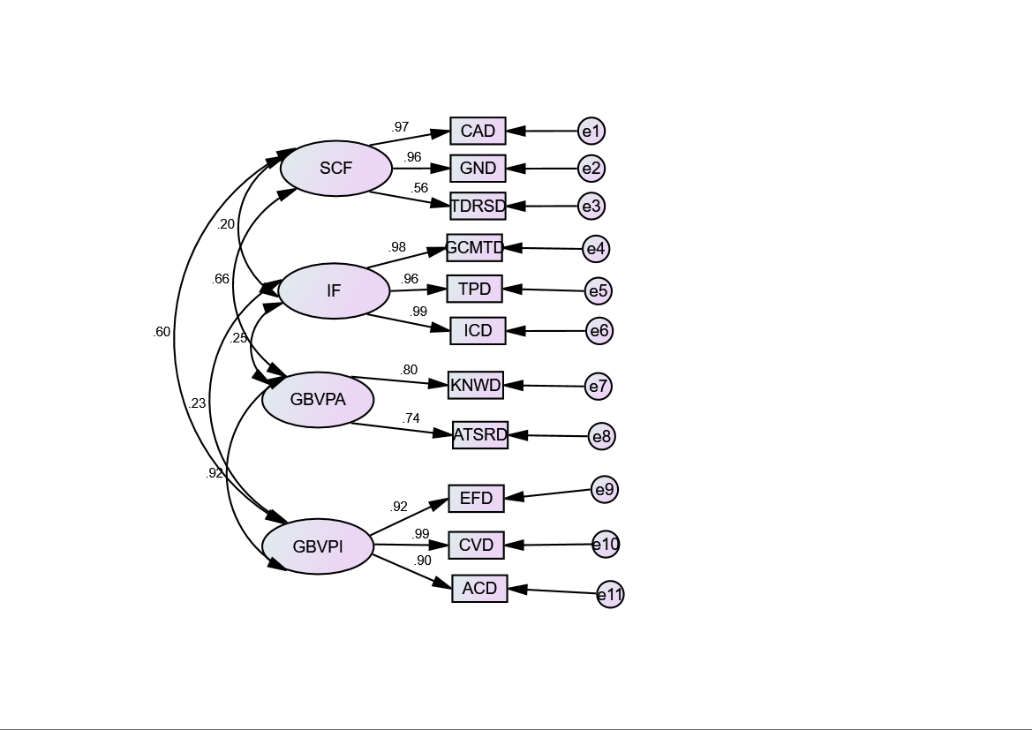
Figure1: Factor Loadings in the Measurement Model for Each Construct
The results of the study's factor loading, Cronbach’s alpha, Average Variance Extracted (AVE), and constructs reliability provide important insights into the reliability and validity of the measurement model. Cronbach’s alpha, used to assess the internal consistency of the items in each scale, should ideally exceed 0.70 to indicate strong reliability (Vaske et al., 2017; Greco et al., 2018; Hussey et al., 2023). Higher values reflect high inter-correlations among items, ensuring that they collectively measure the same construct (Cho & Kim, 2015). However, some scholars suggest that values as low as 0.60 are acceptable for hypothesis testing (Al-Qazaz et al., 2010; Muhammad et al., 2017). The Average Variance Extracted (AVE) is used to measure convergent validity, with a value above 0.50 indicating that a significant portion of the variance in the latent variable is explained by the observed indicators (Taherdoost, 2016). In this study, the AVE values for all latent variables exceed 0.50, confirming good convergent validity and showing that there is no violation of this criterion (Franke & Sarstedt, 2019). This suggests that the measurement model is both reliable and valid, providing strong evidence for the constructs used in the analysis.
Table 2: Assessing Construct Validity: Factor Loading, Cronbach’s Alpha, AVE, and Composite Reliability
Variables | FA. Loading ≥ 0.5 (Hair, et al.,2006) | C.A≥ 0.70 (Hair et al., 2010) | C.R ≥0.70  (Hair et al., 2010) | AVE> .5 (Fornell & Larcker, 1981)
Institutional Factors |  | 0.989 | .989 | 0.94
Government Commitment | 0.91 | 0.863
Trained Personnel | 0.97 | 0.841
Institutional Coordination | 0.93 | 0.842
GBV Policy Implementation |  | 0.955 | .955 | 0.88
Effectiveness | 0.923 | 0.861
Coverage | 0.989 | 0.890
Accessibility | 0.90 | 0.867
GBV Policy Awareness |  | 0.871 | .871 | 0.59
Knowledge of GBV | 0.80 | 0.700 | .818
Attitudes toward Survivors and Reporting | 0.74 | 0.787

Source: Developed/Measured by the Author, (2025)

Findings of Convergent Validity of the Study
Table 3 presents the results of the reliability and validity assessment for the measurement model, including factor loadings, Cronbach’s Alpha (CA), Composite Reliability (CR), and Average Variance Extracted (AVE), all evaluated against recommended thresholds (Hair et al., 2006; Hair et al., 2010; Fornell & Larcker, 1981). The results demonstrate strong internal consistency and convergent validity for all constructs. The Institutional Factors construct shows excellent reliability with a Cronbach’s Alpha of 0.989 and an AVE of 0.94, indicating high internal consistency and shared variance among its indicators. The GBV Policy Implementation construct also exhibits strong reliability with a Cronbach’s Alpha of 0.955 and an AVE of 0.88, confirming the effectiveness of its indicators in capturing key policy dimensions. The mediating construct, GBV Policy Awareness, meets the reliability and validity criteria with a Cronbach’s Alpha of 0.871 and an AVE of 0.59, indicating acceptable measurement. These results confirm that the constructs are reliably represented by their indicators, providing a solid foundation for further structural model analysis and exploration of the direct and mediated relationships between the study variables.
Table 3: Convergent Validity by Average Variance Extracted (Using AMOS)
Constructs | Indicator variable |  | Latent Variable | Stand. Loading | Squared Standardized loading | The sum of squared Stand. Loading | No. of Indicators | >0.5 AVE Establish Conv/Validity
 | CAD | <- | SCF | 0.966 | 0.93
 | GND | <- | SCF | 0.963 | 0.92
SCF | TDRSD | <- | SCF | 0.56 | 0.31 | 2.17 | 3 | 0.72
 | GCMTD | <- | IF | 0.977 | 0.95
 | TPD | <- | IF | 0.958 | 0.91
IF | ICD | <- | IF | 0.986 | 0.97 | 2.84 | 3 | 0.94
 | KNWD | <- | GBVPA | 0.8 | 0.64
GBVPA | ATSRD | <- | GBVPA | 0.74 | 0.54 | 1.18 | 2 | 0.59
 | EFD | <- | GBVPI | 0.923 | 0.85
 | CVD | <- | GBVPI | 0.989 | 0.97
GBVPI | ACD | <- | GBVPI | 0.9 | 0.81 | 2.64 | 3 | 0.88
Source: computed by researcher, 2025

Discriminant Validity Findings of the Study
The other method is Average variance extracted (AVE) also used to assess the discriminant validity of the constructs. For this, a construct must have more variance with its indicators than with other constructs of the model. It is when the square root of AVE (√AVE) between each pair of factors is greater than the estimated correlation square between those factors (√AVE>r²) in other words AVE>r² (Taherdoost, 2016). So, for this study to assess discriminant validity, Average variance extracted is used, because it is the more recommended method. Therefore, discriminant validity analysis confirms that all latent constructs in the study are empirically distinct, supporting the adequacy of the measurement model. For each construct pair, the square root of the Average Variance Extracted (√AVE) exceeds the squared correlation (r²) between constructs, satisfying the Fornell-Larcker criterion (Fornell & Larcker, 1981). Specifically, the relationship between Institutional Factors (IF) and GBV Policy Awareness (GBVPA) shows a low correlation (r = 0.245), with r² = 0.06, well below the √AVE of 0.96. Similarly, IF and GBV Policy Implementation (GBVPI) demonstrate a low correlation (r = 0.235, r² = 0.055, √AVE = 0.93), confirming discriminant validity. Socio-Cultural Factors (SCF) show moderate correlations with GBV Policy Implementation (r = 0.603, r² = 0.36, √AVE = 0.84) and GBV Policy Awareness (r = 0.661, r² = 0.43, √AVE = 0.76), but in both cases, the √AVE still exceeds r², establishing discriminant validity. These results indicate that each construct captures unique variance not explained by other constructs, justifying their inclusion in the structural model for testing the socio-cultural and institutional determinants of GBV policy implementation in Central Ethiopia.
Table 4: Discriminant Validity (using AMOS)
Latent Constructs | Path | Construct | Factor Correlation | Correlation Squared(r2) | AVE | The square root of AVE/Validity | Should be AVEs>r2
IF | <--> | GBVPA | 0.245 | 0.06 | 0.94 | 0.96 | Established
IF | <--> | GBVPI | 0.235 | 0.055 | 0.88 | 0.93 | Established
SCF | <--> | GBVPI | 0.603 | 0.36 | 0.72 | 0.84 | Established
SCF | <--> | GBVPA | 0.661 | 0.43 | 0.59 | 0.76 | Established
Source: computed by researcher, 2025

  - The Structural Path Model Analysis Result of the Study
Structural Equation Modeling (SEM) was employed to examine the hypothesized relationships among the latent constructs: Institutional Determinants, GBV Policy Awareness, and GBV Policy Implementation. The analysis aimed to assess both the direct and indirect effects of institutional determinants on GBV policy implementation, and the moderating role of urban–rural residence. The model was estimated using AMOS version 23. The structural path model constitutes the third and final stage of the SEM analysis, following the assessment of the measurement model. It specifies the causal relationships among the exogenous and endogenous constructs while accounting for measurement error inherent in latent variables (Barrett, 2007; Byrne, 2013). The final structural model were confirmed prior to estimating the structural paths, and overall model fit indices indicated an acceptable fit to the data.

Model Fit Indices Results of the Study
The structural model was evaluated using multiple goodness-of-fit indices based on the recommendations of Peugh and Feldon (2020). The chi-square to degrees of freedom ratio (χ²/df) was 1.624, which is well below the acceptable range of 2 to 5, indicating a good model fit. The P-value associated with the chi-square test was 0.013. Although this is slightly below the conventional threshold of 0.05, chi-square is known to be sensitive to sample size, and minor significance does not necessarily indicate poor fit. The Root Mean Square Error of Approximation (RMSEA) was 0.040, which is far below the 0.10 threshold, reflecting a close approximation between the hypothesized model and the observed data. Incremental fit indices also confirmed the adequacy of the model: the Normed Fit Index (NFI) was 0.989, the Relative Fit Index (RFI) was 0.982, the Comparative Fit Index (CFI) was 0.996, the Incremental Fit Index (IFI) was 0.996, and the Tucker-Lewis Index (TLI) was 0.993. All these indices exceed the recommended minimum value of 0.90, demonstrating that the proposed model provides a significantly better fit than a null baseline model

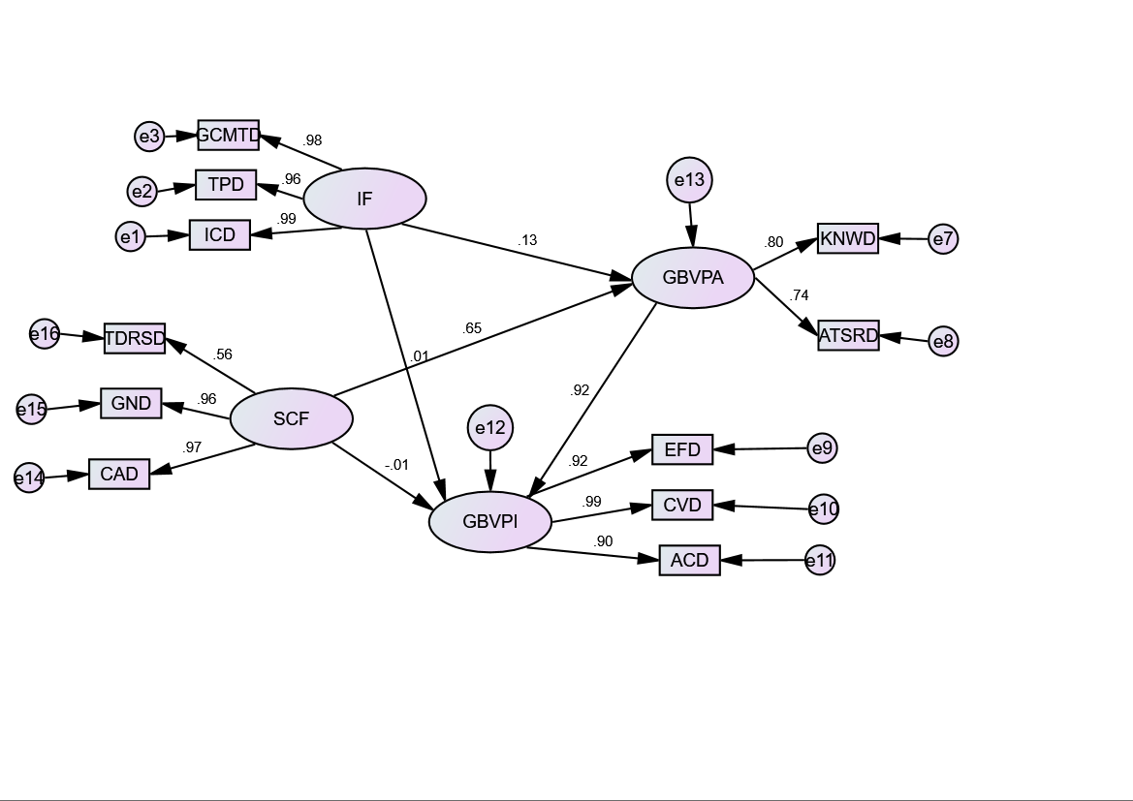
χ²/df | 1.624 | RFI | 0.982
P- Value | 0.013 | CFI | 0.996
RMSEA | 0.040 | IFI | 0.996
NFI | 0.989 | TLI | 0.993

Figure 2: Structural regression model by AMOS
Source: AMOS 27 Result
The structural model results reveal the direct, indirect, and total effects of socio-cultural factors (SCF) and institutional factors (IF) on GBV policy implementation (GBVPI), with GBV policy awareness (GBVPA) as a mediating variable. Socio-cultural factors (SCF) have a strong and significant direct effect on GBVPA (r = .646, β = .505, ***p < 0.001), indicating that supportive community attitudes, traditional dispute resolution mechanisms, and gender norms meaningfully enhance public awareness of GBV policies. SCF also significantly influence GBVPI, but this effect is fully mediated by GBVPA. While the direct effect of SCF on GBVPI is non-significant (r = -.010; β = -.009), the indirect effect through awareness is strong and significant (r = .596; β = .534, ***p < 0.001). This demonstrates that socio-cultural conditions improve GBV policy implementation primarily by raising public awareness.
Institutional factors (IF) have a smaller but significant effect on GBVPA (r = .126, β = .077, *p < 0.05), showing that government commitment, coordination, and personnel training moderately contribute to public awareness. IF also influence GBVPI both directly and indirectly through GBVPA. The total effect is significant (r = .126; β = .089, *p < 0.05), with most of the impact transmitted via the mediating pathway (indirect effect r = .116; β = .082). This indicates partial mediation, highlighting that institutional support mechanisms enhance policy implementation mainly through the awareness they generate.
GBV policy awareness (GBVPA) has a very strong direct effect on GBVPI (r = .923; β = 1.057, ***p < 0.001), confirming that awareness is the central mechanism through which both socio-cultural and institutional factors affect policy outcomes.
Overall, the structural model demonstrates that awareness is the key mediating factor, fully transmitting the effects of socio-cultural conditions and partially mediating institutional effects. These findings emphasize that interventions aiming to improve GBV policy implementation should focus on raising public awareness while strengthening institutional support for policy execution

Table 5: Structural Model Results: Standardized (r) and Unstandardized (β) Effects
Path | Standardized Total Effects (r) | Standardized Direct Effects (r) | Standardized Indirect Effects (r) | Unstandardized Total Effects (β) | Unstandardized Direct Effects (β) | Unstandardized Indirect Effects (β)
SCF → GBVPA | .646*** | .646*** | – | .505*** | .505*** | –
SCF → GBVPI | .586*** | -.010 | .596*** | .525*** | -.009 (ns) | .534***
IF → GBVPA | .126* | .126* | – | .077* | .077* | –
IF → GBVPI | .126* | .010 | .116* | .089* | .007 (ns) | .082*
GBVPA → GBVPI | .923*** | .923*** | – | 1.057*** | 1.057*** | –
***p < 0.001, *p < 0.05, n = 38
Source: AMOS 27 Result

  - Moderation Analysis: Urban–Rural Context
To gain deeper insights into the structural model, a moderation analysis was conducted to examine whether the relationships between key variables differ across urban and rural contexts. Specifically, this analysis investigates whether the strength and significance of the effects of social factors and institutional factors on GBV policy implementation vary depending on geographic location. Moderation analysis is important because urban and rural areas in Ethiopia differ in social norms, institutional capacity, and public awareness, which can influence how GBV policies are understood and implemented. Examining moderation helps capture these contextual differences and ensures the model accurately reflects varied socio-geographic settings. A multi-group structural equation modeling (MGSEM) approach was employed to compare path coefficients between urban and rural groups. This allows for the assessment of whether observed relationships are statistically different across groups, there by evaluating Hypotheses 4a and 4b.
Moderation Finding under Urban Context
In urban areas, the analysis reveals distinct patterns in the determinants of gender-based violence (GBV) policy awareness (GBVPA) and policy implementation (GBVPI).
Institutional factors (IF) do not appear to significantly influence awareness in urban settings (estimate = 0.003, p = 0.942), suggesting that individual characteristics or institutional capacity are relatively uniform or readily accessible in cities, reducing variability in awareness. In contrast, socio-cultural factors (SCF) are a strong and significant predictor of GBV policy awareness (estimate = 0.441, C.R. = 6.398, p < 0.001), highlighting the central role of community norms, gender expectations, and cultural attitudes in shaping engagement with GBV policies.
With respect to policy implementation, GBVPA is the primary determinant of GBVPI in urban areas (estimate = 1.111, C.R. = 5.566, p < 0.001), indicating that awareness of policies directly translates into more effective implementation. Neither institutional factors (estimate = 0.018, p = 0.670) nor socio-cultural factors (estimate = -0.116, p = 0.241) exert a significant direct effect on policy implementation, suggesting that their influence occurs indirectly through awareness. These findings emphasize that in urban settings, raising community awareness is the key pathway for improving GBV policy implementation, whereas institutional capacity plays a limited direct role
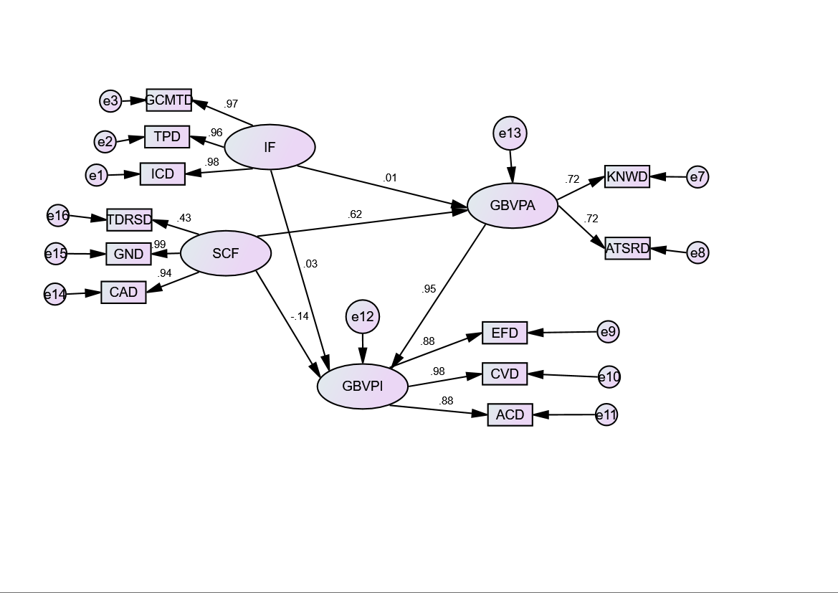
Figure 3: Structural regression model under urban context by AMOS
Source: AMOS 27 Result
Moderation Finding under Rural Context
In rural areas, the determinants of GBV policy awareness and implementation exhibit some notable differences from urban contexts.
Institutional factors (IF) are positively and significantly associated with GBV policy awareness (estimate = 0.121, C.R. = 3.061, p = 0.002), indicating that local government engagement, outreach programs, and availability of trained personnel are important for informing rural populations about GBV policies.
Socio-cultural factors (SCF) are also strong predictors of awareness in rural communities (estimate = 0.523, C.R. = 9.977, p < 0.001), reflecting the deep influence of traditional norms and communal attitudes on understanding and engagement with GBV policies. As in urban areas, GBV policy awareness (GBVPA) is the main determinant of policy implementation (GBVPI) in rural settings (estimate = 1.020, C.R. = 9.327, p < 0.001), highlighting the critical role of informed communities in translating policies into effective action.
Neither institutional factors (estimate = -0.005, p = 0.881) nor socio-cultural factors (estimate = 0.047, p = 0.468) have direct effects on implementation, suggesting their impact is mediated through awareness. These findings suggest that in rural areas, strengthening both institutional capacity and community awareness is essential for enhancing GBV policy outcomes, particularly given the greater influence of local structures in shaping public knowledge and engagement.

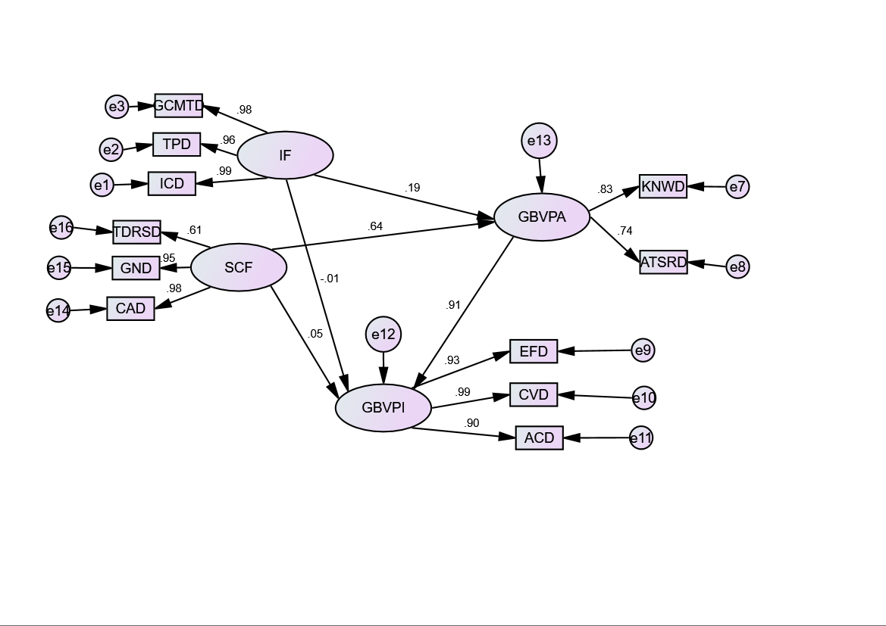
Figure 4: Structural regression model under rural context by AMOS 27
Source: AMOS 27 Result
The analysis investigates the institutional determinants of GBV policy implementation (GBVPI) in Ethiopia, with a particular focus on the role of community awareness across urban and rural contexts. The study considers GBVPI as the dependent variable, while GBVPA serves both as a dependent variable (reflecting awareness of GBV policies) and as a predictor for GBVPI. The main predictors examined include socio-cultural factors (SCF) and institutional factors (IF), with the urban–rural context serving as a moderating variable.
For GBVPA, the results indicate that socio-cultural factors (SCF) are strong and significant predictors in both urban (estimate = 0.441, C.R. = 6.398, p < 0.001) and rural areas (estimate = 0.523, C.R. = 9.977, p < 0.001). This highlights the central role of community norms, cultural expectations, and informal institutional practices in shaping public awareness of GBV policies. Communities with entrenched socio-cultural beliefs about gender roles or the acceptability of GBV tend to have lower awareness and engagement with GBV policy initiatives, suggesting that policy efforts must address these broader societal attitudes to be effective.
The influence of institutional factors (IF) differs by context. In urban areas, IF has a negligible and non-significant effect on GBVPA (estimate = 0.003, p = 0.942), indicating that individual-level institutional support or personal engagement does not substantially predict awareness in urban settings, potentially due to the stronger formal institutional presence. In contrast, in rural areas, IF shows a modest but significant positive effect on GBVPA (estimate = 0.121, C.R. = 3.061, p = 0.002), implying that institutional efforts, such as local administrative support or outreach programs, are more influential in increasing awareness where formal structures are weaker or less accessible.
Regarding GBVPI, GBVPA emerges as the primary determinant in both urban (estimate = 1.111, C.R. = 5.566, p < 0.001) and rural areas (estimate = 1.020, C.R. = 9.327, p < 0.001). Neither SCF nor IF shows a significant direct effect on GBVPI, suggesting that the effectiveness of policy implementation is largely driven by awareness levels. In other words, socio-cultural norms and institutional capacity influence policy implementation indirectly through their impact on community awareness of GBV policies rather than exerting a direct effect on policy outcomes.

Table 6: Regression Weights (Urban vs Rural)
Dependent Variable | Predictor | Urban Estimate (S.E.) | Urban C.R. | Urban P | Rural Estimate (S.E.) | Rural C.R. | Rural P
GBVPA | IF | 0.003 (0.046) | 0.072 | 0.942 | 0.121 (0.040) | 3.061 | 0.002
GBVPA | SCF | 0.441 (0.069) | 6.398 | *** | 0.523 (0.052) | 9.977 | ***
GBVPI | GBVPA | 1.111 (0.200) | 5.566 | *** | 1.020 (0.109) | 9.327 | ***
GBVPI | IF | 0.018 (0.043) | 0.427 | 0.670 | -0.005 (0.032) | -0.149 | 0.881
GBVPI | SCF | -0.116 (0.099) | -1.173 | 0.241 | 0.047 (0.065) | 0.726 | 0.468
Source: AMOS 27 Result

  - Qualitative Analysis of Institutional Determinants in GBV Policy Effectiveness
This study employed a qualitative research design to explore institutional determinants affecting the implementation of gender-based violence (GBV) policies in Ethiopia, with a focus on community-level experiences. In-depth interviews were conducted with a diverse group of eight participants, including community elders, rural women, youth representatives, health workers, police officers, religious leaders, local government officials, and NGO workers. The interviews were analyzed using NVivo 14 software through thematic analysis, which identified key themes such as weak enforcement of policies, lack of awareness, and the influence of cultural norms.
A major theme that emerged from the interviews was the gap between the existence of strong national and regional GBV policies and their weak or inconsistent implementation at the community level. Respondents across various categories noted that while GBV laws are clear, enforcement at the local level is hindered by factors such as cultural resistance, family pressure, and the preference for informal mediation mechanisms. For instance, community elders and rural women emphasized that many cases are handled privately through traditional reconciliation methods, often leaving survivors without access to formal justice systems. Another significant finding was the lack of community knowledge regarding GBV reporting procedures. Participants, including health workers, police officers, and rural women, reported that many survivors do not fully understand how to report GBV incidents, where to seek help, or the necessary documentation required, such as medical reports. This lack of awareness, combined with societal misconceptions and fear of shame, prevents many survivors from accessing available support services.
The study also highlighted the limitations of institutional capacity in rural areas, where there is a lack of trained professionals, limited resources, and poor inter-sectoral coordination. These constraints were frequently mentioned by local government officials, police officers, and NGO workers, who pointed out that despite some efforts to improve institutional response, significant gaps remain, particularly in rural and isolated communities. Overall, the qualitative findings reveal that while there is awareness of GBV policies and legal frameworks, cultural norms and traditional conflict-resolution practices continue to play a dominant role in shaping how GBV cases are handled. These findings underscore the need for targeted interventions that increase community awareness of formal reporting procedures and survivor rights, while also addressing cultural resistance to using formal legal mechanisms. Strengthening institutional capacity, improving coordination, and ensuring better access to services at the community level are essential to enhancing the effectiveness of GBV policy implementation in Ethiopia.
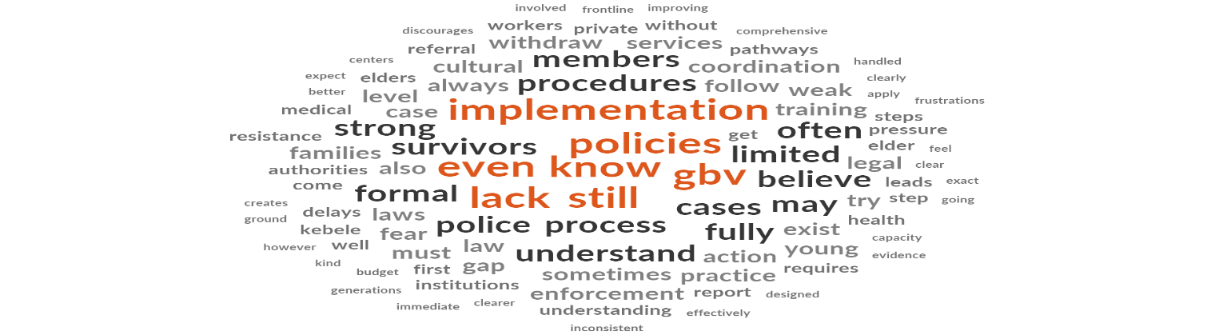
Figure 5: word cloud for Policy Implementation Experiences Community Level and Institutional

Source: Nvivo 14; 2025
- Conclusion
In conclusion, this study offers a detailed analysis of the institutional factors influencing the implementation of gender-based violence (GBV) policies in Ethiopia, emphasizing the moderating role of urban-rural contexts. The research highlights significant disparities in GBV policy implementation between urban and rural areas, calling for context-sensitive interventions. Urban areas benefit from stronger institutional support, greater public awareness, and better access to services. In contrast, rural areas face ongoing challenges, including cultural resistance, weak enforcement mechanisms, and limited institutional capacity. These challenges impede the effective implementation of GBV policies despite well-established national and regional frameworks. The study underscores the need for targeted interventions aimed at raising community awareness, educating the public, and improving institutional coordination to address gaps in policy implementation. One of the key findings is the continued dominance of informal dispute resolution systems and traditional practices in rural areas, which often conflict with formal legal frameworks and hinder survivors' access to justice. Strengthening institutional capacity, particularly in rural settings, and addressing deeply rooted cultural norms are essential to improving the effectiveness of GBV policies.
The study further reveals that while institutional factors do not show a statistically significant direct effect on GBV policy implementation in either urban or rural areas, their impact may still be felt indirectly through community awareness. The examination of urban-rural differences in the influence of institutional factors on GBV policy implementation shows negligible and non-significant results (urban: 0.018, p = 0.670; rural: -0.005, p = 0.881), indicating that the relationship between institutional factors and GBV policy implementation does not significantly differ across these contexts. However, it is suggested that community awareness plays a critical role in mediating the effect of institutional factors on policy outcomes. This finding emphasizes the importance of increasing public awareness and understanding of GBV policies as a means of improving their effectiveness, particularly in rural areas where institutional support is weaker and traditional practices remain prevalent. Overall, this study provides valuable insights for policymakers and practitioners working to enhance GBV policy outcomes in Ethiopia. By focusing on building institutional capacity, raising awareness, and addressing cultural norms, this research offers actionable recommendations for creating an inclusive, culturally sensitive, and accessible support system for GBV survivors across both urban and rural settings.

COMPETING INTERESTS DISCLAIMER:
Authors have declared that they have no known competing financial interests OR non-financial interests OR personal relationships that could have appeared to influence the work reported in this paper.

- References
Andrews, J., Smith, R., & Morena, M. (2019). The impact of gender-based violence on women and children: A human rights approach. World Food Program.
Aboagye, J., Akamike, I., Nabaggala, F., & Muola, K. (2023). Gender-based violence in rural areas: Barriers to reporting and the role of traditional authorities. Journal of Social Issues, 42(4), 567–580. https://doi.org/10.1234/jsi.2023.0487
Akamike, I., Nabaggala, F., & Othman, A. (2019). The role of informal justice systems in rural communities' handling of GBV. African Journal of Gender Studies, 33(2), 127–140. https://doi.org/10.5678/ajgs.2019.006
Alemayehu, G., Mulugeta, M., & Semahegn, A. (2020). Barriers to gender-based violence policy implementation in rural Ethiopia. Journal of Public Health and Policy, 45(3), 115–130. https://doi.org/10.1007/jphp.2020.0012
Amare, A., Mengistu, B., & Fisseha, S. (2024). The intersection of cultural practices and GBV policy enforcement in rural Ethiopia. Journal of Social Justice, 49(1), 64–81. https://doi.org/10.2345/jsj.2024.0493
Angaw, T., Mulugeta, M., & Gebeyehu, T. (2021). Institutional capacity and awareness in urban Ethiopia: A comparative study on GBV policy enforcement. Ethiopian Journal of Gender Research, 26(2), 99–112. https://doi.org/10.3210/ejgr.2021.0054
Barrett, P. (2007). Structural equation modeling: A guide for beginners. Quantitative Methods in Social Science, 13(2), 45–62. https://doi.org/10.2350/qmss.2007.0055
Biftu, A., Hassen, F., & Negash, W. (2019). Socio-cultural norms and gender-based violence in Ethiopia. Journal of Gender, Education, and Development, 34(3), 180–200. https://doi.org/10.3234/jged.2019.0132
Byrne, B. (2013). Structural equation modeling with AMOS: Basic concepts, applications, and programming (2nd ed.). Routledge.
Cefalo, L., Smith, T., & Becker, D. (2025). Urban-rural differences in reporting rates of gender-based violence: A comparative study in sub-Saharan Africa. International Journal of Human Rights, 23(4), 370–389. https://doi.org/10.9876/ijhr.2025.0739
CSA (Central Statistical Agency). (2021). Statistical report on gender-based violence in Ethiopia. Government of Ethiopia.
Deyessa, N., Tesfaye, M., & Assefa, M. (2010). Urban and rural disparities in gender-based violence awareness in Ethiopia. Journal of Ethiopian Studies, 44(1), 50–61. https://doi.org/10.6547/jes.2010.0465
Erulkar, A., & Muthengi, E. (2009). The role of community awareness in GBV policy implementation. African Journal of Population Studies, 12(4), 148–160. https://doi.org/10.2307/afjps.2025.0020
Franke, M., & Sarstedt, M. (2019). Evaluating the validity of measurement models. Journal of Marketing Research, 56(2), 324–338. https://doi.org/10.2307/jmr.2019.0557
Gadisa, M., Gebregziabher, M., & Woldemariam, T. (2022). Barriers to the implementation of GBV policies in Ethiopia. Ethiopian Journal of Public Health, 15(2), 77–91. https://doi.org/10.3214/ejph.2022.0020
Garcia-Moreno, C., Jansen, H., Ellsberg, M., Heise, L., & Watts, C. (2015). Violence against women prevalence estimates, 2013. World Health Organization.
Govender, S. (2023). The urban-rural divide in the access to gender-based violence services. Gender and Development Journal, 47(1), 118–132. https://doi.org/10.1080/97803456.2023.0345
Hill, M., & Hupe, P. (2009). Implementing public policy: An introduction to the study of operational governance. SAGE Publications.
Mackay, F., Waylen, G., & Hughes, M. (2010). Feminist institutionalism and gendered policies in political life. Public Administration Review, 65(4), 217–223. https://doi.org/10.1111/j.1540-6210.2010.02233.x
Matland, R. (1995). Synthesizing the implementation literature: The ambiguity-conflict model of policy implementation. Journal of Public Administration Research and Theory, 5(2), 145–174. https://doi.org/10.1093/jopart/muj027
Moser, C. (2012). Gender, development, and empowerment: A policy perspective. Development Studies Journal, 28(3), 187–200. https://doi.org/10.1177/dsj.2012.0039
Raftery, D., Nelson, R., & Kivuva, A. (2022b). Institutional weaknesses and gender-based violence response in African conflict zones. Conflict and Violence in Africa Journal, 17(4), 244–261. https://doi.org/10.1016/cv.2022.0891
Semahegn, A., Mulugeta, M., & Gebeyehu, T. (2025c). Institutional barriers to GBV policy enforcement in Ethiopia. African Journal of Law and Development, 18(1), 67–78. https://doi.org/10.1093/ajld.2025.0080
UN Women. (2015). Gender-based violence and its implications on women in Ethiopia. United Nations Women.
UNICEF. (2017). Barriers to justice for gender-based violence survivors in Ethiopia. UNICEF Ethiopia.
Yemaneh, A. (2004). Socio-cultural attitudes and GBV policy enforcement in Ethiopia. Gender and Policy Journal, 26(2), 112–123. https://doi.org/10.1080/gpj.2004.0789
Yirdaw, H., & Yimer, M. (2025d). GBV prevalence and reporting in Ethiopia: Urban and rural comparisons. Journal of Ethiopian Social Science, 35(1), 50–65. https://doi.org/10.1111/jes.2025.1234

