Application of artificial intelligence algorithms in digital media arts: Chinese calligraphy Education for children with specific Learning disabilities

ABSTRACT: As an important subject in various fields of research and discussion in the new era, artificial intelligence has been applied more and more widely in the field of children's learning disabilities. The existing literature proves that there is still a lack of relevant research topics at home and abroad, and systematic comprehensive research technology is even less. As an important issue in the field of education, the number of children with special learning disabilities is increasing, and the related topic has become the focus of common discussion in the fields of education, psychology, clinical medicine and so on. Under the development trend of economic globalization, all countries in the world have realized the importance of cultural economy construction, how to use cultural resources rationally and actively cultivate people's learning ability is very important. For example, the Chinese calligraphy art and culture.Therefore, after understanding the development status of artificial intelligence algorithms and digital media art, Combining the art of Chinese calligraphy, this paper mainly discusses the application research of artificial intelligence algorithms in the learning and growth of children with special learning disabilities from the perspective of children with special learning disabilities.

KEYWORDS: Artificial intelligence algorithm, Digital media art,Children with specific learning disabilities, Chinese Calligraphy, Intervene
- INTRODUCTION
Digital media, as a new technology and technology means for the construction and development of today's society, can transform abstract and invisible information and feelings into content that can be recorded, felt and viewed. In fact, artificial intelligence algorithms and advanced technical means are used to show new technology based on art forms. In the construction and development of modern society, digital media has a wide range of applications and plays a very prominent role. For example, digital media can provide valuable information to artificial intelligence technology by letting the operator browse the web or search for content, using big data algorithms to filter out the content that the operator likes. Artificial intelligence refers to the synthesis of computer intelligence and the operation behavior of human brain. With the rapid development of computer technology, its application in practical work and real life more and more widely, can effectively reduce the cost of labor and application in the factory, reduce the risk of contradiction caused by human error, improve the efficiency of enterprises and institutions, and create more benefits for the long-term development of the industry. The general development and application of artificial intelligence is an important link in the development of digital media art, which can effectively optimize and update digital media, and has strong creativity and influence. Nowadays, with the continuous development of the Internet and digital information technology, the communication between information and information is unimpeded, but corresponding network security problems have also emerged. Artificial intelligence in the continuous research, learning and creation of the update, can effectively identify and judge network security problems, strengthen the stability of the network environment, can also be a full range of assessment of possible or existing problems, effectively distinguish the level of risk after automatic processing, timely protection of network information.
After entering the 21st century, artificial intelligence technology is more and more mature, and the application scope is more and more wide, and the education field is one of them. Due to the increasing number of children with learning disabilities, the problems related to children's learning disabilities have been highly valued by scholars. In the past decade, many scholars and research institutions at home and abroad have deeply discussed the research and application of artificial intelligence technology algorithms in children with learning disabilities, and have obtained a wealth of theoretical and research achievements, but there are few topics on the application of artificial intelligence algorithms for children with special learning disabilities from the perspective of digital media art. Therefore, after understanding the basic concepts of artificial intelligence algorithms and children with special learning disabilities, this paper mainly discusses the application research of artificial intelligence algorithms in the education of children with special learning disabilities, in order to provide a reference for the development of digital media art and education in the new era.

- METHODOLOGY
  - Diagnosis
When studying the education of children with special learning disabilities, some scholars put forward an AI algorithm involving the diagnosis of children's learning disabilities, which is mainly used to improve the diagnosis accuracy of children's learning disabilities. Nowadays, the AI algorithms for the diagnosis of children's learning disabilities in academia are divided into two types, one refers to deep learning algorithms, and the other refers to support vector machine algorithms. Some scholars use artificial neural network classifiers to diagnose learning disabilities. The actual process is shown in Figure 1 below. The final result shows that this method can diagnose more than 50% of children with learning disabilities, which is more effective than traditional statistical methods. At the same time, some scholars have proposed to use support vector machine to develop a more accurate and effective diagnosis platform for attention deficit hyperactivity disorder, which can provide medical personnel with diagnostic and certification questionnaire survey data, and use support vector calculation method to judge whether special children suffer from attention deficit hyperactivity disorder. From the perspective of practical application, The classifier and diagnostic platform constructed by the two algorithms have achieved the expected results, and can effectively improve the diagnostic accuracy of children with special learning disabilities. Scholars proposed to develop and design an expert system for the diagnosis of learning disabilities of children with special needs. Fuzzy cognitive maps, as a soft computing method using symbols to describe and model complex systems, can provide expert doctors with differential diagnosis results of specific language disorders, dyslexia and autism, and can achieve excellent results in practical application.
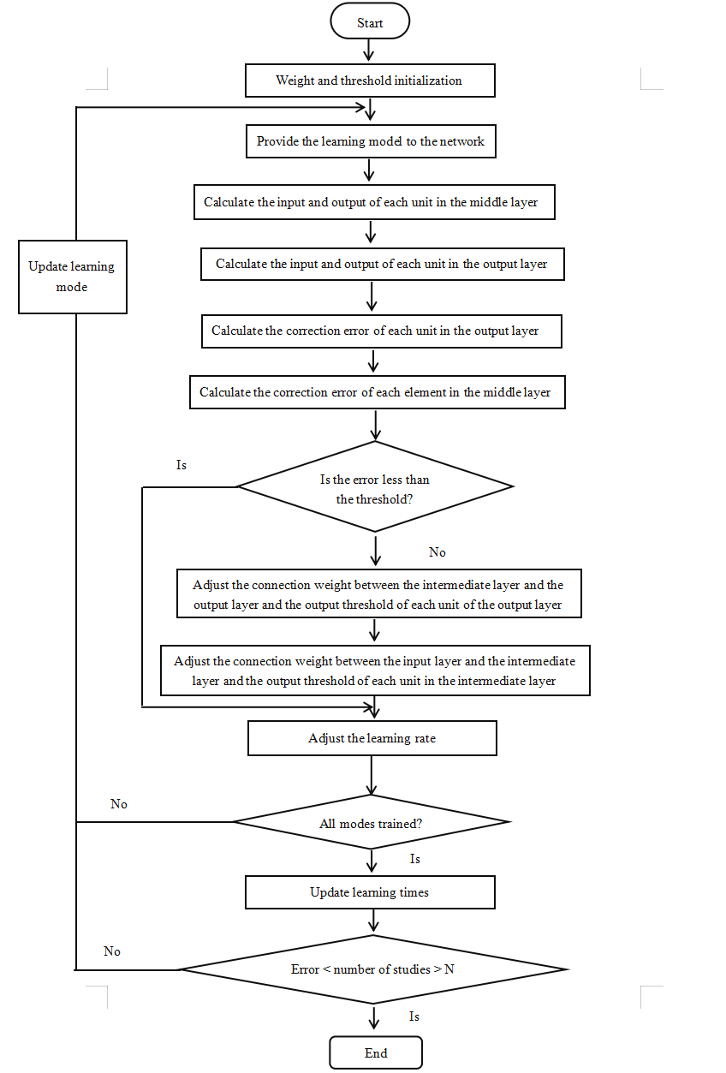
Fig. 1. Flow chart of artificial neural network classifier.
2.2.Intervention
As a basic component of the education of children with special learning disabilities, intervention aims to accurately guide students to learn. Nowadays, the scientific research field uses artificial intelligence technology algorithms to implement intervention education for children with special learning disabilities. Some scholars have found that the development of a system platform based on artificial intelligence technology algorithms should be studied according to different categories of children with special learning disabilities, and the system can be divided into developmental learning disability intervention and learning learning disability intervention. Some scholars have created a speech therapy system with fuzzy expert system as the core, using the fuzzy expert system to develop and design a framework to help special children with speech disorders obtain the best treatment plan and provide more intervention time for special children with speech disorders. The structure of the fuzzy expert system is shown in Figure 2 below:
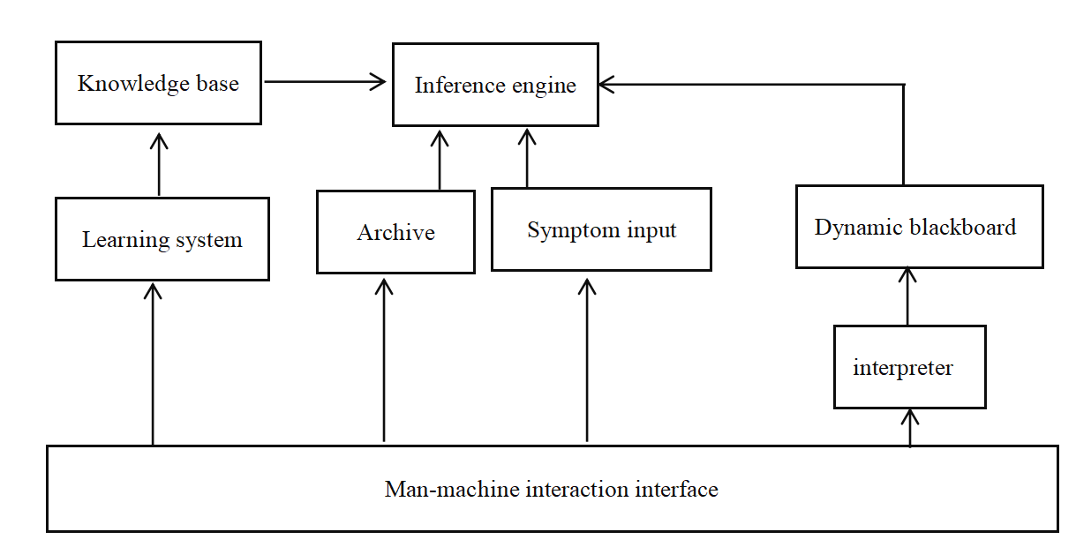
Fig. 2. Structure diagram of fuzzy expert system.

When studying the intervention system for learning disabilities, some scholars have effectively solved the psychological barriers in reading, spelling, writing, mathematics and other learning activities, and built a mathematical intelligent tutoring system with a network platform as the core, mainly used to help children with special learning disabilities learn math knowledge. This system supports children to learn in their own comfortable environment, will use artificial intelligence technology to form an adaptive curriculum system, students can complete modeling, feedback, interactive learning and other work. During the operation of the platform, children with special learning disabilities will conduct self-assessment according to the concepts they have mastered, then choose appropriate learning objectives and learning scenarios, and adjust the difficulty of the course according to their mastery level. The eye tracker in the system can track children's attention and reading time in detail, which is convenient for follow-up education management.
2.3.Evaluation
Learning disabilities can cause children to be unable to learn and use certain skills, so according to the main causes of children's learning disabilities and classification results, the selection of appropriate assessment tools for children with special learning disabilities is the main direction of scholars' discussion. Artificial neural networks, as the focus of attention in the field of artificial intelligence since the 1980s, will use neural network methods to support students with special learning disabilities to conduct self-assessment, and use computer programs to gradually optimize, which can accurately judge the problems of children with special learning disabilities in grammar/sentence structure, reading and writing, letter recognition, alphabetic order, spelling/vocabulary. Some scholars have used the genetic programming neural network method of virtual learning environment to evaluate and analyze special children with disabilities in different directions, which is very suitable for individuals with physical or sensory disorders. Some scholars use artificial neural network to identify dyslexic children with special learning disabilities, which is also the first attempt to use artificial intelligence algorithm to solve the problem of child dyslexia recognition technology application results; Some scholars have used artificial intelligence to build application models, mainly to carry out the assessment of children's learning disabilities. For example, Freitas, as a "mind headset" with BCI technology as the core launched by a company in the United States, can be applied to all groups, but it is mainly used in the attention deficit hyperactivity disorder children. The application model consists of a headset with three electrodes, which can effectively read the child's brain wave signals as input data, mainly used to assess the child's attention level. The results of the experimental study proved that there was a positive correlation between the test results and the self-reported attention level of the participants. Among them, the technical structure is shown in Figure 3 below:
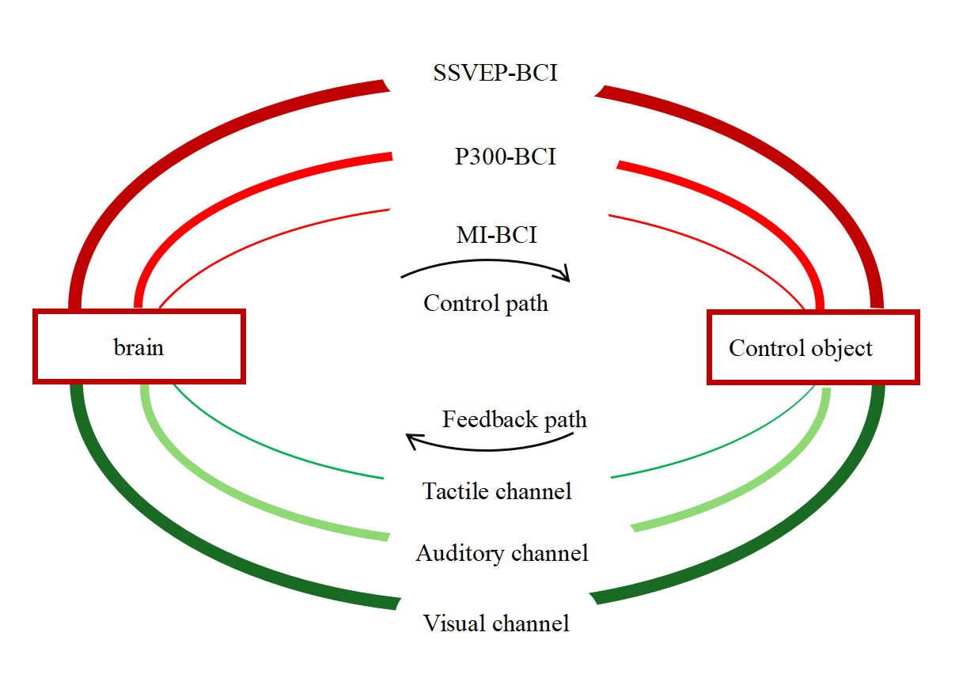
Fig. 3. Structure diagram of BCI technology
2.4.Services
According to the learning support needs of children with special learning disabilities, in the development of big data, cloud computing, Internet and other technologies, artificial intelligence technology algorithms can provide personalized support services for children with special learning disabilities, professional teachers and children's parents based on cloud computing and big data. In 2010, iFLYc Open Platform built corresponding software for children with reading disabilities, which truly realized the use of voice to operate computers, help realize the function of screen reading, and facilitate the access of dyslexic users to the Internet in China; In 2015, iFLYtek launched the "hearing" product, which can completely transform the teacher's speech content into text, which can be implemented in the classroom to help the hearing impaired children better understand the teaching content. Some scholars have studied the artificial intelligence technology with big data technology as the core to provide accurate learning support services for children with special learning disabilities, which is reflected in three aspects: First, according to the learning needs of children with special learning disabilities, provide them with the required learning content from the original data; Secondly, the data generated by children with special learning disabilities during their learning period should be continuously collected to form intervention measures in line with each child's own development according to the obstacles encountered by children during their learning period. Finally, the behavioral data of children with special learning are recorded. Although these data have no regularity and correlation from the surface, when the data accumulates to a certain amount, the in-depth analysis of the data can find the behavioral rules of children with special learning disabilities.

- RESULT ANALYSIS
Based on the knowledge and experience of doctors, experts and scholars, this paper develops and designs a mathematical model and diagnostic process for early warning of children with special learning disabilities. The diagnostic process is shown in Figure 4 below:
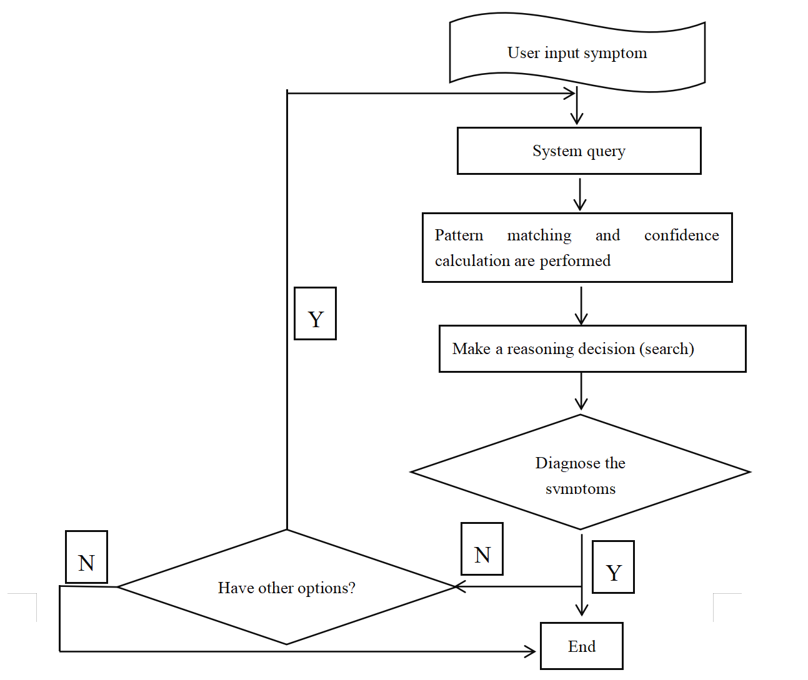
Fig.4. Flow chart of evaluation diagnosis

In the process of evaluation and diagnosis, it is necessary to do data mining and data analysis, as shown in Figure 5 below:
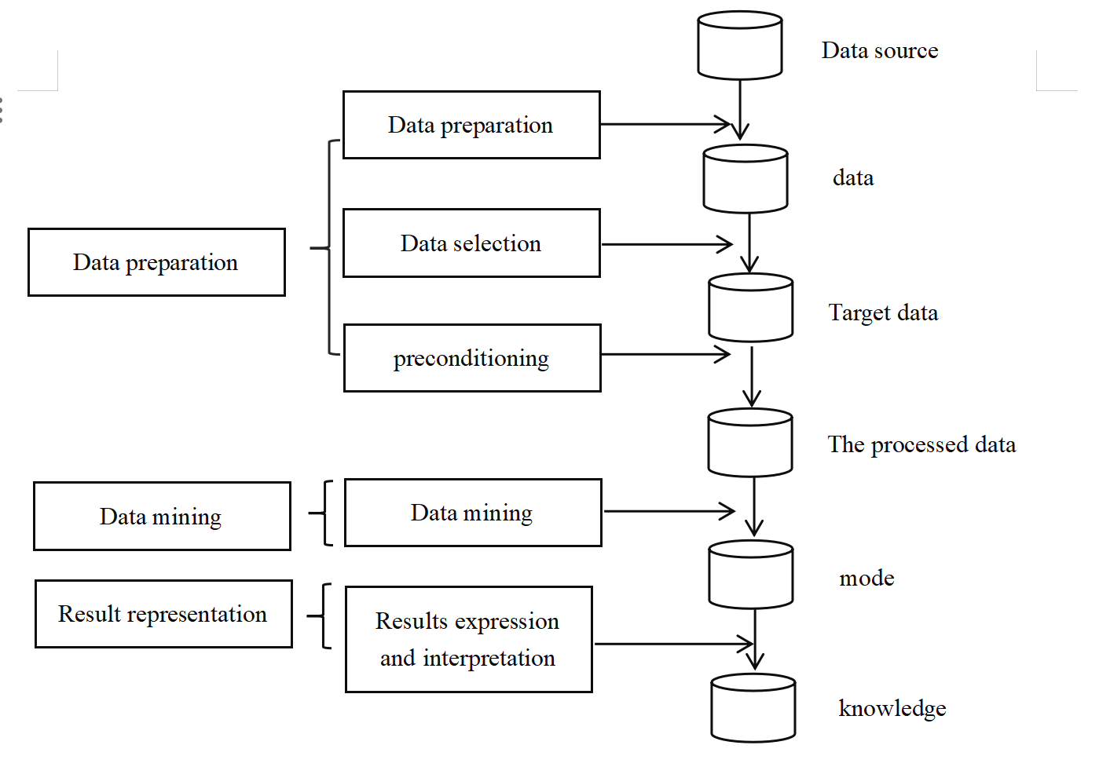
Fig.5. Flow chart of data mining and analysis

Analyze through the above process and proceed to the next important step, which is a test. The research subjects are divided into two groups, namely Group A (control group) and Group B (experimental group). to determine whether the data is normally distributed. To this end, the researchers conducted normality tests using deviant attitudes and kurtosis. The number of differences and the likelihood of occurrence are mainly used to find out what type of analysis will be performed (parametric or non-parametric). The significance of the difference between the means of the two groups was analyzed by statistically processing the data obtained from the two tests using SPSS as a window. This is accomplished by labeling the value of the difference code as t, and the probability of occurrence as p. This allows testing the significance of the difference between the means of the two groups. The form of parametric analysis used was chosen based on the results of difference values and likelihood of occurrence.
After three months of artificial intelligence technology testing, the experimental group (Group B) showed a significant increase in the total number of checks, the number of crossovers, and the number of omissions in the scratch test per unit time, with very significant differences (P < 0.01), and a significant reduction in the number of false crossovers and omissions, with a significant difference (P < 0.05). These results are shown in Table 1.

Table 1: Comparison of the experimental group (group B) before and after the attention deficit test intervention
 | Pre-testing | Post-testing | t | P
Total inspections | 116.58±32.97 | 224.78±64.98 | -8.76 | <0.01
Number of  cross-outs | 69.69±20.54 | 110.85±24.82 | -12.53 | <0.01
Incorrect number  of crossings | 1.08 ±1.04 | 0.46±0.52 | 2.31 | <0.05
Number of  omissions | 9.31 ±4.57 | 6.08±3.01 | 4.88 | <0.01

As can be seen from Table 2, the control group, designated as group, did not reach significant differences between the two tests in the total number of checks, number of crossovers, number of incorrect crossovers, and number of missed crossovers per unit time (P > 0.05).
Table 2: Control group (group A) attention deficit test pre-test and post-test scores
 | Pre-testing | Post-testing | t | P
Total inspections | 118.20±21.38 | 122.66 ±18.32 | -1.73 | >0.05
Number of  cross-outs | 71.15±31.98 | 74.31 ±34.35 | -1.06 | >0.05
Incorrect number  of crossings | 1.08 ±1.66 | 1.08±1.26 | 0.00 | >0.05
Number of  omissions | 10.15 ±2.12 | 9.54±1.81 | 1.60 | >0.05

As can be seen from Table 3, the experimental group (Group B) is significantly better than the control group (Group A) in terms of total number of inspections, number of omissions and other indicators, and there is a significant difference (P < 0.01). In addition, on the indicator of the number of incorrect crossings, the post-test score of the calligraphy behavior group (Group B) was higher than that of the control group. The posttest results of the members of Group B were not significantly different from each other.

Table 3: Comparison of posttest scores on the Attention Deficit Test between the two groups
Post-testing | group B | group A | t | P
Total inspections | 224.78±64.98 | 122.66 ±18.32 | 5.24 | <0.01
Number of  cross-outs | 110.85±24.82 | 74.31 ±34.35 | 2.97 | <0.01
Incorrect number  of crossings | 0.46 ±0.52 | 1.08±1.26 | -1.57 | >0.05
Number of  omissions | 6.08 ±3.01 | 9.54±1.81 | -3.14 | <0.01

After three months of experimental testing, the experimental group (Group B) completed two TMT tests in a shorter period of time, and the difference between the two groups was significant (P < 0.01). This can be shown in Table 4. The difference in the time it took subjects in the control group to complete the TMT for the second time was less than the time it took subjects to complete the pre-test, but the difference did not reach statistical significance (P > 0.05). The difference in the pre-test results between the two groups was not statistically significant, but the difference between the two groups was not statistically significant. The difference in post-test results reached statistical significance (P < 0.05).
Table 4: Comparison of pre- and post-test scores of TMT in the two groups and between the two groups
 | Pre-testing | Post-testing | t | P
group B | 113.92±35.34 | 90.62 ±27.37 | 6.04 | 0.01
group A | 120.54±22.40 | 114.69±24.01 | 2.10 | 0.05
t | 2.15 | 2.29
P | >0.05 | <0.05

This shows that the attention of children with special learning disabilities who belong to the experimental group (Group B) also improved significantly after digital art intervention. Note that flexibility is the term used to describe this improvement.
According to the above analysis, after the evaluation and diagnosis, the system will provide corresponding intervention and correction methods according to the previously stored expert suggestions, and clearly inform users of the professional knowledge and treatment methods of special learning disabilities, so as to facilitate the continued education and guidance of professionals or learning tutors. Judging from the current application of artificial intelligence technology in the education of normally developing children, with the continuous development of digital media art, artificial intelligence technology algorithms are becoming more and more perfect, which can truly practice the automation, personalization and intelligent research goals of education and teaching. However, there are few research and exploration topics related to artificial intelligence technology algorithm in the field of learning disabilities of special children, and there are not many theoretical knowledge and research results obtained. Therefore, future research should comprehensively grasp the latest research methods and technical means in the field of artificial intelligence, start from the perspective of the development of children with special learning disabilities, and according to the characteristics and learning needs of children with special learning disabilities, Gradually optimize the existing artificial intelligence algorithms, pay attention to the four aspects of diagnosis, intervention, evaluation and service continue to study, and finally get more effective algorithm models.

- DISCUSSIONS
The attention experiment results of this study show that artificial intelligence algorithm intervention has a significant restorative effect on improving attention (including attention stability, selectivity and flexibility, etc.). For children with intellectual disabilities. This effect was seen in the children who participated in the study. This is consistent with the conclusions reached by some researchers in Hong Kong and Taiwan. They have done artistic behavior training for some children with ADHD in primary school. They found that it also has a significant impact on the attention of children with special learning disabilities(SLD), especially in selective attention, attention shifting, automatic attention and sustained attention. Pay attention to other aspects. This was discovered after they found that artistic behavioral training had a significant impact on the attention of children with ADHD.
It is possible that artificial intelligence not only provides an explanation for the functions of literature and art, but also for psychological rehabilitation and therapy. Artistic behavior can improve the psychological quality, including attention, and rehabilitation of children with ADHD and special learning disabilities. function. It is a comprehensive approach to psychological and behavioral recovery that includes management of the mind, breath, and body. The purpose of artificial intelligence intervention is to achieve the purpose of intervention by using digital art and Chinese calligraphy to train the effectiveness of relevant behavioral activities.
This enables the subject to restore, maintain and develop personal physical and psychological recovery. On the other hand, because the cognitive expressive intervention was trained for such a short period of time and involved so few participants, progress may have been limited and results may actually be the same as before. This is only a preliminary attempt and to confirm these results further studies are needed and the sample size should be increased.

- CONCLUSION
To sum up, there are more and more researches on the application of artificial intelligence technology algorithms in the diagnosis, intervention, assessment and service of children with special learning disabilities. In the future, it is necessary to continue to combine more theoretical knowledge and technical algorithms for in-depth discussion. Only in this way can we provide technical support for the educational management of children with special learning disabilities and promote the steady development of digital media art.

COMPETING INTERESTS DISCLAIMER:
Authors have declared that they have no known competing financial interests OR non-financial interests OR personal relationships that could have appeared to influence the work reported in this paper.

REFERENCES
Bishop, D. V. M., & Snowling, M. J. (2004). Developmental dyslexia and specific language impairment: Same or different? Psychological Bulletin https://doi.org/10.1037/0033-2909.130.6.858

American Psychiatric Association. (2013). Diagnostic and Statistical Manual of Mental Disorders (5th ed.). Washington, DC: American Psychiatric Association Publishing. https://doi.org/10.1176/appi.books.9780890425596

Cortiella, C., & Horowitz, S. H. (2014). The state of learning disabilities: Facts, trends and emerging issues. National Center for Learning Disabilities. https://www.ncld.org/wp-content/uploads/2014/11/2014-State-of-LD.pdf

Holmes, W., Bialik, M., & Fadel, C. (2019). Artificial Intelligence in Education: Promises and Implications for Teaching and Learning. Boston: Center for Curriculum Redesign.DOI: 10.4324/9781351003870

Dede, C., Richards, J., & Saxberg, B. (2019). Learning engineering for AI-enabled education. Educational Technology, 59(4), 3–14. DOI: 10.1007/978-3-030-12558-4

Kotsiantis, S., Zaharakis, I., & Pintelas, P. (2007). Supervised machine learning: A review of classification techniques. Informatica, 31(3), 249–268.DOI: 10.1016/j.knosys.2006.05.008

Shalev-Shwartz, S., & Ben-David, S. (2014). Understanding Machine Learning: From Theory to Algorithms. Cambridge University Press. https://doi.org/10.1017/CBO9781107298019

Zhang, D., & Lee, W. S. (2006). Learning disabilities identification: A comparison of neural networks and SVM. Applied Soft Computing, 6(3), 285–295.DOI: 10.1016/j.asoc.2005.05.001

Guyon, I. M., Weston, J., Barnhill, S. D., & Vapnik, V. N. (2002). Gene selection for cancer classification using support vector machines. Machine Learning, 46(1), 389–422. https://doi.org/10.1023/A:1012487302797

Kosko, B. (1986). Fuzzy cognitive maps. International Journal of Man-Machine Studies, 24(1), 65–75. https://doi.org/10.1016/S0020-7373(86)80040-2

Rizzo, A. A., & Kim, G. J. (2005). A SWOT Analysis of the Field of Virtual Reality Rehabilitation and Therapy. Presence: Teleoperators and Virtual Environments. https://doi.org/10.1162/1054746053967094

Fletcher, J. M., Lyon, G. R., Fuchs, L. S., & Barnes, M. A. (2018). Learning disabilities: From identification to intervention. Guilford Press. https://www.guilford.com/books/Learning-Disabilities/Fletcher-Lyon-Fuchs-Barnes/9781462536375

Bishop, D. V. M. (2017). Why is it so hard to reach agreement on terminology? Journal of Child Psychology and Psychiatry, 58(6), 611–613.DOI: 10.1111/jcpp.12736

DuPaul, G. J., Weyandt, L. L., & Janusis, G. M. (2011). ADHD in the Classroom: Effective Intervention Strategies. Theory Into Practice, 50(1), 35–42. https://doi.org/10.1080/00405841.2011.534935

Oberer, D., & Erkollar, A. (2018). Adaptive learning systems in education. International Journal of Emerging Technologies in Learning, 13(3), 168–179.DOI: 10.3991/ijet.v13i03.7797

Luckin, R., Holmes, W., Griffiths, M., & Forcier, L. B. (2016). Intelligence Unleashed: An Argument for AI in Education. London: Pearson. https://www.pearson.com/content/dam/corporate/global/pearson-dot-com/files/innovation/Intelligence-Unleashed-Publication.pdf

Reiser, R. A., & Dempsey, J. V. (2018). Trends and Issues in Instructional Design and Technology. Boston: Pearson.DOI: 10.4324/9780203812338

Malchiodi, C. A. (2012). Handbook of Art Therapy. New York: Guilford Press.DOI: 10.4324/9780203841130

Stuckey, H. L., & Nobel, J. (2010). The connection between art, healing, and public health: A review of current literature. American Journal of Public Health, 100(2), 254–263. https://doi.org/10.2105/AJPH.2008.156497

Gardner, H. (2011). Frames of Mind: The Theory of Multiple Intelligences. New York: Basic Books. https://www.hachettebookgroup.com/titles/howard-gardner/frames-of-mind/9780465024339/

Klingberg, T. (2010). Training and plasticity of working memory. Trends in Cognitive Sciences. https://doi.org/10.1016/j.tics.2010.05.002

Posner, M. I., & Rothbart, M. K. (2007). Research on Attention Networks as a Model for the Integration of Psychological Science. Annual Review of Psychology, 58, 1–23. https://doi.org/10.1146/annurev.psych.58.110405.085516

Diamond, A. (2013). Executive functions. Annual Review of Psychology, 64, 135–168.DOI: 10.1146/annurev-psych-113011-143750

Makeig, S., Debener, S., Onton, J., & Delorme, A. (2004). Mining event-related brain dynamics. Trends in Cognitive Sciences, 8(5), 204–210. https://doi.org/10.1016/j.tics.2004.03.008

Wolpaw, J. R., Birbaumer, N., McFarland, D. J., Pfurtscheller, G., & Vaughan, T. M. (2002). Brain–computer interfaces for communication and control. Clinical Neurophysiology, 113(6), 767–791. https://doi.org/10.1016/S1388-2457(02)00057-3

McFarland, D. J., & Wolpaw, J. R. (2011). Brain–computer interface operation of robotic and prosthetic devices. Computer, 44(1), 52–56.DOI: 10.1109/MC.2011.2

Sun, J., & Rao, N. (2014). Chinese calligraphy training and cognitive development. Journal of Cognitive Education and Psychology, 13(2), 231–244.DOI: 10.1891/1945-8959.13.2.231

Kao, H. S. R. (2010). Calligraphy therapy: A complementary approach to psychotherapy. Asia Pacific Journal of Counselling and Psychotherapy, 1(1), 55–66. https://doi.org/10.1080/21507680903570334

Yang, X., & Zhang, L. (2019). Digital media art and AI-driven interaction design. Leonardo, 52(4), 415–421.DOI: 10.1162/leon_a_01769

Boden, M. A. (2016). AI: Its Nature and Future. Oxford University Press. https://doi.org/10.1093/acprof:oso/9780199672973.001.0001

Woolf, B. P. (2010). Building Intelligent Interactive Tutors. Burlington: Morgan Kaufmann.DOI: 10.1016/C2009-0-63520-6

Siemens, G., & Baker, R. (2012). Learning analytics and educational data mining: towards communication and collaboration. Proceedings of the 2nd International Conference on Learning Analytics and Knowledge https://doi.org/10.1145/2330601.2330661.

