Phytotherapy of Anti-asthenia in Individuals Infected with Human Immunodeficiency Virus: An Ethnobotanical Survey in Lower Casamance and Sine-Saloum in Senegal

Abstract
Background: Human immunodeficiency virus (HIV) infection remains a major public health problem in resource-limited countries. Despite the effectiveness of antiretroviral therapies, people living with HIV frequently experience opportunistic infections, among which asthenia is significant due to its high prevalence and impact on quality of life.
Aim: The aim of this ethnobotanical study was to identify medicinal plants used in the treatment of HIV-associated asthenic in Lower Casamance and Sine-Saloum (Fatick and Kaolack regions), two areas with high seroprevalence.
Methods: An ethnobotanical survey was conducted among 93 traditional practitioners and herbalists in the Casamance, Fatick and Kaolack regions over a three-month period (February to April 2023). Data was collected using a standardised questionnaire covering participants' knowledge, the plants used, the parts used and methods of uses.
Results: A total of 28 plant species were recorded in Casamance and 23 species in the Sine-Saloum area. The most frequently cited species included Sarcocephalus latifolia (17.65%), Terminalia macroptera (14.71%) and Cordyla pinnata (11.76%) in Casamance, and Ficus thonningii (55.1%), Pterocarpus erinaceus (46.94%) and Lepisanthes senegalensis (38.77%) in the Sine-Saloum. Roots, leaves and bark were the most commonly used plant parts, while maceration, infusion and decoction were the main preparation methods.
Conclusion: These results highlight the richness of local ethnobotanical knowledge and underscore the value of these plant resources in the traditional treatment of HIV-associated asthenia, opening up prospects for further phytochemical and pharmacological studies.
Keywords : HIV, asthenia, phytotherapy, ethnobotanical survey, Casamance, Sine-Saloum and Senegal.
- Introduction
UNAIDS data indicate that Senegal has a low national HIV prevalence estimated at 0.5%. Nonetheless, marked regional disparities persist, with seroprevalence rates equal to or above 1% in Casamance and the Sine-Saloum areas of Fatick and Kaolack. These differences are associated with heightened social vulnerability, including population displacement, early sexual initiation, and socio-cultural practices such as female genital mutilation and circumcision (UNAIDS, 2020; ANSD & ICF, 2018).
Infection with HIV results in a gradual impairment of immune function, increasing susceptibility to opportunistic infections, which commonly serve as the earliest clinical manifestations of HIV in the African context. However, HIV infection is still a disease of public health concern which in 2018 accounted for 770 000 deaths globally (WHO, 2018).
Among reported worldwide HIV cases, more than 70% are from Sub Saharan Africa.
Asthenia, defined as persistent and unexplained fatigue, is one of the most commonly reported symptoms during HIV infection. It can result from multiple factors, including chronic inflammation, opportunistic infections, nutritional deficiencies, adverse effects of antiretroviral treatments, and psychological disorders associated with the disease. Chronic fatigue syndrome (CFS) is a medically unexplained and debilitating mental and physical condition characterized by persistent fatigue (lasting for at least 6 months) and several other symptoms, including sleep disorders, lengthy malaise after exertion, sore throat, muscle pain, multi-joint pain, tender lymph nodes, headache, impairment of concentration or short-term memory, anxiety, and depression, which lead to severe disability and suffering in patients (Zhang et al., 2022). This chronic fatigue significantly impairs patients' functional abilities and contributes to the overall deterioration of their health (Coulibaly, 2020). The reported prevalence rates for chronic fatigue have ranged from 0.62 % to 6.42 % (median 1%) using the US Centers for Disease Control and Prevention-1994/Fukuda case definition (Brurberg et al., 2014). In addition to this, Asthenia affects considerable inability in the perspectives of daily activities, emotional function and performance in the workplaces, which can be a significant economic impact in both of individual person and the society (Bombardier and Buchwald, 1996). If there is no effective treatment, Asthenia will cause a decline in multi-system function and cause systemic diseases such as immune system, circulatory system, nervous system, digestive system, and visceral dysfunction, thus posing a serious threat to human health (Zhang et al., 2022).
In Senegal, limited access to certain specific treatments and the cost of conventional treatments lead a large proportion of the population to resort to traditional medicine. Phytotherapy, a major component of this medicine, is based on the empirical use of medicinal plants passed down through local knowledge and widely integrated into healthcare practices, including the treatment of HIV-related conditions.
Several medicinal plants are traditionally used to combat fatigue, strengthen the body, boost immunity and improve the general condition of patients with chronic diseases. Ethnobotanical surveys are therefore an essential tool for cataloguing these plant resources, preserving indigenous knowledge and guiding future phytochemical and pharmacological studies.
2. METHODOLOGY
2.1 Study of Area
The survey was conducted among traditional practitioners and herbalists in the regions of Casamance, Fatick and Kaolack.

- Lower Casamance
The Ziguinchor region is located at 12°33' North Latitude and 16°16' West Longitude, with a magnetic declination of 13°05. Its altitude is 19.30 m in the south-western part of Senegal. It is bordered to the north by the Republic of Gambia, to the south by the Republic of Guinea Bissau, to the east by the regions of Kolda and Sédhiou, and to the west by the Atlantic Ocean. The region covers an area of 7,339 km², or 3.7% of the national territory. Its tropical sub-Guinean climate gives it the richest flora and the most extensive hydrographic network in the country (Abubakar & Ibrahim, 2019). The Fig. 1 shows the map of Ziguinchor region.
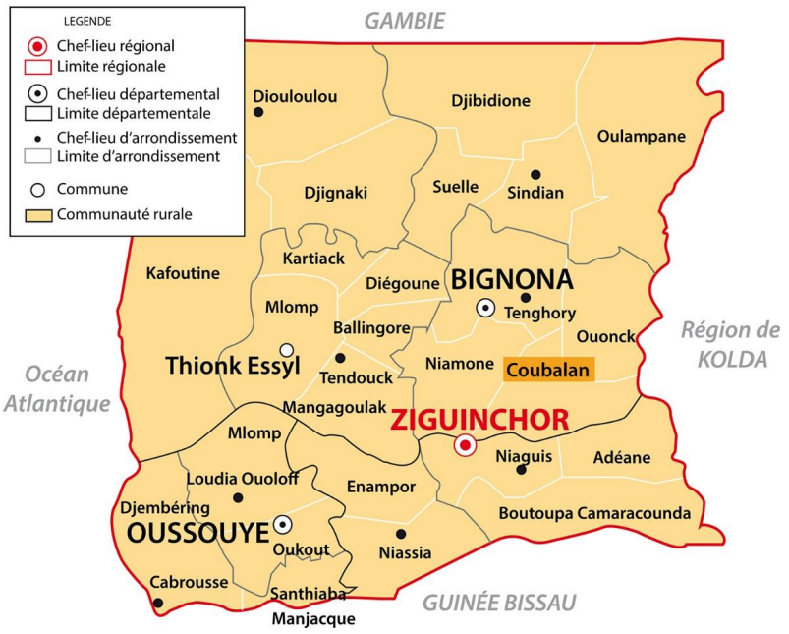
Fig. 1. Map of the Ziguinchor region
- Sine-Saloum
In 1984, the Fatick region was created by Law 84-22 of 22 February, dividing the Sine-Saloum region into two regional entities (Kaolack and Fatick). It underwent a new administrative division introduced by Law No. 2008-14 of 18 March 2008 and covers an estimated area of 6,685 km² compared to 7,535 km² before the division. It is bordered to the east by the Kaolack region, to the south-west by the Atlantic Ocean, to the north by the Diourbel region, to the north-east by the Gossas department, to the north-west by the Thiès region (Mbour department), and to the south by the Saloum River, which flows through Foundiougne. The Fig 2 shows the map of Fatick region.
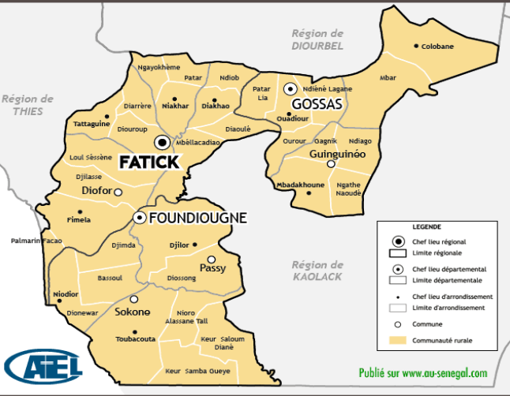
Fig. 2. The map of Fatick region.
The Kaolack region is located between 14°30' and 16°30' west longitude and 13°30' and 14°30' north latitude. Before 2008, its territory covered an area of 16,010 km², or 14% of the national territory. It was created in 1984 from the division of the former Sine-Saloum region, but its configuration is the result of the 2008 reforms following the establishment of the former Kaffrine department as a region, and those of 2010 and 2011. It covers an area of 5,289 km², or approximately 2.8% of the national territory. It is located between the southern Sahelian zone and the northern Sudanese zone, forming the heart of the peanut basin together with the regions of Kaffrine, Fatick and Diourbel (Agence Nationale de la Statistique et de la Démographie, 2023). The Fig. 2 shows the map of Fatick region. The Fig. 2 shows the map of Fatick region.
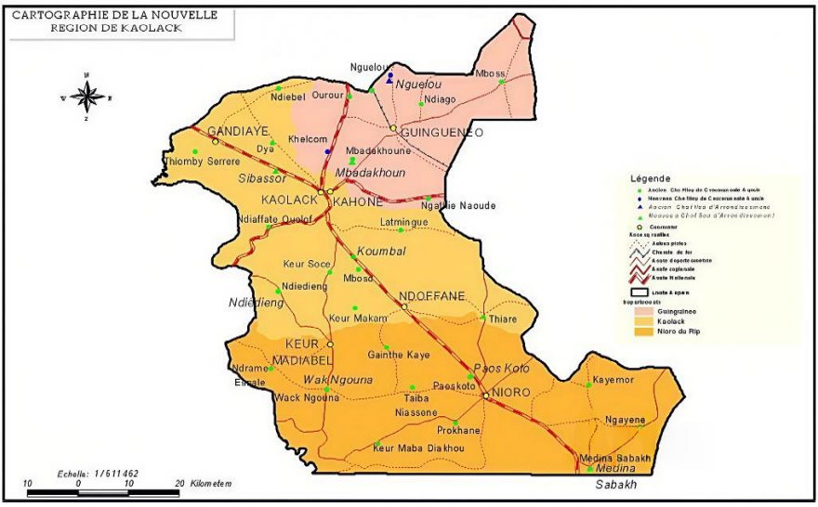
Fig.3. The map of Kaolack region
2.2 Study period
The survey covered the period from February to April 2023. It mainly involved administering the survey questionnaire to participants selected primarily on the basis of their popularity and consent.
2.3 Type of Study
The study was conducted in the form of individual surveys of herbalists, traditional healers, and individuals designated by their communities as custodians of traditional knowledge.
2.4 Botanical Identification
Most of the plants were identified in the field. The identifications were then confirmed at the Botany and Pharmacognosy Laboratory of Cheikh Anta Diop University using reference works such as Berhaut's La Flore du Sénégal and the APG III and IV classification at the family level.
2.5 Data Processing
To process the data collected, we used the method of calculating percentages or citation frequencies (CF), which is the ratio of the number of times the species was cited (n) to the total number of players (N).
CF= n/N

3. RESULTS AND DISCUSSION
3.1 Results
A total of 94 traditional practitioners were interviewed (45 in Casamance and 49 in Sine-Saloum). The medicinal plant sector is dominated by men: 100% of tradipraticians in Casamance and 96% in Sine-Saloum, giving an overall average of 98%.
Participants aged over 40 represented the majority: 89% in Casamance and 81% in Sine-Saloum. The most represented age groups were those aged 40–60 (40% in Casamance and 34% in Sine-Saloum) and 60–80 (49% and 47% respectively). Fig. 4 shows Distribution of actors by age.

Fig. 4. Distribution of actors by age
In Casamance, 28 plants were cited (Table 1), with the following frequencies of citation: Sarcocephalus latifolia 17.65% (6/34 actors), Terminalia macroptera 14.71% (5/34), Cordyla pinnata 11.76% (4/34), Ficus exasperata, Psorospermum senegalensis and Securida longepedunculata 5.88% (2/34), 6.12% (3/49). All other species in the list have a frequency of 2.94% (one actor). Tables 1 shows Plants cited for treating asthenia in Casamance.
Table 1. Plants cited for treating asthenia in Casamance
 | Latin binomial | Parts used | Preparation
1 | Adansonia digitata (Bombacaceae) | Barks | Massage
2 | Cassia sieberiana (Caesalpiniaceae) | Roots | Maceration
3 | Casuarina equisetifolia (Myrtaceae) | Leaves | Infusion
4 | Citrus aurantifolia (Rubiaceae) | Leaves /fruits | Infusion
5 | Combretum micranthum (Combretaceae) | Roots | Maceration
6 | Cordyla pinnata (Caesalpiniaceae) | Roots | Infusion
7 | Cucurbita pepo (Cucurbitaceae) | Fruits | Decoction
8 | Daniellia oliveri (Caesalpiniaceae) | Roots | Infusion
9 | Ekebergia capensis (Meliaceae) | Stem | Maceration
10 | Ficus exasperata (Moraceae) | Roots | Infusion
11 | Gardenia ternifolia (Rubiaceae) | Roots | Maceration
12 | Hibiscus sabdariffa (Malvaceae) | Fruit | Infusion
13 | Khaya senegalensis (Meliaceae) | Leaves | Infusion
14 | Leptadenia hastata (Caesalpiniaceae) | Leaves | Infusion
15 | Leptoderris fasciculata (Fabaceae) | Roots | Maceration
16 | Opilia amentacea (Opiliaceae) | Roots | Maceration
17 | Pericopsis laxiflora (Fabaceae) | Roots | Maceration
18 | Prosopis africana (Fabaceae) | Roots | Infusion
19 | Psorospermum senegalense (Hypericaceae) | Leaves | Infusion
20 | Pterocarpus erinaceus (Fabaceae) | barks | Maceration
21 | Saba senegalensis (Apocynaceae) | Dead leaf | Infusion
22 | Sarcocephalus latifolia (Rubiaceae) | Roots | Maceration
23 | Securidaca longepedunculata (Polygalaceae) | Roots | Massage
24 | Spondias mombin (Anacardiaceae) | Roots | Infusion
25 | Strychnos spinosa (Sterculiaceae) | Roots | Maceration
26 | Terminalia macroptera (Combretaceae) | Barks | Infusion
27 | Trichilia prieureana (Meliaceae) | Leaves | Infusion
28 | Vitex doniana (Verbenaceae) | Dead leaf | Infusion

In Sine Saloum, 28 plants were cited (Table 2), with the following frequencies of citation: Ficus thonningii 55.10% (27/49 actors), Pterocarpus erinaceus 46.94% (23/49), Lepisanthes senegalensis 38.77% (19/49), Grewia bicolor 20.40% (10/49), Cassia italica and Prosopis africana 10.20% (5/49), Pennisetum glaucum 8.16% (4/49), Adansonia digitata 6.12% (3/49), Arachis hypogea, Hibiscus sabdariffa, and Khaya senegalensis 4.08% (2/49). All other species in the inventory have a frequency of 2.04% (i.e. 1/49). Tables 2 shows Plants cited for treating asthenia in Sine-saloum.
Table 2. Plants cited for treating asthenia in Sine-saloum.
 | Latin binomial | Parts used | Preparation
1 | Acacia seyal (Mimosaceae) | Barks | Decoction
2 | Adansonia digitata (Bombacaceae) | Fruit/ Leaves | Maceration
3 | Anacardium occidentale (Anacardiaceae) | Barks | Decoction
4 | Arachis hypogea (Fabaceae) | Seeds | Maceration
4 | Arachis hypogea (Fabaceae) | Seeds | Massage oil
5 | Cassia italica (Caesalpiniaceae) | Leaves | Powder maceration
5 | Cassia italica (Caesalpiniaceae) | Roots | Decoction
6 | Ekebergia capensis (Meliaceae) | Barks | Decoction
7 | Erythrophleum suaveolens (Caesalpiniaceae) | Barks | Decoction
8 | Ficus sur Forssk (Moraceae) | Leaves | Decoction
9 | Ficus sycomorus(Moraceae) | Barks | Maceration
10 | Ficus thonningii (Moraceae) | Barks | Decoction, Maceration or infusion
11 | Flemingia faginea (Fabaceae) | Leaves | Decoction
12 | Grewia bicolor (Tiliaceae) | Barks | Decoction or Maceration
13 | Hexalobus monopetalus (Annonaceae) | Barks | Decoction
14 | Hibiscus sabdariffa (Malvaceae) | Leaves | Maceration
15 | Khaya senegalensis (Sapindaceae) | Barks | Decoction
16 | Lepisanthes senegalensis (Sapindaceae) | Leaves | Decoction, infusion or maceration
17 | Pennisetum glaucum (Poaceae) | Seeds | Soak the flour and consume raw or prepare porridge
18 | Prosopis africana (Mimosaceae) | Barks | Decoction ou maceration
19 | Pterocarpus erinaceus (Fabaceae) | Leaves | Decoction
19 | Pterocarpus erinaceus (Fabaceae) | Barks | Maceration or infusion
20 | Saba senegalensis (Apocynaceae) | Fruit | Ripe fruit
21 | Salacia senegalensis (Celastraceae) | Leaves | Decoction
22 | Stereospermum kunthianum (Bignoniaceae) | Barks | Maceration
23 | Zanthoxylum zanthoxyloides (Rutaceae) | Roots | Maceration

Data analysis reveals a diversity of plant parts used in the treatment of asthenia in patients living with HIV. Roots are the most frequently used part (27.6%), followed by leaves and bark (25.9% each).
Fruits account for 8.6% of recorded uses, while stems, petals and seeds are used infrequently (1.7% each). In terms of preparation methods, maceration is the most common (39%), followed by infusion (30.5%) and decoction (25.4%). Massage, accounting for 5.1% of practices, is a marginal method of administration. Overall, oral administration remains predominant, reflecting a preference for aqueous preparations intended for the extraction of active ingredients, while external use remains limited (Fig. 5).

Fig. 5. Distribution according to the parts of plants used
3.2. Discussion
This study highlights the importance of herbal medicine in the management of asthenia among people living with HIV in Senegal. Ethnobotanical data show a wide variety of plant parts used and methods of preparation, which is consistent with the findings of other studies conducted in sub-Saharan Africa (Kabou et al., 2025). For example, a Ugandan study also showed widespread use of leaves and roots for remedies to treat conditions related to immunosuppression, mainly taken orally and using aqueous preparations such as decoctions and infusions (Ikinyom et al., 2023).
The predominance of roots and bark observed in our results reflects a trend that has often been documented in ethnopharmacological literature (Diatta et al., 2024). Indeed, in some surveys conducted in Africa, these plant parts are frequently cited by traditional practitioners for the general management of HIV-related manifestations and opportunistic infections, probably due to their richness in bioactive secondary metabolites (Kabou et al., 2025; Ikinyom et al., 2023).
However, the literature also highlights the sustainability issues associated with the intensive exploitation of these organs, which can lead to increased pressure on plant populations if conservation measures are not put in place (Ng'weshemi, 2025).
The significant use of leaves in our study is also consistent with ethnobotanical surveys across Africa, where this part of the plant is often favoured for its accessibility, rapid regeneration and substantial content of antioxidants and potentially tonic nutrients (Diatta et al., 2024; Nakibuuka, 2022). The scarcity of fruits, seeds, and petals likely reflects their secondary or specific role in certain traditional recipes, rather than a systemic action on asthenia.
With regard to preparation methods, the predominance of maceration and infusion shows a marked preference for simple methods of water extraction, as also reported in other ethnobotanical contexts (Camara et al., 2025). These preparations are perceived as effective in releasing the active ingredients while avoiding the thermal degradation of certain fragile compounds. Although less frequently used in our survey, decoction remains a classic method for extracting constituents from harder parts such as roots and bark, which explains its substantial presence in local practices (Diatta et al., 2024).
The marginal use of massage illustrates the existence of complementary approaches, sometimes associated with holistic perceptions of fatigue, although less well documented in ethnopharmacological literature.
Previous studies also indicate that plants traditionally used to support immunity in HIV patients may contain specific active ingredients. For example, Hypoxis hemerocallidea (African potato) and Sutherlandia frutescens are reported to be popular immunostimulatory plants in the traditional treatment of HIV and its symptoms, highlighting the potential pharmacological interest of certain species used in herbal medicine (Olarewaju, 2022). Other studies show that traditional plant extracts often contain compounds with antimicrobial and antioxidant properties, which may contribute to improving patients' overall condition (Noura et al., 2025 and Muntean et al., 2023).
Finally, it should be noted that the use of plants as a complement to antiretroviral drugs raises important questions regarding safety, therapeutic interactions and adherence to standard treatment. Some studies suggest that the use of herbal remedies may decrease over the course of antiretroviral treatment, calling for better integration of traditional knowledge into public health programmes and further research on plant-drug interactions (Marwa et al., 2024).
4. Conclusion
This study highlights the importance of herbal medicine in the traditional management of asthenia among people living with HIV in Senegal, through a significant diversity of medicinal plants and therapeutic practices. The results highlight the predominance of roots, leaves and bark, as well as the widespread use of oral aqueous preparations. The convergence of these practices with those reported in other African contexts highlights the ethnopharmacological potential of several species identified. However, the intensive exploitation of certain plant organs and their concomitant use with antiretroviral therapies raise issues of sustainability and safety. These data provide a relevant basis for targeted phytochemical and pharmacological investigations, as well as for the rational integration of traditional knowledge into public health strategies.
Disclaimer (Artificial Intelligence)
Author(s) hereby declare that NO generative AI technologies such as Large Language Models (ChatGPT, COPILOT, etc) and text-to-image generators have been used during writing or editing of this manuscript.
References
Abubakar, A. M., & Ibrahim, R. B. (2019). Review of medicinal plants with antianaemic activity found in Nigeria. Scholars International Journal of Biochemistry, 2(8), 225–229.
Bombardier, C. H., & Buchwald, D. (1996). Chronic fatigue, chronic fatigue syndrome, and fibromyalgia: disability and health-care use. Medical care, 34(9): 924-930.
Brurberg, K.G., Fønhus, M.S., Larun, L, Flottorp, S., Malterud, K (2014). Case definitions for chronic fatigue syndrome/myalgic encephalomyelitis (CFS/ME): a systematic review. BMJ Open, 4 (2), Article e003973.
Camara, M., Camara, A., Bah, T., Wague, I., Diané, S., Balde, A., & Baldé, E. (2025). Étude ethnobotanique et screening phytochimique des plantes médicinales utilisées dans la gestion traditionnelle des symptômes associés à la COVID-19 en Basse Guinée. European Scientific Journal, ESJ, 21(36), 128. https://doi.org/10.19044/esj.2025.v21n36p12
Coulibaly, O. (2020). Study of anemia associated with HIV/AIDS in the infectious diseases department of the Point “G” University Hospital (Doctoral dissertation, Medical thesis, Faculty of Medicine and Odontostomatology of Mali, USTTB).
Diatta, K., Diatta, W., Mbaye, A. I., Sarr, A., Dieng, S. I. M., Seck, A., & Fall, A. D. (2024). Phytotherapy anti-diabetic: Ethnobotanical surveys among in the district of Mbour (Senegal). Asian Journal of Research in Botany, 7(2), 286–297. https://journalajrib.com/index.php/AJRIB/article/view/228
Ikinyom, N., Lamwaka, A.V., Malagala, A.T. et al. (2023). Ethnobotanical study of nutraceutical plants used to manage opportunistic infections associated with HIV/AIDS in Acholi sub-region, Northern Uganda. Trop Med Health, 51 (50), 1-25. https://doi.org/10.1186/s41182-023-00540-w
Kabou, M.L., Diatta, K., Thiaw, M.B., Manga, F., Diop, N., Diouf, M.D., Mbaye, A.I., Diatta, W., Sarr, A., Dieng, S.I.M., Faye, E.H.O., Manga, I., and Fall A.D. (2025). “Phytotherapy of Anaemia in Individuals Infected With Human Immunodeficiency Virus: An Ethnobotanical Survey in Lower Casamance and Sine-Saloum in Senegal”. Asian Journal of Research in Botany 8 (2):682– 692. https://doi.org/10.9734/ajrib/2025/v8i2297 .
Marwa, K. J., Kadodo, J., Iddi, S., Kapesa, A. (2024). Herbal medicines use among HIV/AIDS patients on antiretroviral therapy and its influence on viral suppression and CD4 count: A survey at a tertiary hospital in Tanzania. Public Health Pract (Oxf). 2024 Apr 4,7,100492. doi: https://doi.org/10.1016/j.puhip.2024.100492 . PMID: 38595639; PMCID: PMC11002646.
Muntean, D., & Vulpie, S. (2023). Antioxidant and Antibacterial Activity of Plant Extracts. Antibiotics, 12(7), 1176. https://doi.org/10.3390/antibiotics12071176
Nakibuuka, M. M., & Mugabi, R. (2022). Ethnobotanical study of indigenous nutri-medicinal plants used for the management of HIV/AIDS opportunistic ailments among the local communities of central Uganda. Scientific African, 16, e01245.
National Agency for Statistics and Demography (ANSD) [Senegal], & ICF. (2018). Senegal: Continuous Demographic and Health Survey (DHS-Continuous 2017). https://dhsprogram.com/publications/publication-FR345-DHS-Final-Reports.cfm
National Agency for Statistics and Demography. (2018). Economic and social situation of the Ziguinchor region, 2017–2018 edition. https://core.ac.uk/download/pdf/442646955.pdf
National Agency for Statistics and Demography. (2023). Economic and social situation of the Ziguinchor region, 2022–2023 edition. ANSD. https://www.ansd.sn/publications/ses-regionales/ses-regionale-ziguinchor-2022-2023-24-mar-2025
Ng'weshemi, K. Z., Banyikwa, A. T., Makangara, J. J., Shadrack, D. M., & Mafumiko, F. M. S. (2025). A review of ethnobotanical plants that are used for HIV management in Southern Africa. South African Journal of Botany, 181, 24-31.
Noura, I.A.E., Hanaa, M.S., Galal, A.G., Ahmed, I.E.D., and Ashraf, M.S. (2025). Chemical Composition, Antioxidant and Antimicrobial Activity of Various Therapeutic Plant Aqueous Extracts. Egypt. J. Chem , 68(8),305-317. DOI: https://doi.org/10.21608/ejchem.2024.339017.10875 .
Olarewaju, O. O., Fajinmi, O. O., Naidoo, K. K., Arthur, G. D., & Coopoosamy, R. M. (2022). A review of the medicinal plants with immune-boosting potential. Journal of Medicinal Plants for Economic Development, 6(1), 158.
World Health Organization (WHO) (2018). UNAID Data 2018. World Health Organization, Geneva
Zhang, Y., Jin, F., Wei, X., Jin, Q., Xie, J., Pan, Y and Shen, W. (2022). Chinese herbal medicine for the treatment of chronic fatigue syndrome: A systematic review and meta-analysis. Front. Pharmacol. 13:958005. doi: 10.3389/fphar.2022.958005.

