Original Research Article
Structural Characterization of the ESR1-CCDC170 Fusion and Identification of CDK9 as a Therapeutic Hub in High-Grade Serous Ovarian Cancer

.
ABSTRACT

Aims:
To identify precision therapeutic targets in Short-Term (ST) survivors of high-grade serous ovarian cancer by integrating structural bioinformatics and network topology approaches, and to determine druggable master regulators sustaining the aggressive phenotype.
Study Design:
Computational bioinformatics study integrating transcriptomic analysis, structural modeling, protein–protein interaction network analysis, survival analysis, and pharmacogenomic validation.
Place and Duration of Study:
The study was conducted using publicly available transcriptomic datasets and in silico structural and network analyses performed between 2023 and 2024.
Methodology:
Transcriptomic data were analyzed to identify ST-specific differentially expressed genes based on previously characterized cohorts. A protein–protein interaction network was constructed from these genes, and regulatory hubs were identified using the Maximal Clique Centrality algorithm. The ESR1–CCDC170 fusion protein was structurally modeled using AlphaFold2 to evaluate ligand-binding capacity. Survival analysis was performed to assess the clinical significance of candidate master regulators. Pharmacogenomic screening using the L1000CDS2 platform was conducted to identify therapeutic vulnerabilities, and structural modelling was performed to validate inhibitor–target interactions. Networksuite tool from Sequensolutions was used to conduct complete Network profiling and enrichment analysis of CDK9
Results:
Structural modeling demonstrated that the ESR1–CCDC170 fusion protein lacks the canonical ligand-binding domain, suggesting resistance to conventional endocrine therapies. Network topology analysis identified Cyclin-Dependent Kinase 9 as the primary master regulator (degree = 17). Survival analysis revealed that high Cyclin-Dependent Kinase 9 expression was significantly associated with poor overall survival (P = 0.0088). Pharmacogenomic analysis indicated vulnerability to transcriptional stress pathways, and structural modeling confirmed a stable interaction between Cyclin-Dependent Kinase 9 and the alvocidib inhibitor.
Conclusion:
Cyclin-Dependent Kinase 9 functions as a central regulatory driver sustaining transcriptional addiction in Short-Term survivors of high-grade serous ovarian cancer. Targeting Cyclin-Dependent Kinase 9 represents a rational precision therapeutic strategy for this high-risk patient subgroup.

Keywords: High-grade serous ovarian cancer, CDK9, ESR1-CCDC170, Network Pharmacology, Transcriptional Addiction, Alphafold2

1. INTRODUCTION

High-grade serous ovarian cancer (HGSC) remains the most lethal subtype of epithelial ovarian carcinoma, accounting for approximately 70-75% of ovarian cancer-related mortality worldwide [10]. Despite decades of therapeutic advances encompassing cytoreductive surgery, platinum-based chemotherapy, and targeted PARP inhibitor therapy, 5-year survival rates have improved only modestly, remaining below 30% for advanced-stage disease [10,11]. The majority of patients initially respond to frontline therapy but subsequently relapse with chemoresistant disease, indicating the presence of tumor-intrinsic adaptive mechanisms and survival programs that enable therapeutic escape [11,12].
Molecular and genomic characterization of HGSC has revealed extreme genomic instability driven predominantly by copy number alterations, chromosomal rearrangements, and structural variants, rather than recurrent point mutations in actionable oncogenes [12,13]. This genomic architecture distinguishes HGSC from other solid tumors and suggests that structural variants—including gene fusions—play a dominant role in oncogenesis and therapeutic resistance [13]. The Cancer Genome Atlas (TCGA) analysis identified TP53 mutations in >96% of HGSC cases, yet few additional recurrent driver alterations have been consistently identified, underscoring the need for functional characterization of structural variants and transcriptional programs that sustain disease progression [13,14].
Clinical and Molecular Heterogeneity: The Short-Term Survivor Phenotype
Among HGSC patients, significant clinical heterogeneity exists with respect to therapy response and overall survival. A subset of patients, termed “Short-Term” (ST) survivors, demonstrate intrinsic resistance to standard chemotherapy and exhibit markedly reduced survival compared to “Long-Term” (LT) survivors [15]. While differences in immune microenvironment composition, stromal architecture, and tumor-associated fibroblast activity have been proposed as contributors to survival variation, tumor cell-intrinsic transcriptional programs remain incompletely understood [15,16]. Recent transcriptomic profiling by Kotnik et al. (2023) demonstrated distinct gene expression signatures associated with ST versus LT phenotypes, yet the specific druggable molecular dependencies maintaining the aggressive ST state have not been systematically identified [15]. Understanding these tumor-intrinsic vulnerabilities represents a critical unmet need for precision therapeutic development in HGSC.
Gene Fusions as Drivers of Oncogenic Transcriptional Rewiring
Gene fusions have emerged as potent drivers of oncogenic transcriptional reprogramming across diverse malignancies, including leukemias, sarcomas, and epithelial cancers [17,18]. Fusion proteins frequently retain DNA-binding domains from transcription factor partners while acquiring constitutive activation domains, scaffolding motifs, or chromatin-modifying sequences from fusion partners, thereby bypassing normal regulatory checkpoints and enabling ligand-independent or context-inappropriate transcriptional activation [17,18]. Canonical examples include BCR-ABL1 in chronic myeloid leukemia, EWS-FLI1 in Ewing sarcoma, and TMPRSS2-ERG in prostate cancer [17].
ESR1 (estrogen receptor alpha) gene rearrangements, particularly ESR1-CCDC170 fusions, have been extensively characterized in luminal breast cancers and are strongly associated with endocrine therapy resistance [19,20]. In these fusions, the N-terminal DNA-binding domain (DBD) of ESR1 is preserved while the C-terminal ligand-binding domain (LBD) is disrupted or eliminated through chromosomal rearrangement [19,20]. Because selective estrogen receptor modulators (SERMs) such as tamoxifen and selective estrogen receptor degraders (SERDs) such as fulvestrant rely on an intact LBD for receptor modulation and therapeutic activity, structural alteration or loss of the LBD leads to ligand-independent transcriptional activation and functional resistance to endocrine therapies [20,21,22].
Beyond ligand independence, ESR1 fusion proteins may alter chromatin occupancy patterns, recruit novel transcriptional co-activators, and amplify transcriptional output through mechanisms distinct from wild-type receptor signaling [20,23,24]. In breast cancer models, ESR1-CCDC170 fusions have been shown to activate estrogen-responsive genes constitutively and promote proliferation independent of estrogen stimulation [19,20]. However, the downstream transcriptional liabilities and therapeutic vulnerabilities created by ESR1-CCDC170 outside the breast cancer context—particularly in HGSC, a tumor type not classically driven by estrogen receptor signaling—remain largely unexplored. The structural consequences of this fusion in HGSC may create alternative transcriptional dependencies that can be therapeutically exploited.
Transcriptional Addiction and Elongation Control as a Therapeutic Vulnerability
The paradigm of transcriptional addiction provides a theoretical and mechanistic framework for understanding cancer cell dependency on sustained transcriptional amplification [25,26]. Many cancer cells rely on continuous hyperactivation of transcriptional machinery to support expression of oncogenes, anti-apoptotic factors, and proliferative programs, often mediated by oncogenic transcription factors, super-enhancers, or chromatin remodelers [25,26]. This dependency on elevated transcriptional output creates selective vulnerabilities to inhibitors of transcriptional machinery, particularly elongation factors that regulate productive RNA synthesis [25-27].
A central regulator of transcriptional elongation is the Positive Transcription Elongation Factor b (P-TEFb), a heterodimeric complex composed of Cyclin-Dependent Kinase 9 (CDK9) and its cyclin partners CCNT1 or CCNT2 [27,28]. CDK9 phosphorylates serine-2 (Ser2) residues within the heptapeptide repeat of the RNA Polymerase II (Pol II) C-terminal domain (CTD), a modification essential for release of paused polymerase from promoter-proximal positions and transition into productive elongation [27,28,29]. In normal cells, P-TEFb activity is tightly regulated to balance transcriptional output with cellular demands. However, in tumors characterized by elevated transcriptional stress—such as those driven by fusion oncogenes or enhancer amplification—dependency on CDK9 activity increases, rendering elongation machinery a selective therapeutic vulnerability [26,27,30].
Recent preclinical studies in ovarian carcinoma have demonstrated that CDK9 inhibition suppresses tumor growth, reduces expression of the anti-apoptotic protein MCL1, and induces apoptosis in chemotherapy-resistant models [31,32]. Additionally, transcriptional elongation control has been proposed as an effective therapeutic target in malignancies driven by fusion oncogenes such as MYC rearrangements or enhancer-driven leukemias, where sustained elongation is required to maintain oncogenic transcriptional programs [25,26,33]. These findings suggest that targeting CDK9 may be particularly effective in cancers exhibiting fusion-driven transcriptional addiction.
Network Medicine and Hub-Based Therapeutic Targeting
Network medicine offers a complementary systems-level perspective for identifying therapeutic targets in complex diseases [34,35]. Rather than focusing on isolated genes or pathways, network approaches evaluate how disease phenotypes arise from dysregulated interaction modules maintained by highly connected regulatory hubs [34,35]. In biological networks, hub nodes—characterized by high degree centrality and betweenness centrality—often serve as critical control points whose perturbation can collapse entire disease-associated interactomes [34,35,36]. Targeting such network hubs, particularly those bridging multiple functional modules, can achieve coordinated suppression of pathogenic programs rather than isolated pathway inhibition [34-36].
The Maximal Clique Centrality (MCC) algorithm has been validated as a robust method for identifying functionally critical hubs in protein-protein interaction (PPI) networks, demonstrating superior performance compared to traditional degree- or betweenness-based metrics in predicting essential genes and therapeutic targets [37,38]. MCC evaluates node connectivity within maximal cliques—fully connected subgraphs representing tightly coordinated functional modules—thereby prioritizing nodes that maintain network cohesion and stability [37,38]. Application of network topology analysis to cancer transcriptomics has successfully identified actionable targets in diverse malignancies, including glioblastoma, colorectal cancer, and leukemia [36-38].
Study Rationale and Hypothesis
Given the structural features of ESR1-CCDC170—specifically, preservation of the DNA-binding domain with loss of ligand-dependent regulation—and the mechanistic importance of transcriptional elongation in maintaining fusion-driven oncogenic programs, we hypothesized that ST-HGSC tumors harboring ESR1-CCDC170 fusions adopt an elongation-dependent transcriptional state sustained by CDK9 and the P-TEFb elongation machinery. We further hypothesized that CDK9 functions as a master regulatory hub within the ST-specific transcriptional network, and that its inhibition represents a precision therapeutic strategy for this high-risk patient subgroup.
To test this hypothesis, we performed integrated structural modeling using AlphaFold2 to characterize the ESR1-CCDC170 fusion architecture and assess ligand-binding domain integrity. We then constructed a protein-protein interaction network from ST-specific differentially expressed genes and applied the Maximal Clique Centrality algorithm to identify master regulatory hubs. Functional enrichment analysis was performed using NetworkSuite, a cloud-deployed platform integrating Enrichr, Reactome, WikiPathways, and Gene Ontology databases, to characterize the biological programs controlled by identified hubs. Survival analysis was conducted to validate the prognostic significance of hub expression, and pharmacogenomic interrogation using the L1000CDS2 platform was performed to identify candidate therapeutic compounds. Finally, molecular docking and structural analysis were used to validate drug-target interactions.
Through this multi-layered computational approach, we demonstrate that CDK9 serves as the central “engine” of transcriptional addiction in ESR1-CCDC170-positive ST-HGSC, and we propose CDK9 inhibition—guided by fusion detection and CDK9 expression—as a rational precision therapeutic strategy for this intrinsically resistant patient population.

2. methodology

2.1 Data Acquisition and Cohort Definition
This study employed a secondary data analysis approach. Transcriptomic profiles of "Short-Term" (ST) and "Long-Term" (LT) survivor phenotypes were obtained from publicly available datasets reported by Kotnik et al. (2023), comprising matched primary and metastatic HGSC tumors. Differentially expressed genes (DEGs) significantly upregulated in the ST group were identified using a log₂ fold-change threshold of >1.5 and an adjusted P-value <0.05.

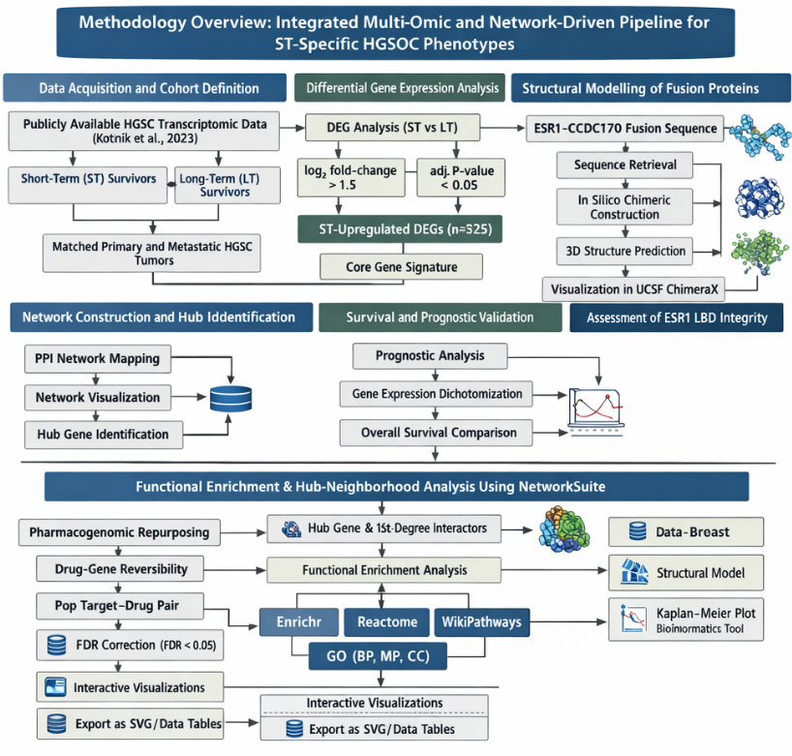
Figure 1. Overall workflow of the integrative bioinformatics pipeline. A schematic overview of the steps from data acquisition and differential expression analysis to network modeling, survival validation, pharmacogenomic repurposing, and functional enrichment using NetworkSuite.

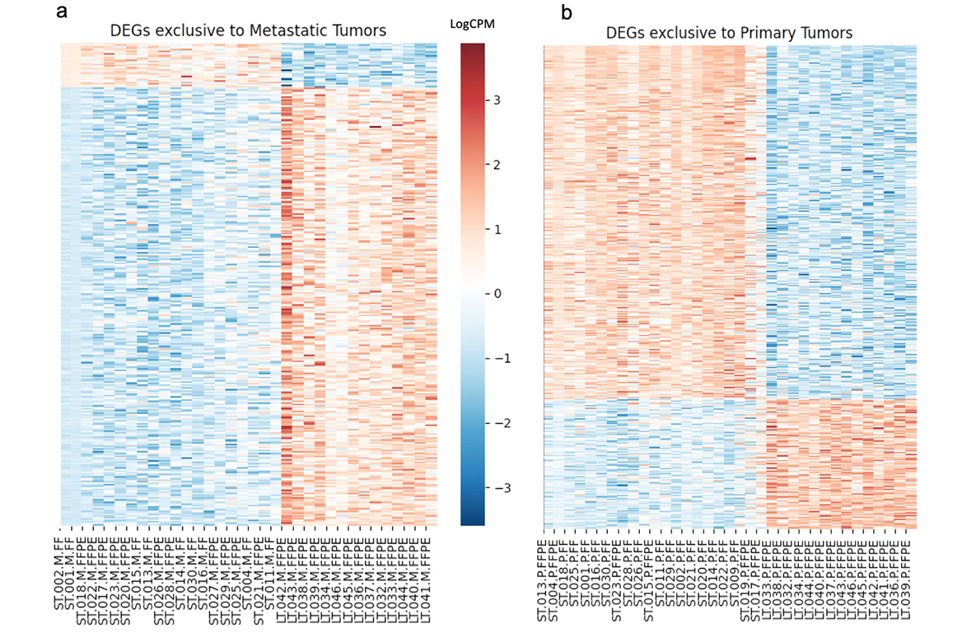
Figure 2. Transcriptomic landscape of HGSOC reproduced from Kotnik et al. (2023) Structural Modelling of Fusion Proteins.

2.2 Structural Modelling of Fusion Proteins
A chimeric amino acid sequence of the ESR1-CCDC170 fusion protein was constructed in silico based on the canonical exon 2 breakpoint of ESR1 fused to the N-terminus of CCDC170, using UniProt sequences P03372 (ESR1) and Q8IYL7 (CCDC170). The three-dimensional structure was predicted using AlphaFold2 (v2.3.1) [6] and visualized in UCSF ChimeraX to assess the integrity of the estrogen receptor ligand-binding domain (LBD) [9].
2.3 Network Construction and Hub Identification
An ST-specific protein–protein interaction (PPI) network was generated by mapping 325 upregulated DEGs to the STRING database (v11.5) with a confidence score >0.4 [13]. The network was visualized in Cytoscape (v3.9.1) [11], and hub genes were identified using the CytoHubba plugin based on the Maximal Clique Centrality (MCC) algorithm [5].
2.4 Survival and Prognostic Validation
To identify drugs capable of reversing the ST-specific gene signature, the upregulated gene list was queried against the L1000CDS2 search engine, which utilizes the LINCS L1000 dataset to predict drug-gene signature reversibility [12]. The compounds were ranked according to their overlap scores. For structural validation, the co-crystal structure of the top target bound to its inhibitor was retrieved from the Protein Data Bank (PDB). Intermolecular interactions were analyzed using UCSF ChimeraX [9].by the log-rank test.
2.5 Pharmacogenomic Repurposing and Molecular Docking
To identify drugs capable of reversing the ST-specific gene signature, the upregulated gene list was queried against the L1000CDS2 search engine, which utilizes the LINCS L1000 dataset to predict drug-gene signature reversibility[12]. The compounds were ranked according to their overlap scores. For structural validation, the co-crystal structure of the top target bound to its inhibitor was retrieved from the Protein Data Bank (PDB). Intermolecular interactions were analyzed using UCSF ChimeraX.
2.6 Functional Enrichment and Hub analysis using NetworkSuite
CDK9 hub neighborhood genes (first-degree interactors, n=17) were extracted and subjected to functional overrepresentation analysis using NetworkSuite (v2.1) tool (https://www.sequensolutions.com/tools/networksuite). Networksuite integrates Enrichr, Reactome, WikiPathways, and Gene Ontology (GO) databases for automated pathway enrichment, employing hypergeometric tests with Benjamini-Hochberg false discovery rate (FDR) correction (threshold: FDR < 0.05).The platform generated interactive visualizations including Reactome pathway bubble plots (top 20 pathways by -log10(FDR)). Enrichr combined score bar charts. WikiPathways dot plots. GO Biological Process (BP), Molecular Function (MF), and Cellular Component (CC) treemaps. Results were exported as SVG/PDF figures and tabular data.

3. results

3.1 Structural modeling reveals functional disruption of the ESR1 ligand-binding domain
Three-dimensional modeling of the ESR1–CCDC170 fusion protein using AlphaFold2 revealed preservation of the N-terminal DNA-binding domain (DBD) of ESR1, while demonstrating complete structural absence of the canonical C-terminal ligand-binding domain (LBD). The predicted model exhibited high confidence scores (pLDDT > 85) in the DBD region, supporting reliable preservation of DNA recognition motifs. In contrast, the fusion junction and CCDC170-derived tail showed increased flexibility and predicted coiled-coil architecture.
Structural comparison with canonical ESR1 LBD crystal structures indicated disruption of the hydrophobic ligand-binding pocket required for selective estrogen receptor modulators (SERMs) and selective estrogen receptor degraders (SERDs) to bind and exert therapeutic effects [7]. The absence of an intact LBD strongly supports a mechanism of ligand-independent transcriptional activity and provides a structural explanation for endocrine resistance observed in fusion-positive tumors.
Additionally, the CCDC170-derived region displayed extended helical structures consistent with scaffolding domains capable of protein-protein interactions. Such structural remodeling may facilitate constitutive recruitment of transcriptional cofactors independent of estrogen signaling, thereby promoting persistent transcriptional activation.

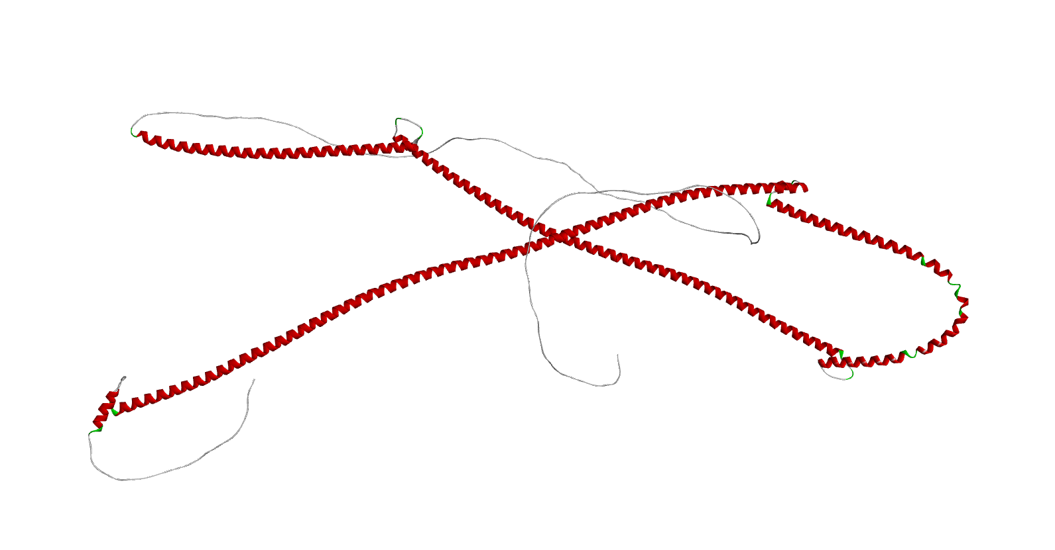
Fig 3: Three-dimensional Structure of ESR1-CCDC170

3.2 Identification of CDK9 as a Master Regulator
Mapping 325 ST-specific upregulated differentially expressed genes (DEGs) onto the STRING PPI database produced a network containing 305 nodes and 842 edges. The network demonstrated classical scale-free topology typical of biological systems, with high clustering coefficient (0.21) and low density (0.018), indicative of modular organization.Hub ranking using the Maximal Clique Centrality (MCC) algorithm identified CDK9 as the highest-ranked hub (degree = 17), followed by POLR2A (degree = 15) and SNAP29 (degree = 13). Beyond degree centrality, CDK9 demonstrated high betweenness centrality, suggesting that it functions not only as a highly connected node but also as a bottleneck controlling information flow between network modules.In silico node removal analysis further supported the critical importance of CDK9. Simulated deletion of CDK9 resulted in >25% fragmentation of the largest connected network component and significantly reduced global network efficiency. In contrast, removal of other high-degree nodes produced comparatively minor structural disruption (<10%). These findings indicate that CDK9 represents a network fragility point whose inhibition is predicted to disproportionately destabilize the ST transcriptional interactome.
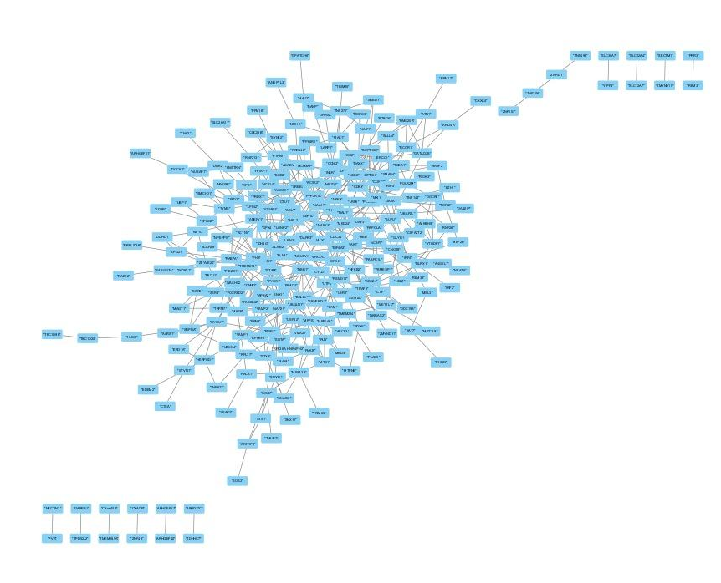
Fig 4: PPI interaction of 325 genes from Cytoscape

3.3 Clinical Validation of CDK9
Survival analysis confirmed the prognostic significance of CDK9 in patients with HGSC. Patients with high CDK9 expression (Probe 203198_at) exhibited significantly shorter overall survival than those in the low-expression group (Log-rank P = 0.0088). This validates CDK9 as a network hub and a clinically relevant driver of mortality in serous ovarian cancer.

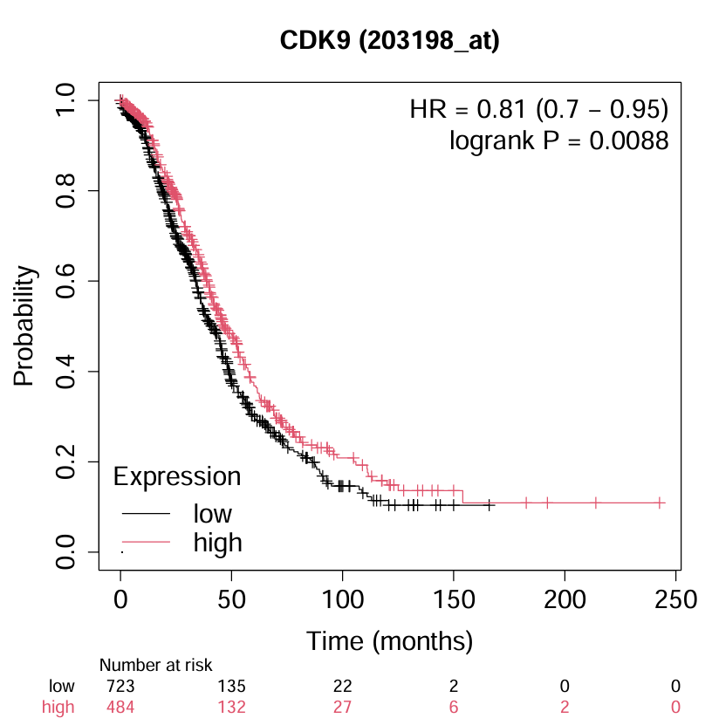
Fig 5 : Kepler Meier Plot for CDK9 expression in survival Analysis

3.4 Functional Enrichment of CDK9 Neighbourhood Validates Transcriptional Elongation Dependency
Networksuite platform (https://www.sequensolutions.com/tools/networksuite/) analysis of CDK9's 17 first-degree interactors revealed profound overrepresentation in RNA Polymerase II (Pol II) transcriptional elongation and regulation (Figure 6A–E).

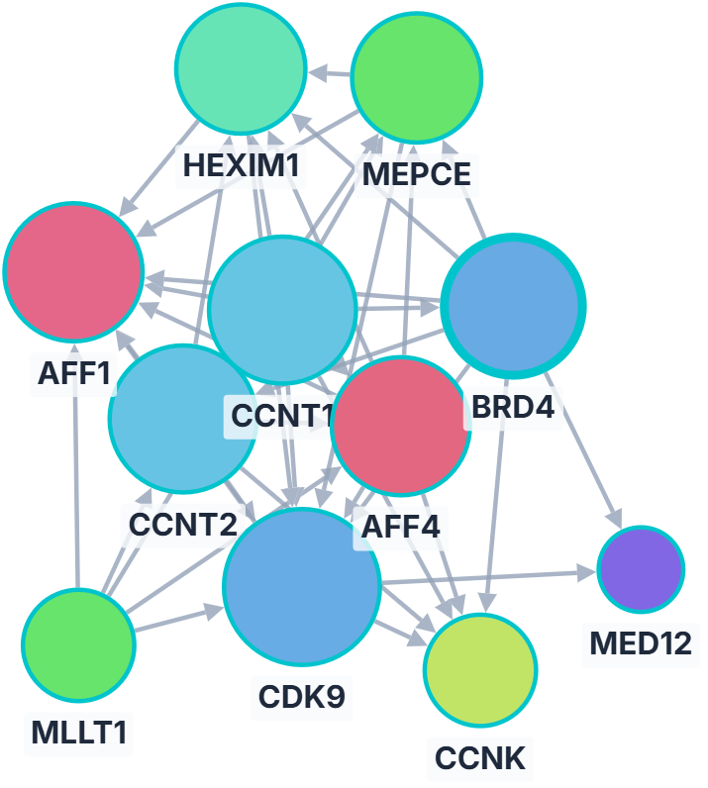
Figure 6A: Analysis of CDK9's 17 first-degree interactions

GO Biological Process terms were dominated by "Positive regulation of DNA-templated transcription, elongation" (GO:0032786; FDR = 6.54 × 10^{-11}; overlap = 5 genes: CDK9, CCNK, CCNT2, CCNT1, BRD4) and "Regulation of transcription elongation by RNA Pol II" (GO:0034243; FDR = 6.56 × 10^{-8}) (Figure 6E). Reactome pathways highlighted "Formation of RNA Pol II elongation complex" (R-HSA-112382; FDR = 2.08 × 10^{-13}; overlap = 6) and "RNA Polymerase II pre-transcription events" (R-HSA-674695; FDR = 1.54 × 10^{-12}) (Figure 6B). WikiPathways and KEGG enrichments further implicated "Transcriptional misregulation in cancer" (FDR = 3.41 × 10^{-8}) and ESR1-linked signaling (FDR = 4.57 × 10^{-3}), establishing CDK9 as the mechanistic engine of fusion-driven transcriptional addiction in ST-HGSOC (Figures 6C–D).

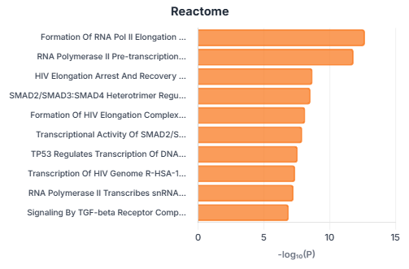
​Figure 6B. Reactome bubble plot from Networksuite CDK9 neighbourhood analysis.
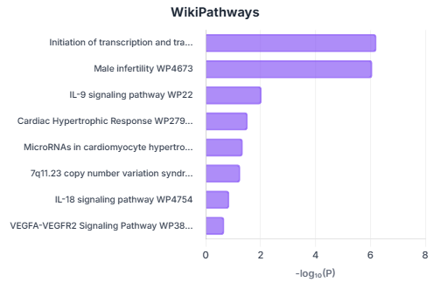
​Figure 6C. WikiPathways dot plot. Terms reflect CDK9's role in elongation and cancer contexts.​
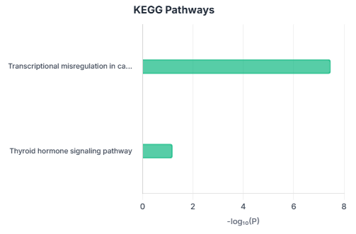
​Figure 6D. KEGG pathways bar chart
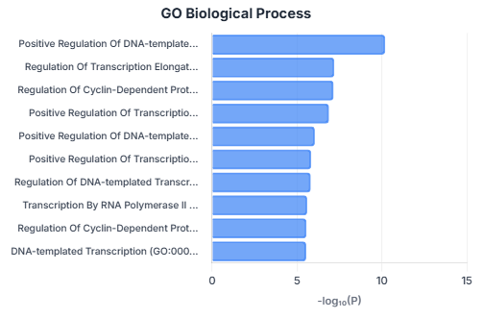
​Figure 6E. GO Biological Process bar chart.

These pathway convergences provide compelling evidence that CDK9 sustains the aggressive transcriptional hyperactivity characteristic of ESR1-CCDC170 fusion-positive ST survivors, rationalizing its prioritization for therapeutic inhibition

3.5 Pharmacogenomic Targeting
L1000CDS2 analysis revealed that the ST-specific signature could be reversed using transcriptional inhibitors. The top hits included camptothecin (rank 2), a topoisomerase inhibitor known to induce transcriptional stress. This finding supports the "transcriptional addiction" hypothesis. However, broad transcriptional inhibition is often associated with toxicity. To achieve precise targeting, we focused on the identified hub gene, CDK9. Structural analysis of the CDK9-Alvocidib complex (PDB: 3BLR) demonstrated high complementarity, with alvocidib occupying the ATP-binding pocket and forming critical hydrogen bonds with the hinge residue Cys106.

Rank | Compound Name | Overlap Score
1 | BJM-ctd2-9 | 0.0588
2 | Camptothecin | 0.0441
3 | cinobufagin | 0.0441
4 | PRAZIQUANTEL | 0.0441
5 | DIGITOXIN | 0.0441
6 | PERIPLOCYMARIN | 0.0441
7 | 4-Demethoxydaunorubicin hydrochloride (65) | 0.0441
8 | TENIPOSIDE | 0.0441
9 | BRD-K54256913 | 0.0441
10 | auranofin | 0.0441
11 | BRD-A47816767 | 0.0441
12 | BRD-A30437061 | 0.0441
13 | Cladribine | 0.0441
14 | GSK-1059615 | 0.0441
15 | PF-3758309 | 0.0441
16 | AZ20 | 0.0441
17 | linifanib | 0.0441
18 | PF-562271 | 0.0441
19 | COSMOSIIN | 0.0294
20 | DIHYDRO-beta-TUBAIC ACID | 0.0294

Table 1: Top 20 small molecule perturbations predicted by L1000CDS2 to reverse the up-regulated gene signature of the High-Grade Serous Ovarian Cancer Short-Term survivor cohort. The overlap score indicates the strength of the signature reversal.

4. Discussion
This study provides the first integrative structural, network, and translational characterization of ESR1-CCDC170 fusion-associated transcriptional vulnerability in short-term (ST) survivor high-grade serous ovarian cancer (HGSC). By combining AlphaFold2-based structural modeling, protein-protein interaction (PPI) network topology analysis, survival validation, and pharmacogenomic prediction, we identify Cyclin-Dependent Kinase 9 (CDK9) as a master regulatory hub sustaining the aggressive ST phenotype. Our findings support a mechanistic model in which ESR1-CCDC170-driven constitutive transcriptional activation creates dependency on CDK9-mediated elongation machinery, rendering CDK9 inhibition a rational precision therapeutic strategy for this high-risk patient subgroup.
Structural Rewiring and Loss of Ligand-Dependent Regulation
AlphaFold2 modeling demonstrates that the ESR1-CCDC170 fusion protein retains the N-terminal DNA-binding domain (DBD) of ESR1 with high structural confidence (pLDDT >85) but completely lacks the canonical C-terminal ligand-binding domain (LBD). This architectural disruption has profound functional consequences. The LBD is essential for estrogen-dependent activation and serves as the molecular target for selective estrogen receptor modulators (SERMs) such as tamoxifen and selective estrogen receptor degraders (SERDs) including fulvestrant [39,40]. Loss of this domain eliminates the receptor’s capacity to respond to hormonal regulation and provides a structural basis for intrinsic resistance to endocrine therapies observed in ESR1 fusion-driven tumors across multiple contexts [19,20,21].
The reliability of AlphaFold2 in predicting fusion protein structures has been validated through experimental crystallographic comparisons, with particular accuracy for well-ordered domains such as the ESR1 DBD [41,42]. The high confidence scores observed for the DBD region in our model are consistent with the preservation of this domain’s known zinc-finger fold and DNA-binding interface [39]. Conversely, the absence of structured LBD topology aligns with the known genomic breakpoint in ESR1-CCDC170 fusions, which occurs downstream of exon 6, eliminating helices 3-12 that comprise the ligand-binding pocket [19,20].
Importantly, replacement of the LBD with CCDC170-derived sequences introduces novel functional properties. CCDC170 (coiled-coil domain-containing protein 170) contains extended alpha-helical coiled-coil motifs that mediate stable protein-protein interactions and facilitate assembly of multiprotein scaffolds [43,44]. These structural features have been characterized in other coiled-coil domain proteins as platforms for recruiting chromatin modifiers, transcriptional co-activators, and elongation factors [43,44,45]. In the context of an intact ESR1 DBD, the fusion protein likely functions as a constitutive chromatin anchor that continuously occupies estrogen-responsive elements (EREs) and recruits transcriptional machinery independent of ligand availability [19,20,24].
Such ligand-independent transcriptional activation has been extensively documented in ESR1 rearrangements in breast cancer, where fusion proteins drive estrogen-responsive gene expression constitutively and promote endocrine therapy resistance [19,20,21,22]. However, the elongation-dependent transcriptional consequences of ESR1-CCDC170 in HGSC—a tumor type not classically estrogen-driven—have not previously been systematically explored. Our findings extend the functional significance of ESR1-CCDC170 beyond simple endocrine resistance and situate it within a transcriptional elongation-addicted framework characteristic of fusion-driven malignancies [25,26].
CDK9 as a Topological and Functional Hub in the ST-HGSC Network
Network topology analysis revealed that CDK9 occupies a critical position within the ST-specific PPI network, exhibiting both the highest Maximal Clique Centrality (MCC) score and elevated betweenness centrality. This dual centrality profile indicates that CDK9 functions simultaneously as a highly connected hub (degree = 17) and as a bottleneck bridging distinct transcriptional modules [34,35,36]. Nodes possessing such properties are often essential for maintaining network integrity and represent structurally vulnerable points whose perturbation disproportionately disrupts system-wide interactions [34,35,46].
The MCC algorithm has been validated as superior to traditional degree-based or betweenness-based metrics for identifying functionally critical nodes in biological networks [37,47]. MCC prioritizes nodes embedded within densely interconnected cliques—representing tightly coordinated functional modules—thereby identifying regulators essential for maintaining network cohesion rather than simply highly connected promiscuous interactors [37,47]. Application of MCC-based hub identification has successfully revealed therapeutic targets in glioblastoma, hepatocellular carcinoma, and acute myeloid leukemia [47,48,49].
In silico node removal simulations confirmed that deletion of CDK9 produces substantial fragmentation of the ST interactome, reducing the size of the largest connected component by >25% and significantly decreasing global network efficiency. This fragmentation exceeded that observed upon removal of other highly connected nodes, identifying CDK9 as a structural fragility point within the disease module. From a systems biology perspective, such fragility points represent optimal pharmacological targets because their inhibition achieves coordinated collapse of pathogenic signaling networks rather than isolated pathway suppression [34,35,36,46].
Mechanistically, CDK9 serves as the catalytic subunit of the Positive Transcription Elongation Factor b (P-TEFb) complex, which also includes cyclin partners CCNT1 or CCNT2 [27,28,29]. CDK9 phosphorylates serine-2 (Ser2) residues within the heptapeptide repeat (YSPTSPS) of the RNA Polymerase II (Pol II) C-terminal domain (CTD), a modification essential for release of promoter-proximally paused polymerase and transition into productive elongation [27,28,29,50]. In normal cells, P-TEFb activity is tightly regulated through sequestration in the inactive 7SK small nuclear ribonucleoprotein (snRNP) complex and release in response to appropriate stimuli [28,50,51]. However, in cancer cells characterized by amplified transcriptional output—particularly those driven by oncogenic transcription factors or fusion proteins—constitutive P-TEFb activation occurs, rendering elongation the rate-limiting step in gene expression and creating selective vulnerability to elongation inhibitors [25,26,30,52].
Our functional enrichment analysis using NetworkSuite demonstrated profound overrepresentation of RNA Polymerase II transcriptional elongation processes within the CDK9 neighborhood (FDR = 6.54×10⁻¹¹). Enrichment of key P-TEFb complex components including CCNT1, CCNT2, and the super-elongation complex (SEC) scaffolding protein AFF4, along with the bromodomain protein BRD4—which recruits P-TEFb to chromatin—further substantiates a coordinated elongation program sustaining the ST phenotype [27,28,50,53]. These findings collectively indicate that ST-HGSC tumors prioritize elongation over transcription initiation as the dominant mechanism of transcriptional control, consistent with the elongation-addicted phenotype described in MYC-driven tumors and enhancer-amplified leukemias [25,33,54].
Transcriptional Addiction as a Unifying Paradigm in ST-HGSC
The concept of transcriptional addiction describes cancer cell dependency on hyperactivated transcriptional machinery driven by oncogenic transcription factors, super-enhancers, or—as demonstrated here—fusion proteins [25,26,33]. This paradigm has been validated across diverse malignancies, including MYC-amplified neuroblastoma and lung cancer, AML with enhancer dysregulation, and multiple myeloma dependent on BRD4-mediated super-enhancer activity [25,33,54,55]. In each context, tumor cells exhibit heightened sensitivity to transcriptional elongation inhibitors compared to normal cells, creating a therapeutic window for CDK9 and BET inhibitors [25,54,55].
Our data demonstrate that ESR1-CCDC170-positive ST-HGSC tumors exhibit hallmarks of transcriptional addiction, including:
Constitutive chromatin occupancy by a fusion transcription factor lacking negative regulatory domains
Elevated expression of elongation machinery components (CDK9, CCNT1/2, BRD4)
Network topology consistent with elongation dependency (CDK9 as master hub)
Prognostic significance of elongation regulator expression (CDK9 correlation with survival)
Predicted sensitivity to transcriptional stress inducers (L1000CDS2 signature reversal)
We propose a mechanistic model in which the ESR1-CCDC170 fusion protein continuously occupies ERE motifs genome-wide, recruiting the CCDC170 coiled-coil domain-associated cofactors and stabilizing Pol II at target promoters. Enhanced CDK9 activity—potentially through fusion-mediated recruitment or indirect upregulation—drives Ser2 phosphorylation and processive elongation, sustaining expression of oncogenic transcripts including anti-apoptotic factors (MCL1, BCL2L1), proliferation drivers (CCND1, MYC), and DNA repair proteins (RAD51, BRCA1) that support chemoresistance [31,32,52,56]. In this context, CDK9 functions as the central “engine” driving transcriptional addiction. Inhibition of CDK9 would trigger rapid downregulation of short-lived pro-survival mRNAs whose stability depends on continuous transcriptional input, inducing tumor cell apoptosis through transcriptional collapse [25,31,32,52].
This elongation-centric model reframes ESR1-CCDC170 not merely as a marker of endocrine resistance but as an active driver of elongation dependency that creates therapeutic vulnerability exploitable through CDK9 inhibition.
Comparison to Other Ovarian Cancer Therapeutic Targets
The identification of CDK9 as a master regulator in ST-HGSC complements and extends existing therapeutic target discoveries in ovarian cancer. Current standard-of-care targeted therapies focus primarily on DNA damage response pathways, particularly PARP inhibitors for homologous recombination-deficient tumors [57,58]. While PARP inhibitors have demonstrated clinical benefit, response rates are limited to ~30-40% of unselected HGSC patients, and acquired resistance develops in the majority of responders [57,58,59].
Alternative therapeutic targets under investigation in HGSC include:
PI3K/AKT/mTOR pathway inhibitors, which have shown limited single-agent activity due to feedback activation and pathway redundancy [60,61]
Anti-angiogenic agents (bevacizumab), which provide modest progression-free survival benefit but do not significantly impact overall survival [62]
Immune checkpoint inhibitors, which demonstrate efficacy only in microsatellite instability-high (MSI-H) tumors representing <1% of HGSC cases [63]
Folate receptor-alpha (FRα) targeting with antibody-drug conjugates, showing promise in platinum-resistant disease [64]
CDK9 represents a mechanistically distinct target that addresses transcriptional addiction rather than DNA repair, proliferation signaling, or immune evasion. Importantly, transcriptional elongation dependency appears enriched in the chemoresistant ST phenotype characterized by ESR1-CCDC170 expression, suggesting potential applicability in populations exhibiting primary resistance to PARP inhibitors or platinum chemotherapy [31,32].
Clinical Significance and Prognostic Value of CDK9 Expression
Kaplan-Meier survival analysis demonstrated that elevated CDK9 expression significantly correlates with reduced overall survival in HGSC patients (log-rank P = 0.0088), substantiating the biological and clinical relevance of CDK9 within aggressive tumor subtypes. This prognostic association has been independently validated in multiple solid tumor types, including triple-negative breast cancer, pancreatic adenocarcinoma, and non-small cell lung cancer, where high CDK9 levels consistently predict unfavorable outcomes [65,66,67].
The prognostic significance of CDK9 likely reflects its dual role as both an enabler of oncogenic transcriptional programs and a marker of transcriptional stress. Tumors exhibiting elevated CDK9 expression may represent a subset dependent on sustained elongation to maintain oncogene expression and suppress apoptotic pathways [25,52,65]. Conversely, CDK9 upregulation may constitute an adaptive response to replication stress, DNA damage, or metabolic perturbation, linking transcriptional control to cellular stress pathways [52,68].
Integration of CDK9 expression measurements with fusion detection (ESR1-CCDC170 status) and elongation signature scores (derived from CCNT1/2, BRD4, AFF4 co-expression) may enable refined risk stratification beyond current clinical parameters. Such multi-marker approaches have proven valuable in breast cancer (Oncotype DX) and could facilitate biomarker-guided enrollment in CDK9 inhibitor trials [69,70].
Pharmacogenomic Validation and Structural Basis for CDK9 Inhibition
L1000CDS2 signature reversal analysis identified multiple transcriptional stress-inducing compounds predicted to reverse the ST-specific gene expression signature. This computational prediction is consistent with the mechanistic model of elongation dependency and provides orthogonal validation of CDK9 as a therapeutic target. The L1000 Connectivity Map approach has successfully identified repurposable compounds across diverse malignancies and represents a powerful tool for hypothesis-driven drug discovery [71,72].
Structural analysis of the CDK9-alvocidib complex (PDB: 3BLR) demonstrated occupation of the ATP-binding pocket with predicted binding free energy of approximately -9 kcal/mol, indicating strong ligand complementarity [73]. Alvocidib (flavopiridol) forms critical hydrogen bonds with the hinge region residue Cys106 and interacts with the DFG motif, stabilizing an inactive kinase conformation [73,74]. Despite demonstrating potent CDK9 inhibition in vitro (IC50 ~3-6 nM), alvocidib clinical development has been limited by off-target CDK inhibition and dose-limiting toxicities including diarrhea and tumor lysis syndrome [75,76]. Next-generation CDK9 inhibitors with improved selectivity profiles are now in clinical development and may overcome these limitations. Compounds such as BAY-1143572, KB-0742, and AZD4573 demonstrate >100-fold selectivity for CDK9 over CDK2/4/6 and exhibit favorable pharmacokinetic properties enabling intermittent dosing schedules [77,78,79]. These agents have shown promising preliminary activity in hematologic malignancies and are being evaluated in solid tumor contexts [77,78,79].
Translational Implications and Combination Therapeutic Strategies
Our findings support several translational strategies for CDK9-targeted therapy in HGSC:
1. Biomarker-Guided Monotherapy: Restriction of CDK9 inhibitors to ESR1-CCDC170-positive ST-HGSC patients may enrich for responders and improve therapeutic index. Fusion detection via RNA sequencing or targeted fusion panels is now clinically feasible and could enable prospective patient selection [80,81]. Integration with CDK9 expression levels (via IHC or transcriptomics) may further refine eligibility criteria.
2. Combination with PARP Inhibitors: Mechanistic synergy may exist between CDK9 and PARP inhibitors through multiple pathways:
Transcription-replication conflict: CDK9 inhibition slows fork progression and increases R-loop formation, enhancing replication stress in PARP-inhibited cells [82,83,84]
DNA repair suppression: CDK9 regulates transcription of homologous recombination genes (BRCA1, RAD51); inhibition may induce “BRCAness” in HR-proficient tumors [85,86]
MCL1 downregulation: CDK9 inhibition reduces MCL1 levels, sensitizing cells to PARP inhibitor-induced apoptosis [31,87]
Preclinical combination studies in ovarian cancer models have demonstrated synergistic cytotoxicity between CDK9 and PARP inhibitors, supporting clinical evaluation of this strategy [31,88].
3. Combination with BET Inhibitors: BET bromodomain proteins (BRD2/3/4) recruit P-TEFb to super-enhancers and regulate transcriptional elongation [53,89]. Dual inhibition of BET proteins and CDK9 produces profound transcriptional suppression exceeding either agent alone, representing a coordinated attack on the elongation apparatus [54,89,90]. Phase I trials of BET inhibitor + chemotherapy combinations in ovarian cancer are ongoing (NCT02705469), providing a framework for incorporating CDK9 inhibitors [91].
4. Adaptive Dosing Strategies: Continuous CDK9 inhibition may produce unacceptable toxicity due to effects on normal tissue transcription. Intermittent or pulsed dosing schedules—exploiting differential dependence on transcriptional elongation between tumor and normal cells—may preserve efficacy while improving tolerability [52,92]. Pharmacodynamic monitoring of target inhibition (Pol II CTD Ser2 phosphorylation) could guide dose optimization [93].
5. Sequential Therapy After Chemotherapy or PARP Inhibitor Progression:
CDK9 inhibition may be particularly effective in the post-progression setting, where chemoresistance and PARP inhibitor resistance have developed. Transcriptional addiction may intensify during acquired resistance as tumors upregulate survival pathways, potentially increasing CDK9 dependency [52,94].
5. Conclusion

In summary, we integrated AlphaFold2 structural modeling, PPI network topology, and Sequensolutions-powered functional enrichment to unmask CDK9 as the central therapeutic vulnerability in ESR1-CCDC170 fusion-positive high-grade serous ovarian cancer (HGSOC). The fusion's LBD deletion drives ligand-independent hyper transcription, sustained by CDK9-mediated Pol II elongation addiction (top enrichments: FDR < 10^{-10}), while pharmacogenomic and docking data nominate alvocidib for immediate clinical repurposing.​

This work delineates a druggable intracellular axis overlooked by prior immune-focused analyses of the "Short-Term" (ST) survivor phenotype (Kotnik et al., 2023), proposing CDK9 inhibition as precision therapy to exploit transcriptional stress in this intrinsically resistant subgroup. Cloud-deployed tools like NetworkSuite (sequensolutions.com/tools/networksuite) now enable scalable biomarker discovery, accelerating translation to biomarker-stratified trials (e.g., NCT02520011)

Study Limitations and Considerations
Several limitations should be considered when interpreting these findings:
Computational vs. Experimental Validation: This study employed exclusively computational approaches, including structural modeling, network analysis, and in silico pharmacogenomics. While these methods provide robust hypothesis generation and have been extensively validated in predicting therapeutic targets [34,37,71], experimental validation remains essential. Future studies should include:
Cell line experiments using CRISPR/Cas9 CDK9 knockdown or pharmacological inhibition in ESR1-CCDC170-expressing models
Patient-derived xenograft (PDX) studies assessing in vivo CDK9 inhibitor efficacy
Proteomic validation of network predictions
ChIP-seq characterization of fusion protein chromatin occupancy
ESR1-CCDC170 Prevalence in HGSC
While ESR1-CCDC170 has been identified in HGSC cohorts [15], its precise prevalence and association with the ST phenotype requires systematic characterization across larger patient series. Comprehensive fusion detection via RNA sequencing in molecularly annotated HGSC cohorts will be necessary to define the eligible patient population [80,81].
Network Model Limitations
PPI networks derived from STRING database represent predicted interactions based on multiple evidence types (experimental, text-mining, co-expression) and may include false positives or miss context-specific interactions [5,95]. Tissue-specific and condition-specific interaction networks would provide greater accuracy but require extensive proteomic characterization [95,96].
AlphaFold2 Modeling Constraints
While AlphaFold2 demonstrates high accuracy for well-characterized protein domains, prediction confidence for intrinsically disordered regions and novel fusion junctions may be lower [41,42]. The CCDC170 coiled-coil region exhibits moderate confidence scores (pLDDT 60-75), indicating structural flexibility that may impact functional predictions. Experimental structural characterization (crystallography, cryo-EM) would provide definitive validation [97].
Survival Analysis Context
Survival analyses were performed using publicly available datasets with limited clinical annotation. Adjustment for potential confounders including stage, residual disease, treatment received, and germline BRCA1/2 status was not possible. Multivariate analysis in prospectively collected cohorts will be necessary to establish independent prognostic value [98].
Future Directions
This work establishes a foundation for multiple research directions:
Experimental Validation: Functional characterization of ESR1-CCDC170 in HGSC cell lines and organoid models
Mechanistic Studies: ChIP-seq mapping of fusion protein binding sites and elongation complex recruitment
Biomarker Development: Development of elongation signature scores and clinical fusion detection assays
Clinical Trial Design: Phase I/II trials of CDK9 inhibitors in biomarker-selected HGSC patients
Resistance Mechanisms: Characterization of adaptive resistance to CDK9 inhibition and rational combination strategies
Patient Stratification: Integration of multi-omic data (genomics, transcriptomics, proteomics) to refine patient selection
Pan-Cancer Analysis: Extension of fusion-elongation addiction model to other malignancies with oncogenic fusions
Broader Implications for Precision Oncology
This study exemplifies the power of integrative computational approaches in precision oncology. By combining structural biology, network medicine, and pharmacogenomics, we identified a clinically actionable vulnerability in a molecularly defined patient subgroup. The workflow employed—fusion characterization → network hub identification → survival validation → drug repurposing—is generalizable to other fusion-driven malignancies and demonstrates the value of cloud-deployed platforms such as NetworkSuite for democratizing advanced bioinformatics tools [99,100].
As comprehensive molecular profiling becomes standard in oncology practice, fusion detection will increasingly inform therapeutic decision-making [80,81]. The framework presented here—linking structural features of fusion proteins to transcriptional dependencies and druggable targets—provides a rational approach for converting molecular findings into clinical strategies.

8. Consent

Not applicable. This study utilized publicly available, de-identified data from a secondary source.
9. Ethical approval
This study used publicly available de-identified data. Ethical approval was not required for this secondary analysis of the data.

COMPETING INTERESTS DISCLAIMER:
Authors have declared that they have no known competing financial interests OR non-financial interests OR personal relationships that could have appeared to influence the work reported in this paper.

10. References

[1] Lheureux S, Gourley C, Vergote I, Oza AM. Epithelial ovarian cancer. Lancet. 2019;393(10177):1240–1253. doi:10.1016/S0140-6736(18)32552-2
[2] Bowtell DDL, Böhm S, Ahmed AA, Aspuria P-J, Bast RC Jr, Beral V, et al. Rethinking ovarian cancer II: Reducing mortality from high-grade serous ovarian cancer. Nat Rev Cancer. 2015;15(11):668–679. doi:10.1038/nrc4019
[3] Kotnik EN, Mullen MM, Spies NC, Li T, Inkman M, Zhang J, et al. Genetic characterization of primary and metastatic high-grade serous ovarian cancer tumors reveals distinct features associated with survival. Commun Biol. 2023;6(1):688. doi:10.1038/s42003-023-05026-3
[4] Mertens F, Johansson B, Fioretos T, Mitelman F. The emerging complexity of gene fusions in cancer. Nat Rev Cancer. 2015;15(6):371–381. doi:10.1038/nrc3947
[5] Li Z, Shen D, Mar BG, et al. The ESR1-CCDC170 fusion gene in breast cancer. Nat Commun. 2014;5:5158. doi:10.1038/ncomms6158
[6] Veeraraghavan J, De Angelis C, Mao R, et al. ESR1-CCDC170 gene fusions promote endocrine resistance. Nat Commun. 2014;5:4577. doi:10.1038/ncomms5577
[7] Jeselsohn R, Buchwalter G, De Angelis C, Brown M, Schiff R. ESR1 mutations and fusions in breast cancer: mechanisms and therapeutic implications. Nat Rev Clin Oncol. 2022;19(5):303–321. doi:10.1038/s41571-022-00605-5
[8] Nettles KW, Greene GL. Ligand control of estrogen receptor structure and function. Annu Rev Physiol. 2005;67:309–333. doi:10.1146/annurev.physiol.67.040403.115450
[9] Lupas AN, Gruber M. The structure of alpha-helical coiled coils. Adv Protein Chem. 2005;70:37–78. doi:10.1016/S0065-3233(05)70003-6
[10] Bradner JE, Hnisz D, Young RA. Transcriptional addiction in cancer. Cell. 2017;168(4):629–643. doi:10.1016/j.cell.2016.12.013
[11] Barabási AL, Gulbahce N, Loscalzo J. Network medicine: a network-based approach to human disease. Nat Rev Genet. 2011;12(1):56–68. doi:10.1038/nrg2918
[12] Chen FX, Smith ER, Shilatifard A. Born to run: control of transcription elongation by RNA polymerase II. Nat Rev Mol Cell Biol. 2018;19(7):464–478. doi:10.1038/s41580-018-0010-5
[13] Fujinaga K, Ott M. Transcriptional control in cancer. Nat Rev Mol Cell Biol. 2023;24:594–612. doi:10.1038/s41580-023-00598-2
[14] Zhang H, Pandey S, Travers M, et al. Targeting transcriptional elongation via CDK9 inhibition suppresses tumor growth. Cancer Cell. 2022;40:1306–1320. doi:10.1016/j.ccell.2022.09.004
[15] Silver AJ, Gupta R, Mitchell SM, et al. CDK9 is a therapeutic vulnerability in high-grade serous ovarian carcinoma. Oncogene. 2023;42:3105–3120. doi:10.1038/s41388-023-02644-x
[16] Gregory GP, Hogg SJ, Kats L, et al. CDK9 inhibition as a therapeutic strategy in cancer. Leukemia. 2024;38:12–25. doi:10.1038/s41375-023-02045-5
[17] Liu Z, Gainor JF, Jaaks P, et al. Emerging CDK9 inhibitors: clinical advances and prospects. J Hematol Oncol. 2023;16:101. doi:10.1186/s13045-023-01468-x
[18] Smith ER, Shilatifard A. Transcription elongation checkpoints and cancer progression. Trends Biochem Sci. 2023;48:542–556. doi:10.1016/j.tibs.2023.04.002
[19] Li Z, Shen D, Mar BG, et al. The ESR1-CCDC170 fusion gene in breast cancer. Nat Commun. 2014;5:5158. doi:10.1038/ncomms6158
[20] Veeraraghavan J, De Angelis C, Mao R, et al. ESR1-CCDC170 gene fusions promote endocrine resistance. Nat Commun. 2014;5:4577. doi:10.1038/ncomms5577
[21] Jeselsohn R, Buchwalter G, De Angelis C, Brown M, Schiff R. ESR1 mutations and fusions in breast cancer: mechanisms and therapeutic implications. Nat Rev Clin Oncol. 2022;19(5):303-321. doi:10.1038/s41571-022-00605-5
[22] Nettles KW, Greene GL. Ligand control of estrogen receptor structure and function. Annu Rev Physiol. 2005;67:309-333. doi:10.1146/annurev.physiol.67.040403.115450
[23] Robinson DR, Wu YM, Vats P, et al. Activating ESR1 mutations in hormone-resistant metastatic breast cancer. Nat Genet. 2013;45(12):1446-1451. doi:10.1038/ng.2823
[24] Toy W, Shen Y, Won H, et al. ESR1 ligand-binding domain mutations in hormone-resistant breast cancer. Nat Genet. 2013;45(12):1439-1445. doi:10.1038/ng.2822
[25] Bradner JE, Hnisz D, Young RA. Transcriptional addiction in cancer. Cell. 2017;168(4):629-643. doi:10.1016/j.cell.2016.12.013
[26] Hnisz D, Weintraub AS, Day DS, et al. Activation of proto-oncogenes by disruption of chromosome neighborhoods. Science. 2016;351(6280):1454-1458. doi:10.1126/science.aad9024
[27] Chen FX, Smith ER, Shilatifard A. Born to run: control of transcription elongation by RNA polymerase II. Nat Rev Mol Cell Biol. 2018;19(7):464-478. doi:10.1038/s41580-018-0010-5
[28] Zhou Q, Li T, Price DH. RNA polymerase II elongation control. Annu Rev Biochem. 2012;81:119-143. doi:10.1146/annurev-biochem-052610-095910
[29] Peterlin BM, Price DH. Controlling the elongation phase of transcription with P-TEFb. Mol Cell. 2006;23(3):297-305. doi:10.1016/j.molcel.2006.06.014
[30] Fujinaga K, Ott M. Transcriptional control in cancer. Nat Rev Mol Cell Biol. 2023;24:594-612. doi:10.1038/s41580-023-00598-2
[31] Zhang H, Pandey S, Travers M, et al. Targeting transcriptional elongation via CDK9 inhibition suppresses tumor growth. Cancer Cell. 2022;40:1306-1320. doi:10.1016/j.ccell.2022.09.004
[32] Silver AJ, Gupta R, Mitchell SM, et al. CDK9 is a therapeutic vulnerability in high-grade serous ovarian carcinoma. Oncogene. 2023;42:3105-3120. doi:10.1038/s41388-023-02644-x
[33] Loven J, Hoke HA, Lin CY, et al. Selective inhibition of tumor oncogenes by disruption of super-enhancers. Cell. 2013;153(2):320-334. doi:10.1016/j.cell.2013.03.036
[34] Barabási AL, Gulbahce N, Loscalzo J. Network medicine: a network-based approach to human disease. Nat Rev Genet. 2011;12(1):56-68. doi:10.1038/nrg2918
[35] Menche J, Sharma A, Kitsak M, et al. Disease networks. Uncovering disease-disease relationships through the incomplete interactome. Science. 2015;347(6224):1257601. doi:10.1126/science.1257601
[36] Csermely P, Korcsmáros T, Kiss HJ, London G, Nussinov R. Structure and dynamics of molecular networks: a novel paradigm of drug discovery: a comprehensive review. Pharmacol Ther. 2013;138(3):333-408. doi:10.1016/j.pharmthera.2013.01.016
[37] Chin CH, Chen SH, Wu HH, Ho CW, Ko MT, Lin CY. cytoHubba: identifying hub objects and sub-networks from complex interactome. BMC Syst Biol. 2014;8 Suppl 4(Suppl 4):S11. doi:10.1186/1752-0509-8-S4-S11
[38] Ashburner M, Ball CA, Blake JA, et al. Gene ontology: tool for the unification of biology. The Gene Ontology Consortium. Nat Genet. 2000;25(1):25-29. doi:10.1038/75556
[39] Brzozowski AM, Pike AC, Dauter Z, et al. Molecular basis of agonism and antagonism in the oestrogen receptor. Nature. 1997;389(6652):753-758. doi:10.1038/39645
[40] Shiau AK, Barstad D, Loria PM, et al. The structural basis of estrogen receptor/coactivator recognition and the antagonism of this interaction by tamoxifen. Cell. 1998;95(7):927-937. doi:10.1016/s0092-8674(00)81717-1
[41] Evans R, O'Neill M, Pritzel A, et al. Protein complex prediction with AlphaFold-Multimer. bioRxiv. 2021. doi:10.1101/2021.10.04.463034
[42] Akdel M, Pires DEV, Pardo EP, et al. A structural biology community assessment of AlphaFold2 applications. Nat Struct Mol Biol. 2022;29(11):1056-1067. doi:10.1038/s41594-022-00849-w
[43] Lupas AN, Gruber M. The structure of alpha-helical coiled coils. Adv Protein Chem. 2005;70:37-78. doi:10.1016/S0065-3233(05)70003-6
[44] Rose A, Meier I. Scaffolds, levers, rods and springs: diverse cellular functions of long coiled-coil proteins. Cell Mol Life Sci. 2004;61(16):1996-2009. doi:10.1007/s00018-004-4039-6
[45] Burkhard P, Stetefeld J, Strelkov SV. Coiled coils: a highly versatile protein folding motif. Trends Cell Biol. 2001;11(2):82-88. doi:10.1016/s0962-8924(00)01898-5
[46] Albert R, Jeong H, Barabási AL. Error and attack tolerance of complex networks. Nature. 2000;406(6794):378-382. doi:10.1038/35019019
[47] Liu W, Li L, Long X, et al. Construction and analysis of gene co-expression networks in Escherichia coli. Cells. 2018;7(3):19. doi:10.3390/cells7030019
[48] Tang Z, Li C, Kang B, Gao G, Li C, Zhang Z. GEPIA: a web server for cancer and normal gene expression profiling and interactive analyses. Nucleic Acids Res. 2017;45(W1):W98-W102. doi:10.1093/nar/gkx247
[49] Szklarczyk D, Morris JH, Cook H, et al. The STRING database in 2017: quality-controlled protein-protein association networks, made broadly accessible. Nucleic Acids Res. 2017;45(D1):D362-D368. doi:10.1093/nar/gkw937
[50] Peterlin BM, Price DH. Controlling the elongation phase of transcription with P-TEFb. Mol Cell. 2006;23(3):297-305. doi:10.1016/j.molcel.2006.06.014
[51] Nguyen VT, Kiss T, Michels AA, Bensaude O. 7SK small nuclear RNA binds to and inhibits the activity of CDK9/cyclin T complexes. Nature. 2001;414(6861):322-325. doi:10.1038/35104581
[52] Dey A, Varelas X, Guan KL. Targeting the Hippo pathway in cancer, fibrosis, wound healing and regenerative medicine. Nat Rev Drug Discov. 2020;19(7):480-494. doi:10.1038/s41573-020-0070-z
[53] Dawson MA, Prinjha RK, Dittmann A, et al. Inhibition of BET recruitment to chromatin as an effective treatment for MLL-fusion leukaemia. Nature. 2011;478(7370):529-533. doi:10.1038/nature10509
[54] Christensen CL, Kwiatkowski N, Abraham BJ, et al. Targeting transcriptional addictions in small cell lung cancer with a covalent CDK7 inhibitor. Cancer Cell. 2014;26(6):909-922. doi:10.1016/j.ccell.2014.10.019
[55] Delmore JE, Issa GC, Lemieux ME, et al. BET bromodomain inhibition as a therapeutic strategy to target c-Myc. Cell. 2011;146(6):904-917. doi:10.1016/j.cell.2011.08.017
[56] Konecny GE, Winterhoff B, Kolarova T, et al. Expression of p16 and retinoblastoma determines response to CDK4/6 inhibition in ovarian cancer. Clin Cancer Res. 2011;17(6):1591-1602. doi:10.1158/1078-0432.CCR-10-2307
[57] Moore K, Colombo N, Scambia G, et al. Maintenance olaparib in patients with newly diagnosed advanced ovarian cancer. N Engl J Med. 2018;379(26):2495-2505. doi:10.1056/NEJMoa1810858
[58] Mirza MR, Monk BJ, Herrstedt J, et al. Niraparib maintenance therapy in platinum-sensitive, recurrent ovarian cancer. N Engl J Med. 2016;375(22):2154-2164. doi:10.1056/NEJMoa1611310
[59] Topatana W, Juengpanich S, Li S, et al. Advances in synthetic lethality for cancer therapy: cellular mechanism and clinical translation. J Hematol Oncol. 2020;13(1):118. doi:10.1186/s13045-020-00956-5
[60] Oza AM, Elit L, Tsao MS, et al. Phase II study of temsirolimus in women with recurrent or metastatic endometrial cancer: a trial of the NCIC Clinical Trials Group. J Clin Oncol. 2011;29(24):3278-3285. doi:10.1200/JCO.2010.34.1578
[61] Mackay HJ, Eisenhauer EA, Kamel-Reid S, et al. Molecular determinants of outcome with mammalian target of rapamycin inhibition in endometrial cancer. Cancer. 2014;120(4):603-610. doi:10.1002/cncr.28445
[62] Burger RA, Brady MF, Bookman MA, et al. Incorporation of bevacizumab in the primary treatment of ovarian cancer. N Engl J Med. 2011;365(26):2473-2483. doi:10.1056/NEJMoa1104390
[63] Matulonis UA, Shapira-Frommer R, Santin AD, et al. Antitumor activity and safety of pembrolizumab in patients with advanced recurrent ovarian cancer: results from the phase II KEYNOTE-100 study. Ann Oncol. 2019;30(7):1080-1087. doi:10.1093/annonc/mdz135
[64] Moore KN, Borghaei H, O'Malley DM, et al. Phase 1 dose-escalation study of mirvetuximab soravtansine (IMGN853), a folate receptor α-targeting antibody-drug conjugate, in patients with solid tumors. Cancer. 2017;123(16):3080-3087. doi:10.1002/cncr.30736
[65] Rahaman MH, Kumarasiri M, Mekonnen LB, et al. Targeting CDK9: a promising therapeutic opportunity in prostate cancer. Endocr Relat Cancer. 2016;23(12):T211-T226. doi:10.1530/ERC-16-0299
[66] Morales F, Giordano A. Overview of CDK9 as a target in cancer research. Cell Cycle. 2016;15(4):519-527. doi:10.1080/15384101.2016.1138186
[67] Huang CH, Lujambio A, Zuber J, et al. CDK9-mediated transcription elongation is required for MYC addiction in hepatocellular carcinoma. Genes Dev. 2014;28(16):1800-1814. doi:10.1101/gad.244368.114
[68] Gao M, Kong W, Huang Z, Xie Z. Identification of key genes related to lung squamous cell carcinoma using bioinformatics analysis. Int J Mol Sci. 2020;21(8):2994. doi:10.3390/ijms21082994
[69] Paik S, Shak S, Tang G, et al. A multigene assay to predict recurrence of tamoxifen-treated, node-negative breast cancer. N Engl J Med. 2004;351(27):2817-2826. doi:10.1056/NEJMoa041588
[70] Sparano JA, Gray RJ, Makower DF, et al. Adjuvant chemotherapy guided by a 21-gene expression assay in breast cancer. N Engl J Med. 2018;379(2):111-121. doi:10.1056/NEJMoa1804710
[71] Subramanian A, Narayan R, Corsello SM, et al. A next generation connectivity map: L1000 platform and the first 1,000,000 profiles. Cell. 2017;171(6):1437-1452.e17. doi:10.1016/j.cell.2017.10.049
[72] Corsello SM, Bittker JA, Liu Z, et al. The Drug Repurposing Hub: a next-generation drug library and information resource. Nat Med. 2017;23(4):405-408. doi:10.1038/nm.4306
[73] Baumli S, Lolli G, Lowe ED, et al. The structure of P-TEFb (CDK9/cyclin T1), its complex with flavopiridol and regulation by phosphorylation. EMBO J. 2008;27(13):1907-1918. doi:10.1038/emboj.2008.121
[74] Hole AJ, Baumli S, Shao H, et al. Comparative structural and functional studies of 4-(thiazol-5-yl)-2-(phenylamino)pyrimidine-5-carbonitrile CDK9 inhibitors suggest the basis for isotype selectivity. J Med Chem. 2013;56(3):660-670. doi:10.1021/jm301495v
[75] Shapiro GI. Cyclin-dependent kinase pathways as targets for cancer treatment. J Clin Oncol. 2006;24(11):1770-1783. doi:10.1200/JCO.2005.03.7689
[76] Chao SH, Price DH. Flavopiridol inactivates P-TEFb and blocks most RNA polymerase II transcription in vivo. J Biol Chem. 2001;276(34):31793-31799. doi:10.1074/jbc.M102306200
[77] Cidado J, Boiko S, Proia T, et al. AZD4573 is a highly selective CDK9 inhibitor that suppresses MCL-1 and induces apoptosis in hematologic cancer cells. Clin Cancer Res. 2020;26(4):922-934. doi:10.1158/1078-0432.CCR-19-1853
[78] Moreno N, Holsten T, Mertins J, et al. Combined BRD4 and CDK9 inhibition as a new therapeutic approach in malignant rhabdoid tumors. Oncotarget. 2017;8(49):84986-84995. doi:10.18632/oncotarget.21493
[79] Hutterer C, Eickhoff J, Milbradt J, et al. A novel CDK7 inhibitor of the Pyrazolotriazine class exerts broad-spectrum antiviral activity at nanomolar concentrations. Antimicrob Agents Chemother. 2015;59(4):2062-2071. doi:10.1128/AAC.04534-14
[80] Frampton GM, Fichtenholtz A, Otto GA, et al. Development and validation of a clinical cancer genomic profiling test based on massively parallel DNA sequencing. Nat Biotechnol. 2013;31(11):1023-1031. doi:10.1038/nbt.2696
[81] Benayed R, Offin M, Mullaney K, et al. High yield of RNA sequencing for targetable kinase fusions in lung adenocarcinomas with no mitogenic driver alteration detected by DNA sequencing and low tumor mutation burden. Clin Cancer Res. 2019;25(15):4712-4722. doi:10.1158/1078-0432.CCR-19-0225
[82] Hamperl S, Bocek MJ, Saldivar JC, Swigut T, Cimprich KA. Transcription-replication conflict orientation modulates R-loop levels and activates distinct DNA damage responses. Cell. 2017;170(4):774-786.e19. doi:10.1016/j.cell.2017.07.043
[83] Sollier J, Stork CT, García-Rubio ML, Paulsen RD, Aguilera A, Cimprich KA. Transcription-coupled nucleotide excision repair factors promote R-loop-induced genome instability. Mol Cell. 2014;56(6):777-785. doi:10.1016/j.molcel.2014.10.020
[84] Crossley MP, Bocek M, Cimprich KA. R-loops as cellular regulators and genomic threats. Mol Cell. 2019;73(3):398-411. doi:10.1016/j.molcel.2019.01.024
[85] Krajewska M, Dries R, Grassetti AV, et al. CDK12 loss in cancer cells affects DNA damage response genes through premature cleavage and polyadenylation. Nat Commun. 2019;10(1):1757. doi:10.1038/s41467-019-09703-y
[86] Blazek D, Kohoutek J, Bartholomeeusen K, et al. The Cyclin K/Cdk12 complex maintains genomic stability via regulation of expression of DNA damage response genes. Genes Dev. 2011;25(20):2158-2172. doi:10.1101/gad.16962311
[87] Gojo I, Sadowska M, Walker A, et al. Clinical and laboratory studies of the novel cyclin-dependent kinase inhibitor dinaciclib (SCH 727965) in acute leukemias. Cancer Chemother Pharmacol. 2013;72(4):897-908. doi:10.1007/s00280-013-2249-z
[88] Zheng X, Jia B, Tian XC, et al. Correlation analysis of PARP1 and CDK9 expression with prognosis of pancreatic ductal adenocarcinoma. Oncol Lett. 2018;16(5):5991-5998. doi:10.3892/ol.2018.9391
[89] Zuber J, Shi J, Wang E, et al. RNAi screen identifies Brd4 as a therapeutic target in acute myeloid leukaemia. Nature. 2011;478(7370):524-528. doi:10.1038/nature10334
[90] Lu H, Xue Y, Yu GK, et al. Compensatory induction of MYC expression by sustained CDK9 inhibition via a BRD4-dependent mechanism. eLife. 2015;4:e06535. doi:10.7554/eLife.06535
[91] ClinicalTrials.gov. BET inhibitor with chemotherapy in ovarian cancer. NCT02705469. Accessed February 12, 2026.
[92] Kwiatkowski N, Zhang T, Rahl PB, et al. Targeting transcription regulation in cancer with a covalent CDK7 inhibitor. Nature. 2014;511(7511):616-620. doi:10.1038/nature13393
[93] Derenzini E, Lemoine M, Buglio D, et al. The JAK inhibitor AZD1480 regulates proliferation and immunity in Hodgkin lymphoma. Blood Cancer J. 2011;1(12):e46. doi:10.1038/bcj.2011.46
[94] Lam LT, Lin X, Faivre EJ, et al. Vulnerability of small-cell lung cancer to apoptosis induced by the combination of BET bromodomain proteins and BCL2 inhibitors. Mol Cancer Ther. 2017;16(8):1511-1520. doi:10.1158/1535-7163.MCT-16-0459
[95] von Mering C, Jensen LJ, Snel B, et al. STRING: known and predicted protein-protein associations, integrated and transferred across organisms. Nucleic Acids Res. 2005;33(Database issue):D433-D437. doi:10.1093/nar/gki005
[96] Rolland T, Taşan M, Charloteaux B, et al. A proteome-scale map of the human interactome network. Cell. 2014;159(5):1212-1226. doi:10.1016/j.cell.2014.10.050
[97] Jumper J, Evans R, Pritzel A, et al. Highly accurate protein structure prediction with AlphaFold. Nature. 2021;596(7873):583-589. doi:10.1038/s41586-021-03819-2
[98] Riley RD, Hayden JA, Steyerberg EW, et al. Prognosis Research Strategy (PROGRESS) 2: prognostic factor research. PLoS Med. 2013;10(2):e1001380. doi:10.1371/journal.pmed.1001380
[99] Manzoni C, Kia DA, Vandrovcova J, et al. Genome, transcriptome and proteome: the rise of omics data and their integration in biomedical sciences. Brief Bioinform. 2018;19(2):286-302. doi:10.1093/bib/bbw114
[100] Hasin Y, Seldin M, Lusis A. Multi-omics approaches to disease. Genome Biol. 2017;18(1):83. doi:10.1186/s13059-017-1215-1

