IDENTIFICATION OF HIGH ZINC AND IRON RICH GENOTYPES THROUGH GERMPLASM SCREENING IN RICE

Abstract: The study evaluated fifty rice germplasm entries for grain zinc (Zn), iron (Fe), manganese (Mn), and copper (Cu) concentrations at RARS, Nandyal, during Kharif 2024. The experiment was conducted in a randomised block design (RBD) with three replications. A wide range of variability was observed among the entries. Zinc content ranged from 13.74 to 37.60 ppm, with the highest Zn concentration recorded in RTCNP-111 (37.60 ppm). Iron content ranged from 3.17 to 28.54 ppm, with the maximum Fe concentration observed in RTCNP-104 (28.54 ppm), followed by RTCNP-106 (27.70 ppm). Manganese content ranged from 0.14 to 1.83 ppm, while copper content varied between 0.02 and 1.05 ppm.
Keywords: Rice, Germplasm, Zinc, Iron, Biofortification, Micronutrients
Introduction
Micronutrient malnutrition, especially deficiencies of zinc (Zn) and iron (Fe), is a major health concern in many rice-eating regions. Since polished rice contains very low levels of essential minerals, people who depend heavily on rice often suffer from “hidden hunger.” Biofortification involves developing crop varieties with higher nutrient content and is an effective and sustainable approach to address the problem (Bouis and Saltzman, 2017).
Rice has a wide range of natural genetic variation for grain micronutrients like Zn, Fe, manganese (Mn), and copper (Cu). This variability exists in landraces, traditional cultivars and germplasm collections, making them valuable sources for improving grain nutritional quality and better research work in breeding programmes like biofortification studies. Earlier studies have also reported that specific metal transporter genes help plants to take up and store micronutrients in grains, indicating a strong genetic basis for nutrient enrichment (Gregorio et al. 2000).
Screening and identifying high-Zn and Fe genotypes is an important step toward developing nutrient-rich rice varieties. Such genotypes can be used in breeding programmes, marker-assisted selection, and future biofortification initiatives. Therefore, the present study focuses on evaluating fifty (50) rice germplasm lines for their grain micronutrient content to identify promising donors for improving the better nutritional quality of rice.
Material and Methods:
Germplasm: A total of fifty rice germplasm entries were obtained from the Rice Germplasm Repository of the Plant Breeding (Rice) Department, Regional Agricultural Research Station, Nandyal. These lines were selected to represent a broad genetic diversity for grain micronutrient content.
Experimental Design and Field Management: The germplasm lines were sown in a randomized block design (RBD) in three replications during Kharif 2024 at the Regional Agricultural Research Station, Nandyal. The crop was grown with the recommended agronomic practices, including irrigation, fertilization, and pest management, which were followed to ensure uniform crop growth.
Grain Sample Collection: At physiological maturity, paddy samples were harvested from the central rows of each plot to avoid border effects. The harvested grains were collected and air-dried, dehusked, and milled using a standard rice milling machine to obtain polished rice for micronutrient analysis.
Micronutrient Analysis: Grain samples were analysed for Zn, Fe, Mn and Cu concentrations. Weighed 0.5 g of finely ground rice powder was digested using a mixture of concentrated nitric acid (HNO₃) and perchloric acid (HClO₄) following the standard wet digestion method. The micronutrient concentrations in the digested samples were estimated using an Atomic Absorption Spectrophotometer (AAS).
Quality Control: Standard reference samples and blank samples were included in each batch of analysis to ensure accuracy and precision. All measurements were repeated three times, and the mean values were used for further statistical analysis.
Data Analysis: Descriptive statistics such as mean, range, and standard deviation were calculated for each micronutrient. Analysis of variance (ANOVA) was performed to test the significance of treatment effects as per the procedure described by Gomez and Gomez (1984) to detect significant differences among germplasm lines. Correlation analysis was conducted to examine relationships among micronutrients, and genotypes with high Zn and Fe contents were identified as potential donors for biofortification breeding programmes.

Results and Discussion
Mean Performance of Rice Germplasm Lines for Micronutrient Traits:
The evaluation of fifty (50) rice germplasm lines revealed substantial genetic variability for grain micronutrients (Zn, Fe, Mn and Cu). Zinc (Zn) concentrations ranged from 13.74 to 37.60 ppm, demonstrating the presence of favourable alleles for enhanced uptake, translocation, and deposition in grains. Genotypes RTCNP-102, RTCNP-104, RTCNP-106, RTCNP-118 and RTCNP-111 with Zn >30 ppm represents valuable sources of Zn enrichment (Gregorio et al., 2000; Harvest Plus, 2014). Metal transporter genes such as ZIP, YSL, and HMA play a key role in Zn loading into grains, as reported by Ishimaru et al. (2005) and Morrissey and Guerinot (2007).
Iron (Fe) concentration ranged from 3.17 to 28.54 ppm. High-Fe genotypes RTCNP-104, RTCNP-106, RTCNP-152, and RTCNP-155 indicate the existence of natural genetic diversity for Fe enrichment. Notably, RTCNP-104, combining high Zn (34.85 ppm) and Fe (28.54 ppm), emerged as an elite donor for biofortification. Multiple Fe-associated QTLs on chromosomes 1, 3, 7, and 12 have been reported, aligning with the genotype-dependent Fe accumulation observed in this study (Stangoulis et al., 2007; Zhang et al., 2014). No strong antagonistic relationship between Zn and Fe was observed, supporting simultaneous improvement of both traits (Welch and Graham, 2004).
Mn and Cu concentrations also varied considerably, contributing to a balanced micronutrient profile. High-Mn genotypes (RTCNP-90, RTCNP-93, RTCNP-153) and high-Cu genotypes (RTCNP-105, RTCNP-162) reflect favourable physiological mechanisms for micronutrient acquisition and storage (Li et al., 2019; Jiang et al., 2008). These genotypes may serve as useful genetic material for broad-spectrum micronutrient improvement.
Overall, high-Zn and Fe lines, particularly RTCNP-104, RTCNP-106, RTCNP-118, RTCNP-142, RTCNP-146, RTCNP-150, RTCNP-154, and RTCNP-163, offer promising potential for future rice improvement programmes. Their nutritional superiority supports direct use in hybridization, QTL mapping, marker-assisted selection (MAS), and genomic-assisted breeding. This study underscores the importance of utilizing native genetic diversity from landraces and germplasm collections to develop nutrient-dense rice varieties and combat hidden hunger (Bouis et al., 2011).

Genetic Parameters for Micronutrient Traits:
The estimates of mean, range, phenotypic and genotypic coefficients of variation (PCV and GCV), broad-sense heritability, and genetic advance as percent of mean (GAM) for zinc (Zn), iron (Fe), manganese (Mn), and copper (Cu) revealed substantial genetic variability among the 50 rice germplasm lines studied (Table 2). Such wide variability is a prerequisite for effective selection and genetic improvement, particularly for rice biofortification programmes (Gregorio et al., 2000; Swamy and Kumar, 2013).
Grain zinc content recorded a mean of 25.35 ppm with a wide range from 13.74 to 37.60 ppm. The close correspondence between GCV (24.12%) and PCV (25.67%) indicates minimal environmental influence on Zn expression. High heritability (88.30%) coupled with high GAM (46.69%) suggests the predominance of additive gene action, indicating good scope for improvement through direct selection. Similar observations for grain Zn variability and inheritance have been reported earlier in rice germplasm (Anuradha et al., 2012; Babu et al., 2014).
Iron content exhibited very high variability, as reflected by high GCV (50.59%) and PCV (51.46%), along with very high heritability (96.60%) and GAM (102.43%). These results indicate strong genetic control over grain iron concentration and suggest that phenotypic selection would be highly effective. The wide range (3.17–28.54 ppm) further confirms the availability of superior genotypes for iron enrichment, consistent with earlier findings that reported multiple genomic regions governing grain Fe concentration in rice (Norton et al., 2010; Zhang et al., 2014).
Manganese and copper also showed high variability, heritability, and genetic advance. Mn recorded high heritability (91.20%) with GAM of 54.43%, while Cu exhibited the highest GCV (61.11%), PCV (61.90%), heritability (97.50%), and GAM (124.26%). Although Mn and Cu are not primary targets of global biofortification initiatives, their genetic variability contributes to balanced micronutrient composition and overall grain nutritional quality (Fageria et al., 2011).
Principal component analysis (PCA) revealed that four principal components explained 100% of the total variation among the germplasm (Table 3). The first two principal components accounted for 58.67% of the total variability, indicating that a limited number of micronutrients largely influenced genetic diversity. Factor loadings (Table 4) showed that Zn contributed strongly to PC1, Mn and Cu to PC2, and Fe to PC3, highlighting both independent and combined contributions of micronutrients to total variation. Similar PCA patterns for grain micronutrients have been reported in rice by Swamy and Kumar (2013) and Zhang et al. (2014).
The biplot (Fig. 1) based on PC1 and PC2 demonstrated wide dispersion of the 50 rice germplasm lines across all quadrants, confirming substantial genetic diversity for micronutrient traits. Genotypes positioned closer to specific trait vectors indicated higher accumulation of the corresponding micronutrient, facilitating identification of nutritionally superior lines. The relative orientation of Zn and Fe vectors suggested a positive association, while Mn and Cu contributed independently to variability. The scree plot (Fig. 2) showed a gradual decline in eigenvalues with an elbow after PC2, confirming that the first two principal components captured most of the variation.
Conclusion
Significant variability was observed for Zn, Fe, Mn, and Cu among the fifty rice germplasm lines. Genotypes like RTCNP-104, RTCNP-106, and RTCNP-118 showed high Zn and Fe, making them promising donors for biofortification. The study demonstrates the potential of native germplasm for developing nutrient-dense rice varieties to combat hidden hunger.
References:
Bouis, H.E. & Saltzman, A. 2017. Improving nutrition through biofortification: A review of evidence from HarvestPlus, 2003 through 2016. Global Food Security: 12. 49–58.
Bouis, H.E., Hotz, C., McClafferty, B., Meenakshi, J.V. and Pfeiffer, W.H. 2011. Biofortification: A new tool to reduce micronutrient malnutrition. Food and Nutrition Bulletin. 32(1): S31–S40.
Gomez, K.A. and Gomez, A.A. 1984 Statistical Procedures for Agricultural Research. 2nd Edition, John Wiley and Sons. New York: 680 p.
Gregorio, G.B., Senadhira, D. and Graham, R.D. 2000. Breeding for trace mineral density in rice. Food and Nutrition Bulletin. 21(4): 382–386.
HarvestPlus. 2014. Breeding crops for better nutrition. Annual Technical Report. HarvestPlus, Washington DC.
Ishimaru, Y., Suzuki, M., Tsukamoto, T. 2005. Zinc, iron, and manganese transporters in rice. Rice. 2:155–164.
Jiang, S. L., Wu, J. G., Thang, N. B., Feng, Y., Yang, X. E. and Shi, C. H. 2008. Genotypic variation of mineral elements contents in rice (Oryza sativa L.). European Food Research and Technology. 228(1): 115–122.
Li, J., Wang, Y., Zheng, L., Li, Y., Zhou, X. and Li, J. 2019. The intracellular transporter AtNRAMP6 is involved in Fe homeostasis in Arabidopsis. Frontiers in Plant Science. 10: 1124.
Morrissey, J. and Guerinot, M. L. 2009. Iron uptake and transport in plants: The good, the bad, and the ionome. Chemical Reviews. 109(10): 4553–4567.
Stangoulis, J., Huynh, B., Welch, R., Choi, E.-Y. and Graham, R. 2007. Quantitative trait loci for phytate in rice grain and their relationship with grain micronutrient content. Euphytica. 154(3): 289-294.
Welch, R.M and Graham, R.D. 2004. Breeding for micronutrients in staple food crops from a human nutrition perspective. Journal of Experimental Botany. 55(396): 353–364.
Zhang, M., Pinson, S. R. M., Tarpley, L., Huang, X.-Y., Lahner, B., Yakubova, E., Baxter, I., Guerinot, M. L. and Salt, D. E. 2014. Mapping and validation of quantitative trait loci associated with concentrations of 16 elements in unmilled rice grain. Theoretical and Applied Genetics. 127(1): 137–165.

Table: 1 Mean Grain Micronutrient Concentrations (Zn, Fe, Mn and Cu) in Rice Genotypes
S.No | Entry name | Zn | Fe | Mn | Cu | S.No | Entry name | Zn | Fe | Mn | Cu
ppm |  |  |  |  |  |  |  | ppm
1 | RTCNP- 37 | 20.74 | 3.71 | 1.00 | 0.22 | 26 | RTCNP-142 | 30.47 | 13.24 | 0.74 | 0.34
2 | RTCNP- 72 | 24.30 | 17.24 | 1.19 | 0.33 | 27 | RTCNP-144 | 25.58 | 7.63 | 0.96 | 0.28
3 | RTCNP- 73 | 23.57 | 7.50 | 0.70 | 0.52 | 28 | RTCNP-146 | 33.20 | 10.34 | 1.03 | 0.26
4 | RTCNP- 90 | 28.42 | 9.69 | 1.83 | 0.63 | 29 | RTCNP-149 | 29.40 | 9.34 | 0.92 | 0.47
5 | RTCNP- 93 | 21.47 | 6.98 | 1.19 | 0.40 | 30 | RTCNP-150 | 32.41 | 10.58 | 0.88 | 0.02
6 | RTCNP- 98 | 33.24 | 5.97 | 0.91 | 0.19 | 31 | RTCNP-151 | 24.36 | 16.34 | 0.64 | 0.31
7 | RTCNP- 96 | 24.38 | 4.11 | 0.80 | 0.26 | 32 | RTCNP-152 | 18.20 | 22.42 | 0.87 | 0.44
8 | RTCNP- 99 | 22.44 | 3.17 | 0.67 | 0.19 | 33 | RTCNP-153 | 17.30 | 6.34 | 1.08 | 0.69
9 | RTCNP- 100 | 18.36 | 19.26 | 1.37 | 0.34 | 34 | RTCNP-154 | 30.82 | 16.34 | 0.64 | 0.34
10 | RTCNP- 102 | 33.40 | 11.36 | 0.73 | 0.25 | 35 | RTCNP-155 | 26.41 | 22.08 | 0.74 | 0.85
11 | RTCNP- 104 | 34.85 | 28.54 | 1.26 | 0.25 | 36 | RTCNP-156 | 20.22 | 13.24 | 0.62 | 0.54
12 | RTCNP- 105 | 32.36 | 6.84 | 1.30 | 1.05 | 37 | RTCNP-157 | 19.30 | 10.74 | 0.77 | 0.46
13 | RTCNP- 106 | 34.41 | 27.70 | 0.99 | 0.22 | 38 | RTCNP-159 | 22.41 | 11.36 | 0.96 | 1.01
14 | RTCNP- 111 | 37.60 | 7.19 | 0.86 | 0.18 | 39 | RTCNP-161 | 26.38 | 8.34 | 1.03 | 0.87
15 | RTCNP- 112 | 13.74 | 3.59 | 1.06 | 0.19 | 40 | RTCNP-162 | 20.30 | 10.36 | 0.84 | 1.05
16 | RTCNP- 118 | 30.25 | 14.83 | 1.05 | 0.25 | 41 | RTCNP-163 | 31.48 | 16.42 | 0.67 | 0.67
17 | RTCNP- 126 | 14.78 | 14.76 | 0.95 | 0.13 | 42 | RTCNP-165 | 22.45 | 10.78 | 0.92 | 0.85
18 | RTCNP- 127 | 32.47 | 5.02 | 1.20 | 0.13 | 43 | RTCNP-166 | 18.47 | 4.69 | 0.14 | 1.03
19 | RTCNP- 130 | 30.74 | 6.99 | 1.00 | 0.13 | 44 | RTCNP-166a | 16.34 | 8.34 | 0.64 | 0.64
20 | RTCNP- 135 | 33.44 | 6.41 | 0.86 | 0.11 | 45 | RTCNP-167 | 19.24 | 12.54 | 0.94 | 0.53
21 | RTCNP-136 | 14.32 | 10.34 | 0.75 | 0.38 | 46 | RTCNP-167a | 30.42 | 10.38 | 0.70 | 0.15
22 | RTCNP-137 | 16.87 | 13.25 | 0.84 | 0.45 | 47 | RTCNP-170 | 28.47 | 6.74 | 1.08 | 0.66
23 | RTCNP-138 | 20.39 | 11.36 | 0.68 | 0.36 | 48 | RTCNP-171 | 26.34 | 12.36 | 0.75 | 0.38
24 | RTCNP-139 | 27.36 | 14.35 | 0.74 | 0.67 | 49 | RTCNP-172 | 23.41 | 9.41 | 0.88 | 0.74
25 | RTCNP-141 | 25.85 | 8.34 | 1.03 | 0.88 | 50 | RTCNP-174 | 23.62 | 17.68 | 0.72 | 0.18
 | Range |  |  |  |  |  |  | 13.74-37.60 | 3.17-28.54 | 0.14-1.83 | 0.02-1.05

Table 2: Mean, Range, Coefficient of variation, Heritability, Genetic Advance as per cent of mean in 50 rice germplasm
S.No | Character | Mean | Range |  | Coefficient of variation | Heritability (%)h²(bs) | Genetic advance as % of mean (GAM)
 |  |  | Minimum | Maximum
1 | Zn | 25.35 | 13.74 | 37.6 | 24.122 | 25.671 | 88.30 | 46.69
2 | Fe | 11.33 | 3.17 | 28.54 | 50.587 | 51.462 | 96.60 | 102.43
3 | Mn | 0.90 | 0.14 | 1.83 | 27.669 | 28.970 | 91.20 | 54.43
4 | Cu | 0.45 | 0.02 | 1.05 | 61.105 | 61.897 | 97.50 | 124.26
PCV and GCV: Phenotypic and genotypic coefficients of variation, h²(bs): Broad-sense heritability, GAM: Genetic advance as a percentage of the mean

Table 3: Total variances explained by different principal components in 50 rice germplasm
S. No |  | Principal Components
S. No |  | PC 1 | PC 2 | PC 3 | PC4
1. | Eigen Value | 1.384 | 0.963 | 0.951 | 0.702
2. | Explained % of variance | 34.603 | 24.063 | 23.779 | 17.555
3. | Cumulative % of variance | 34.603 | 58.667 | 82.445 | 100

Table 4: Factor loading of different characters with respect to different principal factor in 50 rice germplasm
Principal components | PC1 | PC2 | PC3 | PC4
Zn | 0.655 | -0.04 | -0.145 | 0.741
Fe | 0.35 | -0.063 | 0.925 | -0.131
Mn | 0.397 | 0.843 | -0.141 | -0.333
Cu | -0.54 | 0.532 | 0.321 | 0.568

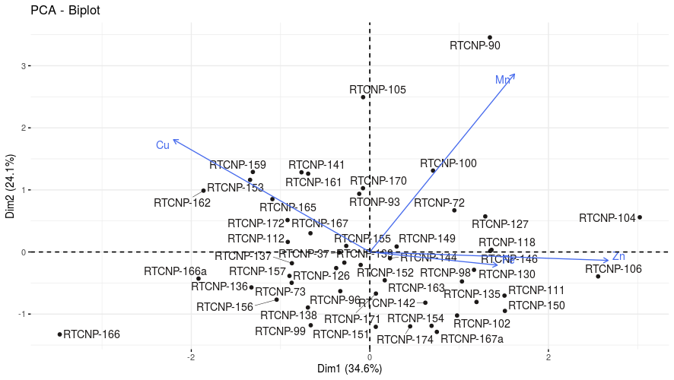
Fig 1: Biplot depicting 50 rice germplasm for four quality traits

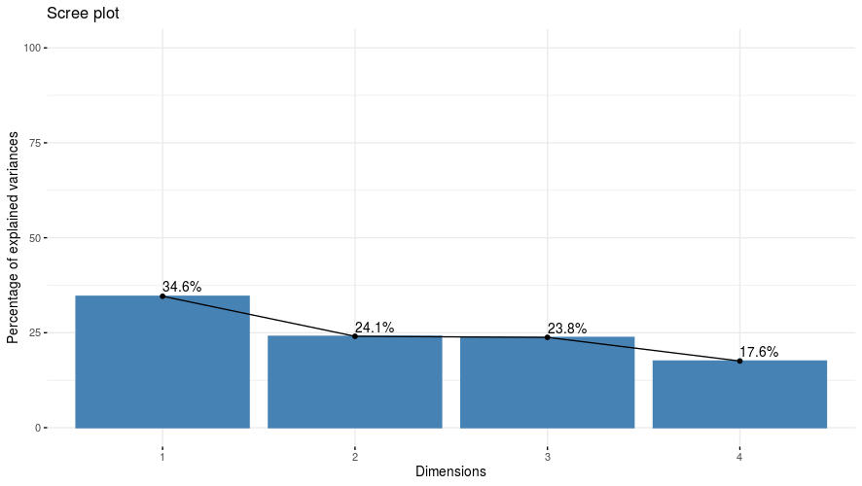
Fig 2: Scree plot showing the eigenvalue variation for four quality traits in 50 rice germplasm

