Case report
Ulnar nerve compression
secondary to a giant lipoma of Guyon’s canal
A Case Report and Literature Review

.
ABSTRACT

Aims: To report a rare case of ulnar nerve compression at Guyon’s canal caused by an extraneural lipoma and to emphasize the role of MRI and surgical treatment.
Presentation of case: A 52-year-old man presented with a painless, slowly enlarging mass on the ulnar side of the right wrist evolving over two years, associated with numbness of the ring and little fingers for three months. Examination revealed a soft mass, decreased sensation in the ulnar nerve distribution, and a positive Tinel’s sign. Nerve conduction studies showed severe ulnar compressive neuropathy at the wrist. MRI demonstrated a well-defined fatty mass extending into Guyon’s canal and displacing the ulnar nerve. Surgical excision was performed, and histopathology confirmed a lipoma. Recovery was uneventful with complete sensory improvement and no recurrence.
Discussion: Guyon’s canal syndrome is uncommon and most frequently caused by ganglion cysts, whereas lipomas are rare etiologies. Clinical presentation varies depending on the level of nerve involvement. MRI is essential for identifying the cause and its relationship to surrounding structures. Surgical decompression with lesion excision is the treatment of choice in mechanical compression.
Conclusion: Lipoma should be considered in the differential diagnosis of Guyon’s canal syndrome. MRI enables accurate diagnosis, and complete surgical excision provides excellent functional outcomes.

Keywords: Nerve entrapment; Ulnar nerve; Guyon’s canal; MRI.

1. INTRODUCTION

Guyon’s canal was first described by Guyon in 1861. It is a fibro-osseous canal located on the palmar aspect of the ulnar side of the wrist (Pierre Jerome et al., 2011).
Guyon's canal syndrome is a relatively rare condition. This disorder is caused by compression of the ulnar nerve when it passes through the Guyon's canal (Quang et al., 2022). Diagnosis of Guyon’s canal syndrome is based on clinical examination, electrophysiology tests and imaging. Studies are essential to identify the cause and location of compression (Huang et al., 2021). We report a rare case of acute ulnar nerve entrapment caused by a lipoma at the Guyon's canal level.

2. CASE PRESENTATION

A 52-year-old right-handed male doctor presented with a slowly growing, painless mass of two years duration in the ulnar side of his right wrist (Fig. 1).
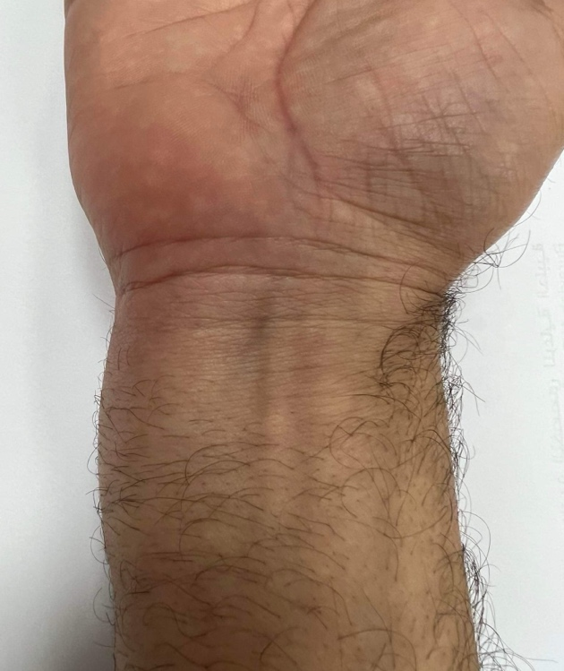
Fig. 1: Swelling at the medial edge of the right wrist

This was associated with numbness of the right ring and little fingers for three months. He had been previously healthy and denied any other history of medical disease.
Physical examination demonstrated a painless oval soft mass measuring 3 cm in long axis sited over the course of the Guyon’s canal. There was no atrophy of muscles of the hand, and digital range of motion and motor powers of intrinsic muscles were normal. However, light touch and two-point discrimination tests disclosed decreased sensitivity along the ulnar nerve distribution, in comparison to his left hand. Tinel’s sign over the mass was positive. He had no other mass-like lesions and no neurological abnormalities in other extremities.
Nerve conduction studies were consistent with right-side ulnar nerve compressive mono-neuropathy at the wrist of very severe intensity.
MRI showed an oblong homogeneous mass of 8.37 x 2.14cm, surrounded by a thin fibrous capsule, starting at the anteromedial distal part of the forearm and extending through the Guyon’s canal and the hypothenar region. The mass was hyperintense in T1W sequence (Fig. 2a), isointense to subcutaneous fat, displaying homogeneous suppression, consistent with lipoma, on the fat-supression T1W image and splaying the ulnar nerve on the axial T1W FS image (Fig. 2b).
Fig. 2a: Coronal T1W MR image of wrist revealing a hyperintense lipomatous mass (arrow) extending through the Guyon’s canal the hypothenar region

Fig. 2b: Axial T1W FS MR image of wrist displaying a lipomatous mass (black arrow) in Guyon’s canal splaying the ulnar nerve (white arrow)

Surgical exploration was performed through an incision centered over Guyon’s canal. After the skin and the volar carpal ligament were incised, a yellowish mass (7 × 4 × 2 cm) was found and removed around the ulnar nerve. The mass was all around the nerve with an extension into Guyon’s canal and overflowing to the hypothenar region (Fig. 3).
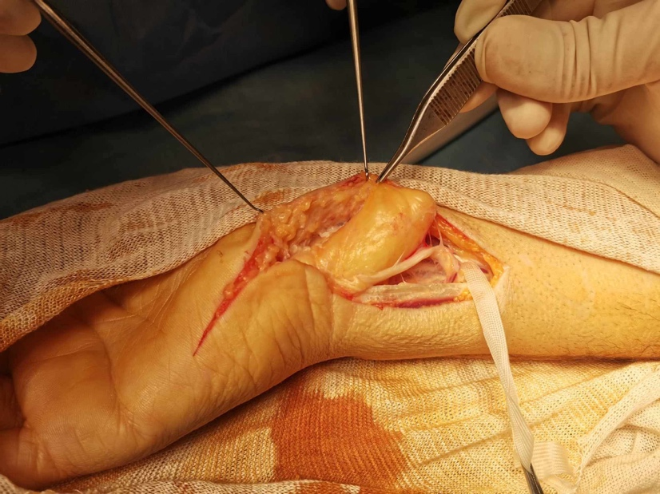
Fig. 3: Intra operative view showing a giant lipoma extended through the Guyon’s canal compressing the ulnar nerve

Histopathology showed mature adipose tissue consistent with lipoma.
The postoperative course was uneventful. Eight weeks later, the mass had not recurred, the patient had full sensibility, normal range of motion of his hand, and no neurologic deficit.

3. discussion

Guyon’s canal, named after a french surgeon Felix Guyon, is a fibroosseous triangular space, with the apex pointing outward radially. Its osseous boundaries are formed ulnarly by the pisiform and the hook of the hamate, and dorsally by the triquetrum and hamate bones. The roof consists of the volar carpal ligament, which is blended with the tendinous insertion of the flexor carpi ulnaris into the pisiform bone (Galeano et al., 2001). This tunnel along the anteromedial portion of the wrist contains the ulnar nerve and artery (Pierre Jerome et al., 2011).
The importance of the tunnel lies in the fact that it is a closed compartment and any compromise in its volume can lead to ulnar nerve compression causing Guyon’s canal syndrome (Rohilla et al., 2009).
Anatomical knowledge of the distal ulnar nerve is critical as the symptoms and signs are determined by the location of the lesion (Gan et al., 2016).
Inside the Guyon's canal, the ulnar nerve is a mixed nerve which divides into superficial sensory and deep motor branches along its course. Therefore, in 1969, Shea and McClain classified ulnar lesions based on affected regions which can be defined as 3 zones.
Zone 1: The proximal part of the ulnar nerve inside the Guyon's canal: proximal to the motor/sensory bifurcation, causing both motor and sensory symptoms. Zone 2: Distal to the bifurcation and affecting deep motor branches only, causing motor deficits and muscle atrophy. This is the most commonly affected region. Zone 3: Distal to the bifurcation and affecting the superficial sensory fibers only, causing sensory symptoms (Quang et al., 2022).
Ulnar nerve compression may occur at different anatomical sites but mostly at elbow and less commonly at wrist (Rohilla et al., 2009).
There are many conditions that cause Guyon's canal syndrome such as tumors (ganglion cyst or lipoma)(2), intravenous malformations, ulnar artery aneurysms, nodular synovitis or metabolic diseases (Ozdemir et al., 2007; Yoshii et al., 1999; Budny et al., 1992). Among these causative factors, ganglion cyst is the most common cause of Guyon's canal syndrome. However, due to the variation of clinical presentations, the clinical diagnosis is not always straightforward, particularly when the sensory symptoms are atypical or absent (Quang et al., 2022).
Lipoma is a benign adipose tumor, which most of time is encountered in subcutaneous tissue. It is thought to be a very rare causative factor that results in narrowing of the Guyon's canal (Lee et al., 2015).
Adipose tumors can affect a peripheral nerve in four different ways: (a) solitary lipomas eventually compress a nerve; (b) encapsulated lipomas can be located in nerve (intraneural lipoma); (c) lipofibrous hamartoma, associated with fatty fibrous mass within the nerve; and (d) macro- dystrophia lipomatosa, which produces an overgrowth of the extremities (Lee et al., 2015). Extraneural lipoma, which is simply called lipoma, is a benign, frequently encountered soft tissue tumor with a well-defined, eccentrically located mass that uncommonly causes extrinsic compression of the peripheral nerve (Spinner et al., 2012).
The diagnosis of adipose tumor is based on clinical findings and radiologic studies, but regardless of diagnosis, MRI enables accurate detection and detailed characterization of soft tissue masses, such as adipose lesions of nerve and anatomic locations (Lee et al., 2015).
Radiologic evaluation is diagnostic in up to 71% of cases . Lipomas most commonly demonstrate signal isointense to subcutaneous fat on all pulse sequences with high signal on T1W and T2W sequences (Ozdemir et al., 2007).
Treatments of Guyon' canal syndrome depend on the severity of the symptoms (numbness, pain, weakness, and muscle atrophy), duration of the symptoms (acute, sub-acute or chronic), previous treatments given, and underlying etiology (Quang et al., 2022).
Surgery is indicated for patients with mechanical compression of the Guyon's canal such as ganglion cysts, tumors or vascular anomalies. The aim of the surgery is to reduce the pressure on the ulnar nerve in the Guyon's canal by opening the roof of Guyon' canal and removing all structures that compress the nerve, thereby reducing the symptoms of Guyon's canal syndrome (Quang et al., 2022). After ulnar nerve identification and incision of the volar carpal ligament, the bifurcation point of the ulnar nerve should be located. All potentially compressive structures such as mass, tight bands, tendinous arcades, or anomalous muscles constricting along the nerve and its branch should be meticulously released.
Post- operative care includes hand elevation, appropriate rest of the hand, and restriction of heavy lifting until the suture is removed. Physical therapy to promote nerve gliding and muscles strength of the hand is indicated. Splint is not routinely but can be prescribed in patients who have a tendency to put mechanical load on the Guyon's canal (Quang et al., 2022).

4. Conclusion

Guyon' canal syndrome is less common than either carpal tunnel syndrome or cubital tunnel syndrome. The anatomy of the ulnar tunnel is complex. MRI appears to be important for the diagnosis of patients with symptoms of ulnar nerve compression to for identifying the underlying etiology preoperatively. Lipoma is a benign soft tumor that rarely compress surrounding structures. However, it can cause compression when occur in a closed compartment such as the Guyon's canal. Surgical removal of lipoma can yield excellent results, although at this time, case series and comparative studies are uncommon because of the rarity of this condition.

Consent
All authors declare that ‘written informed consent was obtained from the patient for publication of this case report and accompanying images.

Ethical approval

All authors hereby declare that all experiments have been examined and approved by the appropriate ethics committee and have therefore been performed in accordance with the ethical standards laid down in the 1964 Declaration of Helsinki.

COMPETING INTERESTS DISCLAIMER:
Authors have declared that they have no known competing financial interests OR non-financial interests OR personal relationships that could have appeared to influence the work reported in this paper.

References

Pierre-Jerome C, Moncayo V, Terk MR. (2011). The Guyon’s canal in perspective: 3-T MRI assessment of the normal anatomy, the anatomical variations and the Guyon’s canal syndrome. Surg Radiol Anat, 33(10):897‑903. DOI: 10.1007/s00276-011-0842-6
Quang VP, Quoc HH, Nguyen B, Quang CN, Chi HN, Nguyen N. (2022). Guyon’s canal resulting from lipoma: A case report and review of the literature. Int J Surg Case Rep. 95:107182. DOI: 10.1016/j.ijscr.2022.107182
Huang CW, Yin CY, Huang HK, Chen TM, Hsueh KK, Yang CY, et al. (2021). Influential factors of surgical decompression for ulnar nerve neuropathy in Guyon’s canal. J Chin Med Assoc. 84(9):885‑9. DOI: 10.1097/JCMA.0000000000000583
Galeano M, Colonna M, Risitano G. (2001) Ulnar Tunnel Syndrome Secondary to Lipoma of the Hypothenar Region: Ann Plast Surg. 46(1):83‑4. DOI: 10.1097/00000637-200101000-00020
Rohilla S, Yadav RK, Dhaulakhandi DB. (2009) Lipoma of Guyon’s canal causing ulnar neuropathy. J Orthop Traumatol. 10(2):101‑3. DOI: 10.1007/s10195-009-0051-9
Gan LP, Tan JSW. (2016) Concomitant Lipoma and Ganglion Causing Ulnar Nerve Compression at the Wrist: A Case Report and Review of Literature. Ann Plast Surg. 76(4):472‑3. DOI: 10.1097/SAP.0000000000000379
Ozdemir O, Calisaneller T, Altinors N. (2007) Compression of the Ulnar Nerve in Guyon’s Canal by an Arteriovenous Malformation. J Hand Surg Eur Vol. 32(5):600‑1. DOI: 10.1016/J.JHSE.2007.04.005
Yoshii S, Ikeda K, Murakami H. (1999) Ulnar nerve compression secondary to ulnar artery true aneurysm at Guyon’s canal. J Neurosurg Sci.43(4):295‑7. PMID: 10864392
Budny PG, Regan PJ, Roberts AHN. (1992) Localized nodular synovitis: A rare cause of ulnar nerve compression in Guyon’s canal. J Hand Surg. 17(4):663‑4. DOI: 10.1016/0363-5023(92)90312-d
Lee HM, Kim YS, Kim JP, Huh DJ. (2015) Entrapment of the dorsal sensory branch of the ulnar nerve by circumferential extraneural lipoma. J Orthop Sci. 20(5):919‑22. DOI: 10.1007/s00776-014-0550-2
Spinner RJ, Scheithauer BW, Amrami KK, Wenger DE, Hébert-Blouin MN. (2012) Adipose lesions of nerve: the need for a modified classification: Clinical article. J Neurosurg. (2):418‑31. DOI: 10.3171/2011.8.JNS101292

