Case report
A Case Report of a Peritoneal Loose Body

Abstract
Background: Peritoneal loose bodies (PLBs), also termed peritoneal mice, are rare benign free-floating intraperitoneal masses most commonly originating from torsion and auto-amputation of epiploic appendages. Progressive saponification, calcification, and concentric fibrous layering lead to their characteristic appearance. While most PLBs are small and asymptomatic, giant peritoneal loose bodies (>4 cm) are extremely rare and may produce pressure-related symptoms or mimic neoplastic lesions on imaging, resulting in diagnostic dilemmas.
We report a 43-year-old male who presented with intermittent lower abdominal pain for three months. Contrast-enhanced computed tomography (CT) of the abdomen and pelvis revealed a well-defined, non-enhancing, calcified pelvic mass measuring 32 × 37 × 28 mm, located anterior to the urinary bladder. Diagnostic laparoscopy demonstrated a freely mobile, smooth, white, encapsulated, firm mass with a characteristic “boiled-egg” appearance, which was completely retrieved laparoscopically. Histopathological examination confirmed a peritoneal loose body composed of concentric hyalinized fibrous lamellae surrounding a central core of necrotic adipose tissue with dystrophic calcification. The postoperative course was uneventful, and the patient remained symptom-free during follow-up.
Although rare, giant peritoneal loose bodies should be included in the differential diagnosis of calcified pelvic masses. Awareness of their characteristic imaging features and intraoperative findings is essential to avoid unnecessary radical surgical procedures. Laparoscopic removal offers both definitive diagnosis and curative treatment with minimal morbidity.

Keywords: Peritoneal loose body, Peritoneal mouse, Epiploic appendage, CT abdomen, Laparoscopy

Introduction
Peritoneal loose bodies (PLBs) are uncommon benign intra-abdominal entities characterized by free, well-circumscribed, mobile masses within the peritoneal cavity. They are most frequently identified incidentally during imaging studies or abdominal surgical procedures performed for unrelated indications¹˒². Most PLBs are small, typically ranging from 0.5 to 2.5 cm, and remain clinically silent throughout life³˒⁴. However, larger lesions, commonly referred to as giant peritoneal loose bodies when exceeding 4 cm in diameter, are rare and can become symptomatic due to compression of adjacent pelvic or abdominal organs⁵˒⁶.
The most widely accepted pathogenesis of PLBs involves torsion of an epiploic appendage with subsequent vascular compromise, ischemic necrosis, and eventual auto-amputation¹˒². Following detachment, the necrotic adipose tissue undergoes saponification and dystrophic calcification. Progressive deposition of fibrin and collagen from peritoneal fluid leads to concentric lamellated fibrosis, resulting in a firm, smooth, oval mass often described as resembling a “boiled egg”⁷. Alternative origins, including omental fat, adnexal tissue, or necrotic lymph nodes, have also been proposed but are considerably less common¹.
Giant peritoneal loose bodies assume particular clinical significance due to their ability to mimic a wide spectrum of pathological conditions, including calcified lymph nodes, mesenteric tumors, teratomas, leiomyomas, urinary bladder calculi, and malignant neoplasms⁸˒⁹. This overlap in radiological appearance frequently leads to diagnostic uncertainty and may prompt extensive investigations or unnecessary aggressive surgical interventions.
Computed tomography (CT) is considered the imaging modality of choice for evaluating suspected PLBs. Typical CT findings include a well-defined, round or oval, non-enhancing mass with central calcification or fatty density, separate from surrounding viscera³˒⁴. Magnetic resonance imaging (MRI) may further aid diagnosis by demonstrating low signal intensity on both T1- and T2-weighted images due to dense fibrous tissue, occasionally with central fat signal⁷˒¹⁰. Despite these features, preoperative diagnosis remains challenging, particularly in giant PLBs, and definitive diagnosis is often achieved only during surgical exploration.
Laparoscopy plays a crucial role in both diagnosis and management of symptomatic or uncertain peritoneal loose bodies. It enables direct visualization of the lesion, confirmation of free mobility and lack of attachment, and safe retrieval with minimal morbidity¹˒⁵˒¹¹. Histopathological examination remains essential to exclude malignancy and confirm the benign nature of the lesion.
This case report highlights a rare presentation of a giant peritoneal loose body presenting with lower abdominal pain and emphasizes the importance of including PLBs in the differential diagnosis of calcified pelvic masses, as well as the role of minimally invasive surgery in achieving definitive diagnosis and treatment.

Case Presentation
A 43-year-old male presented with intermittent lower abdominal pain for three months. There was no history of fever, vomiting, urinary complaints, bowel obstruction, or weight loss. Past medical history was unremarkable and the patient had no comorbidities.

Clinical Examination: The abdomen was soft with no palpable mass. Per rectal and per abdominal examinations were normal. Laboratory investigations, including tumour markers (CEA, CA-125, AFP), were within normal limits. Tumor markers were performed as there was a diagnostic dilemma in view of uncommon presentation.
Radiological Findings: Contrast-enhanced CT abdomen and pelvis revealed a 32 x 37 x 28mm well-defined non-enhancing lesion with internal fat density in the pelvic cavity, closely related to the redundant part of the sigmoid colon and lying superior to the urinary bladder, without evidence of direct communication. Findings suggested peritoneal loose bodies. Preoperative diagnosis: calcified pelvic mass—possible giant peritoneal loose body.

Surgical Procedure: Diagnostic laparoscopy was performed under general anaesthesia. A smooth, white, oval, firm mass was visualized freely lying in the pelvis. The lesion was completely free, with no attachments to bowel, omentum, or mesentery. It was retrieved using a 4 cm infra-umbilical incision. No other abnormalities were detected. The postoperative course was uneventful, and the patient remained asymptomatic at follow-up.

Histopathological Findings: Gross examination: The mass was firm, oval, and measured 3.2 × 3.7 × 2.8 cm. The cut surface showed concentric lamellated layers surrounding a yellowish central core. Microscopic examination: Sections revealed dense hyalinized fibrous tissue arranged in concentric layers with central necrotic adipose tissue and dystrophic calcification. No epithelial lining or neoplastic cells were identified. Final diagnosis: Peritoneal loose body (peritoneal mouse).

Discussion
PLBs typically result from autoamputation of inPeritoneal loose bodies (PLBs) are rare, benign intraperitoneal entities that most commonly arise from torsion and subsequent auto-amputation of epiploic appendages. The process begins with compromised vascular supply leading to ischemic necrosis of the appendage, followed by detachment into the peritoneal cavity. Once free, the necrotic adipose tissue undergoes saponification and dystrophic calcification, while continuous exposure to peritoneal fluid results in gradual deposition of fibrin and collagen, producing concentric lamellated fibrosis. This progressive transformation explains the characteristic firm, smooth, oval morphology and the classic “boiled-egg” appearance described intraoperatively and on gross pathology [2,7].
Most PLBs are small, measuring less than 2.5 cm, and remain clinically silent throughout life, often discovered incidentally during imaging or unrelated abdominal surgery [3,4]. In contrast, giant peritoneal loose bodies—typically defined as lesions exceeding 4 cm—are exceedingly rare and are more likely to become symptomatic due to mass effect on adjacent organs. Reported symptoms include lower abdominal pain, urinary frequency or retention due to bladder compression, constipation, and, in rare instances, bowel obstruction [5,6,8]. In the present case, although the lesion was marginally below the conventional size threshold for a “giant” PLB, its pelvic location and mobility likely contributed to the patient’s intermittent lower abdominal pain, supporting the concept that symptomatology depends not only on size but also on anatomical position and movement within the peritoneal cavity.
Radiological evaluation plays a crucial role in the assessment of PLBs, though preoperative diagnosis remains challenging. Computed tomography (CT) is considered the imaging modality of choice and typically demonstrates a well-circumscribed, non-enhancing, round or oval mass with central calcification or fat density, clearly separated from adjacent viscera [3,4]. A defining feature is the absence of any vascular pedicle or attachment, which helps differentiate PLBs from neoplastic lesions. Magnetic resonance imaging (MRI), when performed, usually reveals low signal intensity on both T1- and T2-weighted images due to dense fibrous tissue, occasionally with a central fatty core corresponding to residual adipose tissue [7,10]. Despite these characteristic findings, PLBs—particularly when large—can closely mimic other pelvic or intra-abdominal pathologies.
The differential diagnosis of a calcified pelvic mass is broad and includes calcified lymph nodes, mesenteric or omental tumors, leiomyomas, teratomas, foreign bodies, urinary bladder calculi, and malignant neoplasms [8,9]. In males, pelvic PLBs may be mistaken for bladder stones or prostatic pathology, whereas in females they may mimic adnexal masses. This diagnostic overlap often leads to extensive investigations, including tumor marker evaluation, as was done in the present case. Awareness of PLBs and their typical imaging characteristics is therefore essential to prevent misdiagnosis and avoid unnecessary radical surgical procedures.
Laparoscopy has emerged as the preferred diagnostic and therapeutic modality for suspected PLBs when the diagnosis is uncertain or when the patient is symptomatic. Direct visualization allows confirmation of the free-floating nature of the mass and exclusion of any attachment to bowel, mesentery, or omentum. Moreover, laparoscopic retrieval is minimally invasive, associated with low morbidity, rapid recovery, and excellent cosmetic outcomes [1,5,9]. In asymptomatic patients with confidently diagnosed small PLBs, conservative management may be considered; however, surgical removal is generally recommended for symptomatic lesions, diagnostic uncertainty, or giant PLBs due to the risk of complications and persistent symptoms.
Histopathological examination remains the gold standard for definitive diagnosis. The typical findings of concentric hyalinized fibrous lamellae surrounding a central core of necrotic adipose tissue with dystrophic calcification, and the absence of epithelial lining or malignant cells, confirm the benign nature of the lesion [5,6]. Following complete removal, recurrence has not been reported, as PLBs represent end-stage sequelae of a localized ischemic event rather than an ongoing pathological process.
This case adds to the limited literature on peritoneal loose bodies and highlights the importance of considering PLBs in the differential diagnosis of calcified pelvic masses. It also underscores the role of laparoscopy as a safe and definitive approach for both diagnosis and management, even when preoperative imaging suggests a benign etiology.
farcted epiploic appendages after torsion and ischemia [2,7]. The detached appendage undergoes progressive fibrosis and calcification, forming a free intraperitoneal mass [1].
Small PLBs are usually asymptomatic, while giant PLBs may cause discomfort, urinary frequency, or obstruction due to pressure effects [5,6,8].
CT shows a well-defined, non-enhancing, ovoid, calcified mass separate from viscera [3,4]. MRI reveals low T1/T2 signal if fibrotic, with central fatty signal in some cases [7].
Symptomatic or uncertain lesions are best managed laparoscopically for diagnosis and cure [1,5,9]. Following removal, recurrence is not expected, and histopathology excludes malignancy [5,6].

Conclusion
Peritoneal loose bodies are rare, benign entities that may mimic pelvic or abdominal tumours. Awareness of their imaging and intraoperative features is essential to avoid unnecessary surgery. Laparoscopic removal offers a definitive diagnosis and cure, with minimal morbidity.

References
[1] Yang DM, et al. Unusual cystic and solid masses in the peritoneal cavity: CT and MRI findings. Radiographics. 2001;21(1):S157–S170.
[2] Jang HJ, et al. Mobile calcified masses in the pelvis: peritoneal loose bodies. Clin Imaging. 2003;27(1):62–64.
[3] Desai HP, et al. Epiploic appendagitis and peritoneal loose bodies. Surg Clin North Am. 2004;84(5):1279–1285.
[4] Martins JL, et al. Imaging findings of peritoneal loose bodies. Radiol Bras. 2004;37(4):273–276.
[5] Gayer G, et al. Peritoneal loose bodies: radiologic appearance. Abdom Imaging. 2006;31(4):413–417.
[6] Sewkani A, et al. Giant peritoneal loose body in pelvis: a case report. J Med Case Rep. 2011;5:297.
[7] Dey S, et al. Giant peritoneal loose body mimicking a calcified pelvic mass. BMJ Case Rep. 2013;2013:bcr2013200901.
[8] Obaid M, et al. Giant peritoneal loose body: A rare cause of lower abdominal discomfort. Int J Surg Case Rep. 2018;51:143–146.
[9] Singh AK, et al. Peritoneal mice: imaging features and clinical significance. J Clin Imaging Sci. 2019;9:34.
[10] Coulier B. Contribution of MDCT in the diagnosis of peritoneal loose bodies. JBR-BTR. 2010;93(2):63–67.
[11] Kim HS, et al. Giant peritoneal loose body: CT and MRI findings. Abdominal Imaging. 2013;38(1):180–183.

Fig 1 : MRI scan report 1
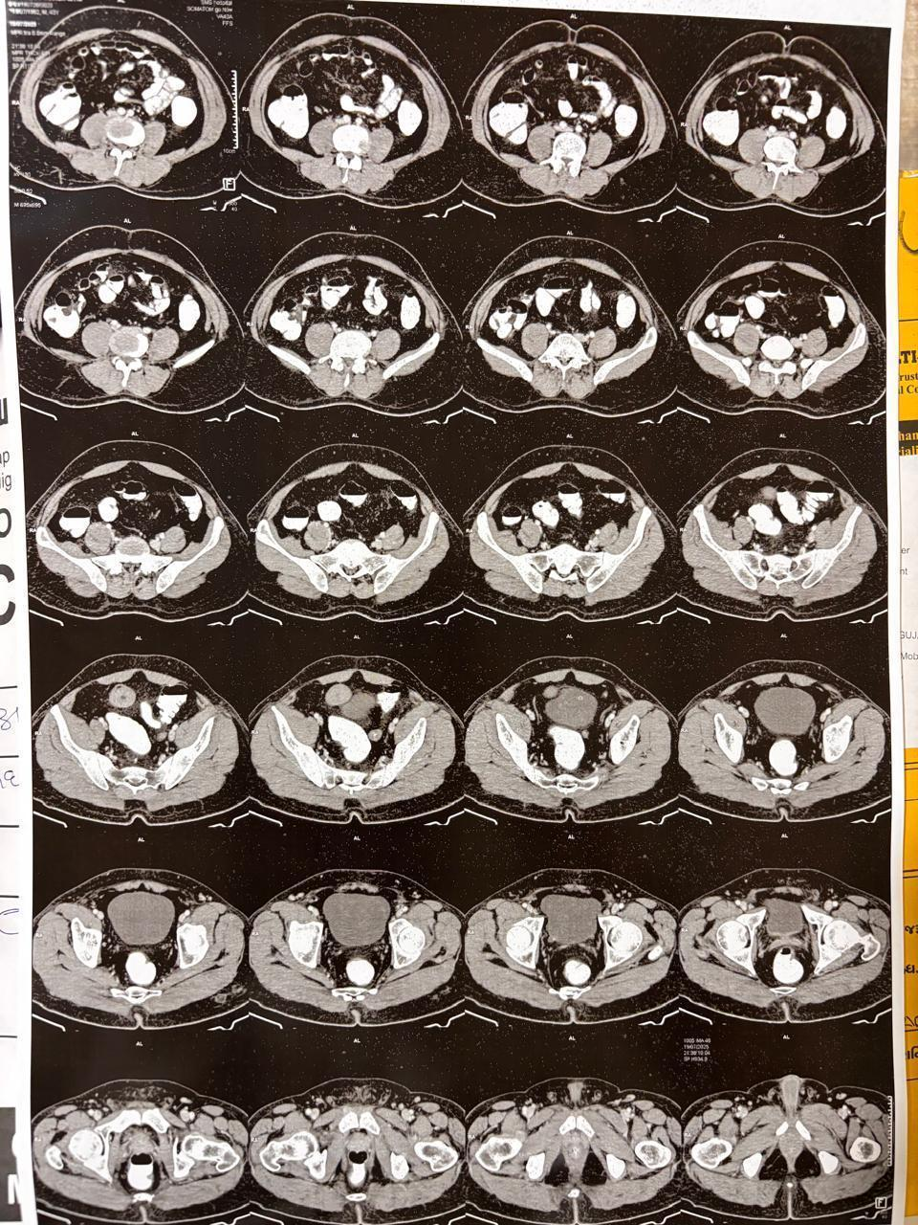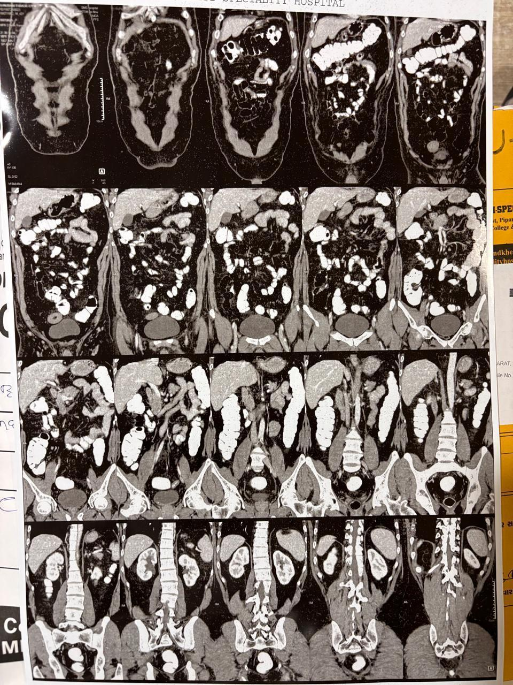

Fig 2 : MRI scan report 2
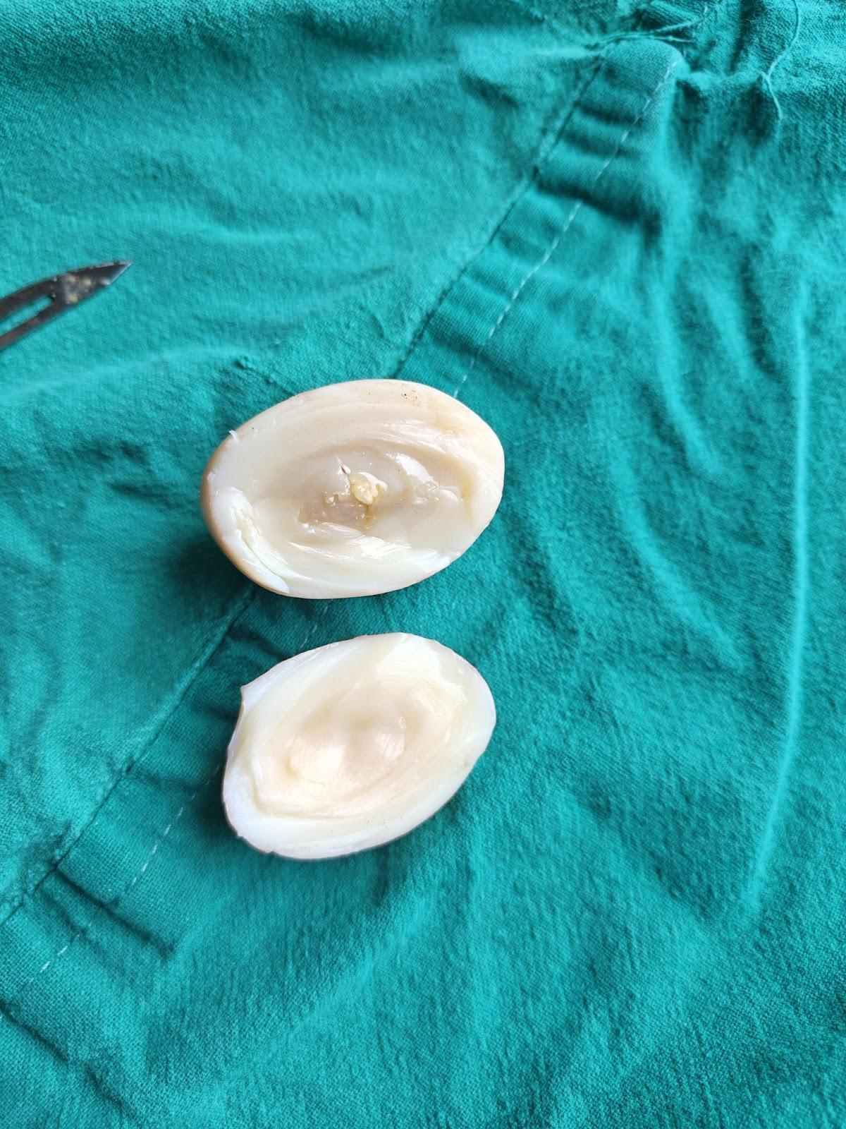

Fig 3 : Peritoneal loose bodies (PLBs)
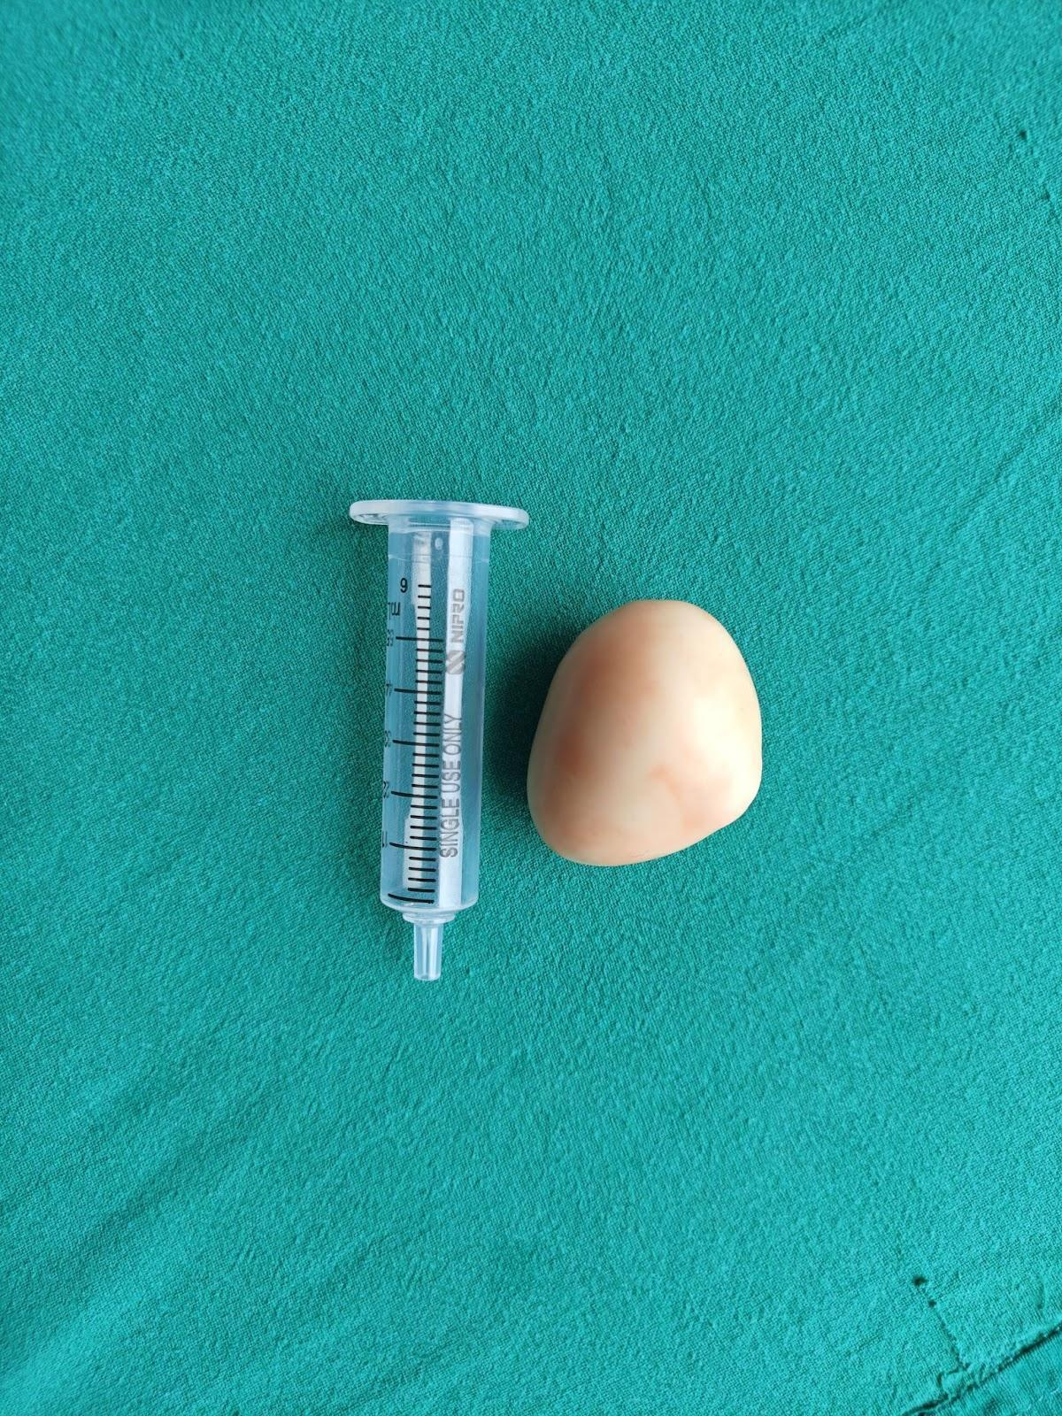
Fig 4 : Ischemic necrosis of the appendage

