Case report

Aggressive Primary Adrenal Leiomyosarcoma with Pancreatic and Gastric Involvement: Lessons from a Rare Case

Abstract
Background:
Primary adrenal leiomyosarcoma (PAL) is an exceedingly rare malignant neoplasm arising from smooth muscle elements of the adrenal gland or its associated vasculature. Fewer than 60 cases have been reported in the literature, and presentation with contiguous multivisceral invasion is exceptionally uncommon, posing significant diagnostic and surgical challenges.
Case Presentation:
A 74-year-old male presented with left flank pain. Cross-sectional imaging revealed a large left adrenal mass measuring 13 × 13 cm with obliteration of surrounding fat planes and direct invasion into adjacent organs, including the pancreas, spleen, gastric muscularis, and left diaphragmatic crus. The mass caused compression of the splenic vessels with associated splenic vein thrombosis. Given the locally advanced nature of the disease, the patient underwent multivisceral en-bloc resection comprising left adrenalectomy, distal pancreatectomy, splenectomy, and distal gastrectomy. Histopathological examination confirmed primary adrenal leiomyosarcoma with infiltration into the pancreatic parenchyma and gastric muscularis propria. All surgical margins were free of tumor.
Discussion:
PAL with direct multiorgan involvement is extremely rare, and preoperative diagnosis is often difficult due to nonspecific clinical and radiological features. Complete surgical excision with negative margins remains the cornerstone of treatment and offers the best chance for durable local control in the absence of distant metastasis.
Conclusion:
This case highlights an exceptionally rare presentation of primary adrenal leiomyosarcoma with extensive contiguous organ invasion. Radical en-bloc resection, when technically feasible, can achieve clear margins and may offer curative potential. Reporting such cases contributes to the limited existing literature and helps guide surgical decision-making in this rare malignancy.

Keywords: adrenal leiomyosarcoma, retroperitoneal sarcoma, pancreas infiltration, multivisceral resection, adrenal mass, case report.

Introduction
Primary adrenal leiomyosarcoma (PAL) is a rare soft-tissue sarcoma arising from smooth muscle cells of the central adrenal vein or its branches. It accounts for <0.2% of all adrenal tumours. Patients typically present with nonspecific abdominal or flank pain, and lesions are often large at diagnosis due to the retroperitoneum’s expansile capacity.
Most PALs remain confined to the adrenal. Direct invasion into adjacent organs such as the pancreas, stomach, spleen, or diaphragm is exceedingly uncommon, with only a few published cases reporting multi-visceral involvement. Due to its aggressive biology and lack of standardized treatment, complete surgical resection with negative margins remains the cornerstone of management.
We report a rare case of left adrenal leiomyosarcoma with infiltration into the pancreas and gastric muscularis, managed successfully with extensive multi-visceral resection.

Case Presentation
Clinical presentation:
A 74-year-old male presented with a three-month history of dull progressively increasing left sided flank pain. There were no associated symptoms such as fever, weight loss, anorexia, or night sweats. He denied gastrointestinal bleeding, vomiting and urinary complaints. His past medical history was unremarkable with no prior malignancy or endocrine disorders. Physical examination revealed mild fullness in the left upper quadrant without a palpable mass. Vital signs and routine laboratory parameters were within normal limits. Hormonal evaluation did not suggest a functioning adrenal tumour.
Contrast-enhanced computed tomography (CECT) of the abdomen revealed a large, heterogeneously enhancing mass arising from the left adrenal gland, measuring approximately 13 × 13 cm. The lesion demonstrated extensive local invasion with complete loss of intervening fat planes and direct infiltration into adjacent structures including the distal pancreas, splenic hilum, gastric muscularis propria along the greater curvature and the left diaphragmatic crus. The splenic artery and vein were encased by the tumour with associated splenic vein thrombosis. The upper pole of the left kidney was abutted but without definite radiological evidence of parenchymal invasion. No distant metastases or lymphadenopathy were identified on staging imaging.
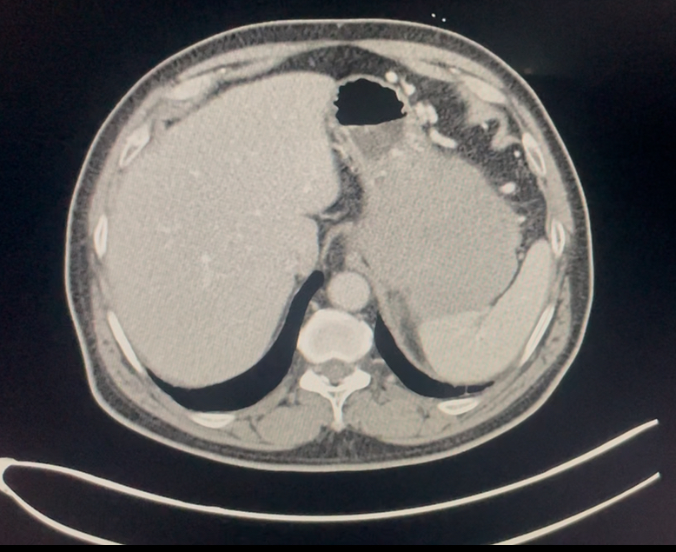
Fig 1. showing left adrenal mass with infiltration of greater curvature of distal stomach (straight arrow)and left crus of diaphragm(irregular arrow)
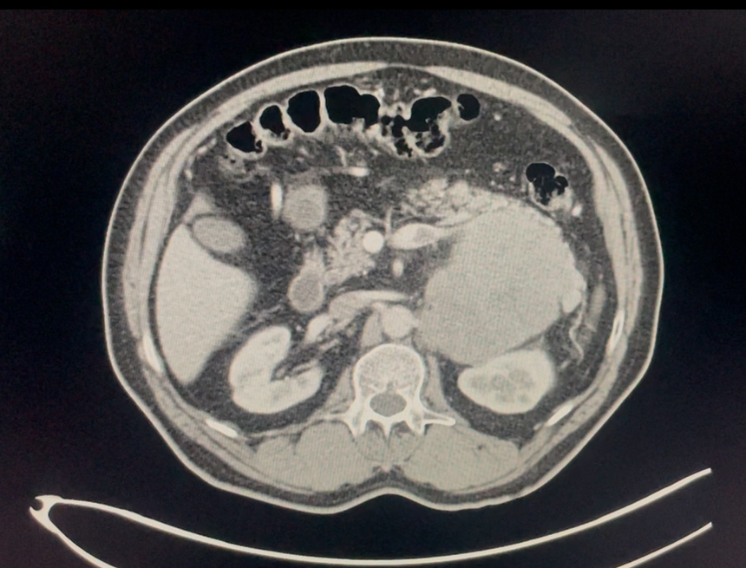Fig 2. showing left adrenal mass with loss of fat planes with distal pancreas (white arrow) and splenic vein thrombosis(blue arrow)
Operative management:
Given the localized but locally advanced nature of the disease, the case was discussed in a multidisciplinary tumour board. In view of the absence of distant metastasis and the possibility of achieving complete oncological clearance surgery with curative intent was recommended.
The patient underwent an en-bloc multivisceral resection consisting of left adrenalectomy, distal pancreatectomy, splenectomy, distal gastrectomy, and partial excision of the involved diaphragmatic crus. Care was taken to avoid tumour violation and to achieve wide surgical margins. The operative course was uneventful with acceptable blood loss and the patient had an uncomplicated postoperative recovery. He was discharged on postoperative day six in stable condition.
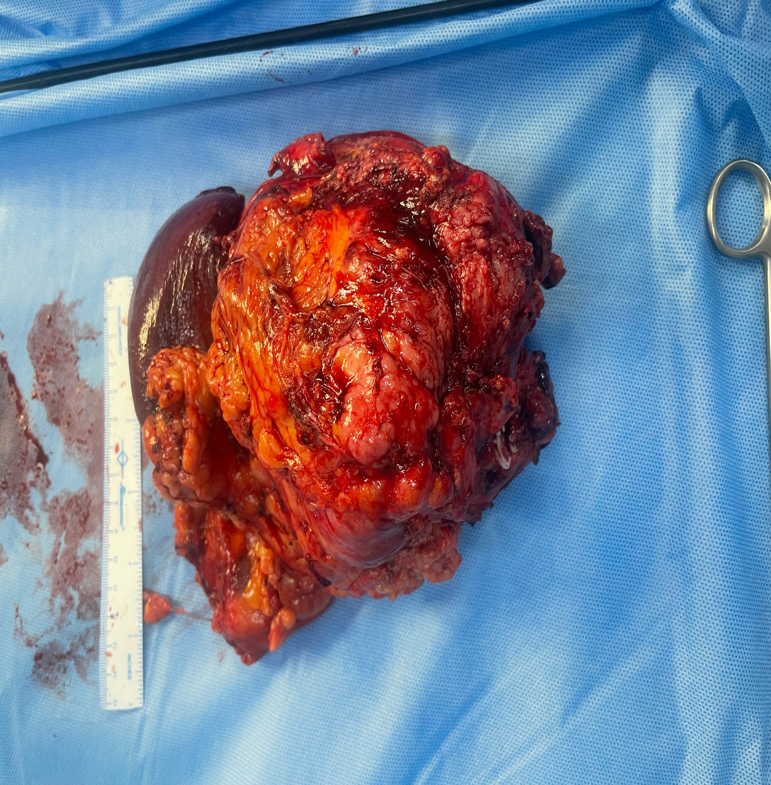
LEFT RENAL IMPRESSION
SPLENIC VEIN CLIPPED
DISTAL STOMACH
DISTAL PANCREAS
ADRENAL MASS
SPLEEN

Fig 3. En-bloc multivisceral resection surgery

Histopathology:
Histopathological examination revealed a high-grade leiomyosarcoma arising from the adrenal gland, with infiltration into the pancreatic parenchyma and gastric muscularis propria. Tumour involvement of the left diaphragmatic crus and a pre-aortic lymph node was noted. Lymphovascular invasion was present. All surgical margins were free of tumour confirming an R0 resection. According to the AJCC 8th edition staging system the tumour was classified as pT3N1.
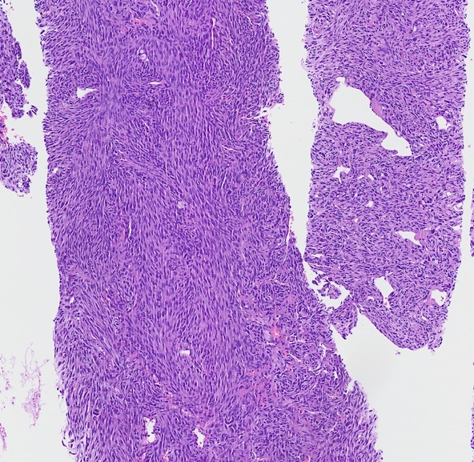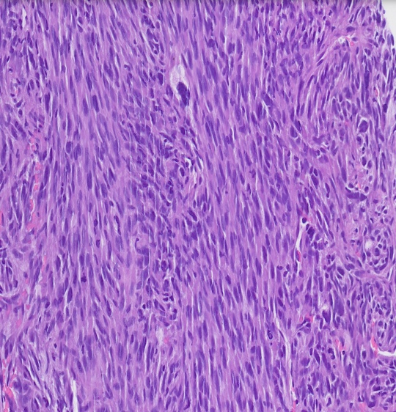
Fig 4. Histopathological examination findings

Immunohistochemistry:
Immunohistochemical analysis demonstrated strong positivity for smooth muscle actin and desmin, with negativity for S-100 and CD34. The Ki-67 proliferation index was approximately 35%, consistent with aggressive tumour biology.
Follow-up:
At six months of follow-up, the patient remains asymptomatic, with no clinical or radiological evidence of local recurrence or distant metastasis on surveillance imaging.

DISCUSSION

Primary adrenal leiomyosarcoma (PAL) is an exceedingly rare, high-grade mesenchymal malignancy thought to arise from smooth muscle cells of the wall of the central adrenal vein or its tributaries [1,2]. Owing to its vascular origin, PAL frequently attains a large size, demonstrates aggressive local behaviour, and may invade adjacent viscera and major vessels, including the inferior vena cava [1–3]. As a result, diagnosis is often delayed until symptoms related to mass effect develop. The published literature consists predominantly of isolated case reports and small case series; consequently, management principles are largely extrapolated from experience with retroperitoneal soft-tissue sarcomas [2,4].

PAL represents an extremely small subset of both retroperitoneal sarcomas and primary adrenal malignancies [1,3]. Reported cases typically occur in middle-aged to elderly patients, with no consistent sex predilection described in the limited literature [2,5]. From a biological standpoint, PALs are characteristically aggressive tumors, often exhibiting high histologic grade, brisk mitotic activity, tumor necrosis, and a propensity for both local invasion and distant metastases—most commonly to the lungs and liver [1,4]. The tendency for vascular invasion and venous thrombosis is attributed to their origin from adrenal venous smooth muscle [3].

Patients commonly present with non-specific symptoms related to tumour mass effect, such as flank, epigastric, or abdominal pain, early satiety, or weight loss, although some tumours are discovered incidentally during imaging for unrelated indications [2,6]. Cross-sectional imaging with CT or MRI typically reveals a large, heterogeneously enhancing adrenal mass with areas of necrosis or haemorrhage [1,6]. Loss of fat planes with adjacent organs and evidence of vascular involvement should raise suspicion for an aggressive adrenal malignancy rather than a benign adenoma. Functional imaging with FDG PET-CT often demonstrates avid uptake but lacks specificity for histologic subtype [6].

In the present case, extensive local invasion into the pancreas and stomach, involvement of splenic vessels, and splenic vein thrombosis are consistent with the aggressive biological behaviour reported in prior PAL cases [3,5].

The differential diagnosis for a large invasive adrenal mass includes adrenocortical carcinoma, metastatic disease to the adrenal gland, retroperitoneal soft-tissue sarcoma secondarily involving the adrenal, and pheochromocytoma [6,7]. Adrenocortical carcinoma is often the primary consideration radiologically, but endocrine evaluation and immunohistochemistry assist in differentiation. Metastatic disease is typically bilateral and occurs in the context of a known primary malignancy. Retroperitoneal leiomyosarcoma should be considered when the tumour appears separable from the adrenal gland intraoperatively or radiologically. Pheochromocytomas are usually functional and hyper-vascular, aiding distinction [6].

Image-guided core biopsy may be useful in selected cases when the diagnosis is uncertain and when results would alter management, particularly in unresectable disease or when neoadjuvant therapy is contemplated [7]. However, many centres favour upfront surgical resection for resectable tumours due to concerns regarding tumour seeding and limited diagnostic yield [2].

Histologically, PAL is characterized by intersecting fascicles of spindle cells with varying degrees of pleomorphism, high mitotic activity, and frequent areas of necrosis [1,4]. Immunohistochemistry typically demonstrates positivity for smooth muscle markers such as smooth muscle actin, desmin, and h-caldesmon , with negativity for cytokeratin, S-100 protein, and neuroendocrine markers—features that help distinguish PAL from adrenocortical carcinoma or sarcomatoid carcinoma [4,8]. Tumour grading using the FNCLCC system provides prognostic information and guides consideration of adjuvant therapy [8].

Complete surgical excision with negative margins (R0 resection) remains the cornerstone of treatment and offers the best chance for durable local control and potential cure [1–3]. Due to frequent local invasion, en-bloc multivisceral resection is often required. Published cases describe adrenalectomy combined with resection of kidney, pancreas, spleen, stomach, and even portions of the inferior vena cava with or without vascular reconstruction [2,3,5].

Our approach—en-bloc left adrenalectomy with distal pancreatectomy, splenectomy, and distal gastrectomy—was undertaken to achieve margin-negative resection and is consistent with recommended surgical principles for resectable PAL. Multidisciplinary collaboration is essential to optimize oncologic outcomes and minimize perioperative morbidity [2]. Achieving negative margins is consistently reported as the most important favourable prognostic factor [1,3].

Due to the rarity of PAL, there are no prospective data guiding adjuvant therapy. Most recommendations are extrapolated from management of extremity and retroperitoneal soft-tissue sarcomas [4,9]. Adjuvant radiotherapy may be considered to improve local control, particularly in high-grade tumours or when margins are close or positive, although toxicity to adjacent organs must be carefully considered [9].

Systemic chemotherapy is generally reserved for high-risk or metastatic disease. Anthracycline-based regimens (doxorubicin with or without ifosfamide) remain the backbone of treatment, while gemcitabine–docetaxel combinations have demonstrated activity in leiomyosarcoma and may be considered in selected patients [9]. Given our patient’s advanced age and achievement of R0 resection, the potential benefit of adjuvant therapy must be weighed against treatment-related morbidity.

Overall prognosis in PAL is guarded. Adverse prognostic factors include large tumour size, high histologic grade, vascular invasion, positive margins, and presence of metastases at diagnosis [1,3,5]. Local recurrence and distant metastases are common during follow-up. Nevertheless, several reports describe prolonged disease-free survival following complete en-bloc resection, highlighting the potential for long-term control when R0 resection is achieved [2,3]. Despite the large tumour size in our case, negative surgical margins represent a favourable prognostic feature, mandating close surveillance.

This case reinforces that aggressive en-bloc resection can achieve R0 margins even in very large PALs with multi-visceral involvement and remains the most important modifiable prognostic factor [1–3]. Given the lack of high-level evidence for adjuvant therapy, treatment decisions should be individualized and guided by multidisciplinary discussion.

The evidence base for PAL remains limited to case reports and small series. Multi-institutional registries and pooled analyses are needed to clarify the role of adjuvant therapies, define survival outcomes specific to adrenal origin leiomyosarcoma, and establish optimal surveillance strategies. Molecular characterization may identify actionable targets and refine systemic treatment options in the future [4,9].

Conclusion
Primary adrenal leiomyosarcoma is an exceptionally rare and aggressive malignancy often diagnosed at an advanced stage due to nonspecific clinical presentation and retroperitoneum’s capacity to accommodate large tumours. Direct contiguous invasion into multiple adjacent organs as observed in the present case is uncommon and have significant diagnostic and surgical challenges.
This case underscores the importance of maintaining a high index of suspicion for aggressive adrenal malignancies when imaging demonstrates large adrenal masses with loss of fat planes and vascular involvement. Complete en-bloc surgical resection with negative margins remains the cornerstone of treatment and represents the most critical determinant of oncologic outcome. Even in the presence of extensive multivisceral involvement, radical surgery can be safely performed in selected patients and may offer the best chance for long term disease control.
Given the rarity of primary adrenal leiomyosarcoma and lack of standardized guidelines, reporting such cases is essential to expanding the existing body of literature and informing future management strategies. Multidisciplinary decision-making and meticulous surgical technique are paramount in optimizing outcomes for this rare but highly aggressive tumour.

COMPETING INTERESTS DISCLAIMER:
Authors have declared that they have no known competing financial interests OR non-financial interests OR personal relationships that could have appeared to influence the work reported in this paper.
References
1. Liu X, Chen Y, Zhang S, et al.Primary adrenal leiomyosarcoma: a rare adrenal malignancy. World J Surg Oncol. 2012;10:128.
2. Khurana A, Gupta R, Rastogi A, et al.Primary adrenal leiomyosarcoma: a rare entity with review of literature. J Cancer Res Ther. 2015;11(3):646–648.
3. Lau SK, Weiss LM.Smooth muscle tumors of the adrenal gland. Arch Pathol Lab Med. 2009;133(9):1472–1476.
4.Miettinen M, Fetsch JF.Evaluation of biological potential of smooth muscle tumours of deep soft tissue. Histopathology. 2006;48(1):97–105.
5. Karakas E, et al.Primary adrenal leiomyosarcoma with vena cava involvement. Surgery Today. 2011;41:124–128.
6. Young WF Jr. Clinical practice: the incidentally discovered adrenal mass. N Engl J Med. 2007;356:601–610.
7. Bancos I, et al. Diagnosis and management of adrenal masses. Lancet Diabetes Endocrinol. 2015;3:234–247.
8. Fletcher CDM, et al. WHO Classification of Tumours of Soft Tissue and Bone. 4th ed. IARC; 2013.
9. Casali PG, et al. Soft tissue sarcomas: ESMO–EURACAN guidelines. Ann Oncol. 2018;29(Suppl 4):iv51–iv67.

