Original Research Article

PREVALENCE OF GLAUCOMA IN EYE CLINIC FMC OWO, ONDO STATE, NIGERIA

Abstract
Purpose: Glaucoma remained one of the leading causes of irreversible blindness globally, and early diagnosis was essential for preventing vision loss. Understanding its risk factors was particularly important in rural and semi-urban settings where awareness and access to eye care were limited. This study assessed the prevalence of glaucoma among patients attending the Federal Medical Center (FMC) Owo Eye Clinic.

Materials and Methods: A hospital-based cross-sectional study was conducted among patients who presented to the FMC Owo Eye Clinic. Data were collected using structured clinical records, including demographic characteristics, occupation, age, and glaucoma diagnosis. Statistical analysis was conducted to determine associations between glaucoma incidence and the patients’ characteristics.

Results: The findings revealed a notable incidence of glaucoma in the facility, leading to the rejection of the null hypothesis. Age showed a strong association with glaucoma, indicating that older patients were more likely to present with the condition. Certain occupations—particularly farming and trading—were identified as higher-risk groups. The results also indicated that females were more susceptible to glaucoma than males.

Discussion/ Conclusion: The study concluded that glaucoma remained a significant eye health challenge at FMC Owo, with age, occupation, and gender emerging as important risk factors. Strengthened public health awareness campaigns and early screening programs are urgently needed, especially in rural areas where awareness of glaucoma is low. Incorporating protective eye care practices and promoting routine eye examinations may help reduce the burden of the disease.

Keywords: Glaucoma, Risk Factors, Age, Occupation, Gender, Blindness.
Introduction
Vision was regarded as one of the most treasured human senses, and the eye was often considered the most crucial organ for perceiving the world. Despite its importance, many individuals lacked adequate knowledge of eye function, the significance of eye health, and the various disorders that threatened vision. This gap was particularly evident in developing countries such as Nigeria, where people often sought ophthalmic care only after noticing significant changes in their vision. As a result, several eye diseases that presented without early symptoms progressed unnoticed until they reached advanced stages.
Glaucoma was one of such diseases and had been recognized globally as a leading cause of irreversible blindness. It comprised a group of eye disorders characterized by progressive optic nerve damage, commonly associated with elevated intraocular pressure (IOP). Early stages of glaucoma were usually asymptomatic, making timely detection difficult and contributing to late presentation in many patients. Globally, glaucoma was the second leading cause of blindness, accounting for approximately 8% of the 39 million people who were blind. In Africa, the burden was even higher, with glaucoma responsible for about 15% of blindness cases (Resnikoff et al., 2004). The number of affected individuals had continued to rise, increasing from 8.4 million adults in 2010 to more than 15 million by 2023.

The normal intraocular pressure ranged from 10 to 20 mmHg, and pressures above 21 mmHg, an inter-eye difference greater than 4 mmHg, or the presence of glaucomatous visual field defects were indicators of glaucoma (Usifoh et al., 2014). The disease presented in several forms, including Primary Open-Angle Glaucoma (OAG), Angle-Closure Glaucoma (ACG), Secondary Glaucoma (SG), Congenital Glaucoma (CG), and Normal-Tension Glaucoma (NTG). Primary glaucoma occurred without an identifiable underlying cause, whereas secondary glaucoma resulted from ocular or systemic conditions that obstructed aqueous humor outflow.
Although glaucoma was clinically well-recognized, its biological basis and the factors influencing its progression were still not fully understood, particularly in Nigeria. Most local studies had focused mainly on clinical indicators such as intraocular pressure and visual acuity, with limited attention given to demographic or population-based risk factors. This left significant gaps in knowledge, especially considering that glaucoma was often silent until advanced stages, leading to delayed diagnosis and treatment. A better understanding of the prevalence and associated risk factors could help primary healthcare providers identify high-risk individuals and facilitate early referral for comprehensive ophthalmic evaluation.
Nigeria, with a population exceeding 206 million, was the most populous country in Africa and one of the most ethnically diverse nations globally. The country was divided into six geopolitical zones—Northeast, Northwest, North-Central, Southeast, Southwest, and South-South—with rural communities accounting for nearly half of the population. The diversity in ethnicity, culture, and socioeconomic conditions posed challenges to accurately determining glaucoma prevalence and its associated risk factors across different regions (Kyari et al., 2015). Limited epidemiological data from many parts of the country, including Ondo State, further underscored the need for localized research.
In response to this gap, the present study aimed to determine the prevalence of glaucoma among patients who attended the Eye Clinic of the Federal Medical Centre (FMC), Owo, Ondo State, Nigeria. Evidence generated from this setting was expected to contribute to understanding the disease burden and support the development of effective strategies for early detection, management, and prevention of glaucoma-related blindness.
Materials and Methods

Research Design
The study employed a hospital-based retrospective study of patients’ records in the archives of Federal Medical Center, Eye Clinic.
Target Population
The target population were 150 Glaucoma patients registered at Federal Medical Center, Owo in the year 2019-2022.

Study Area
This study design was carried out at the premises of the Federal Medical Center in Owo; this facility is a Federal medical hospital with the full complement of eye care staff.
Sample Size and Participant Recruitment
All records of attending glaucoma between the years 2019 and 2022 were collected for this
project.

Method of Data Collection and Data Analysis
The mode of data collection used for this study was data sampling from medical records of the Federal Medical Center Owo eye clinic. All glaucoma patients from the years 2019-2022, both genders, all ages, and all occupations were included. Patients with other eye diseases were excluded. Only socio-demographic and clinical data on the first visit were included in the analysis, while data on subsequent visits for patients with records of multiple visits were excluded. Data collection involved the use of data extraction sheet to collect a data on the first visits of patients on sociodemographic, visual acuities, intraocular pressure, and the management of glaucoma. The data on socio-demographics of patients included sex, age, ethnicity, and occupational status. The clinical profiles recorded were presenting visual acuities, presenting intraocular pressures, and management modality of glaucoma at the eye clinic center. Data were analyzed using the International Business Machines Corporation’s Statistical Package for the Social Sciences (IBM SPSS), version 21 (SPSS Inc., Chicago, USA). Categorical data were presented as frequencies. Descriptive statistics were computed for all variables after the data had been screened.
Results
One thousand six hundred and twenty (1,620) folders/files were retrieved from the eye center’s archives for the speculated years. A total of 833 participants met the inclusion criteria. The prevalence of glaucoma at the eye center for the three years was 833 out of 1,620 representing 51% of the cases reported to the eye clinic.

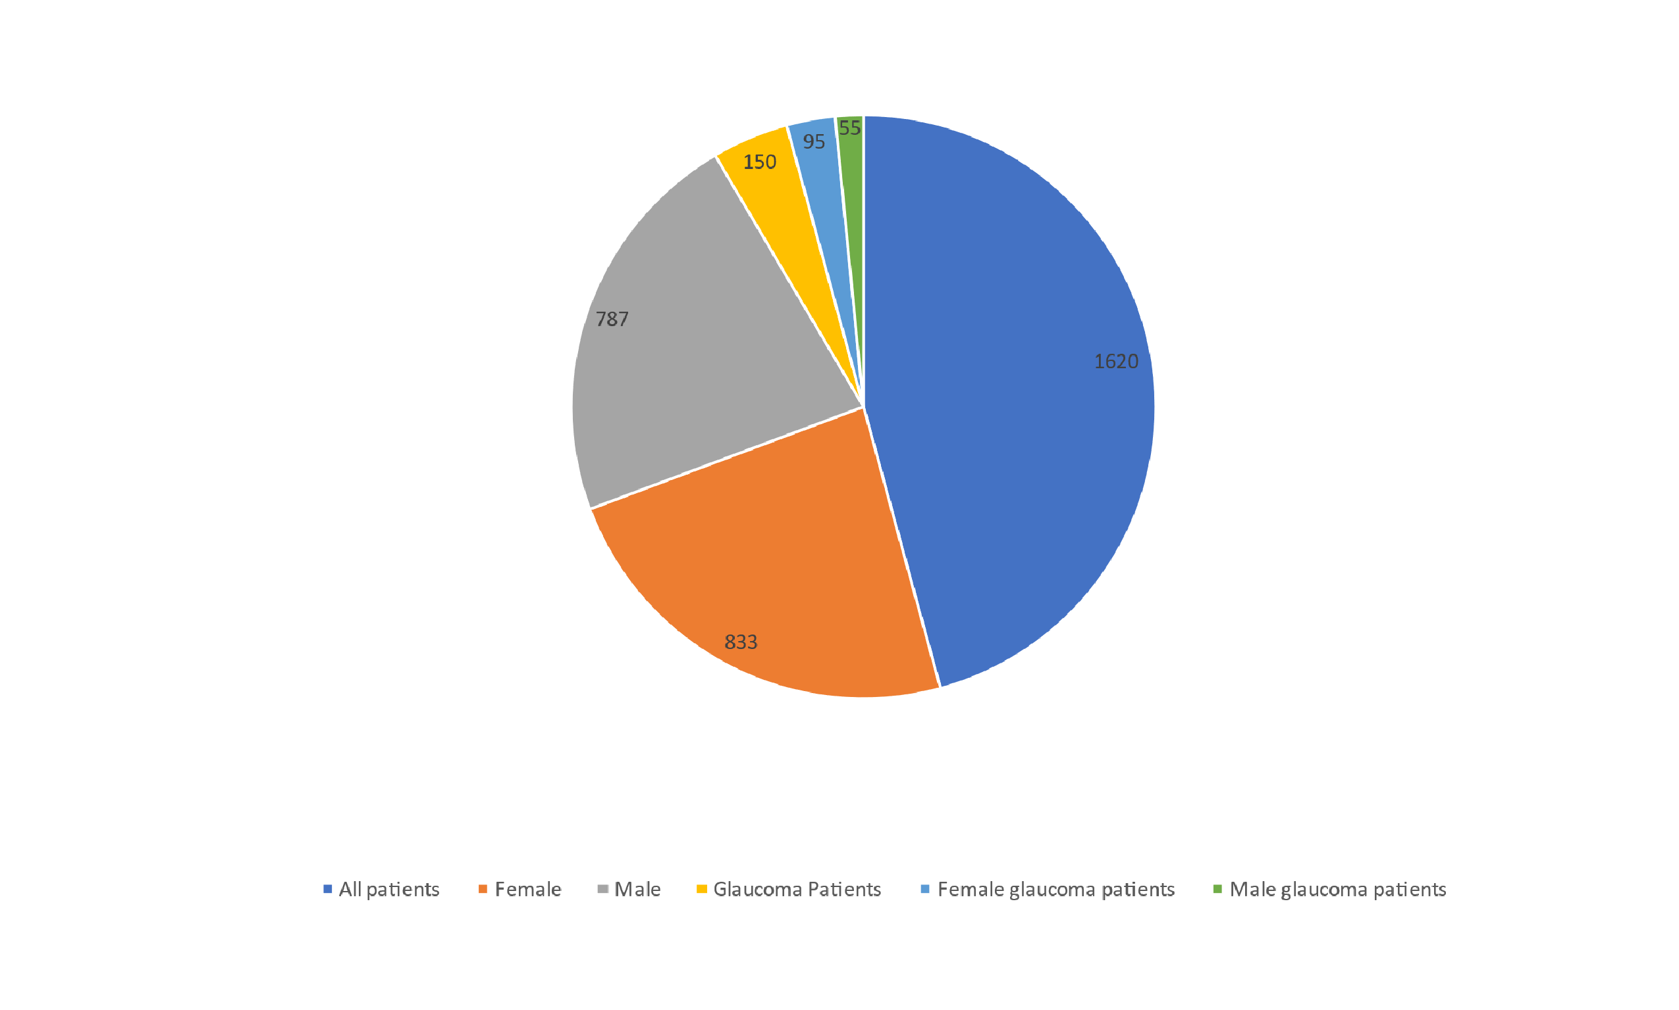
Figure 1. Cases of glaucoma reported to the clinic

Cases of glaucoma reported to the clinic included juveniles but the age frequency suggested most cases of glaucoma were of adult-onset (Figure 1).
The highest frequency occupations with occurrence of glaucoma are farmers 54 (36%) and traders 30 (20%)
TABLE 1: GENDER DISTRIBUTION

GENDER FREQUENCY PERCENT

FEMALE 95 | 63.3
MALE 55 | 36.7

150 case studies were picked out of 833 patients that met the inclusion criteria.
Their ages ranged from 10 to 100 years with age 71-100 holding the highest frequency. Cases of glaucoma reported to the clinic included juveniles but the age frequency suggested most cases of glaucoma were of adult-onset.

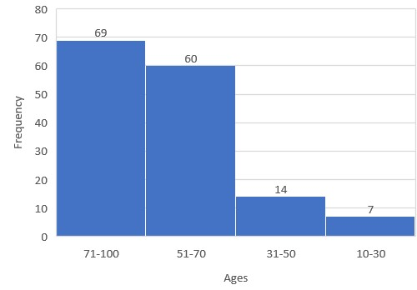
Figure 2 : AGE DISTRIBUTION

TABLE 2. Occupation

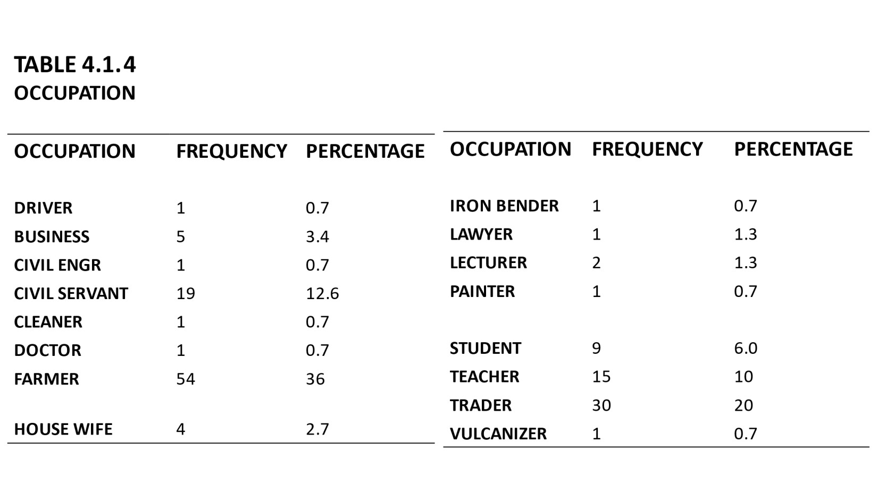

Discussion
It was impossible to overstate the importance of maintaining good eye health. This study highlighted the sociodemographic characteristics of glaucoma patients receiving tertiary care at the Federal Medical Centre (FMC), Owo. Most of the participants were elderly, suggesting that glaucoma occurred at an exceptionally high rate among older adults. Age had long been identified as a major risk factor, and studies in Africa consistently reported that the average age of individuals living with glaucoma was 50 years or above.
Globally, women outnumbered men among glaucoma cases and also lived longer, which increased their lifetime risk of the disease. Consistent with previous evidence, this study found that women were more likely than men to develop glaucoma. A study conducted by Tehrani and published in Current Eye Research in 2015 similarly reported that women were at a greater risk of glaucoma. Although angle-closure glaucoma appeared more common in women, the evidence for sex differences in open-angle glaucoma remained inconclusive. Some studies suggested that female sex hormones might offer some protection to the optic nerve, while reduced lifetime exposure to estrogen was thought to increase the risk of open-angle glaucoma. However, the evidence remained inconsistent, and there was still insufficient data to recommend hormone replacement therapy for glaucoma prevention.
Women also tended to carry a higher burden of glaucoma-related blindness, partly due to their longer life expectancy and their lower socioeconomic status in many African settings. This socioeconomic disadvantage often limited their access to quality eye care services. This was reflected in the finding that some female participants were housewives, which may have contributed to late diagnosis. Tehrani further reported that women were more likely to present with glaucoma at a later stage, increasing the risk of severe visual impairment. Additionally, the higher prevalence of diabetes among women had been implicated as a contributory factor to their increased glaucoma risk. These findings suggested that women might require more frequent glaucoma screening.
This study identified a 51% prevalence of glaucoma in the tertiary healthcare setting, which aligned with findings from similar hospital-based studies. In Nigeria, glaucoma-related disability had significant social and economic consequences. It had been estimated that up to 75% of blindness cases in developing countries were preventable; however, prevention and treatment remained challenging due to poverty and limited access to healthcare, especially in remote areas.
The study also showed that traders and farmers had the highest rates of glaucoma. This could be attributed to prolonged exposure to ultraviolet (UV) radiation due to the nature of their outdoor work. A study by Cáceres-Vélez et al. (2022) also identified UV exposure as a contributing factor to glaucoma development. Evidence from a 2014 study in JAMA Ophthalmology further supported this association, indicating that increased sun exposure and corresponding oxidative stress might elevate glaucoma risk. Research by Dr. Louis Pasquale and colleagues at Harvard Medical School found reduced superoxide dismutase activity in the trabecular meshwork of glaucoma patients. Blood and plasma samples from affected individuals also showed diminished antioxidant status and elevated oxidative stress markers, including protein carbonyls, advanced glycation end products, malondialdehyde, and the DNA damage marker 8-hydroxy-2'-deoxyguanosine (8-OHdG) (Sorkhabi et al., 2011).
Historical studies by Noell and colleagues demonstrated that light—particularly blue light—could induce retinal damage through photochemical pathways that generated reactive oxygen intermediates (ROI). Blue light (450–490 nm) was shown to be especially harmful due to its ability to produce singlet oxygen, superoxide, hydrogen peroxide, and hydroxyl radicals, which damaged cellular proteins and lipids. Although the eye possessed enzymatic defenses such as superoxide dismutase, catalase, and glutathione peroxidase, as well as antioxidant vitamins (A, C, and E), excessive light exposure could overwhelm these systems. Photosensitizers like lipofuscin, melanin, and mitochondrial enzymes such as cytochrome oxidase played a role in generating these harmful intermediates. Studies by Jung et al. and Godley et al. showed that exposure to blue light increased ROI production and caused mitochondrial DNA damage, further supporting the link between oxidative stress and glaucoma pathogenesis.
A major limitation of this study was its hospital-based design, which restricted the ability to generalize the findings to the wider community. The data were skewed toward individuals who were already receiving treatment and might not reflect the true prevalence of glaucoma in the general population. Therefore, future research should include population-based studies to provide more representative data and strengthen the understanding of glaucoma epidemiology in Nigeria.

Conclusion and Recommendation
Glaucoma remained one of the leading causes of blindness, and its impact could be reduced through early diagnosis and improved understanding of its associated risk factors. The study conducted at the Federal Medical Center (FMC), Owo Eye Clinic revealed a notable incidence of glaucoma, leading to the rejection of the null hypothesis and acceptance of the alternative hypothesis. The findings provided strong evidence that age was a significant risk factor among patients presenting to the clinic. Additionally, certain occupational groups—particularly farmers and traders—were found to be at greater risk of developing glaucoma. The study also showed that females were more susceptible to glaucoma than males.
Importantly, based on these findings, the study recommended that public health awareness campaigns be strengthened to improve early detection, especially in rural communities where knowledge and access to eye care remained limited.
Ethics Statement:
I testify on behalf of all co-authors that our article was submitted in accordance with ethical principles in publishing.
All authors agree that:
- This research presents an accurate account of the work performed, all data presented are accurate and methodologies detailed enough to permit others to replicate the work.
- This manuscript represents entirely original works and or if work and/or words of others have been used, that this has been appropriately cited or quoted and permission has been obtained where necessary.
- This material has not been published in whole or in part elsewhere.
- The manuscript is not currently being considered for publication in another journal.
- That generative AI and AI-assisted technologies have not been utilized in the writing process or if used, disclosed in the manuscript the use of AI and AI-assisted technologies and a statement will appear in the published work.
- That generative AI and AI-assisted technologies have not been used to create or alter images unless specifically used as part of the research design where such use must be described in a reproducible manner in the methods section.
- All authors have been personally and actively involved in substantive work leading to the manuscript and will hold themselves jointly and individually responsible for its content.

Conflict of interest: The authors have declared that no competing interests exist.
Ethical Consideration: Approval was granted by the Research Ethics Committee of the Federal Medical Center Owo with reference number FMC/OW/380/VOL.CLXV/74 dated 12th January 2023.
Ethical Considerations
Approval was granted by the Research Ethics Committee of the Federal Medical Center Owo with reference number FMC/OW/380/VOL.CLXV/74 dated 12th January 2023.

COMPETING INTERESTS DISCLAIMER:
Authors have declared that they have no known competing financial interests OR non-financial interests OR personal relationships that could have appeared to influence the work reported in this paper.

References
- Cáceres-Vélez, P. R., Gómez-Olivas, J. D., & Hernández-Mendoza, F. A. (2022). Occupational ultraviolet exposure and its association with glaucoma progression. International Journal of Ophthalmic Research, 8(3), 45–52.

- Godley, B. F., Shamsi, F. A., Liang, F.-Q., Jarrett, S. G., Davies, S., & Boulton, M. (2005). Blue light induces mitochondrial DNA damage and reactive oxygen species in human retinal pigment epithelial cells. Journal of Biological Chemistry, 280(22), 21061–21066.

- Jung, H.., Reme, C., & Mondino, B. (1993). Blue light irradiation and oxidative damage to mitochondrial membranes in retinal cells. Investigative Ophthalmology & Visual Science, 34(4), 1231–1238.

- Kyari, F., Entekume, G., Rabiu, M., Spry, P., Wormald, R., Nolan, W., ... & Gilbert, C. E. (2015). A Population-based survey of the prevalence and types of glaucoma in Nigeria: results from the Nigeria National Blindness and Visual Impairment Survey. BMC ophthalmology, 15(1), 1-15.
- Noell, W. K., Walker, V. S., Kang, B. S., & Berman, S. (1966). Retinal damage by light: The photochemical basis. Science, 154(3756), 439–449.

- Pasquale, L. R., Willett, W., Rosner, B., Kang, J. H., & Wiggs, J. L. (2014). Ultraviolet radiation exposure and glaucoma risk. JAMA Ophthalmology, 132(3), 293–301.

- Resnikoff, S., Pascolini, D., Etya’ale, D., Kocur, I., Pararajasegaram, R., Pokharel, G. P., & Mariotti, S. P. (2004). Global data on visual impairment in the year 2002. Bulletin of the World Health Organization, 82(11), 844–851.

- Sorkhabi, R., Chitsazian, F., Aghdam, K. A., & Amini, H. (2011). Oxidative stress markers in aqueous humor of patients with primary open-angle glaucoma. Molecular Vision, 17, 41–46.
- Tehrani, S. (2015). Gender differences in glaucoma: A review of the literature. Current Eye Research, 40(2), 201–211.

- Usifoh, S. F., Omoti, A. E., & Edema, O. T. (2014). Awareness and knowledge of glaucoma among patients attending the eye clinic of a tertiary hospital in Nigeria. Nigerian Journal of Clinical Practice, 17(4), 491–495. https://doi.org/10.4103/1119-3077.134022

