Recurrent Dysphagia Beyond the Usual Diagnoses: A Case of Fibrostenotic Eosinophilic Esophagitis in an Adult

Abstract
Background
Eosinophilic esophagitis (EoE) is a chronic immune-mediated esophageal disease and an increasingly recognized cause of dysphagia in adults. Diagnostic delay remains frequent and is associated with progression toward fibrostenotic disease and esophageal strictures.
Case presentation
We report the case of a 38-year-old man presenting with long-standing progressive dysphagia, initially attributed to other causes. Upper gastrointestinal endoscopy revealed a tight distal esophageal stenosis. Initial biopsies were non-diagnostic, and the patient underwent repeated endoscopic dilations with only transient improvement. Systematic esophageal biopsies obtained during reassessment demonstrated marked eosinophilic infiltration consistent with eosinophilic esophagitis. A diagnosis of fibrostenotic EoE was established.
The patient was treated with a combined strategy including progressive esophageal dilation and anti-inflammatory medical therapy with topical corticosteroids, followed by orodispersible budesonide. This approach resulted in sustained clinical improvement, increased esophageal caliber, and histological remission under maintenance therapy.
Conclusion
This case highlights the consequences of delayed diagnosis of eosinophilic esophagitis in adults and underscores the importance of systematic esophageal biopsies in patients with unexplained dysphagia. In fibrostenotic EoE, combined anti-inflammatory therapy and endoscopic dilation are essential to achieve durable symptom control and prevent disease progression.
Keywords
Eosinophilic esophagitis; Dysphagia; Esophageal stricture; Endoscopic dilation; Budesonide; Fibrostenotic disease.

Introduction
Dysphagia is a common symptom in adult gastroenterology practice and represents a frequent indication for upper gastrointestinal endoscopy. Its etiologies are multiple, including structural, inflammatory, and motility disorders. While peptic strictures, esophageal cancer, and motility abnormalities are often considered first, inflammatory conditions may be under-recognized, particularly when endoscopic findings are subtle or non-specific [1].
Eosinophilic esophagitis (EoE) is a chronic, immune-mediated esophageal disease characterized by symptoms of esophageal dysfunction and a predominant eosinophilic infiltration of the esophageal mucosa [2]. Initially described in pediatric populations, EoE is now increasingly recognized in adults and represents one of the leading causes of recurrent dysphagia and food bolus impaction in young and middle-aged patients [3,4]. Epidemiological data indicate a continuous rise in both incidence and prevalence worldwide, reflecting increased awareness but also a true increase in disease burden [2,5].
Despite growing recognition, diagnostic delay remains common in adult EoE, often exceeding several years. This delay is clinically relevant, as persistent untreated inflammation is associated with progressive esophageal remodeling, loss of compliance, and development of fibrostenotic complications, including fixed strictures [6–8]. Adult patients frequently adapt their eating behaviors, masking symptoms and further contributing to delayed diagnosis [4].
Endoscopic findings in EoE are variable and may include esophageal rings, longitudinal furrows, white exudates, and strictures. However, up to 15–20% of adult patients may present with a macroscopically normal esophageal mucosa, emphasizing that endoscopic appearance alone is insufficient to exclude the diagnosis [1,3,9]. Consequently, current international and national guidelines strongly recommend systematic esophageal biopsies at multiple levels in all patients with unexplained dysphagia, regardless of endoscopic findings [2,10].
The management of EoE aims not only to relieve symptoms but also to control esophageal inflammation in order to prevent disease progression. In patients with fibrostenotic disease, a combined strategy associating anti-inflammatory medical therapy and endoscopic dilation is often required to achieve sustained clinical and histological remission [7,11].
We report the case of an adult patient with long-standing progressive dysphagia and delayed diagnosis of eosinophilic esophagitis, complicated by severe esophageal stenosis. This case highlights the diagnostic pitfalls of EoE in adults and illustrates the importance of systematic biopsies and combined medical and endoscopic management in fibrostenotic forms of the disease.

Case Presentation
A 38-year-old man was referred to our department for evaluation of progressive dysphagia. His medical history was notable for active tobacco use and occasional alcohol consumption. He had no known history of atopic disease, asthma, or food allergy. There was no significant family history, and he was not receiving any long-term medication.
The patient reported symptoms of gastroesophageal reflux beginning in 2016, for which he did not receive regular medical treatment. In 2021, he developed intermittent dysphagia to solid foods, which progressively worsened over time. By early 2023, dysphagia had become severe, involving both solids and liquids, and was associated with near-complete aphagia and unintentional weight loss. He denied chest pain, odynophagia, or extra-esophageal symptoms.
On admission, physical examination revealed a thin patient with signs of undernutrition. His body mass index was 18 kg/m². Vital signs were stable, and abdominal examination was unremarkable. No peripheral lymphadenopathy or cutaneous signs of systemic disease were observed.
Laboratory investigations showed a normal complete blood count without peripheral eosinophilia. Serum sodium was mildly decreased (128 mmol/L), C-reactive protein was elevated at 16 mg/L, and serum albumin was reduced to 31 g/L, reflecting a state of malnutrition and inflammation. Renal and liver function tests were within normal limits.
Upper gastrointestinal endoscopy revealed a tight, ulcerated stenosis of the distal esophagus, located approximately 36 cm from the incisors. The stenosis was not passable with a standard endoscope and was friable, with contact bleeding (figure 1). Multiple biopsies were obtained at the level of the stenosis. Histopathological examination showed ulcerated esophageal mucosa replaced by granulation tissue with inflammatory infiltrate and fibrino-leukocytic exudate, without evidence of malignancy.
A barium esophagogram demonstrated a circumferential narrowing involving the distal third of the esophagus. Contrast-enhanced computed tomography of the chest and abdomen revealed regular, circumferential thickening of the distal esophageal wall over a 6 cm segment, measuring approximately 4 mm in thickness, without evidence of extrinsic compression or regional lymphadenopathy.
The patient was hospitalized for correction of electrolyte abnormalities and nutritional support, including parenteral nutrition. High-dose proton pump inhibitor therapy was initiated intravenously. Endoscopic management consisted of progressive esophageal dilation using Savary bougies. Three dilation sessions were performed over a two-month period, leading to partial and transient clinical improvement.
Despite initial response, dysphagia recurred shortly after the third dilation. A repeat endoscopy was performed with systematic esophageal biopsies obtained from both proximal and distal esophageal segments, including areas with and without visible mucosal abnormalities (figure 2). Histological examination revealed marked eosinophilic infiltration exceeding 20 eosinophils per high-power field, consistent with eosinophilic esophagitis. No granulomas or fungal elements were identified. Gastric biopsies showed non-atrophic, non-active gastritis without Helicobacter pylori infection (figure 3).
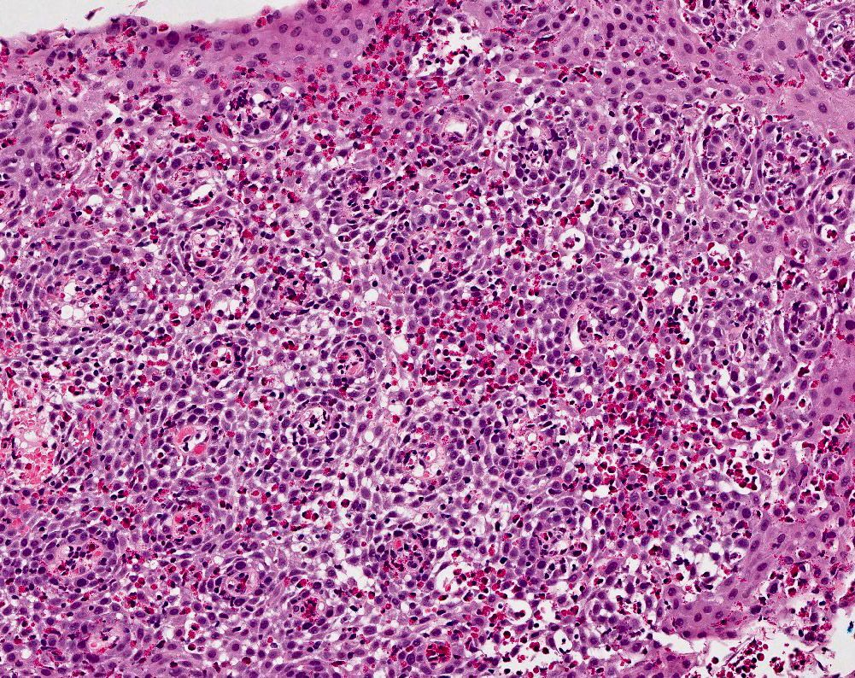
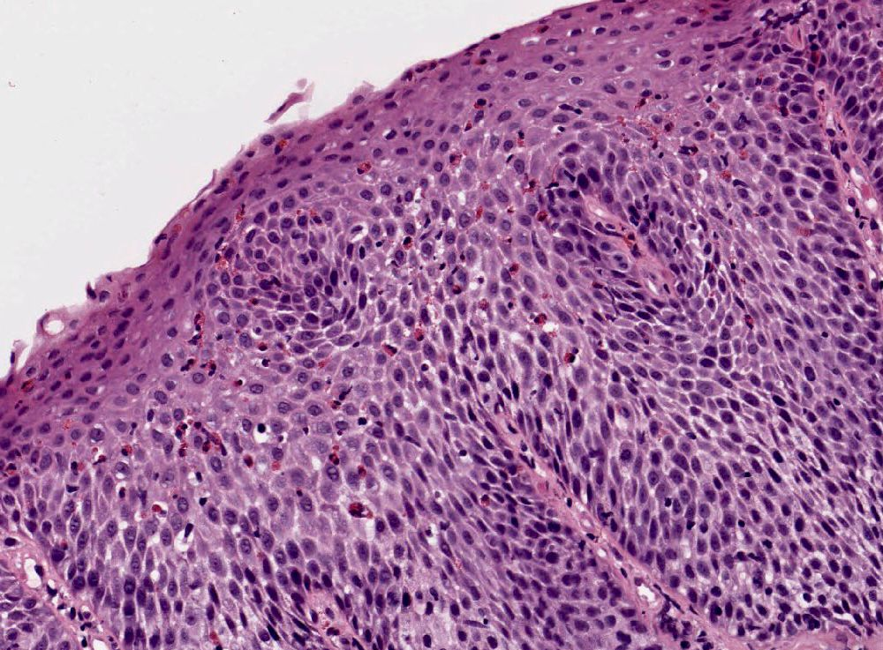
A diagnosis of fibrostenotic eosinophilic esophagitis was established. Swallowed topical corticosteroid therapy was initiated, followed by treatment with orodispersible budesonide. Additional endoscopic dilation sessions were performed in combination with anti-inflammatory therapy. This combined approach resulted in significant clinical improvement, with resolution of dysphagia and improvement in nutritional status. Follow-up endoscopy demonstrated increased esophageal caliber and histological remission under maintenance therapy.

Discussion
This case illustrates a typical yet still challenging presentation of adult EoE, characterized by a prolonged diagnostic delay and progression toward a fibrostenotic phenotype. Despite increasing awareness, EoE remains underdiagnosed in adults, particularly when dysphagia is slowly progressive and endoscopic findings are initially non-specific.
Diagnostic delay and progression to fibrostenotic disease
Several studies have demonstrated a strong association between diagnostic delay and the development of esophageal strictures in EoE. Chronic untreated inflammation leads to transmural remodeling, subepithelial fibrosis, and progressive loss of esophageal compliance, ultimately resulting in fixed stenosis [6–8]. In adults, the median delay between symptom onset and diagnosis may exceed 6–10 years, largely due to symptom adaptation and underestimation of dysphagia severity [3,4]. In the present case, dysphagia evolved over several years before a definitive diagnosis was established, favoring progression toward a severe fibrostenotic form.
Limitations of endoscopic appearance and importance of systematic biopsies
Endoscopic findings in EoE are heterogeneous and may range from typical features—such as rings, longitudinal furrows, and white exudates—to an apparently normal esophageal mucosa. Importantly, up to 15–20% of adult patients may have normal endoscopic findings despite active disease [1,9]. This variability explains why reliance on endoscopic appearance alone may lead to missed or delayed diagnosis. Current international and French guidelines strongly recommend obtaining multiple esophageal biopsies at different levels, including proximal and distal segments, in all patients with unexplained dysphagia, regardless of macroscopic appearance [2,10]. In this case, the diagnosis was only established after repeat endoscopy with systematic biopsies, highlighting a common diagnostic pitfall.
Fibrostenotic phenotype and role of esophageal dilation
Fibrostenotic EoE represents a late stage of the disease and is particularly frequent in adults with long-standing symptoms. Esophageal dilation is an effective therapeutic option to rapidly relieve dysphagia by increasing luminal diameter and improving bolus transit. Multiple studies have demonstrated that dilation is safe in EoE, with a low risk of perforation when performed progressively and cautiously [7,11]. However, dilation addresses the mechanical consequence of the disease rather than the underlying inflammatory process and should not be used as monotherapy.
Need for combined anti-inflammatory and endoscopic treatment
Control of esophageal inflammation is a key therapeutic objective in EoE. Topical swallowed corticosteroids and proton pump inhibitors are effective in inducing histological remission and reducing eosinophilic infiltration [2,10]. Importantly, evidence suggests that adequate control of inflammation significantly reduces the need for repeated dilations in patients with fibrostenotic disease [7]. In the present case, initial improvement after dilation alone was transient, whereas sustained clinical remission was achieved only after introduction of topical corticosteroid therapy combined with endoscopic dilation. This supports current recommendations advocating a combined approach in fibrostenotic EoE [10].
Maintenance therapy and long-term management
EoE is a chronic disease with a high risk of relapse after treatment discontinuation. Maintenance therapy is therefore recommended, particularly in patients with severe disease, prior strictures, or recurrent symptoms [2,10]. Budesonide orodispersible tablets have demonstrated efficacy in maintaining clinical and histological remission and represent a valuable therapeutic option in adult patients [11]. Long-term follow-up, including clinical assessment and periodic endoscopic evaluation, is essential to monitor disease activity, prevent relapse, and limit progression of fibrostenotic complications.

Conclusion
This case highlights the consequences of delayed diagnosis in adult eosinophilic esophagitis and underscores the importance of systematic esophageal biopsies in patients with unexplained dysphagia. Fibrostenotic disease requires a combined therapeutic strategy associating anti-inflammatory medical treatment and endoscopic dilation. Early recognition and sustained maintenance therapy are essential to prevent disease progression and improve long-term outcomes.
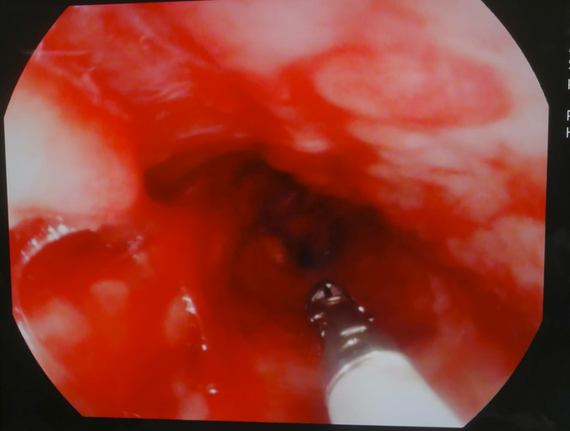
Figure 1. Initial upper gastrointestinal endoscopy showing a tight distal esophageal stenosis (distal esophagus).

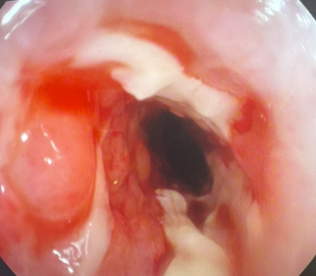
Figure 2. Upper gastrointestinal endoscopy after recurrence of dysphagia.

Figure 3. Histopathological examination of esophageal biopsies.

COMPETING INTERESTS DISCLAIMER:
Authors have declared that they have no known competing financial interests OR non-financial interests OR personal relationships that could have appeared to influence the work reported in this paper.

Références
- Zerbib F. L’œsophagite à éosinophiles. POST’U. 2016.
- De Bortoli N, Visaggi P, Penagini R, et al. The 1st EoETALY Consensus on the Diagnosis and Management of Eosinophilic Esophagitis. Dig Liver Dis. 2024;56:951–963.
- Gupta M, Grinman M. Diagnosis and management of eosinophilic esophagitis. CMAJ. 2024;196:E568–E575.
- Dellon ES, Liacouras CA, Molina-Infante J, et al. Updated international consensus diagnostic criteria for eosinophilic esophagitis. Gastroenterology. 2018;155:1022–1033.
- Savarino E, Ghisa M, Lastroni G, et al. Epidemiology and natural history of eosinophilic esophagitis. Clin Gastroenterol Hepatol. 2017;15:173–182.
- Schoepfer AM, Safroneeva E, Bussmann C, et al. Delay in diagnosis of eosinophilic esophagitis increases risk for stricture formation. Gastroenterology. 2013;145:1230–1236.
- Runge TM, Eluri S, Woosley JT, et al. Control of inflammation decreases the need for subsequent esophageal dilation in patients with eosinophilic esophagitis. Dis Esophagus. 2017;30:1–7.
- Lucendo AJ, Arias Á. The natural history of eosinophilic esophagitis: What do we know so far? Curr Opin Gastroenterol. 2018;34:226–232.
- Hirano I, Moy N, Heckman MG, et al. Endoscopic assessment of the esophagus in eosinophilic esophagitis: Validation of the EREFS system. Gastrointest Endosc. 2013;77:335–342.
- Zerbib F, Berger A, Hagège H, et al. Recommandations françaises pour le diagnostic et la prise en charge de l’œsophagite à éosinophiles chez l’adulte (SNFGE). 2024.
- Dellon ES, Katzka DA, Collins MH, et al. Budesonide orodispersible tablets for induction and maintenance of remission in eosinophilic esophagitis. Gastroenterology. 2019;157:74–86.

