Original Research Article

Cytotoxic effects of cypermethrin and methyl parathion: in vitro and in vivo studies

ABSTRACT:
Cypermethrin and methyl parathion are both insecticides, though they belong to different chemical classes and have distinct characteristics and effects. Apart from these, their frequent use in agricultural and health sectors throughout West Bengal, these insecticides showed significant environmental rises, affecting different life forms. This present study firstly deals with different in vitro methods viz. MTT assay studies for the calculation of IC₅₀ doses of cypermethrin and methyl parathion on human normal kidney cell line HEK-293, these results were further supported by DAPI staining and Comet assay study for direct effects of these two insecticides on cellular DNA and finally DCFDA staining as cellular stress induced ROS regeneration study. These in vitro study reports were finally concluded by in vivo (histological) studies to show the potential toxicity generating effects of these two frequently used chemicals on kidney sections of male albino mice (Mus musculus) . For this in vivo experiment three groups of male mice were chosen and treated intra-peritoneal with normal saline, LD₅₀ values of cypermethrin and methyl Parathion respectively. Apart from the LD₅₀ dose calculation, total accumulation of these two insecticides leading to prominent histological changes viz. glomerular shrinkage, vacuole formation, fat depositions etc. was also studied. All of these experimental results pointed out, though both of the insecticides are capable for generating toxicity in cellular and tissue level, between them methyl parathion was found to be the highly toxic one.
HIGHLIGHTS:
- I have calculated the IC₅₀ values of both the insecticides, Cypermethrin and Methyl Parathion on HEK-293 cell line.
- These cellular inhibitory toxic effects of these two insecticides were further supported by DAPI staining, Comet assay followed by ROS generation study by DCFDA staining (in vitro studies).
- Finally toxic effects of these two chemicals were also studied on kidney of male Swiss albino mice (Mus musculus) by histological studies (in vivo studies).
KEYWORDS: Cypermethrin; Methyl parathion, HEK-293, MTT assay; Comet assay, Histological study.
ABBREVIATIONS: Cypermethrin- CM; Methyl parathione- MPT.

INTRODUCTION:

Pesticide can be chemical or biological agent that are capable to control pests. Approximately 56.7% of Indian populations are in direct contact to pesticides due to agricultural work (Jamil et al.,2004). Though pesticides have positive roles in increasing crop production but their uncontrolled use can directly cause different adverse effects on the environment leading to toxicity on overall animal as well as human health making it an important concern in public health. Worldwide, an estimated three million cases of pesticide poisoning occur every year, resulting in an excess of 250000 deaths, primarily in developing countries (Thakur et al.,2013).The World Health Organization (WHO) and the United Nations Environmental Program estimated that one to five million cases of pesticide poisoning occur among agricultural workers each year with about 20000 mortalities.(Banerjee et al.,2014).
Cypermethrin a pyrethroid insecticide was first synthesized in 1974 (Jamil et al.,2004) and introduced in the market in 1977. Alpha-cypermethrin a potential isomer of Cypermethrin is a most widely utilized pesticide (almost 46%) across West Bengal in agricultural lands apart from health sectors. Its cost effective application have identified it as a prominent tool for pest and vector control. It is found to act as a fast acting neurotoxin in insects affecting the functions of voltage-gated sodium channels in nerve cell-membrane (Singh et al., 2012). Beside sodium channels, cypermethrin also alter other ion channels (chloride, calcium and potassium) (Soderlund, 2011) and interfere with neurotransmitters like GABA and acetylcholine (Singh et al., 2012). It was also found to stimulate oxidative stress and DNA damage (Ullah et al., 2024). Despite its high degradability, cypermethrin is known to be highly toxic to non-target organisms such as fish, bees and aquatic insects (Delabie et al., 1985; Karise et al., 2007; Sinha et al., 2013; Sarıkaya, 2009). Animal studies have indicated potential neurotoxic, reproductive, and genotoxic effects (Singh et al., 2012; Sharma et al., 2014) of cypermethrin, though detailed in vitro and in vivo cellular toxicity generating effects in vital organs such as liver and kidney are still in lacunae.
Methyl Parathion is a highly toxic organophosphate insecticide that is partly restricted but not banned to use for agriculture in West Bengal. For many years it is classified as Extremely Hazardous (Ia) by the World Health Organization and it is classified as Severely Hazardous by the Rotterdam Convention and is not allowed for sale and import in nearly all countries around the world, while a few allows it under subject to specified conditions only. Farmers Exposed to Methyl Parathion can experience symptoms like headache, nausea, burning feeling in eyes throughout spraying. Its toxicity generates from its ability to inhibit acetylcholinesterase (AChe) enzyme (Hahn et al., 1991). Studies on fish gill cell lines have already exposed that methyl parathion causes noticeable alterations in cellular ultrastructure, including dialation of mitochondria, breakdown of rough endoplasmic reticulum and nuclear necrosis (Li and Zhang, 2002).It was also found to persuade DNA damage and apoptosis in various in vitro models (Edwards et al., 2011).Apart from these, it was also found to show neurotoxicity, developmental toxicity , reproductive toxicity, cardiotoxicity and genotoxicity in defferent model animals (Vikash et al.,2018).Though direct cellular pathways of toxicity generating properties of Methyl parathion has not been established so far. So, our present study also depicts about a generalized detailed in vitro and in vivo study of methyl parathion on kidney, which is still in need.

- MATERIALS AND METHODS:

  - Chemicals:
Stock solutions (1%) of cypermethrin and methyl parathion pesticides were prepared in dimethyl sulphoxide (DMSO) and various aliquots from the stock solutions were used throughout the experiments. All experiments were carried out in triplicate and averages recorded (Suman et al., 2006).

  - In vitro studies:
A human normal kidney epithelial cell line viz.HEK-293 was purchased from NCCS, Pune. Cells were grown in DMEM supplemented with 10% heat inactivated fetal bovine serum (FBS) and 1% antibiotic–antimycotic solution, in a humidified atmosphere at 37°C with 5% CO₂.

    - MTT assay:
The percentage of cell viability was tested and I have calculated the IC₅₀ (half-maximal inhibitory concentration) values for the above mentioned cell lines by MTT (1 mg/ml of the tetrazolium dye) assay. 2 × 10⁵ Cells were seeded in 96 well plates for 48 hrs and then the assay was performed. MTT dissolved in phosphate buffer saline are mostly yellowish in color but after treatment to the cell with fresh serum purple formazan crystals were formed which are insoluble in aqueous solutions (Meerloo et al., 2011), so the crystals are then dissolved in 100% DMSO and measured at 595nm. An increase or decrease in cell number generates a simultaneous change in the amount of formazan formed, representing the degree of cytotoxicity caused by the test material. IC₅₀ was calculated by the equation where, T is the optical density of the sample following 48 h drug treatment, T_{o} is the optical density at time zero & C is optical density of control. The experiment was continual three times and standard was taken. After MTT assay, the samples were also directly observed under phase contrast microscope after treatment of IC₅₀ concentrations of CM and MPT (27 and 14 μM) to study cell shape and contour change.
    - DAPI staining:
DAPI (4',6-diamidino-2-phenylindole) staining is a commonly used effectual method for studying nuclear disintegration, a key characteristic of apoptosis (programmed cell death). DAPI is a fluorescent dye that binds strongly to double-stranded DNA with AT rich regions and after binding to DNA, its fluorescence increase to many folds. DAPI staining can generate brightly stained fragments of nucleus (apoptotic bodies). For this method HEK-293 cells were first fixed and then washed with Phosphate-Buffer Saline (PBS). Then these were treated with IC₅₀ dose (27 and 14 μM) of CM and MPT for 48 hours. As a final part cells were treated with DAPI stain (1µg/ml) and after 5 mins incubation directly observed under fluorescence microscope.

    - ROS generation studies:

Cypermethrin was previously showed to boast oxidative stress generating property due to intra cellular stress (Idris et al., 2012). Oxidative stress was also found to be a noteworthy component of the method of organophosphate compound toxicity (Ambali et al., 2007; Sukeet al., 2008). A number of studies explained that oxidative stress is involved in OPs toxicity (Hsu et al.2001; Prakasan et al., 2001; Vidyasagar et al., 2004; Shadnia et al.,2005). Repeated daily oral doses of pesticide in rats changed the biochemical parameters and antioxidant status (Manni, 2004). Several studies reveal that organophosphate compounds stimulate oxidative stress, leading to generation of free radicals and alteration of antioxidant condition (Idris et al., 2012). Toxic effects of both the pesticides (CM and MPT) on HEK-293 cells was again confirmed by the reactive oxygen species generation in cells by DCFDA staining followed by single cell gel electrophoresis or comet assay. 2×10⁵ cells were treated with CM and MPT at IC₅₀ dose of 27μM and 14 µM respectively for 48h and the levels of intracellular ROS were assessed by fluorescence microscopy after incubating with DCFH-DA (20μM) (dichloro fluorescence diacetate) for 30 min at 37°C.

    - Comet assay:

Again, study of DNA disintegration was carried out by comet assay as described by Singh et al (16). While primarily known as a responsive technique for detecting DNA damage in individual cells, Comet assay or Single Cell Gel Electrophoresis (SCGE) also plays decisive role in cytotoxicity studies by enlightening the integrity of cellular DNA, which potentially indicates cellular reaction to toxic substances. Cleaned slides were covered with 120 μl of 1% regular agarose to promote solid attachment of consecutive layers. Second layer included 110 μl of 0.5% low melting agarose along with the 20 μl of sample material (2×10⁵ cells treated with IC₅₀ dose of CM and MPT respectively). The final layer contained only 100 μl of low melting agarose. As the gel becomes solidified, the slides were dipped in cold cell lysing solution and set aside overnight at 4ºC. The slides were finally placed on a horizontal gel electrophoretic unit which was filled with alkaline buffer (pH 13.0). Electrophoresis was performed for 30 min at 27 V and 30 mA. Slides were then washed gently at intervals of 5 min each with neutral buffer (pH 7.5) and finally were stained with 60 ml of silver nitrate and mounted with cover slips to view under a fluorescence microscope.

  - In vivo histological studies:

This entire experiment was performed in the Department of Zoology, University of Kalyani, under the guiding principle of animal ethics committee. For in vivo experiments, male Swiss albino mice (Mus musculus) weighing 22-25g and 4 weeks of age were purchased. All mice were maintained under a temperature of 24±1ºC and humidity of 55±5% with 12 hours light and 12 hours dark cycles. Water and give food to be available to the mice ad libitum (Hua et al., 2012). Animal care and all trial protocols were maintained due to the health criteria of laboratory animals and the study was performed after obtaining Institutional Animal Ethical Committee clearance. The animals were allowed to adapt for 1 week prior to conduct experiment.
    - Experimental design:
The testing intra-peritoneal dose of both CM and MPT were selected as per their LD₅₀ value and acute toxicity on mice maintained in laboratory conditions. The calculated LD₅₀ of CM and MPT was 117 mg/kg and 19 mg/kg bodyweight, respectively through I.P. Three groups of male mice were randomly taken, each group contained five animals.
First group contained Control mice which received only normal saline (0.2ml/kg, B.W. I.P.).
Second group contained CM treated mice which received the dose of CM (25 mg/kg of I.P. for four weeks, total accumulation was 100 mg/kg B.W).
Third group contained MPT injected mice, which received the dose of MPT- 5 mg/kg B.W. of I.P. for 4 weeks (Total accumulation was 100 mg/kg B.W). It was previously reported that cypermethrin (dissolved in DMSO) showed LD50 value of 145mg/kg B.W. in rats when administrated orally (Manna et al., 2004).
Animals from these three groups were sacrificed after particular time intervals. The kidney were excised, washed with normal saline (0.9 % NaCl) and prepared for histological studies. The tissue samples were fixed in 10 % neutral buffer formalin for two days. Finally, tissues were cut at 5-7 µm thick sections by microtome machine. A delicate tissue ribbon made of wax was carefully placed into hot water bath. In the water bath the tissues was separated from the wax and finally these were placed on an ethanol lamp. After that, the tissue was placed on a hotplate. Sections were arranged in a row down the center of the slide (to assist screening under a microscope) and left on the hotplate (on low) for complete night. Next they were counter-stained with hematoxylin-eosin stains. Next, 4 drops of DPX per slide was carefully placed on the slide and the cover slip was put on the top of it. After that, the stained sections were observed under light microscope, Leitz (Biomed) and representative images were taken by Nicon Camera, EOS700D, 18-55 lens. The weight of the mice was also periodically recorded. The kidneys of respective mice groups were excised and their general morphology and weight was examined.
    - Statistical analysis:
The values were expressed as mean ± SEM. Statistical analysis was performed by one way analysis of variance (ANOVA). P values < 0.05 were considered as significant.

- RESULTS AND DISCUSSIONS:

  - Pesticide-induced cell death:
To examine the toxic effects of CM and MPT, HEK-293 cells were treated with varying concentrations of CM (5–50µM) or MPT (5–50µM) and assayed for cell viability at various times after treatment using the MTT . Both CM and MPT reduced MTT metabolism in a concentration- and time-dependent manner (fig.1), suggesting that both of them decreases HEK-293 cells viability. In contrast, 27 µM of CM causes 50% cell death in the population (p<0.05). Besides that, MPT only at concentration of 14 µM is able to stimulate 50% cell death in population after 48 hrs. This result helps to identify MPT as highly potent cytotoxic pesticide between the two causing more cell death with less concentration. These results perfectly correlated with the fundings of Suman et al. 2006 who reported that 33.6 µM is the LC₅₀ dose for Cypermethrin for cultured human lymphocytes (Suman et al., 2006).

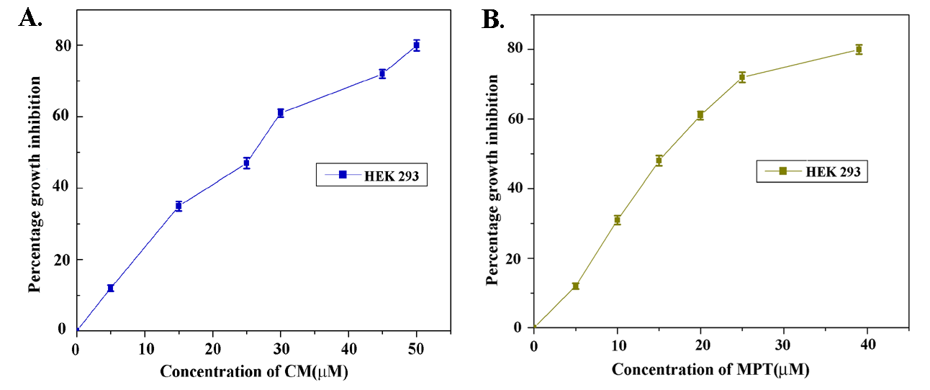
Fig-1.Percentage growth inhibition (IC₅₀ values) of HEK-293 cells following treatment with CM (A) and MPT(B) of varying concentrations for 48 h. Data are statistically calculated with ANOVA test and important values are deliberated against both untreated as well as solvent control (*P< 0.05 vs. solvent control).

Through direct observation under phase contrast microscope for cellular morphological studies showed breakage of cellular nucleus and change in normal cell structure following formation of cellular blebbing (an indication of primary stage of apoptosis).
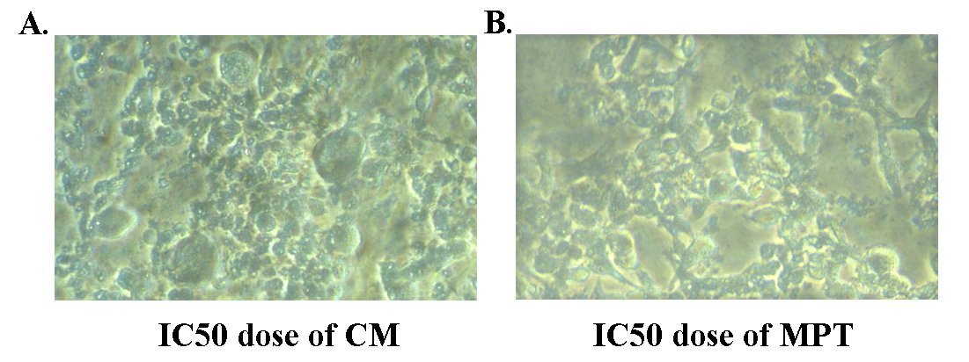

Fig-2.Phase contrast microscopic images of HEK-293 cells following treatment with IC₅₀ doses of CM (A) and MPT (B) for 48 h. There were noteworthy morphological changes, like cells became further round and formation of cell membrane blebbing. In case of MPT cell number markedly decrease following total change of cell contour.

  - Assessment of DNA disintegration:
DAPI staining helps to visualize nuclear fragmentation due to the process of apoptosis or cellular stress. Here, cells treated with IC₅₀ concentration of CM and MPT showed disintegration of intact nucleus as marked by the arrows. This disintegration can be due to intracellular stress generation leading to apoptosis of the cells as a result of insecticides treatments, which was further supported by DCFDA staining results.
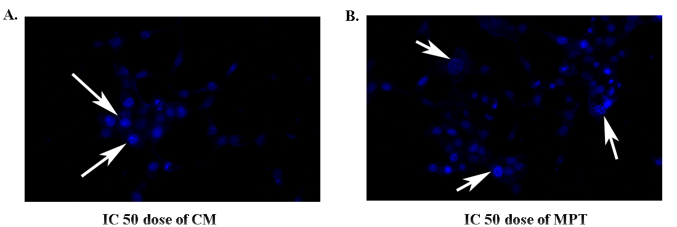

Fig 3. IC₅₀ dose treatment followed by DAPI staining showing prominent nuclear disintegration (marked with white arrows) of two pesticides CM and MPT respectively (A and B), which is indicative of DNA damage. In case of MPT treatment the nuclear disintegration was found to be more profound.

  - ROS generation assessment in treated groups:
The cell-permeant 2′,7'-dichlorodihydrofluorescein diacetate, (H2DCFDA), is generally used to detect the generation of reactive oxygen species (ROS) intermediates like hydrogen peroxide, hydroxyl radical (HO•), nitric oxide (NO), singlet oxygen (1O2), autooxidation etc. The change in green fluorescence is measured using excitation /emission wavelengths of 500/520 nm for DCF. HEK 293 Cells, exposed to IC₅₀ concentrations of CM and MPT (27 and 14 μM) for 48 hrs showed considerable enhance in intracellular ROS as the green colour emission rises in both the cases.
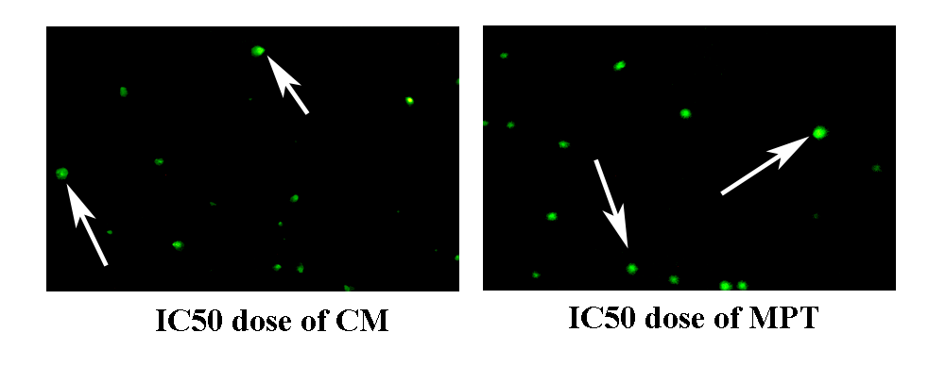

Fig 4. IC₅₀ dose treatment followed by DCFDA staining showing prominent enhance in green fluorescent color (marked with white arrows) in the treated cells; IC₅₀ dose of two pesticides CM and MPT respectively (A and B), which is indicative of ROS generation due to intracellular stress. In case of MPT treatment the green color was markedly increased.

  - Nucleus and DNA disintegration study:

After treating the cells with IC₅₀ dose of CM and MPT, comet assay was performed. It clearly indicated formation of prominent comet tails as a result of nuclear DNA damage. The tail-lengths of the comets were measured by using casp software program. The results showed more DNA strand breaks constituting of 31.4% DNA (longest tail length) with the treatment of MPT at 14 μM, while for CM at IC₅₀ of 27 μM dose treatment,16% DNA was observed in comet tail as calculated by the Casp software (graph not presented in here).

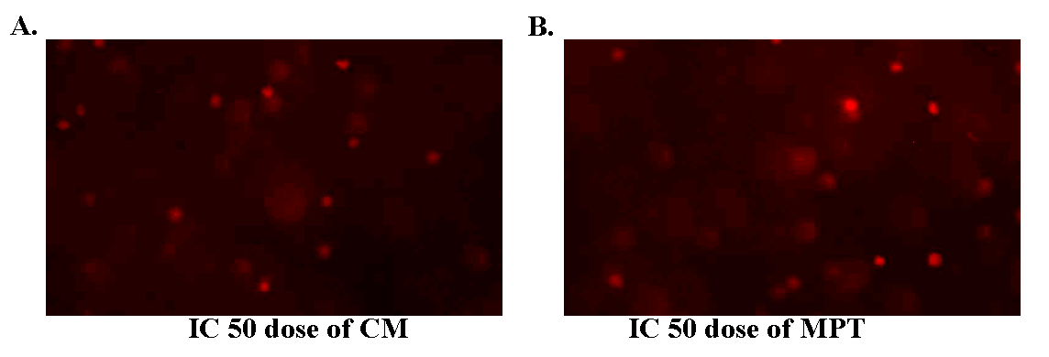

Fig 5. Single cell gel electrophoresis (comet assay) showing prominent comet tails with IC₅₀ dose treatments of two pesticides CM and MPT respectively (A and B), which is indicative of DNA damage.

  - Assessment of body weight and kidney weight changes:
The final body and kidney weights after treatment have been shown in Table 1. All groups were subjected to dying sacrifice after 4th weeks. Final body weights were remarkably decreased in CM and MPT treated groups in comparison to first or untreated group. Beside this, the kidney weights of both the insecticide treated groups were found significant increase than normal or untreated groups. The increase in kidney weight in CM and MPT can be due to the nephrotoxic effects of both these pesticides, which also aids to the fat deposition in kidneys (Rekha et al., 2013; Zain and Aitte, 2023).
Table 1. Body weight and kidney weight in Swiss Albino Mice^{a,b} during all experimental phases
Group | Treatment | No. of Mice | Final  Measurements | 1st week | 4th week
First | Control | 5 | Body weight (g) | 23.3±2.1 | 25.7±2.3
First | Control | 5 | Kidney weight (g) | 0.48±0.3 | 0.52±1.0
Second | CM Treated | 5 | Body weight (g) | 22.4±2.3 | 23.5±1.6
Second | CM Treated | 5 | Kidney weight (g) | 0.47±0.5 | 0.55±0.9*
Third | MPT treated | 5 | Body weight (g) | 22.4±1.9 | 22.3±2.1*
Third | MPT treated | 5 | Kidney weight(g) | 0.49±1.0 | 0.59±1.3*
ªMice were sampled after 4th weeks of initiation of treatment, ^{b}data represented means ±SD, *Significantly diverse from the control groups (p<0.05).

  - Assessment of histopathological changes:
In normal saline treated control group of mice, the section of kidney depicts all normal histological features. All the parts viz. glomerulus, renal tubules, Bowman’s capsule showed intact morphological structures. There is also less fat depositions are found in the structure.
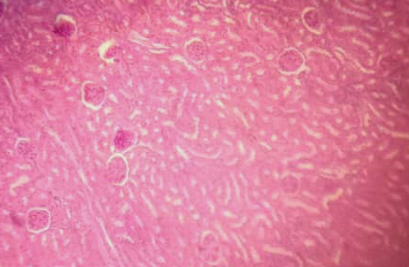
Fig 6 – Histological Section of kidney of Mus musculus showing normal kidney structure, including normal glomerulus, normal kidney tubular structure and normal interstitial connective tissues.

In the CM treated groups, the normal structure was significantly changed. Marked changes were observed as the shape of glomerulus shirnks, followed by an increase space between glomerulus and Bowman’s capsule. There is also loss of connective tissue leading to inflammation and fat deposition, eventually resulting vacuole formation. The MPT treated groups also follows similar results, only leading to more connective tissue destruction. Vacuole formation was also found in here. All these results perfectly correlate with the histological changes in kidney due to the treatment of toxic chemicals (Zain & Aitte 2023).

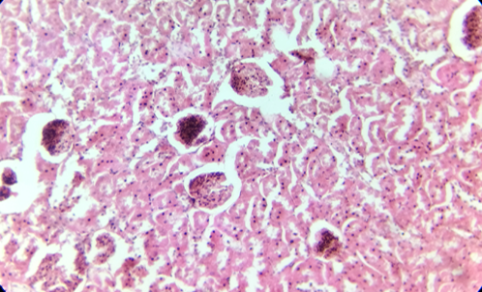

Fig 7 – Histological Section of kidney of Mus musculus exposed to LD₅₀ concentration of CMT showing excessive cellular hyperplasia, shrinkage and necrosis of glomeruli and renal tubules, destruction of blood vessels and connective tissue, vacuole formation due to fat deposition

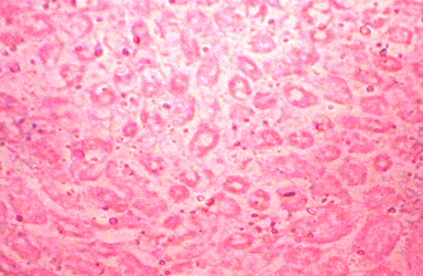
Fig 8 – Histological Section of kidney of Mus musculus exposed to LD₅₀ concentration of MPT showing excessive damage to kidney structure, including shrinkage of glomerulus and renal tubules, total loss of Bowman’s capsule and renal connective tissues following extensive vacuole formation due to fat deposition.

- CONCLUSION:

In conclusion the results of all these experiments suggest that CM and MPT, both the pesticides are able to cause toxic effects on normal kidney cell line (HEK-293) and a considerable amount of cell death and DNA damage most probably through intracellular ROS generation pathway. These results are again supported by in vivo studies, which showed potential glomerular and tissue damage, leading to vacuole formation and fat deposition in mice kidney after these pesticides treatment. Between these two chemicals Methyl Parathion was found to generate highly toxic effects, showing much lower IC₅₀ and LD₅₀ value than Cypermethrin, making it a highly vulnerable insecticide concerned to our health. As both of these pesticides are heavily used in the market of West Bengal, they can easily affect public health in mass number.

DISCLAIMER (ARTIFICIAL INTELLIGENCE):
Author hereby declare, that NO generative AI software (such as Chat GPT, COPILOT etc.) have been used for writing and editing of this manuscript including the images.

REFERENCES:

Banerjee, I., Tripathi, S.K., Sinha Roy, A., & Sengupta, P. (2014). Pesticide use pattern among farmers in a rural district of West Bengal, India. Journal of Natural Science, Biology and Medicine, 5, 313-316.
Delabie, J., Bos, C., Fonta, C., & Masson, C. (1985).Toxic and repellent effects of cypermethrin on the honeybee: Laboratory, glasshouse and field experiments. Pest Management Science, 16, 409-415.
Edwards,F.L., Yedjou, C.G., & Tchounwou, P.B. (2011). Involvement of oxidative stress in methyl parathion and parathion-induced toxicity and genotoxicity to human liver carcinoma (HepG₂) cells. Environmental Toxicology, 28, 342-348.
Hahn, T., Ruhnke, M., & Luppa, H. (1991). Inhibition of acetylcholinesterase and butyrylcholinesterase by the organophosphorus insecticide methylparathion in the central nervous system of the golden hamster (Mesocricetus auratus). Acta. Histochemistry, 91,13-19.
Idris, S.B., Ambali, S.F., & Ayo, J.O. (2012). Review Cytotoxicity of chlopyrifos and cypermethrin:The ameliorative effects of antioxidants. African Journal of Biotechnology,11, 161-164.

Jamil, K., Shaik, A. P., Mahboob, M., & Krishna, D. (2004). Effect of organophosphorus and organochlorine pesticides (monochrotophos, chlorpyriphos, dimethoate, and endosulfan) on human lymphocytes in-vitro. Drug Chemical Toxicology, 27, 133-44.
Karise,R., Viik, E., & Mänd, M. (2007). Impact of alpha-cypermethrin on honey bees foraging on spring oilseed rape (Brassica napus) flowers in field conditions. Pest Management Science, 63,1085-1089.
Li, H., & Zhang, S. (2002). In vitro cytotoxicity of the organophosphorus insecticide methylparathion to FG-9307, the gill cell line of flounder (Paralichthys olivaceus). Cell Biology and Toxicology, 18, 235–241.
Manna, S., Bhattacharyya, D., Basak, D. K., & Mandal, T. K. (2004).Single oral dose toxicity study of α-cypermethrin in rats. Indian Journal of Pharmacology 36(1), 25-28.
Meerloo , J.V., Kaspers G.J.L. & Cloos, J. (2011). Cell sensitivity assays: the MTT assay. Methods Mol Biol. 731, 237-45.
Rekha, Raina, S., & Hamid, S. (2013). Histopathological effects of pesticide-cholopyrifos on kidney in albino rats. International Journal of Research in Medical Sciences, 1(4), 465-475.
Sarıkaya, R. (2009). Investigation of Acute Toxicity of Alpha-Cypermethrin on Adult Nile Tilapia (Oreochromis niloticus L.) .Turkish Journal of Fisheries and Aquatic Science, 9, 85-89.
Sharma, P., Huq , A. U., & Singh, R. (2014). Cypermethrin-induced reproductive toxicity in the rat is prevented by resveratrol. Journal of Human Reproductive Science, 7, 99–106.
Singh, A.K., Tiwari, M.N., Prakash, O., & Singh, M.P. (2012). A Current Review of Cypermethrin-Induced Neurotoxicity and Nigrostriatal Dopaminergic Neurodegeneration. Current Neuropharmacology, 10, 64–71.
Sinha,V., & Shrivastava, S. (2023). Cypermethrin: An Emerging Pollutant and Its Adverse Effect on Fish Health and some Preventive Approach—A Review. Indian Journal of Microbiology, 64, 48–58.
Soderlund, D.M. (2011). Molecular Mechanisms of Pyrethroid Insecticide Neurotoxicity: Recent Advances. Arch Toxicol. 86,165–181.
Suman, G., Naravaneni, R., & Jamil, K. (2006). In vitro cytogenetic studies of cypermethrin on human lymphocytes. Indian Journal of Experimental Biology, 44, 233-239.

Thakur, D., Singh, P., Tripathi, C., Bhadauri, S., Jain, S.K. & Tripathi, R.K. (2013). In Vitro Immunotoxicity Testing of Pesticides using Human Cytokine Promoter Based Reporter Cell Lines. Clinical Experimental Pharmacology ,S4
Ullah , S., Zuberi , A., Ullah , I., & Azzam, M.M. (2024). Ameliorative Role of Vitamin C against Cypermethrin Induced Oxidative Stress and DNA Damage in Labeo rohita (Hamilton, 1822) using Single Cell Gel Electrophoresis. Toxics. 12, 664.
Vikash , Verma , A.K., Jaiswal, A.K., & Mishra, S. (2018). Neurotoxic Effect of Insecticides on Human Nervous System. Journal of Forensic Chemistry and Toxicology. 4, 23-39.
Zain M.H., & Aitte S.A. (2023). Histopathological changes in the kidney tissues of white Swiss mice (Mus musculus L.) exposed to alpha-cypermethrin. Journal of Nephropathology, 12(4),e17303.

