Original Research Article
Agricultural Damage, Livestock Loss, and Human Safety: Insights into Human–Animal Conflict in Southern Tamil Nadu

ABSTRACT
This study explores the patterns, causes, and consequences of human-animal conflict (HAC) from the southern districts of Tamil Nadu, Tirunelveli (6,191 Sq. Km), Tenkasi (532.48 Sq. Km), Thoothukudi (4,707 Sq. Km), and Kanyakumari (1684 Sq. Km), between March 2024 and February 2025. Using newspaper reports from Daily Thanthi and Thinakaran, a total of 94 conflict incidents were documented. The highest number of cases occurred in Tirunelveli (53.19%), followed by Tenkasi (38.3%), Thoothukudi (6.38%) and Kanyakumari (2.13%). Most conflicts occurred in agricultural areas (54.12%) and were concentrated during the night (45.88%) and daytime (43.53%). The primary causes of conflict included agricultural damage, livestock losses, infrastructure damage, and attacks on humans (injury/ kills), involving species such as elephants, wild pigs, bonnet macaques, langurs, and aggressive dogs. This study emphasises the urgent need for mitigation measures, such as public awareness programs, better terrestrial-use planning, and coordinated efforts by forest authorities to balance conservation goals with human safety.
Keywords: Human-animal conflict, Newspapers, KMTR, Dog attacks, Tamil Nadu.

Garphical abstract
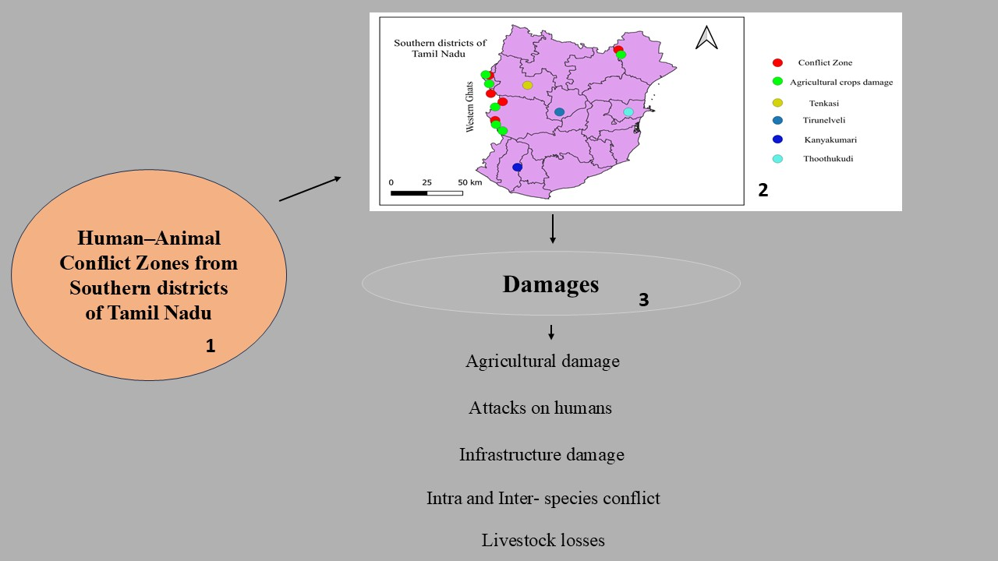
1. INTRODUCTION
Human-animal conflict (HAC) refers to interactions between wild animals and humans that result in either negative or positive consequences for both groups. It is a continuing global issue (Nyhus, 2016; König et al., 2020; Kidane et al., 2024). Most incidents are reported as negative, involving crops and livestock damage, property loss, and, in rare cases, leading to injury or loss of human life due to animal attacks (Ramseena, 2022; Gulati et al., 2021; Madhavan, 2026; Prasad, 2025; Bharti et al., 2025; Senthilkumar et al., 2025). A significant number of conflict events have taken place outside designated protected forests. In contrast, nearly one-third have been recorded within legally protected zones such as national parks, wildlife sanctuaries, elephant and tiger reserves, and reserved forests (Anand & Radhakrishna, 2017). Elephants, wild boars, and bonnet macaques cause most agricultural damage. These wild animals damage major crops such as paddy, coconut, rubber, banana, jackfruit, areca palm, and mango, particularly in the Western Ghats. (Ramseena, 2022; Nair & Jayson, 2021; Chitrambigai et al., 2025). The Western Ghats are a biodiversity hotspot, and the Kalakkad Mundanthurai Tiger Reserve (KMTR), located in this region, is one of the protected areas. It harbours endangered and endemic plant and animal species, including tigers, leopards, Asian wild dogs, Indian elephants, wild pigs, bonnet macaques, and tufted grey langurs (Vanaraj et al., 2024; Annamalai, 2004). In Tamil Nadu's conflict zones within the Western Ghats, a noted conflict area within KMTR spans about 3 km², followed by the Nellai Wildlife Sanctuary at 157 km² (Milda et al., 2023). Factors contributing to HAC include increasing human populations, land-use changes due to growing land demands, deforestation, food scarcity in the wild, climate change, and rising wildlife populations (Distefano, 2005; Singh & Singh, 2023; Treves et al., 2009; Somu and Palanisamy, 2022; Chitrambigai et al., 2025).
2. MATERIALS AND METHODS
This study examines human-animal conflict (HAC) in the southern districts of Tamil Nadu, including Tirunelveli (latitude 8°4301 N and longitude 77°4556 E (6,191 Sq. Km)), Tenkasi (latitude 8° 5728 N and longitude 77°1855 E (532.48 Sq. Km)), Thoothukudi (latitude 8° 4601 N and longitude 78° 0803 E (4,707 Sq. Km)), and Kanyakumari (latitude 8° 0516 N and longitude 77° 3253 E (1684 Sq. Km)) (Figure. 1), based on reports from regional newspapers such as Daily Thanthi and Thinakaran. A total of 94 incidents were recorded between February 2024 and March 2025, with repeated incidents omitted. Data were selected based on specific criteria: biting (humans injured or killed by animals), hunting (animals injured or killed by humans), natural (natural deaths and flood-related incidents), and damages (agricultural loss, infrastructure destruction, and interspecies conflict).
3. Result and Discussion
3.1 Taxonomy Classification
Table 1. Taxonomy Classification and Common name of wild animals.

S. No | Kingdom | Phylum | Class | Order | Family | Genus and Species | Common name
1 | Animalia | Chordata | Mammalia | Proboscidea | Elephantidae | Elephas maximus (Linnaeus, 1758) | Asian elephant
2 | Animalia | Chordata | Mammalia | Carnivora | Felidea | Panthera tigris (Linnaeus, 1758) | Tiger
3 |  |  |  |  |  | Panthera pardus (Linnaeus, 1758) | Leopard
4 |  |  |  |  | Ursidae | Melursus ursinus (Shaw, 1791) | Sloth bear
5 |  |  |  |  | Viverridae | Paradoxurus hermaphroditus (Pallas, 1777) | Asian palm civet
6 | Animalia | Chordata | Mammalia | Artiodactyla | Suidae | Sus scrofa (Linnaeus, 1758) | Wild pig
7 |  |  |  |  | Cervidae | Rusa unicolor  (Kerr, 1792) | Sambar deer
8 | Animalia | Chordata | Mammalia | Primates | Cercopithecidae | Macaca radiata (É. Geoffroy Saint-Hilaire, 1812) | Bonnet macaque
9 |  |  |  |  |  | Semnopithecus priam  Thersites (Blyth, 1847) | Gray langur
10 | Animalia | Chordata | Reptilia | Squamata | Pythonidae | Python molurus (Linnaeus, 1758) | Indian Python
11 |  |  |  |  | Elapidae | Ophiophagus hannah (Cantor, 1836) | King Cobra
12 |  |  |  |  | Viperidae | Daboia russelii (George Shaw, 1797) | Russell’s Viper

3.2 Human – Animal Conflict (HAC)
Most of the conflict incidents occurred in areas surrounding the Western Ghats Forest, particularly in northern Tenkasi (Puliyarai Reserve Forest), central Tirunelveli (Kalakad-Mundanthurai Tiger Reserve - KMTR), and southern Kanyakumari (Kanyakumari Wildlife Sanctuary), where forest boundaries are shared with Tamil Nadu and, to the west, with the Periyar Tiger Reserve in Kerala.
During the period from March 2024 to February 2025, a total of 94 conflict-related reports were documented in newspapers, with Tirunelveli recording the highest number of incidents (50 reports, 53.19%), followed by Tenkasi (36 reports, 38.3%), Thoothukudi (6 reports, 6.38%), and Kanyakumari (2 reports, 2.13%) (Figure 2 - A), while the most dominant incidence was agricultural damage (24), followed by wild animal attacks on humans (16), people being scared by wild animals (15), intraspecies conflict (14), and the forest department rescuing wild animals from the residency area (10) (Figure 2-B). Analysis of temporal activity patterns revealed that 45.88% of animal activity occurred during the night, followed by 43.53% during the daytime, 8.25% in the evening, and 2.35% in the morning hours (Figure 3). During this period, 54.12% of wild animal encounters occurred in agricultural areas, which was higher compared to nearby forest and residential areas (Figure 3). Wild animals were found to damage crops such as banana, coconut, palmyra palm, jackfruit, mango, and paddy, and also caused damage to infrastructure in residential zones near forests (Figure 4). Several farmers were injured by wild animal attacks, particularly in forest-adjacent regions, and wild animals were also reported to attack domestic animals like goats and street dogs (Table 2 and Figure 5). Residents living near forest areas expressed fear of wild animal activity during both day and night. In areas like V.K. Puram and Papanasam, bonnet macaques and grey langurs were reported to bite humans and damage infrastructure, leading to multiple injuries (Figure 4 and Table 2). Table 3 documents aggressive dog attacks on both humans and other animals in three districts. Additionally, many reptiles, leopards, and monkeys were recovered by the forest department from residential areas.
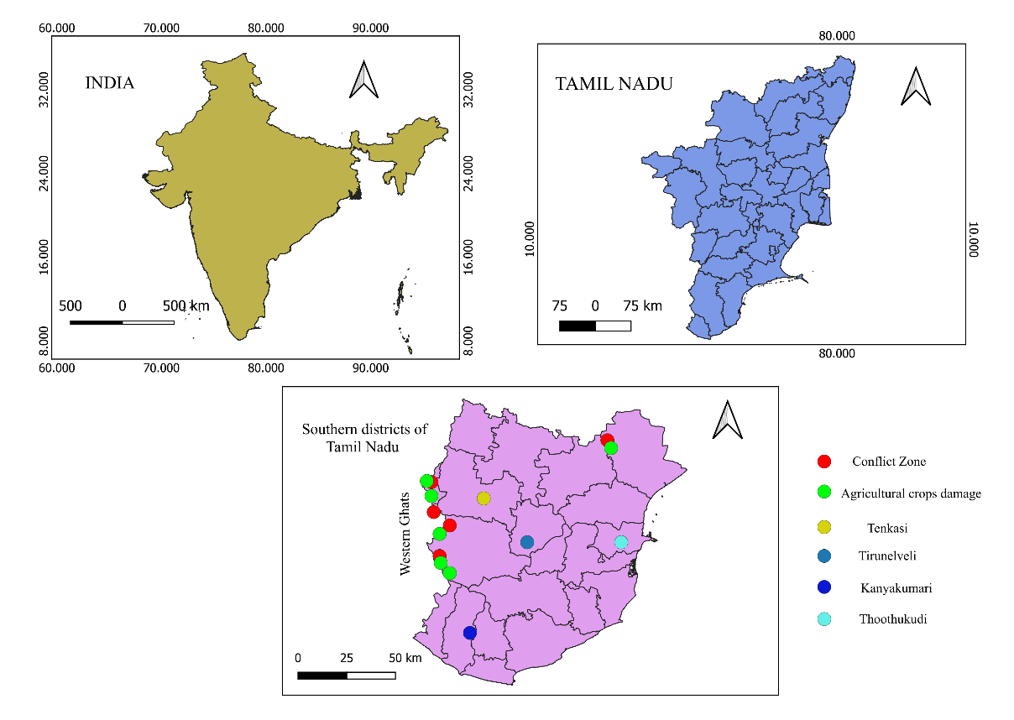
Fig. 1. Human–Animal Conflict and Crop Damage Zones in the Southern Districts of Tamil Nadu, India

In some cases, natural disasters – such as floods – led to wildlife fatalities; for example, two elephants were found dead, one at Papanasam (Servalar dam) and another near Courtallam Falls. Inter-species conflicts, such as an elephant death reported from Sengottai (Table 2), also contributed to the conflict records. Furthermore, incidents of illegal hunting were documented, including the poaching of elephants for tusks, and hunting of wild pigs (Table 2), monitor lizards, and rabbits. The forest department apprehended individuals involved in these illegal activities.

Table 2. The list of Human - Animal Conflict from three districts of Tamil Nadu.
S. No | District | Place | Coordinates | Damage Caused by Animal/Human | Injured/ Killed by animal attack | Date and Newspaper
1 | Tirunelveli | Papanasam | latitude 8°4252 N and longitude 77° 2200 E | Human | One Wild pig killed by hunting | 3/3/2024 (DK)
1 | Tirunelveli | Sivanthipuram | latitude 8° 4150 N and longitude 77° 2422E | Bonnet macaque | Two persons injured | 06/05/2024 (DT)
1 | Tirunelveli | V.K. Puram | latitude 8°4305 N and longitude 77°2302 E | Grey langur | One person injured | 21/05/2024 (DT)
1 | Tirunelveli | Kalakad | latitude 8°3055 N and longitude 77°3303E | Sloth bear | One person Injured | 19/06/2024 (DT)
1 | Tirunelveli | Panagudi | latitude 8°1858 N and longitude 77°3421E | Leopard | Seven Goats killed | 30/07/2024 (DT)
1 | Tirunelveli | Kalakad | latitude 8°3055 N and longitude 77°3303E | Wild pig | One farmer injured | 10/09/2024 (DT)
1 | Tirunelveli | Thirukkurungudi | latitude 8°2606 N and longitude 77°3401E | Wild pig | One farmer injured | 21/09/2024 (DT)
1 | Tirunelveli | Sivanthipuram | latitude 8°4150 N and longitude  77°2422 E | Indian Python | One hen killed | 22/09/2024 (DT)
1 | Tirunelveli | Manimutharu | latitude 8°4002 N and longitude 77°2437E | Leopard | One goat killed | 25/09/24 (DK)
1 | Tirunelveli | V.K. Puram | latitude 8°4305 N and longitude 77°2302E | Leopard | One Street dog injured | 28/11/2024 (DT)
1 | Tirunelveli | Manimutharu | latitude 8°4002 N and longitude 77°2437E | Leopard | Two goats killed | 29/11/2024 (DT)
2 | Tenkasi | Sengottai | latitude 8°5822 N and longitude 77°1453E | Asian elephant | Killed by same species | 31/05/2024 (DT)
 |  |  |  | Asian elephant | One person injured | 27/08/2024 (DT)
2 | Tenkasi | Kadayam | latitude 8°4908 N and longitude 77°2215 E | Leopard | One dog death | 29/09/2024 (DT)
2 | Tenkasi | Alwarkurichi | latitude 8°4644 N and longitude 77°2328 E | Sloth bear | One person injured | 15/10/2024 (DT)
2 | Tenkasi | Kadayanallur | latitude 9°0527 N and longitude 77°1854E | Unknown animal | One goat killed | 03/12/2024 (DK)
 |  |  |  | Indian Python | One goat killed | 17/01/2025 (DT)
3 | Thoothukudi | Thoothukudi | latitude 8°4421 N and longitude 78°0640 E | Asian elephant | One person killed | 19/05/2024 (DT)
3 | Thoothukudi | Ettayapuram | latitude 9°0852 N and longitude 78°0009E | Wild pig | Three persons was injured | 23/11/2024 (DT)
* DT- Daily Thandi and DK – Dinakaran.

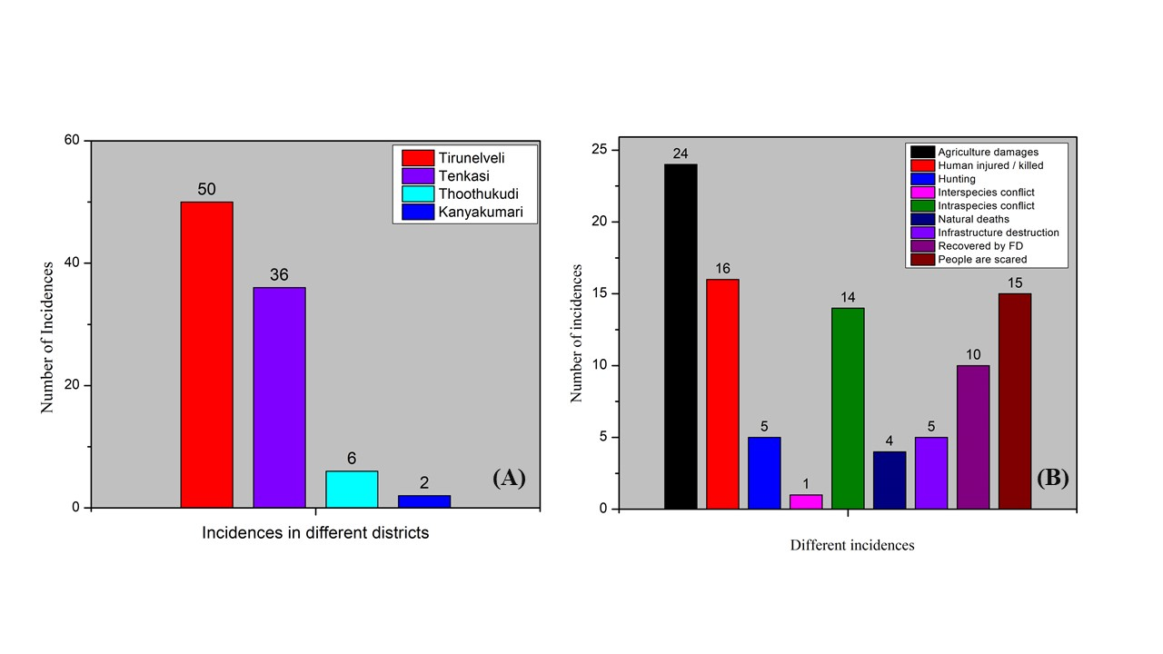 Fig. 2 A. - Number of incidents from different districts and B - Number of different incidents from March 2024 – February 2025.

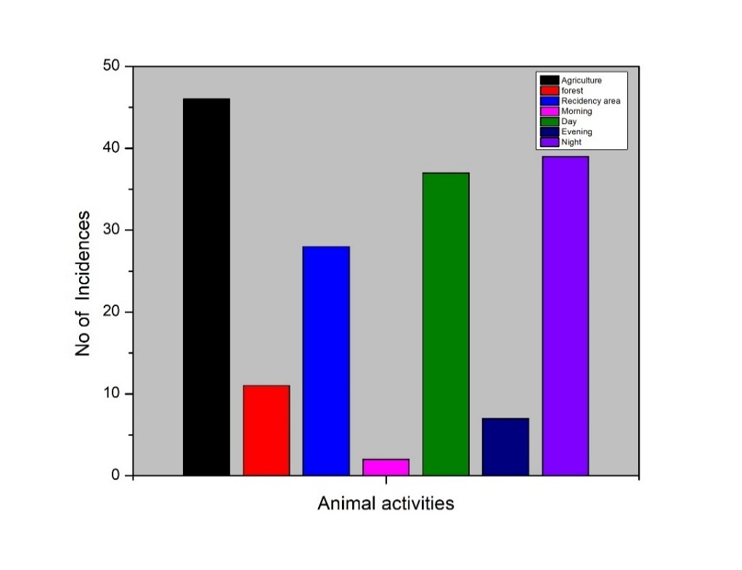
Fig. 3. Animal activities from March 2024 – February 2025

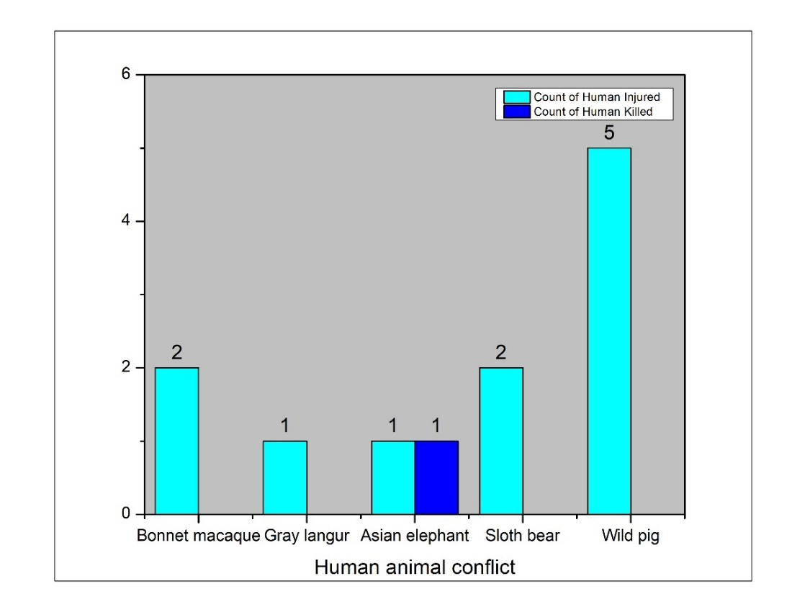
Fig. 4. Human injured / killed by wild animals from March 2024 – February 2025
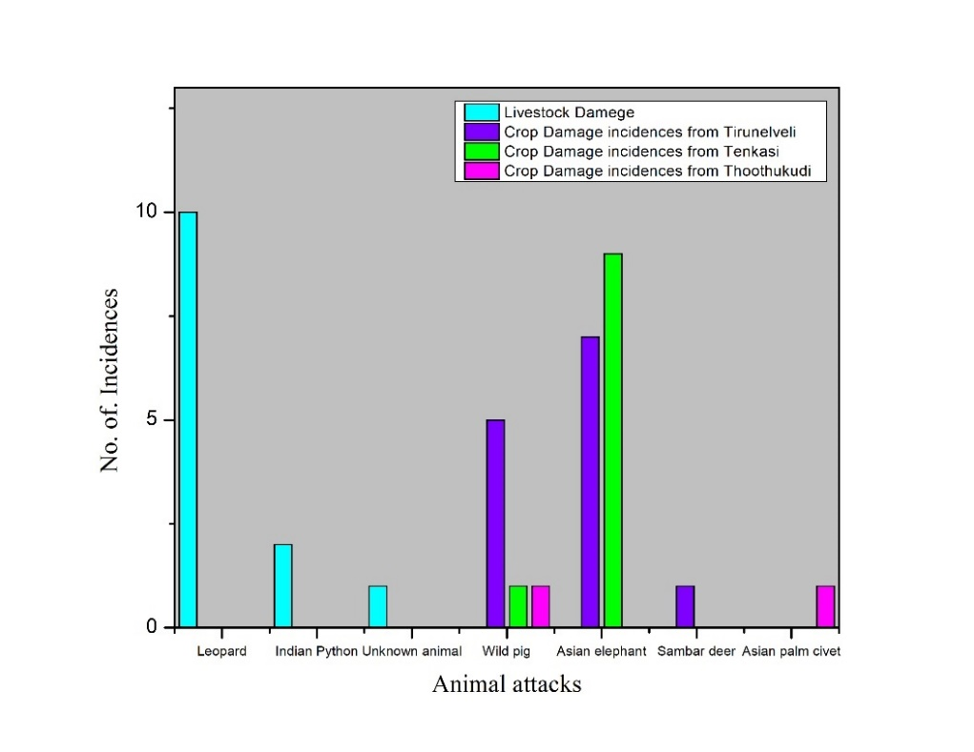
Fig. 5. Livestock and crop damage from March 2024 – February 2025.

Table 3. Dog attack on humans and livestock’s
S. No | District | Place | Coordinates | Area | Newspaper and Date | Bite  (Injured/ death)
1 | Tirunelveli | Panagudi | latitude 8°1858 N and longitude 77°3421 E | Agriculture | 30/06/2024 DT | Fifteen Goats death
2 | Tenkasi | Sengottai | latitude 8°5810 N and longitude 77°1409 E | Residency | 23/06/2024 DK | One Persons Injured
2 | Tenkasi | Kadayanallur | latitude 9°0439 N and longitude 77°1932 E | Residency | 23/07/2024 DT | One Persons Injured
2 | Tenkasi | Alwarkurichi | latitude 8°46'45"N and longitude 77°23'40"E | Residency | 29/07/2024 DK | One Persons Death
2 | Tenkasi | Surandai | latitude 8°58'37"N and longitude 77°24'52"E | Residency | 26/08/2024 DT | Eight Persons was Injured
3 | Thoothukudi | Sathankulam | latitude 8°26'56"N and longitude 77°55'09"E | Agriculture | 13/03/3025 DT | Thirty goat deaths
* DT- Daily Thandi and DK – Dinakaran.

Gulati et al., (2021) reported that a total of 11 wildlife reserves in India are located near more than 5,100 households, where farmers frequently experience negative relations with wild animals such as elephants, nilgai, and wild pigs. Karanth et al., (2012) further analysed that most conflict incidents occur between September and December, with the highest number reported in October, particularly from central protected areas of India. In Wayanad, Münster and Münster (2012) observed that elephants often leave the sanctuary, leading to agricultural damage and even human fatalities. According to Anand and Radhakrishna (2017), approximately 90% of India is now affected by human-wildlife conflict (HWC). Despite this, a survey conducted by Stevens et al., (2025) revealed that 60% of respondents expressed care and a sense of responsibility toward wildlife, with most rejecting the idea of killing animals and instead supporting wildlife protection. Similarly, Milda et al., (2023) in their survey of 1,460 households across the Western Ghats region of Tamil Nadu, found that 50% reported crop damage by wild pigs at various growth stages, while 43% specifically mentioned attacks on mature or harvest-stage crops. Shameer et al., (2025) noted that incidents peak between December and March, with frequent crop damage and human injuries caused by gaur across several forest divisions in Tamil Nadu. In Odisha, Mishra et al., (2025) reported that sloth bears often enter the forest edges during the day or night, leading to human injuries and fatalities. In Chhattisgarh, agriculture crops massively loss by Asian elephants surrounding protected area (Natarajan et al., 2025). Qureshi et al., (2024) documented that leopard’s prey on livestock and sometimes attack humans. In addition, Senthilkumar et al., (2024) observed that large or small groups of monkeys entering villages, especially in the Chengalpattu district, pose threats to residents.
4. Conclusion
The present study highlights the growing human-animal conflict from the southern districts of Tamil Nadu, particularly in areas adjoining the Western Ghats such as Tirunelveli, Tenkasi, Thoothukudi, and Kanyakumari. The majority of conflict incidents occurred in agricultural lands and forest-fringe villages, with elephants, wild pigs, bonnet macaques, and aggressive dogs being the most commonly involved species. The temporal pattern shows high activity during night and day, causing fear among local communities. Human injuries, crop damage, livestock loss, and infrastructure destruction were widely reported. Furthermore, incidents related to illegal hunting and interspecific conflict also raise conservation concerns. The findings emphasise the urgent need for conflict mitigation strategies, awareness programs, and collaborative efforts between forest departments and local communities to ensure both human safety and wildlife conservation.

Disclaimer (Artificial Intelligence)
Author(s) hereby declare that no AI technologies have been used during the writing or editing of
Manuscripts (including Photos).

REFERENCES
- Anand, S., and Radhakrishna, S. (2017). Investigating trends in human-wildlife conflict: is conflict escalation real or imagined?. Journal of Asia-Pacific Biodiversity, 10(2): 154-161. https://doi.org/10.1016/j.japb.2017.02.003
- Annamalai. R. (2004). Biodiversity of Kalakad mundanthurai Tiger Reserve. Lovely offset printer Sivakasi Tamilnadu, 80.
- Distefano, E. (2005). Human-Wildlife Conflict worldwide: collection of case studies, analysis of management strategies and good practices. Food and agricultural organization of the United Nations (FAO), Sustainable agriculture and rural development initiative (SARDI), Rome, Italy. Available from: FAO Corporate Document repository, http://www. fao. org/documents
- Gulati, S., Karanth, K. K., Le, N. A., & Noack, F. (2021) Human casualties are the dominant cost of human–wildlife conflict in India. Proceedings of the National Academy of Sciences, 118(8), e1921338118. https://doi.org/10.1073/pnas.1921338118
- Karanth, K. K., Gopalaswamy, A. M., DeFries, R., & Ballal, N. (2012) Assessing patterns of human-wildlife conflicts and compensation around a central Indian protected area. PloS one, 7(12): e50433. https://doi.org/10.1371/journal.pone.0050433
- Kidane, E. E., Kiros, S., Berhe, A., & Girma, Z. (2024). Human Wildlife conflict and Community Perceptions Towards Wildlife Conservation in and Around a Biodiverse National Park, Northern Ethiopia. Global Ecology and Conservation, 54 e03072. https://doi.org/10.1016/j.gecco.2024.e03072.
- König, H. J., Kiffner, C., Kramer‐Schadt, S., Fürst, C., Keuling, O., & Ford, A. T. (2020). Human–wildlife coexistence in a changing world. Conservation Biology, 34(4): 786-794. https://doi.org/10.1111/cobi.13513
- Milda, D., Ramesh, T., Kalle, R., Gayathri, V., Thanikodi. M., & Ashish, K. (2023). Factors driving human–wild pig interactions: implications for wildlife conflict management in southern parts of India. Biological Invasions, 25(1): 221-235. http://dx.doi.org/10.1007/s10530-022-02911-6
- Mishra, S. P., Barik, S. R., Sahu, D. K., & Padhi, S. (2025). Mapping Human-Wildlife Conflict Hotspots in Odisha, India: Trends, Impacts, and Mitigation Strategies. Annual Research & Review in Biology, 40(3): 116-141. http://dx.doi.org/10.9734/arrb/2025/v40i32216
- Münster, D., & Münster, U. (2012). Human-animal conflicts in Kerala: Elephants and ecological modernity on the agrarian frontier in South India. RCC Perspectives; 5: 41-50.
- Nair, R. P, & Jayson, E. A. (2021). Estimation of economic loss and identifying the factors affecting the crop raiding behaviour of Asian elephant (Elephas maximus) in Nilambur part of the southern Western Ghats, Kerala, India. Current Science, 121(4): 521-528. http://dx.doi.org/10.18520/cs/v121/i4/521-528
- Nyhus PJ. Human–wildlife conflict and coexistence. Annual review of environment and resources 2016; 41(1): 143-171. https://doi.org/10.1146/annurev-environ-110615-085634
- Qureshi, Q., Jhala, Y. V., Yadav, S. P., Tiwari, V. R., Garawad, R., & Mallick, A. (2024) Status of leopards in India, 2022. National Tiger Conservation Authority, Government of India, New Delhi, and Wildlife Institute of India, Dehradun, (No. 2023/03, p. 5).
- Ramseena, P. P. (2022) "The Effects of Human-Wildlife Conflict on Women and it’s Alternatives: Experiences from Kerala." Changing Status of Women In post-independence India, 117.
- Senthilkumar, K., Mathialagan, P., & Manivannan, C. A. (2024). case study on conflict between human and monkey at Chengalpet district, Tamil Nadu. International Journal of Veterinary Sciences and Animal Husbandry, 9(1): 1205-1207. https://doi.org/10.22271/veterinary.2024.v9.i1q.1105
- Shameer, T. T., Routray, P., Udhayan, A., Kanchana, R., Sekar, S., Shankar, S., & Subramaniyam, S. (2025). Ecological and temporal drivers of human-gaur conflict in Tamil Nadu, India. Discover Animals, 2(1): 1-19. https://doi.org/10.1007/s44338-025-00100-y
- Singh, S, & Singh, S. (2023). Human-wildlife conflict and coexistence. Biophilia Insights, 1(2). http://dx.doi.org/10.52679/bi.e202312004
- Stevens, M., Rawat, S., & Satterfield, T. (2025) Care, conflict, and coexistence: Human–wildlife relations in community forests. People and Nature, 7(1): 231-246. DOI: https://doi.org/10.1002/pan3.10760
- Treves, A., Wallace, R. B., & White, S. (2009). Participatory planning of interventions to mitigate human–wildlife conflicts. Conservation biology, 23(6): 1577-1587.
- Vanaraj, G, Pragasan, L. A, & Mutheeswaran, S. (2024). Observations of interspecific grooming in Tufted grey langurs (Semnopithecus priam priam). Species, 25: e10s1636 https://doi.org/10.54905/disssi.v25i75.e10s1636
- Somu, Y., & Palanisamy, S. (2022). Human–wild animal conflict. In Animal Welfare-New Insights. IntechOpen. DOI: 10.5772/intechopen.107891
- Madhavan, C. (2026). A Case Series of Bear Attacks from a Tertiary Center in South India. Journal of Plastic and Reconstructive Surgery, 2024-0065. https://doi.org/10.53045/jprs.2024-0065
- Natarajan, L., Nigam, P., & Pandav, B. (2025). Human–elephant conflict in expanding Asian elephant range in east-central India: implications for conservation and management. Oryx, 1-9. https://doi.org/10.1017/S0030605324000930
- Bharti, S., Kumar, G., & Kapoor, G. (2025). Navigating Human-wildlife Conflict: Key Species, Impacts, Mitigation and Challenges in Himachal Pradesh, India. Asian Journal of Research in Zoology, 8(1), 33-49. https://doi.org/10.9734/ajriz/2025/v8i1180.
- Prasad, R. N. (2025). Patterns and Drivers of Livestock Depredation in Human-Wildlife Conflict Zones: A Case Study from Valmiki Tiger Reserve, India. Asian Journal of Research in Zoology, 8(4), 257-265. https://doi.org/10.9734/ajriz/2025/v8i4236.
- Chitrambigai, K., Prabu, M., Kathiravan, G., Sreekumar, C., & Senthilkumar, K. (2025). Analysis of factors influencing human-wildlife conflict in the western Ghats of Tamil Nadu. International Journal of Advanced Biochemistry Research, 9(8): 41-44. https://www.doi.org/10.33545/26174693.2025.v9.i8a.5076
- Kanya. T. (2025). Conflict Or Co-Existence: Study on Human Animal Interactions in Sirumugai’s Forest Villages. International Journal of Creative Research Thoughts (IJCRT). 13, (1): f174- 178
- Senthilkumar, K. Mathialagan, P. Manivannan, C. (2025). Economic impact of human-wildlife conflicts on agriculture-based livelihood in the forest buffer zones of Tamil Nadu. Int J Agric Extension Social Dev, 8(6S):91-93. DOI: 10.33545/26180723.2025.v8.i6Sb.2039

