Assessing the Role of Mineral Oils in Altering Reproductive Dynamics and Development of Myzus persicae

Abstract
This research examines how different concentrations of four mineral oils—Servo, Orchol, Agrospel, and Arbofine—affect the reproductive characteristics and developmental timing of the green peach aphid, Myzus persicae. Adult parthenogenetic aphids were exposed to leaves treated with these oils, and key biological metrics such as nymphal duration, reproductive phases, fecundity, and adult lifespan were carefully measured across ten replicates under controlled conditions. Findings indicate that treatments with Servo and Arbofine typically accelerated development by reducing pre-reproductive and nymphal durations while prolonging the reproductive period, fecundity, and adult longevity, suggesting a promotive effect on aphid growth and reproduction. Orchol caused modest increases in fecundity and reproductive duration, with minimal impact on longevity and development. Conversely, Agrospel delayed maturation by extending pre-reproductive and nymphal stages and decreased reproductive phase length, fecundity, and adult lifespan. These distinct effects on aphid life history traits highlight important considerations for understanding population dynamics and designing targeted pest control approaches.
Keywords: Myzus persicae, Mineral oil, Reproduction, Aphid, Pest management.
Introduction
Myzus persicae is a prevalent and highly damaging agricultural pest, impacting more than 40 plant families, including numerous essential crops (Ali et al., 2023; Ramsey et al., 2007). This aphid's exceptional capacity to infest a wide range of host plants, coupled with its ability to transmit over 100 plant viruses, places it among the most detrimental insect pests in agriculture (Emden et al., 1969; Troczka et al., 2021). M. persicae causes significant damage by directly consuming plant nutrients and water and indirectly by spreading plant viruses to crops such as beans, sugar beet, brassicas, potatoes, tobacco, and citrus (Ali et al., 2023; Emden et al., 1969). The remarkable adaptability of M. persicae is demonstrated by its ability to colonize distantly related plant species, even within single clonal lineages (Mathers et al., 2017). This phenotypic flexibility is facilitated by rapid transcriptional changes in aphid-expanded gene families, enabling genetically identical individuals to adapt to different host plants within just two days (Mathers et al., 2017). Such adaptability, along with its tendency to develop resistance to multiple insecticides, has led to M. persicae being recognized for its resistance to insecticides (Ali et al., 2023; Troczka et al., 2021). Given the substantial economic impact and challenges in controlling M. persicae, there is an urgent need to develop effective and sustainable management strategies. This has spurred increased research efforts globally, focusing on understanding the aphid's biology, host-plant interactions, and exploring alternative control methods beyond traditional chemical insecticides (Ali et al., 2023; Ward et al., 2023; Xiao et al., 2024). The life cycle of M. persicae includes both sexual and asexual reproduction. This species can reproduce through cyclical parthenogenesis, which involves multiple parthenogenetic generations followed by a single sexual generation, or through obligate parthenogenesis, where reproduction is entirely asexual (Guillemaud et al., 2003; Zamoum et al., 2005). In the cyclical parthenogenetic cycle, M. persicae alternates between primary and secondary hosts. During spring and summer, the aphids reproduce asexually on secondary hosts, producing both wingless (apterous) and winged (alate) forms. The winged forms, known as emigrants, leave the primary host to colonize various plants, while the wingless forms continue reproducing on the current host. As autumn approaches, the aphids, triggered by decreasing temperatures and shorter daylight hours, produce gynoparae and males, which return to the primary host for sexual reproduction and overwintering as eggs (Dixon, 1976). Notably, the reproductive strategies of the apterous and alate forms differ.
Apterous forms tend to be more productive than alates of comparable weight, generating about three additional nymphs on average over any given 5-day period. This difference is linked to the quantity and quality of embryos at hatching and ovulation rates, which appear to be related to the maintenance of wing muscles in alates (Wratten, 1977). Mineral oil has been found to effectively decrease aphid transmission of plant viruses by disrupting the process (Wang, 1996). This indicates that mineral oil might indirectly affect aphid reproduction by restricting their capacity to spread viruses that could otherwise boost their population growth on infected plants. In field trials assessing organic pest control products, mineral oil showed effective control of Myzus persicae aphids on peach trees, achieving an average Abbott's efficiency of 80-88% in one year (Karagounis et al., 2006). However, its effectiveness diminished in a subsequent year with heavy rainfall, underscoring potential limitations of mineral oil under certain environmental conditions. Notably, the application of mineral oil also reduced the numbers of beneficial coccinellid predators, which could indirectly influence aphid population dynamics. Overall, while mineral oil appears promising as an alternative to chemical insecticides for aphid control, its direct effects on aphid reproduction seem limited compared to its impacts on virus transmission and overall population levels. Further research specifically examining mineral oil's influence on aphid fecundity and reproductive rates would be beneficial to fully understand its mode of action and optimize its use. Environmental conditions significantly affect aphid reproduction. Factors such as temperature, day length, and air humidity influence reproductive rates and development (Boulanger et al., 2019). The quality and maturity of host plants also impact aphid reproduction. The abundance of pea aphids, temperature, and alfalfa maturity together accounted for 67% of the variation in alate (winged) production in field populations (Bosch & Ives, 2023). Plant fertilization can affect the protective effects of facultative endosymbionts against parasitoids, potentially influencing aphid survival and reproduction (Ye et al., 2018).
Methodology
Adult parthenogenetic M. persicae were permitted to consume leaves treated with varying concentrations of specific mineral oils in multiple trials. The subsequent count of nymphs produced under each treatment was recorded. For individual monitoring, each nymph was meticulously placed onto host leaves using a single-bristle camel hair brush. These leaves were then positioned in 8 × 1.5 cm petri dishes containing an agar medium to maintain leaf moisture over an extended period, creating a controlled setting for the aphids. Throughout the study, the researcher thoroughly observed several biological parameters. These included the duration of nymphal stages, which sheds light on the aphids' growth rate. The length of the reproductive phases was also carefully tracked, providing essential insights into the aphid life cycle (Fig. 1). Fecundity, or the aphids' reproductive capacity, was another key parameter. Additionally, the lifespan of adult aphids was documented to understand their longevity under the experimental conditions. The study of fecundity, longevity, and nymphal duration focused on the first generation of aphids that resulted from adults feeding on treated leaves. Behavioral observations were also conducted to identify any notable patterns or changes. All treatments were performed under uniform environmental conditions to ensure consistency and reliability. The experiment included ten replicates for each host, ensuring a comprehensive dataset for later analysis. After completing the observations, the gathered data were analyzed using Analysis of Variance (ANOVA) to evaluate the statistical significance of the results across different treatments and hosts.
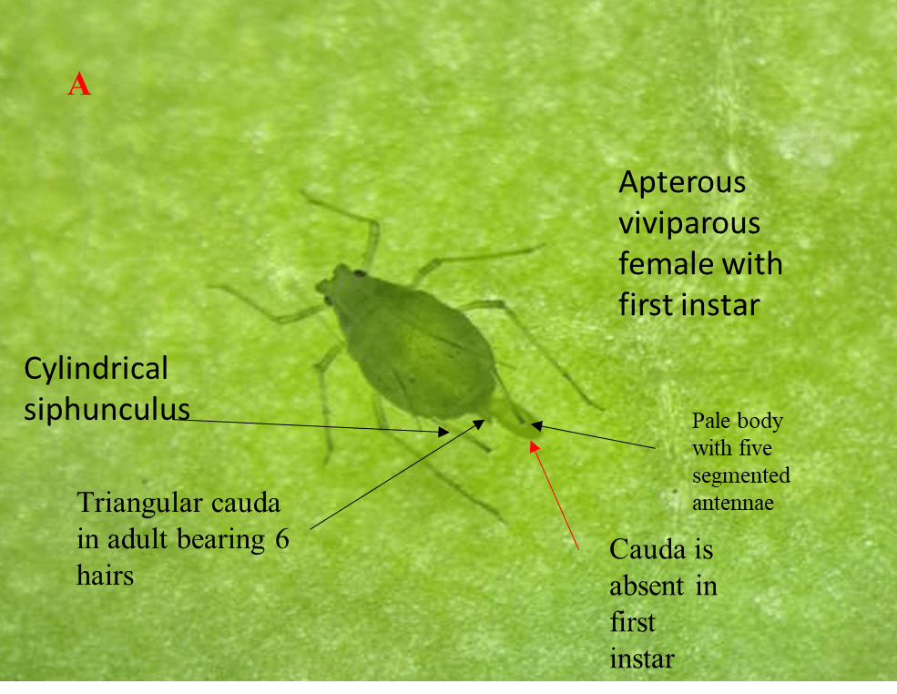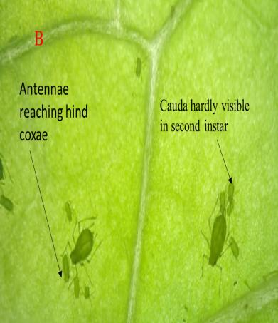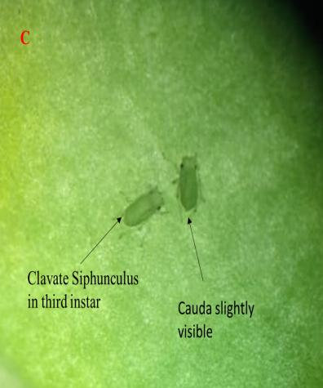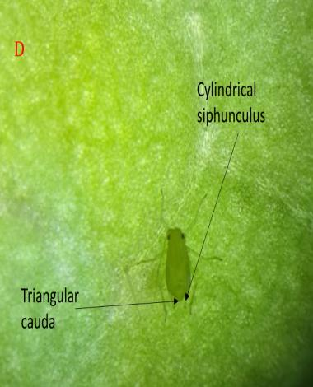
Fig. 1: Different stages of M. persicae development in laboratory conditions under microscope
- Adult M. persicae parthenogenetically developing 1st instar stage
- 2nd instar stage
- 3rd instar stage
- 4th instar stage.

Results
In the control group, the pre-reproductive stage lasted 0.87 days, followed by a reproductive stage of 14.35 days and a post-reproductive stage of 1.02 days (Table & Fig. 1). The aphids produced an average of 34.23 offspring and lived for 16.24 days as adults. The total duration of the nymphal stage was 5.3 days. With a 0.1% Servo treatment, the pre-reproductive stage shortened to 0.72 days, while the reproductive stage slightly increased to 14.99 days. The post-reproductive stage remained nearly the same at 0.99 days. Fecundity rose to 36.14 offspring, and adult lifespan extended to 16.7 days. The total nymphal duration slightly decreased to 5.23 days. At a 0.5% Servo concentration, the pre-reproductive stage further reduced to 0.63 days, and the reproductive stage lengthened to 15.37 days. The post-reproductive stage lasted 0.98 days. Fecundity increased to 38.24 offspring, and adult lifespan increased to 16.98 days. The total nymphal duration decreased to 4.90 days. The highest concentration of 1% Servo resulted in a slight increase in the pre-reproductive stage to 0.66 days compared to the 0.5% treatment group. The reproductive stage was notably longer at 16.76 days, while the post-reproductive stage slightly decreased to 0.96 days. Fecundity significantly increased to 42.8 offspring, and adult lifespan extended to 18.38 days. The total nymphal duration was the shortest at 4.83 days.
The table displays information on the reproductive traits and development of Myzus persicae (green peach aphid) following exposure to Orchol-treated leaves, focusing on the first generation (Table & Fig. 2). In the control group, the pre-reproductive period was 0.87±0.05 days, followed by a reproductive period of 14.35±0.23 days and a post-reproductive period of 1.02±0.21 days. Control aphids produced an average of 34.23±1.81 offspring and had an adult lifespan of 16.24±0.16 days. The total nymphal duration for the control group was 5.3±0.03 days. When exposed to 0.1% Orchol, the aphids exhibited slight changes in their reproductive phase. The pre-reproductive period was 0.81±0.18 days, the reproductive period was 14.41±0.92 days, and the post-reproductive period was 0.92±0.94 days. Fecundity slightly increased to 35.14±2.98 offspring, while adult longevity slightly decreased to 16.14±0.18 days. The total nymphal duration in the Orchol-treated group decreased to 5.02±0.78 days. Exposure to 0.5% Orchol led to minor changes in the reproductive phases of the aphids. The pre-reproductive period was 0.79±0.92 days, followed by a reproductive period of 15.31±0.46 days. The post-reproductive period lasted 0.95±0.28 days. A slight increase in fecundity was noted, with aphids producing an average of 37.25±2.76 offspring. In contrast, adult longevity slightly decreased to 17.05±1.09 days. Notably, the total nymphal duration in the Orchol-treated group was reduced to 5.82±0.82 days. These results indicate that exposure to this concentration of Orchol causes minor changes in aphid life history parameters, potentially affecting population dynamics and reproductive strategies. Exposure to 1.0% Orchol resulted in subtle changes in the aphids' reproductive cycle. The pre-reproductive period was 0.76±0.19 days, indicating a short time before reproduction began. The aphids then entered a prolonged reproductive period of 15.62±0.96 days, during which they actively produced offspring. The post-reproductive period, marking the end of reproductive capability, lasted 0.93±0.38 days. Interestingly, the fecundity of the aphids showed a slight increase, with each individual producing an average of 41.71±3.27 offspring. This increase in reproductive output was accompanied by a slight decrease in adult longevity, with aphids living for an average of 17.31±1.46 days. The Orchol treatment also seemed to affect the developmental stages of the aphids, as evidenced by a reduction in the total nymphal duration to 5.01±0.27 days. These observations suggest that exposure to 1.0% Orchol induces subtle yet significant changes in the life cycle and reproductive patterns of aphids, potentially impacting their population dynamics and ecological interactions.
In the control group, the pre-reproductive stage lasted 0.87 ± 0.05 days, followed by a reproductive stage of 14.35 ± 0.23 days, and a post-reproductive stage of 1.02 ± 0.21 days (Table & Fig. 3). The fecundity was recorded at 34.23 ± 1.81, and the adult lifespan was 16.24 ± 0.16 days. The total duration of the nymphal stage was 5.3 ± 0.03 days. When exposed to a 0.1% concentration of Agrospel, the pre-reproductive stage extended to 1.23 ± 0.05 days, while the reproductive stage shortened to 12.06 ± 0.38 days, and the post-reproductive stage decreased to 0.92 ± 0.19 days. Fecundity dropped to 24.13 ± 2.95, and adult longevity decreased to 14.21 ± 0.27 days. The total nymphal duration increased to 5.93 ± 0.78 days. At a 0.5% Agrospel concentration, the pre-reproductive stage further extended to 1.36 ± 0.39 days, the reproductive stage reduced to 10.97 ± 0.52 days, and the post-reproductive stage remained similar at 0.95 ± 0.49 days. Fecundity further declined to 20.35 ± 1.87, and adult lifespan decreased to 13.28 ± 0.46 days. The total nymphal duration slightly increased to 6.02 ± 0.82 days. At a 1% Agrospel concentration, the pre-reproductive stage reached 1.72 ± 0.09 days, the reproductive stage further decreased to 10.77 ± 0.06 days, and the post-reproductive stage remained relatively stable at 0.93 ± 0.24 days. Fecundity slightly decreased to 19.93 ± 2.57, while adult longevity slightly increased to 13.42 ± 1.93 days. The total nymphal duration increased to 6.71 ± 0.27 days.
The table displays data on various reproductive and life cycle traits of organisms under different conditions (Table & Fig. 4). In the control group, the pre-reproductive stage lasted 0.87 ± 0.05 days, followed by a reproductive stage of 14.35 ± 0.23 days, and a post-reproductive stage of 1.02 ± 0.21 days. The total number of offspring, or fecundity, in the control group was 34.23 ± 1.81. Adult lifespan in this group was 16.24 ± 0.16 days, while the total duration of the nymphal stage was 5.3 ± 0.03 days. When exposed to 0.1% Arbofine, some changes were observed in these parameters. The pre-reproductive stage slightly decreased to 0.71 ± 0.93 days, while the reproductive stage extended to 15.61 ± 0.64 days. The post-reproductive stage was slightly shorter at 0.94 ± 0.19 days. Fecundity increased to 37.22 ± 1.28 with Arbofine treatment. Adult lifespan also rose to 17.26 ± 0.19 days, and the total nymphal duration decreased to 5.02 ± 0.17 days. At a 0.5% Arbofine concentration, the aphid population showed significant changes in life-cycle parameters. The pre-reproductive stage was reduced to 0.65±0.29 days, indicating quicker maturation. Conversely, the reproductive stage was notably extended to 15.92±0.29 days, suggesting a longer period of offspring production. The post-reproductive stage slightly decreased to 0.93±0.92 days. Fecundity increased significantly to 40.43±1.83, indicating enhanced reproductive capacity. Adult lifespan improved, with aphids living an average of 17.5 ± 0.28 days. Additionally, the total nymphal duration decreased to 5.82±0.57 days under the 0.5% Arbofine concentration, indicating faster development during immature stages. These changes suggest that exposure to 0.5% Arbofine significantly alters the aphid life cycle, potentially affecting population dynamics and ecological interactions. At a 1.0% Arbofine concentration, significant changes were observed in various life cycle stages and reproductive parameters. The pre-reproductive stage increased to 0.72±0.25 days. In contrast, the reproductive stage significantly extended to 16.92±0.97 days. The post-reproductive stage slightly decreased to 0.91±0.42 days. Fecundity, a key measure of reproductive potential, increased to 41.79±1.23. Adult lifespan also extended to 18.55±1.48 days. Additionally, the total nymphal duration decreased to 5.01±0.29 days under the 1.0% Arbofine concentration. These changes in life cycle parameters and reproductive measures indicate a significant impact of Arbofine concentration on the organism's development and reproductive capabilities.
Table 1: The table presents the reproductive phases, fecundity, longevity of adults and total nymphal duration in M. persicae after feeding on leaf treated with servo and its impact on the first generation. The values are expressed as mean ± SEM.
Concentration | Reproductive phases (days) |  |  | Fecundity (Total no) | Longevity of adults (days) | Total nymphal duration
Concentration | Pre reproductive phase | Reproductive phase | Post reproductive phase | Fecundity (Total no) | Longevity of adults (days) | Total nymphal duration
Control | 0.87±0.05ª | 14.35±0.23^{d} | 1.02±0.21ª | 34.23±1.81^{d} | 16.24±0.16^{bc} | 5.3±0.03ª
0.1 % servo | 0.72±0.02^{b} | 14.99±0.18^{c} | 0.99±0.26^{b} | 36.14±1.97^{c} | 16.7±0.18^{b} | 5.23±0.18ª
0.5 % servo | 0.63±0.28^{c} | 15.37±0.26^{b} | 0.98±0.72^{b} | 38.24±0.17^{b} | 16.98±1.09^{b} | 4.90±0.17^{b}
1% servo | 0.66±0.77^{c} | 16.76±0.66ª | 0.96±0.27^{b} | 42.8±0.35ª | 18.38±1.46ª | 4.83±0.98^{b}

Fig. 2: The figure depicts the fecundity, longevity and nymphal duration in M. persicae following Servo treatments at concentrations of 0.1%v/v, 0.5%v/v, and 1.0%v/v, compared to a control group. (P≤0.05), df=5, f=308.6, p=<0.01.
Table 2: The table presents the reproductive phases, fecundity, longevity of adults and total nymphal duration in M. persicae after feeding on leaf treated with Orchol and its impact on the first generation. The values are expressed as mean ± SEM.
Concentration | Reproductive phases (days) |  |  | Fecundity (Total no) | Longevity of adults (days) | Total nymphal duration
Concentration | Pre reproductive phase | Reproductive phase | Post reproductive phase | Fecundity (Total no) | Longevity of adults (days) | Total nymphal duration
Control | 0.87±0.05ª | 14.35±0.23^{c} | 1.02±0.21ª | 34.23±1.81^{d} | 16.24±0.16^{b} | 5.3±0.03^{b}
0.1 % Orchol | 0.81±0.18^{b} | 14.41±0.92^{c} | 0.92±0.94^{b} | 35.14±2.98^{c} | 16.14±0.18^{b} | 5.02±0.78^{c}
0.5 % Orchol | 0.79±0.92^{c} | 15.31±0.46^{b} | 0.95±0.28^{b} | 37.25±2.76^{b} | 17.05±1.09ª | 5.82±0.82ª
1% Orchol | 0.76±0.19^{d} | 15.62±0.96ª | 0.93±0.38^{b} | 41.71±3.27ª | 17.31±1.46ª | 5.01±0.27^{c}

Fig. 3: The figure depicts the fecundity, longevity and nymphal duration in M. persicae following Orchol treatments at concentrations of 0.1%v/v, 0.5%v/v, and 1.0%v/v, compared to a control group. df=5, f=379.8, p=<0.01.

Table 3: The table presents the reproductive phases, fecundity, longevity of adults and total nymphal duration in M. persicae after feeding on leaf treated with Agrospel and its impact on the first generation. The values are expressed as mean ± SEM.
Concentration | Reproductive phases (days) |  |  | Fecundity (Total no) | Longevity of adults (days) | Total nymphal duration
Concentration | Pre reproductive phase | Reproductive phase | Post reproductive phase | Fecundity (Total no) | Longevity of adults (days) | Total nymphal duration
Control | 0.87±0.05^{d} | 14.35±0.23ª | 1.02±0.21ª | 34.23±1.81ª | 16.24±0.16ª | 5.3±0.03^{c}
0.1 % Agrospel | 1.23±0.05^{c} | 12.06±0.38^{b} | 0.92±0.19^{d} | 24.13±2.95^{b} | 14.21±0.27^{b} | 5.93±0.78^{c}
0.5 % Agrospel | 1.36±0.39^{b} | 10.97±0.52^{c} | 0.95±0.49^{b} | 20.35±1.87^{c} | 13.28±0.46^{c} | 6.02±0.82^{b}
1% Agrospel | 1.72±0.09ª | 10.77±0.06^{c} | 0.93±0.24^{c} | 19.93±2.57^{d} | 13.42±1.93^{c} | 6.71±0.27ª

Fig. 4: The figure depicts the fecundity, longevity and nymphal duration in M. persicae following Agrospel treatments at concentrations of 0.1%v/v, 0.5%v/v, and 1.0%v/v, compared to a control group. df=5, f=328.7, p=<0.01.

Table 4: The table presents the reproductive phases, fecundity, longevity of adults and total nymphal duration in M. persicae after feeding on leaf treated with Arbofine and its impact on the first generation. The values are expressed as mean ± SEM.
Concentration | Reproductive phases (days) |  |  | Fecundity (Total no) | Longevity of adults (days) | Total nymphal duration
Concentration | Pre reproductive phase | Reproductive phase | Post reproductive phase | Fecundity (Total no) | Longevity of adults (days) | Total nymphal duration
Control | 0.87±0.05ª | 14.35±0.23^{c} | 1.02±0.21ª | 34.23±1.81^{d} | 16.24±0.16^{c} | 5.3±0.03^{b}
0.1 % Arbofine | 0.71±0.93^{b} | 15.61±0.64^{b} | 0.94±0.19^{b} | 37.22±1.28^{c} | 17.26±0.19^{b} | 5.02±0.17^{c}
0.5 % Arbofine | 0.65±0.29^{c} | 15.92±0.29^{b} | 0.93±0.92^{b} | 40.43±1.83^{b} | 17.5±0.28^{b} | 5.82±0.57ª
1% Arbofine | 0.72±0.25^{b} | 16.92±0.97ª | 0.91±0.42^{b} | 41.79±1.23ª | 18.55±1.48ª | 5.01±0.29^{c}

Fig. 5: The figure depicts the fecundity, longevity and nymphal duration in M. persicae following Arbofine treatments at concentrations of 0.1%v/v, 0.5%v/v, and 1.0%v/v, compared to a control group. Columns after ANOVA df=5, f=361.5, p=<0.01.

Discussion
The investigation into the effects of Orchol, Agrospel, and Arbofine on the reproductive and life cycle traits of M. persicae revealed varied results. Orchol, when applied at concentrations of 0.1%, 0.5%, and 1.0%, generally led to slight extensions in the reproductive phase and increased fecundity, while causing minor reductions in adult lifespan and total nymphal duration. These modest alterations imply that Orchol might moderately influence the population dynamics of M. persicae. In contrast, Agrospel had more significant impacts, with higher concentrations resulting in prolonged pre-reproductive phases, shortened reproductive phases, decreased fecundity, and reduced adult longevity. Additionally, the total nymphal duration increased with greater Agrospel concentrations, suggesting that Agrospel could substantially modify M. persicae life cycle parameters, potentially affecting population growth and structure. Arbofine's effects were concentration-dependent; at 0.1%, it increased reproductive phase duration, fecundity, and adult longevity while reducing total nymphal duration. Higher concentrations (0.5% and 1.0%) generally intensified these effects, notably enhancing fecundity and adult longevity. These findings suggest that Arbofine might boost certain aspects of M. persicae reproduction and survival, which could have implications for pest management strategies. The varied responses to different treatments and concentrations underscore the complexity of mineral oil effects on aphid biology. Some treatments, like Agrospel, show potential as pest control agents by reducing reproductive output and shortening adult lifespan. However, others, such as Arbofine at higher concentrations, might inadvertently promote aphid population growth by enhancing reproductive capabilities and extending adult longevity. These findings highlight the importance of careful consideration when selecting and applying mineral oil treatments for pest management. Furthermore, the differential effects on various life cycle parameters indicate that mineral oils may influence aphid populations through multiple mechanisms, affecting not only reproduction but also development and survival. The study's results also raise questions about potential trade-offs in aphid life history traits in response to mineral oil treatments. For instance, the increased fecundity observed with some treatments may be balanced by shorter adult lifespans or longer developmental periods. Ameline et al. (2010) found that the survival of nymphs was adversely impacted on plants that had been treated, while the adults that did survive exhibited greater reproductive success. This was due to a reduced pre-reproductive phase, increased lifespan, and improved fecundity, which collectively resulted in a higher reproductive rate. These trade-offs may have important consequences for population dynamics and the overall effect of mineral oil treatments on aphid infestations.
The effects that vary with concentration across all treatments emphasize the vital role of correct dosage in pest control strategies. Using concentrations that are too low might not only be ineffective in managing pest populations but could also worsen the situation by promoting certain aspects of aphid reproduction or survival. The intricate interactions between mineral oil treatments and the biology of M. persicae uncovered in this study underscore the necessity for a sophisticated approach to pest management. Future studies should aim to clarify the mechanisms behind these diverse effects, examine potential synergistic or antagonistic interactions with other control methods, and assess the long-term impacts of mineral oil applications on aphid populations and the broader ecosystem dynamics.
Conclusion
The results demonstrate that exposure to different concentrations of Servo, Orchol, Agrospel, and Arbofine significantly influences the reproductive parameters and developmental durations of Myzus persicae. Servo and Arbofine treatments generally shortened the pre-reproductive and total nymphal durations while extending the reproductive phase, fecundity, and adult longevity, indicating a stimulatory effect on aphid reproduction and development. Orchol caused subtle increases in fecundity and reproductive phase length, with minor effects on longevity and development. Conversely, Agrospel treatment led to increased pre-reproductive and total nymphal durations but decreased reproductive phase length, fecundity, and adult longevity, suggesting a suppressive impact on aphid life history traits. These findings collectively suggest that the tested compounds differentially modulate aphid population dynamics by altering key life cycle stages and reproductive outputs, which could have implications for pest management strategies targeting Myzus persicae.
References
Ali, J., Karim, M. F., Yusuf, A. A., Ma, Z., King, P. J. H., Mukarram, M., Hafez, M. M. A., Shamsi, I. H., Zhou, F., Mahamood, M., Bayram, A., & Adil, M. F. (2023). Peach–Potato Aphid Myzus persicae: Current Management Strategies, Challenges, and Proposed Solutions. Sustainability, 15(14), 11150.
Ameline, A., Couty, A., Martoub, M., Sourice, S., & Giordanengo, P. (2010). Modification of Macrosiphum euphorbiae colonisation behaviour and reproduction on potato plants treated by mineral oil. Entomologia experimentalis et applicata, 135(1), 77-84.
Bosch, M. J., & Ives, A. R. (2023). Identifying environmental factors affecting the production of pea aphid dispersal morphs in field populations. Ecological Entomology, 48(5), 597–609.
Boulanger, F., Pekas, A., Bolckmans, K., Jandricic, S., & Wäckers, F. L. (2019). Optimizing aphid biocontrol with the predator Aphidoletes aphidimyza, based on biology and ecology. Pest Management Science, 75(6), 1479–1493.
Dixon, A. F. G. (1976). Reproductive Strategies of the Alate Morphs of the Bird Cherry-Oat Aphid Rhopalosiphum padi L. The Journal of Animal Ecology, 45(3), 817.
Guillemaud, T., Mieuzet, L., & Simon, J. C. (2003). Spatial and temporal genetic variability in French populations of the peach–potato aphid, Myzus persicae. Heredity, 91(2), 143-152.
Karagounis, C., Kourdoumbalos, A. K., Margaritopoulos, J. T., Nanos, G. D., & Tsitsipis, J. A. (2006). Organic farming‐compatible insecticides against the aphid Myzus persicae (Sulzer) in peach orchards. Journal of Applied Entomology, 130(3), 150-154.
Mathers, T. C., Chen, Y., Kaithakottil, G., Legeai, F., Mugford, S. T., Baa-Puyoulet, P., ... & Hogenhout, S. A. (2017). Rapid transcriptional plasticity of duplicated gene clusters enables a clonally reproducing aphid to colonise diverse plant species. Genome biology, 18(1), 27.
Ramsey, J. S., Wilson, A. C., de Vos, M., Sun, Q., Tamborindeguy, C., Winfield, A., ... & Jander, G. (2007). Genomic resources for Myzus persicae: EST sequencing, SNP identification, and microarray design. BMC genomics, 8(1), 423.
Troczka, B. J., Hayward, A., Vontas, J., Nauen, R., Bass, C., Zimmer, C. T., & Singh, K. S. (2021). Molecular innovations underlying resistance to nicotine and neonicotinoids in the aphid Myzus persicae. Pest Management Science, 77(12), 5311–5320.
Van Emden, H. F., Eastop, V. F., Hughes, R. D., & Way, M. J. (1969). The ecology of Myzus persicae. Annual review of entomology, 14(1), 197-270.
Wang, R. (1996). Mineral Oil Interferes with Retention of Tobacco Etch Potyvirus in the Stylets of Myzus persicae. Phytopathology, 86(8), 820-823.
Ward, S., Reidy‐Crofts, J., Jalali, T., Van Rooyen, A., Edwards, O., Moore, K., & Umina, P. A. (2023). The evolving story of sulfoxaflor resistance in the green peach aphid, Myzus persicae (Sulzer). Pest Management Science, 80(2), 866–873.
Wratten, S. D. (1977). Reproductive strategy of winged and wingless morphs of the aphids Sitobion avenae and Metopolophium dirhodum. Annals of Applied Biology, 85(3), 319–331.
Xiao, X., Yin, X.-H., Hu, S.-Y., Miao, H.-N., Wang, Z., Li, H., Zhang, Y.-J., Liang, P., & Gu, S.-H. (2024). Overexpression of two odorant binding proteins confers chlorpyrifos resistance in the green peach aphid Myzus persicae. Journal of Agricultural and Food Chemistry, 72(36).
Ye, Z., Traugott, M., Rubbmark, O., Parth, N., & Vollhardt, I. M. G. (2018). Facultative bacterial endosymbionts shape parasitoid food webs in natural host populations: A correlative analysis. Journal of Animal Ecology, 87(5), 1440–1451.
Zamoum, T., Simon, J. C., Crochard, D., Ballanger, Y., Lapchin, L., Vanlerberghe-Masutti, F., & Guillemaud, T. (2005). Does insecticide resistance alone account for the low genetic variability of asexually reproducing populations of the peach-potato aphid Myzus persicae? Heredity, 94(6), 630-639.

