Morpho-anatomical Examination and Phytochemical characterizations of three sleeted Medicinal Plants belong to Solanaceae Family- Authentication Approach

Abstract
This study aimed to authenticate three medicinal plants belonging to Solanaceae by addressing their micro-morphological structures and phytochemical compositions. Transverse sections and epidermal peels were examined using light microscopy with digital imaging. Distinct anatomical markers were identified, including epidermal cell wall patterns, stomatal types (anisocytic, paracytic, and anomocytic), trichome morphology (glandular, non-glandular, and stellate), calcium oxalate crystal forms (druses and crystal sand), and mesophyll organization. To obtain the photochemical characterizations, phytochemical ethanol extracts of the fresh leaves and fruits of the studied species were subjected to gas chromatography-mass spectrometry (GC/MS) to investigate phytochemical compounds. The cell wall patterns of the studied species were quite distinct in the surface view of the epidermis, with a sinuous anticlinal wall on both surfaces. The mesophyll is differentiated into two unequal layers in Datura innoxia and Withania somnifera, while it forms two equal layers in Solanum nigrum. Trichomes were unicellular with glands in the case of Datura innoxia and Withania somnifera, while they are multicellular with glands in Solanum nigrum. Amonotetracytic and anisocytic stomata are present in all the studied species, while meanwhile, Withania somnifera is distinguished by the presence of parasitic stomata. The crude ethanol extract shows promising secondary metabolite contents. The leaves contained a rich array of chemical compounds, with nine phytochemical compounds, compared to the five compounds isolated from the fruits. The compound with the highest concentration isolated from leaves was n-hexanoic acid, accounting for 27.85%, which was scored by Withania somnifera, followed by phytol at 19.89% and vitamin E at 14.43%, which were scored by Datura innoxia. The highest concentration isolated from fruits was 9,12-Octadecadienoic acid (Z,Z) (29.81%) and n-hexanoic acid (12.89), which were scored by Withania somnifera. The study is vital for both taxonomic and ethnobotanical studies. Moreover, the findings have potential applications in pharmacognosy and conservation planning.

Keywords: Solanaceae Family, Morpho-anatomical Examination, Phytochemical characterizations, Medicinal plants, Authentication.

1. Introduction
Plants are the unsung heroes of human health, serving as a rich source of essential nutrients and medicinal compounds that have sustained civilizations for millennia. Globally, people rely on plants for food, medicine, and wellness, with many cultures harnessing their power to prevent and treat diseases.
The Solanaceae family, commonly known as nightshades, plays a significant role in medicine and nutrition globally. For instance, capsaicin from chili peppers (Capsicum spp.) is used in topical analgesics (Fattori et al., 2016). Also, Atropa belladonna contains atropine, used for treating bradycardia and as an antidote for organophosphate poisoning. Nutritionally, tomatoes (Solanum lycopersicum) are rich in lycopene, an antioxidant (Giovannucci, 1999). Also, eggplants (Solanum melongena) and potatoes (Solanum tuberosum) contribute fiber and nutrients (Sinh et al., 2014).In this family the close relationship between anatomical specialization and phytochemical secretion is particularly evident and has significant taxonomic, ecological, and pharmacological implications. Members of the family are well known for producing a wide range of biologically active alkaloids, phenolics, and steroidial compounds. The localization and accumulation of these phytochemicals are closely linked to distinct anatomical structures, which play a central role in regulating their biosynthesis and storage (wink, 2003).
  - Some Medicinal Values of the selected medicinal plants
    - Datura innoxia
D.innoxia is valued for its tropane alkaloids which possess antichloingeric, antispasmodic, analgestic and sedative properities. Traditionally, it has been used to relive asthma, pain, and muscle spasms. However, due its toxicity, its medicinal uses require strict control (Duke, 2002; wink, 2003).
    - Solanum nigrum
S.ngrum (black nightshade) is widely used in traditional medicine for its anti-inflammatory, hepatoproductive, anti-oxidant and anti-cancer prosperities. Extract of the plant have been used to treat liver disorder, ulcer, and skin diseases .it is bioactive mainly attribute to glycoalkaloids and flavonoids (jain et al., 2011; patel et al., 2010).
1.2.3. withania somnifera
W.somnifera is a well known medicinal plant in Ayurvedic medicine. It is recognized for it is adaptogenic, anti-stress, anti-inflammatory and neuroprotective effects. These activates are largely linked to withanolides and other steroids ( Mirjalili et al., 2009; singh et al., 2011).

The World Health Organization (WHO) estimates that up to 80% of the population in developing countries relies on traditional medicine, including plant-based remedies, for primary health care needs (WHO, 2019). However, the lack of regulation and oversight in the herbal medicine industry has led to instances of adulteration, contamination, and misidentification of plant materials (Newmaster et al., 2015). For instance, the substitution of Aristolochia species (containing aristolochic acid) for medicinal plants has caused kidney failure damage in some cases (Debeljak et al., 2006). So, the safe use of herbal medicines is a critical issue and requires prior authentication of the raw herbal materials used to make them. Thus, the rapid and accurate identification of herbal medical plants is highly necessary to ensure their safety and efficacy (Ghadage et al., 2025; Indrayanto, 2022; Srinivasan, 2005). Moreover, adulteration and use of spurious materials as substitutes have become a major concern for users and industry for reasons of safety and efficacy (Kshirsagar et al., 2017; Ganie et al., 2015; Techen et al., 2004).
Authenticating plants can be achieved through a combination of traditional methods, such as macroscopic and microscopic examinations, and modern techniques, such as DNA barcoding, chromatography, and spectroscopy (Sarkar et al., 2015).
This study aimed to authenticate three medicinal plants belonging to Solanaceae by addressing their micro-morphological structures and phytochemical compositions. The study will offer valuable insights for the identification of the selected medicinal plants and contribute to bridging traditional medicinal knowledge with microscopic plant analysis
2. Material and method
2.1. Micro-Morphological Structure Analysis
Fresh leaves of Datura innoxia, Solanum nigrum and Withania somnifera were collected, and epidermal peels were obtained directly from the leaves without the application of any chemical treatments. This process was executed by manual peeling using a razor blade. Epidermal peels were stained with ethanol safranin for duration of one minute. Subsequently, excess safranin stain was removed, and the peels were temporarily mounted in an aqueous glycerol solution. The morphology and dimensions of epidermal cells, stomata, and trichomes were examined. Observations and photomicrographs were captured using a light microscope (Leica DM 750) equipped with a Qwin system and video camera (Leica ICC50 HD) for image acquisition.
2.2. Phytochemical Investigations
2.2.1. Plant Collection and Preparation of Plant Extracts
Fresh healthy leaves and fruits of the studied species under investigation were collected. The plant material was subsequently cleaned, shade dried, and ground into fine powder. Dried plant powder (50 g) was immersed in 95% ethanol and served as an organic solvent for three days. The plant samples were then filtered through Whatman filter paper no.1 using a microfiltration unit. The resulting crude extract was then dried at room temperature.
2.2.2. GC/MS analysis
Gas chromatography (GC) separation and mass spectrometry (MS) analyses were conducted using a Shimadzu QP2010 system, which integrates a gas chromatograph with a mass spectrometer (GC-MS) and is equipped with an Elite-1 fused silica capillary column. The GC-MS conditions were as follows: the column used was a Varian Chrompack CP-Sil 8, measuring 30 m in length with an internal diameter of 0.25 mm. Helium served as the carrier gas and a constant flow rate of 1.0 mL/min. The injector temperature was set to 250°C with a split ratio of 2. The oven temperature program commenced at 40°C with a hold time of 1 min, followed by an increase from 40°C to 150°C at a rate of 10°C/min without a hold, and subsequently from 150°C to 280°C at a rate of 5°C/min with a hold time of 5 min. The total runtime was 30 minutes. The volume of the injected extract was 1 μL and the interface temperature was maintained at 280°C.
2.2.3. Identification of phytochemical components
Identification was conducted based on the molecular structure, molecular mass, and calculated fragments. The mass spectra obtained through GC-MS were interpreted using the National Institute of Standards and Technology (NIST) database. The names, molecular weights, and structures of the components of the test material were determined. The relative percentage of each component was calculated by comparing the average peak area with the total area. Additionally, the spectrum of unknown components was compared using Turbo mass 5.2 software, version 2005.
3. Results
3.1. Anatomical characterizations
3.1.1. Datura innoxia
The transverse section of the lamina of D.innoxia is presented in Fig. (1; A,B,C ). Epidermal cells on the adaxial surface are irregular with sinuous anticlinal walls. The epidermis is composed of a single layer of cells.
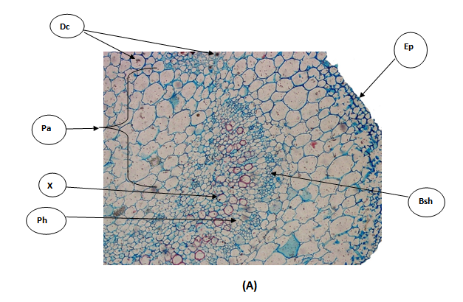
Figure 1:T.S.of D.innoxia ; (A) T.S. throuth the mid-rib region:Bsh= Bundle sheath; Dc= Druse crystal ; Ep=Epidermis ; Ph= Pholem; Xy=Xylem; Pa=Parenchyma cells

Mesophyll tissue consists of upper layer of palisade mesophyll parenchyma cells and 3-4 layers of lower spongy mesophyll parenchyma cells.
Figure 1: (B) T.S. through the lamina: Dc= Druse crystal; Uep= Upper epedermis ; Lep=Lower epidermis ;Pme=Palisade mesophyll;Sme=Spongy mesophyll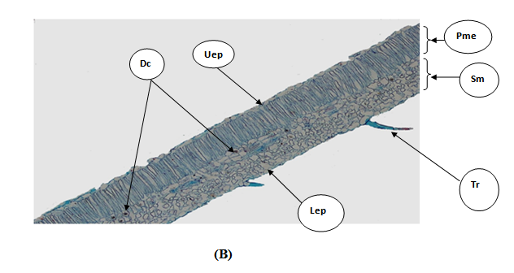

The mesophyll of D. innoxia is bifacial. The crystal of calcium oxalate is present in the spongy mesophyll in druse type. The parenchyma cells occupy the most region of the mid-rib. The vascular bundle in mid-rib is bicollateral type. Amonotetracytic and anisocytic stomata complex types were occurred in the adaxial and abaxial surface of D. innoxia. Trichomes are unicellular with gland.

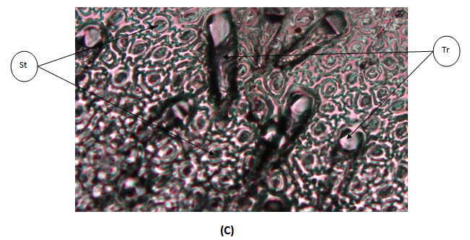Figure 1: (C) T.S through the peel: St= stomat; Tr= trichome.

3.1.2. Solanum nigrum
The transverse section of the lamina of S.nigrum is presented in Fig. ( 2; A,B,C ) Epidermal cells on the adaxial surface are irregular with sinuous walls.
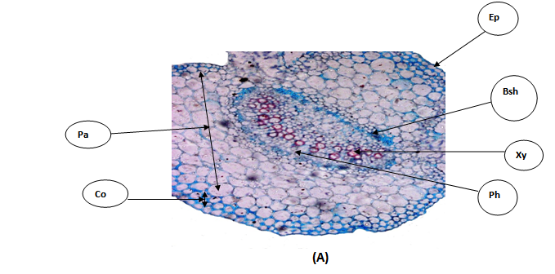
Figure 2 :T.S .of S.nigrum; (A) T.S. throuth the mid-rib region: Bsh= Bundle sheath; Bsh= Bundle sheath;Co=Collenchyma cells; Ep=Epidermis ;Pa=Parenchem cells; Ph= Pholem and Xy=Xylem.
The spongy mesophyll was made of cells which were round or irregular in shape. Large intercellular spaces occurred among these cells. The palisade mesophyll and spongy mesophyll are equally in thickness. The crystal of calcium oxalate is in Druse type. 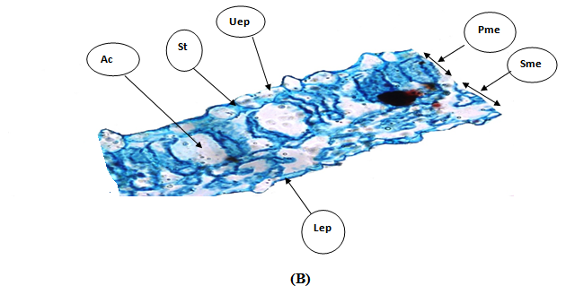

Figure 2. (B) T.S. through the lamina: Ac=Air cavity; Uep= Upper epedermis ;Lep=Lower epidermis ;Pme=Palisade mesophyll;Sme=Spongy mesophyll; St= Stomata
The glandular and non-glandular trichomes are present. The bulk region of mid-rib is occupied by large rounded intercellular parenchyma cells. The vascular bundle is bicollateral and surrounded by sheath. The stomata were mostly anisocytic, sometimes anomocytic type. Glandular trichomes and non-trichomes are present with unicellular type.
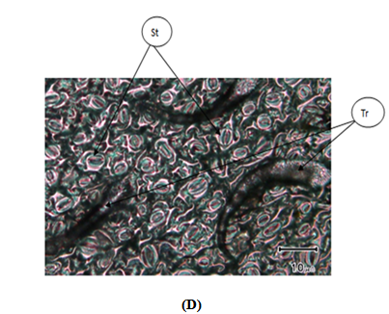
Figure 2 : (D) Trichome.
3.1.3. Withania somnifera
The transverse section of the lamina of W.somnifera is presented in Fig. (3; A, B,C ). Epidermal cells on the adaxial surface are irregular with sinuous anticlinal walls. The epidermis layer is composed of upper epidermis layer with thin cuticle and lower epidermis layer. The mid-rib region is larger and most of its area is occupied by parenchyma cells. The vascular bundle is large and bicollateral type.

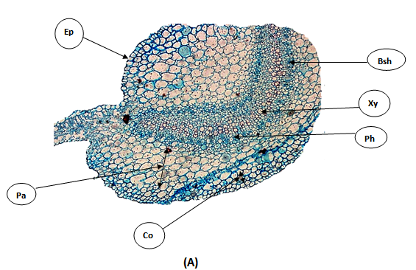

Figure 3 :T.S .of S.americanum; (A) T.S. throuth the mid-rib region: Bsh= Bundle sheath; Bsh= Bundle sheath;Co=Collenchyma cells; Ep=Epidermis ;Pa=Parenchem cells; Ph= Pholem and Xy=Xylem.
Lep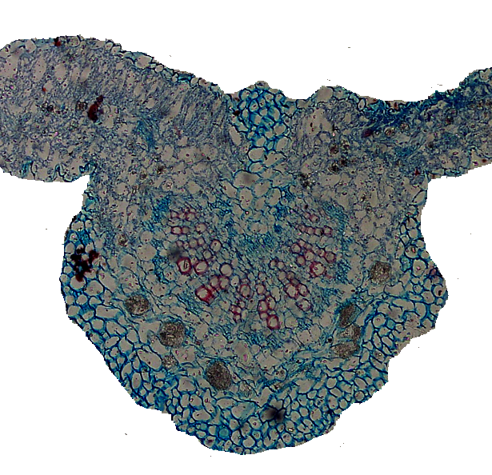
The mesophyll tissue is bifacial composed of palisade mesophyll with intercellular parenchyma cells and spongy mesophyll parenchyma cells. The spongy mesophyll layer is larger than palisade mesophyll layer. The crystal of calcium oxalate is present in druse type. It is noticed the glandular unicellular satellite tricomes are present.
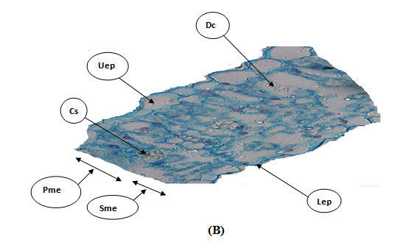

Figure 3 : (B) T.S. through the lamina: Ac=Air cavity; Uep= Upper epedermis ;Lep=Lower epidermis ;Pme=Palisade mesophyll;Sme=Spongy mesophyll; St= Stomata
Anisocytic, paracytic and anomocytic stomata type are characterized the adaxial and abaxial surface of W.somnifera. stellate trichomes are present, also multicellular tricomes with non-gland is present.
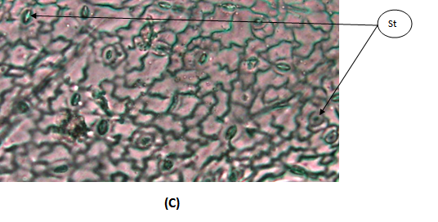
Figure 3 :,(C) T.S througth the pell: St= stomata; Tr= Trichome

GC-MS Analysis
Gas chromatography-mass spectrometry (GC/MS) analyses of ethanolic extracts from the leaves and fruits of the studied species have identified several phytochemical compounds. The findings indicated that the leaves and fruits of the examined species had abundant valuable phytochemical constituents. The analysis demonstrated that the leaves contained a rich array of chemical compounds, with nine phytochemical compounds isolated from the leaves, compared to the five compounds isolated from the fruits (table 1, and 2).
The GC/MS Separated compounds from the leaves

The separated compounds from the leaves appeared retention time ranged from 14-26 minutes which recorded 10 different compounds.
The highest molecular weight was 430g/mol was scored in the all studied species, this has the molecular formula of C₂₉H₅₀O₂ and decided name Vitamin E while the lowest molecular weight was 256 g/mol scored for all the studied species, this has the molecular formula of C₁₆H₃₂O₂ and decided name n-hexadecanoic acid (Fig.4,5,6,)

Table 1: The major occurrenent and frequent phytochemical compounds separated from the leaves of the studied species.

Phytochemical Compound | Plant Species | M.formula | M.weight (g/mol) | Retention Time | Area  %
n-hexadecanoic acid | Datura innoxia | C₁₆H₃₂O₂ | 256 | 16.502 | 4.04
n-hexadecanoic acid | Solanum americaum | C₁₆H₃₂O₂ | 256 | 15.533 | 4.79
n-hexadecanoic acid | Withania somnifera | C₁₆H₃₂O₂ | 256 | 16.522 | 27.85
3, 7, 11, 15-Tetramethyl-2-hexadecen-1-OL | Datura innoxia | C₂₀H₄₀O | 296 | 14.221 | 7.16
3, 7, 11, 15-Tetramethyl-2-hexadecen-1-OL | Solanum americaum | C₂₀H₄₀O | 296 | 14.186 | 3.53
3, 7, 11, 15-Tetramethyl-2-hexadecen-1-OL | Withania somnifera | C₂₀H₄₀O | 296 | 15.398 | 1.31
Phytol | Datura innoxia | C₂₀H₄₀O | 296 | 16.955 | 19.89
Phytol | Solanum americaum | C₂₀H₄₀O | 296 | 16.911 | 5.95
Phytol | Withania somnifera | C₂₀H₄₀O | 296 | 17.864 | 4.77
9-Eicosyne | Datura innoxia | C₂₀H₃₈ | 278 | 14.481 | 1.24
9-Eicosyne | Solanum americaum | C₂₀H₃₈ | 278 | 14.445 | 0.62
9-Eicosyne | Withania somnifera | C₂₀H₃₈ | 278 | 15.585 | 2.47
Phytol, acetate | Datura innoxia | C₂₂H₄₂O₂ | 338 | 14.669 | 2.23
 | Solanum americaum | C₂₂H₄₂O₂ | 338 | 14.631 | 1.11
 | Withania somnifera | C₂₂H₄₂O₂ | 338 | 15.139 | 7.24
9,12,15-Octadecatrienoic acid, ethyl ester, (Z,Z,Z) | Datura innoxia | C₂₀H₃₄O₂ | 306 | 17.237 | 1.40
 | Solanum americaum | C₂₀H₃₄O₂ | 306 | 17.250 | 0.85
 | Withania somnifera | C₂₀H₃₄O₂ | 306 | 18.229 | 11.93
Squalene | Datura innoxia | C₃₀H₅₀ | 410 | 22.639 | 3.25
 | Solanum americaum | C₃₀H₅₀ | 410 | 22.601 | 0.43
 | Withania somnifera | ----- | ------ | ---------- | --------
Vitamin E | Datura innoxia | C₂₉H₅₀O₂ | 430 | 24.883 | 14.43
 | Solanum americaum | C₂₉H₅₀O₂ | 430 | 24.834 | 3.63
 | Withania somnifera | C₂₉H₅₀O₂ | 430 | 25.766 | 3.50
Stigmasterol | Datura innoxia | C₂₉H₄₈O | 414 | 26.133 | 3.53
 | Solanum americaum | C₂₉H₄₈O | 414 | 26.059 | 0.49
 | Withania somnifera | C₂₉H₄₈O | 414 | 26.964 | 3.59

Concentration of the Phytochemical
Compound (%)
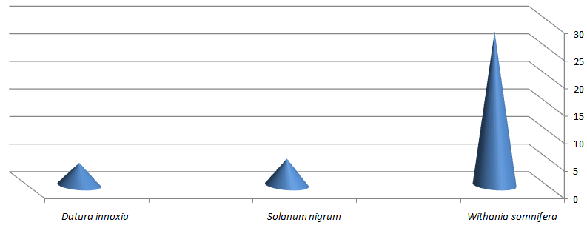
The Studied Species

Figure 4 : Concentration of n-hexadecanoic acid Separated from the Leaves of the Studied Species.
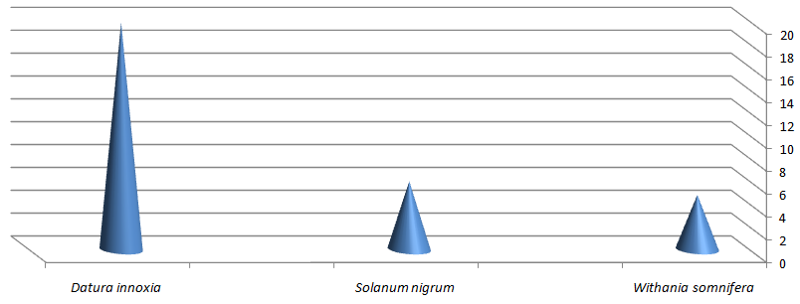
The Studied Species
Concentration of the Phytochemical
Compound (%)

Figure 5: Concentration of Phytol Separated from the Leaves of the Studied Species.
.

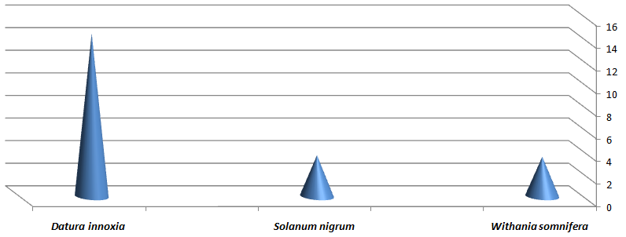
The studied species

Concentration of the Phytochemical
Compound (%)

Figure 6: Concentration of Vitamin E Separated from the Leaves of the Studied Species.

2. Fruits GC/MS Separated compounds from the fruits
For the fruits, the separated compounds appeared at retention time ranged from 11-27 min. The highest molecular weight was 414 g/mol was scored in all the studied species, this has molecular formula of C₂₉H₅₀O and decided name Gamma Sitosterol. on the other hand the lowest molecular weight was 208 g/mol and scored by Datura innoxia and Solanum nigrum only. this has molecular formula C₈H₁₆O₆ and decided name Ethyl alpha-d-glucopyranoside.
The compound with the highest concentration isolated from leaves was
n-hexanoic acid, accounting for 27.85%, which was scored by Withania somnifera, followed by phytol at 19.89 % and Vitamin E at 14.43 which were scored By Datura innoxia (Fig. 7 and 8).

Table 2: the major occurrenent and frequent phytochemical compounds separated from the fruits of the studied species.

Separated phytochemical Compound | Plant species | M.formula | M.weight (g/mol) | Retention time | Area %
n-Hexadecanoic acid | Datura innoxia | C₁₆H₃₂O₂ | 256 | 15.899 | 7.08
 | Solanum americaum | C₁₆H₃₂O₂ | 256 | 15.618 | 4.48
 | Withania somnifera | C₁₆H₃₂O₂ | 256 | 15.889 | 12.88
1-Nonadecene | Datura innoxia | -------- | -------- | ------------- | ----------
1-Nonadecene | Solanum americaum | C₁₉H₃₈ | 266 | 11.678 | 3.17
1-Nonadecene | Withania somnifera | C₁₉H₃₈ | 266 | 11.940 | 2.07
Gamma Sitosterol | Datura innoxia | C₂₉H₅₀O | 414 | 27.460 | 1.76
Gamma Sitosterol | Solanum americaum | C₂₉H₅₀O | 414 | 26.942 | 1.48
Gamma Sitosterol | Withania somnifera | C₂₉H₅₀O | 414 | 27.460 | 2.39
9,12-Octadecadienoic acid (Z,Z)- | Datura innoxia | C₁₈H₃₂O₂ | 280 | 17.566 | 12.56
9,12-Octadecadienoic acid (Z,Z)- | Solanum americaum | ---------- | -------- | ----------- | -------
9,12-Octadecadienoic acid (Z,Z)- | Withania somnifera | C₁₈H₃₂O₂ | 280 | 17.555 | 29.81
Ethyl alpha-d-glucopyranoside | Datura innoxia | C₈H₁₆O₆ | 208 | 12.456 | 4.12
 | Solanum americaum | C₈H₁₆O₆ | 208 | 12.134 | 11.70
 | Withania somnifera |  | --------- | ---------- | --------

Two compounds with the highest concentration isolated from fruits was 9,12-Octadecadienoic acid (Z,Z)- (29.81%) and n-hexanoic acid (12.89), which were scored by Withania smnifera (Fig.7).
Concentration of the Phytochemical
Compound (%)

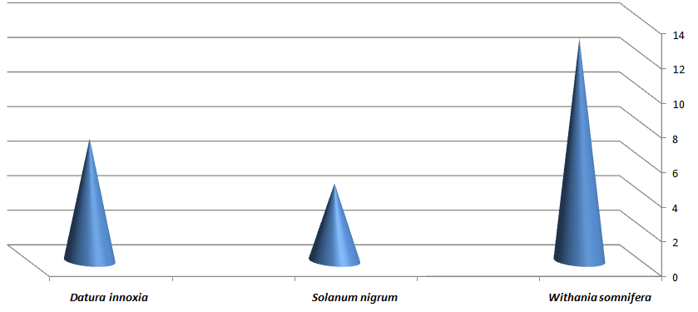
The Studied Species

Figure 7: Concentration of n-hexadonic acid Separated from the fruits of the Studied Species.
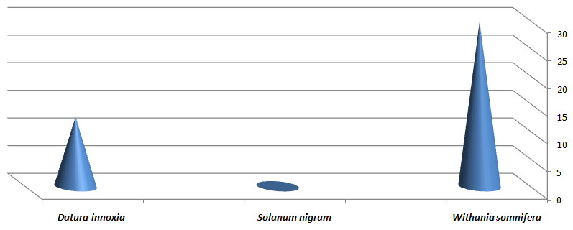
The Studied species
Concentration of the phtochemical compound (%)

Figure 8: Concentration of 9, 12-Octadecadienoic acid (Z,Z)- Separated from the fruits of the Studied Species.

4. Discussion
The present study highlights the strong functional and taxonomic linkage between plant anatomy and the synthesis, accumulation, and secretion of phytochemicals. Specialized secretory tissues represent key anatomical adaptations that regulate the localization and release of secondary metabolites, which are essential for plant defense, ecological interaction, and medicinal value. These structures provide reliable indicators of phytochemical potential and contribute significantly to plant identification and classification.
Diagnostic characters in taxonomic studies have been used to identify plant groups from several others of similar ranking (Arama et al., 2017). Plant anatomical features—including epidermal characteristics, stomatal types, trichomes, vascular bundle arrangement, and internal tissue organization—have proven valuable in distinguishing closely related species and resolving taxonomic ambiguities where morphological traits overlap (Dichkison, 2000). These internal structures are less affected by ecological factors and thus offer consistent diagnostic characters across different habitats (Culter et al., 2008). The use of anatomical structures is particularly important in the identification of medicinal plants, where correct species determination is essential to ensure safety, efficiency, and quality control of herbal products (WHO, 2011). Furthermore, anatomical studies contribute to understanding evolutionary relationships and phylogenetic patterns among plant taxa, complementing morphological and molecular approaches (Judd et al., 2016). Therefore, incorporating anatomical structures into plant identification enhances taxonomic accuracy and supports a more comprehensive understanding of plant diversity. The two studied species, D. innoxia and W. somnifera, are quite distinct in the surface view of the epidermis, with a sinuous anticlinal wall on both surfaces. The sinuous wall characterized the wall of Solanum nigrum. The anomocytic type of stomata was common in the studied species, which was followed by the anisocytic type of stomata. These results are consistent with the study conducted by Krstić et al. (2002); Awan and Murtaza (2016); Hameed and Hussain (2011); Wahua and Edwin-Wosu (2016); and Bello et al. (2017), who investigated the anatomical stomata of Solanaceae. High density of stomata was observed in the Datura innoxia and Solanum nigrum. This can be attributed to the fact that they always inhabit the moist habitats. The type and location of calcium crystals are often used in plant taxonomic classification. Based on crystals of calcium oxalate, the studied species showed the existence of druses crystals. Gómez et al. (2016) reported that druse crystal was mainly found in the leaves of Datura species.
The study of secondary metabolites of leaf and fruit crude extracts revealed that the ethanol crude extract shows promising secondary metabolite contents. Also worth noting is that fruits of Solanaceae can be considered as a rich source of secondary metabolites when compared to the leaves. In her study Almoulah (2017) investigated the phytochemical and biological evaluation of five plants belonging to the family Solanaceae. In her findings, she separated many of the secondary metabolites by GC-MS; some of these secondary metabolites are compatible with what was found in this study. Solanum spp. is considered the largest genus in the family Solanaceae. El-Shaboury et al. (2017) and Yuan et al. (2018) in their study revealed that Solanum species are a rich source of secondary metabolites. Also, the phytochemical compounds of the genus Datura spp. had been investigated by many authors (Philipov and Berkov, 2002; Hossain et al., 2013; Rautela et al., 2018; Cinelli and Jones, 2021); these investigations of Datura spp. are to what extent similar to what was found in Datura innoxia which investigated this study. Usaizan et al. (2014), in his study, reported that the obtained result showed that P. minima which belongs to Solanaceae family has important compounds such as phytol, vitamin E, oleic acid, and n-hexadecanoic acid. Some of these compounds have been separated from the studied species that were investigated in this study.
5. Conclusion
Integrating anatomical and phytochemical evidence enhances the reliability of species identification, particularly in medicinal plants where accurate authentication is essential for quality control and safety. Anatomical markers linked to phytochemical secretion provide stable characters that complement morphological and molecular data.

COMPETING INTERESTS DISCLAIMER:
Authors have declared that they have no known competing financial interests OR non-financial interests OR personal relationships that could have appeared to influence the work reported in this paper.

6. References
Almoulah, N. F. (2017). Phytochemical study and biological evaluation of five plants belonging to the family Solanaceae (Doctoral dissertation, Université de Lorraine).
Arama, P., Jeruto, P., Anyango, B., Nyunja, R., Taracha, C., and Opiyo, S. (2017). Morphometric study of Senna didymobotrya (Fresen.) H.S. Irwin & Barneby in Kenya.
Awan, A. A., and Murtaza, G. (2013). Ethnobotanical uses of plants of family Solanaceae Muzaffarabad division Azad Jammu and Kashmir, Pakistan-13100. Int Pharm Sci Invent, 2, 5-11.
Bello, A. O., Oladipo, O. T., and Saheed, S. A. (2017). Leaf epidermal studies of some Solanum (Solanaceae) species in Nigeria. Phytologia Balcanica, 23(1), 55-63.
Cinelli, M. A., and Jones, A. D. (2021). Alkaloids of the Genus Datura: Review of a Rich Resource for Natural Product Discovery. Molecules, 26(9), 2629.
Cutler,D,F. Botha, T., and Stevenson,D.W. (2008).Plant anatomy:An applied Approach. Blackwell publishing.
Debelle, F. D., Vanherweghem, J. L., and Nortier, J. L. (2008). Aristolochic acid nephropathy: a worldwide problem. Kidney international, 74(2), 158-169.
Dickison, W. C. (2000). Integrative plant anatomy. Elsevier.
Duke, J.A.(2002). Handbook of medicinal herbs (2nd ed.)CRC Press.

El-Shaboury, G., Haroun, S., Shaker, K., and Badr, A. (2017). Systematics Implications of GC-MS analysis of secondary metabolites in the ethanol extract of Solanum species from South West Saudi Arabia. Egyptian journal of botany, 57(3), 429-444.
Fattori, V., Hohmann, M. S., Rossaneis, A. C., Pinho-Ribeiro, F. A., and Verri Jr, W. A. (2016). Capsaicin: current understanding of its mechanisms and therapy of pain and other pre-clinical and clinical uses. Molecules, 21(7), 844.
Ganie, S. H., Upadhyay, P., Das, S., and Sharma, M. P. (2015). Authentication of medicinal plants by DNA markers. Plant Gene, 4, 83–99.
Ghadage, D., Chavan, Y., Jadhav, P., Kengar, M., Aiwale, P., and Patil, A. (2025). Advanced herbal technology: A review of plant identification, authentication, and advanced extraction techniques. Journal of Advancement in Pharmacognosy, 5(1), 1–10.
Giovannucci, E. (1999). Tomatoes, Tomato-based products, lycopene, and cancer. Journal of Nutrition, 129(11), 2081S-2085S.
Gómez-Nucamendi, O. L., Hernández-Sandoval, L., Figueroa-Cabañas, M., & Martínez, M. (2016). Leaf anatomy of four species and one variety of Datura (Solanoidea, Solanaceae).
Hameed, I., and Hussain, F. (2011). Stomatal studies of some selected medicinal plants of family Solanaceae. Journal of Medicinal Plants Research, 5(18), 4525-4529.
Hossain, M. A., ALsabari, K. M., Weli, A. M., and Al-Riyami, Q. (2013). Gas chromatography–mass spectrometry analysis and total phenolic contents of various crude extracts from the fruits of Datura metel L. Journal of Taibah University for Science, 7(4), 209-215.
Indrayanto, G. (2022). The importance of method validation in herbal drug research. Journal of Pharmaceutical and Biomedical Analysis, 214, 114735.
Jain,R., Sharma,A., Gupta , S ., Sarethy,I.P., and Gabrani,R. (2011). Solanum nigrum: current perspectives on therapeutic properties.Alternative Medicine review.
Judd,W.S., Campbell, C.S., Kellogg,E.A, Steven,P.F., and Donoghue, M.J. (2016). Plant systematic : A phylogenetic Approach (4th ed.). sinauer associates.
Krstić, L. N., Merkulov, L. S., and Boža, P. P. (2002). The variability of leaf anatomical characteristics of Solanum nigrum L. (Solanales, Solanaceae) from different habitats. Zbornik Matice Srpske za Prirodne Nauke, (102), 59-70
Kshirsagar, P., Umdale, S., Chavan, J., and Gaikwad, N. (2017). Molecular authentication of medicinal plant, Swertia chirayita and its adulterant species. Proceedings of the National Academy of Sciences, India Section B: Biological Sciences, 87(1), 101–107.
Mirjalili ,M.H., Moyano,E., Bonifll,M ., Cusido,R.M and Palazon,J.(2009). Steroids lactones from Withania somnifera, an ancient plant for novel medicine. Molecules, 14,2373-2393
Patel, S., Gheewala,N., Suther,A., and Shan, A.(2010). In vitro cytotoxicity activity of Solanum nigrum extracts against hela cell line. International journal of pharmacy and pharmaceutical sciences.2 (2), 38-46.
Philipov, S., and Berkov, S. (2002). GC-MS investigation of tropane alkaloids in Datura stramonium. Zeitschrift für Naturforschung C, 57(5-6), 559-561.
Rautela, I., Dheer, P., Thapliyal, P., Joshi, T., Sharma, N., and Sharma, M. D. (2018). GC-MS analysis of plant leaf extract of Datura stramonium in different solvent system. European J. Biomed. Pharm. Sci, 5, 236-245.
Singh,N., Bahalla, M., de Jager, P., and Gilca, M.(2011). An overview on Ashwagandh: A Rasayana (rejuvenator) of Ayurveda. Africa Journal of Traditional, Complementary and Alternative Medicines, 8(5S),208-213.
Singh ,S. et al. (2014). Nutritional and health aspects of eggplant. Journal of food science and technology, 51(11), 2821-2831.
Srinivasan, K. (2005). Role of spices in national health programmers. Indian journal of medical research. ,122(2).
Techen, N., Crockett, S. L., Khan, I. A., & Scheffler, B. E. (2004). Authentication of medicinal plants using molecular biology techniques to complement conventional methods. Current Medicinal Chemistry, 11(11), 1391–1401.
Usaizan, N., Abdullah, N. A. P., Ahmad, S. H., and Saleh, G. (2014). Preliminary phytochemical screening and GC-MS analysis of ethanol extract of Physalis minima L.(Solanaceae). Journal of Advanced Agricultural Technologies Vol, 1(2).
Wahua, C., & Edwin-Wosu, N. L. (2016). Morphological characters, occurrence and distribution among members of the family Solanaceae in parts of the Niger Delta Ecological Zone. Journal of Applied Sciences and Environmental Management, 20(3), 583-590.
WHO (2019). WHO Global report on tradition and complementary medicine.
Wink, M. ( 2003). Evolution of secondry metabolites from an ecological and molecular phylogenic prospective . photochemistry, 64(1),3-19.
World Health Orgnizations (WHO). (2011). Quality control Methods for herbal materials. WHO press.
Yuan, B., Byrnes, D., Giurleo, D., Villani, T., Simon, J. E., an Wu, Q. (2018). Rapid screening of toxic glycoalkaloids and micronutrients in edible nightshades (Solanum spp.). Journal of food and drug analysis, 26(2), 751-760.

