Assessment of Groundnut Rosette Virus Disease Transmitted by Aphid Insect-vector (Aphis craccivora Koch) as Influenced by Sowing Dates in Nigerian Southern Guinea Savannah

ABSTRACT
Field experiment was carried out in 2015 and 2016 cropping seasons to determine the influence of early sowing dates on incidence and severity of groundnut rosette virus disease at the Teaching and Research farm of the Federal University of Agriculture, Makurdi Benue State, Nigeria. The 4mx 2m x 3m factorial experiment containing 24 treatment combinations (Four sowing dates- Mid-May, Late-May, Mid-June and Late-June / Two groundnut varieties- Gyadan-Mandawa and Samnut-14 / Three replications) were laid out in a randomized complete block design (RCBD) in land area of 49m x 8m=392m². The assessment results revealed that early sowing dates significantly influenced rosette virus disease by lowering the incidence from 20 to 30 days after sowing (DAS) in 2015 and from 20 to 40 DAS in 2016 respectively. Those plants sown early in Mid-May and Late-May exhibited lesser disease incidence compared to those sown in Mid-June and Late June from 20 to 30 DAS and from 20 to 40DAS in 2015 and 2016 cropping seasons respectively. The influence of groundnut varieties on disease incidence was significantly different only from 20 to 30 DAS in 2016 but not from 20 to 40 DAS in 2015. Samnut-14 recorded lower disease incidence compared to Gyadan-Mandawa which had higher disease incidence at 20 and 30 DAS respectively in 2016. The influence of early sowing dates on severity of the disease was significantly different from 40 to 70 DAS in 2015 and at 40, 50 and 70 DAS in 2016 accordingly. Those plants grown early in Mid-May and Late-May recorded lesser disease severity compared to those sown in late Mid-June and Late June in the two cropping season respectively. Results showed that among the groundnut varieties, Samnuut-14 recorded lower disease severity compared to Gyadan-Mandawa which exhibited higher disease severity at 40, 60 and 70 DAS in 2015 and from 40 to 70 DAS in 2016 respectively.. Therefore, early sowing date could be strategically used for the management of groundnut rosette virus disease in this region because of its eco-friendliness and economic feasibility.
Keywords: Rosette virus, incidence, aphids, sowing dates, disease, varieties, severity

- INTRODUCTION
Groundnut rosette virus (GRD) is an economic important disease transmitted by an aphid (Aphis craccivora Koch Homoptera Aphididae). It is one of the major biotic production constraints of groundnut that frustrate the efforts of groundnut farmers in Nigeria. The disease is called “kwuturutukan gyada” which mean “groundnut leprosy” among the Hausa speaking tribe in Northern parts of Nigeria. The insect is the only effective vector that can transmits groundnut rosette virus disease agents efficiently (Haciwa and Kannaiyan 1990). Entomological study has shown that insects are intimately involved in facilitating initiation and development of many plant diseases (Almeida et al., 2015). Virtually, all aphids such as Green peach aphid, Cowpea aphid, Melon aphid, Aphis gossypii and Myzus persicae are generally involved as efficient vectors for virus transmission from one plant to another plant such as potatoes, citrus, peppers, okra, cuccumber and varieties of ornamental plants (Henry et al., 2002; Tajashwani et al., 2019).
It is the most destructive viral disease of groundnut in Sub-Saharan Africa (Reddy 1984), and can cause the most significant yield losses (Sudini et al., 2015). The disease is polycyclic in nature and the winged aphids are the disease carriers from infected plants to healthy plants (Thresh, 2003). The rosette virus foliar disease symptoms vary. Reddy (1984) reported three notable groundnut rosette diseases which include groundnut chlorotic rosette (GCR), groundnut mosaic rosette (GMR) which are predominant in Eastern and Southern Africa and ground green rosette (GGR) which appears to be restricted to West Africa. Subrahamanyam and Mamba (1993) reported that both chlorotic and green rosette were present in all the fields visited in Sidvokodvo with over 50% disease incidence. According to them the green rosette is the most common and destructive viral disease of groundnut in West Africa. Bock et al. (1990) stated that the disease is caused by three agents which are groundnut rosette virus (GRV), a satellite RNA of GRV and groundnut rosette assistor virus (GRAV). The complex interaction of these agents in causing the disease makes it is a unique and fascinating virus disease whose origin and perpetuation in nature still remain inconclusive (Waliyar et al, 2007).
In a severe case the occurrence of the disease symptoms either separately or in combination can cause as much as 100% loss in pod yield if the infection occurs before flowering (Naidu et al., 1999; Okello et al., 2010, Training Manual for Trainers, 2011; Tabe-ojong et al., 2022). Nigam et al. (2012) reported that the disease contributed to an annual loss of USA $156 million across Africa. In Nigeria, about 0.7 million hectare of the crop were destroyed which resulted to loss of over 137 million naira during rosette epidemic in some Western African countries in 1975. The circulations of released resistant varieties are limited; spraying of exorbitant chemicals is not economically feasible and equally not common practice among the poor-resourced groundnut farmers in Nigeria. Early sowing could be a viable alternative to synthetic pesticides since it is affordable can easily be manipulated. The objective of this research was to assess the influence of early sowing dates in the management of groundnut rosette virus disease in Nigerian Southern Guinea Savannah.
2. MATERIALS AND METHODS
2.1 Site of the Experiment
The experiment was carried out in 2015 and 2016 cropping seasons at the Teaching and Research farm of the Crop and Environment Protection, College of Agronomy, Federal University of Agriculture Makurdi, Benue State, Nigeria which has been recently renamed as Joseph Sarwuan Tarka University, Benue State.
2.2 Design of the experiment and treatment combinations
The factorial experiments of 4m x 2m were laid out in a randomized complete block design (RCBD) and replicated three times in a cleared and prepared land area of 49m x 8m=392m². The four sowing dates T1=15 Mid-May, T2=30th Late-May, T3=14th Mid-June and T4=29th Late-June and groundnut varieties Gyadan-Madawa (V1) and Samnut-14 (V2) made up the 24 treatment combinations. The groundnut variety seeds were assigned in the main-plot each measuring 15m x 2m (30m²) while the four different sowing dates were assigned in the sub-plots each measuring 3 x 2m (6m²) with four ridges. 1m spacing was in-between the main-plots and sub-plots respectively as walking alley.
2.3 Sowing of groundnut Seeds
Two seeds per-hole were sown at a spacing of 20cm within rows and 75cm between rows. Weeding of the experimental plots was done at regular interval and no chemical was applied throughout the period of the study.

2.4 Methods of data collection
2.4.1Incidence of rosette virus (%)
Leaf disease incidence was assessed at 20, 30 and 40 day after sowing (DAS) by counting the number of plants showing the virus symptoms in the net-plot and divided by the total number of plants in the net plot and multiply by 100 using as follow formula:
Disease incidence = $\frac{\begin{aligned}Number of plant stands showing virus symptoms \\ in the net-plot\end{aligned}}{Total number plant stands in the net-plot}$ X$\frac{100}{1}$
2.4.2 Severity of rosette virus disease (%)
The severity of groundnut rosette virus was assessed at 40, 50 and 60 DAS. Five (5) plant stands were selected at random in each net-plot and the disease severity was scored using adopted disease severity scale of 1 to 8 in an increasing order as follows: 0 – 0% leaf area with no disease symptoms, 1 = 1 to 10% leaf area covered with disease symptoms,2 = 11 to 20% leaf area covered with disease symptoms,3 = 21 to 30% leaf area covered with disease symptoms, 4 = 31 to 40% leaf area covered with disease symptoms, 5 = 41 to 50% leaf area covered with disease symptoms, 6 = 51 to 60% leaf area covered with disease symptoms, 7 = 61 to 70% leaf area covered with disease symptoms, 8 = ≥ 71% leaf area covered with disease symptoms. The disease severity at each stage was computed using the formula below:
Severity of rosette virus disease = Σn x 100
N x 8
Where Σn = Summation of scores of the assessments
N = the number of plants assessed, and
8 = highest severity score.
2.4.3 Insects collection and identification
The observed insects were carefully collected and kept inside a separate clean glass bottle with a perforated cover and taken to the laboratory for proper identification using a book manual by Neil et al. (2004). The insects were snapped using a sensitive digital camera and the macrographs were cropped

2.4.4 One thousand seeds weight (gm.)
At physiological maturity stage, the groundnut stands in the net plots were harvested, the pods were picked, sun dry, unshelled separately, one thousand seeds were hand-picked at random per net-plot yield and weighed in gram using a sensitive electronic weighing scale model (Sartorius 6MBH Gottingen-Type Fabr-Nr.) in the Plant Pathology laboratory
2.5 Statistical data analysis
Two-way analysis of variance (ANOVA) was applied in analyzing all data generated using Statistical analysis software package version 9.1 (SAS). The means were separated using the Duncan’s New multiple Range Test (DNMRT) at 5% probability level (Obi, 2002).
- RESULTS
  - Disease incidence
The incidence of groundnut rosette virus disease as influenced by sowing dates, varieties and their interaction at 20, 30 and 40DAS in 2015 and 2016 cropping seasons are presented in Table 1.
In first cropping season, the results showed that the sowing dates had significant influenced on rosette virus disease incidence at 20 DAS and 30 DAS but did not at 40 DAS. The result revealed that those plants sown in Mid-May and Late-May recorded lower disease incidence from 20 to 30 DAS whereas those plants sown in Mid-June and Late-June recorded higher disease incidence with 24.5% and 27.7% at 20 DAS, and 30.7% and 33.2% at 30 DAS respectively. But the influenced of varieties and the interaction between sowing dates and varieties on disease incidence was not significantly different (P ≤ 0.05) from 20 to 40 DAS.
In second cropping season, the results indicated that the influence of sowing date on disease incidences was significantly different from 20 to 40 DAS while the influenced of varieties on disease incidence was only significant different from 20 to 30 DAS but was not at 40 DAS. The interaction effect between sowing dates and varieties on disease incidence was significant only at 30 DAS but was not significantly different (P ≤ 0.05) at 20 DAS and 40 DAS. Results showed that those plants sown in Early-May and Late-May recorded moderately lower disease incidence from 20 to 40DAS respectively compared to other sowing dates. Highest rosette incidence of 18.08%, 27.35% and 33.92% were recorded at 20, 30 and 40 DAS from those groundnut plants sowed in Late June, but which were statistically similar with those plants sown in Mid-June respectively. Among the two groundnut varieties, Gyadan-Madawa recorded significantly the highest disease incidence with 19.37% and 28.04%, whereas Samnut-14 had lower disease incidence with 12.50% and 19.34% at 20 and 30 DAS respectively.

Table 1 Influence of sowing dates and varieties and their interaction on the incidence of groundnut rosette virus disease at 20, 30 and 40 DAS in 2015 and 2016 cropping seasons
 | Incidence of Groundnut Rosette Virus
 | 2015 |  |  | 2016
Treatments | 20DAS | 30DAS | 40DAS | 20DAS | 30DAS | 40DAS
Sowing Dates  Mid-May | 20.07 | 23.8 | 36.2 | 13.55 | 20.02 | 27.56
Late-May | 19.27 | 16.8 | 37.1 | 15.19 | 21.78 | 27.64
Mid-June | 24.54 | 30.7 | 41.9 | 16.93 | 25.62 | 33.42
Late-June | 27.72 | 33.2 | 49.4 | 18.08 | 27.35 | 33.92
LSD | 4.920* | 7.09* | NS | 3.885* | 3.344* | 5.599*
CV | 42.40 | 69.56 | 20.93 | 30.51 | 34.91 | 28.08
Varieties
Gyadan-Madawa | 27.08 | 33.9 | 41.1 | 19.37 | 28.04 | 31.80
Samnut-14 | 18.72 | 18.4 | 50.7 | 12.50 | 19.34 | 29.47
LSD | NS | NS | NS | 2.622* | 6.849* | NS
CV | 14.7 | 22.5 | 14.5 | 4.7 | 8.66 | 6.9
Inter: Sowing Date X Varieties
Gyadan-Madawa | 24.20 | 31.1 | 36.2 | 15.67 | 20.92 | 29.15
Mid-May | 19.70 | 20.7 | 37.1 | 19.11 | 24.21 | 29.98
Late-May | 29.64 | 40.1 | 41.9 | 21.33 | 33.17 | 34.98
Mid-June | 34.78 | 43.5 | 49.4 | 21.34 | 33.88 | 33.09
Late-June | 15.93 | 16.4 | 57.0 | 11.43 | 19.13 | 25.96
Samnut-14
Mid-May | 18.85 | 12.8 | 47.4 | 11.27 | 19.35 | 25.31
Late-May | 19.44 | 21.3 | 51.6 | 12.48 | 18.07 | 31.85
Mid-June | 20.67 | 23.0 | 52.8 | 14.82 | 20.82 | 34.76
Late-June | NS | NS | NS | NS | 5.606* | NS
LSD | 17.1 | 21.6 | 14.7 | 19.4 | 11.2 | 14.5
CV | 24.20 | 31.1 | 36.2 | 15.67 | 20.92 | 29.15
Means followed by the same letter(s) are not significantly different (P=0.05), NS = not significant, LSD = Least significant, ** = significant at 1% level difference, * = significant at 5% level, CV = coefficient of variation

  - Disease severity (%)
The severity of groundnut rosette virus as influenced by sowing dates and varieties their interaction at 40, 50, 60 and 70 DAS in 2015 cropping seasons are presented in table 2.
In this cropping season, the sowing dates significantly (P≤ 0.05) influenced disease severity from 40 to 70 DAS but the interaction between varieties and sowing dates did not from 40 to 70 DAS respectively. Results revealed that at 40, 50 and 60 DAS, those groundnut plants sown in Mid-June recorded significantly higher disease severity with 15.8%, 23.9% and 33.4% respectively; this was followed by those plants sown in Late-June. Similarly, at 70 DAS higher disease severity of 39.6% and 39.7% which did not differ significantly from each other was also recorded from those groundnut plants sown in Mid-June and Late-June respectively. The lowest disease severity of 10.2%, 13.5%, 18.8% and 26.0%; and 10.6%, 14.4%, 20.7% and 27.7% as indicated by the results were obtained from those groundnut plants sown in late May and early May at 40, 50, 60 and 70 DAS respectively. The influence of varieties on severity of rosette virus were significantly (P≤ 0.05) different at 40, 60 and 70 DAS but was not at 50 DAS. Results showed that among the varieties, Gyadan-Madawa significantly recorded higher severity of the rosette virus with 13.5%, 27.2% and 36.7% compared to Samnut-14 which had lower severity of the disease at 40, 60 and 70 DAS respectively.

Table 2: Influence of sowing dates and varieties and their interaction on the severity of groundnut rosette virus at 40, 50, 60 and 70 DAS in 2015 cropping season
Severity of Groundnut Rosette Virus (%)
Treatments | 40DAS | 50DAS | 60DAS | 70DAS
Sowing Dates
Mid-May | 10.60 | 14.37 | 20.7 | 27.1
Late-May | 10.16 | 13.48 | 18.8 | 26.0
Mid-June | 15.78 | 23.87 | 33.4 | 39.6
Late-Jun | 12.58 | 18.982 | 25.9 | 39.7
LSD | 2.457* | 3.712** | 6.87* | 8.13*
CV | 51.11 | 65.81 | 64.65 | 56.03
Gyadan- Madawa | 13.49 | 19.41 | 27.2 | 36.7
Samnut-14 | 11.07 | 15.94 | 22.2 | 29.5
LSD | 1.770* | NS | 3.38* | 5.40*
CV | 4.1 | 8.0 | 3.9 | 4.6
Sowing Dates x Varieties
Gyadan-Madawa
Mid-May | 11.25 | 14.84 | 22.8 | 31.5
Late-May | 11.42 | 15.30 | 22.5 | 29.2
Mid-June | 18.52 | 26.89 | 35.8 | 42.0
Late-Jun | 12.75 | 20.63 | 27.8 | 44.0
Samnut-14
Mid-May | 9.95 | 13.90 | 18.7 | 22.8
Late-May | 8.89 | 11.66 | 15.1 | 22.8
Mid-June | 13.05 | 20.86 | 31.0 | 37.2
Late-Jun | 12.41 | 17.83 | 24.1 | 35.3
LSD | NS | NS | NS | NS
CV | 15.9 | 16.7 | 22.1 | 19.5
Means followed by the same letter(s) are not significantly different (P=0.05)
NS = not significant, LSD = Least significant,** = significant at 1% level difference
* = significant at 5% level, CV = coefficient of variation, DAS = Das after sowing

The severity of groundnut rosette virus as influenced by sowing dates and varieties their interaction at 40, 50, 60 and 70 DAS in 2016 cropping seasons are presented in table 3.
In this cropping season, the sowing dates significantly influenced severity of rosette virus at 40, 50 and 70 DAS but did not at 60 DAS groundnut varieties significantly influenced the disease severity from 40 to 70 DAS, and while the interactive effects between the sowing dates and varieties on disease severity was not significant from 40 to 60 DAS but was significant only at 70 DAS.
Results of the analysis indicated that those groundnut plants sown in Mid-June recorded higher disease severity with 11.4%, 14.8% and 31.6%, followed by those sown in late June which also had disease severity of 10.5%, 16.0% and 29.0% at 40, 50 and 70 DAS respectively. The lowest disease severity of 4.7%, 9.1% and 18.0% were recorded from those groundnut plants sown in late May, followed by those sown in early May at 40, 50 and 70 DAS respectively. Among the varieties, Gyadan-Madawa recorded significantly higher disease severity with 10.7%, 15.9%, 19.6% and 32.9% compared to Samnut-14 which had lower disease severity of 6.8%, 11.0%, 14.6% and 19.9% at 40, 50, 60 and 70 DAS respectively.

Table 3: Influence of sowing dates and varieties and their interaction on the severity of groundnut rosette virus at 40, 50, 60 and 70 DAS in 2016 cropping season
Severity of Groundnut Rosette Virus (%)
Treatments | 40DAS | 50DAS | 60DAS | 70DAS
Sowing Dates
Mid-May | 8.47 | 13.91 | 16.24 | 26.90
Late-May | 4.70 | 9.09 | 15.12 | 17.96
Mid-June | 11.39 | 14.76 | 18.98 | 31.61
Late-Jun | 10.54 | 15.97 | 17.89 | 28.95
LSD | 1.748** | 2.709** | NS | 4.017**
CV | 82.17 | 54.96 | 24.61 | 54.10
Varieties
Gyadan- Madawa | 10.72 | 15.90 | 19.56 | 32.85
Samnut-14 | 6.83 | 10.96 | 14.56 | 19.87
LSD | 1.271* | 3.746* | 4.405* | 2.205*
CV | 4.1 | 7.9 | 7.3 | 2.4
Sowing Dates x Varieties
Gyadan-Madawa
Mid-May | 10.88 | 15.44 | 17.24 | 32.55
Late-May | 4.69 | 10.48 | 16.49 | 20.11
Mid-June | 14.27 | 18.37 | 24.16 | 42.80
Late-Jun | 13.03 | 19.32 | 20.15 | 36.13
Samnut-14
Mid-May | 6.06 | 12.38 | 15.03 | 21.46
Late-May | 4.72 | 7.71 | 13.75 | 15.82
Mid-June | 8.50 | 11.14 | 13.81 | 20.42
Late-Jun | 8.04 | 12.62 | 15.64 | 21.78
LSD | NS | NS | NS | 5.0*
CV | 15.8 | 16.0 | 17.6 | 12.1
Means followed by the same letter(s) are not significantly different (P=0.05)
NS = not significant, LSD = Least significant,** = significant at 1% level difference
* = significant at 5% level, CV = coefficient of variation, DAS = Das after sowing

3.3 Seed weight (gm.)
The influenced of sowing dates and varieties and their interaction on 1000 seeds weight (gm.) in 2015 and 2016 cropping seasons are presented in (Table 3).
Results of the analysis revealed that the influence of sowing dates on 1000 seeds weight was significantly different in the second cropping season was not in the first cropping season. 1000 seeds weight (gm.) was significantly different among the groundnut varieties in the first cropping season but was not in the second cropping season whereas as the interactive effects between sowing dates and varieties on 1000 seeds weight were not significant in the two cropping seasons.
The result in the second cropping season, showed that the highest 1000 seeds weight of 525.0gm was obtained from those groundnut plants sown in Mid-May, followed by 477.0gm 1000 seeds weight recorded from those sown in Late-May compared to those sown in Mid-June and Late-June respectively
Among the groundnut varieties, Gyadan-Madawa significantly recorded the highest 1000 seeds weight with 410.4gm compared to Samnut-14 which had lower seeds weight with 396.0gm in the first cropping season.

Table 4: Influence of Sowing Dates and Varieties and their Interaction on 1000 Seeds Weight (gm.) in 2015 and 2016 Cropping Seasons
 | 1000 Seeds Weight (gm.)
Treatments | 2015 | 2016
Sowing dates
Mid May | 400.2 | 525.0
Late May | 406.2 | 477.0
Early June | 403.1 | 464.3
Late June | 403.3 | 444.8
LSD(0.05) | NS | 25.54*
CV% | 1.49 | 17.51
Varieties  Gyadan-Madawa | 410.4 | 469.5
Samnut-14 | 396.0 | 486.1
LSD(0.05) | 5.63* | NS
CV% | 0.4 | 3.7
Interaction (AXB)
Varieties
Gyadan-Madawa | 2011 | 2012
Mid May | 410.2 | 506.7
Late May | 415.6 | 459.3
Early June | 412.9 | 464.6
Late June | 403.1 | 447.2
Samnut-14
Mid May | 390.2 | 543.2
Late May | 369.9 | 494.8
Early June | 393.3 | 463.9
Late June | 403.6 | 442.4
LSD(0.05) | NS | NS
CV% | 3.4 | 4.2
Means followed by the same letter(s) are not significantly different (P=0.05), NS = not significant, LSD = Least significant, ** = significant at 1% level difference’ * = significant at 5% level, CV = coefficient of variation

3.4 Occurrence and involvement of groundnut aphids (Aphis craccivora Koch) in disease transmission
In this study, the observational occurrence of clusters of viruliferous Aphids (Aphis craccivora) at early seedling stage preceded the incidence and severity of rosette virus disease symptoms. The adult aphids has a black-shining oval bodies, whereas the young nymphs were hairy with light-brown color body (Plate1) clustered on the adaxial and abaxial tender leaflets of the groundnut plant (Plate 2). Scientific results from researchers showed that Aphis craccivora is one of the major pest affecting early stages of groundnut, peas and beans plants belonging to the Fabaceae Family in Africa, Asia and America (Obeng-Ofori 2007; Omoigui et al 2007; Ouedraogo et al, 2018). Attachment of the aphids on plant shoots enable them to pierce their sharp needles-like stiletto structures into the plant tissues which provide possible means for transmitting the viral particles in a persistent manner. This observation agreed with (Dixon 2012; Soffan and Aldawood 2014; Blackman and Eastop 2007; Togola et al, (2017) who reported that aphids are piercing-sucking insects that feed on plant’s phloem sap which is essential for plant growth and development. They also revealed that adults and nymphs feed on the under-surface of the herbaceous young leaves, stem tissues, growing tips, petioles and flowers of the plants by sucking the fluid. Similarly, Almeida et al. (2015) reported that insects are intimately involved in facilitating initiation and development of many plant diseases. In course of this study, the predatory red ants (Messor sp) were observed actively preying on the young immature aphid nymphs who indicates that their presence too could have impact by lowering the population of the community (Plate 3).

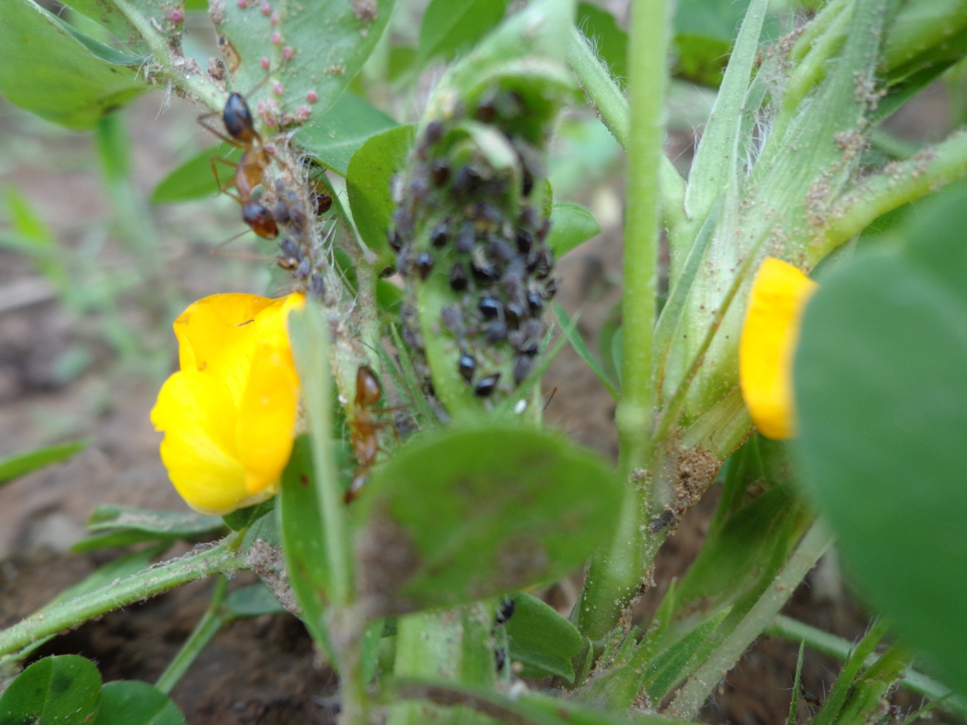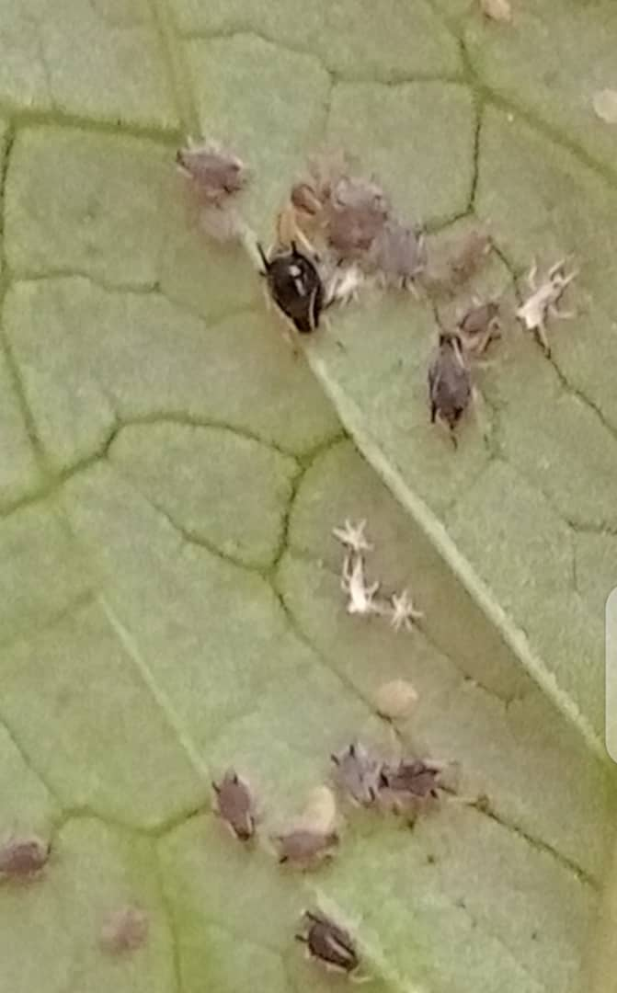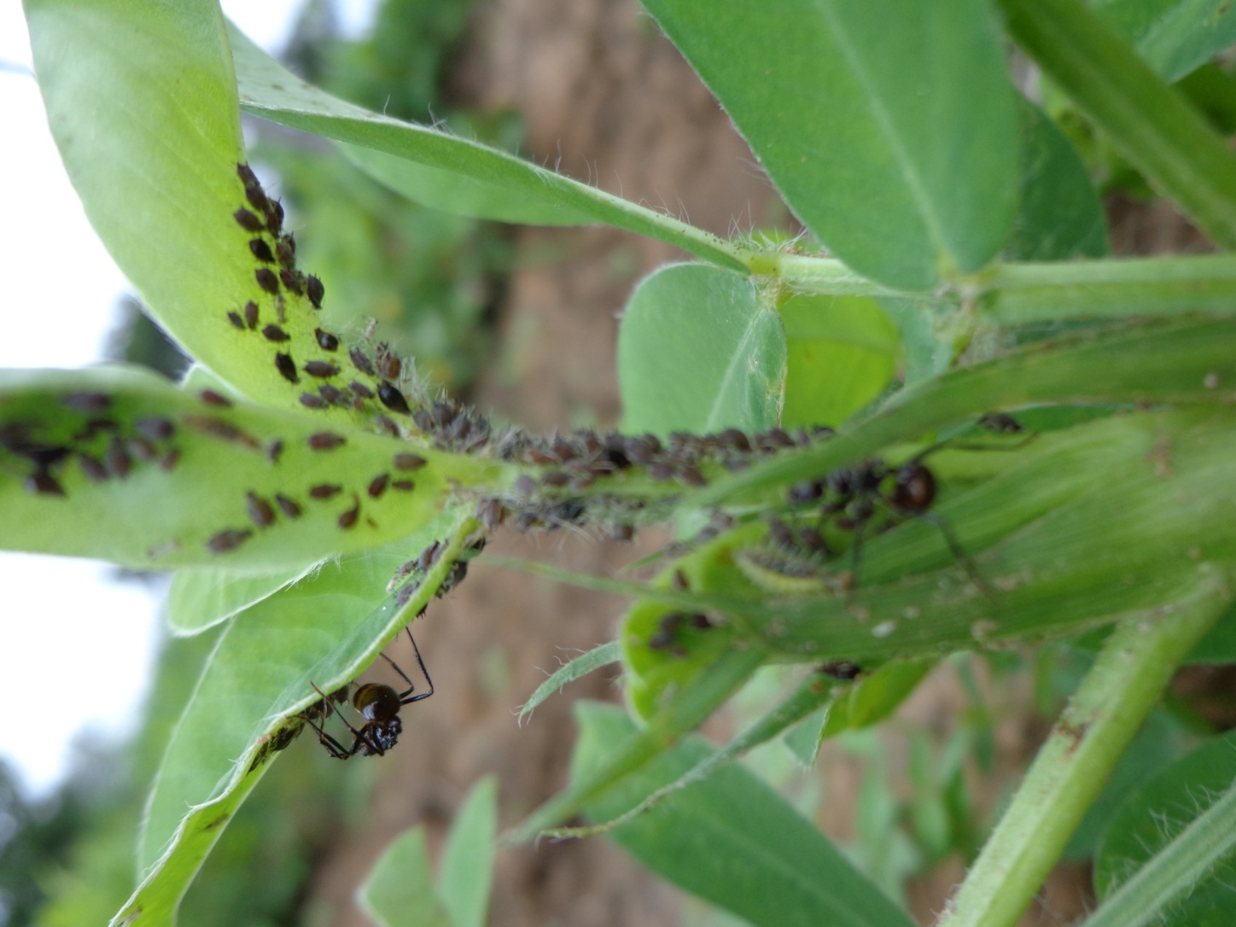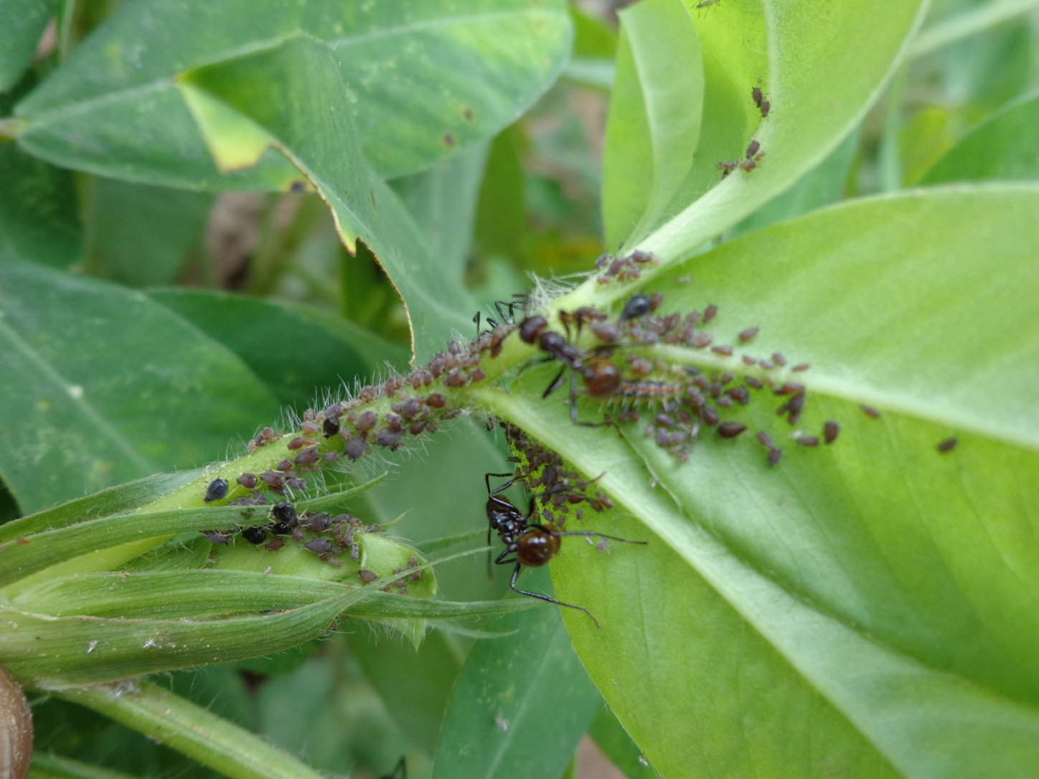
Plate 1: Adult Aphids (Aphis craccivora Koch) Plate 2: clustered of adults aphids and nymphs
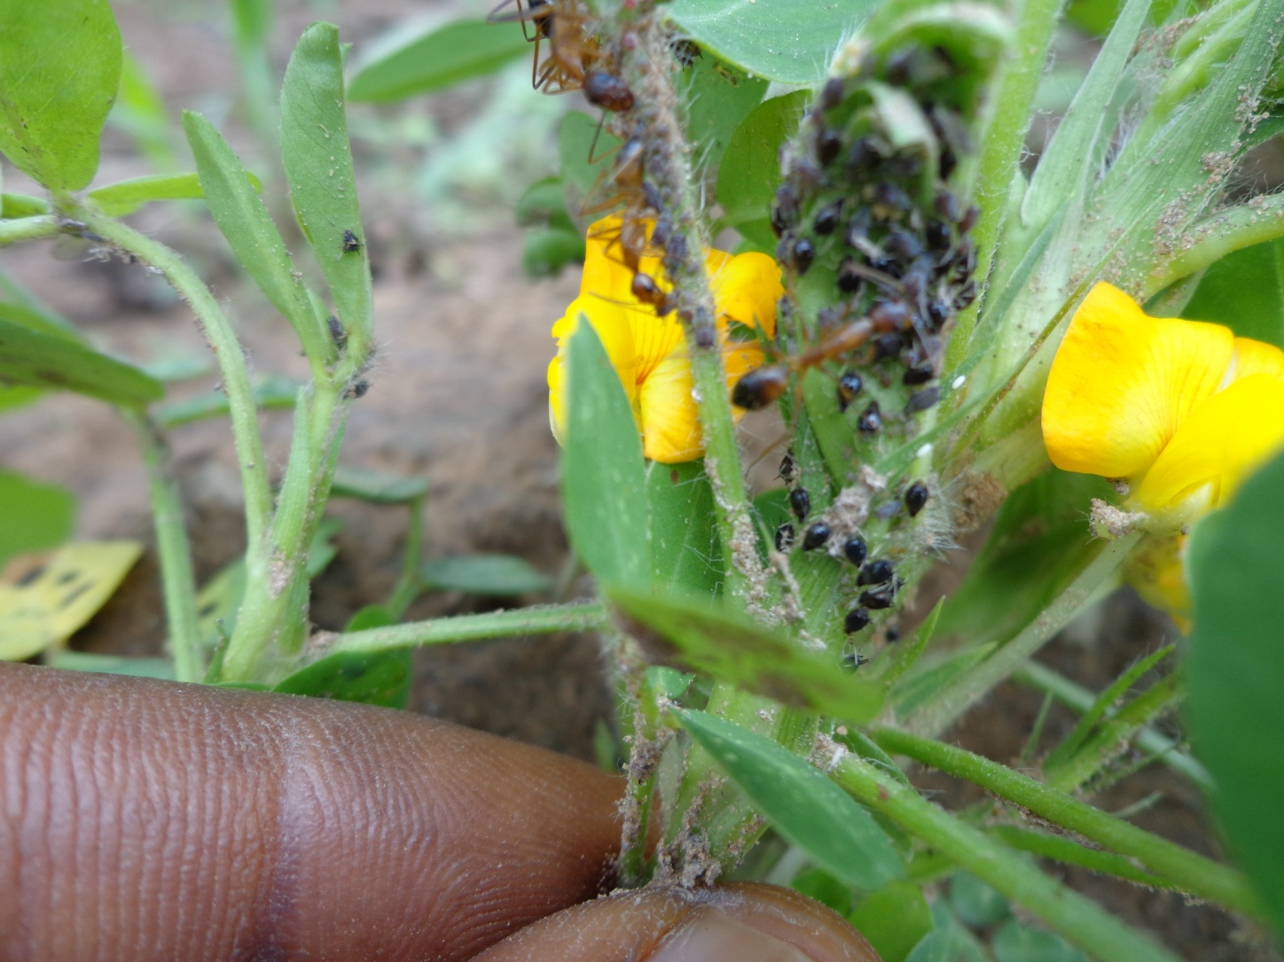
Plate 3: Predatory Red ants (Messor sp) feeding on immature Aphid nymphs

DISCUSSION
The magnitude of economic destruction and yield loss caused by rosette virus on groundnut production in different agro-ecological regions of Nigeria has become a major source of concern. Groundnut rosette virus infection can result to viable less pods and complete crop loss in a severe case. There are annual worldwide economic losses of approximately US$220 billion due to plant diseases (Sarvary et al, 2019). Strategically use of sowing dates judiciously in the management of the aphid’s transmitted viral disease could be economically feasible option. Certainly, the recommendation of sowing date for one particular agro-ecological location may not be applicable to other agro-ecological regions due to variation in patterns of their annual rain fall and other prevailing climatic factors
The findings from this study revealed that genetic traits of the varieties and different sowing dates in presence of prevailing environmental factors significantly influenced the incidence and severity of rosette virus disease in the two cropping seasons. In 2015 cropping season there was no significantly (P ≤ 0.05) variation on incidence of rosette virus among the groundnut varieties from 20 to 40 DAS; whereas in 2016 cropping season there was significant variation among the groundnut varieties on disease incidence from 20 to 30 DAS only, Gyadan-Madawa recorded significantly higher disease incidence compared to Samnut-14 from 20 to 30 DAS respectively. Genetic make-up of different groundnut varieties can result to variation in levels of disease incidences. Loise et al. (2024) also reported that different groundnut varieties exhibit varying resistance to diseases and adverse climatic conditions. Findings from this research has revealed that sowing dates significantly influenced the incidence of groundnut rosette virus from 20 to 30 DAS and from 20 to 40 DAS in 2015 and 2016 cropping seasons respectively. Those plants sown in Mid-May and Late-May in 2015 had lower disease incidence compared to those plants sown in Mid-June and Late-June with higher disease incidence from 20 to 30 DAS respectively. The same disease incidence trend was observed from 20 to 40 DAS in 2016, but on the other hand the incidence of rosette virus in 2015 was slightly higher than that of 2016 cropping season from 20 to 30 DAS. The lower disease incidences among those groundnut plants sown in Mid-May and Late-May could be attributed to washed-down and reduction by dead of the virus vectors during the prolonged onset of rainfall in that periods; whereas the intermittent short dry-spell and warm weather condition favored rapid multiplication of the aphids and transmission of the virus particles resulting to higher disease incidences among those groundnut plants grown later in Mid-June and Late-June. This finding corroborate with the report that late sown groundnut plants showed high disease incidence and pest infestation leading to lower yield (Adipala et al. 2000), and also revealed field information that showed that aphids populations increased rapidly on the groundnut crop from 31 to 45 days from emergency but reduced rapidly as the plants matured (Influential-Point, 2025)
The severity of rosette virus as influenced by sowing dates was higher on Gyadan-Madawa compared to Samnut-14 at 40, 60 and 70 DAS in 2015 and from 40 to 70 DAS in 2016 cropping seasons respectively. In both season, those groundnut plants sown in Mid-May and Late-May showed lower severity of the disease compared to those sown in Mid-June and Late-June with higher disease severity from 40 to 70 DAS respectively. Similarly, the severity of the disease in 2015 was also slightly higher compared to that of 2016 cropping season from 40 to 70 DAS. It was also observed that those groundnut plants sown in Late-June recorded moderately lower severity of the virus disease compared to those sown in Mid-June from 40 to 70 DAS in both seasons. This scenario could be due to decline in aphid’s population caused by different voracious predatory ants and adverse weather conditions which probably did not favor further transmission of virus particles in those groundnut plants grown in Late-June of both season. This finding is in agreement with Saghafipour et al. (2020) who stated that moderate humidity levels support whitefly population growth and facilitate efficient virus transmission while high rainfall may reduce vector activity by washing away insects from plant surfaces. This has a negative impact on the survival of the insect vector and in turn affects the incidence and severity of viral diseases (Montes and Pagan, 2022).
In both cropping seasons, chlorotic leaf, bunchy-top-head, leaf curling, stunted growth and malformed bunchy small size pods disease symptoms were observed on severely infected groundnut plants (Plate: 4-8). Abderrahmane and Laleen (2012) reported slow growth rate, browning, wilting, loss of vigor, damage and discolor, defoliation of the leaves plant death and poor yield return as a result of viral infection. Higher 1000 seeds weight was observed on Gyadan-Madawa in 2015 cropping season and also those groundnut plant sown in Mid-May and in Late-May exhibited higher seeds weight than their counterparts in 2016 cropping season. Hence, sowing dates has significant effects on crop growth and disease development in any agricultural production system (Richard et al, 2018).
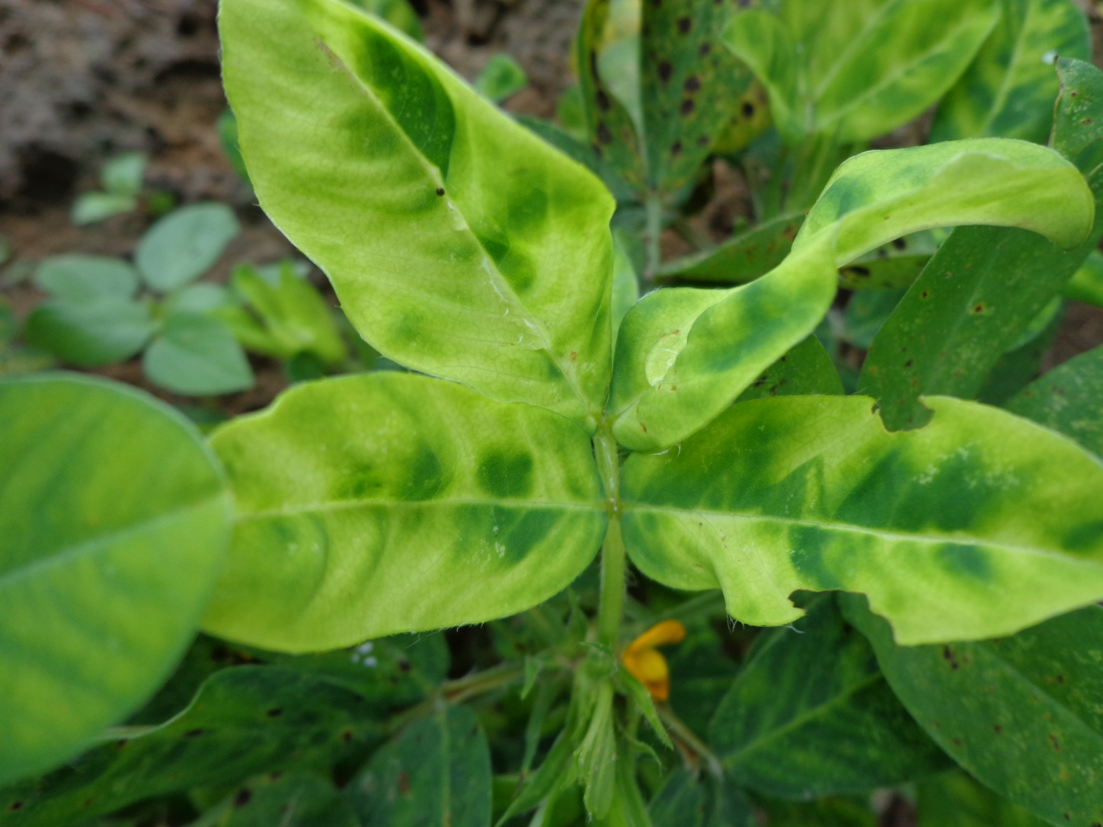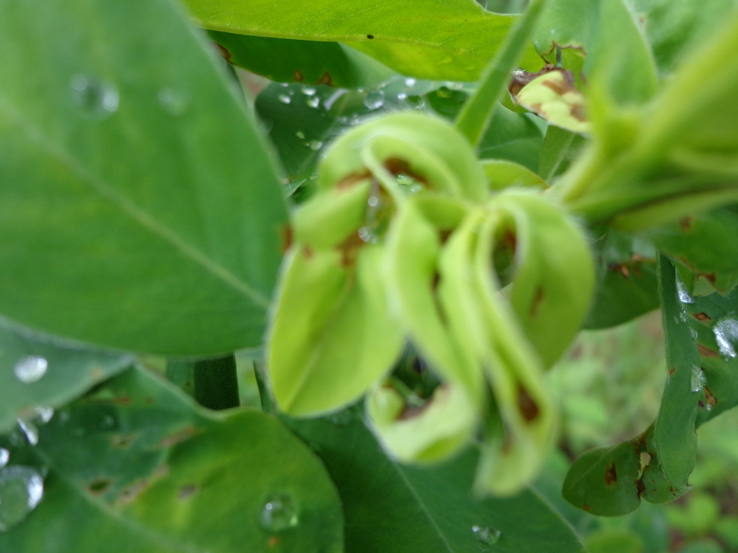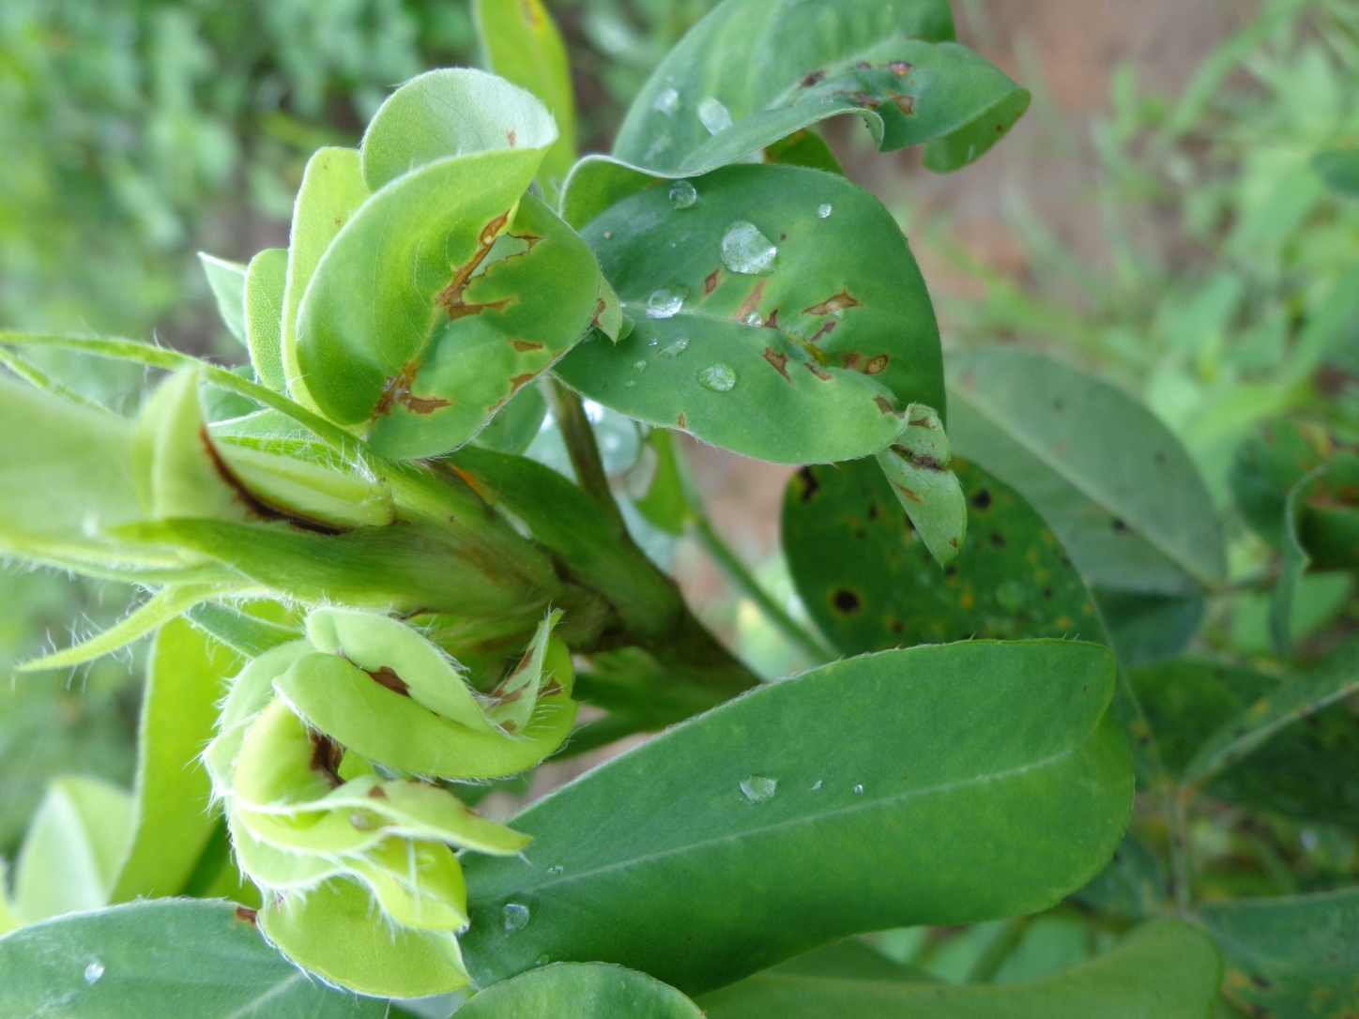
Plate 4: Chlorotic leaf disease symptom Plate 5: Bunchy-top-head disease symptom
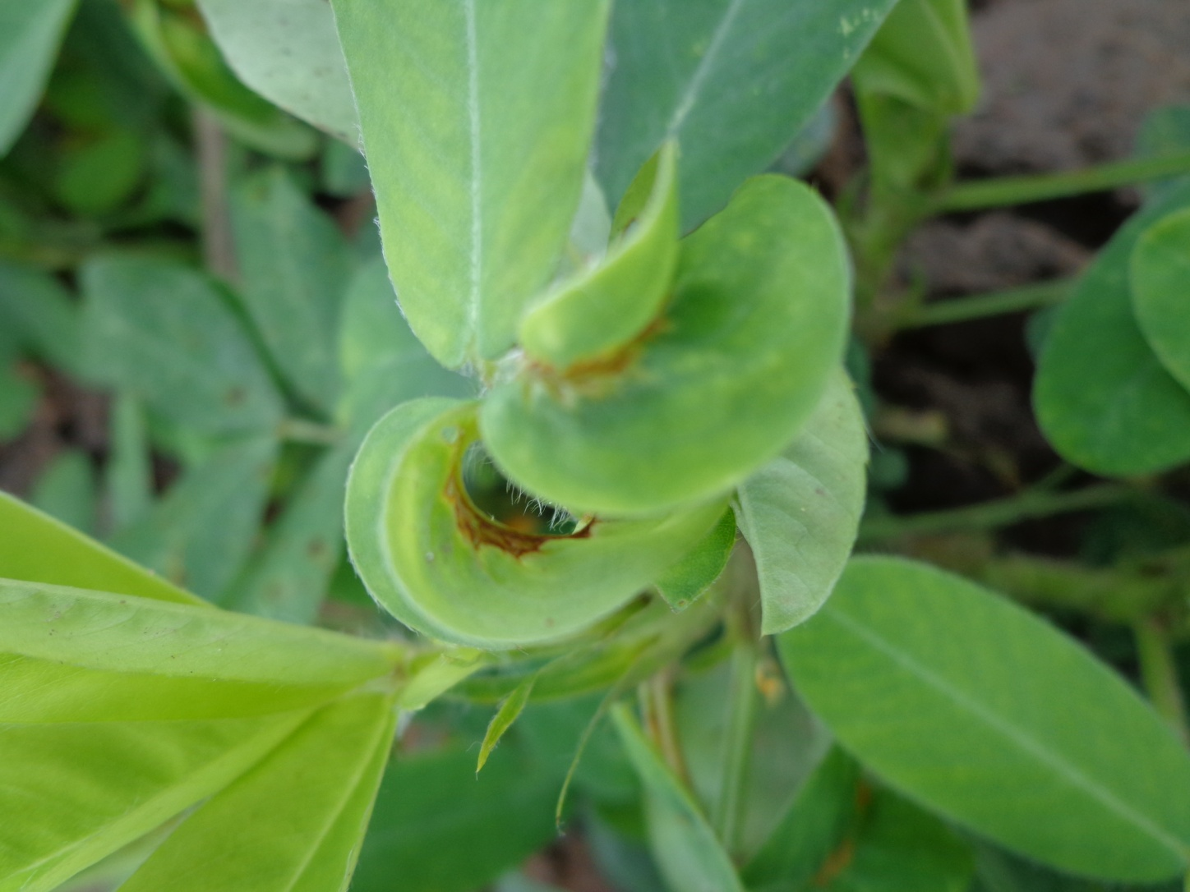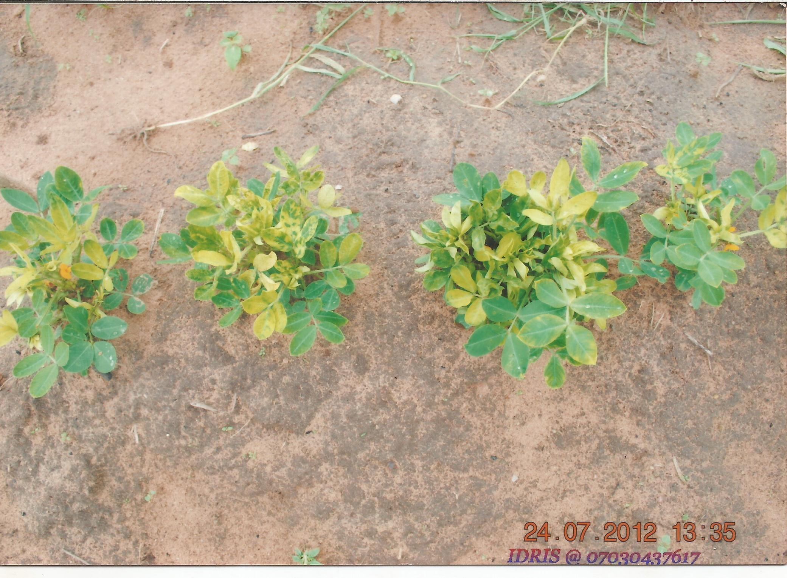
Plate 6: Leaf curling disease symptom Plate 7: Stunted growth disease symptom
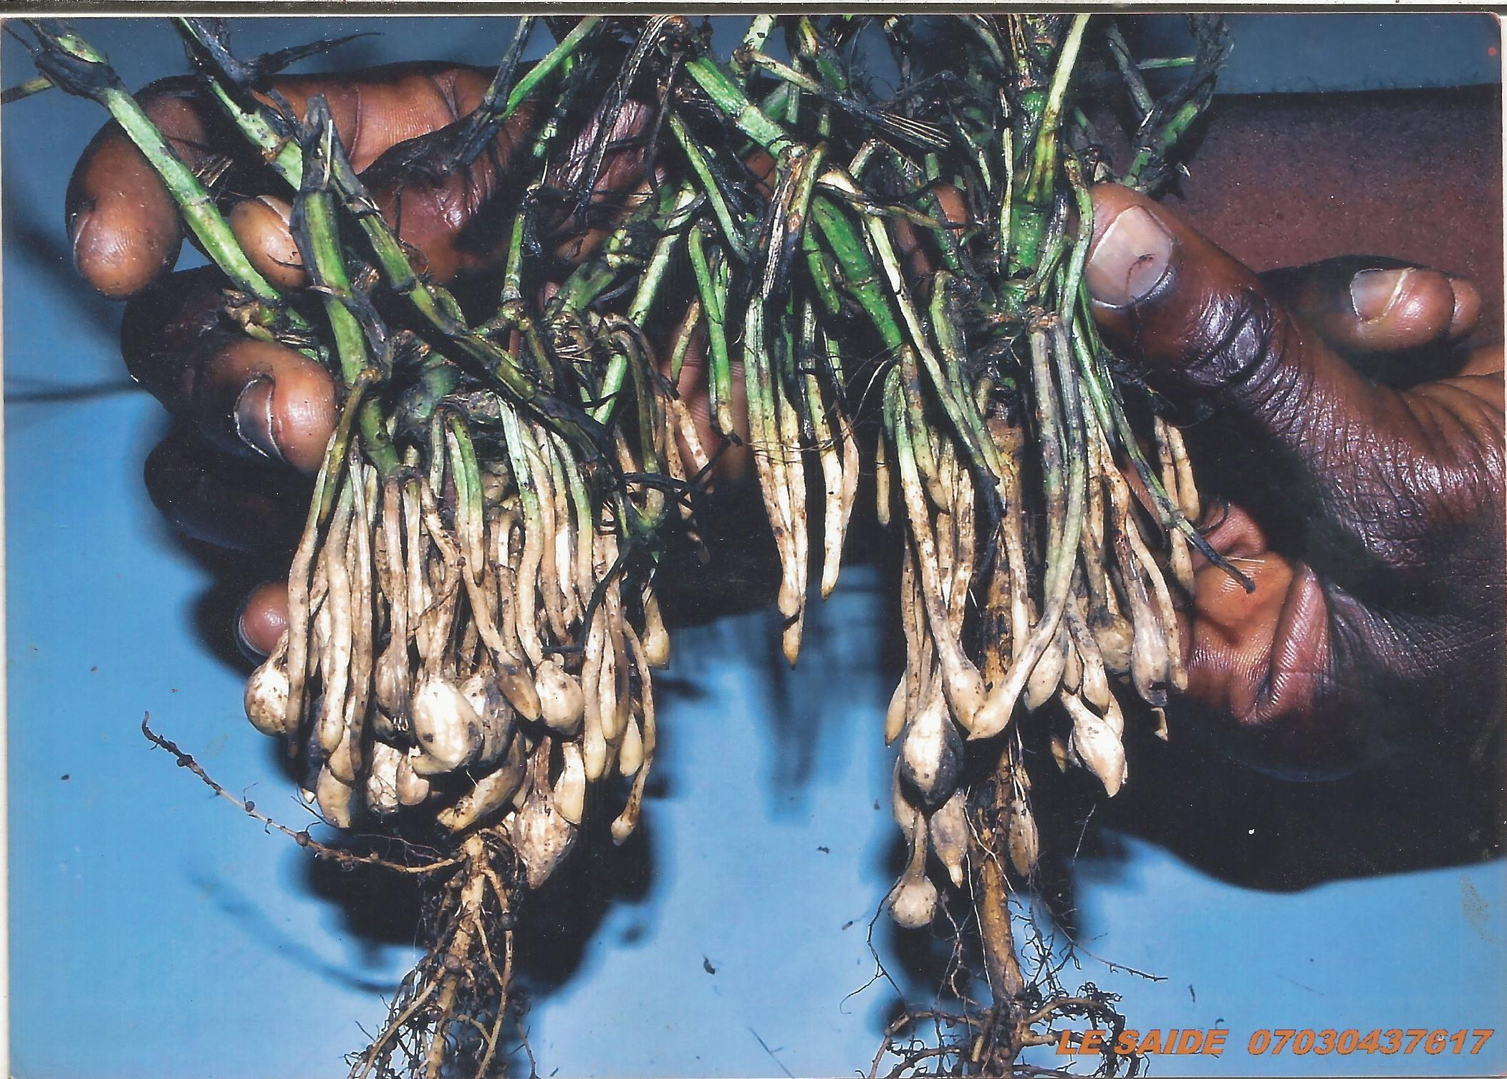
Plate 8: Malformed bunchy small size pods disease symptoms

- CONCLUSION
The results of the assessments have proved that early sowing significantly lowered the groundnut rosette virus disease incidence and severity and also improved grain yield. These findings validated the recommendation of early sowing dates in Mid-May to Late-June at the on-set of rainfall. Hence, it can serve as a good alternative instead of the use of exorbitant pesticides in the management of the disease because its cost-effective and environmental friendliness. The local Gyadan-Madawa variety exhibited higher 1000 grain yield weight (gm.) but requires genetic improvement against the disease. Lastly, study on synergistic effects of the occurrence of Red ant (Messor sp.) and other predatory ants against the aphids as bio-control is advocated.
REFERENCES
Abderrahmane, K. and Laleen, E. (2012). Insecticide Effect of Plant Extracts on Aphids of Watermelon. Journal of Biology, Agriculture and Healthcare, 2(5):20-28.
Adipala, E.C., Mukankusi, S., Kyamanywa, G., Epier, H. W. Wilson, H. (2000). Integrated Management of Groundnut Insect Pests and Diseases. Seventh Annual Report of Integrated Pest Management Collaborative Res. Support Program, Uganda (Abstract)
Almeida, R. P. P., Wayadande, A., & Shelly, T. (2005). Insect Transmission of Plant Pathogens. Annals of the Entomological Society of America, 98(6), 755. https://doi.org/10.1603/0013-8746(2005)098[0755:ITOPP]2.0.CO;2
Blackman, R. L., & Eastop, V. F. (2007). Taxonomic issues. In H. F. van Emden & R. Harrington (Eds.), Aphids as crop pests (pp. 1-29). CAB International. https://doi.org/10.1079/9780851998190.0001
Beasley, J. P., Jr. (Ed.). (2013). 2013 Peanut Production Update. The University of Georgia, Cooperative Extension. https://edis.ifas.ufl.edu/pdf/AG/AG33100.pdf
Dixon, A. F. G. (2012). Aphid ecology and optimization approach. Springer. https://doi.org/10.1007/978-94-011-5868-8
Haciwa, H. C. and Kannaiyan, J. (1990). Prevalence of groundnut diseases and extent of yield losses due to leaf spot diseases in Zambia. Proceedings of the 4th Regional Groundnut Workshop for Southern Africa, 19-23 March. pp 93 97. Arusha, Tanzania. ICRISAT, Patancheru, India.21.
Henry, S. H., Bosch, F. X., & Bowers, J. C. (2002). Aflatoxin, hepatitis and worldwide liver cancer risks. In J. W. DeVries, M. W. Trucksess, & L. S. Jackson (Eds.), Mycotoxins and food safety (pp. 229-233). Kluwer Academic/Plenum Publishers. https://doi.org/10.1007/978-1-4615-0629-4_24
Influential Points (2025). Aphis craccivora- Cowpea aphid, Groundnut aphid: Identification and Distribution, Biology and Ecology (Retrieved from Influential Points. com on 24/11/2025)
Njoki, L., Okoth, S., Wachira, P., Ouko, A., & Kagot, V. (2024). Status of Groundnut Production in Africa: A Review From 2012 to 2022. Journal of Agricultural Science, 16(10), 50. https://doi.org/10.5539/jas.v16n10p50
Montes, N., & Pagán, I. (2022). Challenges and opportunities for plant viruses under a climate change scenario. Advances in Virus Research, 114, 1-66. https://doi.org/10.1016/bs.aivir.2022.08.001
Naidu, R. A., Kimmins, F. M., Deom, C. M., Subrahmanyam, P., Chiyembekeza, A. J., & van der Merwe, P. J. A. (1999). Groundnut Rossette: A Virus Disease Affecting Groundnut Production in Sub-Saharan Africa. Plant Disease, 83(8), 700–709. https://doi.org/10.1094/PDIS.1999.83.8.700
Neil, H., Kevin, B. and Nigel, D .C. (2004). A colour Handbook of BIOLOGICAL CONTROL IN PLANT PROTECTION. Manson Publishing Ltd, 73 Corringham Road, London NW11 7DL.,UK. Pp.1-126
Nigam, S. N., Prasada Rao, R. D. V. J., Bhatnagar-Mathur, P., & Sharma, K. K. (2012). Genetic management of virus diseases in peanut. In J. Janick (Ed.), Plant Breeding Reviews, Volume 36 (pp. 293-356). John Wiley & Sons, Inc. https://doi.org/10.1002/9781118358566.ch4
Obeng-Ofori, D. (2007). Pests of grain legumes. In: Obeng-Ofori, D (ed.) Major pests of food and selected fruit and industrial crop in West Africa. The city publishers Ltd, Accra, 81-112pp
Obi, I. U. (2002). Statistical Methods of detecting differences between treatment means and research methodology issues in laboratory and field experiment 2nd edition AP express Publishers, Nsukka 117pp
Okello, D. K., Biruma, M., & Deom, C. M. (2010). Overview of groundnuts research in Uganda: Past, present and future. African Journal of Biotechnology, 9(39), 6448-6459. https://doi.org/10.5897/AJB09.013
Omoigui, L. O., Ekeuro, G. C., Kamara, A. Y., Bello, L. L., Timko, M. P., & Ogunwolu, G. O. (2017). Identification of new sources of resistance to Striga gesnerioides in cowpea Vigna unguiculata accessions. Genetic Resources and Crop Evolution, 64(5), 901-911. https://doi.org/10.1007/s10722-016-0410-3
Ouédraogo, A. P., Batieno, B. J., Traore, F., Tignegre, J. B., Huynh, B. L., Roberts, P. A., Close, T., & Ouédraogo, J. T. (2018). Screening of cowpea (Vigna unguiculata (L.) Walp.) lines for resistance to three Aphids (Aphis craccivora Koch) strains in Burkina Faso. African Journal of Agricultural Research, 13(29), 1487-1495. https://doi.org/10.5897/AJAR2018.13241
Reddy, D.V.R.(1984). Groundnut Rosette. In: compendium of peanut diseases (Porter, D.M, Smith, D.H and Rodrigues-Kabana eds), St. Paul, M.N, USA, American Psychopathological Society, pp.49-50.
Bwala, R. I., Ekhuemelo, C., & Zacharia, D. (2019). Influence of Variety and Sowing Date on Incidence of Cercospora Leaf Spots Disease of Groundnut (Arachis hypogaea L.) in Makurdi, Benue State of Nigeria. Asian Journal of Research in Crop Science, 2(4), 1-10. https://doi.org/10.9734/AJRCS/2018/45080
Saghafipour, A., Zahraei-Ramazani, A., Vatandoost, H., Asadollahi, A., Fouladi-Fard, R., Hamta, A., & Hasanwand, A. (2020). Relationship between some environmental and climatic factors on outbreak of whiteflies, the human annoying insects. J. Arthropod Borne Dis., 14(1), 78-87. https://doi.org/10.18502/jad.v14i1.2714
Savary, S., Willocquet, L., Pethybridge, S. J., Esker, P. D., McRoberts, N., & Nelson, A. D. (2019). The global burden of pathogens and pests on major food crops. Nature Ecology & Evolution, 3(3), 430-439. https://doi.org/10.1038/s41559-018-0793-y
Soffan, A., & Aldawood, A. S. (2014). Biology and demographic growth parameters of cowpea aphid (Aphis craccivora) on faba bean (Vicia faba) cultivars. Journal of Insect Science, 14(1), 120. https://doi.org/10.1093/jis/14.1.120
Sudini, H., Upadhyaya, H. D., Reddy, S. V., Mangala, U. N., Rathore, A., & Kumar, K. V. K. (2015). Resistance to late leaf spot and rust diseases in ICRISAT's mini core collection of peanut (Arachis hypogaea L.). Australasian Plant Pathology, 44(5), 557-566. https://doi.org/10.1007/s13313-015-0368-1
Tabe-ojong. M.P.J., Smale, M., Jamora, N. and Azevedo, V.(2022). Genebanks and market participation: evidence from groundnut farmers in Malawi. CABI Agriculture and Bioscience. 3(1),12 https://doi.org/10.1186/s43170-022 0082-x
Tejashwini, N. K., Ambika, D. S., Basavarajappa, M. P., Venkateshalu, Rudresh, D. L., & Shashikanth, E. (2019). Occurrence of cucumber mosaic virus (CMV) in cucumber (Cucumis sativus L.) growing areas of Bagalkot, District of Karnataka. Research Journal of Plant Pathology, 2(1), 10. https://www.imedpub.com/abstract/occurrence-of-cucumber-mosaic-virus-cmv-in-cucumber-cucumis-sativus-l-growing-areas-of-bagalkot-district-of-karnataka-23800.html
Thresh, J.M. (2003). Control of Plant Virus Diseases in Sub-Saharan Africa. The Possibility and Feasibility of an Integrated Approach. African Crop Science 11:199-223
Togola, A., Boukar, O., Belko, N., Chamarthi, S. K., Fatokun, C., Tamo, M., & Oigiangbe, N. (2017). Host plant resistance to insect pests of cowpea (Vigna unguiculata L. Walp.): achievements and future prospects. Euphytica, 213(239), 1-16. https://doi.org/10.1007/s10681-017-2030-1
Training Manual for Trainers, (2011). Pathosystem Groundnut (Arachis hypogaea L.). Cercospora spp and Environment in DR-Congo: Overtime Interrelations: In: K.K.C. Nkongola, Ed; contribution to food security and malnutrition in DR-Congo, Laurentian Press, 2010.pp. 195-221.
Waliyar, F., Kumar, P. L., Ntare, B. R., Monyo, E., Nigam, S. N., Reddy, A. S., Osiru, M., & Diallo, A. T. (2007). A century of research on groundnut rosette disease and its management. Information Bulletin no. 75. International Crops Research Institute for the Semi-Arid Tropics. https://oar.icrisat.org/5609/2/IB_75.pdf

