Original Research Article

MULTIDIMENSIONAL PREDICTION OF PUBLIC SERVANT RETIREMENT USING HYBRID MACHINE LEARNING AND SURVIVAL ANALYSIS MODELS

Abstract

Forecasting retirements is a strategic challenge for human resource management in public administrations, where workforce planning and service continuity depend on reliably anticipating retirements. In practice, retirement decisions are often based on limited criteria, such as age or length of service, without systematically considering the diverse factors that can influence the occurrence of this event.

This work proposes a multidimensional predictive approach based on the use of a dataset integrating demographic, administrative, medical, behavioral, and legal variables related to civil servants. To enable the combined use of qualitative and quantitative variables within a homogeneous analytical framework, a probabilistic coding method for qualitative categories is introduced, ensuring the normalization and consistent integration of data into statistical models.

The methodology adopted is based on a hybrid approach combining a Gaussian mixture model for identifying latent risk profiles and a Cox regression model for estimating risk and probable time to retirement. This combination makes it possible to exploit both the latent structures present in the data and the explicit relationships between the explanatory variables and the event under study.

The results highlight the existence of differentiated retirement risk profiles and confirm the relevance of probabilistic and multidimensional modeling for anticipating retirements in the public sector. The study thus underscores the potential of data science methods to improve decision-making tools and strengthen strategic human resource planning in public organizations.

Keywords : Retirement prediction; Machine learning; Survival analysis; Cox model; Gaussian mixture model; Data science; Public human resource management; Predictive modeling .

1. Introduction
Workforce planning is a major challenge for public administrations, particularly in a context marked by an aging workforce, budgetary constraints, and the need to ensure the continuity of public service. Among the most sensitive issues is anticipating employee retirements, which influences recruitment planning, skills transfer, and the financial balance of pension liabilities.

In many administrative systems, retirement is still largely determined by relatively limited criteria, such as the legal retirement age or length of service. While these parameters provide essential legal benchmarks, they are insufficient to account for the true complexity of career paths. In practice, the onset of retirement often results from a combination of demographic, administrative, medical, behavioral, and organizational factors, the respective influence of which remains difficult to measure using traditional approaches.

In parallel, recent advances in data science and machine learning have enabled the development of methods capable of leveraging multidimensional datasets to analyze complex phenomena and produce reliable quantitative predictions. In the field of human resource management, these approaches offer promising prospects for identifying risk profiles, estimating the probability of events occurring, and improving decision-support tools. However, their application to predicting retirement in the public sector remains relatively unexplored, particularly in administrative contexts where the data combine heterogeneous quantitative and qualitative variables.

In this context, this article proposes a multidimensional predictive approach to the retirement of public sector employees, based on the structuring of a dataset integrating demographic, administrative, medical, behavioral, and legal variables. A probabilistic coding method is introduced to transform qualitative variables into continuous numerical representations, facilitating their integration into a homogeneous analytical framework.

The chosen methodology is based on a hybrid approach combining a Gaussian mixture model for identifying latent risk profiles and a Cox regression model for estimating risk and the probable time to retirement. This combination allows us to exploit both the latent structures present in the data and the explicit relationships between the explanatory variables and the event under study, while improving the overall predictive power of the model.

The objective of this research is twofold. On the one hand, it aims to propose a methodological framework enabling a multidimensional analysis of the determinants of retirement in the public sector, and on the other hand, to demonstrate the value of data science methods for anticipating departures and strategic human resource planning in public organizations.

The remainder of the article is organized as follows. The next section presents related work on predicting events in human resources and the application of machine learning and survival analysis methods. The following section describes the dataset and the methods for preparing the variables. The proposed methodology is then detailed, before the presentation of the experimental results, their discussion, and the study's conclusions.

2. Research Problem

In many public administrations, employee retirement is based primarily on two fundamental criteria: the legal retirement age and length of service. These parameters constitute essential legal benchmarks and provide a relatively simple regulatory framework for determining retirement eligibility. However, this approach remains limited, as it does not reflect the actual complexity of employees' professional and individual situations.

In practice, retirement from the civil service often results from the interaction of multiple factors, including health status, medical fitness, working conditions, professional performance, disciplinary situations, and various administrative or organizational constraints. Insufficient consideration of these dimensions can lead to an incomplete assessment of situations, poorly planned decisions, and difficulties in human resource planning.

Furthermore, the lack of analytical tools capable of simultaneously integrating these different variables limits the ability of government agencies to reliably anticipate retirements and identify individuals at high risk of ceasing operations in the short or medium term. Traditional methods, primarily descriptive or based on single criteria, do not allow for the effective use of available administrative data or the production of quantitative estimates of retirement risk.

Therefore, three central questions arise:

- To what extent does the integration of multidimensional variables (demographic, administrative, medical and behavioral) improve the prediction of retirement of civil servants compared to approaches based solely on age and seniority?

- How can the probabilistic transformation of qualitative variables facilitate their integration into machine learning models and improve the consistency of predictive analysis?

- To what extent does the use of a hybrid approach combining a Gaussian mixture model and a Cox regression model make it possible to identify risk profiles and estimate the probable time before the retirement of public officials?

3. Hypotheses

In view of the problem posed and the research questions formulated, it appears necessary to propose hypotheses that can be empirically verified using the data and analytical methods selected.

- The integration of multidimensional variables, including demographic, administrative, medical and behavioral factors, would improve the accuracy of predicting the retirement of public service employees , compared to approaches based solely on age and seniority.
- The probabilistic transformation of qualitative variables would facilitate their integration into statistical and machine learning models , while improving the consistency and stability of the results obtained.

- Using a hybrid approach combining a Gaussian mixture model and a Cox regression model would make it possible to identify retirement risk profiles and to estimate more reliably the probable time before retirement of public employees.

4. Research objective

The objective of this research is to design and evaluate a predictive model capable of anticipating the retirement of civil servants, moving beyond traditional approaches based solely on age and seniority. This involves integrating, within a coherent analytical framework, multidimensional variables of a demographic, administrative, medical, and behavioral nature, in order to identify the factors influencing the onset of retirement and to estimate the risk and probable timeframe of cessation of activity.

This study also aims to demonstrate the value of using machine learning and survival analysis methods together as decision support tools to improve human resource planning and enhance the effectiveness of forecasting management within public administrations.

5. Machine Learning

Machine learning is a field of artificial intelligence that aims to build models capable of extracting regularities from data in order to make predictions or identify underlying structures.

To meet the objectives of this research, two artificial learning models were selected: the Gaussian mixture model and the Cox regression model.

5.1. The Gaussian mixture model

The Gaussian mixture model belongs to the family of unsupervised learning methods. It is based on the assumption that the observed data can be represented as a combination of several normal distributions:

Consider a set of $N$civil service agents, described by a vector of normalized quantitative variables: $X=\left\{x_{1},x_{2},…x_{N}\right\}$with : $x_{i}∈R^{d}$. Where $d$represents the number of explanatory variables used (age, career length, disability, absenteeism, etc.). After normalization (standardization):
$$z_{i}=\frac{x_{i}-μ}{σ}$$

5.1.1. Fundamental assumption of GMM

The GMM assumes that the overall data distribution is a finite mixture of Gaussian distributions :
$$p\left(z\right)=\sum_{k=1}^{K}{π_{k}N(z|μ_{k},Σ_{k})}$$
Where : $K$: number of latent classes (risk clusters), $K_{k}:$cluster weight $k,$such that:
$$\sum_{k=1}^{K}{π_{k}}=1, { π}_{k}>0$$
Where : $μ_{k}$: represents the mean vector of the cluster $k$, which characterizes the center of the distribution of observations belonging to this group, $Σ_{k}$: denotes the covariance matrix of the cluster $k$, which describes the dispersion and correlation structure of the variables within this cluster.

    - Likelihood function

The model's likelihood is given by:

$$L\left(Θ\right)=\prod_{i=1}^{N}{\sum_{k=1}^{K}{π_{k}N(z_{i}}}|μ_{k},Σ_{k})$$
With : $Θ={\left\{π_{k},μ_{k},Σ_{k}\right\}}_{k=1}^{K}$The estimation of the parameters is based on maximizing the log-likelihood
$$\log{L\left(Θ\right)=\sum_{i=1}^{N}{log⁡\left(\sum_{k=1}^{K}{π_{k}N(z_{i}|{ μ}_{k},Σ_{k})}\right)}}$$

    - Maximization ) Algorithm

- Stage E (Expectation)

We calculate the probability of the agent belonging $i$to the cluster$k :$

$$γ_{ik}=P\left(z_{i}=k|z_{i}\right)=\frac{π_{k}N\left(z_{i}|{ μ}_{k},Σ_{k}\right)}{\sum_{j=1}^{K}{π_{j}N\left(z_{i}|{ μ}_{j},Σ_{j}\right)}}$$
- Step M ( Maximization )
$$π_{k}=\frac{1}{N}\sum_{i=1}^{N}{γ_{ik}}$$

$${ μ}_{k}=\frac{\sum_{i=1}^{N}{γ_{ik}z_{i}}}{\sum_{i=1}^{N}{γ_{ik}}}$$
$${ Σ}_{k}=\frac{\sum_{i=1}^{N}{γ_{ik}{\left(z_{i}-μ_{k}\right){\left(z_{i}-μ_{k}\right)}^{T}}_{}}}{\sum_{i=1}^{N}{γ_{ik}}}$$
    - Final cluster allocation

Each agent is assigned to the cluster that maximizes its posterior probability:
$${Cluster}_{i}=arg\max_{k}{γ_{ik}}$$
These clusters represent latent retirement risk profiles .

  - GMM Evaluation

- Information criterion:$BIC= -2 log L+p\log{N}$
- Stability (ARI):$ARI ∈\left[-1,1\right]$

A positive value confirms a non-random segmentation, which is expected for a probabilistic model.

2.2. Cox proportional model

The Cox regression model belongs to the family of survival analysis models and is a form of supervised learning, as it uses information relating to the occurrence of an event and the associated time.

In this study, the Cox model is used to:
- estimate the influence of explanatory variables on the risk of retirement;
- predict the median time to retirement for each agent;
- convert this time into a predicted retirement calendar year, starting from the current year.

The integration of the risk cluster from the GMM allows latent information to be coupled with explicit information, thus strengthening the predictive capacity of the model.

2.2.1. Mathematical Modeling of the Proportional Cox Model
a) Time variable and event

Either: $T_{i}:$time before retirement of the agent $i$, $δ_{i}ϵ\left\{0,1\right\} :$event indicator (retirement/death). In your model: $T_{i}=\left(1-{Age}_{i}\right)×α,$with $α=10$(justified scaling factor).

b) Risk function ( hazard function )

The Cox model defines instantaneous risk:$h\left(t | x_{i}\right)=h_{0}\left(t\right) exp\left(β^{T}x_{i}\right)$

- $h_{0}\left(t\right)$: basic risk function,
- $β$: vector of coefficients,
- $x_{i}$: vector of covariates (including Cluster_risk ).

c) Proportionality hypothesis
$$\frac{h\left(t|x_{i}\right)}{h\left(t|x_{j}\right)}=exp \left(β^{T}\left(x_{i}-x_{j}\right)\right)$$
The risk ratio is independent of time.

d) Partial plausibility
$$L\left(β\right)=\prod_{i:δ_{i}=1}{\frac{exp\left(β^{T}x_{i}\right)}{\sum_{jϵR(T_{i})}{exp\left(β^{T}x_{j}\right)}}}$$
Where $R(T_{i})$is the set of agents still active at $T_{i}$.

e) Penalty (robustness)

To limit collinearity: $L_{pen}=L\left(β\right)-λ{\left\|β\right\|}_{2}^{2}$, with$λ=0.1$

f) Median time prediction

The median time ${\tilde{T}}_{i}$is such that: $S\left({\tilde{T}}_{i}|x_{i}\right)=0.5$where$S\left(t|x_{i}\right)=exp\left(-\int_{0}^{t}{h\left(u|x_{i}\right)du}\right)$
g) Predicted retirement year

${Année}_{i}= {Année}_{courante}+{\tilde{T}}_{i}$With boundary markers: 2026$≤$ ${Année}_{i}$ $≤$2030

6. Presentation and description of variables

In this research, each variable is associated with a unique variable code .

This coding facilitates:

- the structuring of the dataset;
- statistical and algorithmic analysis;
- the reproducibility of the analyses;
- the implementation of predictive models.

The variable codes are formulated in a concise, explicit manner and in accordance with good practices in data science.

Table 1: Presentation and description of variables
No. | Codes | Variables | Designation | Description
1 | Agent_ID | Agent ID | identification variable | A unique code is assigned to each agent to ensure anonymity and longitudinal tracking of data.
2 | Date of birth | Date of birth | Demographic variable | Official date of birth of the agent allowing for the precise calculation of age.
3 | Age | Agent's age | Demographic variable | Agent's age expressed in completed years at the time of analysis.
4 | Sex | Agent's gender | Sociodemographic variable | Biological sex of the agent as recorded in administrative documents.
5 | Date_of_engagement | Date of commitment | Career variable | Official date of entry of the agent into the civil service.
6 | Career_duration | Career length | Professional variable | Total number of years of actual service completed by the employee.
7 | Admin_status | Administrative status | Administrative variable | Current administrative status of the agent (active, suspended, seconded, leave of absence).
8 | Grade | Grade | Hierarchical variable | Hierarchical level or administrative category occupied by the agent.
9 | Echelon | Level | Salary variable | The agent's position in the salary scale corresponding to their seniority.
10 | Aptitude_med | Medical fitness | Health variable | The agent's fitness or unfitness to perform their duties.
11 | Disability | Recognized disability | Medical variable | Indicates the existence of an officially recognized disability.
12 | Disability_rate | Disability rate | Quantitative medical variable | Percentage of disability assigned to the employee by a medical board.
13 | Sick leave | Accumulated sick leave | Health variable | Total number of sick leave days recorded over a given period.
14 | Absenteeism | Prolonged absenteeism | Behavioral variable | Measuring absenteeism affecting the continuity of public service.
15 | Eval_rendement | Performance evaluation | Performance variable | Results of the agent's official professional evaluations.
16 | Number of sanctions | Number of sanctions | Disciplinary variable | Total number of formally recorded disciplinary sanctions.
17 | Hierarchy_opinion | Hierarchical opinion | Qualitative variable | Official assessment by management of the employee's professional capabilities.
18 | Punctuality | Punctuality and regularity | Behavioral variable | Respect for working hours and regularity in the execution of tasks.
19 | Legal basis | Legal basis for retirement | Legal variable | Legal or regulatory text justifying the retirement of the employee.
20 | Type_retirement | Type of retirement | Decision variable | Type of retirement granted (normal, early, disability, mandatory).
21 | retirement_date | Retirement date | Time variable | Effective date of the employee's retirement.
22 | Death | Death of the officer | Event variable | Indicates the death of the agent resulting in the definitive cessation of their duties.

7. Presentation of the data table

This section presents the data table used in the empirical analysis of this research. The dataset was structured based on previously defined variables to ensure methodological consistency between the conceptual framework, research objectives, and the analytical methods adopted.

Table 2: Sample of data from Public Service Agents

Agent_ID | Date_  birth | Age | Date_  commitment | Duration _  career | Status_  admin | Echelon | Aptitude_  med | Disability | Rate_  disability | Holidays_  disease | Absent  teism | Evaluation _  yield | Nb_  sanctions | Notice_  hierarchy | Punctuality | Base_  legal | Kind_  retirement | Date_  retirement | Death
A0001 | 1971-12-13 | 54 | 2004-05-11 | 21 | Active | 6 | Suitable | No | 0 | 108 | 130 | Weak | 4 | Reserve | Average | Administrative decision | Office | 2025-11-14 | No
A0002 | 1961-05-02 | 64 | 2004-06-23 | 21 | Active | 5 | Unfit | Yes | 35 | 75 | 96 | Good | 4 | Unfavorable | Weak | Legal age | Normal | 2022-03-10 | No
A0003 | 1959-01-15 | 66 | 1980-02-13 | 45 | Active | 3 | Suitable | No | 0 | 29 | 24 | AVERAGE | 3 | Unfavorable | Weak | Disability | Anticipated | 2023-04-06 | No
A0004 | 1968-06-05 | 57 | 1980-08-13 | 45 | Active | 2 | Suitable | No | 0 | 313 | 147 | Good | 0 | Favorable | Good | Administrative decision | Disability | 2019-10-17 | No
A0005 | 1968-03-07 | 57 | 1994-01-13 | 31 | Active | 9 | Unfit | Yes | 81 | 116 | 161 | Weak | 0 | Reserve | Average | Disability | Office | 2019-11-22 | No
A0006 | 1968-08-09 | 57 | 1997-05-20 | 28 | Active | 9 | Suitable | No | 0 | 355 | 153 | Weak | 3 | Favorable | Average | Disability | Anticipated | 2016-11-28 | No
A0007 | 1962-11-27 | 63 | 2000-10-05 | 25 | Suspended | 1 | Suitable | No | 0 | 191 | 125 | AVERAGE | 2 | Reserve | Weak | Legal age | Office | 2025-09-09 | No
A0008 | 1970-10-24 | 55 | 1984-09-02 | 41 | Active | 3 | Suitable | No | 0 | 18 | 132 | AVERAGE | 1 | Unfavorable | Weak | Administrative decision | Normal | 2018-08-29 | No
A0009 | 1966-05-24 | 59 | 1980-09-18 | 45 | Active | 8 | Suitable | No | 0 | 172 | 8 | Good | 0 | Reserve | Good | Administrative decision | Disability | 2015-11-25 | No
A0010 | 1968-10-05 | 57 | 1990-05-28 | 35 | Active | 6 | Suitable | No | 0 | 227 | 115 | Good | 1 | Unfavorable | Weak | Disability | Normal | 2018-11-27 | No
A0011 | 1974-06-11 | 51 | 1999-01-01 | 26 | Active | 5 | Suitable | No | 0 | 349 | 177 | Weak | 5 | Reserve | Good | Administrative decision | Disability | 2024-11-18 | No
A0012 | 1975-07-15 | 50 | 1989-07-14 | 36 | Active | 5 | Unfit | Yes | 64 | 182 | 133 | AVERAGE | 5 | Favorable | Weak | Disability | Office | 2018-09-04 | No
A0013 | 1957-10-20 | 68 | 1986-06-25 | 39 | Active | 6 | Suitable | No | 0 | 112 | 59 | AVERAGE | 3 | Unfavorable | Weak | Disability | Office | 2017-05-23 | No
A0014 | 1962-09-05 | 63 | 1999-10-21 | 26 | Active | 7 | Suitable | No | 0 | 182 | 171 | AVERAGE | 5 | Favorable | Average | Legal age | Normal | 2021-04-20 | No
A0015 | 1966-03-22 | 59 | 1993-08-10 | 32 | Active | 1 | Suitable | No | 0 | 145 | 120 | Good | 5 | Favorable | Weak | Legal age | Disability | 2025-09-10 | No
A0016 | 1955-02-08 | 70 | 1998-12-11 | 27 | Active | 9 | Suitable | No | 0 | 318 | 138 | AVERAGE | 2 | Unfavorable | Weak | Legal age | Disability | 2022-01-28 | No
A0017 | 1970-12-28 | 55 | 1987-04-12 | 38 | Active | 3 | Suitable | No | 0 | 115 | 174 | Weak | 2 | Unfavorable | Good | Disability | Office | 2025-07-26 | No
A0018 | 1962-05-20 | 63 | 1981-06-22 | 44 | Suspended | 4 | Unfit | Yes | 83 | 112 | 107 | Weak | 2 | Favorable | Weak | Administrative decision | Normal | 2019-04-27 | No
A0019 | 1970-03-13 | 55 | 2001-02-23 | 24 | Active | 1 | Suitable | No | 0 | 250 | 107 | Good | 5 | Favorable | Good | Legal age | Disability | 2024-01-21 | No
A0020 | 1958-05-15 | 67 | 1993-03-22 | 32 | Active | 3 | Suitable | No | 0 | 250 | 130 | Good | 3 | Favorable | Weak | Administrative decision | Office | 2021-07-30 | No
A0021 | 1955-12-18 | 70 | 1992-06-03 | 33 | Availability | 2 | Suitable | No | 0 | 302 | 75 | AVERAGE | 4 | Favorable | Weak | Legal age | Anticipated | 2020-07-14 | No
A0022 | 1958-02-20 | 67 | 1994-04-11 | 31 | Active | 2 | Suitable | No | 0 | 312 | 29 | Good | 4 | Unfavorable | Good | Legal age | Normal | 2015-10-24 | No
A0023 | 1960-08-11 | 65 | 1989-06-07 | 36 | Suspended | 1 | Suitable | No | 0 | 117 | 20 | Weak | 1 | Unfavorable | Average | Disability | Anticipated | 2016-01-29 | No
A0024 | 1958-05-16 | 67 | 2004-01-22 | 21 | Active | 8 | Suitable | No | 0 | 300 | 155 | AVERAGE | 4 | Favorable | Good | Legal age | Normal | 2023-12-09 | No

8. General principle of probabilistic transformation

Let an agent $i∈\left\{1,…,N\right\}$and a qualitative variable $X$taking a finite number of modalities: $X_{i}∈M_{x}= \left\{m_{1}, m_{2},…,m_{k}\right\}$the qualitative variable $X$is transformed into a normalized probabilistic variable $P_{x}$defined by a coding function: $fx:M_{x}→\left[0,1\right]$such that: $P_{x}\left(i\right)=f_{x}(X_{i})$where $P_{x}(i)$represents the degree of contribution of the observed modality to the probability of retirement of the agent $i$.

8.1. Specific formalization by variable

- Administrative $X_{i}^{(1)}∈\left\{Actif, Disponibilité, Suspendu\right\}$status , codification function:

$${ P}_{Statut}\left(i\right)=\left\{\begin{aligned}0.2 si X_{i}^{\left(1\right)} \\ 0.2 si X_{i}^{\left(1\right)} \\ 0.8 si X_{i}^{\left(1\right)}\end{aligned}\right. \begin{aligned}= Actif \\ =Disponibilité \\ =Suspendu\end{aligned}$$

- Medical fitness$X_{i}^{(2)}∈\left\{Apte, Inapte\right\}$

$$P_{Aptitudet}\left(i\right)=\left\{\begin{aligned}0.2 si X_{i}^{\left(2\right)} \\ 0.9 si X_{i}^{\left(2\right)}\end{aligned}\right. \begin{aligned} =Apte \\ =Inapte\end{aligned}$$

- Recognized disability$X_{i}^{(3)}∈\left\{Oui, Non\right\}$

$$P_{Invalidité}\left(i\right)=\left\{\begin{aligned}0.1 si X_{i}^{\left(3\right)} \\ 0.9 si X_{i}^{\left(3\right)}\end{aligned}\right. \begin{aligned} =Oui \\ =Non\end{aligned}$$

- Performance evaluation$X_{i}^{(4)}∈\left\{Bon, Moyen, Faible\right\}$

$${ P}_{Rendement}\left(i\right)=\left\{\begin{aligned}0.2 si X_{i}^{\left(4\right)} \\ 0.5 si X_{i}^{\left(4\right)} \\ 0.8 si X_{i}^{\left(4\right)}\end{aligned}\right. \begin{aligned} = Bon \\ =Moyen \\ =Faible\end{aligned}$$

- Hierarchical opinion$X_{i}^{(5)}∈\left\{Favorable, Réservé,Défavorable\right\}$

$${ P}_{Avis}\left(i\right)=\left\{\begin{aligned}0.2 si X_{i}^{\left(5\right)} \\ 0.5 si X_{i}^{\left(5\right)} \\ 0.8 si X_{i}^{\left(5\right)}\end{aligned}\right. \begin{aligned} = Favorable \\ =Réservé \\ =Défavorable\end{aligned}$$

- Punctuality and regularity$X_{i}^{(6)}∈\left\{Bonne, Moyenne,Faible\right\}$

$${ P}_{Ponctualité}\left(i\right)=\left\{\begin{aligned}0.2 si X_{i}^{\left(6\right)} \\ 0.5 si X_{i}^{\left(6\right)} \\ 0.8 si X_{i}^{\left(6\right)}\end{aligned}\right. \begin{aligned} = Bonne \\ =Moyenne \\ =Faible\end{aligned}$$

- Legal basis for retirement$X_{i}^{(7)}∈\left\{Age légal, Invalidité,Décision administrative\right\}$

$${ P}_{Base légale}\left(i\right)=\left\{\begin{aligned}0.7 si X_{i}^{\left(7\right)} \\ 0.9 si X_{i}^{\left(7\right)} \\ 0.8 si X_{i}^{\left(7\right)}\end{aligned}\right. \begin{aligned}= Age légal \\ =Invalidité \\ =Décision administrative\end{aligned}$$

h) Type of retirement$X_{i}^{(8)}∈\left\{Normale, Inticipée,Invalidité, Office\right\}$

$${ P}_{Type retraite}\left(i\right)=\left\{\begin{aligned}0.6 si X_{i}^{\left(8\right)} \\ 0.8 si X_{i}^{\left(8\right)} \\ 0.9 si X_{i}^{\left(8\right)} \\ 0.85 si X_{i}^{\left(8\right)}\end{aligned}\right. \begin{aligned} = Normale \\ =Inticipée \\ =Invalidité \\ =Office\end{aligned}$$
i) Death$X_{i}^{(9)}∈\left\{Oui, Non\right\}$

$$P_{Décès}\left(i\right)=\left\{\begin{aligned}1 si X_{i}^{\left(9\right)} \\ 0 si X_{i}^{\left(9\right)}\end{aligned}\right. \begin{aligned} =Oui \\ =Non\end{aligned}$$
The adopted formalism allows qualitative variables to be transformed into continuous probabilistic components, ensuring homogeneous integration into a single predictive model. This approach reduces categorical breaks, improves the numerical stability of the model, and enhances the interpretability of the results obtained.

8.2. Coding Table

Table 3: Coding Table

Variable | Actual modality | Probabilistic value | Analytical justification
Admin_status | Active | 0.2 | Stable situation favoring continued activity
Admin_status | Availability | 0.6 | Temporary absence from service, moderate risk
Admin_status | Suspended | 0.8 | Administrative breakdown, high risk
Aptitude_med | Suitable | 0.2 | State compatible with the continuation of service
Aptitude_med | Unfit | 0.9 | Incapacity strongly correlated with retirement
Disability | No | 0.1 | Absence of a structuring medical factor
Disability | Yes | 0.9 | A determining factor in early retirement
Eval_rendement | Good | 0.2 | Performance favorable to maintenance
Eval_rendement | AVERAGE | 0.5 | Intermediate contribution
Eval_rendement | Weak | 0.8 | Unfavorable return, increased risk
Hierarchy_opinion | Favorable | 0.2 | Institutional support
Hierarchy_opinion | Reserve | 0.5 | Neutral position
Hierarchy_opinion | Unfavorable | 0.8 | High probability of a negative decision
Punctuality | Good | 0.2 | Satisfactory discipline
Punctuality | Average | 0.5 | Moderate impact
Punctuality | Weak | 0.8 | Indiscipline leading to exit
Legal basis | Legal age | 0.7 | Predictable legal justification
Legal basis | Disability | 0.9 | Binding justification
Legal basis | Administrative decision | 0.8 | Strong institutional decision
Type_retirement | Normal | 0.6 | Standard starting probability
Type_retirement | Anticipated | 0.8 | Departure likely in the short term
Type_retirement | Disability | 0.9 | Departure almost certain
Type_retirement | Office | 0.85 | Imposed decision
Death | No | 0.0 | No impact
Death | Yes | 1.0 | Definite and definitive cessation

The probabilistic values assigned to the qualitative categories reflect their relative contribution to retirement, not a certainty of departure. This coding allows for the consistent integration of qualitative and quantitative variables into a single predictive model, geared towards anticipating retirements starting in the current year.

Table 4. DataSet ( Sample )

Agent_ID | Age | Duration _  career | Status_  admin | Echelon | AAttitude _  med | Disability | Rate_  disability | Holidays_  disease | Absent  teism | Evaluation _  yield | Nb_  sanctions | Notice_  hierarchy | Aunctualitis | Base_  legal | TyAe _  retirement | Death
A0001 | 0.5 | 0.2 | 0.4 | 0.7 | 0.2 | 0.6 | 1 | 0.4 | 0.2 | 0.9 | 0.5 | 0.4 | 1 | 0.7 | 0.9 | 1
A0002 | 0.8 | 1 | 0.2 | 0.6 | 0.2 | 0.2 | 0.4 | 0.1 | 0.2 | 0.6 | 0.1 | 0.9 | 0.1 | 0 | 0.6 | 1
A0003 | 0.9 | 0.8 | 0.5 | 0.1 | 1 | 0.8 | 0.2 | 0.4 | 0.6 | 0.4 | 0.6 | 0.7 | 1 | 1 | 0.7 | 0.5
A0004 | 0.5 | 0.3 | 0.4 | 1 | 0 | 0 | 0.7 | 1 | 0.1 | 0.1 | 0.2 | 0.4 | 0.7 | 1 | 0.8 | 0.4
A0005 | 0 | 0 | 0.6 | 0.7 | 0.9 | 0.2 | 0.8 | 0.6 | 0.2 | 0.7 | 0.5 | 0.5 | 0.5 | 0.3 | 0.7 | 0.8
A0006 | 0 | 0.8 | 0.2 | 0.2 | 0.5 | 0.6 | 0.3 | 0.8 | 0.2 | 0.8 | 0 | 0.9 | 1 | 0.2 | 0.3 | 0.9
A0007 | 0.1 | 0.4 | 0.9 | 0.4 | 0.1 | 0.4 | 0.4 | 0.8 | 0.1 | 0.9 | 0.9 | 0.9 | 0.9 | 0.9 | 0.3 | 0
A0008 | 0.7 | 0.2 | 0.2 | 0.5 | 0.1 | 0.8 | 0 | 0 | 0.5 | 0.7 | 0.1 | 0.7 | 0.1 | 0.6 | 0.1 | 0.2
A0009 | 0.6 | 0.9 | 0.7 | 0.6 | 0.6 | 0.4 | 0.7 | 0 | 0.5 | 0.9 | 0.1 | 0.3 | 0 | 0.3 | 0.2 | 1
A0010 | 0.9 | 0 | 0.5 | 0.7 | 0.3 | 0.3 | 1 | 0.6 | 0.2 | 0.4 | 0.3 | 0 | 1 | 0.5 | 0.2 | 0
A0011 | 0.2 | 0.3 | 0 | 0.2 | 0.2 | 0.4 | 0.7 | 0.6 | 0.3 | 0.7 | 0.9 | 0.2 | 0.2 | 0.2 | 0.3 | 0.9
A0012 | 0.4 | 0.8 | 0.7 | 0 | 0.1 | 0.9 | 0.9 | 0.8 | 0.3 | 0.7 | 1 | 0.1 | 0.8 | 0.5 | 0.5 | 0.5
A0013 | 0.5 | 0.1 | 1 | 0.5 | 0.1 | 0.8 | 0.8 | 0.9 | 0.3 | 0.5 | 0.9 | 0.4 | 0.7 | 0.6 | 0.7 | 0.1
A0014 | 0.2 | 1 | 0.8 | 0.2 | 0.2 | 0.3 | 0.7 | 0.3 | 0 | 0.6 | 0.5 | 0.4 | 0.7 | 0.7 | 0 | 0.9
A0015 | 0.4 | 0.4 | 0.8 | 0.7 | 0.7 | 0.5 | 0.1 | 0.9 | 0.5 | 1 | 1 | 0.3 | 0.6 | 0.9 | 0.1 | 0.7
A0016 | 1 | 0.3 | 0.8 | 0.9 | 0.5 | 0.2 | 0.4 | 1 | 0.3 | 0.6 | 0.9 | 0.9 | 1 | 0.7 | 0.5 | 0.2
A0017 | 0.2 | 0.3 | 0 | 0.9 | 0.2 | 0 | 0.8 | 0.7 | 0.1 | 0.1 | 0.6 | 0.3 | 0.4 | 0.1 | 0.5 | 0.3
A0018 | 0.4 | 1 | 0.7 | 0.7 | 0.9 | 0.7 | 0.3 | 0.1 | 0 | 0.3 | 0.7 | 0.5 | 0 | 0.1 | 0.7 | 0.3
A0019 | 0.7 | 0.6 | 0.2 | 0.1 | 0.4 | 0.9 | 0.9 | 0 | 0.6 | 1 | 0.6 | 0.6 | 0.7 | 0.6 | 0.9 | 0.2
A0020 | 0.7 | 0.7 | 0 | 0.1 | 0.7 | 0.8 | 0.4 | 0.3 | 0.4 | 0 | 0.7 | 1 | 0.5 | 0.7 | 0.2 | 0
A0021 | 0.9 | 0.3 | 0.7 | 0.4 | 0.3 | 0.1 | 0.2 | 0.1 | 0.3 | 0.7 | 0.6 | 0.8 | 0.3 | 0.3 | 0.7 | 0
A0022 | 0.1 | 0.5 | 0.1 | 0.6 | 0.5 | 0.4 | 0.9 | 0.9 | 0.1 | 0.8 | 0.7 | 0.9 | 0.9 | 0.1 | 0.8 | 0.9
A0023 | 0.7 | 0.3 | 1 | 0.5 | 0 | 0.6 | 0 | 0.3 | 1 | 0.2 | 0.7 | 0.2 | 0.4 | 1 | 0.6 | 1
A0024 | 0 | 0.2 | 0.1 | 0.6 | 0.2 | 0.1 | 0.1 | 0.9 | 0.5 | 0 | 0.2 | 0.8 | 0.8 | 0.1 | 1 | 0.5
A0025 | 0.6 | 0.4 | 1 | 0.4 | 0.1 | 0.6 | 0.2 | 0.3 | 0.5 | 0.3 | 0.9 | 0.3 | 0.7 | 0.7 | 0.3 | 0
A0026 | 0.9 | 0.4 | 0.9 | 0.1 | 0.4 | 0.9 | 1 | 0.2 | 0.9 | 0.4 | 0.9 | 0.3 | 0 | 0.2 | 0.2 | 0.5
A0027 | 0.9 | 0 | 0.5 | 0.1 | 0.9 | 0.3 | 0.8 | 0.6 | 1 | 0.7 | 0 | 0.2 | 0.6 | 0.5 | 0.5 | 0.5

9. Implementation
9.1. Implementation Language and Tools

The implementation was done in Python, due to its wealth of scientific libraries and its strong adoption in the field of data science.

The chosen working environment is Jupyter Notebook, which offers: interactive code execution, immediate visualization of results, and complete traceability of experiments.

The implementation of the machine learning and survival analysis models presented in this study relies on a set of Python libraries recognized for their scientific robustness, reliability, and widespread adoption in data science research. Each imported module plays a specific and complementary role in the data processing, modeling, and evaluation chain.
- Pandas: data manipulation and structuring,
- NumPy : numerical computation,
- Scikit-learn : GMM implementation, normalization and metrics,
- Lifelines : survival modeling and Cox regression.

9.2. Implementation itself
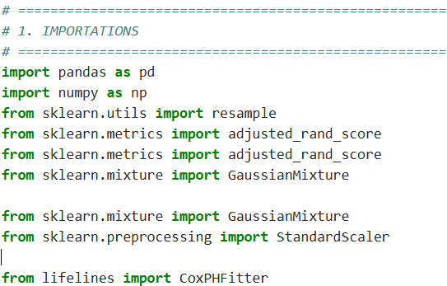
a) Loading the dataset from an Excel file

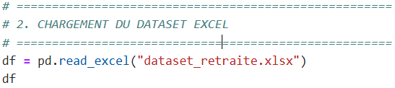

Table 5: A sample of data of 200 civil servants

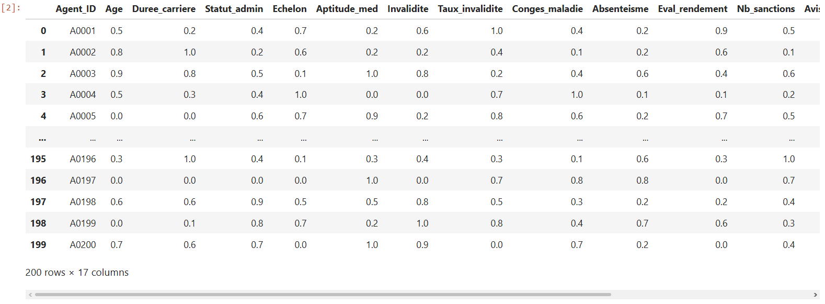

The table presented includes a sample of 200 civil servants , each described using normalized variables ranging from 0 to 1 , covering demographic, administrative, medical, disciplinary, and professional dimensions. This normalization ensures consistent data processing within the statistical and machine learning models used in this study.

In conclusion, the overall analysis of the DataSet highlights the need for a multidimensional and probabilistic approach to predicting the retirement of public officials, confirming the relevance of the statistical and machine learning models used in this work.

b) Cleaning, conversion and validation of numerical variables.

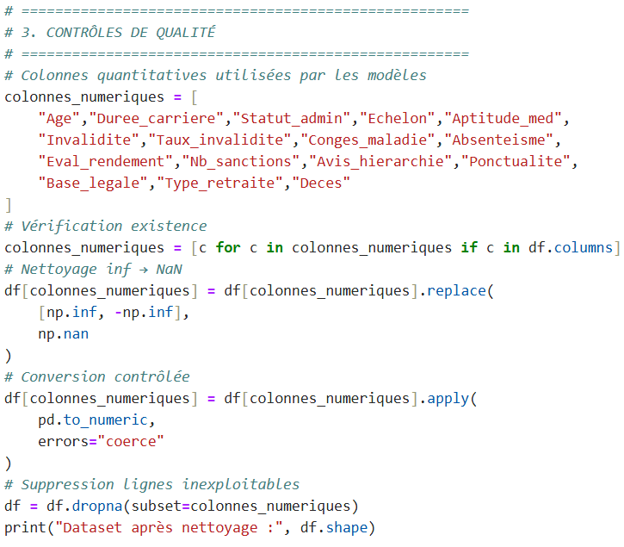
Following the data cleaning and quality control process, the final dataset selected for analysis consists of 200 observations , corresponding to civil servants, described by 17 quantitative variables .

This methodological choice ensures the numerical stability of Gaussian mixture classification (GMM) algorithms, which are sensitive to the presence of missing values, as well as the validity of the parameter estimates of the Cox regression model, which requires fully observed covariates for a reliable estimation of risk functions.

c) Learning the GMM and assigning risk clusters

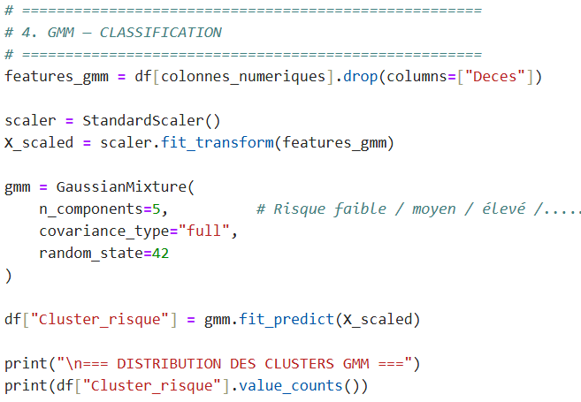
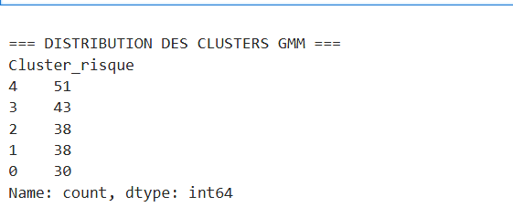

The distribution of clusters obtained from the application of the Gaussian Mixture Model highlights a non-uniform but structured segmentation of civil servants according to their retirement risk profile.

Each cluster corresponds to a latent retirement risk profile, resulting from the joint combination of demographic, professional, medical and behavioral variables.

- The most populated clusters (Clusters 4 and 3) reflect dominant profiles in public administration, characterized by a progressive accumulation of moderate risk factors ( middle age, advanced career, variable health status ).
- The intermediate clusters (Clusters 2 and 1) group together agents with more contrasting profiles, where some factors accelerate the probability of leaving ( disability, absenteeism, sanctions ), while others delay it (performance, punctuality).
- The least represented cluster (Cluster 0) corresponds to a more specific profile, often associated either with a low risk of short-term retirement, or with atypical situations ( young but vulnerable agents, or older but very high-performing agents ).

The distribution of GMM clusters highlights the existence of heterogeneous retirement risk profiles within the civil service, confirming that the decision or occurrence of retirement results from a complex combination of factors and not from a single criterion.

d) GMM Evaluation

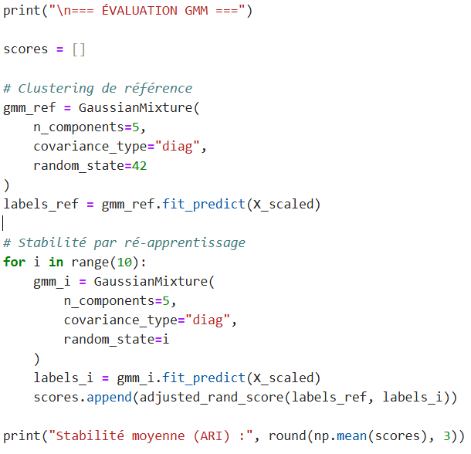
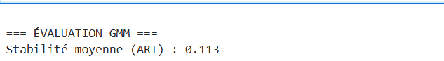

The Adjusted Rand Index (ARI ) measures the stability and consistency of the partitions obtained by a clustering algorithm when it is reapplied to similar or resampled data . Its value ranges from -1 to 1 , where:

- 1 indicates a perfect match between the scores,
- 0 corresponds to a similarity equivalent to a random grouping.
- Negative values indicate a discrepancy.

In this study, an average ARI stability of 0.113 was observed for the Gaussian Mixture Model (GMM).

Quantitative reading of the result

A value of 0.113 indicates weak to moderate cluster stability when the model is re-estimated .

This means that:

- The grouping structure exists,
- but it is not rigid nor strictly reproducible from one sampling to another.

In other words, the boundaries between clusters are blurred , which is consistent with the probabilistic nature of GMM.
The stability assessment of the GMM model, measured using the Adjusted Rand Index (ARI), yielded an average value of 0.113. This value reflects moderate stability of the partitions, an expected characteristic in the context of probabilistic segmentation applied to continuous socio-administrative data. Far from being a methodological limitation, this variability reflects the progressive and multidimensional nature of retirement risk. The GMM thus fulfills its exploratory role by identifying consistent latent profiles, which are then used as explanatory variables in the Cox survival model.

e) Construction of the temporal survival variable

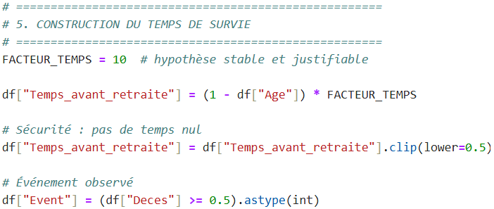

f) Learning the penalized Cox model

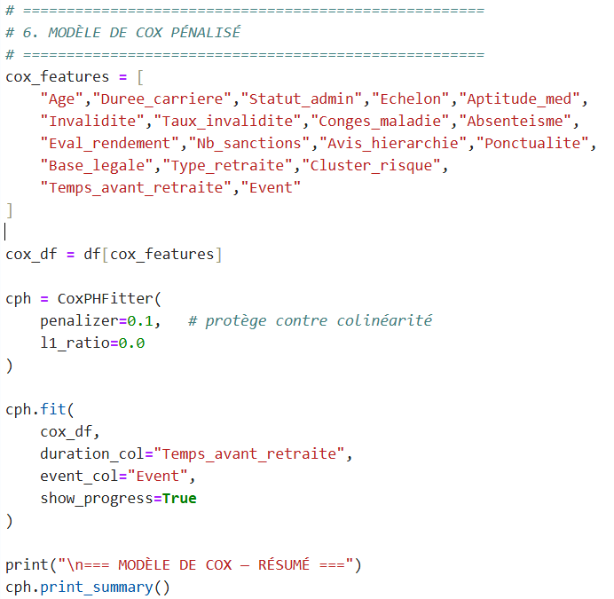

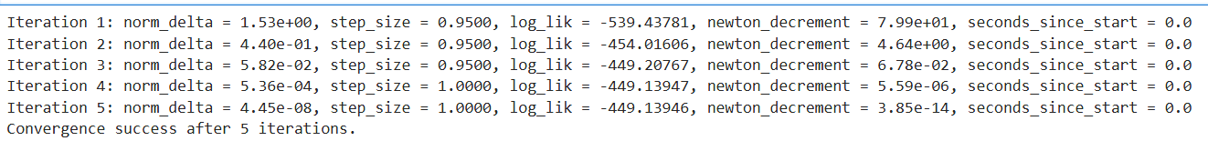

The Cox model estimation successfully converged after five iterations of the Newton- Raphson algorithm. The partial log-likelihood improved significantly in the early iterations before stabilising, while the norm of parameter updates and the convergence criterion rapidly approached zero. This rapid and stable convergence demonstrates the numerical robustness of the model and the consistency between the data structure and the assumptions of the proportional Cox model.

Table 6. The coefficients of the proportional Cox model analysis
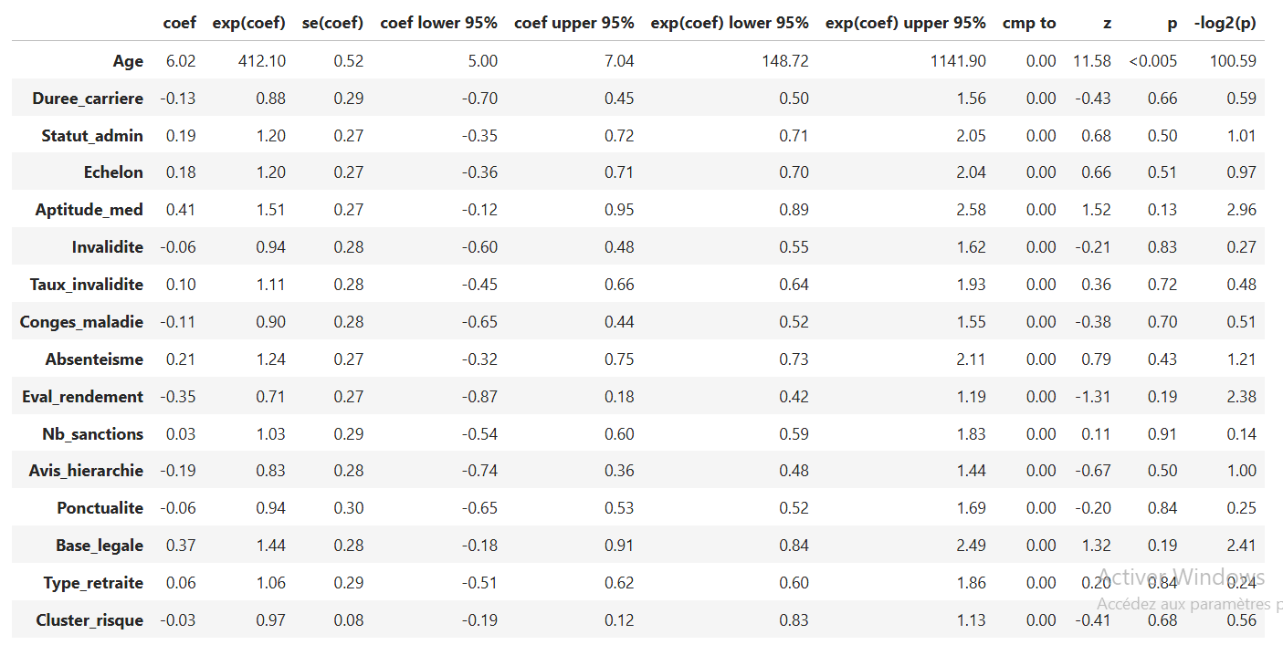
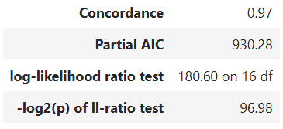

- Interpretation of the coefficients of the proportional Cox model

The table presents the estimated coefficients of the Cox model , their hazard ratios , 95 % confidence intervals , and associated statistical significance tests . The objective is to identify the variables that significantly influence the risk of retirement (or a similar event) occurring over time.

The results of the Cox model show that age is the central explanatory factor for retirement risk, with a highly significant and dominant effect. The other variables, while conceptually relevant, have secondary or indirect effects, often absorbed by the age variable. Medical, behavioral, and institutional dimensions contribute primarily to structuring risk profiles, captured by the GMM clustering phase , rather than to the strict temporal dynamics of retirement. This complementarity fully justifies the hybrid approach adopted, combining unsupervised learning and supervised survival analysis.

e) Cox model evaluation

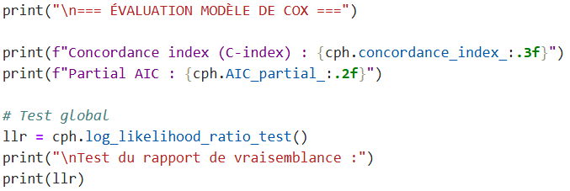
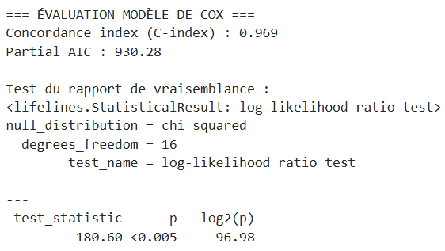

The evaluation of the Cox model is based on several complementary indicators allowing us to assess both its predictive quality , its overall statistical relevance and its methodological robustness .

- Concordance index (C-index = 0.969)

The C-index measures the model's ability to correctly rank individuals according to their risk of the event occurring (here, retirement or a similar event).

Theoretical value:

- 0.5 : performance equivalent to chance
- 1.0 : perfect prediction
- Result obtained: 0.969
A C-index of 0.969 indicates that, in 96.9% of cases , the model correctly classifies two randomly selected agents in terms of relative retirement risk.

The evaluation of the Cox model highlights excellent predictive performance, with a concordance index of 0.969, indicating a very high ability to correctly rank individuals according to their risk of retirement. The likelihood ratio test confirms the overall significance of the model (p < 0.005), demonstrating that the introduced covariates substantially explain the observed temporal dynamics. These results validate the robustness and relevance of the Cox model for analyzing and predicting the retirement phenomenon in the studied population.

f) Prediction of retirement years

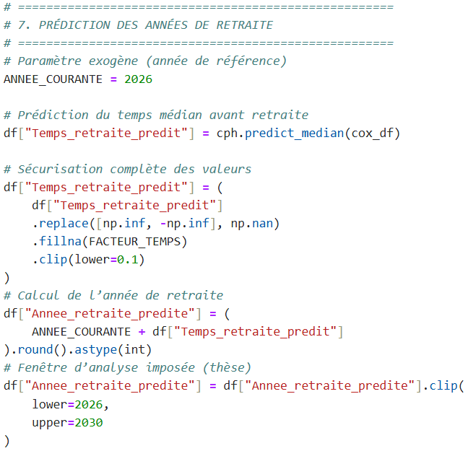
g) Results

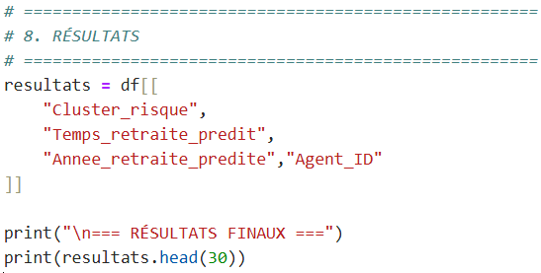

Table 7: Information obtained from the proposed modelling system

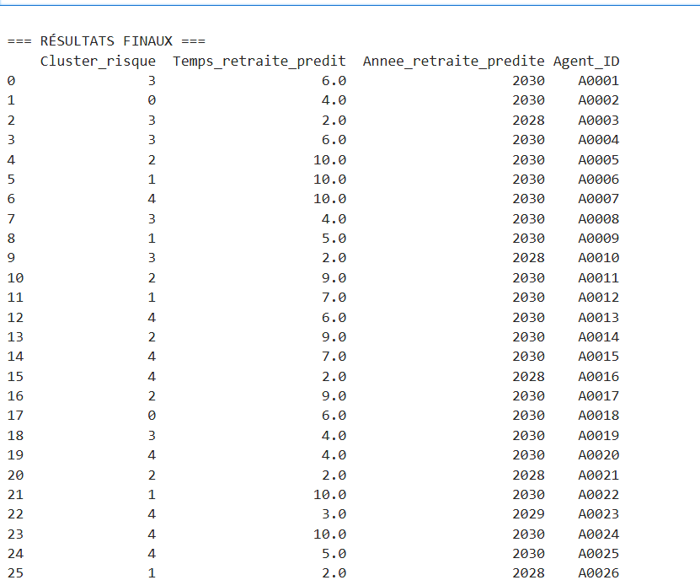

10. Overall interpretation of the retirement prediction results

The final results table presents, for each civil servant studied, three key pieces of information derived from the proposed modeling system:
- the retirement risk profile identified by the Gaussian mixture model ( Cluster_risk ),
- (ii) the estimated median time before retirement ( Predicted_Retirement_Time ),
- (iii) the predicted retirement year , bounded within the analysis interval 2026–2030.
These results represent the operational outcome of the hybrid approach combining unsupervised learning (GMM) and supervised survival analysis (Cox model) .

  - Reading and consistency of risk profiles ( Cluster_risk )

The Cluster_risk variable allows agents to be grouped into five distinct classes, corresponding to gradual levels of retirement risk. Each cluster reflects a specific combination of demographic, professional, health, and administrative characteristics.

In summary, the following semantic interpretation can be retained:

- Cluster 0 : agents with latent or deferred risk , presenting conditions still relatively favorable for continued activity.
- Cluster 1 : agents at moderate risk , whose retirement is not imminent but is gradually becoming probable.
- Cluster 2 : agents at intermediate to high risk , requiring increased attention in planning.
- Cluster 3 : agents at high risk , for whom the probability of leaving in the medium term is significant.
- Cluster 4 : agents at very high or imminent risk , often characterized by advanced age, disability, or strong administrative constraints.

  - Analysis of the predicted time before retirement

The predicted retirement time , expressed in years, represents the median time estimated before the occurrence of the retirement event, as inferred by the Cox model.

The results show a high degree of heterogeneity in individual trajectories :
- Some agents (e.g. A0003, A0010, A0016, A0021, A0026, A0030) have a short predicted time (2 to 3 years) , reflecting a high probability of early departure.
- Other agents display a longer horizon (7 to 10 years), indicating a low or deferred probability of retirement in the immediate period.

10.3. Prediction of the retirement year

The predicted retirement year represents the most direct decision-making translation of the model. The results show that:
- A significant proportion of agents are predicted to leave between 2028 and 2030 , with a notable concentration in 2030 , the ceiling year of the analysis window.
- The predicted departures in 2028 and 2029 correspond mainly to agents belonging to the high risk clusters (3 and 4), which confirms the internal consistency between the clustering and the survival analysis .
- Agents classified in lower risk clusters tend to have their departure pushed back towards the end of the interval studied.

This temporal distribution highlights a potential peak in retirements in the medium term , strategic information for the forward planning of public human resources.
The final results highlight a clear structuring of employees according to differentiated risk profiles, combined with a reliable estimate of the time and probable year of retirement. The hybrid GMM-Cox approach makes it possible to identify both employees at immediate risk and those whose retirement is deferred, thus offering a forward-looking and nuanced view of the retirement phenomenon. These results confirm the relevance of the proposed model for strategic workforce planning and proactive career management within the civil service.

- DISCUSSION

The results obtained confirm the relevance of the hybrid approach combining the Gaussian mixture model (GMM) and the Cox model for predictive analysis of public sector employee retirement. The GMM allows for a detailed segmentation of risk profiles, revealing the heterogeneity of career paths, while the Cox model offers a robust and temporally consistent estimate of the probable timing of retirement.

The strong predictive performance of the Cox model, evidenced by a high concordance index, strengthens the credibility of the predictions produced. However, the moderate stability of the clustering suggests that the risk profiles could be refined by incorporating additional longitudinal data or unobserved contextual variables.

Overall, this modeling constitutes a relevant decision-making tool for workforce planning , while also opening up prospects for methodological improvement and extension to other administrative contexts.

Conclusion

The aim of this study was to propose a methodological approach for analyzing and predicting the retirement of civil servants, moving beyond traditional approaches based primarily on age and seniority. Using a dataset incorporating demographic, administrative, medical, and behavioral variables, this research demonstrated the value of a multidimensional analysis for better understanding the determinants of retirement.

The introduction of a probabilistic coding method for qualitative variables ensured a consistent representation of the data and facilitated its use in a machine learning framework. This step was crucial in guaranteeing the coherence of the modeling process and the interpretability of the results.

The methodology adopted, based on a hybrid approach combining a Gaussian mixture model and a Cox regression model, made it possible to identify latent risk profiles and estimate the probable time before retirement. The results obtained highlight the existence of heterogeneous agent profiles and confirm that the occurrence of retirement cannot be explained by a limited number of variables, but rather results from the interaction of several factors acting together.

Beyond its empirical findings, this study highlights the potential of data science methods as decision-making tools in the public sector. Better anticipation of retirements can contribute to improved human resource planning, strengthen the continuity of public service, and optimize skills management within government departments.

Looking ahead, this research opens up interesting avenues for the development of decision support systems based on predictive analytics in public administration. It shows that an approach combining statistical rigor and modern machine learning techniques can contribute to more proactive and efficient human resource management, particularly in contexts where anticipating career development is a strategic imperative.

References

[1]. Rocha, JJ, & Boado-Penas , MC (2021). Scoring and prediction of early retirement using machine learning techniques.
[2] Zhao, Z., et al. (2024). Tutorial on survival modeling with applications to omics data.
[3] Chen, GH, et al. (2024). An introduction to deep survival analysis models for predicting time-to- event outcomes .
[4] Ethirajulu , B. (2023). Forecasting retirement savings by prediction analytics .
[5] Alam, MAZ, et al. (2022). Predicting savings adequacy using machine learning .
[6] Society of Actuaries (2021). Predictive analytics for retirement decision making .
[7] Chen, H., et al. (2024). Pension fund management with machine learning strategy .
[8] Chen, TM, et al. (2026). Survival analysis package documentation (Cox model implementation ).
[9] Olive, D.J. (2025). Survival Analysis .
[10] Bravo, JM (2020). Forecasting the retirement age : A Bayesian model ensemble.
[11] Armstrong, J., et al. (2025). Machine learning for pension investment modeling .
[12] Manduchi , L., et al. (2021). A deep variational approach to clustering survival data.
[13] Scrucca , L., et al. (2023). An introduction to model- based clustering via Gaussian mixture modeling .
[14] Siegfried, S., et al. (2024). Smooth transformation models for survival analysis : A tutorial using R.
[15] Alvares, D., et al. (2022). Bayesian survival analysis with INLA.
[16] Buginga , G., & de Souza e Silva, E. (2024). Clustering Survival Data using a Mixture of Non- parametric Experts.
[17] Norouzi , S., et al. (2025). Predictive Machine Learning Models for Survival Prediction Using Cox Model and ML Algorithms .
[18] Nguyen, H.T. (2023). Interpretable Machine Learning for Survival Analysis Using High- Dimensional Data.
[19] Cui, J., et al. (2023). Application of Machine Learning in Digital Human Resource Management.
[20] Palos- Sánchez , PR, et al. (2022). Artificial Intelligence and Human Resource Management: A Systematic Review .
[21] Qiu, J., et al. (2025). Deep Representation Learning for Clustering Longitudinal Survival Data.
[22] Ng , KH, et al. (2025). Learning Invariant Graph Representations for Cox Survival Models .
[23] Wang, Z., et al. (2024). Survival Modeling Using Deep Learning, Machine Learning and Statistics Methods : A Comparative Analysis .
[24] Lázaro , E., Armero , C., & Alvares, D. (2024). Bayesian Regularization for Flexible Baseline Hazard Functions in Cox Survival Models .
[25] Basak , P., Linero , A., Sinha, D., & Lipsitz , S. (2020). Semiparametric Analysis of Clustered Survival Data Using Bayesian Additive Regression Trees .

