A Semi-Automatic Ontology Learning Approach for Academic Biographies

.
ABSTRACT

The majority of biographical texts contain lengthy unstructured text often written by the individual authors, and researches have shown the importance of analysing this textual data to extract semantic meanings and connections among researchers. This research explores the use of natural language processing techniques as a possibility for efficiently extracting named entities and creating a knowledge base from free text biographies in personal academic biographies. This machine-readable knowledge base allows for the execution of complex queries that can efficiently retrieve connections between named entities which in turn can serve as a useful data source for future researches.

Keywords: {biographies, ontology, sparql, named entity recognition }

1. INTRODUCTION

Most biographical texts contain lengthy unstructured text often written by the individual authors, with a structural supplement of information about the authors family, education, works, research interest, and so on. A percentage of researchers’ have a textual form of their biography on their personal webpages. Extracting and mining of relevant academic profile information from unstructured text is difficult. Often, people are not only interested in extracting important information relating to the authors, conferences and papers^{[2,11]} but are also interested in searching for semantic information from the text such as research interests and past positions held. Moreover, since textual biographies are unstructured, there is no standard procedure for machine processing that will enable the execution of complex queries to extract semantic information. Considering this, several researchers have investigated different ways to identify named entities in academic biographies^{[14,15,18]}, emphasizing the relevance of using the relationships between the identified named entities as alternate data sources. In this research paper, we present a semi-automated ontology learning technique for constructing academic biography ontology for reasoning by identifying named entities and their respective relationship from plain text which can then be easily processed and/or queried by computer algorithms.

The mining and extraction of semantic information relating to named entities and their respective relationship from a domain such as the academic biographies in order to build an ontology is not a linear process. The application of ontology as a means of representing domain specific conceptual knowledge has been useful in facilitating machines’ ability to process and query knowledge bases. In this research, we implement a technique for instantiating ontology from text using the Stanford CoreNLP to process textual input data to extract semantic triples of different circumstances in text and relate them to ontological concepts and relations in order to create biographical ontology.

2. Problem Statement

Extraction and mining of relevant academic profile information (biographic information) from research authors webpages and other online sources is becoming interesting for statisticians and data analysts. Moreover, in recent times data analyst are not only interested in extracting authors profile information but are also interested in retrieving semantic information about the authors’ research interest, past positions held and so on. While current approaches for extracting relevant information relating to authors biographic information applies statistical and named entity recognition techniques.^{[14,13,15,22,23]} The existing techniques lack the capability to translate the extracted profile information into a machine-readable form which can then be queried to retrieve suitable semantic information relating authors. This research presents a method for constructing and instantiating an academic biographic ontology from unstructured plain text which can then be machine processable.

- RELATED WORKS

Ontological tools are useful in this research, in that they provide a generalised conceptual model for distinct areas in the bibliographic subdomain which will help in solving some of the different semantic problems.^{[3]} Ontology provides the building blocks for modelling some specific and relevant concepts. As a way of fulfilling its role, an ontology provides an abstract and simplified view of domain concepts and relations which can be used as the bases for building models. Ontology could be used for formalizing knowledge in a particular domain. It provides a solid base in the process of knowledge formalization which enables a clear explanation of the underlying assumptions as well as provision of a formal definition of the key components in the domain of interest.^{[10]} One of the uses of ontology in any given domain is for semantic indexing and searching. The beauty of ontologies is that they provide a descriptive model and semantic index of information that makes it easy for semantic content search and retrieval.^{[20]}

Bennett et al.^{[4]} applied an integrated approach that combines machine learning and artificial intelligence technologies alongside with natural language processing techniques to accept unstructured natural language question text and convert it into structured information that is helpful in retrieving user desired information. The focus was to capture the users search intent and provide a matching information. The approach implemented a classification-based technique to classify questions in terms of metadata and structural elements. The problem what thus a classification based on metadata and structural elements which were limited in providing semantic information and as well excluding irrelevant answers. However, the structure of the data used in the experiment^{[4]} is different from the biographic text considered in the research.
Several ontology development methodologies have been proposed. These different methodologies have however not delivered a complete standard for ontology development in software engineering. Suarez-Figueroa et al.^{[19]} presented the NeOn ontology development methodology. NeOn is a scenario-based approach that applies a different insight into existing ontology construction methodologies. However, this approach does not specify a workflow for the ontology development, rather it recognizes nine scenarios for collaborative ontology construction, re-engineering, alignment, and so on. Fawei et al.^{[7]} defined 18 fine grain steps for constructing legal ontologies. The steps include competency question and some other processes aimed at retrieving some specific information which are necessary for applying the law in order construct an ontology for the law. However, the legal ontology emphasized here is developed for the purpose of legal question answering which differs from our intention. De Nicola and Missiko^{[6]} proposed the Unified Process for ONtology (UPON Lite), an ontology construction methodology that depends on an incremental process to enhance the role of end users without requiring any specific ontology expertise at the heart of the process. The approach is established with an ordered set of six steps. Each step displays a complete and independent artefact that is immediately available to end users, which serves as an input to the subsequent step. This whole process reduces the role of ontology engineers.

An overview of ontology design patterns which was presented in^{[9]}, where the author explores how ontologies are constructed in the legal domain. Current approaches on ontology development can be categorized as either “top-down" or “bottom-up". The manual development of ontologies from scratch by a knowledge engineer and with the support of domain experts is known as the top-down approach^{[12]}, which is later used to annotate existing documents. When an ontology is extracted by automatic mappings or extraction rules or by machine learning from vital data sources^{[12]}, then this is regarded as a bottom-up approach. A large percentage of the research works on legal data harmonization apply a standardized formal language to express legal knowledge, its metadata, and its axiomatization.

Unger et al.^{[20]} apply the template-based technique to translate natural language questions into RDF triples that directly represent the internal structure of the question. Deep linguistic analysis technique was used for question translation. The approach creates fillable slots in SPARQL templates to be filled with linguistic information. Zheng et al.^{[24]} adopt an intersection approach between natural language question and SPARQL query workload for the automatic generation of the template. The intersection is measured based on similarity in graph pairs.

- METHODOLOGY

In this section, we present our approach, which consist of two basic tasks along with some manual intervention in extracting relevant and necessary keywords:
- First, we extract structured information in the form of semantic triples from the input text.
- Secondly, the extracted triples are then used to generate an academic biographic ontology that can be easily processed by machines with some human intervention (see Figure 1).
To build the ontology, we manually extracted relevant keywords (both nouns and their relations) often found in academic biographies aside the named entities to build a gazetteer list of biographical keywords related to academic biographies. The gazetteer list provides a finite set of named entities like locations, organizations, date, etc. This list is helpful in searching for the occurrence of such keywords in a text. For example, given the text “John was born 2017” we can look-up 2017 in a gazetteer list to understand that it is a date. The essence is to use the gazetteer list as a lookup for extracting relevant keywords from the input plain text.

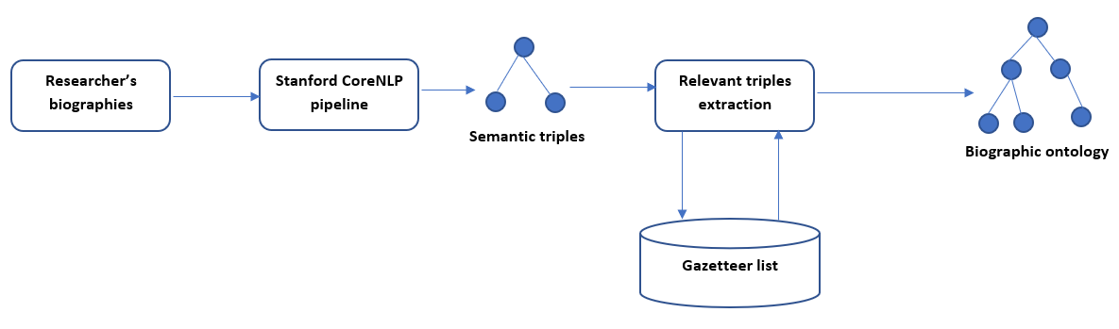
Figure 1. Semi-automatic ontology generation tool.

4.1 Results and discussion

Dataset
The dataset used for this research work was retrieved from Tang et al.^{[18]}, and they include annotated words appearing in web pages of researchers in a categorized form. The upper layer categories appear like the section sentences in the block. An academics’ homepage contains information such as researcher’s biography, contact details, photo, and a possible list of publications. One problem with this content is its noisiness as they contain HTML formatting tags as well as scripts which make it difficult for textual analyses. Moreover, since our interest in this research is academic biographies, we remove certain irrelevant information like publication list, photos etcetera from the content in order to derive plain text information only. The example below shows Kinshuk’s biography in the edited formatted.^{[18]}

Kinshuk joined Athabasca University in August 2006 as the Professor and Director of School of Computing and Information Systems. Before moving to Canada, Kinshuk worked at German National Research Centre for Information Technology as Postgraduate Fellow, and at Massey University, New Zealand as Associate Professor of Information Systems and Director of Advanced Learning Technology Research Centre. Kinshuk also holds Honorary Senior E-Learning Consultant position with Online Learning Systems Ltd., New Zealand, and Docent position with University of Joensuu, Finland. Kinshuk has been involved in large-scale research projects for exploration based adaptive educational environments and has published over 185 research papers in international refereed journals, conferences, and book chapters. Kinshuk is Chair of IEEE Technical Committee on Learning Technology and International Forum of Educational Technology and Society. Kinshuk is also editor of the SSCI indexed Journal of Educational Technology and Society (ISSN 1436-4522).

The edited version was reorganised such that the original content of the text represents the exact information. The edited version is reconstructed into a compatible xml format with each researcher’s biography was made into pair with pair identification for identifying individual researcher, while preserving the original content. See a sample of xml derived text biography:

<pair id="3">
<bio> Kinshuk joined Athabasca University in August 2006 as the Professor and Director of School of Computing and Information Systems. Before moving to Canada, Kinshuk worked at German National Research Centre for Information Technology as Postgraduate Fellow, and at Massey University, New Zealand as Associate Professor of Information Systems and Director of Advanced Learning Technology Research Centre. Kinshuk also holds Honorary Senior E-Learning Consultant position with Online Learning Systems Ltd., New Zealand, and Docent position with University of Joensuu, Finland. Kinshuk has been involved in large-scale research projects for exploration based adaptive educational environments and has published over 185 research papers in international refereed journals, conferences, and book chapters. Kinshuk is Chair of IEEE Technical Committee on Learning Technology and International Forum of Educational Technology and Society. Kinshuk is also editor of the SSCI indexed Journal of Educational Technology and Society (ISSN 1436-4522). </bio>
</pair>

4.2 Input Text Processing
The manual process of annotating semantic information from an input text for each researcher is tedious and time consuming. There have been recent works on information extraction technology that have been observed to be reasonably successful in extracting structured data from plain text. Hence, for the task of information extraction, we applied the Stanford CoreNLP tool for processing the input text. The Stanford CoreNLP contains a series of text processing components which are responsible in extracting specific information from the input text in the various processing steps.^{[16]}
The tool takes a sentence and chunks it into a set of entailed clauses, and each of these clauses is then shortened to produce a set of sentence fragments. These fragments are then segmented into the Stanford NLP triples. The annotators are the underlying strength of the package which behaves like functions on top of the annotations. They perform certain operations like tokenization, parts-of-speech tagging (POS), lemmatization, named entity identification, dependency parsing, Stanford openie and natural logic to extract semantic triples from the plain input text. The Stanford CoreNLP provides a uniform interface for annotators to use annotation object to add extra information. Using the Stanford CoreNLP API, running a pipeline is made easy since it provides a minimal configuration code for user experience. The annotation pipeline can be applied to any form of text, either a paragraph or full document instead of applying to a single sentence (see Figure 2).

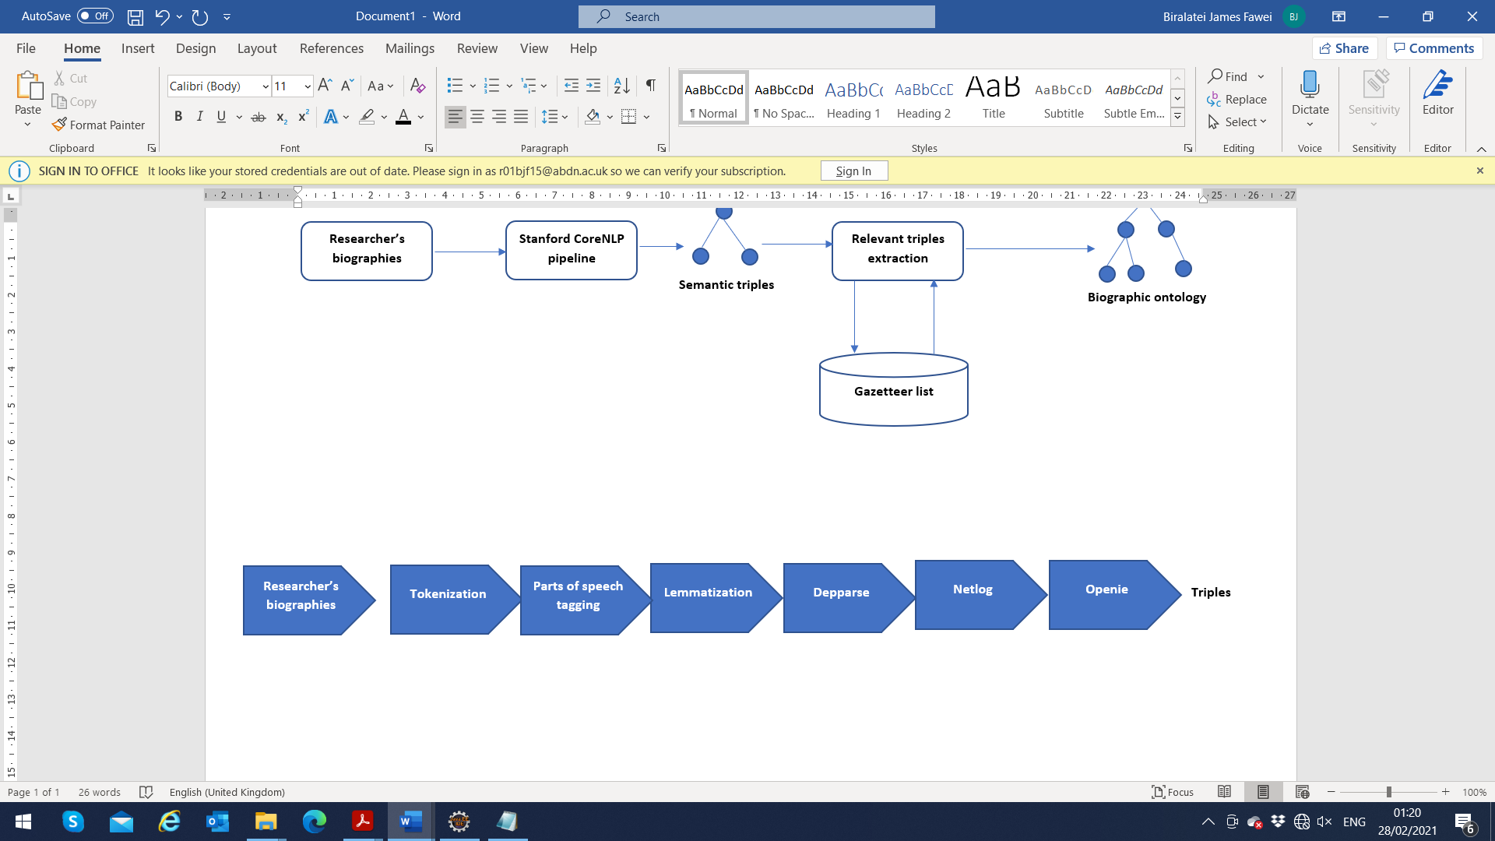
Figure 2. Text processing pipeline.

For the input processing task, a selected number of the default annotators were used. The core annotators for extracting semantic triples are the Natural Logic in NLP (natlog) and Open Information Extraction (openie). The natlog component works based on a model of natural logic to do inferencing on natural language. It decomposes an inference problem into chunks of atomic edits that connects the premises to the hypothesis. This decomposition enables lexical entailment relations for every edit using a statistical classifier to generate the relations through a syntax tree with respect to semantic properties of the nodes and put together the resulting entailment relations along the edit sequence.^{[5]} For example, the sentence Tom is a member of ACM can entail (Tom, member, ACM). Netlog applies proof theory for lexical mutation of a sentence with respect to a more general or specific terms which in turn preserves or negates the truth of the premise. The openie extracts relational tuples, specifically binary relations from a natural language text^{[1]} in two processing stages. Here, the first stage of the processing process splits sentence into chunks of shorter statements. For example, the sentence Tom is a member of ACM is chunked into simple clauses such as Tom member ACM, Tom be member ACM, Tom be member, and so on. While the necessary context is not altered. The binary parse tree of these clauses is then traversed recursively to find an edge that produces an independent clause.

4.3 Named Entity Identification
Also, we applied the Stanford CoreNLP named entity recogniser^{[16]} to identify and extract named entities in the input text. The identification of the named entities is based on a predefined classification such as name of persons, organizations, locations, dates and so on. The named entity recogniser works by matching words extracted from the input text to the reference list (Stanford trained models). Here matching words are retrieved as named entities. This task is to extract the set of named entities from the input text. For example, the sentence Tom started working at the Atlantic Systems Guild 1986. The identified named entities will be Tom as a Person and 1986 as Date. Where Tom and 1986 are extracted as Person and Date respectively.

4.4 Triple Extraction
The interest here is to extract semantic triples from the input text and relate them to concepts and relations defined in the gazetteer list to create and instantiate the ontology. Relevant triples are extracted by matching each set of triples (subject, predicate, object) to the gazetteer list nouns and relations as well as named entities. Matching concepts and relations are retrieved as relevant triples. Where a match is not found, the triples are identified as irrelevant concepts and relations, and are hence, discarded. Triples are a collection of three entities that represents a statement about an information, which is expressed as s-p-o (Subject-Predicate-Object). Also, triples are used in Resource Description Framework (RDF) data model to describe atomic data entity. Here, the predicate describes the relationship between two resources. Semantic triples are important because they form the nodes or relations in the ontology-based domain model and they are part of the triple structure, which is compared to the domain model to find a match.

4.5 Modelling primitives
The concepts and relations extracted as relevant triples are used to develop an ontology. These triples are translated into RDF triples based on ontology modelling primitives such as concepts, instances, taxonomies and relations. Here, one to three-word concepts forming the subject and object of the triples are used to create ontology classes. However, for the purpose of class hierarchy definition (subclass-of-relations), apart from the named entities, we created a taxonomy based on some basic intuition on biographic text.^{[8]} For example, Atlantic Systems Guild in the sentence “Tom started working at the Atlantic Systems Guild 1986” is classed as an Organization. The classification of the named entities is also identified and created as ontology classes. For example, the named entities (Person and Date) as to Tom and 1986 as it appears in the sentence. The concepts Person and Date are used to create ontological classes. Whereas ontological instances are identified based on common nouns. Common nouns are the names for a person, place, and thing.

4.6 Triple Extraction with Sparql Query
Sparql query language is the W3C recommended language for querying RDF data published on the web. The query layer provides an interface to the knowledge base. The Sparql query language allow querying the classes and subclasses of the ontology to discover the resources which are directly classified under them. Sparql query works based on graph pattern matching. It enables user to specify the set of triple patterns which is known as basic graph pattern. The triple patterns are defined with respect to (subject, predicate, object) and are similar to the RDF triples. To execute a sparql query, the query is parsed into abstract syntax form and then transformed into abstract query, which would then be executed on an RDF dataset. In this research, the sparql query language is applied to retrieve semantic information from the developed ontology. For example, the following query retrieves the ‘subject’ and ‘object’ of rdfs:subclassOf relations information from the knowledge base (see Figure 3. for Sparql Query output).

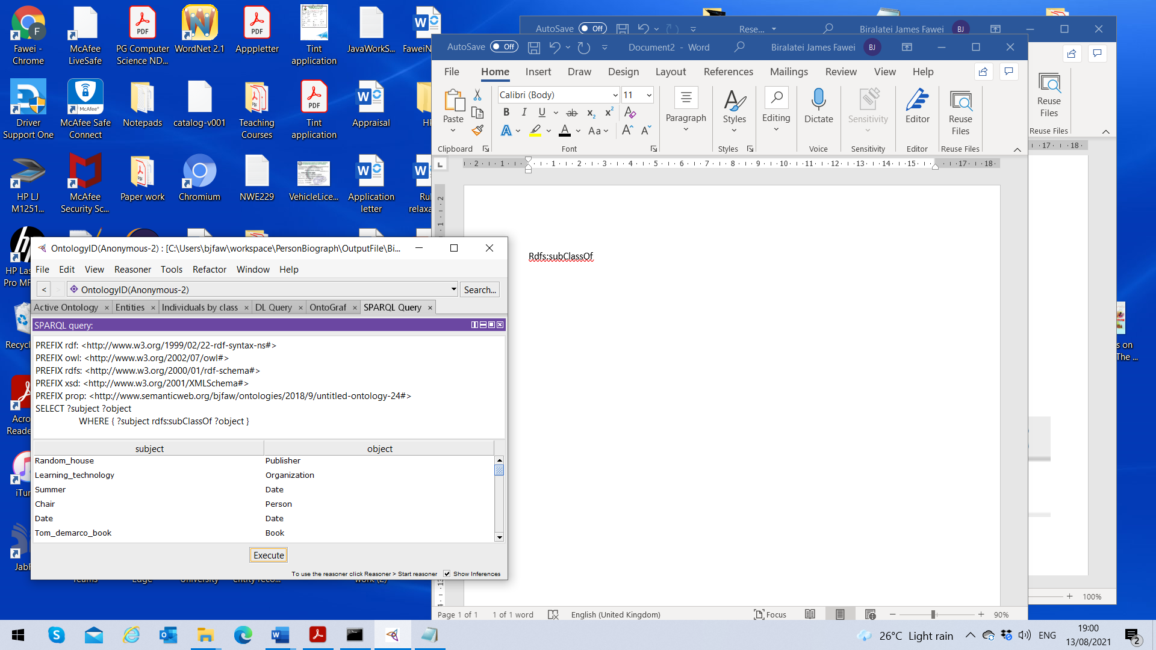
Figure 3. Sparql Query Output

Other sparql queries such as select subject and object where the object property is ‘work_at’ retrieve person and name of a company (see Figure 4 for sparql query and output).

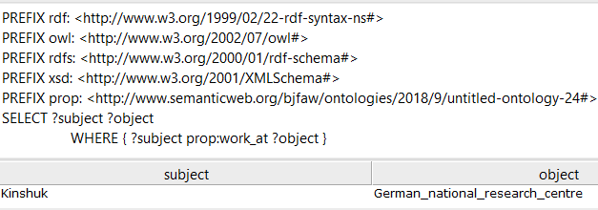
Figure 4. Sparql query with object property defined

Series of other sparql queries were tried to evaluate the suitability of the semiautomatically created ontology. In the queries, the object property is defined with the intention to retrieve the respective ‘subject’ and ‘object’ (see Figure 5, 6 and 7 for sparql queries and outputs).

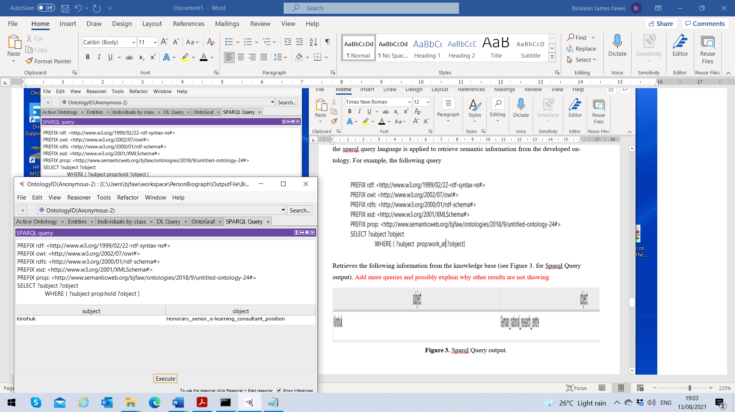
Figure 5. Sparql query with object property defined

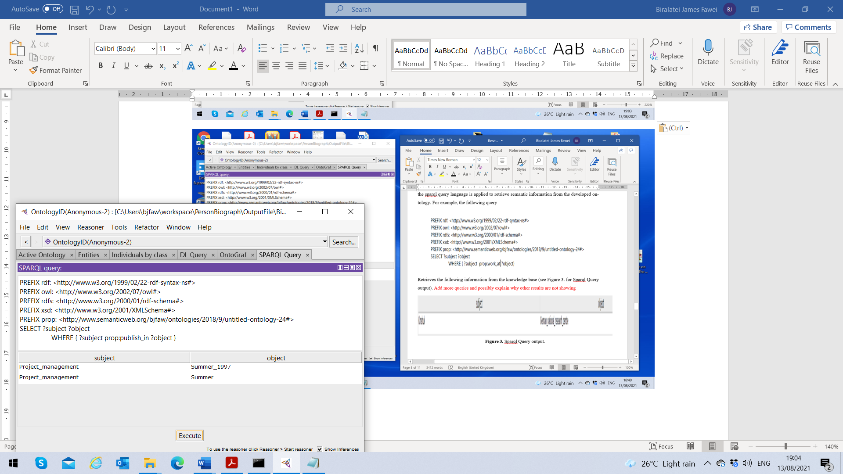
Figure 6. Sparql query with object property defined

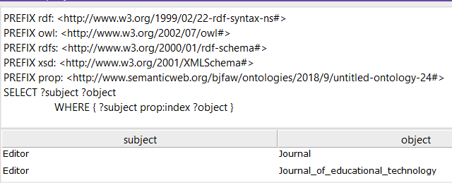
Figure 7. Sparql query with object property defined

5 ONTOLOGY EVALUATION
For ontology evaluation, we applied an online ontology evaluation tool OntOlogy Pitfall Scanner (OOPS) to evaluate our ontology (See Figure 8. for OOPS ontology evaluation result). The evaluation was based on its structural and lexical patterns related pitfalls. The essence of the evaluation is to ascertain how free is our ontology from the basic critical and important pitfalls. The result shows that our ontology is free of critical pitfalls such as polysemous elements as well as synonymous classes. However, two important cases where identified (P38 and P41). Though, important but does not alter the functionality of the ontology. Other pitfalls such as (P08 and P13), which are “missing annotations and inverse relationship not explicitly declared.” Since, the ontology development is still in progress, these pitfalls are seen to be irrelevant. As the construction progresses, proper consideration will be given to this class of pitfalls. Moreover, it is not all the pitfalls^{[8,17]} that are necessary for evaluating our ontology. Other issues like naming criteria were consistent while definition of classes, equivalent properties, class hierarchy, primitives and “is-a” relations were not misused.

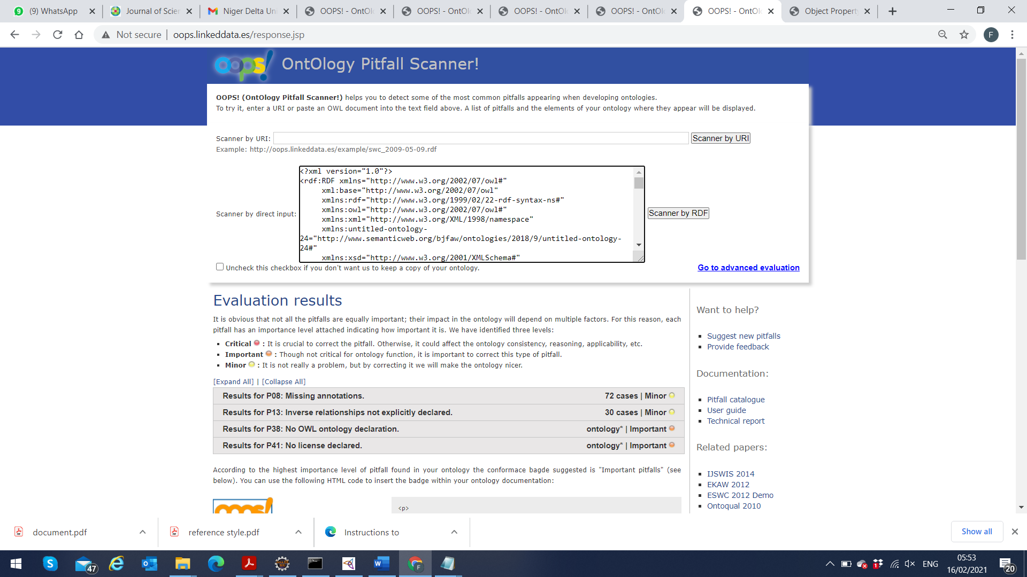
Figure 4. OOPS ontology evaluation result.

6. Conclusion

Analyses of information from free text biographies found in the web page of researchers or in academic articles have not been fully explored because of the difficulty in extracting useful information from unstructured textual data. This research attempted to fill this gap by describing a technique for the creation of a knowledge base of academic researchers. The research applied natural language processing technique to extract named identities and respective relevant concepts and properties for generating and instantiating a biographic ontology of personal academic biographies. However, it is important to highlight at this point that the system does not address some of the challenging issues encountered such as complex compound nouns, polysemy and so on. The generated ontology allows for execution of complex queries. This research has simply described a methodology for the creation of a knowledge base. Further work will focus on retrieving free text biographies from academic web pages on the web, and then using the methods described in this research, create a publicly available knowledge base which can serve as a data source for future infometrics and scientometrics researches.

REFERENCE
- Angeli, G., Premkumar, M. J., Manning, C. D. (2015). Leveraging linguistic structure for open domain information extraction. In Proceedings of the 53rd Annual Meeting of the Association for Computational Linguistics and the 7th International Joint Conference on Natural Language Processing, 344-354.

- Anil, S., Kurian, A., Dey, S. R., Saha, S., Sinha, A. (2018) Genealogy tree: understanding academic lineage of authors via algorithmic and visual analysis. Journal of Scientometric Research, 7(2), 120-124.

- Antoniou, G., Van Harmelen, F. (2004) A semantic web primer. MIT press.

- Bennett, Z., Russell-Rose, T., Farmer, K. A. (2017) Scalable approach to legal question answering. In Proceedings of the 16th edition of the International Conference on Artificial Intelligence and Law, 269-270.
- Bowman, S. R., Potts, C., Manning, C. D. (2015) Learning distributed word representations for natural logic reasoning. In 2015 Association for the Advancement of Artificial Intelligence (AAAI) Spring Symposium Series. 2015 Mar 11.

- De Nicola, A., Missikoff, M. A. (2016) lightweight methodology for rapid ontology engineering. Communications of the Association for Computing Machinery (ACM), 59(3), 79-86.

- Fawei, B., Pan, J. Z., Kollingbaum, M., Wyner, A. Z. (2018) A methodology for a criminal law and procedure ontology for legal question answering. In Joint International Semantic Technology Conference, 198-214. Springer, Cham.

- Fawei, B., Pan, J. Z., Kollingbaum, M., Wyner, A. Z. (2019) A semi-automated ontology construction for legal question answering. New Generation Computing, 37(4), 453-478.

- Gangemi, A. (2007) Design Patterns for Legal Ontology Construction. In Proceedings of LOAIT’07: II Workshop on Legal Ontologies and Artificial Intelligence Techniques Conference 2007, 65-85.

- Gangemi, A., Prisco, A., Sagri, M. T., Steve, G., Tiscornia, D. (2003) Some ontological tools to support legal regulatory compliance, with a case study. In OTM Confederated International Conferences "On the Move to Meaningful Internet Systems", 607-620. Springer, Berlin, Heidelberg.

- Ginde, G., Saha, S., Mathur, A., Vamsi, H., Dey, S. R., Gambhire, S. S. (2018) Use of NoSQL database and visualization techniques to analyze massive scholarly article data from journals. Journal of Scientometric Research; 7(2), 114-119.

- Golbreich, C., Horrocks, I. (2007) The obo to owl mapping, go to owl 1.1. In Proceedings of the OWLED 2007 Workshop on OWL: Experiences and Directions 2007.

- Hogue, A., Nothman, J., Curran, J. R. (2014) Unsupervised biographical event extraction using wikipedia traffic. InProceedings of the Australasian Language Technology Association Workshop 2014, 41-49.

- Kenekayoro, P. (2018) Identifying named entities in academic biographies with supervised learning. Journal of Scientometrics Research, 116(2), 751-765.

- Kenekayoro, P. (2019) Towards Machine Readable Academic Biographies: A Deep Learning Approach. In International Society for Scientometrics and Informetrics 2019, 1-10.

- Manning, C. D., Surdeanu, M., Bauer, J., Finkel, J. R., Bethard, S., McClosky, D. (2014) The Stanford CoreNLP natural language processing toolkit. In Proceedings of 52nd annual meeting of the association for computational linguistics: system demonstrations 2014, 55-60.

- Poveda-Villalón, M., Gómez-Pérez, A., Suárez-Figueroa, M. C. (2014) Oops!(ontology pitfall scanner!): An on-line tool for ontology evaluation. International Journal on Semantic Web and Information Systems (IJSWIS),10(2), 7-34.
- Tang, J., Zhang, J., Yao, L., Li, J., Zhang, L., Su, Z. (2008) Arnetminer: extraction and mining of academic social networks. In Proceedings of the 14th Association for Computing Machinery (ACM) SIGKDD International Conference on Knowledge Discovery and Data mining 2008, 990-998.

- Suárez-Figueroa, M. C., Gómez-Pérez, A., Fernández-López, M. (2012) The NeOn methodology for ontology engineering. In Ontology engineering in a networked world 9-34. Springer, Berlin, Heidelberg.

- Unger, C., Bühmann, L., Lehmann, J., Ngonga-Ngomo, A. C., Gerber, D., Cimiano, P. (2012) Template-based question answering over RDF data. In Proceedings of the 21st international conference on World Wide Web 2012, 639-648.

- Valente, A. (2005) Types and roles of legal ontologies. In Law and the semantic web 2005, 65-76. Springer, Berlin, Heidelberg.

- Viseur, R., (2013) Extraction of Biographical Data from Wikipedia. In the Proceedings of International Conference on Data Technologies and Applications 2013, 29-31.

- Zhang, Y. (2018) Towards Highly Accurate Publication Information Extraction from Academic Homepages [dissertation]. Melbourne, University of Melbourne; 2018

- Zheng, W., Zou, L., Lian, X., Yu, J. X., Song, S., Zhao, D. (2015) How to build templates for RDF question/answering: An uncertain graph similarity join approach. In Proceedings of the 2015 ACM SIGMOD international conference on management of data 2015, 1809-1824..

