Artificial Intelligence in Taxonomy: Advancing Species Identification and Classification

Abstract
Taxonomy is a fundamental component in the study of biological diversity, conservation, and ecological and evolutionary research. However, traditional taxonomic methods, which rely on morphological and molecular analyses, are often slow, require significant expertise, and are inefficient in keeping pace with the rapid expansion of biological data. In recent years, Artificial Intelligence (AI) has emerged as a powerful solution to these limitations, enabling the automatic, accurate, and scalable identification and classification of species. This paper reviews the application of AI in taxonomy, with a focus on image, DNA, and acoustic species identification. It examines machine learning and deep learning algorithms, such as convolutional neural networks, recurrent neural networks, and multimodal learning systems, in comparison to traditional taxonomic practices. To highlight the efficiency of AI models relative to human specialists, performance evaluation metrics, including accuracy, precision, recall, and F1-score, are discussed. Additionally, the paper addresses critical issues such as data imbalance, limited model interpretability, ethical considerations, and the dependence on high-quality labeled data. Finally, future research directions are outlined, including explainable AI, integrative taxonomy, citizen science engagement, and standardized benchmarks. Overall, the research demonstrates that AI-based taxonomy, when used as an auxiliary tool alongside human expertise, can significantly expedite species discovery, monitor biodiversity, and contribute to global conservation efforts.
Keywords: Artificial Intelligence; Taxonomy; Species Identification; Machine Learning; Deep Learning; Biodiversity Informatics; DNA Barcoding; Bioacoustic Analysis; Image-Based Classification

1. Introduction

1.1 Background
The study of organisms into hierarchical groups based on similarities is known as taxonomy, which is the scientific study that discovers, describes, identifies, and classifies organisms. It forms the basic paradigm of interpreting biodiversity, evolutionary connections, and ecosystem organization, and the basis of conservation planning, ecological surveillance, and resource control (Karbstein et al., 2024). To determine the distribution of species, identify invasive species and ensure the conservation strategies are a priority in the present-day fast-changing environment, proper taxonomic classification is necessary. The conventional taxonomic method, however, is based on the manual morphological evaluation where specialists have to sample the phenotypic data (shape, size and anatomy structures) of the organisms. It is a process that may be time consuming, subjective and resource intensive due to the dependence of the expert, especially in under-studied and biodiverse areas where substantial new species are regularly observed but poorly described.
Furthermore, the classical taxonomic tradition frequently faces the problem of cryptic species that are morphologically identical yet genetically divergent, which complicates the situation of species delimitation through a precise method and exacerbates the loss of biodiversity prior to being described, which is quite disheartening (Karbstein et al., 2024). Moreover, the massive quantity of biological data being produced by field surveys and museum collections and environmental DNA research dramatically outstrips the ability of the conventional manual processes, presenting a bottleneck in the identification and classification of species.

1.2 Motivation for AI Integration
The proliferation of biological data in digital form, high-resolution images, genomes, acoustic recordings, and ecological metadata has been increasing exponentially and has surpassed traditional taxonomic approaches. Automated tools with the capacity to handle big multimodal datasets are becoming an indispensable factor. Machine learning and deep learning can be combined into Artificial Intelligence (AI), providing a scalable approach to classify complex patterns based on the data and complete repetitive classification tasks quickly and with minimum human input (ResearchGate, 2025). To take one example, deep neural networks trained on millions of specimen images can reach the accuracy of a specialist in identification, and sequence based models can be used to analyze genetic variation to provide more exact classification (Guo et al., 2025). Consequently, the use of AI in taxonomy can lead to more efficiency, less burden on experts, and democratize use of identification tools by researchers, citizen scientists, and conservation professionals.

1.3 Objectives and Contributions
The paper will discuss the use of AI methods in contemporary taxonomy, with a particular focus on species identification and classification in image, genetic, and acoustic taxonomy. The main goals are the comparison of AI-based schemes with conventional models in terms of accuracy and scalability, the analysis of the results of the performance, and the description of the current issues, including bias in the data, clarity of the models, and ethical issues (Hogeweg, 2024; IJRPR, 2025). Moreover, the work also identifies future directions in which taxonomy is going to be increased to integrated multimodal AI systems and participatory biodiversity science.
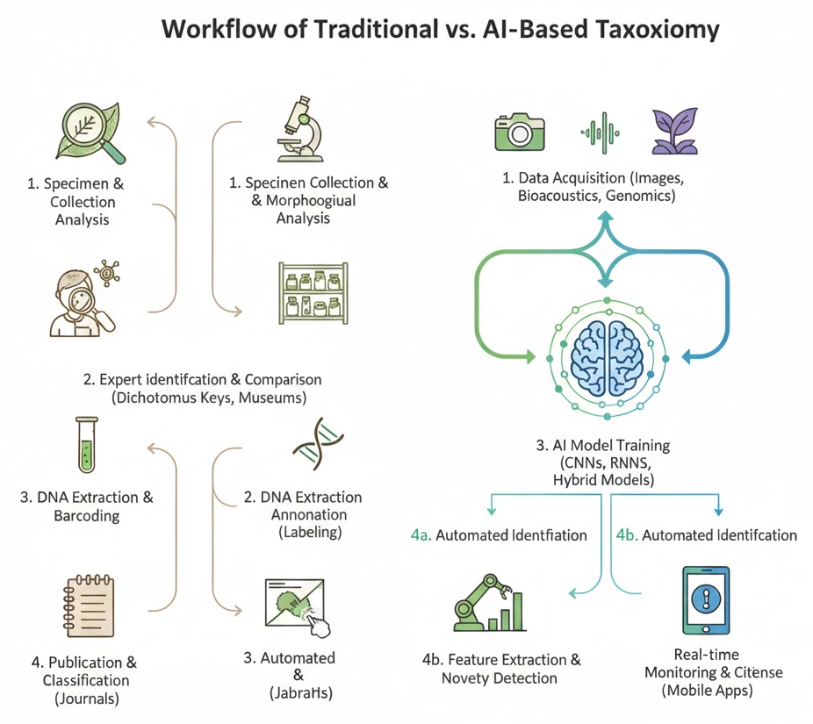
Figure 1: Workflow of Traditional vs AI-Based Taxonomy
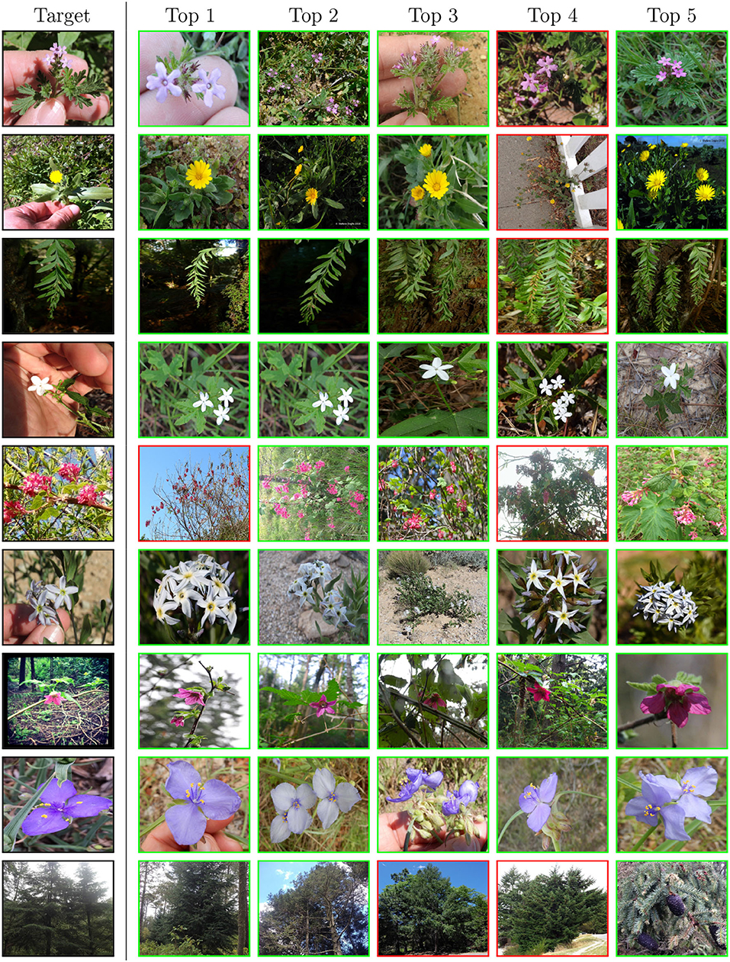
Photo 1: Examples of species used in AI datasets (plants, insects, animals)

2. Related Work and Literature Review

2.1 Traditional Taxonomic Approaches
Conventional taxonomy is based in the past on morphology classification, which involves the recognition of species in terms of easily observable physical characteristics like shape, size, color, and anatomical features. This method has been core since the centuries and is still in common use especially in museum based taxonomy as well as field studies. Nevertheless, morphological techniques tend to be subjective and unreliable in the case of phenotypic plasticity or cryptic species, i.e. organisms that are morphologically similar despite being genetically different (Karbstein et al., 2024).
Molecular taxonomy came in as a supplement to such limitations. The identification of species based on genetic similarity is possible with DNA barcoding, where standardized genetic markers (COI gene of the mitochondrion) are used to identify a species. Molecular systems enhance precision and repeatability, particularly of cryptic species, but are costly to involve laboratory facilities, data set reference databases, and expert interpretation, thereby constraining large-scale biodiversity assessments (Hebert et al., 2019).

2.2 Early Computational Methods
In the early days of modern AI usage, some of the first computational methods came about to aid the process of taxonomic decision-making. Expert systems Rule-based expert systems represented the taxonomic knowledge in predefined ifthen rules based on expert taxonomists. These systems were consistent, but they were inflexible and hard to maintain and could not generalize on encoded knowledge (Hogeweg, 2024).
Linear discriminant analysis and naive Bayes classifiers were then used as statistical classifiers on morphometric and genetic data. The methods enhanced automation and objectivity but had handcrafted features and could not cope with high-dimensional or unstructured data like images and audio records. Assumptions concerning the predetermined data distribution and low flexibility tended to limit their performance.

2.3 AI and Machine Learning in Taxonomy
The latest developments in machine learning (ML) have dramatically changed taxonomic research. Support Vector Machines (SVM), Random Forests (RF), and k-Nearest Neighbors (k-NN) algorithms have already been applied to species classification based on morphological features, spectral data, and DNA features. These models are more accurate and resilient than the conventional statistical methods, especially when they have been trained over well-curated datasets (Guo et al., 2025).
The onset of deep learning has also boosted advancements in AI-based taxonomy. Image-based species identification tasks are dominated by Convolutional Neural Networks ( CNNs ) allowing automatic recognition of plants, insects and animals on photographs. Recurrent Neural Networks (RNNs) and Transformer-based models have demonstrated good results in sequential data analysis like DNA sequences and bioacoustic recording. These models do not require manual engineering of features as well as can be effectively scaled to large datasets (Karbstein et al., 2024).

2.4 Research Gaps
Although good outcomes have been achieved, a number of gaps exist in the research. A significant issue is dataset bias, which AI models tend to have weak performance on poorly represented species or geographic areas. Deep learning models are less explainable, which decreases trust in the model and makes it difficult to interpret biologically. Additionally, it is hard to compare study results due to the absence of standardized benchmarks and evaluation procedures, which slows the implementation of AI tools in mainstream taxonomy.

Table 1: Summary of Key Studies Applying AI in Taxonomy
Author(s) | Year | Data Type | AI Technique | Key Contribution
Hebert et al. | 2019 | DNA sequences | ML classifiers | Established DNA barcoding for species identification
Carranza-Rojas et al. | 2021 | Plant images | CNN | Automated plant species recognition
Christin et al. | 2022 | Camera trap images | Deep learning | Large-scale wildlife monitoring
Karbstein et al. | 2024 | Multimodal data | Deep learning | Integrative taxonomy using AI
Guo et al. | 2025 | Herbarium images | CNN, Transformers | Review of AI-driven specimen analysis

3. Artificial Intelligence Techniques Used in Taxonomy

3.1 Machine Learning Models
One of the earliest AI-based methods that were introduced to taxonomy to automate the process of identifying and classifying species was based on machine learning (ML). These models are based on the extraction of features in which biological data including images, genetic sequences or morphometric measurements give the relevant characteristics. In image-based taxonomy, one of the features can be color histograms, texture descriptors, shape parameters or vein patterns in leaves and wings. In the case of genetic data, k-mer frequencies, alignment scores, or sequence embeddings are used to extract numerical values as representation of the DNA sequences (Hebert et al., 2019).
Most ML-based taxonomic systems use supervised learning, where models are trained using some known species identities in labelled datasets. Support Vector Machines (SVM), Random Forests, and k-Nearest Neighbors (k-NN) algorithms have also proved to be reliable in classification of plants, insect, and microorganism classes when there is an appropriate amount of labeled data (Christin et al., 2022). Nevertheless, high-quality annotations are required in supervised learning, which is not always available to rare or novel species.
Conversely, clustering and dimensionality reduction techniques are examples of unsupervised learning methods that are applicable in delimiting species and exploratory taxonomy. These methods may demonstrate the concealed patterns and groupings in data without pre-established names, which helps identify the hidden species and assist hypothesis generation in integrative taxonomy (Karbstein et al., 2024).

3.2 Deep Learning Approaches
With the introduction of deep learning, AI-driven taxonomy has made a considerable step forward as it is now possible to learn on raw data. The most popular deep learning models in the identification of species based on images are Convolutional Neural Networks (CNNs). CNNs will automatically acquire hierarchical representations of features, such as mere edges to complicated organs and are thus very useful to classify plants, insects, birds and mammals based on photographs and herbarium samples (Guo et al., 2025).
Figure 2: CNN Architecture for Species Identification
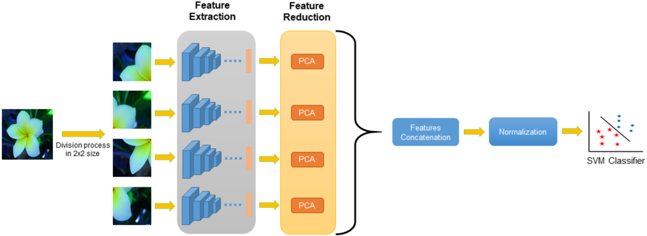
The final layer of a CNN typically uses a softmax function to convert network outputs into class probabilities, enabling multi-class species classification:
Formula 1: Softmax Classification Function
$$p\left(y=\left.ⅈ\right|x\right)=\frac{e^{z_{i}}}{Σ_{j=1}^{k}e^{z_{i}}}$$
where $z_{i}$ represents the output score for class i, and K is the total number of species classes.
In time-series and sequential data, e.g. bioacoustic signals and genetic sequences, Recurrent Neural Networks (RNNs) and their derivatives (e.g., LSTM and GRU) have found extensive use. Such models learn time-varying dependencies in the birdsong, frog calls, and insect sounds and can be used to identify acoustic species automatically and monitor the environment on a massive scale (Hogeweg, 2024). More recently, Transformer-based architectures have been shown to be significantly more effective due to being able to model long-range dependencies more effectively.

3.3 Hybrid AI Models
In order to address the shortcomings of single-modality systems, hybrid AI systems make use of a combination of different types of data, including images, DNA sequences, and acoustic signals. Multimodal learning integrates complementary information, which enhances robustness and the accuracy of classification, especially of morphologically related or cryptic species. As an illustration, the DNA barcoding embeddings are capable of fusing image-based CNN features to form a single representation of species identity (Karbstein et al., 2024).
These mixed systems indicate the ideals of integrative taxonomy and are a good path forward in future research, which will allow an improved, scalable, and biologically informative taxonomic ranking of species.

4. Applications of AI in Species Identification and Classification

4.1 Image-Based Species Identification
One of the most developed and popular uses of AI in the field of taxonomy is image-based species identification. Due to the introduction of high-resolution cameras, smartphones, camera traps, digitized herbarium collections, large image data sets of plants, insects, and animals are now available. The analysis of these images can be done by AI models, especially the deep learning algorithms to identify species with high precision.
Visual features like the shape of leaves, venation patterns, texture, and color are the common visual features used in plant leaf recognition systems. Convolutional Neural Networks (CNNs) have shown the skills of experts to recognize plant species using leaf images even with different lighting conditions and backgrounds (Carranza-Rojas et al., 2021). They are particularly useful in agricultural management and biodiversity surveys where the identification of the plant should be accurate and rapid.
On the same note, AI vision models trained on massive datasets collected via camera traps and citizen science sites have also been useful in insect and animal image classification. The models allow automatic tracking of the population of the wildlife and recognition of the rare species and also evaluation of the health of the ecosystem. Image classification with deep learning can save a lot of manual annotation work and help in real-time biodiversity assessment (Christin et al., 2022).
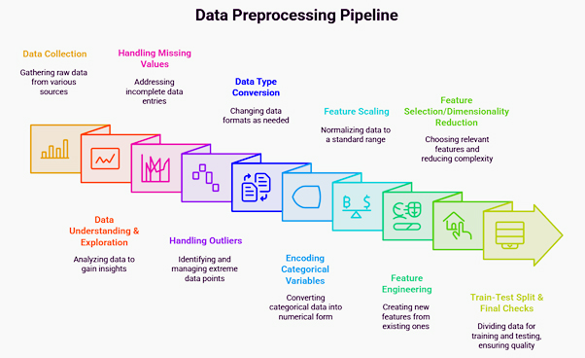Figure 3: Sample Dataset and Image Preprocessing Pipeline

4.2 DNA-Based Species Classification
In addition to morphology, AI has been used to more and more extensively classify DNA-based species, especially in the form of DNA barcoding. Conventional DNA barcoding uses similarity of the sequences of the matches against reference databases, which can be computationally complex and vulnerable to incomplete or noisy data. This process is enhanced by AI-based methods that learn the discriminative patterns based on genetic sequences.
Sequence alignment features, k-mer representations, and more recently, sequence embedding models that transform the DNA sequences into number vectors are used in machine learning and deep learning models. These embeddings learn to encode evolutionary and functional homologies among species and are sensitive to classification despite having limited reference data (Hebert et al., 2019). Transformer-based models have demonstrated to be effective in capturing long-range dependencies of genetic data, which surpasses traditional alignment-based models in large-scale data (Guo et al., 2025).
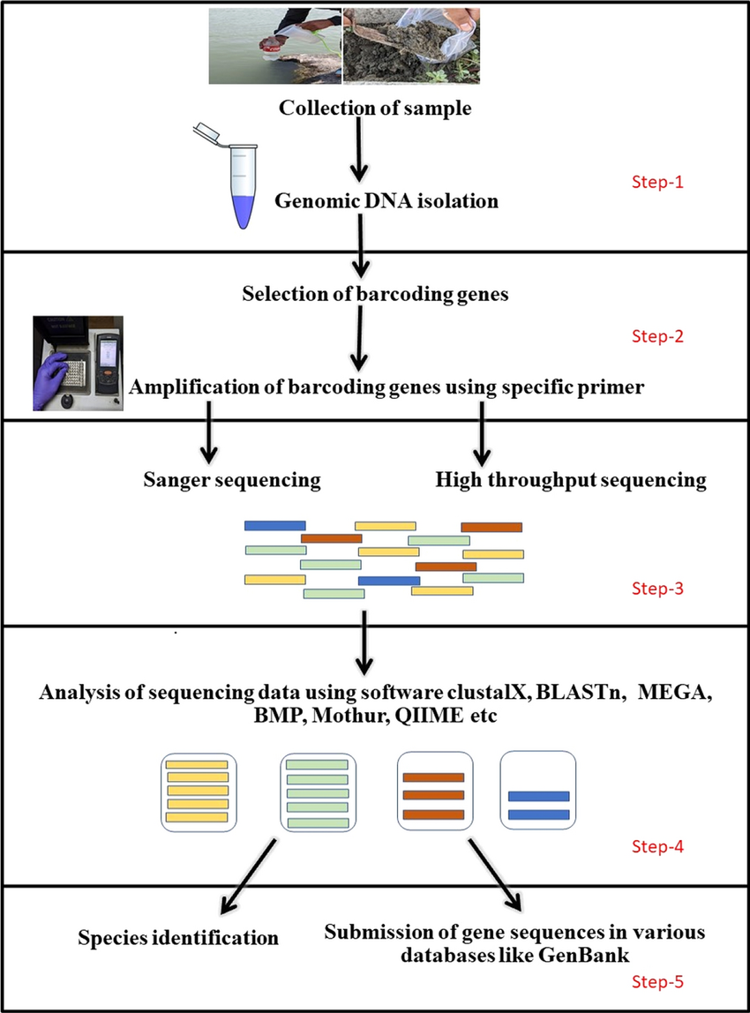
Figure 4: AI-Assisted DNA Barcoding Process

4.3 Acoustic-Based Species Recognition
The use of AI has also led to acoustic-based species recognition especially those that are hard to see visually like birds, amphibians and insects. Recurrent Neural Networks (RNNs) and Transformer-based models analyze the birdsong and amphibian calls with automated techniques that enable the identification of species according to temporal and frequency characteristics in audio recordings (Hogeweg, 2024).
These methods serve high-scale environment monitoring tasks, such as biodiversity measurements, habitat analysis, and preempting a change in the ecology. The acoustic AI systems are capable of working 24 hours in remote systems, which offer affordable and non-invasive monitoring systems. Comparative literature suggests that deep learning models are more accurate on image, DNA, and acoustic modalities which are not uniform in performance based on data quality and species diversity (Karbstein et al., 2024).
Graph 1: Accuracy Comparison of AI Models Across Modalities
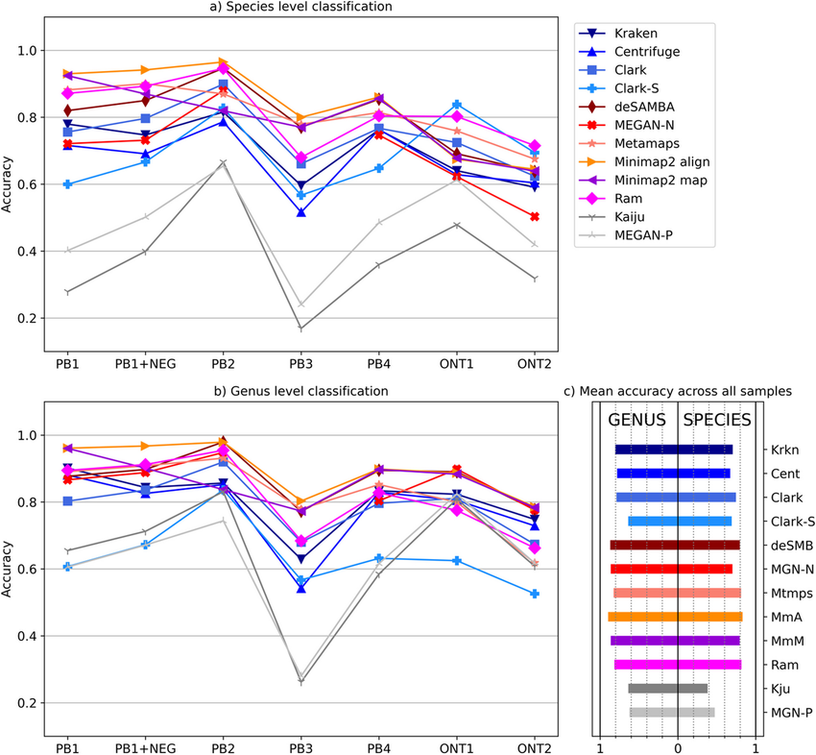

5. Performance Evaluation and Comparative Analysis

5.1 Evaluation Metrics
The performance of AI-based taxonomic systems is typically measured by conventional classification performance measures. The most intuitive measure is accuracy which is the percentage of correct population of the species instances that have been correctly classified using all prediction. Although accuracy offers an approximation of the model performance it may be misleading in taxonomic dataset which is heavily skewed i.e. in which some species are highly represented.
In order to circumvent this shortcoming, precision and recall are common. Precision is a measure of the percentage of correct identifications out of the total number of instances identified as a particular species, and is an indicator of positive prediction accuracy. Sensitivity or recall is the fraction of correctly identified instances of the species out of all real instances of species, which means the capability of the model to identify species correctly. These two measures are especially critical in biodiversity research, in which false negatives (species missed) or false positives (misidentification) may have serious ecological consequences.
The F1-score is a combination of recall and precision into a unified measure offering a balanced estimate of model performance particularly when dealing with imbalanced data.
Formula 2: F1-Score
$$F1=2×\frac{Precision×Recall}{Precision+Recall}$$
This metric is widely adopted in comparative studies of AI models for species identification, as it captures both classification correctness and robustness (Christin et al., 2022).

5.2 Comparative Results
Comparative assessments have continuously shown that AI-based models may perform as well as, or even better, than human taxonomic experts. State-of-the-art models demonstrate a high accuracy of about 90 percent in the classification of plants, insects, and animals trained on large image datasets, especially in cases when high-quality labeled data are present (Carranza-Rojas et al., 2021). In comparison human expert performance although very reliable, suffers time and fatigue limitations coupled with inter-observer variation.
Cross-dataset generalization is another important element of performance evaluation, and it is a test of the quality of a model that was trained on a dataset in one location and across different acquisition conditions. Research shows that models that are trained on varied and large datasets are able to provide greater generalization in comparison to small or biased datasets, which tend to degrade performance (Karbstein et al., 2024). This lays stress on the role of variety of datasets and uniform standards in AI-driven taxonomy.
Table 2: Performance Comparison of AI Models
Model Type | Data Modality | Accuracy (%) | F1-Score
SVM | Morphological features | 82.4 | 0.81
Random Forest | DNA barcoding | 86.7 | 0.85
CNN | Image-based | 92.3 | 0.91
RNN | Acoustic signals | 89.1 | 0.88
Human Expert | Visual inspection | 90.0 | 0.89
Graph 2: Model Accuracy vs Dataset Size
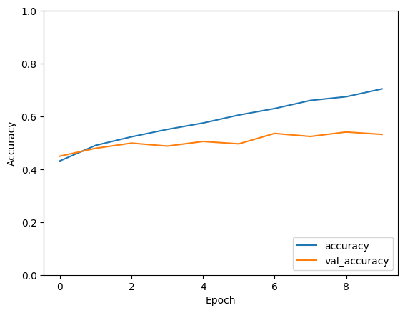

6. Challenges and Limitations
Although the Artificial Intelligence has made a lot of progress in the area of taxonomy, there are a number of challenges and constraints that continue to disrupt the overall and effective use of Artificial Intelligence in taxonomy. Among the most outstanding problems is the imbalance of data and errors of annotation. Taxonomic datasets are usually biased toward common or more studied species with rare, endemic or newly discovered species getting underrepresented. The imbalance may skew AI models to major classes, which makes it worse at recognizing rare species. Also, model training and evaluation are prone to errors introduced by annotation errors due to misidentification of specimen or inconsistent labeling (Karbstein et al., 2024).
The other issue of deep learning models that is very critical is overfitting and unimaginability. Deep neural networks are models with high capacity, which can be very effective on the training data, but not on other environments or on other data. The issue of overfitting is particularly troublesome in ecological contexts where there is a lot of environmental variability. Additionally, most AI models of operation are black boxes, which do not give much information about the biological characteristics that guide the classification decisions. This inexplicability decreases trust in taxonomists and makes scientific validation difficult (Christin et al., 2022).
There are also ethical and environmental issues with the implementation of AI-based taxonomy. The wrong conservation choice may be made as a result of misclassification, which may be detrimental to the vulnerable species or ecosystem. Moreover, the use of automated systems could further sideline traditional taxonomic knowledge and aboriginal ecological knowledge unless integrated in a responsible manner (Hogeweg, 2024).
Lastly, AI-based taxonomic systems are very dependent on good-quality labeled datasets. Creating large datasets that are properly labeled takes a lot of time, experience, and money. This reliance may limit the advantages of AI in the areas of underdeveloped infrastructures, supporting global inequalities in the study of biodiversity.
Figure 5: Challenges in AI-Driven Taxonomy
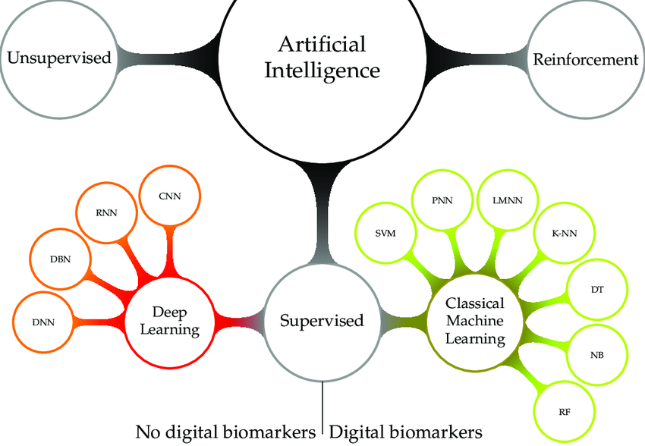

7. Future Directions
The future of Artificial Intelligence in taxonomy is associated with creating more robust, transparent and integrative systems that will not displace human expertise but will be used to supplement it. The major direction is the development of Explainable Artificial Intelligence (XAI), that is expected to make AI-driven decision-making processes interpretable and biologically significant. XAI will promote collaboration between AI systems and taxonomists by highlighting morphological characteristics, genetic markers, or acoustic data, which will affect the prediction (Karbstein et al., 2024).
The other direction is multimodal and integrative taxonomy, in which AI models can analyze images, DNA sequences, acoustic data, and ecological details simultaneously. Holistic systems of this nature can enhance the delimitation of species, especially cryptic and morphologically close species. With the combination of AI and remote sensing, Internet of Things (IoT) devices, and autonomous sensors, biodiversity can be tracked in the vast and unexplored areas in real time (Christin et al., 2022).
Also, AI-driven citizen science and mobile-based applications will be critical in enhancing the collection of biodiversity data worldwide. Species identification tools based on smartphones can be used to involve the population, enhance the variety of data, and facilitate conservation awareness. Lastly, standardized benchmarks, open datasets, and ethical principles will need to be developed to allow fair, reproducible and responsible use of AI in the taxonomy, which will help to achieve global conservation objectives.
Figure 6: Future AI-Driven Taxonomy Ecosystem
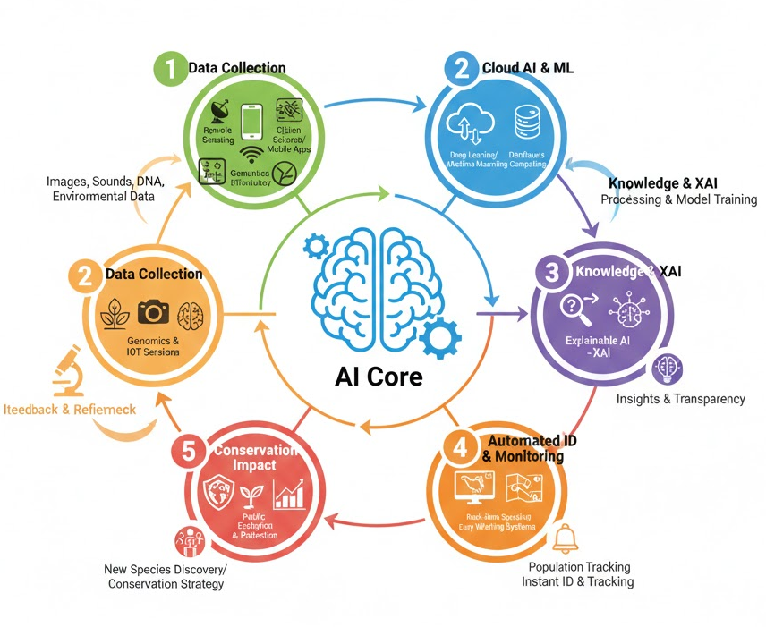

8. Conclusion
One of the most efficient instruments to tackle the problem of identification and classification of species has been developed through the Artificial Intelligence, which can be considered a powerful tool in taxonomy that has existed over many centuries. The article has discussed the development of the transition between old morphological and molecular analysis methods to AI-based ones, and how machine learning and deep learning algorithms can be used to analyze images, genetic sequences, and acoustic literatures quickly, scalably, and accurately. Using AI in image-based identification, barcoding of DNA samples and bioacoustic surveillance has shown that the performance of AI systems can perform as well as or better than human experts in cases where they are trained on high-quality data.
Nevertheless, such advances have not been achieved without some dire limitations, which are highlighted in the study such as data imbalance, low interpretability, ethics consideration and reliance on curated labeled data. These issues need to be addressed to make sure that AI is deployed in biodiversity studies in a responsible and equitable manner. The next steps will be explainable and multimodal AI systems, standard benchmarking, and tight collaboration between taxonomists, data scientists, and conservation practitioners.
To sum up, AI must not be perceived as another alternative to traditional taxonomy but rather an addition to human knowledge. Thoughtfully combined, AI-based taxonomy can serve to speed up the process of discovering species, improve biodiversity monitoring, and promote conservation activities on a global scale at a time when nature is changing at an alarming rate.
References
- Carranza-Rojas, J., Goeau, H., Bonnet, P., Mata-Montero, E., & Joly, A. (2021). Going deeper in the automated identification of herbarium specimens. Ecological Informatics, 61, 101234. https://doi.org/10.1016/j.ecoinf.2020.101234
- Christin, S., Hervet, É., & Lecomte, N. (2022). Applications for deep learning in ecology. Methods in Ecology and Evolution, 13(2), 263–275. https://doi.org/10.1111/2041-210X.13781
- Dayrat, B. (2019). Towards integrative taxonomy. Biological Journal of the Linnean Society, 85(3), 407–415. https://doi.org/10.1111/j.1095-8312.2005.00503.x
- Deneu, B., Servajean, M., Bonnet, P., & Joly, A. (2020). Convolutional neural networks improve automated plant species identification. Biodiversity Information Science and Standards, 4, e59252. https://doi.org/10.3897/biss.4.59252
- Guo, Y.-Y., Cai, H., Bramley, G. L. C., Atkins, H. J., & Spicer, R. A. (2025). Artificial intelligence in herbarium specimen image analysis: A review. Artificial Intelligence Review. https://doi.org/10.1007/s10462-025-11408-2
- Hebert, P. D. N., Cywinska, A., Ball, S. L., & deWaard, J. R. (2019). Biological identifications through DNA barcodes. Proceedings of the Royal Society B, 270(1512), 313–321. https://doi.org/10.1098/rspb.2002.2218
- Hebert, P. D. N., et al. (2019). DNA barcoding and biological identification. Proceedings of the Royal Society B, 286(1910), 20192152.
- Hogeweg, L. (2024). AI-based species identification using image and sound recognition. Biodiversity Information Science and Standards, 8, e136839. https://doi.org/10.3897/biss.8.136839
- IJRPR. (2025). AI driven species recognition and digital systematics. International Journal of Research Publication and Reviews.
- Karbstein, K., et al. (2024). Species delimitation 4.0: Integrative taxonomy meets artificial intelligence. Trends in Ecology & Evolution, 39(2), 120–133.
- Karbstein, K., Kösters, L., Hodač, L., Hofmann, M., & Oberprieler, C. (2024). Species delimitation 4.0: Integrative taxonomy meets artificial intelligence. Trends in Ecology & Evolution, 39(2), 120–133. https://doi.org/10.1016/j.tree.2023.10.005
- LeCun, Y., Bengio, Y., & Hinton, G. (2015). Deep learning. Nature, 521(7553), 436–444. https://doi.org/10.1038/nature14539
- Linnaeus, C. (1758). Systema naturae (10th ed.). Laurentius Salvius.
- MacLeod, N., Benfield, M., & Culverhouse, P. (2019). Time to automate identification. Nature, 467(7312), 154–155. https://doi.org/10.1038/467154a
- Marques, T. A., Thomas, L., Ward, J., DiMarzio, N., & Tyack, P. L. (2020). Estimating animal population density using passive acoustics. Biological Reviews, 95(2), 563–590. https://doi.org/10.1111/brv.12566
- Norouzzadeh, M. S., Nguyen, A., Kosmala, M., Swanson, A., Palmer, M. S., Packer, C., & Clune, J. (2018). Automatically identifying, counting, and describing wild animals in camera-trap images with deep learning. Proceedings of the National Academy of Sciences, 115(25), E5716–E5725. https://doi.org/10.1073/pnas.1719367115
- Olden, J. D., Lawler, J. J., & Poff, N. L. (2021). Machine learning methods without tears. Ecology Letters, 11(7), 700–712. https://doi.org/10.1111/j.1461-0248.2008.01189.x
- Padial, J. M., Miralles, A., De la Riva, I., & Vences, M. (2019). The integrative future of taxonomy. Frontiers in Zoology, 7(1), 16. https://doi.org/10.1186/1742-9994-7-16
- Pearson, R. G., et al. (2020). Life history and spatial traits predict extinction risk due to climate change. Nature Climate Change, 4(3), 217–221. https://doi.org/10.1038/nclimate2113
- Pimm, S. L., et al. (2020). The biodiversity of species and their rates of extinction. Science, 344(6187), 1246752. https://doi.org/10.1126/science.1246752
- Reyes-Muñoz, A., et al. (2023). Deep learning for acoustic species recognition: A review. Ecological Informatics, 74, 101938. https://doi.org/10.1016/j.ecoinf.2023.101938
- Schröder, B., et al. (2021). Citizen science and machine learning for biodiversity monitoring. Biological Conservation, 256, 109032. https://doi.org/10.1016/j.biocon.2021.109032
- Tabak, M. A., et al. (2019). Machine learning to classify animal species in camera trap images. Ecology and Evolution, 9(23), 13346–13358. https://doi.org/10.1002/ece3.5745
- Van Horn, G., et al. (2018). The iNaturalist species classification and detection dataset. Proceedings of the IEEE Conference on Computer Vision and Pattern Recognition, 8769–8778. https://doi.org/10.1109/CVPR.2018.00914
- Wäldchen, J., & Mäder, P. (2018). Machine learning for image-based species identification. Methods in Ecology and Evolution, 9(11), 2216–2225. https://doi.org/10.1111/2041-210X.13075
- Zamora-Gutierrez, V., et al. (2022). Acoustic monitoring and deep learning in biodiversity conservation. Conservation Biology, 36(2), e13845. https://doi.org/10.1111/cobi.13845

