Case report
Right-sided infective endocarditis due to Streptococcus pneumoniae associated with a long-standing implantable venous port: a rare case report

Abstract
Background
Right-sided infective endocarditis (IE) is uncommon, accounting for only 5–10% of cases, and is typically associated with intravenous drug use or intracardiac devices. Streptococcus pneumoniae has become a rare cause of IE, especially on the tricuspid valve. Early diagnosis remains challenging due to nonspecific clinical features and frequent respiratory presentations.
Case presentation
We report a 47-year-old male with a history of chronic lymphocytic leukemia in remission, who presented with prolonged fever and dyspnea while carrying an unused implantable venous chamber. Transthoracic echocardiography revealed a large mobile vegetation on the tricuspid valve with severe regurgitation, and blood cultures isolated Streptococcus pneumoniae. Targeted intravenous antibiotic therapy (ceftriaxone and gentamicin), combined with removal of the intravascular device, resulted in rapid clinical improvement and complete recovery.
Conclusion
This case highlights a rare presentation of pneumococcal right-sided IE in the absence of classic risk factors. It underscores the importance of considering right-sided IE in persistent fever and supports early device removal and targeted antimicrobial therapy to optimize outcomes.
Keywords: case report ; Right-sided infective endocarditis; Streptococcus pneumoniae; Tricuspid valve; Implantable device.
Introduction

Infective endocarditis (IE) is a severe pathology characterized by inflammation and infection of the endocardial tissues, particularly the cardiac valves. Although its overall incidence remains limited—estimated at 3 to 10 cases per 100,000 persons annually—it continues to be associated with considerable morbidity and mortality worldwide. The condition predominantly affects the left-sided cardiac valves, especially the mitral and aortic valves, where high intracardiac pressures and turbulent blood flow predispose to endothelial injury and subsequent microbial adherence [1]. In contrast, right-sided IE, most commonly involving the tricuspid valve, is infrequent and represents only 5–10% of reported cases [2]. This variant is typically linked to specific risk factors, including intravenous drug use, intracardiac devices, or hemodynamic abnormalities generating unusual right-sided flow patterns [3]. Clinical presentation is often nonspecific, complicating diagnosis, particularly in the presence of septic pulmonary emboli [4].
Pneumococcal endocarditis, which was relatively common before the introduction of antibiotics, has become uncommon. Streptococcus pneumoniae—once responsible for 10–15% of IE cases in the pre-penicillin era—now accounts for less than 1% of native-valve infections [5]. Despite its rarity, sporadic cases continue to be documented, often in atypical or unexpected clinical scenarios [6].
The present case concerns right-sided IE in a patient with chronic lymphocytic leukemia in remission who was carrying an implantable venous access device. This presentation is particularly noteworthy, as no conventional risk factors were identified. Additionally, the isolation of Streptococcus pneumoniae in the absence of left-sided valvular involvement makes the case exceptional and aligns with the limited number of similar descriptions in the literature [7]. It also underscores the diagnostic difficulties inherent to right-sided IE, in which symptoms frequently resemble pulmonary or other infectious conditions, contributing to delayed recognition [8].

Case Presentation
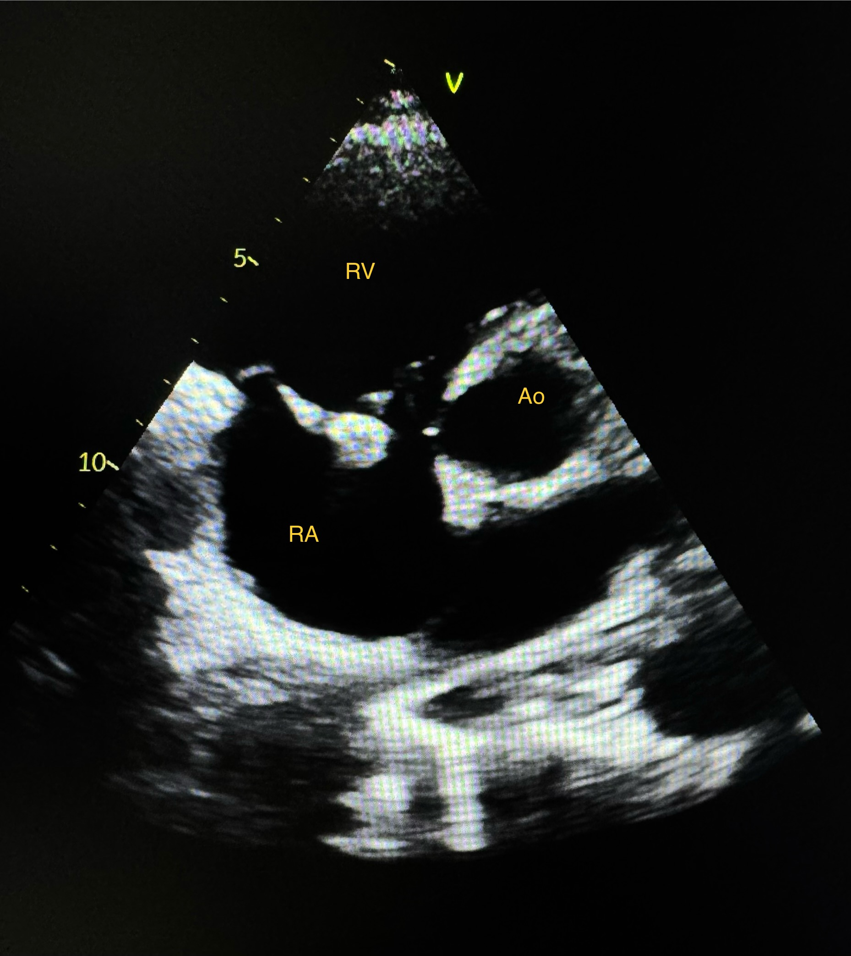
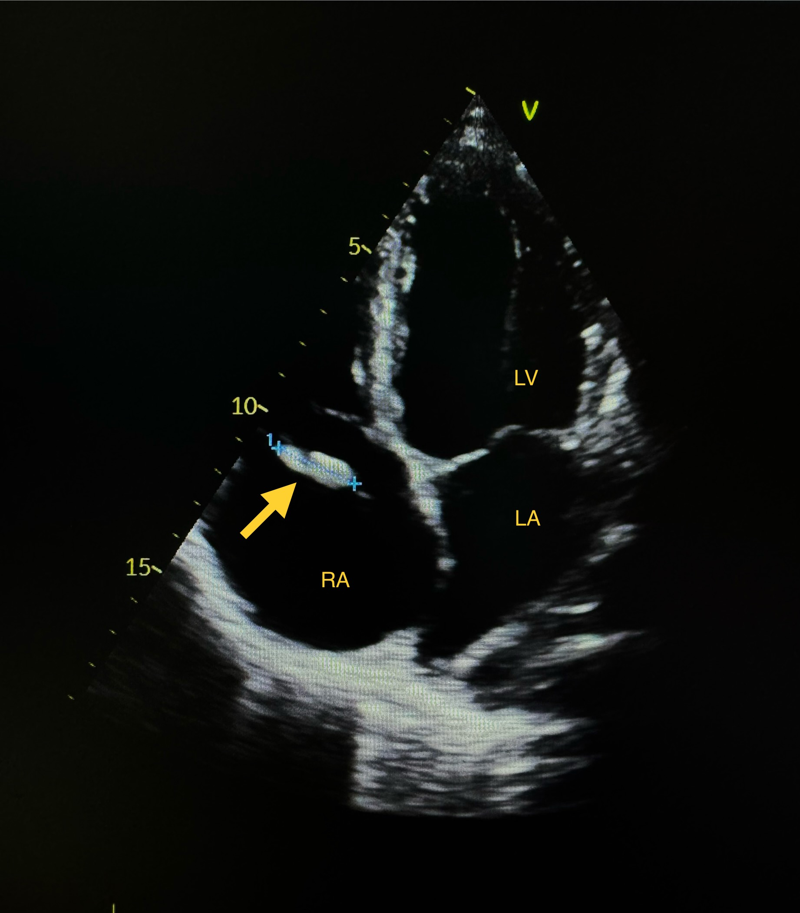
A 47-year-old man, chronic smoker, with a history of chronic lymphocytic leukemia in complete remission since 2019 after chemotherapy, presented with persistent fever. The patient had been lost to medical follow-up since 2019 and had retained the implantable venous access device placed during his oncologic treatment. In 2024, he sought medical attention for a prolonged febrile episode, with temperatures ranging from 39°C to 40°C. Despite several empirical antibiotic therapies, his clinical condition did not improve. He reported a three-month history of persistent fever, night sweats, and exertional dyspnea.
Upon admission, he appeared pale but remained hemodynamically stable, with a blood pressure of 130/64 mmHg, heart rate of 100 bpm, and oxygen saturation of 98%. No clinical signs of heart failure were detected. Cardiac auscultation revealed a grade 3/6 holosystolic murmur at the tricuspid area, and splenomegaly was observed. There was no neck stiffness, and the remainder of the physical examination was unremarkable.
Fig1. Transthoracic echocardiography showing a mobile vegetation attached to the tricuspid valve. (A) Apical four-chamber view demonstrating a hyperechoic mass protruding into the right atrium (arrow). (B) Parasternal short-axis view confirming the tricuspid valve vegetation. RA, right atrium; RV, right ventricle.
Electrocardiography showed a sinus rhythm at 90 bpm. Transthoracic echocardiography revealed a mobile, hyperechoic mass measuring 16 × 8 mm on the posterior leaflet of the tricuspid valve, consistent with vegetation (Figure 1), associated with severe tricuspid regurgitation due to leaflet flail (Figure 2) and moderate right-sided chamber dilation (RV dimension = 46 mm, RA area = 28 cm²). The inferior vena cava was dilated at 25 mm and non-collapsible (Figure 3), with normal pulmonary outflow. Evaluation of the left heart was normal, with no vegetation on the mitral or aortic valves, a non-dilated left ventricle with preserved systolic function (LVEF estimated at 60%), and no intracardiac shunt.

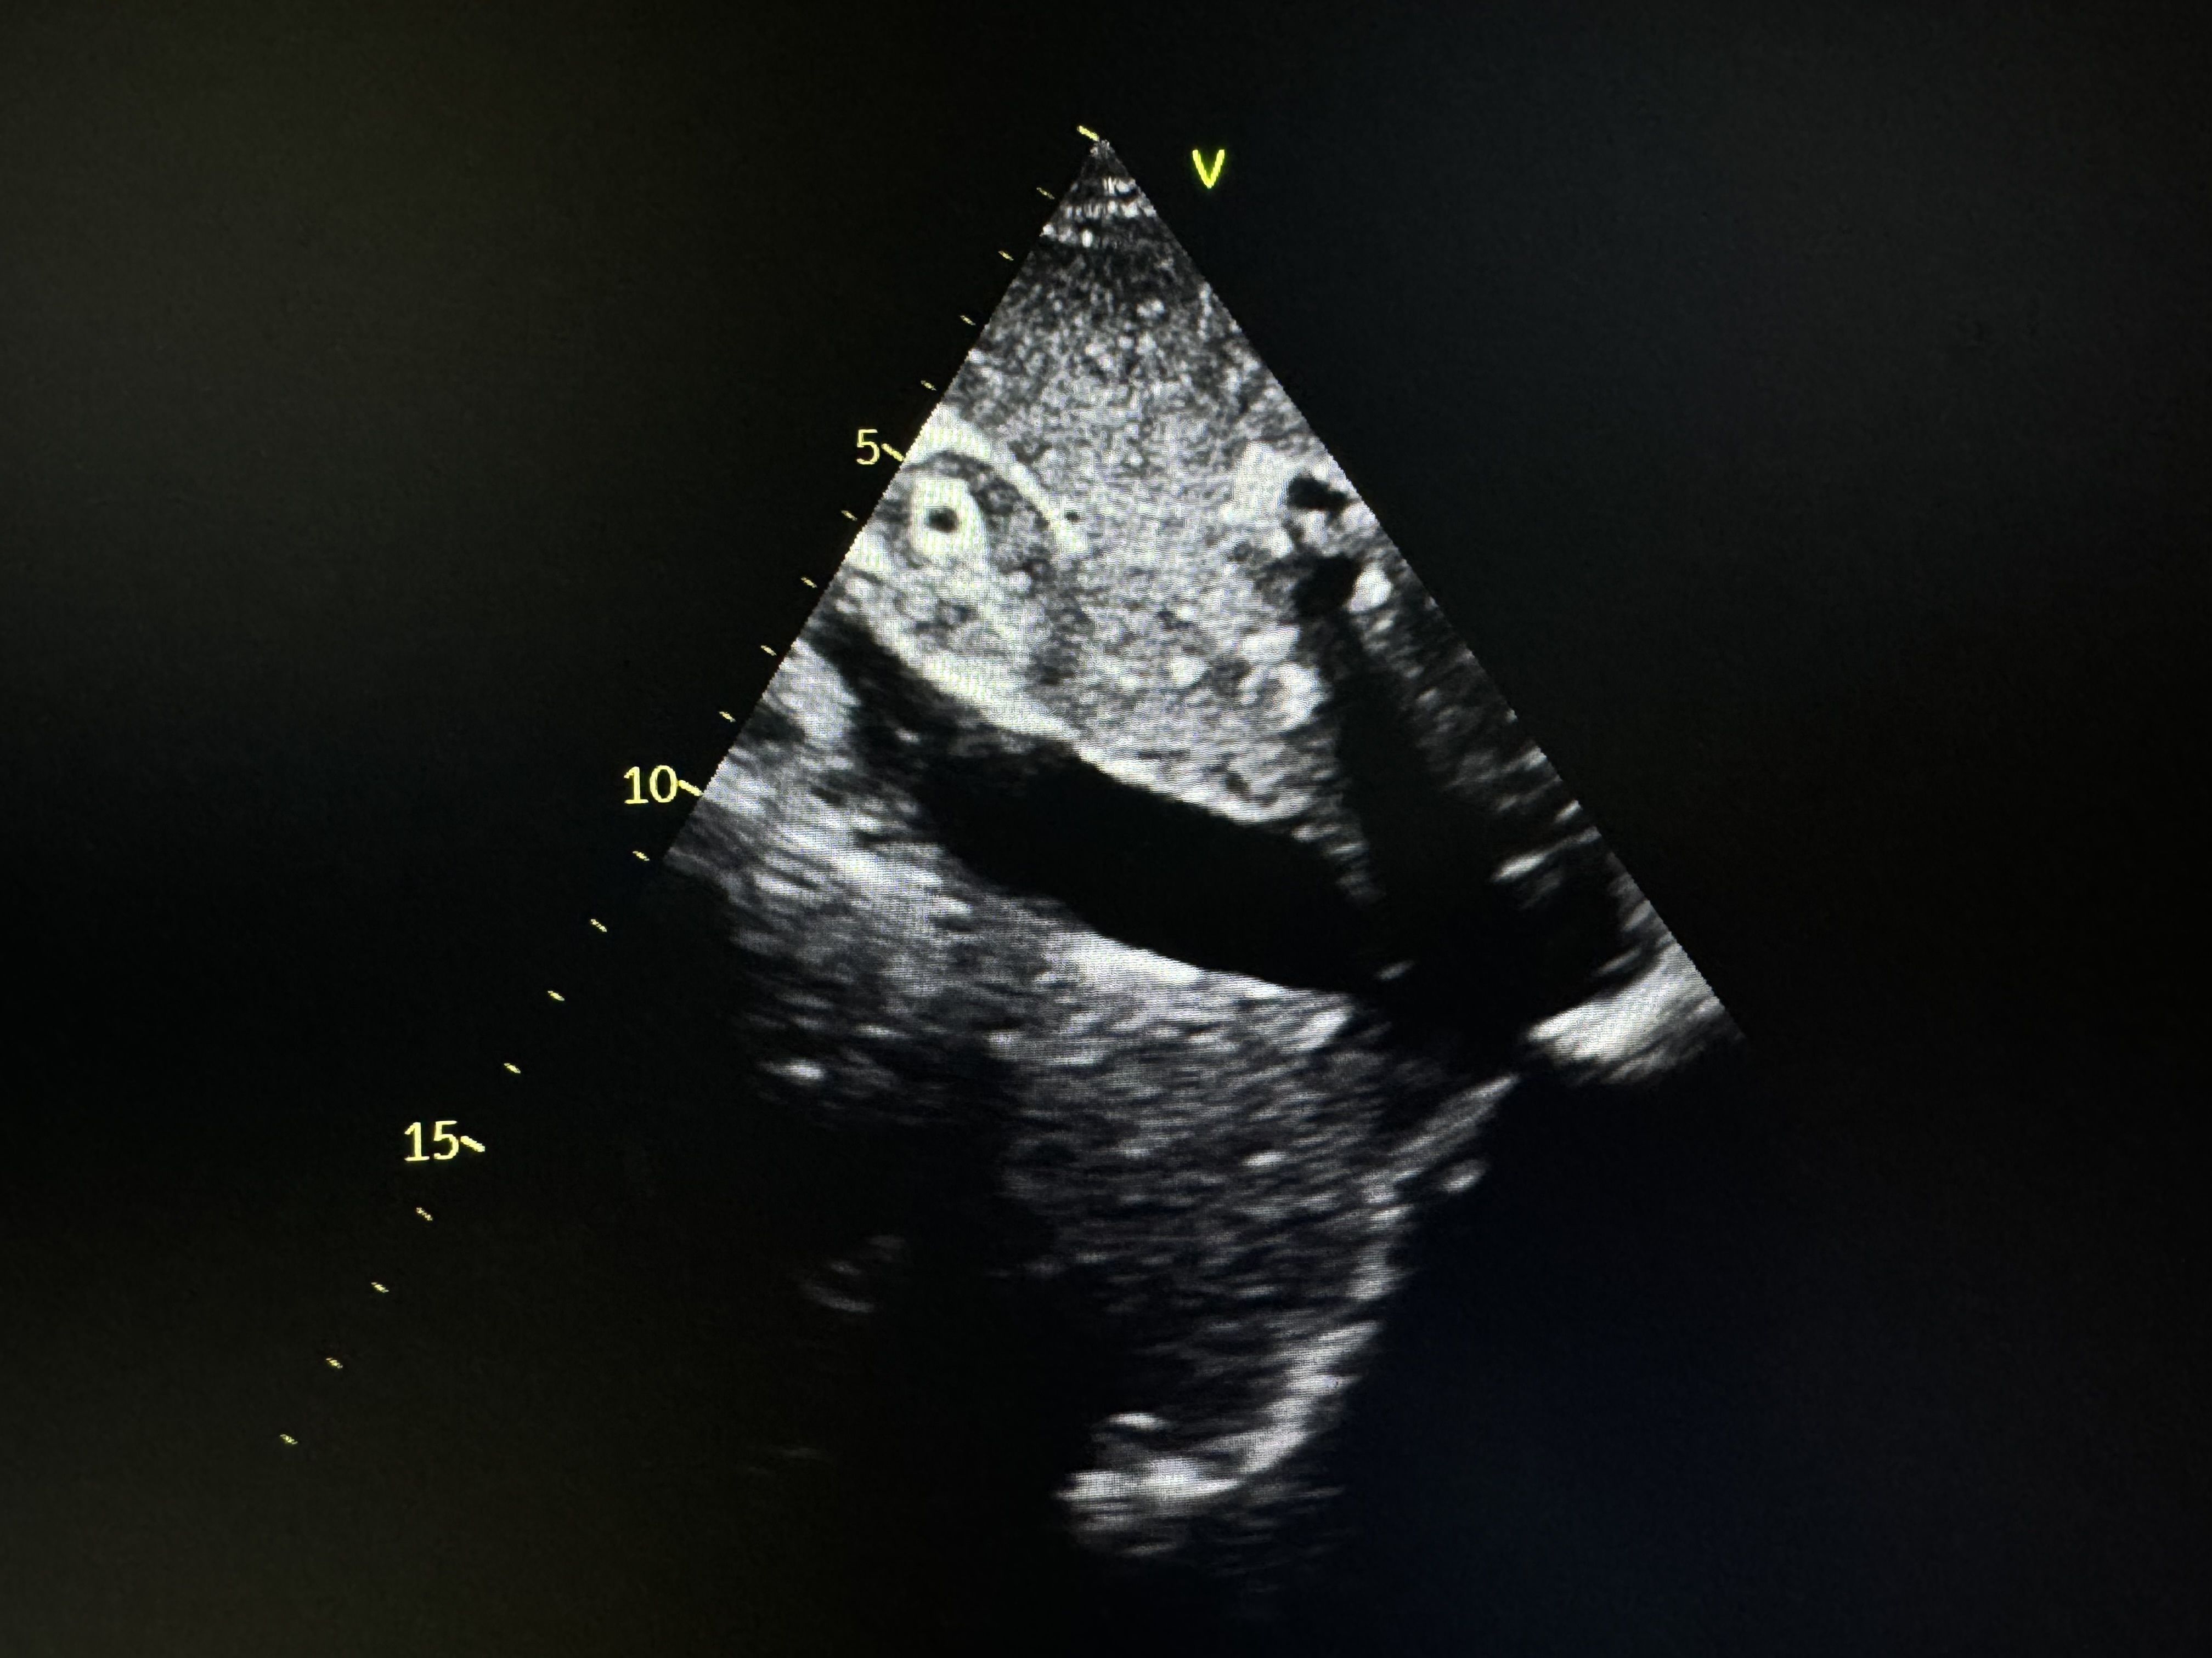
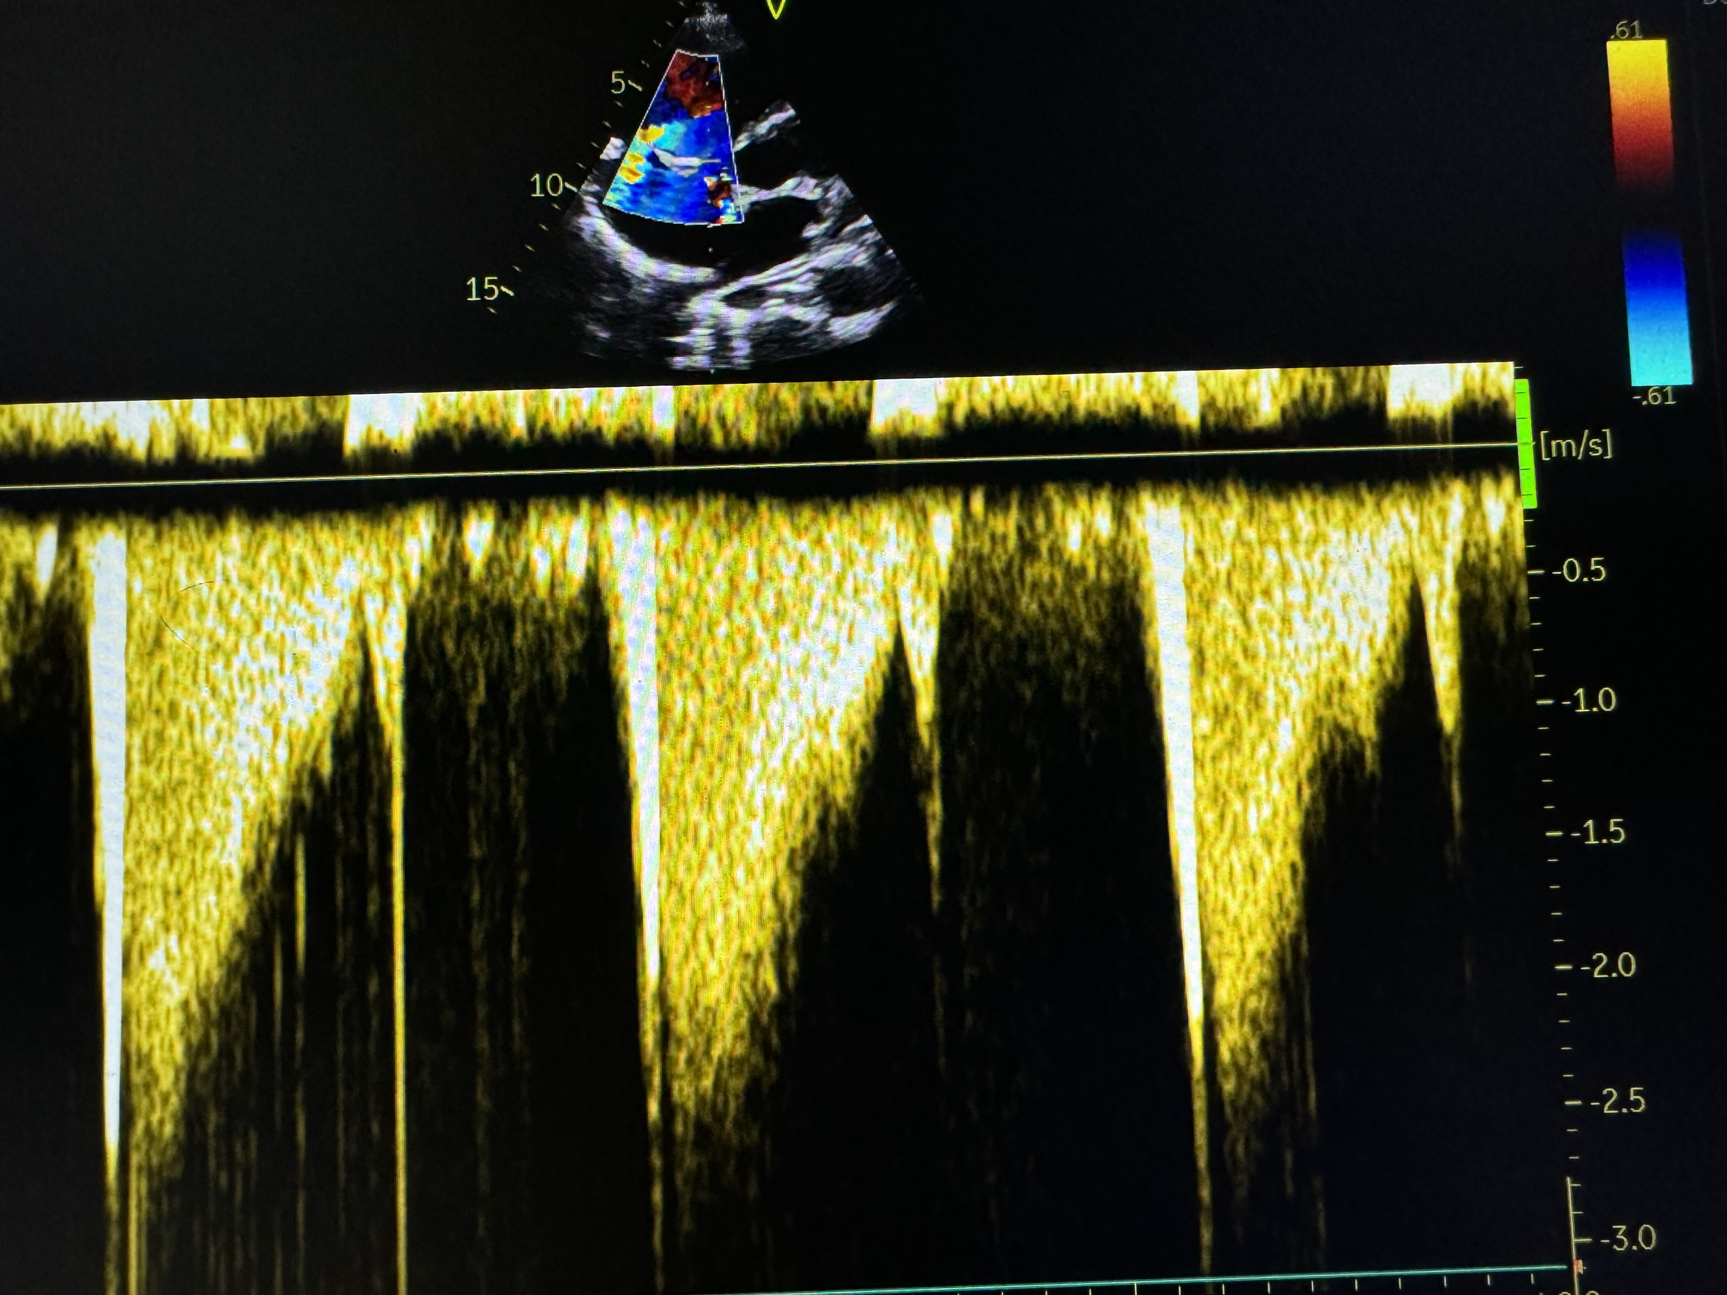
Fig2. Continuous-wave Doppler echocardiography demonstrating a dense, triangular-shaped systolic jet consistent with severe tricuspid regurgitation.
Fig.3 Subcostal transthoracic echocardiographic view showing a dilated inferior vena cava with reduced respiratory collapse, consistent with elevated right atrial pressure.

Contrast-enhanced abdominopelvic CT revealed no significant abnormalities. Laboratory investigations showed anemia (hemoglobin 7.5 g/dL, mean corpuscular volume 80 fL, mean corpuscular hemoglobin 30 g/dL), elevated ferritin (360 µg/L), leukocytosis (12,000/mm³), elevated C-reactive protein (150 mg/dL), positive procalcitonin (1.5 ng/mL), and thrombocytopenia (100,000/mm³). Four blood cultures drawn from different venipuncture sites without delay all grew Streptococcus pneumoniae, sensitive to ceftriaxone (Figure 4). Bacteriological analysis of the implantable venous chamber, removed during hospitalization, showed no evidence of infection. Coombs testing and rheumatoid factor screening were negative, and both urinalysis and urinary sediment examination were unremarkable. The diagnosis of infective endocarditis (IE) was established according to the modified Duke criteria, with two major criteria: echocardiographic evidence of vegetation and positive blood cultures. Empirical intravenous antibiotic therapy with ceftriaxone (4 g/day) and gentamicin was initiated and subsequently adjusted based on antimicrobial susceptibility. The patient experienced rapid improvement, with sustained defervescence, decreasing inflammatory markers, and negative follow-up blood cultures within one week Figure 4 illustrates the evolution of inflammatory markers and microbiological clearance during the first week of therapy, showing a rapid decline in CRP and procalcitonin levels together with complete sterilization of blood cultures.
Fig4. Time-course evolution of inflammatory biomarkers and blood culture results during the first week of antimicrobial therapy, showing a rapid decrease in C-reactive protein and procalcitonin levels together with clearance of bloodstream infection.
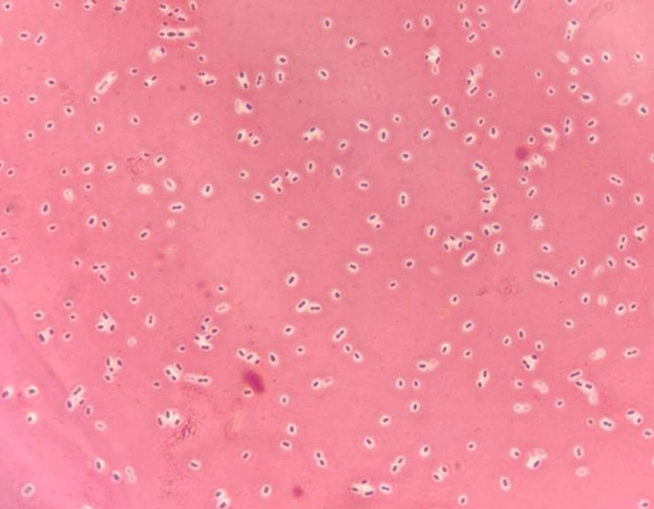
Procalcitonin levels also normalized. Intravenous antibiotic therapy was continued for six weeks. Clinical evolution was favorable, and at a four-week follow-up visit after discharge, the patient remained asymptomatic, without complications, and echocardiography confirmed a progressive redu ction in vegetation size.
Fig.5 Gram-stained smear showing Gram-positive diplococci consistent with Streptococcus pneumoniae, observed under oil immersion light microscopy (×1000 total magnification).

Discussion

This case illustrates a rare presentation of right-sided infective endocarditis caused by Streptococcus pneumoniae in a patient with chronic lymphocytic leukemia in remission who had retained an implantable venous access device for five years. Pneumococcal endocarditis typically involves the left-sided cardiac valves, where elevated intracardiac pressures favor endothelial disruption and subsequent microbial adherence [9]. Conversely, right-sided endocarditis is uncommon and is more frequently linked to intravenous drug use or the presence of intracardiac devices [10]. In the present case, the absence of intravenous drug use or structural heart disease suggests that the long-standing venous device may have facilitated bacterial colonization, as described in prior reports [1].

The patient presented with persistent fever despite empirical antibiotic treatment, together with splenomegaly and a relevant medical history. These elements prompted an evaluation for infective endocarditis, which was subsequently confirmed by transthoracic echocardiography. The examination revealed a mobile vegetation measuring 16 × 8 mm on the posterior leaflet of the tricuspid valve, resulting in severe regurgitation and moderate right ventricular dilation. Figure 6 shows the progressive reduction in tricuspid vegetation size over the course of treatment, supporting the favorable structural response typically observed in medically managed right-sided pneumococcal endocarditis. These findings are compatible with previously reported characteristics of right-sided endocarditis [7], where low-pressure gradients contribute to the formation of larger vegetations. Pneumococcal endocarditis is also recognized for producing voluminous vegetations, which heighten the risk of embolic complications [11]. Streptococcus pneumoniae is an infrequent cause of endocarditis, representing fewer than 2% of cases in recent cohorts [3], and is classically associated with left-sided involvement, particularly in the context of Austrian syndrome. In this patient, S. pneumoniae was isolated from repeated blood cultures and demonstrated susceptibility to ceftriaxone, enabling timely and effective antimicrobial therapy with marked clinical improvement. Prior studies have underscored the substantial morbidity of pneumococcal endocarditis when diagnosis or treatment is delayed [12].

Although direct evidence of device infection was lacking, the implantable chamber was removed to eliminate a potential reservoir for persistent or recurrent bacteremia. This decision aligns with current recommendations, which advocate device extraction in cases of suspected endocarditis [1]. Its removal contributed to infection control and likely reduced the risk of subsequent complications [11].



Fig6. Serial transthoracic echocardiographic measurements showing progressive reduction in tricuspid valve vegetation size during targeted antimicrobial therapy.

Ceftriaxone therapy resulted in rapid fever resolution, decreased inflammatory markers, and clearance of bacteremia. These findings confirm the efficacy of β-lactam antibiotics in managing pneumococcal endocarditis. However, the exceptional nature of right-sided S. pneumoniae infection underscores the need for clinical vigilance and prompt diagnostic testing, especially in patients with long-standing central venous devices, even in the absence of specific clinical signs [5].

This case highlights the diagnostic and therapeutic challenges of right-sided infective endocarditis and reinforces the importance of systematic device removal when infection is suspected. It further demonstrates that even rare presentations of endocarditis can be effectively managed through timely diagnosis, targeted antimicrobial therapy, and appropriate management of associated intravascular devices.

Table 1 — Comparison of published case reports of right-sided infective endocarditis due to Streptococcus pneumoniae.
Parameter | Our Case | Rocha et al., 2021[13] | Yamazaki et al., 2022 [14] | Lacalzada et al., 2015 [15]
Valve involved | Tricuspid (right-sided) | Tricuspid | Possible right-sided involvement | Large vegetations
Valve / site involved | Tricuspid valve (right-sided) | Right ventricle (septum, free wall, outflow tract) with VSD | Aortic valve (left-sided) | Prosthetic aortic valve + tricuspid involvement + pacemaker lead
Risk factors / substrate | Long-standing venous port; CLL in remission | Unrepaired congenital VSD | Acute sinusitis as infection source | Prior aortic valve replacement; permanent pacemaker
Clinical presentation | 3-month fever, dyspnea, 16×8 mm vegetation | 3-month fever, cough, asthenia; extensive RV vegetations; septic pulmonary emboli | Low back pain, ankle pain; high CRP; sinusitis as source | Acute fever, deterioration; prosthetic dysfunction; sepsis
Blood cultures | S. pneumoniae (4/4) | S. pneumoniae | S. pneumoniae | S. pneumoniae
Complications | RV dilation, non-collapsible IVC | Extensive RV involvement + septic pulmonary embolism | Paraspinal abscess; osteoarticular infection | Periannular abscess, prosthetic dehiscence, severe AR
Treatment | Ceftriaxone + gentamicin + device removal | Ampicillin + flucloxacillin + gentamicin → ceftriaxone; surgery | Sequential IV vancomycin, ceftriaxone, ampicillin, gentamicin | IV β-lactams; emergency surgery planned
Outcome | Favorable | Favorable | Favorable | Death before emergency surgery

Table 1 shows that published case reports of right-sided infective endocarditis caused by Streptococcus pneumoniae share several clinical similarities with our observation, despite important contextual variations. Rocha et al. described a pneumococcal tricuspid endocarditis in a patient without conventional risk factors, characterized by a large vegetation and good response to ceftriaxone, a pattern closely matching our case. Likewise, the report by Wenaas et al. represents one of the earliest descriptions of pneumococcal tricuspid valve endocarditis, demonstrating that S. pneumoniae can affect the right heart even in the absence of intravenous drug use, structural heart disease, or overt device infection. Yamazaki et al. highlighted a misleading respiratory presentation that initially suggested pneumonia, mirroring the diagnostic challenges encountered in our patient, whose symptoms were dominated by fever, dyspnea, and nonspecific systemic signs. The case reported by Lacalzada et al. also underlines the potential severity of pneumococcal infections, which may produce large vegetations and rapid clinical deterioration. Compared with these cases, our report is distinctive in that the patient had retained an implantable venous access device for several years, a factor that likely contributed to bacterial seeding despite the absence of microbiologic evidence of device infection. Taken together, these observations indicate that pneumococcal right-sided endocarditis, though rare, should be considered in patients with persistent fever and respiratory or systemic symptoms, particularly when long-standing intravascular devices are present. »

Conclusion
This case underscores the clinical relevance of recognizing atypical presentations of right-sided infective endocarditis, particularly when caused by Streptococcus pneumoniae, an increasingly uncommon pathogen in this context. In the absence of conventional risk factors such as intravenous drug use, congenital heart disease, or overt device infection, the presence of a long-standing implantable venous chamber likely played a key contributory role. The case illustrates the importance of maintaining a high index of suspicion for right-sided IE in patients presenting with persistent fever and respiratory or nonspecific systemic symptoms, especially those with indwelling intravascular devices.
Timely echocardiographic evaluation, systematic blood culture sampling, and early initiation of targeted antimicrobial therapy were essential to achieving a favorable outcome. Device removal, although not bacteriologically proven as the infectious source, aligned with current recommendations and likely contributed to clinical resolution. This report highlights that optimal management of rare forms of IE relies on prompt diagnosis, appropriate antimicrobial selection, and individualized assessment of intravascular devices. Greater awareness of such atypical presentations can help prevent diagnostic delays and improve prognosis in similar patient populations.

Abbreviations

IE: Infective endocarditis

TTE: Transthoracic echocardiography

RA: Right atrium

RV: Right ventricle

IVC: Inferior vena cava

CRP: C-reactive protein

CT: Computed tomography

LVEF: Left ventricular ejection fraction

Ethics approval and consent to participate
Ethical approval was not required for this single-patient case report, as per institutional and international guidelines. Written informed consent to participate was obtained from the patient.

Consent for publication
Written informed consent was obtained from the patient for publication of anonymized clinical data and accompanying images.

References
- RAJANI, Ronak et KLEIN, John L. Infective endocarditis: A contemporary update. Clinical medicine, 2020, vol. 20, no 1, p. 31-35. DOI : 10.7861/clinmed.cme.20.1.1
- CHAHOUD, Jad, YAKAN, Ahmad Sharif, SAAD, Hala, et al. Right-sided infective endocarditis and pulmonary infiltrates: an update. Cardiology in review, 2016, vol. 24, no 5, p. 230-237 DOI : 10.1097/CRD.0000000000000095
- ROCHA, Patrícia, RODRIGUES, Pedro Fernandes, SILVA, Ana Lima, et al. Extensive right-sided infectious endocarditis due to Streptococcus pneumoniae. BMJ Case Reports CP, 2021, vol. 14, no 6, p. e240586 DOI : 10.1136/bcr-2020-240586
- YAMAZAKI, Ken, MIURA, Takashi, SUNOHARA, Daisuke, et al. Infective endocarditis caused by Streptococcus pneumoniae from sinusitis: A case report. Journal of Cardiology Cases, 2022, vol. 25, no 5, p. 279-281. DOI : 10.1016/j.jccase.2021.11.010
- REVILLA, Ana, LÓPEZ, Javier, VILLACORTA, Eduardo, et al. Isolated right-sided valvular endocarditis in non-intravenous drug users. Revista Española de Cardiología (English Edition), 2008, vol. 61, no 12, p. 1253-1259. DOI : 10.1016/S1885-5857(09)60052-9
- AKINOSOGLOU, Karolina, APOSTOLAKIS, Efstratios, MARANGOS, Markos, et al. Native valve right sided infective endocarditis. European journal of internal medicine, 2013, vol. 24, no 6, p. 510-519. DOI : 10.1016/j.ejim.2013.03.012
- YUAN, Shi-Min. Right-sided infective endocarditis: recent epidemiologic changes. International Journal of Clinical and Experimental Medicine, 2014, vol. 7, no 1, p. 199.
- MAHAMID, Muhamad, MASHIAH, Jusinga, ROZNER, Ehud, et al. Right-Sided Endocarditis involving Eustachian Valve Following the Use of a Central Venous Line. The American Journal of Case Reports, 2020, vol. 21, p. e923465-1. DOI :10.12659/AJCR.923465
- KAPOOR, Sumit, THAKKAR, Jyotsana, et SIDDIQUE, Muhammad Asim. Septic pulmonary emboli causing recurrent bilateral pneumothoraces in a patient with right sided endocarditis: a case report and review of literature. SAGE Open Medical Case Reports, 2018, vol. 6, p. DOI :10.1177/2050313X18784823
- LASSEN, Helena, NIELSEN, Stig Lønberg, GILL, Sabine Ute Alice, et al. The epidemiology of infective endocarditis with focus on non-device related right-sided infective endocarditis: a retrospective register-based study in the region of southern Denmark. International Journal of Infectious Diseases, 2020, vol. 95, p. 224-230. DOI: 10.1016/j.ijid.2020.04.011
- WITTEN, James C., HUSSAIN, Syed T., SHRESTHA, Nabin K., et al. Surgical treatment of right-sided infective endocarditis. The Journal of thoracic and cardiovascular surgery, 2019, vol. 157, no 4, p. 1418-1427. e14. DOI: 10.1016/j.jtcvs.2018.07.112
- Lacalzada J, Padilla M, de la Rosa A, Laynez I. Infectious endocarditis due to Streptococcus pneumoniae in a cardiac surgery patient: a new form of clinical presentation. Clin Case Rep. 2015 Dec 8;4(2):129-32. doi: 10.1002/ccr3.448. PMID: 26862407; PMCID: PMC4736536. DOI: 10.1002/ccr3.448
- ROCHA, Patrícia, RODRIGUES, Pedro Fernandes, SILVA, Ana Lima, et al. Extensive right-sided infectious endocarditis due to Streptococcus pneumoniae. BMJ Case Reports CP, 2021, vol. 14, no 6, p. e240586.
- YAMAZAKI, Ken, MIURA, Takashi, SUNOHARA, Daisuke, et al. Infective endocarditis caused by Streptococcus pneumoniae from sinusitis: A case report. Journal of Cardiology Cases, 2022, vol. 25, no 5, p. 279-281.
- LACALZADA, Juan, PADILLA, Marta, DE LA ROSA, Alejandro, et al. Infectious endocarditis due to Streptococcus pneumoniae in a cardiac surgery patient: a new form of clinical presentation. Clinical Case Reports, 2015, vol. 4, no 2, p. 129.

