Case report
Severe Aortic Stenosis in a Patient With Transthyretin Cardiac Amyloidosis: A Case Report

Abstract :
Transthyretin cardiac amyloidosis (ATTR-CA) is increasingly identified in elderly patients with aortic stenosis (AS) and may complicate diagnosis and management. Case Presentation: We report an elderly patient with severe AS and marked left ventricular hypertrophy. The presence of an “apical sparing” strain pattern and diffuse late gadolinium enhancement on cardiac MRI raised suspicion for amyloid cardiomyopathy. Bone scintigraphy showed intense myocardial uptake (Perugini grade 3) without monoclonal proteins, confirming ATTR-CA. The patient underwent successful transcatheter aortic valve implantation (TAVI) and was started on TTR-stabilizing therapy.
Keywords : Aortic Stenosis, stabilizing therapy, scintigraphy, Transthyretin cardiac amyloidosis
Introduction : Transthyretin cardiac amyloidosis (ATTR-CA) is a rare but increasingly recognized cause of heart failure, characterized by myocardial deposition of misfolded transthyretin. Its symptoms often overlap with common cardiac conditions, making diagnosis challenging. Severe aortic stenosis (AS) can coexist with ATTR-CA, further complicating the clinical picture.
We report a case of ATTR-CA in a patient with severe AS, emphasizing the diagnostic approach and key imaging findings. This case highlights the importance of considering cardiac amyloidosis in patients with unexplained left ventricular hypertrophy or atypical heart failure, especially when associated with valvular disease.
Case report : A 77-year-old patient with a history of well-controlled type 2 diabetes mellitus on oral antidiabetic therapy, and no other significant past medical history, was admitted to the cardiology department for the management of a first episode of left-sided heart failure.
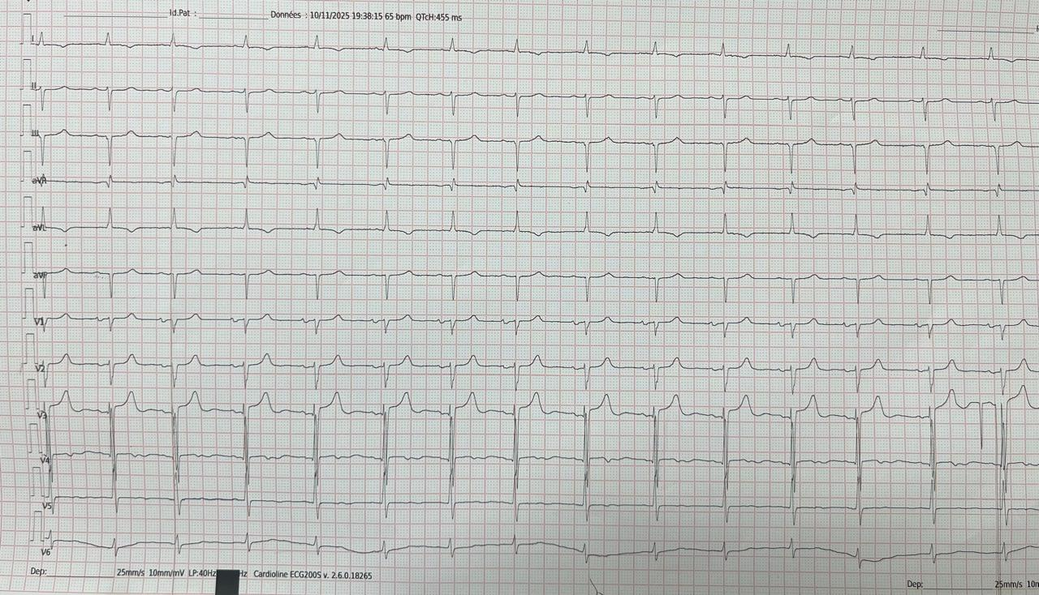
On electrocardiogram, the patient had a regular sinus rhythm with an average ventricular rate of 65 bpm, a leftward cardiac axis, no evidence of left ventricular hypertrophy, and no obvious secondary repolarization abnormalities. Small Q waves suggestive of pseudo-infarction were observed in the inferior leads (Figure 1).
Figure 1 : 12-lead electrocardiogram showing sinus rhythm, left axis deviation, and inferior pseudo-infarction Q waves
Laboratory tests were largely unremarkable, except for an elevated NT-proBNP level. Transthoracic echocardiography revealed a hypertrophied left ventricle with an interventricular septum thickness of 16 mm and a posterior wall thickness of 14 mm, exhibiting a sparkling (“granular”) appearance of the septum. The right ventricle was also hypertrophied, with a free wall thickness of 8 mm.
A severe degenerative aortic stenosis was identified, characterized by a tricuspid calcified aortic valve. The indexed aortic valve area was 0.41 cm²/m², with a mean gradient of 38 mmHg and a peak velocity (Vmax) of 4.04 m/s. Both atria were dilated, and left ventricular filling pressures were elevated, with a dilated, non-compliant inferior vena cava.
Left ventricular ejection fraction was preserved at 55%; however, longitudinal strain was markedly reduced at –9%, showing an apical-to-basal gradient with a characteristic “apical sparing” (cherry-on-top or bull’s-eye) pattern (Figure 2).
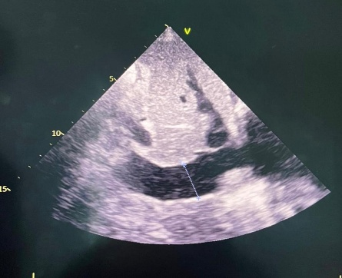
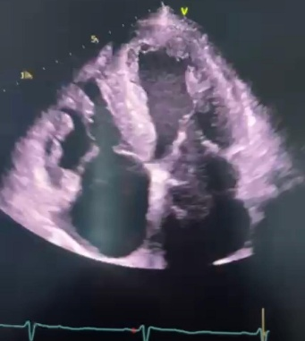
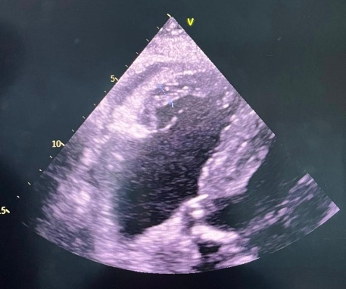
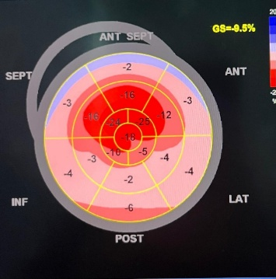
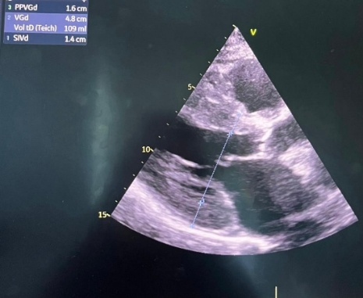
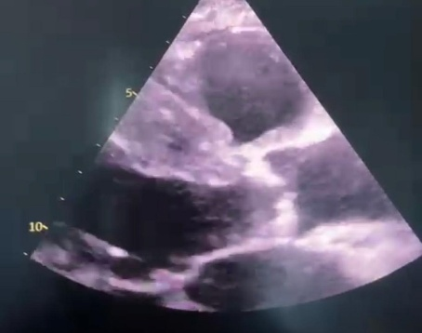
Figure 2 : Transthoracic echocardiography showing concentric left ventricular hypertrophy, “granular” septal appearance, and severe aortic stenosis with calcified tricuspid aortic valve
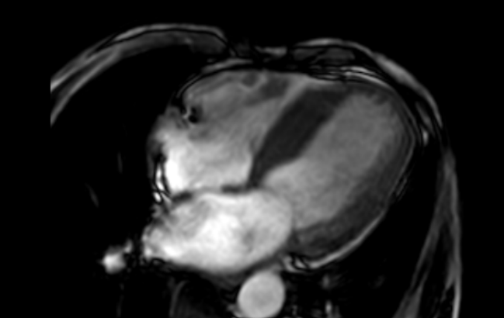
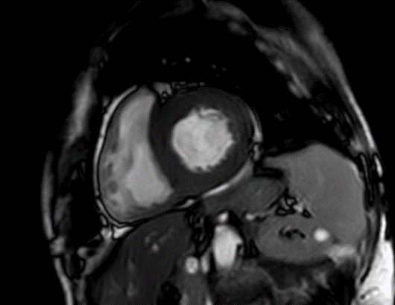
Given the “apical-sparing” pattern observed on global longitudinal strain, a cardiac magnetic resonance (CMR) study was performed. CMR confirmed the diagnosis of cardiac amyloidosis, demonstrating late gadolinium enhancement involving the atria, valves, and ventricular walls (Figure 3).
Figure 3 : Cardiac MRI demonstrating late gadolinium enhancement involving the atria, valves, and ventricular walls, consistent with cardiac amyloidosis

To determine the type of amyloidosis, a bone scintigraphy was performed, showing marked diffuse myocardial tracer uptake, significantly higher than rib uptake, with reduced activity in the upper and lower limbs, corresponding to Perugini grade 3 (Figure 4).
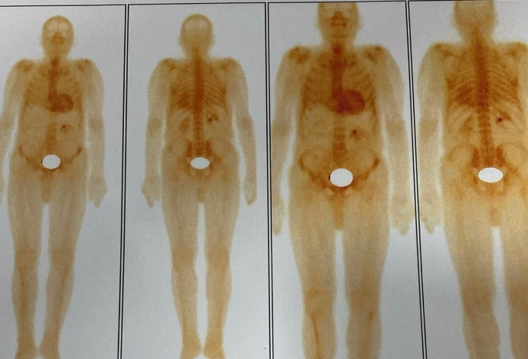
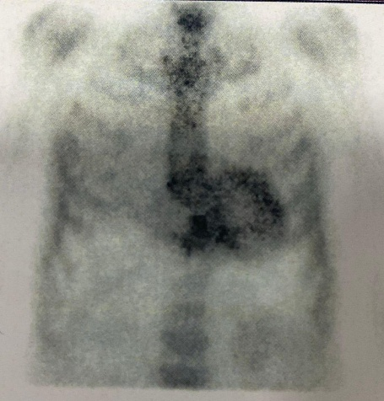
Figure 4 : Technetium-labeled bone scintigraphy showing diffuse myocardial tracer uptake with Perugini grade 3, consistent with transthyretin cardiac amyloidosis
Minor salivary gland biopsy and serum protein electrophoresis were negative, supporting a diagnosis of transthyretin cardiac amyloidosis (ATTR-CA).
The patient was therefore diagnosed with severe aortic stenosis associated with ATTR cardiac amyloidosis. He was transferred to the cardiovascular surgery department, where he underwent transcatheter aortic valve implantation (TAVI). Pharmacological therapy with Tafamidis was initiated.
Discussion :
Transthyretin cardiac amyloidosis (ATTR-CA) has emerged as an increasingly recognized yet frequently underdiagnosed etiology of heart failure, particularly among elderly individuals and those presenting with heart failure with preserved ejection fraction (HFpEF). Over the past decade, the availability of non-invasive diagnostic tools and growing clinical awareness have reshaped the understanding of this disease, revealing that ATTR-CA is considerably more prevalent than previously appreciated. Several contemporary observational studies have demonstrated that ATTR-CA often coexists with aortic stenosis (AS), with prevalence estimates ranging from 4% to over 16% in populations undergoing transcatheter aortic valve implantation (TAVI) or surgical aortic valve replacement. This intersection of two age-related cardiac diseases has important implications for diagnosis, therapeutic decision-making, and patient prognosis (1).
The coexistence of AS and ATTR-CA presents a unique diagnostic challenge because both diseases share overlapping structural and functional cardiac abnormalities. Concentric left ventricular hypertrophy, diastolic dysfunction, restrictive filling patterns, and elevated natriuretic peptides can be observed in either condition. As a result, clinicians may attribute the full spectrum of abnormalities solely to AS, thereby missing the underlying infiltrative process. In ATTR-CA, however, the degree of wall thickening is often disproportionate to the severity of pressure overload, and echocardiographic strain analysis has become a key modality in highlighting this discrepancy. The hallmark “apical sparing” pattern of global longitudinal strain (GLS), in which longitudinal deformation is relatively preserved at the apex compared with the basal and mid segments, provides a highly suggestive, non-invasive indicator of amyloid infiltration. This characteristic pattern has consistently demonstrated strong diagnostic performance and frequently serves as the first clue prompting more targeted evaluation (2).
Cardiac magnetic resonance imaging (CMR) has further strengthened diagnostic capabilities by offering a comprehensive tissue characterization platform. Diffuse or global subendocardial late gadolinium enhancement (LGE), together with markedly elevated extracellular volume (ECV) and abnormal native T1 times, reflects expansion of the interstitial space due to amyloid fibril deposition. These findings not only facilitate diagnosis but also correlate with disease burden and prognosis. CMR plays a particularly important role in differentiating amyloid cardiomyopathy from other causes of hypertrophy such as hypertrophic cardiomyopathy, hypertensive heart disease, or infiltrative conditions like Fabry disease. In the setting of AS, CMR can clarify whether left ventricular remodeling is consistent with pressure overload alone or whether a superimposed infiltrative process should be strongly suspected (3).
Among all available diagnostic tools, bone scintigraphy with technetium-labeled tracers (99mTc-PYP, 99mTc-DPD, or 99mTc-HMDP) has revolutionized the diagnostic pathway of ATTR-CA. A Perugini grade ≥2 in the absence of circulating monoclonal proteins has near-perfect specificity for ATTR-CA and allows a definitive non-biopsy diagnosis in the majority of patients. This is especially valuable in elderly individuals who may be poor candidates for invasive diagnostic procedures. Diffuse, intense myocardial uptake out of proportion to skeletal activity is highly characteristic and reflects the strong affinity of these tracers for amyloid fibrils. In our case, scintigraphy was fundamental in establishing the diagnosis with confidence and in guiding subsequent management (4).
The recognition of concomitant ATTR-CA and severe AS is not merely academic; it carries significant therapeutic and prognostic consequences. Patients with dual pathology often exhibit more advanced myocardial involvement, higher levels of cardiac biomarkers (NT-proBNP, troponin), and more profound diastolic dysfunction. A substantial proportion also present with low-flow, low-gradient AS despite preserved ejection fraction, a phenotype associated with diagnostic uncertainty and increased procedural risk. In this context, ATTR-CA may contribute to reduced myocardial contractile reserve, making standard echocardiographic assessment more complex (5).
Importantly, accumulating evidence indicates that the presence of ATTR-CA should not dissuade clinicians from offering definitive aortic valve intervention. TAVI has become the preferred therapeutic strategy for elderly or high-risk surgical candidates and appears to provide symptomatic and functional benefit even when amyloid cardiomyopathy is present. Observational data suggest that procedural mortality, complication rates, and intermediate-term outcomes are comparable between patients with isolated AS and those with coexisting amyloidosis, although long-term prognosis may be influenced by the progression of the underlying infiltrative disease. In contrast, surgical valve replacement may confer higher perioperative risk due to myocardial fragility, conduction abnormalities, and the multi-systemic burden of amyloidosis (6).
Beyond valve intervention, disease-modifying therapy for ATTR-CA has transformed the management landscape. Tafamidis, a transthyretin stabilizer, has demonstrated robust reductions in all-cause mortality and cardiovascular hospitalizations across a broad spectrum of patients with ATTR cardiomyopathy. Earlier initiation, particularly in symptomatic patients or those with coexisting AS, may slow disease progression, reduce myocardial infiltration, and improve functional capacity. As diagnostic awareness improves, the integration of TTR-targeted pharmacotherapy with timely valve intervention represents a new paradigm capable of extending survival and improving quality of life (7).
In summary, this case highlights the critical importance of maintaining a high degree of clinical suspicion for ATTR-CA in older adults presenting with AS and either disproportionate left ventricular hypertrophy, atypical strain patterns, or discordant hemodynamic parameters. A meticulous, multimodality imaging approach, including advanced echocardiographic strain imaging, CMR, and bone scintigraphy, facilitates accurate and early diagnosis. A comprehensive therapeutic strategy incorporating both aortic valve intervention and targeted TTR-modifying therapy offers the greatest opportunity to optimize outcomes in this complex and increasingly recognized clinical entity (8).
Conclusion :
This case highlights the importance of considering transthyretin cardiac amyloidosis in elderly patients with severe aortic stenosis, particularly when unexplained ventricular hypertrophy or characteristic strain patterns are present. Early recognition allows for timely valve intervention and initiation of disease-specific therapy, optimizing clinical outcomes.
Références :
1 : Bukhari, S. (2023). Prevalence, Predictors and Diagnosis of Cardiac Amyloidosis in Patients with Aortic Stenosis. Journal of Biomedical Research & Environmental Sciences. https://doi.org/10.37871/jbres1796
2 : Jaiswal, V., Ang, S. P., Chia, J. E., Abdelazem, E. M., Jaiswal, A., Biswas, M., Gimelli, A., Parwani, P., Siller-Matula, J. M., & Mamas, M. A. (2022). Echocardiographic predictors of presence of cardiac amyloidosis in aortic stenosis. European Heart Journal - Cardiovascular Imaging, 23(10), 1290-1301. https://doi.org/10.1093/ehjci/jeac146
3 : Costa, J., El-Ali, A., Morland, D., Dejust, S., Papathanassiou, D., Nazeyrollas, P., & Metz, D. (2024). Cardiac amyloidosis prevalence and 1-year outcome in patients with aortic stenosis undergoing transaortic valve implantation: Findings from the CAMPOS-TAVI study. Arch Cardiovasc Dis, 117(8-9), 461–469. https://doi.org/10.1016/j.acvd.2024.04.007
4 : Masri, A., Chen, Y., Colavecchia, A. C., Benjumea, D., Crowley, A., Jhingran, P., Kent, M., Wogen, J., Pankratova, C., Jimenez Alvir, J. M., & Bhambri, R. (2025). Coexisting Calcific Aortic Stenosis and Transthyretin Cardiac Amyloidosis: Real-World Evaluation of Clinical Characteristics and Outcomes. Journal of the American Heart Association, 14(2), e033251. https://doi.org/10.1161/JAHA.123.033251
5 : Prevalence of ATTR cardiac amyloidosis in patients with aortic stenosis: a higher risk population?. J Vasc Med Surg. 2025;3(4):2–13. doi:10.47363/JVMS/2025(3)118
6 : Gonzalez Lopez, E., et al. (2025). What Cardiologists Should Know About Amyloidosis. J. Clin. Med. https://doi.org/10.3390/jcm14186668
7 : Kotecha, T., Martinez-Naharro, A., Treibel, T. A., Francis, R., Nordin, S., Abdel-Gadir, A., Knight, D. S., Zumbo, G., Rosmini, S., Maestrini, V., Bulluck, H., Rakhit, R. D., Wechalekar, A. D., Gilbertson, J., Sheppard, M. N., Kellman, P., Gillmore, J. D., Moon, J. C., Hawkins, P. N., & Fontana, M. (2018). Myocardial edema and prognosis in amyloidosis. J Am Coll Cardiol, 71(25), 2919–2931. https://doi.org/10.1016/j.jacc.2018.03.536
8 : Kodali SK, Hahn RT, Eleid MF, Kumbhani DJ, Lerakis S, Williams MR, et al. Outcomes of transcatheter aortic valve replacement in patients with cardiac amyloidosis: insights from the STS/ACC TVT Registry. JACC Cardiovasc Interv. 2022;15(3):305-14

