Molecular Identification and Characterization of Keratinase-Producing Bacteria from Poultry Waste Sites in Enugu State
ABSTRACT
Introduction: Feather waste poses an environmental challenge because keratin is a structural fibrous polypeptide protein that is highly resistant to proteolytic degradation due to its complex bonding structure, which is stabilized by disulfide and hydrogen bonds.
Aim: In this research, we aimed to identify and characterize the bacteria keratinase that possess the ability to degrade keratin isolated from some poultry waste dumping sites in Enugu state, Nigeria.
Materials and Methods: Six waste soil samples were collected from three different locations, two from each location. A total of thirty bacterial isolates were obtained from the three poultry waste sites. Protease activity served as the main criterion for screening these isolates on skim milk agar plates.
Results: Five of the thirty isolates exhibited proteolytic activity and were further confirmed to possess keratinolytic activity on feather basal medium. Within fifteen days, the test showed nearly complete feather degradation. However, three bacterial isolates—FDS1, GARMS1, and GMIS1—that exhibited the highest keratinase activity were characterized. Further identification using 16S rRNA gene sequencing confirmed their molecular identities. Results on molecular characterization revealed that the isolates FDS1, GARMS1, and GMIS1 belong to the genus Bacillus. The isolates showed more than 95% similarity with Bacillus subtilis subsp. stercoris strain 153.
Conclusion: The soils from the Gariki Awkunanaw waste dumping sites, regardless of location, contained Bacillus subtilis subsp. stercoris strain 153

Keywords: Bacillus subtilis; bacteria; feather hydrolysis; keratin degradation; keratinolytic activity; poultry waste.
1. INTRODUCTION
The rapid growth of the world’s population has made the poultry industry an indispensable source of animal protein, resulting in the generation of large amounts of poultry waste from slaughterhouses and farms (Mozhiarasi and Natarajan, 2025; Orjiakor et al., 2025). As a by-product from poultry farm; untreated feathers harbour microorganisms and generates pollutants that are harmful to human health (Tamreihao et al., 2019). Based on poor waste management in third world countries, huge quantities of feathers are indiscriminately discarded in the environment thereby constituting a menace in the environment. According to Gržinić et al. (2023), these wastes contribute significantly to environmental pollution by producing foul odours, spreading microbial infections, and promoting the growth of flies and rodents. Although efforts are being made to repurpose these materials into useful products such as crop fertilizers and animal feed, developing nations like Nigeria still lack adequate facilities for their proper disposal (Nwobodo et al., 2023). Given that these wastes contain blood and tissue residues, they can serve as breeding grounds for various harmful microorganisms capable of triggering serious disease outbreaks. Among these are H5N1 avian influenza, mycoplasmosis, colibacillosis, and fowl cholera (Agrahari and Wadhwa, 2010; Haq Iu, 2020).
Feathers can be utilized in animal feed, thereby reducing the proliferation of pathogenic strains and discouraging feather accumulation in the environment. This practice functions as a form of recycling and can release important amino acids such as methionine, lysine, and histidine, which are better preserved when feathers are processed biotechnologically rather than chemically to produce feather meal (Xu et al., 2024). The biotechnological recycling of feather waste begins with the degradation of keratin; which is one of the most complex structural proteins found in the cytoskeletal intermediate filaments of epithelial cells in wool, horns, nails, hair, and feathers (Banasaz and Ferraro, 2024). Keratin is a highly stable, insoluble macromolecule that decomposes slowly but can be effectively degraded by keratinase. Through systematic recycling, keratin-rich waste can serve as a valuable source of protein and amino acids. The versatility of keratinase is evident in its broad industrial applications, including leather processing, textiles, waste bioconversion, detergents, and pharmaceuticals (Ashraf et al., 2023; Wang et al., 2023). Consequently, feathers can be recycled into an inexpensive alternative protein source for animal feed, thereby reducing dependence on conventional feed ingredients such as soybean, which is also consumed by humans (Ezenwali, 2022).
The first step in feather recycling involves the biochemical isolation, identification, and characterization of bacterial species capable of degrading feather materials into proteins. The most reliable approach is through genomic analysis of the bacterial strain (Al Mousa et al., 2021). In a study by Nwosu et al. (2021) on the isolation and identification of feather-degrading bacteria from a poultry waste dump site along the Enugu–Port Harcourt expressway, Bacillus spp. were identified as exhibiting strong keratinolytic activity. The authors, however, noted certain limitations in their work, including the absence of advanced techniques such as flow cytometry, polymerase chain reaction (PCR), and molecular sequencing, which are essential for definitive bacterial identification. They recommended that subsequent research should explore the molecular and genomic properties of these bacteria to ensure accurate strain identification. Integrating molecular identification techniques with traditional microbiological methods provides a robust framework for studying keratin-degrading bacteria and developing sustainable strategies for managing feather waste (Kumar et al., 2024). On this note, the present study aimed to investigate the molecular identification and characterization of keratinase-producing bacteria isolated from poultry waste sites in Gariki Awkunanaw, Enugu State.
2. MATERIALS AND METHODS
2.1 Location of the Study and Sample Collection
Following the procedure described by Prasad et al. (2010), poultry waste soil samples were collected from a depth of 3–4 cm. Six samples were obtained from three distinct sites in Gariki Awkunanaw, Enugu: Flyover Dumping Site (FDS), Gariki Agbani Road Market Site (GARMS), and Gariki Market Inside Site (GMIS) (Fig. 1). Each sample was placed in a sterile plastic bag to prevent contamination.
Using a sterile spatula, 2 g of each sample was transferred into sterile containers (Fig. 2). These samples were then transported under aseptic conditions to the Applied Biochemistry Laboratory at Enugu State University of Science and Technology and to Brain-Phosphorylationship Scientific Solution Services, Ogui Road, Enugu State, for further examination.

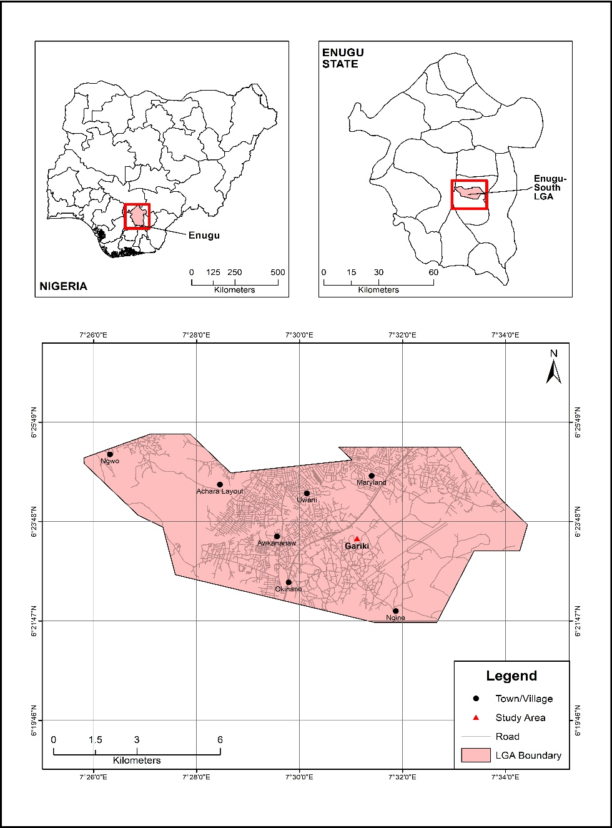
Fig. 1. Map of Gariki Awkunanaw, Enugu State, Nigeria (QGIS, 2025). The study area is characterized by a humid tropical climate with a mean daily temperature of 26.7 °C and an annual rainfall ranging between 1680 mm and 1800 mm. The vegetation consists primarily of rainforest, interspersed with patches of woodland and stunted trees. It also includes areas of secondary forest composed of scattered tall trees, climbers, and occasional shrubs (Anierobi et al., 2023).
Fig. 2. Sample collection containing feather waste
2.2 Microbial Culture of Keratinolytic Bacteria
After preparing the feather substrate according to the standard method of Agrahar (2013), sterilization was performed in an autoclave at 121°C for 15 minutes using a well-calibrated 1000 ml conical flask containing 1000 ml of salt medium, prepared according to the standard method of Wakil et al. (2011). After sterilization and cooling to room temperature, 10 g of feather hair—the only carbon source, collected from the poultry waste site was added to the salt medium. The mixture was then incubated for 72 hours at 200 rpm and 37°C in an orbital shaking incubator.
To obtain distinct colonies within 24 hours of incubation at 37°C, aliquots of this culture were streaked on the same medium containing agar (20 g/L). To achieve pure cultures, individual colonies were sub-cultured onto several petri dishes. The different colonies were subsequently transferred individually into separate labelled 250 ml conical flasks containing 150 ml of a pH 9 phosphate buffer solution and a sterilized yeast extract medium (g/L): yeast extract, 5; peptone, 5; sucrose, 20; and KCl, 20. These samples were incubated for four days at 37°C and 200 rpm in an orbital shaking incubator to promote microbial cell growth and multiplication. The emerging isolates that showed better growth and keratin degradation were selected and subjected to Gram staining, as well as biochemical, physiological, and morphological characterization for identification.
2.3 Primary Screening of Proteolytic Bacteria and Secondary Screening of Keratinolytic Bacteria
The microbial isolates were inoculated onto skimmed milk agar medium. Proteolytic activity was indicated by the formation of a clear zone surrounding the colonies after incubation for 24 hours at 37°C (Jeong et al., 2010). The diameters of all hydrolytic zones were measured, and colonies that produced large zones of clearance were selected for secondary screening. Pure bacterial isolates were maintained on nutrient agar slants at 4°C for further investigation.
For the secondary screening, a basal medium containing chicken feathers was inoculated with the selected isolates. After inoculation and adjustment of the pH to 8.0, the cultures were incubated at 37°C on a rotary shaker set at 150 rpm (Al Hasan, 2018). Following 24 hours of incubation, plate growths were examined, and the isolates were subcultured onto fresh medium plates until pure colonies were obtained. The pure cultures of the isolates were transferred into McCartney bottles and preserved. Identification of the isolates was carried out based on Gram staining, biochemical characteristics, and morphological appearance.
2.4 Genotypic/Molecular Characterization
2.4.1 DNA Extraction
Genomic DNA was extracted using the ZR Fungal/Bacterial DNA Miniprep Kit (Zymo Research, USA) following the manufacturer’s protocol. A ZR Bashing™ Lysis Tube was filled with 2 mL of bacterial cell broth, followed by the addition of 750 μL of Lysis Solution. The tube was secured in a 2 mL bead beater holder assembly and processed at maximum speed for more than 5 minutes to ensure complete cell disruption. The lysate was then centrifuged at 10,000 × g for 1 minute. A Zymo-Spin™ IV Spin Filter (orange cap) was placed into a collection tube, and 400 μL of the supernatant was transferred into it. The mixture was centrifuged at 7,000 × g for 1 minute. The resulting filtrate was combined with 1,200 μL of Fungal/Bacterial DNA Binding Buffer. An 800 μL aliquot of this mixture was transferred onto a Zymo-Spin™ IIC Column fitted in a collection tube and centrifuged at 10,000 × g for 1 minute. The flow-through was discarded. The column was washed with 500 μL of Fungal/Bacterial DNA Wash Buffer and centrifuged at 10,000 × g for 1 minute, followed by an additional wash with 200 μL of DNA Pre-Wash Buffer. To elute the purified DNA, the Zymo-Spin™ IIC Column was placed in a sterile 1.5 mL microcentrifuge tube, and 100 μL (minimum 35 μL) of DNA Elution Buffer was added. The tube was centrifuged at 10,000 × g for 30 seconds to obtain the eluted DNA.
2.4.2 Electrophoresis for DNA and PCR
Two grams of agarose were used for PCR, and one gram was used for DNA. In a microwaveable flask, 100 mL of 1X TAE buffer was mixed with the agarose powder. The mixture was microwaved for one to three minutes until the agarose completely dissolved. This heating process can cause partial evaporation of the buffer, potentially altering the final agarose concentration in the gel. The solution was then allowed to cool for about five minutes to approximately 50 °C before adding 10 µL of EZ Vision DNA stain. When exposed to ultraviolet (UV) light, EZ Vision binds to DNA. The gel mixture was then poured into the tray and allowed to solidify completely at room temperature for 20 to 30 minutes.
2.4.3 Running an Agarose Gel and Loading Samples
Each DNA sample was mixed with a loading buffer, and the solidified agarose gel was carefully placed into the electrophoresis tank. 1X TAE (or TBE) buffer was poured into the tank until the gel was fully submerged. The prepared DNA samples were then loaded into the second well, while a molecular weight ladder was added to the first lane. Electrophoresis was carried out at a voltage of 80–150 V for approximately one and a half hours. After the run, the power supply was switched off, and the electrodes were disconnected. The separated DNA fragments were then visualized under a UV transilluminator.
2.4.4 16SrRNA Gene Amplification of the Bacterial Isolate
A total reaction volume of 25 µL was prepared for the PCR mixture. It consisted of 12.5 µL of New England Biolabs’ Taq 2X Master Mix (M0270), 1 µL each of 10 µM forward (27F: AGAGTTTGATCMTGGCTCAG) and reverse (1525R: AAGGAGGTGWTCCARCCGCA) primers, 2 µL of DNA template, and 8.5 µL of nuclease-free water. The PCR conditions involved an initial denaturation at 94 °C for 5 minutes, followed by 30 cycles of denaturation at 94 °C for 30 seconds, annealing at 56 °C for 30 seconds, and elongation at 72 °C for 45 seconds. A final elongation was carried out at 72 °C for 7 minutes, after which the temperature was held at 10 °C indefinitely.
For the ITS region amplification, the PCR mix contained 12.5 µL of the same Taq 2X Master Mix, 1 µL each of 10 µM forward (ITS1: TCC GTA GGT GAA CCT GCG G) and reverse (ITS4: TCC TCC GCT TAT TGA TAT G) primers, 2 µL of DNA template, and 8.5 µL of nuclease-free water. The cycling profile comprised an initial denaturation at 94 °C for 5 minutes, followed by 36 cycles of denaturation at 94 °C for 30 seconds, annealing at 50 °C for 30 seconds, and extension at 72 °C for 45 seconds. A final extension was performed at 72 °C for 7 minutes, and the reaction was held at 10 °C.
Amplified products were sequenced using the Big Dye Terminator v3.1 Cycle Sequencing Kit and analyzed on an Applied Biosystems 3130xl Genetic Analyzer, following the manufacturer’s protocol. All genomic analyses were performed using MEGA X and BioEdit software.
2.5 Phylogenetic Evaluation and Bootstrap
The complete DNA sequence of Bacillus subtilis available in the GenBank database was used to determine evolutionary relationships between the isolated B. subtilis strain and the Bacillus genealogical phylum. The UPGMA algorithm was employed to infer the evolutionary history. The optimal tree, with the sum of branch lengths, was scaled such that branch lengths represented the same units as the evolutionary distances used to construct the phylogenetic tree. Evolutionary distances, measured as the number of base substitutions per site, were calculated using the Maximum Composite Likelihood method.
This analysis involved four nucleotide sequences. Codon positions included were 1st + 2nd + 3rd + noncoding. All ambiguous positions were removed for each sequence pair using the pairwise deletion option. The final dataset comprised a total of 1,212 positions. Phylogenetic trees were generated using Molecular Evolutionary Genetics Analysis (MEGA) version 6.0.
Sampling and resampling with replacement from the original dataset produced pseudo-alignments derived from random positions within the initial alignment. This allowed the construction of distance matrices and trees from the pseudo-alignments corresponding in length to the original. After 100 iterations of this procedure, a majority consensus tree was generated, showing the frequency (percentage) of occurrence of B. subtilis.
3. RESULTS AND DISCUSSION
3.1 Isolation of keratinase-Producing Bacteria
Table 1 presents the results of the isolated keratinase-producing bacteria from the study sites (FDS, GARMS, and GMIS). A total of 30 bacterial isolates were obtained; however, only five showed proteolytic activity — two from FDS, two from GARMS, and one from GMIS. After 24 hours of incubation, microbial colonies of varying types developed on the skimmed milk agar plates, as shown in Fig. 3.
Table 1. Details of bacterial isolates from FDS, GARMS and GMIS
 | Soil samples | Isolated bacteria | Isolates showing keratinolytic activity
1 | FDS | FDS1, FDS2......10 | FDS1 and FDS2
2 | GARMS | GARMS1, GARMS2……15 | GARMS1 and GARMS2
3 | GMIS | GMIS1, GMIS2……5 | GMS1

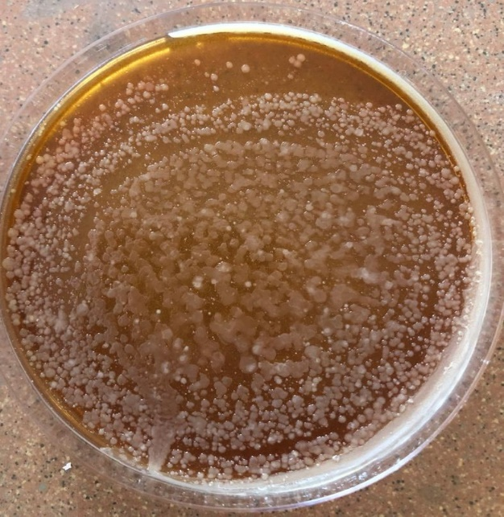
Fig. 3. Diversity of microbes on a skimmed milk agar plate
Based on morphological distinctions, five samples exhibited distinct and well-formed single colonies. When these five isolates were further incubated on nutrient agar plates for 24 hours at 37 °C, three of them (FDS1, GARMS1, and GMIS1) showed clear zones on the plates. After 48 hours of incubation, the diameters of these zones were measured and recorded in millimetres (Fig. 4).
To assess the feather-degrading potential of the selected isolates (FDS1, GARMS1, and GMIS1), secondary screening was performed by inoculating them into a feather-enriched basal medium, in which feathers served as the sole source of carbon and nitrogen. After 15 days of incubation at 37 °C, the isolates completely degraded the feathers, as shown in Fig. 5. Subsequently, morphological and biochemical tests were carried out to determine the bacterial identification characteristics, as presented in Tables 2 and 3.
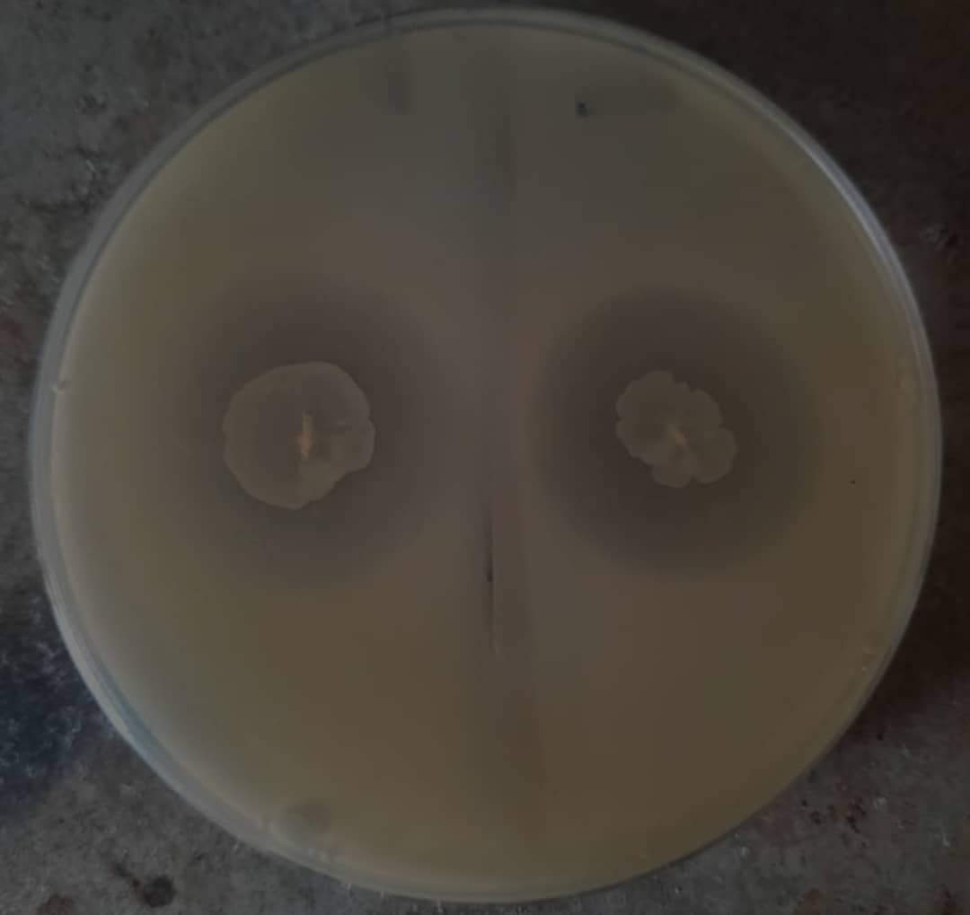
Fig. 4. After 48 hours of incubation, a zone of clearing surrounds the bacterial colonies

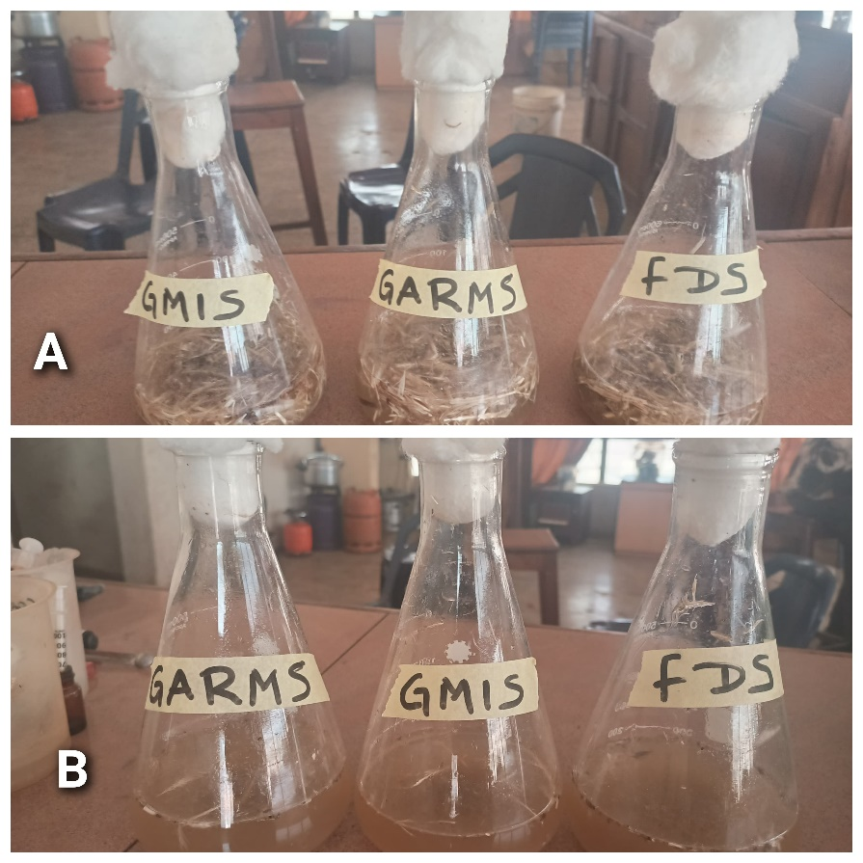
Fig. 5. Test of feather degradation for specific keratinolytic bacterial isolates (A) at the beginning and (B) after incubation for 15 days

Table 2. Morphological characteristics of isolates of FDS1, GARMS1 and GMIS1
Isolates | Bacteria form
FDS1 | Rod
GARMS1 | Rod
GMIS1 | Rod
Gram-stain
FDS1 | Positive
GARMS1 | Positive
GMIS1 | Positive

Table 3. Bacterial isolates exhibiting keratinolytic activity on feather basal media and skimmed milk agar
Biochemical characteristics | FDS1 | GARMS1 | GMIS1
Motility | + | + | +
Oxidase | + | + | +
Catalase | + | + | +
Citrate hydrolysis | - | - | -
Urea hydrolysis | + | + | +
Fermentative test
Lactose | + | + | +
Saccharose | + | + | +
Glucose | + | + | +
Fructose | + | + | +
Galactose | + | + | +
*+ = Positive; - = Negative.
3.2 Molecular Identification of Keratinase-Producing Bacteria
Using 16S rRNA gene sequencing and phylogenetic analysis, the bacterial isolates, FDS1, GARMS1 and GMIS1 which had the highest keratinase-producing activity, were chosen for molecular characterization since they showed closer gene sequencing profile to B. subtilis. However, the amplification of the 16rRNA gene was done at 1600 bp (Fig. 6 and 7).
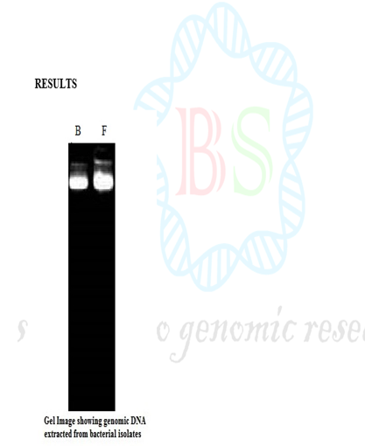
Fig. 6. Genomic DNA isolated from bacterial isolates is displayed in a gel image
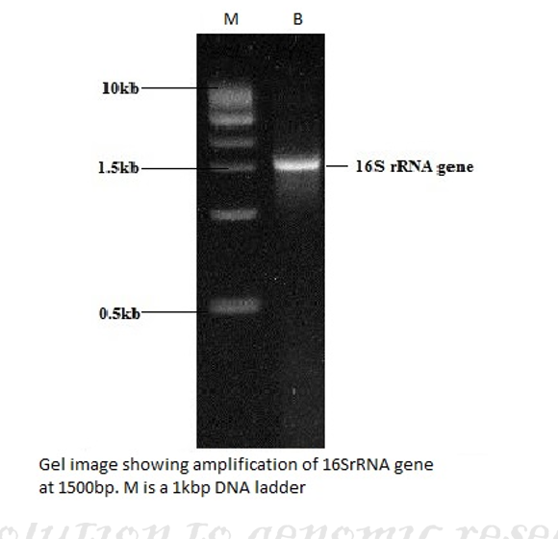
Fig. 7. Gel image showing amplification of 16SrRNA gene at 1600 bp
3.3 Pairwise Identification of Bacillus subtilis sub-specie
As shown in Fig. 8, pairwise identification analysis was performed on isolates FDS1, GARMS1, and GMIS1, revealing that they belong to the Bacillus species. The FDS1 isolate showed a 95.86% pairwise identity with Bacillus subtilis subsp. stercoris 153 and was assigned the NCBI accession number MK389431. The E-value was 0, and the aligned sequences were also provided in Fig. 8.

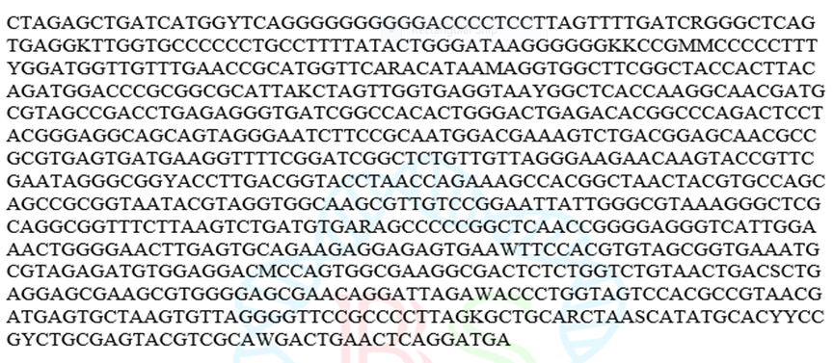
Fig. 8. Isolates FDS1, GARMS1 and GMIS1 with 95.86% pairwise identity to B. subtilis subsp. stercoris 153 with NCBI accession number MK389431
3.4 Phylogenetic Tree Construction
The small subunit rRNA, a highly reliable marker for determining taxonomic relationships among microorganisms, was used for phylogenetic analysis. The phylogenetic characteristics of the identified Bacillus subtilis subsp. stercoris 153 are presented in Fig. 9.
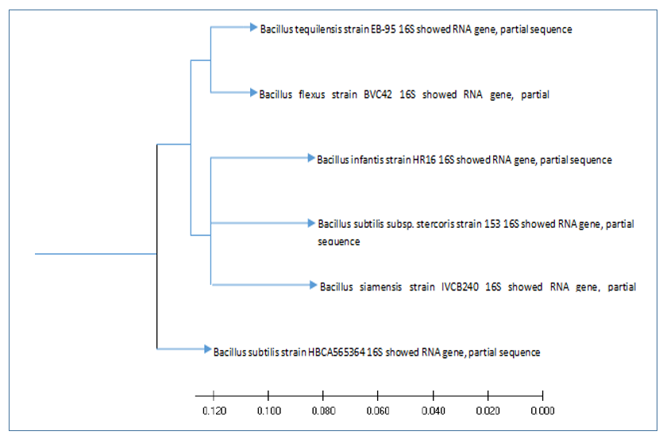
Fig. 9. Phylogenetic tree construction of B. subtilis subsp. stercoris 153
This study employed molecular approaches to successfully identify and characterize keratinase-producing bacteria isolated from poultry waste sites in Gariki Awkunanaw, Enugu State. Microorganisms capable of degrading keratin can inhabit diverse environments such as air, soil, waste, and forage (Anbesaw, 2022). Although chemical and physical methods can be used to remove keratinous waste, they are energy-intensive and often destroy amino acids. Microorganisms, therefore, play a dominant role in keratin recycling and degradation, since keratin is generally resistant to proteolytic enzymes such as papain, trypsin, and pepsin. Consequently, environmentally hazardous keratinous wastes can be converted into valuable products through microbial processing (de Menezes et al., 2021).
The results of this study confirm the presence of several bacterial strains capable of keratin degradation, demonstrating their potential for biotechnological applications in waste management and industrial production. These findings reinforce the ecological importance of poultry waste as a reservoir of microbial biodiversity and align with previous reports on keratinase-producing bacteria. Latafat et al. (2024) documented that Bacillus tropicus KS3 achieved 84% biodegradation of chicken feathers within 15 days, underscoring its efficiency. Similarly, Nnolim et al. (2021) isolated Bacillus sp. Okoh-K1 from a municipal waste site, which produced keratinase with a peak activity of 2350.09 U/mL under optimized conditions. In another study, Tork et al. (2010) reported that seven out of twenty-three bacterial isolates exhibiting clear halos on skim milk agar were capable of keratinase production. The keratinolytic activity of Vibrio sp. strain KR2 in a medium containing raw feathers was reported by Sangali and Brandelli (2000).
On nutrient agar plates, the three isolates obtained from poultry waste exhibited clear zones around their colonies, indicating keratinolytic activity and the ability to degrade feather keratin. The isolates were subsequently cultivated in a basal medium containing chicken feathers as the sole sources of nitrogen and carbon, based on their zones of clearance. Among the five isolates tested, FDS1, GARMS1, and GMIS1 completely degraded the chicken feathers.
Travers et al. (1987) previously noted that colony formation is the initial step in the isolation and identification of bacterial cells from soil. Similarly, Foysal and Lisa (2018) reported that potential Bacillus isolates for analysis should first exhibit morphological characteristics typical of the genus before being selected from an environmental culture that has been highly diluted following heat shock or hot air drying. Typically, Bacillus colonies appear large, diffuse, and irregular in shape. Under the microscope, Bacillus cells appear as rods, with many containing oval endospores at one end, giving the cells a swollen appearance (Caldwell, 2011).
When oxygen is utilized or available, as in this study, cultured Bacillus species test positive for the catalase enzyme (Turnbull, 1996). The most active isolate, Bacillus subtilis subsp. stercoris 153, was identified through Gram staining and morphological analysis as a Gram-positive, rod-shaped, aerobic bacterium belonging to the class Bacilli, family Bacillota, and order Bacillales. Furthermore, biochemical tests revealed positive reactions for catalase, oxidase, motility, and methyl red. These findings are consistent with the reports of Paul et al. (2021), Vema and Kumar (2023), Kumar et al. (2024), and data archived in GenBank U.S. (2019a,b; 2020a,b) on Bacillus species. Such biochemical characteristics are critical indicators of the biotechnological potential of the isolated strains for diverse environmental and industrial applications.
The bacterial isolates FDS1, GARMS1, and GMIS1 from the three locations were genetically characterized through molecular analysis, specifically 16S rRNA sequencing. The 16S rRNA sequence data revealed a high degree of similarity to members of the Bacillus genus. The small subunit rRNA is widely used in phylogenetic studies to establish taxonomic relationships among microorganisms (Iwamoto et al., 2001). The sequencing analysis indicated strong homology with a single subspecies of Bacillus subtilis (Kumar et al., 2024). Comparison with reference sequences in the NCBI database confirmed the definitive identification of isolate FDS1 as Bacillus subtilis subsp. stercoris 153, with the NCBI accession number MG835355. Furthermore, phylogenetic tree construction revealed that isolate FDS1 shares 95.86% similarity with other B. subtilis strains, further validating its genetic identity and evolutionary placement within the Bacillus genus.
4. CONCLUSION
The three dumping sites at Gariki, Enugu, serve as reservoirs of keratinolytic bacteria. The study identified Bacillus subtilis subsp. stercoris 153 as one of the isolates. Given that poultry waste contributes significantly to environmental pollution, this keratinolytic strain’s ability to degrade feather keratin presents valuable potential for producing slow-release nitrogen fertilizers and protein-rich animal feed, thereby addressing waste management challenges. The isolates obtained in this study therefore exhibit strong promise for biotechnological applications. It is recommended that the pure culture of Bacillus subtilis subsp. stercoris 153 be immobilized and utilized in feather hydrolysate production and animal feed formulation. Furthermore, its potential to improve livestock performance when incorporated into biotechnologically processed feather-based diets should be evaluated.
DISCLAIMER (ARTIFICIAL INTELLIGENCE)
Author(s) hereby declares that NO generative AI technologies such as Large Language Models (ChatGPT, COPILOT, etc.) and text-to-image generators have been used during the writing or editing of this manuscript.
REFERENCES
Agrahar, S. (2013). Production of extracellular Keratinase Enzymes from Bacillus pumilis SN3 isolated from soil sample of ghazipur poultry waste site. International Journal of Sustainable Development and Green Economics, 2(1): 109-113.
Agrahari, S., & Wadhwa, N. (2010). Degradation of chicken feather a poultry waste product by keratinolytic bacteria isolated from dumping site at Ghazipur poultry processing plant. International Journal of Poultry Science, 9(5):482-489. https://doi.org/10.3923/ijps.2010.482.489
Al Hasan, M. M. (2018). Isolation and Identification of Extracellular Keratinase Producing Bacteria from Soil. Doctoral Dissertation: BRAC University.
Al Mousa, A. A., Moubayed, N. M., Al Jaloud, A. M., Al Khattaf, F. S., & Dahmasha, N. D. (2021). Chicken feathers waste management by microbial as a sustainable and tool environmental friendly. Journal of Environmental Protection, 12(9), 639-653. https://doi.org/10.4236/jep.2021.129039
Anbesaw, M. S. (2022). Bioconversion of keratin wastes using keratinolytic microorganisms to generate value‐added products. International journal of biomaterials, 2022(1), 2048031. https://doi.org/10.1155/2022/2048031
Anierobi, C. M., Nwalusi, D. M., Efobi, K. O., Nwosu, K. I., Nwokolo, N. C., & Ibem, E. O. (2023). Urban Housing Inequality and the Nature of Relationship Between Formal and Informal Settlements in Enugu Metropolis, Nigeria. Sage Open, 13: 3. https://doi.org/10.1177/21582440231192390
Ashraf, M., Hussain, N., Baqar, Z., Kumar, A., Ferreira, L. F. R., & Iqbal, H. M. (2023). Bioprospecting microbial proteases in various industries/sectors, In: Microbial biomolecules. eds. Ajay Kumar, Muhammad Bilal and Madhuree Kumari, et al. (Salt Lake City, UT: Academic Press), 301–324. https://doi.org/10.1016/B978-0-323-99476-7.00013-2
Banasaz, S., & Ferraro, V. (2024). Keratin from animal by-products: structure, characterization, extraction and application—a review. Polymers, 16(14): 1999.https://doi.org/10.3390/polym16141999
Caldwell, F. E. (2011). The Students Reference Guide to Bacteria. Lulu.com. ISBN 978-1-257-42416-0.
de Menezes, C. L. A., Santos, R. D. C., Santos, M. V., Boscolo, M., da Silva, R., Gomes, E. et al. (2021). Industrial sustainability of microbial keratinases: production and potential applications. World Journal of Microbiology and Biotechnology, 37(5), 86. https://doi.org/10.1007/s11274-021-03052-z
Ezenwali, O. M. (2022). Optimization, Isolation and Characterization of a keratinolytic Protease from Human Hair-Degrading Bacterium Alcaligenes faecalis strain TPB18. World Journal of Research and Review, 15: 1-4. https://www.researchgate.net/publication/362814134
Foysal, M. J., & Lisa, A. K. (2018). Isolation and characterization of Bacillus sp. strain BC01 from soil displaying potent antagonistic activity against plant and fish pathogenic fungi and bacteria. Journal, Genetic Engineering & Biotechnology, 16(2): 387–392. https://doi.org/10.1016/j.jgeb.2018.01.005
GenBank. U.S. (2019ª). Bacillus subtilis strain WS1A. National Library of Medicine.
GenBank. U.S. (2019^{b}). Bacillus subtilis strain KSP163A. National Library of Medicine.
GenBank. U.S. (2020ª). Bacillus subtilis strain YBS29. National Library of Medicine.
GenBank. U.S. (2020^{b}). Bacillus subtilis strain OA122. National Library of Medicine.
Gržinić, G., Piotrowicz-Cieślak, A., Klimkowicz-Pawlas, A., Górny, R. L., Ławniczek-Wałczyk, A., Piechowicz, L. et al. (2023). Intensive poultry farming: A review of the impact on the environment and human health. Science of the Total Environment, 858: 160014. https://doi.org/10.1016/j.scitotenv.2022.160014
Haq, I. U., Akram, F., & Jabbar, Z. (2020). Keratinolytic enzyme-mediated biodegradation of recalcitrant poultry feathers waste by newly isolated Bacillus sp. NKSP-7 under submerged fermentation. Folia Microbiologica, 65, 823-834. https://doi.org/10.1007/s12223-020-00793-6
Iwamoto, K., Yoshikawa, T., Sakata, T., & Maeda, H. (2001). Phylogenetic analysis of marine algicidal filamentous bacteria inferred from SSU rDNA and intergenic spacer regions. Microbes Environ., 16: 213-221. https://doi.org/10.1264/jsme2.2001.213
Jeong, J. H., Park, K. H., Oh, D. J., Hwang, D. Y., Kim, H. S., Lee, C. Y. et al. (2010). Keratinolytic enzyme-mediated biodegradation of recalcitrant feather by a newly isolated Xanthomonas sp. P5. Polymer Degradation and Stability, 95(10), 1969-1977. https://doi.org/10.1016/j.polymdegradstab.2010.07.020
Kumar, K. R., Nikhitha, L, Venkanna, S., & Rao, J. R. (2024).Isolation and Molecular Identification of Novel Chicken Feather Degrading Bacteria, Bacillus tropicus KRKJVR 5. Uttar Pradesh Journal of Zoology, 45(17): 60-71. https://doi.org/10.56557/upjoz/2024/v45i174347
Latafat, S. M. H., Ashish, V. A., & Bhargava, P. (2024). Isolation and screening of keratinolytic bacteria from feather dumping soil near in Lucknow and Kanpur city, North region of Indian. Biocatalysis and Biotransformation, 42(1), 68-76. https://doi.org/10.1080/10242422.2023.2235053
Mozhiarasi, V., & Natarajan, T.S. (2025). Slaughterhouse and poultry wastes: management practices, feedstocks for renewable energy production, and recovery of value added products. Biomass Conversion and Biorefinery, 15: 1705–1728. https://doi.org/10.1007/s13399-022-02352-0
Nnolim, N. E., Okoh, A. I., & Nwodo, U. U. (2021). Elucidation of coding gene and characterization of alkaline metallo-keratinase produced by acidophilic Bacillus sp. Okoh-K1 grown on chicken feather. Environmental Technology & Innovation, 21, 101285. https://doi.org/10.1016/J.ETI.2020.101285
Nwobodo, C. E., Okoronkwo, D. J., Eze, R. I., Ozorngwu, A. M., Iwuchukwu, J. C., Azuka, V. C. et al. (2023). Knowledge capabilities for sustainable poultry production in Sub-Sahara Africa: Lessons from Southeast Nigeria. Sustainability, 15(14), 11174. https://doi.org/10.3390/su151411174
Nwosu, I. C., Ibeziako, E. A., & Igugo, R. U. (2021). Isolation and Identification of Feather Degrading Bacteria from Poultry Waste Dump site along Enugu - Port Harcourt Express way, Gariki, Awkunanaw, Enugu. Journal of Agriculture and Ecosystem Management. 2(1): 75-80. https://doi.org/10.36265/jonages.2021.010209
Orjiakor, F. S., Ali, L. C., Umeugokwe, P. I., & Machebe, N. S. (2025). Kerosene-contaminated feed: insights on haematology and organ histopathology of broiler chickens. Ukrainian Journal of Veterinary and Agricultural Sciences, 8(2), 88–96. https://doi.org/10.32718/ujvas8-2.15
Paul, S. I., Rahman, M. M., Salam, M. A., Khan, M. A., & Islam, M. T. (2021). Identification of marine sponge-associated bacteria of the Saint Martin's island of the Bay of Bengal emphasizing on the prevention of motile Aeromonas septicemia in Labeo rohita. Aquaculture, 545: 737156. https://doi.org/10.1016/j.aquaculture.2021.737156
Prasad, V, H., Kumar, G., Kartik, L., & Rao, K.V. (2010). Screening of Extracellular Keratinase Producing Bacteria from Feather Processing Areas in Vellore, Tamil Nadu, India. Journal of Scientific Research, 2(3), 559. https://doi.org/10.3329/jsr.v2i3.4567
QGIS. (2025). QGIS Geographic Information System. QGIS Association. http://www.qgis.org.
Sangali, S., & Brandelli, A. (2000). Feather keratin hydrolysis by a Vibrio sp. strain KR-2. Journal of Applied Microbiology, 89(5): 735-743. https://doi.org/10.1046/j.1365-2672.2000.01173.x
Tamreihao, K., Mukherjee, S., Khunjamayum, R., Devi, L. J., Asem, R. S., & Ningthoujam, D. S. (2019). Feather degradation by keratinolytic bacteria and biofertilizing potential for sustainable agricultural production. Journal of Basic Microbiology, 59(1): 4-1. https://doi.org/10.1002/jobm.201800434
Tork, S., Aly, M.M., & Nawar, L. (2013). Biochemical and molecular characterization of a new local keratinase producing Pseudomomanas sp. MS21. Asian Journal of Biotechnology, 2(1): 1-13. https://doi.org/10.3923/ajbkr.2010.1.13
Travers, R. S., Martin, P. A., & Reichelderfer, C. F. (1987). Selective Process for Efficient Isolation of Soil Bacillus spp. Applied and Environmental Microbiology, 53 (6): 1263–1266. https://doi.org/10.1128/aem.53.6.1263-1266.1987
Turnbull, P. C. (1996). Bacillus: Barron's Medical Microbiology (4th ed.). University of Texas Medical Branch. Galveston, TX, USA; ISBN 0-9631172-1-1.
Vema, R., & Kumar, V. (2023). Isolation and characterization of keratinolytic bacteria from poultry waste soils of Himachal Pradesh. Journal of Applied Biology & Biotechnology, 11(3): 172-179. https://doi.org/10.7324/JABB.2023.112620
Wakil, S. M., Dada, M. T., & Onilude, A. A. (2011). Isolation and characterization of keratinase-producing bacteria from poultry waste. Journal of Pure Applied Microbiology, 5(2), 567-580.
Wang, Z., Chen, Y., Yan, M., Li, K., Okoye, C. O., Fang, Z. et al. (2023). Research progress on the degradation mechanism and modification of keratinase. Applied Microbiology and Biotechnology, 107(4): 1003-1017. https://doi.org/10.1007/s00253-023-12360-3
Xu, G., Shan, M., Chen, H., Cao, Y., Nie, P., Xiang, T. et al. (2024). Recycling of chicken feathers. Carbon Neutralization, 3(4): 533-556. https://doi.org/10.1002/cnl2.132

