Diversity of Bambusicolous Endophytic Fungi Associated with Dendrocalamus strictus in Doon Valley, Uttarakhand, India

Abstract
Bamboo belongs to Poaceae, the grass family. As a major Non-Timber Forest Product, it has been an important source of livelihood. Despite its significant use in socio-economic aspects, bamboo species also harbor important fungal endophytes. In the present study, 79 isolates of endophytic fungi were obtained from the roots, stems, and leaves of Dendrocalamus strictus collected from three different locations in Doon Valley, Uttarakhand, India. A total of 30 isolates were obtained from the roots, 24 from the stems, and 25 isolates from the leaves. The fungal isolates belonged to the phylum Ascomycota and were categorized into 10 genera based on morphology and microscopic examination. Isolates that were unable to sporulate were classified as ‘mycelia sterilia.’ Sordariomycetes was the most dominant class, followed by Eurotiomycetes. Fusarium oxysporum and Nigrospora sphaerica were common at two of the sites, while F. oxysporum, Calonectria kyotensis, and Apiospora arundinis were common between the roots and stems. The diversity of the bambusicolous endophytic fungi of Doon Valley was analyzed for the first time. Site 3 had the highest diversity index, while the leaves had a higher diversity index compared to the roots and stems.
Keywords: Bambusicolous, bamboo, diversity, endophytes, fungi

Introduction
Bamboos are grasses that belong to the Poaceae family and sub-family Bambusoideae and include around 1670 species categorized into 125 genera (Gagliano et al. 2022). Due to its immense use and economic aspects, bamboo is commonly known as ‘Green Gold’, ‘Friend of the People’, and ‘poor man’s timber’(Devi 2013; Escamilla et al. 2019). They are distributed naturally in the tropics and sub-tropical belts and are found in Asia, Africa, and South and Central America. India is the second largest producer of bamboo after China, comprising approximately 148 species within 29 genera (Sharma & Nirmala 2015; Chawla et al. 2022). Three large genera, Dendrocalamus, Bambusa, and Ochlandra, have been recorded in India, with over 10 species in each genus. Bambusa (37 species and 2 varieties) and Dendrocalamus (18 species) thrive in a wide range of locations and surroundings, while Ochlandra (11 species and 1 variety) is found only in South India. These three genera account for around 45% of the total bamboo species reported from India (Tewari et al. 2019). Despite its immense uses, bamboo also plays a significant role in the environment by minimizing up to 35% of Carbon Dioxide and emitting more Oxygen into the environment. It acts as a substitute for timber and thus helps in reducing timber consumption. Moreover, it also helps in controlling soil erosion and decreases water pollution by consuming a high amount of nitrogen (Ramakrishnan et al. 2018).
Dendroclalmus strictus (Roxb.) Nees. is one of the important species that is prevalent throughout the different forest types of India. It is widely distributed in semi-arid and arid zones throughout plains and hilly tracts, often up to an elevation of 1000 meters. It makes up 53% of the total area of bamboo in India. It is also commonly grown throughout the plains and foothills. The International Network on Bamboo and Rattan (INBAR) and the National Bamboo Mission (NBM) likewise identify it as a priority species in terms of genetic advancement, variety, and conservation (Bakshi & Rasool 2015).
Endophytes are the microorganisms that reside within the tissues of plants, throughout or for a part of their life cycle without generating any observable symptoms (Verma et al. 2021). These endophytes associate with the host plant, and the plant, in turn, modifies the metabolism of these endophytes and produces chemicals that could possess protective effects on the microbe and the host (Kusari et al. 2012). Endophytic fungi are regarded as an excellent source of novel biologically active compounds (Ancheeva et al. 2020). Many active and biologically active compounds are produced and classified into various categories due to the association between endophytes and their hosts (Chutulo & Chalannavar 2018). The region, the habitat, and the host range influence the diversity of endophytic fungi (Doungporn et al. 2006). Endophytes are isolated from plants that grow in multiple environments, including temperate, tropical, semitropical, cold, hot, and deep sea (Borse et al. 2016).
“Fungorum bambusicolorum” (bambusicolous fungi) term was first used in 1938 (Hino 1938). However, a definition was provided by Hyde et al. (2002) as fungi that flourish on the substrate of bamboo including roots, rhizomes, culms, branches, and leaves.
Hyde et al. (2002) initially reported about 500 species of bambusicolous endophytes in Asia, among which 38% had been recorded only from Japan. Further, Molecular diversity analysis of the endophytic fungi was also carried out by Morakotkarn et al. (2007). Later studies were carried out in different parts of Asia by Shen et al. (2014), Arzanlou et al. (2013), and Shen et al. (2012).
Shen et al. (2012) and Shen et al. (2014) isolated and studied the diversity and antimicrobial activity of the endophytic fungi isolated from various plant parts of Phyllostachys edulis in China. As per the review of the literature, the work carried out on bambusicolous endophytic fungi in India is limited. In a study carried out by Giba et al. (2020) in Arunachal Pradesh, fungal endophytes were isolated from three bamboo species, Dendrocalamus sikkimensis, Bambusa polymorpha, and Phyllostachys bambusoides. Xylaria species and Nigrospora species were the most dominant. A review was carried out in India to address the work carried out on bambusicolous fungi by Giba et al. (2020) and Thapa et al. (2024). Diversity analysis of the Dark-septate endophytes (DSE) associated with four economically important bamboo species had also been carried out in India. The authors (Parkash et al. 2019) observed a hundred percent colonization of the DSE and endomycorrhizal hyphae in the roots of all the studied bamboo plants.
The present study aims to characterize the diversity of culturable fungal endophytes associated with D. strictus in Doon Valley, Uttarakhand, India. A standard procedure was employed to isolate the fungal endophytes. The study will help to develop a reservoir of fungal strains that can be studied further for their biological control potential, and cataloging of the fungi that are asymptomatically associated with the above-ground parts of bamboos will be initiated.

Materials and methods
Study area and sampling
Root, stem, and leaf samples of D. strictus were collected from three different sites in Doon Valley, Uttarakhand (Figure 1.) (Table 1.). Site 1, situated in the Asarori range, is a freshwater swamp covering the northern parts of the Shivalik hills. Site 2 is situated in Uttarakhand’s first urban forest, while Site 3 is situated in the natural sal forest of the Lachhhiwala forest range. The plants were selected based on appearance. Healthy and symptomless plants were used for the study. The samples were collected in zipper bags and were taken to the laboratory and stored at a temperature of 4 °C until the isolation procedure was initiated.

Table 1. Collection sites for the isolation of fungal endophytes
Site | Site Name | Forest Range | Latitude | Longitude
Site 1 | KarwaPani | Asarori | N 30°17'07.27" | E 77°54'48.75"
Site 2 | Jhajra | Jhajra | N 30°20'49.65" | E 77°54'56.82"
Site 3 | Lachhiwala | Lachhiwala | N 30°13'22.84" | E 78°07'13.58"

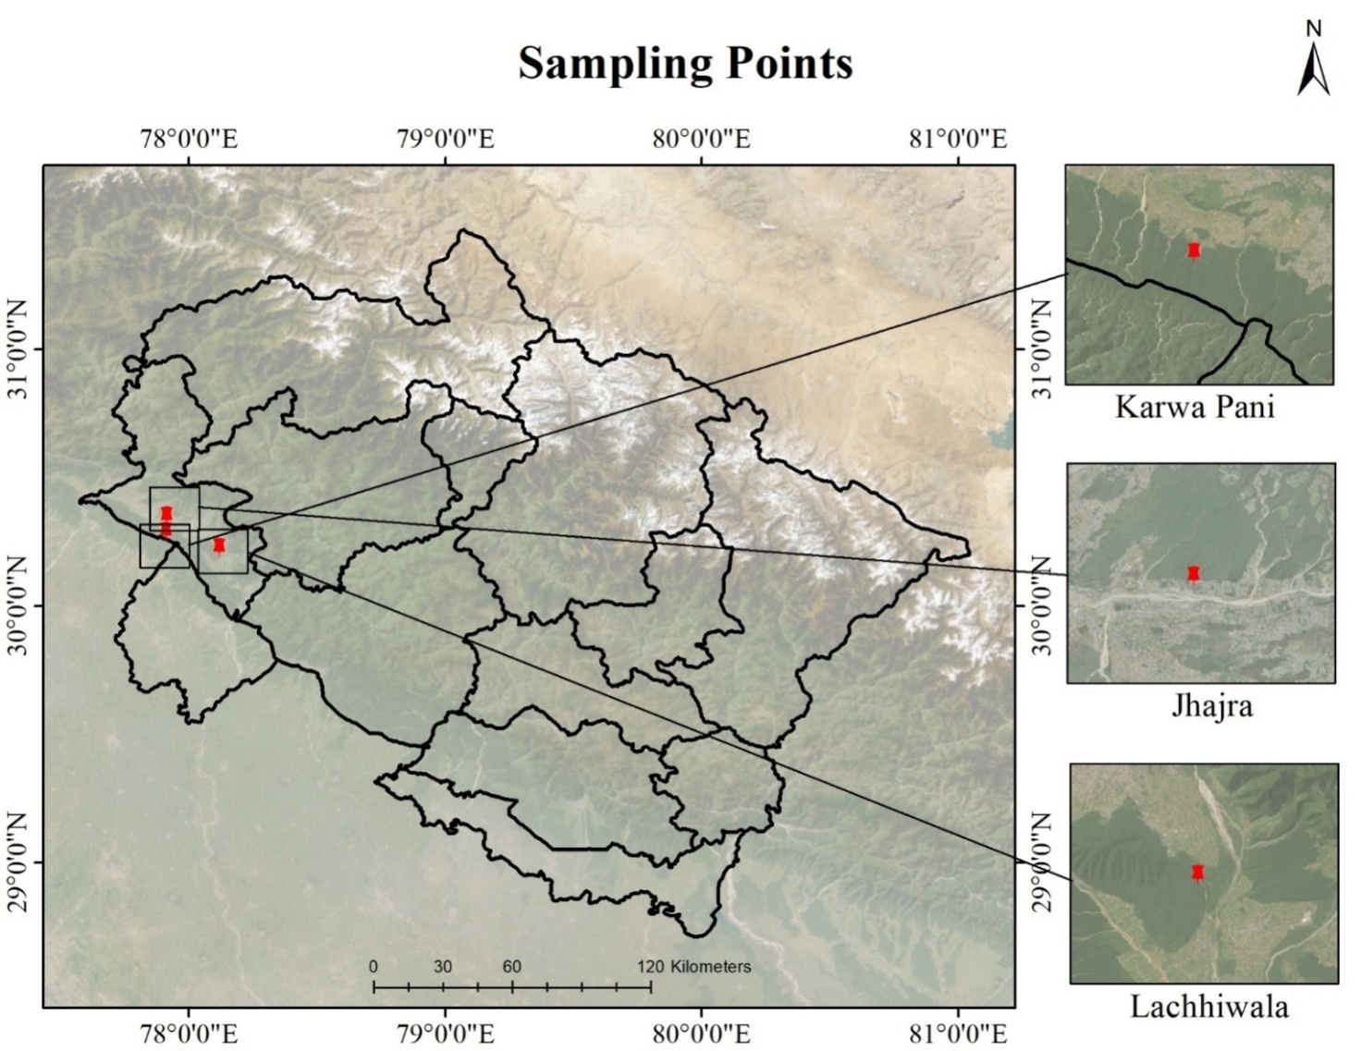
Fig. 1 Map of collection site (Note: Map not to scale)
Isolation and Identification of the Fungal Endophytes
The isolation of endophytic fungi was carried out by following the prescribed protocols of Hallmann et al. (2006) with slight modifications. Four plants per site were sampled. A total of 89 segments (24 from the root, 33 from the stem, and 32 from the leaf) were used for the isolation of fungal endophytes. The samples were first washed under running water to get rid of the soil and dirt. The samples were then made into small segments and dipped into 75% ethanol for 30 seconds, followed by 5% Sodium Hypochlorite for 1 minute, and then in 75% ethanol for 30 seconds. The segments were finally dipped in sterile distilled water for 2 minutes and then dried on sterile filter paper. To confirm the disinfection of segments 1 ml aliquot of sterile distilled water used for the final washing was spread on the Potato Dextrose Agar (PDA) plates. The fragments were then placed on Petri plates containing PDA supplemented with the antibiotic (tetracycline) to inhibit the growth of bacteria. The plates were further incubated at 26 + 2 °C until the growth was attained. Subculturing was carried out to obtain pure cultures of the endophytic fungi.
The fungal endophytes were identified based on the colony morphology and spore characteristics. The cultural characteristics observed were colour, texture, margin shape, types of mycelia, and pigments produced. Microscopic examination, like hyphal characteristics, spores, conidiophores, and conidia, was also observed. To study the microscopic features, semi-permanent slides of the endophytic fungi were prepared using the stain lactophenol cotton blue. The taxonomic keys of Barnett & Hunter (1972) were also used for identification.

Statistical analysis
Colonization frequency for each fungus was calculated as the total number of segments colonized by a specific fungus divided by the total number of segments examined (Hata & Futai 1995). The parameters used for the diversity analysis were species richness and relative species abundance. The diversity of bambusicolous endophytic fungi was accessed with the help of Shannon Weiner’s diversity index (Shannon & Weiner 1963), Simpson’s Index (Simpson 1949), and Margalef’s species richness index (Margalef 1958). The analysis was carried out by using Microsoft Office Excel 2019. Shannon Weiner’s Index and Simpson’s Index were used to determine the diversity of the fungal endophytes among different sites and within different plant parts; the Margalef’s Index was used to calculate the species richness of the fungal endophytes among different sites and within different plant parts.

Shannon Weiner's diversity index:
$$HS=-\sum_{i=1}^{s}{\left(p_{i}\right)\left(\ln{p_{i}}\right)}$$
where,
HS = shannon diversity index
S = total number of species
Pi = Proportion of i^{th} species in the sample
ln = natural log
Simpson’s index:
$$D=1-\frac{\sum{n( n-1 )}}{N( N-1 )}$$

Where,
n = total number of individuals of a species
N = total number of individuals of all species
Margalef’s species richness Index:
$$R1=\frac{S-1}{Ln (N)}$$
Where,
S= total number of Species
N= total number of isolates of all Species
Results
Isolation of endophytic fungi
In total, 79 fungal endophytic isolates were obtained from the roots, stems, and leaves of healthy D. strictus plant which have been listed in Tables 2 and 3. 30 isolates were isolated from roots, 24 from stems, and 25 isolates from leaves. The fungal isolates were members of the phylum Ascomycota and were categorized into 10 genera based on morphology and microscopic examination. Sordariomycetes was the most dominant class followed by Eurotiomycetes. The total 51 isolates that failed to sporulate were classified as ‘Mycelia sterilia’. Fusarium oxysporum Schlecht. emend. Snyder & Hansen and Apiospora arundinis (Corda) Pintos & P. Alvarado [syn. Arthrinium arundinis] were the most abundant genus, with 5 isolates each. A Venn diagram in Figure 2 represents the distribution of fungal endophytes within different parts of the plant and various sites of Doon Valley. Within the plant, Mycelia sterilia were common in all parts, including roots, stems, and leaves. Neopestalotiopsis saprophytica Maharachch., K.D. Hyde & Crous species was common between the roots and leaves; Colletotrichum gloeosporioides (Penz.) Penz. & Sacc. species was common between the stem and leaves, while Calonectria kyotensis Terash. [syn. Cylindrocladium scoparium], F. oxysporum, and A. arundinis were common between roots and stem. Aspergillus glaucus (L.) Link was isolated from only the roots, while Paecilomyces formosus Urquhart, Triangularia anserina (Rabenh.) X. Wei Wang & Houbraken [syn. Podospora anserina], Nigrospora sphaerica Mason, Sordaria fimicola (Roberge ex Desm.) Ces. & De Not., and unidentified genera were isolated only from the leaves. Among different sites, Mycelia sterilia was common in all three sites, while N. sphaerica and F. oxysporum were common between Site 2 and Site 3. A. glaucus, P. formosus, T. anserina, and C. Kyotensis were isolated from Site 1 only, while N. saprophytica, S. fimicola, C. gloeosporioides, A. arundinis, and unidentified genera were isolated from Site 3 only. Figure 3 exhibits pictures of some of the endophytic fungal isolates. The colonization frequency of C. kyotensis (20%) was the highest in the roots collected from site 1 (Table 4).

Table 2.: Diversity of endophytic fungi within roots, stems, and leaves of Dendrocalamus strictus
S.no. | Name of species | Division | Class | Order | Family | Roots | Stem | Leaves
1. | Aspergillus glaucus | Ascomycota | Eurotiomycetes | Eurotiales | Aspergillaceae | + | - | -
2. | Paecilomyces formosus | Ascomycota | Eurotiomycetes | Eurotiales | Trichochomaceae | - | - | +
3. | Triangularia anserina | Ascomycota | Sordariomycetes | Sordariales | Podosporaceae | - | - | +
4. | Calonectria kyotensis | Ascomycota | Sordariomycetes | Hypocreales | Nectriaceae | + | + | -
5. | Nigrospora sphaerica | Ascomycota | Sordariomycetes | Trichosphaeriales | Trichosphaeriaceae | - | - | +
6. | Fusarium oxysporum | Ascomycota | Sordariomycetes | Hypocreales | Nectriaceae | + | + | -
7. | Neopestalotiopsis saprophytica | Ascomycota | Sordariomycetes | Amphisphaeriales | Sporocadaceae | + | - | +
8. | Sordaria fimicola | Ascomycota | Sordariomycetes | Sordariales | Sordriaceae | - | - | +
9. | Colletotrichum gloeosporioides | Ascomycota | Sordariomycetes | Glomerellales | Glomerellaceae | - | + | +
10. | Apiospora arundinis | Ascomycota | Sordariomycetes | Amphisphaeriales | Apiosporaceae | + | + | -
11. | Unidentified | - | - | - | - | - | - | +
12. | Mycelia sterilia | - | - | - | - | + | + | +
‘+’ sign designates presence of species ‘-’ sign designates absence of species

Table 3: Diversity of fungal endophytes in different sites of Doon Valley
S.no. | Name of species | Division | Class | Order | Family | Site 1 |  | Site 2 | Site 3
1. | Aspergillus glaucus | Ascomycota | Eurotiomycetes | Eurotiales | Aspergillaceae |  | + | - | -
2. | Paecilomyces formosus | Ascomycota | Eurotiomycetes | Eurotiales | Trichochomaceae |  | + | - | -
3. | Triangularia anserina | Ascomycota | Sordariomycetes | Sordariales | Podosporaceae |  | + | - | -
4. | Calonectria kyotensis | Ascomycota | Sordariomycetes | Hypocreales | Nectriaceae |  | + | - | -
5. | Nigrospora sphaerica | Ascomycota | Sordariomycetes | Trichosphaeriales | Trichosphaeriaceae |  | - | + | +
6. | Fusarium oxysporum | Ascomycota | Sordariomycetes | Hypocreales | Nectriaceae |  | - | + | +
7. | Neopestalotiopsis saprophytica | Ascomycota | Sordariomycetes | Amphisphaeriales | Sporocadaceae |  | - | - | +
8. | Sordaria fimicola | Ascomycota | Sordariomycetes | Sordariales | Sordriaceae |  | - | - | +
9. | Colletotrichum gloeosporioides | Ascomycota | Sordariomycetes | Glomerellales | Glomerellaceae |  | - | - | +
10. | Apiospora arundinis | Ascomycota | Sordariomycetes | Amphisphaeriales | Apiosporaceae |  | - | - | +
11. | Unidentified | - | - | - | - |  | - | - | +
12. | Mycelia sterilia | - | - | - | - |  | + | + | +
‘+’ sign designates presence of species ‘-’ sign designates absence of species

Table 4: Colonization frequency (%) of endophytic fungi in roots, stems, and leaves of Dendrocalamus strictus from three different sites
 |  | Colonisation frequency (%)
 |  | Roots |  |  | Stem |  |  | Leaves
Endophytes | Site 1 |  | Site 2 | Site 3 | Site 1 | Site 2 | Site 3 | Site 1 | Site 2 | Site 3
Aspergillus glaucus |  | 6.67 | - | - | - | - | - | - | - | -
Paecilomyces formosus |  |  | - | - | - | - | - | 6.67 | - | -
Triangularia anserina |  | - | - | - | - | - | - | 6.67 | - | -
Calonectria kyotensis |  | 20 | - | - | 6.67 | - | - | - | - | -
Nigrospora sphaerica |  | - | - | - | - | - | - | - | 4 | 6.12
Fusarium oxysporum |  | - | 4 | 6.12 | - | 4 | - | - | - | -
Neopestalotiopsis  saprophytica |  |  | - | 2 | - | - | - | - | - | 4
Sordaria fimicola |  | - | - | - | - | - | - | - | - | 2
Colletotrichum  gloeosporioides |  |  | - | - | - | - | 2 | - | - | 2
Apiospora arundinis |  | - | - | 4 | - | - | 6.12 | - | - | -
Unidentified |  | - | - | - | - | - | - | - | - | 2
Mycelia sterilia |  | 20 | 4 | 16.32 | 6.67 | 28 | 35.89 | 13.33 | 36 | 14.28

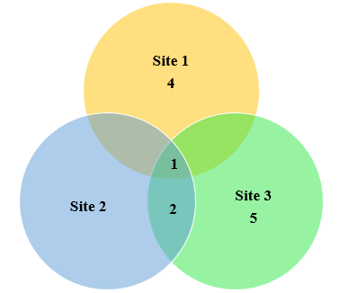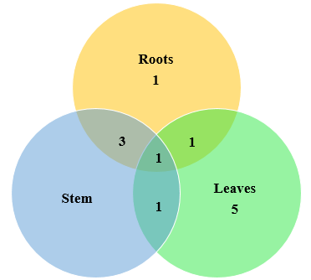
B
A
Fig. 2 Similarity of isolated fungi in different sites and within the plant parts represented by Venn diagram. A: Total fungal distribution among different sites B: total fungal distribution within different plant parts (Number indicates the number of fungal isolates)

Diversity analysis
The Shannon Diversity Index, Simpson’s Diversity Index, and Margalef’s Species Richness Index values have been represented in Figure 4 and Figure 5. The highest level of diversity among different sites was observed in Site 3 with a resultant value of HS = 1.38032 and D = 0.615459 in the Shannon and Simpson’s Diversity Index. Within the plant parts, leaves showed the highest diversity with values of HS = 1.46374 and D = 0.673333 in the Shannon and Simpson’s Diversity Index. Site 3 had the greatest species richness (R1 = 1.828325) among all the sites while within the plant parts, leaves had the greatest species richness (R1 = 2.174672). According to the statistical analysis, Site 1 was more even in terms of species distribution (J = 0.81484) (Figure 5.) while within the plant parts roots were more even (J = 0.70391) (Figure 6 and 7).

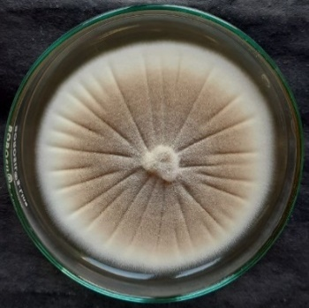 | 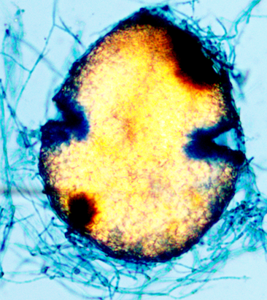 | 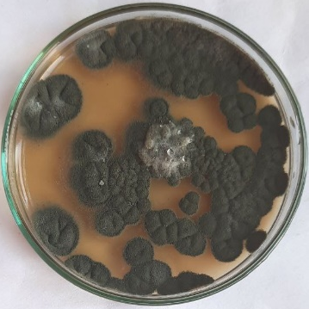 | 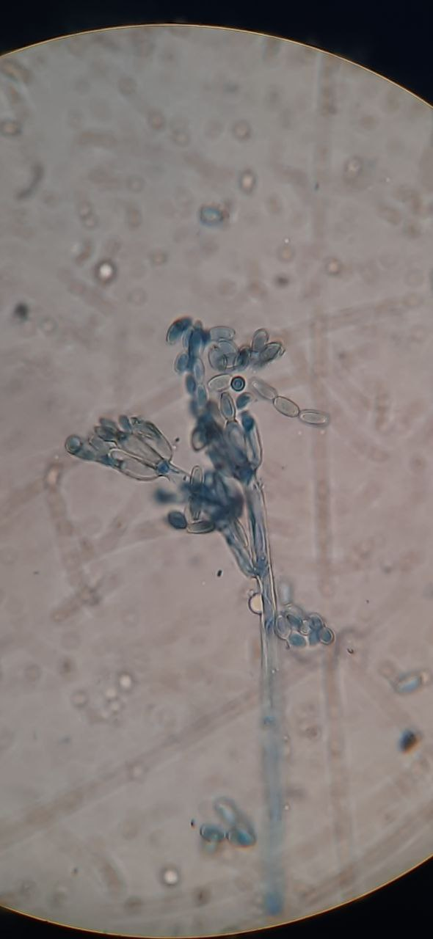
A: Aspergillus glaucus (Cleistothecium) |  | B: Paecilomyces formosus
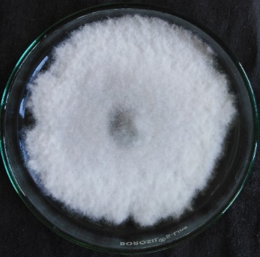 | 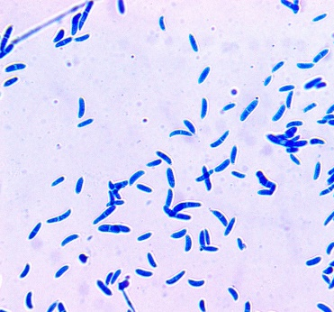 | 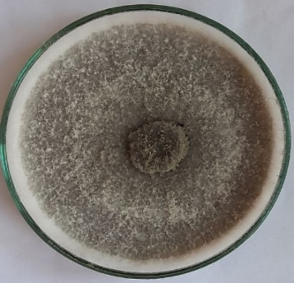 | 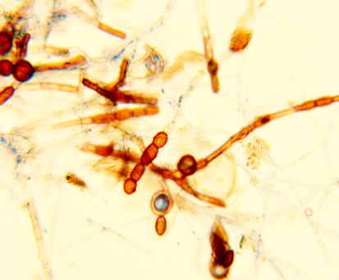
C: Fusarium oxysporum |  | D: Calonectria kyotensis
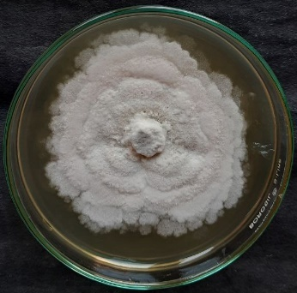 | 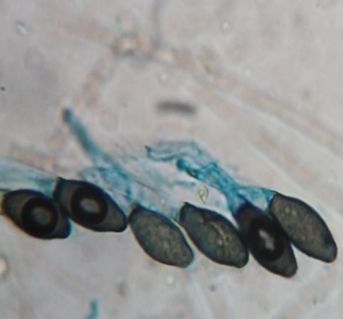 | 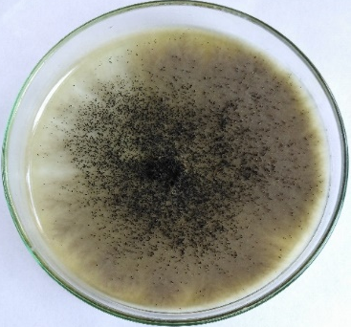 | 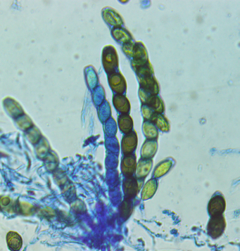
E: Triangularia anserina |  | F: Sordaria fimicola
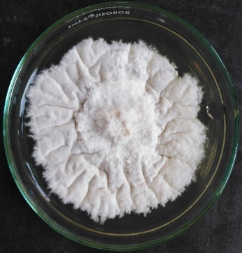 | 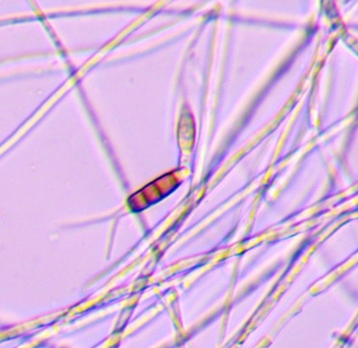 | 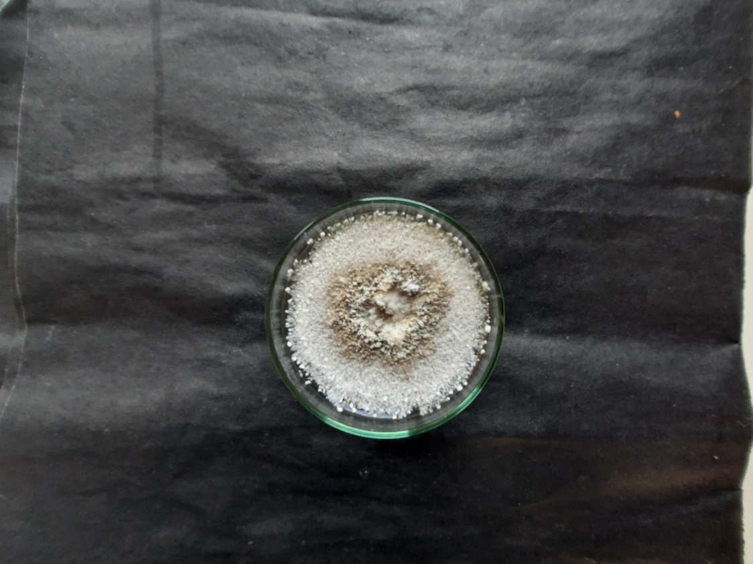 | 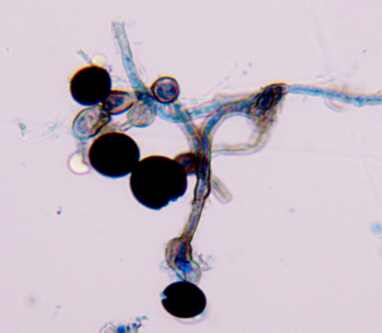
G: Neopestalotiopsis saprophytica |  | H: Nigrospora sphaerica
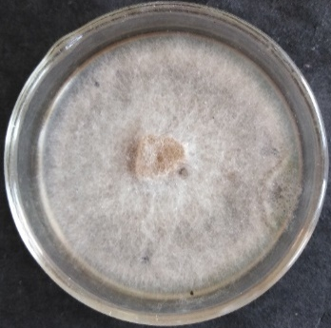 | 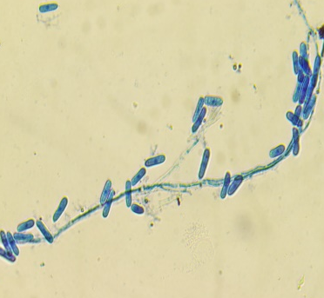 | 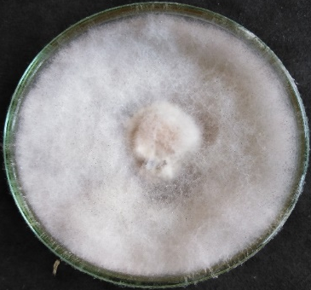 | 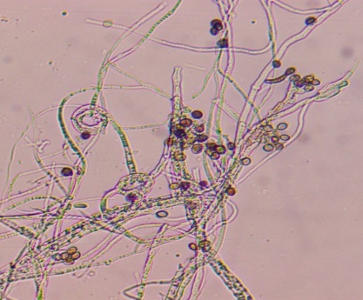
I: Colletotrichum gloeosporioides |  | J:Apiospora arundinis

Fig. 3 Some of the isolated fungal endophytes; A: Aspergillus glaucus, B: Paecilomyces formosus, C: Fusarium oxysporum, D: Calonectria kyotensis, E: Triangularia anserina, F: Sordaria fimicola, G: Neopestalotiopsis saprophytica H: Nigrospora sphaerica, I: Colletotrichum gloeosporioides, J: Apiospora arundinis

Fig. 4 Shannon-wiener index, Simpson index, Margalef index (site wise)

Fig. 5 Shannon-wiener Index, Simpson index, Margalef index (plant parts)

Fig. 7 Evenness Index (plant parts)
Fig. 6 Evenness Index (site wise)

Discussion
All the isolated fungal endophytes had been recorded earlier as mentioned in Table 5. The plant parts must be properly disinfected to isolate endophytic fungi to eliminate epiphytic microbes effectively (Sun & Guo 2012). Plants free of diseases have been used, and it was made sure that the leaves and roots exhibited no evidence of microbial infection during the disinfection process. The process of disinfection proved that every fungal isolate had endophytic origins.
Bamboos are the grasses whose endobiota has not been evaluated much in India. Giba et al. (2020) isolated 196 fungal isolates characterized into 11 morphotypes from the leaves of Dendrocalamus sikkimensis, Bambusa polymorpha, and Phyllostachys bambusoides. The genera Nigrospora, Fusarium, Pestalotiopsis, Sordaria, Colletotrichum, and Apiospora reported in this study have also been reported in the studies of Giba et al. (2020), Shen et al. (2014), Shen et al. (2012), and Morakotkarn et al. (2007). However, some of the genera Aspergillus, Paecilomyces, Triangularia, and Calonectria were not reported earlier on bamboo (Table 4).
The identification was carried out using morphological characteristics only, as also carried out by Giba et al. (2020). Fusarium oxysporum was the most abundant in the present study. The Fusarium instance is fascinating because non-pathogenic isolates are regularly found as endophytes in various plants (Gotz et al. 2006; Sun et al. 2014). Fusarium species have been recorded as endophytes by Morakotkarn et al. (2007), Shen et al. (2014), and Giba et al. (2020). Another abundant genus reported in the present study was Apiospora. Apiospora species have been reported as a bambusicolous endophyte by Shen et al. (2012), Shen et al. (2014), Helander et al. (2013), and Giba et al. (2020).

Table 5.: Previous reports of isolated fungal endophytes
S.no. | Name of species | Division | Class | Order | Family | Previous report
1. | Aspergillus glaucus | Ascomycota | Eurotiomycetes | Eurotiales | Aspergillaceae | From Ipomoea batatas (Asker et al. 2013)
2. | Paecilomyces formosus | Ascomycota | Eurotiomycetes | Eurotiales | Trichochomaceae | From Glycine max L. (Bilal et al. 2017)
3. | Triangularia anserina | Ascomycota | Sordariomycetes | Sordariales | Podosporaceae | From Laggera alata (Matasyoh et al. 2011)
4. | Calonectria kyotensis | Ascomycota | Sordariomycetes | Hypocreales | Nectriaceae | From Syzygium aqueum (Habisukan et al. 2021)
5. | Nigrospora sphaerica | Ascomycota | Sordariomycetes | Trichosphaeriales | Trichosphaeriaceae | From Bauhinia purpurea L. (Kantari et al. 2023)
6. | Fusarium oxysporum | Ascomycota | Sordariomycetes | Hypocreales | Nectriaceae | From Phyllostachys spp. and Sasa spp. (Morakotkarn et al. 2007)
7. | Neopestalotiopsis saprophytica | Ascomycota | Sordariomycetes | Amphisphaeriales | Sporocadaceae | From Cordia dichotoma (Reddy et al. 2016)
8. | Sordaria fimicola | Ascomycota | Sordariomycetes | Sordariales | Sordriaceae | From Phyllostachys spp. and Sasa spp. (Morakotkarn et al. 2007)
9. | Colletotrichum gloeosporioides | Ascomycota | Sordariomycetes | Glomerellales | Glomerellaceae | From Phyllostachys spp. and Sasa spp. (Morakotkarn et al. 2007)
10. | Apiospora arundinis | Ascomycota | Sordariomycetes | Amphisphaeriales | Apiosporaceae | From Nicotiana tabacum L. (Zhang et al. 2018)

All the isolated endophytes belonged to Ascomycota in Sordariomycetes and Eurotiomycetes, which was in corroboration with the previous findings of Morakotkarn et al. (2007) and Shen et al. (2012). Morakotkarn et al. (2007) reported Sordaria as a bambusicolous endophyte for the first time. In the present study, two genera belonged to Eurotiomycetes. One genera under Eurotiomycetes was also been reported from the seeds of P. edulis by Shen et al. (2014). Mycelia sterilia was the most dominant fungi in the present study. Similar findings have been made by Giba et al. (2020), Wu et al. (2020), and Jiaojiao et al. (2016).
The diversity indices for endophytic fungi isolated from different plant parts and sites have been represented in Table 2 and Table 3. The relative abundance of species and species richness are assessed by the Shannon-Wiener index. The highest value was found in Site 3 (1.38032), while within plants, leaves (1.46374) had the highest index value. The Simpson’s Index was also greater for the leaves, depicting that leaves have more fungal diversity as compared to roots and stems. Evenness refers to the contribution of an individual to the community. It ranges between 0 and 1, where 1 represents maximum evenness. The evenness was high in Site 1 (0.81484) and roots (0.70457), which depicts that among sites, Site 1 had greater uniformity and within plants, roots had greater uniformity.
Conclusion
This study revealed that a variety of fungal endophytes had colonized Dendrocalamus strictus. The data gathered during this research enhances our understanding of the biodiversity of fungal endophytes in Doon Valley, Uttarakhand, India. Mycelia sterilia was the most dominant, followed by Fusarium oxysporum and Apiospora arundinis. According to the statistical analysis, Site 3 exhibited the highest diversity, while the leaves of the plant contained a greater diversity of fungal endophytes compared to the roots and stems. Therefore, it can be concluded that leaves are favorable for the growth of fungal endophytes in D. strictus. This study establishes a foundation for further research on the diversity analysis of bambusicolous endophytic fungi in other bamboo species of Uttarakhand State.

References
Ancheeva E, Daletos G, Proksch, P. 2020. Bioactive secondary metabolites from endophytic fungi. Current medicinal chemistry, 27(11), 1836-1854.
Arzanlou M, Torbati M, Khodaei S. 2013. Phenotypic and molecular characterization of Plectosphaerella cucumerina on bamboo from Iran. Mycosphere, 4(3), 647-651.
Asker MMS, Mohamed SF, Mahmoud MG, El-Sayed OH. 2013. Antioxidant and antitumor activity of a new sesquiterpene isolated from endophytic fungus Aspergillus glaucus.
Bakshi M, Rasool S. 2015. Genetic variability in different accessions of Dendrocalamus strictus (Roxb.) Nees as assessed through culm characteristics. In 10th World Bamboo Congress, Korea (pp. 1-16).
Barnett HL, Hunter BB 1972. Illustrated genera of imperfect fungi.
Bilal S, Khan AL, Shahzad R, Asaf S, et al. 2017. Endophytic Paecilomyces formosus LHL10 augments Glycine max L. adaptation to Ni-contamination through affecting endogenous phytohormones and oxidative stress. Frontiers in plant science, 8, 870.
Borse BD, Borse KN, Patil SY, Pawara CM, et al. 2016. Freshwater higher fungi of India. Lulu. com.
Chawla VK, Seshasayee V, Yadav R. 2022. Use of lignocellulosic biomaterials for sustainable development of bamboo strand lumber for structural applications. BioResources, 17(2), 2864.
Chutulo EC, Chalannavar RK. 2018. Endophytic mycoflora and their bioactive compounds from Azadirachta indica: A comprehensive review. Journal of Fungi, 4(2), 42.
Devi YR. 2013. Bamboo forest resources of India and its role in food security-a review. Agricultural Reviews, 34(3), 236-241.
Doungporn M, Kawasaki H, Seki T, et al. 2006. Molecular diversity of bamboo-associated fungi isolated from Japan. - FEMS Microbiology Letters 266(1): 10-9.
Gagliano J, Anselmo-Moreira F, Sala-Carvalho WR, Furlan CM. 2022. What is known about the medicinal potential of bamboo?. Advances in Traditional Medicine, 22(3), 467-495.
Giba J, Tangjang S, Wangpan T, Taka T, Tesia, P. 2020. Isolation of Endophytic Fungi from Selected Bamboo Species of Arunachal Pradesh, India. International Journal of Scientific and Research Publications, 10(12), 263-270.
Giba J, Wangpan T, Tangjang S. 2020. Endophytic Fungi in Bamboo: A Review. International Journal of Current Microbiology and Applied Science, 9(11), 2024-2031.
Götz M, Nirenberg H, Krause S, Wolters H, et al. 2006. Fungal endophytes in potato roots studied by traditional isolation and cultivation-independent DNA-based methods. FEMS Microbiology Ecology, 58(3), 404-413.
Habisukan UH, Widjajanti H, Setiawan A, Kurniawati AR. 2021. Diversity of endophytic fungi in Syzygium aqueum. Biodiversitas: Journal of Biological Diversity, 22(3).
Hallmann J, Berg G, Schulz B. 2006. Isolation procedures for endophytic microorganisms. In Microbial root endophytes (pp. 299-319). Berlin, Heidelberg: Springer Berlin Heidelberg.
Hata K, Futai K. 1995 – Endophytic fungi associated with healthy pine needles and needles infested by the pine needle gall midge, Thecodiplosis japonensis. Canadian Journal of Botany 73(3), 384–390.
Helander M, Jia R, Huitu O, Sieber TN, et al. 2013. Endophytic fungi and silica content of different bamboo species in giant panda diet. Symbiosis, 61, 13-22.
Hino I. 1938. Illustrationesfungorumbambusicolorum. - Bull Miyazaki CollAgric For. 10: 55-64.
Hyde KD, Zhou D, Dalisay T. 2002. Bambusicolous fungi: a review. Fungal Diversity.
Kantari SAK, Biswal RP, Kumar P, Dharanikota M, Agraharam A. 2023. Antioxidant and antidiabetic activities, and UHPLC-ESI-QTOF-MS-based metabolite profiling of an endophytic fungus Nigrospora Sphaerica BRN 01 isolated from Bauhinia purpurea L. Applied Biochemistry and Biotechnology, 195(12), 7465-7482.
Kusari S, Hertweck C, Spiteller M. 2012. Chemical ecology of endophytic fungi: origins of secondary metabolites. Chemistry & biology, 19(7), 792-798.
Margalef R. 1958. Temporal Succession and Spatial Heterogeneity in Phytoplankton In AA Buzzati-Traverso (ed), Perspective in Marine Biology.
Matasyoh JC, Dittrich B, Schueffler A, Laatsch H. 2011. Larvicidal activity of metabolites from the endophytic Podospora sp. against the malaria vector Anopheles gambiae. Parasitology research, 108, 561-566.
Morakotkarn D, Kawasaki H, Seki T. 2007. Molecular diversityof bamboo-associated fungi isolated from Japan. FEMS microbiology letters, 266(1), 10-19.
Parkash V, Handique L, Dhungana P. 2019. Diversity and distribution of endomycorrhizae and dark septate endophytes of some economically important bamboos of Assam, India. Notulae Scientia Biologicae, 11(3), 447-454.
Ramakrishnan M, Zhou M, Baskar K, Packiam S. 2018. Role of bamboo in ecosystem. Austin Journal of Environmental Toxicology, 4(1), 1023.
Reddy MS, Murali TS, Suryanarayanan TS, Rajulu MG, Thirunavukkarasu N. 2016. Pestalotiopsis species occur as generalist endophytes in trees of Western Ghats forests of southern India. Fungal ecology, 24, 70-75.
Shannon CE. Weaver W. 1963. The Mathematical Theory of Communication, (first published in 1949). Urbana: University of Illinois Press.
Sharma ML, Nirmala C. 2015. Bamboo diversity of India: an update. In 10th World Bamboo Congress, Korea (pp. 17-22).
Shen XY, Cheng YL, Cai CJ, Fan L, et al. 2014. Diversity and antimicrobial activity of culturable endophytic fungi isolated from moso bamboo seeds. PloS one, 9(4), e95838.
Shen X, Zheng D, Gao J, Hou C. 2012. Isolation and evaluation of endophytic fungi with antimicrobial ability from Phyllostachys edulis. Bangladesh Journal of Pharmacology, 7(4), 249-257.
Simpson, E. H. 1949. Measurement of Diversity. Nature, 163.
Song JiaoJiao, Pongnak W, Soytong K. 2016. Isolation and identification of endophytic fungi from 10 species palm trees. International Journal of Agricultural Technology, 12(2), 349-363.
Sun SS, Chen XM, Guo SX. 2014. Analysis of endophytic fungi in roots of Santalum album Linn. and its host plant Kuhnia rosmarinifolia Vent. Journal of Zhejiang University SCIENCE B, 15(2), 109-115.
Sun X, Guo LD. 2012. Endophytic fungal diversity: review of traditional and molecular techniques. Mycology, 3(1), 65-76.
Tewari S, Negi H, Kaushal R. 2019. Status of bamboo in India. International Journal of Economic Plants, 6(Feb, 1), 030-039.
Thapa M, Parkash V, Pandey A, Kaundal R, Paul S. 2024. Bambusicolous endophytic fungi: A systematic review with an emphasis related on India. Advances in Bamboo Science, 100065.
Verma SK, Sahu PK, Kumar K, Pal G, et al. 2021. Endophyte roles in nutrient acquisition, root system architecture development and oxidative stress tolerance. Journal of Applied Microbiology, 131(5), 2161-2177.
Wu Z, Su Q, Cui Y, He H, et al. 2020. Temporal and spatial pattern of endophytic fungi diversity of Camellia sinensis (cv. Shu Cha Zao). BMC microbiology, 20, 1-11.
Zea Escamilla E, Archilla H, Nuramo DA, Trujillo D. 2019. Bamboo: An engineered alternative for buildings in the global south. Bioclimatic Architecture in Warm Climates: A Guide for Best Practices in Africa, 397-414.
Zhang P, Li X, Yuan XL, Du YM, et al. 2018. Antifungal prenylated diphenyl ethers from Arthrinium arundinis, an endophytic fungus isolated from the leaves of tobacco (Nicotiana tabacum L.). Molecules, 23 (12),3179.

