Emerging Insights into Climate, Forest and Wildlife Dynamics: Global Research Patterns, Interdisciplinary Developments, and Conservation Implications

Abstract
The acceleration of climate change, extensive destruction of forests and the growing rate of biodiversity loss have generated more threats in the world about the complicated and mutually sustained relationships among climate-forest-wildlife systems. These interactions modify the structure of ecosystems, suitability of some habitats, species distribution, and wildlife behaviour, which then alters the coupled human-natural systems on several spatial and temporal scales. During the last twenty years, the scientific literature on climate-forest-wildlife has grown exponentially due to the development of ecological modelling, remote sensing, biodiversity surveillance, climatic analytics, and international conservation and climate policy frameworks. The present study uses an extensive bibliometric review to perform a systematic analysis of the development, organisation, and cooperation of the worldwide research on climate-forest-wildlife interactions. It was ensured that bibliometric records were obtained via a large global citation database and evaluated with the help of the Bibliometrix package located in R Studio. The review of the literature assesses the trends of publications, source application, citation influence, thematic heterogeneity, search term variation, authorship organisation and global collaboration web to disclose the intellectual organisation and developmental path of the discipline. The results show that the sphere of research is rapidly changing and interdisciplinary with a great level of collaboration practice and an increasing thematic scope. Although the variety of keywords and the diversity of sources can be attributed to the conceptual richness and novelty of the method, it also implies that there is no common vocabulary and a lack of thematic homogenization. The growing global cooperation underscores the topicality of climate-forest-wildlife research and the conformity of the latter to the current environmental and policy issues.
Keywords: Bibliometrics, Climate change, Forest ecosystems, Knowledge mapping, Research trends, Wildlife dynamics
- Introduction
Forests are one of the best natural processes in mitigating the effects of climate change because they stabilise the climate through the regulation of carbon cycles, ecosystem moderation, and wildlife interaction, which contribute to the resilience of biodiversity and ecosystem processes (Fischer, et al. 2024). Climate change increases the risk of human casualties by altering habitats and resource availability and wildlife behaviour, thereby intensifying encounters between humans and bodily hazardous wildlife across changing socio-ecological landscapes (Newsom, Sebesvari and Dorresteijn 2023). Climate​‍​‌‍​‍‌​‍​‌‍​‍‌ change is having a major impact on biodiversity. It is changing the behaviour of species and where they live, affecting the functioning of ecosystems, increasing the number of extreme events, and influencing the provision of essential ecosystem services (Weiskopf, et al. 2020). Climate​‍​‌‍​‍‌​‍​‌‍​‍‌ change is doubling the effect of heat, drought, fire risk, the spread of invasive species, habitat loss, ecological stress, and management challenges in forest and wildlife systems globally, while forcing research to find adaptive solutions that safeguard biodiversity, ecosystem functions, and community ​‍​‌‍​‍‌​‍​‌‍​‍‌well-being ( Nunes, et al. 2021). The literature review states the existence of the topic and policy advocacies in the conservation and environmental awareness of forests and demonstrates forests as an important part of the climate, biodiversity, and human welfare (Pawar and Rothkar 2015). The current research findings on the quality of habitat, the reaction of species to climate change, human-wildlife interactions, and monitoring methods based on long-term datasets and spatial analysis and there is evidence to indicate human disturbances are crucial in defining forest wildlife conservation outcomes (Ciauskas 2025). The ecological principles, conservation practices, policy frameworks and case studies across the world by narratives of literature review and documentation efforts to review and evaluate the ecology of forests and their wildlife conservation efforts (Qadir , et al. 2025). The restoration of forest landscape within a Himalayan context by reviving ecosystem services, recovery of biodiversity and regeneration of native species are very crucial in the era of climate change (Samant, et al. 2025) There is a case where the conservation and sustainable use of wildlife resources in China tries to establish critical obstacles that prevent ecological balance and sustainable development by conducting a systematic review using analytic hierarchy process where the results indicate that the primary constraints include weak legal enforcement, inadequate funding, limited technological capability, and limited understanding by the population, which presents an obvious empirical and methodological gap because there are no integrated and data driven national frameworks to follow effective wildlife conservation practice (Du, Fathollahi-Fard, and Wong 2023).
The paper defines bibliometric analysis as a systematic review of large amounts of literature and the purpose of bibliometric analysis is to inform researchers on when and how to use techniques of performance and science-mapping to comprehend research trends and knowledge structures (Donthu, et al. 2021). In bibliometric research, there are no widely accepted guidelines for conducting research or reporting progress, which has led researchers to favour different methods, different reporting lengths, and different methods of evaluation of reported bibliometric studies, hence the need for an international framework (Ozturk, Kocaman and Kanbach 2024)
1.1 Rationale of the study
The acceleration in climate change is directly linked to the massive destruction of forests and the increase in biodiversity loss (Sintayehu 2018). It has emerged as a scientific and policy imperative to comprehend the intricate climate- forest- wildlife nexus (Dandabathula, et al. 2021). Understanding Climate variability and extreme events is also changing the structure of forests, the services they provide, the distribution of species, the suitability of habitats and wildlife behaviour, thus transforming the coupled human natural systems on many spatial and temporal scales (Kindlmann, et al. 2025). The study of climate-forest-wildlife interactions has grown at a fast pace over the past twenty years, with the development of ecological modelling, remote sensing, biodiversity surveillance, climate analytics and conservation planning, as well as international policy efforts such as the Convention on Biological Diversity, REDD+ and climate adaptation frameworks. Although this is a growing literature where it is still scattered among disciplines, regions and silos in themes, usually looking at broken fragments, like the effect of climate on forests or wildlife reaction within a given ecosystem. The overall picture of the intellectual organisation, the development of the themes, and the landscape of cooperation in this field of research is not well understood.
This bibliometric analysis aims to fill this gap by mapping the world's research on climate-forest-wildlife interactions in a systematic manner in the period between 2000 and 2025. Based on a solid set of 8,271 records registered in both Web of Science and Scopus databases, the study reflects the booming growth, interdisciplinary nature, and rising global networking, which define this research. The study will examine publication patterns, source and author impact, the patterns of keyword co-occurrence, and the network of collaborators to reveal the prevalent research themes, hotspots, and under researched topics. Such synthesis is critical to addressing knowledge gaps, future interdisciplinary research, and evidence-based policymaking to accomplish climate-resilient forest management and wildlife conservation. The study eventually leads to a more cohesive realisation of the way scientific knowledge is changing to undertake the combined problems of climate change, forest ecologies and conservation of biodiversity on a worldwide scale.
  - Objectives

- To investigate the trend of the past decades in terms of the amount and direction of global academic activity on climate-forest-wildlife interactions over the duration 2000-2025.
- To identify the most popular publication outlets, major contributors, and major institutional affiliations that define the research in the climate-wildlife interface.
- To understand the forces of cross-national and cross-institutional collaboration and networks of knowledge exchange in this area of research.
- To examine the intellectual and thematic structure of literature on climate forest wildlife nexuses through analysis of keyword co-occurrence, thematic mapping, and factorial analysis, to find out which themes are dominant, emergent, specialized, and declining.
- To trace the changes in the research focus and thematic trend concerning climate-forest-wildlife associations at various time periods.

- Methodology
Bibliometric analysis systematically examines the amount and direction of global academic activity on climate-forest-wildlife interactions over the duration 2000-2025. Bibliometric analysis is a quantitative research method that uses statistical and network-based techniques to evaluate the structure, performance, and evolution of a scientific field (Adarsh T. and H.Sulthana 2025).
A timespan of 26 years from 2000-2025 is a long-term view on the field’s development across multiple phases of technological and methodological advancement. The dataset comprised a total of 8271 documents retrieved from the Web of Science and Scopus databases, ensuring comprehensive coverage of peer reviewed journals, conference proceedings, and scholarly publications relevant to the topic from multidisciplinary sources (Fig. 1).
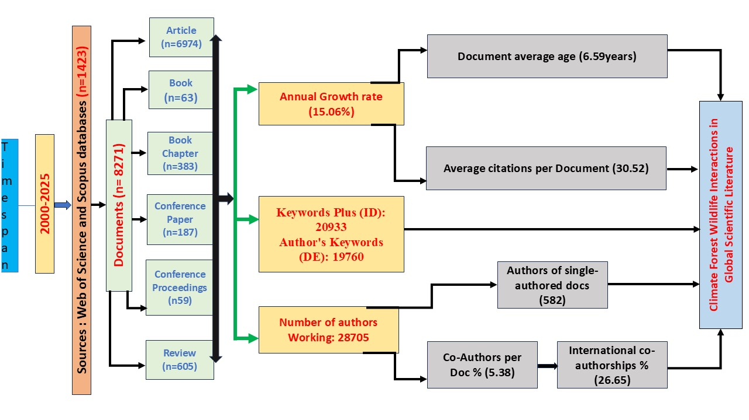
Fig 1. Methodology Chart

To completely capture material pertinent to the study's scope, a dual-topic query method was used in the formulation of the search strategy. Well-defined and verified search terms were used to get research articles from the Web of Science (WoS) and Scopus databases (as explained below). The combined dataset was processed in RStudio, where duplicate records from the two databases were methodically found and eliminated using the data-cleaning features of the Bibliometrix package in order to guarantee data integrity and avoid duplication. The resultant dataset represented a distinct and accurate collection of publications for further analysis thanks to this preprocessing phase (Adarsh T, Pillai, et al. 2025).
Querry; =TITLE-ABS-KEY(("climate change" OR "global warming" OR "climate variability" OR "climate impact*" OR "climatic stress")AND ("forest" OR "forest ecosystem*" OR "forest ecology" OR "forest dynamics" OR "forest biodiversity" OR "forest habitat*" OR "forest conservation")AND ("wildlife" OR "forest wildlife" OR "fauna" OR "forest fauna" OR "flora" OR "forest flora" OR "plant species" OR "animal species" OR "mammal*" OR "bird*" OR "avian" OR "amphibian*" OR "reptile*" OR "invertebrate*")
2.1 Data Analysis
The extensive and methodological review of the literature for this study utilised Biblioshiny, which is a bibliometric analysis tool that is based on the bibliometrix R package (Aria, M. and Cuccurullo, C 2017). Descriptive analysis was conducted in the first place, aimed to determine the general trends in publication, the most popular journals, the most influential authors, and the dynamics in citation relationships in the sphere. To examine the conceptual framework of the climate-forest-wildlife interaction study, a keyword co-occurrence analysis was implemented to allow visualisation of the connection between the important words using network diagrams. To reveal the latent structures in the data and classify the major thematic clusters, factorial analysis carried out via multiple correspondence analysis was used. Thematic mapping was subsequently used in order to classify the research themes based on their centrality and density to divide them into motor, basic, niche, and emerging or declining themes. Moreover, thematic evolution analysis through the application of Sankey diagrams was employed to follow the time development of research themes and shifts in the scholarly focus through the years. Lastly, an analysis of collaboration networks on the country level was performed to observe the trends in international co-authorship to identify the major research centres and international collaborative relationships that influence the discipline.
- Results & Discussions
  - Analysis of Publication Lifecycle Plots
The life cycle graphs depict the scientific area to be a typical logistic growth situation. During the first few years, the number of publications grows very slowly, which is characteristic of a newly established field. This is then followed by a long period of fast, almost exponential, growth, as more and more researchers, institutions, and topics get involved. Over the last few years, the growth rate has slowed down, and the cumulative curve is starting to flatten, which indicates that the field is approaching saturation. The curve of annual publications also shows a bell shape, as it is constantly increasing and is expected to reach its maximum around 2030, from where it will start to decrease. The logistic model matches the data very well, as shown by the high R-squared value of 0.987. The model accounts for nearly all of the variation in cumulative publications. The RMSE of 30.39 indicates some variation between predicted and actual values, but it is relatively small, and thus, the reliability of the model is not compromised. In addition to this, the strong model fit is an indication that the logistic curve is a suitable way of describing the growth of this research area.
The model's key parameters shed light on the matter beyond the surface. The carrying capacity (K = 26576.715) is the approximate maximum number of publications that the field will produce is the point of saturation. The inflexion point (t = 2030.301) is the year when the growth rate is the highest; after this year, the rate slows down gradually. The delta t value (28.97439) relates to the time over which the growth is spread; however, it does not have a direct conceptual interpretation. These temporal patterns uncover the existence of three distinct phases. The emergence phase (before 2005) is characterised by slow growth, which implies a small number of researchers and initial exploratory studies. The expansion phase (2005-2020) is characterised by extremely rapid growth, which was mainly due to the increased global interest, technological advancements, and expanding collaboration networks. The maturity phase, starting approximately from 2020 and continuing to the projected future, is characterised by a gradual slowing of growth which can be inferred that the field is becoming more established and stable.
Scientific significance is a key element in the growth pattern and the reduced growth rate indicates that the field is becoming mature, and at present, the main concepts are well established. The previous growth must have been due to more funding for research, methodological advancements, impactful articles, and the formation of research teams. The logistic model implies that the field is going to experience slow growth and eventually reach its saturation point. Nevertheless, the trajectory may still change in the future due to breakthroughs the changes in research interests or the appearance of novel subfields. Another aspect that should be noted is that the Web of Science and Scopus merged dataset does not have all the metadata, and this fact reveals the role of proper data cleaning in bibliometric studies.
The logistic model is an excellent and practical model for analysing the development of the field of research and the way it is expected to develop. The analysis indicates that the arena is no longer in a rapid growth phase but in a more mature growth phase, with growth being sluggish as it nears saturation.

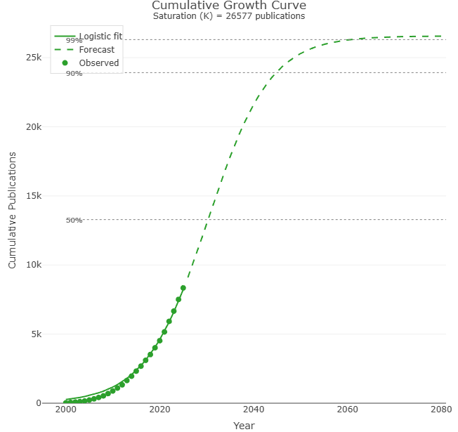
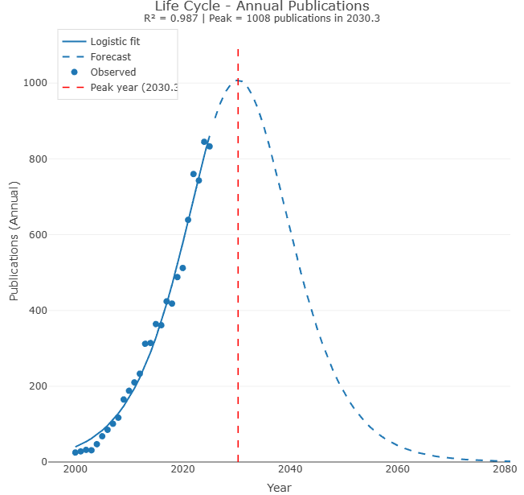

Fig: 2 & Fig 3. Graphs representing the Annual Publications Lifecycle & Cumulative Growth Curve

3.2 Annual Scientific Production
An upward trend of 2000-2025 annual scientific output proves that significant growth and an increasing global applicability of the research in the field are two undeniable factors. In 2000, the discipline generated only 25 publications, which was the initial stage of the scholarly exploration. The following years saw a slow rise in the amount of research, to 85 publications in 2006 and 100 documents in 2007. This acceleration is even stronger after 2008, and there is an increase in the annual output to 210 documents (2011) after 117 documents (2008) which indicates a growing research community and an increase in thematic diversification. There exists a significant increase after 2012, and the number of publications rises to 233 and then to 312 in 2013 and 2014, respectively.
Since 2017, the sphere has had a high growth rate, and the number of publications per year is above 400. Another historical high was achieved in 2021, as 639 documents were published, and then the growth is even greater in 2022 (760 publications), which is one of the most productive years of the entire period. The highest number of publications was reached in 2024, which is 845, and it indicates the increased scientific interest and urgency of the situation with issues that are connected to climate change, forests, and wildlife at that time.
The year 2025 also indicates a slight decrease to 833 publications, but again, there is not much difference, and it could be since not all publications of the year have been indexed yet, as opposed to a decline in scientific activity. The trend in the annual publication certainly depicts an exponential pattern growth, with the annual growth rate being calculated to be 15.06. Such a trend suggests that there is growing globalisation, broadening of partnership networks and new interdisciplinary connection points that propel research output in this discipline.

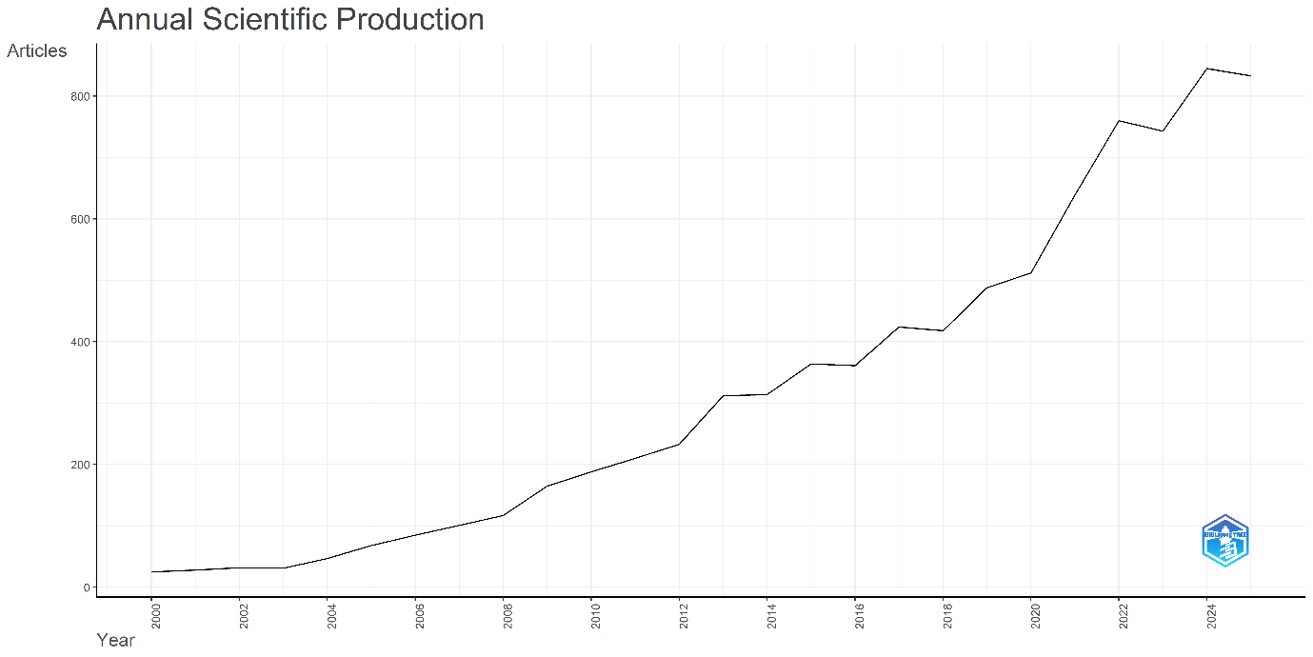
Fig: 4. Representation of Annual Scientific Production from 2000-2025
(Prepared using Biblioshiny (Aria and Cuccurullo, 2017)).
3.3 Average Citations Per Year
Early publications of the 2000s have higher citation averages due to being a subject of longer duration. To give an illustration, 2000 has a MeanTCperYear of 6.39 and 2002 has the highest number across the dataset of 8.46, which shows that papers published in this year were more significant. The values of citation changes during the initial years, but still are comparably high and another significant peak can be seen in 2009 with 5.51 citations per year as the research activity increased. The average citation rates are steady between 2010 and 2016, ranging between approximately 3.5 and 4.9 citations per year, which represents a period of consistent scholarly influence in a field of major development. The same slight increases can be observed in 2015, 2017, and 2019, which indicates that research published in these years received more academic interest, presumably because of the growing discourse of climate change, forests, and biodiversity across the world.
Since 2020, the citation averages have decreased steadily, with the starting point of 3.93 in 2020 and gradually decreasing to the current point. This decreasing tendency is maintained until 2021, 2022, and 2023 and decreases even more to 2.02 and 0.89 in 2024 and 2025, respectively. This decline is not surprising and does not indicate that there has been a decline in the quality or relevance of the papers that have been published recently, but rather indicates the little time that they have to gather citations. The citation pattern demonstrates a stereotypical bibliometric pattern where the older the publication, the greater the citation impact; middle years are associated with the continued scholarly presence and recent years demonstrate lower averages because of citation lags. The results of this study show that this area is not only mature but also well-developing and, probably, the wave of recent publications will shortly get numerous citations.
3.4 Most Relevant Sources
The review of the most topical sources of publications reveals that the number of publications in the given field is focused on a few powerful journals, each of which makes a significant contribution to the creation and spread of knowledge. The prime source turns out to be Forest Ecology and Management, with 256 articles, which means that it is the dominant publication in the field of furthering the research in the field of the overlap of forest ecosystems, climate change, and biodiversity. Next, PLOS ONE is added with its 206 articles, which show that it is a very multidisciplinary journal and open to a variety of methodologies. There are 164 publications in Global Change Biology, which proves its significance as one of the sources where the ecological reaction to climate variability and environmental change is discussed.
The journal Ecology and Evolution has had 141 articles published, which is why it has relevance to the evolutionary views and ecological processes in which species and the ecosystem respond. The 132 publications of the journal, Biological Conservation, are one of the major sources of research on conservation strategy and biodiversity management. Science of the Total Environment, which makes a contribution of 130 articles, suggests that the interaction between environmental science and climate forest wildlife interactions is very well integrated in the science. Forests journal is then followed by 114 articles as the interest is paid to open-access publication and practical research in forests. The journal Biogeography has already published 109 articles proving the significance of the dynamics of spatial ecological patterns and the dynamics of species distribution in the field. Otherwise, the method of species distribution modelling and biodiversity measurements is also important as noted by Diversity and Distributions which has 98 publications. Lastly, there are 95 articles in Ecosphere, which proves the increasing importance of such a medium as the outlet of ecological and environmental studies.
3.5 Core Sources by Bradford's Law
The Bradford’s Law analysis shows a distinct concentration of publications within a limited number of highly productive journals, forming the core zone of knowledge dissemination in this field. The curve in the plot begins with a steep decline, indicating that only a few journals publish a disproportionately large number of articles. This steep segment represents the core sources, where journals such as Forest Ecology and Management, PLOS ONE, Global Change Biology, Ecology and Evolution, and Biological Conservation dominate the research output. As the curve progresses, it flattens rapidly, illustrating that a much larger number of journals contribute progressively fewer publications, which is consistent with the classical Bradford distributions (Bradford, S. C. 1934).
The shaded region highlights the core area, where the density of articles is highest and where the majority of influential research is concentrated. Beyond this region, the long tail of the curve represents the peripheral sources that publish fewer papers and contribute less frequently to the field’s central discourse. This pattern confirms that research in this domain relies heavily on a relatively small set of specialised and interdisciplinary journals that act as the primary hubs for scientific communication. The Bradford distribution underscores the structured nature of scholarly publishing in the field, where a small group of journals consistently anchors the intellectual output while a broad and diverse range of peripheral sources contribute to supporting but less frequent publications.
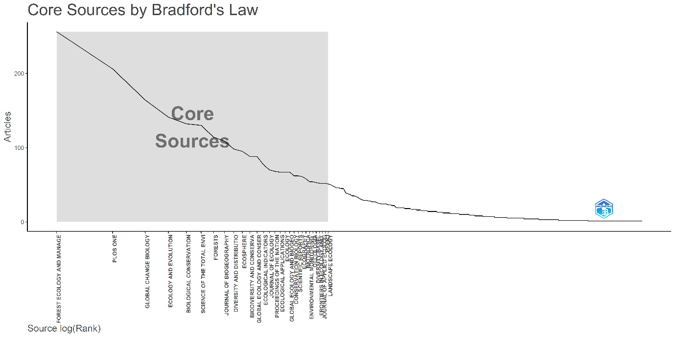
Fig 5. Core Sources Identified by Bradford’s Law for Publications. The shaded region highlights the “core zone” of journals contributing the majority of publications in the dataset.
3.6 Sources' Local Impact
The discussion regarding the source impact metrics reveals that several journals are forming dominance in the intellectual framework of the field. Global Change Biology is the most influential journal with an h-index of 60, the total number of citations of 11,190 and 164 publications since 2003, which means that the journal publishes highly cited work that contributes to conceptual and methodological improvements. PLOS ONE comes in with a h-index of 46 and 6,738 citations in 206 publications, which represent how broad the PLOS has been and how it has been able to communicate interdisciplinary research to a large number of people. The most productive source with 256 articles, Forest Ecology and Management, is also an excellent research source as it boasts an h-index of 44 and 7,039 citations, thus proving to be one of the most important sources of forest-related and climate-related research since 2000.
The Proceedings of the National Academy of Sciences of the United States of America (PNAS) is a journal of extremely strong influence given the fact that it publishes fewer works. Having 68 publications only it has already had 11,146 citations, and its h-index is 42, showing that the journal has been publishing high-impact publications that are highly cited. With contributions starting in 2001, and an h-index of 41, 5,993 citations and 132 articles in all, the Journal of Biological Conservation is a prominent hub of conservation scholarship.
The Journal of Biogeography is a journal that offers 109 articles with an h-index of 40 and 5,252 citations, meaning that it plays a significant role in developing the biogeographical and spatial ecological views. The long established ecological journals, Journal of Ecology and Ecology, are also very relevant, and both have an h-index of 34 and 33 and 4,520 and 3,259 citations, respectively, publishing foundational papers on ecological processes and species-environment interactions.
In the same manner, the field of Conservation Biology has a significant impact exhibiting an h-index of 32 with 4,185 citations, 62 publications and is therefore and significant contributor to the development of conservation science. With an h-index of 32 with 3,427 citations and 67 publications, Global Ecology and Biogeography is another treasure of the field that offers work in the sphere of global-scale ecological and biogeographical patterns.
Collectively, these measurements indicate that the knowledge base of the field is grounded in the conglomeration of extremely specialised ecology journals, multidisciplinary journals, and journals of broad scope, as well as the journals of elite science. The inherent correspondence between the productivity, citation influence, and h-index scores illustrates the fact that the studies concerning climate change, forests, and wildlife are well-supported by the clearly defined set of high-impact scholarly sources.
3.7 Most Relevant Authors
The table tabulates the top ten authors who have posted the greatest number of publications in the dataset. The most productive is ZHANG Y with 46 articles and a fractionalized score of 7.91, indicating that they are actively engaged in their publications. WANG Y comes next with 45 articles and a fractionalized value of 7.48, which means it is contributing equally. The contributions of LI Y and WANG X are fractionalized 5.68 and 6.53, respectively, meaning they are an active participant in their joint article. LI X is an author of 39 articles having a fractionalized score of 6.16, which makes them one of the prolific authors. There are 34 articles that have been published by SVENNING J with a fairly high fractional count of 6.93 indicating the active participation in publications. ZHANG J, 34 articles, has the fractionalized score of 4.73 and ZHANG Z has 32 articles and the fractionalized score of 4.89 both of which point to frequent contributions to the collaborative research. DE F P has 31 articles, but the ratio of the fractionalized score is 2.90, which implies involvement in bigger research teams. Lastly, LIU Y contains 31 articles and a contribution of 5.03 which is fractioned indicating a constant interest in several publications. These ten authors are the most prolific writers in the field.
3.8 Author Productivity through Lotka's Law
The Lotka’s Law plot shows a highly skewed pattern of author productivity, demonstrating that the vast majority of authors contribute only a single publication to the field, whereas a very small minority produce multiple works (Lotka 1926). The curve drops steeply at the beginning, indicating that a large percentage of authors have written just one document, which is characteristic of most scientific domains where occasional contributors far outnumber prolific researchers. As the number of documents written increases, the curve flattens noticeably, illustrating that authors who publish more than three or four papers represent only a tiny fraction of the community. The dashed line representing the theoretical Lotka distribution closely parallels the observed data, suggesting that author productivity within this field conforms strongly to Lotka’s expected inverse-square pattern. This alignment indicates a typical scientific structure in which research output is dominated by a small group of highly productive experts, while the field also benefits from a broad base of occasional contributors who provide diversity and breadth. Overall, the plot confirms that the field exhibits a classical distribution of productivity, with a few prolific authors shaping much of the scientific discourse and many authors contributing on a more limited, one-time basis.
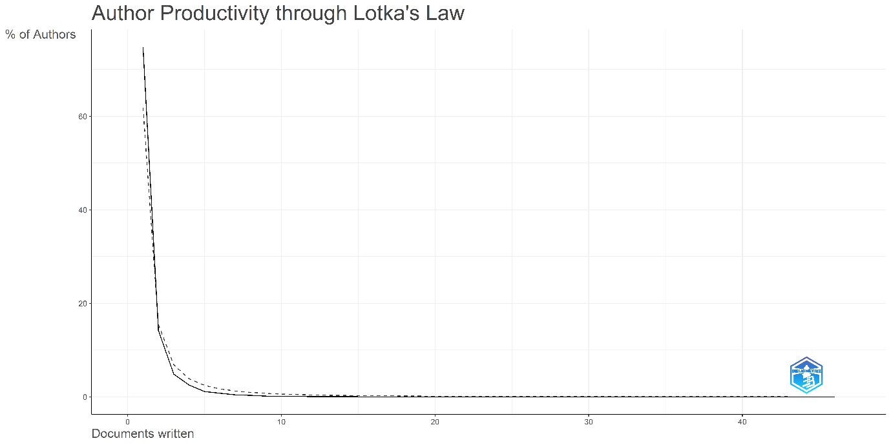
Fig.6. Author Productivity Distribution Following Lotka’s Law (2000–2025).
3.9 Most Relevant Affiliations
The institutional contribution analysis has shown that the productivity of research in this sector is highly encouraged by a list of notable international organisations with the Chinese Academy of Sciences appearing to be the most powerful HOP with 454 articles and proving the active and increasing investment of China in climate, forest, and biodiversity research achievements. The United States Department of Agriculture (USDA) is the next follower with 395 publications and is associated with the main priorities of the forest management work, ecological monitoring, and research on agriculture in relation to climatic conditions. U.S. federal agencies are also involved in the production of empirical and policy-relevant work on forest ecosystems and wildlife, as pointed out by the United States Forest Service, which has 346 articles.
The United States Department of the Interior, with 311 publications, is no exception, as it funds numerous ecological and environmental research projects with the help of many agencies like the National Park Service or the U.S. Geological Survey. It has 297 publications in the University of California System, which indicates the significant academic involvement of a significant network of public universities around the world in ecology, conservation biology, and climate change studies. The Centre National de la Recherche Scientifique (CNRS) in Europe supplies 245 articles and proves the high level of scientific activity of France and established research networks in terms of environmental sciences.
The State University System of Florida, which publishes 198 works, also has a significant role and especially in the research connected to subtropical and coastal ecosystems, climate vulnerability, and the conservation of biodiversity. The United States Geological Survey (USGS) is another agency to focus on with 195 publications, creating the significance of federal scientific agencies in the production of long-term ecological data and in aiding landscape-level assessments. The list is supplemented by the Consejo Superior de Investigaciones Cientificas (CSIC) in Spain which places significant emphasis on the increasing role of European research institutions in the ecological scholarship of the world. Lastly, the University of Florida has 152 articles, and it is one of the biggest academic contributors in the field of forest ecology, wildlife sciences, and climate resilience research. These associations depicts a scene of a landscape in which both major research universities and national scientific agencies are highly involved, especially in the United States, China and Europe. This publication highlights the interdisciplinary and internationally coordinated effort of climate change, forest, and wildlife research, which depends greatly on institutions that have a massive ability to conduct long-term ecological surveillance, field studies on a large scale, and worldwide collaboration.
3.10 Corresponding Author's Countries
The studies of the affiliations of the corresponding authors indicate that there is a very uneven distribution of research productivity worldwide, with the United States as a dominant source of research, contributing 1,775 publications, which is considerably higher than the output of all other nations. China and Australia (494 and 384), Brazil (416), and Canada (613) are the other significant contributors with 613 and 494, 416, and 613 publications, respectively. The trends in international cooperation in the form of Multiple Country Publication (MCP) ratio indicate a high degree of variation in the intercountry relations of the countries with the global research networks. Switzerland has the highest ratio of MCP of 54.5% showing that over half of its published publications with related authorship have international partners. Other countries with a high level of international cooperation are the United Kingdom (45.2%) and Germany (44.4%), which illustrates a key role of European research networks, such as EU funded consortia and multinational scientific programs. The high MCP in Sweden and Finland, in addition, indicates the emphasis on cooperation in research to generate better and expand the disciplinary influence.
India is the least with an MCP ratio of 13.7, which indicates a clear focus on research that is led locally. Poland, having an equally low index of 15.1, has the same pattern of narrow internationalisation. These low ratios in MCP do not mean that the research productivity is lower in those countries, but divergent priorities in the countries, funding models, or practices of collaboration. MCP ratio in the USA is 21% which means that the predominant majority of its publications are led in the domestic market. This is not surprising considering the magnitude and autonomy of the U. S. research ecosystem with its expansive funding programs, extensive research institutions, and a high concentration of the scientific faculty. China is a country with an MCP ratio of 28.1, which means that it is becoming more active in terms of international cooperation and is becoming more involved in international research and strategic activities aimed at strengthening its scientific presence. The MCP ratio of Brazil is 34.9, which is quite high compared to the total volume of its publications, indicating a specific emphasis on collaborative work in comparison with such countries as Australia and Canada with the same productivity rates.
These trends point to the general trends in research collaboration in the world. The developed nations like the USA, Germany, the United Kingdom, Switzerland, Sweden, and Finland are inclined to strike a balance between the well-developed domestic research and the involvement in global partnerships. Their high MCP ratios are indicators of long-standing research alliances and collaborative systems particularly in the interdependent academic environment in Europe. Emerging economies such as China and Brazil demonstrate the growing involvement in cross-national relations, which is advantageous in terms of the resources available, the increased visibility, and the integration into the world's scientific discourses. Domestic research seems to be a priority in countries such as India or Poland and probably due to the national agendas, national funding mechanisms, and local institutional frameworks.
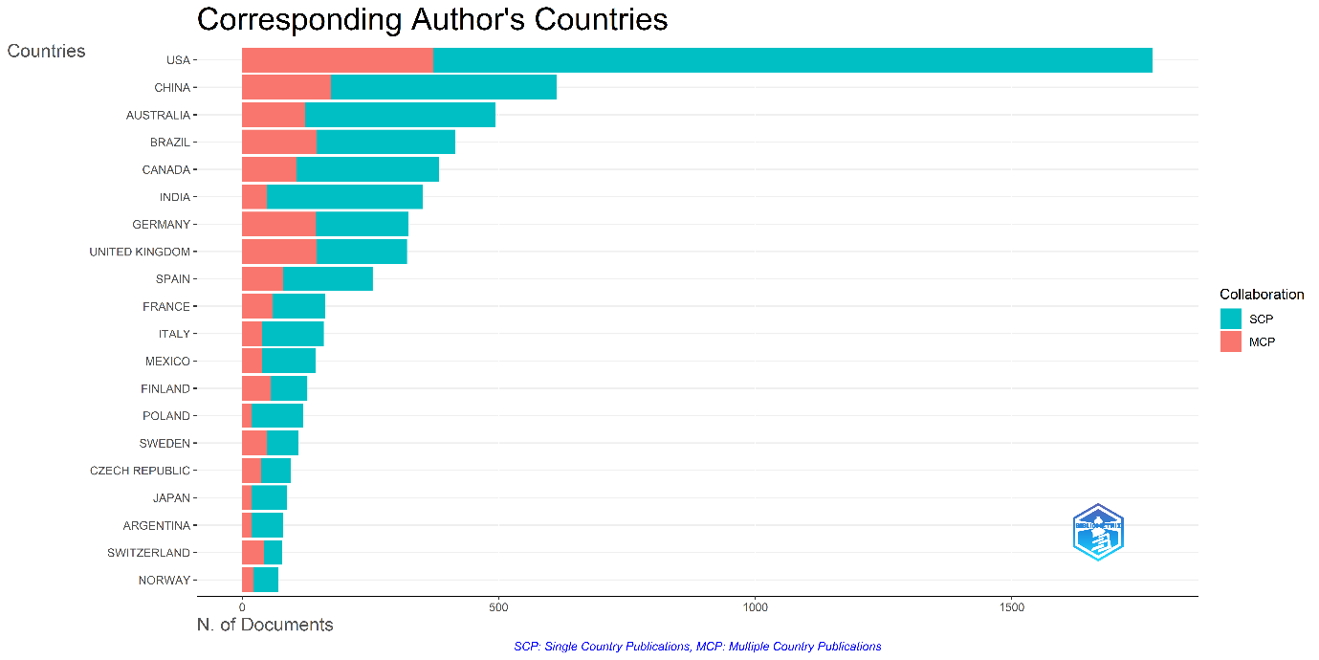
Fig.7. Contribution of the Corresponding Author’s Countries
3.11 Countries' Scientific Production
The scientific production distribution across the countries reveals the United States leading by a substantial margin at 6,016 publications. It reflects the country’s long standing investment in environmental and ecological research and its extensive network of universities and federal scientific agencies, and its central role in global climate and biodiversity studies. China follows as the second most productive country with 1,652 publications, demonstrating its rapid growth in ecological and climate-related research and its increasing global scientific presence. Brazil, with 1,609 publications, emerges as a major contributor, particularly notable given its ecological importance as home to the Amazon rainforest and its extensive research activity in conservation, forest ecosystems, and biodiversity.
Australia ranks fourth with 1,410 publications, reflecting the country’s strong research capacity in ecology, wildlife biology, and environmental management, especially in the context of climate-sensitive biomes such as drylands, coral reefs, and temperate forests. Germany contributes 1,242 publications, continuing its long-standing tradition of high-quality environmental science research and its strong participation in European collaborative networks. Close behind are Canada and the United Kingdom, with 1,183 and 1,180 publications respectively, both countries benefiting from well-developed research infrastructures and strong academic traditions in forest ecology, climate science, and conservation biology.
European contributions continue with Spain, which has produced 815 publications, highlighting its growing role in environmental research, particularly in Mediterranean ecosystems and climate vulnerability studies. India, contributing 765 publications, demonstrates its expanding interest in forest ecology, climate impacts, and wildlife conservation, although its overall output remains lower compared to major research economies. Finally, France, with 638 publications, maintains a solid position driven by institutions such as CNRS and its strong ecological research communities.
The distribution of scientific production is characterised by significant concentration in a handful of research-intensive countries, with the United States dominating the landscape and China, Brazil, Australia, and leading European nations forming a strong secondary tier. This pattern reflects global disparities in research funding, infrastructure, and scientific capacity, but also highlights the international nature of research on climate change, forests, and wildlife, where contributions from both developed and emerging economies play essential roles in shaping the field.
3.12 Most Cited Countries
There have been the most total citations of 73,393 citations, and the mean of 41.30 citations per article, which indicates that the publications of the United States are already numerous and have many references. The United Kingdom has a significantly higher average citation rate of 68.50, which means that despite having fewer articles as compared to the USA, its articles are read with great favour. Australia has a good performance too with 19,321 citations and an average of 39.10 citations per article, exhibiting consistent impact. China has 14,265 citations but a lower average of 23.30 citations per article, demonstrating high productivity and low citation intensity. Canada accrues 11,458 citations and an average of 29.80, which are stable and well-recognised research contributions. Spain is one of the countries with a high publication influence since it has been cited 10,364 times with an average of 40.80. Brazil has 9,000 citations and an average citation of 21.60 which implies moderate impact, although its volume is high. Germany has 8632 citations and a mean of 26.60 and this indicates stability in making contributions to the field. France has 7, 781 citations with an average of 48.00 which means that its publications are the most impactful among all in relation to output. Finland, 5576 citations with an average of 43.90 also shows a high level of influence, even though it has fewer papers than the big countries. These trends reveal that some nations perform better on the volume, whereas others perform better on the high citation averages, which represent high visibility and effectiveness within the research community.
3.13 Most Global Cited Documents
The article by Butchart of the 2010 journal of science is the most frequently cited article in the dataset and it has 3,573 citations indicating its significant impact in the field. This is preceded by 2015 Nature article by Newbold with 3263 citations and 2009 Nature article by Loarie with 1857 citations, which have all made a significant impact. The 2008 Science paper by Lenoir has received 1,703 citations and it is an indication of high and still relevant value. Hanson has 1,639 citations of his 2000 article in Biogeochemistry and Ewers has 1,603 citations of his article in 2006 in the journal Biological Reviews, demonstrating that the works have been recognized over the years. The most influential papers are two papers published by the Environmental Conservation one by Steneck (2002) with 1,596 citations and the other by Alongi (2002) with 1, 320 citations. The article by Vicente-Serrano (1) in PNAS in 2013 cites 1,381 sources, which is very visible nevertheless despite its recent publication date compared to others in the list. Last but not least, in Diversity and Distributions, Marmion (2009) has 2009 papers with 1,135 citations, which is one of the most influential additions in the data set. All in all, these articles are considered groundbreaking and commonly cited papers which have contributed greatly towards research on climate change, forests, biodiversity and ecological reactions.
3.14 Most Frequent Words
The occurrence of keywords is analysed and it turns out that the most frequent word in the data is climate change that occurs 2,949 times, which proves that the thematic focus of the field is more concerned with the analysis of how climate variability and long-term environmental change affect the forest ecosystems and the related biodiversity. This focus, and the closeness of the similar term climate change, with 2,420 instances, is supported by the fact that in both cases the databases indexing rules differ, but both terms indicate a strong and consistent research focus on global climatic drivers. The prevalence of the term biodiversity (1,593 times) points to the field’s long term interest in the amount of species, environmental integrity, and conservation result under the pressure of environmental change acceleration.
The word forest (1,224 times) highlights that the keyword forest ecosystems are used as the primary spatial and ecological setting in most studies contained in the dataset. The high frequency of conservation (1,075 instances) also indicates the high applied aspect of the study with much focus being on the protection of ecosystems, reduction of effects and development of sustainable management approaches. The word diversity (used 822 times) indicates a balanced consideration of the both species-level and ecological diversity trends across the forest landscapes.
The terms like vegetation (637 occurrences) and patterns (549 occurrences) show that there is a significant amount of literature focused on the evaluation of the ecological dynamics of space and time (changes in vegetation structure, distributional patterns, and ecosystem processes) in changing climatic conditions. The frequent presence of the word responses (474 times) serves as evidence that there are numerous studies on the reaction of ecosystems and species to environmental stressors, which may be either adaptive, migration, physiological or manipulation of ecosystem processes. Species richness, which was documented 461 times, is a term that is closely linked to the concept of biodiversity research and is based on attempts to measure ecological variation in various types of forests and along climatic gradients.
The most frequent keyword is temperature (453 times), which demonstrates that thermal variation is one of the most studied climatic drivers that are in line with the global tendencies of warming and the significant consequences such changes have on forest dynamics, species distribution, and ecological stability. Taken together, these high-frequency keywords provide a picture of a research gap based on the knowledge of interactions between climate change, biodiversity, forest ecology, and conservation priorities with a high focus on ecological responses, spatial trends, and environmental drivers.
3.15 Trend Topics
The evolution of research topics over the period from 2000 to 2025 reveals clear shifts in thematic priorities and methodological approaches within the field. Several themes emerge prominently in the later years of the dataset, especially between 2022 and 2024. Terms such as “Abiotic,” “Biotic,” “Machine Learning,” “Procedures,” “Invertebrates,” “Random Forest,” and “Nonhuman” appear mainly in the most recent period, indicating that these areas represent newly developing or rapidly expanding fronts in the research landscape. The presence of “Machine Learning” and “Random Forest” suggests a growing emphasis on advanced computational and statistical tools, reflecting the broader integration of artificial intelligence and predictive modelling into ecological and environmental studies. The increasing attention to “Abiotic,” “Biotic,” and “Invertebrates” indicates a shift toward exploring more mechanistic ecological processes, species interactions, and the responses of less-studied taxa to environmental change.
In contrast, several major themes demonstrate long-term continuity and sustained relevance. Terms such as “Climate Change,” “Ecosystem,” and “Ecosystem Services” consistently appear across many years and continue to hold a central place in the literature. Their enduring presence underscores the persistent importance of climate-driven ecological change, the structure and functioning of ecosystems, and the societal importance of ecosystem services. The long lifespan of these themes suggests that they remain foundational to the field, likely due to their broad applicability, policy relevance, and the continuing need for research supporting environmental management and conservation.
Other topics show a more defined rise and decline over time. Early terms such as “riparian,” “betula,” and “Western Hemisphere” appear more strongly in the earlier years of the timeline but decrease in prominence as the field evolves. These patterns may indicate that certain research questions reached maturity, that methodologies shifted, or that scientific attention moved toward broader or more integrative themes. The decline in prominence of some early topics suggests a transition from localized or species-specific studies to more global or process-oriented research frameworks.
Geographical and taxonomic terminology also plays an important role in shaping thematic development. The presence of terms such as “North America,” “Far East,” “Northern Europe,” and “Western Europe,” along with taxonomic labels such as “Cervidae,” “Picea,” and “Ungulata,” highlights a strong regional and organism-specific dimension within the research landscape. These terms suggest ongoing interest in understanding how climate and environmental drivers influence specific ecosystems or species groups, particularly in regions with distinctive climatic sensitivities or ecological significance.
The progression of topics over the past two decades demonstrates a field that is continually adapting to new scientific challenges, methodological innovations, and policy demands. The emergence of advanced analytical techniques, the persistence of core environmental themes, and the decline of earlier niche topics together reflect an increasingly integrative and technology-driven research environment. This thematic evolution suggests that future work in the field will likely continue to combine ecological understanding with advanced modelling tools to address complex environmental questions.
3.16 Co-occurrence Network
The co-occurrence network, which is depicted in the Fig 8, represents the conceptual organization of the area of research graphically by showing the frequency of co-occurrence of the keywords in the combined Web of science and Scopus database. The size of each node in the diagram will be used to show the number of times a keyword appears and the thickness of the line linking two nodes will be used to show how strongly the two terms are associated once the frequency of both terms have been normalized by the association frequency. The Louvain clustering algorithm used in the figure finds discrete clusters of terms, showing how the thematic of the field has a structure forming cohesive conceptual clusters.
The thematic cluster centred around climate change and forest is the red cluster, and it is the area related with the effects of climate change on forest ecosystems mainly in terms of the ecological effects of climate change. The close relationship between words like climate, ecosystems, drought, global warming, forestry, evolution, animals, birds, temperature, carbon, phenology and tropical forest in the red cluster graphically depicts the way these terms have a tendency to cluster in investigations on ecological processes, species responses, and forest dynamics. The high density of these words in the diagram reflects the fact that this community is a tightly knit body of research concerned with the realization of how environmental change affects forest structure, forest function and biodiversity.
The blue cluster, whose keywords include biodiversity, climate-change, and conservation, is a second large thematic community that focuses on the effect of environmental change on biodiversity and measures that are needed to conserve it. Some of the terms including vegetation, wild fire, forest management, ecology services, boreal forest, growth, disturbance, management, landscape, deforestation, ecology, abundance, species richness, patterns, dispersal, extinction, species distribution models, land-use, communities, responses, rain forest, diversity, and habitat are tightly around the central nodes.
The node "climate change" holds one of the largest places in the whole network itself, which implies that it serves as a basis of numerous lines of inquiry, especially when one speaks about forest ecosystems and ecological processes. Forest is also a word that is shown as a very prominent and well-connected word in the red cluster, indicating high priority that has been given to the ecological studies revolving around forests in the dataset. The blue cluster displays central terms such as biodiversity and conservation, which connect a vast number of subtopics and indicate the sustainability of the field in learning about the loss of biodiversity and how it can be conserved. The fact that "climate-change" is a hyphenated word which was placed in another but a related node indicates that there is a data harmonization problem due to the combination of records, though the fact that the term appeared in the blue cluster proves that the word has strong conceptual connections with the field of biodiversity and conservation studies.
The co-occurrence network in the diagram illustrates a research area that is based on two broad thematic poles: one of these poles is based on climate-inclined ecological transformation of forest ecosystems, and another one is based on the reaction of biodiversity, biodiversity conservation strategies. The high level of connectivity both inside and outside the clusters is indicative of a cohesive research environment where forest ecology, climate effects, conservation biology, and biodiversity research support each other.
.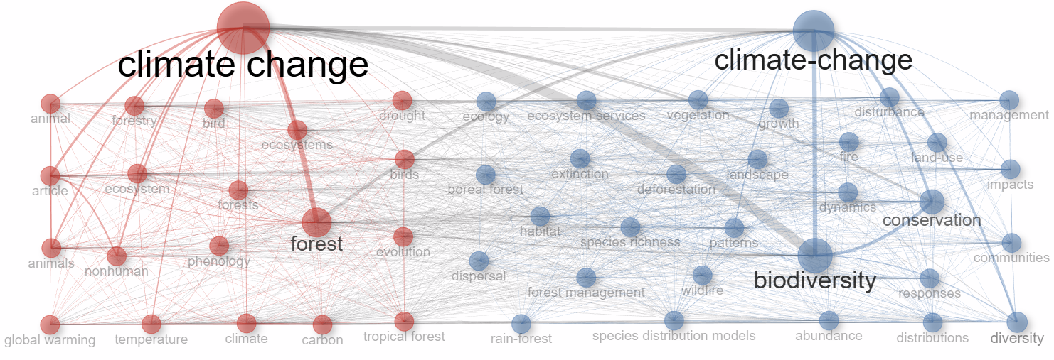
Fig.8 Co-Occurrence network

3.17 Thematic Map
The thematic map reveals how the major research themes in the field are organised according to their centrality, which reflects their relevance to the overall domain, and their density, which reflects their internal development and cohesion. These two dimensions allow the themes to be positioned conceptually within the research landscape, identifying which areas function as foundational topics, which operate as driving forces, and which may be either emerging specialities or declining areas of interest. It can be seen in the analysis that the “temperature” is a motor theme, and it is both highly centralised and dense. The fact that it has a great internal development and has very high linkages with other themes implies that the research that is related to temperature is one of the driving forces in the field. The works by Augustsson (2025), Yousefi (2025), and Wathen (2014) demonstrate the scope and maturity of the given field that has taken the centre stage in comprehending the ecological processes, reactions to climatic conditions, and adaptations of species.
According to the results of the analysis, the themes Climate Change and Climate Change - Ecosystems - Forestry are basic ones, having high centrality but lower density. Their close associations with a broad spectrum of issues signify their primary significance in the area, although the overall organisation is yet to be established. In ecological research and forestry research, respectively, the studies of Campos (2024), Gajendiran (2024), and Nukazawa (2023) reveal the pivotal role of climate change. On the same note, the larger theme connecting climate change to ecosystems and forestry takes up a fundamental role, which implies that the two domains remain a fundamental element of the conceptual base of the field.
There are two niche themes, two themes namely “Climate and Climate-Change” (vow-hyphened name), that have high density and low centrality. Their high level of internal cohesion indicates that the research in these clusters is advanced and methodologically specialised, but has less contact with the larger system of themes. According to the foundational research of Stewart (2015), Liu (2023), Prowse (2009), Li (2024), Pykala (2017), and Wu (2025), these clusters focus on a particular area of study of climate-related processes, which may represent a long-standing but more limited area of investigation.
The theme Drought is an emerging or dwindling theme, characterised by low density and low centrality. Its placement indicates that it is a comparatively emerging area of research that still requires conceptualisation or a theme that has lost its momentum over the years. According to the information provided by Du (2021), Li (2021), and Shao (2023), drought is currently being acknowledged as having an ecological significance that is on par with other topics, yet the prevailing research literature indicates that it is not yet as connected and mature as other themes.
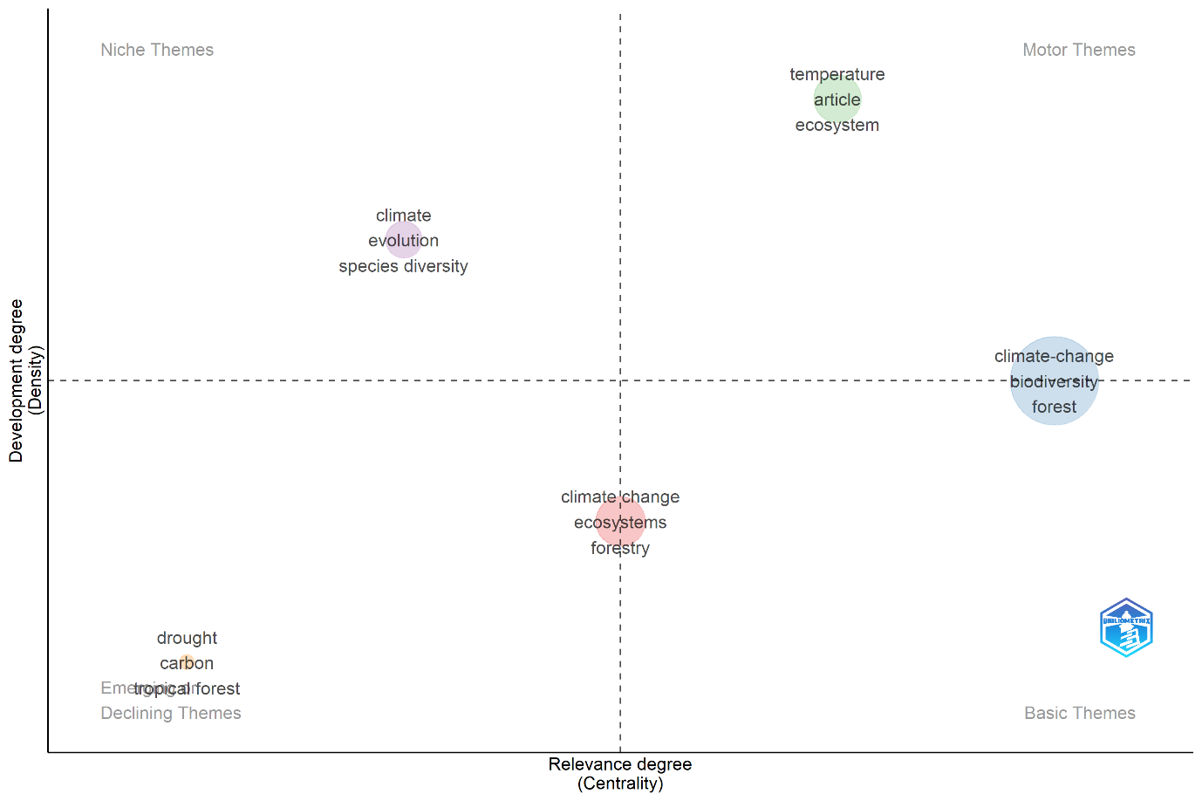
Fig.9: Strategic visualisation of the intellectual structure of research on Climate Change-Forest & Wildlife interaction by plotting the main themes based on two key metrics: centrality and density
3.18 Thematic Evolution
This strategic thematic analysis, which was conducted on the premise of combined data from both Web of Science and Scopus with the KW_Merged field, demonstrates an evident and well-organised historical development of the research area, indicating not only the consolidation of concepts but also the growing analytical complexity with time. The early approach of the period between 2000 and 2009 was mainly influenced by early ecological and geographical themes, and much focus was made on forests, vegetation, evolution, and regional settings like Europe and Eurasia. At this stage, climate change and biodiversity served as wide-cutting structures, whereas several more specialised ecological subjects, such as fungi, animalia and ecosystem responses, were more niche or loosely linked to the more general research network.
The 2010-2019 decade can be described as the period of consolidation and growth, as it was marked by the transition from a focus on narrowly defined ecological components to the more integrated ecologically-focused worldviews. Climate remained a motor theme, but now animals and ecosystems became significant motors, which indicated a further shift toward systems-based thinking of environmental change. Simultaneously, climate change and global warming were no longer central, but more and more became their contextual backdrops, as opposed to internally coherent thematic clusters. Historical and biogeographical perspectives were also established as niches during this period, with the gradual development of conservation planning and endangered species research showing thematic diversification, but not complete structural integration.
The most recent period of 2020-2025 is characterised by an extreme shift to specificity, quantification, and impact-focused inquiry. The theme of temperature is a well-developed and central motif, which means that much attention is paid to the measurable climate variables and their direct ecological implications. The rising significance of nonhuman systems also notes that there is a greater interest in ecological responses that are not human-centred. Meanwhile, once-dominant terms like climate change and ecosystems are found in the emerging or lowering quadrant, not to show the diminished significance, but to reflect the thematic saturation and the division into more specific subtopics. This transition is supported by the development of drought, carbon, biomass, and region keywords like Australia, which indicate increased attention to concrete effects of climate change, biogeochemical processes, and geographically-located case studies.
The change in themes is indicative of an advanced and dynamically reorganising science that has evolved out of the general ecological investigation into the specific, process-based, and quantitative studies of the effects of climate change. Conventional background issues like climate change, biodiversity and forests still anchor the field with new issues, however, pointing to temperature dynamics, drought and carbon processes, indicating the future research horizon. The steady loss or contraction of previous generic ecological terminology reflects the growing specialisation and conceptual sophistication, which implies that future studies will be motivated not so much by general description models but by granular, impact studies.
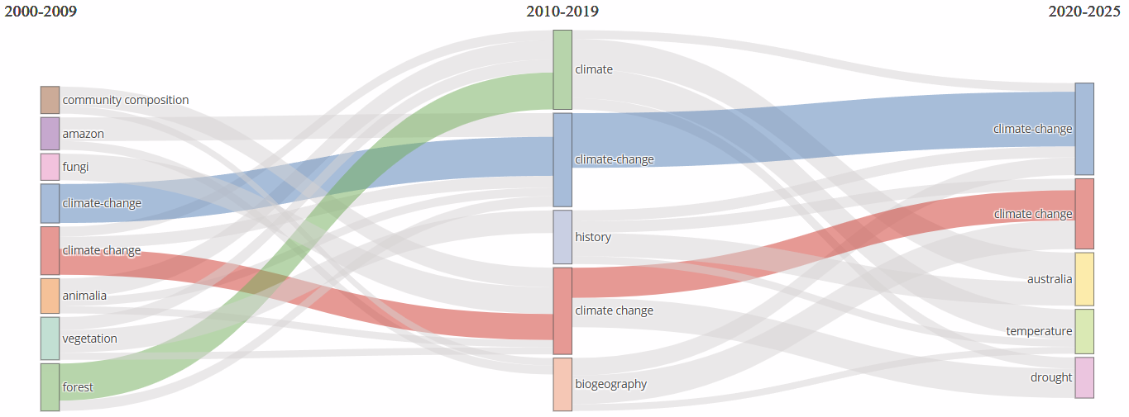
Fig.10: Representation of Thematic Evolution of concepts over time
3.19 Factorial Analysis
A factorial analysis as shown in the factorial map, involves Multiple Correspondence Analysis (MCA) to reduce the convoluted design of a keyword co-occurrence to a two-dimensional conceptual area. Each point in the diagram corresponds to a keyword and the relative position of the point indicates the strength with which the keyword is associated with other terms. The most frequently occurring keywords are those plotted close to each other whereas the further the space between in the diagram, the less conceptual overlap. The diagram, therefore, gives a graphic representation of the way central themes in the dataset cluster into separate areas of thought. The dominant thematic axis is dimension 1 which covers 83.53 per cent of the total variance and runs horizontally in the diagram. This axis in the figure is effective in separating terms associated with general ecological and animal-specific studies, which are near the left side, and those that are related to climate-change effects, distributions, forestry uses, and conservation measures, which are all located to the right. The additional differentiation is offered by Dimension 2, which explains 5.93% of the variance and which runs vertically in the diagram. At the top of the plot, one can see that there are some keywords like forestry and ecosystems, which are clustered with each other, meaning that the plot is thematically concentrated on forest systems, the functioning of ecosystems, and management procedures. The bottom section, on the other hand, contains more broadly or cross-cutting ecological words indicating that this dimension is used to differentiate between studies that have an ecosystem-focused context and those that have a more general ecological or conservation-related focus.
A number of sub-thematic concentrations in the overall cluster are also visible in the diagram. The words forestry and ecosystems are similar and in the upper-left quadrant, they create a familiar cluster around the management of forests and the processes within ecosystems in managed systems. On the left side of the diagram, the cluster "animal, animals, nonhuman, ecosystem and bird" visually illustrates the research that is based on general ecology and research on animals. In the right of the diagram, a heavy clustering of terms, including climate change, conservation, distributions, species richness, evolution, habitat, growth, boreal forest, tropical forest, carbon, and forest management, creates a broad thematic area associated with climate influences, patterns of biodiversity and management of forest ecosystems. The graphical density and spatial integrity of this cluster in the diagram reflect that it mainlines several strands of research.
The words adding up most significantly to Dimension 1, especially those opposing animal-oriented ecology with climate-change and conservation topics are the ones that define the major structure that is apparent in the map, establishing the large left-to-right divide that can be seen in the diagram. Similarly, keywords that add to Dimension 2 especially the ones related to forestry and ecosystems, define the vertical distinction between forest-specific studies and ecological studies in general. The combination of these axes forms the visual construct in the diagram that shows a research landscape with the main contrasts in the ecological core, climate-change effects, and forestry practice.
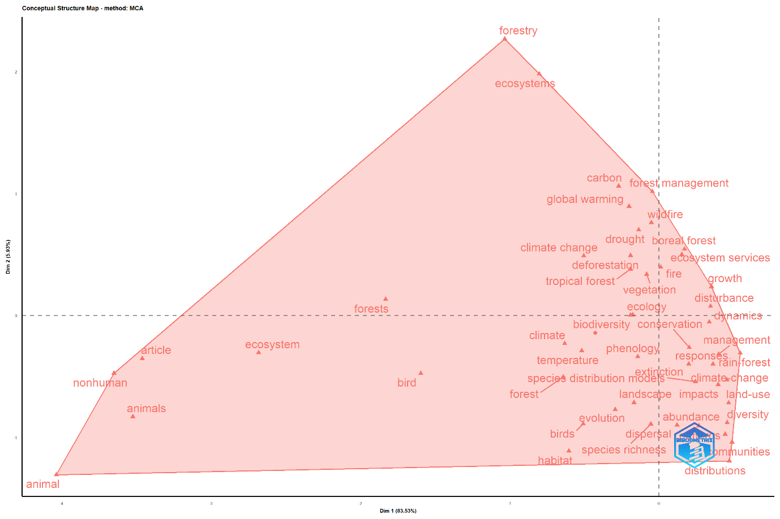
Fig.11 The factorial analysis, performed using Multiple Correspondence Analysis (MCA)
3.20 Collaboration Network
The available world map of collaboration of the countries demonstrates a well-developed network of research, organised globally, with a high level of concentration of scientific production and high international co-authorship. The United States, Canada, the United Kingdom, Germany, China, and Australia are the most prolific countries in terms of research and thus they come out as the powerhouses as seen by the brightest colour. Such countries altogether underpin the international knowledge system and have high shares of the scholarly production in the discipline, which indicates their well-functioning research systems, funding base and scholarly image. A specifically thick network of activity is constituted by Western Europe, where there is a large amount of intra-regional cooperation, and North America and East Asia are other significant centres of production.
The points of collaboration further emphasise how a few dominant countries have been at the centre of influencing international research collaborations. A thick transatlantic web between North America and Europe is the most eminent cooperating axis that emphasises the long-term academic contacts and mutual research interests. These hubs have strong east-west connections to Asian research centres, especially China, Japan, South Korea, and India, which suggests the growing internationalisation of scientific collaboration. Australia is in a strategic bridging location and has strong relations with both Asian and North American allies and solidifying its position as an intermediary in the world network.
Unexpectedly, some other countries like Brazil, Argentina, and South Africa show significant incorporation into global research by the work of international productive countries despite their relatively small output. This trend demonstrates a central periphery, in which the basic powers of research serve as the centre hubs that call and enable cooperation in different regions. The high level of co-location between high productivity and high collaboration intensity indicates that it is a rich club phenomenon, where dominant countries interact with each other most of the time and also act as entry points to the global interaction.
The collaboration map can be used to depict a globally connected yet structurally uneven research landscape where scientific influence is held by a small group of highly productive states. Although there is some evidence of regional clustering that is supported by geographic proximity, which is more evident in Europe, there seem to be more pronounced influences on collaboration patterns which are academic affinity, shared language, and historical ties. These results highlight the power of international collaboration in field development and the ongoing necessity to develop more inclusive and equal global research partnerships and especially with underrepresented and climate vulnerable locations.
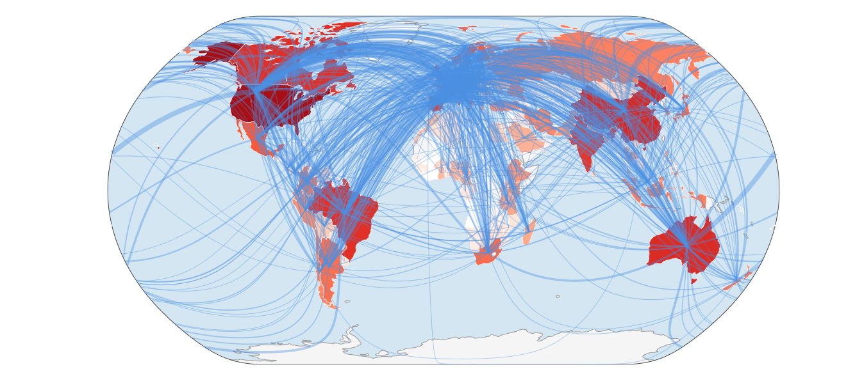
Fig.12 Representation of Countries’ Collaboration World Map
- Conclusion
Altogether, this bibliometric analysis indicates that the volume of research on the intersection of climate change, forest ecosystems, biodiversity, and wildlife has increased steadily in the last 26 years as the world started paying more and more attention to the issue of environmental change and ecosystem resilience. The steady increase in the number of publications and the slowing growth rate of the output indicate that the discipline is going through the mature stage, where its main ideas and principles are established, and studies are becoming narrower and more specialised. The input of large research areas in North America, Europe, Asia, and even the Global South also indicate the worldwide interest in these problems, and the differences in international cooperation refer to disparities in research potential, fundraising schemes, and domestic priorities.
Thematic organisation of the literature shows that the field is stable and in change. The focus on climate change, ecosystems, biodiversity, and conservation is all an issue of concern and the basis of future research, and the focus on temperature variability, drought, and extreme events is indicative of the rising effects of climate stressors on forest and wildlife systems. Simultaneously, the development of data-driven techniques, such as machine learning and sophisticated modelling, suggests that the approach to methodological change is towards less qualitative and predictive methods that are more capable of reflecting the intricate processes of ecology.
According to the analysis, it can be anticipated that future research will make the connection between ecological theory, technological tools, and applied conservation stronger. The field should also respond to urgent environmental issues with more focus being put on long-term monitoring, cross-ecosystem comparisons, species vulnerability assessments, and policy-relevant outcomes. In this sense, the bibliometric evaluation is not only able to provide an oversight of the previous and current research trends but can also provide a clear insight into the scientific directions that will most likely define climate-forest-biodiversity research in the next few years.

References
Nunes, L J R, C I R Meireles, C J P Gomes, and N M C A Ribeiro. 2021. “The Impact of Climate Change on Forest Development: A Sustainable Approach to Management Models Applied to Mediterranean-Type Climate Regions.” Plants (MDPI) 11 (1): 69. doi:https://doi.org/10.3390/plants11010069.
Adarsh T, and Haneena K.P Sulthana. 2025. “Trends & Insights in Nature Based Solutions: A Bibliometric study.” Journal of Disaster Studies & Climate Resilience 1 (1): 22-34. doi:https://doi.org/10.64866/j.ijdscr.2025.10003.
Adarsh T, Neenu S Pillai, Suresh S, and Balu M. 2025. “Global Research Landscape and Knowledge Evolution of Early Warning Systems in Natural Disaster Management.” Asian Journal of Geographical Research 8 (4): 360-388. doi:10.9734/ajgr/2025/v8i4343.
Aria, M., and Cuccurullo, C. 2017. “Bibliometrix: An R-tool for comprehensive science mapping analysis.” Journal of Informetrics 11 (4): 959-975. doi:https://doi.org/10.1016/j.joi.2017.08.007.
Bradford, S. C. 1934. “Sources of information on specific subjects.” Engineering: An Illustrated WeeklyJournal 137: 85-86. https://www.scirp.org/reference/referencespapers?referenceid=3027930.
Ciauskas, Linas Balˇ. 2025. “Conservation and Management of Forest Wildlife.” Forests (MDPI) 16: 1134. doi:https://doi.org/10.3390/f16071134.
Dandabathula, Giribabu , Sudhakar Reddy Chintala, Sonali Ghosh, Padmapriya Balakrishnan, and Chandra Shekhar Jha. 2021. “Exploring the nexus between Indian forestry and the Sustainable Development Goals.” Regional Sustainability 2 (4): 308-323. doi:https://doi.org/10.1016/j.regsus.2022.01.002.
Donthu, Naveen , Satish Kumar, Debmalya Mukherjee, Nitesh Pandey, and Weng Marc Lim. 2021. “How to conduct a bibliometric analysis: An overview and guidelines.” Journal of Business Research (ELSEVIER) 133: 285-296. doi:https://doi.org/10.1016/j.jbusres.2021.04.070 .
Du, N, A.M Fathollahi-Fard,, and K.Y Wong. 2023. “Wildlife resourceConservation and utilization for achieving sustainable development in China: main barriers and problem identification.” Environmental Science and Pollution Research. doi:https://doi.org/10.1007/s11356-023-26982-7.
Fischer, A P, M A R Shah, A C Segnon, C Matavel, P A Agyei, Y Shang, M Muir, R Khaufmann, and The Global Adaptation Mapping Team. 2024. “Human adaptation to climate change in the context of forests: A systematic review.” Climate Risk Management 43. doi:https://doi.org/10.1016/j.crm.2023.100573.
Kindlmann, Pavel , Spyros Tsiftsis, Lucie Buchbauerová, Iva Traxmandlová, and Zuzana Štípková. 2025. “How Will Environmental Conditions Affect Species Distribution and Survival in the Coming Decades-A Review.” Diversity (MDPI) 17 (11): 793. doi: https://doi.org/10.3390/d17110793.
Lotka, A. J. 1926. “The frequency distribution of scientific productivity.” Journal of the Washington Academy of Sciences 16 (12): 317-323. https://www.jstor.org/stable/24529203.
Newsom, Amy , Zita Sebesvari, and Ine Dorresteijn. 2023. “Climate change influences the risk of physically harmful human-wildlife interactions.” Biological Conservation 286. doi:https://doi.org/10.1016/j.biocon.2023.110255.
Ozturk, Oguzhan, Rıdvan Kocaman, and Dominik K Kanbach. 2024. “How todesign bibliometric research: anoverview andaframework proposal.” Review of Managerial Science 18 (11): 3333-3361. doi:DOI:10.1007/s11846-024-00738-0.
Pawar, K V, and R V Rothkar. 2015. “Forest Conservation & Environmental Awareness.” Global Chal;lenges, Policy Framework & Sustainable Development of Mining Mineral & Fossil Energy Resources (GCPF2015). Elsevier. 211-215. doi: 10.1016/j.proeps.2015.06.027 .
Qadir , MKU, R Kausar, S Rehan, MQS Ahmed , R Bashir, H Hira, T Batool, Z Nasreen, SET Razia , and S Rashid . 2025. “Forest Ecology and Wildlife Conservation.” Integrated Health and Sustainability: Plants, Wildlife & Genetic Resilience 369-375.
Samant, S. S. , Vikram S Negi, R Pathak, Bhawana Dangwal, R K Joshi, Subodh AirI, K C Sekar, Shreekar Pant, and I D Bhatt. 2025. “Biodiversity conservation and management through forest landscape restoration in the Western Himalaya, India.” Frontiers in Conservation Science 6. doi:https://doi.org/10.3389/fcosc.2025.1663322.
Sintayehu, Dejene W. . 2018. “Impact of climate change on biodiversity and associated key ecosystem services in Africa: a systematic review.” Ecosystem and Health Sustainability 4 (9): 225-239. doi:https://doi.org/10.1080/20964129.2018.1530054.
Weiskopf, S R, M A Rubenstein, L G Crozier, S Gaichas, R Griffis, J E Halofsky, K J W Hyde, et al. 2020. “Climate change effects on biodiversity, ecosystems, ecosystem services, and natural resource management in the United States.” Science of the Total Environment 733. doi:https://doi.org/10.1016/j.scitotenv.2020.137782.

