Numerical Simulation of Laser-Induced Thermal Therapy for Superficial Tumors Using COMSOL Multiphysics

Abstract:
Laser irradiation represents a highly precise method for delivering thermal energy to superficial cancer cells while minimizing injury to surrounding healthy tissue. Mathematical modeling of laser–tissue interaction is essential for treatment planning and outcome prediction. This study presents a comprehensive numerical simulation of heat distribution during laser-induced thermal therapy for superficial tumors using COMSOL Multiphysics. The novelty of this work lies in the integration of a multi-layered skin geometry with a tumor-specific domain to perform a detailed parametric analysis of critical treatment variables. A 2D cross-sectional skin model consisting of the epidermis, dermis, and subcutaneous layers was constructed, with a circular tumor embedded within the dermis. Heat transfer was modeled using Pennes’ bioheat equation coupled with a laser heat source described by the Beer–Lambert absorption model. The effects of blood perfusion, optical absorption, laser intensity, exposure duration, and tumor geometry were systematically investigated. The simulation demonstrates that optimized laser parameters can selectively raise tumor temperature to the therapeutic hyperthermia range (42–45 °C) and induce localized thermal damage. For instance, under an intensity of 3 W/cm² applied for 50 seconds, the tumor center reached a peak temperature of ~48 °C, while surrounding healthy tissue remained below 40 °C. The model underscores the critical role of parameter optimization, particularly laser intensity and exposure time, in enhancing the efficacy and safety of laser-based tumor therapy, providing a valuable framework for preclinical treatment planning.
Keywords: Laser ablation, COMSOL modeling, superficial tumor, hyperthermia, Pennes’ bioheat equation, thermal therapy.
- Introduction
Skin cancer has become increasingly prevalent in recent decades [1]. Although modern dermoscopic imaging aids in identifying suspicious lesions, definitive diagnosis still requires biopsy, an invasive, time-consuming procedure that depends on specialized expertise [2]. The skin, the largest organ of the body, consists of three primary layers: the epidermis (protective outer barrier), the dermis (containing vasculature, glands, and structural tissues), and the subcutaneous layer (mainly adipose tissue providing insulation and cushioning) [3], as illustrated in Figure 1.
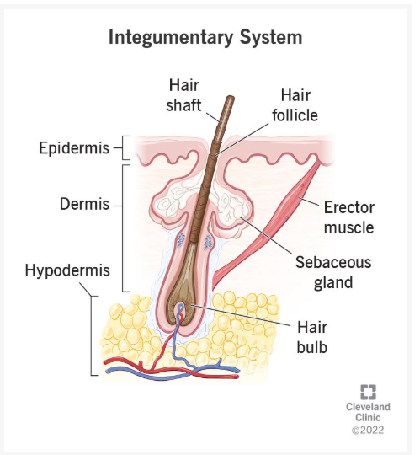
Figure 1: skin anatomy integumentary system
Skin cancers fall broadly into two categories: non-melanoma and melanoma. Non-melanoma cancers, including Basal Cell Carcinoma (BCC) and Squamous Cell Carcinoma (SCC), arise in the epidermis and are highly curable when detected early [4]. BCC is the most common type, while SCC carries a higher, yet still limited, risk of metastasis. Melanoma, originating in melanocytes, is less common but significantly more aggressive and life-threatening [5] (Figure 2).
(a) 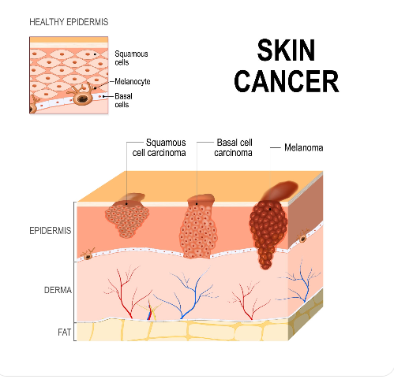 (b)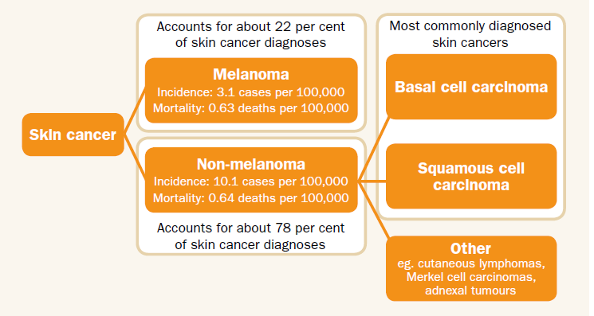
Figure 2: Type of skin cancer
Traditional treatment methods include surgery, radiotherapy, cryosurgery, and radiofrequency ablation. In contrast, laser therapy offers a controlled, minimally invasive technique capable of selectively destroying malignant cells while sparing healthy tissue [6]. The safety and efficacy of laser-based interventions for dermatological conditions in diverse populations, including those with higher Fitzpatrick skin types common in regions like Sudan, have been recently demonstrated [7,8]. Building upon prior research into laser-tissue interactions in biological materials [9.10], this study extends the application of laser modeling to therapeutic hyperthermia in superficial tumors. Optimization of laser parameters, such as wavelength, intensity, and exposure duration, is crucial for maximizing energy deposition in the tumor and minimizing collateral thermal injury.
While clinical trials provide essential outcome data, they are expensive, time-consuming, and cannot exhaustively test the infinite combination of possible laser parameters and patient-specific tissue geometries. Furthermore, invasive temperature measurement during treatment is impractical. Mathematical modeling is therefore indispensable for predicting light transport, heat generation, and thermal damage in a safe, cost-effective manner. The combination of Pennes’ bioheat transfer model with laser absorption physics enables accurate simulation of spatiotemporal temperature patterns during treatment [11,12]. Recent advancements in computational power and software have made detailed, patient-specific modeling increasingly feasible for treatment planning [13,14].
Although the Pennes bioheat equation and Beer–Lambert absorption model are well-established in thermal therapy research [15], comprehensive, end-to-end computational workflows for superficial skin tumors, particularly using accessible platforms like COMSOL Multiphysics, are not widely documented in the literature. Such reproducible models are needed to bridge the gap between theoretical principles and clinical pre-planning.
This study aims to address this gap by developing and validating a detailed, reproducible numerical model in COMSOL Multiphysics to simulate laser-induced thermotherapy for superficial tumors. The primary objectives are: (1) to construct a realistic 2D multi-layered skin geometry with an embedded tumor; (2) to simulate the spatiotemporal temperature distribution using the Pennes bioheat equation coupled with a laser source; (3) to quantitatively assess the influence of key parameters (laser intensity, exposure time, perfusion) on achieving selective tumor hyperthermia (42–45 °C) and ablation (>45 °C) while sparing healthy tissue; and (4) to provide a validated modeling framework that can serve as a template for future parameter optimization studies.
- Laser Therapy for Superficial Tumors
Laser therapy for BCC and other superficial lesions is based on selective targeting of chromophore-rich tumor vessels and precise thermal ablation [16]. Ablative lasers, mainly CO₂ (10,600 nm) and Er:YAG (2,940 nm), operate by vaporizing intracellular water. High-energy, short-duration pulses allow tissue removal with minimal thermal spread [17,18].
  - Continuous-Wave vs Pulsed Technologies
- Continuous-wave (CW) lasers deliver constant power but risk broad thermal injury.
- Quasi-Continuous Mode (QSM) lasers interrupt the beam using mechanical shutters.
- Pulsed lasers provide optimal fluence and short pulse duration, reducing coagulative damage while ensuring precise ablation.
  - CO₂ vs Er:YAG Ablative Lasers
Table 1. Comparative characteristics of CO₂ and Er:YAG ablative lasers relevant for superficial tumor therapy.
Property | CO₂ Laser (10,600 nm) | Er:YAG Laser (2,940 nm)
Ablation depth | ~20 µm per pass | ~2 µm per pass
Water absorption | Moderate | Very high (≈15× CO₂)
Coagulation | Significant (excellent hemostasis) | Minimal
Collagen stimulation | High | Low
As shown in Table 1, the CO₂ laser provides greater ablation depth per pass and significant coagulation, while the Er:YAG laser offers higher water absorption with minimal collateral thermal damage. CO₂ lasers are therefore preferred where hemostasis and deeper controlled ablation are required.
Clinical studies report high cure rates for CO₂ laser treatment of BCCs, with excellent cosmetic outcomes when appropriate settings are used [19–23].
- Methods and Models
This study developed a computational framework to simulate laser-induced thermal therapy within skin tissue using COMSOL Multiphysics (Heat Transfer Module). The model integrates tissue geometry, thermal and optical properties, blood perfusion, and laser absorption physics.
  - Geometry Construction
A two-dimensional axisymmetric cross-section of the skin was constructed, approximating a region of clinical interest:
Skin slab dimensions: 1.0 cm height × 0.3 cm radius.
Tumor geometry: A circular tumor with a radius of 0.2 cm was embedded within the dermal layer.
Layers represented: Epidermis (0.1 mm), Dermis (1.0 mm), and Subcutaneous tissue (remainder).
The geometry is illustrated in Figure 3.
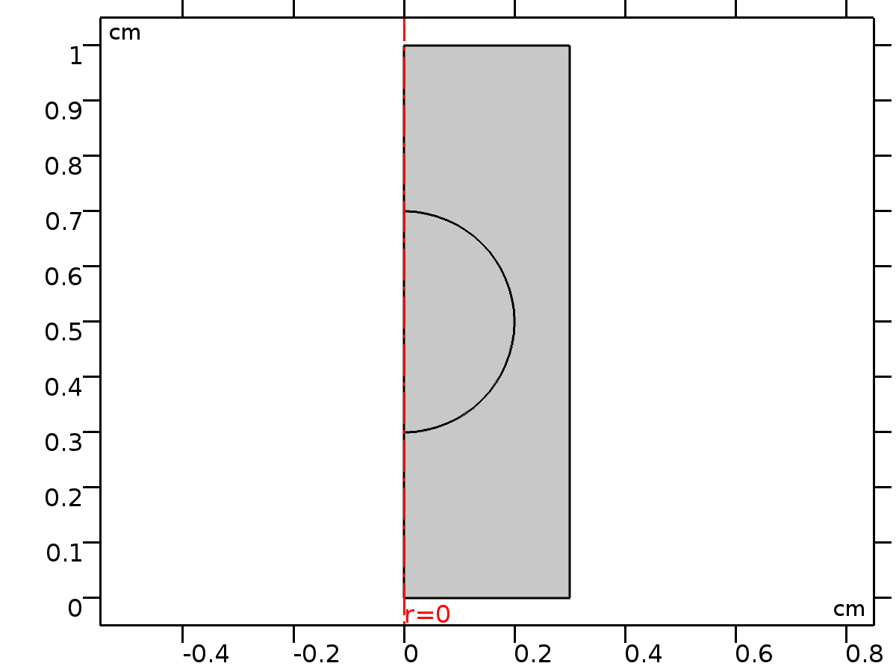
Tumor
Skin
Figure 3: Model geometry of skin layers and embedded tumor (2D axisymmetric cross-section).
An axisymmetric 2D geometry was adopted to reduce computational cost while preserving the radial heat diffusion characteristics of a centrally irradiated laser beam. The dimensional layout of the computational domain is shown in Figure 4.
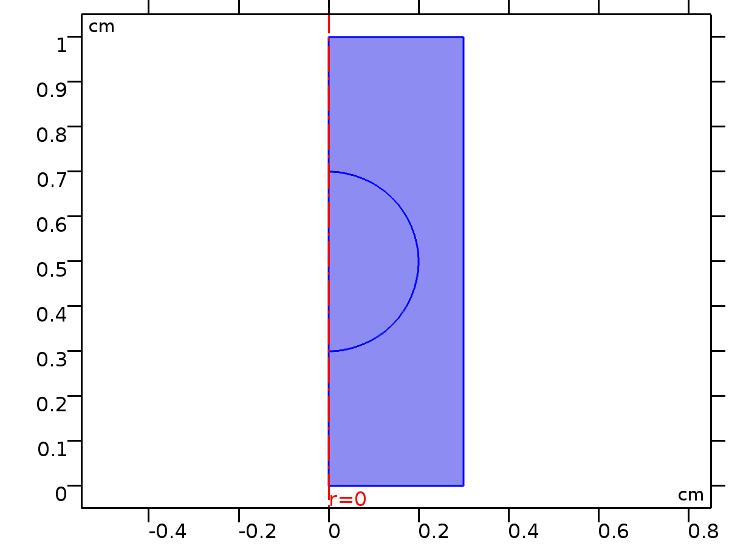
Figure 4. Two-dimensional axisymmetric geometry used for the biothermal simulation, showing the skin tissue domain and the embedded superficial tumor. The red dashed line represents the axis of symmetry (r = 0), and all dimensions are given in centimeters.
  - Governing Equation: Pennes’ Bioheat Model
    - Pennes' Bioheat Transfer Equation
Heat transfer in perfused biological tissue was modeled using the Pennes' bioheat equation:
ρc_{p}$∂$T/ $∂$t = $∇⋅$ (k$∇$T) + ρ_{b} c_{b} ω_{b} (T_{a} - T) +Q_{met} + Q_{laser} (1)
Where ρ, c_{p}​, and k are the tissue density (kg/m³), specific heat capacity (J/kg·K), and thermal conductivity (W/m·K), respectively. ρ_{b}, c_{b}, ω_{b} and T_{a} are the blood density, specific heat, perfusion rate (1/s), and arterial temperature (37 °C). Q_{met}​ is the metabolic heat generation, assumed negligible for this short-duration simulation. Q_{laser}​ is the volumetric heat source from laser absorption (W/m³).
    - Laser Heat Source (Beer–Lambert Law)
The laser energy deposition was modeled as a volumetric heat source derived from the Beer-Lambert law for light attenuation in a scattering medium. The source term is given by:
Q_{laser} (z) = $μ_{a}$ $I_{0}$ $e^{-μ_{eff}z}$ (2)
where $μ_{a}$is the tissue absorption coefficient (m⁻¹). I₀​ is the incident laser irradiance at the surface (W/m²), treated as a radially uniform beam. ​ $μ_{eff}=\sqrt{3μ_{a}​(μ_{a}​+{μ_{s}}^{'​} )​ }$ is the effective attenuation coefficient, with ${μ_{s}}^{'​}$=${μ_{s}}^{​}$(1−g) being the reduced scattering coefficient. z is the depth from the irradiated surface.
Laser Parameters: The simulation assumed a CO₂ laser wavelength of 10,600 nm. A continuous-wave beam with a Gaussian radius (1/e²) of 0.5 mm was applied perpendicularly to the skin surface. The baseline power density (I₀​) was set to 3 × 10⁴ W/m² (3 W/cm²) for a duration of 50 seconds.
  - Material Properties
The thermal, optical, and perfusion properties assigned to the skin and tumor domains are critical for an accurate simulation. The values used in this model, based on literature data for soft tissue at the relevant wavelength [24, 25], are listed in Table 2 and Table 2a.
Table 2. Thermal and Perfusion Properties
Property | Skin | Tumor | Units
Density, ρ | 1109 | 1040 | kg/m³
Thermal Conductivity, k | 0.37 | 0.51 | W/m·K
Heat Capacity, c_{p}​ | 4300 | 3700 | J/kg·K
Perfusion Rate, ω_{b}​ | 0.005 | 0.009 | 1/s
Table 2a. Optical Properties (λ = 10,600 nm)
Property | Epidermis | Dermis | Tumor | Units
Absorption Coefficient, μ_{a​} | 200 | 150 | 350 | m⁻¹
Scattering Coefficient, μ_{s}​ | 80 | 100 | 90 | m⁻¹
Anisotropy Factor, g | 0.90 | 0.85 | 0.88 | -
  - Initial and Boundary Conditions
The model's initial state and boundaries were defined to replicate physiological conditions and the clinical treatment scenario.
Initial Condition:
The entire computational domain was initialized at a uniform core body temperature of 37 °C. The initial temperature field was configured using an axial symmetry condition to reduce computational cost, as shown in Figure 5.
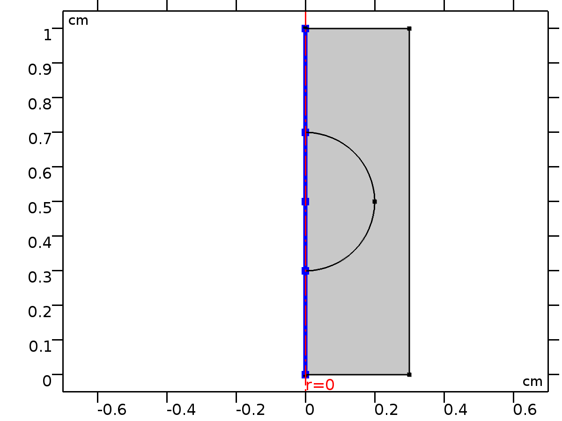
Figure 5. Initial values defined in COMSOL using axial symmetry.
Thermal Boundaries:
- Top Surface (Epidermis): Experienced natural convection to ambient air (convective heat flux, h = 10 W/m²·K, T∞ = 22 °C).
- Lateral Boundaries: Treated as thermally insulated (zero heat flux) to represent minimal lateral heat exchange in vivo, as defined in Figure 6.
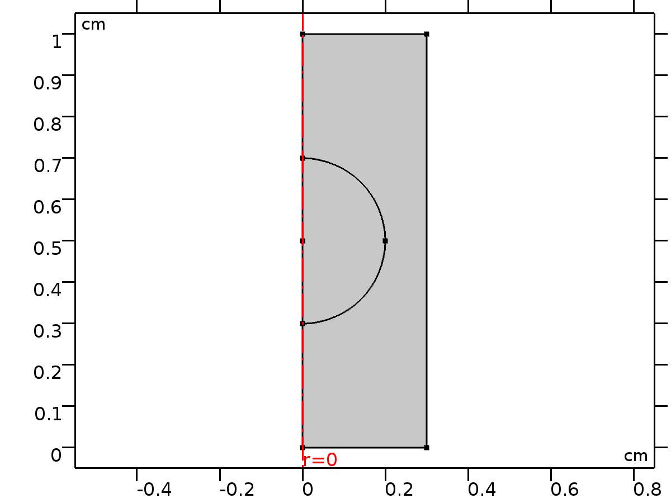
Figure 6. Thermal insulation applied to the lateral boundary.
- Bottom Boundary: Fixed at a constant temperature of 37 °C to simulate the isothermal core of the body and the thermal sink effect of systemic blood flow (Figure 7).
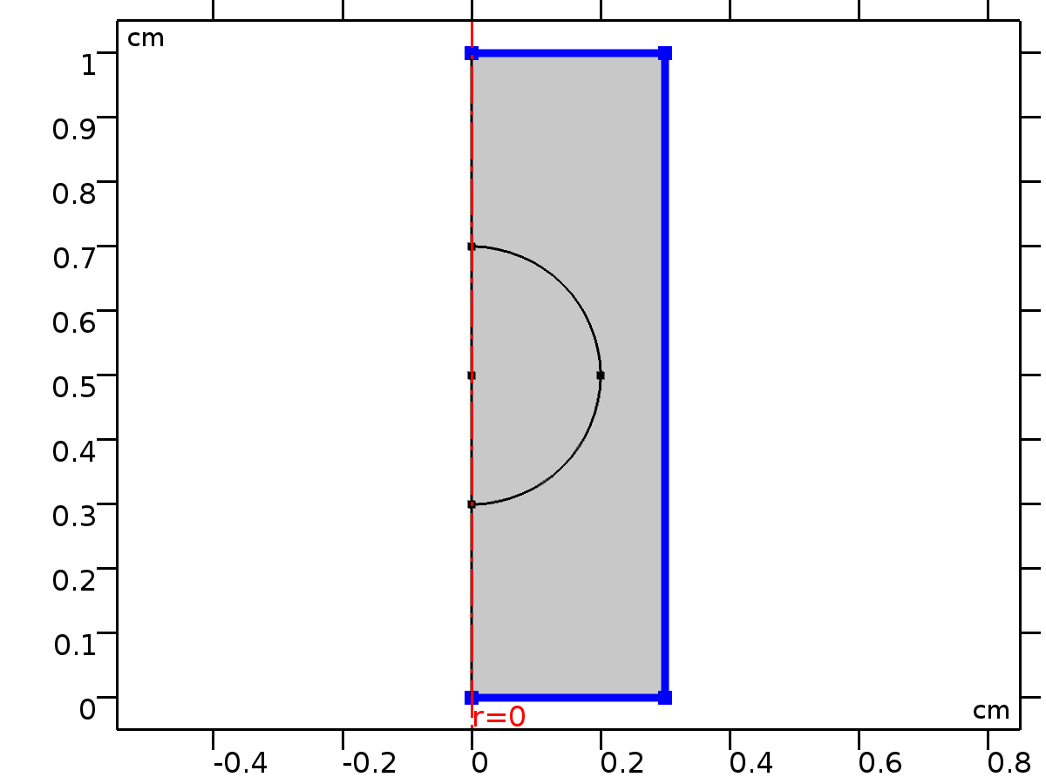
Figure 7. Fixed temperature condition (37 °C) applied to the bottom boundary.
Laser Source Application:
The volumetric heat source Q_{laser}​ (Eq. 2) was applied within the tissue domains. The spatial distribution and magnitude of the source were defined in the physics settings, as illustrated in Figure 8.
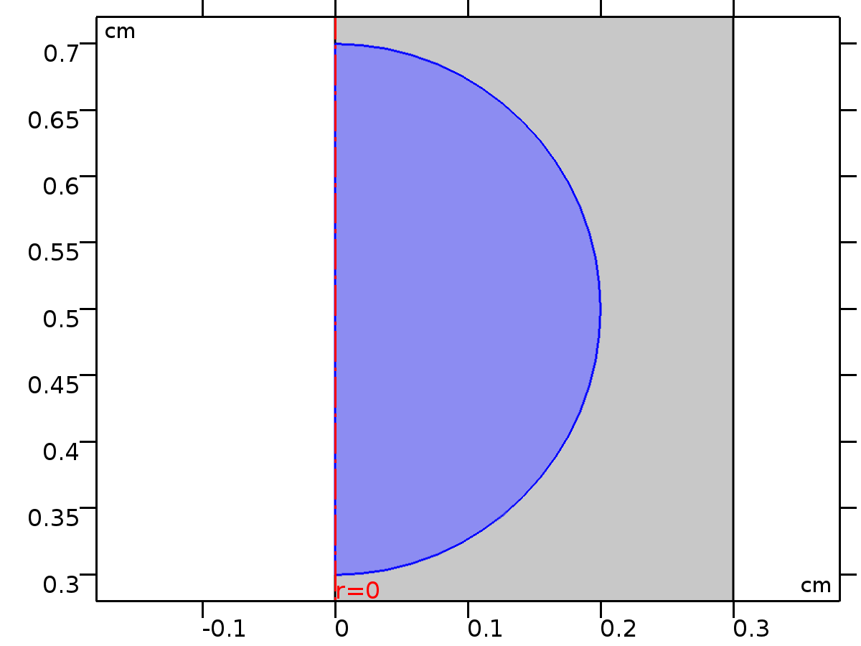
Figure 8. Laser heat source definition in COMSOL.
  - Meshing and Solver Settings
A physics-controlled, extra-fine mesh was generated with local refinement around the tumor and the irradiated surface to accurately resolve steep temperature gradients. Key mesh statistics are provided in Table 3.
Table 3. Mesh Configuration Statistics
Description | Value
Minimum Element Quality | 0.7664
Average Element Quality | 0.9695
Triangular Elements | 2138
Maximum Element Size | 0.02 m
Minimum Element Size | 7.5×10⁻⁵ m
The mesh distribution is shown in Figure 9.
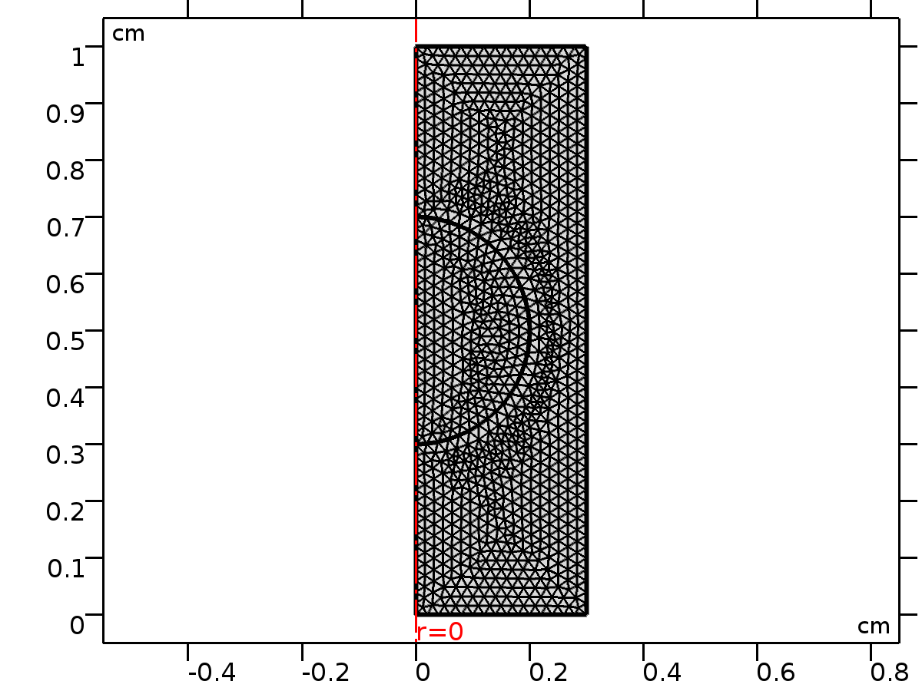
Figure 9. Mesh distribution showing refined element density around the tumor and epidermal surface.
A time-dependent study was configured to simulate the treatment from t = 0 to 50 s with a step of 0.1 s, using a direct (MUMPS) solver for the coupled heat transfer and laser absorption physics.
- Results
This section presents the quantitative and qualitative outcomes of the numerical simulation.
  - Baseline Thermal Distribution
Under baseline parameters (CO₂ laser, λ = 10,600 nm, I₀ = 3 W/cm², t_{exp} = 50 s), the model achieved selective tumor heating.
Key Quantitative Outcomes:
- Peak Temperatures: The maximum temperature reached 48.2 °C at the tumor center. The epidermal surface reached a maximum of 38.7 °C.
- Therapeutic Volume Analysis: Post-treatment analysis (t = 50 s) indicated that the majority (~87%) of the tumor volume was heated above the hyperthermia threshold of 42 °C, with a central region (~18%) exceeding the 45 °C ablation threshold.
- Healthy Tissue Status: The surrounding dermal tissue remained below 40 °C (max: 39.2 °C), confirming minimal thermal injury to healthy structures.
Figure 10 shows the final 3D temperature profile, illustrating the focal heating zone.
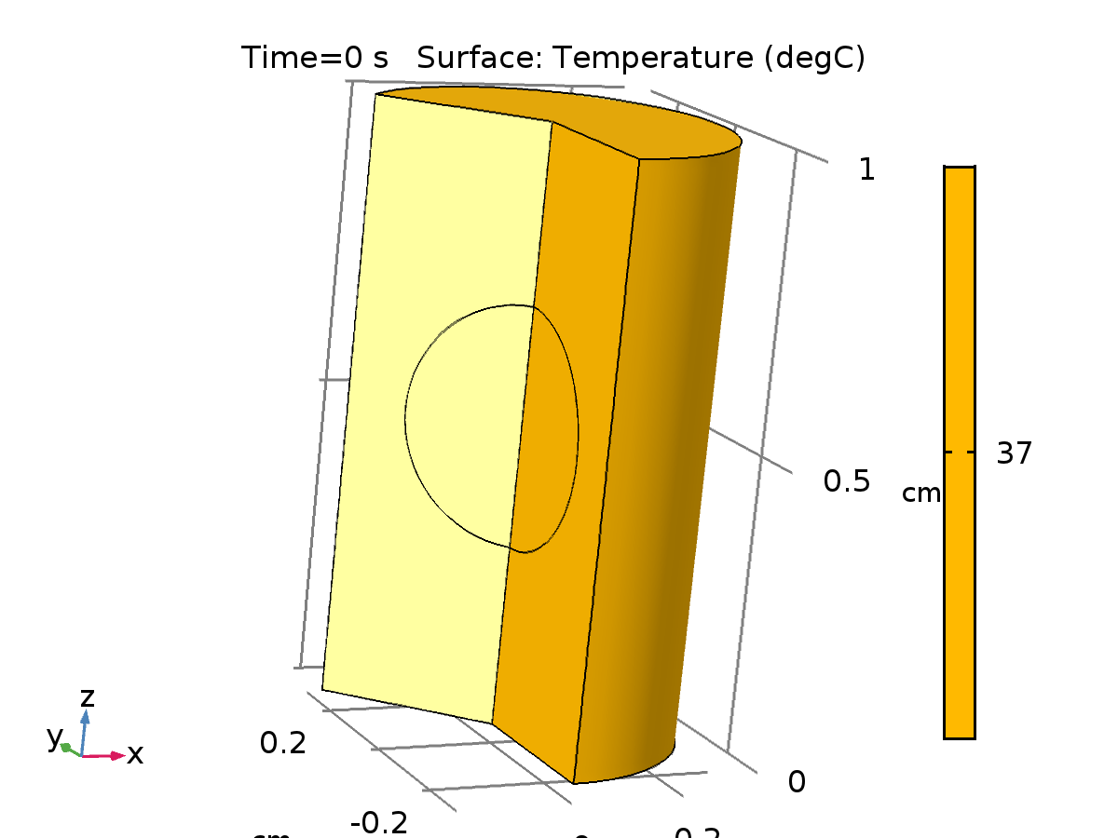
Figure 10. Three-dimensional surface plot of the temperature distribution at the end of laser exposure (t = 50 s).
  - Temporal and Spatial Evolution
Figure 11 illustrates the spatial distribution of temperature at the end of laser exposure (t = 50 s). Figure 11a presents the color-wash temperature distribution, Figure 11b highlights the 42 °C and 45 °C isotherms, and Figure 11c shows the corresponding 2D surface temperature map.
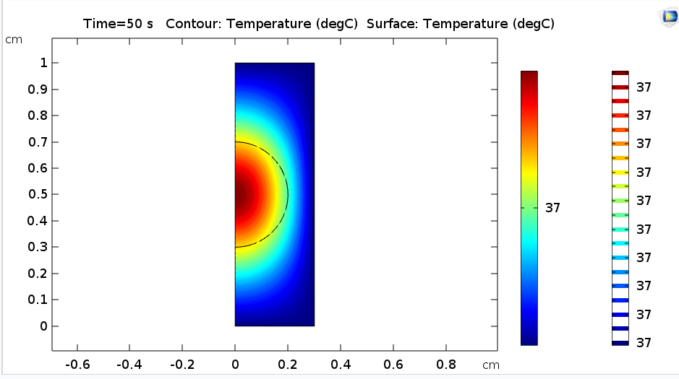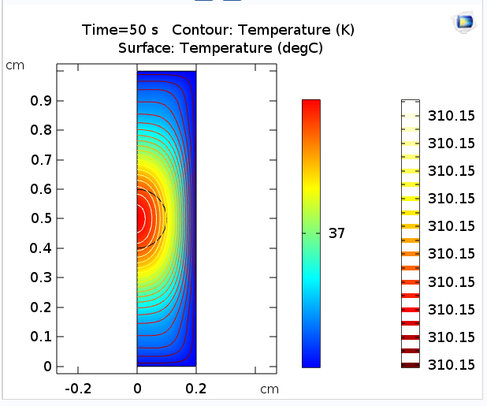
(a) (b)
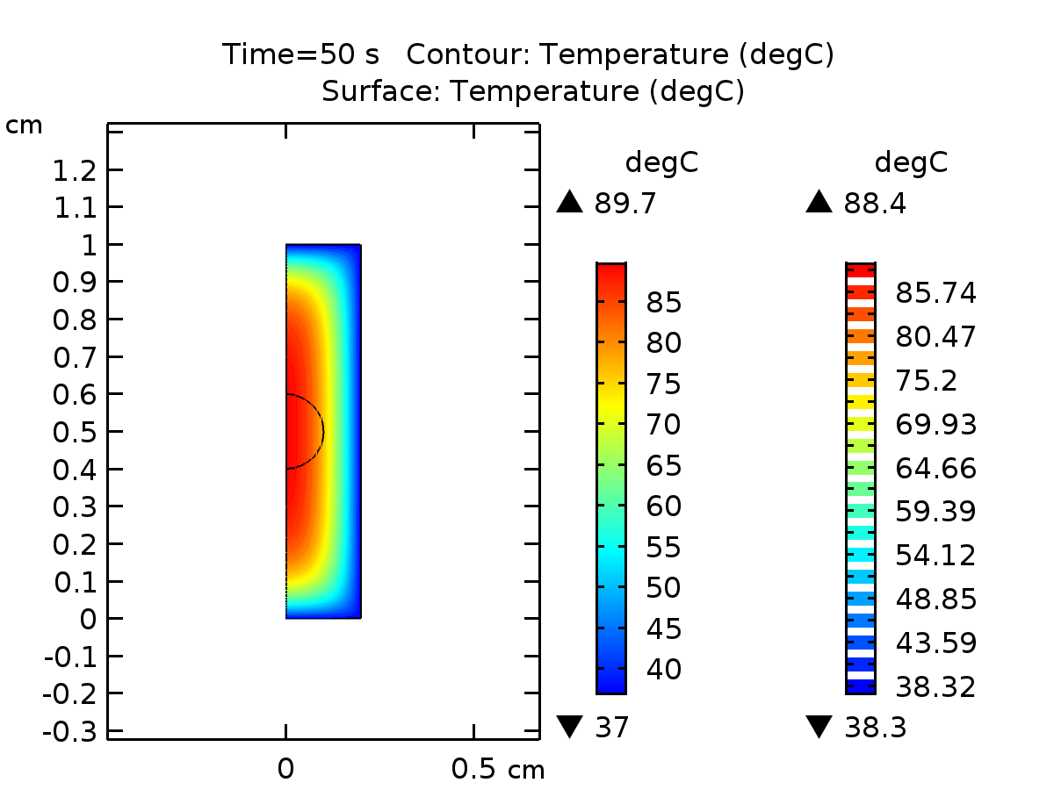
(c)
Figure 11. Temperature distribution at the end of laser exposure (t = 50 s): (a) Color-wash temperature distribution; (b) Isoline map highlighting the 42 °C (orange) and 45 °C (red) contours; (c) 2D surface temperature map.
Figure 12 presents (a) the cross-sectional temperature profile along the central axis and (b) a schematic of the laser heating process, illustrating the steep thermal gradient at the tumor–healthy tissue interface.
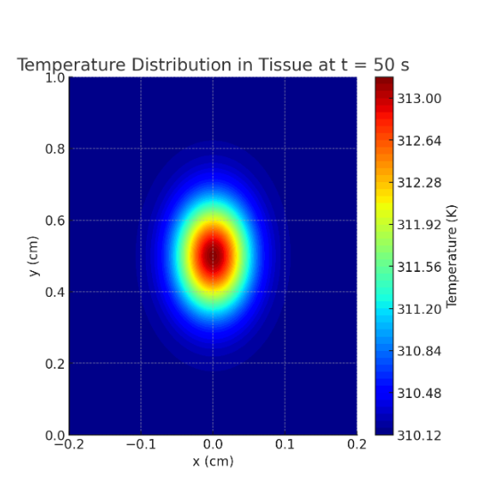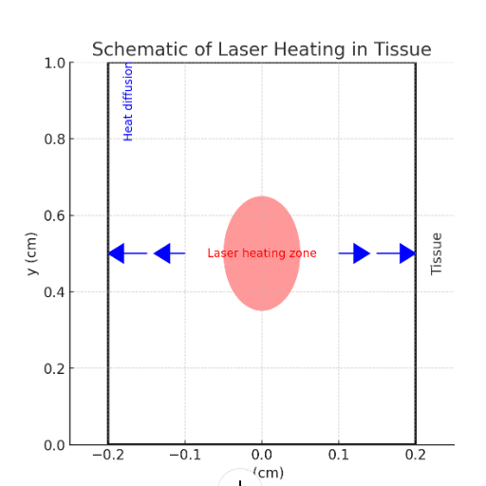
(a) (b)
Figure 12. (a) Temperature distribution in the tissue at the end of laser exposure (t = 50 s), illustrating the spatial extent of tumor heating. (b) Schematic representation of laser-induced heat propagation within the tissue, indicating the direction of laser irradiation and resulting thermal diffusion.
The temporal evolution at the tumor center is plotted in Figure 13, showing a rapid temperature rise followed by a plateau.
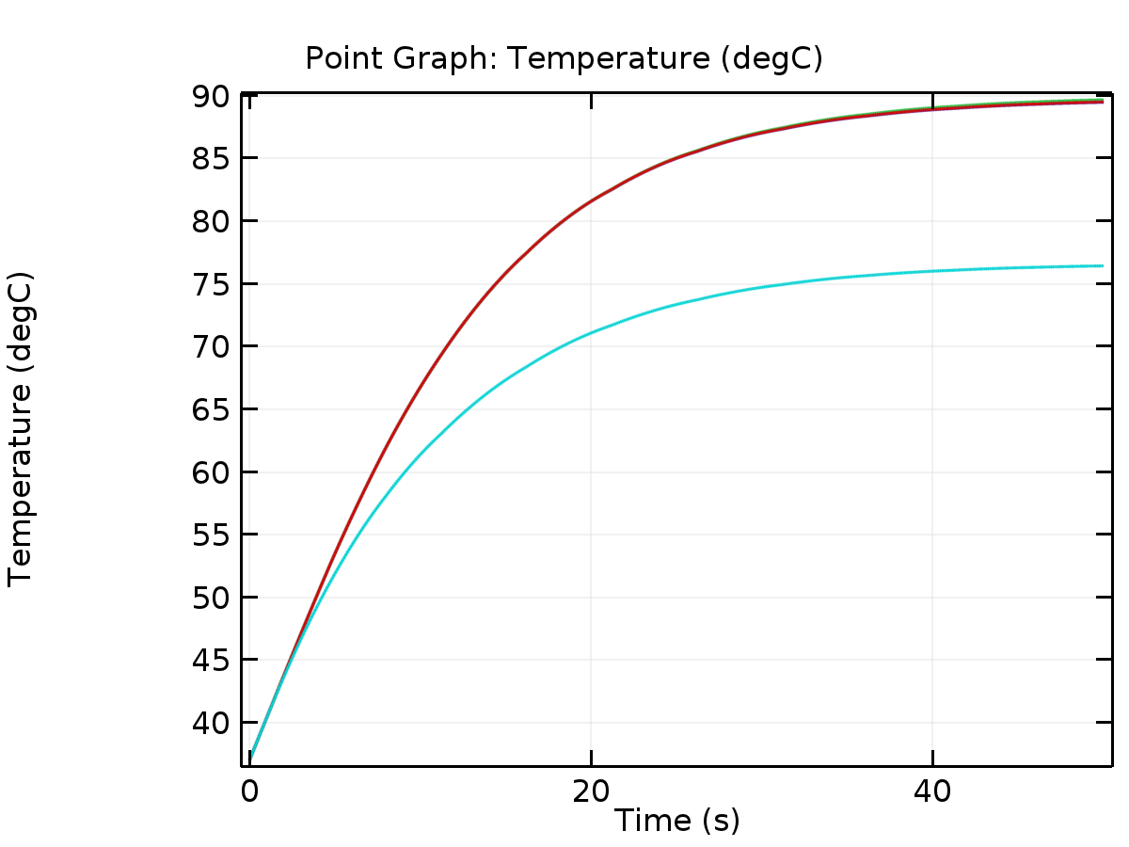
Figure 13. Temperature vs. time at the tumor center during the 50-second laser irradiation.
  - Parametric Sensitivity Analysis
A systematic analysis was conducted to evaluate the influence of key treatment parameters (Table 4).
Table 4. Results of parametric sensitivity analysis.
Parameter & Range | Effect on Max Tumor Temp. | Effect on Max Epidermal Temp. | Clinical Implication
Laser Intensity (I₀)  1.5 to 4.5 W/cm² | Near-linear increase from 43.1 to 53.5 °C | Increase from 37.5 to 41.9 °C | Primary control variable; >3.5 W/cm² risks epidermal damage.
Exposure Time (t_{exp})  20 to 60 s | Increase from 44.2 to 48.5 °C; plateaus after ~50 s | Gradual increase from 38.1 to 39.0 °C | Diminishing returns beyond 50 s; shorter times may under-treat.
Tumor Absorption (μ_{a})  ±20% from baseline | ±~2.5 °C change in peak temperature | Minimal change (<0.3 °C) | Critical for dose planning; highlights need for patient-specific optical properties.
  - Mesh Convergence and Validation
Mesh Independence: A convergence study showed that the maximum tumor temperature varied by less than 0.1% between the selected mesh (2138 elements) and a finer mesh (4215 elements), confirming solution independence.
Energy Balance: A global check confirmed that the total energy input from the laser was balanced by conductive, convective, and perfusion losses with a relative error of < 0.5%.
- Discussion
The results demonstrate the utility of a Pennes-Beer-Lambert model implemented in COMSOL for simulating and optimizing laser-induced thermal therapy. The successful isolation of a hyperthermic/ablative temperature zone within the tumor aligns with the fundamental goal of selective photothermal therapy [16, 17]. The peak tumor temperature of ~48 °C and the sustained hyperthermia in 87% of its volume are consistent with thermal doses known to induce coagulative necrosis and cellular apoptosis [26].
Our parametric analysis reveals critical insights for treatment planning. The near-linear relationship between laser intensity and peak temperature (Table 4) confirms its role as the most direct control parameter. However, the concurrent rise in epidermal temperature above 40 °C at intensities exceeding 3.5 W/cm² underscores a key safety trade-off, validating the need for precise, patient-specific dosimetry as emphasized in clinical guidelines [27]. The plateau in tumor heating after approximately 50 s aligns with the concept of thermal equilibrium between laser energy input and conductive/perfusive losses, suggesting an optimal window for exposure duration [28].
The significant sensitivity of the model to the tumor's optical absorption coefficient (μa) highlights a major challenge for clinical translation. This mirrors findings in cosmetic laser applications, where the choice of wavelength (e.g., 808 nm diode vs. 1064 nm Nd:YAG) is critical for safe and effective treatment in patients with high melanin content [7,8]. This principle extends beyond dermatology; prior studies on laser interaction with biological matrices such as leather and wool have similarly underscored the importance of matching laser parameters to substrate-specific optical and thermal properties [9,10]. This parallel underscores a broader principle: successful clinical outcomes depend on matching laser parameters, especially wavelength and fluence, to the target's optical properties and the patient's tissue characteristics. Inter-patient variability in tumor chromophore concentration can lead to under- or over-treatment if a standardized dose is applied. This finding strongly supports the integration of pre-treatment optical diagnostics (e.g., diffuse reflectance spectroscopy) to personalize laser parameters, an active area of research [29].
Limitations
This study has several limitations inherent to its modeling approach: (1) The 2D axisymmetric geometry, while computationally efficient, does not capture complex 3D tumor shapes or asymmetric blood vessel networks. (2) Tissue properties (thermal, optical, perfusion) were assumed homogeneous and static, whereas they can be heterogeneous and temperature-dependent. (3) The model predicts temperature only; it does not incorporate a tissue damage integral (e.g., Arrhenius model) to directly predict necrotic volume. (4) Validation is purely numerical; experimental correlation with tissue phantoms or histology is needed.
Future Work
To address these limitations and enhance clinical relevance, future work will focus on: (1) Developing 3D patient-specific models from medical imaging data. (2) Implementing temperature-dependent perfusion dynamics and an Arrhenius damage integral to predict necrotic zones. (3) Experimental validation using tissue-mimicking phantoms with embedded thermocouples. (4) Exploring machine learning techniques to rapidly optimize laser parameters based on patient-specific inputs. Furthermore, optimizing treatment protocols to enhance patient tolerance and procedural comfort will be prioritized, building on evidence from photobiomodulation and low-level laser therapy studies that demonstrate improved pain management and anesthesia efficacy in clinical settings [30,31].
- Conclusion
This study developed and validated a detailed, reproducible numerical model for simulating laser-induced thermal therapy of superficial skin tumors using COMSOL Multiphysics. The model successfully demonstrated that optimized laser parameters (e.g., 3 W/cm² for 50 s) can selectively elevate a tumor's temperature into the therapeutic hyperthermia (42–45 °C) and local ablation (>45 °C) ranges while preserving surrounding healthy tissue at near-physiological levels (<40 °C). A comprehensive sensitivity analysis quantified the influence of laser intensity, exposure duration, and tissue optical properties, providing clear guidance for parameter optimization and revealing critical trade-offs between efficacy and safety.
The work provides a validated computational framework that can serve as a template for preclinical treatment planning and parameter studies. By highlighting the importance of patient-specific optical properties and the limitations of static 2D models, it clearly outlines a pathway for future research towards more personalized and predictive treatment strategies in laser oncology.

References
- Y. Teng, Y. Yu, S. Li, Y. Huang, D. Xu, and X. Tao, Front. Public Health 9, 666528 (2021).
- M. A. Deif and R. E. Hammam, J. Clin. Eng. 45, 1 (2020).
- W. Lopez-Ojeda, A. Pandey, M. Alhajj, and A. M. Oakley, in StatPearls (StatPearls Publishing, Treasure Island, FL, 2023).
- K. L. Moore, A. F. Dalley, and A. M. R. Agur, Clinically Oriented Anatomy, 8th ed. (Wolters Kluwer, Philadelphia, PA, 2018).
- American Cancer Society, “Basal and squamous cell skin cancer,” https://www.cancer.org (accessed March 2025).
- C. M. Pacella, T. Jiang, and G. Mauri, Image-Guided Laser Ablation (Springer, Cham, 2020).
- R. M. A. Mohammed, S. M. Yousif, and A. A. Marouf, Lasers Med. Sci. 40(1), 362 (2025).
- E. E. Mahmoud, O. A. Elbasheer, and A. A. Marouf, Lasers Med. Sci. 40(1), 1 (2025).
- M. A. K. Alameen, A. H. Diab, and A. A. Marouf, J. Soc. Leather Technol. Chem. 109(3), 87 (2025).
- M. A. K. Alameen and A. A. Marouf, J. Soc. Leather Technol. Chem. 109(2), 39 (2025).
- C. Chang, Y. Zhao, E. Xing, Z. Wang, and Y. Yu, Opt. Commun. —, 131909 (2025).
- A. M. I. Trefilov, M. Oane, and L. Duta, Materials 18(15), 3524 (2025).
- F. Montazer, B. Mehdikhani, N. Noroozi, R. Nezameslami, A. Nezameslami, A. Shahbazi, F. Jayervand, A. Naseri, A. Rahmani, A. Negahi, and M. Danaei, Asian Pac. J. Cancer Prev. 26(8), 2725 (2025).
- G. Tourassi, Front. Med. Eng. 1, 1112763 (2023).
- H. Kaur, S. Singh, S. Upadhyay, and K. Kaur, Heat Transf. 54, 1 (2025).
- A. Heisterkamp and P. J. van der Veen, Lasers Med. Sci. 33(4), 1835 (2018).
- T. Soleymani, M. Abrouk, and K. M. Kelly, Dermatol. Surg. 43(5), 615 (2017).
- K. Riggs, M. Keller, and T. R. Humphreys, Clin. Dermatol. 25(5), 462 (2007).
- A.-C. Chen, C. Zheng, Q.-C. Jian, and P. Zhang, Front. Surg. 12, 1628257 (2025).
- H. Sierra, K. B. Kim, and B. P. Hibler, J. Biophotonics 9(5), 458 (2016).
- E. A. Eisenhauer, P. Therasse, J. Bogaerts, L. H. Schwartz, D. Sargent, R. Ford, et al., Eur. J. Cancer 45(2), 228 (2009).
- E. Adams and N. Price, J. Dermatol. Surg. Oncol. 5(10), 803 (1979).
- I. S. McKay, P. Rainsbury, and G. Smith, Ann. R. Coll. Surg. Engl. 103(2), 126 (2021).
- M. Falone, V. D’Alessandro, L. Giammichele, and R. Ricci, Int. J. Therm. Sci. 197, 108820 (2024).
- F. Sadeghi, H. R. M. Zarandi, H. A. Ahangar, M. H. Mollaei, M. Torabi, M. Ghasemi, and V. Soleimanian, Sci. Rep. 15, 25485 (2025).
- T. Iba, Y. Kondo, C. L. Maier, J. Helms, R. Ferrer, and J. H. Levy, J. Intensive Care 13, 4 (2025).
- B. Dizman and M. K. Ruhi, Lasers Med. Sci. 40(1), 254 (2025).
- K. K. Ramajayam, A. M. Wolfe, A. Motamarry, G. J. Nahhas, J. Yost, M. J. Yost, and D. Haemmerich, IEEE Open J. Eng. Med. Biol. 2, 187 (2021).
- S. Voulgarelis, F. Fathi, A. G. Stucke, K. D. Daley, J. Kim, M. A. Zimmerman, J. C. Hong, N. Starkey, K. P. Allen, and B. Yu, J. Biomed. Opt. 26(5), 055002 (2021).
- S. A. Muctar, A. A. Marouf, and E. M. Awooda, Indian J. Pain 35(1), 52 (2021).
- S. M. A. Abduljalil, N. T. H. Ahmed, M. M. Rahman, A. A. Marouf, N. S. Farghal, and B. G. Gismalla, J. Contemp. Dent. Pract. 24(7), 438 (2023).

