Geroderma osteodysplasticum confirmed by a homozygous pathogenic GORAB variant associated with severe factor V deficiency in a child: a case report

Abstract
Geroderma osteodysplasticum is characterized by a typical progeroid facial appearance, wrinkled, lax skin, joint laxity, skeletal abnormalities with variable degree of osteopenia, frequent fractures, scoliosis, bowed long bones, vertebral collapse, and hyperextensible fingers. The disorder results from mutations in the GORAB - golgin, RAB6 interacting. GORAB is important for vesicle transport at the Golgi complex and the correct processing of sugar chains on cargo proteins transiting through this compartment. Underlying defect of the skin and bone defects in GO patients is due to impaired COPI (coat protein complex I) trafficking at the Golgi apparatus resulting in abnormal glycosylation of extracellular matrix composition. We report a pediatric case of GO confirmed by clinical exome sequencing, associated with severe factor V deficiency identified during hemostasis workup. From a diagnostic standpoint, differentiating hereditary from acquired deficiency is essential. Reviews recommend global coagulation tests (PT and aPTT often prolonged), mixing studies, and—in relevant contexts—inhibitor testing (notably in acquired forms). Confirmation of a GORAB pathogenic variant enables genetic counseling and multidisciplinary care. The associated severe factor V deficiency warrants an anticipatory hematologic management plan to reduce bleeding risk.
Keywords: Geroderma osteodysplasticum; GORAB; cutis laxa; joint hyperlaxity; vertebral compression; factor V deficiency; hemostasis; pediatrics.
Introduction
Geroderma osteodysplasticum (GO) is a rare autosomal recessive connective tissue disorder caused by pathogenic variants in the GORAB gene. It is characterized by marked skin laxity giving a “premature aging” appearance, joint hyperlaxity, and bone fragility that may manifest as osteopenia, fractures, and vertebral compression. The clinical presentation can mimic Ehlers–Danlos syndrome (EDS) or hereditary cutis laxa, making genetic confirmation essential.
We report a pediatric case of GO confirmed by clinical exome sequencing, associated with severe factor V deficiency identified during hemostasis workup.
Case presentation
General information
A school-aged girl born to consanguineous parents (reported genetic relationship) was referred for evaluation of joint hyperlaxity with an initial suspicion of EDS.
History
The history revealed recurrent epistaxis and easy bruising, without major bleeding. Information regarding fracture history, chronic pain, and detailed family history was not available in the documents provided.
Physical examination
- Skin: Marked skin laxity with prominent abdominal folds at rest and increased skin extensibility on pinching/traction.
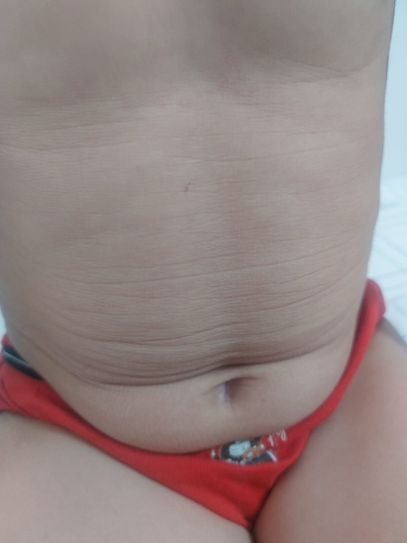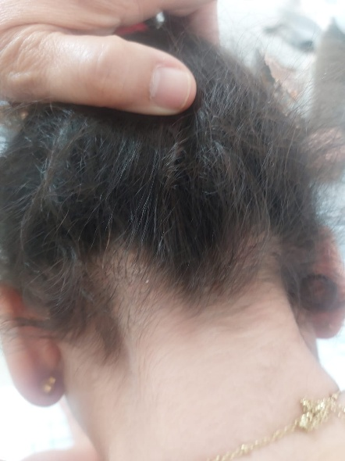
- (B)
Figure 1 : Cutaneous manifestations. (A) Prominent abdominal skin folds at rest. (B) Increased truncal skin extensibility on traction, consistent with constitutional skin laxity.

- Musculoskeletal system: Clinical peripheral hyperlaxity (ankles/feet); a Beighton score was not documented.
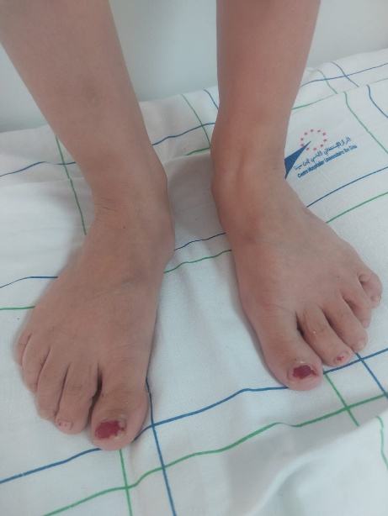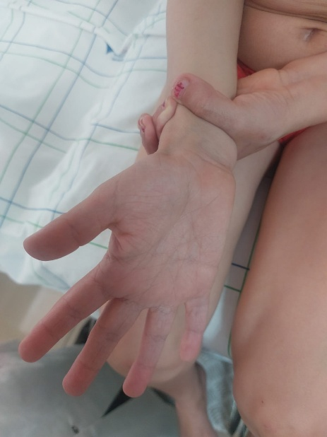
Figure 2: Clinical appearance of the feet/ankles suggesting peripheral hyperlaxity.

- Other systems: No specific abnormality reported on cardio-respiratory examination.
Investigations
Musculoskeletal imaging
Cervico-thoraco-lumbar spine radiographs (AP and lateral): Exaggerated thoracic kyphosis; mild thoracolumbar scoliosis with right convexity; predominantly anterior wedging/compression of vertebral bodies T5 and T7; no other visible disco-somatic abnormalities; smooth and harmonious posterior vertebral wall alignment.
Cardiac evaluation
Transthoracic echocardiography: Situs solitus; normal atrioventricular and ventriculoarterial connections; normal chamber size; thin valves without significant regurgitation; no atrial or ventricular septal defect; patent ductus arteriosus absent; no pericardial effusion.
Hemostasis
Factor V: <1% (reference 62–139) → severe deficiency
Factor X: 84% (reference 77–131) → normal
Factor VII: moderate decrease reported (numeric value not available in the provided documents)
A first-line workup (PT/INR, aPTT, fibrinogen, CBC/platelets, liver tests, and inhibitor evaluation depending on context) is recommended to characterize the disorder and guide peri-procedural management.
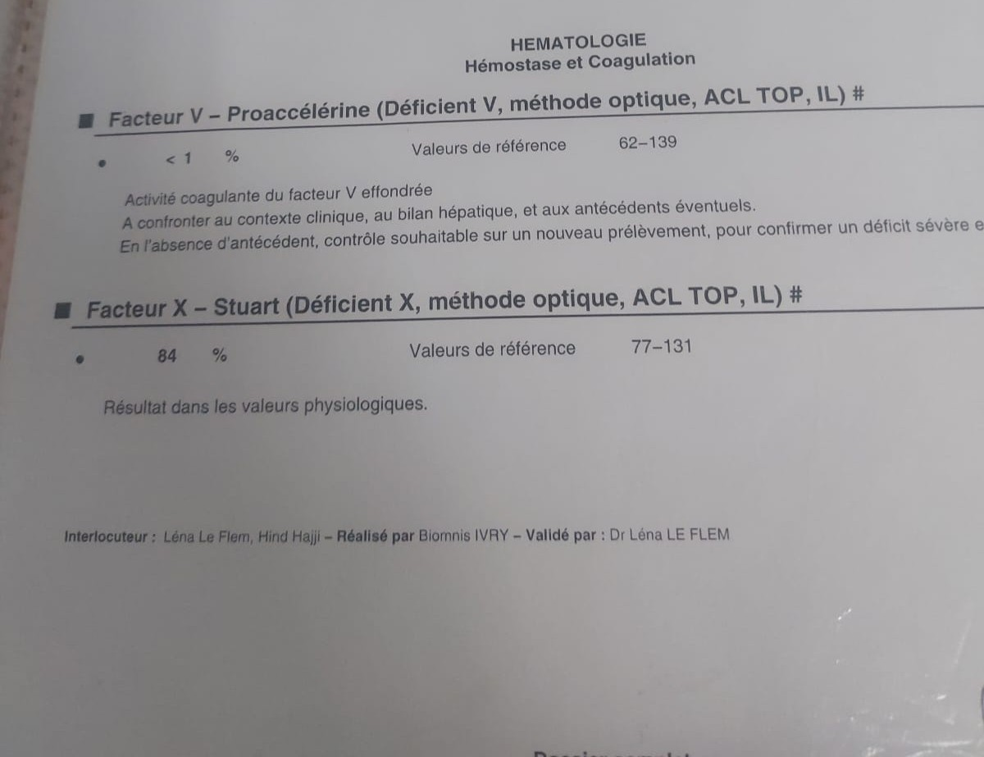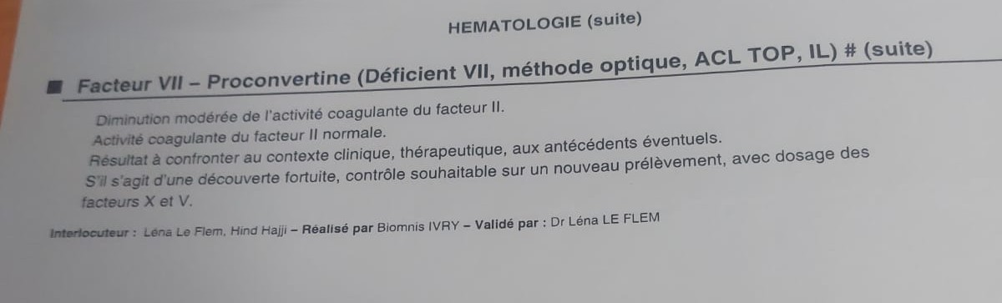
Figure 3: Hemostasis workup showing severe factor V deficiency with preserved factor X activity and a moderate reduction in factor VII activity.
Genetics
Targeted clinical exome sequencing did not identify relevant pathogenic variants in genes classically associated with EDS within the analyzed panel. It revealed a homozygous pathogenic truncating variant in GORAB: NM_152281.3:c.79C>T, p.(Arg27*), confirming the diagnosis of geroderma osteodysplasticum.
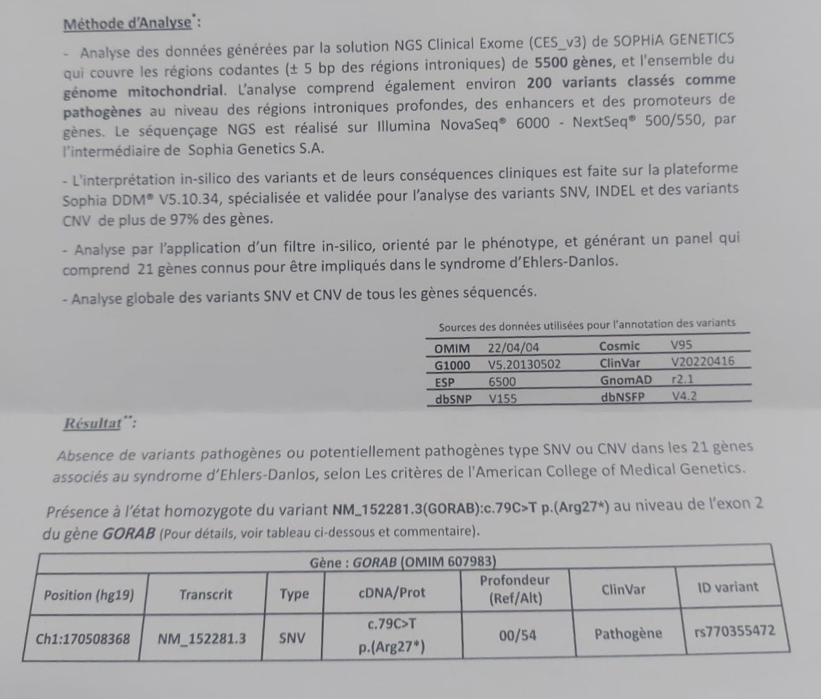
Figure 4: Clinical exome sequencing report identifying a homozygous pathogenic truncating GORAB variant (NM_152281.3:c.79C>T; p.Arg27*) with no pathogenic variants detected in the analyzed Ehlers–Danlos gene panel.
Management and follow-up
Regular orthopedic follow-up was initiated with physiotherapy and radiologic monitoring. An individualized hematology plan was discussed to prevent and manage bleeding episodes and to cover invasive procedures, considering the severe factor V deficiency, according to local protocols (often fresh frozen plasma in the absence of a specific concentrate).
Genetic counseling was offered to the family given autosomal recessive inheritance and parental consanguinity.
Discussion
1) Geroderma osteodysplasticum: a rare connective tissue disorder to recognize
Geroderma osteodysplasticum (GO) is a rare, typically autosomal recessive connective tissue disorder characterized by skin laxity (often striking over the trunk/abdomen and extremities), joint hypermobility, and skeletal fragility including osteopenia/osteoporosis, fractures, and sometimes vertebral compression and kypho-scoliosis [1–4]. Pathophysiology involves defects in proteins associated with the Golgi apparatus/secretory pathway. Historically, the gene was identified as SCYL1BP1, now named GORAB (golgin, RAB6 interacting) [1]. Rare disease resources (Orphanet, GARD/NIH) describe GO as combining lax skin, hyperlaxity, and bone complications, with autosomal recessive inheritance linked to GORAB [3,4].
2) Diagnostic rationale in this case
Several features converge in our patient:
- highly suggestive cutaneous phenotype (marked abdominal folds and skin hyperextensibility
- peripheral hypermobility
- vertebral involvement with anterior compression of T5 and T7 and exaggerated thoracic kyphosis
- consanguinity supporting an autosomal recessive condition
- decisive molecular confirmation with a homozygous pathogenic truncating GORAB variant, establishing the diagnosis [1–4]
The main differential diagnosis was EDS (especially hypermobile/classic types) and, more broadly, hereditary cutis laxa syndromes. GO shares clinical overlap with these entities, and clinical distinction can be challenging; reviews and series emphasize the importance of genetic testing in “cutis laxa/EDS-like” phenotypes [2,5,6].
3) Bone and vertebral involvement: a key feature of GO
Skeletal complications are central to the GO phenotype: osteopenia/osteoporosis, fractures, deformities, and wedge vertebrae/compression that may result in kyphosis or scoliosis [3,4]. In our case, radiographs documented T5 and T7 compression with kyphosis, consistent with the described spectrum. Case reports and reviews detail vertebral anomalies, kyphoscoliosis, and fractures/vertebral collapse in GO [2–4]. These findings support a structured management approach: orthopedic surveillance, injury prevention, physiotherapy, and consideration of bone evaluation (vitamin D/calcium status, densitometry) according to available resources [2–4].
4) Cardiovascular assessment
Some connective tissue disorders (including certain EDS subtypes) can involve vascular/valvular abnormalities; echocardiography is therefore appropriate at diagnosis. Here, transthoracic echocardiography was reassuring, with no significant valvular leak or shunt. While this does not preclude long-term surveillance depending on clinical evolution and complete phenotype, the absence of baseline structural abnormalities is favorable.
5) Severe factor V deficiency: rarity, interpretation, and practical impact
The most original and potentially publishable aspect of this case is the association with severe factor V deficiency (<1%). Congenital factor V deficiency (parahemophilia) is a rare coagulopathy, often autosomal recessive, that may present with mucocutaneous bleeding (epistaxis, bruising, gingival bleeding), with wide variability and imperfect correlation between factor level and clinical severity [7,8]. Our patient’s epistaxis and easy bruising fit this phenotype [7,8].
From a diagnostic standpoint, differentiating hereditary from acquired deficiency is essential. Reviews recommend global coagulation tests (PT and aPTT often prolonged), mixing studies, and—in relevant contexts—inhibitor testing (notably in acquired forms) [7]. In our available documents, PT/aPTT and mixing test results were not provided; thus, it is prudent to state that the complete evaluation should include these steps [7].
6) Treatment: why fresh frozen plasma is central
No widely available specific factor V concentrate exists; therefore, fresh frozen plasma (FFP) is classically the cornerstone of replacement therapy for significant bleeding or procedural prophylaxis [7–10]. Reference sources describe FFP as standard treatment in hereditary forms, with possible use of antifibrinolytics for mild cases and, in selected situations, platelets, PCC, or rFVIIa depending on benefit–risk and local expertise [7,9]. Transfusion guidelines specifically indicate plasma for congenital single-factor deficiencies when no specific product is available—factor V being a typical example [10]. Perioperative reports confirm the use of FFP around surgical procedures in patients with factor V deficiency [11,12].
7) GO–factor V relationship: coincidental association or shared predisposition?
GO is classically linked to GORAB and is not described as a primary coagulopathy. The association of GO with severe factor V deficiency may therefore represent:
- a coincidental coexistence of two rare autosomal recessive disorders (particularly plausible in consanguinity), or
- a non-constitutional (acquired) factor V deficiency, pending full investigation [7]
In the manuscript, it is preferable to present these hypotheses in a balanced manner, emphasizing the immediate practical implication: anticipating bleeding risk in a patient who may also have tissue fragility related to the connective tissue disorder.
8) Case contributions
This case highlights:
- the value of a phenotype → imaging → genetics approach to differentiate EDS from related entities [5,6]
- the need for multidisciplinary care (pediatrics, genetics, orthopedics, cardiology, hematology)
- the importance of identifying and documenting a hemostasis disorder when mucocutaneous bleeding is present, as this changes emergency and peri-procedural management [7–12]
Conclusion
Geroderma osteodysplasticum should be considered in patients presenting with cutis laxa, joint hyperlaxity, and skeletal involvement, particularly in the setting of consanguinity. Confirmation of a GORAB pathogenic variant enables genetic counseling and multidisciplinary care. The associated severe factor V deficiency warrants an anticipatory hematologic management plan to reduce bleeding risk.
References

- Hennies HC, Kornak U, et al. Gerodermia osteodysplastica is caused by mutations in SCYL1BP1 (GORAB). Nature Genetics. 2008;40(12):1410–1412. doi:10.1038/ng.252.
- Alotaibi M, Aldhubaiban D, et al. A Case of Geroderma Osteodysplasticum Syndrome: Unique Clinical Findings. Global Medical Genetics. 2022;9:175–178.
- Orphanet. Geroderma osteodysplastica (ORPHA:2078).
- GARD/NIH. Geroderma osteodysplastica (caused by GORAB, autosomal recessive; lax skin, loose joints, bone problems).
- Kariminejad A, et al. Cutis Laxa IIA, Cutis Laxa IIB, and Geroderma Osteoplastica (review/differential, role of GORAB). [PMC] 2017.
- Uitto J, et al. Clinical heterogeneity of cutis laxa / perspective (GO among related entities, phenotypic overlap). Experimental Dermatology. 2013.
- Stoj KM. Factor V Deficiency. StatPearls (NCBI Bookshelf). 2024.
- Thalji N, Camire RM. Parahemophilia: New Insights into Factor V Deficiency. Seminars in Thrombosis and Hemostasis. 2013.
- Medscape. Factor V Deficiency Treatment & Management. Updated 2023.
- Wong MP, et al. Guidelines for frozen plasma transfusion. British Columbia Medical Journal.
- Pan African Medical Journal. Congenital factor V deficiency: perioperative management. 2020.
- Tanaka KA, et al. Perioperative Management of Hereditary Factor V Deficiency. Journal of Cardiothoracic and Vascular Anesthesia. 2022.

