Case report

NATIVE-VALVE INFECTIVE ENDOCARDITIS COMPLICATED BY A LEFT FOOT GANGRENE IN A NIGERIAN GIRL

ABSTRACT
Infective endocarditis in native valve is not common, Most reported cases of infective endocarditis have either a congenital cardiac defect or acquired valvular defect as the nidus. Infective endocarditis can lead to morbidity and mortality especially with complications such as congestive cardiac failure and systemic embolism. There are few literatures that reported systemic embolization complicating infective endocarditis especially inAfrican. Gangrene of a part of the body is not a common presentation of infective endocarditis; we therefore report acaseof a 7 year old girl with left foot gangrene from a systemic embolic phenomenon complicating infective endocarditis.

INTRODUCTION
Infective endocarditis in native valve is not common.¹ Most reported cases of infective endocarditis have either a congenital cardiac defect or acquired valvular defect as the nidus.²Infective endocarditis can lead to morbidity and mortality especially with complications such as congestive cardiac failure and systemic embolism.³There are few literatures that reported systemic embolization complicating infective endocarditis especially in Africa.^{4,5} Gangrene of a part of the body is not a common presentation of infective endocarditis; we therefore report a case of a 7 year old girl with left foot gangrene from a systemic embolic phenomenon complicating infective endocarditis.

CASE REPORT
A 7 years old girl who presented with a two month old history of recurrent fever, fast breathing and paedal edema of a month and a 3 days history of darkish discoloration of the left foot. Fever washigh grade, intermittent and transiently relived with antipyretics. Fast breathing was insidious in onset and associated with easy fatigability and orthopnea. Paedal edema progressively worsened with facial puffiness and abdominal distension. There was no history suggestive of a congenital heart defectand no history of fever with features of heart failure preceding this present presentationbut patient had dental procedures for a chronic toothache done few weeks prior to presentation. She initially presented to the referring hospital where echocardiography done showed vegetations and a blood culture that yielded growth of staphylococcus aureus. She was being managed for an infective endocarditis complicated by a heart failure with antifailure medications and antibiotics, when she was noticed to develop darkish discoloration of the left foot by the 5th week on admission. The left foot discoloration was progressive and associated with severe pain. Doppler ultrasonography of the left lower limb showed features suggestive of an occlusive arterial thrombo-embolic disease. She was subsequently referred to our facility for multidisciplinary care.

Pregnancy, birth and neonatal periods were uneventful.Had normal her developmental milestones. She was a basic two pupil with good academic performance. Patient had received all vaccines according to the National program on immunization schedule. She was the last of four children in a monogamous family.

On examination at presentation, was dyspnoeic, febrile at 39.7C, mildly pale, acyanosed in room air, with mild pedal oedema, tachypnoeic with respiratory rate of 40cpm, breath sounds were vesicular, oxygen saturation in room air was 96%, tachycardic with a pulse rate of 140 bpm which was regular, normal volume and synchronous with other peripheral pulses, had normal blood pressure of, 95/60 mmHg for age and height. The precordium was hyperactive, apex beat was displaced, located at the 6th left intercostal space mid-axillary line, first, second heart sounds were normal withof grade 3/6 systolic murmur loudest at the apex of the heart, andradiating to the left axilla. Abdominal examination revealed a soft, smooth and tender hepatomegaly palpable 6cm below the right costal margin. Musculoskeletal system examination revealed dark discoloration of the left foot involving the 5 digits, with diffuse swelling, tender, and foul smelling, absent dorsalis paedis artery pulsation (Figure 1 -3).
A diagnosis of congestive cardiac failure in a child with infective endocarditis complicated by gangrene of the left foot was made. Patient was admitted, commenced on intranasal oxygen, nursed in a cardiac position, intravenous antibiotics meropenem, metronidazole and vancomycin, antifailure medications enalapril and furosemide, oral aspirin, strict monitoring of fluid input and output were done. Chest radiograph showed cardiomegaly. (figure 4)
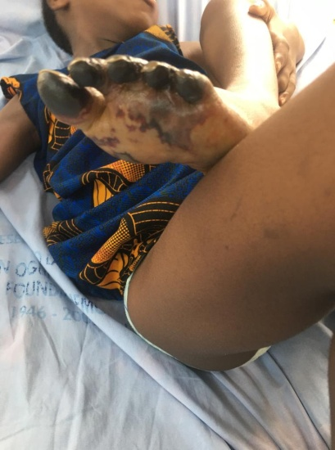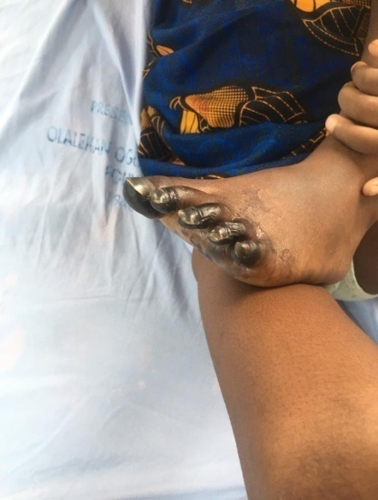Figure 1-3- Musculoskeletal examination showing the dark discolouration of the left foot
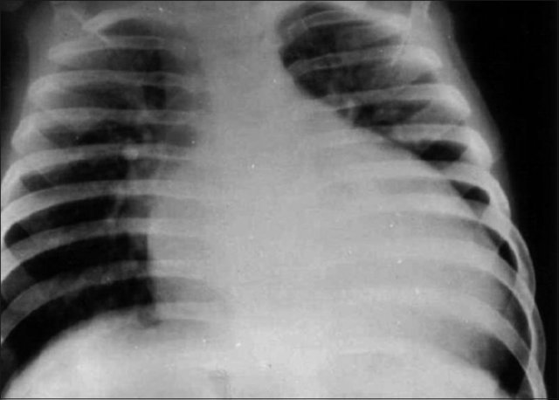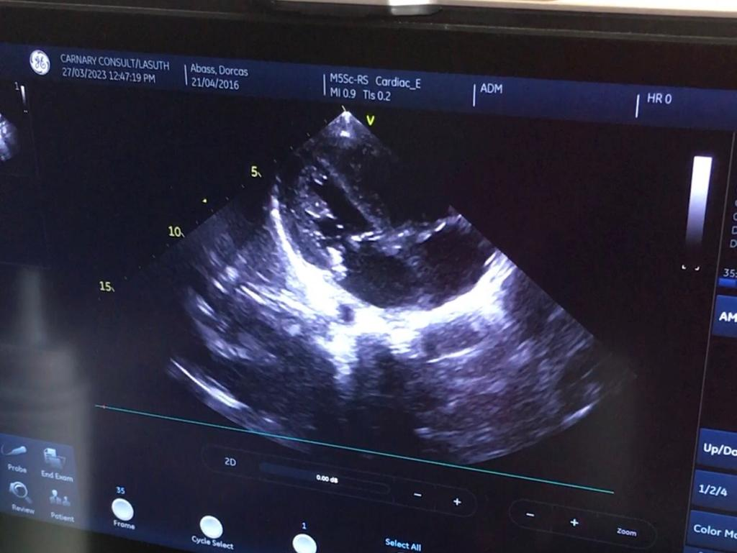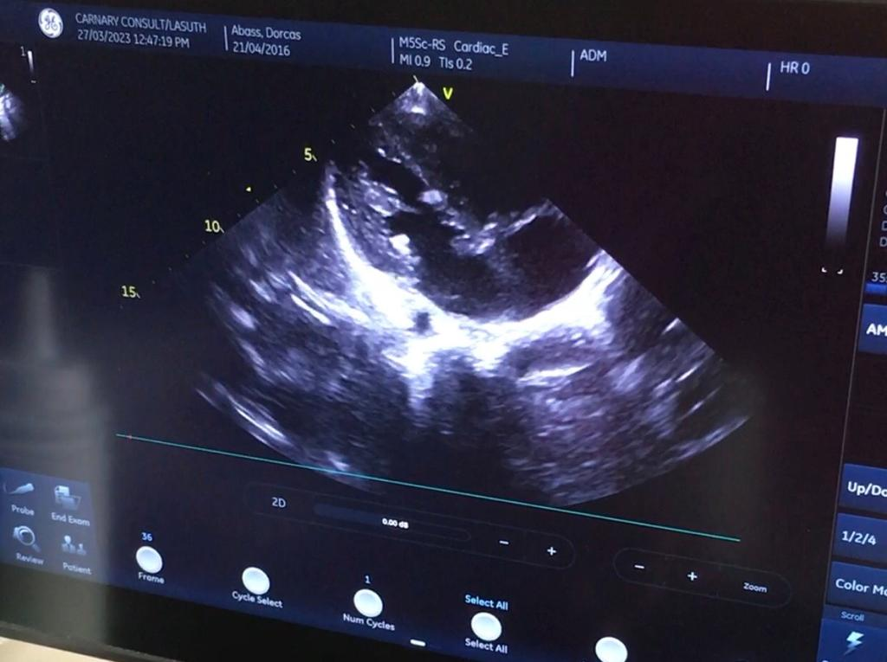Figure 4-6- Chest radiograph showing cardiomegaly; Echocardiography showing vegetation on the tricuspid valve
Echocardiography (Figure 5, 6) revealed vegetation on the tricuspid valve, severe pulmonary arterial hypertension, moderate tricuspid regurgitation and severe mitral regurgitation. The vegetation measured 11mm and was mobile.
Serum electrolytes, urea and creatinine were normal. The full blood count result showed anemia with PCV of 24%, leucocytosis with relative neutophilla, platelet count was normal, clotting profile showed INR of 1.11, normal PT and APTT,C- reactive protein was 130mg/l and D-dimer of 2.31ug/ml which are elevated and points to an ongoing inflammation with thrombus formation.⁶
The cardiothoracic surgical unit reviewed, requested for a CT angiogram of both lower limbs and planned for an embolectomy in conjunction with the orthopaedic unit for an ablation, patient however discharged against medical advice due to severe financial constraint.
DISCUSSION
Infective endocarditis is an infection of the heart’s endocardial surface^{7,8}.The disease represents a complex interplay between a pathogen and host factors such as endothelial disruption and immune function that is still not completely understood.⁷ It is caused majorly by bacteria Streptococcus viridians and Staphylococcus aureus, others are viruses, fungi.⁹In the case report above, Staphylococcus aureus was the microorganism implicated. Infective endocarditis accounts for 0.5 to 1 of every 1000 hospital admissions with a crude incidence between 1.5 and 11.6 cases per 100,000 populations globally.¹⁰It is commoner in the developed countries. The common predisposing factors to developing infective endocarditis in children are congenital or rheumatic heart disease, however, it can occur in native valves as is seen in the case report. Other risk factors are prosthetic valve, previous episode of bacterial endocarditis, surgical systemic to pulmonary shunts and conduits, cardiac transplantation, central venous catheters, dental manipulations among others. The girl in the case report had a dental procedure to remove a tooth about 3 weeks prior to onset of symptoms. Although, Streptococcus viridians group are the commonest microorganisms implicated following a dental procedure, Staphylococcal aureus which is known to be common in patients with no underlying heart disease was the organism cultured from the blood stream in the case above.¹¹ Infective endocarditis can lead to morbidity and mortality especially with complications such as congestive cardiac failure and systemic embolism.³The incidence of gangrene of a limb from infective endocarditis is rare, however a debilitating complication. Animasahun et al⁵ reported a case of gangrene of the left upper limb from central embolism in a fourteen months old girl with Tetralogy of Fallot and infective endocarditis from the same center in 2016. The gangrene of a limb from a septic emboli results from the travel of a detach vegetation from the infected valve in infective endocarditis^{12,13}.The vegetations on the valve infected dislodge and travel through the blood circulation and block blood vessels depending on the size and the location.¹³Adeodu and Senbanjo⁴ in 2004 at the Obafemi Awolowo University Ile-ife, reported digital gangrene complicating septicaemia in a 4 year old girl involving both hands and feet leading to auto-amputation. .
The major risk factors for septic embolism in patients with infective endocarditis are the length of the vegetation(greater than 10mm) and the mobility of the vegetation which were both significant in the case report presented above.^{14,15}
The management of septic emboli includes prolonged antibiotic therapy and surgical removal of the valve vegetations and repair of the valve involved. The antimicrobial therapy of Infective endocarditis and subsequent septic emboli usually requires 4-6 weeks of intravenous antimicrobial therapy.¹⁶
The prognosis ranges from asymptomatic presentation to high mortality depending on the affected organs and the combined effect of both ischemic and infectious insults.^{3,17} Acute limb ischemia from septic emboli, if severe enough may result in limb amputation due to critical limb ischemia.^{4,18}
REFERENCES
1. Chambers HF, Bayer AS. Native-Valve Infective Endocarditis. N Engl J Med. 2020;383(6):567–76.
2. Myung K P. Park ’ s Pediatric Cardiology for Practitioners Sixth Edition. Vol. Sixth Edit, Elsevier Saunders. 2016. 30–146 p.
3. David R. Murdoch; G. Ralph Corey Clinical Presentation, Etiology, and Outcome of Infective Endocarditis in the 21st Century. Arch Intern Med. 2009;169(5):463.
4. Adeodu OO SI. Septicemia complicated by Digital Gangrene - A Case Report. Niger J Paediatr. 2005;31(4):137–9.
5. Animasahun BA, Amoah E. Gangrene of the Left Forearm Following Septicaemia in a Nigerian Child With Tetralogy of Fallot: A Case Report. Hear Res - Open J. 2017;4(1):6–9.
6. Demirbaǧ R. Using the D-dimer test in infective endocarditis. Turk Kardiyol Dern Ars. 2013;41(7):595–7.
7. Kliegman RM RM. Bernstein, D. (2016). The Cardiovascular System. In: Nelson Textbook of Pediatrics. 2020. 2157–3229 p.
8. Lam ACK. Infective endocarditis. Ashraf Al SD, editor. Hong Kong Pract. 2nd ed. 2003;25(11):551–61.
9. Holland TL, Baddour LM, Bayer AS, Hoen B, Miro JM, Fowler VG. Infective endocarditis HHS Public Access. Nat Rev Dis Prim. 2017;2(16059):1–49.
10. Bin Abdulhak AA, Baddour LM, Erwin PJ, Hoen B, Chu VH, Mensah GA, et al. Global and regional burden of infective endocarditis, 1990-2010: A systematic review of the literature. Glob Heart 2014;9(1):131–43
11. Bumm C V., Folwaczny M. Infective endocarditis and oral health — A Narrative Review. Cardiovasc Diagn Ther. 2021;11(6):1403–15.
12. Yu Z, Fan B, Wu H, Wang X, Li C, Xu R, et al. Multiple systemic embolism in infective endocarditis underlying in Barlow’s disease. BMC Infect Dis 2016;16(1):4–8.
13. Kildahl HA, Brenne EL, Dalen H, Wahba A. Systemic embolization in infective endocarditis. Indian J Thorac Cardiovasc Surg 2024;40(Suppl 1):40–6.
14. Berthelot P, Lemetayer F, Comtet C, Fresard A, Cazorla C, Fascia P, et al. Risk factors for systemic emboli in infective endocarditis. 2004;
15. Thuny F, Disalvo G, Belliard O, Avierinos JF, Pergola V, Rosenberg V, et al. Risk of embolism and death in infective endocarditis: Prognostic value of echocardiography - A prospective multicenter study. Circulation. 2005;112(1):69–75.
16. Galyfos G, Giannakakis S, Kerasidis S, Geropapas G, Kastrisios G, Papacharalampous G, et al. Infective endocarditis as a rare cause for acute limb ischemia. World J Emerg Med. 2016;7(3):231.
17. Habib G, Erba PA, Iung B, Donal E, Cosyns B, Laroche C, et al. Clinical presentation, aetiology and outcome of infective endocarditis;Eur Heart J. 2019;40(39):3222-3232B.
18. Dombrowski SC. Assessment Results. Psychoeduc Assess Rep Writ. 2020;159–72.

