A Retrospective Review of Biomedical Applications of Neutrosophic Probability Distributions

Abstract
This paper provides a comprehensive review of the applications of Neutrosophic probability distributions in biomedical research. Rooted in the philosophy of Neutrosophy, these distributions explicitly model uncertainty through truth, indeterminacy, and falsity components, offering a flexible and nuanced framework for analyzing complex and imprecise biomedical data. Compared to traditional statistical methods, Neutrosophic approaches demonstrate superior performance in handling interval-valued, vague, and indeterminate information commonly encountered in biomedical studies. We discuss their advantages, such as enhanced modeling of uncertainty and robustness to assumption violations, alongside limitations including interpretability challenges and the need for standardized tools. Future research directions are outlined to foster the development of novel distributions, software implementations, and validation techniques. This review underscores the significant potential of Neutrosophic probability distributions to advance biomedical data analysis, particularly in emerging fields such as personalized medicine and genomics.
Keywords: Neutrosophic Probability Distribution, Biomedical Data Analysis, Uncertainty Modeling, Neutrosophic Statistics, Indeterminacy, Medical Diagnosis, Survival Analysis.

1. Introduction

The field of biomedical research relies heavily on the analysis of complex data to advance our understanding of biological processes, disease mechanisms, and the effectiveness of medical interventions. Statistical methods are indispensable tools in this endeavor, enabling researchers to extract meaningful insights from often intricate datasets. However, biomedical data is frequently characterized by inherent uncertainties, vagueness, and indeterminacy. For instance, medical diagnoses can be challenging due to overlapping symptoms and the subjective interpretation of clinical signs. Survival analysis, which examines the time until a specific event occurs, often grapples with censored data and variability in patient outcomes. Clinical trials, designed to evaluate the efficacy of new treatments, are susceptible to diverse patient responses and imprecise measurements. These complexities can pose significant challenges for traditional statistical approaches that often assume data certainty [4],[12],[13],[14]. The limitations of classical methods in handling the multifaceted nature of biomedical data can potentially lead to incomplete or even inaccurate conclusions, thereby underscoring the necessity for more advanced statistical tools capable of effectively addressing these inherent complexities.
In response to the need for more robust methods for handling uncertainty, the philosophical framework of Neutrosophy has emerged, extending beyond the boundaries of classical logic by incorporating the concepts of truth, indeterminacy, and falsity [1]. This framework posits that every proposition or entity can be viewed through these three independent components, offering a richer perspective on information that is not always clear-cut. Building upon Neutrosophy, the concepts of Neutrosophic sets, Neutrosophic logic, and Neutrosophic statistics have been developed, leading to the formulation of Neutrosophic probability distributions [1]. These distributions represent a potential avenue for addressing the limitations encountered by traditional probability distributions when confronted with the uncertain nature of biomedical data. By explicitly considering indeterminacy alongside the likelihood of an event occurring or not occurring, Neutrosophic probability distributions offer a more nuanced approach to statistical modeling in biomedical research [2],[3],[5].
Given the increasing interest in and development of Neutrosophic probability distributions, a retrospective study is warranted to synthesize the existing body of research on their applications within the biomedical domain. Such an endeavor is crucial for mapping the current state of the field, identifying areas where these novel methods have been successfully employed, and pinpointing gaps that necessitate further investigation. This comprehensive overview can provide valuable insights for researchers seeking to leverage Neutrosophic probability distributions in their work and can guide future research directions to maximize the potential of these tools in advancing biomedical science [6],[8],[9],[16].
This paper aims to provide a comprehensive review of the role and impact of Neutrosophic probability distributions within the biomedical domain. The objective is to present the fundamental principles behind Neutrosophic distributions, explore their specific applications in biomedical research, analyze retrospective studies to assess their effectiveness, and offer detailed examples that highlight their utility in handling uncertainty inherent in biomedical data. Further, this study compares Neutrosophic approaches with traditional statistical methods, discusses their advantages and limitations, and identifies key opportunities for future research and development in this emerging field.
In Section 2, “Fundamentals of Neutrosophic Probability Distributions,”explains the key concepts of Neutrosophy, including its philosophical foundation, and describes how Neutrosophic probability extends classical probability by incorporating truth, indeterminacy, and falsity components. The section 3, “Applications of Neutrosophic Distributions in Biomedical Research,” reviews the diverse biomedical areas where these distributions have been applied, including medical diagnosis, survival analysis, and clinical trials, emphasizing their ability to better model uncertain and interval-valued data. In Section 4, “Retrospective Analysis of Existing Research,” we synthesize previous studies and findings that demonstrate the effectiveness of Neutrosophic distributions, highlighting their growing importance in biomedical data analysis. The section 5, “Specific Examples of Neutrosophic Probability Distributions in Biomedical Applications,” presents detailed case studies and instances where these distributions have been utilized, offering insights into practical implementation and outcomes. The section 6, “Handling Uncertainty in Biomedical Data with Neutrosophic Probability Distributions,” discusses how these distributions effectively manage data vagueness, interval values, and indeterminacy, providing a robust framework for biomedical researchers. In Section 7, “Comparative Effectiveness with Traditional Statistical Methods,” we examine comparative studies that evaluate the performance of Neutrosophic methods relative to classical statistical techniques, with a focus on scenarios involving significant uncertainty. The section 8, “Advantages and Limitations of Using Neutrosophic Probability Distributions in Biomedical Research,” critically assesses the strengths of Neutrosophic approaches in modeling complex biomedical data as well as the challenges and limitations currently faced, including software availability and interpretability issues. The section 9, “Conclusion and Future Directions” identifies promising areas for further investigation, inclusing development of new distributions tailored to biomedical complexities, improved validation methodologies, and expanded software tools to encourage broader adoption.

2. Fundamentals of Neutrosophic Probability Distributions

2.1 Neutrosophy and Its Foundations

At the foundation of Neutrosophic probability distributions lies the philosophical framework of Neutrosophy, a discipline that delves into the origin, nature, and scope of neutralities, as well as their interplay with diverse ideational spectra [1]. A core concept within Neutrosophy is the examination of any entity or idea in relation to its opposite and a neutral or indeterminate state. This consideration of neutrality as a fundamental aspect, alongside the traditional binary opposition, distinguishes Neutrosophy and resonates with the inherent complexities of biomedical phenomena where clear-cut distinctions are not always feasible [7], [15]. Neutrosophy is considered a generalization of Hegel's dialectics, which focuses solely on opposites, and an extension of fuzzy logic, which deals with degrees of truth [1].

2.2 Neutrosophic Sets and Logic

The principles of Neutrosophy are mathematically formalized through Neutrosophic Sets and Neutrosophic Logic [2], [3], [5].

In a Neutrosophic Set, each element is characterized by a triplet (T, I, F):

- T = degree of truth
- I = degree of indeterminancy
- F = degree of falsity

These degrees are independent of each other and can be subsets of the interval ]-0, 1+[. This representation, using a triplet (T, I, F), allows for a more nuanced understanding of membership, accommodating partial belonging, partial non-belonging, and a level of uncertainty about the membership status—a paradigm particularly relevant in classifying biomedical entities [5]. Neutrosophic Logic, in turn, provides a framework for handling statements where the truth value is not simply true or false but encompasses degrees of truth, indeterminacy, and falsity, thus generalizing many existing logical systems [5], [7].

2.3. Neutrosophic Probability and Random Variables

The concepts of Neutrosophy and Neutrosophic Sets are extended to the realm of probability, giving rise to Neutrosophic Probability [2]. This is defined as a generalization of both classical and imprecise probability, where the likelihood of an event is characterized by a triplet (T, I, F). Here, T represents the chance of the event occurring, I signifies the indeterminate chance (neither occurring nor not occurring), and F denotes the chance of the event not occurring [10]. The function that models the Neutrosophic Probability of a random variable is termed a Neutrosophic Probability Distribution (NPD). An NPD is represented by three curves, T(x), I(x), and F(x), corresponding to the truth, indeterminacy, and falsity probabilities, respectively [10]. This representation allows NPDs to handle indeterminate parameters, resulting in a range of possible probabilities rather than a single, fixed value.
Furthermore, the concept of Neutrosophic Random Variables extends classical random variables by incorporating indeterminacy [6]. These variables are defined as variables whose values and potential indeterminacy can be represented by intervals or unions of intervals, thereby reflecting the inherent uncertainty often encountered in real-world data [9]. The use of intervals to represent the values of Neutrosophic random variables proves particularly beneficial in biomedical research, where data is frequently collected within a certain range due to measurement error or biological variability [11].

3. Applications of Neutrosophic Distributions in Biomedical Research

The application of Neutrosophic probability distributions is garnering increasing attention across various scientific disciplines, including a notable rise in their utilization within biomedical research. These novel statistical tools are being employed to address the inherent uncertainties and complexities prevalent in biomedical data across a range of applications.

3.1. Medical Diagnosis

One significant area of application is in medical diagnosis. Neutrosophic probability distributions offer a framework for handling the uncertainty that often accompanies medical diagnoses, where symptoms can be vague, test results might be inconclusive, and clinical signs can be subject to interpretation [3]. For instance, in situations where a patient presents with a set of symptoms that could potentially indicate multiple conditions, a Neutrosophic approach allows for a more nuanced assessment by considering not only the presence or absence of these symptoms but also the degree of certainty and the level of indeterminacy associated with them [3].

3.2. Survival Analysis

Another crucial area is survival analysis, where Neutrosophic probability distributions are being utilized to model data concerning the time until a specific event occurs, such as death or disease remission. The inherent uncertainty in event times, which might be recorded as intervals or have indeterminate endpoints due to factors like patient drop-out or censoring, can be better accommodated by these methods [11]. Specific Neutrosophic distributions, including the Exponential, Weibull, Pareto, and Lindley distributions, have been adapted to handle the uncertainties inherent in survival data, potentially leading to more accurate estimations of survival probabilities [11].

3.3. Clinical Trials

Clinical trials represent another significant area where Neutrosophic probability distributions are finding application. In the design and analysis of these trials, where patient responses to interventions can be highly variable and subject to uncertainty, Neutrosophic methods offer a way to account for this variability [9]. By modeling the uncertainty in patient responses, which can arise from individual differences or imprecise measurements, these distributions can contribute to a more realistic assessment of treatment effectiveness.

3.4. Reliability Analysis of Medical Equipment

Finally, in the realm of reliability analysis of medical equipment, Neutrosophic probability distributions are being employed to assess the likelihood of failure and the lifespan of medical devices. The operational conditions and usage of medical equipment can be uncertain, and Neutrosophic methods provide a way to model this uncertainty, offering a range of possible failure times and supporting more informed decisions regarding maintenance and replacement [1].

4. Retrospective Analysis of Existing Research

An examination of the provided research material reveals a growing body of work focused on the application of Neutrosophic probability distributions across various domains, including biomedical research. While the term "retrospective study" is not consistently applied, many papers describe the use of Neutrosophic methods to analyze existing biomedical datasets or provide an overview of the development and application of these techniques in the field [2]. Methodologies commonly involve extending classical probability distributions by incorporating neutrosophic parameters, often represented as intervals, or by applying neutrosophic logic to handle the inherent uncertainty present in biomedical data [9].
The findings from these studies suggest a growing trend in the adoption of Neutrosophic probability distributions within biomedical research. Several papers report that Neutrosophic methods yield superior results compared to traditional statistical approaches, particularly when dealing with datasets characterized by uncertainty and indeterminacy [16]. These studies often use metrics such as accuracy, sensitivity, specificity, and goodness-of-fit to demonstrate the enhanced performance of Neutrosophic methods.
While the existing research indicates a promising trajectory for the application of Neutrosophic probability distributions in biomedicine, a potential gap exists in comprehensive reviews that critically evaluate the overall impact and effectiveness of these methods across different biomedical domains. Many studies tend to focus on introducing new Neutrosophic distributions or applying them to specific datasets. A more holistic and critical analysis of the existing literature would be beneficial to further consolidate knowledge and guide future research efforts in this evolving field [36].

5. Specific Examples of Neutrosophic Probability Distributions in Biomedical Applications

Neutrosophic distributions have demonstrated significant potential for handling uncertainties and indeterminacy in biomedical data, which are often characterized by measurement errors, variability across patient populations, and reporting ambiguities. The following examples illustrate the versatility and practical relevance of neutrosophic probability models in diverse biomedical contexts:

5.1 Neutrosophic Lindley Distribution for Environmental Health Data

The Neutrosophic Lindley Distribution (NLiD) was applied to average daily ingestion of dioxins from the typical diet (1998–2015), obtained from the Yearly Report on Environmental Statistics (18). The data are reported as imprecise intervals, for example: [0.80, 2.06], [0.51, 1.26], [0.12, 1.47], [0.36, 1.47], [1.04, 1.46], [0.35, 1.19], [0.42, 0.65], [0.02, 0.91], [0.04, 1.05], [2.36, 2.44], [1.029, 1.62], [1.17, 2.26], [0.05, 0.96], [0.48, 1.35], [0.18, 1.18], [0.26, 1.24], [0.14, 0.80].

Descriptive statistics for this dataset are summarized in Table 1, with the neutrosophic model producing mean values in the range [0.6887,0.7115] and variance [0.3243,0.3448]. Skewness close to zero indicates near-symmetry, while negative kurtosis suggests a flatter-than-normal distribution, supporting the suitability of the NLiD.

Descriptives | Ingestion of dioxins
Mean | [0.6887, 0.7115]
Variance | [0.3243, 0.3448]
Median | [0.2823, 0.2973]
First Quartile | [0.1192, 0.1257]
Third Quartile | [0.5517, 0.5802]
Skewness | [-0.0548, -0.0500]
Kurtosis | [-0.8476, -0.7604]
Table 1:Descriptives statistics for the proposed model with dataset

Parameter estimates obtained through maximum likelihood estimation (MLE) are shown in Table 2. Compared with the classical Lindley distribution, the neutrosophic version provided narrower standard error intervals, highlighting improved parameter stability.
Distribution | θ | Standard Error
N Lindley | [3.0168,2.8884] | [0.5554,0.5297]
Lindely | 3.0168 | 0.5554
Table 2: ML estimates and standard errors of the proposed distribution for ingestion of dioxins dataset

Model selection criteria (Table 3) and KS test results further confirm that the NLiD achieves a better fit than its classical counterpart.
Models | LL | AIC | BIC | CAIC | HQIC | KS-value | P-value
N Lindley  I_{N}=[0.05] | [-1.0638, -2.1032] | [4.1277,6.2063] | [4.9609,7.0395] | [4.3943,6.473] | [4.2105,6.2891] | [0.1672,0.1661] | [0.669,0.6761]
Lindely | -1.0638 | 4.1277 | 4.9609 | 4.3943 | 4.2105 | 0.1672 | 0.669
Table 3: Model selection criteria fot ingestion of dioxins dataset
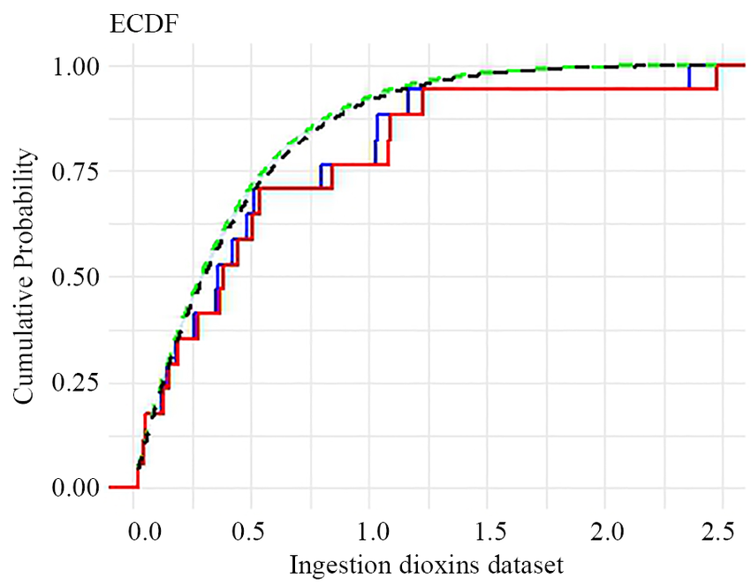
Figure 1: Empirical cumulative distribution function with real life dataset
The figure 1 illustrates how closely the neutrosophic model aligns with the empirical cumulative distribution, particularly within the central range of observed values. Overall, because the dataset is inherently interval-valued, traditional models fail to account for its uncertainty. The NLiD successfully addresses this limitation, making it a more reliable option for analyzing biomedical and environmental datasets characterized by ambiguity and indeterminacy.

5.2 Neutrosophic Burr-III Distribution for COVID-19 Mortality Data

The neutrosophic Burr-III (NeS-BrIII) distribution was evaluated using two real-world datasets: COVID-19 mortality data from the Netherlands (Data 1) and analgesic relief times in patients (Data 2) (4). Classical crisp data were transformed into neutrosophic form using X_{Neu}=[X_{L},X_{L}(1+I_{N})] with I_{Neu=}[0,0.05], thereby introducing interval uncertainty. The converted datasets are shown in Table 4.
Data1 | Data 2
(14.918, 15.66390), (10.056, 11.18880), (12.274, 12.88770), (10.289, 10.80345), (10.832, 11.37360), (7.099, 7.45395), (5.928, 6.22440), (13.211, 13.87155), (7.968, 8.36640), (7.584, 7.96320), (5.555, 5.83275), (6.027, 6.32835), (4.097, 4.30185), (3.611, 3.79155), (4.960, 5.20800), (7.498, 7.87290), (6.940, 7.28700), (5.307, 5.57235), (5.048, 5.30040), (2.857, 2.99985), (2.254, 2.36670), (5.431, 5.70255), (4.462, 4.68510), (3.883, 4.07715), (3.461, 3.63405), (3.647, 3.82935), (1.974, 2.07270), (1.273, 1.33665), (1.416, 1.48680), (4.235, 4.44675) | (1.1, 1.155), ( 1.4, 1.470), (1.3, 1.365), (1.7, 1.785), (1.9, 1.995), (1.8, 1.890), (1.6, 1.680), (2.2, 2.310), (1.7, 1.785), (2.7, 2.835), ( 4.1, 4.305), (1.8, 1.890), (1.5, 1.575), (1, 1.050)
Table 4: The data values for data 1 and data 2.
Model fitting was carried out for neutrosophic and classical Burr distributions, alongside stan dard alternatives such as Weibull and Nadarajah–Haghighi. Maximum likelihood estimates, standard errors, and model selection criteria for Data 1 are presented in Table 5, and for Data 2 in Table 6. In both datasets, the NeS-BrIII model achieved consistently lower AIC, BIC, CAIC, and HQIC values than competing models, with smaller standard errors and tighter parameter intervals.

Distribution | MLEs and standard errors (in parentheses) |  | Goodness-of-fit statistics for models
Distribution | ^𝜆𝑁𝑒u | ^𝜃𝑁𝑒u | AIC | CAIC | BIC | HQIC
NeS-BrIII  I_{Neu}=[0,0.05] | [10.009,10.636]  (2.634,2.862) | [1.655,1.665]  (0.198,0.199) | [164.721,167.727] | [165.165,168.171] | [167.523,170.529] | [165.617,168.624]
Burr-XII | 7.51 (6.06) | 0.080 (0.066) | 193.26 | 193.71 | 196.07 | 194.16
W | 0.026(0.014) | 1.86 (0.24) | 164.70 | 165.52 | 167.87 | 165.97
NH | 20.32 (22.03) | 0.005 (0.006) | 164.92 | 165.36 | 167.72 | 165.81
Table 5: MLEs and their standard errors (in parameters)and goodness-of-fit statistics for models for data set 1.
Distribution | MLEs and standard errors (in parentheses) |  | Goodness-of-fit statistics for models
Distribution | ^𝜆𝑁𝑒𝑢 | ^𝜃𝑁𝑒𝑢 | AIC | CAIC | BIC | HQIC
NeS-BrIII  INeu=[0,0.05] | [5.226,6.043]  (1.680,2.044) | [3.897,3.841]  (0.736,0.723) | [27.809,29.181] | [28.900,30.272] | [29.087,30.459] | [27.690,29.063]
Burr-XII | 37.47 (51.48) | 0.045 (0.062) | 46.47 | 47.18 | 48.46 | 46.86
W | 0.121 (0.055) | 2.785 (0.425) | 45.17 | 45.87 | 47.16 | 45.561
NH | 32.39 (99.36) | 0.011 (0.036) | 59.757 | 60.46 | 61.74 | 60.14
Table 6: MLEs and their standard errors (in parameters)and goodness-of-fit statistics for models for data set 2.
Figures 2 and 3 further illustrate the superior performance of NeS-BrIII. The fitted probability density plots (Figure 2) closely track the empirical distributions, capturing central tendencies effectively with unimodal shapes. The model comparison plot (Figure 3) highlights that the NeS-BrIII distribution yields the lowest information criteria values across all metrics, with narrower uncertainty bounds than the classical Burr-XII.
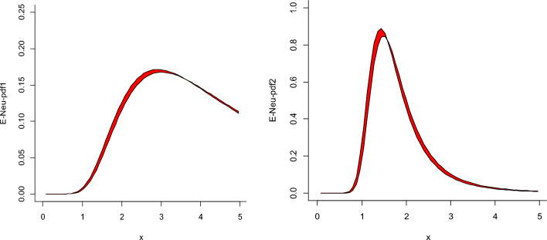
Figure 2. Estimated plots for the NeS-BrIII model for data sets 1 and 2.
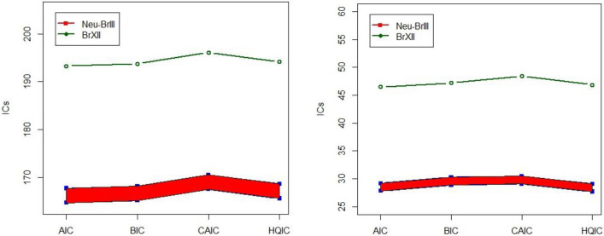
Figure 3. Plots of ICs for NeS-BrIII in contrast to Burr-XII model for data sets 1 and 2.
Overall, these findings confirm that NeS-BrIII provides a more accurate and robust fit un der uncertainty, outperforming both its classical counterpart and other standard models for biomedical datasets.

5.3 Neutrosophic Exponential Distribution for Cancer Remission Analysis

The Neutrosophic Exponential Distribution (NED) was applied to remission periods (in months) from 128 cancer patients, originally reported in a bladder cancer study by Lee and Wang (17). Figure 4 shows that both the CDF and PP plots support the suitability of the exponential family for this dataset. Although the original data contained precise values, a subset was represented as neutrosophic intervals (e.g., [7.26, 8.2], [12, 14.77], [15, 17.2], [5.3, 7.1], [75.02, 81], [1.5, 3.2]) to illustrate the handling of uncertainty. Under such conditions, the classical exponential model is inadequate, while the NED provides a more realistic alternative. The results given below Figure 4 highlight that the NED can effectively accommodate vague, interval-type data within real life medical datasets.
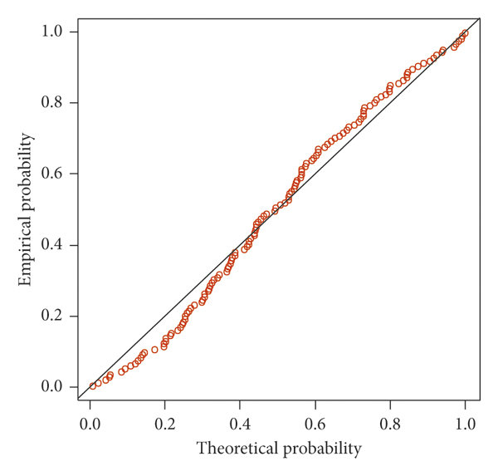
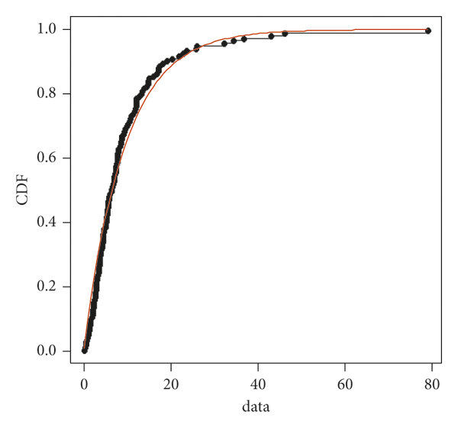

Figure 4. Graphical overview of the remission time dataset - CDF-plot & PP-plot
The full remission dataset, including both exact and interval values, is listed in Table7. As shown, many entries are reported as ranges, confirming the need for neutrosophic modeling. Descriptive measures under the NED framework are presented in Table8, where each statistic is expressed as an interval (e.g.,mean [9.18,9.24], variance [84.29,85.39]).

Remission times
0.08 | 2.09 | 3.48 | 4.87 | 6.94 | 8.66 | 13.11 | 23.63 | 0.2 | 2.23 | 3.52 | 4.98 | 6.97
9.02 | 13.29 | 0.4 | 2.26 | 3.57 | 5.06 | 7.09 | 9.22 | 13.8 | 25.74 | 0.5 | 2.46 | 3.64
5.09 | [7.26,8.2] | 9.47 | 14.24 | 25.82 | 0.51 | 2.54 | 3.7 | 5.17 | 7.28 | 9.74 | 14.76 | [5.3,7.1]
0.81 | 2.62 | 3.82 | 5.32 | 7.32 | 10.06 | [12,14.77] | 32.15 | 2.64 | 3.88 | 5.32 | 7.39 | 10.34
14.83 | 34.26 | 0.9 | 2.69 | 4.18 | 5.34 | 7.59 | 10.66 | 15.96 | 36.66 | 1.05 | 2.69 | 4.23
5.41 | 7.62 | 10.75 | 16.62 | 43.01 | 1.19 | 2.75 | 4.26 | 5.41 | 7.63 | [15,17.2] | 46.12 | 1.26
2.83 | 4.33 | 5.49 | 7.66 | 11.25 | 17.14 | [75.02,81] | 1.35 | 2.87 | 5.62 | 7.87 | 11.64 | 17.36
1.4 | 3.02 | 4.34 | 5.71 | 7.93 | 11.79 | 18.1 | 1.46 | 4.4 | 5.85 | 8.26 | 11.98 | 19.13
1.76 | 3.25 | 4.5 | 6.25 | 8.37 | 12.02 | [1.5,3.2] | 3.31 | 4.51 | 6.54 | [7.5,8.2] | 12.03
20.28 | 2.02 | 3.36 | 6.76 | 12.07 | 21.73 | 2.07 | 3.36 | 6.93 | 8.65 | 12.63 | 22.69
Table 7: Remission periods of 128 cancer patients.

Based on this dataset, the authors calculated basic descriptive statistics under the NED framework, as shown in table 8.
Descriptive Measures
Mean | [9.18,9.24]
Variance | [84.29,85.39]
Median | [6.40,6.36]
First Quantile | [2.64,2.71]
Third Quantile | [12.12,12.71]
Table 8: Descripitive measures
These results demonstrate that the NED effectively incorporates vagueness and uncertainty into survival-type data. By reporting descriptive statistics as ranges, it offers clinicians a more flexible and robust tool for interpreting heterogeneous patient outcomes compared to classical approaches.

5.4. Comparative Insights from Case Studies

Table 9 summarizes the three biomedical case studies reviewed in this paper. Each neutro sophic distribution is presented along with the dataset used, key outcomes, and observed strengths and limitations.

Distribution | Biomedical Dataset | Key Findings | Strengths | Limitations
Neutrosophic Lindley | Environmental health data (toxin expo sure) | Outperformed classical Lindley distribution in model fit | Captures uncertainty in exposure data | Applicable mainly for moderate-sized datasets
Neutrosophic Burr-III | COVID-19 mortality data | Provided better fit than Weibull and NH models | Flexible tail behavior, useful for extreme event modeling | Higher computational complexity
Neutrosophic Exponential | Cancer remission times | More realistic modeling compared to classical exponential distribution | Simple and interpretable | Less flexible for skewed or heavy tailed data
Table 9:Comparison of Neutrosophic Distributions in Biomedical Case Studies.

Overall, the comparative analysis indicates that each neutrosophic distribution offers distinct advantages depending on the biomedical context. The Lindley model balances parsimony and fit, the Burr-III is more suitable for extreme or heavy-tailed datasets such as pandemic related mortality, and the Exponential remains useful for simple survival data. Future work could explore neutrosophic extensions of multivariate and longitudinal models, which are still largely absent in biomedical research.

6. Handling Uncertainty in Biomedical Data with Neutrosophic Probability Distributions

Neutrosophic probability distributions offer a distinct advantage in their ability to explicitly model various forms of uncertainty inherent in biomedical data. Vagueness and imprecision in measurements or parameters can be addressed through the use of interval-valued or fuzzy neutrosophic numbers within these distributions [2]. For example, instead of a single, precise value for a physiological parameter like blood glucose, a range or interval can be used to represent the inherent variability or measurement error. Similarly, diagnostic thresholds that might not be sharply defined can be modeled using fuzzy or interval-based neutrosophic numbers.
Furthermore, Neutrosophic probability distributions are uniquely positioned to address indeterminacy in biomedical data through the explicit inclusion of the indeterminacy component (I) [1]. This component allows for the formal modeling of aspects that are unknown or uncertain, a common occurrence in biomedical research. For instance, in studying a novel disease, the underlying mechanisms might not be fully understood, leading to indeterminacy in predicting disease progression. Patient compliance with treatment regimens can also be an indeterminate factor affecting study outcomes. Neutrosophic methods provide a way to quantify and incorporate this lack of complete knowledge into the statistical analysis.
The potential to handle contradictory information represents another key strength of Neutrosophic probability distributions [1]. In biomedical research, it is not uncommon to encounter situations where different pieces of evidence might point to conflicting conclusions. For example, a patient might exhibit symptoms strongly suggestive of one condition while simultaneously showing test results more indicative of another. Traditional statistical methods often struggle with such inconsistencies. Neutrosophic probability, with its ability to represent degrees of truth, falsity, and indeterminacy independently, offers a potential framework for modeling and analyzing these types of contradictory findings, allowing for a more nuanced interpretation of the overall evidence.

7. Comparative Effectiveness with Traditional Statistical Methods

A growing number of studies have sought to compare the effectiveness of Neutrosophic probability distributions with traditional statistical methods in the context of biomedical research. Several of these investigations report that Neutrosophic approaches yield superior performance, particularly when the data is characterized by significant uncertainty and indeterminacy [3]. These studies often employ various performance metrics to facilitate the comparison, including accuracy in classification tasks, sensitivity and specificity in diagnostic testing, and measures of goodness-of-fit for statistical models. For instance, Neutrosophic statistical tests for normality and homogeneity of variance have been shown to be more effective than their classical counterparts when applied to interval-valued biomedical data [8].
While the majority of comparative studies in the provided material highlight the advantages of Neutrosophic methods in handling uncertainty, it is important to note that the relative novelty of the field means that the body of evidence is still developing. Further research is needed to explore scenarios where traditional methods might perform comparably or even better, particularly when the biomedical data is highly precise and exhibits minimal uncertainty. However, the existing literature suggests that the advantage of Neutrosophic methods becomes most apparent when the data deviates from the assumptions underlying traditional statistical approaches, such as the assumption of normality or the availability of precise measurements. In situations involving high levels of uncertainty, interval-valued data, or potentially contradictory information, Neutrosophic probability distributions appear to offer a significant advantage by providing a more robust and realistic framework for analysis.

8. Advantages and Limitations of Using Neutrosophic Probability Distributions in Biomedical Research

8.1. Advantages

The application of Neutrosophic probability distributions in biomedical research presents several potential advantages. Foremost among these is the enhanced ability to handle uncertainty, vagueness, and indeterminacy that are often inherent in biomedical data, a capability that surpasses that of traditional statistical methods which typically assume data certainty [2]. These distributions are also capable of modeling interval-valued data and data containing indeterminate components directly, without requiring transformations or simplifications that might lead to a loss of information [2]. In situations where traditional methods struggle due to violations of their underlying assumptions, Neutrosophic approaches have shown the potential to provide more accurate and reliable results [3]. Furthermore, the representation of uncertainty through the truth, indeterminacy, and falsity components in Neutrosophic probability distributions offers a more comprehensive understanding of the data and the associated probabilities [5]. The flexibility to extend and generalize classical probability distributions within the Neutrosophic framework allows for the adaptation of statistical tools to address a wider range of complex biomedical problems.

8.2. Limitations

Despite these advantages, there are also limitations associated with the use of Neutrosophic probability distributions in biomedical research. The relative novelty of the field means that there might be a limited availability of well-established methodologies and user-friendly software tools compared to traditional statistics. Interpreting the results, particularly the indeterminacy component, can be complex for researchers who are not familiar with the principles of Neutrosophy. Furthermore, the lack of standardized approaches for validating Neutrosophic models and comparing them across different studies can pose challenges for the broader adoption of these methods. Notably, some researchers have raised questions regarding the applicability and overall usefulness of Neutrosophic statistical methods, highlighting the need for more rigorous validation and clearer guidelines on their appropriate use in biomedical research. Finally, the interpretation of the indeterminacy component might be context-dependent and require specific domain expertise to fully understand its implications.

9. Conclusion and Future Directions

This review has provided a comprehensive synthesis of Neutrosophic probability distribu tions and their applications in biomedical research. By explicitly incorporating truth, falsity, and indeterminacy, these distributions address the limitations of classical models in handling vague, interval-valued, and uncertain data. Their applications span medical diagnosis, sur vival analysis, clinical trials, and medical equipment reliability, demonstrating their versatility in dealing with real-world biomedical complexities. The unique contribution of this work lies in consolidating scattered literature into a unified perspective focused exclusively on biomedical applications of NPDs. In doing so, it high lights detailed case studies that illustrate practical implementations and identifies important research gaps in validation, interpretability, and the development of computational tools. At the same time, the review is not without limitations: it concentrates primarily on se lected distributions and does not extend to broader connections with machine learning or non-parametric frameworks, and it emphasizes established applications while potentially un derrepresenting emerging interdisciplinary uses. Looking ahead, several promising directions can be identified. These include the development of novel NPDs tailored to biomedical challenges such as disease progression and genomic variability, rigorous comparative studies with real-world datasets across diverse clinical do mains, and the creation of user-friendly software packages and standardized methodologies to support wider adoption. Further opportunities lie in expanding applications to personalized medicine, genomics, and medical imaging, as well as enhancing the interpretability of the indeterminacy component and establishing robust validation protocols. In conclusion, Neutrosophic probability distributions hold considerable promise for advanc ing biomedical research by offering a more realistic and nuanced framework for uncertain data. With continued theoretical development, computational support, and empirical validation, they can become indispensable tools in biomedical statistics, bridging the gap between uncertainty and reliable scientific inference. Importantly, their integration with emerging technologies such as artificial intelligence and machine learning has the potential to trans form biomedical data analysis, leading to more precise clinical decision-making, improved patient outcomes, and stronger evidence-based health policies.

REFERENCES

[1] F. Smarandache, M. Abdel-Basset, M. Leyva-Vázquez, and S. Broumi, Eds., “Neutrosophic Sets and Systems, vol. 69/2024 {Special Issue on Neutrosophy and Plithogeny: Fundamentals and Applications}: An International Journal in Information Science and Engineering”, Infinite Study, (2024).
[2] F. Smarandache, "Introduction to neutrosophic statistics. arXiv," arXiv:1406.2000, (2014).
[3] F. Smarandache, “Introduction to Neutrosophic Statistics”, Zenodo, (2014).
[4] F. Jamal, S. Shafiq, M. Aslam, S. Khan, Z. Hussain, and Q. Abbas, “Modeling COVID-19 data with a novel neutrosophic Burr-III distribution”, Sci. Rep., vol. 14, no. 1, (2024), Art. no. 10810.
[5] F. Smarandache, “Neutrosophic Statistics is an Extension of Interval Statistics, While Plithogenic Statistics is the Most General Form of Statistics (Second Version)”, vol. 2, Infinite Study, (2022).
[6] F. Smarandache, “Three Decades of Neutrosophic and Plithogenic Theories with Their Applications (1995-2024)”, Infinite Study, (2024).
[7] Smarandache, Florentin, and Maissam Jdid. "An Overview of Neutrosophic and Plithogenic Theories and Applications." (2023).
[8] Al-khazaleh, Ahmad MH, and Shawkat Alkhazaleh. "Neutrosophic conditional probabilities: theories and applications." International Journal of Fuzzy Logic and Intelligent Systems 22, no. 1 (2022): 78-88.
[9] Lathamaheswari, M., S. Sudha, Said Broumi, Florentin Smarandache, and Casablanca Othman. "Neutrosophic perspective of Neutrosophic probability distributions and its application." Collected Papers. Volume X: On Neutrosophics, Plithogenics, Hypersoft Set, Hypergraphs, and other topics (2022): 267.
[10] R. Alhabib, M. M. Ranna, H. Farah, and A. A. Salama, “Some Neutrosophic Probability Distributions”, Infinite Study, (2018).
[11] Aslam, Muhammad, and Mohammed Albassam. "Neutrosophic geometric distribution: data generation under uncertainty and practical applications." AIMS Math 9, no. 6 (2024): 16436-16452.
[12] Hassan, Marwa K., and Muhammad Aslam. "Birnbaum Saunders distribution for imprecise data: statistical properties, estimation methods, and real life applications." Scientific Reports 14, no. 1 (2024): 6955.
[13] Aslam, Muhammad, Osama H. Arif, and Rehan Ahmad Khan Sherwani. "New diagnosis test under the neutrosophic statistics: an application to diabetic patients." BioMed Research International 2020, no. 1 (2020): 2086185.
[14] Nguyen, Gia Nhu, Le Hoang Son, Amira S. Ashour, and Nilanjan Dey. "A survey of the state-of-the-arts on neutrosophic sets in biomedical diagnoses." International Journal of Machine Learning and Cybernetics 10 (2019): 1-13.
[15] Essa, Ahmed K., Ramiz Sabbagh, A. A. Salama, Huda E. Khalid, A. A. Aziz, and Ahmed A. Mohammed. "An overview of neutrosophic theory in medicine and healthcare." Neutrosophic Sets and Systems 61 (2023): 196-208.
[16] Fatima, Adeena, Usama Afzal, Muhammad Aslam, and Florentin Smarandache. "A Comprehensive Review of Neutrosophic Statistics for Data Analysis in Applied Sciences." Journal of Reliability and Statistical Studies (2025): 25-40.
[17] Duan, Wen-Qi, Zahid Khan, Muhammad Gulistan, and Adnan Khurshid. "Neutrosophic exponential distribution: modeling and applications for complex data analysis." Complexity 2021, no. 1 (2021): 5970613.
[18] Bashir, Shakila, Bushra Masood, Ishmal Shehzadi, Zainalabideen Al-Husseini, and Muhammad Aslam. "Neutrosophic Lindley Distribution: Simulation, Application, and Comparative Study." Contemporary Mathematics (2025): 551-564.

