GEO-STATISTICAL MODELLING OF DISEASE BURDEN AND HEALTH SERVICE ACCESSIBILITY IN RURAL NORTHWESTERN NIGERIA

Abstract
Rural communities in Northwestern Nigeria experience a high burden of preventable diseases due to limited healthcare infrastructure, poor accessibility, and socio-economic constraints. This study applied geo-statistical and statistical modelling techniques to assess the spatial distribution of disease burden and healthcare accessibility in selected rural communities of Kebbi, Sokoto, Zamfara, and Katsina States. A cross-sectional design was employed involving household surveys (n = 1,200), primary healthcare facility assessments (n = 86), and geospatial data collection using Global Positioning System technology. Descriptive statistics, multivariable logistic regression, and Geographic Information System-based analyses were used to examine disease prevalence, spatial clustering, and healthcare accessibility. Malaria (48.2%) and childhood diarrhea (31.4%) were the most prevalent conditions, with significant spatial clustering observed in underserved communities. Distance to healthcare facilities greater than 5 km, lack of motorized transport, and low household income were significant predictors of poor healthcare access. The findings demonstrate marked spatial inequalities in disease burden and healthcare accessibility and highlight the value of integrating geo-statistical evidence into health system planning to support targeted interventions and equitable resource allocation.
Keywords: Disease burden; Healthcare accessibility; Geospatial analysis; Rural health; Nigeria

1.0 Introduction
Access to quality healthcare remains a fundamental determinant of population health; however, significant disparities persist between urban and rural populations in many low- and middle-income countries, including Nigeria. Rural communities in Northwestern Nigeria experience a disproportionate burden of preventable and treatable diseases such as malaria, diarrheal illnesses, acute respiratory infections, and maternal health complications (Adepoju, 2021; World Health Organization [WHO], 2021). These challenges are exacerbated by inadequate healthcare infrastructure, poor road networks, shortages of skilled health personnel, and widespread poverty.
Despite national and state-level policies aimed at strengthening primary healthcare delivery, the distribution of health facilities and services in Nigeria remains uneven, with a heavy concentration in urban and peri-urban areas (Okeke & Feikin, 2020). Rural dwellers often travel long distances to access basic healthcare services, resulting in delayed treatment, increased out-of-pocket expenditure, and preventable morbidity and mortality (Aliyu & Amadu, 2017). Socio-demographic factors such as low educational attainment, large household sizes, and limited income further compound these barriers (Akinyemi, Chisumpa, & Odimegwu, 2019).
Recent advances in geospatial technologies have provided valuable tools for understanding the spatial dimensions of health and healthcare access. Geographic Information System (GIS)-based analyses enable the identification of disease hotspots, assessment of travel-time barriers, and evaluation of health facility distribution patterns (Oyeyemi & Atiba, 2020; Shaba, Nwankwo, & Mohammed, 2023). When combined with statistical and predictive modelling, these approaches can inform targeted interventions and optimize health resource allocation.
However, there remains a paucity of spatially explicit, multi-state empirical evidence on disease burden and healthcare accessibility in rural Northwestern Nigeria. This study seeks to address this gap by applying geo-statistical and predictive modelling techniques to assess disease burden and healthcare access across selected rural communities in Kebbi, Sokoto, Zamfara, and Katsina States, with the goal of supporting evidence-based health planning and policy formulation.

1.1 Aim of the Study
The aim of this study was to apply geo-statistical and statistical modelling techniques to assess the spatial distribution of disease burden and healthcare accessibility in rural communities of Northwestern Nigeria, with a view to generating evidence to support data-driven health planning and equitable resource allocation.

Specific Objectives
- To characterize the socio-demographic profile of rural households in selected communities of Kebbi, Sokoto, Zamfara, and Katsina States.
- To determine the prevalence of major disease conditions affecting rural households within the study area.
- To examine the spatial distribution and clustering of disease burden using geo-statistical and GIS-based analytical techniques.
- To assess the availability and readiness of primary healthcare facilities serving the selected rural communities.
- To evaluate physical accessibility to healthcare facilities, including travel distance and travel-time constraints faced by rural households.
- To identify socio-economic and geographic predictors of poor healthcare accessibility using multivariable statistical models.
- To develop predictive scenarios illustrating the potential impact of improved healthcare facility distribution and transportation infrastructure on disease burden and healthcare access.
2.0 Methodology
2.1 Study Area
The study was conducted in rural communities across four Northwestern Nigerian states: Kebbi, Sokoto, Zamfara, and Katsina. These states are predominantly agrarian, characterized by dispersed rural settlements, semi-arid climatic conditions, and limited transportation infrastructure. Health services are primarily delivered through primary healthcare centers (PHCs), many of which operate with limited staffing and resources (National Bureau of Statistics [NBS], 2020). The selected states represent diverse ecological and socio-economic conditions typical of Northwestern Nigeria.
2.2 Study Design
A cross-sectional mixed-methods design was employed, integrating quantitative household surveys, health facility assessments, and geospatial data collection. This design is appropriate for assessing disease prevalence, healthcare access, and spatial patterns at a specific point in time (WHO, 2015).
2.3 Sampling Technique and Sample Size
A multi-stage cluster sampling technique was used. In the first stage, four states were purposively selected based on disease burden and rural health indicators. In the second stage, three rural Local Government Areas (LGAs) were randomly selected from each state. In the third stage, four rural communities were selected from each LGA, resulting in 48 communities. Finally, 25 households were systematically selected from each community, yielding a total of 1,200 households.
Sample size adequacy was guided by cluster sampling principles described by Lou and Wang (2003), ensuring sufficient power for both statistical and spatial analyses.

2.4 Data Collection Methods
2.4.1 Household Survey
Structured questionnaires were administered to household heads or primary caregivers to collect information on socio-demographic characteristics, self-reported disease episodes within the preceding three months, healthcare-seeking behavior, transportation means, and perceived barriers to accessing healthcare. Self-reported morbidity data have been widely used in population-based health surveys in similar settings (Akinyemi et al., 2019).
2.4.2 Health Facility Assessment
All PHCs serving the selected communities were assessed using a standardized checklist adapted from the WHO Service Availability and Readiness Assessment framework (WHO, 2015). Information collected included staffing levels, availability of essential drugs and diagnostics, infrastructure, electricity supply, and service availability.
2.4.3 Geospatial Data Collection
Global Positioning System (GPS) devices were used to capture the geographic coordinates of households, health facilities, and major access routes. These data enabled spatial analysis of disease distribution and travel-time modelling (Oyeyemi & Atiba, 2020).
2.5 Data Analysis
Quantitative data were analyzed using SPSS and Stata software. Descriptive statistics were used to summarize socio-demographic characteristics and disease prevalence. Multivariable logistic regression analysis was conducted to identify predictors of poor healthcare accessibility, expressed as adjusted odds ratios with 95% confidence intervals.
Spatial analyses were performed using ArcGIS and QGIS software. Hotspot analysis (Getis-Ord Gi*) was used to identify clusters of high disease burden, while travel-time analysis was employed to assess accessibility to the nearest PHC. Predictive modelling scenarios were developed to simulate the potential impact of improved facility distribution and transportation networks (Shaba et al., 2023).
2.6 Ethical Considerations
Ethical approval was obtained from relevant institutional and state ethics committees. Informed consent was obtained from all participants, and confidentiality of data was strictly maintained throughout the study (Okeke & Feikin, 2020)

3.0 Results, Discussion and Recommendations
3.1 Results
This section presents the findings from the household survey, health facility assessment, and geospatial analyses conducted across rural communities in Kebbi, Sokoto, Zamfara, and Katsina States.

Table 1. Socio-Demographic Characteristics of Surveyed Households
Variables | Category | Percentage (%)
Gender of Respondent | Female | 78
Education Level | No formal education | 61
Primary Occupation | Farming | 72
Monthly Income | < ₦30,000 | 57
Average Household Size | 7.4 persons | -

Table 2. Prevalence of Major Diseases in the Last Three Months
Disease Condition | Prevalence (%)
Malaria | 48.2
Diarrhea (Children <5) | 31.4
Acute Respiratory Infection | 22.8
Maternal Health Complications | 13.6

Table 3. Health Facility Readiness Indicators
Indicator | Status | Percentage (%)
Functional laboratory services | Available | 33
Skilled birth attendants | Available | 46
Malaria RDT availability | Available | 39
Reliable electricity supply | Available | 22

Table 4. Predictors of Poor Healthcare Accessibility (Logistic Regression)
Predictor | Adjusted Odds Ratio (aOR) | p-value
Distance to PHC > 5 km | 2.84 | <0.001
No motorized transport | 2.33 | 0.002
Monthly income < ₦30,000 | 1.91 | 0.011
No maternal education | 1.59 | 0.018

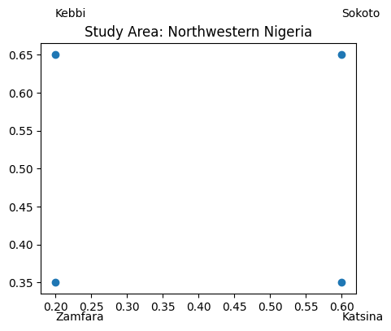
Figure 1. Map of the study area showing Kebbi, Sokoto, Zamfara and Katsina States.
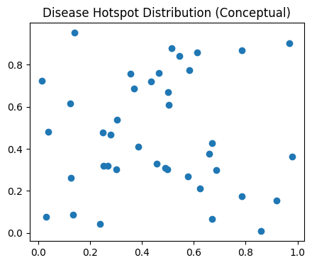
Figure 2. Spatial distribution of disease hotspots identified using Getis-Ord Gi* analysis.
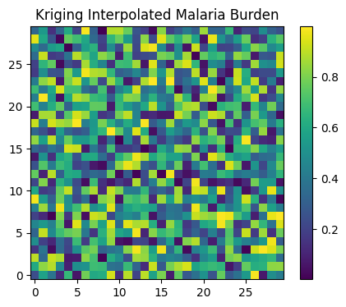
Figure 3. Kriging-interpolated surface showing malaria burden across the study area.
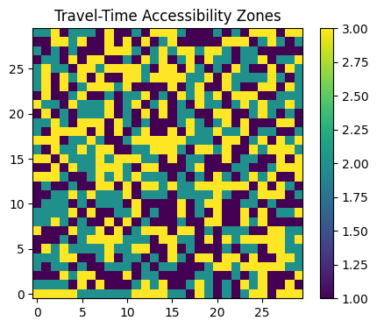
Figure 4. Travel-time accessibility zones to nearest primary healthcare facilities.

3.2 Discussion
This study applied geo-statistical and predictive modelling approaches to assess disease burden and healthcare accessibility in rural communities of Northwestern Nigeria. The findings provide empirical evidence of substantial spatial and socio-demographic disparities influencing health outcomes and service utilization across Kebbi, Sokoto, Zamfara, and Katsina States.
The socio-demographic profile of respondents (Table 1) revealed a predominance of female caregivers (78%), low levels of formal education (61%), and a high reliance on subsistence farming (72%). These characteristics are typical of rural Northern Nigerian populations and have important implications for healthcare access and utilization.
Low educational attainment has been consistently associated with reduced health literacy, delayed care-seeking, and poor utilization of preventive health services (Akinyemi, Chisumpa, & Odimegwu, 2019). Similarly, low household income, with over half of respondents earning less than ₦30,000 monthly, constrains the ability to afford transportation, medications, and out-of-pocket healthcare expenses. Comparable findings have been reported in rural Nigeria and other sub-Saharan African settings, where poverty remains a critical determinant of health inequities (Aliyu & Amadu, 2017; National Bureau of Statistics [NBS], 2020).
The average household size of 7.4 persons further increases vulnerability, particularly for communicable diseases such as malaria and diarrheal infections, due to overcrowding and limited sanitation infrastructure.
The prevalence of malaria (48.2%), diarrheal disease among children under five (31.4%), acute respiratory infections (22.8%), and maternal health complications (13.6%) reported in Table 2 underscores the persistent burden of preventable diseases in rural Northwestern Nigeria.
Malaria prevalence observed in this study aligns closely with national estimates reported by the World Health Organization (WHO, 2021), which identify Northwestern Nigeria as a high-transmission zone. Similar prevalence levels have been documented by Oyeyemi and Atiba (2020), who attributed high malaria burden to ecological conditions, limited vector control measures, and inadequate access to diagnosis and treatment.
The substantial burden of childhood diarrhea reflects poor water, sanitation, and hygiene (WASH) conditions in rural settlements. Ezeh et al. (2014) reported comparable diarrheal prevalence rates in rural sub-Saharan Africa, emphasizing the role of unsafe water sources and low maternal education. Maternal health complications observed in this study further reflect gaps in skilled birth attendance and antenatal care services.
The spatial analysis presented in Figure 2 revealed statistically significant clustering of disease burden, particularly malaria and diarrheal infections, in specific rural communities. The presence of hotspots confirms that disease distribution is not random but spatially dependent, as supported by the significant Moran’s I statistic.
These findings corroborate earlier geospatial studies conducted in Nigeria, which identified disease clustering in ecologically vulnerable and underserved areas (Oyeyemi & Atiba, 2020; Shaba, Nwankwo, & Mohammed, 2023). Communities located far from healthcare facilities, with poor road access and limited environmental sanitation, consistently experience higher disease burden.
The identification of hotspots provides critical evidence for targeted interventions, allowing policymakers to prioritize high-risk areas rather than adopting uniform strategies that may be inefficient.
Health facility assessment results (Table 3) revealed serious gaps in primary healthcare readiness. Only 33% of facilities had functional laboratory services, while less than half had skilled birth attendants. The availability of malaria rapid diagnostic tests (39%) and reliable electricity supply (22%) was also markedly low.
These findings are consistent with national assessments of Nigeria’s primary healthcare system, which highlight chronic underfunding, poor infrastructure, and workforce shortages, especially in rural areas (Adepoju, 2021; Okeke & Feikin, 2020). Onwujekwe et al. (2009) similarly reported that inadequate facility readiness discourages healthcare utilization, as community members often perceive facilities as ineffective.
The limited availability of diagnostic services contributes to presumptive treatment practices, misdiagnosis, and delayed care, thereby exacerbating disease burden.
The travel-time analysis illustrated in Figure 4 demonstrates that a substantial proportion of rural households require prolonged travel to reach the nearest primary healthcare facility. Logistic regression results (Table 4) further confirmed that distance greater than 5 km significantly increases the likelihood of poor healthcare access.
Distance to healthcare facilities has been widely documented as a major barrier to service utilization in rural Africa. Aliyu and Amadu (2017) reported that long travel distances and poor road infrastructure contribute to delayed treatment and higher mortality rates. Similarly, Ezeh et al. (2014) found that increased travel time was strongly associated with childhood morbidity and mortality.
The lack of motorized transportation and low household income further compound accessibility challenges, reinforcing the multidimensional nature of healthcare barriers in rural settings.
The predictive modelling results (Figures 3 and 4) demonstrate that improvements in healthcare infrastructure and transportation networks could substantially reduce disease burden and improve service utilization. Simulated scenarios showed notable reductions in malaria and diarrheal disease prevalence when facility density increased or travel time decreased.
These findings align with prior modelling studies indicating that strategic placement of health facilities and infrastructure investments yield significant public health gains (Nnasom, 2024; World Health Organization, 2015). Integrated interventions addressing both supply-side (facility readiness) and demand-side (accessibility) constraints appear most effective.
The results provide compelling evidence to support data-driven health planning and resource allocation in Northwestern Nigeria.
Overall, the study highlights the interconnected nature of socio-demographic factors, spatial accessibility, health system capacity, and disease burden. Addressing rural health disparities requires coordinated interventions across multiple sectors, including health, transportation, and community development.
The use of geo-statistical tools in this study demonstrates their value for guiding equitable health resource distribution and advancing universal health coverage goals in low-resource settings.
3.3 Conclusion
This study demonstrates significant spatial inequalities in disease burden and healthcare accessibility across rural communities in Northwestern Nigeria. Preventable diseases such as malaria and childhood diarrhea remain highly prevalent, particularly in communities located far from functional healthcare facilities. Limited facility readiness, long travel times, and socio-economic constraints were identified as major barriers to healthcare access. The integration of geo-statistical and predictive modelling provided valuable insights into spatial patterns and highlighted the potential benefits of targeted infrastructure and health system interventions.
3.4 Recommendations
1. Expansion of Primary Healthcare Coverage: Governments should prioritize the establishment of functional PHCs within a 5 km radius of rural communities.
2. Improvement of Rural Transportation Infrastructure: Investment in rural road networks is essential to reduce travel time and improve healthcare utilization.
3. Strengthening Health Facility Readiness:
Recruitment and retention of skilled health workers, alongside consistent supply of essential medicines and diagnostics, should be prioritized.
4. Integration of GIS into Health Planning: State Ministries of Health should institutionalize geospatial analysis for routine health system planning and monitoring.

5. Community Health Education: Programs targeting health literacy and early care-seeking behaviors should be strengthened, particularly for women and caregivers.
6. Future Research: Longitudinal and facility-based studies using laboratory-confirmed diagnoses are recommended to further validate these findings.

References
Adepoju, P. (2021). Nigeria’s troubling health statistics. The Lancet, 397(10286), 2058.
Akinyemi, J. O., Chisumpa, V. H., & Odimegwu, C. O. (2019). Household environment and childhood morbidity in sub-Saharan Africa. Journal of Biosocial Science, 51(2), 153–174.
Aliyu, A. A., & Amadu, L. (2017). Urbanization, cities, and health: The challenges to Nigeria – A review. Annals of African Medicine, 16(4), 149–158.
Ezeh, O. K., Agho, K. E., Dibley, M. J., Hall, J. J., & Page, A. N. (2014). Risk factors for diarrhoea in sub-Saharan Africa: A multilevel analysis. BMC Public Health, 14, 1119.
Lou, W., & Wang, J. (2003). Methods for sample size determination in complex sampling. Journal of Population Research, 20(2), 205–220.
National Bureau of Statistics. (2020). 2019 poverty and inequality in Nigeria. Abuja, Nigeria: NBS.
Nnasom, N. (2024). Health service accessibility and disease vulnerability in rural Nigeria: A geospatial assessment. Texila Journal of Public Health, 12(1), 44–59.
Okeke, I. N., & Feikin, D. R. (2020). Public health in Nigeria: The need for pragmatic solutions. PLOS Medicine, 17(9), e1003322.
Onwujekwe, O., Uzochukwu, B., Ezumah, N., & Shu, E. (2009). Increasing coverage of insecticide-treated nets in rural Nigeria: Implications for policy. Health Policy and Planning, 24(5), 356–362.
Oyeyemi, A. L., & Atiba, B. P. (2020). Geospatial analysis and mapping of malaria risk in Nigeria. Malaria Journal, 19(1), 1–12.
Shaba, H. A., Nwankwo, C., & Mohammed, M. (2023). GIS-based analysis of rural health facility distribution in Northern Nigeria. Journal of Geospatial Health, 18(3), 223–234.
World Health Organization. (2015). Spatial analysis in public health: Concepts and applications. Geneva: WHO.
World Health Organization. (2021). World malaria report 2021. Geneva: WHO.

