Review Article

Bone Marrow Aspirate Concentrate (BMAC) augmentation in Anterior Cruciate Ligament (ACL) reconstruction: Systematic Review and Meta-Analysis of Randomized Control Trials

.
ABSTRACT

Aims: ACL tears represent a significant biomechanical challenge, frequently resulting in long-term joint instability and post-traumatic osteoarthritis despite surgical reconstruction. BMAC has emerged as a biological adjunct to enhance the "ligamentization" process at the graft-bone interface by providing a concentrated milieu of mesenchymal stem cells (MSCs) and growth factors. However, clinical outcomes remain controversial, and the cost-effectiveness of the procedure is under scrutiny. This article aims to provide a definitive synthesis the therapeutic, functional outcomes, and safety profile of BMAC augmentation in primary ACL reconstruction (ACLR).
Study design: Meta Analysis of Randomized Control Trials
Methodology: This study followed PRISMA guidelines, with RCTs studies through August 15, 2025 were included. Primary outcomes were the Visual Analog Scale (VAS), Lysholm, and International Knee Documentation Committee (IKDC) scores. Data synthesis utilized the Inverse Variance method (RevMan 5.4), and risk of bias was assessed via the Cochrane RoB 2.0 tool. The protocol of this study was already registered on PROSPERO (CRD420261304072)
Results: 6 RCTs were included for analysis. BMAC augmentation demonstrated a statistically significant improvement in functional outcomes by IKDC score (MD 2.50; 95% CI: 0.89 to 4.11; P = .002) with no statistical heterogeneity (I² = 0%). An improvement was noted in the Lysholm score, though it reached only borderline significance (MD 2.82; P = .05). No significant difference was found in postoperative pain levels (VAS: MD 0.15; P = .26). Regarding safety, BMAC showed a comparable profile to standard care, with no increased risk of serious adverse events.
Conclusion: BMAC augmentation in ACLR provides statistically detectable functional gains at 12 to 24 months, particularly in IKDC scores. However, these improvements may not meet the threshold for minimal clinically important difference and do not correlate with a reduction in pain. Given the procedural requirements and costs, routine clinical adoption is currently unsupported for the general patient population.

Keywords: ACL reconstruction, BMAC, Stem Cells

1. INTRODUCTION
The occurrence of ACL tears presents a significant issue for the knee, particularly during non-contact actions like deceleration, pivoting, or landing, which are common in sports. With over 200,000 cases annually in the U.S., these injuries primarily impact younger, active individuals (Moon et al., 2021; Musahl & Karlsson, 2019). Untreated ACL tears may lead to decreased postural control, increased rates of meniscal injury, and earlier onset osteoarthritis. A complete tear causes major instability and disrupts this critical neurosensory pathway (Youn et al., 2019). Surgical reconstruction using a tendon graft is the standard method for restoring mechanical stability, but it cannot replicate the biological and sensory functions of the original ligament. This permanent change in joint movement, along with the initial inflammation caused by the injury, sets off a damaging process that leads to the deterioration of articular cartilage (Fu et al., 2019; Moon et al., 2021). As a result, post-traumatic osteoarthritis is not just a potential risk but a common long-term outcome for many patients within 15 years, even after what is considered a successful surgery (Musahl & Karlsson, 2019; Wang et al., 2017).
The success of ACL reconstruction faces a biological challenge: integrating a soft tissue graft within a hard bone tunnel. This surgical interface is very different from the natural ACL insertion site (the enthesis), which has a complex area of fibrocartilage that effectively cushions stress between the ligament and bone. In contrast, the reconstructed interface creates a sudden connection that is prone to failure. The healing process is like a race against time; while the graft is first fixed mechanically, long-term stability depends on gradual biological integration. During the critical early healing period, the avascular graft undergoes a process called "ligamentization," which requires it to be repopulated with cells and receive blood supply (Musahl & Karlsson, 2019; Youn et al., 2019). This phase initially involves cell death and significant mechanical weakness. If biological fixation does not happen quickly enough, movement at the graft-tunnel junction can create a shear-stress environment. This can lead to a weak fibrous scar tissue layer instead of strong fibrocartilage. This inadequate healing process is mainly responsible for tunnel widening, graft looseness, and subsequent reconstructive failure, with re-tear rates reported as high as 11.7% (Fu et al., 2019; Moon et al., 2021; Wang et al., 2017). To address these biological shortcomings, using stem cells has emerged as a targeted approach.
BMAC is more than just a cell source; it is a complex autologous product designed to promote a better healing response (Anz et al., 2023; Bhamare et al., 2023; Forsythe et al., 2022; Lavender et al., 2025; Lin et al., 2024; Silva et al., 2014). Its therapeutic potential is broad. First, it provides a concentrated group of mesenchymal stem/stromal cells (MSCs), which have both direct and indirect healing effects. Directly, they can differentiate into the cartilage and bone cells necessary to create a more natural enthesis. Indirectly, they release signaling molecules that attract host repair cells, reduce the post-surgical inflammatory response, and promote the growth of new blood vessels to speed up graft revascularization. Second, BMAC contains a wealth of native growth factors (e.g., TGF-β, PDGF) and anti-inflammatory cytokines (e.g., IL-1Ra) that encourage cell growth and matrix creation while reducing harmful effects that lead to scar tissue and joint damage. The main idea is that by delivering this powerful biological toolkit directly to the healing area, BMAC can encourage real tissue regeneration instead of fibrous scarring(Anz et al., 2023; Bhamare et al., 2023; Forsythe et al., 2022; Lavender et al., 2025; Lin et al., 2024).
Despite this strong biological reasoning, a significant gap exists between research and real-world application, and the clinical use of BMAC in ACL reconstruction is still debated. Early clinical studies have produced inconsistent and often conflicting results, causing uncertainty for both surgeons and patients. This variability is likely due to a lack of standard procedures for preparing BMAC, which leads to differences in cell concentrations and viability, as well as variations in application techniques and patient groups (Anz et al., 2023; Bhamare et al., 2023; Forsythe et al., 2022; Lavender et al., 2025; Lin et al., 2024). Given that this therapy costs around $3,000 USD per procedure, there is an urgent need to move from anecdotal evidence to a clear, evidence-based consensus (Moon et al., 2021). The existing literature does not provide enough information to shape clinical guidelines. Therefore, a thorough summary of the most rigorous evidence is necessary to solve this clinical issue from randomized controlled trials (RCTs) studies.

2. material and methods
This systematic review and meta-analysis were conducted using the standards provided by the Preferred Reporting Items for Systematic Reviews and Meta-analysis (PRISMA), which may be found at http://www.prisma-statement.org/ (Fig. 1). The protocol of this study was already registered on PROSPERO (CRD420261304072)
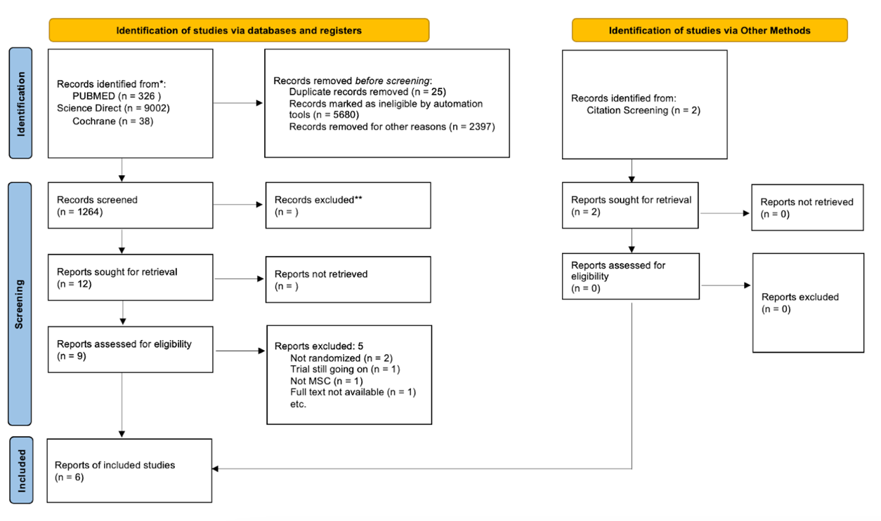
Fig. 1. PRISMA Chart

2.1 Eligibility Criteria
We included studies that met the following criteria: (1) RCTs; (2) skeletally mature patients or patients aged 18 or older; (3) patients with partial or complete ACL tears undergoing primary ACL reconstruction; (4) use of any autograft or allograft (5) incorporation of Mesenchymal Stem Cell for biological augmentation; (6) minimum follow-up of three months; and (7) reporting of at least one primary or secondary outcome. Studies were excluded if they met any of the following criteria: (1) use of synthetic grafts or xenografts; (2) non-English publications; (3) literature with incomplete data; and (4) abstract only.
2.2 Information Sources
A comprehensive literature search was conducted using the following databases and sources: science direct, PubMed, and Cochrane Library. The last search was performed on 15 august 2025
2.3 Search Strategy
We conducted individual searches of papers from PubMed, Cochrane Central Register of Controlled Trials (CENTRAL), and Science Direct using Boolean operators, namely: (”Stem Cell” OR “wharton's jelly” OR “Mesenchymal Stem Cell” “Stromal Cell” OR “Bone Marrow Stem Cell”) AND (”ACL” OR “Anterior Cruciate Ligament” OR “Cruciate Ligament” OR “Knee Ligament” OR “ACL Reconstruction” OR “ACL Repair”) The authors incorporated several Medical Subject Headings (MeSH) and supplementary free-text phrases to generate search terms that are pertinent to the database. The determination of inclusion and exclusion criteria was conducted prior to the literature search, following the PICO methodology (Table 1). There are no limitations or constraints on the utilization of language during the process of doing the data search. Furthermore, the writers have assembled an extensive collection of references derived from the included studies. Afterwards, the acquired results are eliminated of any duplicates and validated based on the eligibility requirements.

Table 1 . PICO Analysis
PICO | Explanation
Population | Patient undergo ACL reconstruction
Intervention | BMAC added during and/or after procedure
Comparison | placebo / without stem cell treatment
Outcome | functional scoring
Study design | RCTs

2.4 Selection Process
Titles and abstracts were screened independently in Rayyan application by reviewer to determine study eligibility. Full-text articles were then assessed against inclusion and exclusion criteria.
2.5 Data Collection Process
Data extraction was performed by two independent reviewers using a standardized data extraction form. Any disagreements among the investigators will be addressed at a later stage, after all duplicated studies have been resolved. The data were acquired by employing a specified reporting form. The chosen studies were transferred to a Google sheet and thereafter evaluated for their suitability through a process of deliberation until a consensus was reached. The following information was extracted from eligible studies: author's name, year of publication, trial protocol (if any), study design, number of samples, Graft type, stem cell source and dose for intervention, timing of biologic, duration of treatment, and the outcome
2.6 Data Items
2.6.1 Primary Outcomes
The primary outcomes assessed were: VAS score, lysholm score, and IKDC score). Data for all relevant outcome measures were collected.
2.6.2 Other Variables
Additional variables extracted included adverse event. If data were missing or unclear, the following assumptions were made: the corresponding authors were contacted.
2.7 Study Risk of Bias Assessment
2.7.1 Quality assessment
The assessment of bias was conducted using the Cochrane Risk of Bias Tool (RoB 2.0) Scale score for Randomized control trial studies (Fig. 2). The tool evaluates a study across five key domains where bias can be introduced. For each domain, you answer a series of signaling questions to form a judgment about the risk of bias (low, some concerns, or high).
Five Domains of Bias includes:
1. Bias arising from the randomization process
2. Bias due to deviations from intended interventions
3. Bias due to missing outcome data
4. Bias in the measurement of the outcome
5. Bias in the selection of the reported result
By evaluating a study across these domains, the Cochrane tool provides a systematic and transparent way to understand the potential flaws and determine the reliability of its findings.

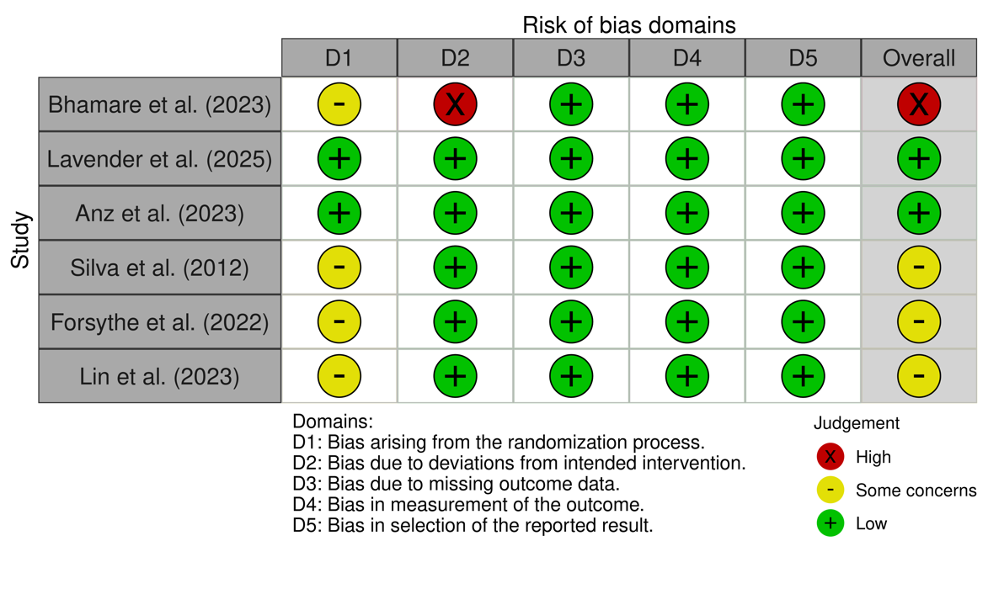
Fig 2. Risk of Bias Assesment

2.7.2 Quantitative analysis
A quantitative pooled meta-analysis is conducted when there is data from multiple studies with similar measurements and outcomes. The meta-analysis was conducted using RevMan 5.4 (The Cochrane Collaboration, The Nordic Cochrane Centre, Copenhagen, Denmark). Inverse Variance method was used to obtain mean difference (MD) and its standard deviation (SD). Mean difference (MD) and the corresponding 95% confidence interval (CI) of the continuous endpoints were calculated to compare the efficacy of both treatments. The safety endpoints were quantitatively analyzed as risk ratio (RR) and the 95% CI. A P-value of < .05 was considered statistically significant.

3. results and discussion
3.1 Results
The systematic search identified 1,264 records, of which six randomized controlled trials (RCTs) met the eligibility criteria for final inclusion. These studies evaluated a total of 154 patients undergoing primary ACL reconstruction with autologous bone marrow aspirate concentrate (BMAC) vs 127 control, in which for baseline characteristic of the included studies shown on (Table 2).
Table 2. Baseline Characteristic of The Included RCTs Studies
No | Authors | Year | Study Design | Sample | Graft |  | Stem cell |  |  |  | Timing of biologics | Duration of treatment
 |  |  |  |  | Type | Origin | Type | Origin | Source | Dose | Timing of biologics | Duration of treatment
1 | Adam Anz et al | 2023 | prospective, single-blinded, randomized controlled  trial | 20 patients in the BMAC group & 20 patients in the control group | BTB / hamstring | Autograft | BMAC | autologous | distal  femur, the anterior iliac crest, or the posterior iliac  crest | 2mL | intraoperative | 24 month
2 | Bhamare | 2023 | RCT | 15 patients in the BMAC group & 15 patients in the control group | quadrupled | Autograft | BMAC | autologous | ipsilateral iliac crest | 3mL | intraoperative | 24 month
3 | Forsythe et al. | 2022 | Double-blinded, randomized controlled trial. | 36 patients in the BMAC group and 37 patients in the control group. | BTB | allograft | BMAC | autologous | iliac crests | 2.5 mL | intraoperative | 12 month
4 | Lavender et al. | 2025 | A single-blinded, prospective RCT | 29 patients in the augmented group: BMAC, demineralized bone matrix  (DBM), and mechanical augmentation (suture tape  augmentation [STA]) and 30 patients in the non-augmented group (group NA). | quadriceps  tendon | <25 years old: Autograft ; >=25years old: GraftLink Allograft | BMAC | autologous | proximal lateral tibia | 3mL | intraoperative | 24 month
5 | Lin et al | 2024 | RCT double blind | 9 patients in the combination of BMAC and PRP group ; 8 patients in the PRP group ; 10 patients in the control group | hamstring | Autograft | BMAC | autologous | proximal tibia area | NR | intraoperative | 12 month
6 | Bhamare | 2023 | RCT | 15 patients in the BMAC group & 15 patients in the control group | hamstring | Autograft | BMAC | autologous | ipsilateral iliac crest | 3ml | intraoperative | 9 month

This meta-analysis found no statistically significant difference in Visual Analog Scale (VAS) scores between the BMAC and control group following ACLR (Fig. 3). The overall pooled Mean Difference (MD) was 0.15 with a 95% Confidence Interval (CI) of -0.11 to 0.40. Because the CI crosses the line of no effect (zero) and the overall effect (P = .26), the result is not statistically significant, implying that mesenchymal stem cell treatment did not lead to a greater improvement in pain scores compared to the control. The analysis revealed moderate to substantial heterogeneity among the studies (I² = 59%, P = .003), which indicates that the observed treatment effects varied considerably across different studies or time points. This significant variability suggests that underlying differences in study protocols or patient populations may be influencing the outcomes, thus warranting caution when interpreting the pooled result.

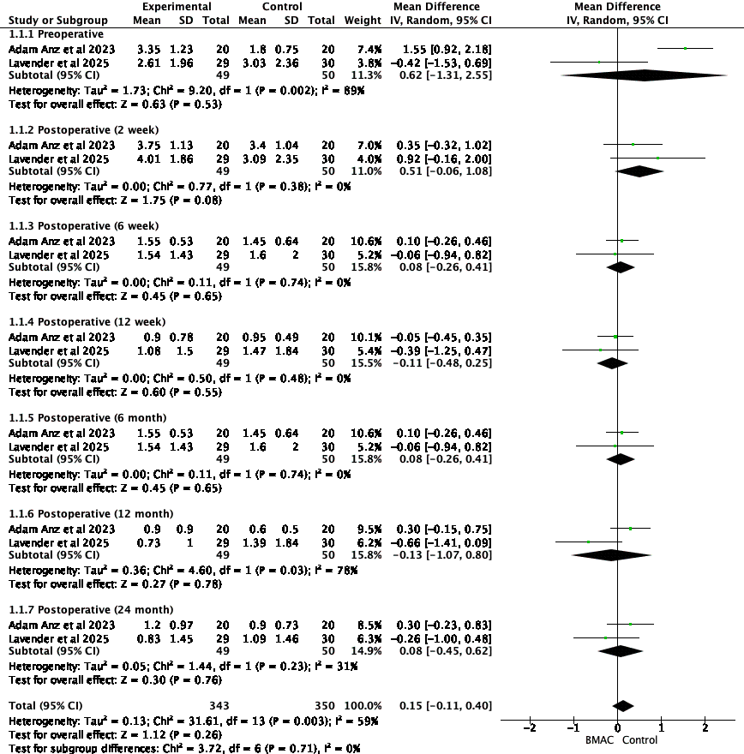
Fig. 3. Comparison of VAS score overtime

On IKDC score shows a statistically significant improvement in the for patients receiving BMAC compared to the control group after ACLR (Fig. 4). The overall pooled Mean Difference (MD) was 2.50 with a 95% Confidence Interval (CI) of 0.89 to 4.11. Since the entire confidence interval is above zero (P = .002), the result is statistically significant. This implies that BMAC treatment leads to a better functional outcome as measured by the IKDC score. Importantly, the analysis shows no statistical heterogeneity among the studies (I² = 0%, P = .77), indicating that the positive treatment effect was consistent across the different studies and time points. This homogeneity strengthens the validity of the conclusion that BMAC therapy provides a significant benefit in functional recovery after ACLR.

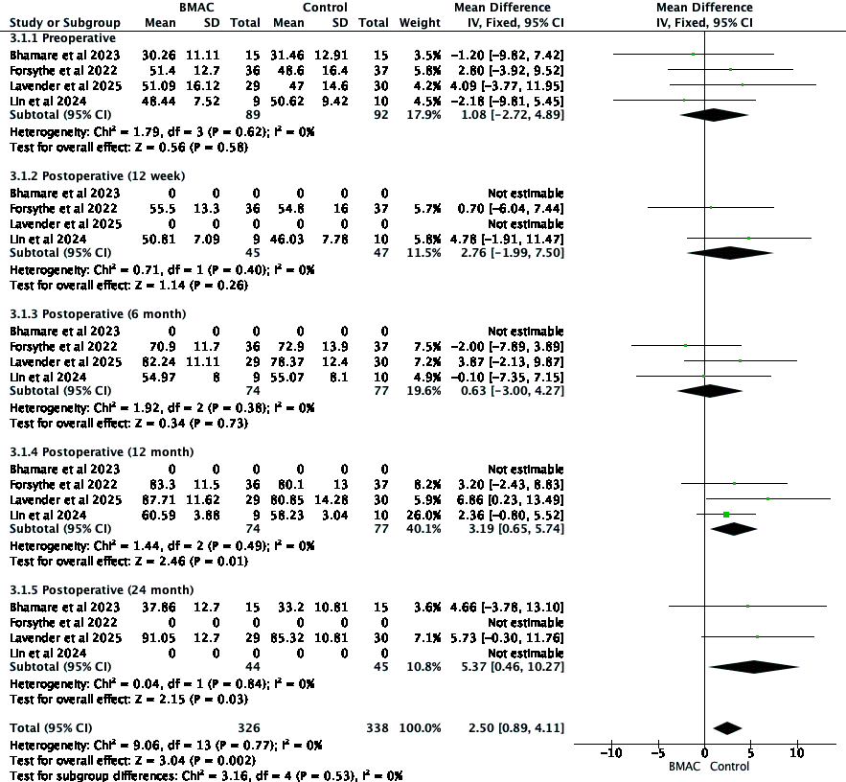
Fig. 4. Comparison of IKDC score overtime

Lysholm score shows improved functional outcomes with BMAC, though the result is of borderline statistical significance (Fig.5). The overall pooled Mean Difference (MD) was 2.82 in favor of the BMAC group, with a 95% Confidence Interval (CI) of -0.06 to 5.71. Because the CI just crosses the line of no effect (P = .05), the finding does not meet the conventional threshold for statistical significance. This suggests a potential positive effect that warrants further investigation but cannot be definitively concluded from this analysis. The study showed low heterogeneity (I² = 19%, P = .29), implying that the treatment effects were largely consistent across the included studies, which adds confidence to the precision of the pooled estimate.

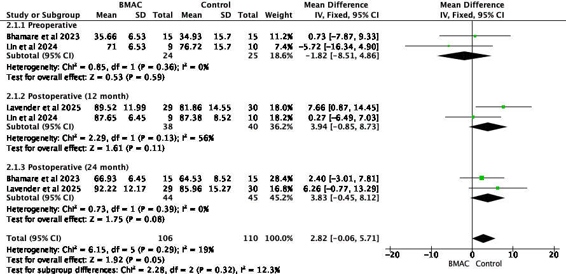
Fig. 5. Comparison of Lysholm score overtime

Lastly, the tegner activity scale score shows no statistically significant difference in functional outcomes between patients receiving BMAC and those in the control group after ACLR. The overall pooled MD was negligible at .07, with a 95% confidence interval (CI) of [-0.28, 0.41]. Because the CI broadly crosses the line of no effect (zero) and the P = .71, there is no evidence to suggest that stem cell therapy improves or worsens patients' return to physical activity levels. The analysis exhibited low and non-significant heterogeneity (I² = 21%, P = .28), indicating that the results were consistent across the included studies. This consistency reinforces the overall conclusion that, based on the available evidence, BMAC does not have a significant impact on the Tegner activity score.

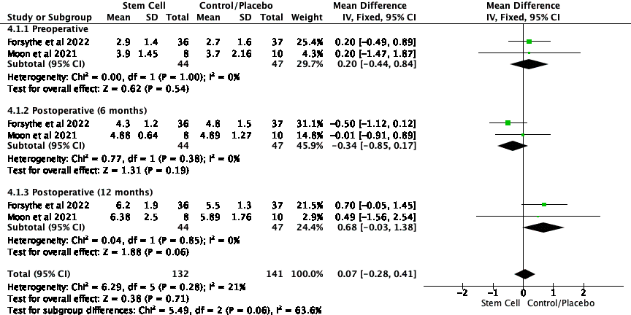
Fig. 6. Comparison of Tegner score overtime

3.2 Discussion
Our systematic review and meta-analysis (SRMA) is aim to understand the therapeutic benefits of BMAC augmentation in ACLR. The clinical urgency for such an analysis is underscored by the significant challenges in achieving reliable graft-to-bone healing after ACLR, with re-rupture rates reported as high as 11.7%. Furthermore, a common long-term complication following ACL injury, regardless of treatment, is the development of post-traumatic osteoarthritis (Fu et al., 2019; Moon et al., 2021; Wang et al., 2017). The intervention, BMAC, leverages Mesenchymal Stem Cells (MSCs), which possess the ability to self-renew, differentiate into various tissues, regulate immunity, and facilitate regeneration. Bone marrow is a primary source for these cells, which have a natural homing ability to migrate to injured sites and secrete growth factors to aid in tissue repair. While autologous MSCs have shown promise in animal studies, their use requires an invasive secondary harvesting procedure. This meta-analysis found that while BMAC augmentation offers a statistically significant improvement in functional outcomes as measured by the IKDC score at 12 and 24 months (MD 2.50, P = .002), this benefit did not extend to a significant reduction in pain (VAS, P = .26) and was only of borderline significance for the Lysholm score (P = .05).
The finding of a statistically significant functional improvement, yet no corresponding reduction in pain, aligns with previous research. Individual trials by Anz et al. (2023) and Lavender et al. (2025) also found no significant difference in pain between augmented and control groups. This disconnect suggests the benefits of BMAC are likely driven by enhanced biological healing rather than direct pain modulation. One potential advantage is improved structural integration; for instance, some studies indicate that BMAC may lead to reduced bone tunnel enlargement, which could enhance knee stability and function without altering pain levels (Anz et al., 2023; Lavender et al., 2025). Conversely, the intervention is not without its drawbacks, as other studies have reported that BMAC may induce a greater early inflammatory response, potentially delaying graft maturation and widening the tendon-bone interface, which could temper its overall benefits. The borderline significance of the Lysholm score further supports the conclusion that the functional benefit of BMAC is not overwhelmingly strong across all metrics. Although Lavender et al. (2025) reported significantly better Lysholm scores at one year, our pooled analysis indicates this effect is less consistent than that observed with the IKDC score (Bhamare et al., 2023; Lavender et al., 2025).
The therapeutic effect of BMAC is attributed to the mechanism of action of its cellular components, particularly MSCs. These cells possess a "homing ability," allowing them to migrate directly to the site of injury within the bone tunnels and graft substance. Once at the target tissue, MSCs can exert their effects through two primary pathways. First, they have multidirectional differentiation potential, enabling them to transform into local cell types such as chondrocytes and osteoblasts to facilitate the creation of a fibrocartilaginous enthesis, mimicking the native tendon-to-bone insertion. Second, they secrete a host of chemokines, cytokines, and growth factors that create a pro-regenerative microenvironment by resisting inflammation and promoting angiogenesis. Regarding safety, the most frequently reported potential side effect in the literature was postoperative stiffness. However, analysis of the available data does not suggest that BMAC increases this risk (Forsythe et al., 2022; Hur et al., 2019; Lavender et al., 2025; Wei & Bao, 2023). In the trial by Lavender et al. (2025), the rate of reoperation for stiffness was not significantly different between the augmented (10%) and control (13%) groups, with the authors suggesting the rate was influenced by other surgical factors rather than the biologic itself (Lavender et al., 2025). Other studies reported no treatment-related serious adverse events, confirming a strong safety profile for the procedure.
The primary clinical implication of this meta-analysis is that while BMAC augmentation is a safe procedure that provides a statistically detectable improvement in postoperative function, this improvement does not appear to be clinically significant for the average patient. Therefore, its routine adoption in all ACLR procedures is not supported by the current evidence, especially considering the associated downsides of increased operative time, additional cost, and potential donor site morbidity from bone marrow aspiration. Clinicians should weigh this small, likely imperceptible functional gain against these procedural burdens. The decision to use BMAC may be best reserved for specific cases, such as in elite athletes where any marginal gain is valuable. Furthermore, the potential for reduced bone tunnel widening could be a relevant factor for patients deemed at high risk for revision surgery, as it may simplify future procedures (Anz et al., 2023; Bhamare et al., 2023; Forsythe et al., 2022; Lavender et al., 2025; Lin et al., 2024; Moon et al., 2021; Silva et al., 2014; Wang et al., 2017; Youn et al., 2019).
This meta-analysis is strengthened by its exclusive inclusion of level-one RCTs; however, its conclusions must be viewed in light of the limitations of the included studies. A major weakness is the significant heterogeneity in augmentation techniques, with some studies using BMAC alone while others combined it with adjuvants like PRP, demineralized bone matrix, or suture tape. Pooling these varied protocols may obscure the true effect of BMAC as a standalone treatment. A second critical limitation is the lack of standardization in the source of the bone marrow and the final concentration of MSCs across studies, which is a key variable that influences efficacy. Future research should therefore focus on large-scale, multicenter RCTs with standardized protocols for BMAC preparation and application, including the quantification of cellular content to understand the dose-response relationship. These trials should be powered to detect clinically meaningful differences and should stratify results by patient demographics to identify which populations, if any, derive the most benefit. Finally, long-term follow-up beyond two years is essential to determine if the subtle functional and radiographic benefits seen in some studies translate into improved graft survival rates and a reduced incidence of post-traumatic osteoarthritis.

Table 3. Adverse Event
Study | Time | Complication | BMAC Group, n(%) | Control Group, n(%)
Lavender et al | 6 weeks | Stiffness; release by arthroscopic and Manipulation Under Anesthesia (MUA) | 2 (6.9) | 2 (6.7)
 |  | Stiffness; release by MUA only | 1 (3.4) | 2 (6.7)
Lin et al | not reported | not reported
Adam Anz et al | none | none
Bhamare | not reported | not reported
Forsythe et al. | not reported | not reported
Moon et al. | none | none

4. Conclusion
Augmenting anterior cruciate ligament reconstruction with BMAC leads to a statistically significant improvement in functional outcomes as measured by the IKDC score at one and two years. However, this improvement does not meet the established threshold for a minimal clinically important difference, suggesting it may not be perceptible to the average patient. Furthermore, the functional gain does not correspond with a significant reduction in postoperative pain. The procedure demonstrates a safety profile comparable to standard reconstruction, with no evidence of an increased risk for adverse events such as postoperative stiffness.

Consent (where ever applicable)
Data and materials are available upon request by contacting the corresponding author.
The authors did not receive support from any organisation for the submitted work.

Ethical approval
Ethical approval This article does include any studies with human participants or animals conducted by any of the authors.

References
Anz, A. W., Jordan, S. E., Ostrander, R. V., Branch, E. A., Denney, T. S., Cohen, A., & Andrews, J. R. (2023). Augmentation of ACL Autograft Reconstruction With an Amnion Collagen Matrix Wrap and Bone Marrow Aspirate Concentrate: A Pilot Randomized Controlled Trial With 2-Year Follow-up. Orthopaedic Journal of Sports Medicine, 11(11), 1–13. https://doi.org/10.1177/23259671231210035
Bhamare, D., Nathani, G., Shevate, I., & Deshmukh, A. (2023). Functional outcome of anterior cruciate ligament reconstruction with hamstring graft along with augmentation of bone marrow aspirate concentrate. Medical Journal of Dr. D.Y. Patil Vidyapeeth, 16(3), 329–332. https://doi.org/10.4103/mjdrdypu.mjdrdypu_648_20
Forsythe, B., Chahla, J., Bs, A. K., Lavoie-gagne, O., Forlenza, E., Ba, C. C. D., Chung, C. B., Bae, W. C., Bach, B. R., Mba, B. C., Yanke, A. B., & Verma, N. N. (2022). Bone Marrow Aspirate Concentrate Augmentation may Accelerate Allograft Ligamentization in Anterior Cruciate Ligament Reconstruction: A Double Blinded Randomized Controlled Trial. Elsevier.
Fu, X., Liu, G., Halim, A., Ju, Y., Luo, Q., & Song, G. (2019). Mesenchymal stem cell migration and tissue repair. Cells, 8(8). https://doi.org/10.3390/cells8080784
Hur, C. I., Ahn, H. W., Seon, J. K., Song, E. K., & Kim, G. E. (2019). Mesenchymal stem cells decrease tunnel widening of anterior cruciate ligament reconstruction in rabbit model. International Journal of Stem Cells, 12(1), 162–169. https://doi.org/10.15283/ijsc18022
Lavender, C. D., Schaver, A. L., Taylor, S., Peluso, R., Berdis, G., Singh, V., Cipriani, K., Lycans, D., Jasko, J., & Hewett, T. E. (2025). Anterior Cruciate Ligament Reconstruction Augmentation With Bone Marrow Aspirate Concentrate, Demineralized Bone Matrix, and Suture Tape Shows No Difference in Outcomes—But Faster Functional Recovery—Versus Non-augmented Anterior Cruciate Ligament Reconst. Arthroscopy - Journal of Arthroscopic and Related Surgery, 41(5), 1496–1508. https://doi.org/10.1016/j.arthro.2024.06.042
Lin, Y. C., Chen, Y. J., Fan, T. Y., Chou, P. H., & Lu, C. C. (2024). Effect of bone marrow aspiration concentrate and platelet-rich plasma combination in anterior cruciate ligament reconstruction: a randomized, prospective, double-blinded study. Journal of Orthopaedic Surgery and Research, 19(1), 1–12. https://doi.org/10.1186/s13018-023-04512-y
Moon, S. W., Park, S., Oh, M., & Wang, J. H. (2021). Outcomes of human umbilical cord blood-derived mesenchymal stem cells in enhancing tendon-graft healing in anterior cruciate ligament reconstruction: an exploratory study. Knee Surgery and Related Research, 33(1), 1–10. https://doi.org/10.1186/s43019-021-00104-4
Musahl, V., & Karlsson, J. (2019). Anterior Cruciate Ligament Tear. New England Journal of Medicine. https://doi.org/10.1056/NEJMcp1805931
Silva, A., Sampaio, R., Fernandes, R., & Pinto, E. (2014). Is there a role for adult non-cultivated bone marrow stem cells in ACL reconstruction? Knee Surgery, Sports Traumatology, Arthroscopy, 22(1), 66–71. https://doi.org/10.1007/s00167-012-2279-9
Wang, Y., Shimmin, A., Ghosh, P., Marks, P., Linklater, J., Connell, D., Hall, S., Skerrett, D., Itescu, S., & Cicuttini, F. M. (2017). Safety, tolerability, clinical, and joint structural outcomes of a single intra-articular injection of allogeneic mesenchymal precursor cells in patients following anterior cruciate ligament reconstruction: A controlled double-blind randomised trial. Arthritis Research and Therapy, 19(1), 1–12. https://doi.org/10.1186/s13075-017-1391-0
Wei, P., & Bao, R. (2023). Intra-Articular Mesenchymal Stem Cell Injection for Knee Osteoarthritis: Mechanisms and Clinical Evidence. International Journal of Molecular Sciences, 24(1). https://doi.org/10.3390/ijms24010059
Youn, G. M., Remigio Van Gogh, A. M., Alvarez, A., Shin Yin, S. S., Chakrabarti, M. O., McGahan, P. J., & Chen, J. L. (2019). Stem Cell–Infused Anterior Cruciate Ligament Reconstruction. Arthroscopy Techniques, 8(11), e1313–e1317. https://doi.org/10.1016/j.eats.2019.07.006

