Case study

Deformity Correction Surgery in Different Cases of Spinal Deformity: A Case Series

.
ABSTRACT

Introduction: Spinal deformity correction surgery is indicated for progressive or severe deformities that cause pain, functional limitation, or cardiopulmonary compromise. Outcomes and complication profiles vary according to deformity etiology, curve magnitude, and perioperative management.
Case series: Three patients underwent spinal deformity correction surgery. Two female patients with adult idiopathic scoliosis (AIS) (Lenke 1 and Lenke 6B) presented with different chief complaint, one with back pain and one with dyspnea. One male patient with ankylosing spondylitis (AS) presented with painful kyphotic deformity. Surgical correction achieved substantial radiographic improvement, with Cobb angle reduction up to 75% in AIS and marked sagittal realignment in AS. One patient developed deep surgical site infection requiring debridement, antibiotics, and negative-pressure wound therapy.
Discussion: All patients demonstrated meaningful clinical improvement, including pain relief, improved mobility, and resolution of respiratory symptoms when present. Radiographic correction was consistent with published outcomes, although extreme curves showed more limited correction. Complications were limited to one infectious event and minor sensory neurological sequelae, aligning with reported rates in deformity surgery literature.
Conculsion : Spinal deformity correction surgery provide favorable outcomes across different deformity etiologies when appropriately indicated and managed. Individualized surgical planning, effective perioperative care, and early rehabilitation are critical to optimizing outcomes while minimizing complications.

Keywords: Spinal, Deformity Correction, AIS, AS, Outcomes
1. INTRODUCTION
Spinal deformities is defined as a 3 dimensional malaligment of the spine primarily in the coronal, sagittal, and/or axial planes.¹ The most common forms of spinal deformities found in the clinical practice are adolescent idiopathic scoliosis (AIS) which contribute about 56.7% of the case. This is followed with kyphotic deformities secondary to systemic inflammatory diseases such as ankylosing spondylitis (AS). Spinal deformities incidence reached 17.9 per 100.000 individuals.² Spinal deformities not always causes symptoms sometimes it remain mild and asymptomatic, but progressive deformities will lead to chronic back pain, cosmetic concerns, impaired pulmonary function, and reduced quality of life.³ At 40-50 degree of Cobb angle, scoliosis become severe and almost always cause non-negligible symptoms.⁴ On ankylosing spondylitis, spinal rigity and sagittal imbalance due to chronic inflammation will lead to fixed kyphosis with pain, impaired horizontal gaze, dan often a functional disability in young adults.⁵
Scoliosis severity is able to quantitatively measured with Cobb angle. Cobb angle itself is calculated between the most tilted vertebrae at the upper and lower ends of spinal curve on the standing radiography. Diagnosis is determined when there is more than 10 degrees of curvature. This score is also utilized for progression monitoring and forms the basis for treatment thresholds.⁶ Maturity of the skeletal bones can influence the progression of scoliosis severity. Although skeletal maturity does not exclude the possibilities of disease progression, because there is study that reported more than 50% patients with skeletal maturity still has a progression in the disease severity. Risser grade is a method to assess skeletal maturity by evaluating the degree of ossification of the iliac apophysis on pelvic radiograph. Ossification is graded from 0 to 5 with lower grades indicating a substantial remaining growth potential and higher curve progression while grade 5 indicates a skeletal maturity.⁷
Surgical correction remains as the definitive treatment for severe spinal deformities. On the milder spinal deformities, there is bracing and other conventional therapy that can be considered.^{8,9} Main targets of spinal deformities therapy aims to prevent progressive functional worsening. Common spinal deformity correction surgery indications involve progressive curve deformity, functional impariment, dan postural correction. Expected results of deformity surgery varies based on the deformity type.¹⁰ Thus requiring an individualized and specialized therapy for each individual. Lenke classification is utilized as a surgical classification system used to identifying which curves would require surgical correction. This allow the operator to plan the extent and levels of spinal fusion. Lenke classification is divided into six curve types based on which curves are structural, and further refines the classification using lumbar spine modifiers and thoracic sagital modifiers.¹¹
Deformity surgeries are a complex surgeries with multiple risk. Blood loss in spinal deformity correction is often substantial exceeding 1500 cc.¹² Neurologic injury is fortunately rare in deformity correction surgery which only accounts for less than 1% of cases.¹³ Newer study shows neurologic complication overall incidence reached 7%.¹⁴ Other complication include deep infection, nonunion, cerebrospinal fluid leak, and thromboembolism. Complication rates significantly rises when there is a significant increase in operative times and bigger area of tissue dissection.¹⁵ Surgical site infection itself is generally low, but any complication may prolong recovery and increase the risk of morbidity and mortality. Awareness toward these complication during perioperative is very important. Especially in the post operative period to improve the long term outcome for the patients.¹⁶
This case series reported three distinct patients undergoing deformity correction. First patient is a 22-year-old woman with a right thoracic AIS (Lenke 1CN, Cobb thoracal 60). Second patient presenting a 25 year-old woman with a severe double-curve scoliosis (Lenke 6B, Cobb 57 thoracal and 109 lumbar). Third patient is a 25-year-old man with fixed thoracolumbar kyphosis due to long standing ankylosing spondylitis. Each patient required individualized surgical strategies and postoperative management. This case series aim to compare these cases against current evidence on deformity correction, highlighting indication, and outcomes in different etiologies of spinal deformity.

2. CASE SERIES
2.1. CASES 1
A 22-year-old woman presented with complaints of back pain and a feeling that her back was crooked, which she had been experiencing for approximately 7 years (since 2015). She had never sought medical attention for these complaints until now. She felt that her back was becoming increasingly crooked. The patient also often complained of stiffness in her right back when sitting for long periods of time. The patient denied complaints of shortness of breath, heaviness, tingling, or weakness in the arms and legs. The patient denied complaints of bowel and bladder problems. The patient denied a history of previous trauma. There was no family history of scoliosis. The patient is a pharmacist assistant at a community health center.
On physical examination of the thoracolumbar area, inspection revealed deformity, rib hump, and pelvic tilt. On palpation, there was no midline tenderness and sensory examination was normal. The patient's motor skills were within normal limits. Shoulder tilt was found to be 2 cm to the left, plumb line 1 cm to the right, rib hump 2 cm to the right, body arm distance 2 cm to the right and 0 cm to the left, and pelvic tilt 2 cm to the left. Scoliometer examination showed a curvature of 14.1 degrees. The patient's height was 155 cm with a weight of 50 kg.
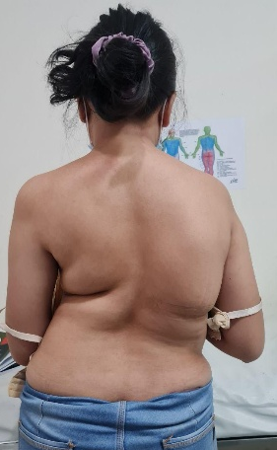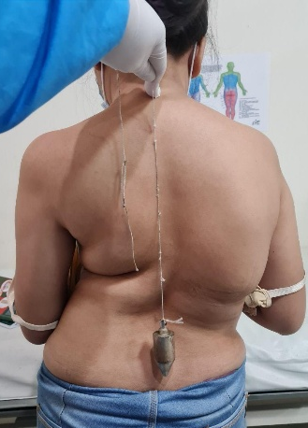
Figure 1. Clinical Picture of Patient 1.
Supporting examination in the form of a thoracolumbar X-ray at the Negara Hospital showed apex T8, Cobb angle 55°, right bending 30°, left bending 65°, and Risser grade 5. Meanwhile, a follow-up thoracolumbar X-ray at Prof. Ngoerah Hospital showed T9 apex, upper end vertebrae T4, lower end vertebrae L1, Cobb angle 60°, right bending 31°, left bending 63°. An AP pelvic X-ray concluded Risser stage V. Patient assessment is Adolescent Idiopathic Scoliosis Lenke 1CN Risser V.
During the surgical procedure, the patient experienced bleeding of 1800 cc and received a PRC transfusion of 2 units. After spinal deformity correction surgery, the patient regained consciousness well. Pain in the surgical wound area was controlled with a VAS ranging from 2-3. The patient's ability to move all four limbs was good. Complaints of weakness, numbness, and tingling in both hands and feet were denied. The patient denied any other complaints. Inspection of the thoracolumbar area revealed dressing without leakage and drainage limited to the tube 2 hours post-operatively. Palpation revealed tenderness at the surgical site, no hypoesthesia, and no anesthesia.

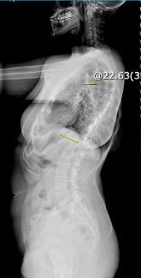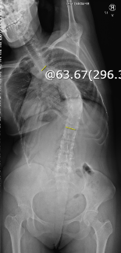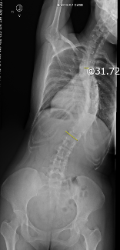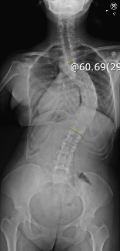
Figure 2. Scoliosis Series of Patient 1.
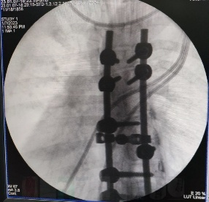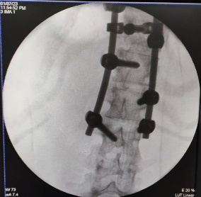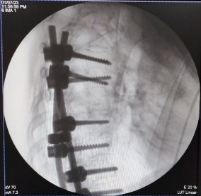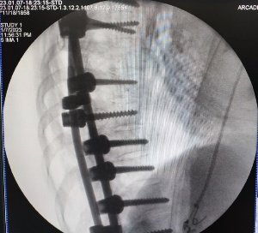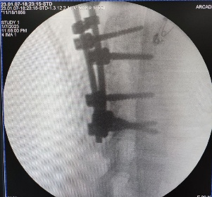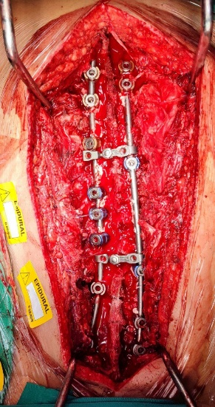
Figure 3. Surgical Site Picture and C-Arm durante Operation of Patient 1.
Postoperative management given to the patient was ceftriaxone 2x1 gram IV, tranexamic acid 3x500 mg IV, vitamin K 3x2 mg IV, omeprazole 2x40 mg IV, and methylcobalamin 3x500 mg IV. The analgesic management provided by the anesthesiologist consisted of 0.1% bupivacaine epidural plus 1 mg of morphine in 10 ml every 12 hours, and 500 mg of paracetamol every 6 hours PO. Meanwhile, the patient was scheduled for a complete blood count postoperatively and PRC transfusion if Hb < 10 g/dL, postoperative x-ray, mobilization with thoracolumbar sacral orthosis (TLSO), consultation with a medical rehabilitation specialist, and wound care on the third postoperative day or if the wound leaked.
On the first day after surgery, the patient was able to urinate via catheter. The patient was found to have anemia and received additional therapy in the form of PRC transfusion with a target Hb >10 g/dL. Patient is also planned to undergo X-ray examination. On the second day of monitoring, the patient complained of abdominal bloating since the previous night, no flatus, and no bowel movement after surgery. The patient also complained of itching all over the body, which appeared when exposed to cold temperatures. The patient has received 3 units of PRC transfusion and is scheduled to receive 1 more unit today. The patient is able to eat and drink well and no longer requires oxygen to achieve 99% saturation. Post operative Cobb angle is 15.32°. The patient's therapy continues as before with the addition of fleet enema suppositories and loratadine 2x5 mg tablets.
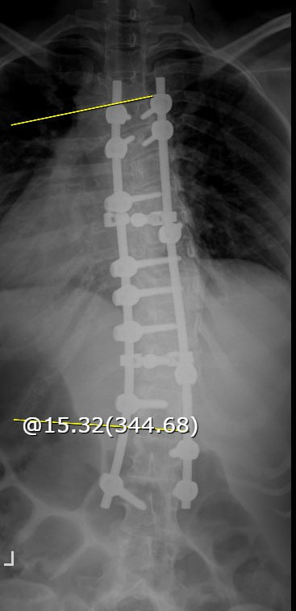
Figure 4. Cobb Angle post Operation 15.32°.
On the third day of monitoring, the itching and abdominal bloating complaints have improved. The last bowel movement was before the operation. Vitamin K administration has been stopped and ceftriaxone has been replaced with cefixime 2x200 mg orally. PRC transfusion was discontinued as the target Hb (10.0 g/dL) had been reached. On the 4th day of monitoring, the patient was able to urinate spontaneously and had a bowel movement the previous night. The patient was able to sit leaning against the bed. The drain was removed and the dressing was dry without leakage. On the 5th day of monitoring, the patient began walking mobilization exercises. Methylcobalamine administration was discontinued. On the 6th day of monitoring, the patient performed walking mobilization exercises without pain. Complaints of abdominal bloating and itching were no longer present. Loratadine and omeprazole administration was discontinued. Pain management was changed to paracetamol 4x500 mg tablets. The thoracolumbar sacral orthosis (TLSO) was completed and fitted to the patient today. The patient was scheduled to be discharged from the hospital today.
At the first follow-up 3 days after discharge from the hospital, postoperative pain was reported to have improved. The patient was able to mobilize without assistance using the TLSO. Cefixime administration was discontinued and the paracetamol dose was reduced to 3x500 mg PO if pain was felt. At the 2-week postoperative follow-up, postoperative pain was no longer felt. Tenderness at the surgical site was no longer present. Paracetamol administration was discontinued, and the sutures were removed from the wound. At the one-month post-operative follow-up, the patient underwent a thoracolumbar X-ray for evaluation. At the three-month post-operative follow-up, the patient was able to walk for one hour without pain complaints. The patient then underwent another X-ray for evaluation. At seven months post-operatively, the patient was able to mobilize without assistance.
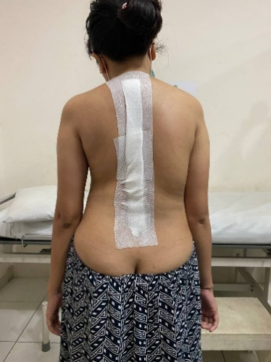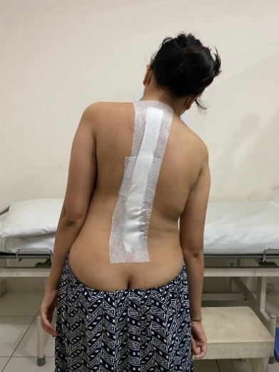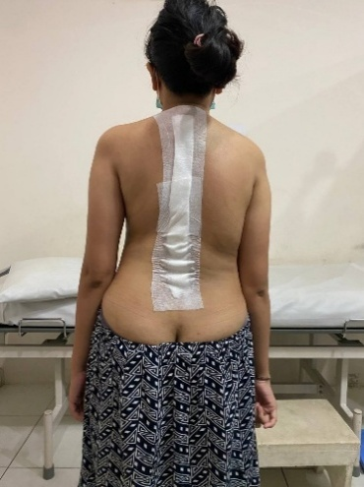
Figure 5. Post Operative Clinical Picture of Patient 1
2.2. CASES 2
A 25-year-old woman presented with complaints of shortness of breath since 1 year ago, which worsened when walking long distances and improved when resting. The patient also complained of a curved spine, which she had been aware of since childhood. According to the patient's parents, the patient's spine had been curved since birth and had worsened with age. The patient also complained of pain in her left side, which came and went, appearing when she was tired and when sitting for long periods. She was unable to walk long distances due to pain and shortness of breath. She denied any numbness, tingling, or weakness in her arms or legs. The patient is unable to bend over because her back feels stiff, and she walks with a limp and tiptoes on her left foot. She denies having any complaints regarding bowel movements or urination. She denies any previous history of trauma. The patient has never had her back examined before. She is the first of eight siblings, and no one else in her family has similar complaints. The patient's mother admitted that during pregnancy she used a corset to hide her pregnancy and did not undergo regular pregnancy check-ups. The patient works as a store cashier.
Physical examination of the thoracolumbar area began with inspection, which revealed deformity, rib hump, and pelvic tilt. Palpation revealed no midline tenderness and sensory examination was normal. Motor strength was within normal limits. Shoulder tilt was 0.5 cm to the left, plumb line was 2 cm to the left, rib hump was 0.5 cm to the left, body arm distance was 0 cm to the right and 2 cm to the left, pelvic tilt was 7 cm to the left, and the scoliometer examination showed a tilt angle of 7°. The patient's height was 120 cm with a weight of 50 kg.
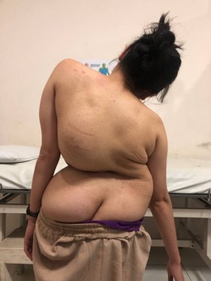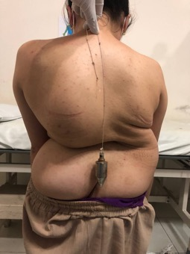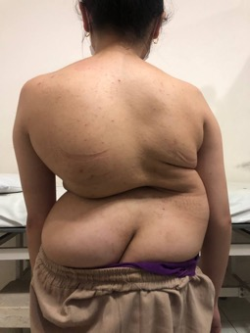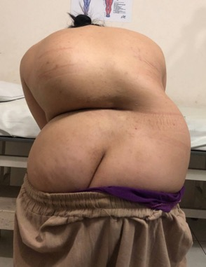
Figure 6. Clinical Picture of Patient 2.
The patient is scheduled for deformity correction. Prior to that, the patient is scheduled by medical rehabilitation to undergo traction before surgery. Physiotherapy is performed twice a week and evaluated after 5 sessions. Traction is performed in the form of whole traction (Coutrell traction). The patient is also advised to perform deep breathing exercises in chest expansion.
The patient then underwent a thoracolumbar MSCT axial slice examination, with 3D reconstruction reformatting without contrast. The radiology findings concluded double curve scoliosis in the main thoracic and lumbar regions, wedge shape in the vertebral bodies T8-9 and L2, and no narrowing of the spinal canal. The current assessment of the patient is Adolescent Idiopathic Scoliosis Lenke 6B with Risser Stage V. Preoperative laboratory tests are within normal limits.
The night after surgery, the patient was still intubated. During surgery, the patient received 3 units of PRC blood transfusion. Blood pressure was 94/64 mmHg, pulse rate was 94 beats per minute, respiratory rate was 14 breaths per minute, oxygen saturation was 100% on a ventilator with PEEP 5.0, FiO2 60%, and axillary temperature was 36.1°C. Drainage output within 2 hours post-surgery was 300 ml of hemorrhagic fluid. Postoperative pharmacological therapy administered included ceftriaxone 2x1 g IV, methylprednisolone 3x125 mg IV, pantoprazole 2x40 mg IV, and mecobalamin 3x500 mg IV. The anesthesia management provided was PCA morphine 1 mg/ml, continuous 0.5 mg/hour plus demand 1 mg/dose, LOI 10 minutes with a maximum dose of 4 mg/6 hours. Additionally, the patient was administered paracetamol 1000 mg every hour IV and ibuprofen 400 mg every 6 hours PO.
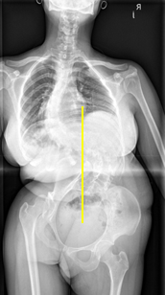
Figure 7. Scoliosis Series of Patient 2
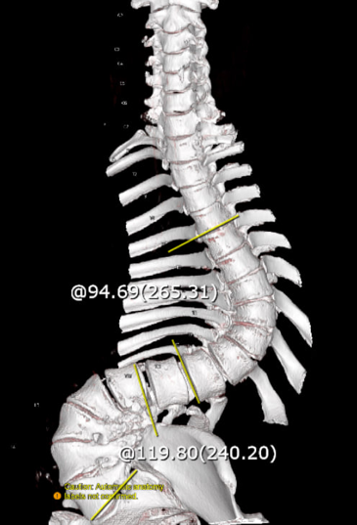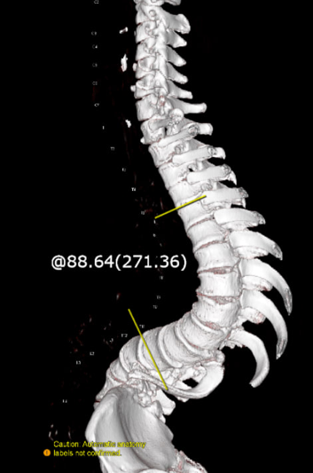
Figure 8. Thoracolumbar MSCT Axial Slice 3D Reconstruction Reformat of Patient 2.
The patient regained consciousness well on the first day post-operatively. Postoperative pain was controlled with analgesics, with a VAS score of 2-3. Both thighs remained difficult to lift due to pain, and weakness in the legs was denied. Numbness and heaviness in the legs were denied. Bowel movements occurred yesterday, while urination is still via catheter. Mobilization can be performed by lying on the right and left sides. The patient is currently extubated. Postoperative laboratory results show mild anemia with Hb 8.3 g/dL. First-day therapy was continued with an adjusted dose of methylprednisolone at 2x125 mg IV. The patient is then scheduled to begin bladder training and receive PRC transfusions until Hb reaches 10 g/dL.

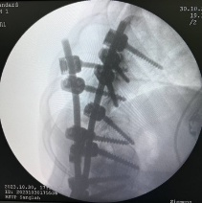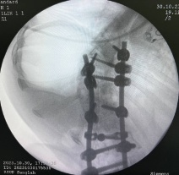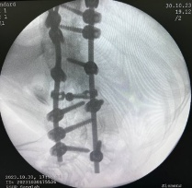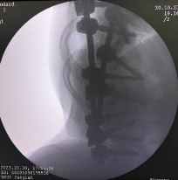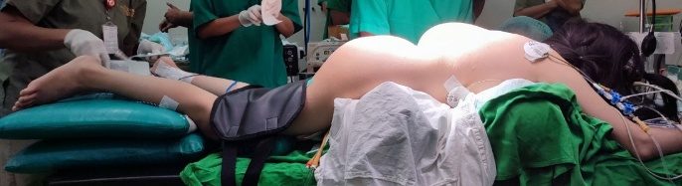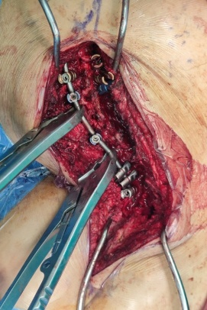
Figure 9. Surgical Site, C-Arm, and Patient 2 Positioning during Operation
The patient's second day post-operative laboratory tests showed anemia with an Hb of 8.3 g/dL. The patient then received a total of 3 units of PRC transfusion. The patient complained of tingling and numbness in the tips of the toes on the left foot on the third day post-operatively, which improved on the fifth day post-operatively. On the third day after surgery, the patient underwent thoracolumbar and lumbosacral x-rays with a thoracic curve Cobb angle of 62.56 and a lumbar curve Cobb angle of 74.06. On the fifth day, the patient was able to urinate spontaneously without a catheter. On the sixth day, the patient was able to sit leaning against the bed. However, the patient had an additional complaint of a thick feeling in the inner left thigh area. Based on physical examination, there was hypoesthesia at L2 left. On the 7th day, the patient was able to sit in a chair but was still unable to walk. Hypoesthesia was still present at L2 left. The patient began to stand on the 8th day after surgery. The patient was then scheduled for outpatient care.
The results of a thoracolumbar axial MSCT with 3D sagittal reconstruction reformat without contrast on the 5th day post-surgery showed an expert conclusion of double curve scoliosis of the main thoracic and lumbar spine with interpedicle and screw internal fixation at T7 – L4 with adequate positioning, wedge shape of the vertebral bodies at T8-9, a drain catheter with the distal tip directed cranially projected at the level of T9, pneumonia, fibrosis in the posterior segment of the left lower lung lobe suspected to be an old inflammatory process, and right and left pleural effusion.
The patient then returned with complaints of a non-healing surgical wound that was discharging fluid. Back pain was still present, especially when moving the legs. The patient was able to stand but still required assistance. Thickness in the left thigh area was occasionally still felt. There were no complaints of bowel movements or defecation. Physical examination revealed hypoesthesia at the level of L2 left. The patient was scheduled for debridement and wound culture.
After surgery, the patient still complained of back pain, especially when lying flat, which improved when lying on her side. The patient also denied any weakness in her lower limbs. However, the patient still felt thickening and tingling in her inner left thigh. Wound care was performed daily. The wound culture results isolated Pseudomonas aeruginosa, but its significance as the causative agent of infection still needs to be assessed based on the patient's clinical condition and infection markers. Subsequently, the patient was given levofloxacin 3x500 mg IV antibiotics according to the culture results to treat the infection. The patient began to feel improvement in back pain on the 6th day post-surgery. On the 8th day, the patient reported feeling numbness in the right calf when sitting, which disappeared when lying down. Physical examination still revealed hypoesthesia up to L2 on the left side. The patient began walking on the 12th day after debridement or approximately 1 month after the deformity correction surgery. The patient underwent gradual mobilization with a TLSO. The patient was discharged for outpatient care on the 15th day after surgery. At the first outpatient clinic visit, the patient's complaints remained the same as during hospitalization, and there was minimal oozing from the wound dressing.
The patient returned for debridement, culture, and vacuum dressing. At the first outpatient follow-up after the vacuum dressing was applied, the patient reported slight leakage from the vacuum and the word “leakage” appeared. The culture results were available and isolated Acinetobacter baumannii bacteria, but its significance as the causative agent of infection still depends on the patient's clinical condition and infection markers. Three months post-operatively, postoperative pain was reported to have improved and was controlled with paracetamol. Shortness of breath was also reported to have improved. However, a thick sensation in the inner left thigh was still occasionally felt. Meanwhile, bowel movements and urination were within normal limits. Physical examination revealed hypoesthesia at the L2 level on the left side.
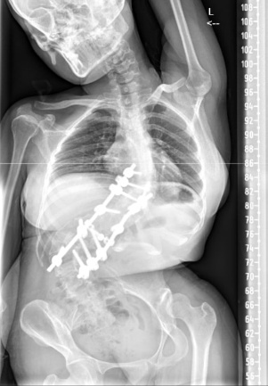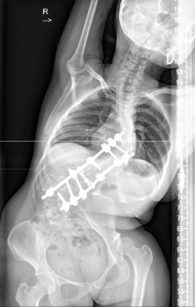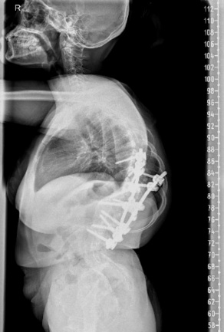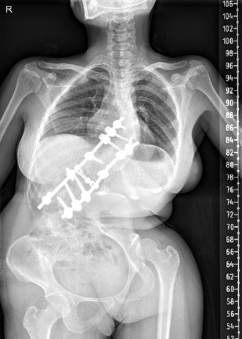
Figure 10. Steaching Spine of Patient 2.

2.3. CASES 3
A 25-year-old male patient presented with complaints of lower back pain that had started 3 years ago. The pain was mainly felt in the lower back. The pain worsened when the patient changed position, sat for long periods, bent over, and slept on his back. The pain was relieved by bending forward and lying down. The patient denies any pain radiating to both buttocks or legs. He reports intermittent numbness or tingling sensations. Numbness is felt in the little finger and sole of the right foot. The patient does not complain of weakness in either leg. The patient has no complaints regarding bowel movements or urination. Currently, the patient can walk without assistance. However, daily activities are beginning to be disrupted due to pain. The patient has a history of arthritis and has been taking 90 mg of Coxtor once a day for the past year. There is no history of similar complaints in the family. The patient currently works as a villa guard. Physical examination revealed kyphotic deformity and midline tenderness at L5-S1. Additionally, the Schober test was positive. The patient was diagnosed with ankylosing spondylitis. The patient is scheduled for corrective deformity surgery.
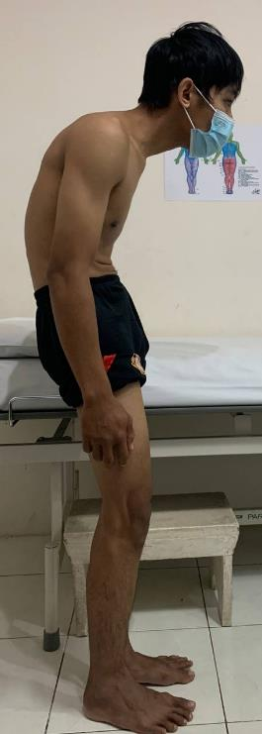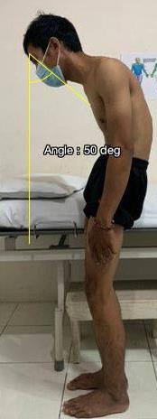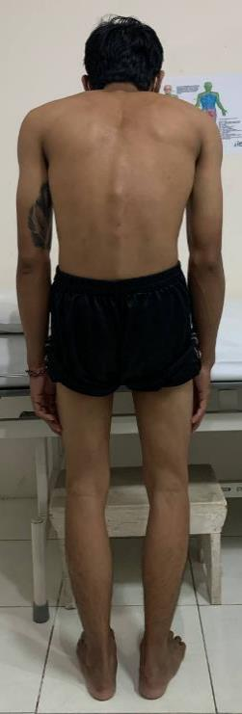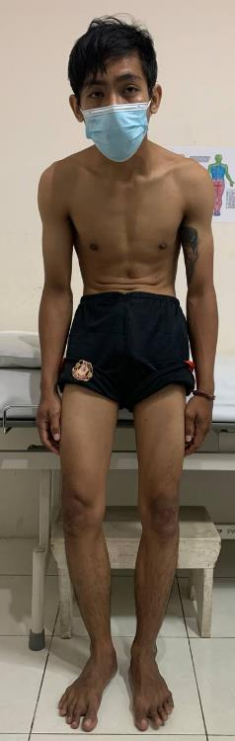
Figure 11. Clinical Picture of Patient 3, CBVA 50°.
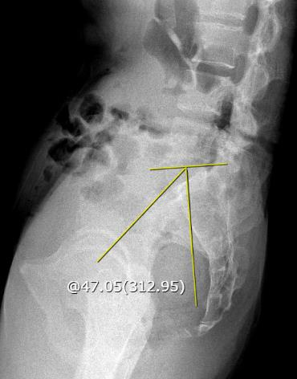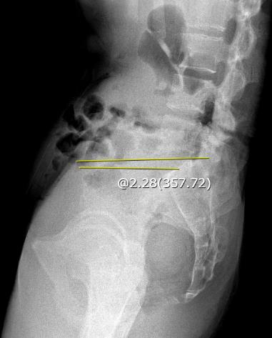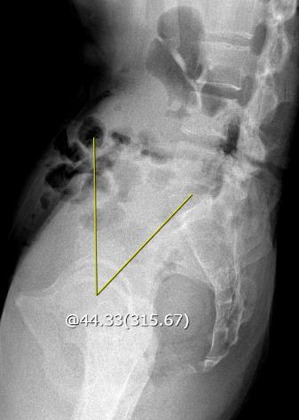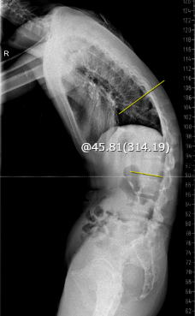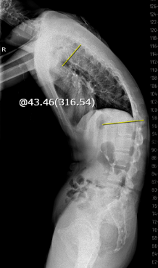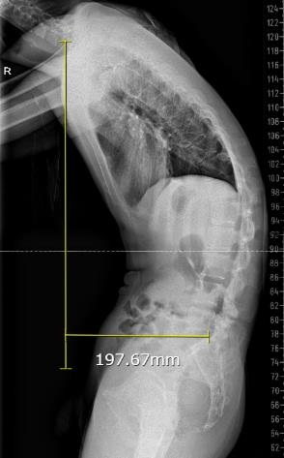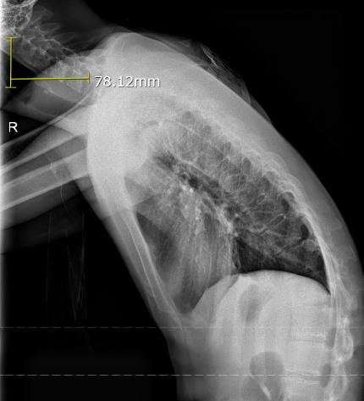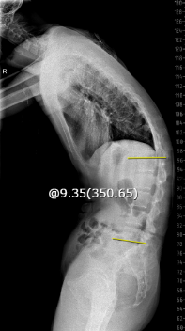
H
G
E
F
D
C
A
B
Figure 12. Lumbosacral X-ray of Patient 3. (A) C2-7 SVA: 78.1 mm; (B) C7-S1 SVA: 197.6 mm; (C) Thoracal kyphosis: 43.4; (D) Thoracolumbal kyphosis: 45.8; (E) Lumbar lordosis: 9.3; (F) Pelvic tilt: 44.3; (G) Sacral slope: 2.2; (H) Pelvic incidence: 47.
Postoperatively, the patient remains intubated but is alert and responsive. Complaints of weakness and heaviness in both lower limbs are denied. The patient received 2 units of packed red blood cells during surgery. Blood loss during surgery was 3000 ml. Drainage output over 14 hours was 140 ml of blood. Postoperative therapy included ceftriaxone 2x1 g IV, methylprednisolone 3x125 mg IV, pantoprazole 2x30 mg IV, and mecobalamin 3x500 mg IV. Subsequently, therapy from the intensivist included Entramix milk diet 150 ml every 4 hours via NGT, IVFD RL 2000 ml/24 hours, fentanyl 300 mcg plus ketamine 20 ml in 50 ml, 0.9% NaCl at a rate of 2.1 cc/hour, paracetamol 1000 mg every hour IV, dexmedetomidine 0.8 mcg/kg/hour IV, omeprazole 40 mg every 24 hours IV, and tranexamic acid 500 mg every 8 hours IV. The patient was advised to undergo passive mobilization and head up 40-45 degrees. The patient's target GDS is 140-180 mg/dL. The patient is scheduled for routine wound care, repeat complete blood count, and post-operative x-ray.
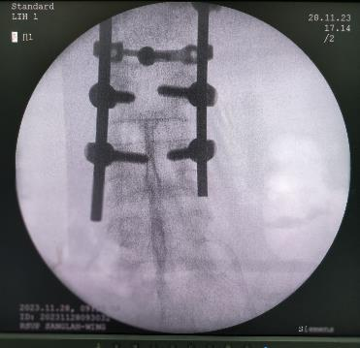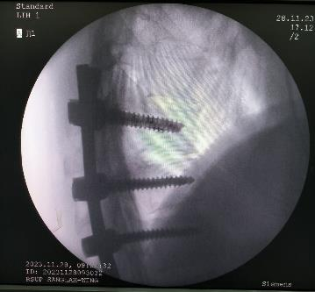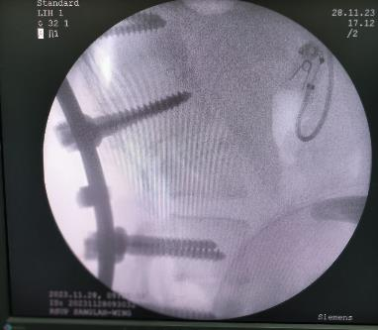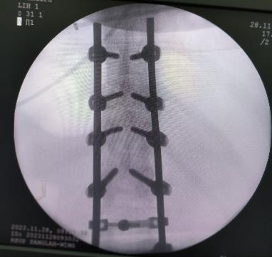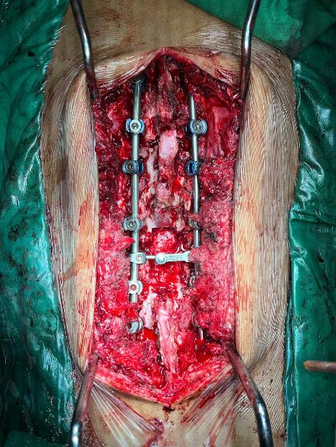
Figure 13. Surgical Site and C-Arm durante Operation of Patient 3.
On the first day after surgery, the patient complained of a slight thickening in the left calf. Postoperative pain was still controlled with analgesics. The patient's therapy continued without change. The patient was scheduled for extubation. Drainage production over 24 hours was 175 ml of blood. On day 3, physical examination revealed hypoesthesia, and the patient underwent a thoracolumbar X-ray. On day 4, drain output was limited to fluid. The patient began experiencing urinary sensations with bladder training. Medical rehabilitation for the patient included positioning, log rolling turning, chest physiotherapy, chest mobility exercises, range of motion (ROM) exercises, and will be continued with mobilization after the TLSO is applied.
On day 5, the patient still complained of minimal pain in the surgical wound area with analgesic control. There were no complaints of weakness in the four extremities. Urination was still via catheter, but bladder training had been attempted 3 times. The patient was able to mobilize independently by turning to the right and left. The patient still had difficulty when starting to sit, but gradually began to be able to do so and started practicing standing. Physical examination revealed tenderness in the wound area and hypoesthesia below the left L4. On day 6, the patient began gradual standing mobilization. On day 7, the patient was able to urinate spontaneously and mobilize while standing and immobilized with a TLSO. On day 8, the patient no longer complained of back pain. Tingling was occasionally felt in the right knee. Thickness was still felt, but improved in the left shin area. The wound appeared well with no infection.
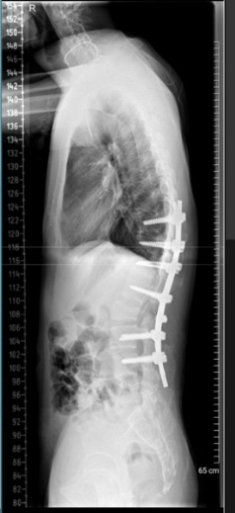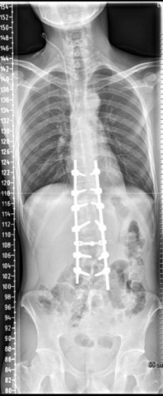
Figure 14. Steaching Spine Post Operative Patient 3.
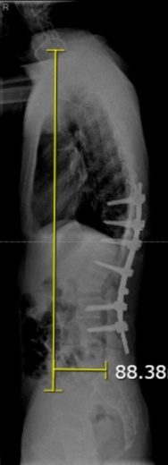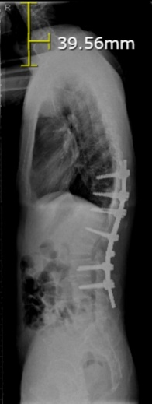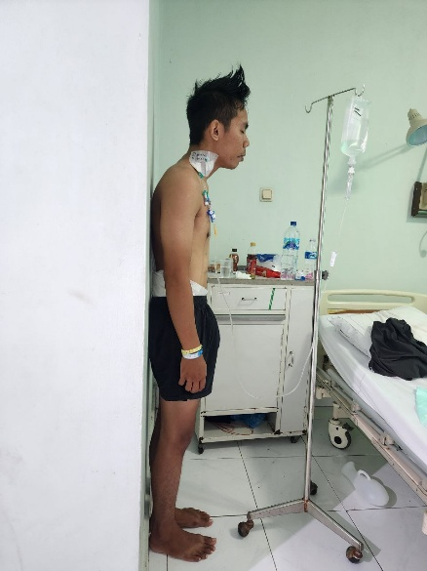
B
A
Figure 15. Figure 16. Post Operative Comparison and X-Ray of Patient 3. (A) Post Op C2-S7 SVA: 39.56 mm; (B) Post Op C2-S1 SVA: 88.38 mm.

.
3. discussion
Large or progressive curves of spinal deformity are generally the indication for deformity correction surgery. In AIS, deformity correction is recommended based on the Cobb angle. The surgery is indicated when the Cobb angle exceeds 50 at the end of spinal growth or 40-45 in immature skeletal patient because at this point the curves tend to progress even after skeletal maturity, has a high risk on causing problem in pulmonary function, and the surgeries get increasingly harder when the curves get bigger.^{4,17,18} Both of the AIS cases presented in this case series presented with a major curve beyond this threshold, 60 and 57 in thoracic, and 109 in lumbar. This justifies the decision of deformity correction surgery on the patients. Untreated large scoliosis leads to a high risk of restrictive pulmonary diseases and known to reduce lung volumes, especially when Cobb angle exceeds 70.¹⁹ In this case review, cases 2 patient experienced dyspnea with Cobb angle of 57 thoracic and 109 lumbar which affirm this theory. In theory, AS is indicated for deformity surgery when there is forward-stooping posture, deformity, sleep disturbance, digestive issues, respiratory problems, sagittal imbalance, and progressive pain.²⁰ In cases 3, patient has an AS with a progressive back pain and postural deformity that fit the criteria for deformity surgery.
Significant curve correction was achieved in all three patients, in line with published case report. Deformity correction surgery for AIS is typically able to reduce major curves by 60-70%. On the systematic review by Gatam et al. showed that vertebral column resection has a reduction rate of 62.1% on the mean Cobb angle 107, but this technique also has the highest complication rate on about 24% of the cases. Meanwhile the non-osteotomy technique yield similar correction (61.5%) with lower complication rate (19.6%). Ponte osteotomy technique showed lowest complication rate of 4% with 60.5% on the level of correction.¹⁶ In this case series, Case 1’s Cobb was corrected to 15 from 60 or about 75% reduction. Meanwhile in case 2, there is minimal change in thoracic curve from Cobb 57 to 62. On the lumbar curve, the change is from 109 to 74 in which reduction is only about 32%. The result in extreme curve case in case 2 is unable to meet this expectation. On the third case with AS, kyphosis correction is able to meet the expectation. Average local kyphosis correction surgery is yield 30.9% correction.²⁰ Cases 3 reduce C2-7 SVA from 78.12 mm to 39.56 mm or about 50% reduction. Meanwhile on C7-S1 SVA reduced about 55% from 197.6 mm to 88.38 mm.
Pain relief is achieved within the first week in all three cases. Notably, case 1 reach pain free within 6 days with continuous epidural analgesia which far superior than the case 2 that still had mild pain within 3 months, although the case highly likely confounded by infection on case 2. Evidence supports epidural over IV opioid in postoperative pain management for spine surgery. Mean pain score on a 0 to 10 score is 1.3 points lower in average within 6-8 hours compared to the systemic opioids, meanwhile in 72 hours the difference is about 0.8 points lower.²¹ This suggest the excellent pain control in case 1 is due to the choice of epidural regimen, which consistent with the literature that favors epidural than PCA in early pain relief.
In case 1 and 3, early mobilization is achieved within 5-7 days post operatively. Mobilization is achieved after intensive postoperative rehabilitation. This plan of therapy is in line with the previous study that concluded five days of intensive postoperative rehabilitation is superior than early mobilization in reducing the length of hospitalization and improving physical and functional outcomes.²² In case 2, surgical site infection delayed full recovery. Independent walk is achieved within one month and dyspnea is also resolved around the same time. Improved pulmonary function after scoliosis deformity correction is variably reported and unrealible. Pulmonary rehabilitation showed a more consistent results for long term respiratory.²³ Treatment plans on case 2 is in line with this theory, which planned to undergo respiratory training since preoperatively and continued in post operative treatment as soon as possible.
Blood loss is substantially bigger in larger curves. In the review by Elfakharany et al., Cobb angle larger than 66.8 is associated with bleeding more than 1000 ml.¹² In case 1, the blood loss is known to be 1800 ml and needed about 6 flask of packed red cells (PRC). Deformity corrective surgeries in AS characteristically associated with heavier blood loss due to the rigid deformity. More often than not, AS patients usually have anesthetic challenges that includes chronic NSAID use and comorbidities. These factors can worsen bleeding and increase the cardiopulmonary risk.²⁰ This case series aligns with the study with the third case showing a massive bleeding of 3000 ml.
Serious complication is seen in case 2 with deep wound infection caused by Pseudomonas aeruginosa and Acinetobacter baumannii. Instrumented surgical site infection (SSI) is generally low, but the consequences are often severe. Reported SSI rate in adult with kyphosis is about 4.2% and 3.7% in adult with scoliosis. In which, about 25% of the SSI case is reported due to gram negative organisms.²⁴ Treatment requires debridement and antibiotics.²⁵ In this case, negative pressure therapy is also included as the management. There is a study that showed benefit on vacuum assisted closure system for recurrent surgical site infection in the spine after surgery such as in case 2.²⁶ The outcome in this patient fortunately good with no long term sequelae except mild sensory loss at L2.
Neurological injury rates in deformity surgeries are low. A review reports that new neurological deficits in AIS surgery is around 5%.²⁷ In our cases, no motor deficits occurred. Case 2 reported a persistent sensory hypoesthesia at L2 and in case 3 reported occasional knee paresthesia and hypoesthesia at the L4 level. These are classified as a minor neurologic sequelae. Major deficits such as paralysis are very rarely to happen. Overall neurological complication rate is varied on the range of 0.5 – 17%. There is one study included in Yagi et al. study with a population of 1301 patients in corrective spine surgery for AIS showed the incidence is only 0.46% and most of it resolved within 3 months.²⁸

4. Conclusion
In summary, this case series illustrates how deformity correction surgery must be individualized to the pathology of each patients. All three patients responded well on the corrective deformity surgery. In this case series, only minor comlplication such as hypoesthesia is observed. There is no paralysis or other major complication reported. Preoperative planning, including traction if needed, and vigilant perioperative management which consist of blood conservation, multimodal analgesia, and infection control are keys to this approach to be successful. Our experiences align well with pubslihed data, affirming that even complex deformities can be corrected safely and effectively when managed according to the current best practice in spinal surgery.
DATA AVAILABILITY
This study relied on research article data that can be requested from the corresponding author.
ETHICAL APPROVAL
Ethical approval was waived by the author’s institution due to the observational nature of this study and multi-centre authorship.
CONSENT
Written informed consent was obtained from the patient for publication of this case report and accompanying images. A copy of the written consent is available for review by the Editor-in-Chief of this journal on request.
REGISTRATION OF RESEARCH STUDIES
Not applicable.

COMPETING INTERESTS DISCLAIMER:
Authors have declared that they have no known competing financial interests OR non-financial interests OR personal relationships that could have appeared to influence the work reported in this paper.

REFERENCES
1. Kim HJ, Yang JH, Chang DG, Lenke LG, Suh SW, Nam Y, et al. Adult spinal deformity: a comprehensive review of current advances and future directions. Asian Spine J. 2022;16(5):776.
2. Tsirikos AI, Roberts SB, Bhatti E. Incidence of spinal deformity surgery in a national health service from 2005 to 2018. Spine (Phila Pa 1976). 2020;1(3):19–28.
3. Diebo BG, Shah N V, Boachie-Adjei O, Zhu F, Rothenfluh DA, Paulino CB, et al. Adult spinal deformity. Lancet. 2019;394(10193):160–72.
4. Nam Y, Patel U, Chang DG, Lee Y Bin, Lim J, Yang JH, et al. Curve progression in adolescent idiopathic scoliosis with Cobb angles between 40 and 50 degrees at the late stage of skeletal growth: a minimum 5-year follow-up study. J Clin Med. 2025;14(15):5272.
5. Zhang H, Zhang X, Hu F, Hu W, Wang Y, Hao Y. Ankylosing spondylitis kyphosis surgical correction postoperative evaluation via SRS-22 domain investigation. J Orthop Surg Res. 2018 Jan;13(1):5.
6. Jin C, Wang S, Yang G, Li E, Liang Z. A review of the methods on cobb angle measurements for spinal curvature. Sensors. 2022;22(9):3258.
7. Sanders J. Growth and Maturity in Musculoskeletal Care. The Atlas. 2017;47.
8. Ali A, Fontanari V, Fontana M, Schmölz W. Spinal deformities and advancement in corrective orthoses. Bioengineering. 2020;8(1):2.
9. Cerillo JL, Becsey AN, Sanghadia CP, Root KT, Lucke-Wold B. Spine bracing: when to utilize—a narrative review. Biomechanics. 2023;3(1):136–54.
10. Bettany-Saltikov J, Turnbull D, Ng SY, Webb R. Management of spinal deformities and evidence of treatment effectiveness. Open Orthop J. 2017;11:1521.
11. Slattery C, Verma K. Classifications in brief: the Lenke classification for adolescent idiopathic scoliosis. Clin Orthop Relat Res. 2018;476(11):2271–6.
12. Elfakharany MM, Torky SM, Ibrahim MA, Abouelnaga BF, Shamhoot IA. Surgical Outcome of Correction of Adolescent Idiopathic Scoliosis. Arq Bras Neurocir Brazilian Neurosurg. 2025;44(04):e252–60.
13. Murphy RF, Mooney JF 3rd. Complications following spine fusion for adolescent idiopathic scoliosis. Curr Rev Musculoskelet Med. 2016 Dec;9(4):462–9.
14. Man YW, Lui JYS, Lam CY, Cheung JPY, Cheung PWH. Prevalence and Risk Factors for Postoperative Neurological Complications in Spinal Deformity Surgery: A Systematic Review and Proportional Meta-Analysis. Neurospine. 2025 Mar;22(1):243–63.
15. Luo J, Wu T, Yang Z, Duan C, Tao H. An effective strategy for treatment of severe kyphosis secondary to ankylosing spondylitis: one-level modified osteotomy combined with shoulders lifting correction method. J Orthop Surg Res. 2024 Sep;19(1):536.
16. Gatam L, Phedy P, Mahadhipta H, Husin S, Gatam AR, Kadar PD, et al. Surgical outcomes and complication rates in severe scoliosis: a systematic review. Sicot-J. 2025;11.
17. Souder C, Newton PO, Shah SA, Lonner BS, Bastrom TP, Yaszay B. Factors in Surgical Decision Making for Thoracolumbar/Lumbar AIS: It’s About More Than Just the Curve Magnitude. J Pediatr Orthop. 2017;37(8).
18. Jain A, Ahuja K, Roberts SB, Tsirikos AI. Techniques of Deformity Correction in Adolescent Idiopathic Scoliosis—A Narrative Review of the Existing Literature. Vol. 14, Journal of Clinical Medicine. 2025. p. 2396.
19. Lee SY, Lee YJ, Chiu CK, Chandirasegaran S, Hasan MS, Chan CYW, et al. Analysis of Clinical and Radiological Predictive Factors for Moderate and Severe Pulmonary Impairment in 102 Adolescent Idiopathic Scoliosis (AIS) Patients With Major Cobb Angle ≥45°: A Study of an Asian Population. Glob Spine J. 2025 Feb 17;15(7):3172–9.
20. Chehrassan M, Shakeri M, Nikouei F, Sabbaghan S, Sour B, Mahabadi EA, et al. Understanding the pros and cons of spine surgery for ankylosing spondylitis: experience from a single institution study. BMC Rheumatol. 2025;9(1):11.
21. Guay J, Suresh S, Kopp S, Johnson RL. Postoperative epidural analgesia versus systemic analgesia for thoraco-lumbar spine surgery in children. Cochrane database Syst Rev. 2019 Jan;1(1):CD012819.
22. Bazancir Z, Talu B, Korkmaz MF. Postoperative rehabilitation versus early mobilization following scoliosis surgery: A single-blind randomized clinical trial. J Orthop Sci. 2023;28(2):308–14.
23. Hashem M. Assessment of Pulmonary Function After Treatment of Scoliosis: Meta-Analysis and Review Article. Medicina (Kaunas). 2025 Jun;61(7).
24. Shillingford JN, Laratta JL, Reddy H, Ha A, Lehman RA, Lenke LG, et al. Postoperative Surgical Site Infection After Spine Surgery: An Update From the Scoliosis Research Society (SRS) Morbidity and Mortality Database*. Spine Deform. 2018;6(6):634–43.
25. Lener S, Hartmann S, Barbagallo GM V, Certo F, Thomé C, Tschugg A. Management of spinal infection: a review of the literature. Acta Neurochir (Wien). 2018;160(3):487–96.
26. Alcala-Marquez C, Torrealba R, Mehbod AA, Dawson JM, Dressel TD, Transfeldt EE. Recurrent surgical site infections in the spine after treatment with the vacuum-assisted closure (VAC) system. Clin Spine Surg. 2018;31(8):351–5.
27. Alahmari ASA, Qari SK, Asiri RI, Almohammadi TA, Alqarni MAM, Aljahdali HM, et al. An Overview on the Role of Surgical Management in Ankylosing Spondylitis. Arch Pharm Pract. 2021;12(2–2021):106–11.
28. Yagi M, Michikawa T, Hosogane N, Fujita N, Okada E, Suzuki S, et al. Risk, Recovery, and Clinical Impact of Neurological Complications in Adult Spinal Deformity Surgery. Spine (Phila Pa 1976). 2019;44(19).

