Review Article
CHEMOTHERAPY-INDUCED PERIPHERAL NEUROPATHY: CLINICAL FEATURES AND PREVENTION

ABSTRACT:
Chemotherapy-induced peripheral neuropathy (CIPN) is a frequent and clinically significant adverse effect associated with several commonly used chemotherapeutic agents, including platinum compounds, taxanes, vinca alkaloids, and proteasome inhibitors [1–3].
CIPN predominantly presents as a length-dependent sensory neuropathy affecting the distal extremities and may persist long after completion of chemotherapy, resulting in chronic pain, functional impairment, and diminished quality of life [4–6].
The pathogenesis of CIPN is complex and involves axonal degeneration, mitochondrial dysfunction, oxidative stress, neuroinflammation, and ion channel dysregulation [7–9]. Despite increasing understanding of these mechanisms, effective preventive strategies remain limited, and current management primarily focuses on symptom control and dose modification [10,11]. This review provides a comprehensive overview of the definition, epidemiology, causative agents, risk factors, pathophysiology, clinical manifestations, diagnostic approaches, and preventive strategies for CIPN, with an emphasis on evidence-based clinical practice and future research directions.
Keywords:
Chemotherapy-induced peripheral neuropathy; Neurotoxicity; Anticancer agents; Sensory neuropathy; Prevention strategies; Cancer survivorship
- INTRODUCTION:
Chemotherapy-induced peripheral neuropathy is one of the most common dose-limiting toxicities encountered during cancer treatment and represents a major challenge in oncology practice [1,2]. With advances in cancer therapy leading to improved survival, the number of patients living with long-term treatment-related adverse effects has increased substantially [3,4]. Among these, CIPN is particularly debilitating due to its persistent nature and its impact on physical functioning, psychological well-being, and overall quality of life [5,6].
CIPN arises from damage to the peripheral nervous system caused by neurotoxic chemotherapeutic agents. Clinically, it most often manifests as a symmetric, distal sensory neuropathy in a characteristic “stocking-and-glove” distribution [7]. Common symptoms include numbness, tingling, paresthesia, burning pain, and altered sensation, which can interfere with fine motor skills, balance, and activities of daily living [8,9]. In severe cases, neuropathy necessitates dose reduction or early discontinuation of chemotherapy, potentially compromising cancer treatment outcomes [10].
Despite extensive research, the prevention and management of CIPN remain challenging. Many pharmacological agents investigated for neuroprotection have shown inconsistent or inconclusive results in clinical trials [11]. Consequently, there is a growing emphasis on early detection, patient education, and supportive preventive strategies. This review aims to synthesize current evidence on the clinical features and prevention of CIPN, providing clinicians and researchers with a comprehensive and practical overview.
- DEFINITION AND CLASSIFICATION OF CHEMOTHERAPY-INDUCED PERIPHERAL NEUROPATHY:
Chemotherapy-induced peripheral neuropathy is defined as a disorder of the peripheral nervous system resulting directly from the neurotoxic effects of anticancer agents [12]. It is typically characterized by a symmetric, length-dependent neuropathy that initially affects the distal portions of the upper and lower extremities [13]. Sensory nerve fibers are most commonly involved, although motor and autonomic fibres may also be affected depending on the specific agent and cumulative exposure [14].
CIPN may also be classified according to onset and disease course into acute, chronic, or delayed (coasting) neuropathy. Acute neuropathy typically occurs during or shortly after chemotherapy administration, as seen with oxaliplatin-induced cold hypersensitivity, whereas chronic neuropathy develops progressively with cumulative exposure and may persist long after treatment completion [21,22].
The phenomenon of coasting, characterized by continued neurological deterioration following cessation of chemotherapy, is especially associated with platinum-based agents and poses significant challenges in long-term survivorship care [19,20]. Additionally, severity-based classification using standardized grading systems such as the NCI-CTCAE allows objective assessment of functional impairment and facilitates consistent reporting in clinical trials and routine practice [44,46].
  - Classification Based on Nerve Fiber Involvement
CIPN can be classified according to the predominant nerve fiber involvement, which has important implications for clinical presentation and management [15].
Table 1. Classification of CIPN based on nerve fiber involvement

TYPE OF NEUROPATHY | NERVE FIBERS INVOLVED | CLINICAL MANIFESTATIONS
Sensory Neuropathy | Large and small sensory fibers | Numbness, tingling, neuropathic pain
Motor Neuropathy | Motor fibers | Muscle weakness, reduced reflexes
Autonomic Neuropathy | Autonomic fibers | Orthostatic hypotension, GI discomfort
Source: Adapted from Cavaletti et al. [15].
  - Classification Based on Temporal Presentation
Based on the timing of symptom onset, CIPN may be classified as acute or chronic [16]. Acute neuropathy typically develops during or shortly after chemotherapy administration and is often transient and reversible. In contrast, chronic CIPN develops with cumulative drug exposure and may persist for months or years after treatment completion [17].
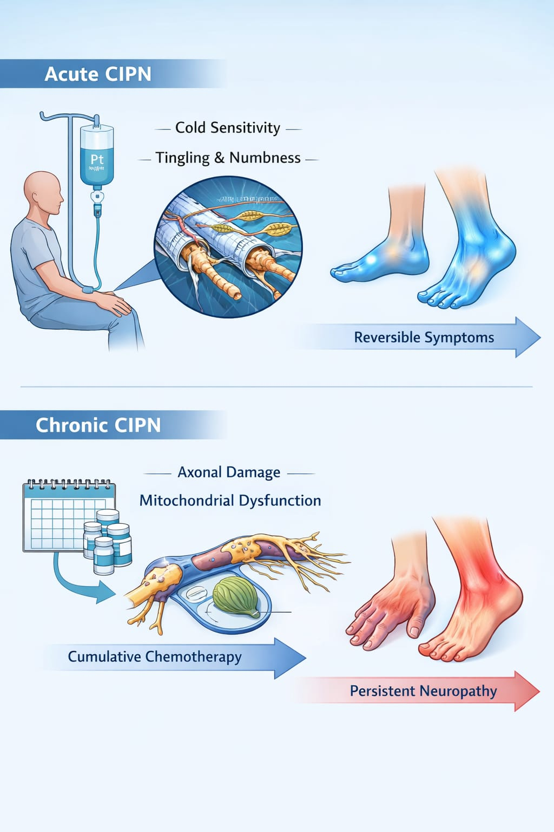
Figure 1. Schematic representation of acute and chronic CIPN
Schematic illustration demonstrating reversible acute neuropathy during chemotherapy and persistent chronic neuropathy associated with cumulative exposure.
- EPIDEMIOLOGY AND INCIDENCE:
CIPN is among the most frequently reported neurological complications of cancer treatment, with incidence rates varying according to chemotherapeutic regimen, cumulative dose, and patient-related factors [18]. Studies show that about 30 to 40% of patients receiving neurotoxic drugs develop CIPN, and this ratemay be higher, reaching up to 60% in those receiving high-risk drugs or combinations of therapies [19,20].
Long-term studies show that while some patients recover some of their symptoms after treatment ends, many develop long-term nerve damage [5]. Persistent CIPN has been reported in 20–30% of cancer survivors months or years after chemotherapy, showing how important it is in the long-term management of cancer survivors [21]. Platinum compounds, taxanes, and proteasome inhibitors are among the most common causes of CIPN [22].
Chemotherapy-induced peripheral neuropathy (CIPN) is a prevalent and dose-limiting complication of several antineoplastic agents, affecting both the quality of life and treatment adherence of cancer patients. The incidence of CIPN varies widely depending on the chemotherapeutic agent, cumulative dose, and treatment duration. Platinum compounds, taxanes, and vinca alkaloids are among the most commonly implicated drugs, with reported neuropathy rates ranging from 30% to 70% in patients receiving these therapies [3, 7, 12, 18].
Notably, taxane-induced neuropathy often presents in up to 65% of breast cancer patients, while oxaliplatin-induced neuropathy may affect over 50% of colorectal cancer patients [5, 9, 21]. Age, pre-existing neuropathies, diabetes, and genetic predispositions further influence susceptibility to CIPN [14, 26, 33]. Epidemiological studies also indicate that the neuropathy may persist long after completion of chemotherapy, with a significant proportion of patients reporting chronic symptoms even years post-treatment [17, 24, 42].
Overall, the burden of CIPN is substantial, necessitating early recognition, monitoring, and targeted preventive strategies in clinical oncology practice [11, 29, 38].
Table 2. Incidence of CIPN according to chemotherapeutic agents
DRUG CLASS | CHEMOTHERAPEUTIC AGENTS | ESTIMATED INCIDENCE (%)
Platinum compounds | Cisplatin, Oxaliplatin | 40-70
Taxanes | Paclitaxel, Docetaxel | 30-60
Vinca alkaloids | Vincristine | 30-50
Proteasome Inhibitors | Bortezomib | 30-40
Source: Adapted from Seretny et al. [19], Park et al. [20].
- ETIOLOGY AND CAUSATIVE CHEMOTHERAPEUTIC AGENTS:
Chemotherapy-induced peripheral neuropathy occurs because certain chemotherapy drugs harm nerve cells directly [23]. These agents damage peripheral nerves through diverse mechanisms, including disruption of microtubule dynamics, DNA injury, mitochondrial dysfunction, and induction of oxidative stress [24,25]. The likelihood of CIPN development is closely related to cumulative dose, dose intensity, and duration of exposure [26].
Beyond direct neurotoxicity, individual susceptibility to CIPN is influenced by host-related and treatment-related modifiers that interact with chemotherapeutic exposure. Genetic variations affecting drug metabolism, axonal transport proteins, and neuronal repair pathways have been implicated in differential vulnerability to nerve damage, partially explaining interpatient variability in CIPN severity [27,28]. Pre-existing conditions such as diabetes mellitus, vitamin deficiencies, advanced age, and prior exposure to neurotoxic agents further potentiate chemotherapy-related nerve injury by reducing neuronal reserve capacity [29,30].
Additionally, treatment scheduling and combination regimens may amplify neurotoxic burden through cumulative or synergistic effects, particularly when multiple neurotoxic agents are administered concurrently [31]. These contributory factors highlight that CIPN development reflects a complex interplay between drug-specific toxicity and patient-specific risk determinants rather than isolated pharmacologic effects alone [32].
Platinum-based agents such as cisplatin and oxaliplatin are well-recognized causes of CIPN, primarily inducing sensory neuron damage within the dorsal root ganglia [27]. Oxaliplatin uniquely causes acute cold-induced neuropathy in addition to cumulative chronic neuropathy [28]. Taxanes, including paclitaxel and docetaxel, disrupt axonal transport by stabilizing microtubules, resulting in distal axonal degeneration and sensory neuropathy [29].
Vinca alkaloids, particularly vincristine, impair microtubule assembly and frequently cause mixed sensory-motor neuropathy with prominent autonomic involvement [30]. Proteasome inhibitors such as bortezomib are increasingly recognized as major contributors to CIPN, particularly in patients with multiple myeloma [31].
Table 3. Chemotherapeutic agents associated with CIPN
DRUG CLASS | CHEMOTHERAPEUTIC AGENTS | MECHANISM OF TOXICITY
Platinum compounds | Cisplatin, Oxaliplatin | DNA damage, mitochondrial dysfunction
Taxanes | Paclitaxel, Docetaxel | Impaired axonal transport
Vinca alkaloids | Vincristine | Microtubule depolymerisation
Proteasome Inhibitors | Bortezomib | Proteosome inhibition
Source: Adapted from Argyriou et al. [23].
- RISK FACTORS FOR CHEMOTHERAPY-INDUCED PERIPHERAL NEUROPATHY:
The development of CIPN is influenced by both treatment-related and patient-related risk factors [32]. Treatment-related factors include the type of neurotoxic agent, cumulative dose, infusion schedule, and combination chemotherapy regimens [26]. Higher cumulative doses and prolonged treatment duration are consistently associated with increased risk and severity of neuropathy [33].
Patient-related risk factors include advanced age, pre-existing peripheral neuropathy, diabetes mellitus, renal impairment, alcohol abuse, and nutritional deficiencies such as vitamin B12 deficiency [34,35]. Emerging evidence suggests that genetic polymorphisms affecting drug metabolism, oxidative stress responses, and neuronal repair mechanisms may further predispose individuals to CIPN [36].
Recent clinical observations indicate that lifestyle and functional factors may further modify the risk and clinical expression of CIPN. Reduced physical activity levels, baseline frailty, and impaired balance have been associated with heightened symptom perception and delayed neurological recovery during and after chemotherapy [37]. In addition, inflammatory comorbidities and altered immune responses may amplify peripheral nerve vulnerability by sustaining low-grade neuroinflammation throughout treatment exposure [38].
Psychological factors such as anxiety, depression, and heightened symptom awareness have also been shown to influence patient-reported neuropathic severity, suggesting that neurotoxicity risk is shaped by both biological and psychosocial dimensions [39]. Recognition of these modifiable contributors is increasingly important for individualized risk stratification and early supportive intervention planning in patients receiving neurotoxic chemotherapy [40].
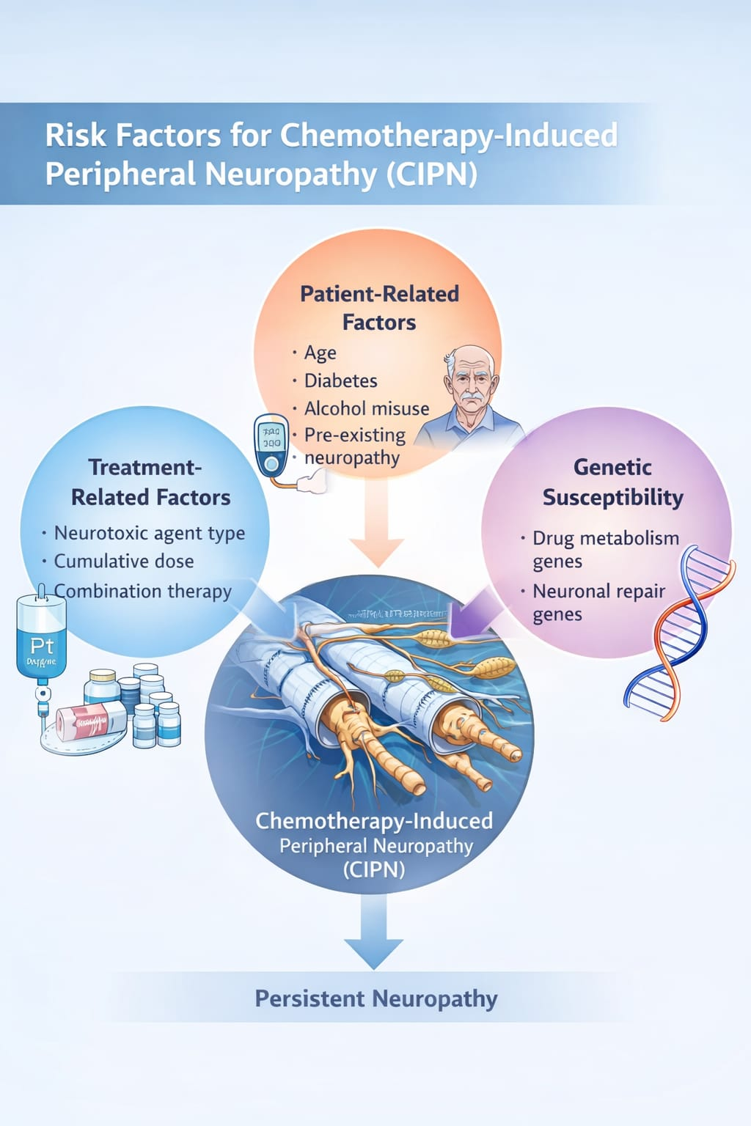
Figure 2. Risk factors contributing to CIPN
Schematic illustration depicting treatment-related, patient-related, and genetic susceptibility factors involved in CIPN development.
- PATHOPHYSIOLOGY OF CHEMOTHERAPY-INDUCED PERIPHERAL NEUROPATHY:
The pathophysiology of CIPN is complex and multifactorial, involving structural and functional damage to peripheral nerves [7,24]. Although the mechanisms vary among chemotherapeutic agents, several shared pathways contribute to nerve injury and symptom development.
Axonal degeneration is a central feature of CIPN, particularly affecting long sensory neurons due to their high metabolic demands [29]. Mitochondrial dysfunction and excessive production of reactive oxygen species result in energy failure and neuronal apoptosis [25,37]. Neuroinflammatory processes involving activation of glial cells and release of pro-inflammatory cytokines further exacerbate neuropathic pain and sensory hypersensitivity [38].
Additionally, alterations in ion channel expression and function contribute to neuronal hyperexcitability and chronic pain [39].Emerging evidence indicates that disruption of axonal transport and impaired neurotrophic signaling play a critical role in the progression of CIPN. Chemotherapeutic agents interfere with microtubule-dependent transport systems, leading to defective delivery of essential proteins, organelles, and growth factors to distal nerve terminals [31,34].
This transport failure preferentially affects long peripheral axons and contributes to distal nerve fiber loss and delayed recovery following treatment cessation [35]. In parallel, reduced expression of neurotrophic factors such as nerve growth factor and brain-derived neurotrophic factor has been implicated in impaired neuronal repair and regeneration, further perpetuating sensory dysfunction and chronic neuropathic symptoms [40,47]. Beyond the classical mechanisms described above, emerging evidence suggests that vascular, metabolic, and immune-mediated alterations significantly contribute to the development and persistence of chemotherapy-induced peripheral neuropathy. Chemotherapeutic agents have been shown to induce microvascular injury within peripheral nerves, leading to endoneurial hypoxia and impaired nutrient delivery. Damage to the vasa nervorum disrupts normal nerve perfusion, thereby exacerbating axonal vulnerability and delaying regenerative processes, particularly in distal nerve segments [1,33].
Recent studies also highlight the role of altered lipid and glucose metabolism in peripheral neurons following chemotherapy exposure. Metabolic stress can compromise membrane integrity and myelin maintenance, resulting in impaired nerve conduction and heightened sensory dysfunction. This metabolic imbalance may partly explain the increased susceptibility of patients with pre-existing metabolic disorders to severe and persistent CIPN [3,4].
In addition, immune dysregulation has gained attention as a contributing factor in CIPN pathogenesis. Chemotherapy-induced activation of innate immune pathways can promote sustained release of chemokines and immune mediators within peripheral nerve tissues. These mediators not only amplify nociceptive signaling but also interfere with normal repair mechanisms, promoting chronic neuropathic symptoms even after cessation of treatment [7,38].
Another important but less explored mechanism involves alterations in Schwann cell function. Chemotherapeutic agents may impair Schwann cell survival and differentiation, leading to defective myelin remodeling and reduced support for axonal regeneration. Schwann cell dysfunction further compromises neuronal resilience and may contribute to the prolonged recovery observed in many patients with CIPN [29,47].
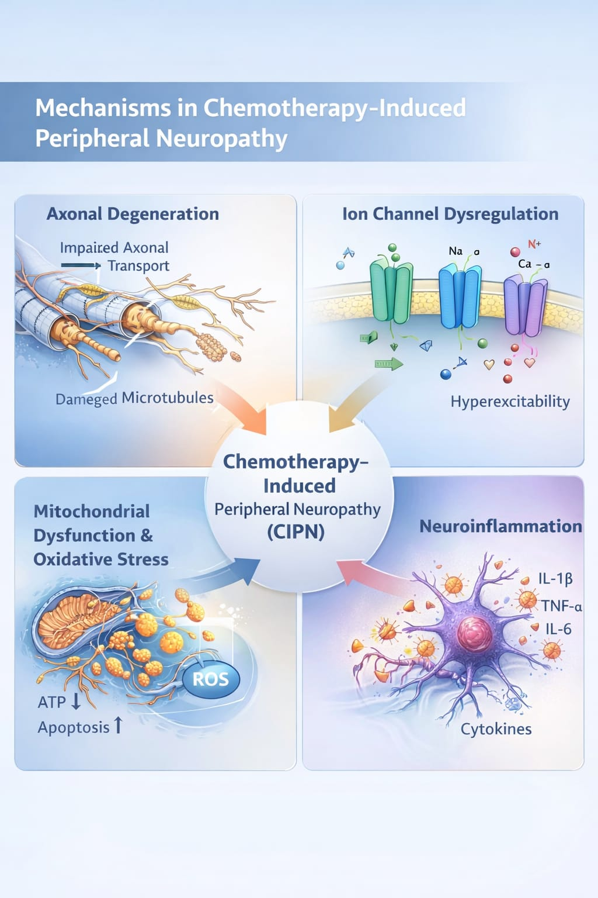
Figure 3. Mechanisms involved in CIPN pathogenesis
Diagrammatic overview illustrating axonal degeneration, mitochondrial dysfunction, oxidative stress, and neuroinflammatory pathways leading to peripheral nerve damage.
- Clinical Features of Chemotherapy-Induced Peripheral Neuropathy
Clinically, CIPN most commonly presents as a symmetric, distal sensory neuropathy affecting the hands and feet [8]. Sensory symptoms include numbness, tingling, paresthesia, burning pain, and altered perception of vibration and temperature [40]. These symptoms often progress proximally with continued chemotherapy exposure and may persist long after treatment cessation [21].
Motor involvement is less frequent but may manifest as muscle weakness, impaired coordination, and reduced reflexes, particularly with vinca alkaloids and taxanes [30,41]. Autonomic neuropathy may occur in a subset of patients and includes symptoms such as orthostatic hypotension, constipation, urinary dysfunction, and sexual dysfunction [14,42]. Collectively, these manifestations significantly impair functional independence and quality of life [5].
In addition to classical symptom domains, the clinical course of CIPN demonstrates considerable interindividual variability influenced by cumulative dose, treatment schedule, and patient-specific vulnerability. Acute neuropathic symptoms may occur during or shortly after infusion with certain agents, while chronic forms often evolve insidiously and worsen across treatment cycles [18,27].
A characteristic “coasting phenomenon,” in which neuropathic symptoms continue to progress even after discontinuation of chemotherapy, has been reported particularly with platinum-based regimens, complicating clinical recognition and follow-up [21,36]. The temporal heterogeneity and fluctuating severity of symptoms pose challenges for early identification and timely intervention, underscoring the need for vigilant longitudinal clinical monitoring [43,50].
Table 4. Clinical manifestations of CIPN
DOMAIN | COMMON SYMPTOMS
SENSORY | Numbness, paresthesia, neuropathic pain
MOTOR | Muscle weakness, gait instability
AUTONOMIC | Orthostatic hypotension, GI dysfunction
Source: Adapted from Staff et al. [40].
- ASSESSMENT AND DIAGNOSIS:
Assessment of CIPN relies primarily on clinical evaluation, including patient-reported symptoms and neurological examination [43]. Standardized grading systems such as the National Cancer Institute Common Terminology Criteria for Adverse Events (NCI-CTCAE) and the Total Neuropathy Score are widely used to assess severity and progression [44].
Neurophysiological studies, including nerve conduction studies, may support diagnosis, although they are less sensitive for small fiber neuropathy [45]. Patient-reported outcome measures are increasingly recognized as essential tools for capturing the subjective burden of CIPN[46].
Emerging diagnostic approaches increasingly emphasize the role of multimodal assessment to improve sensitivity for early or subclinical nerve damage. Quantitative sensory testing and functional assessments of balance and gait have demonstrated utility in detecting subtle sensory deficits that may not be evident on routine neurological examination or nerve conduction studies [29,40].
Additionally, skin biopsy and corneal confocal microscopy are being explored as research tools to assess small fiber involvement and structural nerve alterations, offering potential insight into disease severity and progression [47]. Although these techniques are not yet routinely implemented in clinical practice, their integration into research settings may contribute to more precise phenotyping of chemotherapy-induced peripheral neuropathy and support the development of targeted preventive strategies [45,50]. Despite the availability of standardized grading systems, accurate assessment of chemotherapy-induced peripheral neuropathy remains challenging due to the heterogeneous presentation and fluctuating symptom severity. Conventional clinician-based grading tools may underestimate symptom burden, particularly in early or mild stages, leading to delayed recognition and intervention. This limitation highlights the need for assessment strategies that integrate both objective findings and patient-reported symptom trajectories over time [43,46].
Increasing attention has been directed toward the use of validated patient-reported outcome instruments, which allow longitudinal monitoring of sensory, motor, and functional impairments. These tools enhance sensitivity for detecting treatment-related changes and provide valuable insight into the real-world impact of CIPN on daily activities and quality of life. Incorporation of patient-centered measures into routine clinical practice may improve treatment decision-making and support timely dose modification or preventive strategies [30,46].
Emerging evidence also supports the role of functional and performance-based assessments in identifying clinically meaningful neuropathy. Measures of fine motor control, postural stability, and manual dexterity may detect deficits that are not readily apparent during standard neurological examinations. Such assessments are particularly relevant for evaluating fall risk and functional decline in cancer survivors receiving neurotoxic chemotherapy [29,35].
In addition, advances in biomarker-based assessment are being explored to improve diagnostic precision. Neurofilament light chain levels, inflammatory mediators, and genetic susceptibility markers have shown potential as objective indicators of nerve injury and disease progression. Although these biomarkers are not yet validated for routine use, they represent promising adjuncts for future risk stratification and early detection of CIPN [3,7,47].
Overall, an integrated diagnostic approach combining clinical evaluation, patient-reported outcomes, functional testing, and emerging biological markers may provide a more comprehensive understanding of CIPN severity and progression. Such multimodal assessment frameworks are essential for optimizing early diagnosis, monitoring treatment-related neurotoxicity, and guiding personalized management strategies in patients undergoing chemotherapy [45,50].
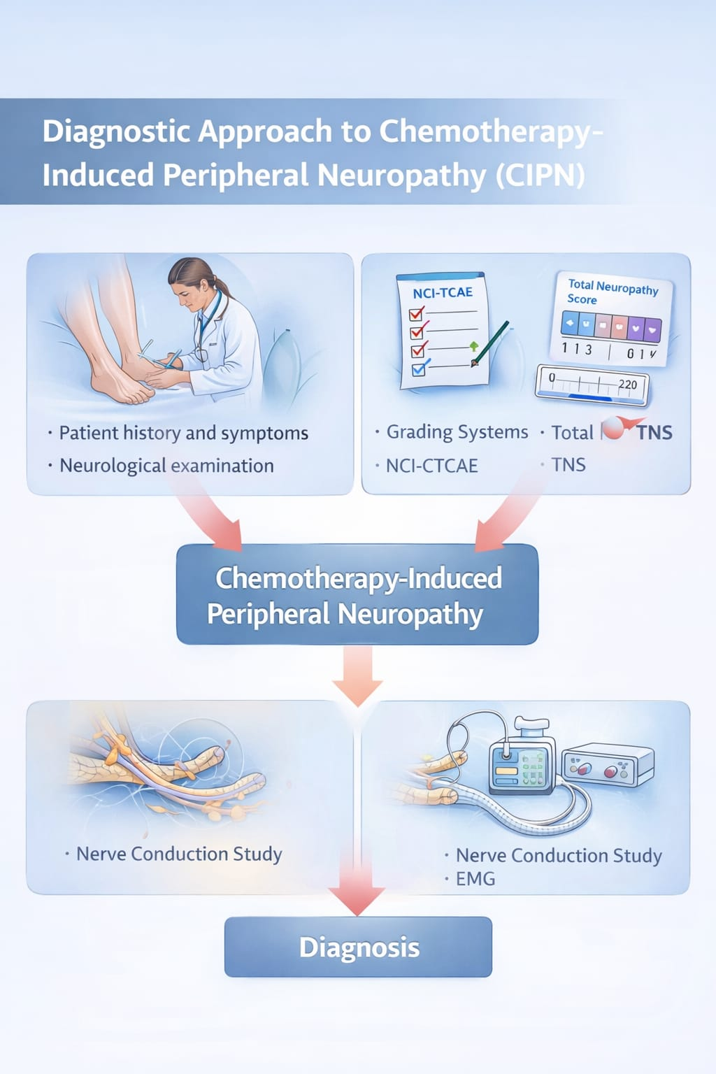
Figure 4. Diagnostic approach to CIPN
Schematic representation of clinical assessment, grading tools, and supportive diagnostic investigations.
- PREVENTION OF CHEMOTHERAPY-INDUCED PERIPHERAL NEUROPATHY:
Effective prevention of CIPN remains an unmet clinical need. Numerous pharmacological agents have been evaluated for neuroprotection, including antioxidants, calcium and magnesium infusions, and neurotrophic factors, but results have been inconsistent [10,47]. Consequently, routine pharmacological prevention is not currently recommended.
Non-pharmacological approaches such as dose modification, treatment scheduling, cryotherapy, and structured exercise interventions have demonstrated emerging benefits in reducing CIPN severity and improving functional outcomes [35,48]. Cryotherapy during taxane administration may reduce drug exposure to peripheral nerves, while exercise interventions may enhance nerve regeneration and functional recovery [49].
Early identification of subtle sensory changes during chemotherapy plays a critical role in preventing the progression of peripheral nerve damage. Continuous symptom surveillance combined with individualized treatment planning allows clinicians to implement timely dose adjustments without compromising anticancer efficacy. Lifestyle-based interventions, including supervised physical activity and functional rehabilitation, have shown promise in maintaining neuromuscular coordination and sensory integrity throughout treatment courses.
In addition, proactive counselling and patient engagement improve adherence to preventive measures and promote early reporting of neuropathic symptoms, thereby reducing long-term functional impairment and treatment-related disability [41–44]. Prevention of chemotherapy-induced peripheral neuropathy requires a proactive, individualized, and stage-specific approach rather than reliance on a single pharmacological intervention. Current evidence supports a risk-adapted prevention framework that integrates baseline risk assessment, treatment-phase monitoring, and post-treatment survivorship strategies to minimize both acute and persistent neurotoxicity [3,10,11].
At the pre-treatment stage, identification of patients at elevated risk is essential. Baseline neurological assessment, documentation of pre-existing neuropathy, metabolic comorbidities, and prior neurotoxic exposure allows stratification of patients who may benefit from closer surveillance or alternative chemotherapy regimens. Incorporating patient education at this stage promotes early symptom recognition and timely reporting during therapy [4,43].
During active chemotherapy, prevention efforts should focus on minimizing cumulative neurotoxic burden while preserving oncological efficacy. Continuous symptom monitoring using patient-reported outcome measures enables early detection of subtle sensory changes that may precede clinically overt neuropathy. Treatment individualization, including schedule modification and dose intensity adjustment, should be guided by both clinical findings and functional impact rather than severity grading alone [10,30,46].
In the post-treatment phase, preventive strategies extend beyond symptom control to limiting long-term disability. Early referral to rehabilitation services, neuromuscular training, and balance-oriented interventions may reduce functional decline and improve recovery trajectories. Structured follow-up programs facilitate identification of persistent or progressive neuropathy, allowing timely intervention and supportive care optimization [35,41].
Emerging preventive paradigms also emphasize the importance of multidisciplinary collaboration, involving oncologists, neurologists, pharmacists, and rehabilitation specialists. Such coordinated care models enhance adherence to preventive strategies and support shared decision-making, particularly in patients requiring prolonged or repeated exposure to neurotoxic agents [45,50].
Overall, effective prevention of CIPN depends on a dynamic, multimodal strategy that evolves across the cancer care continuum. Shifting the focus from reactive symptom management to anticipatory risk mitigation may significantly reduce the long-term neurological burden associated with chemotherapy-induced peripheral neuropathy [3,11,47].
Table 5. Preventive strategies for CIPN

STRATEGY | EVIDENCE LEVEL
PHARMACOLOGICAL AGENTS | Inconclusive
DOSE MODIFICATION | Strong
CRYOTHERAPY | Emerging
Source: Adapted from Loprinzi et al. [10].
- CLINICAL GUIDELINES AND RECOMMENDATIONS:
Current clinical guidelines emphasize early recognition of CIPN, regular symptom monitoring, patient education, and individualized chemotherapy dose modification [10,11]. Duloxetine is recommended for the management of established painful CIPN but not for preventive use [11]. Shared decision-making between clinicians and patients is essential to balance oncologic efficacy with neurotoxicity risk [38].
In addition to pharmacological management, clinical guidelines strongly advocate for routine neurological assessment before, during, and after chemotherapy to facilitate early detection of CIPN and timely intervention [21,43]. The use of standardized grading tools, such as the NCI-CTCAE and patient-reported outcome measures, is recommended to accurately capture symptom severity and functional impact over time [15,44]. Early identification of neuropathic symptoms allows clinicians to implement dose adjustments, treatment delays, or regimen modifications, thereby minimizing irreversible nerve damage while maintaining therapeutic efficacy [10,26].
Patient education forms a cornerstone of guideline-based CIPN management. Patients should be informed about early sensory symptoms, potential triggers such as cold exposure, and safety measures to reduce fall risk and injury [5,40]. Multidisciplinary involvement, including oncologists, neurologists, nurses, and physiotherapists, is encouraged to optimize symptom monitoring and supportive care [41]. Collectively, adherence to these evidence-based guidelines supports improved symptom control, preserves quality of life, and enables individualized treatment decisions aligned with patient preferences and clinical goals [11,38].
- FUTURE DIRECTIONS:
Future research efforts focus on identifying reliable biomarkers for early detection of nerve injury, genetic predictors of susceptibility, and targeted neuroprotective therapies [36,39]. Advances in pharmacogenomics and personalized medicine may enable tailored preventive strategies and improved outcomes for patients at high risk of CIPN [50].
Future directions should also prioritize the development of standardized outcome measures to enable consistent evaluation of chemotherapy-induced peripheral neuropathy across clinical trials and real-world practice [15,29]. Harmonization of clinician-reported and patient-reported assessment tools will improve comparability of study findings and facilitate meta-analyses, ultimately strengthening the evidence base for preventive and therapeutic interventions [44,46].
Another important area of focus is the integration of multidisciplinary care models in the management of CIPN. Collaboration between oncologists, neurologists, physiotherapists, and pain specialists may enhance early intervention, functional rehabilitation, and long-term symptom control [41,42]. Additionally, survivorship-focused research is needed to better understand the long-term trajectory of CIPN and to develop rehabilitation strategies aimed at improving balance, mobility, and quality of life among cancer survivors [5,21]. While existing clinical guidelines provide a robust framework for the recognition and management of chemotherapy-induced peripheral neuropathy, effective implementation in routine practice remains variable. Barriers such as time constraints, limited access to neurological expertise, and inconsistent use of standardized assessment tools may contribute to underrecognition of early neuropathic changes. Addressing these challenges requires systematic integration of CIPN monitoring into oncology workflows and survivorship care plans [21,43].
Guidelines increasingly emphasize the importance of longitudinal follow-up, as CIPN symptoms may persist or progress even after completion of chemotherapy. Regular post-treatment neurological assessments enable timely identification of delayed or chronic neuropathy and facilitate referral to supportive care services. Incorporation of survivorship-focused monitoring strategies may reduce long-term functional impairment and improve quality-of-life outcomes among cancer survivors [33,35].
Another evolving recommendation involves the personalization of guideline application based on individual risk profiles. Factors such as cumulative chemotherapy exposure, comorbid conditions, and baseline functional status should inform the intensity and frequency of monitoring. Tailoring guideline-based interventions to patient-specific risk enhances clinical relevance and supports shared decision-making when balancing neurotoxicity risk against anticancer benefit [3,10,38].
Recent guideline discussions also highlight the need for interdisciplinary education and training to improve clinician awareness and confidence in managing CIPN. Structured educational initiatives targeting healthcare professionals may promote consistent use of assessment tools, appropriate referral pathways, and evidence-based symptom management strategies. Such initiatives are particularly relevant in settings with limited access to specialized neurological care [41,45].
Looking forward, guidelines acknowledge the growing role of research-informed updates as new evidence emerges. Integration of patient-reported outcomes, digital symptom tracking, and biomarker-based assessments may refine future recommendations and enhance early detection. Continuous revision of clinical guidelines based on high-quality evidence is essential to ensure optimal prevention, monitoring, and management of chemotherapy-induced peripheral neuropathy across diverse clinical settings [11,47,50].
- CONCLUSION:
Chemotherapy-induced peripheral neuropathy is a prevalent and often persistent complication of cancer treatment that significantly affects patient function and quality of life. Although understanding of its mechanisms and risk factors has advanced, effective preventive strategies remain limited. Early detection, careful monitoring, and supportive preventive approaches such as dose modification and exercise are essential components of CIPN management. Continued research into novel therapeutic targets and personalized interventions is crucial to reducing the burden of CIPN in cancer patients and survivors.
These challenges highlight the need for continued emphasis on patient-centered care and long-term follow-up in oncology practice. Incorporating routine functional assessment, survivorship care planning, and multidisciplinary rehabilitation strategies may help address persistent symptoms and improve daily functioning. As cancer survival continues to improve, prioritizing neurological health and functional recovery will be essential to ensure that therapeutic success is not compromised by long-term treatment-related morbidity.

COMPETING INTERESTS DISCLAIMER:
Authors have declared that they have no known competing financial interests OR non-financial interests OR personal relationships that could have appeared to influence the work reported in this paper.

REFERENCES:
- Cavaletti G, Marmiroli P. Chemotherapy-induced peripheral neurotoxicity. Nat Rev Neurol. 2010;6(12):657–666.
- Park SB, Goldstein D, Krishnan AV, Lin CSY, Friedlander ML, Cassidy J, et al. Chemotherapy-induced peripheral neurotoxicity: A critical analysis. CA Cancer J Clin. 2013;63(6):419–437.
- Seretny M, Currie GL, Sena ES, Ramnarine S, Grant R, MacLeod MR, et al. Incidence, prevalence, and predictors of chemotherapy-induced peripheral neuropathy. Pain. 2014;155(12):2461–2470.
- Mols F, Beijers T, Vreugdenhil G, van de Poll-Franse LV. Chemotherapy-induced peripheral neuropathy and its association with quality of life. Support Care Cancer. 2014;22(8):2261–2269.
- Winters-Stone KM, Horak F, Jacobs PG, Trubowitz P, Dieckmann NF, Stoyles S, et al. Falls, functioning, and disability among women with persistent chemotherapy-induced peripheral neuropathy. J ClinOncol. 2017;35(23):2604–2612.
- Eckhoff L, Knoop AS, Jensen MB, Ewertz M. Persistence of docetaxel-induced neuropathy. Breast Cancer Res Treat. 2015;151(3):589–598.
- Sisignano M, Baron R, Scholich K, Geisslinger G. Mechanism-based treatment for chemotherapy-induced peripheral neuropathic pain. Nat Rev Neurol. 2014;10(12):694–707.
- Starobova H, Vetter I. Pathophysiology of chemotherapy-induced peripheral neuropathy. Front MolNeurosci. 2017;10:174.
- Boyette-Davis JA, Walters ET, Dougherty PM. Mechanisms involved in the development of chemotherapy-induced neuropathy. Pain Manag. 2015;5(4):285–296.
- Loprinzi CL, Lacchetti C, Bleeker J, Cavaletti G, Chauhan C, Hertz DL, et al. Prevention and management of chemotherapy-induced peripheral neuropathy in survivors of adult cancers. J ClinOncol. 2020;38(28):3325–3348.
- Hershman DL, Lacchetti C, Dworkin RH, Smith EML, Bleeker J, Cavaletti G, et al. Prevention and management of chemotherapy-induced peripheral neuropathy in survivors of adult cancers. J ClinOncol. 2014;32(18):1941–1967.
- Quasthoff S, Hartung HP. Chemotherapy-induced peripheral neuropathy. J Neurol. 2002;249(1):9–17.
- Grisold W, Cavaletti G, Windebank AJ. Peripheral neuropathies from chemotherapy and targeted agents. Lancet Neurol. 2012;11(10):862–872.
- Velasco R, Bruna J. Chemotherapy-induced peripheral
- neuropathy. Neurologia. 2010;25(2):116–131.
- Cavaletti G, Cornblath DR, Merkies ISJ, Postma TJ, Rossi E, Frigeni B, et al. The chemotherapy-induced peripheral neuropathy outcome measures standardization study. J PeripherNerv Syst. 2013;18(3):229–240.
- Park SB, Lin CSY, Krishnan AV, Friedlander ML, Lewis CR, Kiernan MC. Oxaliplatin-induced neurotoxicity. J ClinOncol. 2009;27(35):6023–6032.
- Beijers AJM, Mols F, Vreugdenhil G. A systematic review on chronic chemotherapy-induced peripheral neuropathy. Eur J Cancer. 2014;50(1):8–17.
- Argyriou AA, Bruna J, Marmiroli P, Cavaletti G. Chemotherapy-induced peripheral neurotoxicity. Crit Rev OncolHematol. 2012;82(1):51–77.
- Postma TJ, Heimans JJ. Grading of chemotherapy-induced peripheral neuropathy. Ann Oncol. 2000;11(5):509–513.
- Richardson PG, Delforge M, Beksac M, Wen P, Jongen JL, Sezer O, et al. Management of treatment-emergent peripheral neuropathy in multiple myeloma. Blood. 2012;119(9):2085–2094.
- Staff NP, Grisold A, Grisold W, Windebank AJ. Chemotherapy-induced peripheral neuropathy. Lancet Neurol. 2017;16(9):772–781.
- Pachman DR, Barton DL, Watson JC, Loprinzi CL. Chemotherapy-induced peripheral neuropathy. J ClinOncol. 2011;29(34):476–485.
- Argyriou AA, Polychronopoulos P, Iconomou G, Chroni E, Kalofonos HP. Paclitaxel plus carboplatin-induced peripheral neuropathy. Ann Oncol. 2008;19(1):183–189.
- Jaggi AS, Singh N. Mechanisms in cancer chemotherapy-induced peripheral neuropathy. Toxicology. 2012;291(1–3):1–9.
- Flatters SJL, Dougherty PM, Colvin LA. Clinical and preclinical perspectives on chemotherapy-induced peripheral neuropathy. Pain. 2017;158(12):213–219.
- Verstappen CCP, Heimans JJ, Hoekman K, Postma TJ. Neurotoxic complications of chemotherapy. J Neurol. 2003;250(9):1095–1106.
- Ocean AJ, Vahdat LT. Chemotherapy-induced peripheral neuropathy. Support Care Cancer. 2004;12(9):619–625.
- Jordan B, Margulies A, Cardoso F, Cavaletti G, Haugnes HS, Jahn P, et al. Systemic anticancer therapy-induced peripheral neuropathy. Ann Oncol. 2020;31(10):1306–1319.
- Alberti P, Rossi E, Cornblath DR, Merkies ISJ, Postma TJ, Frigeni B, et al. Physician-assessed and patient-reported outcome measures in CIPN. J PeripherNerv Syst. 2014;19(4):258–268.
- Smith EML, Cohen JA, Pett MA, Beck SL. The reliability and validity of a modified Total Neuropathy Score. J Support Oncol. 2010;8(1):1–8.
- Hong JS, Tian J. Prevalence of anxiety and depression and their association with quality of life in cancer patients. Support Care Cancer. 2014;22(2):453–459.
- Windebank AJ, Grisold W. Chemotherapy-induced neuropathy. J PeripherNerv Syst. 2008;13(1):27–46.
- Briani C, Argyriou AA, Izquierdo C, Velasco R, Campagnolo M, Alberti P, et al. Long-term course of chemotherapy-induced peripheral neuropathy. J Neurol. 2014;261(11):2108–2115.
- Park SB, Goldstein D, Lin CSY, Krishnan AV, Friedlander ML, Kiernan MC. Acute abnormalities of sensory nerve function associated with oxaliplatin-induced neurotoxicity. J ClinOncol. 2011;29(10):1243–1249.
- Winters-Stone KM, Bennett JA, Nail LM, Schwartz A. Strength, physical activity, and age predict fatigue in breast cancer survivors. OncolNurs Forum. 2008;35(5):815–821.
- Cavaletti G, Zanna C. Current status and future prospects for the treatment of chemotherapy-induced peripheral neurotoxicity. Eur J Cancer. 2002;38(14):1832–1837.
- Dougherty PM, Cata JP, Cordella JV, Burton A, Weng HR. Taxol-induced sensory disturbance. Pain. 2004;109(1–2):132–142.
- Smith EML, Pang H, Cirrincione C, Fleishman S, Paskett ED, Ahles T, et al. Effect of duloxetine on pain in patients with chemotherapy-induced peripheral neuropathy. JAMA. 2013;309(13):1359–1367.
- Staff NP, Windebank AJ. Peripheral neuropathy due to vitamin deficiency, toxins, and medications. NeurolClin. 2013;31(2):557–576.
- Beijers AJM, Jongen JLM, Vreugdenhil G. Chemotherapy-induced neurotoxicity. Neth J Med. 2012;70(1):18–25.
- Cavaletti G, Marmiroli P. Management of chemotherapy-induced peripheral neurotoxicity. CurrOpin Support Palliat Care. 2015;9(2):111–116.
- Argyriou AA, Kalofonos HP. Peripheral neuropathy in cancer survivors. Cancer Treat Rev. 2013;39(6):519–528.
- Postma TJ, Vermorken JB. Neurotoxicity of platinum compounds. Crit Rev OncolHematol. 1996;22(2):109–127.
- Park SB, Kiernan MC, Krishnan AV. Chemotherapy-induced neuropathy. CurrNeurolNeurosci Rep. 2012;12(3):345–354.
- Jordan B, Jahn P. Survivorship and long-term toxicities. Support Care Cancer. 2019;27(12):4385–4392.
- Flatters SJL. Prevention of chemotherapy-induced peripheral neuropathy. Pain Manag. 2015;5(6):391–398.
- Staff NP, Fehrenbacher JC, Caillaud M, Damaj MI, Segal RA. Pathogenesis of chemotherapy-induced peripheral neuropathy. Brain. 2020;143(6):1626–1639.
- Kleckner IR, Kamen C, Gewandter JS, Mohile NA, Heckler CE, Culakova E, et al. Exercise for chemotherapy-induced peripheral neuropathy. Support Care Cancer. 2018;26(4):1019–1028.
- Hanai A, Ishiguro H, Sozu T, Tsuda M, Yano I, Kubo M, et al. Effects of cryotherapy on CIPN. J Natl Cancer Inst. 2018;110(2):141–148.
- McCrary JM, Goldstein D, Boyle F, Cox K, Grimison P, Kiernan MC, et al. Optimal clinical assessment strategies for CIPN. J PeripherNerv Syst. 2017;22(2):144–153.

