Effect of heat treatment on the solubility of natural Tahoua phosphate in perchloric acid and water

Abstract
The natural phosphate from Tahoua is a sedimentary phosphate containing a range of impurities. However, their presence in apatite makes phosphorus less available to plants. This work aims to enrich the natural phosphate from Tahoua to increase its solubility. In the first step, we carried out a heat treatment of the commercial phosphate from Tahoua. Calcination was performed in a kiln at 900°C for two hours. After treatment, we observed a loss of phosphate mass (from 8 g to 7.36 g). We then proceeded to chemically characterize the calcined phosphate by X-ray fluorescence spectrometry to determine the quantity of impurities removed from the phosphate's chemical composition. The results obtained were Al₂O₃ (from 4.64% to 0.485%), SiO₂ (from 3.35% to 0.05%), and P₂O₅ (from 20.6% to 30.8%). Finally, we dissolved the product obtained in perchloric acid and in water. The solubilization rates of calcined and merchant phosphate in perchloric acid and water were 58.75% and 16.30%, and 27.70% and 6.99%, respectively. Calcination of merchant phosphate significantly increased the concentration of P₂O₅ dissolved in both acid and water.
Keywords : Phosphate naturel, solubility, acid perchloric, water
Introduction
Located in West Africa, Niger is a country rich in various raw materials, the majority of which have not yet been exploited industrially. It abounds in invaluable mineral resources, including iron, gold, uranium, limestone, tin, natron, phosphates, clays, etc. [1]. Furthermore, the population faces food insecurity due to climate change and soil degradation. To regenerate agricultural productivity, Niger's soil therefore requires the addition of certain nutrients, especially phosphorus, nitrogen, and potassium, which are fundamental to plant life. Of these three elements, phosphorus plays a crucial role in plant mineral nutrition [2]. In Niger, two natural phosphate deposits have been identified over the past several decades. The Tapoa natural phosphate deposit, with reserves estimated at 1.254 billion tonnes, and the Ader Doutchi deposit, estimated at 7,371,812 tonnes, are both significant mineral resources. The latter was exploited by the Nigerien government through the National Office of Mining Research (ONAREM) and marketed by CAIMA (Central Supply of Agricultural Inputs and Materials), but the company's operations were suspended due to the product's low solubility [1]. The marketable phosphate from Tahoua is a nodular sedimentary phosphate, composed primarily of fluoroapatite, with an average P₂O₅ content of approximately 30%. High levels of Fe₂O₃, Al₂O₃, SiO₂, and organic matter affect the marketability of the nodules. However, Nigerien soils remain poor in phosphorus. To address this problem, numerous studies have been conducted on the agricultural use of natural phosphate from Tahoua. Trials of direct application of commercial phosphate from Tahoua to agriculture have not yielded convincing results due to its low water solubility, which stems from its apatite form. The phosphorus in natural phosphate is only available to plants in an assimilable form [2]. It is an essential product for agriculture, just like nitrogen (N) and potassium (K), and is among the few non-substitutable raw materials [3]. In this case, natural phosphates contain impurities that negatively impact the product's quality. This justifie the need for processing to make it usable. This processing is carried out using physical and/or chemical methods (particle size analysis, water washing, flotation, separation, calcination, etc.). Thus, the calcination and the study of the solubility of natural phosphates from Tahoua (PNTs) in perchloric acid and in water were carried out.
Materials and Methods
II.1. Materials
II.1.1. Phosphate Ore
Before being ready for processing, natural phosphate must undergo several treatment stages to obtain the desired quality. At the Tahoua mining complex, the treatments are geared towards producing a grade of phosphate suitable for market. In our research, we used market phosphate from Tahoua (Figure 1), purchased from the Central Supply Agency for Agricultural Inputs and Materials (CAIMA). The particle size of this powder ranges from 100 to 150 μm [4].
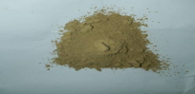

Figure 1: Merchantable phosphate powder from Tahoua
After heat treatment of the merchantable phosphate, we obtained a calcined product of a different color and with a lower mass than the initial product. The calcined phosphate is shown in Figure 2.
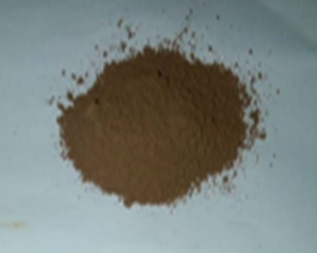
Figure 2: Calcined Tahoua phosphate powder
II.1.2. Chemicals
The chemicals used in this work are described in the table below.
Table 1: Chemicals
Produits | Formule | Masse molaire g/mol | Densité | Pureté | Origine
Acide sulfurique | H₂SO₄ | 98 | 1,84 | 95̶̶ 98% | Prolabo̶Normapur
Acide citrique | C₆H₈0₇ H₂O | 210,124 | 1,55 | 100% | ProlaboNormapur
Molybdate d’ammonium | NH₄M₀₇. 4H₂O | 1235,86 | _ | _ | ACROS ORGANICS
Tartrate de potassium et antimoine | C₄H₄O₆ K(SbO).0, 05H2O | 333,93 | 2,6 | 99% | ACROS ORGANICS
Acide ascorbique | C₆H₈0₆ | 176,13 | _ | 99,7% | ProlaboNormapur
Phosphate mono potassique | KH₂PO₄ | 136,1 | _ | _ | _

II.1.3. Equipment
The equipment used in our work included:
▪ a molecular absorption spectrophotometer;
▪ an analytical balance ;
▪ filtrate collection bottles;
▪ magnetic stirrers;
▪ a hot plate ;
▪ certain laboratory equipment (volumetric flasks, pipettes, funnel, wash bottle);
▪ filter paper;
▪ an X-ray fluorescence spectrometer
II.2. Methods
II.2.1. Enrichment of Tahoua Natural Phosphate by Calcination
An 8 g mass of Tahoua natural phosphate powder, weighed using a precision balance, was placed in a crucible. It was then placed in a furnace at the calcination temperature of 900 °C for 2 hours. Then it is left to cool in the oven for 24 hours and collected in a dry container. This type of calcination burns off the organic matter without significantly affecting the superior qualities of the sedimentary phosphates.
II.2.2. Principles of X-ray Spectrometry
X-ray fluorescence (XRF) is a method used to quantify the elemental composition of solid samples. X-rays are used to excite the atoms in the sample, causing them to emit X-rays with energies characteristic of each element present. It is also a quantitative analytical method that utilizes X-ray energy. X-rays obey the law of electromagnetic radiation, which states that a body surface can absorb incident radiation and reflect it as a spherically symmetric mirror capable of transmitting and emitting radiation.
The origin of X-rays stems from the energy loss associated with the interaction of high-energy electrons with atoms. Electrons from the X-ray cell move towards the electron field of the atoms in the target material. The incident electrons are decelerated and lose energy. High-energy incident electrons enter the outer orbit of atoms and collide with an electron in the inner orbit. These inner electrons can be completely removed, leaving the atom in an unstable state. An electronic rearrangement to restore stability occurs, leading to the release of energy in the form of X-rays. The X-rays thus generated have a discrete wavelength that is related to the atomic number of the atoms that produce them. These are called "characteristic X-rays." The detection and measurement of characteristic X-rays form the basis of X-ray spectrometry [5].
Chemical analysis was performed on 20 g of crude powder using an energy-dispersive X-ray fluorescence spectrometer (Minipal 4 model). Kapton filters were selected for major oxides, and Ag/Al-thin filters were used for trace elements and rare earth elements. The measurement time for each sample was 100 seconds, and the medium used was always air. Loss on ignition (LOI) was determined gravimetrically by heating 1 g of the powdered sample in a clean, weighed crucible at 1000 °C. The crucible and its contents were then weighed to obtain the weight difference before and after heating.
LOI = (a-b) x 100%
Where a = weight of crucible + sample before heating
b = weight of crucible + sample after heating.
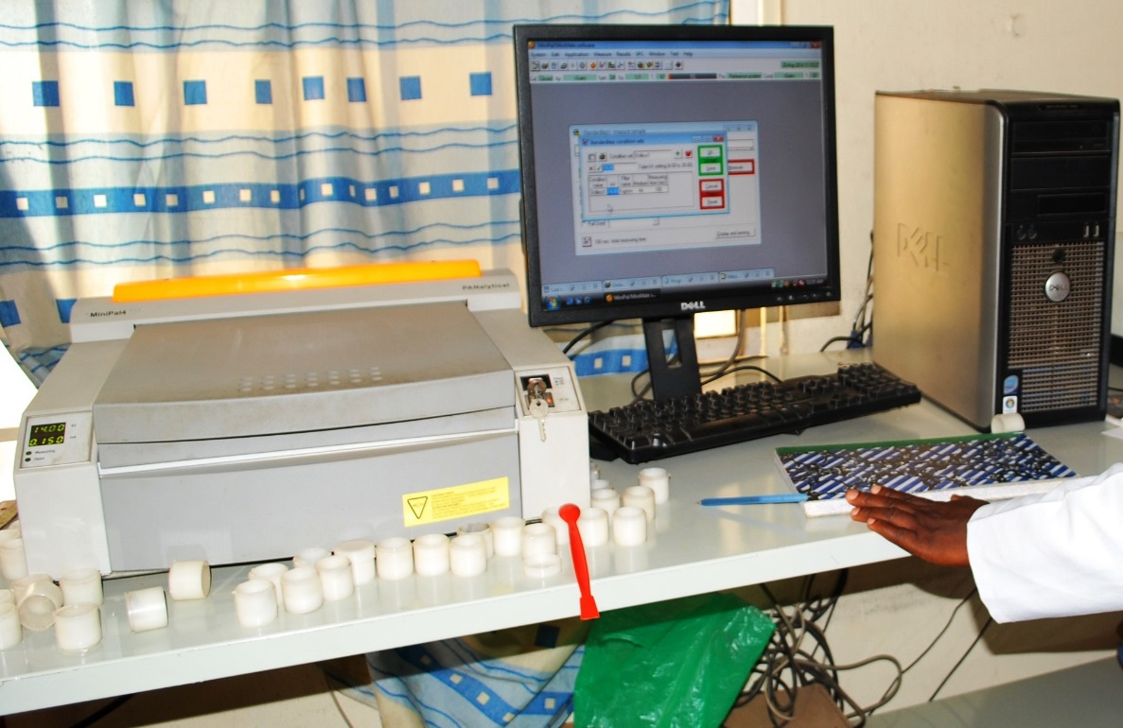
Figure 3: X-ray fluorescence spectrometer [5]
II.1.3.1. Determination of total P₂O₅ (P₂O₅ T)
A 0.50 g mass of the simple superphosphate fertilizer, weighed using a precision balance (Precisa 205 A type), is placed in a previously washed and dried 250 mL beaker. A few mL of distilled water are added, along with 7.5 mL of perchloric acid. The mixture is heated until all the white coloration disappears on a plate. After cooling, the contents are transferred quantitatively into a 250 mL volumetric flask, after thoroughly rinsing the beaker with distilled water. The mixture is homogenized, and the volume is then filled to the mark on the calibration cylinder. The resulting mixture is filtered through pleated filter paper, discarding the first few mL of the filtrate into a dry flask. Finally, the concentration of dissolved phosphoric anhydride (P₂O₅) was determined in the filtrate [6].
II.1.3.1. Determination of Water-Soluble P₂O₅ (P₂O₅ SE)
In a 250 mL flask thoroughly rinsed with distilled water, 0.25 g of simple superphosphate fertilizer and 100 mL of distilled water were introduced. The mixture was stirred with a magnetic stirrer at room temperature. The stirring speed was set at 500 rpm for a reaction time of 20 minutes. After stirring, each mixture was filtered through rapid filter paper, collecting the solution in a clean, dry plastic bottle (the first few milliliters of the filtered solution were discarded). To assess the effect of water in simple superphosphate, the concentration of dissolved phosphoric anhydride (P₂O₅) was measured in each filtrate. To ensure the reproducibility of the results, these measurements were performed three times.
II.1.3.3. Preparation of the Complexing Solution
The complexation of phosphate ions dissolved during the attack was carried out using a complexing solution. The preparation of such a solution consists of carefully preparing three different solutions in equal proportions and mixing them in the order [6]. The solutions are prepared as follows:
Solution 1: a 250 mL solution was prepared, consisting of one volume of nitric acid and two volumes of distilled water;
Solution 2: 0.625 g of ammonium metavanadate (NH₄VO₃) was dissolved in a 250 mL volumetric flask with 150 mL of boiling distilled water. After stirring, 5 mL of nitric acid (HNO₃, d = 1.38) was added. The volume was then made up to the mark with distilled water after cooling;
Solution 3: A mass of 12.5g of ammonium molybdate tetrahydrate Mo₇O₂₄(NH₄)₆ 4H₂O is dissolved in 200 mL of boiling distilled water and the volume is made up to 250 mL with distilled water.
Results and Discussion
III.1. Processing of Tahoua Merchant Phosphate
The enrichment of natural phosphate by calcination is a means of removing impurities from the raw phosphate, namely water and organic matter. This increases the phosphate (P₂O₅) content in the ore. The variation in mass obtained by calcining the ore is shown in Table 2:
Table 2: Masses of Raw and Calcined Natural Phosphate from Tahoua
 | Merchand phosphate | Calcined phosphate
Masses in g | 8 | 7,36

After heat treatment of the raw phosphate, the results show a decrease in phosphate mass. This mass loss can be attributed to the removal of impurities such as organic matter, water, etc. This removal could contribute to an increase in the P2O5 content of the phosphate. In this regard, El Ouardi and his colleagues [7] observed a mass loss and an increase in P2O5 content in the calcined phosphate.
III.2. Determination of the Chemical Composition of Calcined Phosphate by X-ray Fluorescence
Three samples of raw phosphate and two samples of calcined phosphate were analyzed by energy-dispersive X-ray fluorescence spectrometry (EDXRF) using the Minipal 4 model, but only the average of the results is presented in Table 3.
Table 3: Chemical Composition of Raw and Calcined Phosphate
Major eléments in % |  |  |  | Trace elements in ppm
Oxides | Crud Phosphate | Calcined Phosphate |  | Métals | Crud Phosphate | Calcined Phosphate
CaO | 53,18 | 51,13 |  | Sr | 4579,02 | 3191,69
P₂O₅ | 20,6 | 30,8 |  | Sc | 41,667 | 212,18
Fe₂O₃ | 9,89 | 14,88 |  | Nb | 39,967 | 150,73
Al₂O₃ | 4,64 | 0,485 |  | Ba | - | 501,52
SiO₂ | 3,35 | 0,051 |  | Cu | 219,68 | 60,23
MnO | 0,931 | 0,751 |  | Zr | 301,96 | 200
MgO | 0,763 | 0,015 |  | Zn | 8,246 | 5,03
TiO₂ | 0,346 | 0,2 |  | Bi | - | 28,5
Na₂O | 0,081 | <0,001 |  | Hg | - | 3,869
K₂O | 0,048 | <0,001 |  | La | - | 0,48
LOI (loss in ignition) | 5,2 | 1,1 |  | Hf | 24,06 | 41,465
 |  |  |  | Pb | <0,01 | 225
 |  |  |  | Y | - | 21,25
 |  |  |  | V | 9,976 | -
 |  |  |  | As | 14,056 | -
 |  |  |  | W | 0,626 | -
 |  |  |  | Ta | 12,016 | -

The results obtained before and after heat treatment are respectively: for P₂O₅ (from 20.6% to 30.8%), for Al₂O₃ (from 4.64% to 0.485%), for SiO₂ (from 3.35% to 0.051%), and for MgO (from 0.763% to 0.015%). We observe an increase in the P₂O₅ content of calcined phosphate and a decrease in certain impurities such as Al₂O₃, SiO₂, and MgO. This can be explained by the removal of large portion of impurities such as organic matter, silica, water, aluminum oxide, and magnesium oxide. In other studies, authors have shown that impurities do not promote phosphate valorization processes and their effectiveness in direct agricultural application [8, 9]. Similarly, Mr. El Ouardi and his colleagues [7] showed that the P₂O₅ content increases and the impurity content decreases at a temperature of 850°C for 30 minutes. Removing the impurities does not affect the P₂O₅ content. It is important to note that the presence of organic matter and oxides in marketable phosphate affects its valorization and solubility.
III.2. Solubility of Natural Phosphate from Tahoua in Solutions
Tradeable phosphate from Tahoua is a sedimentary phosphate [10]. It is mainly composed of fluoroapatite. The decomposition reaction of fluoroapatite occurs on the surface of solid materials; it is a chemical reaction without a catalyst. During the dissolution of solid materials, bond breaking occurs from the weakest to the strongest. Consequently, the dissolution of fluoroapatite begins with the breaking of Ca-F bonds, followed by Ca-P bonds. In contrast, the P-O bonds, the most energetic, do not break, so the structure is completely destroyed [11]. In acidic media, the phosphate, in the form of PO₄³⁻ ions, binds H⁺ ions to form HPO₄²⁻ or H₂PO₄⁻ ions, depending on the strength of the acid. The decomposition reaction of fluoroapatites in acidic solutions can be written [12]:
Ca₁₀(PO₄)₆F₂ + 14H⁺ → 10Ca²⁺ + 6H₂PO₄⁻ + 2HF
We studied the dissolution of the ores in perchloric acid and water. This was evaluated by measuring the P₂O₅ content in the different filtrates collected after treatment. We will present and discuss the results of this study in the following paragraphs.
III.2.1. Solubility of PMT and Calcined Phosphate in Perchloric Acid Solution
The dissolution of natural phosphates from Tahoua (PMT and PMC) in perchloric acid solution was carried out. The results obtained are presented in Figure 4. It shows the total P₂O₅ content in the marketable and calcined phosphate.

Figure 4 Dissolved P₂O₅ content in perchloric acid
Analysis of these results shows that the percentage of dissolved P₂O₅ in calcined phosphate (58.75%) is double that of raw phosphate (27.70%). This increase in the dissolved P₂O₅ content of calcined phosphate can be explained by the increase in the specific surface area of ​​phosphate, according to FAO [13], and by the release of phosphate particles and the destruction of organic matter. D. Akila and F. Zahia [14] showed that the rise in P₂O₅ content is due to the release of phosphate particles after the destruction of carbonates and organic matter by thermal effect. This results in significant consumption of H₃O⁺ ions in the medium, increasing the dissolution of ores [15]. The solubilization rates we obtained after calcination are higher than those obtained [15, 16, 17] for the dissolution of Tahoua merchant phosphate, natural phosphate from Togo [40], and natural phosphate from Algeria [18].
III.2.2. Solubility of Calcined Phosphate (CP) and Tahoua Merchant Phosphate (PMT) in Water
The determination of phosphoric anhydride in the filtrates obtained from the treatment of calcined and merchant phosphate with distilled water yielded the results shown in Figure 5.

Figure 5 : Water-soluble P₂O₅ content
These results show that the dissolved P₂O₅ content of calcined phosphate (16.30%) is almost twice that of commercial phosphate from Tahoua (6.99%) in water. This reveals that heat treatment has a major impact on the release of soluble phosphates. Calcination appears to promote the transformation of less soluble phosphate forms into more reactive and bioavailable forms. This increase in dissolution could be attributed to the effect of heat treatment, i.e., the removal of impurities, particularly organic matter, water, aluminum oxide, iron oxide, and free phosphate ions, promotes the dissolution of calcined phosphate in water. Our results are consistent with the work carried out by Bassirou I on the comparative study of the dissolution of natural phosphate from Tahoua in various mineral and organic acids [15].
III.2.3. Comparative Study of the Dissolution of Phosphates (Calcined and Merchant) by Perchloric Acid Solution and Water
To better understand the differences and similarities in the reaction processes of apatite with perchloric acid and water, we conducted a comparative study of the dissolution rates of merchant and calcined phosphates by perchloric acid solution and water. The dissolution rates of calcined and raw phosphates in the two solutions are shown in Figure 6.

Figure 6 : Comparison of the P₂O₅ Dissolution Rate in Perchloric Acid Solution and Water
Based on these results, the dissolution rates of calcined phosphate and merchantable phosphate in perchloric acid and water solutions show a notable difference, with the perchloric acid solution exhibiting the highest dissolution rate. The dissolution rates of calcined phosphate were only 58.75% and 16.30%, and for merchantable phosphate, 27.70% and 6.99%, respectively, in perchloric acid and water solutions. These results indicate that phosphate dissolution is not complete, confirming the difficulty in fully dissolving certain natural phosphates. This can be explained by the presence of residual impurities in the ores, such as SiO₂, Fe₂O₃, and Al₂O₃, which hinder dissolution. Furthermore, dissolution is generally slow and depends on the ability of phosphate ions to release themselves from mineral structures in water, while dissolution is rapid and also depends on hydronium ions, which facilitate the decomposition of phosphate structures, releasing phosphate ions into the solution. Previous work has shown that dissolution depends on the destruction of carbonates and organic matter by thermal effect to release phosphate particles [14].
Conclusion
In this study, we performed calcination at 900°C for 2 hours. At the end of the process, a decrease in the mass of the phosphate sample was observed. Characterization of the calcined and raw phosphate using X-ray fluorescence spectrometry showed that the P₂O₅ content increased from 20.6% in the raw phosphate to 30.8% after calcination, representing a 10.2% increase. We then studied the dissolution of the commercial and calcined phosphate in perchloric acid and water. The results of the dissolved phosphorus analysis, expressed as a percentage of phosphoric anhydride (P₂O₅), showed that the calcined phosphate dissolves more readily and that dissolution is greater in perchloric acid than in water.
Disclainer(Artifical Intelligence)
Author(s) hereby declare that NO generative AI technologies such as Large Language Models (ChatGPT, COPILOT, etc) and text-to-image generators have been used during writing or editing of this manuscript.
Competing Interests
Authors have declared that no competing interests exist.

COMPETING INTERESTS DISCLAIMER:
Authors have declared that they have no known competing financial interests OR non-financial interests OR personal relationships that could have appeared to influence the work reported in this paper.

References
- [1]. Greigeri, J. (1970-1971). Phosphate exploration in the Tahoua region, report by the Canadian International Development Agency in Niger, 1970-1971
- Zanguina, A. (2011). Contribution to the physicochemical characterization and agronomic development of natural phosphate from Tahoua (Niger): Trials for manufacturing certain mineral fertilizers and phospho-compost. Doctoral thesis in Physical Chemistry of Materials, Abdou Moumouni University of Niamey, 149 p.
- Akila, D., Zahia, F. (2016). The influence of heat treatment on the particle size distribution of beige phosphate ore from the Kef Es Sannoun Djebel Onk deposit. Master's thesis in mineral resource valorization. Abderrahmane Mira University of Bejaia
- Natatou, I., Maman, A., Zanguina, I., Khalid, A., Boos, and Burgard, M. (2004). Physicochemical studies of merchantable phosphate from Tahoua (Niger). J. Soc. Ouest-Afr. Chim.; 018 ; pp. 137–148.
- Willis, Ken Turner, and Gary Pritchard (2011). XRF in the workplace: A Guide to Practical XRF Spectrometry. Analytical Australia, pp. 4–16.
- Boulahbel, Hani (2009–2010). Study of the formation reaction of simple superphosphates produced from djeb phosphates. Master's thesis in catalysis.
- El Ouardi, M., Mrani, I., Anoua, M., and Chehouani, H. (2009). Optimization of the thermal treatment of a phosphate : application to the phosphate of the Gantour basin in Morocco. Materials & Techniques, 97(2), 133-142.
- Cuney, M. (2004). “Factors controlling the nature and concentration of impurities in sedimentary phosphates,” COVAPHOS I (ed.), Proceedings of the First International Conference on the Valorization of Phosphates and Phosphorus Compounds, pp. 11-14.
- United Nations Industrial Development Organization (UNIDO) & IFDC (1998). Fertilizer Manual. Dordrecht, The Netherlands: Kluwer Academic Publishers, p. 615.
- Greigeri, J. (1970-1971). Phosphate exploration in the Tahoua region, report by the Canadian International Development Agency in Niger, 1970-1971.
- Claire, C. (2005). Experimental study of the kinetics and alteration mechanisms of apatite minerals. Application to the behavior of a minor actinide confinement ceramic. Doctoral thesis, University of Toulouse III, in experimental geochemistry.
- Valyasko V. M., Kogardo L. N., Khodakovsky I. L., Stability of fluorapatite, chloroapatite and hydroxylapatite in aqueous solutions at different temperatures. Goech. Inter., 5, (1968), pp. 21–30.
- Food and Agriculture Organization of the United Nations (FAO, 2013). Use of natural phosphates for sustainable agriculture. FAO Fertilizers and Plant Nutrition Bulletin. Mining of natural phosphates in Khourigba, Morocco.
- Akila D., Zahia F., (2016). The influence of heat treatment on the particle size distribution of beige phosphate ore from the Kef Es Sannoun Djebel Onk deposit. Master's thesis in mineral resource valorization. Abderrahmane Mira University of Bejaia.
- Bassirou, I., Halidou, (2015). Comparative study of the dissolution of natural phosphate from Tahoua in various mineral and organic acids. Master's thesis in inorganic chemistry, Abdou Moumouni University of Niamey, 60 pp.
- Zanguina, A., (2011). Contribution to the physicochemical characterization and agronomic development of natural phosphate from Tahoua (Niger): Trials for the production of certain mineral fertilizers and phospho-compost. Doctoral thesis in Physical Chemistry of Materials, Abdou Moumouni University of Niamey, 149 pp.
- Ousmane M. S., (2018). Physicochemical characterizations and improvement of agronomic efficiency through phosphocomposting of natural phosphates from Niger. Doctoral thesis in applied sciences, Abdou Moumouni University of Niamey. 116 p.
- Lassis, M., A. Mizane, N. Dadda, R. Rehamnia, (2015). Dissolution of Djebel Onk phosphate ore using sulfuric acid. ENMM-20; No., p.

