Original Research Article

Defect Engineering in UiO-66 MOFs for Enhanced Phenol Adsorption: A Comparative Study of Kinetics, Thermodynamics, and Isotherm Behavior

ABSTRACT
Defect engineering in metal–organic frameworks (MOFs) offer a strategic route to tailor adsorption performance for environmental applications. In this study, phenol adsorption was comparatively evaluated using defective and defect-free UiO-66 MOFs, with an emphasis on kinetics, thermodynamics, and isotherm behavior. The materials were characterized using FT-IR, XRD, TGA, DSC, and SEM. Batch adsorption experiments examined the influence of initial phenol concentration, adsorbent dosage, pH, temperature, and contact time. Both MOFs achieved >95% removal efficiency and rapid equilibrium within 30 minutes. The defect-free UiO-66 demonstrated superior adsorption at low concentrations and across diverse pH levels, attributed to its uniform pore architecture and consistent active sites. Conversely, defective UiO-66 exhibited enhanced uptake under acidic conditions, likely due to increased porosity and defect-induced adsorption sites. Kinetic data conformed to the pseudo-first-order model for both materials, confirming physisorption dominance; the defective MOF also fit well to Elovich, intraparticle, power function and pseudo-second-order models. Isotherm analysis revealed that defective UiO-66 best fitted Langmuir, Temkin, and Jossen’s 3P models, while the non-defective material aligned more with Freundlich and Redlich–Peterson models. Thermodynamic analysis indicated spontaneous, exothermic, and entropy-driven adsorption for both materials, with the non-defective UiO-66 showing greater enthalpic and entropic favorability. These findings highlight the tunable adsorption behavior of UiO-66 via defect engineering and its implications for targeted pollutant remediation.
Keywords: Phenol, Defect Engineering, UiO-66, Adsorption Isotherms, Kinetics, Thermodynamics.

- INTRODUCTION
The persistent release of phenolic compounds into aquatic environments from industrial activities such as petroleum refining, plastics manufacturing, and pharmaceutical production presents a significant threat to public health and ecosystems. This challenge is due to the high toxicity, persistence, and potential carcinogenic properties of these compounds. The removal of phenolic compounds from contaminated water has attracted a lot of attention because the maximum permitted concentration of phenol and its derivatives in wastewater is 1 ppm (mg/kg⁻¹); however, due to the high stability and solubility of these compounds in water, this process is still difficult [1]. Because of its detrimental impacts on environmental living things, phenol has been designated as a priority contaminant [2, 3]. The removal of phenol from wastewater is particularly difficult due to its high stability and solubility in water [4]; hence, traditional treatment techniques, including biological degradation, chemical oxidation, and membrane filtration, have often proven ineffective. These approaches have drawbacks, such as their dependence on unsustainable methods, high operating costs, and partial removal.
Conversely, the use of adsorption as a technique for pollutant removal has become a viable, successful, and economical alternative; the adsorbent material's characteristics play a major role in the efficacy of contaminant removal [5]. According to recent research, metal–organic frameworks (MOFs) are a novel class of porous crystalline materials that are useful adsorbents for adsorption-based water purification because of their high surface areas, high absorption capacity, customizable structures, and functional diversity. Among various MOFs, UiO-66, a zirconium-based MOF made of Zr₆O₄(OH)₄ clusters and terephthalate (BDC) linkers, has proven to be an effective adsorbent for removing various contaminants such as dyes, heavy metals, and organic compounds from water due to its high surface area, thermal and chemical stability, water resistance, structural rigidity, and well-defined pores, which allow efficient access for pollutant molecules [6].
Although numerous studies have examined the application of MOFs in the adsorption of different organic pollutants [7 - 9], limited research has specifically focused on UiO-66 as a potential adsorbent for phenol. This gap indicates a lack of understanding of its performance and mechanism in the removal of phenol. This study captures the synthesis of both defective and non-defective UiO-66 MOFs and investigates their behavior in the adsorption of phenol from aqueous solution, with an emphasis on adsorption kinetics, thermodynamics, and isotherm characteristics. The findings of this study will contribute to a deeper understanding of structure–performance relationships in MOFs for water treatment applications and support the development of sustainable and efficient adsorbents for environmental remediation.
- MATERIALS AND METHODS

2.1. MATERIALS Terephthalic acid, Zirconium chloride, N, N-dimethylformamide (DMF), Phenol, Methanol, Ethylenediaminetetraacetic acid (EDTA), and 2-Propanol were purchased from Sigma Aldrich. All reagents used were of analytical grade.

2.2 METHODS

.2.2.1 Synthesis of Non-defective and Defective UiO-66

A previously reported procedure [10] was used to synthesize Zr-based MOFs with slight modification under hydrothermal conditions. In 50 mL of a solution (20 mL/259.95 mmol DMF: 15 mL/195.92 mmol 2-propanol), precisely 1.0g (6.0 2 mmol) of teraphthalic acid was added to it. Zirconium chloride 1.4g (6.0 mmol) was then dissolved in the solution of terephthalic acid, DMF, propanol, and distilled water. After 30 minutes of agitating, the mixture was transferred to a Teflon-lined stainless autoclave reactor and heated to 120 °C for four hours. Methanol was used to filter and wash the crystal product for five days. The remnant traces of contaminants from the mixture were evaporated by activating UiO-66 (Zr) for 72 hours at 70 °C. For the defective MOFs, 15 mL/833.33 mmol 0.1M EDTA was used instead 15mL/833.33mmol distilled water.

2.2.2 Preparation of Stock Solution

The standard solutions nitrates were prepared by diluting a portion of the stock standard solution with de-ionized water. nitrate stock solution of 50 mg/L concentration was prepared by dissolving 0.05 g of nitrate into 100ml of de-ionize water in a beaker and continuous mixing with magnetic stirrer at room temperature until complete adsorption occurs. The solution was transfer into a 1000mL volumetric flask and diluted up to the required volume. Required standard concentrations of 10-50 mg/L of the nitrate in aqueous solution were obtained by serial dilution of the nitrate.

2.2.3 Batch Adsorption Studies

Phenol solution of 100mg/L was prepared and concentrations of 20,40, 60 and 80 mg/L were obtained by serial dilution of the stock solution with deionized water. Batch adsorption studies for the removal of phenol were carried out for the effects of contact time, initial ion concentration, adsorbent dosage, temperature, and pH respectively. At the end of each equilibrium time, the concentration of dye in aqueous solution was measured using UV-Vis Spectrophotometer at λmax = 590 nm.

3. RESULTS AND DISCUSSION
3.1. Characterization
Fourier-Transform Infrared (FTIR) spectroscopy confirmed the successful synthesis of UiO-66 and verified the presence of structural defects (Figure 1). The spectra exhibited characteristic vibrations at ~1585 cm⁻¹ and ~1395 cm⁻¹, corresponding to asymmetric and symmetric carboxylate (O–C–O) stretches from the BDC linker coordinated to Zr₆O₄(OH)₄ clusters, and a Zr–O vibration at 550 cm⁻¹ [11-12]. The defective sample showed a distinct C=O stretching band at ~1685 cm⁻¹, indicative of uncoordinated carboxylic acid groups from missing-linker defects [11]. This defect-induced modification is anticipated to enhance phenol adsorption by creating additional interaction sites.
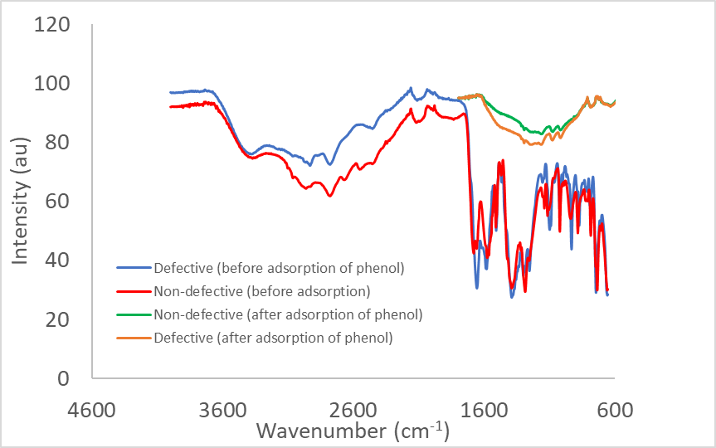

Figure 1: Fourier-Transform Infrared (FTIR) spectra of synthesized non-defective and defective UiO-66 metal-organic frameworks.

3.1.2 X-ray Diffraction (XRD) Analysis
X-ray Diffraction (XRD) analysis confirmed the preservation of the UiO-66 framework with a face-centered cubic topology in both non-defective and defective samples (Figure 2). The defective sample exhibited significant peak broadening and reduced intensity, consistent with decreased crystallite size and long-range order due to missing-linker and missing-cluster defects [11,13]. The absence of peak shifts confirms maintenance of the fundamental cubic structure while introducing structural vacancies that enhance porosity for adsorption applications [12].

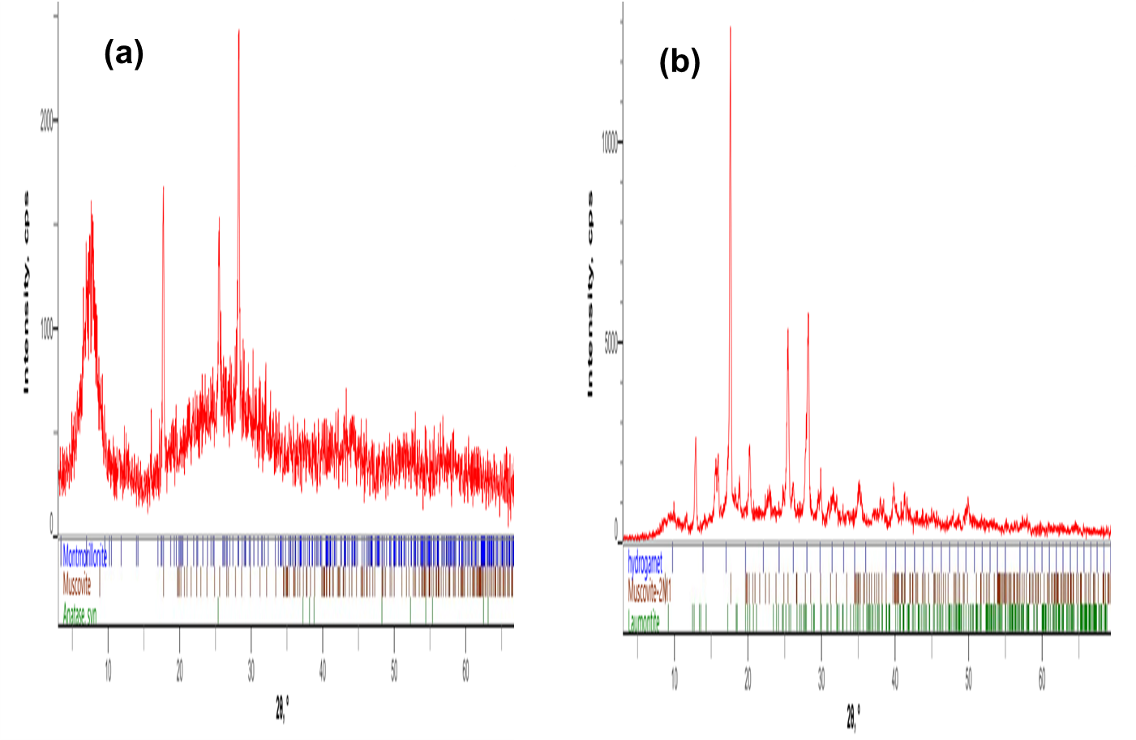

Figure 2. X-ray diffraction (XRD) patterns showing (a) non-defective UiO-66 and (b) defective UiO-66.
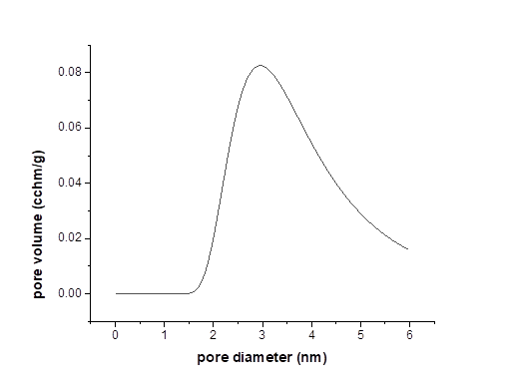
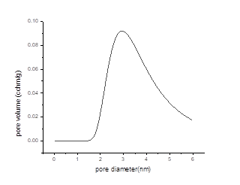
The pattern for the non-defective sample matches the simulated structure, while the defective sample shows significant peak broadening and reduced intensity, indicative of structural defects from missing linkers/clusters. Nitrogen physisorption at 77 K revealed that defect engineering induces a hierarchical pore structure in UiO-66 (Figure 3). While the non-defective sample exhibited a Type I(b) isotherm characteristic of microporous materials, the defective sample displayed a hybrid Type I/IV(a) isotherm with a distinct hysteresis loop, confirming mesoporosity generation [14].

(b)
(a)

Figure 3. Nitrogen adsorption-desorption isotherms at 77 K for (a) non-defective UiO-66 and (b) defective UiO-66. The defective sample exhibits a hybrid Type I/IV isotherm with a distinct hysteresis loop, indicating the creation of mesoporosity alongside microporosity, resulting in a significantly enhanced surface area and pore volume.
This textural modification resulted in a substantial increase in both BET surface area and total pore volume, attributed to missing-linker/cluster defects creating larger cavities. The resulting hierarchical porosity enhances phenol adsorption by providing improved molecular accessibility and diffusion pathways [15].

Scanning Electron Microscopy (SEM) revealed significant morphological alterations resulting from defect engineering in UiO-66 (Figure 4). The non-defective sample exhibited characteristic, well-faceted octahedral crystals with uniform size distribution, consistent with its high crystallinity [16]. In contrast, the defective sample showed a pronounced reduction in particle size, aggregation, loss of defined faceting, and substantial surface roughening. This morphological disruption directly reflects the introduction of missing-linker defects during modulated synthesis, which terminate regular crystal growth and create a more heterogeneous, nanostructured material [11, 17]. These structural changes correlate with enhanced external surface area and improved accessibility for adsorbate molecules.
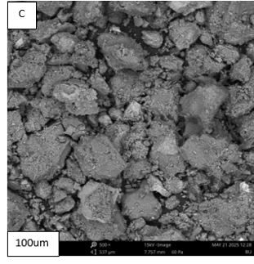
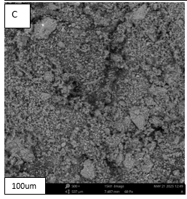
(a)
(b)

Figure 4. Scanning Electron Microscopy (SEM) images at 100 μm scale showing (a) non-defective UiO-66, exhibiting characteristic well-faceted octahedral crystals, and (b) defective UiO-66, showing a significant reduction in particle size, loss of defined morphology, and increased surface roughness due to the introduction of structural defects.
Differential Scanning Calorimetry (DSC) revealed that defect engineering measurably reduces the thermal stability of the UiO-66 framework (Figure 5). The defective sample exhibited a significantly lower onset temperature for framework decomposition compared to the highly stable non-defective counterpart. This decrease in thermal robustness is a direct consequence of missing-linker defects, which compromise the structural integrity by reducing network connectivity and creating localized weaknesses [11,17]. While this represents a material trade-off, the operational stability remains sufficient for aqueous-phase adsorption applications, where the enhanced porosity afforded by defects is the critical performance factor.
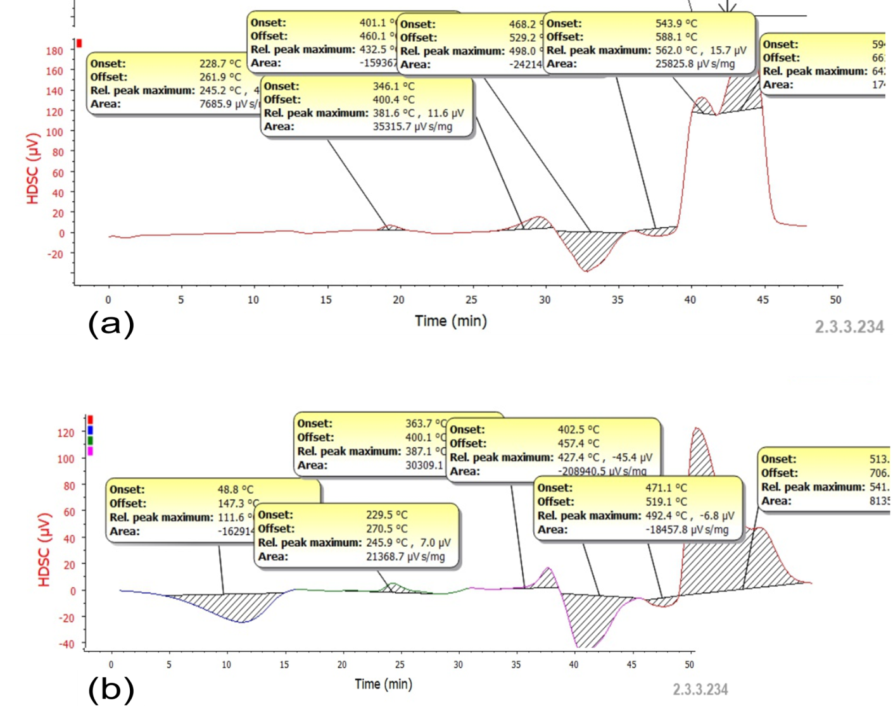
Figure 5. Differential Scanning Calorimetry (DSC) thermograms of non-defective and defective UiO-66. The defective sample shows a lowered onset temperature for framework decomposition, indicating reduced thermal stability due to the introduction of structural defects.
Differential Scanning Calorimetry (DSC) and Thermogravimetric Analysis (TGA) quantified the impact of defects on the thermal stability of UiO-66 (Figure 6). The defective framework undergoes structural changes at significantly lower temperatures. Its main decomposition exotherm shifts from 432.5 ° C (non-defective) to 402.5-457.4 °C, directly evidencing reduced thermal robustness due to missing-linker vacancies [11]. This is preceded by an endotherm at 229.5-270 °C, attributed to the removal of strongly bound solvent and the onset of node dehydroxylation (Zr₆O₄(OH)₄ → Zr₆O₆), a process that occurs at ~381.6 °C in the pristine framework. TGA confirms a multi-stage decomposition, where the final formation of thermally stable ZrO₂ occurs at a lower temperature for the defective sample while defect engineering lowers the decomposition onset, both materials demonstrate sufficient stability for aqueous-phase applications, with the defective structure collapsing completely by ~500 °C.

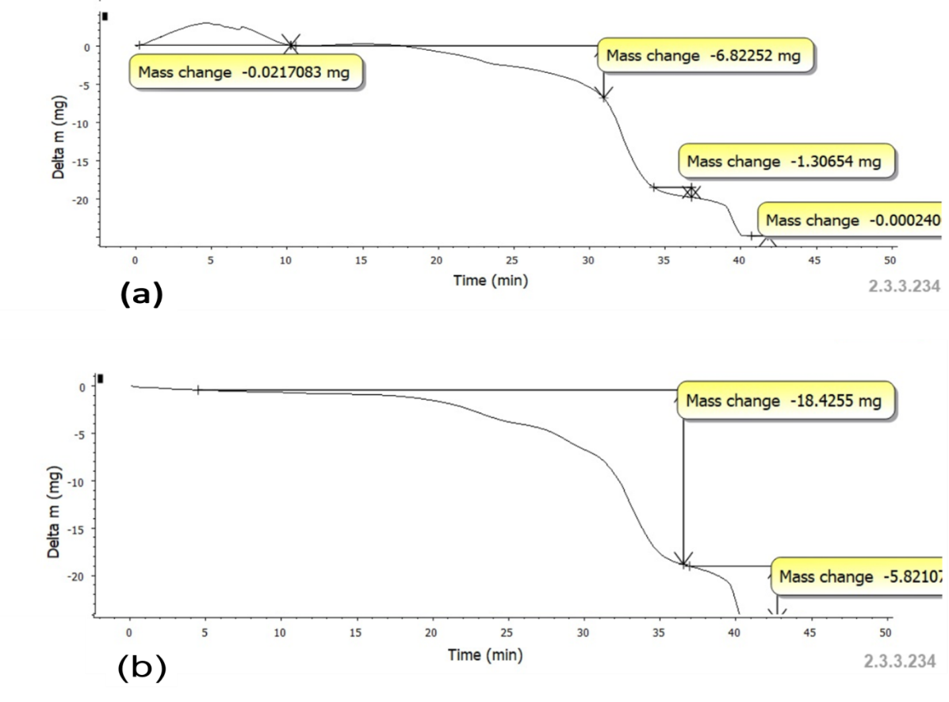
Figure 6. Thermogravimetric analysis (TGA) and differential scanning calorimetry (DSC) profiles of non-defective (a) and defective (b) UiO-66.
3.2. Batch Adsorption Studies
Batch adsorption studies demonstrated the high efficacy of both UiO-66 variants for phenol removal, with efficiencies consistently exceeding 95% under varied conditions (Tables 1-5). While the non-defect framework achieved slightly higher removal (~96.9%) at lower concentrations and reached equilibrium faster (30 mins), the defective framework exhibited superior performance at minimal adsorbent dosage (97.4% at 0.1 g) and its adsorption was enhanced at elevated temperatures, suggesting an endothermic process facilitated by its mesoporous defect structure [11]. Both materials showed maximal affinity for phenol in its protonated state, with peak efficiency observed at pH 1 [15]. The comparable overall performance, despite differing kinetics and thermal responses, confirms that both microporous and hierarchically porous UiO-66 are highly effective adsorbents.
Table 1
Effect of Initial Ion Concentration

Table 2
Effect of Adsorbent Dosage

Conc. (mg/L) | Defective UiO-66  % Removal | Non-Defect UiO-66  % Removal
10 | 95.7180 | 96.8669
20 | 95.6820 | 96.6051
30 | 95.6918 | 96.6231
40 | 95.69345 | 96.4676
50 | 95.70164 | 95.8620
Dosage (g) | Defective UiO-66  % Removal | Non-Defect UiO-66  % Removal
0.1 | 97.4283 | 96.6836
0.2 | 96.4545 | 96.0077
0.3 | 95.7720 | 95.8506
0.4 | 95.6493 | 95.8097
0.5 | 95.4856 | 95.7458

Temp. (°C) | Defective UiO-66  % Removal | Non-Defect UiO-66  % Removal
30 | 95.5396 | 96.0241
40 | 95.4872 | 95.8686
50 | 95.5511 | 95.9013
60 | 95.5183 | 95.9406
70 | 95.4381 | 95.8980
Time (mins) | Defective UiO-66  Table 4  Effect of Contact Time  % Removal | Non-Defect UiO-66  % Removal
30 | 95.5773 | 96.1321
60 | 95.6100 | 96.0421
90 | 95.6051 | 95.8800
120 | 95.6329 | 95.9439
150 | 95.6133 | 95.8751
Table 3
Effect of Temperature

pH | Defective UiO-66  Table 5  Effect of pH  % Removal | Non-Defect UiO-66  % Removal
1 | 98.6525 | 98.6182
3 | 95.5903 | 96.6951
5 | 95.6083 | 96.0568
7 | 95.6967 | 96.0241
9 | 95.6231 | 95.9291
11 | 95.6149 | 95.6525

3.3 Adsorption Isotherms: The adsorption equilibrium data were analyzed using several isotherm models, with the results summarized in Table 6. The Langmuir and Redlich-Peterson models provided an excellent fit (R² = 1.000) for both adsorbents, suggesting that phenol uptake occurs primarily via monolayer adsorption onto homogeneous surfaces. The high affinity constants further support a chemisorption-dominated process. The maximum adsorption capacity (Qmax) was slightly higher for the non-defect UiO-66 (4.93 mg/g) compared to the defective variant (4.87 mg/g), which is consistent with the marginally higher efficiency observed for the defect-free material in batch studies.
3.4 Kinetics Studies Kinetic modeling, detailed in Table 7, was employed to elucidate the adsorption rate and mechanism. The process was best described by the pseudo-second-order model, confirming that chemisorption, involving electron sharing or exchange between the phenol molecules and the MOF surface, is the rate-limiting step. This indicates strong chemical interactions, likely between the phenol molecules and the zirconium clusters or the organic linkers of the framework, govern the adsorption kinetics for both UiO-66 variants.

The kinetic data for phenol adsorption on UiO-66 frameworks (Table 7) reveal a complex mechanism dominated by surface chemisorption. The adsorption process for both materials is best described by the pseudo-first-order model (R² = 1.0000 and 0.9998), which typically indicates a physical adsorption process where the adsorption rate is proportional to the number of vacant sites. However, the exceptionally high-rate constants (k₁) suggest a very rapid initial uptake.

Table 6
Isotherm Parameters
Isotherms | Parameters | Values
 |  | Defective UiO-66 | Non-Defect UiO-66
Freundlich | R² | 1.0000 | 0.9981
 | n | -22.2700 | -26.3900
 | K_{F} (L/g) | 5.2626 | 5.2360
Langmuir | R² | 1.0000 | 1.0000
 | Qmax (mg/g) | 4.8661 | 4.9285
 | B (L/mg) | -0.0925 | -0.0670
Temkin | R² | 1.0000 | 0.9982
 | K_{T} (Lg⁻¹) | 9.9785 | 537,395
 | b (Jmol⁻¹) | -9937.4868 | -11711.6700
Reddlich-Peterson | ß | 1.0449 | 1.0379
 | A | 0.1900 | 0.1909
 | R² | 1.0000 | 1.0000
Jossen's 3P | F | 5.39×10⁹ | 2.72×10⁹
 | H | 0.2042 | 0.203
 | R² | 1.0000 | 0.9983
Conversely, the pseudo-second-order model, which is often indicative of chemisorption involving valence forces through sharing or exchange of electrons [18], yielded a poor fit (R² = 0.5644 and 0.9000). This discrepancy suggests that while chemisorptive interactions are present, the overall kinetics may be influenced by the highly microporous nature of UiO-66, where diffusion limitations can alter the expected kinetic profile.
Further analysis using the intraparticle diffusion model shows that the plots do not pass through the origin (Cᵢ ≠ 0), indicating that while pore diffusion is involved, it is not the sole rate-controlling step. The initial high Cᵢ values signify a significant contribution from boundary layer diffusion [19]. The multi-linear nature of the diffusion plots (not shown) implies that the adsorption occurs in multiple stages, beginning with rapid surface adsorption followed by a gradual intra-particle diffusion phase until equilibrium is reached. The superior fit of the Power Function model for the defective UiO-66 (R² = 0.9905) further underscores the heterogeneity of its surface sites introduced by missing-linker defects, leading to a more complex, multi-mechanistic adsorption process compared to the more uniform non-defect framework
3.5 Thermodynamic Studies
Thermodynamic analysis provides critical insight into the energy changes and spontaneity associated with the adsorption process. The parameters calculated for phenol adsorption on both UiO-66 variants are summarized in Table 8. The Gibbs free energy change (ΔG) was negative across the entire temperature range (303–343 K) for both adsorbents. This unequivocally confirms that the adsorption of phenol onto both defective and non-defect UiO-66 is a spontaneous process [20]. Furthermore, the increasing negativity of ΔG with rising temperature indicates that the spontaneity of adsorption is enhanced at higher temperatures for both materials.
Table 7
Parameters derived from kinetic models for phenol adsorption on UiO-66 frameworks.
Kinetic models and equation | Constant | Non-Defective | Defective
Pseudo-first-order | q_{e}(mg/g) cal.  k₁ (min⁻¹)  R² | 0.0058  0.0371  0.9998 | 1.7700  0.0354  1.0000
Pseudo-second-order | q_{e}(mg/g) cal.  k₂ ( g·mg⁻¹·min⁻)  R² | 5.0400  32.8300  0.5644 | 4.9300  0.095  0.9000
Intraparticle diffusion | C_{i}  K_{p} (mg·g⁻¹·min⁻¹/²)  R² | 5.0410  3 ×10⁻⁵  0.5570 | 5.2628  3 .8×10⁻²  0.9200
Elovich Kinetics | β  ɑ  C  R² | 100000  504.16  5.0416  0.6666 | 526.32  2767.35  5.2628  0.9301
Power Function | n  K  R² | 12.299  17.446  0.4579 | 20.111  28.077  0.9905
The enthalpy change (ΔH) was also negative, revealing the adsorption process is exothermic. The magnitude of ΔH offers insight into the adsorption mechanism. Values of -5.83 kJ/mol for defective UiO-66 and -10.58 kJ/mol for non-defect UiO-66 suggest that physical forces, such as van der Waals interactions and hydrogen bonding, are the primary mechanisms at play, as these typically fall in the range of 2.1–20.9 kJ/mol [21]. The more negative ΔH value for the defect-free framework points to stronger, more favorable adsorption interactions. This is likely attributable to its more uniform crystalline structure and homogeneous distribution of active sites, particularly the well-defined zirconium clusters, which provide consistent coordination environments for phenol molecules [10].
The entropy change (ΔS) was positive for both materials. An increase in entropy at the solid-liquid interface suggests a greater degree of disorder is generated during adsorption. This can be explained by the displacement of previously ordered water molecules or solvent from the MOF's pores upon the entry of a phenol molecule. The release of these solvating molecules into the solution, where they have more degrees of freedom, results in a net increase in the system's randomness, which drives the spontaneous process alongside the exothermic enthalpy change [22].
In conclusion, the thermodynamic data confirm that phenol adsorption is a spontaneous and exothermic process governed by physical interactions. The non-defect UiO-66 exhibits a more favorable enthalpy change, indicating stronger adsorbate-adsorbent interactions, while both materials display increased spontaneity at elevated temperatures

 | Defective UiO-66 |  |  | Non-Defect UiO-66
T (K) | ∆G (J/mol) | ∆H(J/mol) | ∆S(J/mol) | ∆G(J/mol) | ∆H(J/mol) | ∆S (J/mol)
303 | -51.4148 | -5.8306 | 6.6470 | -51.5507 | -10.5787 | 7.3953
313 | -52.9192 |  |  | -52.9029
323 | -54.4236 |  |  | -54.2551
333 | -55.9281 |  |  | -55.6073
343 | -57.4325 |  |  | -56.9595

Table 8
Thermodynamic Parameters

4.0 CONCLUSION
This study shows the effectiveness of both UiO-66 (Zr) metal-organic frameworks in removing phenol from aqueous solutions, achieving removal efficiencies over 95% under all tested conditions. Defective UiO-66 showed improved performance at optimal dosage and elevated temperatures due to the presence of defect-induced high-energy sites and larger pore openings. However, it required a longer contact time to reach equilibrium. In contrast, the non-defect UiO-66 achieved slightly higher removal rates at low concentrations, exhibited stronger adsorption energies, and reached equilibrium more quickly due to its uniform pore structure and broader energy distribution of active sites. Both types of MOFs displayed chemisorption and a mixture of monolayer and multilayer adsorption on heterogeneous surfaces, as indicated by fitting several isotherm models and adhering to pseudo-second-order kinetics. Thermodynamic analysis confirmed that the adsorption processes were spontaneous, exothermic, and entropy-driven in both cases. Defective UiO-66 is better suited for high-temperature applications requiring longer contact times, while non-defect UiO-66 is more appropriate for rapid treatments under ambient conditions. Both materials are effective advanced adsorbents for treating phenol-contaminated water, especially in acidic conditions where removal is optimized.

COMPETING INTERESTS DISCLAIMER:
Authors have declared that they have no known competing financial interests OR non-financial interests OR personal relationships that could have appeared to influence the work reported in this paper.

REFERENCES
- Busca, G., Berardinelli, S., Resini, C., & Arrighi, L. (2008). Technologies for the removal of phenol from fluid streams: a short review of recent developments. Journal of Hazardous Materials, 160(2-3), 265-288.
- Guo, M., Wang, J., Wang, C., Strong, P. J., Jiang, P., Ok, Y. S., & Wang, H. (2019). Carbon nanotube-grafted chitosan and its adsorption capacity for phenol in aqueous solution. Science of the Total Environment, 682, 340-347.
- Zhang, Y., Qin, L., Cui, Y., Liu, W. F., Liu, X. G., & Yang, Y. Z. (2020). A hydrophilic surface molecularly imprinted polymer on a spherical porous carbon support for selective phenol removal from coking wastewater. New Carbon Materials, 35(3), 220-231.
- Liu, B., Yang, F., Zou, Y., & Peng, Y. (2014). Adsorption of phenol and p-nitrophenol from aqueous solutions on metal–organic frameworks: effect of hydrogen bonding. Journal of Chemical & Engineering Data, 59(5), 1476-1482.
- Mohamed, M. H., Udoetok, I. A., Solgi, M., Steiger, B. G., Zhou, Z., & Wilson, L. D. (2022). Design of sustainable biomaterial composite adsorbents for point-of-use removal of lead ions from water. Frontiers in Water, 4, 739492.
- Chen, L., Pan, W., Li, K., Chen, M., Li, P., Liu, Y., ... & Lu, H. (2025). University of Oslo-66: A Versatile Zr-Based MOF for Water Purification Through Adsorption and Photocatalysis. Processes, 13(4), 1133.
- Xie, K., Shan, C., Qi, J., Qiao, S., Zeng, Q., & Zhang, L. (2015). Study of adsorptive removal of phenol by MOF-5. Desalination and Water Treatment, 54(3), 654-659.
- Nath, K., Wright, K. R., Ahmed, A., Siegel, D. J., & Matzger, A. J. (2024). Adsorption of natural gas in metal–organic frameworks: selectivity, cyclability, and comparison to methane adsorption. Journal of the American Chemical Society, 146(15), 10517-10523.
- Cho, K., Li, Z., & MacLachlan, M. J. (2024). Growth of metal organic frameworks on the surface of individual cellulose nanocrystals. Crystal Growth & Design, 24(4), 1792-1797.
- Katz, M. J., Brown, Z. J., Colón, Y. J., Siu, P. W., Scheidt, K. A., Snurr, R. Q., ... & Farha, O. K. (2013). A facile synthesis of UiO-66, UiO-67 and their derivatives. Chemical Communications, 49(82), 9449-9451.
- Shearer, G. C., Chavan, S., Bordiga, S., Svelle, S., Olsbye, U., & Lillerud, K. P. (2016). Defect engineering: Tuning the porosity and composition of the metal–organic framework UiO-66 via modulated synthesis. Chemistry of Materials, *28*(11), 3749–3761. https://doi.org/10.1021/acs.chemmater.6b00602
- Valenzano, L., Civalleri, B., Chavan, S., Bordiga, S., Nilsen, M. H., Jakobsen, S., Lillerud, K. P., & Lamberti, C. (2011). Disclosing the complex structure of UiO-66 metal–organic framework: A synchrotron powder diffraction study. Chemistry of Materials, *23*(7), 1700–1718. https://doi.org/10.1021/cm1022882.

- Cliffe, M. J., Wan, W., Zou, X., Chater, P. A., Kleppe, A. K., Tucker, M. G., ... & Goodwin, A. L. (2014). Correlated defect nanoregions in a metal–organic framework. Nature Communications, *5*(1), 4176. https://doi.org/10.1038/ncomms5176

- Thommes, M., Kaneko, K., Neimark, A. V., Olivier, J. P., Rodriguez-Reinoso, F., Rouquerol, J., & Sing, K. S. (2015). Physisorption of gases, with special reference to the evaluation of surface area and pore size distribution (IUPAC Technical Report). Pure and Applied Chemistry, 87(9-10), 1051–1069. https://doi.org/10.1515/pac-2014-1117.

- Fouladi, M., Amooey, A. A., & Ghasemi, S. (2021). Improved adsorption of phenol from aqueous solution by carbon-based adsorbents: A review. Journal of Environmental Chemical Engineering, 9(4), 105342. https://doi.org/10.1016/j.jece.2021.105342

- Cavka, J. H., Jakobsen, S., Olsbye, U., Guillou, N., Lamberti, C., Bordiga, S., & Lillerud, K. P. (2008). A new zirconium inorganic building brick forming metal organic frameworks with exceptional stability. Journal of the American Chemical Society, *130*(42), 13850–13851. https://doi.org/10.1021/ja8057953

- Wu, H., Chua, Y. S., Krungleviciute, V., Tyagi, M., Chen, P., Yildirim, T., & Zhou, W. (2013). Unusual and highly tunable missing-linker defects in zirconium metal–organic framework UiO-66 and their important effects on gas adsorption. Journal of the American Chemical Society, *135*(28), 10525–10532. https://doi.org/10.1021/ja404514r
- .
- Simonin, J. P. (2016). On the comparison of pseudo-first order and pseudo-second order rate laws in the modeling of adsorption kinetics. Chemical Engineering Journal, 300, 254–263. https://doi.org/10.1016/j.cej.2016.04.079
- Weber, W. J., & Morris, J. C. (1963). Kinetics of adsorption on carbon from solution. Journal of the Sanitary Engineering Division, American Society of Civil Engineers, 89(2), 31–59.
- Liu, Y. (2009). Is the free energy change of adsorption correctly calculated?. Journal of Chemical & Engineering Data, 54(7), 1981-1985.
- Zayyat, R. M., Yahfoufi, R., Al-Hindi, M., Kordahi, M. A., Ayoub, G. M., & Ahmad, M. N. (2024). Elucidating the dynamics of carbamazepine uptake using date pit-derived activated carbon: a comprehensive kinetic and thermodynamic analysis. Heliyon, 10(20).
- Ratkova, E. L., Palmer, D. S., & Fedorov, M. V. (2015). Solvation thermodynamics of organic molecules by the molecular integral equation theory: approaching chemical accuracy. Chemical reviews, 115(13), 6312-6356.

