Original Research Article

Design of electrochemical sensor for the detection of melamine in adulterated milk

.
ABSTRACT

A highly sensitive electrochemical sensor was designed through the modification of a gold electrode with silver nanoparticles capped by L-cysteine-functionalized carbon quantum dots. Cyclic voltammetry analysis of the gold electrode modified with these L-cysteine-functionalized carbon quantum dot-capped nanoparticles demonstrated significant electrochemical interaction with melamine, indicating the enhanced electrochemical activity.
The electrochemical interaction between the modified electrode and melamine was observed exclusively in sodium sulfate solution, with an enhanced response at a concentration of 0.1 M sodium sulfate, maintained at pH 7.5, and a scan rate of 50 mV/s during voltammetric cycling. Furthermore, pulsed differential voltammetry conducted under the optimized cyclic voltammetry conditions revealed a linear correlation in melamine detection using the modified electrode. This analytical study, performed over a melamine concentration range of 5 ng/mL to 50 ng/mL, established a limit of detection and a limit of quantification of 3.488 ng/mL and 11.627 ng/mL, respectively. Evaluation of the sensor’s performance parameters demonstrated a recovery rate ranging from 98% to 100% in the absence of interfering substances, and between 90% and 98% in a complex food matrix such as powdered milk, with relative standard deviations below 8%.

Keywords: electrochemical sensor; cCDs/AgNPs-modified gold electrode; Melamine; Detection; Food safety

1. INTRODUCTION

Melamine is a synthetic compound that was first synthesized in the 1830s and continues to be utilized in contemporary applications. It is predominantly employed as a key component in thermoplastics used for the production of a wide range of highly durable and extensively utilized products. There exists the potential for melamine to migrate from these industrial materials into foodstuffs in trace, non-toxic quantities (Skinner et al., 2010)
Moreover, melamine is extensively utilized as a fertilizer in agriculture due to its high nitrogen content and its characteristic slow mineralization rate. Owing to this slow mineralization, agricultural products may be vulnerable to melamine contamination if appropriate measures to eliminate melamine residues are not implemented (Qin et al., 2010). Recently, it has been established that certain sectors of the food industry have employed melamine as an additive to artificially enhance the non-protein nitrogen content of their products. A notable incident occurred in China in 2008, wherein over 294,000 children sought medical attention for urinary calculi following the consumption of powdered milk adulterated with melamine. Among these cases, 53,000 children were hospitalized, and six fatalities were reported (Xiu & Klein, 2010). In fact, infants secrete five to eight times more uric acid in their bodies, a potential factor predisposing them to the formation of melamine-urate stones. Thus, for safety reasons, many regulatory and standardization bodies have imposed restrictions on melamine in foods intended for infants and young children. In the USA, the FDA has set the tolerable daily intake (TDI) at 0.063 mg/Kg and the maximum level of melamine in food at 1 mg/Kg; The World Health Organization has adopted a TDI for melamine of 0.2 mg/kg; the European Food Safety Authority has imposed a TDI for melamine of 0.5 mg/kg; in Canada, the TDI for melamine is set at 0.2 mg/kg and the maximum tolerated level of melamine in food is set at 0.5 mg/kg (Skinner et al., 2010). In addition to these restrictions, there is a need for reliable and non-binding methods for monitoring melamine in food products that may contain melamine. Indeed, the literature contains a number of methods used to determine traces of melamine in food products. The most common methods are spectrophotometry (Chansuvarn et al., 2013), spectrofluorimetry (Othman, 2012), quenching of luminescence (Attia et al., 2011), gas chromatography-mass spectrometry (X. Xu et al., 2009), liquid chromatography-mass spectrometry (Filigenzi et al., 2007), high-performance liquid chromatography (Nong et al., 2014), fluorescence resonance energy transfer (Du et al., 2015), mid- and near-infrared spectroscopy (Mauer et al., 2009), and enzyme-linked immunosorbent assay (Lei et al., 2011). Most of these methods present numerous difficulties and constraints related to the rigor of the sample preparation steps, the use of expensive and sometimes toxic solvents, skilled and quality labor, or the complexity of the instrumentation. Therefore, the implementation of simple, inexpensive, rapid, selective and highly reliable techniques for the detection and quantification of traces of melamine in food products is required and highly necessary. In this regard, electrochemical techniques appear to be a promising alternative for the design of reliable methods for monitoring traces of melamine in food products. Thus, in this work, an electrochemical sensor was designed by modifying the surface of a gold electrode with silver nanoparticles capped with carbon quantum dots functionalized with cysteine ​​(cCDs/AgNPs). This sensor was used in Na₂SO₄ medium for the determination of traces of melamine. Furthermore, the designed electrochemical sensor exploits the high reactivity of cCDs/AgNPs based on the creation of strong hydrogen bonds between the electroactive polymer of melamine (pMelamine) and the carboxyl groups strongly present on the surface of cCQDs. This strong presence of hydrogen bonding could induce the adsorption of pMelamine and its ability to bind to the oxo-surface groups of the electrochemical sensor. To highlight the performance of the electrochemical sensor and the reliability of the analytical method: first, a cycle voltammetry study was carried out to define the optimal conditions and parameters for detecting traces of melamine; then, a pulsed differential voltammetry treatment made it possible to highlight the validation parameters of the designed method.

2. material and methods

2.1. Reagents
All chemicals were used without prior treatment. To carry out this work, silver nitrate (AgNO₃, 99%) was purchased from Scharlab S.L. (Spain), glycine (C₂H₅O₂N, 98%)) and cysteine (C₃H₇NO₂S, 98%) were acquired from Merck (Darmstadt in Germany), melamine (C₃H₆N₆ , 99%) was supplied by DAMAS-BETA, magnesium chloride (MgCl₂ , 99%), soluble starch ((C₆H₁₀O₅)_{n}, 90%) were obtained from CHEM-LAB (Belgium), aluminum sulfate (Al₂(SO₄)_{3,} 18H₂O, 99%), sodium sulfate anhydrous (Na₂SO₄ , 99%), iron sulfate (FeSO₄,nH₂O, 84%) were obtained from PROLABO (France), ascorbic acid (C₆H₈O₆, 99%), sulfuric acid (H₂SO₄, 95%), anhydrous calcium sulfate (CaSO₄, 98%) and anhydrous magnesium sulfate (MgSO₄, 98%) were provided by Chem-Lab (Belgium), magnesium oxide (MgO) was synthesized according to the protocol of Ghorbani et al. (Ghorbani et al., 2015); and lemon peel samples were obtained from the fruit purchased at the local market. All experiments were done using deionized (DI) water with a resistivity of 18.25 MΩ.cm. The pH was adjusted by using sulfuric acid solution (1M) and sodium hydroxide solution (1M).

2.2. Apparatus and electrochemical measurements
Melamine detection was achieved by combining two electrochemical methods. First, a cyclic voltammetry (CV) study was performed to define the optimal conditions and parameters for melamine detection; And, a differential pulsed voltammetry (DPV) study was performed to identify the validation parameters for the proposed detection method. These various studies, conducted at room temperature, were carried out using a MiniONE electrochemical workstation from the Chinese company MiniONE Instruments based in Shanghai. In these studies, the MiniONE workstation was installed on a conventional three-electrode system, including a modified gold electrode (cCDs/AgNPs/Au) used as the working electrode (d = 1 mm), in the presence of a saturated calomel electrode (SCE) and a platinum wire, which served as the reference and counter electrodes, respectively. Furthermore, the study of the effect of the pH of the electrolyte was made using the HI2211 pH-meter equipped with a platinum probe.

2.3. Fabrication of the cCDs/AgNPs/Au electrode
Synthesis of cCDs/AgNPs: The Cys-AgNPs nanostructures were synthesized following the previously reported method (Sylvestre et al., 2025). In this procedure, 250 µL of pre-prepared cCDs were dispersed in 200 mL of deionized water. Subsequently, 0.01 g of AgNO₃ was dissolved in the cCDs solution under continuous stirring. After complete dissolution of AgNO₃, 0.025 g of NaOH was added to the mixture, which immediately developed a yellow-brown coloration. The reaction system was then maintained at 65°C with gentle magnetic stirring for 5 hours to obtain the cCDs/AgNPs nanostructures.

Pretreatment of the Au electrode: Before using the Au electrode, the surface of the disc was polished with alumina (slurry diameter of 0.05 mm), followed by cleaning with DI water and then ethanol for two minutes at each step. Then, this electrode was electrochemically cleaned in a sulfuric acid solution (H₂SO₄, 1 M) for 60 s over a potential range of -500 mV to 0 mV.

cCDs/AgNPs/Au electrode fabrication: Following the physical, chemical, and electrochemical pretreatment of the bare Au electrode, it was rinsed one final time with deionized water prior to the deposition of cCDs/AgNPs on its surface. After the application of the cCDs/AgNPs colloidal solution, the modified gold electrode was dried at room temperature (28 °C). The resultant cCDs/AgNPs/Au electrode was subsequently employed for the electrochemical detection of melamine.

2.4. Electrochemical detection of melamine
2.4.1. Cyclic voltammetric (CV) study
This technique enabled the investigation of the behavior of the cCDs/AgNPs/Au electrode in the presence of melamine over a potential range from -500 mV to 1500 mV, determined by the electrode’s sensitivity to melamine, with a scanning rate fixed at 50 mV/s. The aim of this study was to identify the optimal electrolyte for the electrochemical detection of melamine and to determine key parameters that facilitate optimal detection. These parameters include the ideal concentration of the selected electrolyte, the number of cCDs/AgNPs deposits on the bare gold electrode surface to enhance modification, the optimal scanning rate, and the ideal pH of the electrolytic solution for effective detection.

2.4.2. Differential Pulsed Voltammetry (DPV) Study
This study, based on the results obtained from the cyclic voltammetry (CV) analysis, aims to evaluate specific validation parameters of the developed analytical method. In particular, the objective is to demonstrate the linearity and selectivity of melamine detection using the cCDs/AgNPs/Au electrode, as well as to assess the limits of detection (LOD) and quantification (LOQ), accuracy (expressed as recovery rate), and precision. All differential pulse voltammetry (DPV) measurements were conducted over a potential range from -500 mV to 0 mV, with a scan rate of 50 mV/s, a pulse time of 50 ms, a sampling time of 100 ms, a rest time of 2 s, and an amplitude of 100 mV. The melamine concentration range tested was between 5 ng/mL and 50 ng/mL.

2.5. Application in a food matrix
For the purposes of these studies, various powdered milk samples were artificially contaminated with melamine in the laboratory. An extraction protocol, based on the method proposed by Kumar et al., was subsequently applied, followed by detection using the newly developed cCDs/AgNPs/Au electrode. The detection was carried out by differential pulse voltammetry (DPV) in 25 mL of 0.1 M Na₂SO₄ solution at pH 7.5, containing one milliliter (1 mL) of the extract from each powdered milk sample.

3. results and discussion

3.1. Electrochemical behavior of cCDs/AgNPs/Au in Na₂SO₄ solution
The study of electrochemical behavior of cCDs/AgNPs/Au electrode by CV in 25 mL Na₂SO₄ solution (0.1 M, 5 < pH < 9) in the presence of melamine (0.24 µg/mL) with a scan rate of 50 mV/s in the spectrum of Fig.1.
In the Na₂SO₄ solution (Fig.1. a), the Au electrode presents six characteristic peaks including three oxidation peaks (-30 mV; 486 mV; 1100 mV) and three reduction peaks (-114 mV; 166 mV and 66 mV). In this configuration of the Au electrode, the -114 mV / -30 mV and 66 mV / 1100 mV peaks could correspond to surface redox reaction peaks but not detectable. And, the 166 mV / 468 mV peaks, representing the most important characteristics of the voltammetric cycle, could reflect the rapid loss of the most active Au atoms present on the surface of the Au electrode (Burke et al., 2003). Moreover, the fact that the I₁₆₆ peak of the Au electrode is more intense than that of the I₁₆₆ peak of the cCDs/AgNPs/Au electrode could justify the surface modification of the Au electrode by the cCDs/AgNPs. This cCDs/AgNPs layer would act as a surface protective layer preventing the unstable surface Au atoms. Moreover, Fig. 1.c and d which respectively describe the electrochemical behavior of the Au and cCDs/AgNPs/Au electrodes in the presence of melamine reveals a sensitivity of the cCDs/AgNPs/Au electrode with melamine unlike the bare gold electrode. Indeed, the cyclic voltammogram of the cCDs/AgNPs/Au electrode presents an obvious increase at the reduction peak at 166 mV and a weak modification of the oxidation peaks at 468 mV (Fig. 1.d). It is therefore evident that the presence of cCDs/AgNPs enhances the sensitivity of the Au electrode by initiating an electron transfer process in the said reaction medium according to the studies carried out by Kar, P., et al., (Kar et al., 2013). Thus, the new electrode (cCDs/AgNPs/Au) emits an electrochemical response in the presence of melamine in the neutral medium Na₂SO₄. Indeed, Guan-Ping has shown that in a neutral aqueous medium, melamine can undergo electropolymerization to give a very electroactive product (Guan-Ping et al., 2011). Moreover, this electropolymerization of melamine necessarily requires the presence of traces of an active chlorine species (Cl , ClOH, ClO ̶ ,…) (S. Chen et al., 2018). Thus, the neutral medium Na₂SO₄ with a proportion of 0.001% chlorine was chosen as the ideal electrolytic medium for the detection of melamine using the cCDs/AgNPs/Au electrode. Under this condition, trace chlorine will have almost no effect on the cCDs/AgNPs present on the surface of the Au electrode.
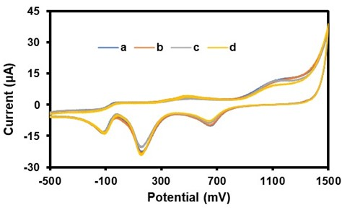
Fig. 1. Cyclic voltammograms of bare Au and cCDs/AgNPs/Au in Na₂SO₄ solution. (a) bare Au and (b) cCDs/AgNPs/Au without melamine; (c) bare Au and (d) cCDs/AgNPs/Au with melamine (2.4 µg/mL).
3.2. Optimization of Melamine Detection Conditions
To define optimal conditions for melamine detection in Na₂SO₄ solution using the cCDs/AgNPs/Au electrode, optimization studies of certain performance parameters using cyclic voltammetry were conducted. These were the electrolyte concentration (Na₂SO₄), the number of cCDs/AgNPs deposits on the Au electrode surface, the scanning speed during the tests, and the pH of the electrolyte solution. For each of these studies, the melamine concentration in the reaction medium was set at 0.240 µg/mL.

3.2.1. Effect of Na₂SO₄ Solution Concentration
In the presence of melamine, a study was conducted to determine the optimal concentration of the electrolytic solution using the cCDs/AgNPs/Au electrode. For this study, seven different Na₂SO₄ concentrations in the range from 0.005 M to 0.200 M were considered with a scan rate set at 50 mV/s. The results of this study are presented in Fig. 2 :
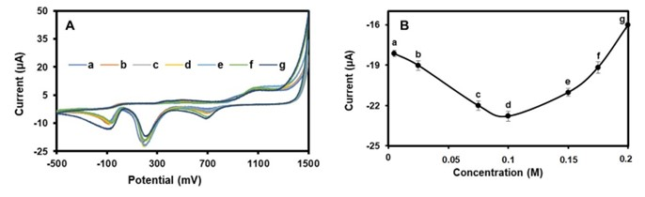
Fig. 2. A) Cyclic voltammograms of different concentrations of Na₂SO₄ solution (a) 0.005 M, (b) 0.025 M, (c) 0.075 M, (d) 0.1 M, (e) 0.150 M, (f) 0.170 M and (g) 0.2 M. B): Trend curve of Na₂SO₄ concentrations as a function of reduction current.

The spectra obtained by CV present the evolution of the characteristic peak of the reduction current as a function of the variation of the Na₂SO₄ concentration (Fig. 2.A). Moreover, the trend curve linking each concentration of Na₂SO₄ to its current peak shows that the maximum value of the reduction current peak is obtained for the 0.1 M concentration (Fig. 2.B). Thus, the 0.1 M Na₂SO₄ solution is the reaction medium favorable to a more intense formation of the electroactive derivative of melamine because of the strong presence of the active species of chlorine. Moreover, at this concentration, the formation of hydrogen bonds becomes increased between the electroactive derivative of melamine and the cCDs/AgNPs/Au electrode via the hydroxyl, carbonyl, carboxyl or even amino groups present on the surface of the cCDs/AgNPs. This strong presence of hydrogen bonds could induce an intensification of electron transfers at the origin of the increase in the reduction current at the cCDs/AgNPs/Au electrode. It follows from this study that at 0.1M Na₂SO₄, the electrochemical activity between melamine and the cCDs/AgNPs/Au electrode is optimal.

3.2.2. Effect of the number of cCDs/AgNPs deposits on the gold electrode
In this study, the surface of the gold electrode was successively coated with a number of cCDs/AgNPs deposits ranging from 1 to 3. Then, after drying at room temperature, the electrochemical behavior of the cCDs/AgNPs/Au electrode was studied in the presence of melamine in a 0.1 M Na2SO4 solution. Fig. 3 presents the results of this study.
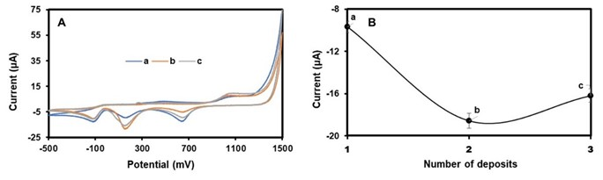
Fig. 3. A) Cyclic voltammograms for (a) 1 deposit, (b) 2 deposits and (c) 3 deposits of cCDs/AgNPs on the surface of the Au electrode; B) Trend curve of the number of cCDs/AgNPs deposition as a function of the maximum peak of the associated reduction current.

As can be seen in (Fig. 3.A, b) the peak of the reduction current is maximum for a modification made with two deposits of cCDs/AgNPs on the surface of the Au electrode. It is therefore very likely that with two deposits of cCDs/AgNPs, the electrochemical response of the cCDs/AgNPs/Au electrode seems to be more intense because of the increased availability of active sites which can strengthen the transfer of electrons in the reaction medium (Fig. 3.B). In addition, it is possible that beyond two deposits, congestion of active sites can reduce the performance of the cCDs/AgNPs/Au electrode translated by a shoulder present on the spectrum corresponding to three deposits (Fig. 3.A, c). Therefore, we opted for a two-layer deposition of cCDs/AgNPs for the fabrication of the working electrode (cCDs/AgNPs/Au) in a 0.1 M Na₂SO₄ solution.

3.2.3. Effect of Scanning rate
A study was conducted to determine the optimal scanning speed and to better understand the electroreduction process undergone by melamine in Na₂SO₄ medium in the presence of the designed cCDs/AgNPs/Au electrode. For this study, seven scanning speeds in the range 50 mV/s - 200 mV/s were chosen. Fig. 4 presents the evolution of the CV spectrum for seven selected scanning speeds.
From this study, we find that the increase in the scanning speed is accompanied by a decreasing shift in the potential (E) and with an increase in the reduction current (i_{red}).
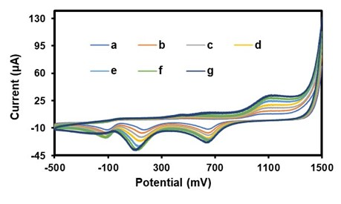
Fig. 4. Cyclic voltammograms of the cCDs/AgNPs/Au electrode for different scanning speeds (a) 50 mV/s, (b) 75 mV/s, (c) 100 mV/s, (d) 125 mV/s, (e) 150 mV/s, (f) 175 mV/s and (g) 200 mV/s in 0.1 M Na₂SO₄ solution in the presence of melamine (0.24µg/mL)

From these two parameters, it is possible to develop approaches to define the reversibility and the type of control (adsorption or diffusion) governing the reactions of melamine in the Na₂SO₄ medium in the presence of the cCDs/AgNPs/Au electrode. Indeed, by establishing the mathematical relationships between the reduction current (i_{red}) and the scanning speed (v) through the equations i_{red} = f(v^{1/2}) and ln(i_{red}) = ln(v), it is possible to deduce the type of control that governs the movement of melamine towards the cCDs/AgNPs/Au electrode in the reaction medium. Thus, Fig.5 presents the shape and the relationship obtained in each case.
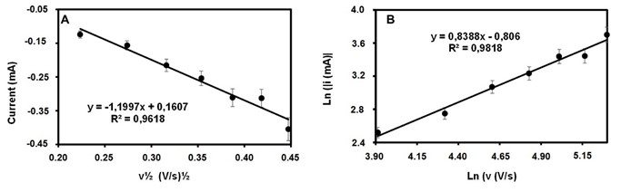
Fig. 5. A) Dependence of the reduction currents (I_{red}) on the square root of the scanning speed (v^{1/2}), B): Dependence of the logarithm of the absolute value of the reduction current on the logarithm of the scanning speed
As shown in Fig. 5.A, the graph representing the relationship ired = f(v^{1/2}) is linear with a correlation coefficient R² = 0.981. In addition, the graphical representation of the reduction current as a function of the square of the scanning speed is defined by the equation:
I_{red} = - 1.199 v^{1/2} + 0.1607 (E.1)
While Fig.6B displays the representative graph of the relation ln(i_{red}) = ln(v), also linear (R² =0.9919) and defined by the equation:
Ln(|i_{red}|) = 0.8388Ln(v) - 0.806 (E.2)

According to equation (E1), the slope (|-1.199|) closer to 1, indicates a reaction controlled by an adsorption process at the cCDs/AgNPs/Au – Na₂SO₄ interface. Similarly, the slope (0.8388) of equation (E.2) close to 1 corroborates the fact that the reaction of melamine in the medium is controlled by an adsorption process. This result obtained is similar to that deduced by Zhe Ji and collaborators (Ji et al., 2017). Furthermore, the reversibility of this adsorption reaction undergone by melamine in the medium can be deduced through the graphs E = f(v) and E = f(ln(v)). The representative results of the two graphs are presented in Fig.6:
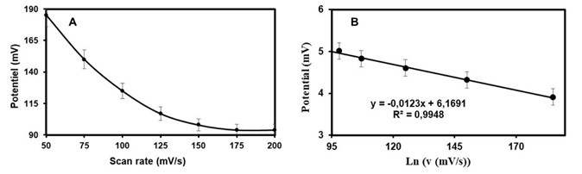
Fig. 6. A) Dependence of the potential on the scanning speed, B): Dependence of the potential on the logarithm of the scanning speed

Fig. 6.A shows the trend of the potential evolution as a function of the scanning speed. The shape of this trend curve indicates that the potential depends on the scanning speed with a strong linearity (R² = 0.9948) between the potential and the logarithm of the scanning speed (Fig. 6.B). According to the literature, only in reversible electrochemical phenomena is it possible to have a potential independent of the scanning rate (Kamyabi & Aghajanloo, 2008) ; (Novak, 2022). Thus, the adsorption-controlled reaction at the cCDs/AgNPs/Au-Na₂SO₄ electrode interface is carried out following an irreversible process. In order to avoid any overload at our working electrode, the scanning speed of 50 mV/s was adopted as the optimal scanning speed for two-layer cCDs/AgNPs deposits on the surface of the gold electrode for the detection of melamine in 0.1 M Na₂SO₄.
3.2.4. Effect of pH variation
Like the scanning speed, the pH of the reaction medium is an important parameter for understanding the reaction mechanism that melamine could undergo with the cCDs/AgNPs/Au electrode. For this study, eight pHs were chosen over the range of 5.0 to 11.5. Representative results are summarized in Fig. 7.
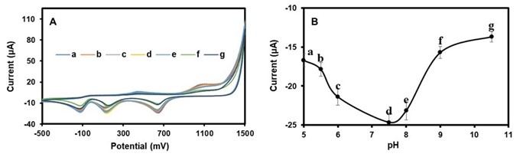
Fig. 7. A) Cyclic voltammogram of the cCDs/AgNPs/Au electrode for different values ​​(a) pH5, (b) pH5.5, (c) pH6, (d) pH7.5, (e) pH8, (f) pH9, (g) pH10.5, (h) pH11.5 in a Na₂SO₄ solution (0.1 M) in the presence of melamine (0.24 µg/mL), B) pH curve as a function of current

As we can see in Fig. 7A, the reduction current reaches its maximum value at pH =7.5 with a decreasing shift of the potential (E). Furthermore, the study of the transfer of electrons and protons is done by establishing the relationships E = f(pH) and E1/2 = f(pH), allowing to determine the number of protons and electrons exchanged by melamine with the reaction medium and the cCDs/AgNPs/Au electrode. Fig.9 represents the results obtained from this study.
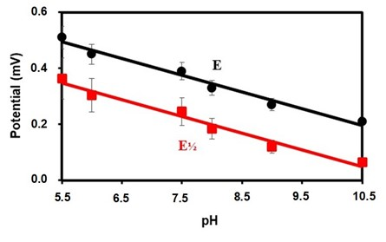
Fig. 8. Effect of pH on potential (E) and half-wave potential (E_{1/2})
Thus, the graphs of dependence of the potentials E and E_{1/2} with the pH (Fig. 9) reveal two linear plots with the equations:
E = 0,08462 -0,0617pH with R² = 0,9799 (E.3)

E_{1/2} = 0,7010 – 0,0619pH with R² = 0,9787 (E.4)

Considering Nernst's law translated by the relation:

E = E⁰ - 0,059(m/n)pH (E.5)

Where the parameters m and n represent respectively the number of protons and electrons exchanged. By relating equation (E.5) to equations (E.3) and (E.4), the ratios (m/n) give 1.045 for E and 1.049 for E_{1/2}. The fact that the ratios (m/n) are very close 1 reflects an equality between the parameters m and n. Thus, the electrochemical reaction between melamine and the cCDs/AgNPs/Au electrode is governed by a transfer of the same number of electrons and protons. This particularity of the electron-proton exchanges makes it possible to translate the mechanism of the electropolymerization reaction of melamine in the presence of active chlorine; as well as that of interaction with the cCDs/AgNPs/Au electrode:
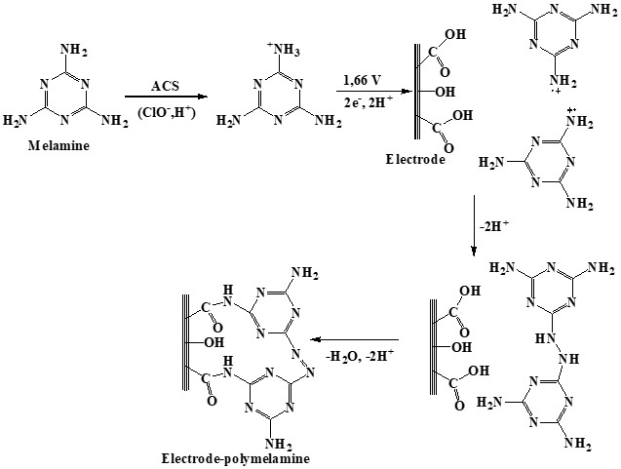
Fig. 9: Probable pathway of melamine electropolymerization (Kanagavalli et al., 2023)
3.3. Validation of the Melamine Detection Method
This part of the work focused on certain validation parameters applied to the designed analytical method. These parameters included: linearity, limits of detection (LOD) and quantification (LOQ), accuracy (or recovery rate), precision, and selectivity. These validation studies were conducted using the Differential Pulse Voltametry (DPV) technique under optimal melamine detection conditions with the cCDs/AgNPs/Au electrode in 0.1 M Na₂SO₄.

3.3.1. Linearity Study
In order to demonstrate the linearity of the implemented detection method, a calibration study was conducted in the range 0.5 ng/mL to 50 ng/mL. For this study, ten (10) different melamine concentrations were considered. Representative results are summarized in Fig. 10:
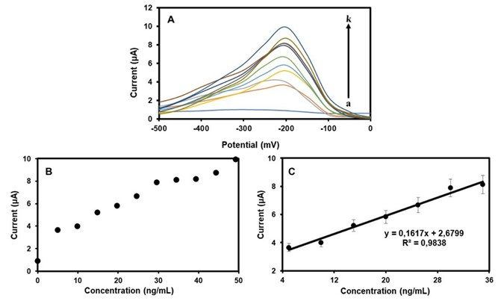
Fig. 10. A) DPV for (a) 00 ng/mL, (b) 05 ng/mL, (c) 10 ng/mL, (d) 15 ng/mL, (e) 20 ng/mL, (f) 25 ng/mL, (g) 30 ng/mL, (h) 35 ng/mL, (i) 40 ng/mL, (j) 45 ng/mL and (k) 50 ng/mL of melamine in 0.1M Na₂SO₄ in the presence of the cCDs/AgNPs/Au electrode, B) and C) Correlations between current and melamine concentration

Fig. 10.A shows the evolution of the DPV spectra of the current with the increase in the concentration of melamine in the detection medium. The observation is that the current seems to increase linearly with the concentration of melamine. Moreover, this hypothesis is confirmed by the extrapolation of the results of Fig. 10.B and 10.C which made it possible to obtain an equation defined by the expression:
i (µA) = 0,1617C (ng/mL) + 2,6799 with R² = 0,9838

So, the implemented detection method has good linearity (R² = 0.9838). And this result is corroborated by literature (X. Liu et al., 2017). Using the slope (S) and standard deviation of deviation (s) of the calibration curve (E.7), the value obtained by calculation for the detection limit is 3.488 ng/mL and 11.627 ng/mL for the quantification limit. However, according to certain regulatory agencies working in the field of food safety, such as the FDA (Food and Drug Administration) in the USA, the recommended limit for excess melamine is 1 µg/mL in dairy foods for infants and 2.5 µg/mL for other individuals. As for the World Health Organization (WHO), it has set the limit for excess melamine at 0.2 µg/ml in dairy products (Ingelfinger, 2008). In the context of our work, the detection limit obtained is well below the limit values ​​adopted by the FDA and the WHO. And, given that in Côte d'Ivoire and in many countries in sub-Saharan Africa, legislation and analyses aimed at providing evidence of the presence of melamine in dairy products are very weak, the popularization of our work will therefore be a relief for many countries in sub-Saharan Africa (Akinyemi et al., 2021).

3.3.2. Detection Method Accuracy Study
To demonstrate the reliability of the designed detection method, a study was conducted to evaluate the cCDs/AgNPs/Au electrode's ability to recover melamine of known concentrations. This study involved the analysis of six melamine standard solutions with concentrations ranging from 0 to 50 ng/mL. The results are summarized in Table 1. It appears from this study that the melamine recovery rates by the cCDs/AgNPs/Au electrode vary between 98.2% and 100.8%. Therefore, the cCQDs/AgNPs/Au electrode has an excellent melamine recovery capacity which confirms the reliability of the analytical method.

Table 1. Recovery rates in different melamine solutions (n ​​= 3)
Added (ng/mL) | Found (ng/mL) | Recovery (%)
07.3 | 07.28 | 099.7 ± 1.9
12.3 | 12.08 | 098.2 ± 2.4
17.2 | 17.02 | 098.9 ± 2.3
22.2 | 22.04 | 099.3 ± 3.5
27.0 | 27.18 | 100.7 ± 1.9
32.0 | 32.25 | 100.8 ± 2.4

3.3.3. Detection Method Accuracy Study
Following the optimized parameters, the accuracy of the designed detection method was evaluated through intra-/inter-day detection tests. This study aimed to evaluate the relative standard deviation (RSD) of the intra-day and inter-day detection tests of melamine. And for this study, the six melamine concentrations chosen for the accuracy study were repeated. Table 2 presents the summary of the results obtained :

Table 2. Relative Standard Deviation (RSD)
Added (ng/mL) | Found (ng/mL) |  |  | RSD (%)
 | Intra-day ± SD | Inter-day± SD |  | Intra-day | Inter-day
07.3 | 07.29 ± 0.31 | 07.30 ± 0.31 |  | 4.2 | 4.2
12.3 | 12.11 ± 0.96 | 12.06 ± 0.31 |  | 7.9 | 2.6
17.2 | 17.06 ± 1.20 | 17.00 ± 0.26 |  | 7.0 | 1.5
22.2 | 22.05 ± 0.98 | 22.10 ± 0.85 |  | 4.4 | 3.8
27.0 | 27.10 ± 1.57 | 27.19 ± 0.16 |  | 5.8 | 0.6
32.0 | 32.09 ± 1.65 | 32.09 ± 2.32 |  | 5.1 | 7.2

This study shows that the RSD for intra-day detection tests varies between 4.2% and 7.9%; while that for inter-day detection tests vary between 0.6% and 7.2%. Thus, the detection of melamine using the cCDs/AgNPs/Au electrode has an overall RSD of less than 8%. This result therefore confirms the good accuracy of our method and its usability for the control and prevalence of melamine under the conditions established by our work.

3.3.4. Detection Method Selectivity Study
The performance of the designed detection method is closely related to its ability to respond to melamine in a charged medium. Based on this principle, the cCDs/AgNPs/Au electrode was used to detect and quantify melamine in the presence of interfering potentials commonly used to fortify commercial powdered milk. These interferents included inorganic compounds (Na₂SO₄, FeSO₄, CaSO₄, MgSO₄), protein-like substances (glycine, cysteine) or carbohydrate-like substances (starch), and vitamins (ascorbic acid (Vit C)). For this study, each of these interferents was added at a concentration 10 times higher than that of melamine. Representative results are summarized in CHART 1:
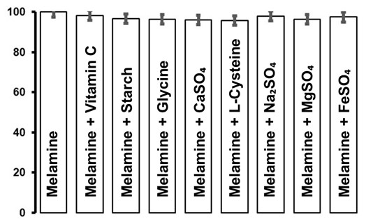
CHART. 1. Selectivity of the cCDs/AgNPs/Au electrode in the detection of 1 µg/mL of melamine in the presence of 10 µg/mL of interferent

Overall, the melamine recovery rate by the cCQDs/AgNPs/Au electrode in this charged medium varies between 95% and 100%, demonstrating the performance of the method. However, in the presence of ascorbic acid (97.9%) or starch (97.95%) or glycine (98.84%) or cysteine ​​(95.65%), the melamine recovery rate by the cCDs/AgNPs/Au electrode appears slightly impacted. This effect is explained by the fact that, firstly, in the presence of ascorbic acid, the hydroxyl groups ( ̶ OH) bind to melamine by the amine functions ( ̶ NH2) through strong hydrogen bonds (Li et al., 2012). This characteristic of ascorbic acid tends to reduce the availability of melamine and thus interferes with its detection. Second, in the presence of starch, melamine is able to release nitrogen in the form of ammonia by relying on the strong hydrogen bonds between the hydroxyl groups of starch and the amine functions of melamine (Giroto et al., 2019). In addition, starch has the ability to associate with melamine to form the resin via strong hydrogen bonds (Amanda S. Giroto et al., 2020). All these parasitic effects of starch impact the detection of melamine by the cCDs/AgNPs/Au electrode. Third, it is possible that under certain pH conditions (pH > 7), glycine is able to associate with melamine to form a glycine-melamine network acting as an oxygen reduction However, the absence of ferric ion (Fe³⁺) reduces the parasitic nature of this network during melamine detection. Fourth, cysteine, unlike glycine, has an organothiol group (R-SH₂) in its structure that can impact the stability of cCDs/AgNPs present on the surface of the gold electrode (Siriwardana et al., 2015). This effect has the ability to deactivate the active sites available at the cCDs/AgNPs/Au electrode, thus reducing its melamine detection capacity (Toh et al., 2014).
Concerning inorganic interferents (CaSO₄, MgSO₄, Na₂SO₄ and FeSO₄), frequently encountered in commercial powdered milk, our work presents very low interference of these substances in the detection of melamine by the cCDs/AgNPs/Au electrode. This result is similar to some works in the literature (Gaucheron, 2005). However, the presence of Fe³⁺ and Fe²⁺ ions in powdered milk suspected of containing melamine is considered because these ions have high sensitivity with cCDs/AgNPs. In summary, the cCDs/AgNPs/Au electrode shows good selectivity for melamine, however, it is necessary to perform melamine extraction before any detection in commercial powdered milk.

3.3.5. Reusability of the cCDs/AgNPs/Au Electrode
To demonstrate the reusability of the cCDs/AgNPs/Au electrode, a detection series of five (05) tests was carried out under optimal melamine detection conditions. For each detection series, the melamine concentration was set at 0.246 µg/mL. In this study, the objective was to determine the recovery rate and the relative standard deviation for each test. During the process, the surface of the cCDs/AgNPs/Au electrode was washed with ultrapure water, then with ethanol before being dried for the next test. Table 3 shows representative results for each detection series.

Table 3. Recovery rate and relative standard deviation for a series of 5 tests
Essai | Added (ng/mL) | Found (ng/mL) | Recovery (%) | RSD % (n = 3)
01 | 0.246 | 0.2457 ± 0.0043 | 99.9 | 1.7
02 | 0.246 | 0.2402 ± 0.0218 | 97.6 | 9.1
03 | 0.246 | 0.2394 ± 0.0044 | 97.3 | 1.8
04 | 0.246 | 0.2453 ± 0.0175 | 99.7 | 7.1
05 | 0.246 | 0.2414 ± 0.0087 | 98.1 | 3.6

This study shows that for all five tests, the recovery rate ranges between 97% and 99%, with a relative standard deviation ranging from 1.8% to 9.1%. Overall, the cCDs/AgNPs/Au electrode exhibits an excellent recovery rate with an RSD of less than 10%. Thus, the reusability of the cCDs/AgNPs/Au electrode is confirmed for to melamine detection tests under the conditions established in this work.

3.3.6. Detection of melamine in a real environment
The new cCDs/AgNPs/Au electrode was used to determine traces of melamine in powdered milk extracts. To do this, five samples of powdered milk (Bonnet Rouge, Nido, Lait en Poudre (Lp), Laity, and Top-Lait), widely marketed on national and international markets, were recollected, then were contaminated in the laboratory (5 mg melamine added to 2.5 g milk powdered, or 2 mg/g) for the purposes of this study. The detection of melamine was done using the liquid extracts of each of the powdered milk samples mentioned above. Fig. 11 presents the results of this study.
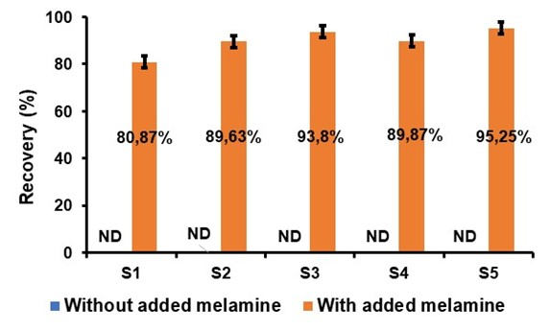
Fig. 11. Melamine recovery diagram in different milk powder samples with S1: extract from Bonnet rouge sample, S2: extract from Nido sample, S3: extract from Lait en Poudre Lp sample, S4: extract from Laity sample and S5: extract from Top-Lait sample

This study shows that the powdered milks present on the Ivorian market and subjected to the detection test do not contain any traces of melamine. This result provides proof of the credibility of the various manufacturers and suppliers of powdered milk in Côte d'Ivoire and the good quality of the powdered milk made available to consumers. Furthermore, in the event of accidental or intentional contamination of these powdered milks with melamine, the method implemented by this work is capable of revealing its presence and assessing its quantity with a recovery rate of between 90% and 98%. Thus, the proposed method is a promising alternative for monitoring and prevalence of melamine contamination. However, it is necessary to establish legislation to restrict the addition of certain vitamins such as vitamins A and D whose hydroxyl or carboxyl groups could interfere with the detection process and reduce the recovery capacity of the proposed method; or vitamins B2 (C₁₇H₂₀N₄O₆) and B12 (C₆₃H₈₈CoN₁₄O₁₄P), whose structures contain nitrogen atoms that could be used as a shield to cover the presence of melamine by reducing the sensitivity of the cCDs/AgNPs/Au electrode.
3.3.7. Comparative Study
To reaffirm the reliability of the melamine detection method implemented, a comparative study was conducted with other melamine detection methods already made public and validated by the scientific community. This comparative study is summarized in Table 4 :

Table 4. Comparison with other published methods for the detection of melamine
Electrode | Plage de Conc. | LOD* | Reference
pCAF-GCE | 1.0x10⁻⁸ – 1.0x10⁻³ M | 163.96 µg/L | (Xue et al., 2014)
OMC/GCE | 1.0x10⁻⁸ – 2.0x10⁻⁵ M | 0.252 µg/L | (Guo et al., 2018)
Au@PANI/GCE | 1.0x10⁻¹¹ – 1.0x10⁻⁵ M | 1.75x10⁻⁴ µg/L | (Rao et al., 2017)
MIP/GCE | 4.0x10⁻⁶ – 4.5x10⁻⁴ M | 45.4 µg/L | (Y. T. Liu et al., 2011)
GCE | 1.0x10⁻⁸ – 2.0x10⁻⁵ M | 0.189 µg/L | (Li et al., 2012)
AuNPs/rGO/GCE | 5.0x10⁻⁹ – 5.0x10⁻⁸ M | 0.126 µg/L | (N. Chen et al., 2015)
d(T)₂₀/Au | 3.9x10⁻⁸ – 3.5x10⁻⁷ M | 1.21 µg/L | (Cao et al., 2009)
DMEs | 1.0x10⁻⁶ – 6.6x10⁻⁵ M | 37.84 µg/L | (Yilmaz & Yazar, 2012)
MIPs/GCE | 6.3x10⁻⁷ – 1.1x10⁻⁴ M | 8.58 µg/L | (G. Xu et al., 2014)
cCDs/AgNPs/Au | 4.0x10⁻⁹ – 4.0x10⁻⁶ M | 3.488 µg/L | This work

It follows from this study that the detection method proposed by this work proves to be an advantageous alternative due to the simplicity of design of the cCDs/AgNPs/Au electrode and application of the method. In addition, the limit of detection (LOD) obtained is in the order of magnitude of the methods already proposed and validated. It even proves to be lower than the LOD of some of them. Furthermore, the method implemented does not require any derivatization and contributes to sustainable development through its green analytical character based on the recovery of lemon zest, waste from agriculture. In addition, this fast and efficient method is based on an electrochemical sensor, highly sensitive and selective, easy to design at low cost.

4. Conclusion

In the search for new green analytical methods, the cCDs/AgNPs/Au electrode was designed and used for the detection and quantification of melamine in aqueous media. The performance of this electrode is linked, on the one hand, to the strong presence of carboxyl groups on the surface of cysteine-functionalized carbon quantum dots (cCDs), whose reactivity is enhanced by the presence of silver nanoparticles (AgNPs); and, on the other hand, to the stability of the cCDs/AgNPs nanocomposite on the surface of the gold electrode (Au electrode) in sodium sulfate (Na₂SO₄) media. The detection limit of this method under optimal detection conditions is 3.488 ng/mL, of the same order of magnitude (or even lower) as those of other proposed, validated, and frequently used methods for melamine detection. This LOD, lower than the limit values ​​imposed by certain international (WHO) and national (USFDA) institutions in milk and milk products for infants and young children, suggests that the method implemented can also be used on a large scale for the detection and quantification of melamine. Thus, this method appears to be a reliable alternative in the fight against food insecurity through the monitoring of melamine fraudulently used as an additive in powdered milk in order to improve its non-protein nitrogen content. In addition, the low cost, simplicity of implementation, high sensitivity and excellent reproducibility make it a method of choice to prevent the world from another scandal related to the consumption of powdered milk contaminated by the addition of melamine.

COMPETING INTERESTS DISCLAIMER:
Authors have declared that they have no known competing financial interests OR non-financial interests OR personal relationships that could have appeared to influence the work reported in this paper.

References

Akinyemi, M. O., Ayeni, K. I., Ogunremi, O. R., Adeleke, R. A., Oguntoyinbo, F. A., Warth, B., & Ezekiel, C. N. (2021). A review of microbes and chemical contaminants in dairy products in sub-Saharan Africa. Comprehensive Reviews in Food Science and Food Safety, 20(2), 1188‑1220. https://doi.org/10.1111/1541-4337.12712
Amanda S. Giroto, Rodrigo H.S. Garcia, Luiz A. Colnago, Artur Klamczynski, Greg M. Glenn, & Caue Ribeiro. (2020). Role of urea and melamine as synergic co-plasticizers for starch composites for fertilizer application. International Journal of Biological Macromolecules, 144, 143‑150. https://doi.org/10.1016/j.ijbiomac.2019.12.094
Attia, M. S., Bakir, E., Abdel-aziz, A. A., & Abdel-mottaleb, M. S. A. (2011). Determination of melamine in different milk batches using a novel chemosensor based on the luminescence quenching of Ru(II) carbonyl complex. Talanta, 84(1), 27‑33. https://doi.org/10.1016/j.talanta.2010.11.071
Burke, L. D., Moran, J. M., & Nugent, P. F. (2003). Cyclic voltammetry responses of metastable gold electrodes in aqueous media. Journal of Solid State Electrochemistry, 7(9), 529‑538. https://doi.org/10.1007/s10008-003-0359-y
Cao, Q., Zhao, H., Zeng, L., Wang, J., Wang, R., Qiu, X., & He, Y. (2009). Electrochemical determination of melamine using oligonucleotides modified gold electrodes. Talanta, 80(2), 484‑488. https://doi.org/10.1016/j.talanta.2009.07.006
Chansuvarn, W., Panich, S., & Imyim, A. (2013). Simple spectrophotometric method for determination of melamine in liquid milks based on green Mannich reaction. Spectrochimica Acta Part A: Molecular and Biomolecular Spectroscopy, 113, 154‑158. https://doi.org/10.1016/j.saa.2013.04.019
Chen, N., Cheng, Y., Li, C., Zhang, C., Zhao, K., & Xian, Y. (2015). Determination of melamine in food contact materials using an electrode modified with gold nanoparticles and reduced graphene oxide. Microchimica Acta, 182(11), 1967‑1975. https://doi.org/10.1007/s00604-015-1533-5
Chen, S., Liu, S., Wen, A., Zhang, J., Nie, H., Chen, J., Zeng, R., Long, Y., Jin, Y., & Mai, R. (2018). New insight into electropolymerization of melamine. I : Chloride promoted growth of polymelamine in different pH medium. Electrochimica Acta, 271, 312‑318. https://doi.org/10.1016/j.electacta.2018.03.146
Du, J., Wang, Y., & Zhang, W. (2015). Gold nanoparticles-based chemiluminescence resonance energy transfer for ultrasensitive detection of melamine. Spectrochimica Acta Part A: Molecular and Biomolecular Spectroscopy, 149, 698‑702. https://doi.org/10.1016/j.saa.2015.04.067
Filigenzi, M. S., Tor, E. R., Poppenga, R. H., Aston, L. A., & Puschner, B. (2007). The determination of melamine in muscle tissue by liquid chromatography/tandem mass spectrometry. Rapid Communications in Mass Spectrometry, 21(24), 4027‑4032. https://doi.org/10.1002/rcm.3289
Gaucheron, F. (2005). The minerals of milk. Reproduction Nutrition Development, 45(4), 473‑483. https://doi.org/10.1051/rnd:2005030
Ghorbani, H. R., Mehr, F. P., Pazoki, H., & Rahmani, B. M. (2015). Synthesis of ZnO nanoparticles by precipitation method. Orient. J. Chem, 31(2), 1219‑1221.
Giroto, A. S., Guimarães, G. G., Colnago, L. A., Klamczynski, A., Glenn, G., & Ribeiro, C. (2019). Controlled release of nitrogen using urea-melamine-starch composites. Journal of Cleaner Production, 217, 448‑455. https://doi.org/10.1016/j.jclepro.2019.01.275
Guan-Ping, J., Bo, Y., Zhen-Xin, C., Xiu-Yu, C., Ming, Z., & Chang, Z. (2011). Electrochemical behaviors and determination of melamine in neutral and acid aqueous media. Journal of Solid State Electrochemistry, 15(11), 2653‑2659. https://doi.org/10.1007/s10008-010-1249-8
Guo, Z., Zhao, Y., Li, Y., Bao, T., Sun, T., Li, D., Luo, X., & Fan, H. (2018). A Electrochemical Sensor for Melamine Detection Based on Copper-Melamine Complex Using OMC Modified Glassy Carbon Electrode. Food Analytical Methods, 11(2), 546‑555. https://doi.org/10.1007/s12161-017-1025-9
Ingelfinger, J. R. (2008). Melamine and the Global Implications of Food Contamination. New England Journal of Medicine, 359(26), 2745‑2748. https://doi.org/10.1056/NEJMp0808410
Ji, Z., Chen, W., Wang, E., & Deng, R. (2017). Electropolymerized Molecular Imprinting & Graphene Modified Electrode for Detection of Melamine. International Journal of Electrochemical Science, 12(12), 11942‑11954. https://doi.org/10.20964/2017.12.34
Kamyabi, M. A., & Aghajanloo, F. (2008). Electrocatalytic oxidation and determination of nitrite on carbon paste electrode modified with oxovanadium(IV)-4-methyl salophen. Journal of Electroanalytical Chemistry, 614(1), 157‑165. https://doi.org/10.1016/j.jelechem.2007.11.026
Kanagavalli, P., Natchimuthu Karuppusamy, M., Ganesan, V. S., Saravanan, H. P., Palanisamy, T., & Veerapandian, M. (2023). Electropolymerized Melamine on Electrochemically Reduced Graphene Oxide : Growth Mechanistics, Electrode Processing, and Amperometric Sensing of Acyclovir. Langmuir, 39(9), 3512‑3525. https://doi.org/10.1021/acs.langmuir.3c00128
Kar, P., Tatard, F., Lamblin, G., Banet, P., Aubert, P. H., Plesse, C., & Chevrot, C. (2013). Silver nanoparticles to improve electron transfer at interfaces of gold electrodes modified by biotin or avidin. Journal of Electroanalytical Chemistry, 692, 17‑25. https://doi.org/10.1016/j.jelechem.2012.12.020
Lei, H., Su, R., Haughey, S. A., Wang, Q., Xu, Z., Yang, J., Shen, Y., Wang, H., Jiang, Y., & Sun, Y. (2011). Development of a Specifically Enhanced Enzyme-Linked Immunosorbent Assay for the Detection of Melamine in Milk. Molecules, 16(7), Article 7. https://doi.org/10.3390/molecules16075591
Li, J., Kuang, D., Feng, Y., Zhang, F., Xu, Z., & Liu, M. (2012). A Novel Electrochemical Method for Sensitive Detection of Melamine in Infant Formula and Milk using Ascorbic Acid as Recognition Element. Bulletin of the Korean Chemical Society, 33(8), 2499‑2507. https://doi.org/10.5012/bkcs.2012.33.8.2499
Liu, X., Song, M., & Li, F. (2017). Triplex DNA-based Bioanalytical Platform for Highly Sensitive Homogeneous Electrochemical Detection of Melamine. Scientific Reports, 7(1), 4490. https://doi.org/10.1038/s41598-017-04812-4
Liu, Y. T., Deng, J., Xiao, X. L., Ding, L., Yuan, Y. L., Li, H., Li, X. T., Yan, X. N., & Wang, L. L. (2011). Electrochemical sensor based on a poly(para-aminobenzoic acid) film modified glassy carbon electrode for the determination of melamine in milk. Electrochimica Acta, 56(12), 4595‑4602. https://doi.org/10.1016/j.electacta.2011.02.088
Mauer, L. J., Chernyshova, A. A., Hiatt, A., Deering, A., & Davis, R. (2009). Melamine Detection in Infant Formula Powder Using Near- and Mid-Infrared Spectroscopy. Journal of Agricultural and Food Chemistry, 57(10), 3974‑3980. https://doi.org/10.1021/jf900587m
Nong, Y., Ma, X., Fan, S., & Yu, Y. (2014). A fast and low-cost method for determination of melamine in soil and sediment using high performance liquid chromatography. Analytical Methods, 6(12), 4124‑4129. https://doi.org/10.1039/C3AY42138D
Novak, I. (2022). Efficiency of reversible reaction : A graphical approach. Chemistry Teacher International, 4(3), 271‑277. https://doi.org/10.1515/cti-2022-0004
Othman, A. M. (2012). Spectrofluorimetric determination of melamine formaldehyde in solid and liquid forms and in wastewater. Journal of Analytical Chemistry, 67(4), 349‑353. https://doi.org/10.1134/S1061934812020098
Qin, Y., Lv, X., Li, J., Qi, G., Diao, Q., Liu, G., Xue, M., Wang, J., Tong, J., Zhang, L., & Zhang, K. (2010). Assessment of melamine contamination in crop, soil and water in China and risks of melamine accumulation in animal tissues and products. Environment International, 36(5), 446‑452. https://doi.org/10.1016/j.envint.2010.03.006
Rao, H., Chen, M., Ge, H., Lu, Z., Liu, X., Zou, P., Wang, X., He, H., Zeng, X., & Wang, Y. (2017). A novel electrochemical sensor based on Au@PANI composites film modified glassy carbon electrode binding molecular imprinting technique for the determination of melamine. Biosensors and Bioelectronics, 87, 1029‑1035. https://doi.org/10.1016/j.bios.2016.09.074
Siriwardana, K., Wang, A., Gadogbe, M., Collier, W. E., Fitzkee, N. C., & Zhang, D. (2015). Studying the Effects of Cysteine Residues on Protein Interactions with Silver Nanoparticles. The Journal of Physical Chemistry C, 119(5), 2910‑2916. https://doi.org/10.1021/jp512440z
Skinner, C. G., Thomas, J. D., & Osterloh, J. D. (2010). Melamine Toxicity. Journal of Medical Toxicology, 6(1), 50‑55. https://doi.org/10.1007/s13181-010-0038-1
Sylvestre, K. K. K., Li, D., Fodjo, E. K., Alla Martin, A., Narcisse, P. B. B., & Williams, I. B. I. (2025). Fast detection of melamine using silver nanoparticles capped with l -cysteine functionalized carbon dots. RSC Advances, 15(39), 32031‑32040. https://doi.org/10.1039/D5RA03280F
Toh, H. S., Batchelor-McAuley, C., Tschulik, K., & Compton, R. G. (2014). Chemical interactions between silver nanoparticles and thiols : A comparison of mercaptohexanol against cysteine. Science China Chemistry, 57(9), 1199‑1210. https://doi.org/10.1007/s11426-014-5141-8
Xiu, C., & Klein, K. K. (2010). Melamine in milk products in China : Examining the factors that led to deliberate use of the contaminant. Food Policy, 35(5), 463‑470. https://doi.org/10.1016/j.foodpol.2010.05.001
Xu, G., Zhang, H., Zhong, M., Zhang, T., Lu, X., & Kan, X. (2014). Imprinted sol–gel electrochemical sensor for melamine direct recognition and detection. Journal of Electroanalytical Chemistry, 713, 112‑118. https://doi.org/10.1016/j.jelechem.2013.12.004
Xu, X., Ren, Y., Zhu, Y., Cai, Z., Han, J., Huang, B., & Zhu, Y. (2009). Direct determination of melamine in dairy products by gas chromatography/mass spectrometry with coupled column separation. Analytica Chimica Acta, 650(1), 39‑43. https://doi.org/10.1016/j.aca.2009.04.026
Xue, J., Lee, P. T., & Compton, R. G. (2014). Electrochemical Detection of Melamine. Electroanalysis, 26(7), 1454‑1460. https://doi.org/10.1002/elan.201400166
Yilmaz, Ü. T., & Yazar, Z. (2012). Determination of Melamine by Differential Pulse Polarography/Application to Milk and Milk Powder. Food Analytical Methods, 5(1), 119‑125. https://doi.org/10.1007/s12161-011-9214-4

