STUDY OF LUMINESCENCE DEPENDENCE OF ZnO AND SiO₂:Pr³⁺ NANOPHOSPHOR CONCENTRATION, TEMPERATURE

Abstract
The emission peaks centered at 890 and 1005 nm correspond to the ¹D₂→³F₂ and ¹D₂→³F_{3,4} transitions, respectively. The identified these at 884 and 1060 nm when Pr³⁺ was incorporated into SiO₂. The initial wide emission peak is centered at 309 nm within the UV spectral range; single exponential luminescence decays were noted in SiO₂ samples with concentrations of 0.05, 0.1, 0.2, and 0.5 mol% Pr³⁺. This shows the luminescence decay curves for ZnO, SiO₂:0.2 mol% Pr³⁺, and ZnO emissions recorded at room temperature. As the temperature rises from 8 K to 300 K, the ¹D₂ lifetime drops. The swift decline of the Pr³⁺ ¹D₂→³H₄ emission from SiO₂:Pr³⁺, having a lifetime of 144 µs, showed that SiO₂:Pr³⁺ and ZnO displayed similar characteristic emissions from the Pr³⁺ ion, chiefly with red emission peaks at 605 nm, when excited by VUV light on the 4f5d state of the Pr³⁺ phosphors that include SiO₂ and Pr³⁺ particles. The prominent emission bands in the ultraviolet (UV) range between 200 and 300 nm correspond to particles with diameters varying from 2 to 10 nm. The ³H₆ and ³H₄ emit red lines at 605 and 614 nm, respectively.
Keywords; Photoluminesence, Cathodoluminesence, HRTEM, TEM, EDS, VUV
Introduction;
Optimizing the luminescence efficiency resulting from transitions in the ¹D₂ or ³P₀ emission levels of Pr³⁺ has proven to be challenging because to the regularly observed self-quenching of the luminescence [1-6]. The quenching effect may occur for a number of causes, including (i) multiphoton relaxation, (ii) cross relaxation within pairs of Pr³⁺ ions, and (iii) energy migration to quenching centers. Both of the subsequent steps are Pr³⁺ concentration dependent [7-13].
Due to their high excitation cross sections and effective band-to-band absorptions, semiconductor nanocrystals, also known as quantum dots, have attracted a lot of attention as potential sensitizing centers for the radiative relaxing of activator ions. There has been prior research on glass matrices doped with rare earth ions that contain sol-gel produced semiconductor nanocrystals [13-19]. Efficient energy transmission from silicon quantum dots to rare earth ions boosted their luminosity. Potentially beneficial for PDP technology, this might increase luminescence efficiency. Energy transfer from ZnO nanoparticles embedded in sol-gel silica leads to an increase in Pr³⁺ emission, which is detailed in this study [19-22]. To find the lifetimes of the ¹D₂ Pr³⁺ state at various temperatures, luminescence decay curves measurements were also taken. The self-quenching of ¹D₂ emission with rising Pr³⁺ concentration and the effects of temperature on the ¹D₂ multiple lifespan was studied. Also covered is the potential process by which Pr³⁺ and ZnO transmit energy in a SiO₂ host.
Experimental Technique;
Sample Preparation
- ZnO Nanocrystals
The last twenty years have seen research into ways to prepare colloidal solutions of ZnO nanoparticles in alcohols. A solution of ZnO nanocrystals was prepared by dissolving 0.459 g of Zn(CH₃COO)₂.2H₂O in 30 ml of boiling 100% ethanol, stirring for approximately 1 hour to create a clear solution, and then cooling it in ice water. A 0.2 g solution of Nao in 10 ml of 100% ethanol was dissolved in an ultrasonic bath set at room temperature. The mixture was chilled in ice water before being added dropwise to the Zn²⁺ ethanol suspension while vigorously stirring. The subsequent transparent sol was allowed to sit at room temperature for one day to facilitate nanoparticle nucleation and development. After that, it was centrifuged and washed with heptane multiple times to eliminate any undesirable Na⁺ and CH₃COO⁻ ions. Either re-dispersion in ethanol or drying in an oven at 90ºC for 2 hours was used to get the ZnO precipitate.
- SiO₂:Pr³⁺ and ZnO.SiO₂:Pr³⁺ phosphor powders
As a catalyst, nitric acid (HNO₃), tetraethyl orthosilicate (TEOS), de-ionized water, ethanol, and Pr (NO)₃.6H₂O were used to prepare Pr³⁺ doped SiO₂ samples by a sol-gel procedure. After 1 hour of stirring at room temperature, a clear solution was obtained by adding 1 mole% of Pr (NO) _{3.}6H₂O dissolved in 5 ml of ethanol. The combination, which included 0.05 mol of TEOS, 0.1 mol of H₂O, 0.1 mol of ethanol, and 0.145 mol of dilute nitric acid, was then agitated for 30 minutes. Two portions of the resulting SiO₂:Pr³⁺ (1 mol %) sol were separated. A petri dish was used to dry the first portion, and then, after vigorously swirling at room temperature for one hour, the second portion was mixed with an ethanol mixture containing 1 mol% of ZnO nanoparticles. After eight days of room temperature drying, the gels were crushed with a mortar and pestle and subjected to a two-hour heat treatment in ambient air at 600°C.
The phosphor powders of SiO₂:Pr³⁺ and ZnO.SiO₂:Pr³⁺ were studied at the Deutsche Electronic Synchrotron (DESY) in Hamburg, Germany, utilizing the apparatus at his lab's superluminal experimental station, for their excitation and emission spectra. The measurements of lifetime were taken using an optical parametric oscillator (OPO Continuum Sure lite) that was excited by third harmonics of a Nd: YAG laser. A digital oscilloscope from Tektronix, the TDS 3052, was used to identify and record the decay signals. The observations were conducted using a cryostat (CF-1204 Oxford Instruments) in continuous flow mode at temperatures equivalent to liquid helium. Using an LS 55 Fluorescence Spectrophotometer, the PL spectra of micro- and nano-sized ZnO particles in ethanol were recorded.
Result And Discussion;
Particle morphology (HRTEM)
Nanoparticles of zinc oxide are shown in Figure 1. (a) in a Transmission Electron Microscopy (TEM) picture. The picture shows a cluster of particles with hexagonal shapes. The average diameter of the particles was 4 nm. Particles appeared to have been spread at random, as shown in Figure 1. (b) of the High Resolution Transmission Electron Microscopy (HRTEM) picture, which displays bands in various orientations. This picture also made the hexagonal ZnO's lattice fringes more apparent. Additional examination of this picture led to a determined d-spacing of 2.6 Å, which is in agreement with the ZnO (110) plane.
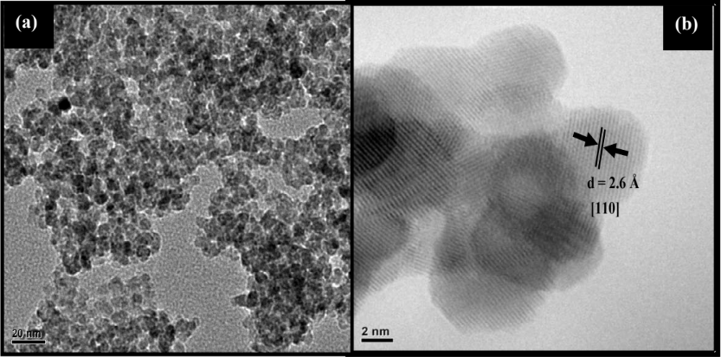
Figure 1: (a) TEM and (b) HRTEM images of the clustered ZnO nanoparticles
Results from the Energy Dispersive X-ray Spectrometer (EDS) and TEM analyses validated the existence of doped ion or particle clusters embedded in the amorphous silica matrix. Here is a TEM picture of amorphous SiO₂ (Figure 2 (a)). An aggregation of spherical particles was revealed by the field emission scanning electron microscopy picture of SiO₂ . Zooming in on ZnO.SiO₂:Pr^{3+,} we can see its TEM picture in Figure 2 (b). It reveals uniform distribution of tiny particles in amorphous SiO₂. These particles ranged in size from 2 to 10 nm in diameter and were spherical, as seen in the insert of figure 2 (b). The particles in the TEM image of figure 2 (b) consisted of Si, O, Zn, and Pr elements, as corroborated by the EDS data in figure 3. This proves that the nanoparticles of Pr³⁺ and ZnO were successfully incorporated into the SiO₂ host. When researchers saw a homogeneous distribution of particles of Eu³⁺ and ZnO co-doped in SiO₂, they also reported similar results.
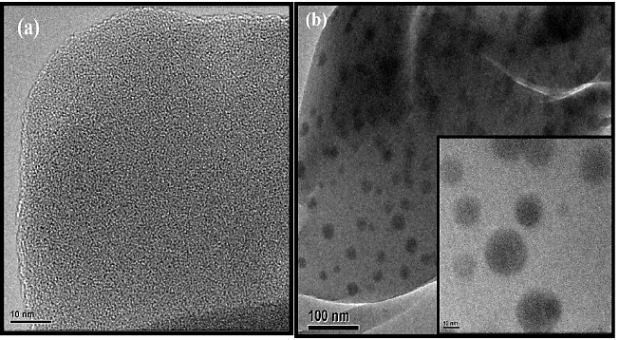
Figure 2: TEM images of (a) SiO₂ nanoparticles, (b) ZnO.SiO₂:Pr³⁺ nanophosphor and the insert of HRTEM image of ZnO.SiO²:Pr^{3+.}
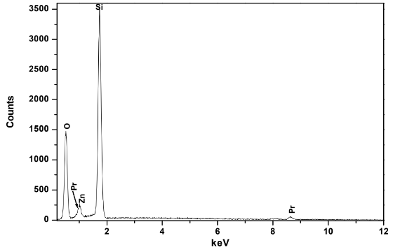
Figure 3: Energy dispersive X-Ray spectrum of 1 mol% ZnO.SiO₂:0.2 mol% Pr³⁺ phosphor.
PL properties of Pr³⁺ singly doped SiO₂
It is theoretically possible for two kinds of emission transitions to happen from Pr³⁺ when excited with Vacuum Ultraviolet (VUV) light: inter-configurational 4f5d→4f² and intra- configurational 4f ²→4f². A host has a significant impact on where the 4f5d states are energetically in relation to the ¹S₀ state. The parity-allowed inter-configurational 4f5d→4f² transition can be stimulated by a high energy excitation if the lowest 4f5d state is located below the 1S0 state. This broad emission is caused by the lowest 4f5d state. The strong emission bands in the Ultraviolet (UV) region from 200 to 300 nm, as observed in the CaSO₄:Pr³⁺ phosphor following VUV excitation at 190 nm, are attributed, for instance, to the parity-allowed 4f ¹5d¹→4f ² transitions of Pr^{3+.} The 4f¹5d¹ levels are located below the ¹S₀ level, according to these data. On the other hand, when Pr³⁺ was introduced into SrSO₄ and BaSO₄ systems, a narrow emission peak at 400 nm was noted, indicating that the 4f ¹5d¹ levels are located above the ¹S₀ level. For SiO₂:0.2 mol% Pr^{3+,} the PL excitation and emission spectra are shown in figure 4. Using synchrotron light, the excitation spectra were measured by tracking the Pr³⁺ emission at 605 nm. Weak bands at the 140–240 nm spectral range are visible in this spectrum. These bands could be explained as transitions from the 4f² ground state to the lowest 4f5d sublevels of Pr^{3+,} given that the possible charge transfer transitions from Pr³⁺ to O²⁻ occur at very short wavelengths. This is in line with what the researchers have found, which is that the excitation efficiency of Ca₃Sc₂Si₃O₁₂:0.2%Pr³⁺ is highest at 75 nm and lowest in the 85–160 nm spectral region. Figure 4. shows the emission spectrum, which corresponds to the parity-allowed transitions from the lowest excited state of the 4f5d configuration to the ³H_{4, 5, 6} and ³F₂ of the 4f² configurations. The first broad emission peak, centres at 309 nm in the UV spectral region, was seen. These findings corroborate your findings for the YBO₃ system doped with Pr^{3+.} Emission peaks in the orange, red, and infrared regions follow this blue peak; these peaks are likely caused by transitions from the ³P₀ and ¹D₂ levels to the ³H⁴_{,5,6}, and ³F_{2,3,4} levels. The ¹D₂→³H₄ transition of Pr³⁺ can be attributed to the wide band seen between 600 and 630 nm, with a conspicuous red emission peak centered at 605 nm.
The ³P₀→³H₆ and ³P₀→³F₂ transitions are corresponding to the tiny shoulders at around 614 and 660 nm, respectively. The findings for Pr³⁺ doped in tellurite glasses are in good agreement with the emission peak assignments made here. The ¹D₂→³F₂ and ¹D₂→³F_{3,4} transitions are corresponding to the emission peaks that are centered at 890 and 1005 nm, respectively. Researchers also found these at 884 and 1060 nm when Pr³⁺ was doped in SiO₂.The luminescence decay curves of the Pr³⁺ emission during the ³P₀→³H₆ and ¹D₂→³H₄ transitions are shown in Figure 5 (a) and (b). ³P₀ and ¹D₂ have lifetimes of 1.8 and 179 µs, respectively, calculated from the decay curve data using the first order exponential fitting. According to these findings, the ³P₀ level of Pr³⁺ had a substantially shorter lifetime due to its quicker degradation compared to the ¹D₂ level. Researchers also found evidence of simultaneous emissions from ³P₀ and ¹D₂ levels, which supports the existence of these emissions. Numerous Pr³⁺ doped systems, such as glasses and crystals, have shown the self-quenching of the ¹D₂ luminescence of Pr^{3+.} Various Pr³⁺ concentrations in SiO₂ were measured at room temperature and plotted against the luminescence decay curves of the ¹D₂ level, as illustrated in figure 6 . To eliminate the emission overlap that happens while exciting into the ³P_{J} states, the ¹D₂ level was excited straight instead.
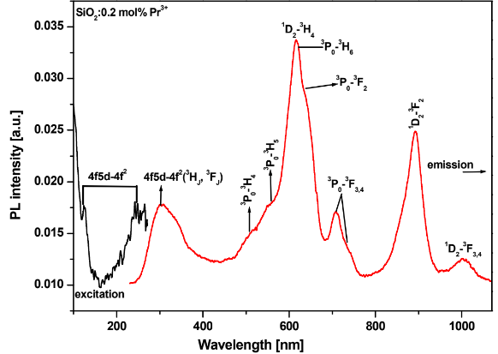
Figure 4 : VUV excitation spectrum and emission spectrum of 0.2 mol% Pr³⁺ single doped SiO₂.
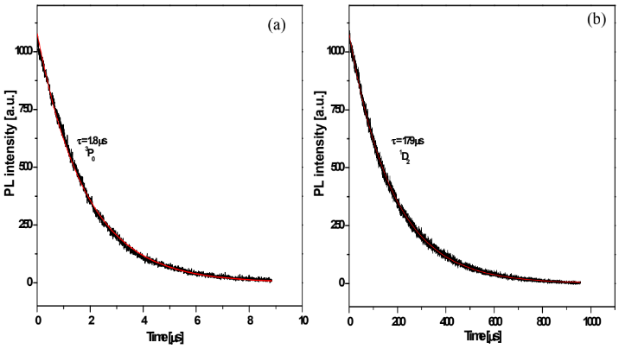

Figure 5 : Luminescence decay curves of the ³P₀ and ¹D₂ levels of Pr³⁺ (0.2 mol%) in SiO₂ obtained at 8 K. The solid black line corresponds to the experimental data and the solid red line is the fit to a single exponential.
The lifetimes calculated from the decay curves using a single exponential fitting were 138, 141, and 144 for 0.05, 0.1, and 0.2 Pr³⁺ concentrations, respectively, and it was noted that the fluorescence intensity from the Pr³⁺ ¹D₂→³H₄ emission declined slowly at these concentrations. But the Pr³⁺ ¹D₂→³H₄ emission decreased significantly faster with a lifespan of 123 when the concentration was raised to 0.5 mol%. There have been earlier reports of similar findings. As the quantity of Pr³⁺ in zinc borate glass increased (0.5, 1, and 2%), the researchers found that the ¹D₂ level decreased over time. The author also mentioned that the ¹D₂ level's lives were reduced when the concentration of Pr³⁺ in fluorophosphates glass increased from 0.1 to 1 mol %. The typical decay mechanism of the ¹D₂ Pr³⁺ ion emission level is controlled by a combination of various competing mechanisms, including radiative decay, non-radiative decay via multi-phonon relaxation, and non-radiative decay through energy transfer to the Pr³⁺ ions. The non-radiative ¹D₂→¹G₄ multi-phonon relaxation is anticipated to be small because of the big energy difference between the ¹D₂ and ¹G₄ energy levels. In addition, the concentration dependency would suggest that energy transfer activities, rather than multi-phonon processes involving a single ion, predominate during the depopulation of the ¹D₂ state. The self-quenching of luminescence occurs in extremely concentrated systems as a result of ion-ion interaction, which causes Pr³⁺ ions to relax with each other and migrate the excitation energy from one Pr³⁺ ion to another through energy transfer mechanisms. When the cross-relaxation process is enabled by the energy level structure of luminous ions, this process in particular becomes efficient.
Luminescence decay curves are traditionally exponential, but this breaks down if the migration rate of excitation energy is minimal relative to the cross-relaxation rate. The donor-acceptor system becomes more homogeneous and the luminescence decay curves have a single exponential time dependency when the excitation migration energy is fast. According to the present findings, the rate of excitation energy migration is greater than the rate of cross-relaxation processes since single exponential luminescence decays were observed in SiO₂ samples with concentrations of 0.05, 0.1, 0.2, and 0.5 mol% Pr^{3+.} The rapid reduction in lifespan observed at Pr³⁺ concentrations greater than 0.2 mol% may be primarily caused by the migration of the excitation energy, which occurs via resonance energy transfer among Pr³⁺ ions, to the quencher center.
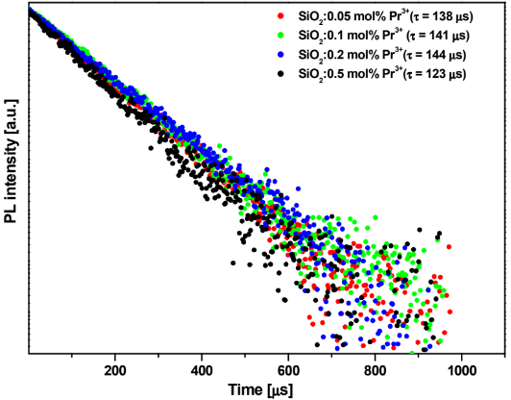
Figure 6: Luminescence decay curves of the ¹D₂→³H₄ emission for various concentrations of Pr³⁺ (0.2 mol%) in SiO₂.
Figure 7. displays the luminescence decay curves from the ¹D₂ level, measured at temperatures ranging from 8 to 300 K, when the ¹D₂ was excited directly with a pulsed laser. With the ¹D₂ lifespan falling from 179 μs at 8 K to 148 s at 300 K, the luminescence decay curves followed the single exponential, as illustrated in the figure. It has been previously noted that the ¹D₂ lifespan depends on temperature.
Transitions from the ground state of acceptor ions that originate in thermally populated crystal field components are expected to follow a temperature dependent process once the resonance condition is met. Lattice phonons will have to help with the energy mismatch if this is not the case, and temperature controls the cross relaxation rate. As the temperature rises from 8 K to 300 K, the ¹D₂ lifetime drops. This drop is not due to non-radiative decay via multi-phonon relaxation, but to the non-resonant cross relaxation process. This is because, in most host matrices, the rate of multi-phonon decay at the ¹D₂ level is much lower than the rate of radiative decay, because of the large energy gap between ¹D₂ and ¹G₄. It is thought that the self-quenching process's cross relaxation mechanism moves through the intermediate ¹G₄ and ³F₄ levels.
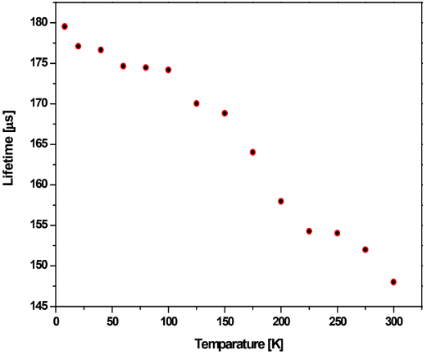
Figure 7 : Lifetimes of the ¹D₂→³H₄ transition of Pr³⁺ (0.2 mol%) doped in SiO₂ plotted against the temperature in the 8-300 K regions.
Energy Transfer from Zno Nanoparticles to Pr³⁺ Ions In Sio₂.
The PL emission spectra of ZnO and SiO₂:0.2 mol% Pr³⁺ are shown in Figure 8. Synchrotron radiation excited SiO₂:0.2 mol% Pr³⁺ phosphors at 90 nm. Both SiO₂:Pr³⁺ and ZnO exhibited the same typical emissions from the Pr3+ ion, with the primary red emission centres at 605 nm, when excited with VUV light on the 4f5d state of Pr^{3+.}phosphors with SiO₂ and Pr³⁺ particles. Although the concentration of Pr³⁺ was lower in ZnO.SiO₂:Pr^{3+,} the green emission from ZnO nanoparticles was reduced, and the intensity of the Pr³⁺ emission was around double that of SiO₂:Pr^{3+.} A sensitivity of Pr³⁺ emission centers by ZnO nanoparticles is shown by the dampening of green ZnO emission caused by enhanced Pr³⁺ emission.
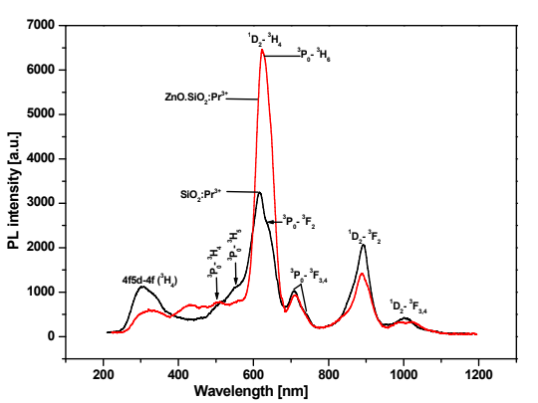
Figure 8 : PL emission spectra of SiO₂:Pr³⁺ and ZnO.SiO₂:Pr³⁺ after VUV excitation at 90 nm using synchrotron radiation.
Figure 9. shows the PL excitation spectra of ZnO.SiO₂:Pr^{3+,} which, when compared to pure SiO₂:Pr^{3+,} exhibit significantly stronger bands. This supports the idea that ZnO has an energy-transfer impact on the 4f electron excitation in Pr³⁺ ions.
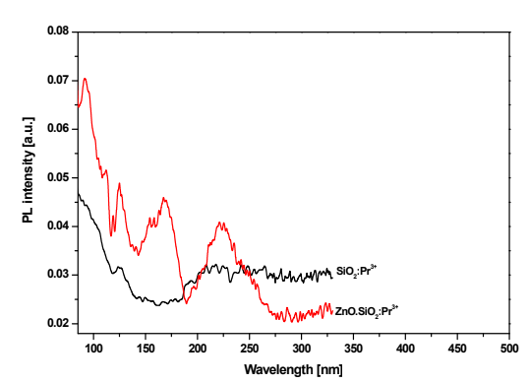
Figure 9 : PL excitation spectra of SiO₂:Pr^{3+:}0.2 mol% with and without ZnO nanophosphors monitoring the emission peak at 605 nm.
Figures 10. (a) and (b) show the luminescence decay curves of ZnO, SiO₂:0.2 mol% Pr^{3+,} and ZnO emissions measured at room temperature. The rapid decay of the Pr³⁺ ¹D₂→³H₄ emission from SiO₂:Pr³⁺, with a lifespan of 144 µs, is evident from figure 10 (a). This is nearly twice as short as the lifetime of ZnO.SiO₂:Pr^{3+,} which was 236 µs. Figure 10 (b) shows that the lifetime of pure ZnO nanoparticles was found to be 2 µs, which is significantly shorter than the lifetimes of SiO₂:Pr³⁺ with and without ZnO, and the decay curve for these particles likewise followed a first-order exponential profile.
These findings are consistent with what the researchers found. In theory, the radiative recombination rate of SiO₂:Pr³⁺ should remain constant both before and after the addition of ZnO. Assuming no change to the non-radiative decay time, a shorter decay time would be expected, suggesting the presence of energy transfer via other non-radiative paths. Defects formed at the surface or borders of ZnO nanocrystals can facilitate energy transmission in the system and explain the longer lifetime seen from ZnO.SiO₂:Pr³⁺ in the present studies. The existence of electron-or hole-trapped surface levels in pure ZnO nanocrystals is undeniable, as the bandgap widens with decreasing particle sizes (365 nm). Additionally, ZnO contains oxygen vacancies and other inherent flaws. Some of the sites created by these flaws can act as non-radiative recombination centers, capturing free electrons in the process. Incorporating ZnO into SiO₂:Pr^{3+,} on the other hand, drastically reduces the non-radiative decay rate due to the strong interaction between the Pr³⁺ ion near the border between the two materials and the photo-generated trapped electron or hole at the surface. Therefore, extra nonradioactive decay routes were not a factor in the longer lifespan found for SiO₂:Pr³⁺ with ZnO.
Figure 11. displays an energy level scheme of Pr³⁺ and ZnO, which explains the emission processes and transitions that take place during the energy transfer from ZnO to Pr³⁺. The exposure of the ZnO.SiO₂:Pr³⁺ nanocomposite phosphor to visible ultraviolet light causes the ZnO to absorb the excitation energy, which then moves the electrons from the valence band to the conduction band. This causes an exciton to be created and, thereafter, the non-radiative relaxation to the defect states. Compared to entire entrapment and recombination with electrons in the valence band, the energy transfer process from ZnO to Pr³⁺ was faster, as seen by quenching of ZnO emission leading to enhanced red emission from Pr^{3+.} So, some of the recombination energy went to Pr³⁺ ions, which raised their electrons from the ground state (4f₂) to the excited state (³P₂), which decayed non-radioactively to the ³P₀ and ¹D₂, respectively, and then relaxed radioactively to the ³H₆ and ³H₄, emitting red lines at 605 and 614 nm, respectively. Because there was no spectral overlap between the ZnO donor's emission and the Pr³⁺ acceptor's excitation, which may have resulted in energy transfer from ZnO to Pr^{3+,} phonon mediated processes are postulated as the likely mechanism of this transfer. A comparable process for Eu³⁺ doped SiO₂ including embedded ZnO nanoparticles was also suggested by the researchers.
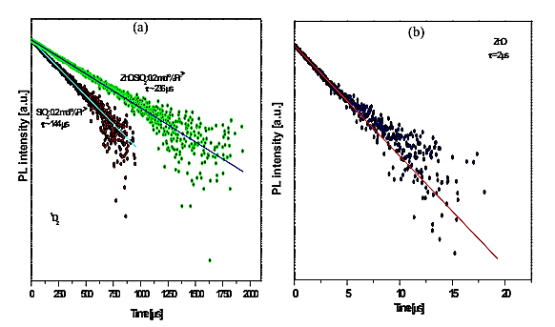
Figure 10 : Luminescence decay curves of (a) SiO₂:Pr³⁺ , ZnO.SiO²:Pr³⁺ nanophosphors and (b) ZnO nanocrystals.
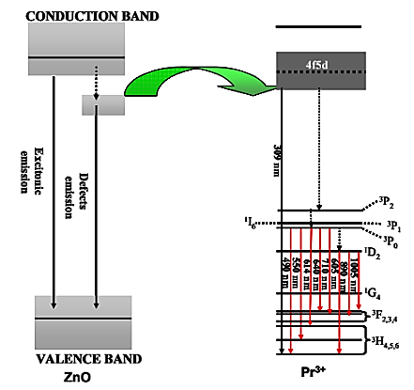
Figure 11 : Schematic energy level diagram showing the transition localized within Pr³⁺ ions and ZnO nanoparticles.
Both the SiO₂:Pr³⁺ with and without embedded ZnO nanoparticles emitted red light, which might be attributed to the ³P₀ and ¹D₂ Pr³⁺ emission levels. According to luminescence decay statistics, the ¹D₂ level has a longer lifetime than the ³P₀ level. Studying the Pr³⁺ luminescence in SiO₂ with respect to Pr³⁺ concentration showed that ¹D₂ lifespan decreases as Pr³⁺ concentration increases, i.e., beyond 0.2 mol%. It was believed that the primary consequence of self-quenching of the ¹D₂ level was the concentration quenching effect caused by the transit of excitation energy among Pr³⁺ ions. As the ¹D₂ level's lifetime gradually dropped from 8 to 300 K, it was also determined that temperature plays a role. Incorporating ZnO nanoparticles into Pr³⁺ doped SiO₂ increased its red emission, suggesting that ZnO functions as a potent sensitizer for Pr³⁺ emission. The decrease in green emission from ZnO and the subsequent increase in luminescence from Pr³⁺ were thought to be caused by energy being transferred from ZnO to Pr³⁺.
Conclusion;
The co-doping of Ce³⁺ into SiO₂:Pr³⁺ was examined to evaluate its effects on CL intensity under different beam voltages and current densities. Ce³⁺ ions, being efficient sensitizers, were found to significantly influence the energy transfer dynamics within the SiO₂ host. The presence of Ce³⁺ enhanced the CL intensity of Pr³⁺ due to efficient energy transfer from the 5d–4f transitions of Ce³⁺ to the 4f levels of Pr³⁺. However, this enhancement was strongly dependent on Ce³⁺ concentration, as excessive Ce³⁺ led to competitive absorption and non-radiative energy losses, thereby diminishing overall luminescence. Furthermore, the dependence of CL intensity on beam voltage and current revealed the critical role of excitation density in activating defect states and facilitating energy transfer. At moderate beam voltages, enhanced CL emission was observed, while excessively high beam currents induced local heating, defect generation, and luminescence degradation. Thus, an optimum balance of Ce³⁺ concentration and excitation conditions was established as a prerequisite for maximizing CL efficiency in SiO₂:Pr³⁺– Ce³⁺ systems.

Reference;
- Nadiia Rebrova. Synthesis and Upconversion Luminescence of LiY₉(SiO₄)6O₂ Phosphor Doped with Pr^{3+.}The Journal of Physical Chemistry C 2024, 128 (22),9090 -9098. https://doi.org/10.1021/acs.jpcc.3c08163
- Srivastava, A. M. The Interconfigurational (4f¹5d¹→4f²) Luminescence of Pr³⁺ in LuPO₄, K₃Lu(PO₄)₂ and LiLuSiO₄. Opt. Mater. 2012, 34, 1347– 1352, DOI:10.1016/j.
optmat.2012.02.016
- Srivastava, A. M. Aspects of Pr³⁺ Luminescence in Solids. J.Lumin .2016, 169, 445- 449, DOI: 10.1016/j.jlumin.2015.07.001
- Wu, J.; Zheng, H. UVC Upconversion Material Under Sunlight Excitation: LiYF₄: Pr³⁺. Opt. Lett. 2016, 41 (4), 792– 795, DOI: 10.1364/OL.41.000792
- Espinoza, S.; Müller, M.Characterization of Micro- and Nanoscale LuPO₄:Pr³⁺, Nd³⁺with Strong UV-C Emission to Reduce X-Ray Doses in Radiation Therapy. Part. Part. Syst. Charact. 2019, 36 (10), 1900280 DOI:10.1002/ppsc. 201900280
- Cates, E. L. Visible-to-UVC Upconversion Efficiency and Mechanisms of Lu₇O₆F₉:Pr³⁺ and Y₂SiO₅:Pr³⁺ Ceramics. J. Lumin. 2015, 160, 202– 209, DOI: 10.1016/j.jlumin.2014.11.049
- Lv, P.; Li, L.; Wang, C.; Wu, Z.; Qiu, J.; Yang, Y. 450 nm Photon-Pumped Ultraviolet-C Luminescence for Multifunctional Applications. Laser Photonics Rev. 2022, 16, 2200389 DOI: 10.1002/lpor.202200389
- Lai, F.; Xu, X.; Shen, J.; Wang, Y.; Yan, Y.; Nie, Y.; You, W.; Wu, D.; Han, L.; Xiao, Z. Structure and Upconversion Luminescence Properties of Pr³⁺-Doped Y₂SiO₅ Phosphor. Silicon. 2023, 15, 1913– 1923, DOI: 10.1007/s12633-022-02148-x
- Yin, Z. Q.; Yuan, P.; Zhu, Z.; Li, T. Y.; Yang, Y. M. Pr³⁺ Doped Li₂SrSiO₄: an Efficient Visible-Ultraviolet C Up-conversion Phosphor. Ceram. Int. 2021, 47, 4858– 4863, DOI: 10.1016/j.ceramint.2020.10.058
- Zhou, W.; Pan, F.; Zhou, L.; Hou, D.; Huang, Y.; Tao, Y.; Liang, H. Site Occupancies, Luminescence, and Thermometric Properties of LiY₉(SiO₄)₆O₂:Ce³⁺ Phosphors. Inorg. Chem. 2016, 55, 10415– 10424, DOI: 10.1021/acs.inorgchem.6b01656
- Li, J.-Y.; Hou, D.; Zhang, Y.; Li, H.; Lin, H.; Lin, Z.; Zhou, W.; Huang, R. Luminescence, Energy Transfer and Temperature Sensing Property of Ce³⁺, Dy³⁺ doped LiY₉(SiO₄)₆O₂ phosphors. J. Lumin. 2019, 213, 184– 190, DOI: 10.1016/j.jlumin.2019.05.027
- Zhang, Z.; Wang, L.-J.; Yang, S.-S.; Chen, W.-G.; Chu, X.-J.; Wang, D.-J. Luminescence Properties of a Novel Promising Red Phosphor LiY₉(SiO₄)₆O₂:Eu³⁺. Mater. Lett. 2017, 204, 101– 103, DOI: 10.1016/j.matlet.2017.05.118
- Zhang, J.; Jin, C. Structure, Morphology and Upconversion Luminescence of Rare Earth Ions Doped LiY₉(SiO₄)₆O₂ for Temperature Sensing. Ind. Eng. Chem. Res. 2019, 58, 3490– 3498, DOI: 10.1021/acs.iecr.8b05543
- Redhammer, G. R.; Roth, G. Lithium and Sodium Yttrium Orthosilicate Oxyapatite, LiY₉(SiO₄)₆O₂ and NaY₉(SiO₄)₆O₂, at both 100 K and Near Room Temperature. Acta Crystallogr. C Struct. Chem. 2003, 59, 120– 124, DOI: 10.1107/S0108270103023321
- Shannon, R. D. Revised Effective Ionic Radii and Systematic Studies of Interatomic Distances in Halides and Chalcogenides. Acta Crystallogr. 1976, A32, 751– 767, DOI: 10.1107/S0567739476001551
- Malyukin, Yu.V.; Masalov, A. A.; Zhmurin, P. N.; Znamenskii, N. V.; Petrenko, E. A.; Yukina, T. G. Two Mechanisms of ¹D₂ Fluorescence Quenching of Pr³⁺-Doped Y₂SiO₅ Crystal. Phys. Stat. Sol. (b). 2003, 240 (3), 655– 662, DOI: 10.1002/pssb.20030190
- Li, K.; Lian, H.; Shang, M.; Lin, J. A Novel Greenish Yellow-Orange Red Ba₃Y₄O₉:Bi³⁺, Eu³⁺ Phosphor with Efficient Energy Transfer for UV-LEDs. Dalton Trans. 2015, 44, 20542– 20550, DOI: 10.1039/C5DT03565A
- Rebrova, N.; Zdeb, P.; Lemański, K.; Macalik, B.; Bezkrovnyi, O.; Dereń, P. J. Upconversion Luminescence Properties of Pr³⁺ Doped BaYF₅ Nanoparticles Prepared by Microwave Hydrothermal Method. Inorg. Chem. 2024, 63 (6), 3028– 3036, DOI: 10.1021/acs.inorgchem.3c03821
- Dereń, P. Spectroscopic Characterization of LaALO₃ Crystal Doped with Pr³⁺ Ions. J. Lumin. 2007, 122–123, 40– 43, DOI: 10.1016/j.jlumin.2006.01.081
- Yina, M.; Krupa, J. C.; Antic-Fidancev, E.; Makhov, V. N.; Khaidukov, N. M. Excitation Spectroscopy of K₂YF₅:Pr³⁺ Crystals. J. Lumin. 2003, 101, 79– 85, DOI: 10.1016/S0022-2313(02)00391-5
- Sun, Y.; Wang, Y.; Hu, C.; Zhou, X.; Hao, J.; Li, W.; Li, H. Energy Transfer from Pr³⁺ to Gd³⁺ and Upconversion Photoluminescence Properties of Y₇O₆F₉:Pr³⁺, Gd³⁺. Mater. 2022, 15, 7680, DOI: 10.3390/ma15217680
- Hu, C.; et al. Visible-to-Ultraviolet Upconversion in Pr³⁺:Y₂SiO₅ Crystals. Chem. Phys. 2006, 325 (2–3), 563– 566, DOI: 10.1016/j.chemphys.2006.01.037

