From Policy to Practice: A Governance Case Study of Rural Water Supply Implementation Under India's Jal Jeevan Mission

.
ABSTRACT

This study presents a comprehensive policy analysis of rural water supply implementation frameworks in Solapur district, Maharashtra, India—a semi-arid region facing acute water stress. We examine the institutional architecture, monitoring mechanisms, and adaptive strategies outlined in governmental guidelines for achieving universal water access. We employ systematic policy document analysis combined with institutional framework assessment, examining implementation protocols across five dimensions: beneficiary targeting, infrastructure planning, digital monitoring systems, inter-agency coordination, and quality assurance mechanisms. The study reveals a multi-layered governance architecture integrating four digital platforms (DWSM, ZPPMS, Sujalam Bharat App, PM GATISHAKTI) for real-time monitoring. Critical implementation priorities include 100% Functional Household Tap Connections (FHTC), targeted provisions for Particularly Vulnerable Tribal Groups (PVTG) and persons with disabilities, and convergence with seven complementary rural development schemes. Water source sustainability emerges as the primary challenge in semi-arid contexts, requiring adaptive strategies beyond conventional policy frameworks. The framework demonstrates how centralized policies can be adapted for local hydrogeological conditions through flexible implementation protocols, digital monitoring integration, and multi-stakeholder coordination. Recommendations include strengthening block-level technical capacity, developing district-specific water sustainability plans, and establishing third-party monitoring mechanisms.

Keywords: Digital monitoring, Institutional framework, Jal Jeevan Mission, Maharashtra Policy implementation, Rural water supply, Semi-arid regions, Water governance

1. INTRODUCTION

Access to safe drinking water remains a fundamental developmental challenge across rural India, particularly acute in semi-arid regions experiencing groundwater depletion, quality degradation, and climatic variability (Srivastava & Chinnasamy, 2023). Solapur district in Maharashtra exemplifies these challenges, characterized by annual rainfall below 600mm, high nitrate concentrations in groundwater, and recurrent drought conditions affecting 2.8 million rural residents across 1067 villages (Joshi et al., 2019, Shaikh and Birajdar, 2024b, Shaikh and Birajdar, 2024c, Shaikh and Birajdar 2025b) (Figure 1).

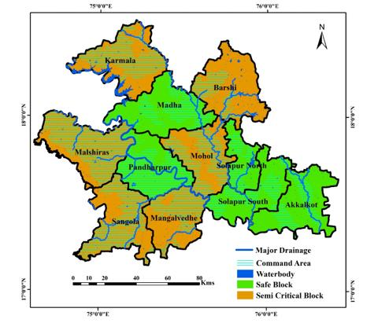

Fig. 1. Solapur District Map with respect to Groundwater stress zones
The Jal Jeevan Mission (JJM), launched in 2019, represents a paradigm shift in India's rural water supply approach—from infrastructure-centric models to functionality-focused, service delivery frameworks emphasizing Functional Household Tap Connections (FHTC) as the primary outcome indicator (Singh & Naik, 2024) (Fig. 2).
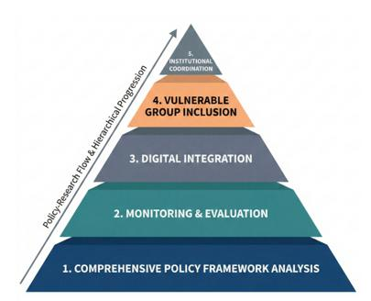
Fig. 2. Evolution of Rural Water Supply Governance in India
By December 2025, governmental guidelines established comprehensive implementation protocols integrating digital monitoring, multi-sectoral convergence, and adaptive mechanisms for diverse hydrogeological contexts. Despite significant policy evolution and financial commitments (₹3.6 trillion national allocation), substantial implementation gaps persist between policy objectives and ground-level outcomes. The Solapur district is comes under semi arid climate and it has its own challenges (Shaikh and Birajdar, 2024) (Fig. 3).

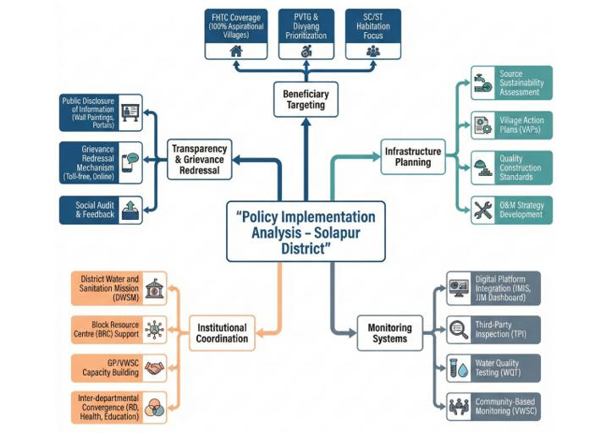
Fig. 3. Semi-Arid Challenges for rural water
Three critical questions emerge: (1) How are centralized water policies translated into implementable frameworks at district level within challenging hydrogeological contexts? (2) What institutional mechanisms enable monitoring, coordination, and quality assurance across multiple governance tiers? (3) How can policy frameworks adapt to semi-arid conditions while maintaining universal coverage objectives? (Wang et. al. 2022)
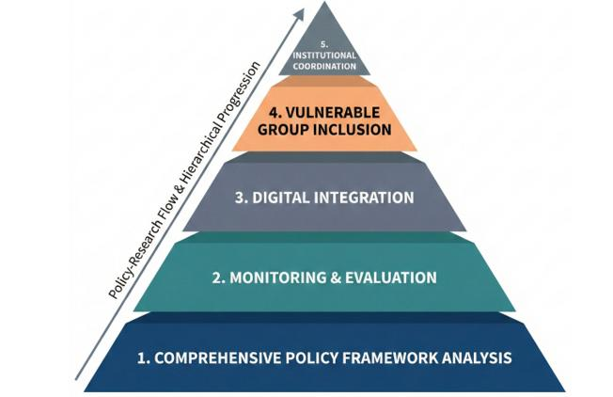
Fig. 4. Hierarchical Framework of Research Objectives and Policy Implementation Logic in Rural Water Supply Governance
This study systematically analyzes the implementation architecture for rural water supply in Solapur district, examining institutional mechanisms for policy translation, integration of digital monitoring platforms, provisions for vulnerable populations, coordination protocols, and adaptation strategies for semi-arid conditions (Basu et.al.2020) (Fig. 4). Understanding implementation frameworks in water-stressed districts contributes to broader discourse on water governance effectiveness and adaptive policy implementation (Singh & Chudasama, 2020, Shaikh and Birajdar, 2025c) (Fig. 5).

2. Methodology

This study adopts an institutional analysis approach coupled with systematic policy document examination to investigate the implementation architecture of rural water supply governance. The analytical framework prioritizes examining institutional mechanisms and implementation protocols rather than conducting outcome-based impact evaluation. The research draws upon multiple primary documentary sources to construct a comprehensive understanding of the policy ecosystem. Core materials include the operational guidelines of the Jal Jeevan Mission as promulgated by the Ministry of Jal Shakti, which establish the programmatic framework and implementation parameters at the national level. District-level contextual data is derived from the Solapur District Profile and associated development reports, providing geographical and socio-economic specificity to the analysis from GSDA organization. The study further integrates policy evolution insights from the National Rural Drinking Water Programme frameworks, which constitute the antecedent institutional structure. To capture the digital governance dimension, the research examines technical documentation from three key monitoring platforms: the District Water and Sanitation Mission portal (DWSM), the Zila Parishad Planning and Monitoring System (ZPPMS), and the Sujalam Bharat dashboard. This multi-tiered documentary analysis enables a systematic deconstruction of policy architecture, institutional coordination mechanisms, and implementation modalities within the rural water supply sector.

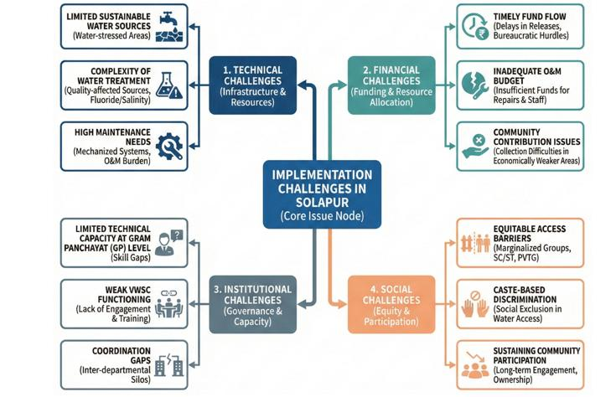
Fig. 5. Analytical Framework for Institutional Analysis of Rural Water Supply Policy Implementation: A Multi-Dimensional Conceptual Lens
Analysis is structured across five dimensions: beneficiary coverage and targeting, infrastructure planning and development, monitoring and evaluation systems, institutional coordination, and quality assurance and grievance redressal.
Solapur district, encompassing a geographical area of 14,895 km², presents a characteristic semi-arid landscape that poses significant challenges to sustainable water resource management (Birajdar & Shaikh, 2024). The district supports a predominantly rural population of approximately 2.8 million inhabitants distributed across 1,067 villages, reflecting substantial spatial dispersion of settlement patterns (Shaikh & Birajdar 2024a). Hydrologically, the region is classified as water-stressed, receiving an average annual precipitation of merely 545 mm, considerably below the national average and indicative of chronic moisture deficit conditions (Shaikh & Birajdar 2024b). The groundwater regime exhibits critical quality and quantity constraints, marked by widespread nitrate, TDS contamination that poses endemic health risks, compounded by accelerated aquifer depletion due to intensive extraction patterns (Shaikh & Birajdar 2015). The demographic profile reveals pronounced socio-economic vulnerabilities, with Scheduled Castes constituting 21% of the population, Scheduled Tribes comprising 8%, and families below the poverty line representing 45% of households. This confluence of adverse hydrogeological conditions, resource scarcity, and socio-economic marginalization renders Solapur district a representative case for examining water security interventions in resource-constrained rural settings, where policy implementation faces the dual challenges of infrastructural deficits and social inequality (Pradhan et.al. 2022) (Fig. 5). This institutional analysis does not include empirical effectiveness assessment, beneficiary satisfaction surveys, or comparative analysis across districts—aspects requiring subsequent field-based research (Shaikh & Birajdar 2025).

3. Results and Analysis

3.1 Beneficiary Coverage and Targeting

The policy establishes 100% FHTC as the primary objective, defining "functional" as: (i) tap connections with individual metering capability; (ii) adequate water supply (55 LPCD minimum); (iii) regular supply (daily or alternate day minimum); (iv) potable quality meeting BIS 10500:2012 standards.

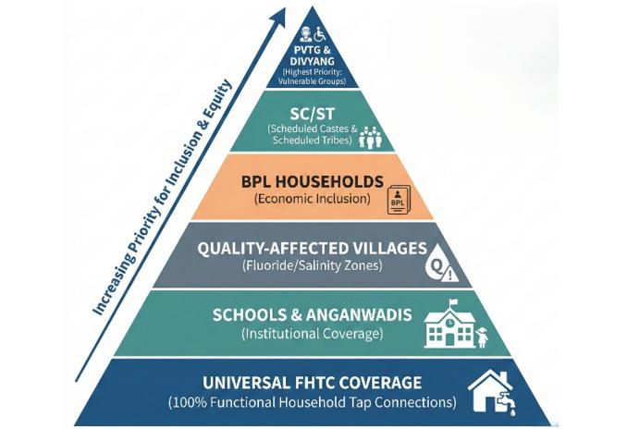
Fig. 6. Equity-Based Beneficiary Coverage Pyramid: Three-Tiered Hierarchical Prioritization Framework for Inclusive Water Access
The targeting mechanism employs a stratified hierarchical framework to sequence interventions based on vulnerability and equity. The apex tier prioritizes 1,247 households from Particularly Vulnerable Tribal Groups (PVTGs) across 23 villages and populations with disabilities (Divyang), mandating preferential coverage, accessible infrastructure design, and dedicated monitoring. The intermediate tier integrates multiple vulnerability dimensions: 318 villages with >40% Scheduled Caste and Scheduled Tribe populations, 167 habitations with hydrogeochemical contamination (nitrate/salinity) requiring source substitution or treatment. The tertiary tier addresses economic vulnerability through subsidized connection schemes for families below the poverty line. It concurrently prioritizes 2,456 institutional nodes (schools and anganwadis) to ensure water security for children and lactating mothers. This hierarchical sequencing is operationalized via Geographic Information System based spatial analytics, synthesizing composite indices of water scarcity, infrastructure deficits, population density, and distance from viable sources. This enables evidence driven resource allocation privileging the most marginalized and water insecure communities (Fig. 6).

3.2 Infrastructure Planning and Development

The infrastructure development protocol follows a four-stage sequential process from baseline data collection to technical design, ensuring evidence-based planning and hydrological sustainability. The initial stage involves comprehensive village-level surveys to establish demographic baselines, map existing water infrastructure, assess available sources, and conduct hydrogeological investigations of aquifer properties. Subsequent demand assessment employs demographic projections over a 15-year horizon to calculate aggregate water requirements, integrating domestic, institutional, and livestock needs. The third stage focuses on source identification and viability, evaluating surface and groundwater potential, conducting water quality testing, and performing sustainability assessments to ensure abstraction remains within safe yield limits. The final design stage translates these analyses into engineering specifications, including intake structures, treatment processes calibrated to water quality, storage reservoirs sized for demand variation, distribution networks optimized for equitable delivery, and pumping system specifications. This systematic progression from assessment to design ensures technical rigor and context-specific adaptation. (Fig. 7).

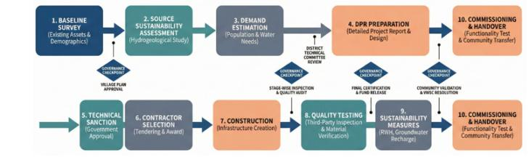
Fig. 7. From Baseline Assessment to commissioning and handover
The technical specifications mandate rigorous quality standards across all components, requiring ISI-certified HDPE or PVC pipes with appropriate pressure ratings, BEE 4-star rated pumps with solar capability, and RCC or steel storage tanks designed per codified norms. Multi-barrier treatment protocols are prescribed for sources with quality impairments. In response to the district’s semi-arid, water-stressed conditions, the policy integrates sustainability measures focused on augmenting availability and improving efficiency. These include constructing and rehabilitating 340 percolation tanks and 1,200 farm ponds and 3540 recharge shafts for managed aquifer recharge. Rainwater harvesting is mandated at multiple scales—from rooftops to surface runoff capture—to maximize precipitation utilization. System designs incorporate dual-source configurations combining surface and groundwater to enhance reliability. Demand-side management is operationalized through leak detection and pressure management in distribution networks to minimize non-revenue water losses and optimize hydraulic efficiency. The matrix operationalizes adaptive water governance by mapping local challenges to prioritized policy responses across institutional, technological, and implementation dimensions is shown in Fig. 8.

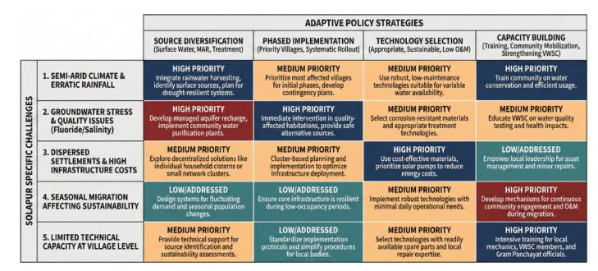

Fig. 8. District Challenges versus Adaptation Matrix in Semi-Arid Rural Water Supply Implementation
3.3 Digital Monitoring Framework

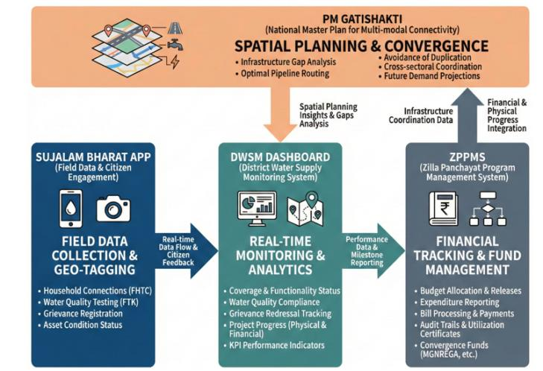
Fig. 9. Integrated Digital Public Infrastructure Architecture for Rural Water Supply Monitoring and Accountability
The governance architecture integrates digital platforms for multi-dimensional monitoring, tracking, engagement, and coordination. The District Water Supply Monitoring system serves as the primary dashboard, enabling real-time tracking of Functional Household Tap Connection coverage, supply adequacy, and water quality compliance across all villages through mobile-based field data entry and automated alerts. The Zila Parishad Planning and Monitoring System functions as the financial backbone, ensuring transparent fund flow tracking, milestone-linked payments, contractor oversight, and streamlined administrative approvals (Fig. 9). Citizen engagement is enabled via the Sujalam Bharat mobile application, which allows beneficiaries to report service disruptions, water quality concerns, and tap functionality issues with geotagged evidence, establishing direct feedback channels. Infrastructure coordination is facilitated by the PM GATISHAKTI platform, which employs GIS visualization to optimize pipeline alignments, avoid duplication, and promote convergence with complementary rural infrastructure projects. Accountability flows through a hierarchical structure from village-level committees to the State Water and Sanitation Committee, enabling multi-tiered oversight (Fig. 10).

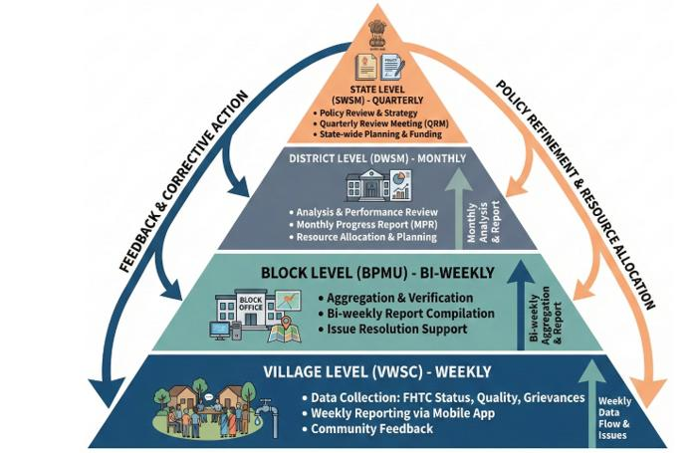
Fig. 10. Reporting Hierarchy and Administrative Accountability Framework
Table 1. Institutional responsibilities and reporting frequencies across administrative levels for water supply monitoring
Level | Responsibility | Frequency
Village (VWSC) | Daily supply data, maintenance records, quality tests | Daily collection
Gram Panchayat | Compilation and DWSM entry | Weekly
Block | Dashboard monitoring, district reports | Daily monitoring, weekly reporting
District | Real-time dashboard, comprehensive reports | Monthly
State | District aggregation, inter-district comparison | Quarterly

The quality assurance framework mandates third-party assessments at six-month intervals. These systematic evaluations include physical infrastructure verification through on-ground inspections for conformity to technical specifications, and functional performance testing measuring flow rates, endpoint pressures, and water quality against potability standards. The methodology incorporates participatory beneficiary interviews with a representative 10% random household sample to capture service reliability and satisfaction. Documentary rigor is maintained through geo-tagged photographic and video evidence of infrastructure condition and functionality, creating an immutable spatial-temporal record. The assessment culminates in comprehensive evaluation reports that undergo state-level certification. Validated findings are translated into corrective action matrices, triggering remedial interventions and establishing closed-loop accountability. Standardized formats for village-wise progress, functionality, quality, and financial data are shown in Fig. 11.

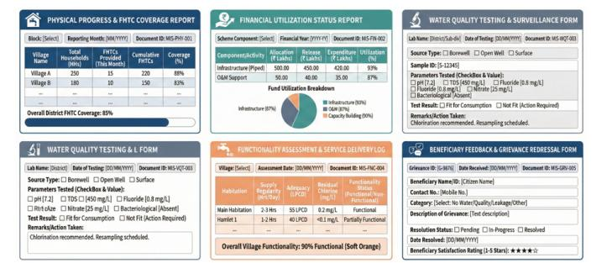
Fig. 11. Monitoring Formats and MIS Templates for Implementation Tracking
3.4 Financial Management

District allocation formula:
Base: Population × ₹3,800 per FHTC
Loadings: +25% quality-affected, +15% difficult terrain, +10% PVTG/Divyang
Solapur allocation: ₹342 crores (2025-26)

The financial disbursement mechanism employs a milestone-linked, three-stage release protocol. An initial 40% tranche is released upon approval of the Detailed Project Report and completion of baseline village surveys. An intermediate 40% is disbursed following independent verification of 60% physical progress, measured through pipeline laying, pump installation, tank construction, and household connections. The final 20% is paid upon project completion, evidenced by infrastructure commissioning and functionality certification confirming compliance with service standards for flow, pressure, regularity, and water quality (Fig. 12).
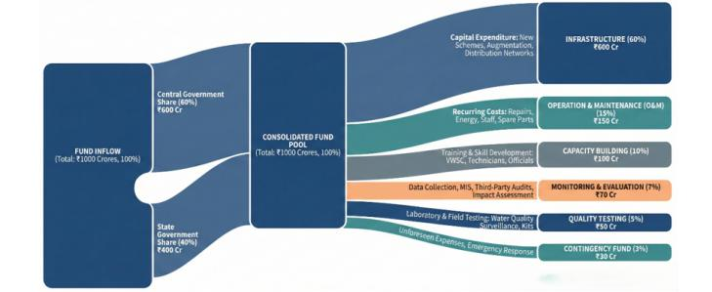
Fig. 12. Fund Flow and Allocation Mechanism in Rural Water Supply Implementation
This architecture institutionalizes payment-for-performance, creating incentives for timely implementation while establishing fiscal checkpoints. The framework also illustrates cross-sectoral convergence mechanisms integrating the Jal Jeevan Mission with complementary schemes for resource optimization (Fig. 13).

Table 2. Convergence financing (₹170 crores potential)
Scheme | Purpose | Amount (₹ Cr)
MGNREGA | Asset creation | 48
Swachh Bharat Mission | Sanitation linkages | 12
PMAY | Household plumbing | 8
State Water Grid | Inter-basin transfer | 76
District Mineral Fund | Treatment plants | 15
CSR | Community incentives | 6
GP Funds | Annual O&M | 5

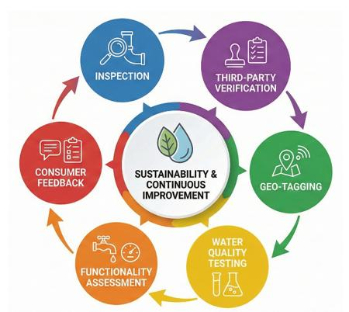
Fig. 13. Scheme Convergence Framework: Integrated Multi-Sectoral Approach

3.5 institutional coordination
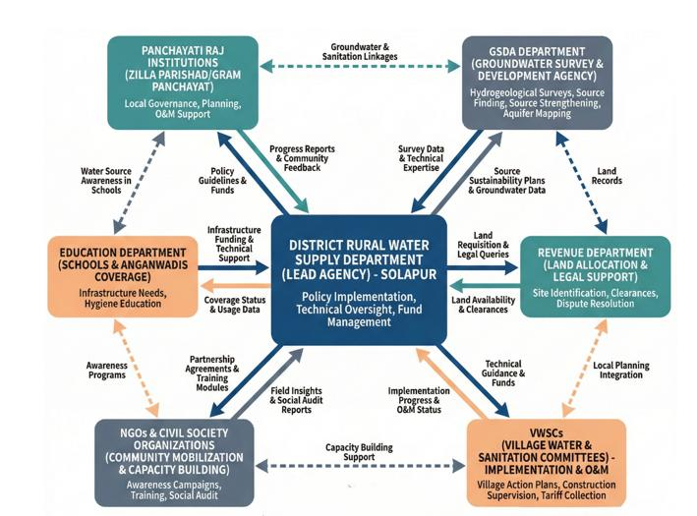
Fig. 14. Institutional Coordination Framework
District Water Security Committee (DWSC):
The institutional coordination framework is anchored in a district-level steering committee for strategic oversight (Fig. 14). Chaired by the District Collector, the committee ensures cross-sectoral alignment and expedites bottleneck resolution. Its composition integrates functional expertise, including the Zila Parishad Chief Engineer, District Senior Geologist, District Water Supply Mission, District Health Officer, District Education Officer, and District Rural Development Agency Project Director. Meeting monthly, the committee performs strategic policy formulation, fund allocation, dispute adjudication, and convergence planning with complementary sanitation, housing, and agricultural initiatives. This architecture provides unified command, technical pluralism, and systematic inter-agency collaboration essential for universal rural water supply.
Block Implementation Committee:
The Block Implementation Committee provides decentralized coordination at the sub-district tier for proximate supervision and context-responsive management. Chaired by the Block Development Officer, it incorporates elected Panchayat Samiti representatives, technical field staff, and Village Water and Sanitation Committee (VWSC) members to ensure multi-stakeholder input. Meeting fortnightly, the committee focuses on granular implementation monitoring, grievance escalation, and authorizing local adaptations to standard protocols due to site-specific conditions. This meso-level structure bridges strategic district planning with operational village execution, ensuring implementation remains both technically rigorous and contextually appropriate.
Village Water & Sanitation Committees (VWSC):
Village Water & Sanitation Committees (VWSC) constitute the foundational tier for community ownership and decentralized operation and maintenance. Comprising 10-15 members selected through participatory processes, they mandate minimum 50% women's representation and proportional representation of Scheduled Caste and Scheduled Tribe populations to ensure inclusive governance. VWSCs are vested with administrative and financial powers, including autonomous management of Operation and Maintenance funds and the authority to levy user tariffs for sustainable revenue. Their operational responsibilities encompass daily system monitoring, execution of minor repairs, and first-point resolution of beneficiary complaints. A mandated five-day capacity building program equips members with technical, financial, and administrative skills for sustainable service delivery. The framework delineates coordination mechanisms across district, block, and village levels, as shown in Fig. 15.

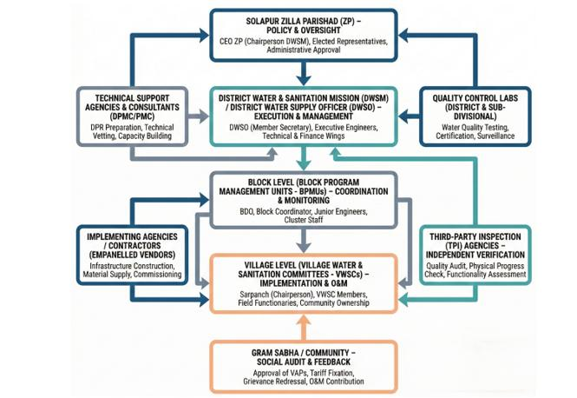
Fig. 15. Solapur District Institutional Structure

Technical support tiers:
The technical support architecture is structured as a three-tiered hierarchical system. At the village tier, Jalsurakshaks conduct daily system monitoring and basic troubleshooting, supported by shared mechanics and plumbers for routine repairs across village clusters. The block tier provides intermediate capacity through Deputy Engineers for civil works, Assistant Geologists for groundwater monitoring, field engineers for technical guidance, and Chemists for water quality testing. The district tier constitutes the apex of expertise, including Executive Engineers with overall technical authority, Senior Geologists for hydrogeological assessments, specialized multidisciplinary teams for complex upgrades, and Chemists operating accredited laboratories for comprehensive contaminant profiling. This cascading framework ensures local attention to routine issues while escalating complex challenges to higher expertise levels (Fig. 16).

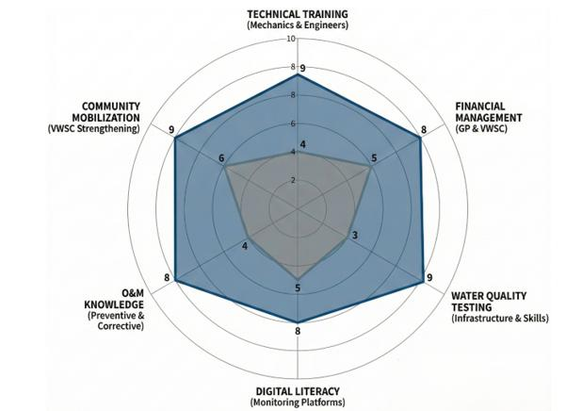
Fig. 16. Capacity Building Gap Analysis
3.6 Quality Assurance and Grievance Redressal
The quality assurance protocol employs verification system spanning the project lifecycle. The first point mandates material testing and laboratory certification of components against Bureau of Indian Standards norms prior to procurement. The second requires continuous on-site installation supervision by qualified engineers to validate adherence to design and workmanship standards. The third stipulates stage-wise photographic documentation, creating a visual audit trail for retrospective verification. The fourth mandates independent third-party inspection prior to commissioning, covering structural integrity, hydraulic performance, and operational readiness. The final safeguard is a one-year defect liability period, during which contractors remain responsible for rectifying any failures or deficiencies (Fig. 17).

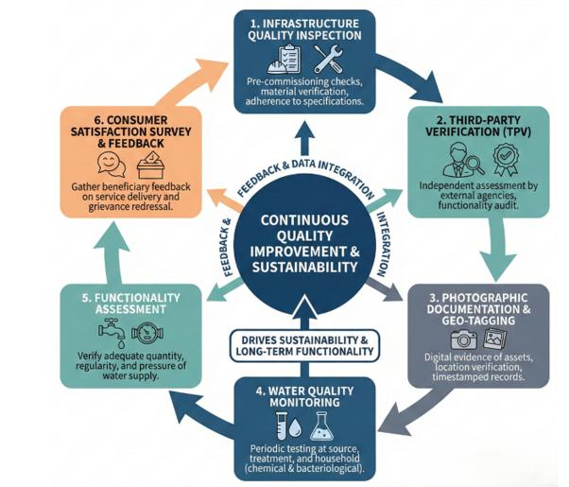
Fig. 17. Quality Assurance Cycle
Table 3. Four-level water quality monitoring

Level | Frequency | Parameters | Responsibility
Field Test | Daily | pH, chlorine, turbidity | Village
Block Lab | Weekly | 10 parameters | Block
District Lab | Monthly | 18 parameters (BIS 10500) | District
Referral Lab | Quarterly | Heavy metals, pesticides, microbiological | State

The performance monitoring framework employs quarterly functionality surveys using multi-dimensional assessment protocols. Key metrics include temporal availability, quantifying days of water supply per month; adequacy, measured in liters per capita per day (LPCD) against a 55 LPCD threshold; and quality, assessed through combined beneficiary perception surveys and laboratory physicochemical and bacteriological testing. Accessibility is evaluated for persons with disabilities (Divyang), examining tap placement and pathway usability. Reliability is measured through breakdown frequency and mean resolution time. Fig. 18 illustrates the grievance redressal pathways from multi-channel registration (Sujalam Bharat app, helpline, physical submission) to three-tiered resolution (village, block, district), including escalation mechanisms and prescribed timeframes.

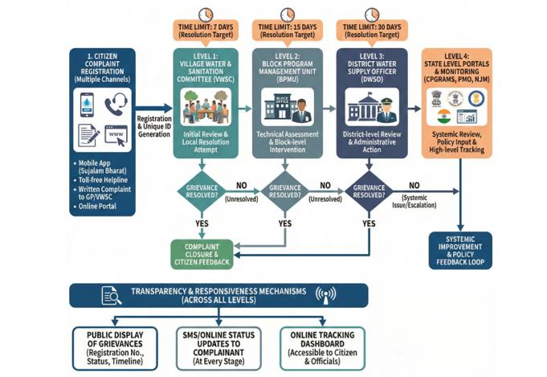
Fig. 18. Citizen-Centric Grievance Redressal Flow
Table 4. Grievance architecture

Level | Authority | Timeline | Integration
Village | VWSC | 48 hours | Direct resolution
Gram Panchayat | GP Office | 7 days | DWSM entry
Block | Block PMU | 15 days | Escalation tracking
District | DWSO | 30 days max | CPGRAMS, SMS

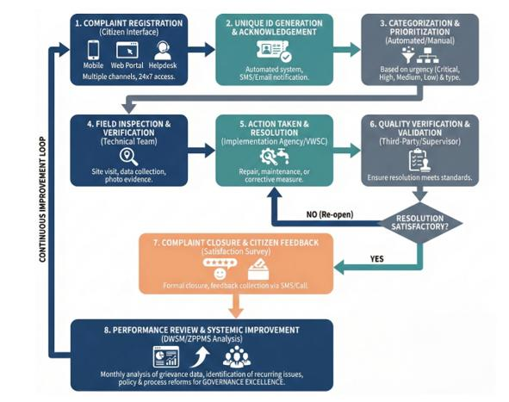

Fig. 19. Grievance Standard Operating Procedure and Process Discipline Framework
The Standard Operating Procedure (SOP) details systematic grievance handling protocols covering complaint registration, categorization, assignment, time-bound resolution, escalation, and closure verification (Fig. 19). The accountability architecture embeds comprehensive transparency measures. Village-wise Functional Household Tap Connection coverage statistics are published monthly for granular progress tracking. Water quality testing results are disclosed physically at Gram Panchayat offices and digitally on dedicated portals. Financial transparency is ensured through quarterly fund utilization statements detailing allocations, expenditures, and payments at village and block levels. Grievance redressal performance is tracked via monthly publication of resolution rates by category, timeframe, and administrative tier. Accessibility is enhanced through disclosure of officer contact details across multiple channels, reducing information asymmetries and enabling direct citizen access.

3.7 Semi-Arid Adaptations
The sustainability framework integrates source prioritization, demand management, and climate-appropriate technologies to address chronic water scarcity. Groundwater augmentation includes constructing 340 percolation tanks and 1,200 farm ponds and 3540 recharge shafts for monsoon recharge. Resource management incorporates participatory annual water budgeting at village scale to establish extraction limits. Demand management involves leak detection programs and community conservation campaigns. The technological architecture prioritizes solar pumping systems (78% of new installations) for energy efficiency and grid independence. Supervisory Control and Data Acquisition (SCADA) systems enable real-time network monitoring for anomaly detection. Smart metering in 240 water-stressed villages supports consumption tracking and demand forecasting. Pressure management through reducing valves minimizes pipeline failures and conserves water.
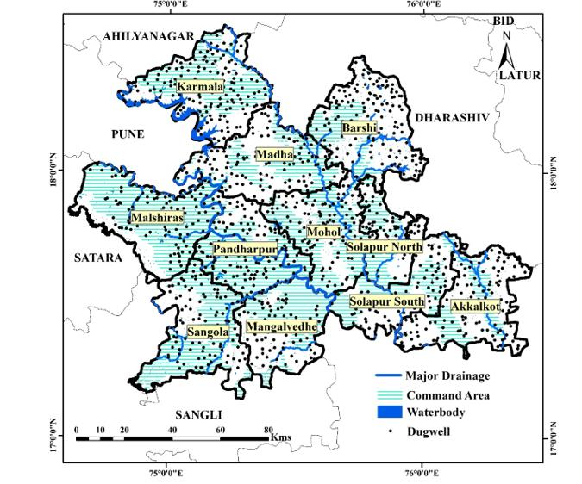

Fig. 20. Spatial Integration Framework: PM GATISHAKTI Platform Utilization
The framework utilizes GIS-based spatial planning for infrastructure identification, pipeline route optimization, prevention of duplication, and cross-sectoral convergence (Fig. 20). Implementation incorporates climate-informed seasonal planning. Construction is scheduled during the dry season (November–May) to avoid monsoon disruptions and ensure workmanship. Source augmentation, including percolation tank desilting, is timed to the monsoon for optimal recharge. Recognizing semi-arid vulnerability, the policy mandates enhanced storage equivalent to two days’ supply—double the national norm—as a buffer for service continuity. Emergency protocols for summer months include pre-positioned spare parts, intensified monitoring, tanker standby, and prioritized allocation for vulnerable populations. This temporally differentiated approach demonstrates adaptive management aligned with environmental cycles.

3.8 Performance Measurement
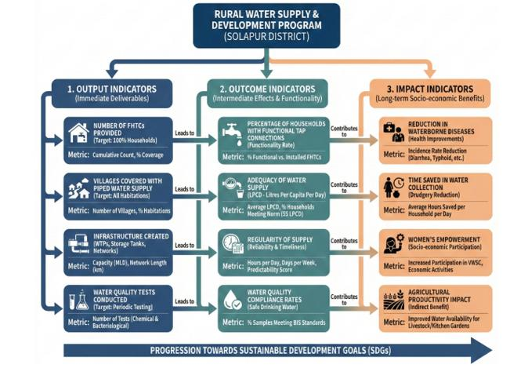
Fig. 21. Performance Indicator Hierarchy
The monitoring and evaluation framework employs a three-tiered indicator architecture (Fig. 21). Output indicators quantify infrastructure creation, including Functional Household Tap Connections, treatment plants, storage capacity, and network length. Outcome indicators assess service delivery, measuring functional connection rates, supply adequacy (LPCD), supply regularity, and water quality compliance. Impact indicators capture developmental transformations: reductions in waterborne disease incidence, time savings from reduced water collection, increased women’s economic participation, and improved school attendance, especially among girls. As of December 2025, Solapur district has achieved 67% coverage, targeting universal access by December 2026. The functional rate of provided connections is 94%. Average supply is 48 LPCD, below the 55 LPCD threshold. Quality compliance is 89%, with ongoing nitrate remediation in 167 contaminated villages.

4. Discussion

4.1 Policy Translation Mechanisms
The policy architecture translates national objectives into operational directives through three mechanisms. The first employs hierarchical decomposition, cascading national water access goals into quantified district targets, block quotas, and village work plans. The second demonstrates adaptive flexibility, maintaining core principles while permitting local variation in implementation. In Solapur, this resulted in 32% reliance on surface water, contrasting with groundwater-centric approaches elsewhere. The third leverages digital integration via platforms like the District Water Supply Monitoring system, enabling real-time progress tracking and rapid corrective intervention. Collectively, these mechanisms balance rights uniformity with contextual diversity, incorporating evidence-based planning and adaptive management (Fig. 22).
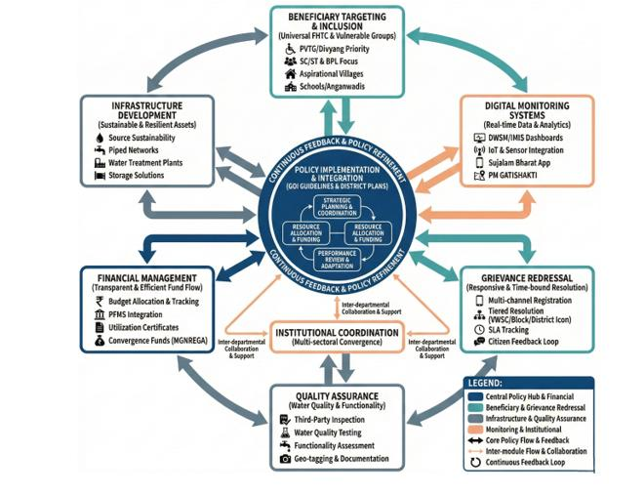

Fig. 22. Overall Policy Implementation Architecture
4.2 Institutional Challenges
Empirical implementation reveals three persistent institutional challenges. First, departmental silos fragment water supply, sanitation, and conservation initiatives across separate administrative units, limiting coordination to information exchange rather than genuine programmatic convergence. Second, pronounced capacity asymmetries exist across administrative tiers. Technical expertise is disproportionately concentrated at the district level, while block and village units operate with inadequate support, causing delays and compromising supervision quality. Third, Village Water and Sanitation Committee effectiveness varies significantly. Committees function robustly where antecedent social capital exists but underperform in communities without such foundations. The framework inadequately addresses deep-rooted social barriers—including caste hierarchies, patriarchal norms, and power asymmetries—that undermine genuine inclusive participation. These challenges highlight structural constraints requiring sustained capacity development, social mobilization, and governance reforms addressing underlying power relations (Fig. 23).
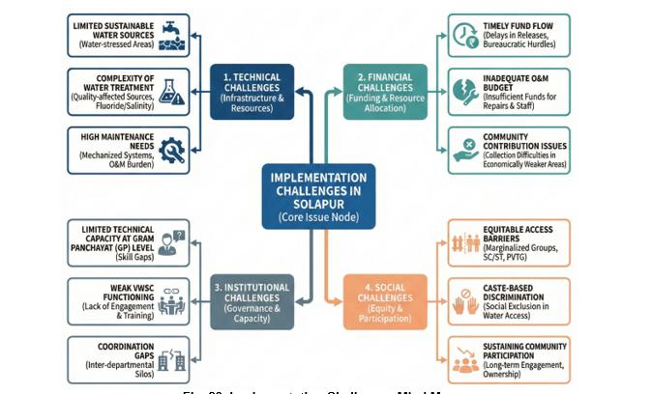
Fig. 23. Implementation Challenges Mind Map

4.3 Digital Monitoring: Opportunities and Constraints

The deployment of integrated digital platforms represents a transformative governance innovation, enabling transparency and real-time accountability. However, substantive constraints mediate this technological potential. First, data quality integrity is compromised as approximately 30% of villages show inconsistent data updating due to variable technical literacy and support at the Gram Panchayat level. Second, the rural digital divide—limited smartphone access among marginalized groups—constrains mobile grievance systems, potentially excluding the most vulnerable. Third, limited interoperability across platforms necessitates duplicate manual data entry, increasing administrative burden and error probability. Fourth, persistent capacity gaps among block-level staff require continuous training for platform proficiency, data validation, and analytical insight generation. These realities underscore that digital transformation depends on addressing foundational issues of capacity, connectivity, and system design, not just technological deployment.

4.4 Semi-Arid Adaptation
Solapur's surface water transition (32% coverage) acknowledges groundwater limitations. However, 68% villages remain groundwater-dependent with unresolved sustainability. Unlike water-abundant districts emphasizing supply augmentation, Solapur integrates demand management—leak detection, awareness, smart metering—responding to scarcity realities. Monsoon variability necessitates 2-day storage (vs. 1-day national norm) and summer emergency protocols, demonstrating national framework accommodation of regional climatic challenges.

4.5 Equity and Social Inclusion

The policy framework embeds equity commitments through hierarchical prioritization of marginalized groups. However, translating these principles into substantive inclusion faces three critical implementation challenges. First, physical accessibility requirements for persons with disabilities (Divyang) are inadequately operationalized, as contractor training and supervision often neglect specialized design specifications, resulting in functionally exclusive infrastructure. Second, in caste-stratified contexts, infrastructure provision alone cannot overcome entrenched social discrimination; complementary social mobilization and legal enforcement remain inadequately integrated into the technocratic framework. Third, economic barriers persist. While subsidized connections address upfront costs, recurring Operation and Maintenance tariffs strain economically weaker communities, risking service disconnection and system deterioration. These challenges highlight that substantive inclusion requires interventions beyond infrastructure, encompassing social transformation, legal protection, and financial mechanisms sensitive to structural vulnerabilities.

4.6 Financial Sustainability

The financial architecture demonstrates adequate capital investment (₹342 crores) and effective milestone-based disbursement. However, critical weaknesses in Operation and Maintenance (O&M) financing threaten long-term sustainability. The Village Water and Sanitation Committee tariff model is unsustainable due to community payment resistance and technical billing difficulties. Annual Gram Panchayat O&M allocations (₹48,000 per village) are insufficient for system-wide maintenance, leading to chronic underfunding and accelerated asset deterioration. Addressing this deficit requires alternative mechanisms: dedicated state-level O&M grants, cross-subsidies from urban tariffs, or hybrid public-community financing. Convergence potential with complementary rural schemes (estimated ₹170 crores) exists but faces institutional barriers, including bureaucratic coordination challenges, misaligned planning cycles, and departmental territoriality. These challenges underscore that capital investment alone is insufficient for durable service delivery, necessitating equal focus on recurrent financing and inter-sectoral coordination reforms.

4.7 Quality Assurance Effectiveness

Five-point assurance (material testing, supervision, third-party inspection, documentation, defect liability) is robust, but effectiveness depends on inspector independence and competence. Four-level water quality testing is comprehensive but resource-intensive. Solapur's 167 nitrate-affected villages requiring continuous monitoring strain district lab capacity. Quarterly functionality surveys provide outcome data, but reliability depends on methodology rigor, sample representativeness, and assessor independence.

4.8 Grievance Redressal

The grievance redressal architecture, with its four-tiered structure and defined timelines, provides a formal accountability framework. However, significant operational challenges constrain its effectiveness. Village-level resolution capacity is limited, with only 35% of complaints resolved locally due to technical complexity, resource constraints, or social marginalization. Low first-level resolution necessitates frequent escalation, introducing substantial delays that erode beneficiary trust. Platform accessibility suffers from critically low awareness; only 40% of households know of the Sujalam Bharat mobile application. Compounding this, language barriers in predominantly Marathi interfaces exclude non-speakers and those with limited digital literacy. These constraints illustrate how procedural frameworks can fail to deliver functional accountability when implementation overlooks local capacity, communication deficits, and socio-cultural diversity.

4.9 NRDWP vs. JJM Era

The transition from the National Rural Drinking Water Programme (NRDWP, 1999–2019) to the Jal Jeevan Mission (JJM, 2019) represents a fundamental governance paradigm shift. NRDWP was infrastructure-focused, measuring coverage by physical assets irrespective of service delivery. Its monitoring was rudimentary, relying on manual, periodic surveys with weak accountability and no digital transparency. In contrast, JJM prioritizes verified service outcomes through the Functional Household Tap Connection metric, mandating adequate quantity, regularity, and potability. It employs real-time digital monitoring platforms, public dashboards, and citizen grievance channels, enabling unprecedented transparency and bottom-up accountability. The mission institutionalizes cross-sectoral convergence and establishes piped water supply as a justiciable right. Solapur district’s performance illustrates these improvements. Coverage accelerated from 23% (644,000 individuals) in 2019 to 67% (1.87 million) in 2025. The functionality rate improved from 56% to 94%, and water quality compliance rose from 42% to 89% of villages, though 167 nitrate-affected villages require ongoing remediation. These gains validate that governance architecture—outcome orientation, digital systems, and continuous accountability—is critical to program effectiveness. A Gantt chart illustrates sequential and parallel project activities (Fig. 24).
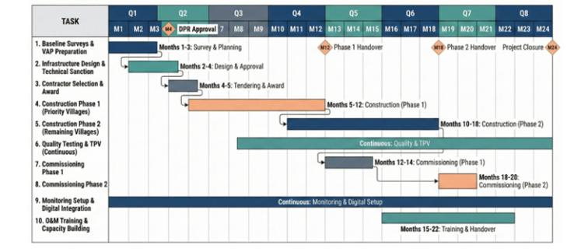

Fig. 24. Month Implementation Timeline: Phased Activity Schedule and Milestone Framework
The implementation timeline operationalizes the proposed policy framework by translating strategic objectives into time-bound actions. The phased approach reflects policy emphasis on prioritizing vulnerable villages, ensuring regulatory approvals, embedding continuous monitoring, and strengthening local capacity through structured O&M training and digital integration. This sequencing supports accountability, risk mitigation, and sustainability in large-scale groundwater and water-supply interventions (Fig. 24).

4.10 Broader Implications
This study demonstrates centralized policy adaptation to diverse local contexts through institutional flexibility, digital integration, and multi-stakeholder coordination—contributing to federal policy implementation literature. The framework provides a template for water-stressed districts emphasizing, source sustainability assessment preceding infrastructure, climate-appropriate technology selection, phased implementation prioritizing affected areas and demand management integration.
The Fig. 25 presents an integrated action framework that operationalizes water security policy across technical, financial, institutional, and environmental domains. By linking implementation, monitoring, and sustainability actions with Solapur-specific adaptation needs, the framework emphasizes coordinated governance, financial accountability, institutional strengthening, and environmental safeguards. This multidimensional approach supports resilient groundwater management under conditions of semi-arid climate stress and groundwater quality constraints.
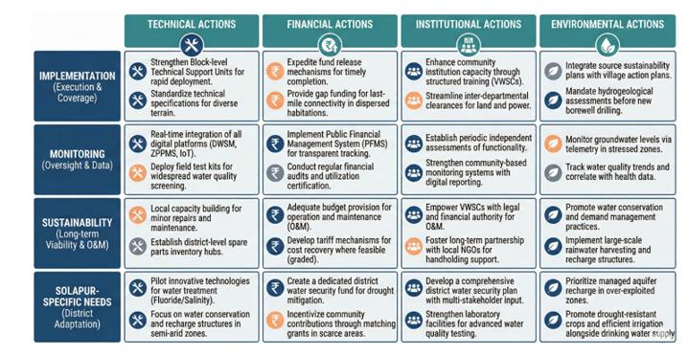
Fig. 25. Recommendations Framework
The framework synthesizes six policy recommendations addressing key implementation constraints. First, establish a dedicated state-level Operation and Maintenance fund with formula-based allocations to Gram Panchayats to ensure predictable, adequate recurrent financing. Second, create block-level technical support units with multidisciplinary teams to decentralize expertise and reduce maintenance response times. Third, integrate comprehensive social inclusion interventions, including anti-discrimination campaigns, gender sensitization training, and disability accessibility audits. Fourth, develop a unified digital platform architecture with offline functionality to eliminate redundant data entry and address connectivity challenges. Fifth, mandate comprehensive District Water Security Plans using participatory water budgeting and climate adaptation strategies with 20–30 year horizons. Sixth, institutionalize independent third-party monitoring by academic or civil society organizations to enhance transparency and generate rigorous evidence. These recommendations collectively address the governance ecosystem required to translate policy commitments into durable service delivery.

5. Conclusion

This study examines the institutional architecture governing rural water supply in Solapur district, revealing a sophisticated multi-layered framework integrating digital monitoring, inter-agency coordination, and context-specific adaptations. The analysis demonstrates successful policy translation through hierarchical decomposition of goals, adaptive flexibility in technical design, and digital infrastructure enabling real-time corrective interventions. The digital transformation, via four integrated platforms, provides unprecedented transparency. However, its potential is constrained by data quality inconsistencies in 30% of villages, interoperability deficiencies necessitating redundant data entry, and persistent capacity gaps at the block level. Semi-arid adaptations include prioritizing surface water for 68% of villages, constructing 340 percolation tanks and 1,200 farm ponds and 3540 recharge shafts for aquifer recharge, deploying demand management interventions, and mandating enhanced two-day storage reserves. These offer replicable lessons for water-stressed regions. Equity provisions systematically target marginalized groups, yet physical infrastructure alone is insufficient to overcome entrenched social discrimination. Complementary community mobilization and legal enforcement are required. Institutional coordination through district, block, and village committees is constrained by departmental silos, capacity asymmetries concentrating expertise at district level, and variable effectiveness of Village Water and Sanitation Committees dependent on pre-existing social capital. Two critical vulnerabilities are identified: water source sustainability, with 68% of villages reliant on overexploited groundwater; and unsustainable Operation and Maintenance financing, where tariff collection models fail and Gram Panchayat allocations (₹48,000 annually per village) are inadequate. This research contributes to understanding policy adaptation in federal systems, providing an implementation template emphasizing source sustainability assessment, climate-appropriate technology, phased equity-focused roll-out, and demand management. Future research should extend to empirical field studies, longitudinal sustainability tracking, social impact assessments, financial analyses, and comparative cross-district frameworks. The Jal Jeevan Mission framework represents substantial improvement but requires sustained attention to financial sustainability, decentralized capacity building, and social inclusion. Solapur’s experiences offer valuable insights for developing context-appropriate, climate-resilient water governance.

Competing interests

The authors declare that they have no known financial or personal relationships that could have appeared to influence the work reported in this paper. Authors have declared that no competing interests exist
References

Basu, M., DasGupta, R., Hashimoto, S., & Hoshino, S. (2020). A multi-actor and bottom-up perspective on attaining rural water security: qualitative evidence from India. Environment, Development and Sustainability. https://doi.org/10.1007/s10668-020-00631-2
Birajdar, F., & Shaikh, M. (2024). Groundwater Exploration and Assessment in Arid and Semi-Arid Regions of Basaltic Terrain of Solapur: Lessons Learned and Future Prospects. International Journal of Innovative Science and Research Technology (IJISRT). https://doi.org/10.38124/ijisrt/IJISRT24APR2344
Joshi, M. P., Barde, P. V., Mungantiwar, P. V., Bhole, A. V., & Devarkar, V. D. (2019). Environmental Impact Assessment Studies of Ground Water in Solapur Thermal Power Plant Area (Maharashtra), India. Plantae Scientia, 2(4), 48-52. https://doi.org/10.32439/ps.v2i4.48-52
Shaikh, M. A., & Birajdar, F. (2025). Policy Innovations for Sustainable Aggregates: Maharashtra’s M-Sand Strategy in a Global Context. International Journal of Research and Scientific Innovation (IJRSI), 12(8), 1707-1713. https://doi.org/10.51244/IJRSI.2025.120800152
Pradhan, I., Kandapan, B., & Pradhan, J. (2022). Uneven burden of multidimensional poverty in India: A caste based analysis. PLoS ONE. https://doi.org/10.1371/journal.pone.0271806
Shaikh, M. A. J., & Birajdar, F. (2024). Water Harvesting: Importance and Techniques for Mitigating Drought in Solapur District. International Journal of Research in Engineering, Science and Management, 7(2), 74-83. https://journal.ijresm.com/index.php/ijresm/article/view/2942
Shaikh, M., & Birajdar, F. (2015). Mapping of Feasibility of Groundwater for Drinking Water Zones of Akkalkot Taluk, Solapur, India using GIS Techniques. International Journal of Science and Research (IJSR). https://doi.org/10.21275/15041507
Shaikh, M., & Birajdar, F. (2024). Advancements in Remote Sensing and GIS for Sustainable Groundwater Monitoring: Applications, Challenges, and Future Directions. International Journal of Research in Engineering, Science and Management, 7(3), 16-24. https://journal.ijresm.com/index.php/ijresm/article/view/2955
Shaikh, M., & Birajdar, F. (2024). Groundwater depletion in agricultural regions: Causes, consequences, and sustainable management: A case study of basaltic terrain of Solapur district. EPRA International Journal of Multidisciplinary Research, 10(2), 237–242. https://www.researchgate.net/publication/378540000_GROUNDWATER_DEPLETION_IN_AGRICULTURAL_REGIONS_CAUSES_CONSEQUENCES_AND_SUSTAINABLE_MANAGEMENT_A_CASE_STUDY_OF_BASALTIC_TERRAIN_OF_SOLAPUR_DISTRICT
Shaikh, M., & Birajdar, F. (2024). Harmony in Hydroinformatics: Integrating AI and IEC for sustainable groundwater conservation in Solapur. International Journal of Science and Research Archive. https://doi.org/10.30574/ijsra.2024.11.1.0294
Shaikh, M., & Birajdar, F. (2025). Site Selection to Community Handover: Effective Recharge Shaft Development for Rural Water Security in Shetphal, Maharashtra. International Journal of Research and Innovation in Applied Science. https://doi.org/10.51584/ijrias.2025.100900030
Shaikh, M., & Birajdar, F. (2025). Economic Impacts of Collective Farming and Groundwater Management in Drought-Prone Regions: A Solapur Case Study. International Journal of Latest Technology in Engineering, Management & Applied Science, 14(9), 830-841. https://doi.org/10.51583/IJLTEMAS.2025.1409000097
Singh, A., & Naik, G. (2024). Rural drinking water supply program and societal development: Evidence from the early implementation phase of India’s Jal Jeevan Mission. PLOS ONE. https://doi.org/10.1371/journal.pone.0312144
Singh, P. K., & Chudasama, H. (2020). Pathways for climate change adaptations in arid and semi-arid regions. Journal of Cleaner Production. https://doi.org/10.1016/j.jclepro.2020.124744
Srivastava, A., & Chinnasamy, P. (2023). Watershed development interventions for rural water safety, security, and sustainability in semi-arid region of Western-India. Environment, Development and Sustainability. https://doi.org/10.1007/s10668-023-03387-7
Wang, R. Y., van Rijswick, M., & Dai, L. (2022). Improving connectivity in water governance: The implementation of water cooperation mechanisms in disparate political and social contexts. International Journal of Water Resources Development, 38(4), 545-553. https://doi.org/10.1080/07900627.2022.2071848
Wang, R. Y., van Rijswick, M., & Dai, L. (2022). Improving connectivity in water governance: the implementation of water cooperation mechanisms in disparate political and social contexts. International Journal of Water Resources Development, 38(4), 545-553. https://doi.org/10.1080/07900627.2022.2071848 .

