Original Research Article
Antifungal and Antioxidant Evaluation of a Thiazole-Based Schiff Base Ligand and its Binuclear Co(II), Ni(II), Cu(II), and Zn(II) Complexes

.
ABSTRACT

Increasing MDR (Multiple Drug Resistance), has emerged as a great challenge, propelling the need for newer pharmacophoric entities, always. The present study reports the antifungal and antioxidant activities of a thiazole-based Schiff base ligand (LA) and its binuclear metal complexes with Co(II), Ni(II), Cu(II), and Zn(II). The biological potential of the ligand and complexes was evaluated using standard in vitro antifungal assays against selected fungal strains and antioxidant assays employing DPPH radical scavenging methodology. The results reveal that metal coordination significantly tailors the biological activity of the bioactive SB-compound. The antifungal and antioxidant performance order of synthesized compounds, is as : compared to the free ligand. Factors governing the biomedical ADMET mechanism, are responsible for such bioactivity.

Keywords: Thiazole Schiff base; binuclear metal complexes; antifungal activity; antioxidant activity.

1. INTRODUCTION

A continuous search for new and newer bioactive compounds, creates an intense drive and opportunity for synthetic chemists for alternative organic or metallo-organic entities, in the field of pharma- and agriculture. Schiff base ligands and their transition metal complexes have long been recognized as an important class of coordination compounds due to their facile synthesis, versatile coordination behavior, and wide-ranging applications in electrochemistry, catalysis, and medicinal chemistry. The presence of the azomethine (–C=N–) functional group provides an effective donor site for metal coordination, enabling the formation of stable complexes with diverse geometries and electronic properties. Modulation of these properties through rational ligand design remains a key strategy for developing functional metal-based systems [1, 2].
Schiff base ligands containing heterocyclic moieties such as thiazole have attracted considerable attention due to their versatile coordination behavior and promising biological properties. Metal complexes derived from such ligands often show enhanced antimicrobial and antioxidant activities as compared to their parent ligands. The present work is exclusively focused on the evaluation of their antifungal and antioxidant properties. The potential of the Schiff base ligand and its metal complexes as antimicrobial agents will be determined against different strains of fungi [3-5].
The analysis will also consider how such coordination affects the biological activity of the ligand, thereby providing valuable information for the further development of metal-based drugs and therapeutic biomaterials. Against this backdrop, this study advances the understanding of the potential application of Schiff base metal complexes in medicine by focusing on the structural and biological characteristics of the complexes [6-8].
The present study is exclusively devoted to the systematic evaluation of the antifungal and antioxidant activities of a newly synthesized thiazole-based Schiff base ligand and its corresponding binuclear metal complexes. The ligand was coordinated with biologically relevant transition metal ions, namely Co(II), Ni(II), Cu(II), and Zn(II), to investigate the influence of metal chelation on biological performance. Schiff base ligands containing thiazole moieties are of considerable interest due to their structural versatility and well-documented pharmacological potential. In particular, metal complexation is known to significantly modulate the physicochemical and biological properties of such ligands by enhancing stability, lipophilicity, and redox behavior.
In this context, the antifungal activity of the synthesized ligand and its binuclear metal complexes was assessed against selected pathogenic fungal strains to determine their inhibitory efficacy and structure–activity relationships. Additionally, the antioxidant potential of the compounds was evaluated using established in vitro assays to examine their ability to scavenge free radicals and mitigate oxidative stress. A comparative analysis between the free ligand and its metal complexes was carried out to elucidate the role of the coordinated metal ions in enhancing or modifying biological activity. The findings of this study aim to contribute to the development of novel metal-based therapeutic agents with improved antifungal and antioxidant properties.

2. material and methods

2.1 Materials

All chemicals and reagents used for biological studies were of analytical grade and used without further purification.

2.2 Synthesis of Ligand and Metal Complexes

The thiazole-based Schiff base ligand (LA) and its binuclear Co(II), Ni(II), Cu(II), and Zn(II) complexes were synthesized and fully characterized using elemental analysis, spectroscopic, thermal, and electrochemical techniques. These details have been reported in a separate manuscript, submitted elsewhere for publication.

2.3 Antifungal activity

The antifungal activity of the synthesized Schiff base ligand LA and its corresponding metal complexes, LA-Co, LA-Ni, LA-Cu and LA-Zn was tested against the growth of Aspergillus niger and Fusarium oxysporum using the mycelial growth inhibition technique. Sterilized 2% malt extract agar (MEA) was poured into 9 cm Petri plates under aseptic conditions and allowed to solidify. Test compounds were dissolved in DMSO to get stock solutions of 1 mg mL⁻¹ and mixed with the medium so that the final concentrations were 50, 75, and 100 µg mL⁻¹, while DMSO-containing plates were used as control. A 1.5 mm agar disc taken from the periphery of a 7-day-old fungal culture was placed at the centre of each plate. The inoculated plates were maintained at 25 °C for 7 days, after which the colony diameter of the fungal growth was measured [9]. The percentage of growth inhibition was calculated relative to equation 1.

$\% Growth Inhibition=\frac{D_{0}-D_{t}}{D_{0}} X 100$(1)

where Dt denotes the diameter of the fungal colony in the presence of the test compounds, and D0 represents the colony diameter observed in the control plates [9].

2.4 Antioxidant Activity

The synthesized compound's free radical scavenging activity, was assayed by the method involving DPPH (2,2-diphenyl-1-picrylhydrazyl). Stock solution of DPPH (50 µM) was prepared in methanol. In DMSO, test solutions of the compounds (100, 200, 300, and 400 µg mL⁻¹) were prepared. For each assay, the 1 mL test solution was mixed with 5 mL freshly prepared DPPH solution. Reaction mixtures were shaken thoroughly and incubated at room temperature in the dark for 30 min. At 517 nm against a control solution, the decrease in absorbance was recorded using a UV–Visible spectrophotometer [11]. The radical scavenging efficiency of the tested compounds was expressed as the percentage inhibition of DPPH radicals and calculated using the following equation-2:

$$\% DPPH Scavanging=\frac{A_{control}-A_{sample}}{A_{control}} X 100 (2)$$

where A_{control} represents the absorbance of the DPPH solution in the absence of the test compound (DPPH + DMSO), and A_{sample} denotes the absorbance of the DPPH solution containing the test compounds [10].

3. results and discussion

3.1 Antioxidant Activity

The antioxidant activity of the synthesized Schiff base ligand (LA) and its metal complexes, LA-A(Co), LA-B(Ni), LA-C(Cu), and LA-D(Zn) were determined by the free radical scavenging assay using the DPPH assay, with ascorbic acid as a standard. The percentage scavenging activity was determined at various concentrations ranging from 100 to 400 µg mL⁻¹, and plots were drawn as shown in Fig. 1. It was observed that all tested compounds dose-dependently increased their activity in scavenging the free radicals. As expected, ascorbic acid was found to possess the highest antioxidant activity at all points of concentration. The free ligand LA showed moderate activity, and this activity increases with the elevation of concentration, upto optimal level. After coordination with metal ions, a considerable increase in antioxidant activity has been noted for all metal complexes compared to the free ligand. Among the metal complexes, the highest scavenging ability has been shown for the Cu(II) complex [LA-C(Cu)], at all concentrations, followed by Zn(II), Ni(II), and Co(II) complexes. At a concentration of 400 µg mL⁻¹, a study revealed that the order of antioxidant efficacy is as follows: Ascorbic acid > LA-C(Cu) > LA-D(Zn) > LA-B(Ni) > LA-A(Co) > LA. The increase in antioxidant activity for metal ions has been attributed to a rise in electron donations owing to metal interactions. Based on their redox properties, Cupric ions are found to be involved in more favourable redox cycles for effective free radical scavenging. The findings from this study support that metal ions are capable of increasing the antioxidant potential of N, O- donor ligand LA considerably; hence, all synthesized metal complexes exhibit a considerable ability for free radical scavenging [11-13].

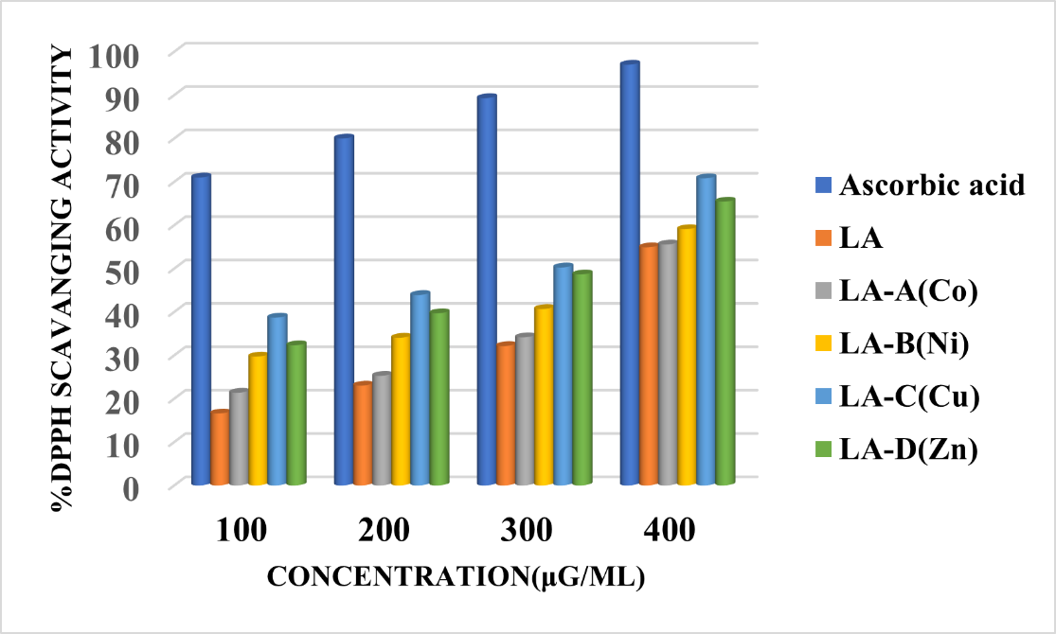
Fig. 1. Represents the % DPPH scavenging activity graph of synthesized Schiff base ligand LA and its metal complexes.

3.2 Antifungal activity

Antifungal activity of the synthesized ligand LA and its metal complexes LD-A(Co), LA-B(Ni), LA-C(Cu), and LA-D(Zn), were tested against Aspergillus niger and Fusarium oxysporum. Bavistin was used as a positive control. DMSO and drug-free plates are used as a negative control (Table 1). The ligand LA showed moderate inhibitory activity, having 67.41% against A. niger and 59.37% against F. oxysporum. There was a remarkable increase in inhibitory activity upon binding to the metal. The most potent compound among the complexes was found to be LA-C(Cu), which showed 88.76% inhibitory activity against A. niger and 82.81% against F. oxysporum. The Ni(II) complex, LA-B(Ni), showed relatively strong inhibitory activity, especially against F. oxysporum (92.81%), reaching the efficacy level of the antifungal standard drug Bavistin (96.8%). The LA-A(Co) and LA-D(Zn) complexes showed improved inhibitory activity against the tested organisms compared to the free ligand; thus the general trend of activity against both fungal species was: LA increased inhibition of the metal complexes, this could be due to chelating effects that result in increased lipophilicity and electron availability; enabling to penetrate a fungal cell membrane and bind active molecules in-vivo, thus increasing bioactivity [14, 15]. The overall effect may be biocidal and/or biostatic, synergistically.

Table 1. Represents the fungal growth inhibition % data of synthesized Schiff base ligand LA and its metal complexes.

Compounds | Growth Inhibition %
Compounds | Aspergillus  niger | Fusarium oxysporum
Bavistin | 97.75 | 96.8
DMSO | 42.69 | 46.87
Control | 1.1 | 28
LA(HL₂) | 67.41 | 59.37
LD-A(Co) | 71.91 | 64.06
LA-B(Ni) | 84.26 | 92.81
LA-C(Cu) | 88.76 | 82.81
LA-D(Zn) | 77.52 | 67.18

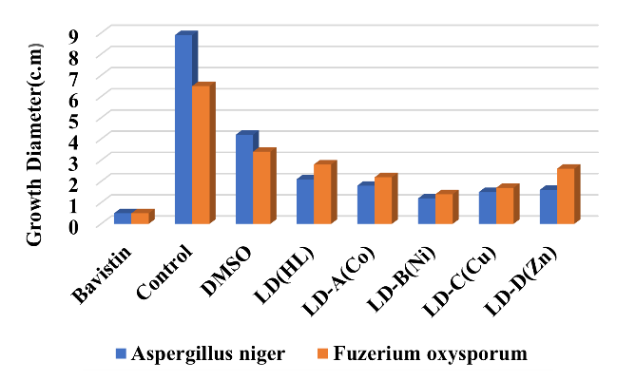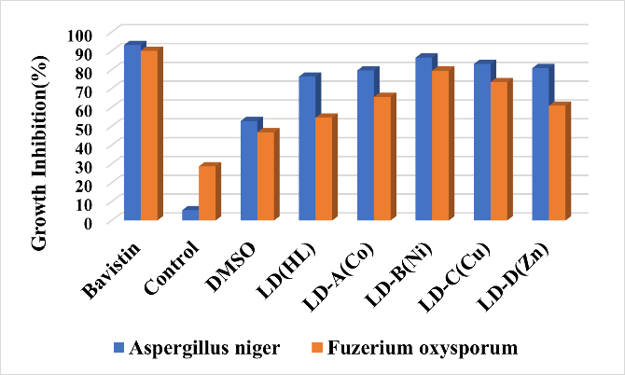
(a)
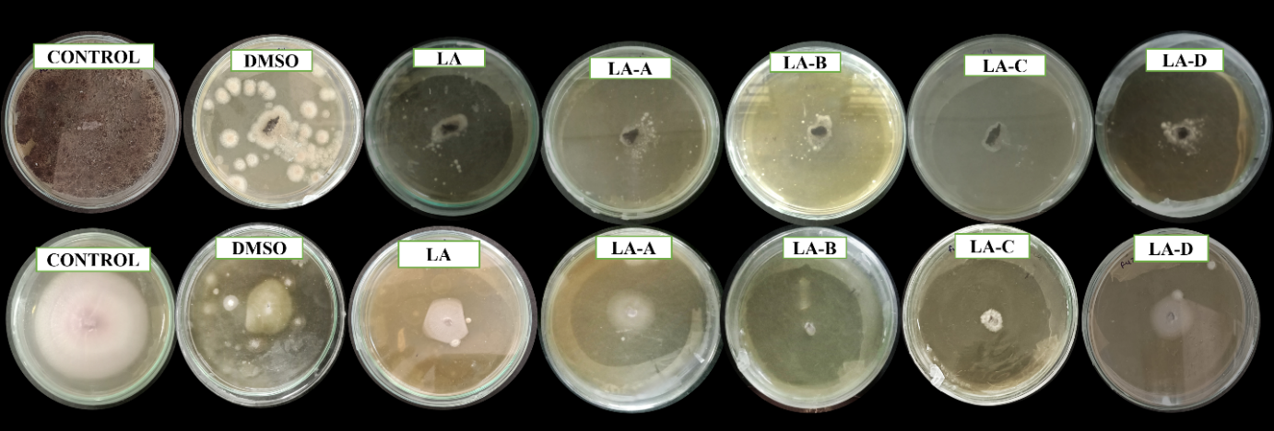
(b)
Fig. 2. (a) Graphical representation of % Growth inhibition of newly synthesized compounds against two fungal strains Aspergillus niger and Fusarium oxysporum; and (b) pictorial representation of % Growth inhibition of newly synthesized compounds against two fungal strains Aspergillus niger and Fusarium oxysporum.

4. Conclusion

The study demonstrates that coordination of a thiazole-based Schiff base ligand with transition metal ions significantly affect, its antifungal and antioxidant activities. The findings suggest that these binuclear metal complexes may serve as potential candidates for the development of new bioactive agents or newer APIs. Among the complexes, the Cu(II) complex displayed the highest antioxidant activity. Furthermore, antifungal studies against Aspergillus niger and Fusarium oxysporum unveil potential possibilities in free ligand and their metal complexes with life essential metal ions viz. Co(II), Ni(II), Cu(II) and Zn(II).

Ethical approval

No ethical approval was necessary for this study

References

- Lemilemu, F., Bitew, M., Demissie, T. B., Eswaramoorthy, R., & Endale, M. (2021). Synthesis, antibacterial and antioxidant activities of thiazole-based Schiff base derivatives: A combined experimental and computational study. BMC Chemistry, 15(1), 67.
- Sahoo, J., & Paidesetty, S. K. (2018). Biological investigation of novel metal complexes of 2-amino-4-substituted phenylthiazole Schiff bases. Journal of Taibah University Medical Sciences, 13(2), 142–155.
- Malav, R., & Ray, S. (2025). Recent advances in the synthesis and versatile applications of transition metal complexes featuring Schiff base ligands. RSC Advances, 15(28), 22889–22914. https://doi.org/10.1039/d5ra03626G
- Achonye, C. C., Ezenweke, L. O., Ojiako, E. N., & Ogbuagu, O. E. (2025). Spectroscopic and biological investigations of 4-[(1E)-N-(2-aminophenyl)ethanimidoyl]-3-methyl-1-phenyl-1H-pyrazol-5-ol and its Copper(II) complex. International Journal of Research and Innovation in Applied Science (IJRIAS), 10(11).
- Bhosale, D. G., Nimal, S., Gacche, R., Raut, D., Chaudhari, P. B., Deshmukh, P., Puri, G., Khobragade, R., & Lawand, A. S. (2024). Novel Co(II), Cu(II) and Zn(II) complexes derived from thiazole containing Schiff base ligands: Green synthesis, antimicrobial and anti-cancer studies. Inorganic Chemistry Communications, 170, 113320. https://doi.org/10.1016/j.inoche.2024.113320
- Catalano, A., Sinicropi, M. S., Iacopetta, D., Ceramella, J., Mariconda, A., Rosano, C., Scali, E., Saturnino, C., & Longo, P. (2021). A review on the advancements in the field of metal complexes with Schiff bases as antiproliferative agents. Applied Sciences, 11(13), 6027. https://doi.org/10.3390/app11136027
- Rai, A., Pradhan, P., Sahoo, J., Nayak, R., & Jena, S. (2023). Antimicrobial peptides as future therapeutics: Challenges and prospects. Current Research in Microbial Sciences, 6, 100211.
- Das, K., Datta, A., Massera, C., & Sinha, C. (2019). Structural diversity, topology and luminescent properties of a two-dimensional Cd(II) coordination polymer incorporating 4,4′-dipyridyl and 4,4′-sulfonyldibenzoic acid. Journal of Molecular Structure, 1179, 618–622.
- Lu, J., Huang, Y., Liu, R., Liang, Y., Zhang, H., Shen, N., Yang, D., & Jiang, M. (2024). Antimicrobial mechanisms and antifungal activity of compounds generated by banana rhizosphere Pseudomonas aeruginosa Gxun-2 against Fusarium oxysporum f. sp. cubense. Frontiers in Microbiology, 15, 1456847.
- Baliyan, S., Mukherjee, R., Priyadarshini, A., Vibhuti, A., Gupta, A., Pandey, R. P., & Chang, C.-M. (2022). Determination of antioxidants by DPPH radical scavenging activity and quantitative phytochemical analysis of Ficus religiosa. Molecules, 27(4), 1326. doi:10.3390/molecules27041326.
- Ashrafuzzaman, M., Khanm Camellia, F., Rahman, M. H., Hossain, M. D., Hossain, M. T., Rahman, H., Shovon, G. M., Paul, G. K., Zahan, M. K.-E., & Haque, M. M. (2023). Synthesis, characterization, antibacterial and antioxidant activities of Cu(II), Ni(II), and Zn(II) mixed ligand complexes containing isoniazid based bidentate Schiff base. Asian Journal of Chemical Sciences, 13(5), 112–122.
- Saif, M., El-Shafiy, H. F., Mashaly, M. M., Eid, M. F., & Fouad, R. (2016). Synthesis, characterization, and antioxidant/cytotoxic activity of new chromone Schiff base nano-complexes of Zn(II), Cu(II), Ni(II) and Co(II). Journal of Molecular Structure, 1118, 75–82.
- Ramadan, M. M., Naeem, A. M. A., Aboelhasan, A. E., & Abdel Aziz, A. A. (2024). DNA binding and antioxidant activities of novel synthesized Fe(III), Ni(II) and Cu(II) complexes derived from monodentate V-shaped Schiff bases. Journal of Transition Metal Complexes, 7, Article 246166.
- Raman, N., Sakthivel, A., & Rajasekaran, K. (2007). Synthesis and spectral characterization of antifungal sensitive Schiff base transition metal complexes. Mycobiology, 35(3), 150–153.
- Yimer, A. M. (2014). Chemical synthesis, spectral characterization and antimicrobial studies on complexes of Ni(II), Cu(II) and Zn(II) with N,N-di(o-hydroxybenzenoylmethylene)ethylenediamine. American Journal of Bioscience, 2(6-1), 22–34.

