Short communication

A range extension of the eastern Himalayan herb Rohdea wattii (Asparagaceae) to Eastern Ghats of Odisha, India

ABSTRACT
Rohdea wattii (C.B.Clarke) Yamashita & M.N.Tamura (Asparagaceae), previously known from the Eastern Himalaya, South China and North Vietnam, is here reported for the first time from Eastern Ghats, India. During a recent floristic survey in Odisha, the species was collected from Barbara Reserve Forest, Hatigada, Khordha district. A critical assessment of relevant literature and herbarium specimens confirmed this collection as a new distributional record for the Eastern Ghats. A detailed taxonomic description, information on habitat and phenology, along with colour photographs, are provided to facilitate accurate identification and future field recognition.

Key words: Asparagaceae, Barbara Reserve Forest, Campylandra wattii, Eastern Himalaya, Eastern Ghats

INTRODUCTION
Odisha harbours extensive and ecologically diverse forest ecosystems, covering nearly one-third of its geographical area. These forests encompass tropical semi-evergreen, moist and dry deciduous vegetation types, as well as ecologically significant mangrove ecosystems. Among them, Barbara Reserve Forest, located in the Eastern Ghats near Chilika Lake, represents a distinct landscape unit spanning the districts of Khordha, Nayagarh and Ganjam and supports heterogeneous vegetation contributing to high floristic diversity (Kumar et al. 2022). The genus Rohdea Roth comprises about 34 species distributed across the Eastern Himalaya, South China and North Vietnam (POWO, 2025). In India, the genus is represented by three species, viz. R. eucomoides (Baker) N.Tanaka, R. nepalensis (Raf.) N.Tanaka and R. wattii (C.B.Clarke) Yamashita & M.N.Tamura (POWO, 2025).
During ongoing floristic investigations in Odisha (Kumar et al. 2022a, 2022b, 2025; Devi et al. 2023, 2024, 2025; Mishra et al., 2025), an unusual species of Rohdea was collected from Barbara Reserve Forest, Hatigada, Khordha district, at about 120 m a.s.l. Detailed morphological examination and comparison with the protologue and type specimens confirmed its identity as R. wattii (Fig. 1), a rhizomatous perennial herb previously known from the Eastern Himalaya. This collection represents the first record of R. wattii from the Eastern Ghats of Odisha. The species was earlier reported from the lower Himalayan ranges of Northeast India, including Arunachal Pradesh, Manipur, Meghalaya, Nagaland and Sikkim (Dhatchanamoorthy et al. 2024; POWO 2025).

MATERIALS AND METHODS
Specimens of Rohdea wattii were collected from Barbara Reserve Forest, Hatigada, Khordha district, Odisha, India. Voucher specimens were processed following standard herbarium techniques (Jain & Rao, 1977) and deposited in the Herbarium of the Ambika Prasad Research Foundation, Cuttack, Odisha. Habitat, habit and floral characters were documented in the field using a Nikon D300S digital camera with an 18–55 mm lens. The present study is based on field observations of living plants, examination of type specimens housed at BM, CAL and K, and a critical review of relevant taxonomic literature.

TAXONOMIC TREATMENT
Rohdea wattii (C.B.Clarke) Yamashita & M.N.Tamura, J. Pl. Res. 117(5): 369. 2004. Campylandra wattii C.B.Clarke, J. Linn. Soc., Bot. 25: 78, t. 32. 1889. Tupistra wattii (C.B.Clarke) Hook.f., Fl. Brit. India 6: 325. 1892.
Lectotype (designated by Dhatchanamoorthy et al., 2024): India, Manipur, Kupra, 6000 ft, 6 February 1882, G. Watt 5885 (CAL0000253817!); isolectotypes BM000617038!, K000846034! (Fig. 2).
Remaining syntype: India, Manipur, Mayang, 16 November 1885, C.B. Clarke 42045A (K003735742!, Fig. 3).
Perennial herbs, rhizomatous, 40–60 cm high. Rhizome 20–30 cm long, 1–1.5 cm thick, brownish-yellow when dried, stem like, elongate, terete, slightly curved. Stem as long as rhizome or little shorter, elongate, subterete, glabrous, internodes 1.5–4.5 cm long. Cataphylls or scaly leaves 1–2, present at base of each series of 2–3 consecutive foliage leaves, lanceolate, involute, chartaceous, 4–5.5 cm long, 1.2–1.6 cm wide midway, hyaline along margins, apex acuminate, many-veined. Leaves 6–12, elliptic-ovate or narrowly elliptic, 8–21 × 3.5–7.5 cm, chartaceous, apex acuminate, base cuneate, entire along margins, glabrous; primary veins 6–7 pairs; petiole 5–7 cm long, subcanaliculate, glabrous, basally widened and clasping. Inflorescence a terminal spike, ellipsoid, 2.5–3.5 cm long, densely-flowered, light green, apically terminating with several sterile bracts; peduncle 2.5–3 cm long, glabrous; fertile bracts 2, narrowly lanceolate, 6–15 × 2–5 mm, apex acute-shortly acuminate, minutely denticulate along margins, glabrous. Perianth cupulate-subcampanulate, 8–10 mm across, light green; tube 3.5–5 mm long; lobes 6, broadly ovate-suborbicular, 3–4.5 mm across, hyaline and obscurely-denticulate at margins, acute-shortly acuminate at apex, glabrous. Stamens 6; filaments 2–3 mm long, proximally adnate to tube and widened, incurved above; anther broadly ovate, 1–1.2 mm long, pale green. Ovary slightly depressed globose, 2.2–2.5 mm long, glabrous; style minute, inconspicuous; stigma 3-lobed, lobes ovate. Berries red when ripe, globose, 9–12 mm across, glabrous.
Phenology: Flowering from late February to early May and fruiting from October to January.
Ecology and habitat: In Odisha, the species occurs in moist deciduous forests, primarily along stream margins within dense forest at about 120 m a.s.l. In the Eastern Himalaya, it is found in moist sites in dense forests, on hillsides and along valleys or streams, between 750 and 3000 m a.s.l.
Species examined: India, Odisha, Khordha district, Hatigada, Barbara Reserve Forest, 19º52ʹ42ʺ N, 85º01ʹ05ʺ E; 120 m a.s.l., 14, November, 2025, R.S Devi 192 (Herbarium of Ambika Prasad Research Foundation, Fig. 4).
Distribution: Bhutan, China, Vietnam and India (Arunachal Pradesh, Manipur, Meghalaya, Nagaland, Sikkim and present record from Odisha).

COMPETING INTERESTS DISCLAIMER:
Authors have declared that they have no known competing financial interests OR non-financial interests OR personal relationships that could have appeared to influence the work reported in this paper.

REFERENCES
Devi, R.S., Kumar, S. & Singh, R.K. (2023). A new species of Smithia Aiton (Fabaceae) from Odisha state, India. Indian Forester 149(4): 471–473. https://doi.org/10.36808/if/2023/v149i4/167627
Devi, R.S., Kumar, S. & Singh, R.K. (2024). Lectotypification of three names in Aeschynomene (Fabaceae), a new species from Odisha, India and a new combination in Ctenodon. Journal of Biodiversity and Conservation 8(1): 49–62.
Devi, R.S., Mishra, S., Marndi, S., Singh, R.K., Mishra, A.K. & Kumar, S. (2025). Lindernia tamilnadensis (Linderniaceae), a new record to the flora of Odisha state, India from Mahanadi River areas of Cuttack. Species 26: e15s1801. https://doi.org/10.54905/disssi.v26i77.e15s1801
Dhatchanamoorthy, N., Devanathan, K., Lokho, K., Begum, S.N. & Balachandran, N. (2024). Rediscovery and lectotypification of Rohdea wattii (C.B.Clarke) Yamashita & M.N.Tamura (Asparagaceae) from Manipur, India. Phytotaxa 641 (2): 177–182. https://doi.org/10.11646/phytotaxa.641.2.9
Kumar, S., Mishra, S., Mishra, A.K. & Kumar, S.N. (2022a). Floral diversity of Koira & Barsuan Ranges of Bonai Forest Division, Odisha. Bonai Forest Division & Ambika Prasad Research Foundation, Odisha.
Kumar, S., Marndi, S., Mishra, S., Devi, R.S. & Singh, R.K. (2025). Setaria viridis (L.) P.Beauv.: A new record to the grass flora of Odisha, India. Species 26: e44s3197. https://doi.org/10.54905/disssi.v26i78.e44s3197
Kumar, S.N., Mishra, S., Kumar, S. & Singh, R.K. (2022b). Zehneria bodinieri (H. Lév.) W.J. de Wilde & Duyfjes (Cucurbitaceae) – A new addition to the flora of Odisha, India. Geophytology 51(1&2): 139–142.
POWO. (2025). Plants of the World Online. Royal Botanic Gardens, Kew. Available from: http://www.plantsoftheworldonline.org/ (accessed 24 November 2025).
Tanaka, N. (2010). A taxonomic revision of the genus Rohdea (Asparagaceae). Makinoa New Series. 9: 1–54.

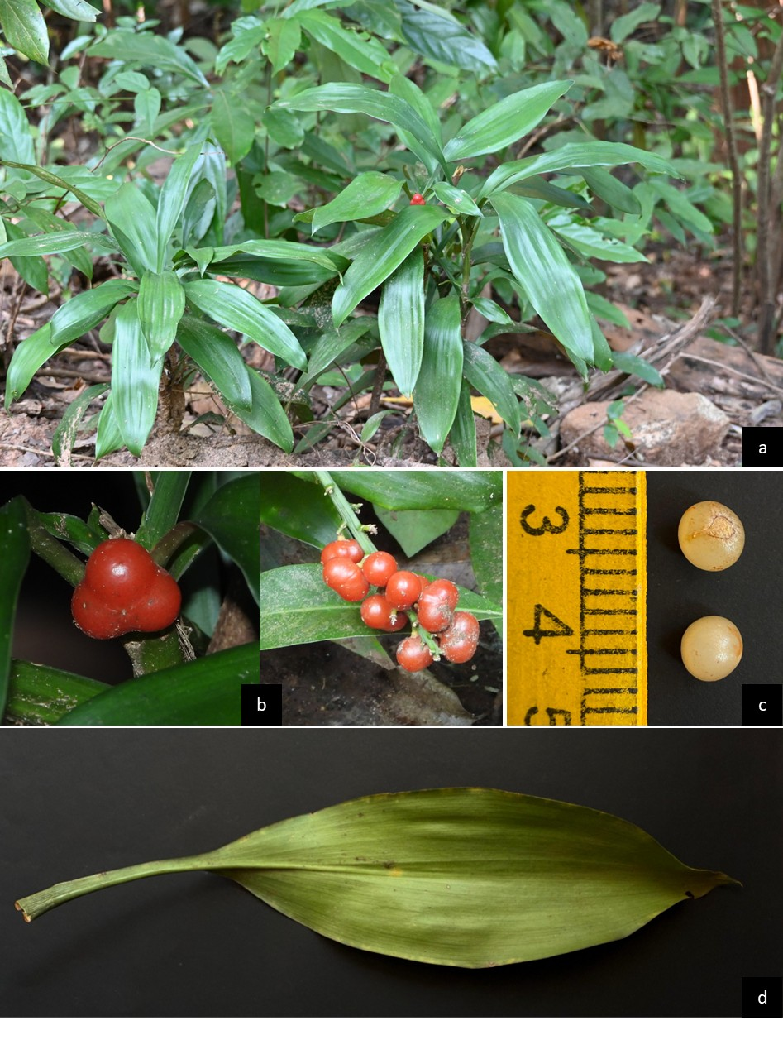
Fig. 1. Rohdea wattii. a) Habitat. b) Fruits. c) Seeds. d) Adaxial leaf.

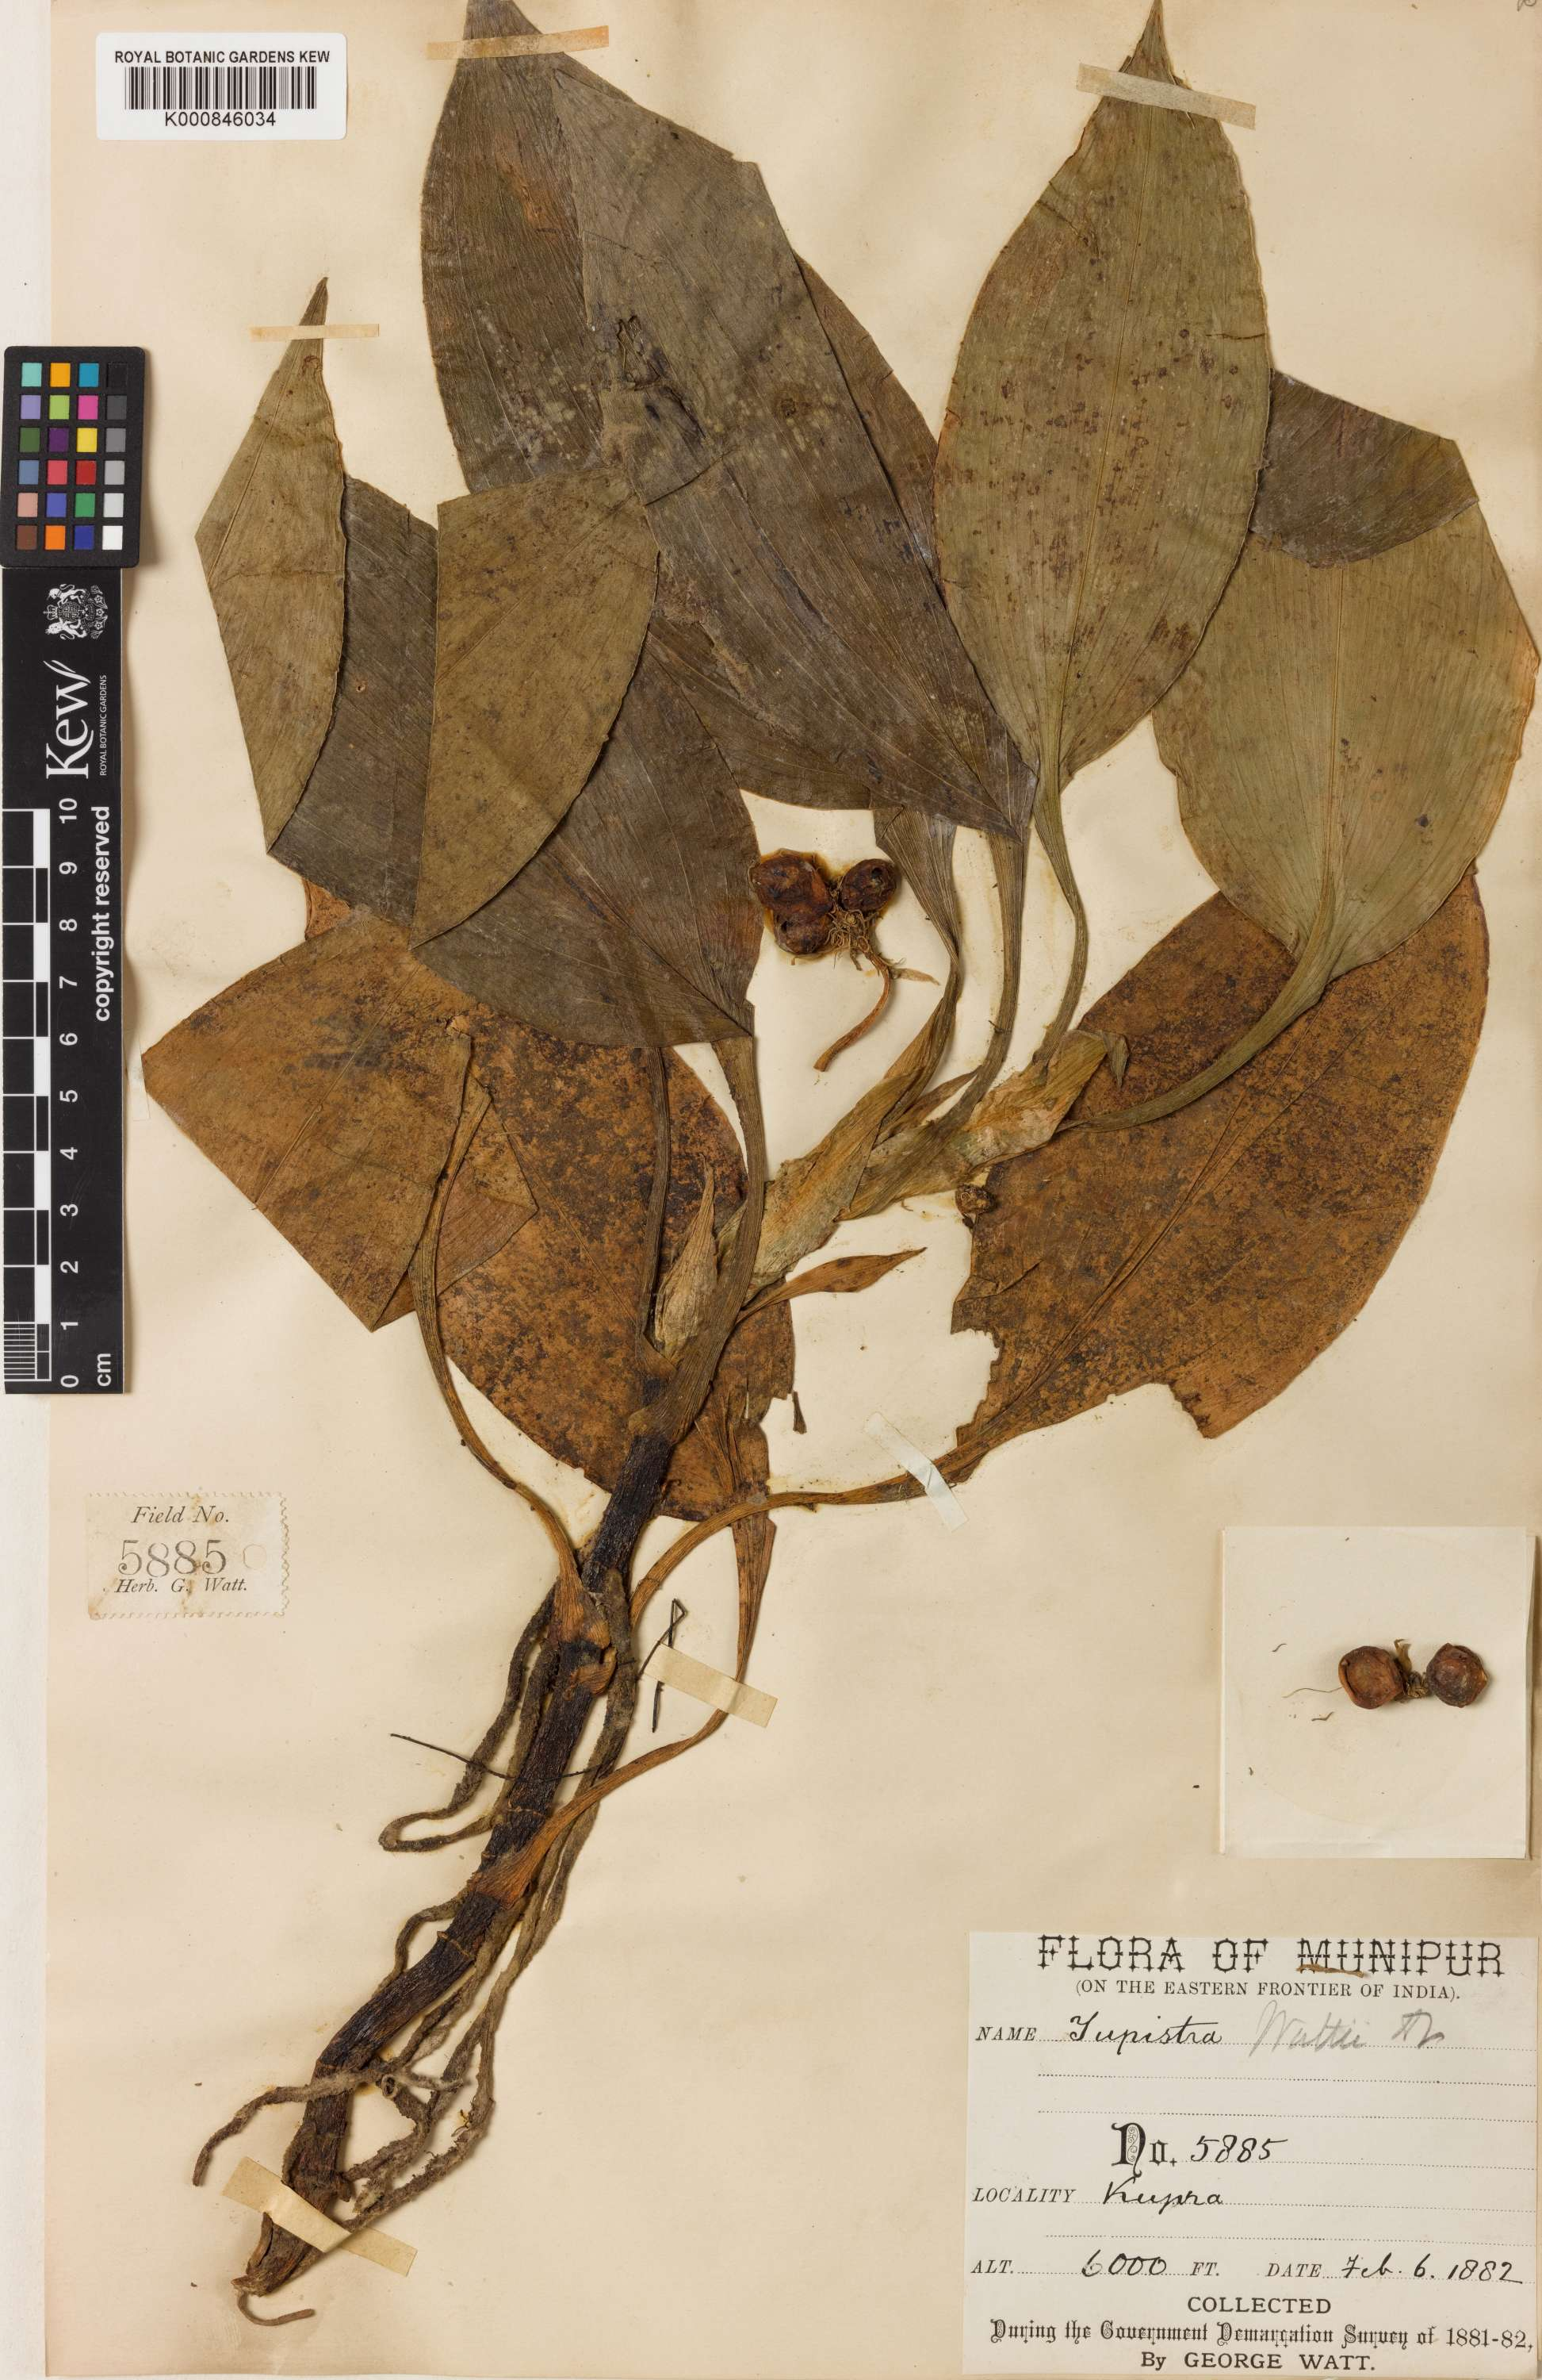
Fig. 2. Isolectotype of Campylandra wattii C.B.Clarke (K000846034).

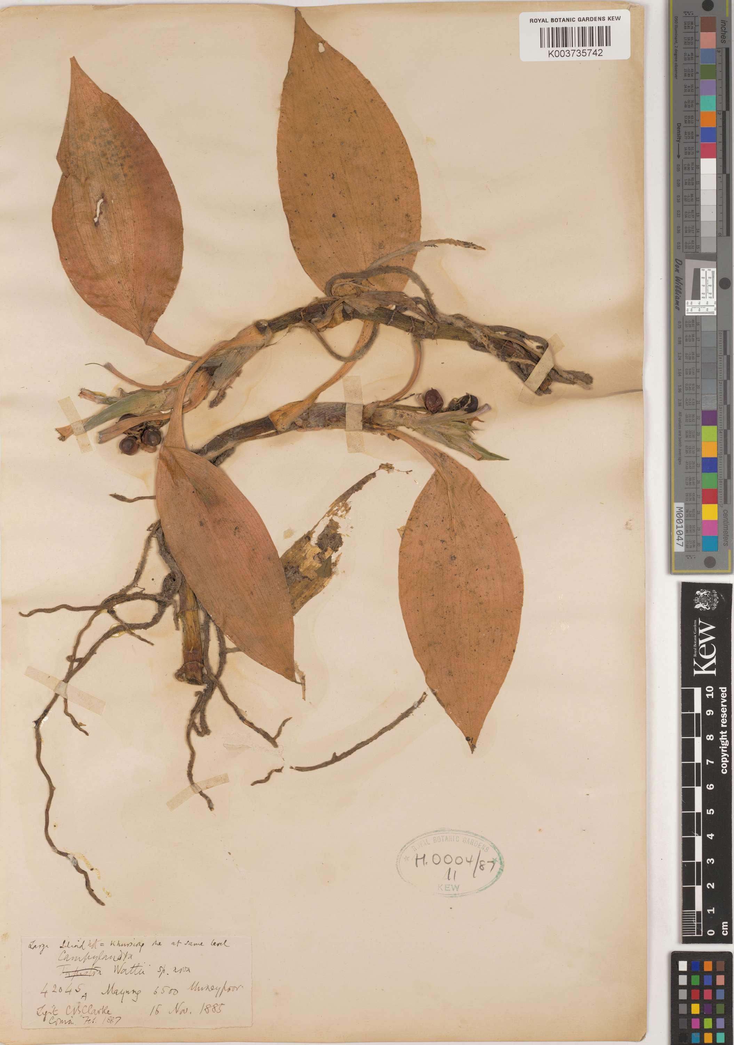
Fig. 4. Remaining syntype of Campylandra wattii C.B.Clarke (K003735742).

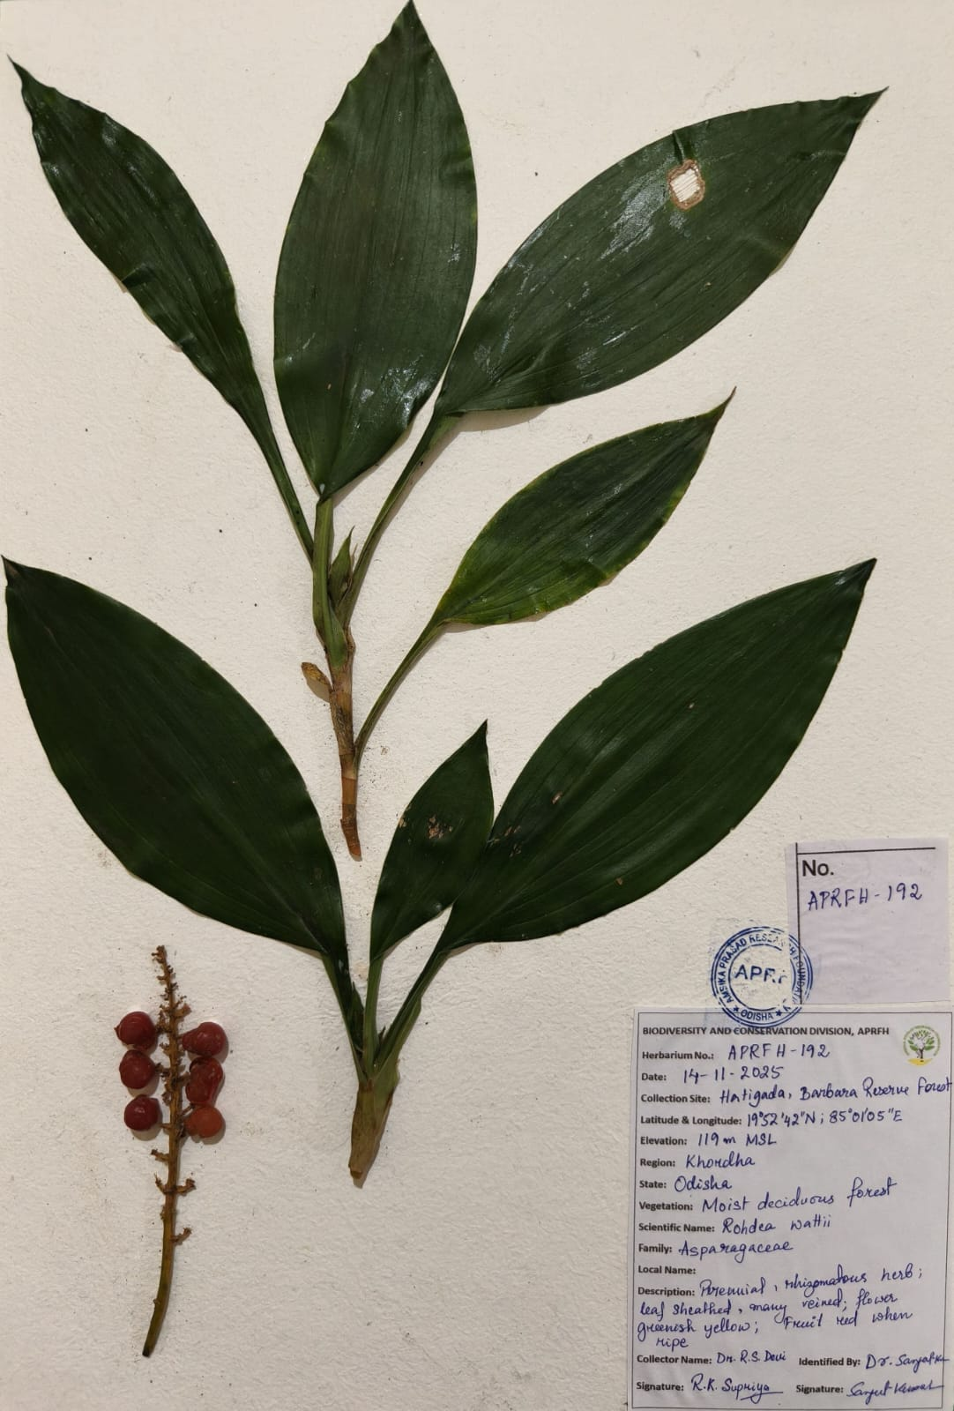
Fig. 5. Herbarium specimen of Rohdea wattii deposited in the Herbarium of the Ambika Prasad Research Foundation.

