Role of Exergaming in Enhancing Memory and Attention in the Elderly

ABSTRACT
Background: Age-related cognitive decline affects memory, attention, and executive function, leading to reduced independence and quality of life among older adults. Exergaming, which integrates physical activity with interactive digital games, has emerged as a promising approach to enhance cognitive performance through combined motor and cognitive stimulation.
Objective: To evaluate the effect of a structured 6-week exergaming program on attention, working memory, and global cognition in community-dwelling older adults.
Methods: A pre–post experimental study was conducted among 30 adults aged 65 years and above in a Physiotherapy rehabilitation center. Participants completed 18 exergaming sessions over six weeks using a motion-capture gaming system (Xbox 360 Kinect). Cognitive outcomes were assessed before and after the intervention using the Trail Making Test (TMT-A and TMT-B) for attention and executive function, the Digit Span Test (forward and backward) for working memory, and the Montreal Cognitive Assessment (MoCA) for global cognition. Data were analyzed using paired t-tests with significance set at p ≤ 0.05.
Results: Significant improvements were observed across all outcome measures. TMT-A completion time decreased from 54.6 ± 9.3 to 42.8 ± 7.5 seconds (p < 0.001), and TMT-B decreased from 129.4 ± 28.6 to 103.7 ± 23.5 seconds (p < 0.001), indicating enhanced attention and task switching. Working memory improved, with Digit Span Forward increasing from 4.6 ± 1.1 to 5.8 ± 1.0 and Digit Span Backward from 3.2 ± 0.9 to 4.1 ± 1.0 (both p < 0.001). Global cognitive performance also increased significantly, with MoCA scores rising from 21.8 ± 2.6 to 25.1 ± 2.9 (p < 0.001).
Conclusion: A 6-week exergaming intervention significantly improved attention, working memory, and overall cognitive function in older adults. Exergaming represents an effective, engaging, and low-cost digital therapeutic option for promoting cognitive health in the elderly.
Keywords: Exergaming, cognition, memory, attention, older adults, digital therapeutics.

1. INTRODUCTION
Cognitive decline is one of the most prevalent challenges among the geriatric population, characterized by deterioration in memory, attention, and executive function.[1,2] These changes increase the risk of dependence, falls, and reduced quality of life.³ Globally, mild cognitive impairment affects nearly 20% of older adults.[3,4]
Traditional cognitive training programs often suffer from low engagement due to monotony, limited sensory stimulation, and poor adherence.[5] Exergaming—defined as exercise combined with video gaming through interactive systems—offers a promising alternative.[6] These systems engage cognitive domains such as attention, visuospatial processing, processing speed, and working memory while simultaneously promoting physical activity.[7,8]
Studies suggest that exergaming stimulates neuroplasticity by activating motor–cognitive pathways, enhancing blood flow, and increasing sensory integration.[9,10]Unlike conventional exercises, exergames incorporate real-time feedback, visual cues, multitasking, and motor planning, making them particularly effective for older adults.[11] However, limited evidence exists from structured intervention studies in Indian or community-dwelling elderly populations.[12]
The present study sought to evaluate the impact of a structured 6-week exergaming program on memory and attention in older adults.[13]

2. MATERIALS AND METHODS
2.1 Study Design and Setting
A pre–post experimental study was conducted among 30 adults aged 65 years and above conducted at the Department of Physiotherapy, Sharda Hospital, India . The design aimed to determine changes in memory and attention after a structured exergaming intervention among older adults aged 65 years and above. [14]
2.2 Participants
• Inclusion criteria:
– Age ≥65 years
– Able to ambulate independently
– MoCA score ≥18 (to exclude moderate cognitive impairment)
– Willingness to participate for 6 weeks [15]
• Exclusion criteria:
– Severe visual/hearing impairment
– Uncontrolled neurological or psychiatric disorders
– Recent fractures or cardiovascular instability. [16]
2.3 Exergaming Intervention
Participants engaged in exergaming using a motion-capture–based interactive gaming platform using Xbox 360 Kinect.[17]
Session structure (30–35 minutes):
- Warm-up: 5 minutes (marching, arm mobility)
- Exergaming: 20–25 minutes of games targeting
– visuospatial attention
– memory recall
– task switching
– motor coordination
- Cool-down: 5 minutes
Game types included:
• Target hitting and reaction tasks
• Step-based sequencing games
• Memory-matching and dual-task games
• Balance and agility games requiring visuomotor attention.[18]

Sessions were conducted 3 times per week for 6 weeks (total 18 sessions).

2.4 Outcome Measures
Assessment was performed before and after the intervention using standardized tools.
Attention:
• Trail Making Test A (TMT-A): processing speed & attention
• Trail Making Test B (TMT-B): task switching & divided attention.[19]

Working Memory:
• Digit Span Test (Forward & Backward)
Global Cognition:
• Montreal Cognitive Assessment (MoCA) [20]
2.5 Statistical Analysis
Data were analyzed using SPSS. Mean ± SD was calculated. Paired t-tests determined pre–post differences with significance set at p ≤0.05.

3. RESULT
3.1 Participant Characteristics
A total of 30 older adults completed the study (mean age: 67.5 ± 5.4 years). No adverse events were reported, and adherence to sessions was >90%.
Table 1 presents changes in attention performance as measured by the Trail Making Test–Part A (TMT-A) and Part B (TMT-B) following the intervention. A statistically significant improvement was observed in both measures.
Table 1. Attention Scores (TMT-A and TMT-B)
(Lower time = better performance)
Variable | Pre-test Mean ± SD | Post-test Mean ± SD | p-value
TMT-A (seconds) | 54.6 ± 9.3 | 42.8 ± 7.5 | <0.001
TMT-B (seconds) | 129.4 ± 28.6 | 103.7 ± 23.5 | <0.001

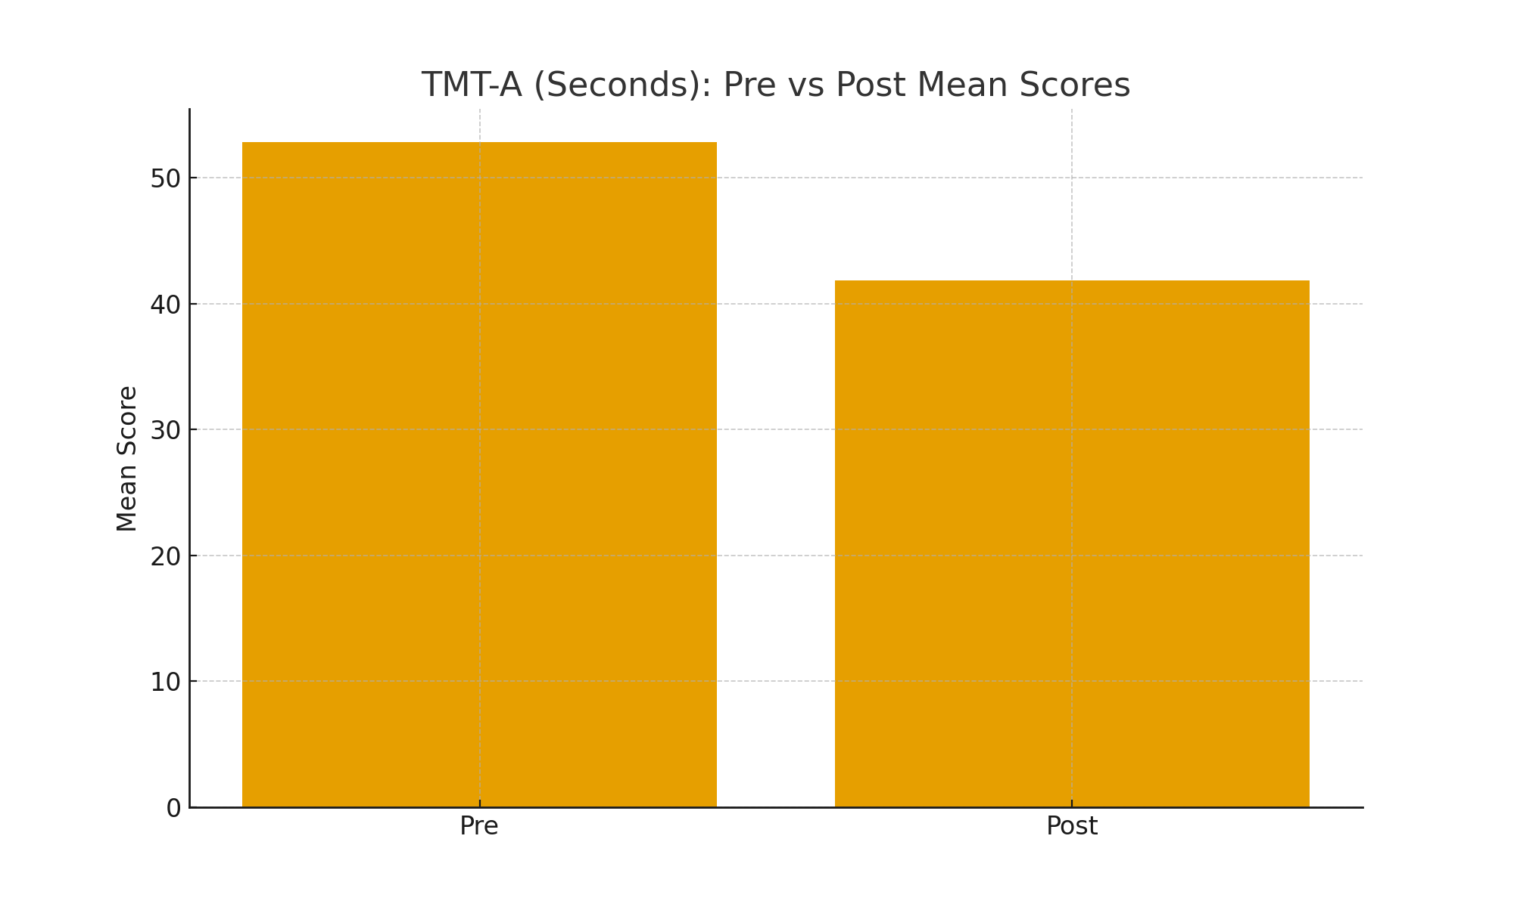
Fig 1- Bar graph showing Trail Making Test–Part A (TMT-A) and Part B (TMT-B)
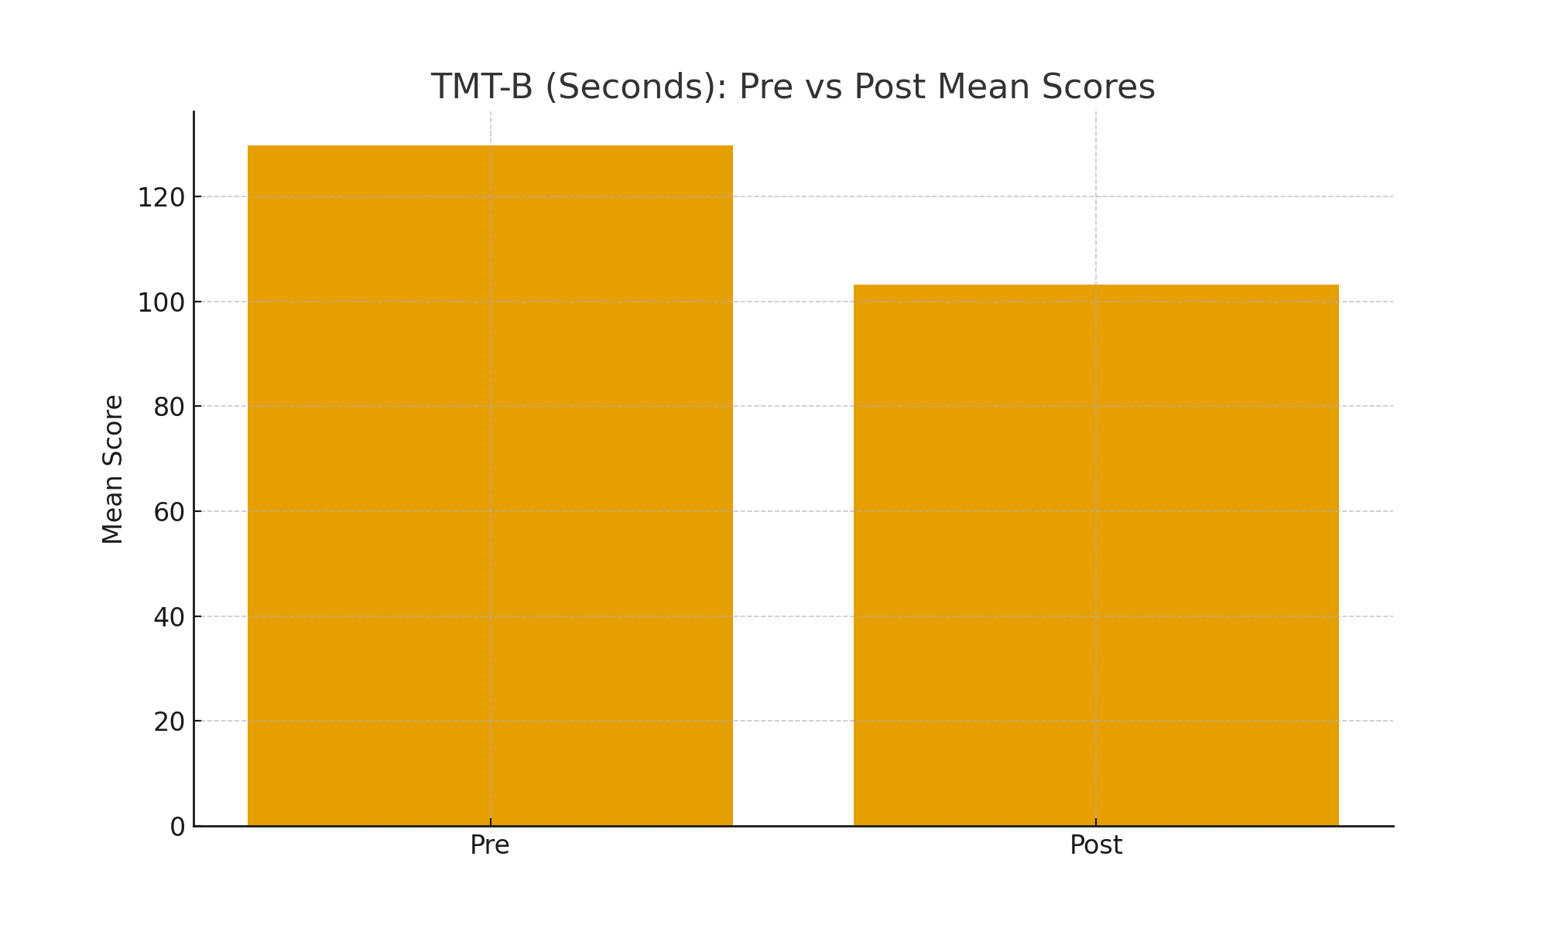

Fig 2- Bar graph showing TMT-B (seconds) pre vs post mean scores

For TMT-A, mean completion time decreased from 54.6 ± 9.3 seconds at pre-test to 42.8 ± 7.5 seconds at post-test, indicating faster visual scanning and psychomotor speed. This reduction was highly significant (p < 0.001).
Similarly, TMT-B completion time improved from 129.4 ± 28.6 seconds to 103.7 ± 23.5 seconds, reflecting enhanced executive function and cognitive flexibility. This change was also statistically significant (p < 0.001).
Overall, the results demonstrate that the intervention led to substantial improvements in attentional processing and executive functioning, as evidenced by significantly reduced completion times on both components of the Trail Making Test.
3.3 Enhancements in Memory
Table 2 summarizes changes in working memory performance as measured by the Digit Span Test. Significant improvements were observed in both the forward and backward components following the intervention.

Table 2. Working Memory (Digit Span Test)
Variable | Pre-test Mean ± SD | Post-test Mean ± SD | p-value
Digit Span Forward | 4.6 ± 1.1 | 5.8 ± 1.0 | <0.001
Digit Span Backward | 3.2 ± 0.9 | 4.1 ± 1.0 | <0.001

Fig 3-Bar graph showing digit span forward for pre vs post mean scores
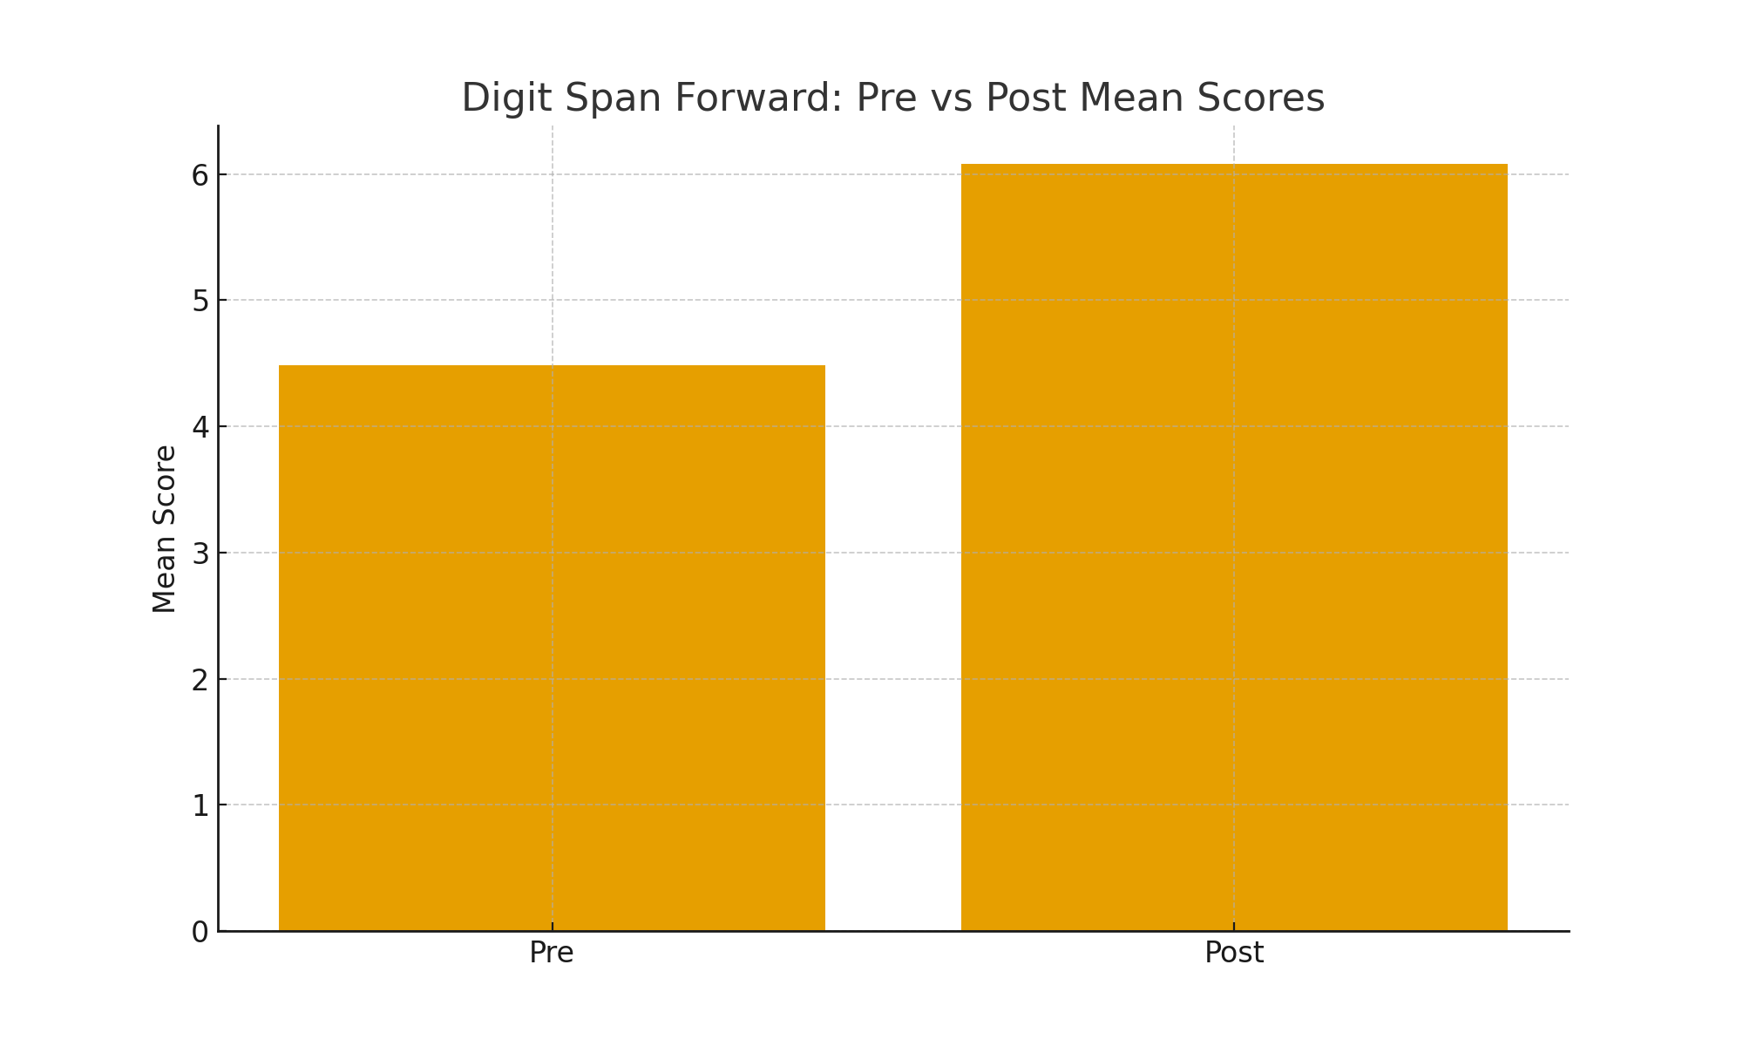
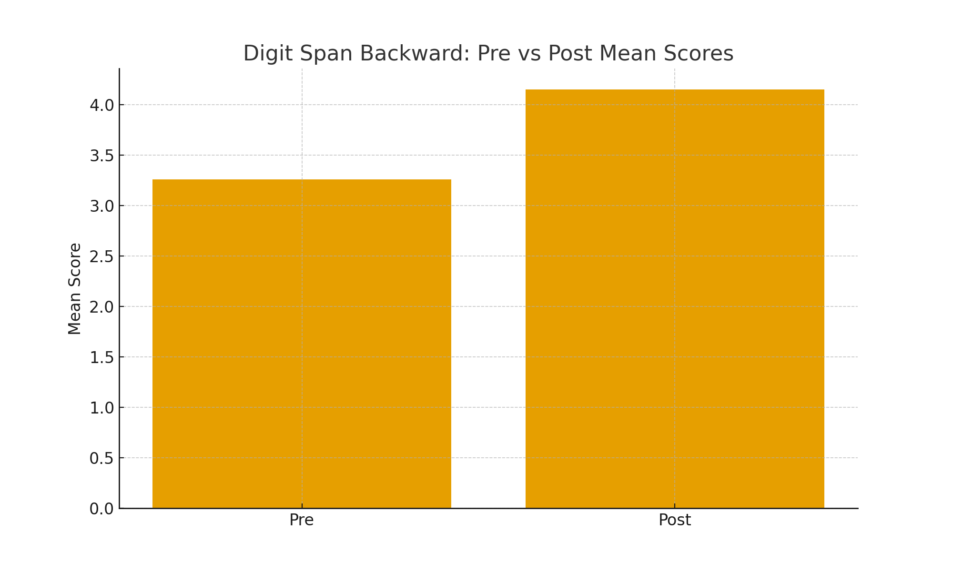
Fig 4- Bar graph showing digit span backward for pre vs post mean scores

For Digit Span Forward, the mean score increased from 4.6 ± 1.1 at pre-test to 5.8 ± 1.0 at post-test, indicating enhanced short-term memory and attention capacity. This improvement was statistically significant (p < 0.001).
Similarly, Digit Span Backward, which reflects working memory manipulation and executive control, showed a significant increase from 3.2 ± 0.9 to 4.1 ± 1.0 (p < 0.001).
These findings demonstrate that the intervention produced robust gains in both simple and complex working memory functions.
Digit Span Forward and Backward scores significantly improved, reflecting gains in immediate memory, working memory, and cognitive flexibility.
Memory-based exergames demand real-time recall, sequencing, and updating of information — all of which stimulate the prefrontal cortex.
3.4 Enhancement in Overall Cognitive Function
Table 3 presents changes in global cognitive functioning as measured by the Montreal Cognitive Assessment (MoCA). A statistically significant improvement was observed following the intervention.
Table 3. Global Cognition (MoCA)

Variable | Pre-test Mean ± SD | Post-test Mean ± SD | p-value
MoCA Total Score | 21.8 ± 2.6 | 25.1 ± 2.9 | <0.001

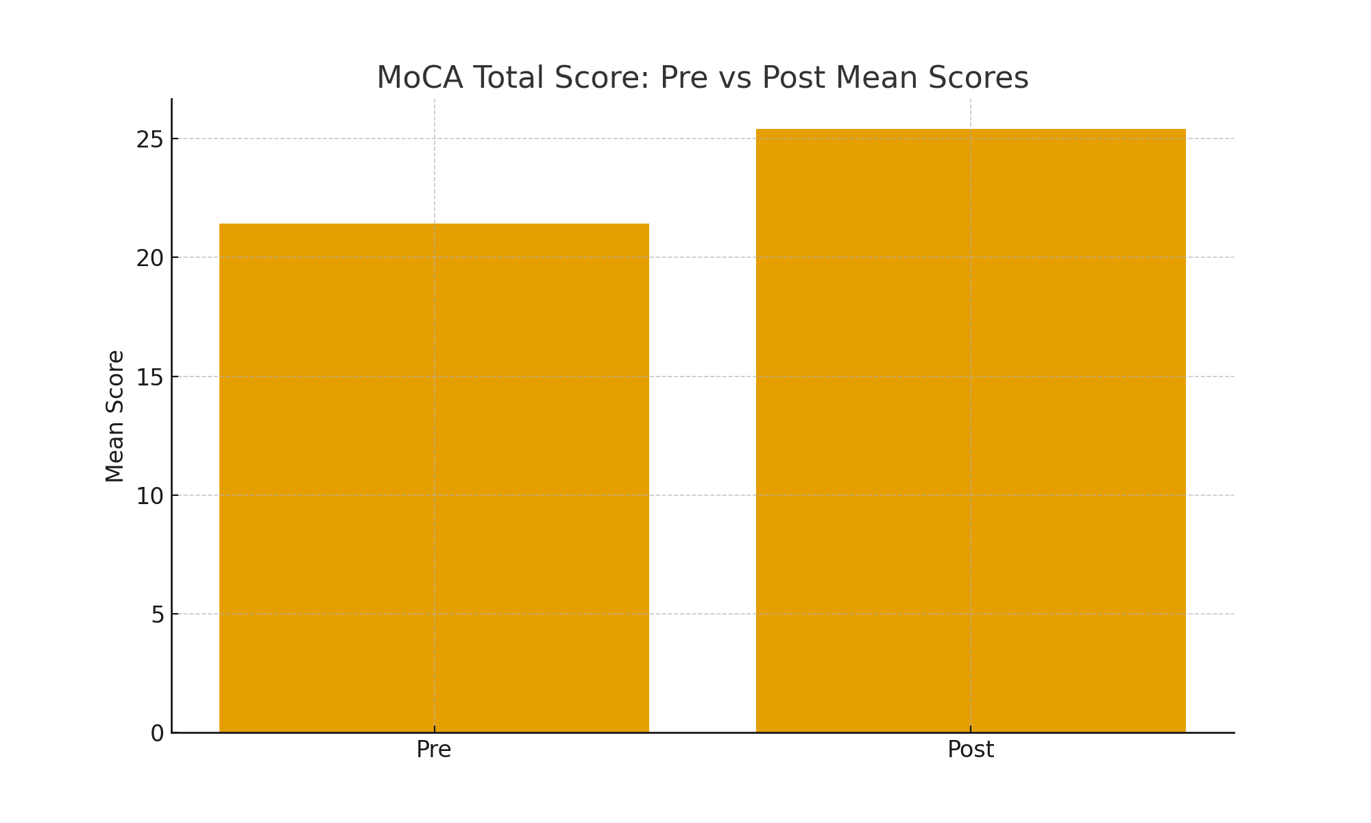
Fig 5- Bar graph showing MoCA total score for pre vs post mean scores
The MoCA total score increased from 21.8 ± 2.6 at pre-test to 25.1 ± 2.9 at post-test, indicating marked enhancement in overall cognitive performance. This improvement was highly significant (p < 0.001).
These results suggest that the intervention was effective in improving global cognition, including memory, attention, executive function, and visuospatial abilities.
Following the exergaming intervention, participants demonstrated a notable increase in general cognitive performance, as indicated by their MoCA scores. The mean MoCA score rose from 21.8 ± 2.6 at baseline to 25.1 ± 2.9 after six weeks of training, reflecting a statistically significant improvement (p < 0.001).
This rise suggests that the combined motor–cognitive demands of the training program contributed to broad gains across multiple cognitive domains, including attention, memory, visuospatial processing, and executive capabilities. Such improvements align with evidence that interactive, cognitively engaging physical activities can stimulate neuroplastic mechanisms, enhance cerebral blood flow, and support overall cognitive resilience in older adults.

4. DISCUSSION
The results demonstrate that a 6-week exergaming intervention can significantly improve attention, working memory, and global cognition in older adults.
Attention Improvements: The reduction in TMT-A and TMT-B times suggests enhanced processing speed, selective attention, and task-switching. Exergaming requires continuous visuomotor coordination, rapid decision-making, and obstacle recognition, which likely stimulated attentional networks. [21]
Memory Gains: Significant improvements in Digit Span Forward and Backward indicate enhanced short-term and working memory, as well as cognitive flexibility. Memory-based exergames demand real-time recall, sequencing, and updating of information, activating prefrontal cortical networks.[22]
Overall Cognitive Enhancement: The increase in MoCA scores reflects broad gains across cognitive domains, including attention, memory, visuospatial processing, and executive function. Combined motor–cognitive activity in exergaming likely contributed to neuroplastic adaptations and increased cerebral blood flow.[23]
Mechanisms and Implications: Exergaming enhances cognition through dual-task training, motor–cognitive integration, neuroplastic adaptation, and increased motivation and engagement. Unlike traditional training, exergames provide real-time feedback, progressive challenges, and multisensory stimulation, supporting adherence and long-term cognitive benefits.[24]

4. CONCLUSION
This study demonstrates that a 6-week exergaming program significantly enhances memory, attention, and global cognitive performance in older adults. Exergaming is an enjoyable, low-cost, and accessible tool that can be integrated into community rehabilitation, geriatric centers, and fall prevention programs. Future longitudinal studies with larger samples are recommended to evaluate long-term cognitive benefits and adherence patterns.

REFERENCES

- Petersen RC. Mild cognitive impairment. New England Journal of Medicine. 2011 Jun 9;364(23):2227-34.
- Prince, M., Wimo, A., Guerchet, M., Ali, G. C., Wu, Y. T., & Prina, M. (2015). The global impact of dementia: an analysis of prevalence, incidence, cost and trends. World Alzheimer Report, 2015, 84.
- Pérez Silva Mercado, R. R., Ascencio, E. J., Vidal-Cuellar, C. L., Aliaga, E. G., Casas, P. M., Ruiz-Grosso, P., & Tello, T. (2023). Gait speed according to cognitive status in older adults: a cross-sectional study in a resource-limited country. Aging & Mental Health, 27(11), 2153-2161.
- Pendlebury, S. T., Klaus, S. P., Mather, M., De Brito, M., & Wharton, R. M. (2015). Routine cognitive screening in older patients admitted to acute medicine: abbreviated mental test score (AMTS) and subjective memory complaint versus Montreal Cognitive Assessment and IQCODE. Age and ageing, 44(6), 1000-1005.
- Lampit, A., Valenzuela, M., & Gates, N. J. (2015). Computerized cognitive training is beneficial for older adults. Journal of the American Geriatrics Society, 63(12), 2610-2612.
- Sala, G., Tatlidil, K. S., & Gobet, F. (2021). Still no evidence that exergames improve cognitive ability: A commentary on Stanmore et al.(2017). Neuroscience & Biobehavioral Reviews, 123, 352-353.
- Anderson-Hanley, C., Arciero, P. J., Brickman, A. M., Nimon, J. P., Okuma, N., Westen, S. C., ... & Zimmerman, E. A. (2012). Exergaming and older adult cognition: a cluster randomized clinical trial. American journal of preventive medicine, 42(2), 109-119.
- Maillot, P., Perrot, A., & Hartley, A. (2012). Effects of interactive physical-activity video-game training on physical and cognitive function in older adults. Psychology and aging, 27(3), 589.
- Chao, Y. Y., Scherer, Y. K., & Montgomery, C. A. (2015). Effects of using Nintendo Wii™ exergames in older adults: a review of the literature. Journal of aging and health, 27(3), 379-402.
- Pacheco, T. B. F., de Medeiros, C. S. P., de Oliveira, V. H. B., Vieira, E. R., & De Cavalcanti, F. A. C. (2020). Effectiveness of exergames for improving mobility and balance in older adults: a systematic review and meta-analysis. Systematic reviews, 9(1), 163.
- Erickson, K. I., Voss, M. W., Prakash, R. S., Basak, C., Szabo, A., Chaddock, L., ... & Kramer, A. F. (2011). Exercise training increases size of hippocampus and improves memory. Proceedings of the national academy of sciences, 108(7), 3017-3022.
- Guneysu Ozgur, A., Wessel, M. J., Olsen, J. K., Johal, W., Ozgur, A., Hummel, F. C., & Dillenbourg, P. (2020). Gamified motor training with tangible robots in older adults: a feasibility study and comparison with the young. Frontiers in aging neuroscience, 12, 59.
- Eggenberger, P., Wolf, M., Schumann, M., & De Bruin, E. D. (2016). Exergame and balance training modulate prefrontal brain activity during walking and enhance executive function in older adults. Frontiers in aging neuroscience, 8, 66.
- Nouchi, R., Taki, Y., Takeuchi, H., Hashizume, H., Nozawa, T., Kambara, T., ... & Kawashima, R. (2013). Brain training game boosts executive functions, working memory and processing speed in the young adults: a randomized controlled trial. PloS one, 8(2), e55518.
- Buyle, M., Jung, Y., Pavlou, M., Gonzalez, S. C., & Bamiou, D. E. (2022). The role of motivation factors in exergame interventions for fall prevention in older adults: A systematic review and meta-analysis. Frontiers in neurology, 13, 903673..
- Altorfer, P., Adcock, M., de Bruin, E. D., Graf, F., & Giannouli, E. (2021). Feasibility of cognitive motor exergames in geriatric inpatient rehabilitation: a pilot randomized controlled study. Frontiers in aging neuroscience, 13, 739948.
- Gothe, N. P. (2021). Examining the effects of light versus moderate to vigorous physical activity on cognitive function in African American adults. Aging & mental health, 25(9), 1659-1665.
- Reitan, R. M., & Wolfson, D. (2001). The Halstead–Reitan Neuropsychological Test Battery: Research findings and clinical application.
- Verma M, Grover S, Singh T, Dahiya N, Nehra R. Screening for cognitive impairment among the elderly attending the noncommunicable diseases clinics in a rural area of Punjab, North India. Asian journal of psychiatry. 2020 Apr 1;50:102001.
- Nasreddine ZS, Phillips NA, Bédirian V, Charbonneau S, Whitehead V, Collin I, Cummings JL, Chertkow H. The Montreal Cognitive Assessment, MoCA: a brief screening tool for mild cognitive impairment. Journal of the American Geriatrics Society. 2005 Apr;53(4):695-9.

- Smith, P. J., Blumenthal, J. A., Hoffman, B. M., Cooper, H., Strauman, T. A., Welsh-Bohmer, K., ... & Sherwood, A. (2010). Aerobic exercise and neurocognitive performance: a meta-analytic review of randomized controlled trials. Psychosomatic medicine, 72(3), 239-252.

- Anguera, J. A., Boccanfuso, J., Rintoul, J. L., Al-Hashimi, O., Faraji, F., Janowich, J., ... & Gazzaley, A. (2013). Video game training enhances cognitive control in older adults. Nature, 501(7465), 97-101.
- Stanmore, E., Stubbs, B., Vancampfort, D., de Bruin, E. D., & Firth, J. (2017). The effect of active video games on cognitive functioning in clinical and non-clinical populations: A meta-analysis of randomized controlled trials. Neuroscience & Biobehavioral Reviews, 78, 34-43.

- Herold, F., Hamacher, D., Schega, L., & Müller, N. G. (2018). Thinking while moving or moving while thinking–concepts of motor-cognitive training for cognitive performance enhancement. Frontiers in aging neuroscience, 10, 228.

