Impact of Health Education on the Knowledge, Practice and Attitudes of Female Undergraduates of Adekunle Ajasin University, Akungba-Akoko towards Breast Cancer Preventive Practices

.
ABSTRACT
Aims: To evaluate the effect of a structured health education programme on the knowledge, attitudes, and preventive practices regarding breast cancer among female undergraduates of Adekunle Ajasin University, Akungba-Akoko.
Study Design: Quasi-experimental one-group pre-test and post-test design.
Place and Duration of Study: Adekunle Ajasin University, Akungba-Akoko, Nigeria, between September and December 2020.
Methodology: 60 female undergraduates drawn from six faculties were selected using proportionate stratified sampling. Data were collected using a semi-structured questionnaire incorporating Breast-CAM, Knowledge–Attitude–Practice (KAP) instruments, and the Breast Cancer Prevention Scale (BCPS). Descriptive statistics summarized variables. Bloom’s cut-off classified knowledge and attitudes, while mean scores assessed practices. Inferential analysis using SPSS version 25 included paired sample t-tests and McNemar tests to determine intervention effects at p = .05.
Results: Respondents’ mean age was 23.28 ± 4.05 years. Knowledge scores improved significantly following the intervention (mean difference = −2.45, SD = 3.08), t(59) = −6.155, p = .001, 95% CI [−3.25, −1.65]. Preventive practice scores also showed significant improvement (mean difference = −3.00, SD = 3.91), t(59) = −5.950, p = .001, 95% CI [−4.01, −1.99]. McNemar test indicated a significant change in preventive practices (p =.035). However, no statistically significant effect was observed on attitudes toward breast cancer prevention (χ² = 2.690, df = 2, p =.261).
Conclusion: Health education significantly enhanced breast cancer knowledge and preventive practices but did not produce significant attitudinal change. Institutionalized, theory-driven health education within university settings can strengthen preventive behaviors, though strategies targeting attitudinal transformation require further refinement.

Keywords: Breast cancer, health education, knowledge of breast cancer, practice of breast cancer, attitudes to breast cancer, female undergraduates

1. INTRODUCTION
The world is currently faced with female breast cancer as the most commonly diagnosed among women, with 11.6% representing the number of newly diagnosed cancer cases in 2022 and 6.9% representing the proportion of cases of cancer-related deaths. Around the world, the new cancer incidence and cancer fatalities each stood at approximately 20 million and 9.7 million respectively in the same year, which is projected to increase to 35 million new cancer cases in the coming 2050 in case of a continuity of the current trends (Bray et al., 2024). Though the incidence of breast cancer is lower in Africa than in most other high-income areas, age-standardised mortality rate is the highest in Africa. Specifically, Sub-Saharan Africa is already being understood as a significant epicentre of aggressively and late-presenting breast cancer, and the impact on poverty and gender equity as well as wider development outcomes is severe (Azubuike et al., 2018; Fu et al., 2025). Simultaneously, college is becoming more and more conceptualised as a high-stakes risk-defining period of life course. Repeated survey of female undergraduates across Asia, Middle East, Latin America and Africa continues to show a contradictory situation. Although the overall awareness of the existence of breast cancer as a prevalent disease is high, comprehensive information on risk factors, nutrition-based preventive and screening is deficient. In many studies, 60–70% or more of respondents demonstrate poor or only moderate knowledge scores, while over 80–98% report poor preventive practices, including unhealthy dietary patterns and non-performance of breast self-examination, BSE (Shamsuddeen et al., 2023; Kolawole et al., 2024; Deeb et al., 2024; Lahiji et al., 2019; Zhang and Lu, 2022). Even among medical and health science students, substantial minorities exhibit weak knowledge and negative attitudes, and the vast majority do not engage in recommended screening behaviours such as regular BSE or mammography (Kolawole et al., 2024; Baas et al., 2025; Rezaei et al., 2025).
Health education within tertiary institutions is often treated as an optional or peripheral activity rather than as a strategic, theory-driven intervention. This occurs despite strong evidence from experimental and quasi-experimental studies showing that structured, peer-led or web-based educational programmes can produce marked improvements in knowledge, attitudes and preventive practices. Reported outcomes include increases in correct 12-step BSE performance from 4.8% to 58.1% and rises in monthly BSE practice from approximately 20–30% to over 70–80% within a few months of intervention (Coşkun et al., 2025; Pardhan et al., 2025; Alsaraireh and Darawad, 2019; Kusyani and Vidhiastutik, 2025; Mohamed et al., 2023; Uruntie et al., 2024). Consequently, a growing body of literature challenges the assumption that awareness alone is sufficient for prevention. Instead, scholars increasingly argue for context-sensitive, behaviour-change-oriented health education grounded in theoretical frameworks such as the Knowledge–Attitude–Practice model and the Health Belief Model, which emphasise the translation of information into sustained preventive action among young women in tertiary institutions (Manatunga and Kuruppu, 2025; Kolawole et al., 2024; Hasi et al., 2025; Baas et al., 2025). Taken together, the escalating global burden of breast cancer and the persistent gap between what female undergraduates know and what they practise position university-based health education as a critical yet under-optimised frontier for breast cancer prevention.
Breast cancer currently accounts for approximately 1 in 8 of all new cancer cases worldwide and remains a leading cause of cancer-related mortality among women. This pattern reflects a global failure to translate early-detection knowledge into preventive practice at scale (Bray et al., 2024). In Africa alone, nearly 1 in 2 women diagnosed with breast cancer on the continent is expected to die from the disease, in stark contrast to much lower fatality rates observed in high-income settings (Azubuike et al., 2018; Fu et al., 2025). Recent analyses based on GLOBOCAN data indicate that Nigeria already carries the largest national breast cancer burden in Africa, with approximately 32,278 new cases and 16,332 deaths recorded in 2022. Projections further suggest that Nigeria, alongside Egypt, will bear the highest absolute incidence and mortality on the continent by 2050 if decisive preventive strategies are not implemented (Fu et al., 2025).

Despite this alarming national burden, evidence from African university settings reveals deeply concerning patterns at the individual level. In Benin, 20.5% of female university students reported that they had never heard of breast cancer, while 80% did not practise BSE at all (Brun et al., 2023). In Nigeria, female undergraduates frequently report inadequate knowledge of breast cancer risk factors, low participation in awareness programmes, with 46% never having attended any session, and very limited engagement with screening practices. More than 70% report never having undergone mammography, and around 30% report never performing BSE (Shaikh et al., 2024; Kolawole et al., 2024; Uruntie et al., 2024). Importantly, interventional studies conducted in private Nigerian universities demonstrate that targeted health education can more than double or triple mean scores for knowledge, attitudes and practices related to BSE within 1 month. These findings suggest that existing deficits are not inevitable but rather reflect the consequences of neglecting structured, youth-centred cancer education within higher institutions (Kolawole et al., 2024; Uruntie et al., 2024). This situation highlights a critical contradiction. Nigeria is already the leading breast cancer hotspot in Africa, yet its female university students, who are future professionals and potential community opinion leaders, remain under-informed and under-engaged with respect to basic preventive behaviours. This gap contributes directly to late presentation and high mortality. Against this background, the present study seeks to examine the impact of health education on the knowledge, attitudes and practices of female undergraduates of Adekunle Ajasin University, Akungba-Akoko, regarding breast cancer preventive practices.

2. methodology

2.1 Study Design
This study utilized a quasi experimental study design that used a one group pre-test and post-test design. A structured questionnaire was used to gather baseline data that was collected before the intervention. The health education on breast cancer and its preventive measures was then provided over two weeks. The same questionnaire was again administered to the participants after the intervention was completed to establish the impact of health education on knowledge, practice and attitudes one month (31days) later.
2.2 Sample Size Determination
The sample size was calculated using Cochran formula of categorical data considering that, at the time of collecting data for this research (2020), the total population of female students in the six faculties in Adekunle Ajasin University, Akungba-Akoko (AAUA) was 4,500.
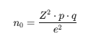
Where:
- ( n_0 ) = initial sample size
- ( Z ) = 1.96 for 95% confidence level
- ( p ) = estimated proportion of the population with the attribute (0.5)
- ( q = 1 - p = 0.5 )
- ( e ) = margin of error (0.05)
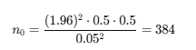
Meanwhile, for feasibility and logistical considerations, the sample size was further reduced to 60 participants.

2.2.1 Sampling Technique
A proportionate stratified sampling technique was employed to ensure representation from all six faculties (table 1). The proportionate sample from each faculty was determined as:
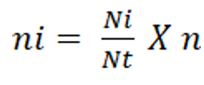
Where:
- (ni ) = sample size for each faculty
- (Ni ) = population of female students in the faculty
- (N) = total population
- (n) = total sample size (60)

Table 1: The proportional allocation of Students Selected
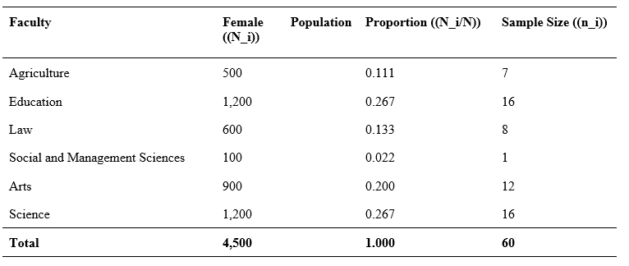

2.3 Instrument for Data Collection.
The knowledge of breast cancer was assessed using an adapted version of the Breast Cancer Awareness Measure (Breast-CAM) developed by (Cancer Research UK, 2011), in which the original mix of “Yes/No/Don’t Know” and open-ended items was converted into True/False statements to facilitate quantitative scoring while preserving core symptom and risk factor content. Correct responses were scored 1 point, and incorrect or “Don’t Know” responses were scored 0, with a total possible score of 20 points. Knowledge levels were categorized into poor, fair, and good using Bloom’s cut-off points (80–100% of the total score being Good, 60–79% being fair, <60% been poor) as described by Alzahrani et al. (2021). Preventive practices were measured using 10 key behaviors adapted from (Alwan et al., 2011) KAP instruments, with declarative statements specifying the quality of practice (e.g., “I use the pads of my fingers”). Each practice performed correctly was awarded 2 points, while incorrect practices received 0 points, giving a total possible score of 20 points. Participants scoring below the mean were classified as having poor preventive practices, whereas those scoring at or above the mean were classified as having good preventive practices. Attitudes towards preventive practices were measured using 15 items extracted from the Breast Cancer Perception Scale (BCPS) (as used in (Taylan et al., 2021)) focusing on treatment beliefs and the need for health checks. Responses were scored on a 5-point Likert scale, with 5 indicating Strongly Agree and 1 indicating Strongly Disagree, and negative/barrier statements were reverse-scored. The total possible score was 75 points, and attitudes were categorized into poor, fair, and good based on Bloom’s cut-off points as applied by Alzahrani et al. (2021).

2.3.1 Validity of the Instrument
The questionnaire was reviewed by the experts in the field of public health, and health education in the department of Health Education of Adekunele Ajasin University to make sure that the items are clear, relevant, and sufficient to measure the knowledge and attitude towards breast cancer preventive practices. Corrections and amendments were done where necessary depending on the recommendations that were given before administration.
2.3.2 Instrument Reliability.
The instrument reliability was established using a pilot test that was done on female undergraduate students of a university that was not within the study area but had the same characteristics as the study population. Cronbach alpha coefficient was used to determine the internal consistency of the instrument and a reasonable coefficient of 0.70 and above was deemed as sufficient to conduct the study.
2.4 Data Analysis and Management.
Questionnaires that had been completed were reviewed to determine their completeness, coded, and entered into the Statistical Package of Social Sciences (SPSS) version 25 to conduct the analysis. Frequency, percentage, mean and standard deviation were employed to describe socio-demographic variables and the study variables. The effect of health education was determined using inferential statistics. The comparison of mean scores in knowledge and attitude before and after the intervention was compared with the help of paired sample t-test. Practices category was also checked by also McNemar Test. The level of statistical significance was 0.05.

3. results and discussion

3.1 Respondents Social Demographics.
The socio-demographic and breast health characteristics of the respondents are presented in Table 2. The mean age of the respondents was 23.28 ± 4.05 years. 31 (51.7%) were 24–29 years, 15 (25.0%) were aged 16–19 years and 14 (23.3%) were adults aged 20–23 years. Students in 200 level and 400 level each constituted 16 (26.7%) of the sample, followed by those in 100 level with 13 (21.7%). Respondents in the 300 level accounted for 8 (13.3%), while those in the 500 level represented the smallest proportion at 7 (11.7%). The majority of respondents reported no known family history, comprising 37 (61.7%), while 10 (16.7%) indicated a positive family history of breast cancer. A notable proportion of respondents, 13 (21.7%), were unsure of their family history status. In relation to breast health practices, only 21 (35.0%) of the respondents reported ever performing breast self-examination, whereas a substantial majority, 39 (65.0%), indicated that they had never performed breast self-examination.

Table 2: Socio-demographic and Breast Health Characteristics of Respondents (n = 60)
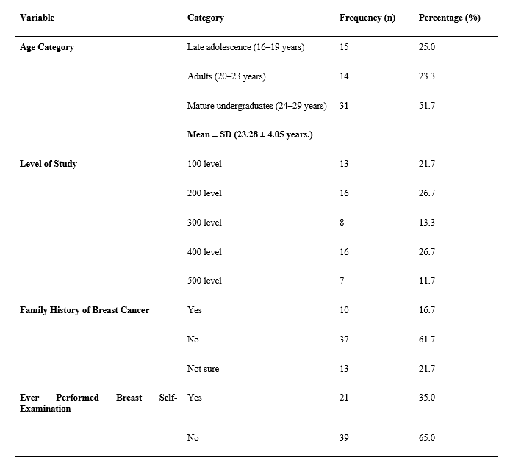

3.2 Pre-test and Post-test Knowledge of Breast Cancer among Female Undergraduates
The record of pre-test and post-test responses shows a clear improvement in breast cancer knowledge among the female undergraduates following the health education intervention. As seen in table 3, at the pre-test stage, correct responses across most knowledge statements ranged between 31.7% and 56.7%, indicating generally low to moderate baseline knowledge. After the intervention, the proportion of correct responses increased markedly for all items, with post-test correct responses ranging from 65.0% to 85.0%. Notable improvements were observed in recognition of clinical signs of breast cancer. Correct identification of a painless breast lump increased from 32 (53.3%) at pre-test to 49 (81.7%) at post-test, while knowledge of nipple position change as a warning sign rose from 27 (45.0%) to 50 (83.3%). Similarly, awareness of dimpling or puckering of the breast skin increased substantially from 19 (31.7%) before the intervention to 50 (83.3%) after the intervention.
Knowledge of risk factors also improved between the pre-test and post-test assessments. Correct responses regarding family history as a risk factor increased from 29 (48.3%) to 46 (76.7%), and awareness of obesity after menopause as a risk factor rose from 28 (46.7%) to 47 (78.3%). Understanding of lifestyle-related risks and protective factors showed comparable gains, with correct responses on alcohol consumption increasing from 30 (50.0%) to 43 (71.7%) and on the protective role of physical activity increasing from 31 (51.7%) to 43 (71.7%). In addition, several misconceptions were reduced following the intervention. The belief that breast cancer only affects women over 50 years was correctly addressed by 31 (51.7%) at pre-test compared with 42 (70.0%) at post-test. Knowledge that breast cancer risk does not decrease with age increased from 24 (40.0%) to 41 (68.3%), and awareness that men can develop breast cancer rose from 26 (43.3%) to 45 (75.0%). Misconceptions related to wearing tight bras as a cause of breast cancer were also significantly reduced, with correct responses increasing from 26 (43.3%) to 50 (83.3%). Using blooms cutoff categorization for knowledge (table 4), at pretest, most participants (45; 75.0%) demonstrated poor knowledge, 15 participants (25.0%) had fair knowledge, and none achieved good knowledge. Following the intervention, poor knowledge decreased to 22 participants (36.7%), fair knowledge increased to 34 participants (56.7%), and 4 participants (6.7%) attained good knowledge.
Table 3: Comparison of Pre-test and Post-test Knowledge of Breast Cancer among Female Undergraduates (n = 60)
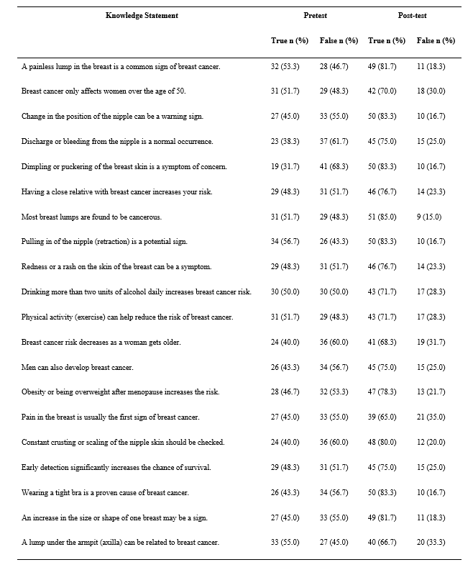
Table 4: Bloom's categorization of knowledge levels before and after the health education intervention (n = 60)
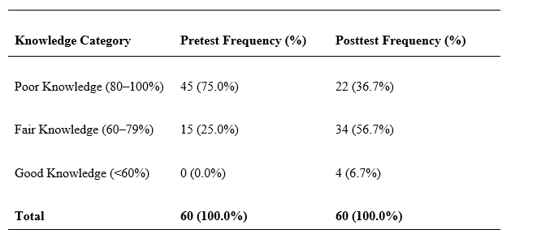
*Blooms Categorization as used in Alzahrani et al. (2021).

3.3. Breast Cancer Preventive Practices Before and After Health Education
At baseline (table 5), only 22 (36.7%) of the respondents reported performing breast self-examination once every month, whereas this proportion increased markedly to 43 (71.7%) at post-test. Similarly, 19 (31.7%) reported visiting a doctor for a clinical breast examination at least once a year before the intervention, compared with 47 (78.3%) after the intervention. Correct timing of breast self-examination, defined as performing it 3–5 days after the end of menstruation, was reported by 29 (48.3%) at pre-test and increased to 40 (66.7%) at post-test. Appropriate techniques for breast self-examination also improved following the intervention. Before health education, only 18 (30.0%) of respondents reported using the pads of their fingers to feel for lumps, whereas 47 (78.3%) reported doing so at post-test. Likewise, checking both breasts and the armpit area during monthly examinations increased from 19 (31.7%) before the intervention to 44 (73.3%) after the intervention. Visual inspection of the breasts in a mirror to detect changes in shape increased from 25 (41.7%) at pre-test to 44 (73.3%) at post-test. Changes were also observed in attitudes toward inappropriate or suboptimal practices. At pre-test, 27 (45.0%) reported that they only checked their breasts when they felt unusual pain, whereas this increased to 46 (76.7%) at post-test, reflecting greater awareness and engagement with breast checking practices. In addition, avoidance of mammography due to the absence of symptoms was reported by 13 (21.7%) at pre-test and increased to 43 (71.7%) at post-test. Use of herbal remedies instead of medical screening was reported by 20 (33.3%) before the intervention and increased to 42 (70.0%) after the intervention. Furthermore, keeping a record of self-examination findings increased from 20 (33.3%) at pre-test to 48 (80.0%) at post-test. Using mean categorisation for practices (table 6), At pretest, 32 participants (53.3%) exhibited poor practices, while 28 participants (46.7%) demonstrated good practices. Following the intervention, poor practices decreased to 19 participants (31.7%), and good practices increased to 41 participants (68.3%).
Table 5: Table: Respondents Breast Cancer Preventive Practices Before and After Health Education (n = 60)
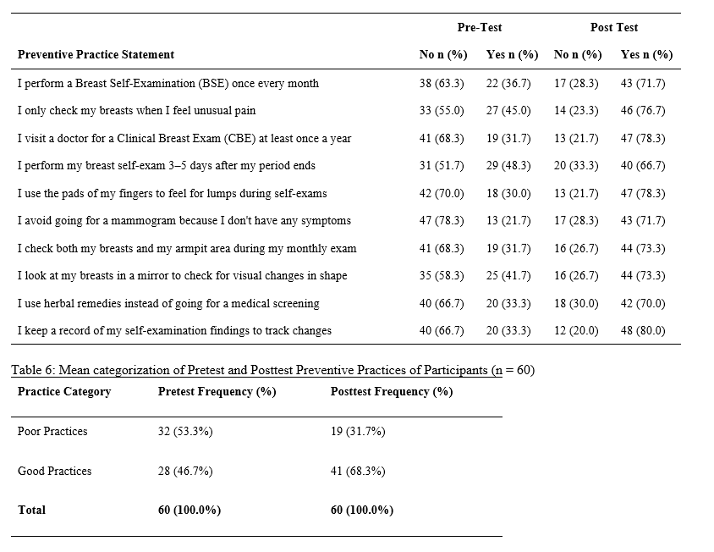
3.4 Pre- and Post-Intervention Attitudes toward Breast Cancer Preventive Practices
At the pre-intervention stage (table 7), attitudes toward the benefits of early detection were generally mixed. For example, only 10 (16.6%) of the respondents either agreed or strongly agreed that breast cancer can be successfully treated if found early, while a larger proportion, 31 (51.7%), either strongly disagreed or disagreed. Following the intervention, positive attitudes increased markedly, with 35 (58.4%) of respondents agreeing or strongly agreeing with this statement, alongside a reduction in negative responses. Fear-related attitudes also changed after the intervention. Before health education, fear of finding a lump prevented self-examination among 18 (30.0%) respondents who agreed or strongly agreed with this statement. Post-intervention, this proportion increased to 34 (56.7%), reflecting greater acknowledgement of fear as a barrier, while strong disagreement with this belief declined substantially, suggesting increased openness in discussing emotional barriers to screening.
Misconceptions regarding the necessity of screening were reduced. At pre-test, 12 (20.0%) respondents agreed or strongly agreed that there was no need for a check-up if the breasts felt normal. After the intervention, this increased to 39 (65.0%), indicating a shift toward recognising the importance of routine screening irrespective of symptoms. Similarly, the belief that breast cancer treatment is more harmful than the disease itself declined, as agreement increased from 11 (18.3%) at pre-test to 38 (63.4%) at post-test, reflecting improved confidence in modern treatment options. Stigma-related attitudes showed notable improvement. Prior to the intervention, embarrassment about breast examination was reported by 14 (23.3%) respondents who agreed or strongly agreed, whereas this increased to 40 (66.7%) after the intervention, suggesting greater willingness to confront social and personal discomfort associated with screening. Fatalistic beliefs that breast cancer is a matter of fate and not preventable were held by 14 (23.3%) respondents at pre-test, increasing to 38 (63.3%) at post-test, indicating a shift away from fatalism toward preventive thinking.
Perceptions related to femininity and social consequences of diagnosis also improved. At baseline, 16 (26.6%) respondents agreed or strongly agreed that a breast cancer diagnosis ends life as a woman, compared with 41 (68.4%) at post-test, reflecting increased awareness that survivorship and quality of life are achievable outcomes. Likewise, agreement with the belief that screening is a waste of time without a family history rose from 16 (26.7%) at pre-test to 38 (63.3%) at post-test, indicating improved understanding of population-wide risk. Confidence in healthcare and preventive control increased following the intervention. Agreement that regular check-ups give women control over their health increased from 15 (25.0%) at pre-test to 43 (71.7%) at post-test. Trust in healthcare professionals also improved, with agreement rising from 15 (25.0%) before the intervention to 39 (65.0%) after the intervention. Perceived personal risk of breast cancer despite feeling healthy increased from 13 (21.6%) at pre-test to 42 (70.0%) at post-test, reflecting heightened risk perception, which is essential for preventive action. Using blooms cut off to categorize attitudes (table 8), At pretest, 21 participants (35.0%) had poor attitudes, 38 participants (63.3%) had fair attitudes, and 1 participant (1.7%) had a good attitude. After the intervention, poor attitudes increased to 42 participants (70.0%), and fair attitudes decreased to 18 participants (30.0%).

Table 7: Pre- and Post-Intervention Attitudes toward Breast Cancer Preventive Practices (n = 60)
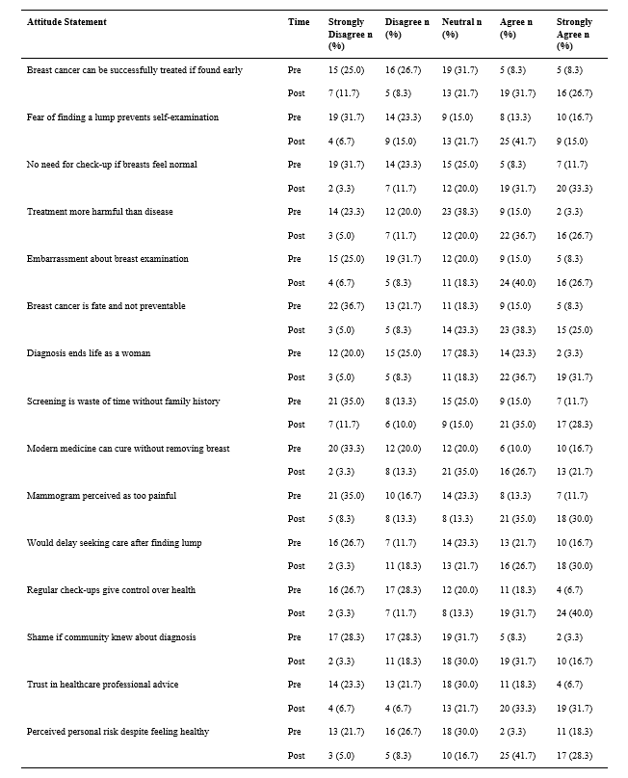

Table 8: Blooms cutoff categorization of Participants’ attitudes before and after the health education intervention (n = 60)
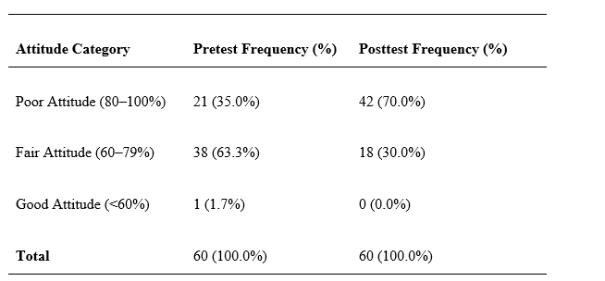
*Blooms Categorization as used in Alzahrani et al. (2021).

3.5 Test of Hypotheses
3.5.1 Hypothesis 1: Health education has no significant effect on knowledge of breast cancer among female undergraduates.
To test the effect of health education on knowledge of breast cancer among female undergraduates, a paired sample t-test was conducted to compare the mean knowledge scores before and after the intervention (table 9). The results indicated a significant increase in knowledge scores following the intervention, with a mean difference of -2.45 (SD = 3.08), t(59) = -6.155, p = .001, 95% CI [-3.25, -1.65]. This finding suggests that the health education program effectively improved participants’ knowledge of breast cancer. Consequently, we reject the null hypothesis, which states that health education has no significant effect on knowledge.
Table 9: Paired Samples t-Test of Pretest and Posttest Knowledge Scores on Breast Cancer (n = 60)
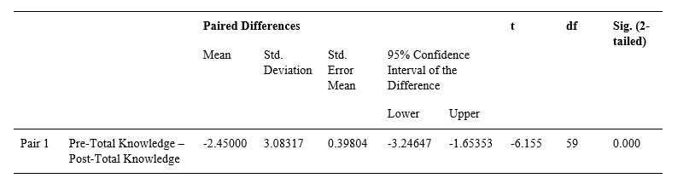
3.5.2 Hypothesis 2: Health education has no significant effect on breast cancer preventive practices among female undergraduates.
To evaluate the effect of health education on breast cancer preventive practices among female undergraduates, a paired sample t-test was conducted to compare the mean practice scores before and after the intervention (table 10). The results revealed a significant improvement in practice scores following the intervention, with a mean difference of -3.00 (SD = 3.91), t(59) = -5.950, p = .001, 95% CI [-4.01, -1.99]. This indicates that the health education program effectively enhanced participants’ breast cancer preventive practices. Consequently, we reject the null hypothesis, which states that health education has no significant effect on preventive practices.

Table 10: Paired Samples t-Test of Pretest and Posttest Breast Cancer Preventive Practice Scores (n = 60)
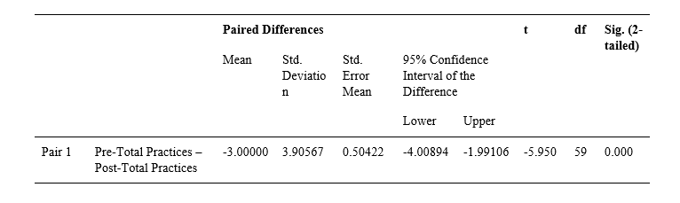
3.5.3 Hypothesis 3: Health education would not significantly change the distribution of preventive practices
To assess changes in preventive practice categories before and after the health education intervention, the McNemar test was employed (table 11). Results indicated a significant shift in practice categories, with 23 participants moving from poor to good practices and 10 participants moving from good to poor. The McNemar test yielded a p = .035 (Exact Sig., 2-sided), indicating a statistically significant improvement in preventive practices after the intervention. Consequently, we reject the null hypothesis, which states that health education has no significant effect on breast cancer preventive practices.

Table 11: McNemar Test Showing Effect of Health Education on Breast Cancer Preventive Practices (n = 60)
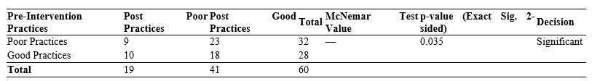

3.5.4 Hypothesis 4: Health education has no significant effect on attitudes towards breast cancer preventive practices among female undergraduates.
To test if health education had a significant effect on attitudes towards breast cancer preventive practices among female undergraduates, a Chi-square test was used (table 12). The result showed no statistically significant association (χ² = 2.690, df = 2, P = .261). Because some expected cell counts were less than 5, Fisher’s Exact Test was also computed (P = .274), which confirmed the result. This indicates that overall attitude changes were not statistically significant. Consequently, we fail to reject the null hypothesis, which states that health education has no significant effect on attitudes.

Table 12: Comparison of Pretest and Posttest Attitude Categories towards Breast Cancer Preventive Practices (n = 60)
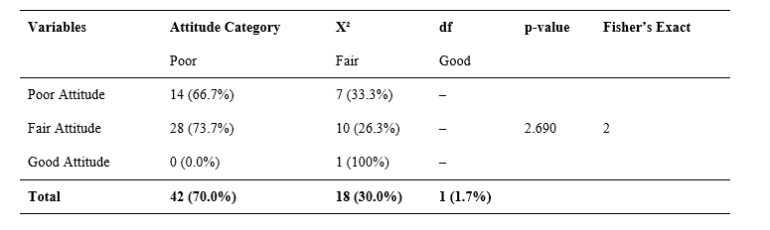
3.6 Discussion
The paired samples t-test revealed a highly significant increase in knowledge scores following the health education intervention. This indicates that the program effectively enhanced participants’ understanding of breast cancer. This result is consistent with the previous study in Bangladesh, which revealed significant differences in the knowledge about symptoms, risk factors, prevention, and breast self-examination steps following an educational intervention in the form of a quasi-experimental study in a university (Sarker et al., 2022). The same results were observed with female undergraduates in Ethiopia and Iraq, where health-belief-model-based interventions led to significant knowledge of breast cancer and BSE increase compared to the control groups, which was maintained over follow-ups (Ibraheem et al., 2025; Wondmu et al., 2022). Similar results were found in Nigeria and Pakistan, where pre-post intervention in university women and pharmacists showed that knowledge with 40-60% correct answers rose to more than 90% after structured educational lessons (Uruntie et al., 2024; Mansoor et al., 2024). Also, there is a significant positive effect of community and clinic-based educational interventions in rural India and Egypt on risk-factor awareness and early-detection strategies (Mahmoud et al., 2020; Gogolla et al., 2023; Rakhshani et al., 2022). Together, these results indicate that the impressive increase in the level of knowledge in the Nigerian undergraduates in the current study is not isolated but rather in line with the regional and global data.
The outcomes of the paired t-test were also that the scores of breast cancer preventive practices were significantly increased following the educational intervention, which implied that the participants embraced more preventive practices. This finding has been supported by the findings of a study in Bangladesh, Ethiopia, and Iraq, where educational programs in universities significantly increased monthly BSE rates among undergraduates who are female (Sarker et al., 2022; Ibraheem et al., 2025; Wondmu et al., 2022). In Nigeria, mean BSE practice scores among students of one of the private universities showed a significant increase after the intervention, still, forgetfulness was observed as one of the barriers to regular practice (Uruntie et al., 2024). Likewise, BSE performance and other screening behaviors were strongly boosted by health education or health-belief-model interventions in both community and clinic settings in Egypt and India (Mahmoud et al., 2020; Hamed et al., 2025; Gogolla et al., 2023; Rakhshani et al., 2022). In Egypt, Turkey, and Pakistan, web-based and peer-education were also proven to produce positive changes in BSE and health-promoting behaviors in women (Coşkun et al., 2025; Mohamed et al., 2023; Mansoor et al., 2024). These results suggest that educational programs can be effective in improving preventive behavior in female undergraduates and corroborate the evidence on the continent and globally.
The categorical change analysis of the McNemar test showed that there was a significant net change of poor to good practice categories after the health education intervention. This tendency is similar to the results of Bangladesh, where the analysis of McNemar revealed an important rise in the percentage of students practicing BSE by 21.3 to 33.8 after training (Sarker et al., 2022). The same shifts were also noticed in Ethiopia and Iraq, where large shares of students changing their statuses to never practicing BSE to regular practice in the intervention groups (Ibraheem et al., 2025; Wondmu et al., 2022). Research on rural areas in India and southern Nigeria using community-based and university methods found that the rate of women conducting BSE or practicing proper screening practices rose significantly after health education programs (Uruntie et al., 2024; Gogolla et al., 2023). These findings support the general trend in the world that educational interventions can not only increase knowledge and mean practice scores but also result in significant changes in categorical preventive behaviors.
Chi-square and Fisher Exact tests revealed no statistically significant difference in the attitudes of the participants towards preventive practices of breast cancer before and after the health education intervention. This result is an indicator of the intricacy of the attitudinal change and is in line with mixed results in the international literature. The school-based BSE education programs in Indonesia were also found to significantly raise knowledge but not statistically significant alterations in attitude scores, with a positive tendency present (Sari et al., 2025). The same interventions based on the health-belief-model reported knowledge improvement and perceived benefits without a significant increase in perceived susceptibility, seriousness, or motivation in other settings, especially in younger women with a low personal risk perception (Ibraheem et al., 2025; Alsaraireh and Darawad, 2019). On the other hand, programs in Jordan and Iran showed the positive changes in attitude and knowledge of university students and members of the community (Alsaraireh and Darawad, 2019; Rakhshani et al., 2022). Positive post-intervention attitudes toward BSE were also achieved in Nigeria through the use of structured educational interventions (Uruntie et al., 2024). Similar results are also shown in health-belief-model programs in Iran that demonstrated that combined improvement in knowledge, attitudes, and preventive behaviors can be achieved with more intensive and multidimensional interventions (Sasanfar et al., 2022). Internationally, it is argued that knowledge and behavior can be easily affected by health education, whereas attitudinal change is more complicated and less regular (Pudyastuti et al., 2025). The non-significant attitudinal change observed in the present study is therefore scientifically credible and highlights the need for more sustained or motivationally enriched interventions to achieve reliable shifts in attitudes (Coşkun et al., 2025; Ibraheem et al., 2025; Alsaraireh & Darawad, 2019; Pudyastuti et al., 2025; Sari et al., 2025).
4. Conclusion

The research indicates that health education was effective in enhancing knowledge and preventive behaviour in relation to breast cancer in female undergraduates, which proves the value of structured educational interventions in encouraging preventive health behaviour. The lack of meaningful shift in attitudes, however, demonstrates the multi-faceted nature of behavioural change and shows that the attitude change involves more long-term and multi-layered interventions than knowledge transfer alone. On the whole, the results emphasise the need to incorporate continuous and behaviour-based health education in university health promotion programmes as an effective measure of enhancing breast cancer awareness and preventive measures among young women..

Limitations of the Study.
- This study adopted a quasi-experimental one-group pretest–posttest design, which limits causal inference because the absence of a control group makes it difficult to completely rule out external influences such as exposure to other information sources during the study period.
- The calculated minimum sample size for adequate statistical representation was 384 participants, only 60 participants were included due to feasibility and logistical constraints, which may limit generalizability of the findings to the wider undergraduate population.
- The relatively small sample size may also reduce statistical power, particularly in detecting changes in attitudinal outcomes where behavioural shifts often require longer exposure periods.
- Reliance on self-reported data introduces the possibility of response bias, including social desirability bias, especially in reporting preventive practices.
Recommendations for Practice.
- University health authorities and student health services should implement structured breast cancer education programmes at least once per academic session, targeting female undergraduates through seminars, workshops, and digital learning platforms, to sustain improvements in knowledge and preventive practices.
- Faculty administrations and university management should collaborate with healthcare professionals, including nurses and public health educators, to integrate breast cancer awareness modules into general studies or health promotion activities within one academic year.
- Student unions and peer health educators should be engaged to facilitate peer-led awareness campaigns and practical demonstrations of breast self-examination, as peer influence has been shown to improve behavioural adoption among young adults.
- University clinics should establish routine breast health awareness weeks that include screening information, counselling, and educational materials, ensuring continuous reinforcement of preventive behaviours rather than one-time interventions. These actions should be monitored through periodic evaluation using standardized assessment tools to measure sustained behavioural outcomes.
Recommendations for Future Research.
- Future studies should adopt randomized controlled or multi-group quasi-experimental designs to strengthen causal inference and allow comparison between intervention and non-intervention groups.
- Larger sample sizes drawn from multiple universities should be considered to improve representativeness and enhance external validity.
- Longitudinal studies are also recommended to assess whether improvements in knowledge and practices are sustained over time and whether attitudinal changes emerge with prolonged exposure to health education.
- Further research should additionally explore psychosocial and cultural determinants influencing attitudes toward breast cancer preventive practices, as these factors may explain the limited attitudinal change observed despite improvements in knowledge and behaviour.

Consent (where ever applicable)

Informed consent was obtained from all participants prior to data collection. The first page of the questionnaire contained detailed information about the study purpose, procedures, voluntary participation, confidentiality, and the right to withdraw at any time. Participants were required to indicate their consent before proceeding to complete the questionnaire.

Ethical approval (where ever applicable)
Ethical approval was obtained from the Adekunle Ajasin University Research Committee with registration Code 170216004.

References

Alsaraireh, A., & Darawad, M. (2019). Impact of a Breast Cancer Educational Program on Female University Students’ Knowledge, Attitudes, and Practices. Journal of Cancer Education, 34, 315-322. https://doi.org/10.1007/s13187-017-1304-6
Alsaraireh, A., & Darawad, M. W. (2017). Impact of a Breast Cancer Educational Program on Female University Students’ Knowledge, Attitudes, and Practices. Journal of Cancer Education, 34. https://doi.org/10.1007/s13187-017-1304-6
Alwan, N. A. S., Al-Attar, W. M., Eliessa, R. A., Madfaie, Z. A., & Tawfeeq, F. N. (2011). Knowledge, attitude and practice regarding breast cancer and breast self-examination among a sample of the educated population in Iraq. Eastern MediterraneanHealth Journal, 18(4).
Alzahrani, M. M., Alghamdi, A. A., Alghamdi, S. A., & Alotaibi, R. K. (2021). Knowledge and Attitude of Dentists Towards Obstructive Sleep Apnoea. International Dental Journal, 72(15). https://doi.org/10.1016/j.identj.2021.05.004
Azubuike, S., Muirhead, C., Hayes, L., & McNally, R. (2018). Rising global burden of breast cancer: the case of sub-Saharan Africa (with emphasis on Nigeria) and implications for regional development: a review. World Journal of Surgical Oncology, 16. https://doi.org/10.1186/s12957-018-1345-2
Baas, M., Sánchez, J., Torres, K., & Domínguez, E. (2025). Knowledge and preventive practices regarding breast cancer among nursing students in Northern Mexico: A cross-sectional correlational study. The Journal of Palembang Nursing Studies. https://doi.org/10.55048/jpns148
Bray, F., Laversanne, M., Sung, H., Ferlay, J., Siegel, R., Soerjomataram, I., & Jemal, A. (2024). Global cancer statistics 2022: GLOBOCAN estimates of incidence and mortality worldwide for 36 cancers in 185 countries. CA: A Cancer Journal for Clinicians, 74, 229 - 263. https://doi.org/10.3322/caac.21834
Brun, L., Béhanzin, L., Togbenon, N., Pognon, M., Houéhanou-Sonou, Y., Atadé, S., Doussengue, C., Séidou, F., Salifou, K., & Akpo, M. (2023). Knowledge, Attitudes and Practice Regarding Breast Cancer among Parakou University Female Students in 2021. Open Journal of Pathology. https://doi.org/10.4236/ojpathology.2023.131003
Cancer Research UK. (2011). Breast Module of the Cancer Awareness Measure (Breast-CAM) Toolkit. https://assets.ctfassets.net/u7vsjnoopqo5/41jWjBmodoqoe9Je1FqoNU/6c69cd1b9894c8161a5e76effccce9db/breast_cam_toolkit.pdf
Coskun, S., Alibekiroğlu, N., & Gençyürek, G. (2025). Effect of Peer Education on Early Breast Cancer Detection, Health Responsibility, Health Beliefs, Knowledge, and Practices Among University Students. Public Health Nursing, 42. https://doi.org/10.1111/phn.70000
Coşkun, S., Alibekiroğlu, N., & Gençyürek, G. (2025). Effect of Peer Education on Early Breast Cancer Detection, Health Responsibility, Health Beliefs, Knowledge, and Practices Among University Students. Public Health Nursing (Boston, Mass.), 42, 1694 - 1706. https://doi.org/10.1111/phn.70000
Deeb, N., Naja, F., Nasreddine, L., Kharroubi, S., Darwiche, N., & Hwalla, N. (2024). Nutrition Knowledge, Attitudes, and Lifestyle Practices That May Lead to Breast Cancer Risk Reduction among Female University Students in Lebanon. Nutrients, 16(7), 1095. https://doi.org/10.3390/nu16071095
Fu, M., Peng, Z., Wu, M., Lv, D., Lyu, S., & Li, Y. (2025). Assessing the African burden of breast cancer: A demographic analysis using Global Cancer Observatory 2022.. European journal of surgical oncology : the journal of the European Society of Surgical Oncology and the British Association of Surgical Oncology, 51 5, 109627. https://doi.org/10.1016/j.ejso.2025.109627
Gogolla, B., Kumari, S., & Priyanka, S. (2023). Impact of health education on preventive practices of breast cancer among women from rural field practice area of a Medical College in Hyderabad, Telangana State. MRIMS Journal of Health Sciences, 11, 29 - 33. https://doi.org/10.4103/mjhs.mjhs_25_22
Hamed, B., Bary, N., & Hebesh, E. (2025). The Impact of Health Education on Compliance to Screening Practices in Breast Cancer. Asian Pacific Journal of Cancer Care. https://doi.org/10.31557/apjcc.2025.10.1.33-41
Hasi, S. N., Tabassum, S., Arny, R. T., Pervin, M. D., Hossain, M. G., Hasan, F., & Kibria, M. K. (2025). Breast Cancer Knowledge and Self-Examination Practices Among University Female Students in Dinajpur, Bangladesh: A Cross-Sectional Study. Health Science Reports, 8(7), e71048. https://doi.org/10.1002/hsr2.71048
Ibraheem, S., Ahmed, S., & Amer, T. (2025). Effectiveness of the health-belief model-based intervention in improving the knowledge, practices and awareness among females with breast lumps. Al-Turath Journal of Nursing. https://doi.org/10.63964/atjn.2024.1.1
Kolawole, I. D., Kunle, O., Ajayi, K., & Ong, T. P. (2024). Assessing nutrition-related knowledge, attitudes, and practices towards breast cancer prevention among female students at the Federal University of Oye-Ekiti, Nigeria. Journal of the Egyptian National Cancer Institute, 36(1). https://doi.org/10.1186/s43046-024-00226-2
Kusyani, A., & Vidhiastutik, Y. (2025). Early Detection Health Education is Aware Of The Influence Of Attitudes In Preventing Breast Cancer In Grade VII Female Students. Care : Jurnal Ilmiah Ilmu Kesehatan. https://doi.org/10.33366/jc.v13i2.6593
Kusyani, A., & Vidhiastutik, Y. (2025). Early Detection Health Education is Aware Of The Influence Of Attitudes In Preventing Breast Cancer In Grade VII Female Students. Care : Jurnal Ilmiah Ilmu Kesehatan. https://doi.org/10.33366/jc.v13i2.6593
Lahiji, M., Dehdari, T., Shoormasti, S., Hosseini, A., Navaei, M., & Zarrati, M. (2019). Nutrition knowledge, attitudes, and practice towards breast cancer prevention among the female population of Iran University of medical science students. Nutrition and Cancer, 71, 1355 - 1364. https://doi.org/10.1080/01635581.2019.1607410
Mahmoud, A., Abosree, T., & Aliem, R. (2020). Effect of The Health Belief Model-Based Education on Preventive Behaviors of Breast Cancer. **, 2, 11-11. https://doi.org/10.47104/ebnrojs3.v2i4.168
Manatunga, P., & Kuruppu, D. C. (2025). Breast Cancer Awareness, Attitudes, and Practices among Non-Medical Female Undergraduates in Sri Lanka: Implications for Health Education and Early Detection Strategies. Asian Pacific Journal of Cancer Prevention, 26(7), 2445–2454. https://doi.org/10.31557/apjcp.2025.26.7.2445
Mansoor, N., Naveed, S., Ali, H., Manzoor, A., Zahoor, S., & Sheikh, J. (2024). Evaluation of a pre-post quasi-experimental educational intervention on breast cancer awareness among pharmacy professionals in Karachi, Pakistan. Frontiers in Public Health, 12. https://doi.org/10.3389/fpubh.2024.1443249
Mohamed, A., Ibrahim, E., Madian, A., & Moustafa, A. (2023). Impact of Web-Based Educational Intervention on Preventive Behaviors of Breast Cancer among Damanhour University Female Students. Damanhour Scientific Nursing Journal. https://doi.org/10.21608/dsnj.2023.337864
Mohamed, A., Ibrahim, E., Madian, A., & Moustafa, A. (2023). Impact of Web-Based Educational Intervention on Preventive Behaviors of Breast Cancer among Damanhour University Female Students. Damanhour Scientific Nursing Journal. https://doi.org/10.21608/dsnj.2023.337864
Pardhan, S., Mendhrani, S., Mohmand, Z., Bibi, A., Afzal, L., Fatima, S., Solangi, T., Michael, A., & Khan, K. (2025). Effectiveness of Structural Teaching Program on Knowledge, Attitude and Practice (KAP) Regarding Breast Cancer and Breast Self-Examination (BSE) Among Undergraduate Nursing Students. Biological and Clinical Sciences Research Journal, 6(5), 91–96. https://doi.org/10.54112/bcsrj.v6i5.1752
Pudyastuti, R., Sujono, S., Kariyadi, K., & Tomasoa, J. (2025). Increasing Women's Awareness and Concern for Breast Cancer through Health Education: Impact of Educational Programs on Early Detection and Prevention. Oshada. https://doi.org/10.62872/jake1725
Rakhshani, T., Dada, M., Kashfi, S., Kamyab, A., & Jeihooni, A. (2022). The Effect of Educational Intervention on Knowledge, Attitude, and Practice of Women towards Breast Cancer Screening. International Journal of Breast Cancer, 2022. https://doi.org/10.1155/2022/5697739
Rezaei, F., Mesbah, Z., Mazidimoradi, A., Khezri, R., Shahabinia, Z., Allahqoli, L., & Salehiniya, H. (2025). Knowledge, Attitude, and Practice of Female Medical Science Students Regarding Breast Cancer Screening and Related Factors in Iran. Indian Journal of Gynecologic Oncology, 23. https://doi.org/10.1007/s40944-025-00970-w
Sari, R., , M., Lusiana, E., , M., & Pratiwi, R. (2025). THE IMPACT OF HEALTH EDUCATION USING FOCUS GROUP DISCUSSION ON BREAST SELF-EXAMINATION (BSE) BEHAVIOR AMONG FEMALE STUDENTS AT SMAN 14 MAKASSAR. Journal of Child, Family, and Consumer Studies. https://doi.org/10.29244/jcfcs.4.1.40-50
Sarker, R., Islam, M., Moonajilin, M., Rahman, M., Gesesew, H., & Ward, P. (2022). Effectiveness of educational intervention on breast cancer knowledge and breast self-examination among female university students in Bangladesh: a pre-post quasi-experimental study. BMC Cancer, 22. https://doi.org/10.1186/s12885-022-09311-y
Sasanfar, B., Toorang, F., Rostami, S., Yeganeh, M., Ghazi, M., Seyyedsalehi, M., & Zendehdel, K. (2022). The effect of nutrition education for cancer prevention based on health belief model on nutrition knowledge, attitude, and practice of Iranian women. BMC Women's Health, 22. https://doi.org/10.1186/s12905-022-01802-1
Shaikh, S. I., Channar, H. B., Ahmed, W., Memon, A., Asma, & Samo, A. A. (2024). Knowledge, Attitude and Practice of Breast Cancer among Female Students: A Cross-Sectional Study from Pakistan. Pakistan BioMedical Journal, 18–24. https://doi.org/10.54393/pbmj.v7i12.1190
Shamsuddeen, S. B., Ansari, A., & Ali, M. S. (2023). Nutrition Knowledge, Attitude, Practice towards Breast Cancer Prevention among the Female Students of University of Hail, Saudi Arabia. Medical Science and Discovery, 10(3), 187–194. https://doi.org/10.36472/msd.v10i3.899
Taylan, S., Özkan, İ., & Adıbelli, D. (2021). Breast Cancer Perception Scale: Psychometric Development Study. European Journal of Breast Health, 17(2), 95–102. https://doi.org/10.4274/ejbh.galenos.2020.6088
Uruntie, R., Oputa, C., Peters, E., & Otovwe, A. (2024). Effect of educational intervention on the knowledge, attitude and practice of breast self-examination among female students at a private university in Southern Nigeria. BMC Cancer, 24. https://doi.org/10.1186/s12885-024-12116-w
Uruntie, R., Oputa, C., Peters, E., & Otovwe, A. (2024). Effect of educational intervention on the knowledge, attitude and practice of breast self-examination among female students at a private university in Southern Nigeria. BMC Cancer, 24. https://doi.org/10.1186/s12885-024-12116-w
Wondmu, K., Tessema, M., Degu, G., Mihiret, G., & Sinshaw, M. (2022). Effect of breast cancer education based on the health belief model on knowledge, health belief, and breast self-examination among female students of Debre Markos University, Northwest Ethiopia, in 2021. Frontiers in Oncology, 12. https://doi.org/10.3389/fonc.2022.1034183
Zhang, Q., & Lu, H. (2022). Knowledge, attitude, practice and factors that influence the awareness of college students with regards to breast cancer. World Journal of Clinical Cases, 10, 538 - 546. https://doi.org/10.12998/wjcc.v10.i2.538

Definitions, Acronyms, Abbreviations
- Breast Cancer: A malignant growth originating from breast tissue cells, characterized by uncontrolled cell proliferation.
- Breast Self-Examination (BSE): A systematic method by which a woman examines her own breasts regularly to detect unusual lumps or changes.
- Preventive Practices: Health behaviors undertaken to reduce the risk of disease occurrence or enable early detection.
- Health Education: A structured learning process designed to improve knowledge and influence health-related attitudes and behaviors.
- Knowledge–Attitude–Practice (KAP) Model: A behavioral framework suggesting that knowledge influences attitudes, which in turn shape practices.
- Breast-CAM: Breast Cancer Awareness Measure, a standardized tool for assessing awareness of breast cancer symptoms and risk factors.
- BCPS: Breast Cancer Perception Scale, an instrument used to measure beliefs and perceptions about breast cancer.
- Bloom’s Cut-off: A scoring classification method used to categorize knowledge or attitude levels into poor, fair, and good based on percentage scores.

