Original Research Article
Genomic Detection of Toxigenic and Antibiotics Resistance genes in Staphylococcus aureus associated with Wound Contamination at a Tertiary Hospital in Port Harcourt, Nigeria

ABSTRACT
Staphylococcus aureus is a common hospital and community-acquired pathogen known to be frequently associated with wound infections. Therefore, the aim of the research was to carry out the genomic detection of toxigenic and antibiotics resistance genes in Staphylococcus aureus associated with wound contamination at a tertiary hospital in Port Harcourt, Nigeria. A total of 150 specimens from different types of wounds (traumatic wound, caesarean section, scrotal wound, surgical wounds, burns, diabetic foot, and plastic surgery) were collected from the Hospital for a period of six months and processed for isolation of S. aureus, following standard microbiological procedures. Samples were cultured on sterile Mannitol Salt Agar (MSA) plates and characterized phenotypically based on cultural and biochemical identities. Pure isolates was characterized at the molecular level following the given steps: DNA extraction, PCR amplification, Agarose Gel Electrophoresis, 16S rRNA sequencing, sequence analysis and phylogenic tree construction. Data obtained showed 38.7% of the wound cases were contaminated with Staphylococcus aureus isolates. The study also revealed the presence of mecA gene in all the isolates screened genotypically. The molecular analysis indicated the presence of a toxigenic (panton-valentine leucocidine) gene in the genome of 66.6% of the isolates screened. The results of this study represent serious public health concerns, thus emphasizing the need for proper wound management.
Keywords: Panton valentine leucocidin gene (PVL), Genomic, mecA gene, toxigenic, Staphylococcus aureus, resistance.
1.0 InTroduction
Staphylococcus is responsible for a large amount of diseases in humans and animals. S. aureus is a non-motile, facultative Gram-positive aerobic bacterium that occurs in pairs [1]. ‟It is a major pathogen that colonizes and infects both immunocompromised hospital patients and healthy immunocompetent people in the community. These bacteria are found naturally on the skin and in the nasopharynx of the human body. If there is a break in the skin due to injury or surgery, or if a person's immune system is suppressed, the presence of Staphylococcus aureus on the skin can cause an infection [2]. S. aureus occurs mainly on mucosal surfaces [3] and is often involved in many nosocomial infections [3]. Wound infection happens because of a unique interaction between humans and disease causing microbes [4]. Wound contamination is defined as the appearance of the organism on the wound area [5].
Staphylococcus aureus expresses a number of virulence factors which helps it to establish infection by facilitating tissue attachment, tissue invasion and evading from host immune response. The ability to acquire resistance to multiple antibiotics classes make Staphylococcus aureus, a challenging pathogen to treat [7]. Staphylococcus aureus is one of the most significant pathogens in terms of antibiotic resistance, as it has been able to develop resistance mechanisms to nearly all antibiotics used against it [8]. Infections by some species of staphylococci are difficult to treat because of frequency of multiple antibiotic resistant strains [9].
The increasing level of resistance of Staphylococcus aureus to antibiotics could be as a result of the presence of resistance genes. Therefore the need to probe for antibiotic resistance in isolates is very essential. S. aureus uses a wide range of virulence factors, such as toxins, production of biofilm and lysing of red blood cells to develop an infection in the host and persist in their infection. Analysis for the presence of toxigenic (panton-valentine leucocidine) genes is therefore important in probing the pathogenic potentials of these isolates. The aim of the study was therefore to carry out the genomic detection of toxigenic and antibiotics resistance genes in staphylococcus aureus associated with wound contamination at a tertiary hospital in Port Harcourt, Nigeria.
2.0 MATERIALS AND METHODS
2.1 Description of Study location
The study was conducted at the University of Port Harcourt Teaching Hospital (UPTH), East West Road Port Harcourt, Rivers State, Nigeria. The hospital lies within 4.8998º North and 6.9292º East. It is a major tertiary healthcare and research facility in Rivers State, which consists of various departments for distinct health cases, and a great number of patients from many geographical regions accessing it.
2.2 Study Design and Sample Collection
A cross-sectional (prevalence) study design was implemented to determine the incidence of Staphylococcus aureus associated with wound infection at the University of Port Harcourt Teaching Hospital, Port Harcourt, Rivers State, Nigeria. The study sampled one hundred and fifty (150) wound cases collected randomly from patients with different wound types in the hospital using sterile swab sticks. The samples were taken aseptically and transported to the Microbiology Laboratory, Rivers State University.
2.3 Sample Size determination
The sample size for the study was determined by the formula [10]:
N = [Z²(pq)]/d² [10]
Where:
N= the desired sample size
Z= Normal standard distribution that corresponds to confidence interval as 1.96
p= Prevalence of Pseudomonas species
q = 1-p
d= degree of accuracy / precision expected at 0.05
2.4 Isolation of Staphylococcus aureus
The different swab sticks specimens were plated on sterile Mannitol Salt Agar (MSA) plates using the streak plate method and incubated at 37ºC for 24 hours.
2.5 Purification and Preservation of Isolates
The distinct tentative Staphylococcus colonies on the MSA plates were further purified on freshly prepared Nutrient Agar (NA) plates by repeated subculturing until pure colonies (isolates) were obtained. Obtained pure isolates were inoculated aseptically into nutrient agar slants in Bijou bottles and incubated for 24 hours at 37ºC. After incubation, agar slants were then refrigerated at 4ºC to preserve the isolates.
2.6 Molecular Characterization
a. DNA Extraction (Boiling method)
Five milliliters of an overnight broth culture of the bacterial isolate in Luria Bertani (LB) was spun at 14000rpm for 3 min. The cells were re-suspended in 500ul of normal saline and heated at 95⁰C for 20 min. The heated bacterial suspension was cooled on ice and spun for 3 min at 14000rpm. The supernatant containing the DNA was transferred to a 1.5ml microcentrifuge tube and stored at -20ºC for other downstream reactions.
b. DNA Quantification
The extracted genomic DNA was quantified using the Nanodrop 1000 spectrophotometer. The sofware of the equipment was lunched by double clicking on the Nanodrop icon. The equipment was initialized with 2 ul of sterile distilled water and blanked using normal saline. Two microlitre of the extracted DNA was loaded onto the lower pedestal, the upper pedestal was brought down to contact the extracted DNA on the lower pedestal. The DNA concentration was measured by clicking on the “measure” button.

c. 16S rRNA Amplification
The 16s rRNA region of the rRNA gene of the isolates were amplified using the 27F: 5'-AGAGTTTGATCMTGGCTCAG-3' and 1492R: 5'-CGGTTACCTTGTTACGACTT-3' primers on an ABI 9700 Applied Biosystems thermal cycler at a final volume of 40 microlitres for 35 cycles. The PCR mix included: the X2 Dream taq Master mix supplied by Inqaba, South Africa (taq polymerase, DNTPs, MgCl), the primers at a concentration of 0.5uM and the extracted DNA as template. The PCR conditions were as follows: Initial denaturation, 95ºC for 5 minutes; denaturation, 95ºC for 30 seconds; annealing, 52ºC for 30 seconds; extension, 72ºC for 30 seconds for 35 cycles and final extention, 72ºC for 5 minutes. The product was resolved on a 1% agarose gel at 130V for 30 minutes and visualized on a blue light transilluminator.
d. Sequencing
Sequencing was done using the BigDye Terminator kit on on a 3510 ABI sequencer by Inqaba Biotechnological, Pretoria South Africa. The sequencing was done at a final volume of 10ul, the components included 0.25 ul BigDye® terminator v1.1/v3.1, 2.25ul of 5 x BigDye sequencing buffer, 10uM Primer PCR primer, and 2-10ng PCR template per 100bp. The sequencing conditio were as follows 32 cycles of 96°C for 10s, 55°C for 5s and 60°C for 4min.
e. Phylogenetic Analysis
Obtained sequences were edited using the bioinformatics algorithm Trace edit, similar sequences were downloaded from the National Center for Biotechnology Information (NCBI) data base using BLASTN. These sequences were aligned using MAFFT. The evolutionary history was inferred using the Neighbor-Joining method in MEGA 6.0 [11]. The bootstrap consensus tree inferred from 500 replicates is taken to represent the evolutionary history of the taxa analysed [12]. The evolutionary distances were computed using the Jukes-Cantor method [13].
2.7 Molecular Antibiotic Resistance Screen
2.7.1 MecA Gene Amplificatiion
MecA genes from the isolates were amplified using the mecAF: TGGCTATCGTGTCACAATCG and mecAR: CTGGAACTTGTTGAGCAGAG primers on a ABI 9700 Applied Biosystems thermal cycler at a final volume of 40 microlitres for 35 cycles. The PCR mix included: the X2 Dream Taq Master mix supplied by Inqaba, South Africa (Taq polymerase, DNTPs, MgCl), the primers at a concentration of 0.4M and 50ng of the extracted DNA as template. The PCR conditions were as follows: Initial denaturation, 95ºC for 5 minutes; denaturation, 95ºC for 30 seconds; annealing, 58ºC for 30 seconds; extension, 72ºC for 30 seconds for 35 cycles and final extension, 72ºC for 5 minutes. The product was resolved on a 1% agarose gel at 120V for 25 minutes and visualized on a UV transilluminator.
2.8 Toxigenic (PVL) Gene Amplification
The pvl gene amplification was carried out using the primer pair 5’-ATCATTAGGTAAAATGTCTGGACATGATCCA-3’ and 5’-GCATCAAGTGTATTGGATAGCAAAAGC-3’ on an ABI 9700 Applied Biosystems thermal cycler at a final volume of 40 microlitres for 35 cycles. The PCR mix included: the X2 Dream Taq Master mix supplied by Inqaba, South Africa (taq polymerase, DNTPs, MgCl), the primers at a concentration of 0.4M and 50ng of the extracted DNA as template. The PCR conditions were as follows: Initial denaturation, 95ºC for 5 minutes; denaturation, 95ºC for 40 seconds; annealing, 50ºC for 45 seconds; extension, 72ºC for 40 seconds for 35 cycles and final extension, 72ºC for 5 minutes. The product was resolved on a 1% agarose gel at 130V for 25 minutes and visualized on a UV transilluminator.

3.0 RESULTS
3.1 Molecular Characteristics of the Isolates
Results of the 1% agarose gel electrophoresis for the visualization of the 16s rRNA region of the rRNA gene of the isolates showed that the PCR products were amplified to possess a molecular weight that each corresponds to 1500 base pairs. The purified lanes labelled B1-B2 shown in Plate 1 represented the 16s rRNA gene bands (1500bp), while lane L represents the 100 base pair (bp) molecular ladder.
The obtained 16s rRNA sequence from the isolate produced an exact match during the megablast search for highly similar sequences from the NCBI non-redundant nucleotide (nr/nt) database. The evolutionary distances computed using the Jukes-Cantor method were in agreement with the phylogenetic placement of the 16S rRNA of the isolates B1, and B2 and revealed a close relatedness to Staphylococcus aureus (Figure 2).

Figure 1 Agarose Gel Electrophoresis of the 16S rRNA Gene of selected Bacterial Isolates. Lanes B1 and B2 represent the 16SrRNA gene bands (1500bp), lane L represents the 100bp molecular ladder

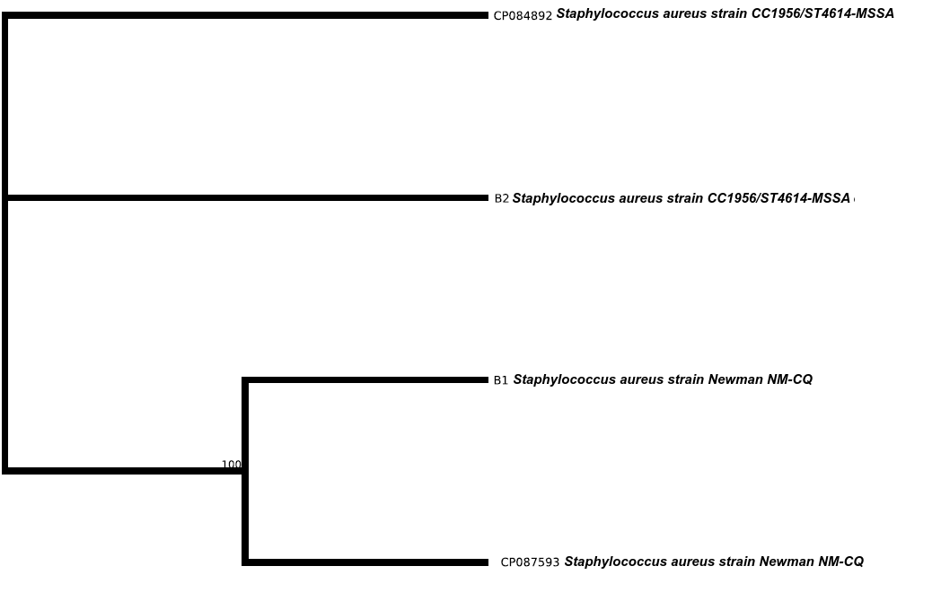
Figure 2 Phylogenic Placement Tree of Staphylococcus isolates from Wound Specimens

3.2 Prevalence of mecA positive isolates
The agarose gel electrophoresis output showed the presence of MecA gene in 100 % of the isolates screened, as shown in Plate 2.
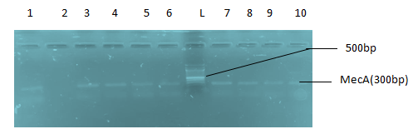
Plate 2: Agarose Gel Electrophoresis showing the Amplified MecA Gene Bands at 300bp. Lane 1, 3-10 represent the MecA bands while L represents the 100bp ladder.

3.3 Prevalence of PVL positive isolates
The result of the molecular screening for a toxigenic gene, PVL in isolated Staphylococcus aureus is shown in Plate 3. From the result, 67 % of the isolates had the PVL (toxigenic gene in their genome.

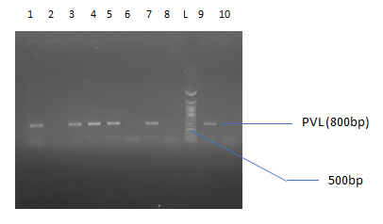
Plate 3 Agarose Gel Electrophoresis showing the Amplified PVL Gene from the staphylococcal isolates. Lanes 1, 3-5, 7 and 9 showing the PVL gene bands at 800bp while lane L represents the 100bp molecular ladder.

4. 0 DISCUSSION
The study aimed to carry out the genomic detection of toxigenic and antibiotics resistance genes in staphylococcus aureus associated with wound contamination at a tertiary hospital in Port Harcourt, Nigeria. included a total sample size of 150 different wound types [traumatic wound (16%) and caesarean section (14, 7 %), scrotal wound). (12%), surgical wound (4%), accident and emergency (13.4%), burns (25.3%), diabetic foot ulcer 2.6%, plastic surgery (12.3%), traumatic injury (16%)]. Since Staphylococcus aureus is a normal skin flora, it was important to sample different types of wounds to decipher the pattern of staphylococcal wound contamination in hospital environment. All isolated species were characterized and identified to be Staphyococcus aureus and have their 16S RNA gene bands to be at 1500bp as recorded and shown in figure 1.
Antibiotic resistance was further illustrated by the molecular detection of MecA gene in virtually all species sampled (plate 3). The presence of the mecA gene allows for bacterial cells to be resistant to antibiotics such as methicillin, penicillin and a good number of B-lactam class of antibiotics [14]. So the vast resistance of the isolated Staphylococcus species can be linked to the presence of this gene.
This gene PVL, confers toxicity by expressing a combination of two proteins (Leuk S and F) that act supergistically to activate and destroy leucocytes by creating lytic pores; and are associated with the necrotic infections of the skin subcutaneous fat and pneumonia [15]. The effect of the expression of this gene could result in complications of further ulceration, persistent biofilm formation and retarded wound healing.
4.0 Conclusion
With regards to the data generated from the entire course of study, it can be inferred that Staphylococcus is an evident component of the micro biome associated with infection of different wound types and that the incidence of biofilm- forming species is of a concern to healing rates and other biofilm-associated complications.
Resistance to the antibiotic groups must have been brought about by presence of the mecA gene in the species which was probably transmitted to the vast number of these species in a bit to help them thrive in the presence of these antibiotic classes. The transmission of this gene (mecA) is pretty evident, from the resistant pattern of the species after plasmid curing. The reversal of resistance by plasmid curing resulted to a decrease in resistance in the range of 3.5 and 17.3 %.
The presence of a key toxigenic gene (PVL gene) in 66% of the isolates is a key indication of virulence in species associated with wounds. In a more general terms, Staphylococcus aureus is prevalent in wounds and can persist in their infection by forming biofilms, lysing blood cells and resisting a vast majority of antibiotics.
CONSENT AND ETHICAL APPROVAL
As per international standard guideline participant consent and ethical approval has been collected and preserved by the authors.
COMPETING INTERESTS
Authors have declared that no competing interests exist.
REFERENCES
- Akpaka, P. E., Kissoon, S., Swanston, W. & Monteil, M. (2006). Prevalence and antimicrobial Susceptibility pattern of methicillin resistant Staphylococcus aureus isolates from Trinidad & Tobago. Annuals of Clinical Microbiology. Antimicrobials. 5, 10.
- Koneman, E. W., Allen, S. D., Janda, W. M., Schreckenberger, P. C. and Winn Jr., W. C. (1997). The Gram Positive Cocci. I. Staphylococci and Related Organisms. In: Color Atlas and Textbook of Diagnostic Microbiology. Koneman, E. W. (Ed.). 5th Edn. Lippincott The Williams and Wilkins Co., Philadelphia, PA., USA. 539-576.
- Chiquet, C., Pechinot, A., Creuzot-Garcher, C., Benito, Y. & Croize J. (2007). Acute postoperative endophthalmitis caused by Staphylococcus lugdunensis. Journal of Clinical Microbiology. 45, 1673-1678.
- White, R. J. (2009). Wound infection-associated pain. Journal of Wound Care. 18(6), 245–249.
- Stotts, N. A. (2004). Wound infection: diagnosis and management. In: Morison, M. J., Ovington, L. G. and Wilkie, K. (eds.). Chronic Wound Care. A Problem-Based Learning Approach. Mosby Elsevier Limited, London: 101–116.
- Gnanamani, Arumugam & Periasamy, Hariharan & Paul Satyaseela, Maneesh. (2017). Staphylococcus aureus: Overview of Bacteriology, Clinical Diseases, Epidemiology, Antibiotic Resistance and Therapeutic Approach. Frontiers in Staphylococcus aureus, 10, 5772-67338.
- Foster, T.J. (2017). Antibiotic resistance in Staphylococcus aureus. Current status and future prospects, FEMS Microbiology Reviews, 007, 430–449.
- Simpson, A. H., Dave, J. & Cookson, B. (2007). The value of routine screening of staff for MRSA. Journal of Bone and Joint Surgery British volume, 89, 565-566.
- Dale, J. W. & Park, S. (2004). Molecular Genetics of Bacteria. 4th Edn. John Wiley and Sons Inc., Chichester, UK. 22-24.
- Niang, L., Winn, T. & Nordin, R. (2006). Practical issues in calculating the sample size for prevalence studies. Archives of Orofacial Sciences, 1.
- Saitou, N. & Nei, M. (1987). The neighbor-joining method: a new method for reconstructing phylogenetic trees. Molecular Biology and Evolution, 4 (4), 406-425.
- Felsenstein, J. (1985). Confidence limits on phylogenies: An approach using the bootstrap. Evolution, 39 (4), 783-791.
- Jukes, T. & Cantor, C. (1969). Evolution of protein molecules. Mammalian Protein Metabolism, 21-132.
- Calderon, C. B. & Sabundayo, B. P. (2007). Antimicrobial Classifications: Drugs for Bugs. In Schwalbe, R., Steele-Moore, L. and Goodwin, A. C. (Eds.). Antimicrobial Susceptibility Testing Protocols. CRC Press. Taylor & Frances group. 45.
- Dinges, M. M., Orwin, P. M. & Schlievert, P. M. (2000). Exotoxins of Staphylococcus aureus. Clinical Microbiology Reviews, 13, 16–34.

