Original Research Article

Functional, Phytochemical and Vitamin Attributes of Millet-Based Gluten-Free Transitional Foods

.
ABSTRACT
Aim: For the growing interest in alternative gluten-free flour blends to whole wheat flour in transitional food production, selected functional properties, phytochemicals, and vitamin profiles of flour blends formulated were determined to ascertain their nutritional quality for gluten-free transitional food products.

Place and Duration of Study: Sample preparation and functional properties were carried out at the Food Technology Laboratory, Auchi Polytechnic, Auchi, Nigeria while phytochemicals and vitamins were determined at Food Science and Technology Laboratory, Federal University of Technology, Akure, Nigeria between January and July, 2025.

Methodology: Blends of millet flour with banana and soybeans were formulated in the ratios 60:20:20 (MBS₁) and 50:30:20 (MBS₂) with multiple Design Expert® version 11.0, and their functional, phytochemical and vitamin profiles were compared with those of a commercial flour (CFL) and a whole wheat flour (WFL).

Results: An increasing order of bulk density < viscosity < least gelation concentration < solubility < swelling power < water absorption capacity (p < 0.05) was observed for all the samples. Phytate contents of the millet-based flour blends (MBS₁ and MBS₂) were lower than those of CFL and WFL. Tannins followed the same trend in the samples. Phenol contents ranged from 0.22 mg/g in WFL to 9.30 mg/g in CFL while oxalate contents ranged from 2.97 mg/g in CFL to 4.50 mg/g in MBS₂. Vitamins B₁, B₁₂ and C in the samples were within the RDA with slight deviation of vitamin B₁₂ in MBS₂.

Conclusion: The formulated products, MBS₁ and MBS₂ had functional and nutritional values with potentials to serve as alternatives to whole wheat flour and commercial weaning foods.

Keywords: Transitional food; Phytochemicals; Vitamins; Gluten-free flour

1. INTRODUCTION

In bakery and pasta industries, the rising demand for gluten-free products has called for the replacement of wheat flour by blend of flours, due to resulting health disorders such as celiac disease associated with consumption of wheat (Wabali et al., 2020). A blend of flours has been defined as one that is freely available, culturally acceptable, affordable and capable of competing with the nutritional and functional values of wheat (Chinma et al., 2012).
Functional properties such as solubility, swelling power, water absorption capacity, oil absorption capacity, foam capacity and stability, gelation, and viscosity are among food properties, which are non-nutritional value, but affect processing and utilization (Mshayisa et al., 2022). Their interaction with water, inter-molecular interaction, polar molecules and non-polar molecules influence the suitability of flour blends for bakery products (Kalla-Bertholdt et al., 2023).
According to Kinsella (1979), functional properties reveal the interaction between the architectural structure and the intrinsic functional properties of food components in relation to their chemical environment. Simulation of new food components such as proteins, fat, fibre and carbohydrates to replace the conventional ones can be predicted by evaluating their functional properties (Mattil, 1971).
Pearl millet (Pennisetum typhoideum) is the most prevalent, among the various types of millet, largely because it thrives in tough, arid, and dry conditions, making it an exceptionally adaptable crop (Kathembe et al., 2023). Millet is significantly nutritional and is gluten free, accounting for its health benefits in preventing and managing cancer and CVD, blood pressure, gastrointestinal health, tumor development and metastasis (Truswell, 2002).
Soybean (Glycine max), originally from East Asia, is crucial for food security throughout Africa (Siamabele, 2021). It boasts a higher protein content compared to other legumes and serves as an excellent source of healthy fats, essential fatty acids, and bioactive compounds (Messina, 2022). Products derived from soybeans, including oil, meal, and various fermented and non-fermented soy foods, contain additional elements like isoflavones, lecithins, saponins, and fiber, which may enhance cardiovascular health through distinct mechanisms (Messina, 2022). Soybeans are well-suited to fulfill future global demands for energy and protein (Messina, 2022).
Banana (Musa sp.), whether ripe or unripe, ranks among the most extensively cultivated tropical fruits worldwide (Falcomer et al., 2019). It is a gluten-free food (Białek-Dratwa et al., 2022) that offers significant nutritional and physiological benefits to human health (Zandonadi et al., 2012). Bananas are rich in dietary fibres, magnesium, potassium, phosphorus, zinc, vitamins A, C, and B₆. They also contain bioactive compounds, including phenolic compounds and resistant starch (Popoola et al., 2023). The aim of this study is to evaluate selected functional properties, phytochemicals, and vitamin profiles of flour blends formulated as prerequisites to determine their nutritional quality for gluten-free transitional food products.

2. material and methods
2.1 Materials
Millet and soybeans were obtained from Oja-Oba Market in Ondo-West Local Government Area, Ondo State, Nigeria, while green (unripe) bananas were freshly harvested from a farm in Owan-West Local Government Area, Edo State, Nigeria. The crops were solely utilized for research purposes. Reagents used were of analytical grade and used with further treatment.

2.2 Flour Blends Formulation
The millet grains were separated from dirts, followed by washing and soaking in distilled water (1:4 w/v) for 72 h at room temperature. The soaked grains were milled, sieved with a muslin bag, and oven-dried at 60 ºC for 36 h (plus II Sanyo Gallenkamp Plc, UK). The dried sample was aseptically milled in a laboratory blender (Moreal KM 9010, Kenwood Electronic Hertfordshire, UK) and sieved through 200 mm sieve to obtain fermented millet flour. Likewise, for 72 h at room temperature, soybeans were sorted, washed soaked in distilled water before rinsing and oven-drying. The beans were roasted, dehulled, milled in a laboratory blender, and sieved through 200 mm sieve to obtain soybean flour. Ripe bananas were sorted, peeled, mashed to paste, dried (Akinola et al., 2017), and packaged prior to the flour blends formulation (Table 1). An optimal mixture design methodology (Design Expert® Software Version 11.0) was employed to generate sixteen (16) experimental runs, including 100% commercial Nutriborn and 100% whole millet. The sixteen (16) runs obtained from the experimental design were prepared by accurately weighing and mixing the independent variables to produce different blends. The dependent variables, particularly vitamins B and K were determined through vitamin analysis. The results were used to select best formulations identified as MBS₁ (60% millet; 20% banana; 20% soybeans) and MBS₂ (50% millet; 20% banana; 30% soybeans) as shown in Table 1.

Table 1. Formulations of the samples
Sample | Formulation
CFL | 100% Commercial Nutriborn
WFL | 100% whole millet flour
MBS₁ | 60% millet; 20% banana; 20% soybeans
MBS₂ | 50% millet; 20% banana; 30% soybeans
Obtained as the best mixture using multiple RSM design 7.0

2.3 Functional Properties
Standard chemical methods were adopted for the determination of functional properties of the flour blends. The least gelation concentrations of the samples were determined by the method of Coffman & Garcia (1977), while bulk densities, swelling power, solubilities and water absorption capacities were determined according to the methods described by Oladebeye et al. (2018).

2.4 Phytochemical Analysis
2.4.1 Determination of Phytate Content
The procedure outlined by Essien & Akpan (2014), involving extraction and precipitation was adopted to determine the phytate contents of the flour blends. The extraction process involved dispersing 2 g of each sample in 100 mL of 0.533 M HCl for 3 h with stirring, followed by filtration. A solution made from 50 mL of the filtrate, diluted with 107 mL of distilled was titrated with a standard iron chloride solution containing 0.00195 g/mL of iron in the presence of ammonium thiocyanate solution as an indicator to obtain a brownish-yellow colour, which persisted for approximately 5 min as an endpoint.
$$Phytate Content (mg/g)= \frac{Titre value (mL)×0.00195×1.9}{Sample weight}$$

2.4.2 Determination of Oxalate Content
Iwuozor (2019) described the chemical method with minor modifications by Oladebeye & Oladebeye (2023). The oxalate contents of the samples were determined by digestion, precipitation, and titration. In a 250 mL volumetric flask, 2 g of each sample dissolved in 190 mL of distilled water was digested with 10 mL of 6 M HCl for 1 h at 100 ºC. The mixture was cooled and diluted to 250 mL. Duplicate portions of the filtrate were placed in beakers, and NH₄OH was added dropwise until the solution changed from pink to pale yellow in the presence of few drops of methyl red indicator. Ferrous ion precipitate formed was dissolved by heating the portions to 90 °C, cooling, and filtering; the filtrate was heated to 90 °C and 10 mL of 5% CaCl₂ solution was added with stirring. The mixture was centrifuged at 2000 rpm for 5 min and allowed to stand overnight at 25 °C. The filtrate was topped up to 300 mL after decanting the supernatant and dissolving the precipitate in 20 Ml of 3.01 M H₂SO₄. An aliquot of the filtrate prepared was heated to almost boiling, and then titrated with 0.02 M standardized potassium permanganate solution to the endpoint indicated by a pale pink colour lasting for about 30 s.
$$Oxalate Content (mg/g)= \frac{Titre value×volume-mass equivalent×Dilution factor}{Molar equivalent×Sample weight}$$

2.4.3 Determination of Tannins
A 1.0 g of each sample was dissolved in 10 mL of distilled water, gently shaken, left undisturbed at room temperature for 30 min, centrifuged to obtain a supernatant. A 2.5 mL potion of the supernatant was treated with 1.0 mL of Folin-Denis reagent and 2.5 mL of saturated Na₂CO₃ solution and the volume made up to 50 mL with distilled water. A blank solution was prepared with the reagents. After incubating the two mixtures at 27 ºC for 90 min, their absorbances measured at 250 nm with a UV spectrophotometer (UV-1900, Shimadzu) (Iwuozor, 2019).

$$Tannin (mg/g)= \frac{{Absorbance }_{sample}×Concentration×{Volume }_{total extract}}{{Absorbance }_{standard solution}×{Volume }_{extract analyzed}×Sample weight}$$

2.4.5 Determination of Phenols
The defatting of 2.0 g of the sample was carried out, first, for 2 h in a Soxhlet extractor, using 100 mL of diethyl ether as a solvent, and subsequently for 15 min with 50 mL of ether. In a 50 mL volumetric flask, 10 mL of distilled water, 2 mL of NH₄OH and 5 mL of conc. amyl alcohol were added to 5 mL portion of the extract in a sequential order. The mixture was allowed to develop colour after making up to the mark with distilled water. The absorbance of the mixture was measured at 505 nm using a UV spectrophotometer (UV-1900, Shimadzu) (Oladebeye & Oladebeye, 2023).

2.4.6 Determination of Vitamins
The method of Okwu and Josiah (2006), which was modified by Oladebeye & Oladebeye (2023). was adopted to determine vitamins B₁, B₂, B₃ and C of the flour blends whereas vitamins B₆, B₉, B₁₂ and K were determined by the method described by Munteanu et al. (2023). Whereas vitamin A was determined by the method of Rodriguez-Amaya & Kimura (2004), vitamins D (calciferol) and E (tocopherol) were determined by the method of Yao et al. (2025).

2.5 Statistical Analysis
SPSS Statistics version 26.0 was used to statistically analyze the data collected in this study. One-way analysis of variance (ANOVA) for mean comparison, and Duncan’s multiple range test were analyzed at a 5% level of significance.

3. results and discussion
3.1 Functional Properties
Figure 1 depicts the result of the functional properties of the transitional foods. The bulk density ranges from 0.41±0.04 g/mL in CFL to 0.65±0.02 g/mL in MBS₂. Bulk density informs about the heaviness of flour sample, which suggests the packaging size, and packaging material to optimize storage, transportation and shelf-life of food products (Oppong et al., 2015). Conversely, a higher bulk density means more flour can be packed into a smaller space while a low bulk density requires a larger space. From Figure. 1, the peak least gelation concentration (LGC), 6.00±0.00%.is obtained in CFL while the least, 2.00±0.00% in MBS₁. This parameter indicates the smallest quantity of flour required to form a stable gel in a given volume of water, which is influenced by the proportions of its structural components such as proteins, carbohydrates, and lipids (Ohizua et al., 2017). A high least gelation concentration (LGC) indicates high proportion protein is needed to form a gel, thus inferring a reduced ability of the flour to form a gel. In other words, LGC and gel-forming capacity are inversely proportional. The swelling and solubility profiles of the flour samples range from 10.34±0.06g/g (MBS₁) to 13.69±0.08g/g (WFL) and 4.20±006% (MBS₁) to 11.56±0.02% (CFL) respectively. WFL exhibits the least value of water absorption capacity (WAC), 97.69±2.52% and the peak value, 165.00±5.00% in CFL. Thus, all the samples studied appear as potential ingredients in the production of bakery products, soups and ready-to-eat (RTE) foods (Ohizua et al., 2017). Viscosity ranges from 1.52±0.03 cps in CFL to 1.75±0.05 cps in MBS₁. Viscosity is important in assessing the characteristic quality of the dough. Peak viscosity serves as an important parameter for assessing the consistency of flour paste following thermal processing. It reflects the degree of starch granule swelling and gelatinization that occurs during heating. A higher peak viscosity typically indicates greater granule expansion and enhanced water absorption capacity, although this property can be influenced by factors such as enzymatic activity, flour composition, and processing conditions (Mauro et al., 2023).

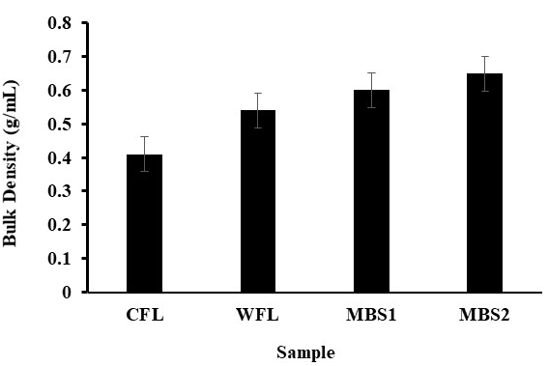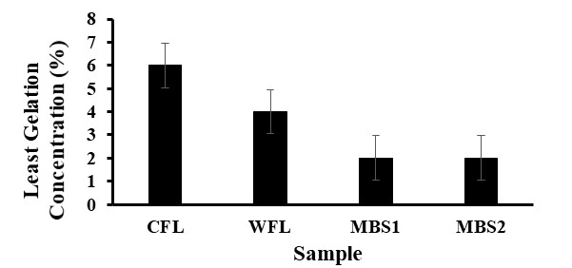

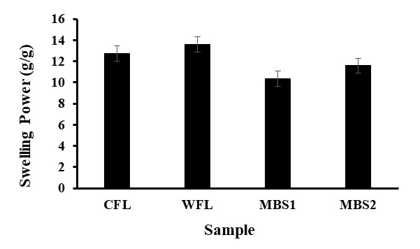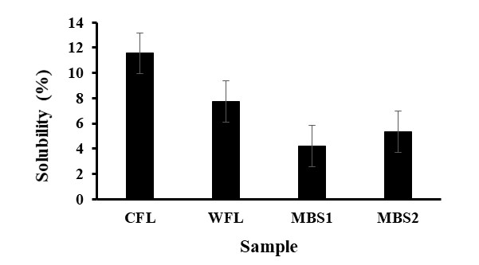

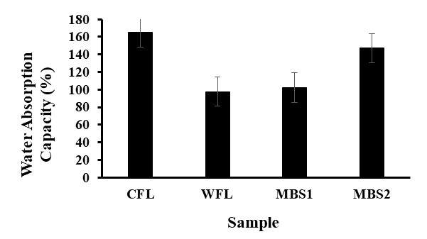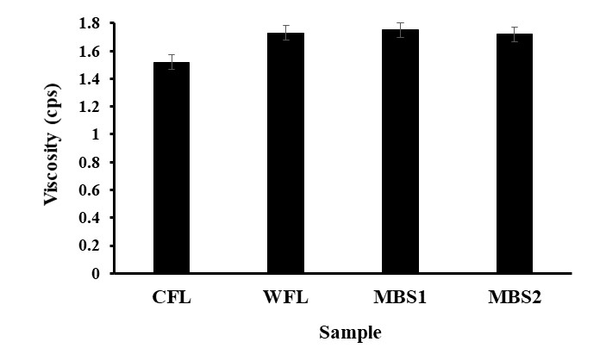
Fig. 1. Functional properties of the flour blends

3.2 Phytochemicals
Table 2 depicts the results of anti-nutritional factors of complementary food from millet, soybean and banana flour blends. The peak value of phytate, 7.84±0.01 mg/g is obtained in CFL and lowest, 5.29±0.12 mg/g in MBS_{1.} Oxalate is highest (4.50±0.01 mg/g) in MBS₂ and lowest (2.97±0.01mg/g) in CFL, tannins highest in CFL with the value 0.37±0.00 mg/g and lowest in MBS₂ with the value of 0.07±0.01 mg/g and phenols highest in CFL at 9.30±0.00 mg/g and lowest in WFL at 0.22±0.06 mg/g. CFL has the highest value in all the phytochemicals studied except oxalate where MBS₂ has the highest value. Although certain phytochemicals are considered anti-nutrients due to their potential adverse effects, others have been recognized for their beneficial roles in promoting health when consumed in low concentrations (Popova & Mihaylova, 2019). For instance, phytic acid has been associated with potential protective effects against colon cancer, while tannins exhibit antiviral, antibacterial, and antiparasitic properties (Shukla et al., 2024). This suggests that these compounds are not inherently detrimental despite their limited nutritional contribution, as their effects depend on dosage—where moderate intake can provide health benefits without posing risks. The findings of this study revealed a significant reduction in the levels of the analyzed phytochemicals following processing.

Table 2. Phytochemicals of the samples
Sample | Phytochemicals (mg/g)
Sample | Phytate | Oxalate | Tannins | Phenols
CFL | 7.84ª±0.01 | 2.97^{d}±0.01 | 0.37ª±0.00 | 9.30ª±0.00
WFL | 7.15^{b}±0.26 | 3.96^{b}±0.01 | 0.22^{b}±0.01 | 0.22^{d}±0.06
MBS₁ | 5.29^{d}±0.12 | 3.54^{c}±0.01 | 0.08^{c}±0.01 | 2.12^{b}±0.03
MBS₂ | 6.18^{c}±0.01 | 4.50ª±0.01 | 0.07^{d}±0.01 | 1.95^{c}±0.04
Results are the means of triplicate determination ± standard deviation values in the same column with the same superscripts letters (a > b > c > d) are not significantly different (P < 0.05).

3.3 Vitamin Contents
Table 3 depicts the vitamin contents of the blended samples in comparison with the recommended daily allowance (RDA) (Kamangar & Emadi, 2012). The vitamin A (retinol) contents of the samples are 1.41±0.01 mg, 1.12±0.01 mg, 1.21±0.01 mg and 1.11±0.01 mg for CFL, WFL, MBS₁ and MBS₂ respectively. The maximum value of vitamin A content obtained in CFL is generally higher (P < 0.05) than the proportions of vitamins B₂ (riboflavin), B₃ (niacin), B₆ (pyridoxine), D (cholecalciferol) and K (phylloquinone; menaquinone) but lower than vitamins B₁ (thiamin), B₉ folate), B₁₂ (cobalamin), C (ascorbic acid) and E (tocopherol). An opposite trend is obtained for vitamins B₂, B_{3,} B₆, D and K of all the samples studied. While the vitamin B₉ contents in CFL and WFL are within the RDA, the contents of vitamins B₉ in MBS₁ and MBS₂ are respectively slightly higher and lower than the RDA. A lowering from RDA is observed in MBS₂ in terms of vitamin B₁₂, which has the peak proportion of 160.67±1.15 µg in MBS₁. The relative abundance of vitamin C in the samples studied is 72.13±0.23 mg (MBS₂) > 70.54±0.59mg (MBS₁) > 70.07±0.02 mg (CFL) > 50.97±1.09 mg (WFL). These values are all within the RDA (50.00‐200.00 mg). Vitamin E contents of CFL (1.57±0.01 µg), MBS₁ (1.76±0.01 µg) and MBS₂ (1.92±0.03µg) are above the RDA (0.70-1.40 µg) while WFL (0.92±0.02 µg) is within the range of RDA. Vitamins in diets, either as fat-soluble vitamins A, D, E, and K or water-soluble vitamins B and C, are noted for developing the body. Since vitamin A is significant for good sight, the samples studied cannot be used single diets to manage poor eye sight because of lower relative abundance of vitamin A in the samples than RDA. A deficiency in vitamin A exposes the eyes to infection with an extension of possible dysfunctional salivary glands and genitourinary tracts while vitamin D normalizes the proportions of phosphorus and calcium in the blood via absorption from the small intestines (Nair & Maseeh, 2012). The samples studied are rich in vitamin E, implying that they can be used as single diets or supplements of anti-oxidants in the body with enhanced immunity and aids to wounds healing (Nair & Maseeh, 2012). The water-soluble vitamins are also basically used for building and developing tissues in the body. All the samples studied are suitable sources of vitamin B₁, which is a cofactor for several enzymes involved in energy metabolism (Morris & Mohiuddin, 2020). In the same league with vitamin B₁ are vitamins B₉ and B₁₂ except for their values in MBS₂. B₉ and B₁₂ are coenzymes that play significant roles conversion and isomerization cellular metabolites and coenzymes. The samples studied are rich in vitamin C, suggesting them as single diets or supplements that can manage scurvy, common cold by acting as a reductant in enzymatic reactions and soluble anti-oxidant in non-enzymatic reactions (Morris & Mohiuddin, 2020).

Table 3. Vitamins of the samples
Vitamin | *RDA (mg) | Sample
Vitamin | *RDA (mg) | CFL | WFL | MBS₁ | MBS₂
A (mg) | 8.00‐10.00 | 1.41ª±0.01 | 1.12^{c}±0.01 | 1.21^{b}±0.01 | 1.11^{c}±0.01
B₁ (mg) | 1.00-3.00 | 2.37^{b}±0.01 | 2.36^{bc}±0.00 | 2.38^{ab}±0.01 | 2.39ª±0.01
B₂ (mg) | 1.00-1.20 | 0.17^{b}±0.01 | 0.14^{c}±0.01 | 0.17^{b}±0.01 | 0.19ª±0.01
B₃ (mg) | 2.00-2.20 | 0.13^{c}±0.01 | 0.11^{d}±0.01 | 0.15^{b}±0.01 | 0.17ª±0.01
B₆ (mg) | 1.00-3.00 | 0.17^{c}±0.02 | 0.15^{d}±0.01 | 0.21^{ab}±0.01 | 0.22ª±0.01
B₉ (µg) | 100.00-200.00 | 151.67^{c}±2.89 | 186.67^{b}±11.55 | 206.67ª±5.77 | 96.67^{d}±5.77
B₁₂ (µg) | 100.00-200.00 | 152.67^{b}±1.15 | 125.33^{c}±1.15 | 160.67ª±1.15 | 81.67^{d}±2.89
C (mg) | 50.00‐200.00 | 70.07^{c}±0.02 | 50.97^{d}±1.09 | 70.54^{b}±0.59 | 72.13ª±0.23
D (µg) | 8.00-10.00 | 0.16^{c}±0.01 | 0.13^{d}±0.02 | 0.17^{b}±0.01 | 0.21ª±0.01
E (µg) | 0.70-1.40 | 1.57^{c}±0.01 | 0.92^{d}±0.02 | 1.76^{b}±0.01 | 1.92ª±0.03
K (µg) | 0.80‐0.10 | 0.05^{b}±0.01 | 0.04^{bc}±0.01 | 0.05^{b}±0.01 | 0.08ª±0.01
*RDA: Recommended daily allowance (Kamangar and Emadi, 2012). Results are the means of triplicate determination ±standard deviation values in the same row with the same superscripts letters (a > b > c > d) are not significantly different (P < 0.05).

4. Conclusion

The functional attributes of the blended flours examined are crucial in determining the storage stability, texture, taste, flavor, and overall quality of food products. The findings from this study indicate that these gluten-free flour blends hold significant potential for use in food manufacturing and could contribute meaningfully to addressing global food insecurity challenges. The results obtained show significant reduction in the proportions of the phytochemicals studied through processing methods. Oxalate content is found highest in mbs₂ (50% millet; 20% banana; 30% soybeans) flour blend. The samples studied can as single diets or supplements of vitamins B₁, B₉, B₁₂, C and E with prominent proportions found in 60% millet; 20% banana; 20% soybeans (MBS₁) and 50% millet; 20% banana; 30% soybeans (MBS₂) flour blends. The formulated products, mbs₁ and mbs₂ had functional and nutritional values with potentials to serve as alternatives to whole wheat flour and commercial weaning foods.

Consent

Not applicable to this manuscript.

Ethical approval (where ever applicable)

Not applicable to this manuscript.

COMPETING INTERESTS DISCLAIMER:
Authors have declared that they have no known competing financial interests OR non-financial interests OR personal relationships that could have appeared to influence the work reported in this paper.

References
Akinola, S. A., Badejo, A. A., Osundahunsi, O. F., & Edema, M. O. (2017). Effect of preprocessing techniques on pearl millet flour and changes in technological properties. International Journal of Food Science and Technology, 52(4). https://doi.org/10.1111/ijfs.13363
Białek-Dratwa, A., Soczewka, M., Grajek, M., Zbieta Szczepá Nska, E., & Kowalski, O. (2022). Use of the Baby-Led Weaning (BLW) Method in Complementary Feeding of the Infant-A Cross-Sectional Study of Mothers Using and Not Using the BLW Method. Molecules. https://doi.org/10.3390/nu14122372
Chinma, C. E., Igbabul, B. D., & Omotayo, O. O. (2012). Quality characteristics of cookies
prepared from unripe plantain and defatted sesame flour blends. American Journal of Food
Technology, 7(7). https://doi.org/10.3923/ajft.2012.398.408
Coffman, C. W., & Garcia, V. V. (1977). Functional properties and amino acid content of a protein isolate from mung bean flour. International Journal of Food Science & Technology, 12(5). https://doi.org/10.1111/j.1365-2621.1977.tb00132.x
Essien, E. E., & Akpan, S. M. (2014). Phytochemical and anti-nutrients evaluation of some wild fruiting polypore macrofungi. Journal of Chemical & Pharmaceutical Research, 6(12), 792-796.
Falcomer, A. L., Riquette, R. F. R., De Lima, B. R., Ginani, V. C., & Zandonadi, R. P. (2019). Health benefits of green banana consumption: A systematic review. In Nutrients (Vol. 11, Issue 6). https://doi.org/10.3390/nu11061222.
Hasmadi, M., Noorfarahzilah, M., Noraidah, H., Zainol, M. K., & Jahurul, M. H. A. (2020).
Functional properties of composite flour: A review. In Food Research (Vol. 4, Issue 6).
https://doi.org/10.26656/fr.2017.4(6).419.
Iwuozor, K. O. (2019). Qualitative and Quantitative Determination of Anti-Nutritional Factors of Five Wine Samples. Advanced Journal of Chemistry, Section A, 2(2).
https://doi.org/10.29088/SAMI/AJCA.2019.2.136146.
Kalla-Bertholdt, A. M., Baier, A. K., & Rauh, C. (2023). Potential of Modification of TechnoFunctional Properties and Structural Characteristics of Citrus, Apple, Oat, and Pea Dietary Fiber by High-Intensity Ultrasound. Foods, 12(19). https://doi.org/10.3390/foods12193663.
Kamangar, F., & Emadi, A. (2012). Vitamin and mineral supplements: Do we really need them? In International Journal of Preventive Medicine (Vol. 3, Issue 3).
Kathembe, J., Tapkigen, J., Mwangome, M. K., Prentice, A. M., & Nabwera, H. M. (2023).
Stunting of Growth in Developing Countries. In World Review of Nutrition and Dietetics
(Vol. 126, pp. 17–31). S. Karger AG. https://doi.org/10.1159/000527936.
Mauro, R. R., Vela, A. J., & Ronda, F. (2023). Impact of Starch Concentration on the Pasting and Rheological Properties of Gluten-Free Gels. Effects of Amylose Content and Thermal and Hydration Properties. Foods, 12(12). https://doi.org/10.3390/foods12122281.
Messina, M. (2022). Perspective: Soybeans Can Help Address the Caloric and Protein Needs of a Growing Global Population. Frontiers in Nutrition, 9.
https://doi.org/10.3389/fnut.2022.909464.
Morris, A. L., & Mohiuddin, S. S. (2020). Biochemistry, Nutrients. In StatPearls {internet]. https://www.ncbi.nlm.nih.gov/books/NBK554545/
Mshayisa, V. V., Van Wyk, J., & Zozo, B. (2022). Nutritional, Techno-Functional and Structural Properties of Black Soldier Fly (Hermetia illucens) Larvae Flours and Protein Concentrates. Foods, 11(5), 724. https://doi.org/10.3390/foods11050724.
Munteanu, C., Berindean, I., Mihai, M., Pop, B., Popa, M., Muntean, L., Petrescu, O., & Ona, A. (2023). E, K, B5, B6, and B9 vitamins and their specific immunological effects evaluated by flow cytometry. In Frontiers in Medicine (Vol. 9).
https://doi.org/10.3389/fmed.2022.1089476.
Nair, R., & Maseeh, A. (2012). Vitamin D: The sunshine vitamin. In Journal of Pharmacology and Pharmacotherapeutics (Vol. 3, Issue 2). https://doi.org/10.4103/0976-500X.95506.
Ohizua, E. R., Adeola, A. A., Idowu, M. A., Sobukola, O. P., Afolabi, T. A., Ishola, R. O.,
Ayansina, S. O., Oyekale, T. O., & Falomo, A. (2017). Nutrient composition, functional, and pasting properties of unripe cooking banana, pigeon pea, and sweetpotato flour blends. Food Science and Nutrition, 5(3). https://doi.org/10.1002/fsn3.455.
Oladebeye, A. O., & Oladebeye, A. A. (2023). Physicochemical and Nutritional Properties of Baby-Led Cookies Produced from Rice, Banana and Cashew-nut Flour Blends. European Journal of Nutrition & Food Safety, 15(7). https://doi.org/10.9734/ejnfs/2023/v15i71318.
Oladebeye, A. O., Oshodi, A. A., Amoo, I. A., & Karim, A. A. (2018). Gaseous Ozonation of Pigeon Pea, Lima Bean, and Jack Bean Starches: Functional, Thermal, and Molecular
Properties. Starch/Starke, 70(11–12). https://doi.org/10.1002/star.201700367.
Oppong, D., Arthur, E., Kwadwo, S., Badu, E., & Sakyi, P. (2015). Proximate Composition and Some Functional Properties of Soft Wheat Flour. International Journal of Innovative
Research in Science, Engineering and Technology, 4 (2): 753 – 758. doi:10.15680/IJIRSET.2015.0402097
Popoola, J. O., Ojuederie, O. B., Aworunse, O. S., Adelekan, A., Oyelakin, A. S., Oyesola, O. L., Akinduti, P. A., Dahunsi, S. O., Adegboyega, T. T., Oranusi, S. U., Ayilara, M. S., & Omonhinmin, C. A. (2023). Nutritional, functional, and bioactive properties of african
underutilized legumes. In Frontiers in Plant Science (Vol. 14).
https://doi.org/10.3389/fpls.2023.1105364.
Popova, A., & Mihaylova, D. (2019). Antinutrients in Plant-based Foods: A Review. The Open Biotechnology Journal, 13(1). https://doi.org/10.2174/1874070701913010068
Rodriguez-Amaya, D., & Kimura, M. (2004). Harvest Plus Handbook for Carotenoid Analysis. Washington, DC and Cali: IFPRI and CIAT, 58. (Harvest Plus Technical Monograph, 2).
Shukla, V., Srivastava, S., Singh, S., Mursal, M., & Hussain, S. (2024). Unveiling the intricacies of phytate antinutrients in millets and their therapeutic implications in breast cancer. In Intelligent Pharmacy (Vol. 2, Issue 4). https://doi.org/10.1016/j.ipha.2023.12.005.
Siamabele, B. (2021). The significance of soybean production in the face of changing climates in Africa. In Cogent Food and Agriculture (Vol. 7, Issue 1).
https://doi.org/10.1080/23311932.2021.1933745.
Truswell, A. S. (2002). Cereal grains and coronary heart disease. In European Journal of Clinical Nutrition (Vol. 56, Issue 1). https://doi.org/10.1038/sj.ejcn.1601283.
Wabali, V. C., Giami, S. Y., Kiin-Kabari, D. B., & Akusu, O. M. (2020). Physiochemical, Antinutrient and in-vitro Protein Digestibility of Biscuits Produced from Wheat, African Walnut and Moringa Seed Flour Blends. Asian Food Science Journal.
https://doi.org/10.9734/afsj/2020/v14i130120.
Yao, D., Ren, Q., Zhang, J., Farag, M. A., Liu, L., & Liu, L. (2025). Simultaneous determination of vitamins A, D3 and E in milk and dairy foods by HPLC. Journal of Food Composition and Analysis, 143, 107573. https://doi.org/10.1016/j.jfca.2025.107573.
Zandonadi, R. P., Botelho, R. B. A., Gandolfi, L., Ginani, J. S., Montenegro, F. M., & Pratesi, R. (2012). Green Banana Pasta: An Alternative for Gluten-Free Diets. Journal of the Academy of Nutrition and Dietetics, 112(7). https://doi.org/10.1016/j.jand.2012.04.002.

Abbreviations

CFL = 100% Commercial Nutriborn
WFL = 100% whole millet flour
MBS₁ = 60% millet; 20% banana; 20% soybeans
MBS₂ = 50% millet; 20% banana; 30% soybeans
LGC = Least gelation concentration

